State of Florida   |  | Public Service Commission  Capital Circle Office Center ● 2540 Shumard Oak Boulevard  Tallahassee, Florida 32399-0850  -M-E-M-O-R-A-N-D-U-M-
DATE: | September 17, 2008
TO: | Office of Commission Clerk (Cole)
FROM: | Office of the General Counsel (Hartman)  Division of Economic Regulation (Fletcher)
RE: | Docket No. 060122-WU – Joint petition for approval of stipulation on procedure with Office of Public Counsel, and application for limited proceeding increase in water rates in Pasco County, by Aloha Utilities, Inc.
AGENDA: | 09/29/08 – Regular Agenda – Motion to Dismiss –Decision Prior to Hearing - Oral Argument Requested on Issue 2
COMMISSIONERS ASSIGNED: |  |  | All Commissioners
PREHEARING OFFICER: |  |  | Skop
CRITICAL DATES: |  |  | None
SPECIAL INSTRUCTIONS: |  |  | None
FILE NAME AND LOCATION: |  |  | S:\PSC\GCL\WP\060122.RCM.DOC

Background
Aloha Utilities, Inc. (Aloha or utility) is a Class A water and wastewater utility located in Pasco County. The utility consists of two distinct service areas: Aloha Gardens and Seven Springs. The utility has been exceeding its Southwest Florida Water Management District water use permit (WUP) limits. To address Aloha’s excess withdrawals, on October 26, 2004, Aloha entered into a Bulk Water Agreement with Pasco County (County), wherein it contracted to purchase water from the County in order to meet the needs of current and future customers and eliminate excess withdrawals from its wells.

On February 13, 2006, OPC and Aloha filed a Joint Petition to Approve Stipulation on Procedure (Stipulation), which formalized an agreement between Aloha and OPC regarding the procedure to be followed and the issues to be addressed in the event Aloha filed a future limited proceeding to recover the costs of purchased water and related chloramination facilities. The Commission approved the Stipulation on Procedure by Order No. PSC-06-0169-S-WU, issued March 1, 2006, in this docket.

On September 28, 2007, Aloha filed its application for a limited proceeding to recover the costs for the chloramination and purchased water from the County.

The Commission considered this application at its February 12, 2008, Agenda Conference, where the Commission heard from the utility, the Office of Public Counsel (OPC), and interested customers. Subsequently, the Commission issued proposed agency action (PAA) Order No. PSC-08-0137-PAA-WU, on March 3, 2008. The order allows the utility, after it has completed the construction of a fully operating interconnection with Pasco County, to recover phase one costs associated with the interconnection and with the utility’s purchase of bulk water from Pasco County. On March 24, 2008, Aloha, OPC, and certain members of the Better Water Now Committee protested the order and requested a hearing on the matter. The hearing is currently scheduled for November 24-25, 2008.
On August 29, 2008, OPC filed a Motion to Dismiss or in the Alternative Motion to Amend Procedural Order (Motion), alleging that Aloha’s testimony is insufficient and is essentially an attempt to revise its application for a limited proceeding rate case. Aloha filed a response in opposition to OPC’s Motion on September 5, 2008, simultaneously with a request for oral argument.
Upon consideration of these pleadings, the prehearing officer tolled the time for the filing of OPC and staff’s direct testimony and exhibits by Order No. PSC-08-0601-PCO-WU, issued September 17, 2008, in order to allow for OPC’s Motion to be heard by the full Commission.
The Commission has jurisdiction pursuant to Chapters 120 and 367, Florida Statutes.

Discussion of Issues
Issue 1: Should the Commission grant Aloha’s request for oral argument?

Recommendation: Yes, the Commission should grant Aloha’s request for oral argument, and recommends that 10 minutes per side should be allowed. (Hartman, Fletcher)

Staff Analysis: In response to OPC’s Motion to Dismiss or in the Alternative Motion to Amend Procedural Order, Aloha filed its response and filed a request for oral argument pursuant to Rule 25-22.0022, Florida Administrative Code (F.A.C.). Rule 25-22.0022(1), F.A.C., requires requests for oral argument to be filed concurrently with the motion on which argument is requested and to state with particularity why oral argument would aid the Commission in understanding and evaluating the issues to be decided. Aloha states that oral argument will allow the Commission to achieve a more comprehensive understanding of OPC’s motions and the ramifications of granting the same.

OPC counsel has indicated to staff its support of Aloha’s request for oral argument. Rule 25-22.0022(7)(a), F.A.C., provides, “[o]ral argument at an agenda conference will only be entertained for recommended orders and dispositive motions, such as motions to dismiss, motions for summary final order, and motions for reconsideration of non-final or final orders. Only parties to the docket and the staff attorney may participate in the oral argument.” Staff believes oral argument may allow the Commission to achieve a more comprehensive understanding of the matter at issue and recommends that the request be granted. Staff recommends that 10 minutes per side (OPC and Aloha) is a reasonable and sufficient amount of time to address the Commission on Issue 2.
Issue 2:0
What action should the Commission take with regard to OPC’s Motion to Dismiss or in the Alternative Motion to Amend Procedural Order and Aloha’s Response in opposition?
Recommendation: The Commission should deny OPC’s Motion to Dismiss and should grant the Motion to Amend the Procedural Order. Staff recommends the Commission order Aloha to refile its direct testimony and exhibits by October 15, 2008. (Hartman, Fletcher)

Staff Analysis: Pursuant to the Order Establishing Procedure, Order No. PSC-08-0427-PCO-WU, Aloha was directed to file its direct testimony and exhibits on August 5, 2008, in support of its request for a limited proceeding. On August 5, 2008, Aloha filed direct testimony and exhibits of Stephen Watford, Aloha President; David Porter, Professional Engineer; and Robert C. Nixon, Certified Public Accountant. On August 29, 2008, OPC filed its Motion to Dismiss or in the Alternative Motion to Amend Procedural Order. On September 5, 2008, Aloha filed its response in opposition.
OPC’s Motion alleges that Aloha’s testimony is insufficient and is essentially an attempt to revise its application for a limited proceeding rate case. OPC states that Aloha has refiled its original case by resubmitting its original application which includes the original accounting exhibit, while at the same time presenting accounting and engineering witness testimony which states that Aloha needs to modify its rate increase request based on known and measurable changes, but does not anticipate filing these major changes until it files its rebuttal testimony.

OPC asserts that Aloha is essentially seeking to file a new rate case on rebuttal. OPC further asserts that “[p]ermitting Aloha to materially change all of the numbers associated with all of the protested issues in this proceeding when it files its rebuttal testimony would make a mockery of the Commission’s procedures and the due process rights of customers.” OPC argues that the Commission should dismiss the case to avoid setting “a bad precedent permitting utilities to increase their original rate request every time a Commission’s PAA order is protested.”

OPC contends that Aloha is attempting to materially alter its direct testimony filing date from August 5, 2008 to October 15, 2008. OPC’s own direct testimony and exhibits were due September 16, 2008, and staff testimony and exhibits, if any, were due October 1, 2008; this alteration deprived OPC and staff from any meaningful review of, and ability to respond to, Aloha’s testimony and exhibits.

In the alternative, OPC requests the Commission amend the controlling dates in this proceeding to preserve the customers’ due process rights and to assure the public that the rates that result from the Commission hearing are supportable and reasonable. In anticipation of Aloha filing rebuttal testimony as currently scheduled on October 15, 2008, including known and measurable changes in costs and fees, OPC requests a 90 day minimum delay in this proceeding. OPC requests the delay run from October 15, 2008, to allow it an opportunity to evaluate the new and revised filing the utility intends to provide. Also, OPC asks for a new procedural schedule setting its testimony and exhibits to be due on January 13, 2009, and the remaining dates adjusted accordingly.

In its Response, Aloha asks the Commission to deny OPC’s Motion. The utility argues that OPC’s request violates the Stipulation OPC signed and invites the Commission to ignore its own prior order, that is Order No. PSC-06-0169-S-WU, approving the stipulation on procedure. Aloha argues that OPC is now moving to dismiss a proceeding which it earlier stipulated could and should occur. Aloha states that it has been under pressure from the Southwest Florida Water Management District for several years to decrease its groundwater withdrawals, and this stipulated proceeding was the culmination of the efforts of the utility, staff and OPC to achieve that end. Aloha contends that to dismiss or continue this matter would be entirely inconsistent with Order No. PSC-06-0169-S-WU. Aloha also responds by asserting that OPC has failed to state good cause to dismiss because its arguments are premature and are timely made when evidence is actually put in the record. Finally, Aloha argues OPC fails to state good cause for its motion to amend the procedural order. Aloha appears to argue that whether it will propose adjustments in this case, based on known and measurable changes is speculative. This final argument appears to be in conflict with the utility’s testimony. For example, in witness Nixon’s testimony, he presents, on pages 9 through 10, a list of seven areas of material change to the utility’s application which need to be recognized by the Commission. Mr. Nixon, however, does not provide any proposed adjustments or calculations for these proposed changes.

Staff has reviewed Aloha’s direct testimony. In the utility’s testimony, its accounting and engineering witnesses indicate that many of Aloha’s major rate base components, as well as operations and maintenance (O&M) expenses from the original application, may be increased, and Aloha has not provided known and measureable changes for those items for which it seeks an increase. According to the utility’s testimony these changes include: changes in Allowance for Funds Used during Construction (AFUDC), accrual of capacity charges paid to Pasco County and the interconnection costs, changes in labor costs, changes in purchased water costs, changes in land costs, and changes to chemical prices as the result of rising oil prices, among other changes. Aloha apparently plans to provide the known and measurable changes in its rebuttal testimony, which is currently due on October 15, 2008.

Attached to this recommendation as Attachment A is OPC’s Summary of Aloha’s adjustments, which staff has reviewed and verified. Staff believes that Aloha’s filed testimony is inadequate and does not provide OPC, the other intervenors and staff, with a meaningful opportunity to address Aloha’s direct case.

Motions to dismiss are typically addressed by considering whether the facts set forth in the initial pleadings, viewed in the most favorable light, demonstrate a claim for which the Commission can grant relief under the substantive law on the matter. In order to sustain a motion to dismiss, the moving party must demonstrate that, accepting all allegations in the petition as facially correct, the petition fails to state a cause of action for which relief can be granted. OPC’s argument for dismissal, however, appears to be based largely on policy considerations.

Staff recommends the Motion to Dismiss be denied as OPC has not met the standard for dismissal. Further, the parties entered into a Stipulation, approved by Commission order, for this limited proceeding in order to move forward with this application. At this time, staff believes the better course of action is for Aloha to be directed to refile its direct testimony and exhibits with the updated information.

Staff is also concerned that dismissing this case would only further delay a decrease in groundwater withdrawals. It is likely that an order of dismissal would further delay this matter by at least six months. Staff remains mindful that Aloha has been exceeding its Southwest Florida Water Management District water use permit limits, and its application to interconnect and purchase water from Pasco County is a necessary step towards correcting this problem.

Therefore, staff recommends the Commission deny OPC’s motion to dismiss the instant proceeding. Instead, staff recommends that Aloha be directed to refile its testimony and exhibits on October 15, 2008, direct the utility to account for adjustments for known and measurable changes that it wishes the Commission to consider, and allow the Prehearing Officer to modify the order establishing procedure as needed.

Issue 3:0
Should this docket be closed?
Recommendation:
No, this docket should remain open pending the resolution of the protest, and further action associated with the Stipulation. (Hartman)
Staff Analysis:
This docket should remain open pending the resolution of the protest, and further action associated with the Stipulation.
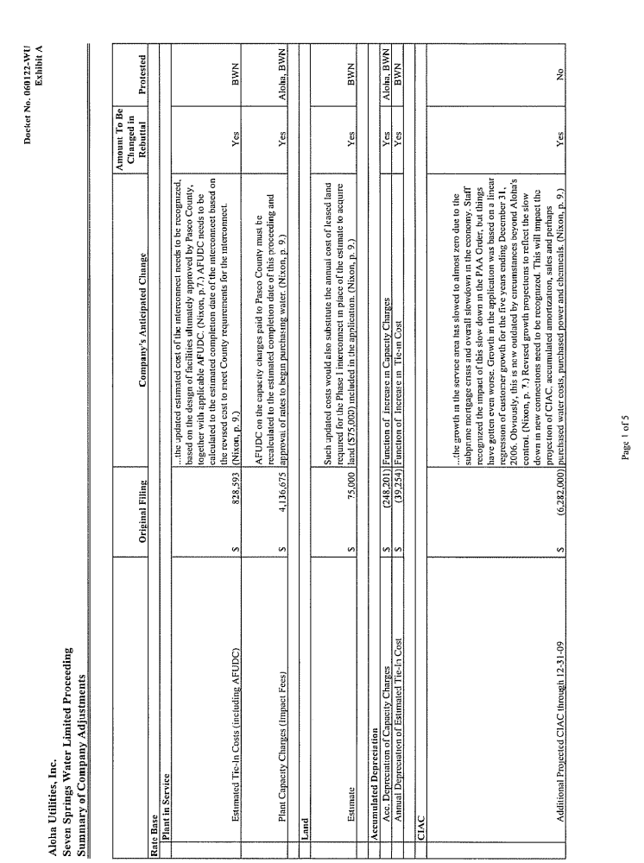
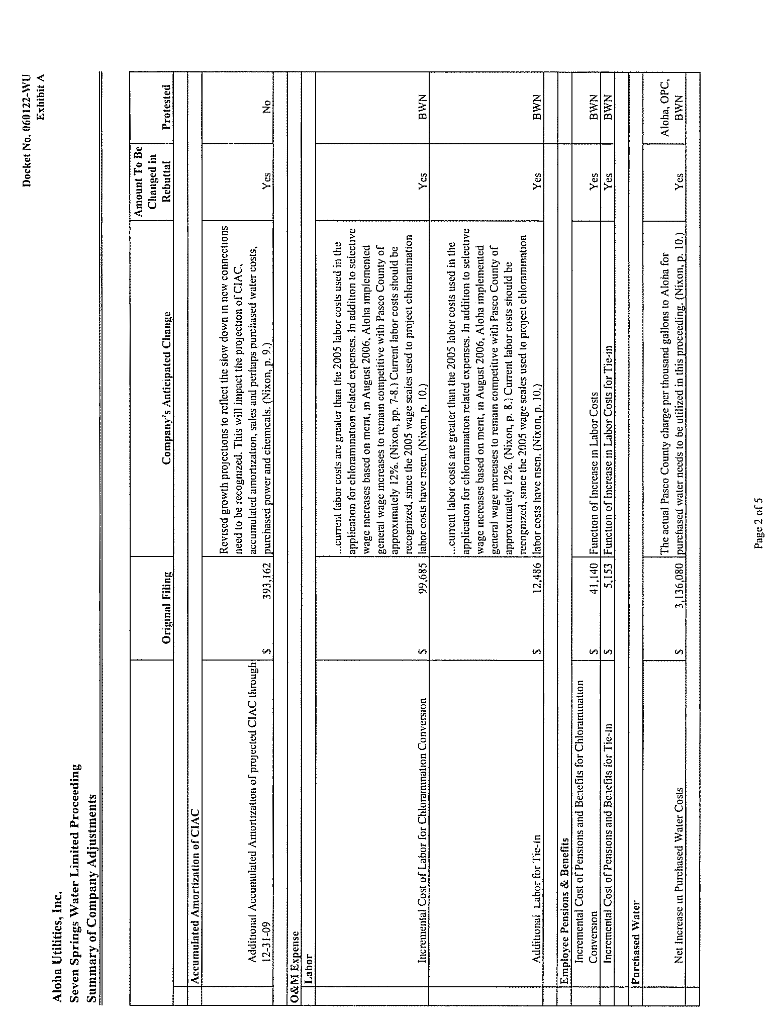
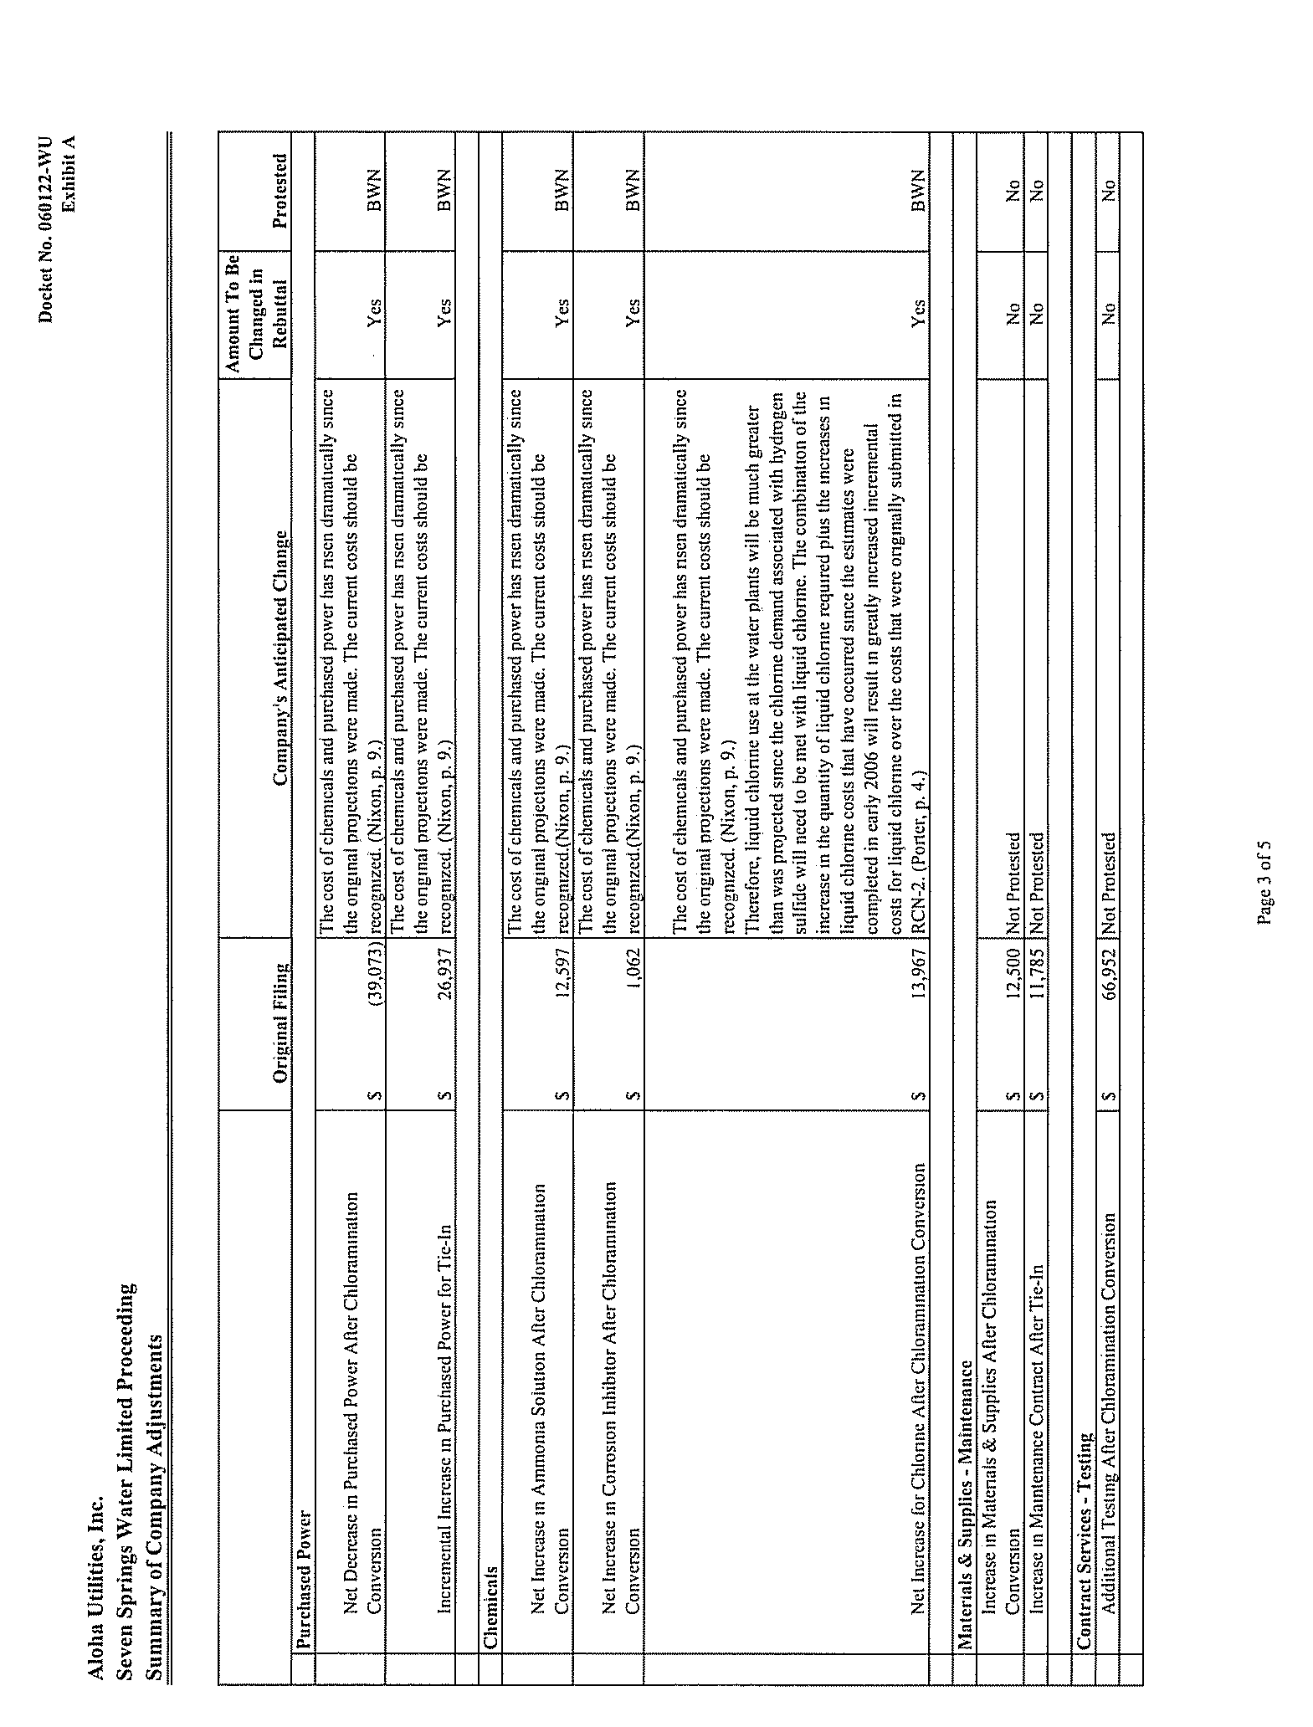
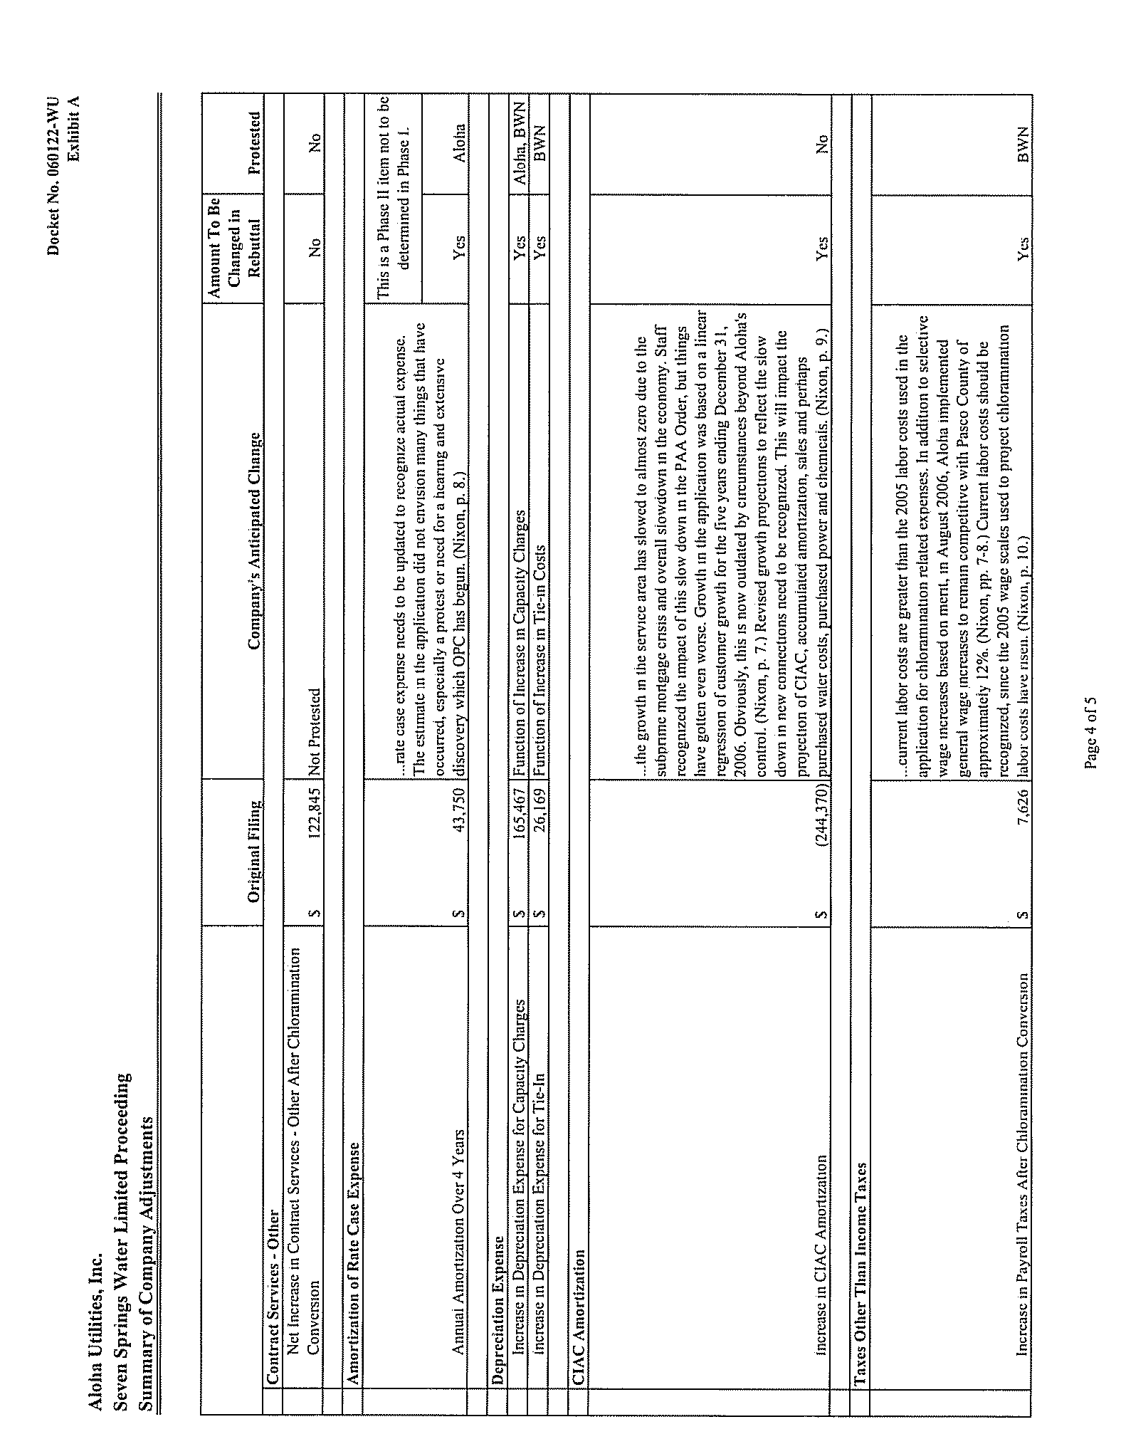

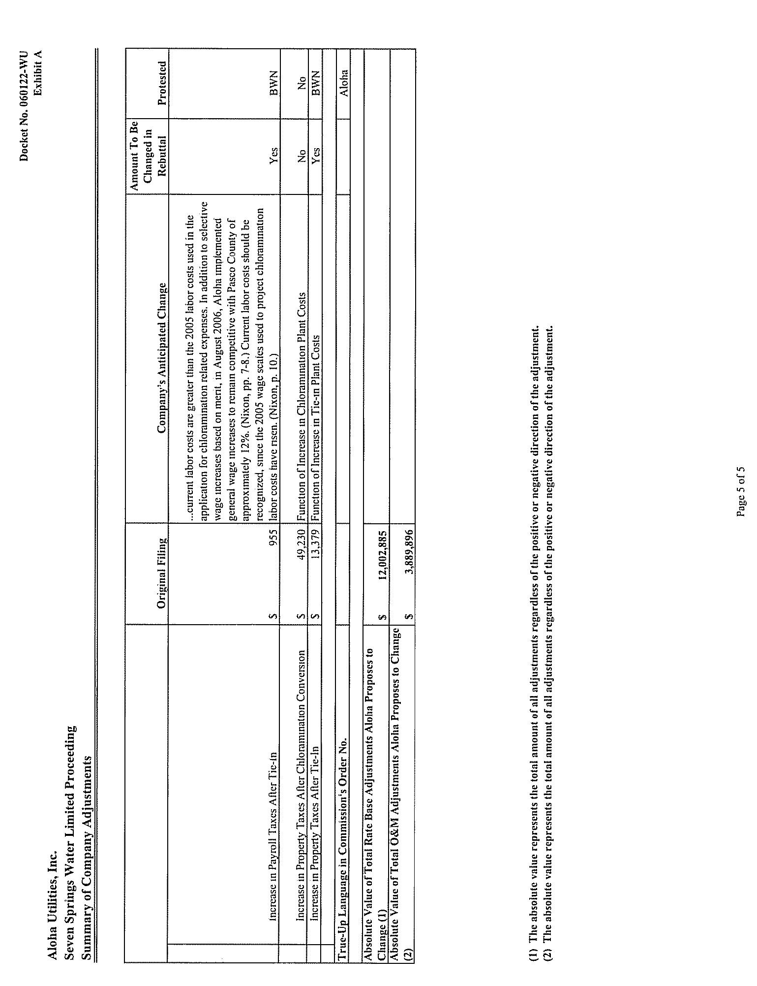

See direct testimony of Robert C. Nixon, C.P.A., filed August 5, 2008, in the instant docket.
A motion to dismiss raises as a question of law the sufficiency of the facts alleged in a petition to state a cause of action. See Varnes v. Dawkins, 624 So. 2d 349, 350 (Fla. 1st DCA 1993). The standard to be applied in disposing of a motion to dismiss is whether, with all factual allegations in the petition taken as true and construed in the light most favorable to the petitioner, the petition states a cause of action upon which relief may be granted. When “determining the sufficiency of the complaint, the trial court may not look beyond the four corners of the complaint, consider any affirmative defenses raised by the defendant, nor consider any evidence likely to be produced by either side.” Id.
The time involved in the refiling of Aloha’s limited proceeding request, the investigation and preparation of staff’s recommendation, the Commission’s consideration of the request at Agenda Conference, the issuance of an order, the running of the protest period, and subsequent scheduling for hearing of a protest, would likely extend resolution of this matter by at least six months.

