State of Florida   |  | Public Service Commission  Capital Circle Office Center ● 2540 Shumard Oak Boulevard  Tallahassee, Florida 32399-0850  -M-E-M-O-R-A-N-D-U-M-
DATE: | September 24, 2009
TO: | Office of Commission Clerk (Cole)
FROM: | Division of Economic Regulation (Mouring, Bulecza-Banks, Fletcher, Lingo)  Office of the General Counsel (Jaeger)
RE: | Docket No. 080249-WS – Application for increase in water and wastewater rates in Pasco County by Labrador Utilities, Inc.
AGENDA: | 10/06/09 – Regular Agenda – Interested Persons May Participate
COMMISSIONERS ASSIGNED: |  |  | McMurrian, Edgar, Argenziano
PREHEARING OFFICER: |  |  | Argenziano
CRITICAL DATES: |  |  | 8-Month Effective Date Waived Through 4/6/10
SPECIAL INSTRUCTIONS: |  |  | None
FILE NAME AND LOCATION: |  |  | S:\PSC\ECR\WP\080249.RCM.DOC

Case Background
Labrador Utilities Inc. (Labrador or Utility) is a Class B utility providing water and wastewater service to approximately 897 water and 892 wastewater customers in Pasco County. Water and wastewater rates were last established for this Utility in 2004.
On August 28, 2008, Labrador filed an Application for Rate Increase in the instant docket. By Order No. PSC-08-0751-PCO-WS, issued November 13, 2008, the Commission approved interim annual revenue increases of $97,862 or 62.83 percent for water and $29,611 or 8.17 percent for wastewater. The revenue increases are being secured through a corporate undertaking by Utilities, Inc. (UI), Labrador’s parent company. By Order No. PSC-09-0462-PAA-WS (PAA Order), issued June 22, 2009, the Commission approved rates that were designed to generate a water revenue requirement of $257,003 and a wastewater revenue requirement of $497,755.
On July 13, 2009, the Office of Public Counsel (OPC) timely filed a protest of the PAA Order. On July 22, 2009, Labrador timely filed a cross-petition to protest the PAA Order pursuant to Rule 25-22.029(3), Florida Administrative Code (F.A.C.).
On September 3, 2009, the Utility and OPC (collectively, Parties) filed a Joint Motion Requesting Commission Approval of Settlement Agreement (Joint Motion). That motion and settlement agreement are incorporated in this recommendation as Attachment A.
This recommendation addresses the Parties’ Settlement Agreement. The Commission has jurisdiction pursuant to Sections 367.081 and 367.121, Florida Statutes (F.S.).
Discussion of Issues
Issue 1:1
Should the Commission approve the Joint Motion Requesting Commission Approval of Settlement Agreement?
Recommendation:
Yes. The Joint Motion and Settlement Agreement should be approved. The Utility should file a proposed customer notice and revised tariff sheets within 15 days of the Commission vote, which is consistent with the Commission’s decision. The approved rates should be effective for service rendered on or after the stamped approval date of the tariff pursuant to Rule 25-30.475(1), F.A.C., after staff has verified that the proposed customer notice is adequate and the notice has been provided to the customers. The Utility should provide proof that the customers have received notice within 10 days after the date of the notice. (Mouring)
Staff Analysis:
In the Settlement Agreement, the Parties note that they have not agreed on certain language in the PAA Order as follows: (1) the quality of service provided by the Utility, (2) the determination of the used and usefulness of Labrador’s wastewater treatment plant, (3) the appropriate salaries and benefits expense, and (4) the appropriate amount of rate case expense. The Parties, have however, agreed that the PAA Order is to have no precedential value as to determining the aforementioned items. The Commission has previously approved a proposed settlement where language was stricken from a proposed agency action order. Staff agrees that the language in the PAA Order which the Parties seek to strike can be removed because each rate case is decided on its own merits. The Parties have agreed that the water revenue requirement be reduced by $3,379 to $253,624, and the wastewater revenue requirement be reduced by $37,620 to $460,135.
In lieu of stipulating to the above-mentioned items, Labrador and the Citizens have agreed and stipulated to a total revenue requirement and rates and charges to be paid by the customers. The Parties have further stipulated that no refund of the interim rates is required. Further, the Parties agree that the stipulated revenue requirement shall in no way limit or estop either party from espousing whatever positions either deems appropriate for each and every issue in any subsequent proceeding. Finally, Labrador “agrees not to file the minimum filing requirements for any new rate case until at least two years after the execution of the settlement agreement, except for price indexes and pass-throughs pursuant to Section 367.081(4), F.S., for the recovery of government-mandated improvements and those agreed upon between Labrador and the Citizens in the future.”
Staff believes that the Parties’ Settlement Agreement is a reasonable resolution because it results in mutually acceptable rates. Further, staff believes that it is in the public interest for the Commission to approve the Settlement Agreement because it promotes administrative efficiency and avoids the time and expense of a hearing.
The Utility should file a proposed customer notice and revised tariff sheets within 15 days of the Commission vote, which is consistent with the Commission’s decision. The approved rates should be effective for service rendered on or after the stamped approval date of the tariff pursuant to Rule 25-30.475(1), F.A.C., after staff has verified that the proposed customer notice is adequate and the notice has been provided to the customers. The Utility should provide proof that the customers have received notice within 10 days after the date of the notice.
Issue 2:2
Should this docket be closed?
Recommendation:
Yes. If the Commission approves staffs recommendation in Issue 1, this docket should be closed upon the issuance of the final order approving the Parties’ Settlement Agreement. Further, upon the issuance of the final order approving the Parties’ Settlement Agreement, staff recommends the corporate undertaking amount approved by the Commission for interim rates should be released. (Jaeger, Mouring)
Staff Analysis:
If the Commission approves staffs recommendation in Issue 1, this docket should be closed upon the issuance of the final order approving the Parties’ Settlement Agreement. Further, upon the issuance of the final order approving the Parties’ Settlement Agreement, staff recommends the corporate undertaking amount approved by the Commission for interim rates should be released.
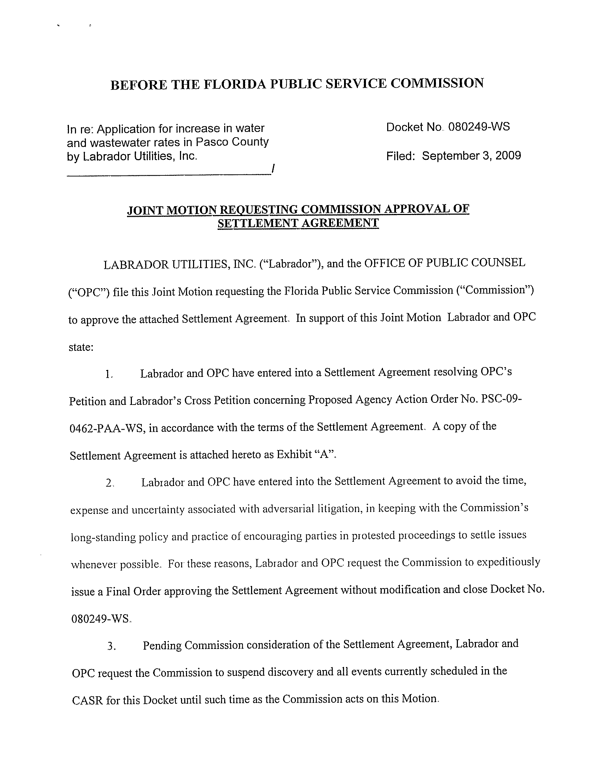
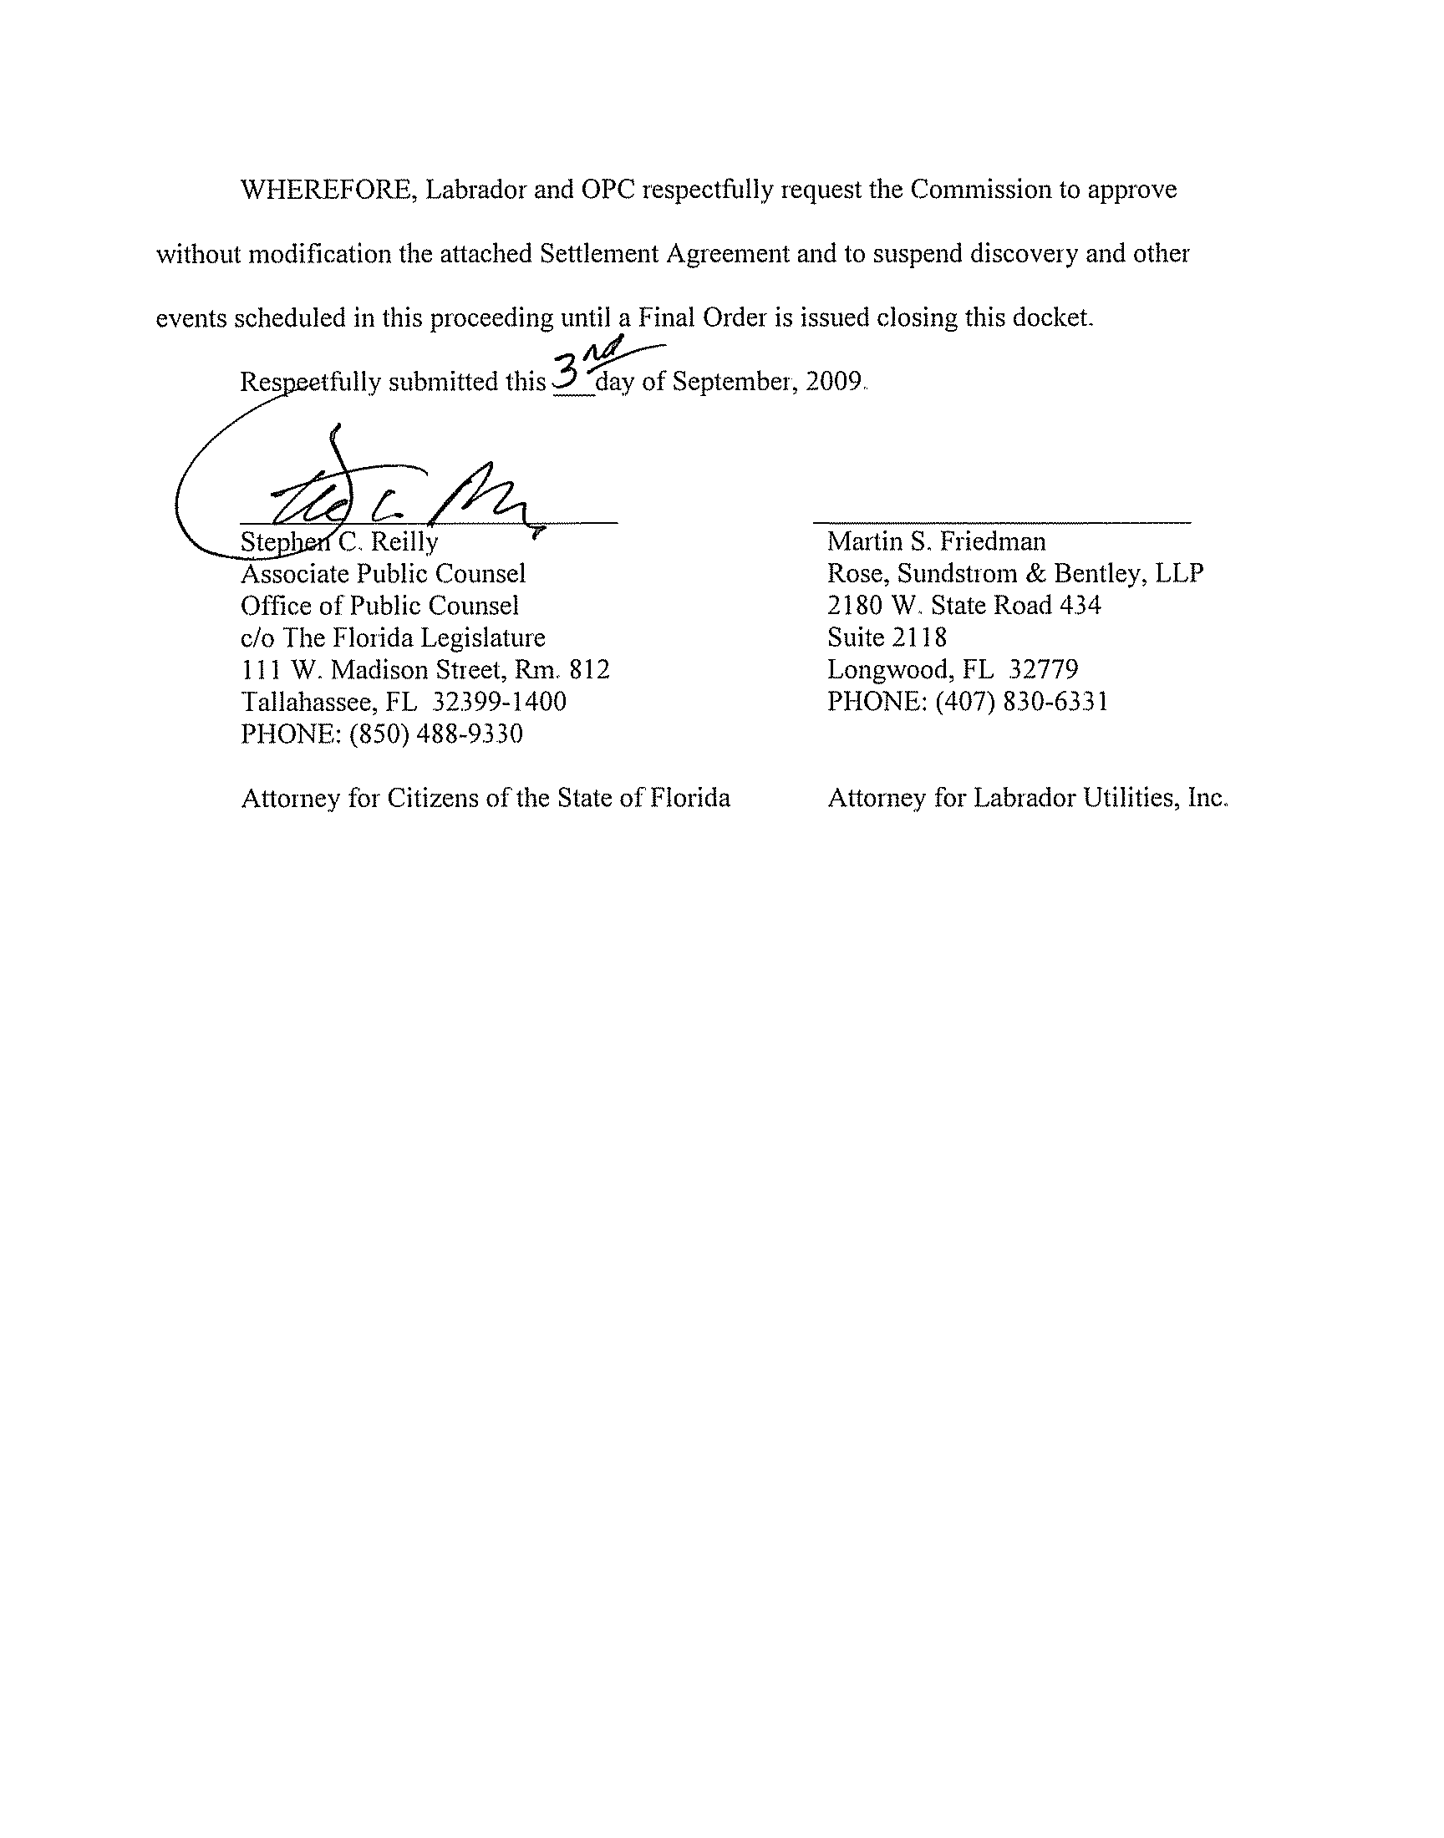
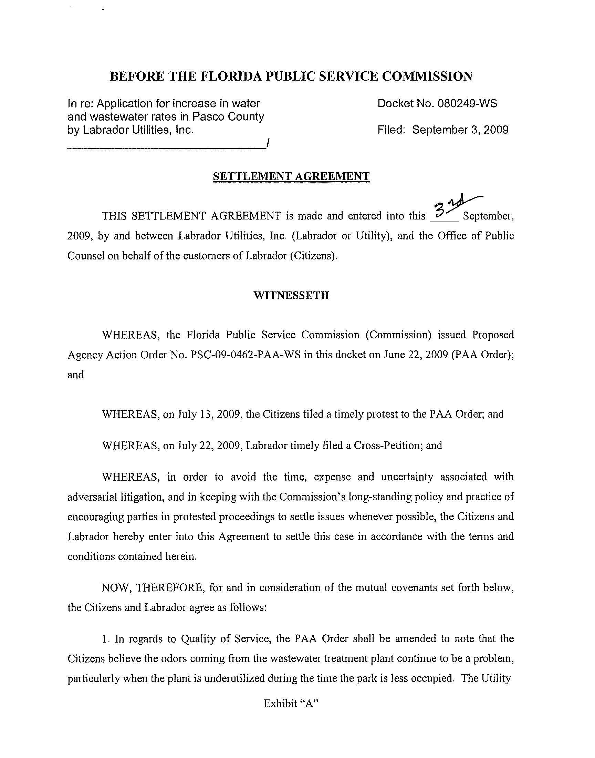
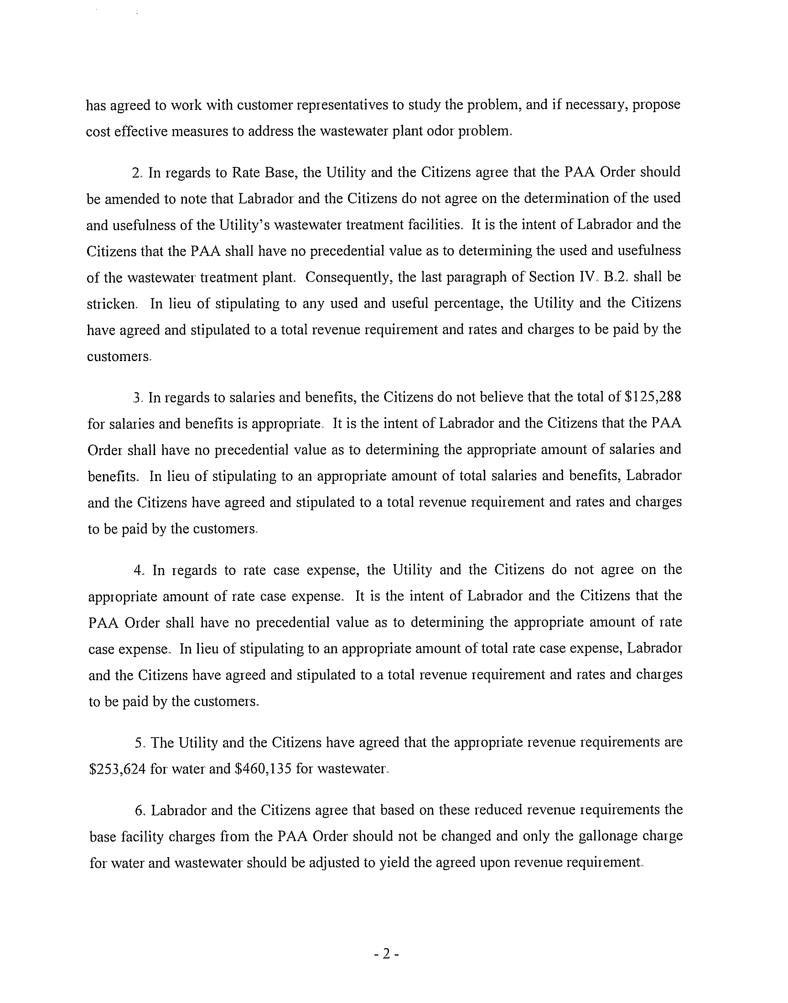
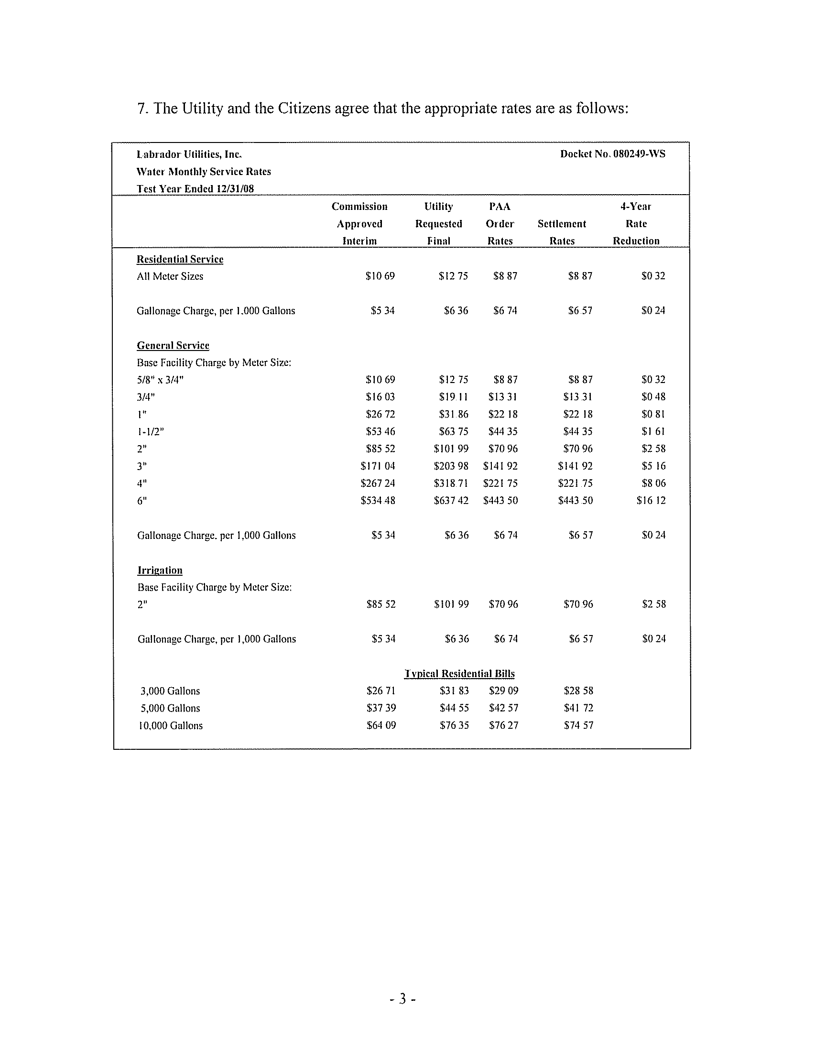
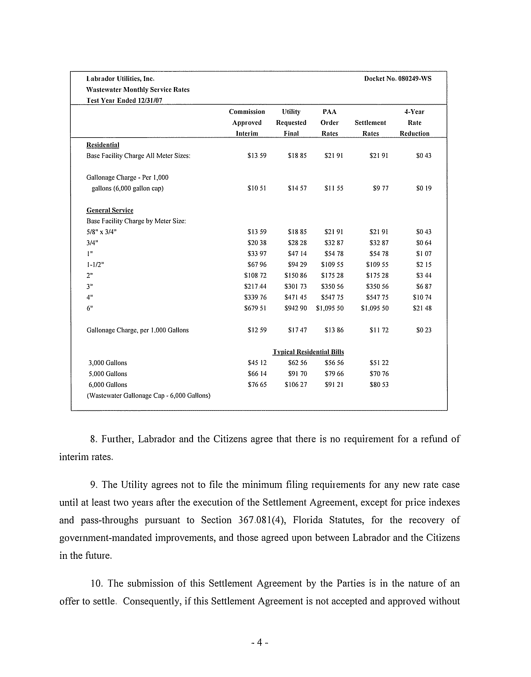
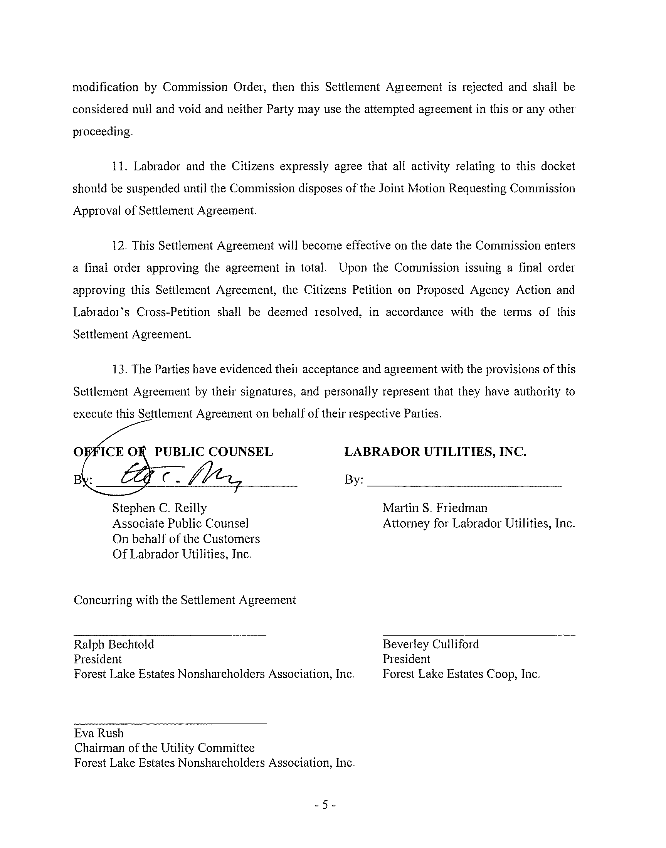

OPC believes the odors coming from the wastewater treatment plant continue to be a problem, and the Utility has agreed to work with customer representative to study the problem and propose cost effective measures to address the problem.
The Parties do not agree on the calculation of the used and usefulness of the wastewater treatment facilities, and the last paragraph of Section IV. B. 2 of the PAA Order shall be stricken and have no precedential value.
The Parties do not agree on the calculation of the appropriate amount for salaries and benefits, and the amount of $125,288 listed in the PAA Order shall have no precedential value.
The Parties do not agree on the appropriate amount of rate case expense and the amount of rate case expense listed in the PAA Order shall have no precedential value.
See Order No. PSC-06-0665-S-WS, issued August 7, 2006, in Docket No. 050281-WS, In re: Application for increase in water and wastewater rates in Volusia County by Plantation Bay Utility Company.

