State of Florida   |  | Public Service Commission  Capital Circle Office Center ● 2540 Shumard Oak Boulevard  Tallahassee, Florida 32399-0850  -M-E-M-O-R-A-N-D-U-M-
DATE: | August 19, 2010
TO: | Office of Commission Clerk (Cole)
FROM: | Division of Regulatory Analysis (Lewis, Brown, Garl, Gilbert)  Office of the General Counsel (Fleming, Sayler)
RE: | Docket No. 100161-EG – Petition of approval of demand-side management plan of Orlando Utilities Commission.
AGENDA: | 08/31/10 – Regular Agenda – Proposed Agency Action – Interested Persons May Participate
COMMISSIONERS ASSIGNED: |  |  | All Commissioners
PREHEARING OFFICER: |  |  | Administrative
CRITICAL DATES: |  |  | None
SPECIAL INSTRUCTIONS: |  |  | None
FILE NAME AND LOCATION: |  |  | S:\PSC\RAD\WP\100161.RCM.08-19-10.DOC

Case Background
The Commission, as required by the Florida Energy Efficiency and Conservation Act (FEECA), Sections 366.80 through 366.85 and 403.519, Florida Statutes (F.S.), adopted annual goals for seasonal peak demand and annual energy consumption for the FEECA Utilities. These include Florida Power & Light Company (FPL), Progress Energy Florida, Inc. (PEF), Tampa Electric Company (TECO), Gulf Power Company (Gulf), Florida Public Utilities Company (FPUC), JEA, and Orlando Utilities Commission (OUC).
Pursuant to Rule 25-17.008, Florida Administrative Code (F.A.C.), in any conservation goal setting proceeding, the Commission requires each FEECA utility to submit cost-effectiveness information based on, at a minimum, three tests: (1) the Participants Test; (2) the Rate Impact Measure (RIM) Test, and (3) the Total Resource Cost (TRC) Test. The Participants Test measures program cost-effectiveness to the participating customer. The RIM Test measures program cost-effectiveness to the utility’s overall rate payers, taking into consideration the cost of incentives paid to participating customers and lost revenues due to reduced energy sales that may result in the need for a future rate case. The TRC Test measures total net savings on a utility system-wide basis. In past goal setting proceedings, the Commission established conservation goals based on measures that pass both the Participants Test and the RIM Test.

The 2008 Legislative Session resulted in several changes to the FEECA Statute, and the Commission’s goal-setting proceeding was the first implementation of these modifications. By Order No. PSC-09-0855-FOF-EG, the Commission established annual goals for the FEECA Utilities for the period 2010 through 2019. The resulting Commission approved DSM goals for OUC are the average savings achieved from existing DSM programs over the past four years. These goals are divided into residential and commercial/industrial, with each of these further subdivided into three categories: summer peak demand, winter peak demand, and annual energy.
On March 30, 2010, OUC filed a petition requesting approval of its Demand-Side Management (DSM) Plan pursuant to Rule 25-17.0021, F.A.C. The Southern Alliance for Clean Energy (SACE) petitioned for leave to intervene, but the Commission Order has not been issued as of August 20, 2010.

On July 14, 2010, the SACE filed comments on the FEECA Utilities’ DSM Plans. These comments were amended on August 3, 2010, to include comments regarding FPUC. No other intervenors filed comments. On July 28, and August 12, 2010, PEF and Gulf, respectively, filed responses to SACE’s comments. SACE’s comments focused on the IOUs and do not materially affect OUC’s DSM plan.

The Commission has jurisdiction over this matter pursuant to Sections 366.80 through 366.85 and 403.519, F.S.

Discussion of Issues

Issue 1:1 Does OUC’s proposed 2010 Demand-Side Management (DSM) Plan satisfy the Company’s numeric conservation goals set by the Commission in Order No. PSC-09-0855-FOF-EG?
Recommendation:
Yes. OUC has proposed a DSM Plan that projects peak demand and energy savings that exceed the Commission approved residential and commercial/industrial goals. (Lewis)
Staff Analysis:
By Order No. PSC-09-0855-FOF-EG, the Commission established annual goals for the FEECA Utilities for the period 2010 through 2019. The resulting Commission approved DSM goals for OUC are the average savings achieved from existing DSM programs over the past four years. These goals are divided into residential and commercial/industrial, with each of these further subdivided into three categories: summer peak demand, winter peak demand, and annual energy. Staff believes the DSM Plan submitted by OUC fulfills this requirement, as discussed below.
OUC has proposed a DSM Plan for the ten-year period 2010 to 2019 that projects peak demand and energy savings that exceed the residential and commercial/industrial goals established by the Commission in Order No. PSC-09-0855-FOF-EG. Tables 1 and 2 below depict the Commission-approved goals and OUC’s projection of DSM program savings for each of the ten years.

Table 1 – Comparison of Residential Goals
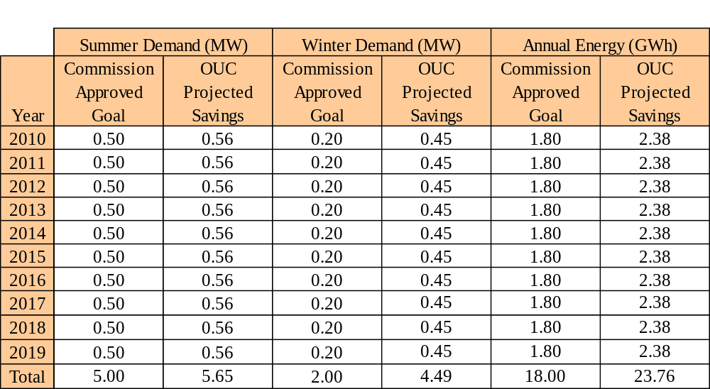

Table 2 – Comparison of Commercial/Industrial Goals

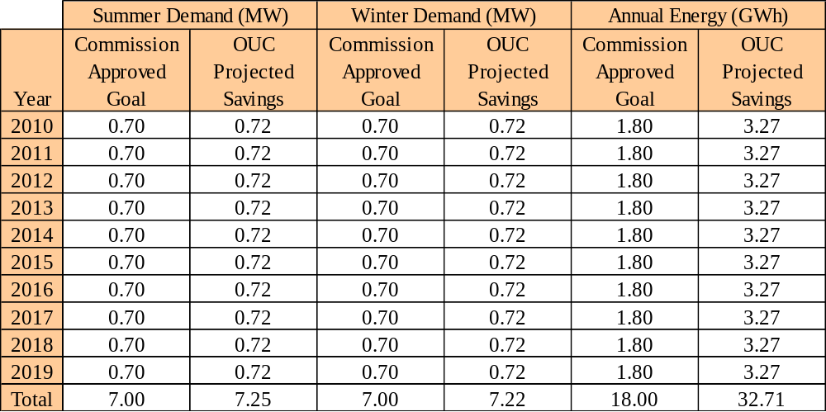

OUC relied upon historical program participation to project customer enrollment and savings for its programs.
Conclusion
Staff believes OUC’s estimates and projections to be reasonable at this time. The proposed annual energy and seasonal peak demand savings contained in the OUC’s 2010 DSM Plan satisfy the numeric conservation goals set by the Commission in Order No. PSC-09-0855-FOF-EG.
Issue 2:1
Do any of the programs in OUC’s proposed DSM Plan have an undue impact on the costs passed on to customers?

Recommendation:
No. Since OUC is continuing existing programs, its customers should see no change in monthly bills due to DSM programs. (Lewis)
Staff Analysis:
OUC’s proposed DSM Plan for the period 2010-2019 contains 13 existing residential programs and 7 existing commercial programs. Though OUC’s Plan contains no programs specifically for renewable energy systems, the Company does currently have six photovoltaic panels installed on schools as part of its renewable energy portfolio. Table 3, below, summarizes OUC’s DSM programs by segment (residential, commercial/industrial, and renewable).

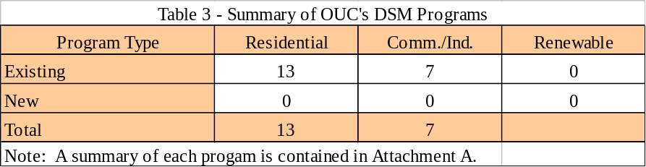

During the goal setting proceeding, OUC proposed DSM goals of zero since no measures were found to be cost-effective pursuant to the RIM test. However, OUC did propose to continue its existing DSM programs. By Order No. PSC-09-0855-FOF-EG, the Commission approved new DSM goals based on OUC continuing its existing programs. Specifically, page 16 of the Order states, “OUC and JEA proposed goals of zero, yet committed to continue their current DSM program offerings. We are setting goals for OUC and JEA based on their current programs so as not to unduly increase rates.”
Staff did request OUC to provide cost-effectiveness results for its existing programs which are shown in the table below. Unlike the IOUs, OUC does not include an estimated cost for greenhouse gas emissions. Therefore, the results shown are for traditional RIM and TRC tests:

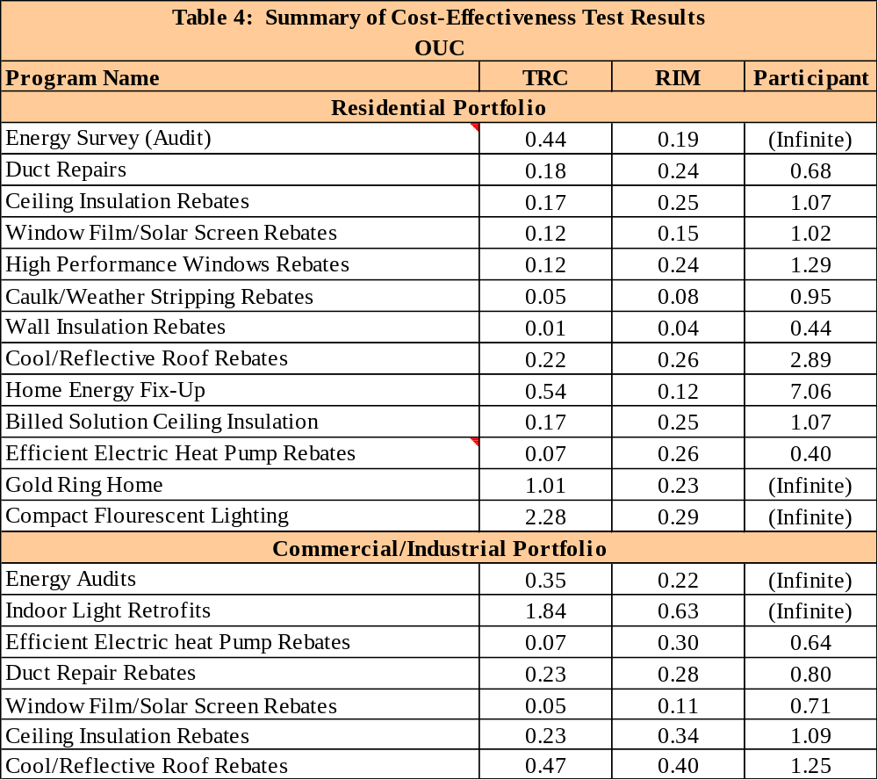
Since OUC proposes to continue existing DSM programs, its customers should not see an increase to rates due to additional DSM programs. However, OUC’s existing programs do increase a typical residential bill by approximately $0.46 per month. Individual residential program impacts range from less than $0.01 to $0.14, as shown in the following chart:

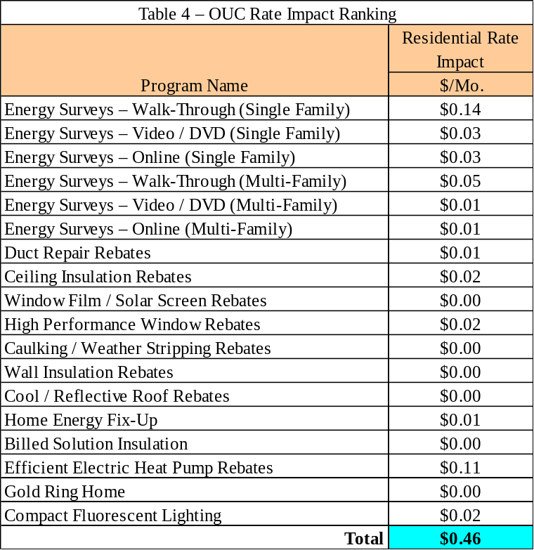

Conclusion

OUC’s DSM Plan continues existing programs, as directed by the Commission. Customer rates, therefore, should not be unduly affected due to additional DSM programs.

Issue 2:2
Should this docket be closed?
Recommendation:
Yes. If no person whose substantial interests are affected by the proposed agency action files a protest within 21 days of the issuance of the Order, this docket should be closed upon the issuance of a Consummating Order. (Fleming, Sayler)
Staff Analysis:
If no person whose substantial interests are affected by the proposed agency action files a protest within 21 days of the issuance of the Order, this docket should be closed upon the issuance of a Consummating Order.
Descriptions of OUC’s DSM Programs
Residential Programs:
- Residential Energy Surveys: OUC will provide three types of Residential Energy Surveys (walk-through, DVD, and on-line) designed to provide customers with energy conservation advice and to encourage the implementation of efficiency measures resulting in energy savings. The survey process includes a complete examination of the attic; heating, ventilation, and air conditioning (HVAC) system; air duct and air returns; window caulking; weather stripping around doors; faucets and toilets; and lawn sprinkler systems. Follow-up work monitors and tracks the installation of additional conservation features and/or duct repairs. The primary benefit of the Residential Energy Survey Program is the education it provides to customers on energy conservation measures and ways their lifestyle can directly affect their energy use.
- Duct Repair Rebate: The Duct Repair Rebate Program originated in 2000 and is designed to encourage customers to repair leaking ducts on existing systems. Customers will receive up to a $150 rebate for duct repairs on their homes.
- Ceiling Insulation Rebates: The ceiling insulation rebate program is designed to encourage customers to upgrade their attic insulation. Customers will receive a $100 rebate for upgrading their attic insulation to R-19 or higher.
- Window Film/Solar Screen Rebates: The window film/solar screen rebate program is designed to encourage customers to install solar shading on their windows. Customers will receive up to a $100 rebate for installation of solar shading film with a shading coefficient of 0.5 or less.
- High Performance Windows Rebates: Energy-efficient windows can help minimize heating, cooling, and lighting costs. The high performance windows rebate program is designed to encourage customers to install windows that improve energy efficiency in their homes. Customers will receive a $1 rebate per square foot (up to $250) for the purchase of ENERGY STAR® rated energy efficient windows.
- Caulking and Weather Stripping Rebates: The caulking and weather stripping rebate program is designed to encourage customers to caulk and weather strip their homes. Customers will receive a rebate of 50 percent of the cost (up to $50) for the caulking and weather stripping of their homes.
- Wall Insulation Rebates: The wall insulation rebate program is designed to encourage customers to insulate the walls of their homes. Customers will receive a rebate of $300 for wall insulation.
- Cool/Reflective Roof Rebate: The cool/reflective roof rebate program has been offered in the last couple of years and is designed to encourage customers to install new roofing to help insulate their homes. Customers will receive a rebate of $150 for ENERGY STAR® cool/reflective roofing that has an initial solar reflectance greater than or equal to 0.70.
- Home Energy Fix-Up Program: The home energy fix-up program is available to residential customers with a total annual family income of $35,000 or less. Each customer must request and complete a free Residential Energy Survey. Ordinarily, Energy Survey recommendations require a customer to spend money replacing or adding energy conservation measures, which low-income customers may not have the discretionary income to implement. Under this program, OUC will arrange for a licensed, approved contractor to perform the necessary repairs and will pay 85 percent of the total cost, not to exceed $2,000. The remaining 15 percent can be paid directly or over an interest-free 12-month period on the participant's monthly electric bill.
- Efficient Electric Heat Pump Rebates: The efficient electric heat pump rebate program has been offered for several years and provides rebates to qualifying customers in existing homes who install heat pumps having a seasonal energy efficiency ratio (SEER) of 14.0 or higher. Currently, Customers will obtain a rebate in the form of a credit on their bill of $1 00, $200 or $300, if they install heat pumps with a SEER rating of 14, 15, or 16 and above, respectively.
Commercial Programs:
- Indoor Lighting Retrofit Program: The indoor lighting retrofit program reduces energy consumption for the commercial customer through the replacement of older fluorescent and incandescent lighting with newer, more efficient lighting technologies. A special alliance between OUC and the lighting contractor enables OUC to offer the customer a discounted project cost.
- Efficient Electric Heat Pump Rebates: The efficient electric heat pump rebate program started in 2009. OUC will rebate $100 for SEER 14, $200 for SEER 15, and $300 for SEER 16 and above for customers' purchase of an energy-efficient heat pump.
- Duct Repair Rebates: The duct repair rebate program started in 2009. OUC will rebate up to $150 on repairs made to leaking ducts on existing systems that are 5.5 tons (66,000 BTUs) or less.
- Window Film/Solar Screen Rebates: The window film/solar screen rebate program started in 2009 and is designed to help reflect the heat during hot summer days and retain heat on cool winter days. OUC will rebate customers $0.75 per square foot, up to $55 per room for window tinting and solar screening with a shading coefficient of 0.5 or less.
- Ceiling Insulation Rebates: The ceiling insulation rebate program started in 2009 and was designed to increase a building's resistance to heat loss and gain. OUC will rebate customers up to $100 plus $0.07 per square foot above 1,500 square feet for ceiling insulation of R-19 or higher.
- Cool/Reflective Roofs Rebates: The cool/reflective roofs rebate program started in 2009 and was designed to reflect the sun's rays and lower roof surface temperature while increasing the lifespan of the roof. OUC will rebate customers at $0.10 per square foot up to $15,000 for ENERGY STAR@ cool/reflective roofing that has an initial solar reflectance greater than or equal to $0.70.

