State of Florida   |  | Public Service Commission  Capital Circle Office Center ● 2540 Shumard Oak Boulevard  Tallahassee, Florida 32399-0850  -M-E-M-O-R-A-N-D-U-M-
DATE: | June 26, 2014
TO: | Office of Commission Clerk (Stauffer)
FROM: | Division of Engineering (Matthews, Mtenga)  Office of the General Counsel (Lawson)
RE: | Docket No. 140064-EQ – Petition for approval of new standard offer for purchase of firm capacity and energy from renewable energy facilities and approval of tariff schedule REF-1, by Gulf Power Company.
AGENDA: | 07/10/14 – Regular Agenda – Proposed Agency Action – Interested Persons May Participate
COMMISSIONERS ASSIGNED: |  |  | All Commissioners
PREHEARING OFFICER: |  |  | Administrative
CRITICAL DATES: |  |  | None
SPECIAL INSTRUCTIONS: |  |  | None

Case Background
Section 366.91(3), Florida Statutes (F.S.) requires that each investor-owned utility (IOU) continuously offers to purchase capacity and energy from renewable energy generators. Commission Rules 25-17.200 through 25-17.310, Florida Administrative Code (F.A.C.), implement the statute and require each IOU to file with the Commission by April 1 of each year a standard offer contract to purchase the capacity and energy from such renewable generators, with estimated payments based on the next avoidable fossil-fueled generating unit of each technology type identified in the utility’s current Ten-Year Site Plan.
Gulf Power Company (Gulf or Utility) did not have any avoidable fossil-fueled generating unit or avoidable power purchases in its 2013 Ten-Year Site Plan. However, in an effort to encourage renewable generation, in 2013 Gulf identified a 803 MW natural gas-fired combined cycle (CC) unit at a greenfield site with an expected in-service date of June 1, 2023, as its next avoidable unit so that capacity payments could be offered in addition to energy payments. However, Gulf’s 2014 Ten-Year Site Plan includes a planned generating unit which serves as the avoided unit on which the 2014 standard offer contract is based.
On March 31, 2014, Gulf filed a petition for approval of its standard offer contract and associated rate schedule REF-1. The Commission has jurisdiction over this standard offer contract pursuant to Sections 366.04 through 366.06 and 366.91, F.S.
Discussion of Issues
Issue 1:1
Should the Commission approve the revised standard offer contract filed by Gulf Power Company?
Recommendation:
Yes. The provisions of the revised standard offer contract and related rate schedule REF-1 conform to all requirements of Rules 25-17.200 through 25-17.310, F.A.C. The revised standard offer contract provides flexibility in the arrangements for payments so that a developer of renewable generation may select the payment stream best suited to its financial needs. Staff recommends that the revised standard offer contract and related rate schedule REF-1 submitted by Gulf be approved as filed. (Matthews, Mtenga)
Staff Analysis:
Rule 25-17.250, F.A.C., requires that Gulf, an IOU, continuously make available a standard offer contract for the purchase of firm capacity and energy from renewable generating facilities (RF) and small qualifying facilities (QF) with design capacities of 100 kilowatts (kW) or less. Pursuant to Rule 25-17.250(3), F.A.C., the standard offer contact must provide a term of at least ten years, and the payment terms must be based on the Utility’s next avoidable fossil-fueled generating unit identified in the most recent Ten-Year Site Plan or, if no avoided unit is identified, its next avoidable planned purchase. Gulf has identified an 349 MW natural gas-fired combustion turbine (CT) unit as its next avoidable fossil-fueled generating unit in its 2014 Ten-Year Site Plan. The projected in-service date of this unit is June 1, 2023.
The RF/QF operator may elect to make no commitment as to the quantity or timing of its deliveries to Gulf, and to have a committed capacity of zero (0) MW. Under such a scenario, the energy is delivered on an as-available basis and the operator receives only an energy payment. Alternatively, the RF/QF operator may elect to commit to certain minimum performance requirements based on the identified avoided unit, such as being operational and delivering the agreed upon amount of capacity by the in-service date of the avoided unit, and thereby becomes eligible for capacity payments in addition to payments received for energy. The standard offer contract can also serve as a starting point for negotiation of contract terms by providing payment information to an RF/QF operator, in a situation where one or both parties desire particular contract terms other than those set down in the standard offer.
In order to promote renewable generation, the Commission requires the IOU to offer multiple options for capacity payments, including the options to receive early or levelized payments. If the RF/QF operator elects to receive capacity payments under the normal or levelized contract options, it will receive as-available energy payments only until the in-service date of the avoided unit (in this case June 1, 2023), and thereafter begin receiving capacity payments in addition to the energy payments. If either the early or early levelized option is selected, then the operator will begin receiving capacity payments earlier than the in-service date of the avoided unit. However, payments made under the early capacity payments options tend to be lower in the later years of the contract term because the net present value (NPV) of the total payments must remain equal for all contract options.
Table 1 below estimates the annual payments for each payment option available under the revised standard offer contract to an operator with a 50 MW facility and an in-service date of January 1, 2015, and operating at capacity factor of 95 percent, which is the minimum capacity factor required to qualify for full capacity payments.

Table 1- Estimated Annual Payments to a 50 MW Renewable Facility
(95% Capacity Factor)
Year | Energy Payment | Capacity Payment (By Type)
Year | Energy Payment | Normal | Levelized | Early | Early Levelized
Year | ($000) | ($000) | ($000) | ($000) | ($000)
2015 | 13,064 | 0 | 0 | 1,603 | 1,874
2016 | 14,554 | 0 | 0 | 1,644 | 1,883
2017 | 16,072 | 0 | 0 | 1,685 | 1,893
2018 | 16,765 | 0 | 0 | 1,728 | 1,902
2019 | 17,664 | 0 | 0 | 1,772 | 1,912
2020 | 18,583 | 0 | 0 | 1,816 | 1,922
2021 | 19,832 | 0 | 0 | 1,862 | 1,932
2022 | 21,023 | 0 | 0 | 1,909 | 1,942
2023 | 22,611 | 2,349 | 2,588 | 1,958 | 1,953
2024 | 24,314 | 4,107 | 4,455 | 2,007 | 1,964
2025 | 25,611 | 4,211 | 4,479 | 2,058 | 1,976
2026 | 26,794 | 4,317 | 4,503 | 2,110 | 1,987
2027 | 28,363 | 4,427 | 4,527 | 2,163 | 1,999
2028 | 30,125 | 4,539 | 4,552 | 2,218 | 2,011
2029 | 31,481 | 4,653 | 4,578 | 2,274 | 2,024
2030 | 33,267 | 4,771 | 4,605 | 2,332 | 2,037
2031 | 34,776 | 4,892 | 4,632 | 2,391 | 2,050
2032 | 36,160 | 5,015 | 4,660 | 2,451 | 2,063
2033 | 37,902 | 5,142 | 4,688 | 2,513 | 2,077
2034 | 39,735 | 5,272 | 4,717 | 2,577 | 2,091
Total | 508,695 | 53,695 | 52,985 | 41,070 | 39,492
2014 NPV | 252,041.00 | 21,697 | 21,697 | 21,697 | 21,697
The type-and-strike format versions of the revised standard offer contract and associated rate schedule are included as Attachment A to this recommendation. Revisions include updates to the avoided unit, dates, and payment information which reflect the current economic and financial assumptions for the avoided unit. All of the changes made to the revised rate schedule sheets, as well as the economic and financial assumptions used in the contract, are consistent with the updated unit.
Conclusion
The provisions of the revised standard offer contract and associated schedule, as filed on April 1, 2014, conform to all requirements of Rules 25-17.200 through 25-17.310, F.A.C. The standard offer contract provides flexibility in the arrangements for payments so that a developer of renewable generation may select the payment stream best suited to its financial needs. Staff recommends that the revised standard offer contract and rate schedule REF-1 be approved as filed.
Issue 2:2
Should this docket be closed?
Recommendation:
Yes. This docket should be closed up the issuance of a consummating order, unless a person whose substantial interests are affected by the Commission’s decision files a protest within 21 days of the issuance of the Commission’s proposed agency action order. Potential signatories should be aware that, if a timely protest is filed, Gulf’s standard offer contract may subsequently be revised. (Lawson)
Staff Analysis:
This docket should be closed up the issuance of a consummating order, unless a person whose substantial interests are affected by the Commission’s decision files a protest within 21 days of the issuance of the Commission’s proposed agency action order. Potential signatories should be aware that, if a timely protest is filed, Gulf’s standard offer contract may subsequently be revised. (Lawson)

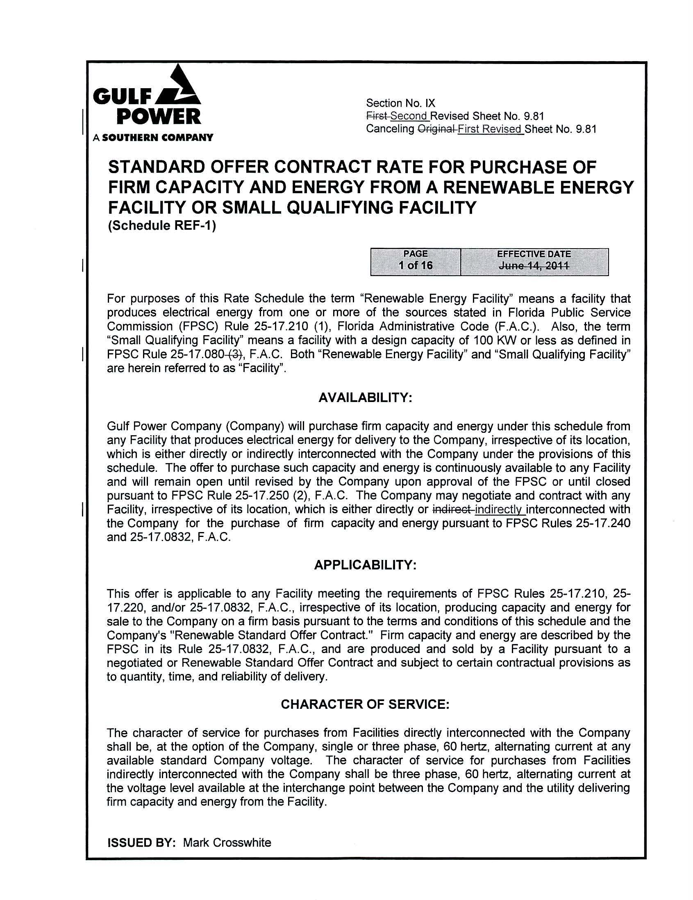
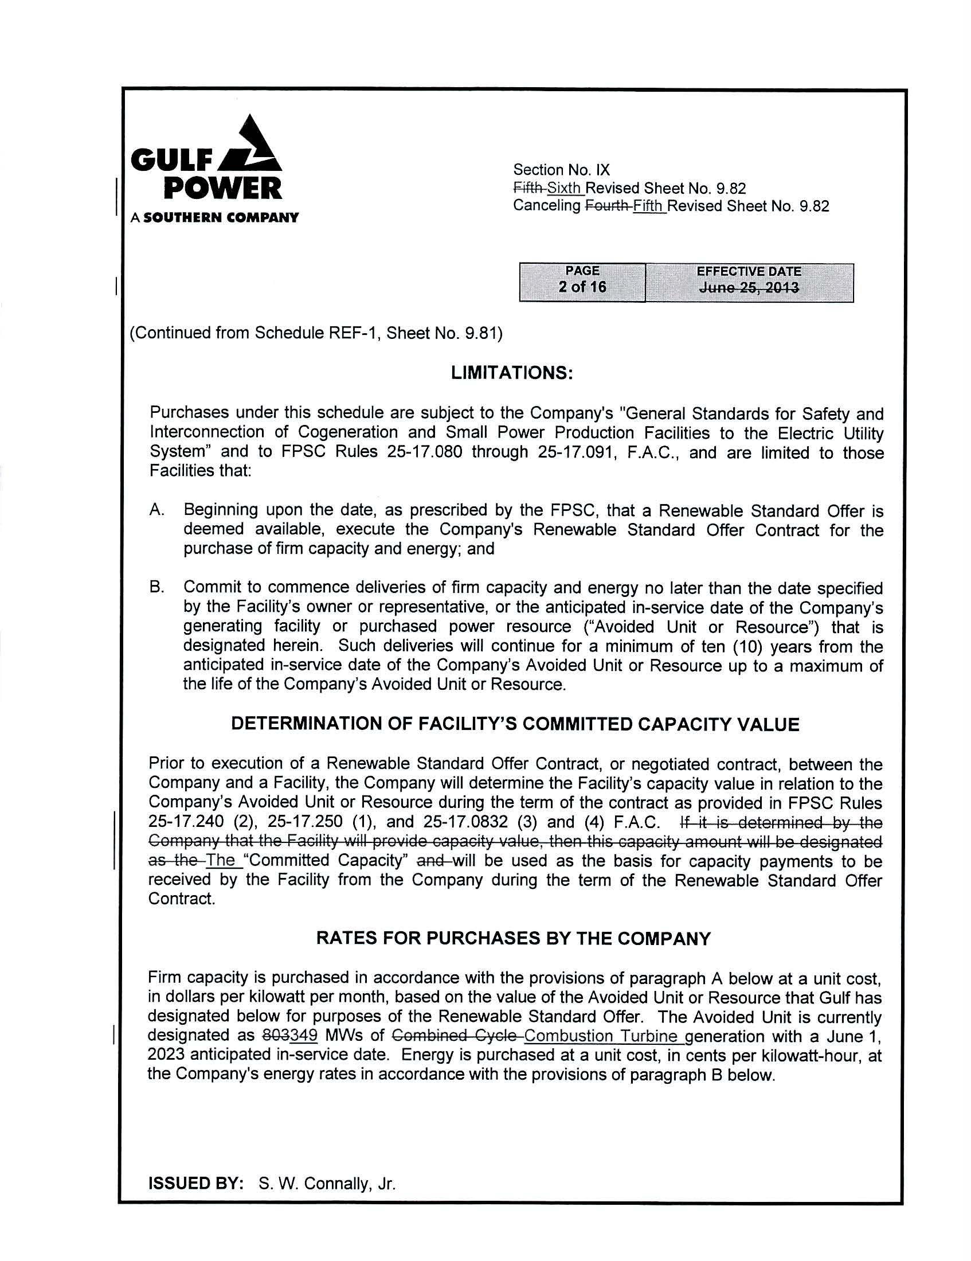
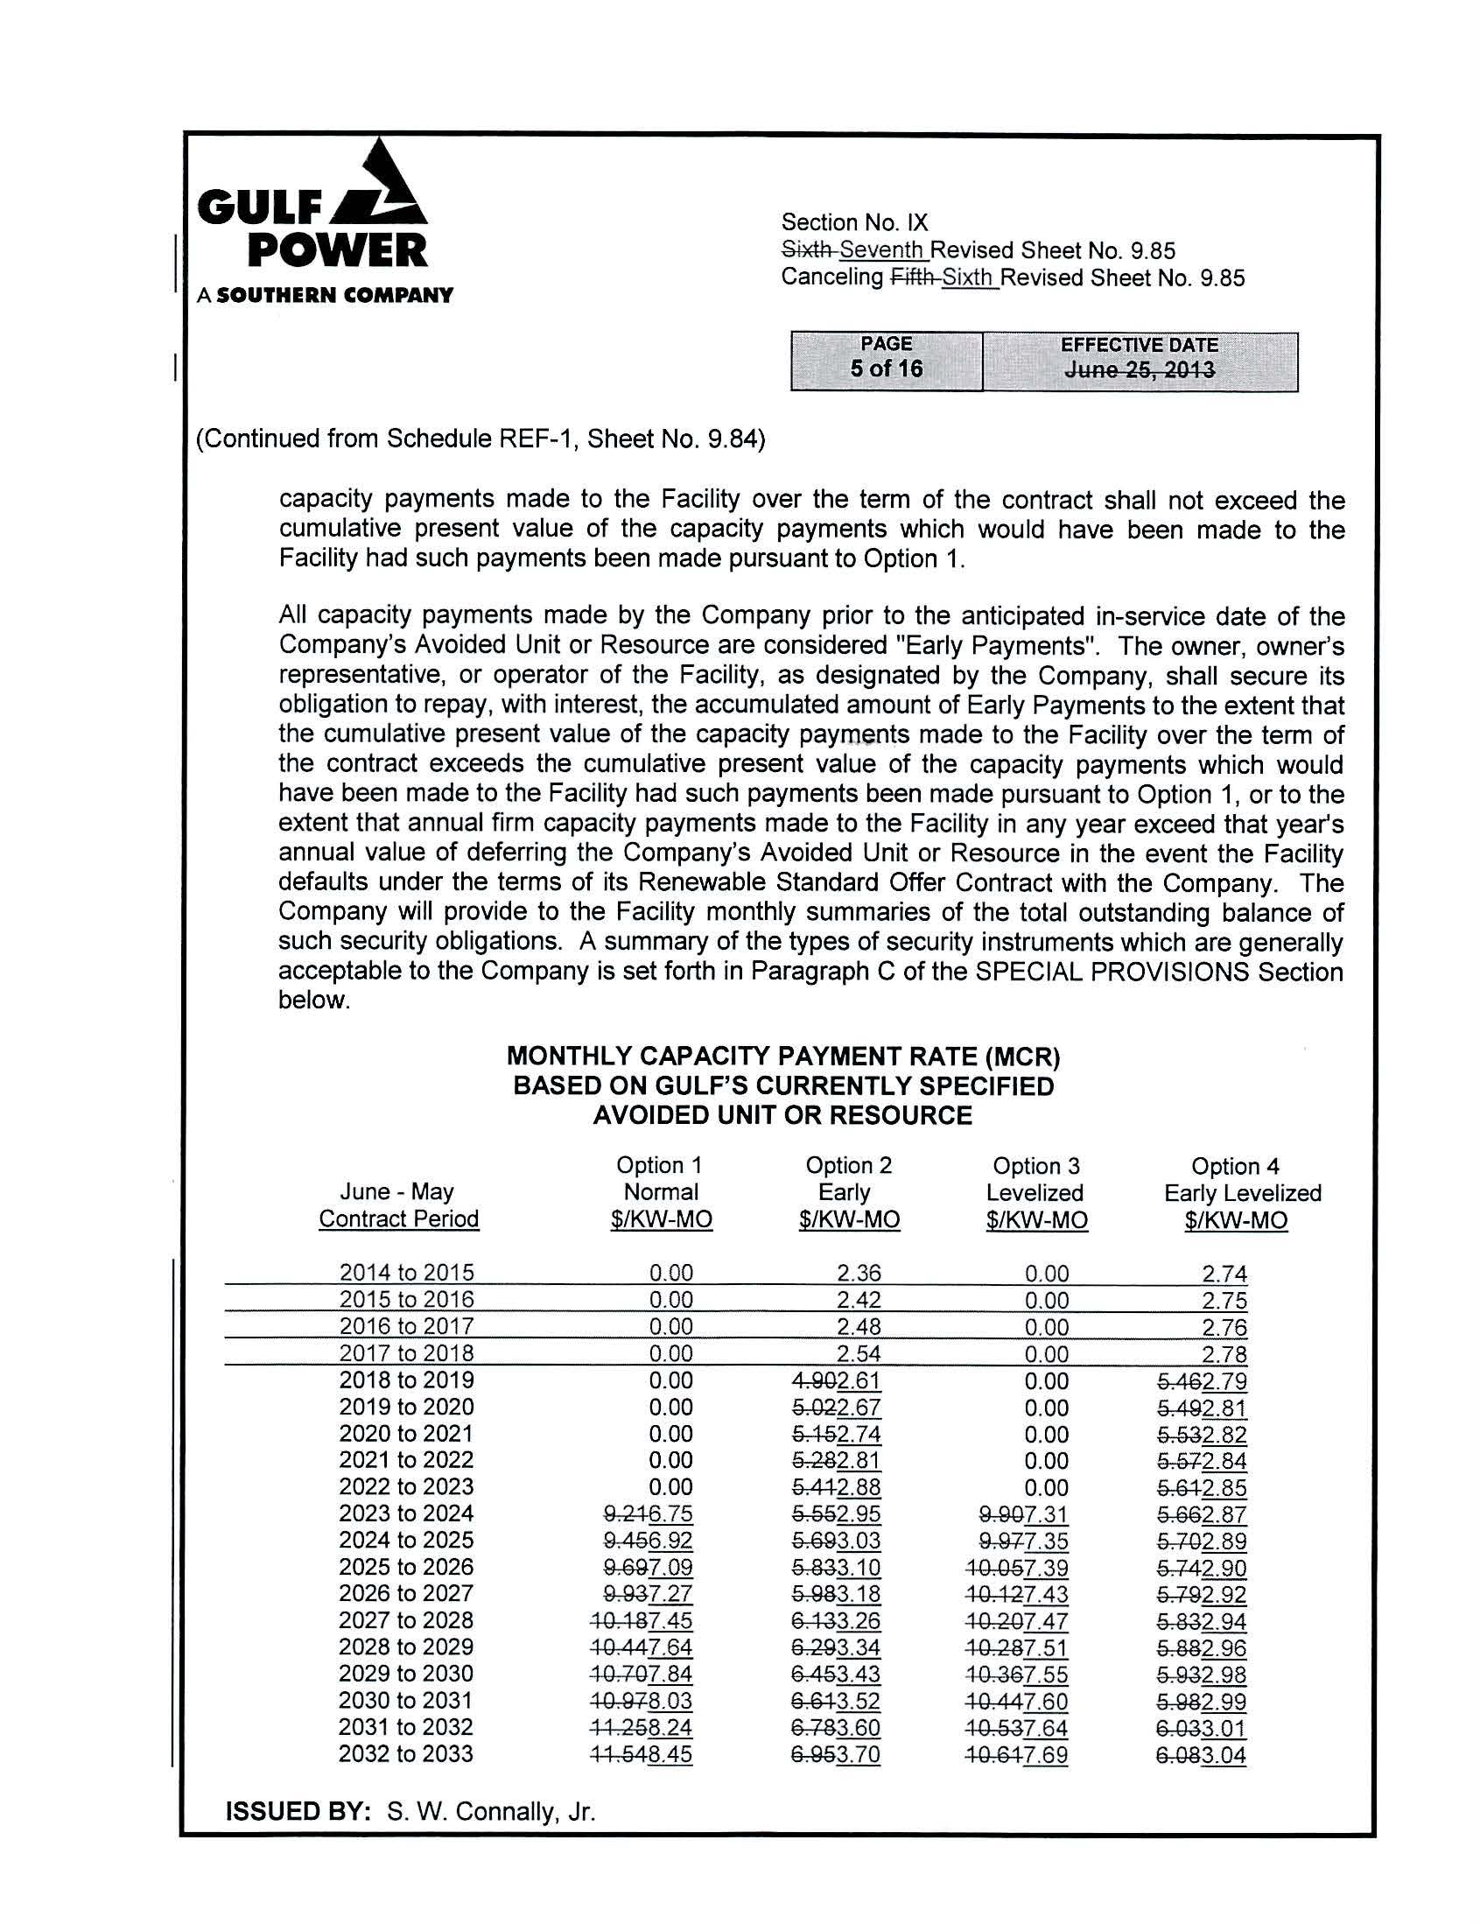
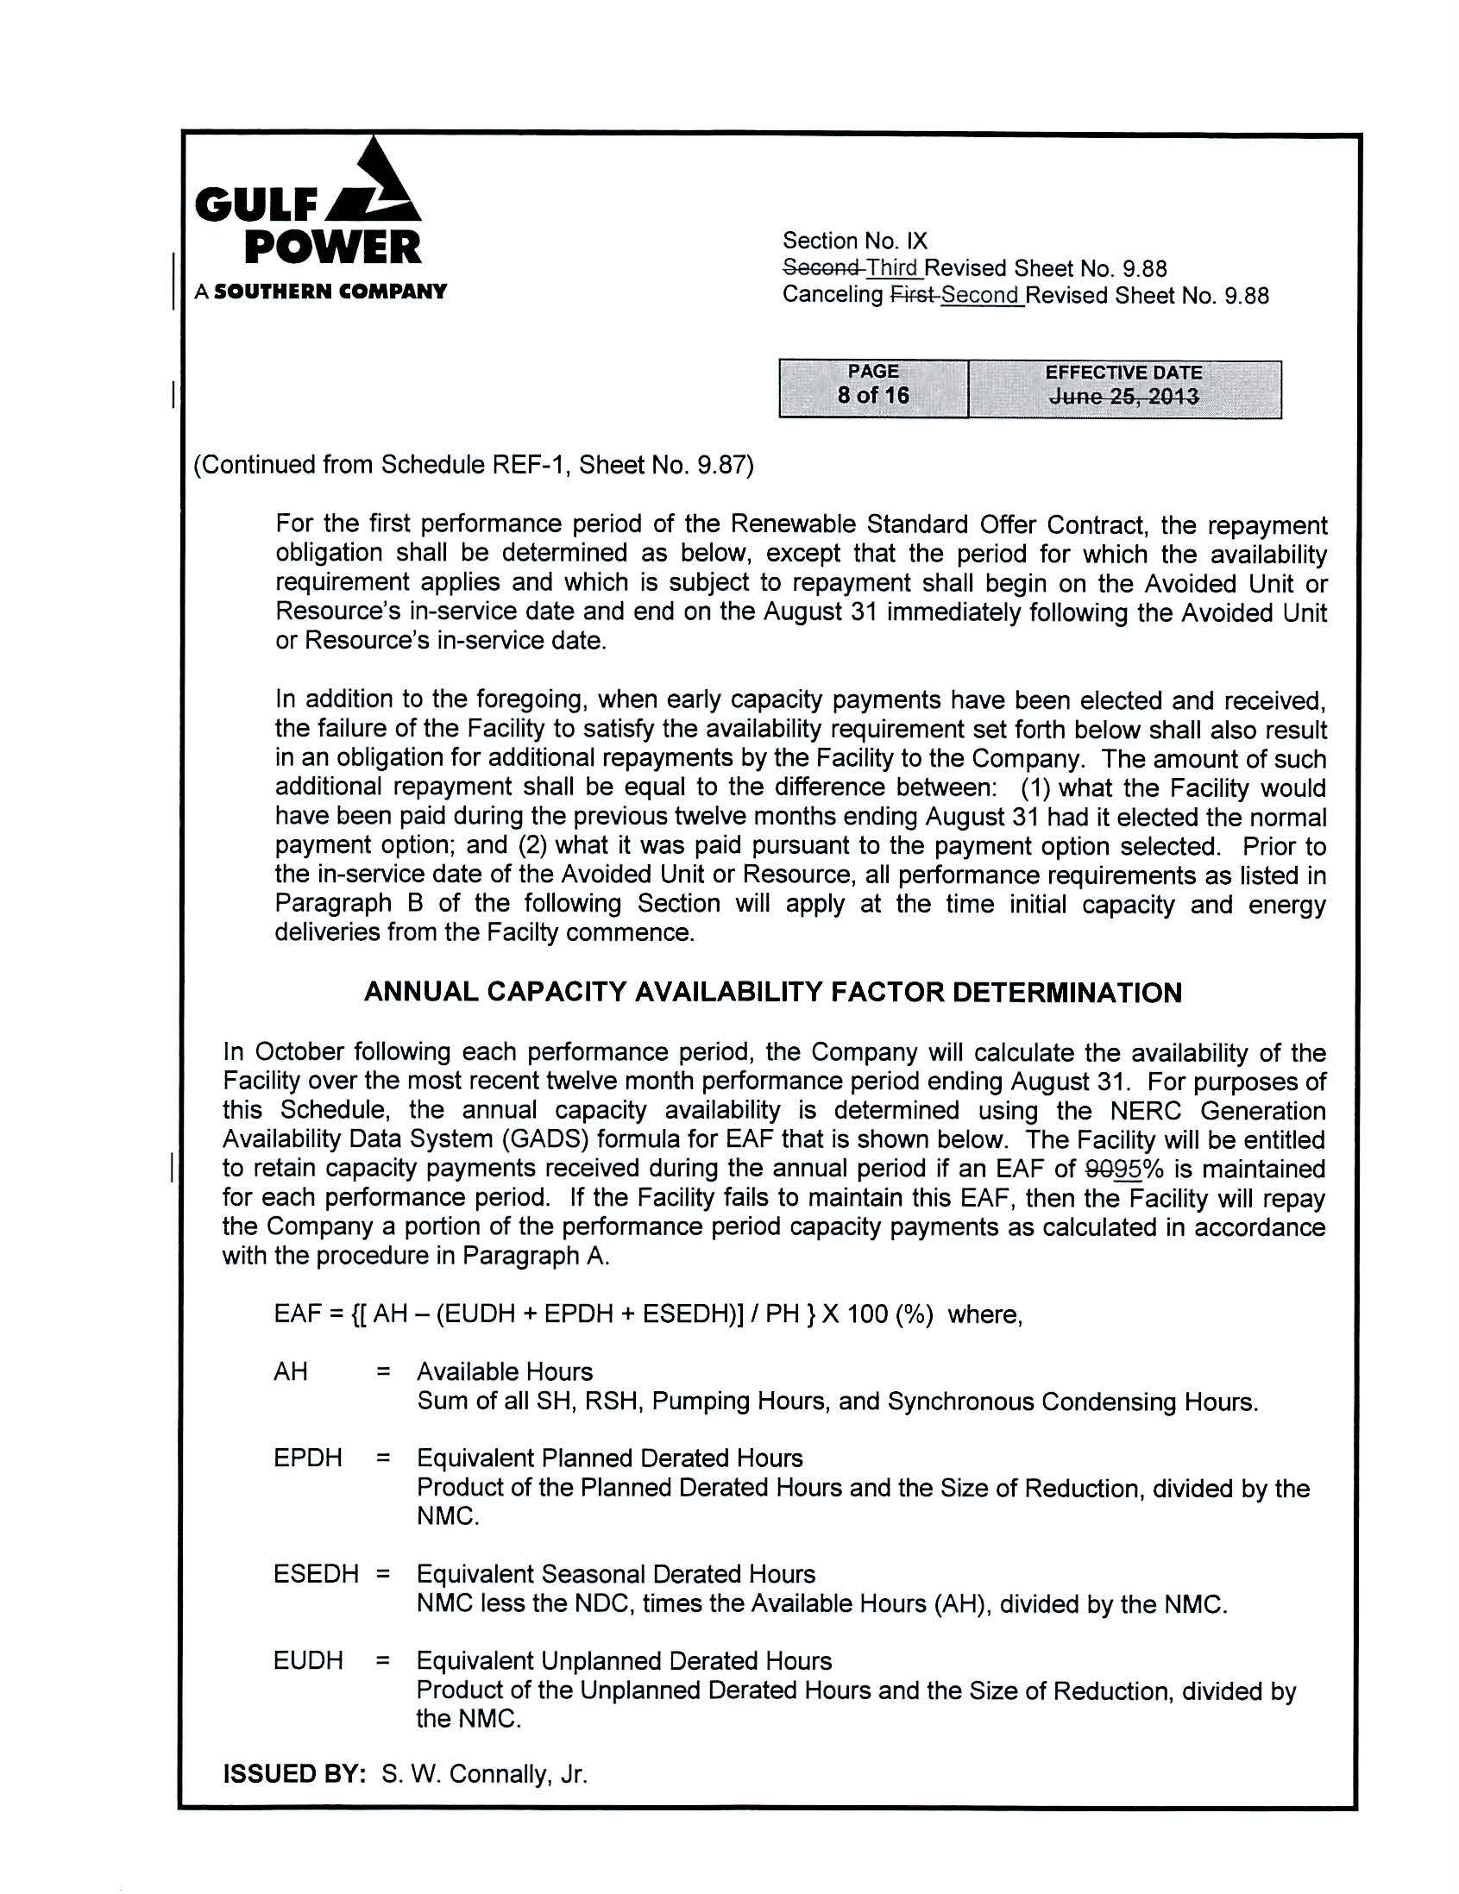
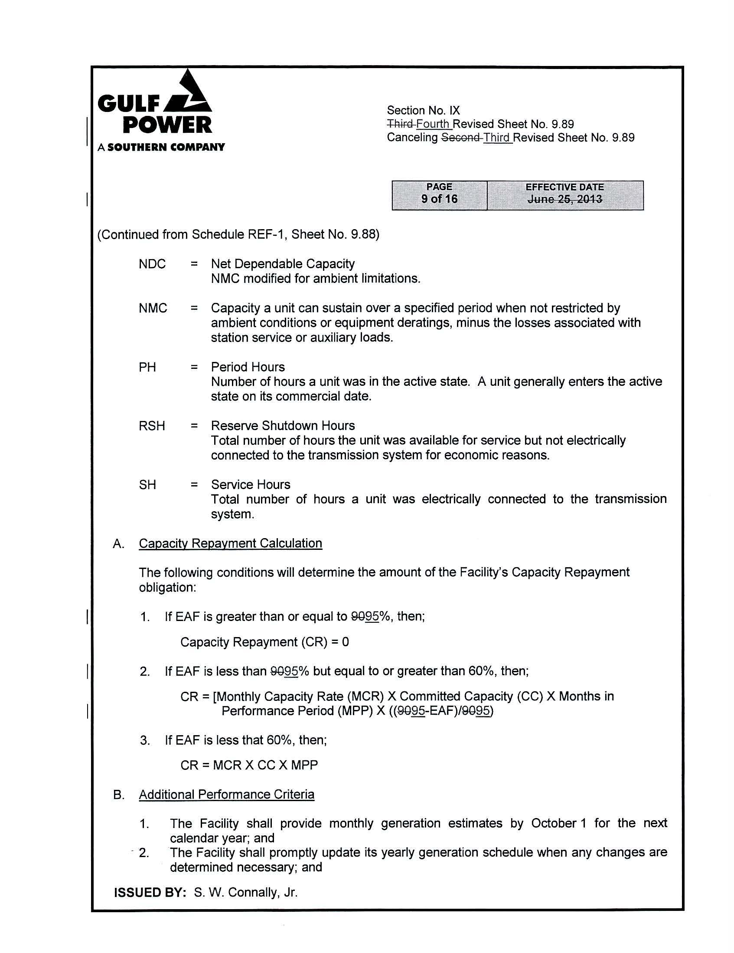
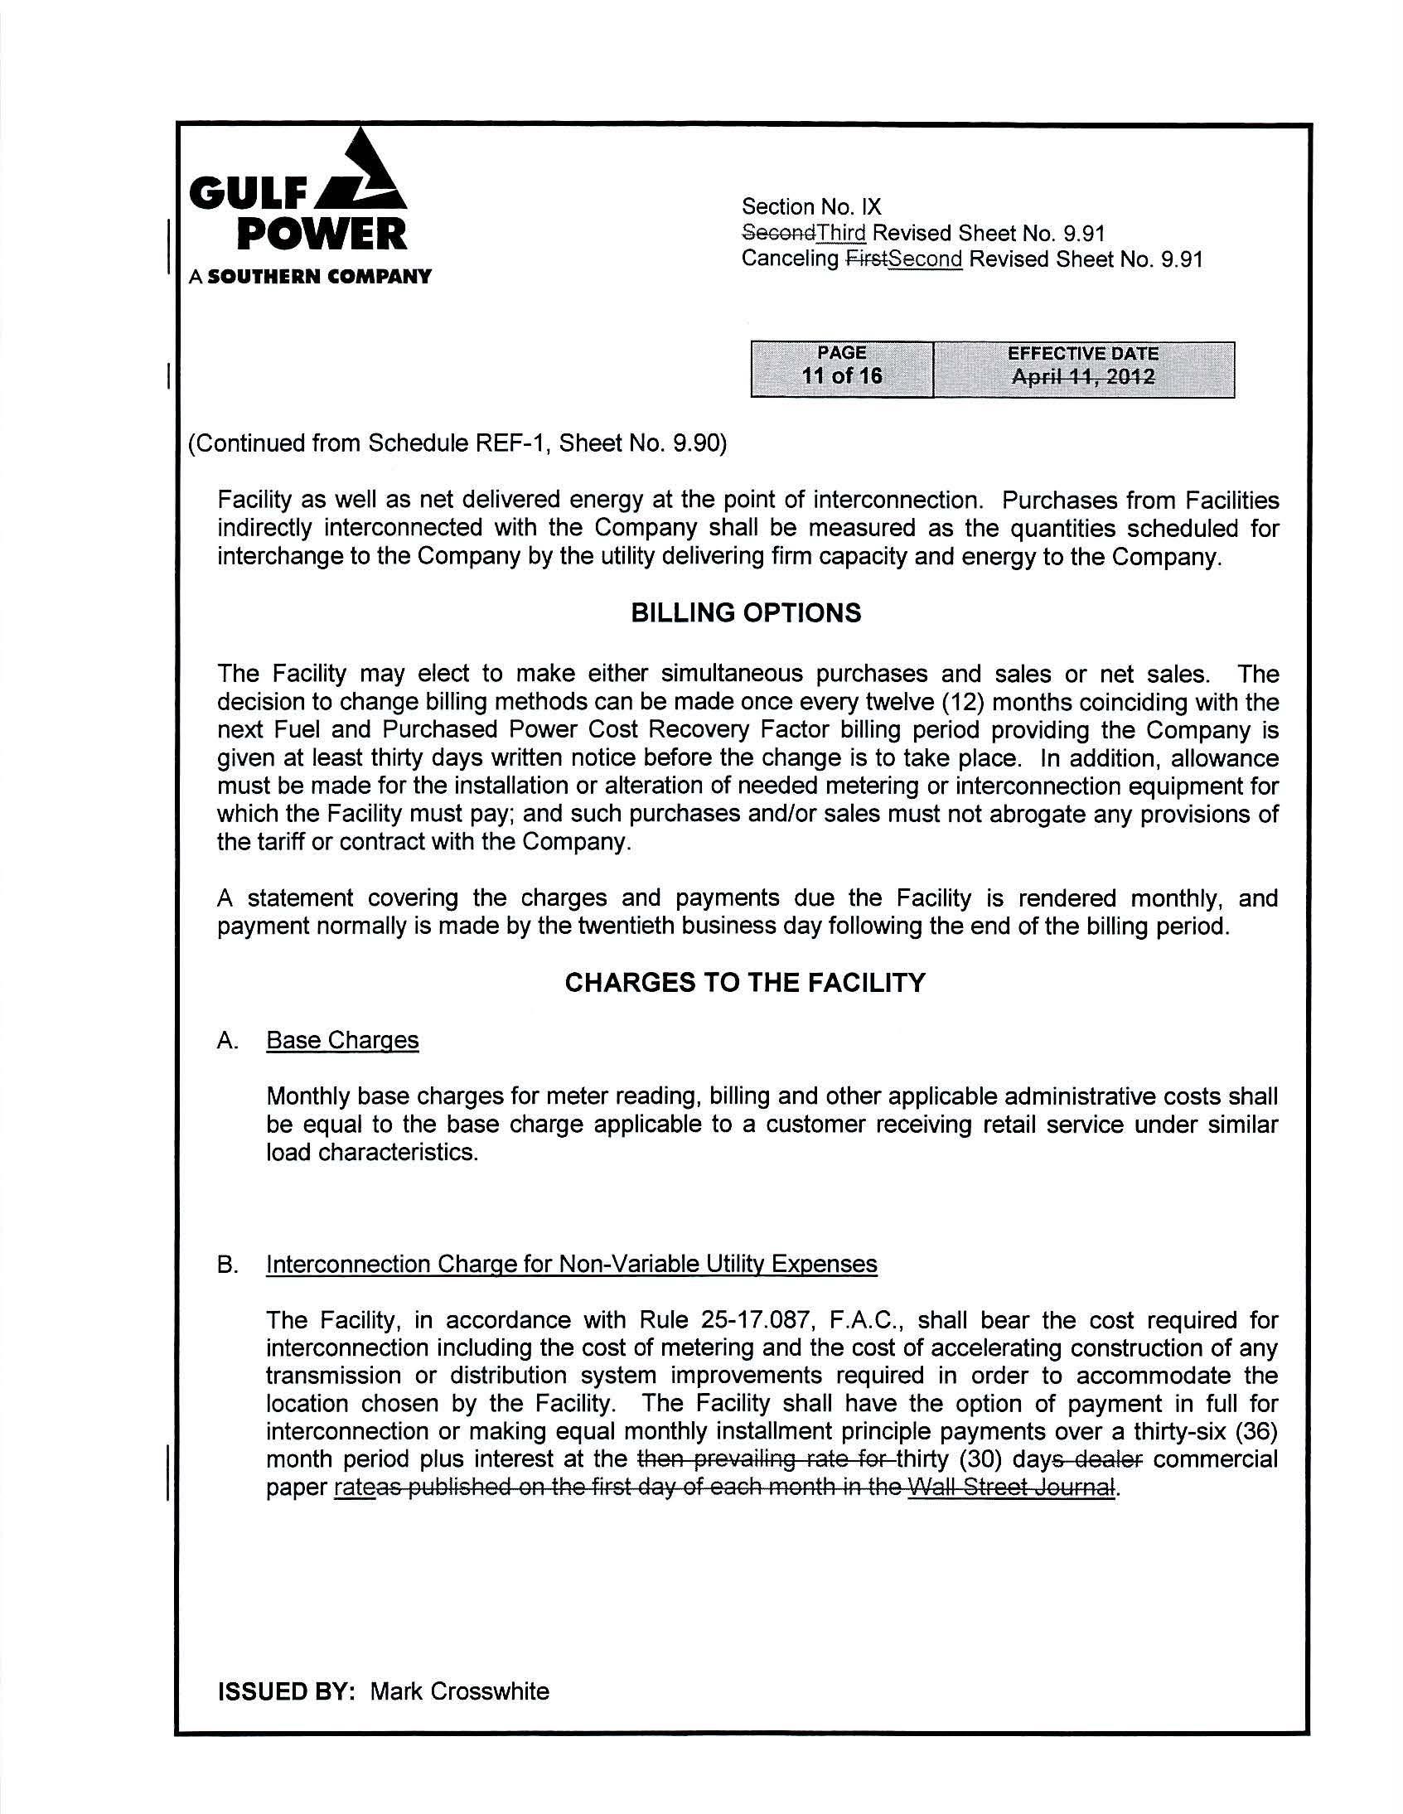
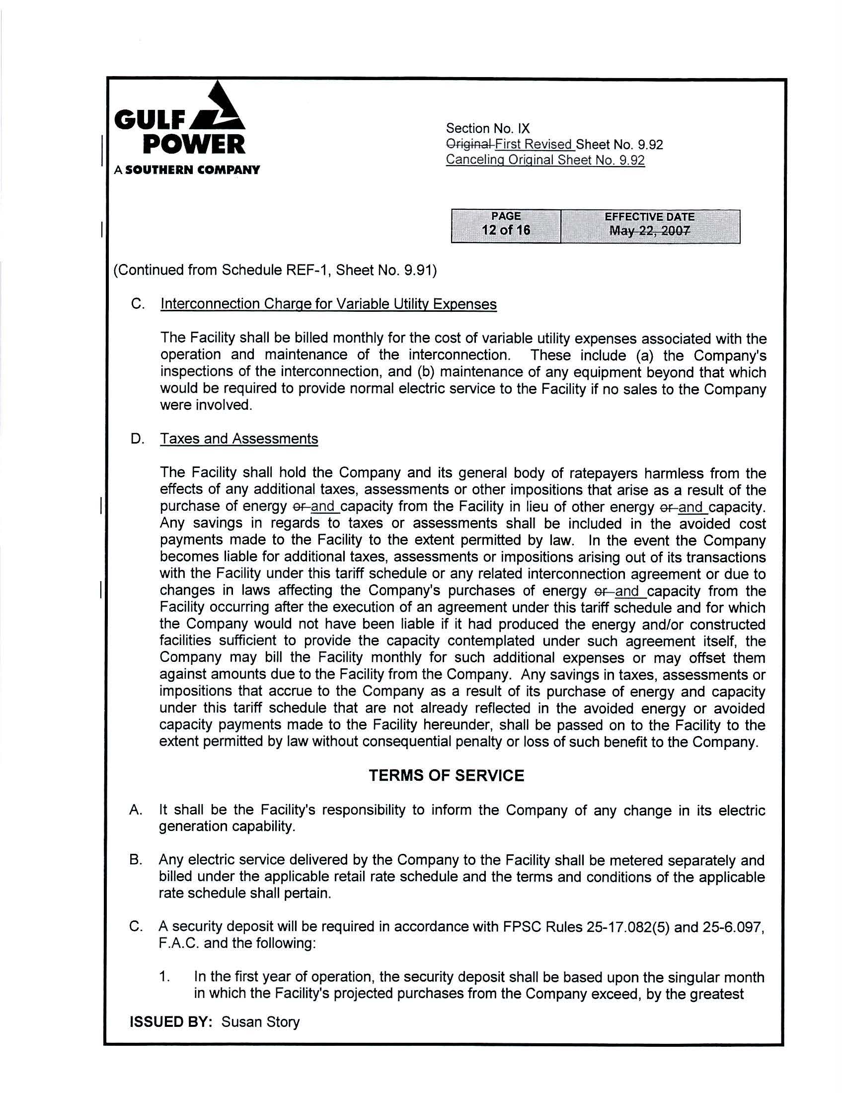
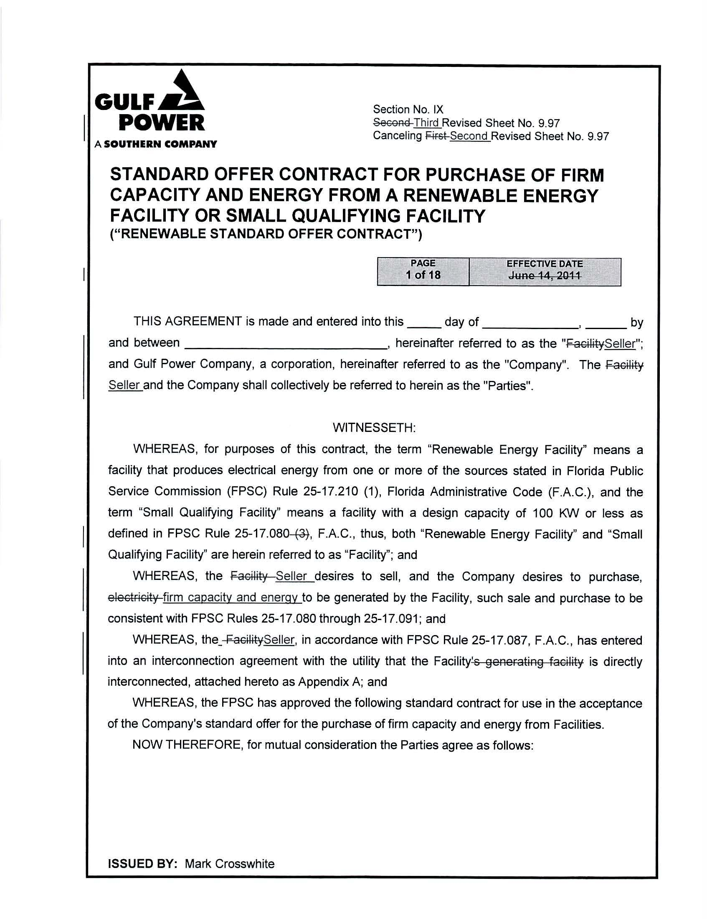
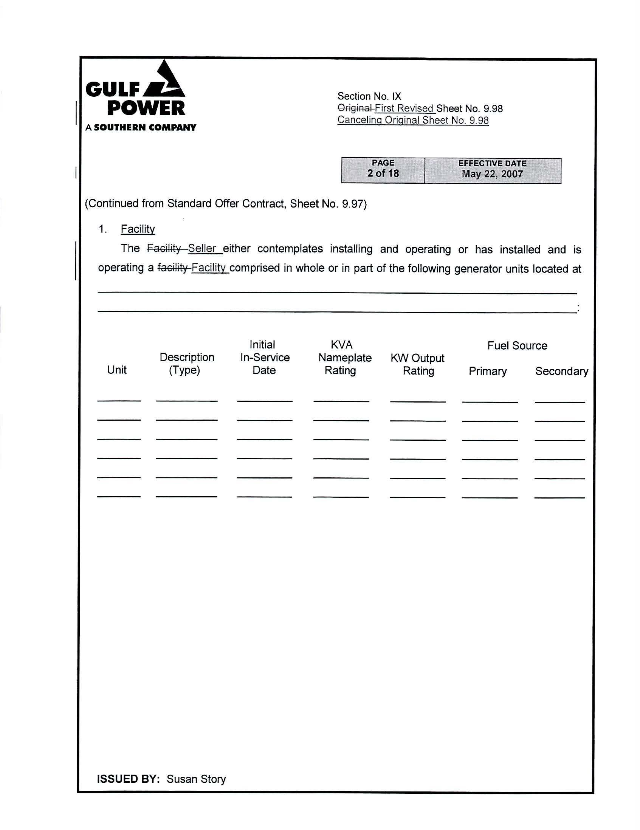
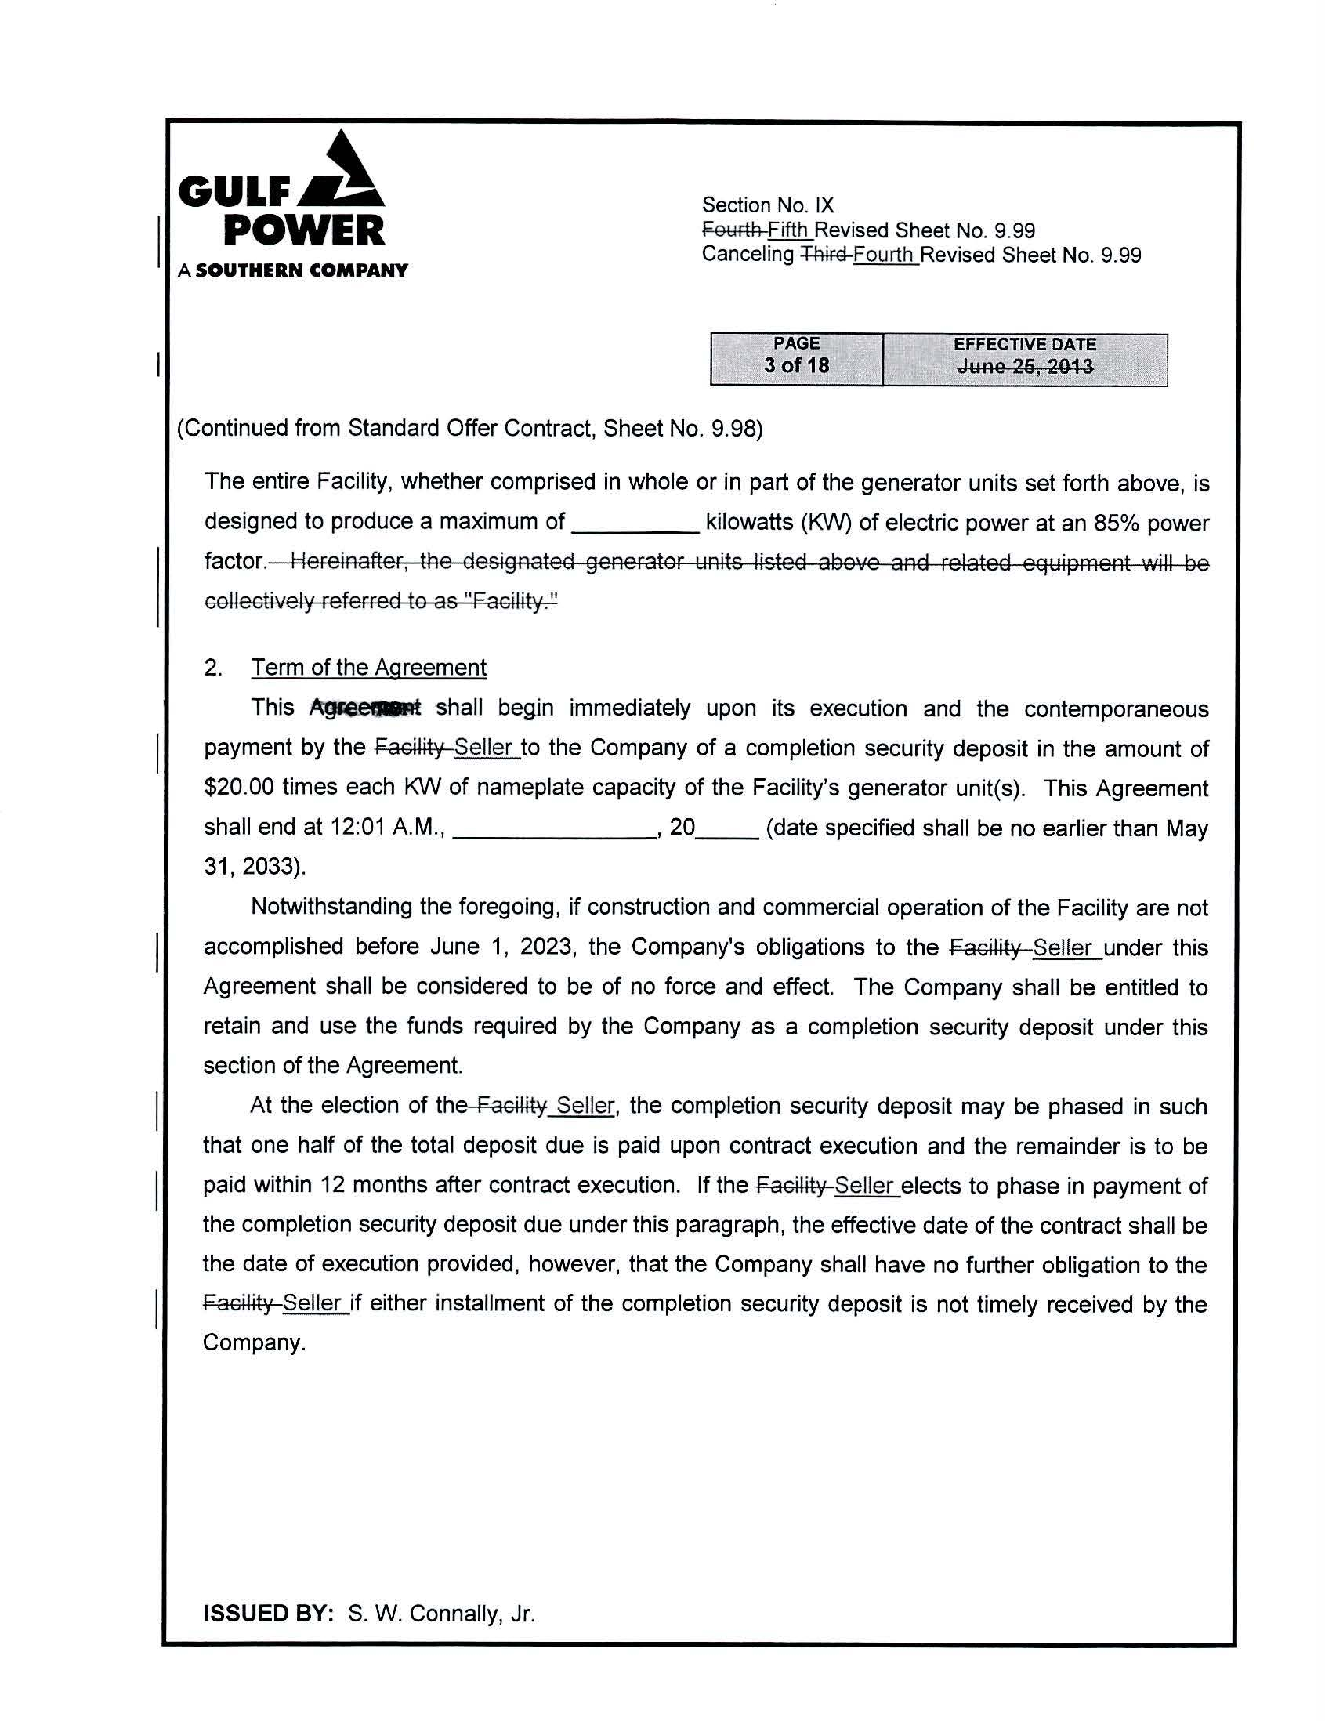
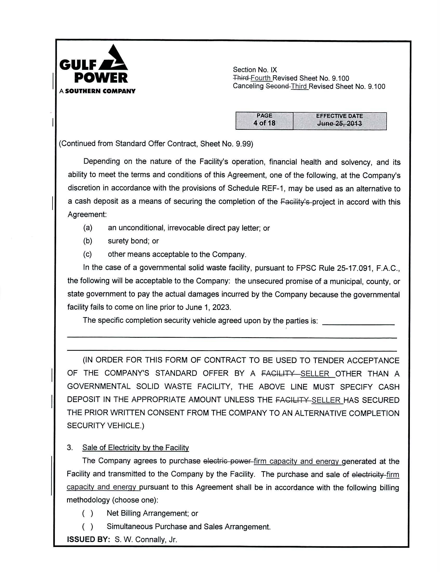
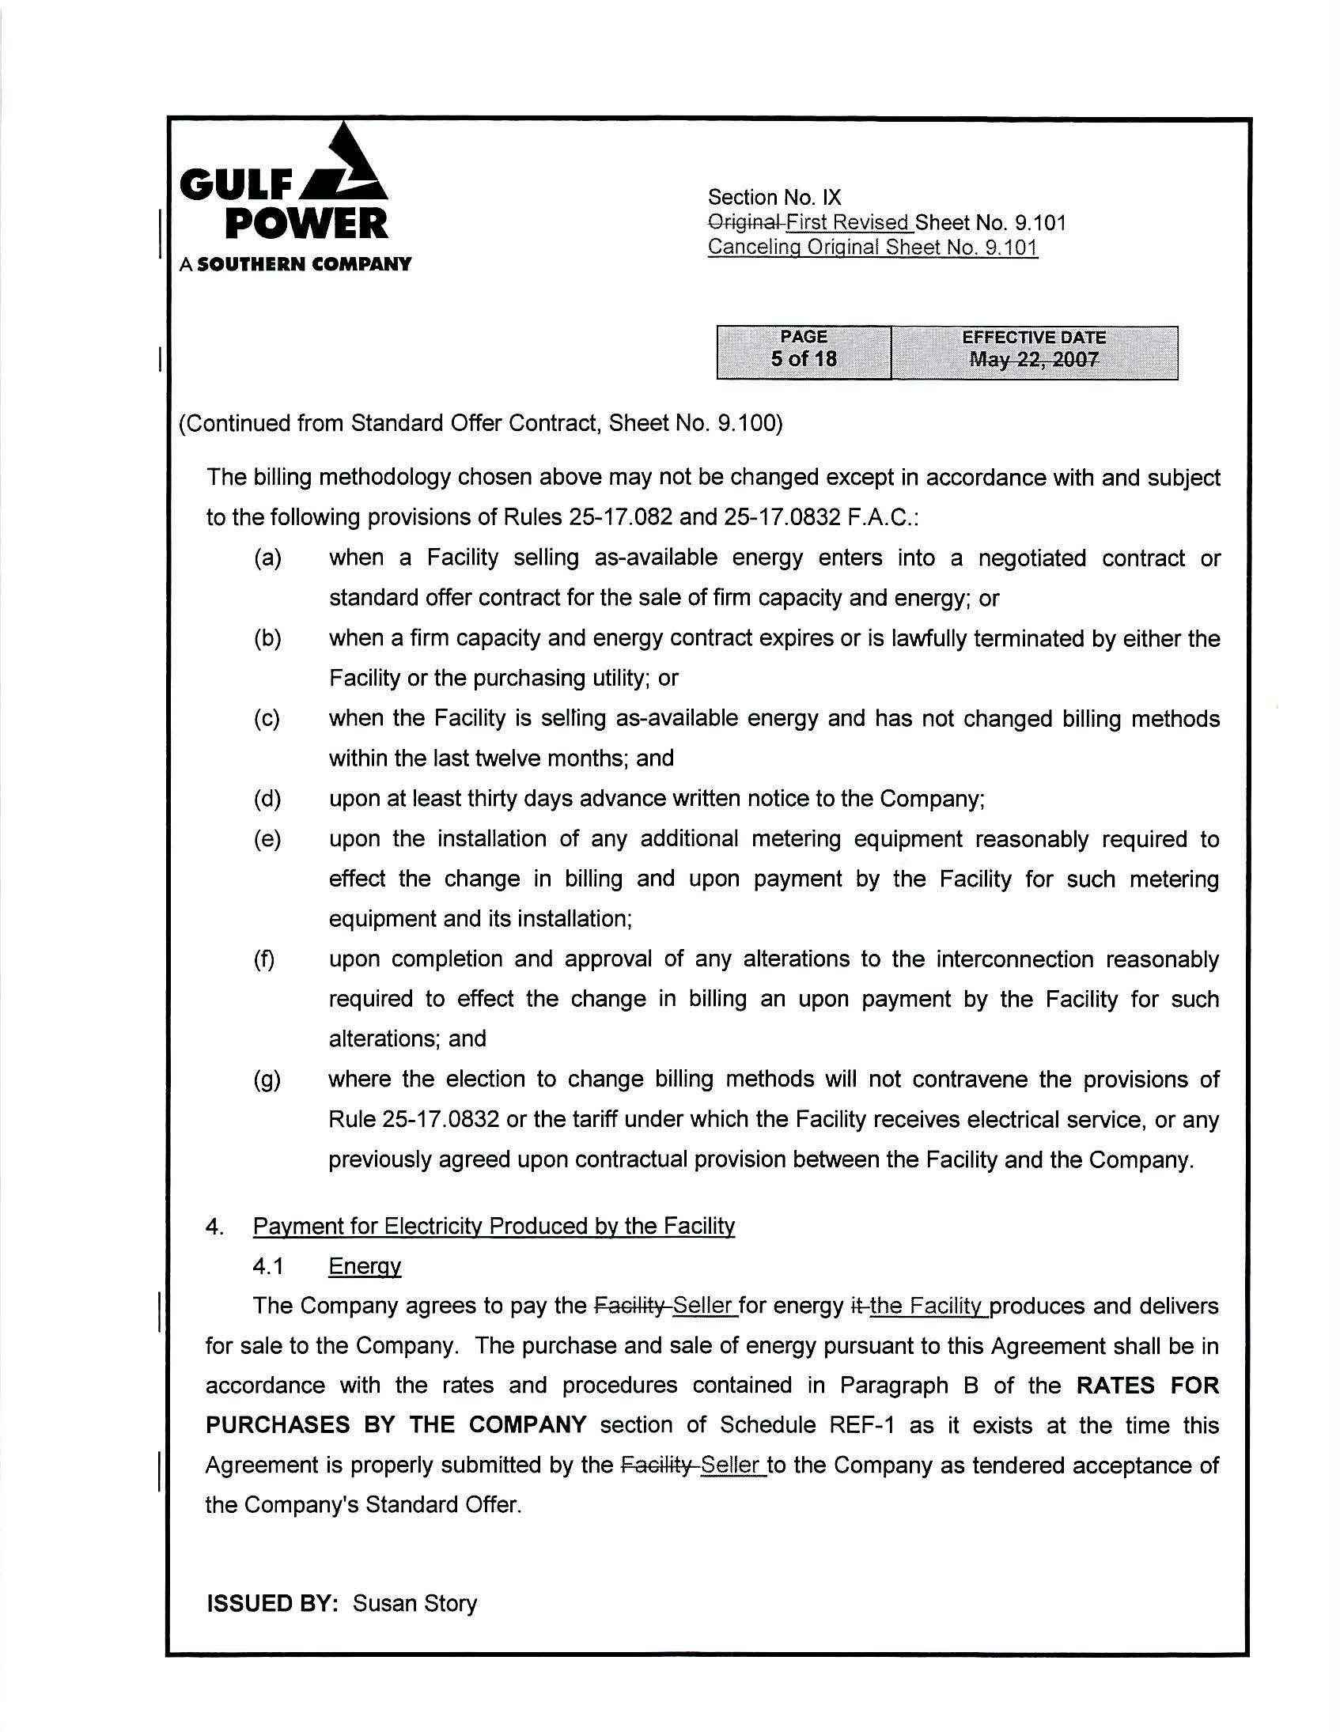
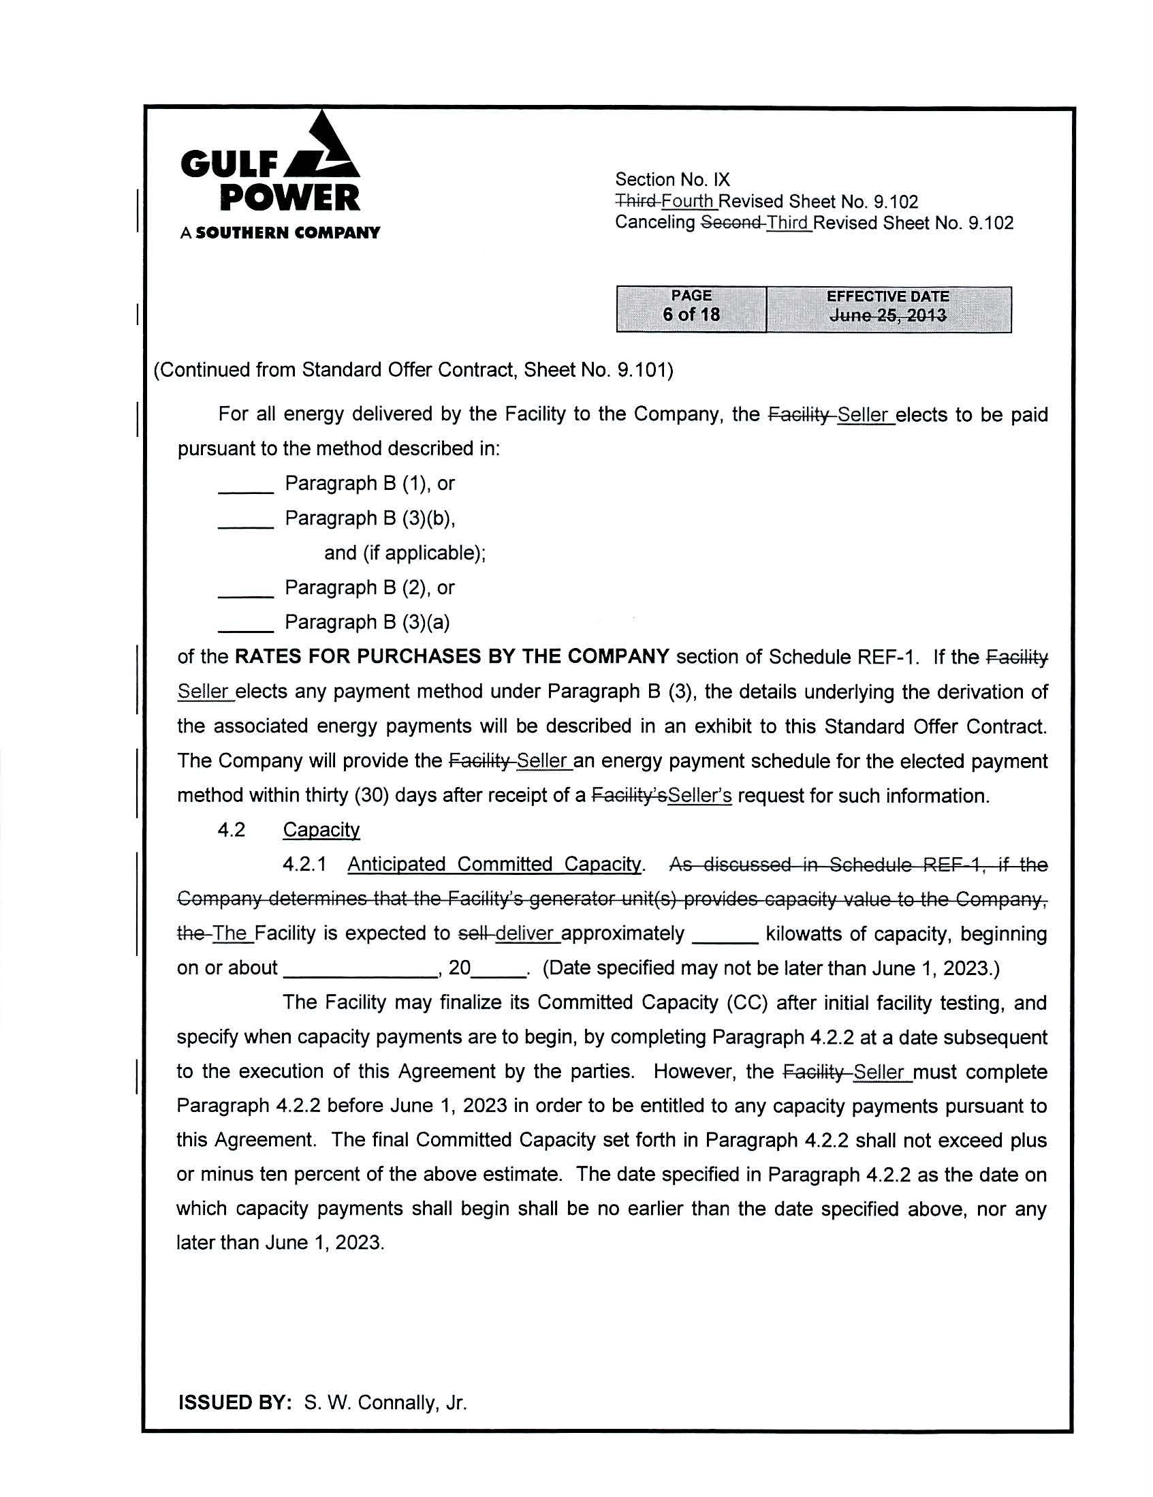
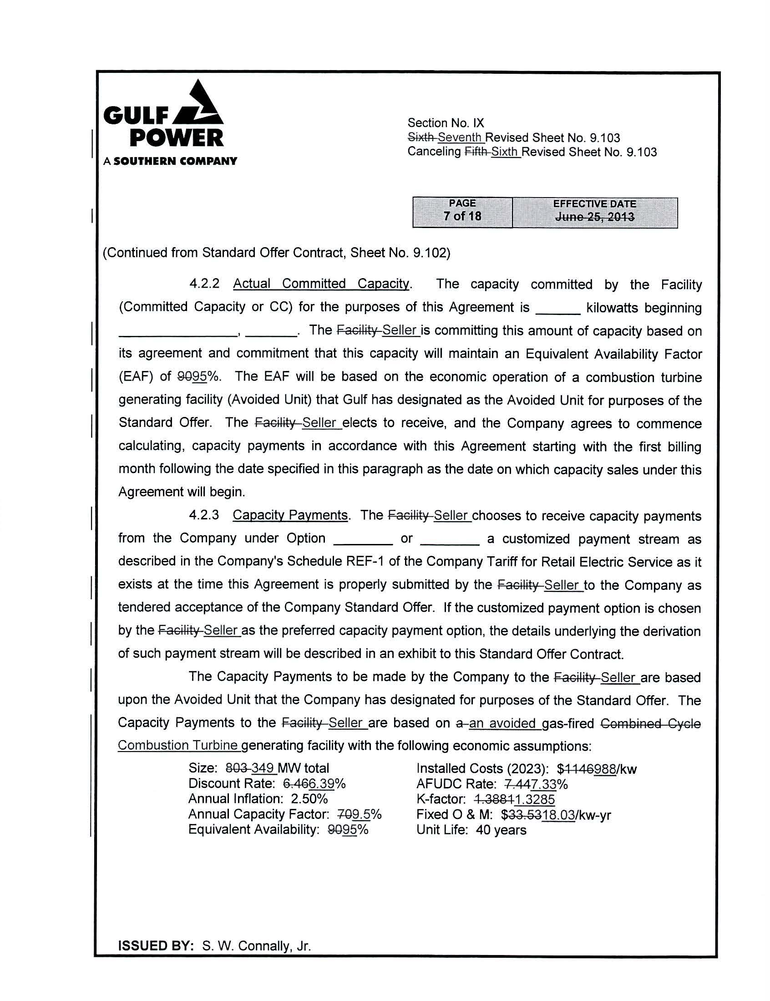
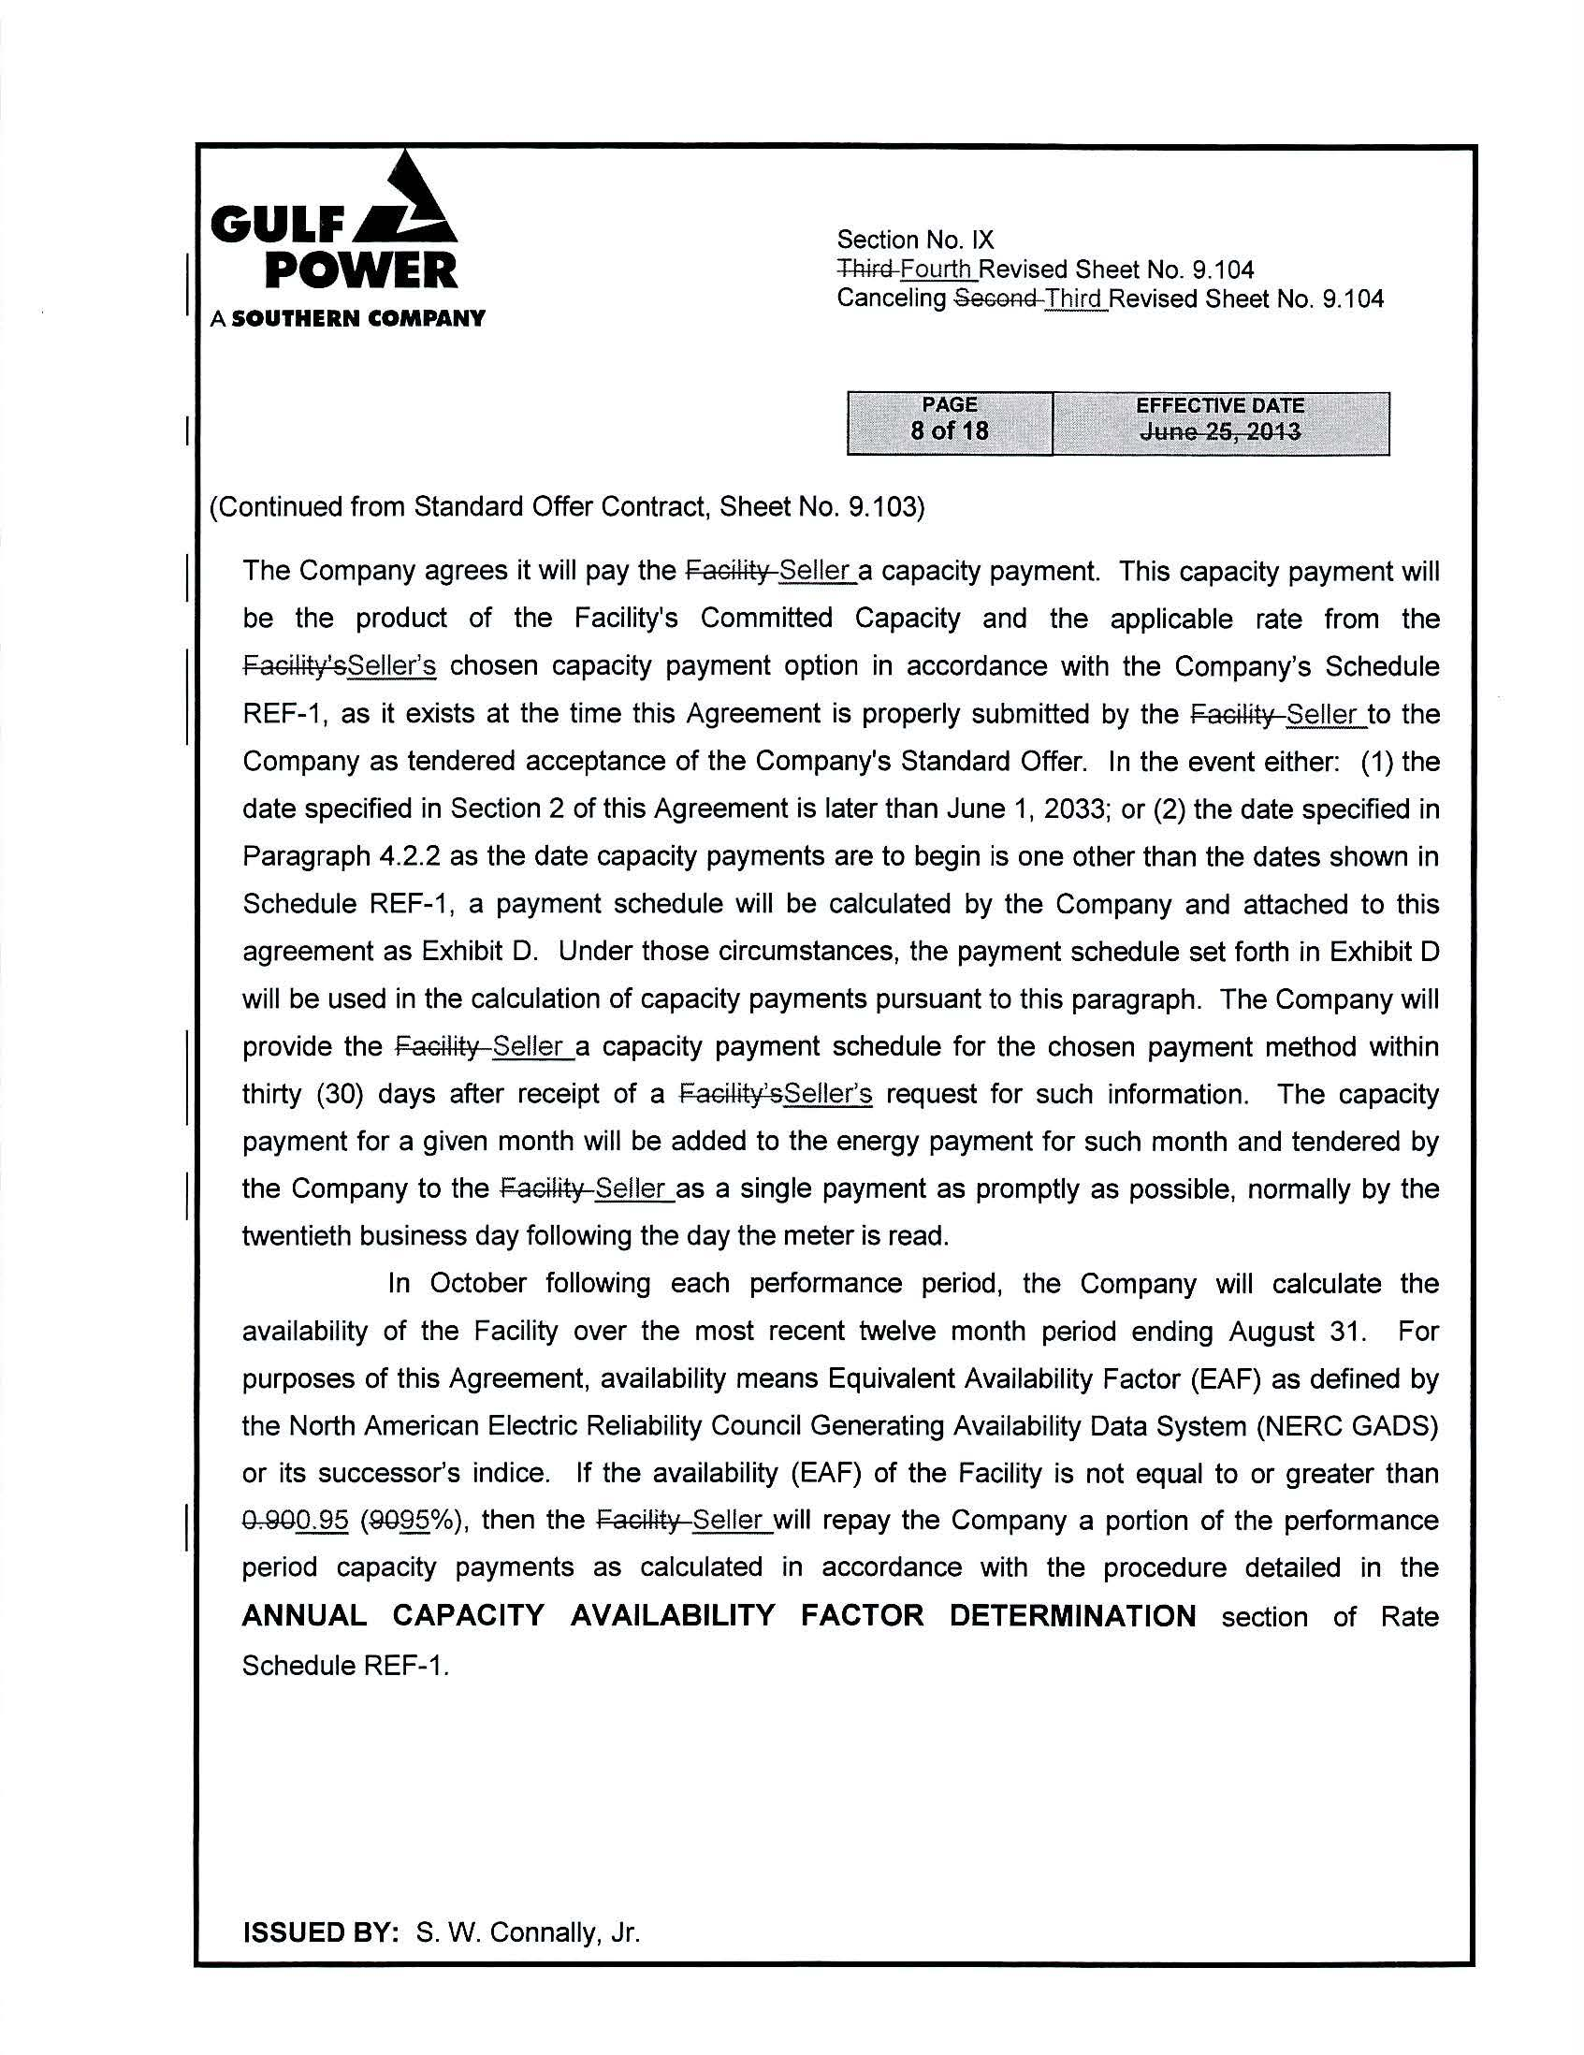
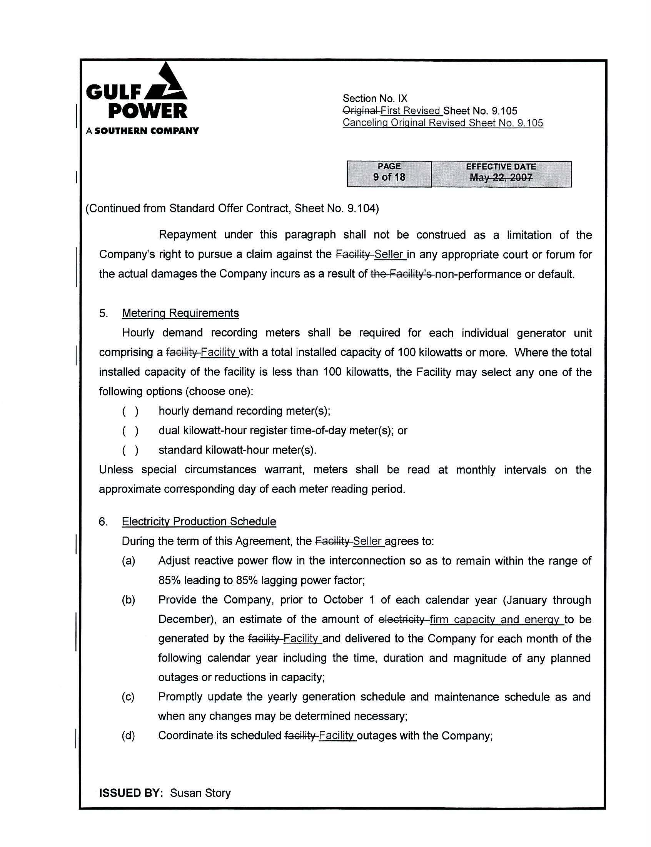
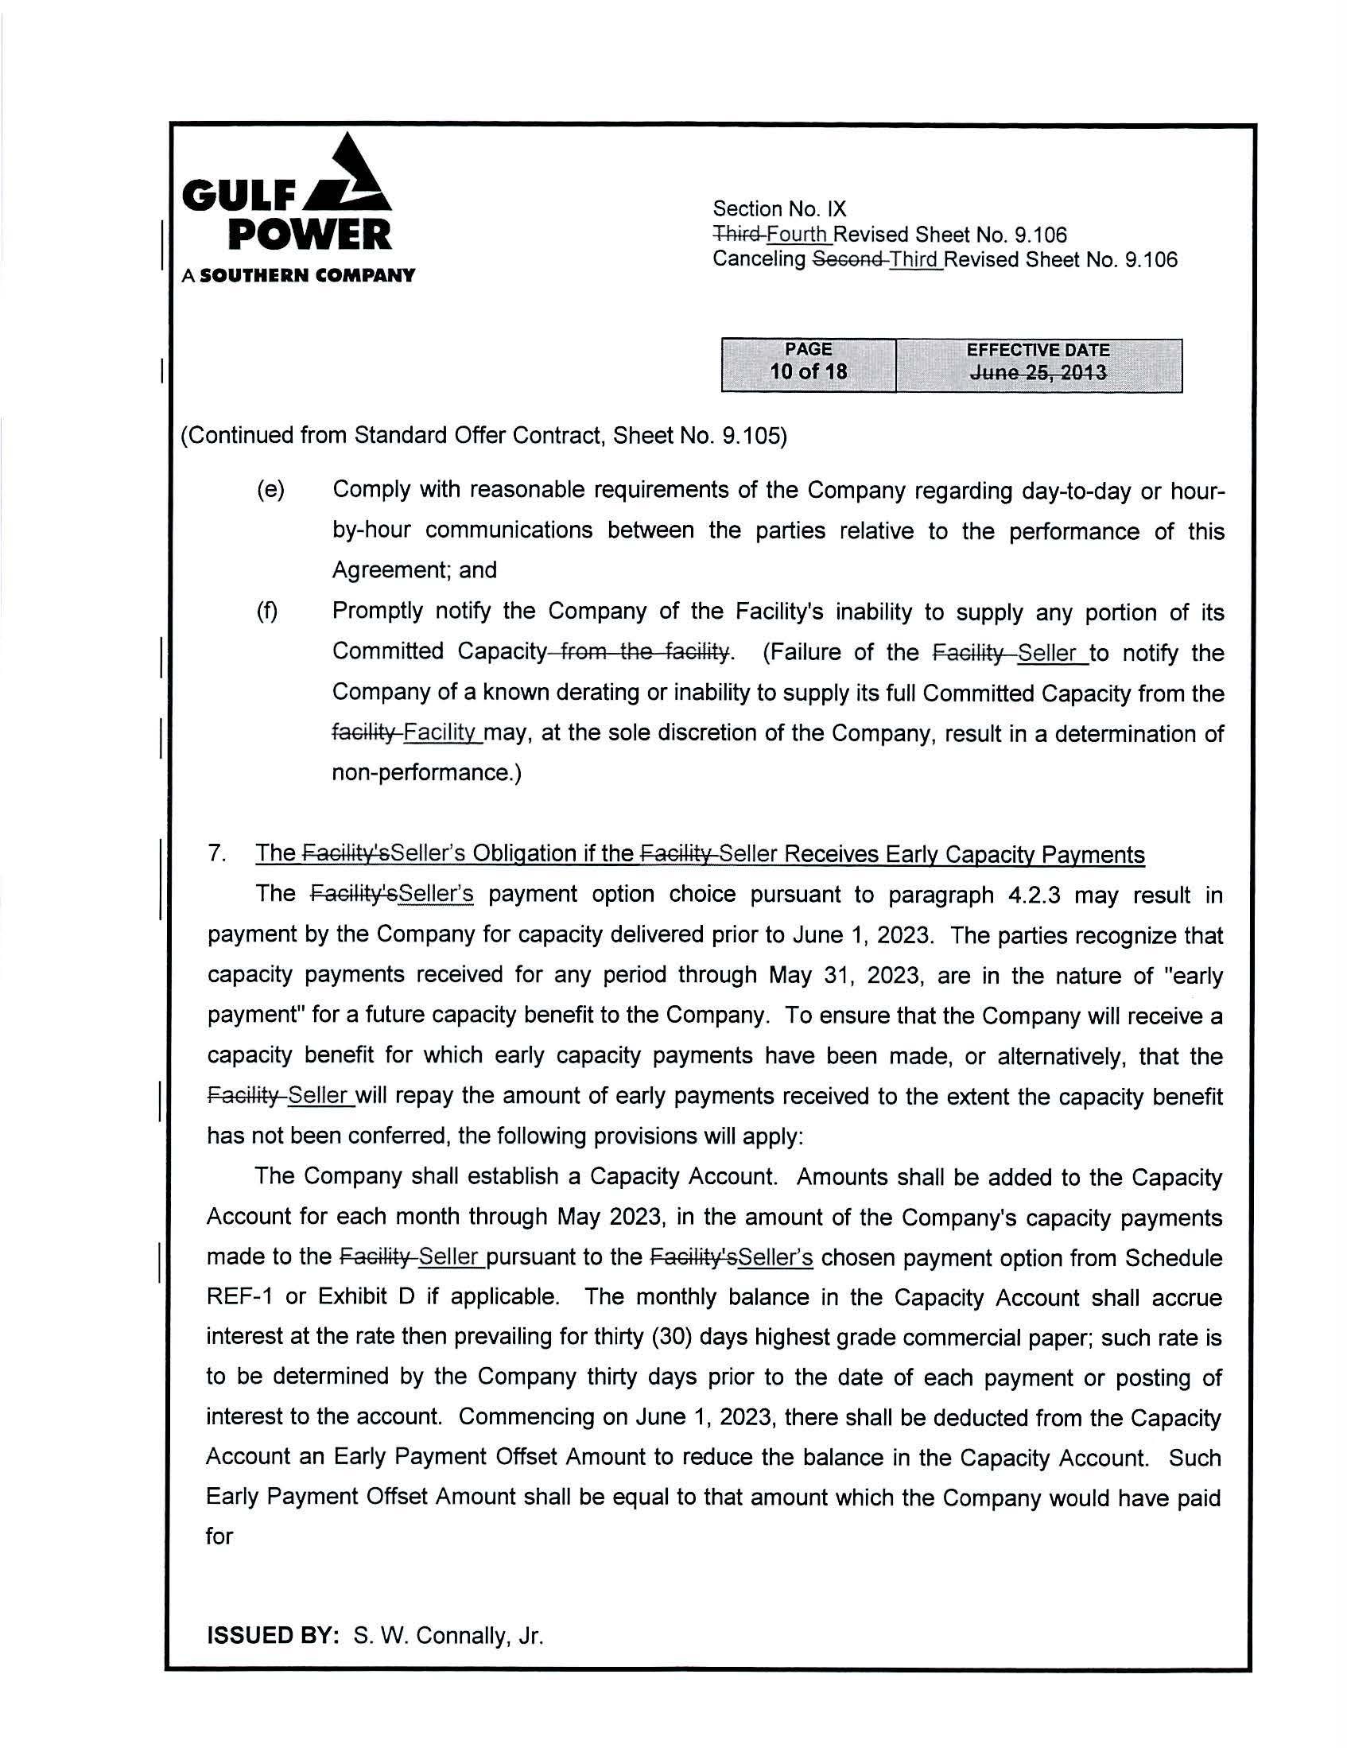
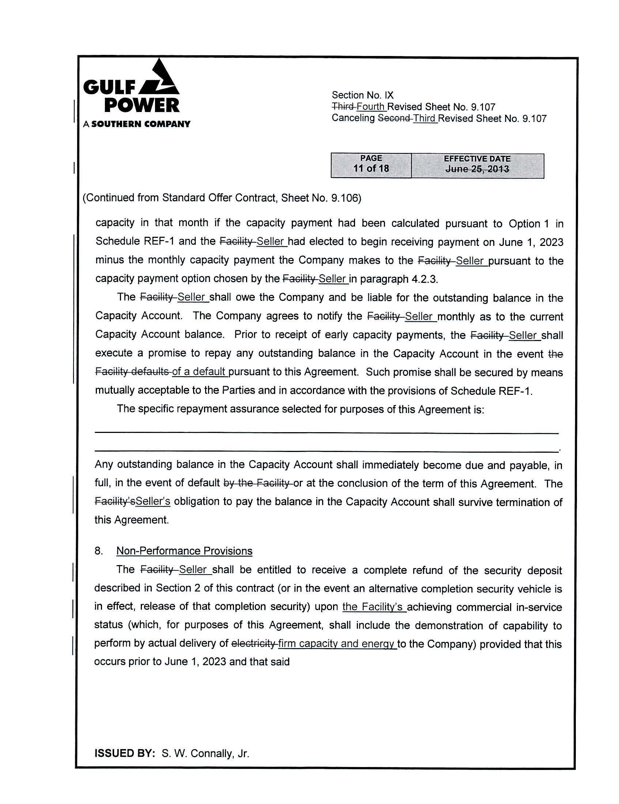
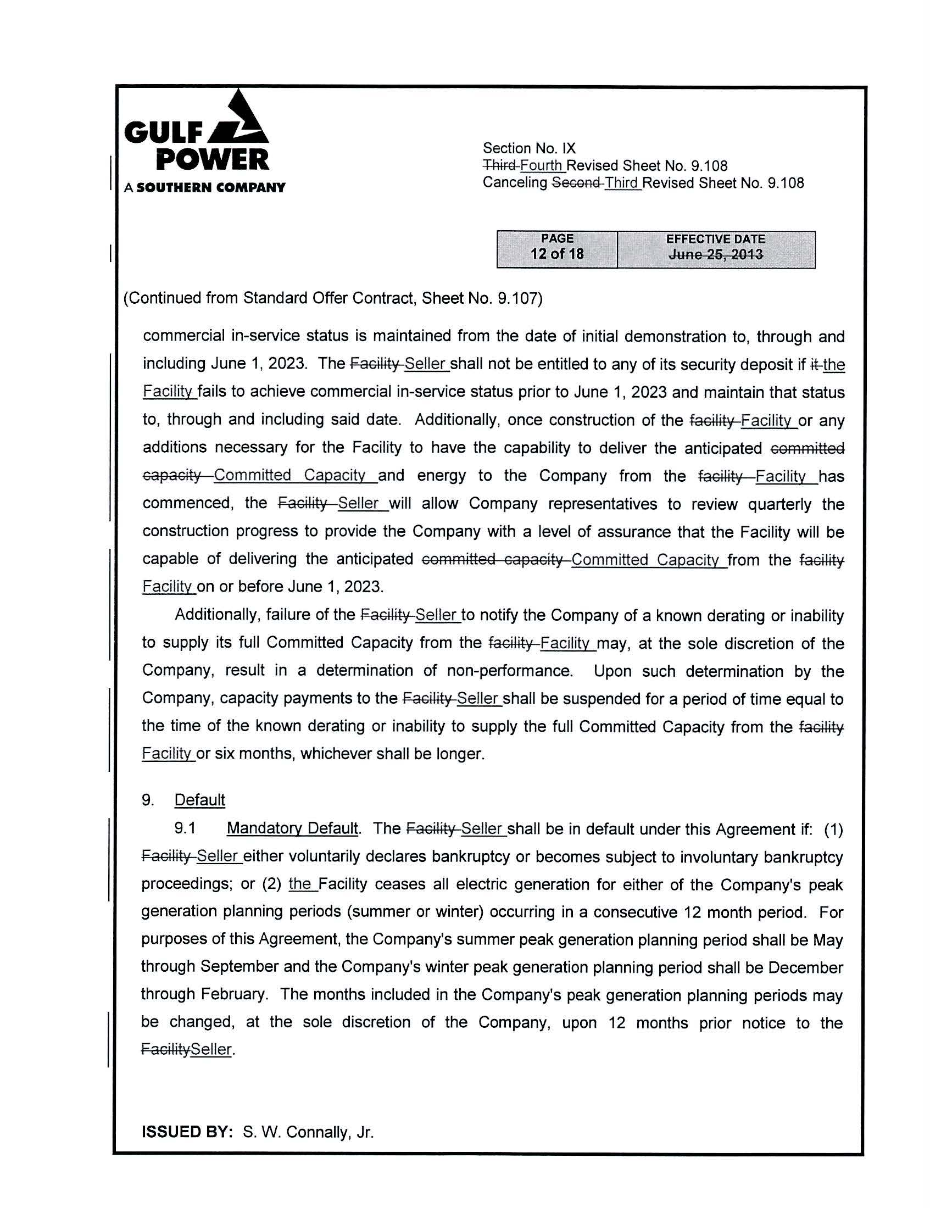
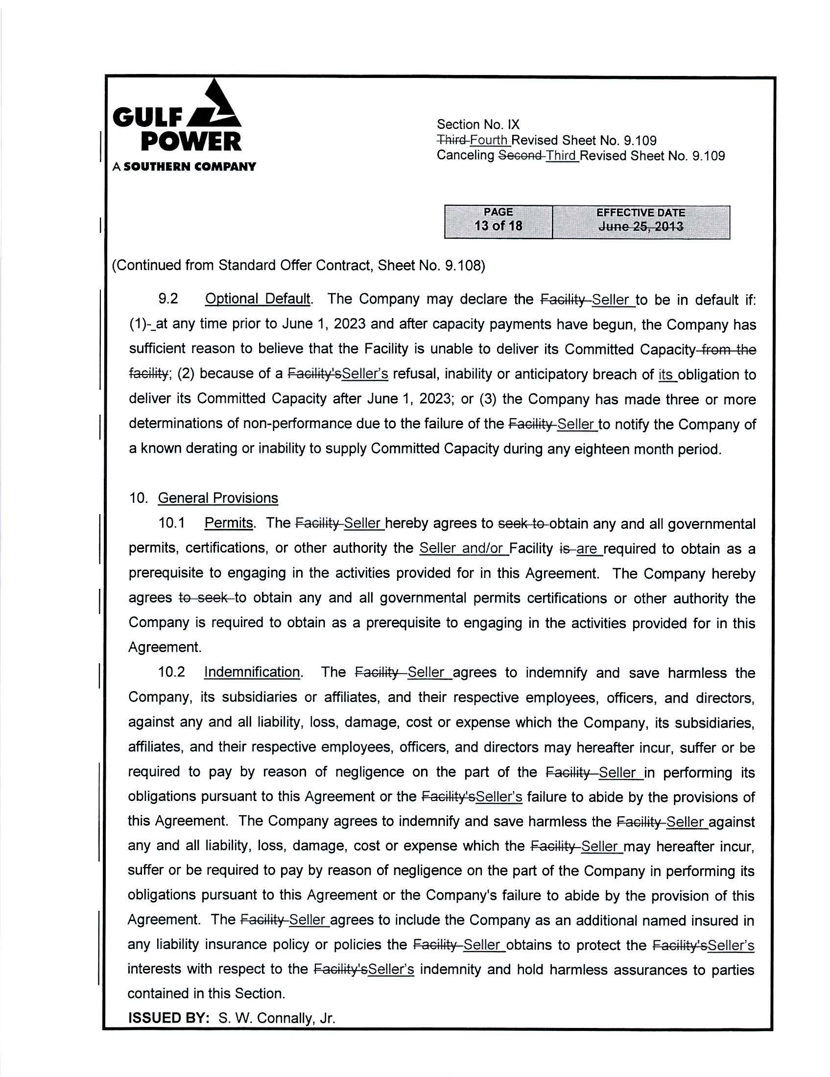
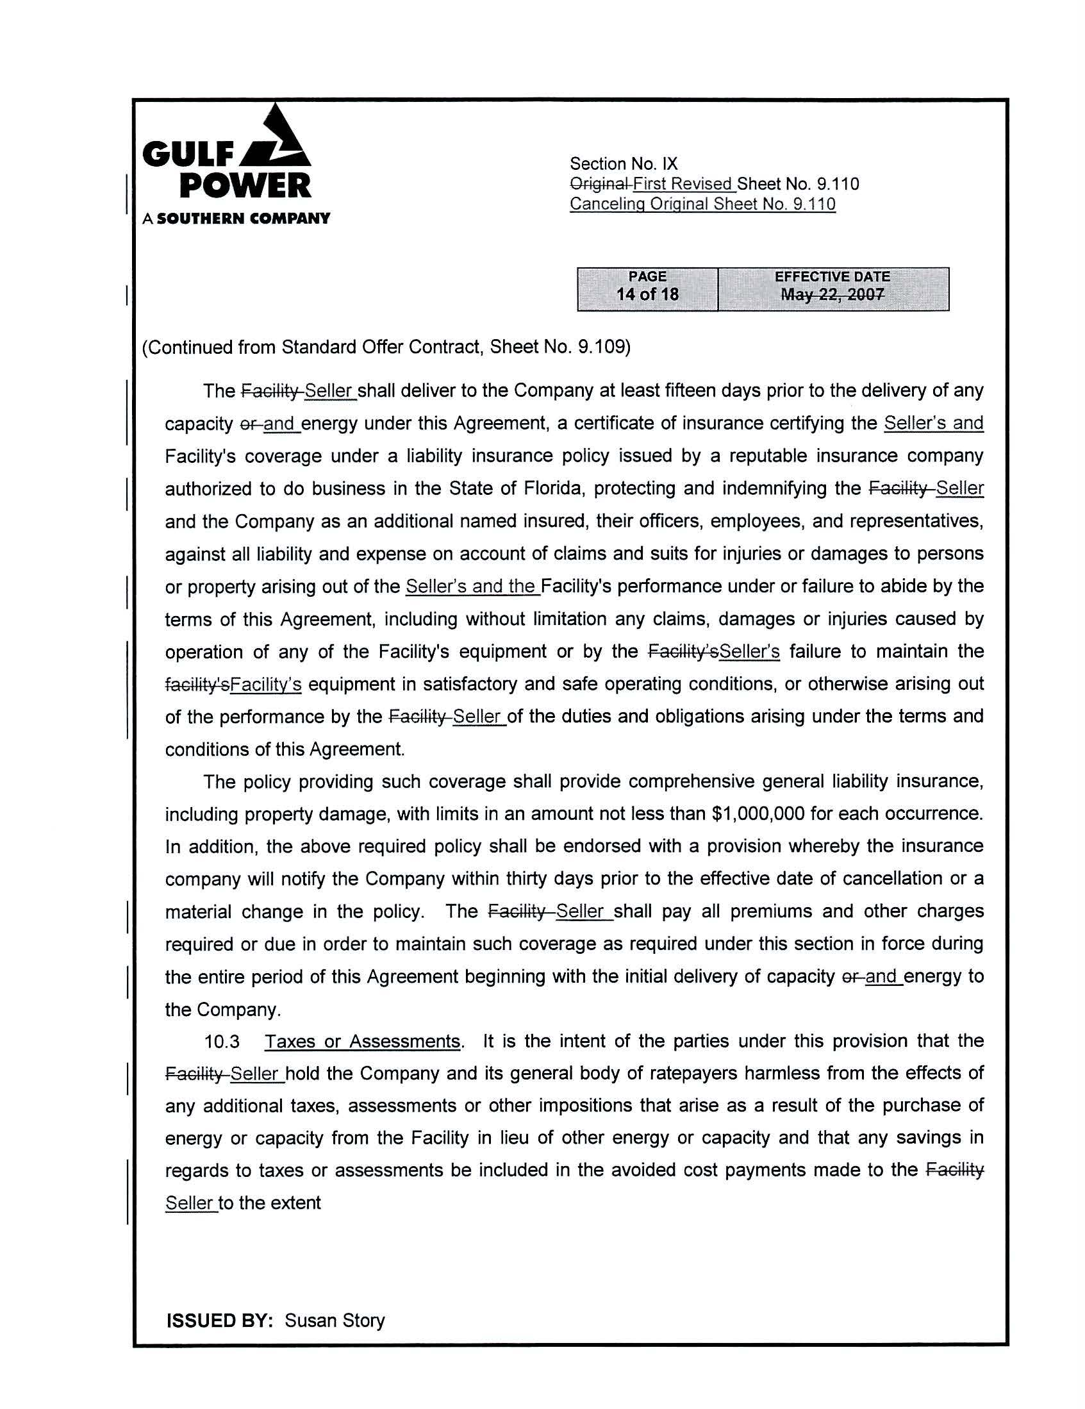
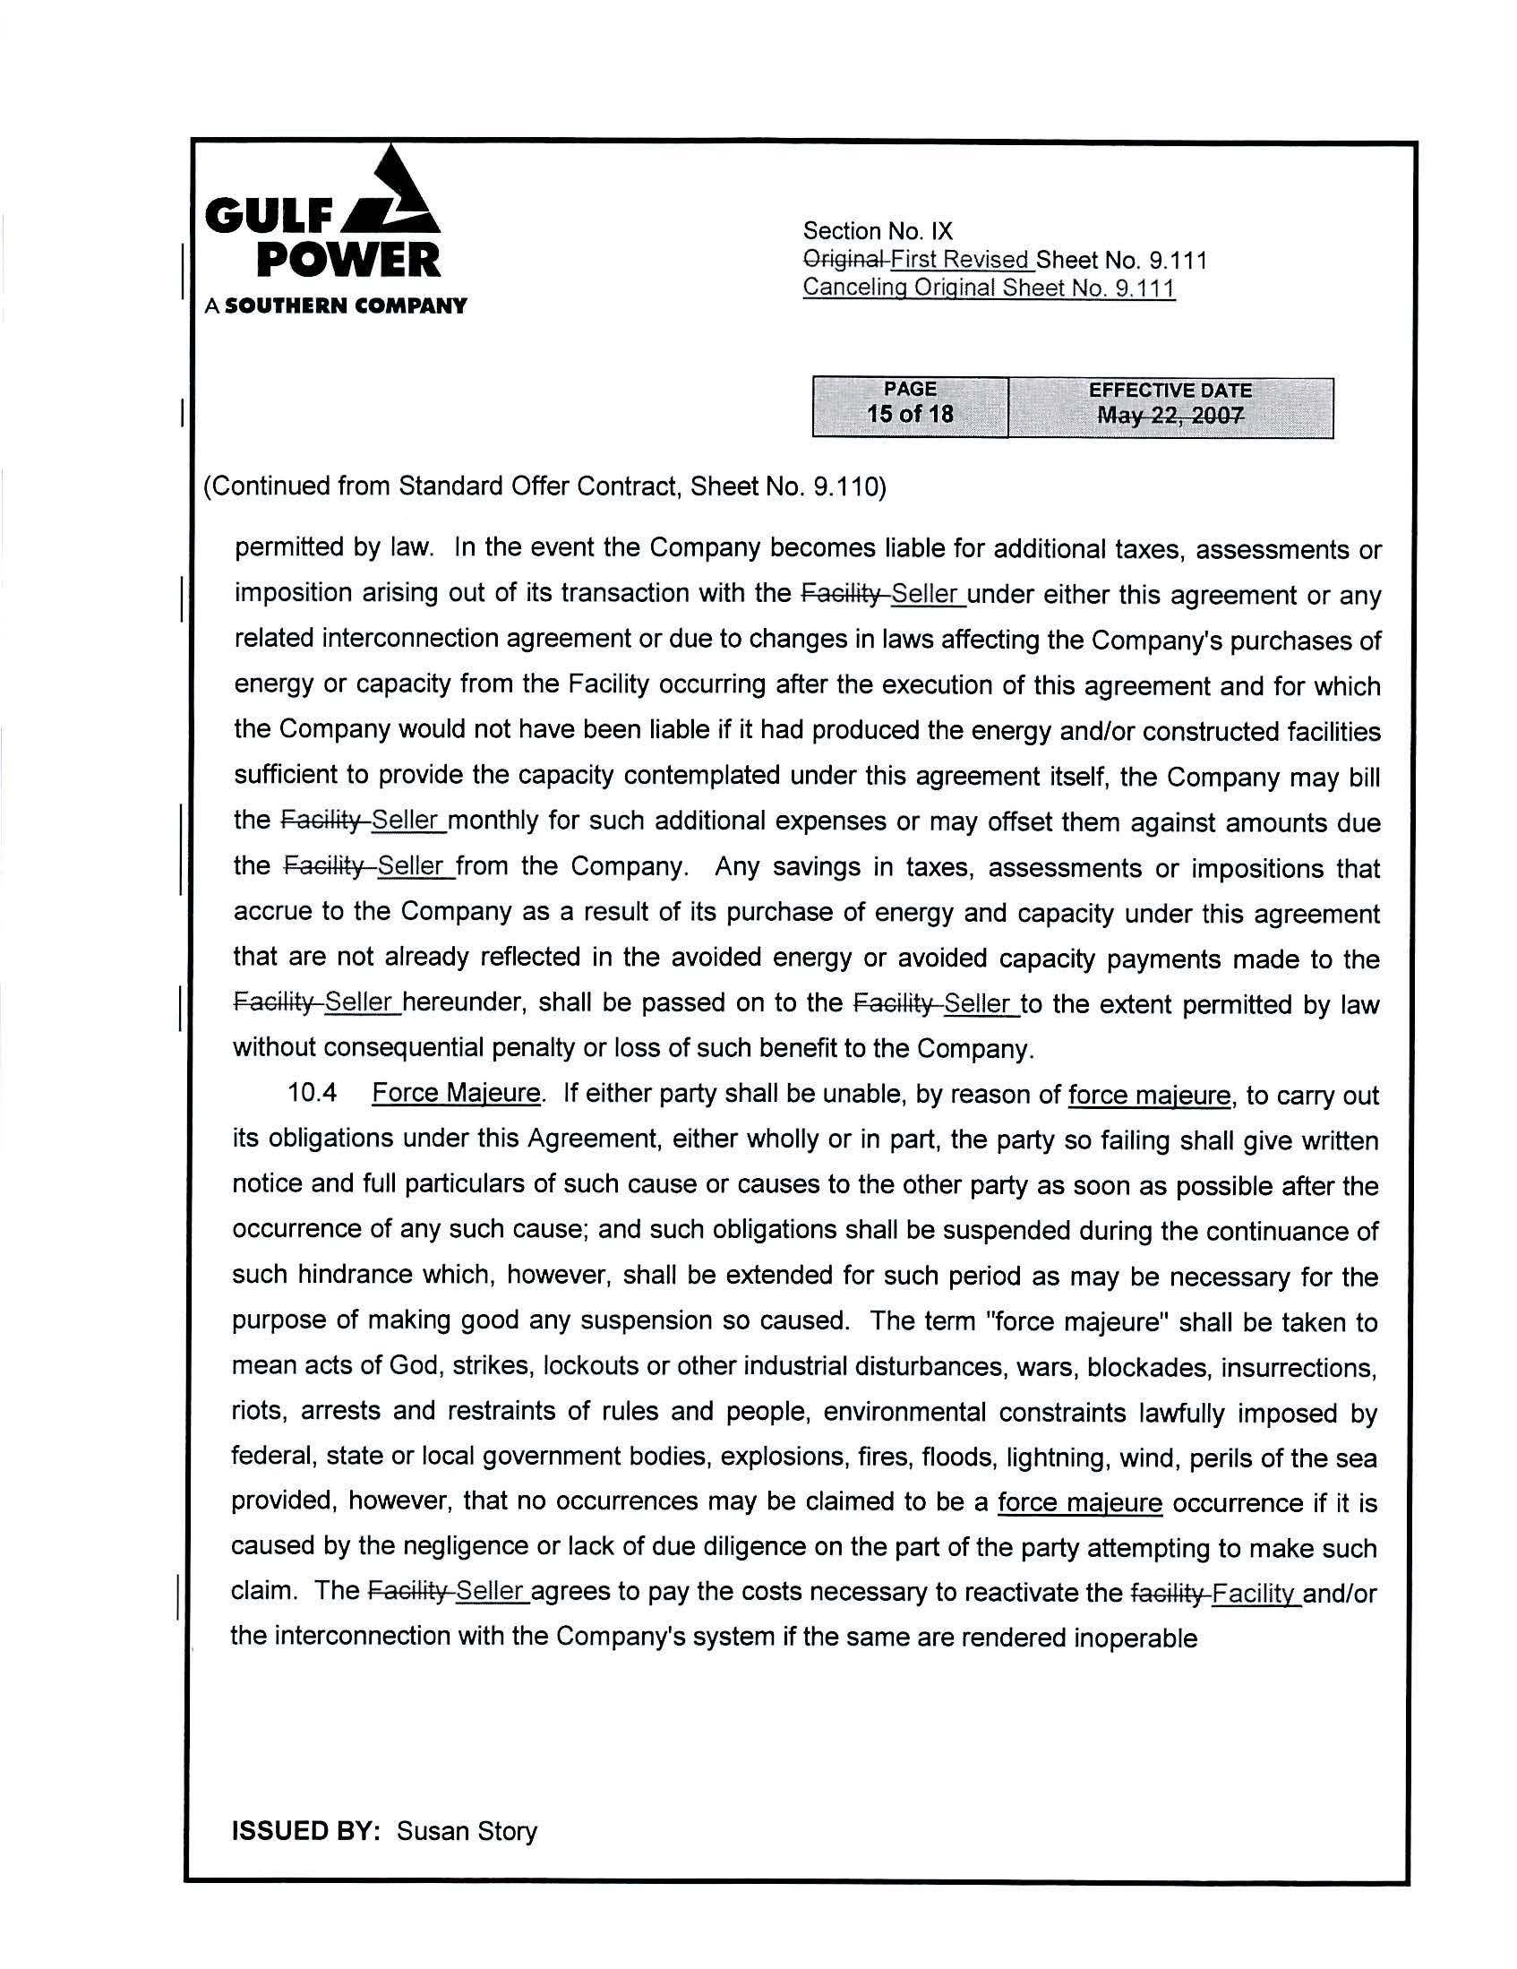
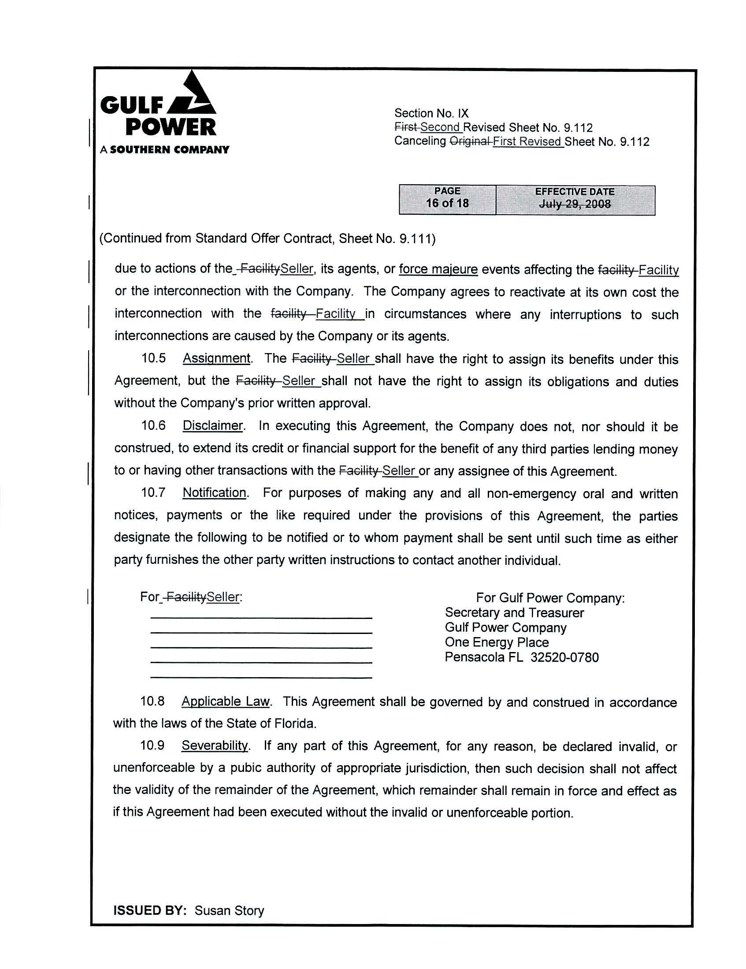
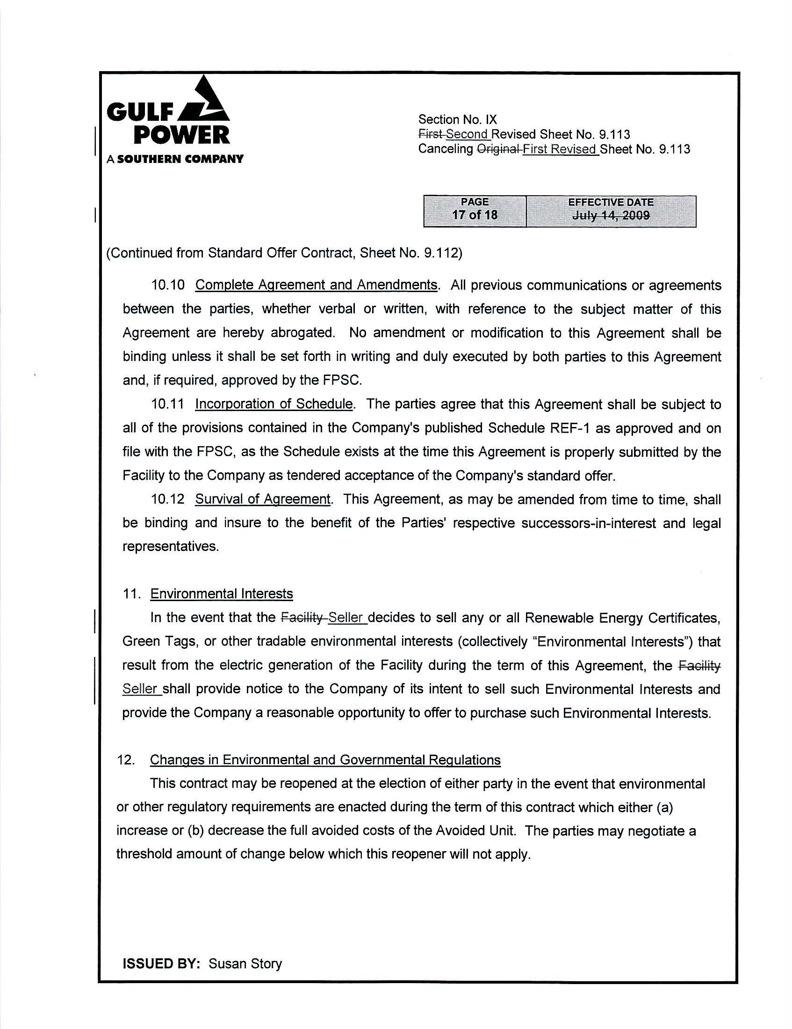
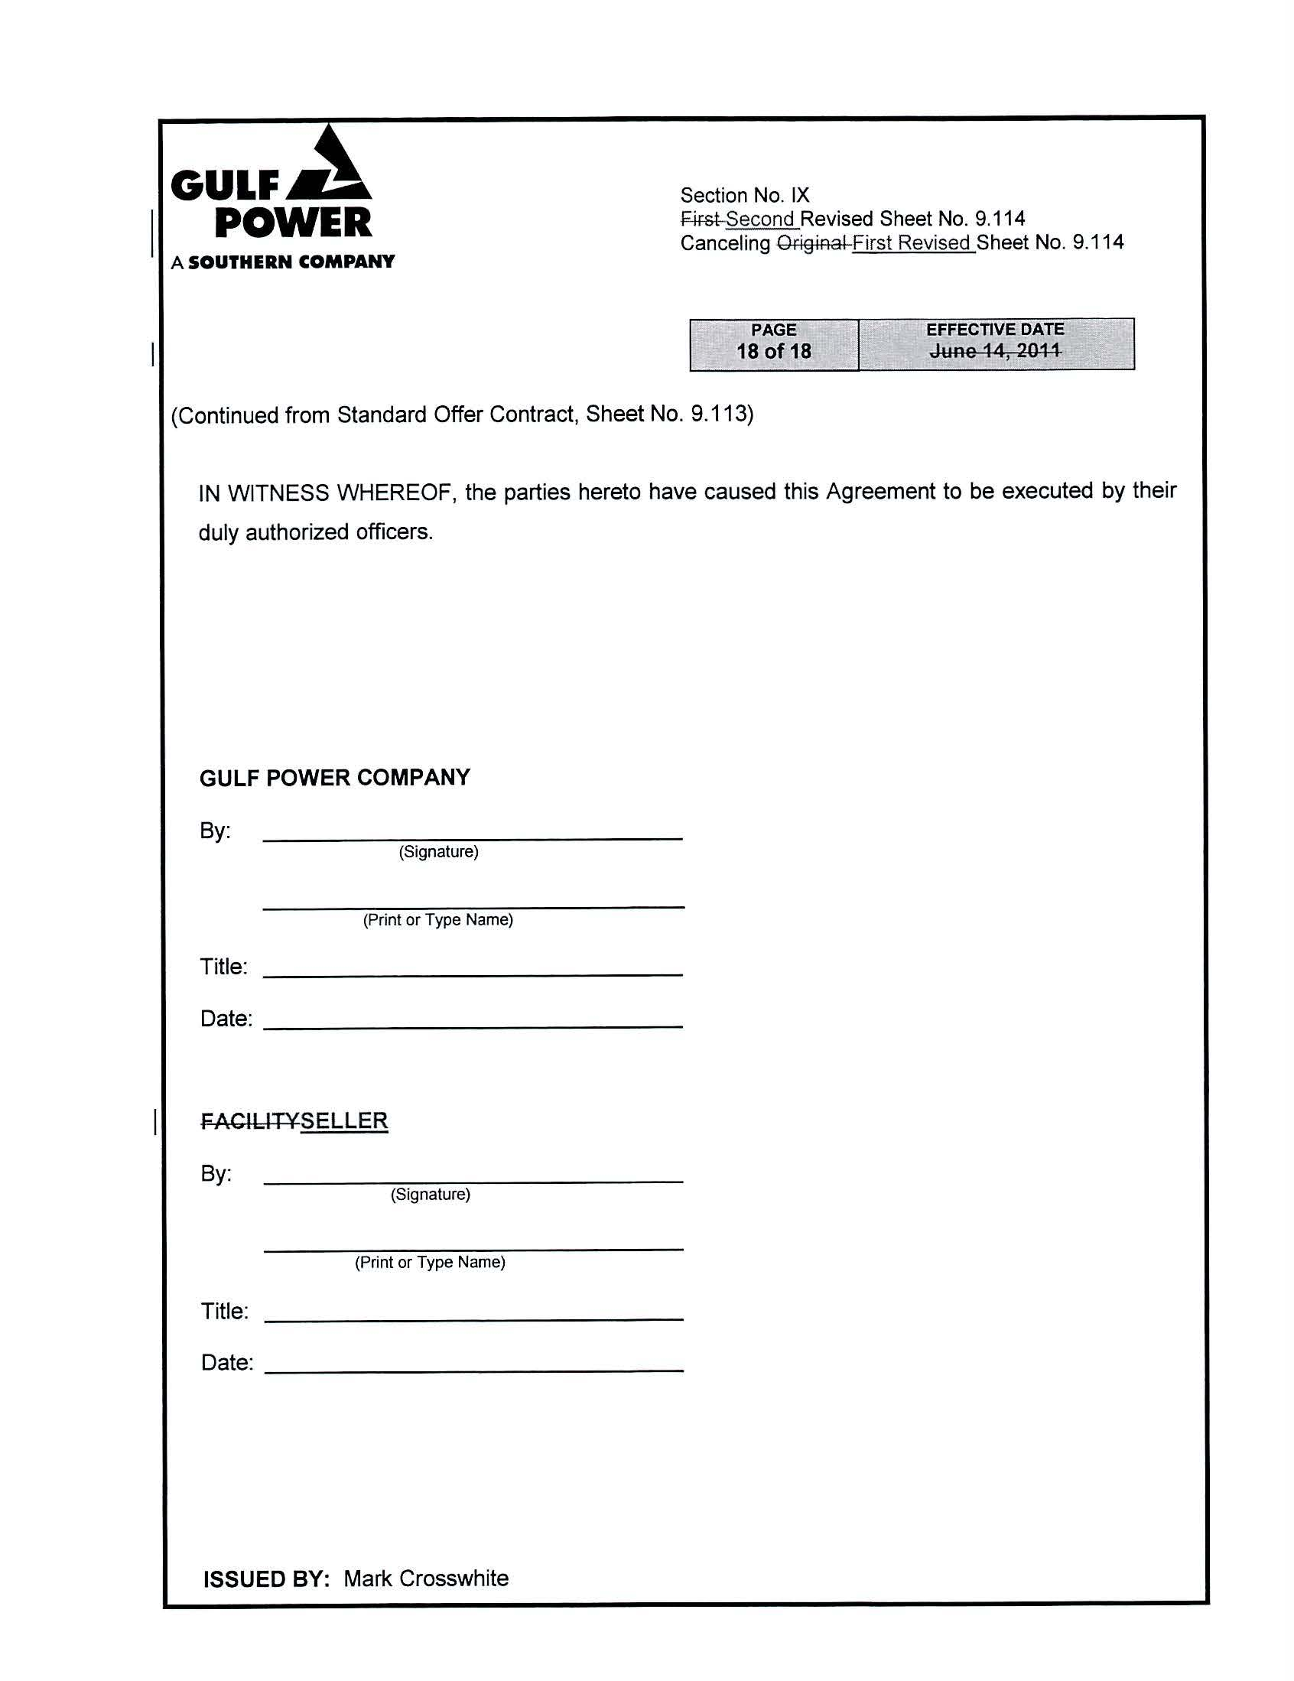

Capacity payments shown in Table 1 were calculated using a calendar year from January to December, while the tariff sheets used a calendar year from June to May. Therefore these calculations will differ from any made using values in the tariff sheet.

