BEFORE THE FLORIDA PUBLIC SERVICE COMMISSION

In re: Petition for approval to close firm transportation service - 13 rate schedule, by Florida Division of Chesapeake Utilities Corporation. | DOCKET NO. 140151-GU  ORDER NO. PSC-14-0592-TRF-GU  ISSUED: October 22, 2014

The following Commissioners participated in the disposition of this matter:

ART GRAHAM, Chairman
LISA POLAK EDGAR
RONALD A. BRISÉ
EDUARDO E. BALBIS
JULIE I. BROWN

ORDER APPROVING PETITION TO CLOSE FIRM TRANSPORTATION SERVICE-13 RATE SCHEDULE

BY THE COMMISSION:

Background

On August 13, 2014, the Florida Division of Chesapeake Utilities Corporation (Chesapeake) filed a petition requesting Commission approval to close its Firm Transportation Service-13 (FTS-13) rate schedule to new customers. This Commission last reviewed the FTS-13 rate schedule in Chesapeake’s 2009 rate case, acknowledging that the rate was based on unique circumstances of the one customer taking service under this rate, the Mosaic phosphate company. Mosaic has the ability to bypass Chesapeake’s distribution system since the Florida Gas Transmission (FGT) pipeline traverses Mosaic’s property and Mosaic could directly interconnect with FGT. The FTS-13 Firm Transportation Charge was developed as a retention rate based on Mosaic’s cost to bypass Chesapeake. Mosaic is the only customer on the rate, but the rate is open to any other qualified customer. We have jurisdiction in this matter pursuant to Section 366.06, Florida Statutes.

Decision

As previously mentioned, we reviewed the FTS-13 rate, along with all other rate schedules, during Chesapeake’s last rate case in 2009. At that time, the FTS-13 rate covered the cost to serve Mosaic, the one customer taking service under that rate. Chesapeake’s 2nd Quarter Earnings Surveillance Reports for 2014, dated August 8, 2014, shows a rate of return within the approved range.
Chesapeake acknowledged in its petition that rate schedule FTS-13 was created for Mosaic and is more akin to a special contract. The rate was specifically designed to retain this customer and to cover the cost to serve Mosaic so the general body of ratepayers did not subsidize service to this one customer.
Chesapeake further explained that a new customer seeking service under the same tariff may not have the same cost to serve profile as Mosaic. A different cost profile could result in Chesapeake’s FTS-13 rate schedule not covering the cost to serve the new customer, thereby causing Chesapeake to lose revenues and the new customer to be subsidized by the general body of ratepayers. Chesapeake stated that it knows of no such potential customers.
Chesapeake proposed to retain Mosaic on the FTS-13 rate schedule, i.e. grandfather the only customer, until Chesapeake files for a rate case or Mosaic terminates service with Chesapeake, whichever occurs first. Upon filing of a rate case, Chesapeake would reassess whether the rate for Mosaic continues to recover the cost to serve Mosaic, and whether it would be more appropriate to either move Mosaic to another rate class or attempt to establish a special contract with Mosaic.
Special contracts can be individually tailored for customers that have the option to bypass a utility. In this case, the “open-tariff” shall be closed to ensure that special contracts are used to retain at-risk customers.
Chesapeake’s proposal to close rate schedule FTS-13 to new customers, and to grandfather Mosaic under the FTS-13 rate is in the best interest of Chesapeake and its ratepayers. The proposed tariff shall become effective October 2, 2014. The proposed tariff revision is included as Attachment A. We approve Chesapeake’s request.

Based on the foregoing, it is

ORDERED by the Florida Public Service Commission that the Florida Division of Chesapeake Utilities Corporation’s petition to close firm transportation service-13 rate schedule to new customers is granted. It is further

ORDERED that if a protest is filed within 21 days of issuance of the Order, the tariff shall remain in effect with any increase in revenue collected held subject to refund pending resolution of the protest. It is further

ORDERED that if no timely protest is filed, this docket shall be closed and the provisions of this Order made final upon the issuance of a Consummating Order.

By ORDER of the Florida Public Service Commission this 22nd day of October, 2014.

/s/ Carlotta S. Stauffer
CARLOTTA S. STAUFFER
Commission Clerk
Florida Public Service Commission
2540 Shumard Oak Boulevard
Tallahassee, Florida 32399
(850) 413-6770
www.floridapsc.com

Copies furnished: A copy of this document is provided to the parties of record at the time of issuance and, if applicable, interested persons.

KRM

NOTICE OF FURTHER PROCEEDINGS

The Florida Public Service Commission is required by Section 120.569(1), Florida Statutes, to notify parties of any administrative hearing or judicial review of Commission orders that is available under Sections 120.57 or 120.68, Florida Statutes, as well as the procedures and time limits that apply. This notice should not be construed to mean all requests for an administrative hearing or judicial review will be granted or result in the relief sought.

Mediation may be available on a case-by-case basis. If mediation is conducted, it does not affect a substantially interested person's right to a hearing.

The Commission's decision on this tariff is interim in nature and will become final, unless a person whose substantial interests are affected by the proposed action files a petition for a formal proceeding, in the form provided by Rule 28-106.201, Florida Administrative Code. This petition must be received by the Office of Commission Clerk, 2540 Shumard Oak Boulevard, Tallahassee, Florida 32399-0850, by the close of business on November 12, 2014.

In the absence of such a petition, this Order shall become final and effective upon the issuance of a Consummating Order.

Any objection or protest filed in this docket before the issuance date of this order is considered abandoned unless it satisfies the foregoing conditions and is renewed within the specified protest period.
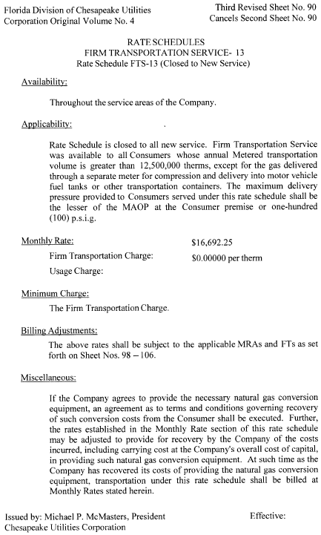

See Order No. PSC-10-0029-PAA-GU, issued January 14, 2010, in Docket No. 090125-GU, In re: Petition for increase in rates by Florida Division of Chesapeake Utilities Corporation.
Id.
Florida Public Utilities Company (Electric and all Gas Divisions), and Central Florida Gas (Florida Division of Chesapeake Utilities Corporation) 2nd Quarter Surveillance Reports, available at http://www.floridapsc.com/library/ Financials/GU616-DOCS/EARNINGS-SURVEILLANCE/GU616-2014-06-ESR.pdf.

