BEFORE THE FLORIDA PUBLIC SERVICE COMMISSION

In re: Joint petition to reopen and extend the term of existing territorial agreement in Columbia, Lafayette, Madison, and Suwannee Counties, by Suwannee Valley Electric Cooperative, Inc. and Duke Energy Florida, Inc. | DOCKET NO. 150039-EU  ORDER NO. PSC-15-0128-PAA-EU  ISSUED: March 20, 2015

The following Commissioners participated in the disposition of this matter:

ART GRAHAM, Chairman
LISA POLAK EDGAR
RONALD A. BRISÉ
JULIE I. BROWN
JIMMY PATRONIS

NOTICE OF PROPOSED AGENCY ACTION
ORDER TO REOPEN AND EXTEND THE TERM OF
THE EXISTING TERRITORIAL AGREEMENT

BY THE COMMISSION:

NOTICE is hereby given by the Florida Public Service Commission that the action discussed herein is preliminary in nature and will become final unless a person whose interests are substantially affected files a petition for a formal proceeding, pursuant to Rule 25-22.029, Florida Administrative Code.

BACKGROUND
On January 27, 2015, Suwannee Valley Electric Cooperative (SVEC) and Duke Energy Florida, Inc. (DEF) filed a joint petition for approval of a stipulation between the two parties that would reopen and extend the term of their existing territorial agreement until March 14, 2016. This Commission approved the existing agreement in March 1995 for a term of 20 years expiring March 14, 2015, unless modified by this Commission. The joint petitioners stated that they need additional time to negotiate a new territorial agreement. The stipulation is shown in Attachment A. We have jurisdiction over this matter pursuant to Section 366.04, Florida Statutes (F.S.).

DECISION
The stipulation regarding the territorial agreement, as shown in Attachment A, extends the term of the existing agreement until March 14, 2016, to allow the joint petitioners additional time to negotiate a new territorial agreement. All other provisions of the existing territorial agreement remain in effect.
The existing territorial agreement provides that all customer transfers were to be completed within five years from the date of our approval (1995). The existing agreement further details the treatment of customer account transfers, customer deposits, cost of facilities, and calculation of lost revenue. In response to a staff inquiry, SVEC and DEF both stated that these actions have been completed to the satisfaction of both parties.
In approving the existing agreement, we found that the agreement is “in the public's interest and that its adoption will further the Commission's policy of avoiding unnecessary and uneconomic duplication of facilities.” We find the requested extension of time is reasonable and does not appear to be detrimental to the parties or the public interest. Any subsequent modification to the territorial agreement will be brought before us for our consideration pursuant to Section 366.04, F.S. We therefore approve of the stipulation to open and extend the existing territorial agreement so SVEC and DEF will have additional time to negotiate a new territorial agreement.

Based on the foregoing, it is

ORDERED by the Florida Public Service Commission that the existing territorial agreement by Suwannee Valley Electric Cooperative, Inc. and Duke Energy Florida, Inc. shall be extended until March 14, 2016. It is further

ORDERED that the provisions of this Order, issued as proposed agency action, shall become final and effective upon the issuance of a Consummating Order unless an appropriate petition, in the form provided by Rule 28-106.201, Florida Administrative Code, is received by the Commission Clerk, 2540 Shumard Oak Boulevard, Tallahassee, Florida 32399-0850, by the close of business on the date set forth in the “Notice of Further Proceedings” attached hereto. It is further

ORDERED that in the event this Order becomes final, this docket shall be closed.

By ORDER of the Florida Public Service Commission this 20th day of March, 2015.

/s/ Carlotta S. Stauffer
CARLOTTA S. STAUFFER
Commission Clerk
Florida Public Service Commission
2540 Shumard Oak Boulevard
Tallahassee, Florida 32399
(850) 413-6770
www.floridapsc.com

Copies furnished: A copy of this document is provided to the parties of record at the time of issuance and, if applicable, interested persons.

JEV

NOTICE OF FURTHER PROCEEDINGS OR JUDICIAL REVIEW

The Florida Public Service Commission is required by Section 120.569(1), Florida Statutes, to notify parties of any administrative hearing that is available under Section 120.57, Florida Statutes, as well as the procedures and time limits that apply. This notice should not be construed to mean all requests for an administrative hearing will be granted or result in the relief sought.

Mediation may be available on a case-by-case basis. If mediation is conducted, it does not affect a substantially interested person's right to a hearing.

The action proposed herein is preliminary in nature. Any person whose substantial interests are affected by the action proposed by this order may file a petition for a formal proceeding, in the form provided by Rule 28-106.201, Florida Administrative Code. This petition must be received by the Office of Commission Clerk, 2540 Shumard Oak Boulevard, Tallahassee, Florida 32399-0850, by the close of business on April 10, 2015.

In the absence of such a petition, this order shall become final and effective upon the issuance of a Consummating Order.

Any objection or protest filed in this/these docket(s) before the issuance date of this order is considered abandoned unless it satisfies the foregoing conditions and is renewed within the specified protest period.

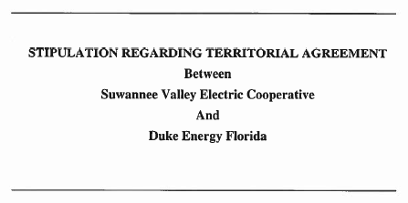

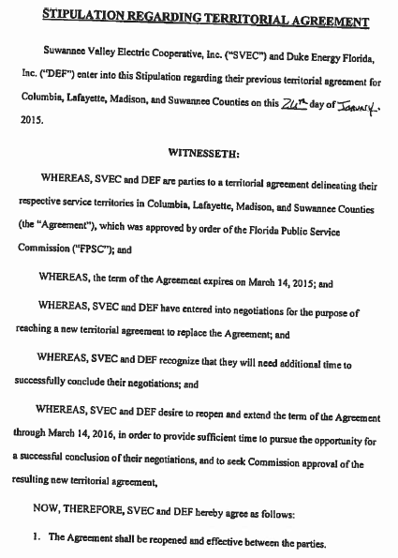
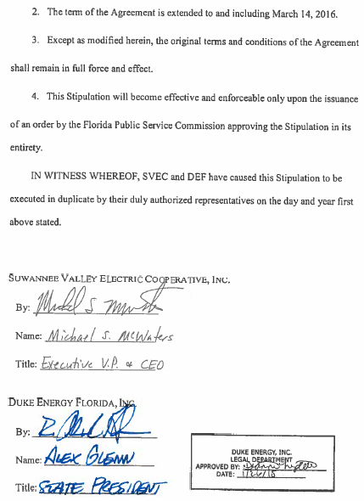

Order No. PSC-95-0351-FOF-EU, issued March 14, 1995, in Docket 940331-EU, In re: Petition to resolve territorial dispute with Florida Power Corporation by Suwannee Valley Electric Cooperative, Inc.
Id. at 2.

