BEFORE THE FLORIDA PUBLIC SERVICE COMMISSION

In re: Petition for approval of revised flexible gas service tariff by Florida Division of Chesapeake Utilities Corporation. | DOCKET NO. 150073-GU  ORDER NO. PSC-15-0172-TRF-GU  ISSUED: May 5, 2015

The following Commissioners participated in the disposition of this matter:

ART GRAHAM, Chairman
LISA POLAK EDGAR
RONALD A. BRISÉ
JULIE I. BROWN
JIMMY PATRONIS

ORDER APPROVING REVISED FLEXIBLE GAS SERVICE TARIFF BY FLORIDA DIVISION OF CHESAPEAKE UTILITIES CORPORATION

BY THE COMMISSION:

Background

On March 5, 2015, the Florida Division of Chesapeake Utilities Corporation (Chesapeake) filed a petition for approval to revise its Flexible Gas Service (FGS) tariff. We approved Chesapeake’s FGS tariff in Order No. PSC-98-1485-FOF-GU. In 2014, we also approved similar FGS tariffs for Florida Public Utilities Company (FPUC), FPUC – Fort Meade, and FPUC – Indiantown Division. Chesapeake and the FPUC companies are subsidiaries of Chesapeake Utilities Corporation. We have jurisdiction in this matter pursuant to Section 366.06, Florida Statutes.

Decision

Customers, especially large industrial customers, have multiple fuel options available to them. These options include the ability to bypass Chesapeake’s distribution system and connect directly to interstate or intrastate pipelines, or replace natural gas with fuel oil or electricity. Chesapeake provides transportation service only. In a transportation service environment, the utility such as Chesapeake only transports the gas to the customer using its distribution system. The customer is responsible for purchasing gas from other parties, such as shippers or gas marketers.
Chesapeake’s revision to its FGS tariff is intended to create consistency in the FGS tariff language between Chesapeake and the FPUC companies. The FGS tariff enables Chesapeake to negotiate competitive rates with customers who can provide verifiable documentation of a viable energy alternative and places Chesapeake’s shareholders at risk, not the general body of ratepayers. All incremental capital costs, expenses, and revenues associated with this tariff are placed below-the-line in earnings surveillance reports and future rate cases. Chesapeake will not attempt to recover the difference between the applicable tariff and the negotiated lower FGS rate from other customers through cost recovery clauses or in future rate cases. In our recent order approving FGS tariffs for the FPUC companies, we found that the FGS tariffs contained adequate safeguards to protect existing customers from being adversely affected by or subsidizing FGS customers.
Chesapeake’s current tariff includes a provision requiring it to file each confidential service agreement and related documents with the Office of Commission Clerk so that staff can review the documents. This provision does not require our approval of each FGS contract; it is strictly a reporting requirement. When recently approving the FGS tariffs for the FPUC companies, we found that the filing of each agreement was not necessary; instead, a notice filed with the Office of Commission Clerk, within 30 days of the execution of an FGS service agreement, would be sufficient since any executed agreements would be available for review by Commission staff if necessary.
Chesapeake’s revised tariff as shown in Attachment 1 shall be approved, effective April 16, 2015. As with the tariffs approved for the FPUC companies, when Chesapeake executes an FGS service agreement, notice of such agreement shall be filed within 30 days with the Office of Commission Clerk.

Based on the foregoing, it is

ORDERED by the Florida Public Service Commission that Chesapeake Utilities Corporation’s petition for approval of its revised flexible gas service tariff is hereby approved. It is further

ORDERED that when Chesapeake executes an FGS service agreement, notice of such agreement shall be filed within 30 days with the Office of Commission Clerk. It is further

ORDERED that tariff shall become effective on April 16, 2015. It is further

ORDERED that if a protest is filed within 21 days of issuance of the Order, the tariff shall remain in effect with any charges held subject to refund pending resolution of the protest. It is further

ORDERED that if no timely protest is filed, this docket shall be closed upon the issuance of a Consummating Order.

By ORDER of the Florida Public Service Commission this 5th day of May, 2015.

/s/ Carlotta S. Stauffer
CARLOTTA S. STAUFFER
Commission Clerk
Florida Public Service Commission
2540 Shumard Oak Boulevard
Tallahassee, Florida 32399
(850) 413-6770
www.floridapsc.com

Copies furnished: A copy of this document is provided to the parties of record at the time of issuance and, if applicable, interested persons.

MFB

NOTICE OF FURTHER PROCEEDINGS

The Florida Public Service Commission is required by Section 120.569(1), Florida Statutes, to notify parties of any administrative hearing or judicial review of Commission orders that is available under Sections 120.57 or 120.68, Florida Statutes, as well as the procedures and time limits that apply. This notice should not be construed to mean all requests for an administrative hearing or judicial review will be granted or result in the relief sought.

Mediation may be available on a case-by-case basis. If mediation is conducted, it does not affect a substantially interested person's right to a hearing.

The Commission's decision on this tariff is interim in nature and will become final, unless a person whose substantial interests are affected by the proposed action files a petition for a formal proceeding, in the form provided by Rule 28-106.201, Florida Administrative Code. This petition must be received by the Office of Commission Clerk, 2540 Shumard Oak Boulevard, Tallahassee, Florida 32399-0850, by the close of business on May 26, 2015.

In the absence of such a petition, this Order shall become final and effective upon the issuance of a Consummating Order.

Any objection or protest filed in this docket before the issuance date of this order is considered abandoned unless it satisfies the foregoing conditions and is renewed within the specified protest period.

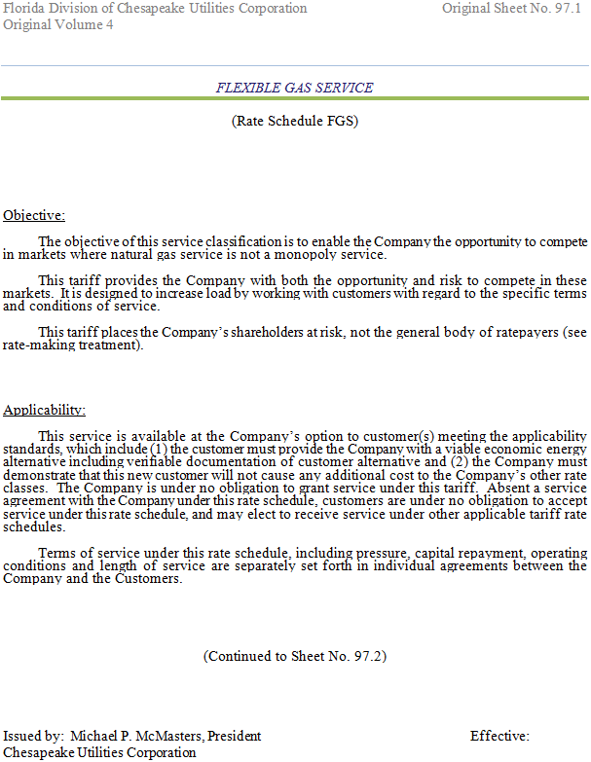

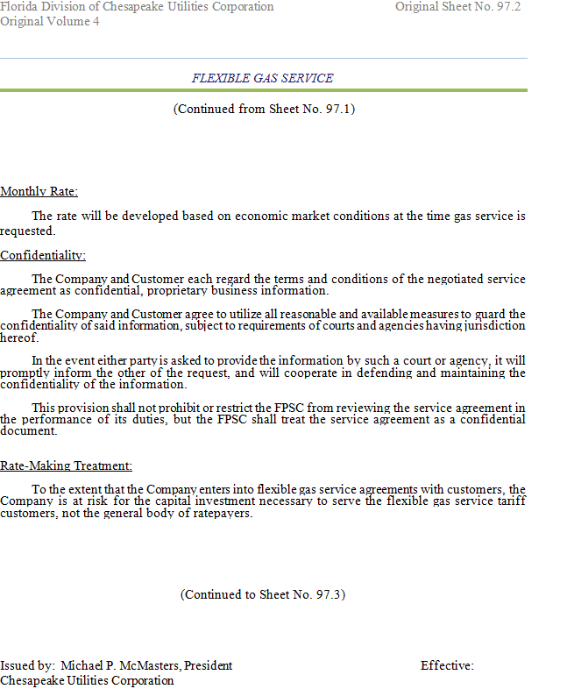

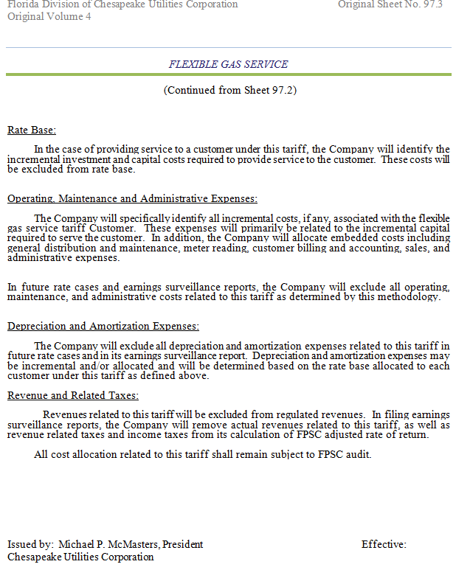

Order No. PSC-98-1485-FOF-GU, issued November 5, 1998, in Docket No. 980895-GU, In re: Petition by Florida Division of Chesapeake Utilities Corporation for authority to implement proposed flexible gas service tariff and to revise certain tariff sheets.
Order No. PSC-14-0710-TRF-GU, issued December 30, 2014, in Docket No. 140204-GU, In re: Joint petition for approval of flexible gas service tariff by Florida Public Utilities Company, Florida Public Utilities Company – Fort Meade, and Florida Public Utilities Company – Indiantown Division.
Order No. PSC-14-0710-TRF-GU, issued December 30, 2014, in Docket No. 140204-GU, In re: Joint petition for approval of flexible gas service tariff by Florida Public Utilities Company, Florida Public Utilities Company - Fort Meade, and Florida Public Utilities Company - Indiantown Division.

