BEFORE THE FLORIDA PUBLIC SERVICE COMMISSION

In re: Request for submission of proposals for relay service, beginning in June 2015, for the deaf, hard of hearing, deaf/blind, or speech impaired, and other implementation matters in compliance with the Florida Telecommunications Access System Act of 1991. | DOCKET NO. 140029-TP  ORDER NO. PSC-15-0240-CO-TP  ISSUED: June 9, 2015

CONSUMMATING ORDER AND ORDER APPROVING REVISED BUDGET

BY THE COMMISSION:

By Order No. PSC-15-0200-PAA-TP, issued May 18, 2015, this Commission proposed to take certain action, subject to a Petition for Formal Proceeding as provided in Rule 25-22.029, Florida Administrative Code. No response has been filed to the order, in regard to the above mentioned docket.

Order No. PSC-15-0200-PAA-TP also required Florida Telecommunications Relay, Inc. (FTRI) to submit a revised budget and granted Commission staff administrative authority to approve the revised budget as long as the budget adhered to our decision. FTRI submitted a revised budget on May 20, 2015. Attachment A. Commission staff has verified that the revised budget comports with the Commission’s decision. Attachment B. Accordingly, the revised 2015-2016 budget is approved. It is therefore

ORDERED by the Florida Public Service Commission that Order No. PSC-15-0200-PAA-TP has become effective. It is further

ORDERED that FTRI’s revised budget submitted on May 20, 2015, is approved. It is further

ORDERED that this docket shall remain open.

By ORDER of the Florida Public Service Commission this 9th day of June, 2015.

/s/ Carlotta S. Stauffer
CARLOTTA S. STAUFFER
Commission Clerk
Florida Public Service Commission
2540 Shumard Oak Boulevard
Tallahassee, Florida 32399
(850) 413-6770
www.floridapsc.com

Copies furnished: A copy of this document is provided to the parties of record at the time of issuance and, if applicable, interested persons.

PHP

NOTICE OF FURTHER PROCEEDINGS OR JUDICIAL REVIEW

The Florida Public Service Commission is required by Section 120.569(1), Florida Statutes, to notify parties of any judicial review of Commission orders that is available pursuant to Section 120.68, Florida Statutes, as well as the procedures and time limits that apply. This notice should not be construed to mean all requests for judicial review will be granted or result in the relief sought.

Any party adversely affected by the Commission’s final action in this matter may request judicial review by the Florida Supreme Court in the case of an electric, gas or telephone utility or the First District Court of Appeal in the case of a water and/or wastewater utility by filing a notice of appeal with the Office of Commission Clerk and filing a copy of the notice of appeal and the filing fee with the appropriate court. This filing must be completed within thirty (30) days after the issuance of this order, pursuant to Rule 9.110, Florida Rules of Appellate Procedure. The notice of appeal must be in the form specified in Rule 9.900(a), Florida Rules of Appellate Procedure.

State of Florida
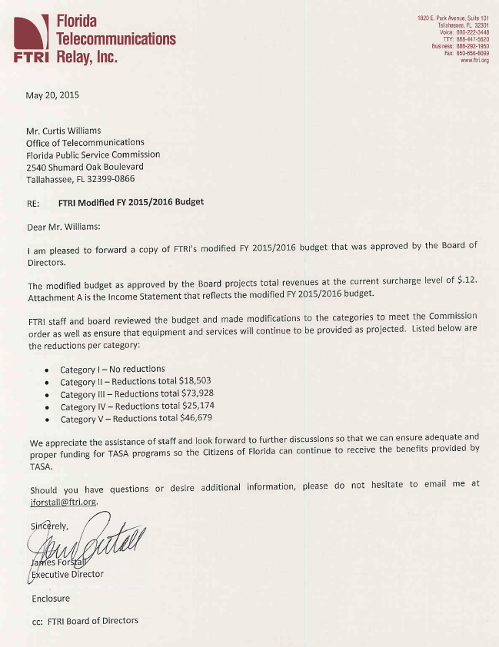

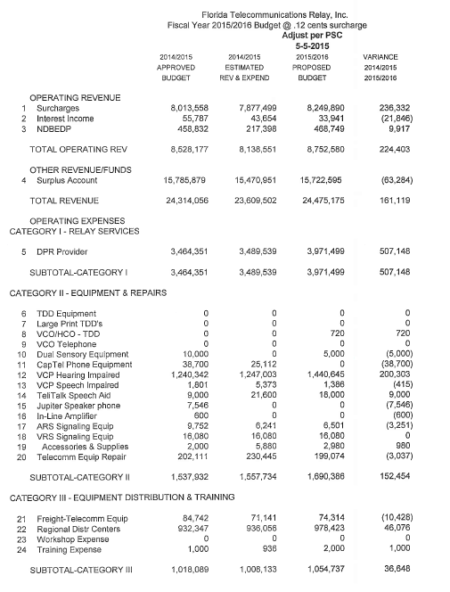

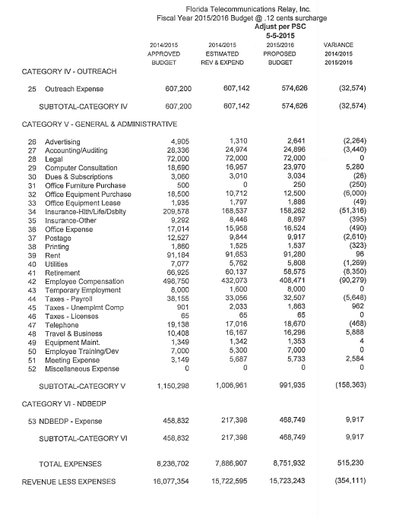

FTRI 2015-2016 Commission-Approved Budget
