BEFORE THE FLORIDA PUBLIC SERVICE COMMISSION

In re: Joint petition for approval of territorial agreement in Hardee County, by Peoples Gas System and Sebring Gas System, Inc. | DOCKET NO. 150093-GU  ORDER NO. PSC-15-0279-PAA-GU  ISSUED: July 7, 2015

The following Commissioners participated in the disposition of this matter:

ART GRAHAM, Chairman
LISA POLAK EDGAR
RONALD A. BRISÉ
JULIE I. BROWN
JIMMY PATRONIS

NOTICE OF PROPOSED AGENCY ACTION
ORDER APPROVING TERRITORIAL AGREEMENT

BY THE COMMISSION:

NOTICE is hereby given by the Florida Public Service Commission that the action discussed herein is preliminary in nature and will become final unless a person whose interests are substantially affected files a petition for a formal proceeding, pursuant to Rule 25-22.029, Florida Administrative Code (F.A.C).

Background

On March 23, 2015, Peoples Gas System (PGS) and Sebring Gas System, Inc. (Sebring) filed a joint petition requesting this Commission’s approval of a territorial Agreement for a portion of Hardee County located within and adjacent to the City of Wauchula, Florida. PGS provides natural gas sales and transportation service to customers in Hardee County, Florida. In addition, PGS provides gas transportation service to the gas marketer supplying natural gas to customers that are served by Sebring. PGS plans to continue expanding its distribution system in Hardee County and the surrounding area as provided in the extension of facilities policy contained in its tariff on file with this Commission.
Sebring provides natural gas transportation service to customers within and adjacent to the City of Sebring in Highlands County, immediately east of Hardee County. On May 12, 2014, the City of Wauchula Commission adopted Ordinance 2014-10 awarding a franchise to Sebring to provide natural gas service to residents of the city.
During its evaluation of the petition, Commission staff issued one data request to PGS and Sebring. The questions posed by Commission staff were intended to clarify background information about natural gas service to the City of Wauchula, some provisions of the Agreement, and its impact on ratepayers of both companies. We have jurisdiction over this matter pursuant to Section 366.04, Florida Statutes (F.S.).

Decision

Pursuant to Section 366.04(3)(a), F.S., we have the jurisdiction to approve territorial agreements between and among natural gas utilities. Rule 25-7.0471, F.A.C., provides that in approving territorial agreements, this Commission shall consider:
(a) The reasonableness of the purchase price of any facilities being transferred;
(b) The reasonable likelihood that the agreement, in and of itself, will not cause a decrease in the reliability of natural gas service to the existing or future ratepayers of any utility party to the agreement, and
(c) The reasonable likelihood that the agreement will eliminate existing or potential uneconomic duplication of facilities.
(d) Other relevant factors that may arise from the circumstances of a particular case.
Unless this Commission determines that the agreement will cause a detriment to the public interest, the agreement should be approved.
The territorial Agreement establishes the area Sebring will serve within the corporate limits of the City of Wauchula and certain adjoining areas as depicted on the map included as Attachment A to this order. The Agreement specifically excludes the Hardee County Fleet Maintenance facility occupying approximately one block in the southern portion of the city, which will be served by PGS. The term of the Agreement is until termination or modification is mutually agreed to by the parties or as mandated by an entity or court of appropriate jurisdiction.
In response to Commission staff’s data request, the companies stated that natural gas service was not previously available to the City of Wauchula. As a result, there are no customers or facilities to be transferred between PGS and Sebring. Reliability of service will increase from no service to full access to natural gas service for residents of Wauchula. Furthermore, there will be no uneconomic duplication of facilities within the area to be served by Sebring, because Sebring’s installation of its distribution system will be the only natural gas pipelines in the area, with the exception of the one excluded facility.
The PGS and Sebring response to Commission staff’s data request further explained that the excluded facility belongs to Hardee County. Prior to the negotiation of the PGS-Sebring territorial agreement, PGS and Hardee County had committed to the construction of a Compressed Natural Gas (CNG) station to service Hardee County vehicles. PGS will provide gas service to the station. The carve out of this customer from the Agreement is necessary to keep the agreements made between PGS and the customer (Hardee County) intact since construction of the CNG station has been completed. Sebring currently has no facilities near the CNG station. If necessary for Sebring to serve customers in this area, and to avoid duplication of service facilities, PGS and Sebring may establish a second interconnect on the PGS main line in this area. From that interconnect, Sebring could proceed to design and build-out their distribution facilities.
After review of the petition, the Agreement, and the parties’ response to the data request, we find that the Agreement is in the public interest and will enable PGS and Sebring to better serve their current and future customers. We find that the Agreement eliminates any potential uneconomic duplication of facilities and will not cause a decrease in the reliability of natural gas service. As such, we find that the Agreement between PGS and Sebring will not cause a detriment to the public interest and hereby approve it.

Based on the foregoing, it is

ORDERED by the Florida Public Service Commission that the Joint Petition for approval of a territorial agreement in Hardee County by Peoples Gas System and Sebring Gas System, Inc. is approved. It is further

ORDERED that the provisions of this Order, issued as proposed agency action, shall become final and effective upon the issuance of a Consummating Order unless an appropriate petition, in the form provided by Rule 28-106.201, Florida Administrative Code, is received by the Commission Clerk, 2540 Shumard Oak Boulevard, Tallahassee, Florida 32399-0850, by the close of business on the date set forth in the “Notice of Further Proceedings” attached hereto. It is further

ORDERED that if no person whose substantial interests are affected by the proposed agency action files a protest within 21 days of the issuance of the order, this docket shall be closed upon the issuance of a consummating order. It is further

ORDERED that Attachment A, attached to this Order, is incorporated herein by reference. It is further

ORDERED that in the event this Order becomes final, this docket shall be closed.

By ORDER of the Florida Public Service Commission this 7th day of July, 2015.

/s/ Carlotta S. Stauffer
CARLOTTA S. STAUFFER
Commission Clerk
Florida Public Service Commission
2540 Shumard Oak Boulevard
Tallahassee, Florida 32399
(850) 413-6770
www.floridapsc.com

Copies furnished: A copy of this document is provided to the parties of record at the time of issuance and, if applicable, interested persons.

JEV

NOTICE OF FURTHER PROCEEDINGS OR JUDICIAL REVIEW

The Florida Public Service Commission is required by Section 120.569(1), Florida Statutes, to notify parties of any administrative hearing that is available under Section 120.57, Florida Statutes, as well as the procedures and time limits that apply. This notice should not be construed to mean all requests for an administrative hearing will be granted or result in the relief sought.

Mediation may be available on a case-by-case basis. If mediation is conducted, it does not affect a substantially interested person's right to a hearing.

The action proposed herein is preliminary in nature. Any person whose substantial interests are affected by the action proposed by this order may file a petition for a formal proceeding, in the form provided by Rule 28-106.201, Florida Administrative Code. This petition must be received by the Office of Commission Clerk, 2540 Shumard Oak Boulevard, Tallahassee, Florida 32399-0850, by the close of business on July 28, 2015.

In the absence of such a petition, this order shall become final and effective upon the issuance of a Consummating Order.

Any objection or protest filed in this/these docket(s) before the issuance date of this order is considered abandoned unless it satisfies the foregoing conditions and is renewed within the specified protest period.

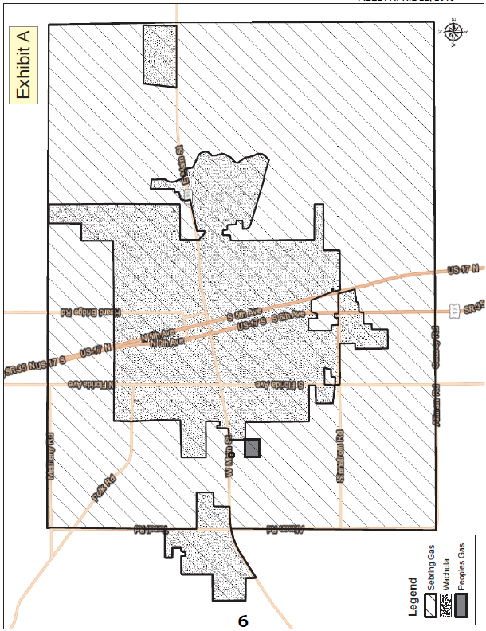

Peoples Gas System Tariff, Original Volume No. 3, Fourth Revised Sheet No 5.601, effective March 13, 2012; Second Revised Sheet No. 5.601-1, effective January 6, 2004; and Second Revised Sheet No. 5.601-2, effective January 29, 2008.
Utilities Commission of the City of New Smyrna Beach v. Florida Public Service Commission, 469 So. 2d 731 (Fla. 1985).

