State of Florida |  | Public Service Commission  Capital Circle Office Center ● 2540 Shumard Oak Boulevard  Tallahassee, Florida 32399-0850  -M-E-M-O-R-A-N-D-U-M-
DATE: | July 9, 2015
TO: | Office of Commission Clerk (Stauffer)
FROM: | Division of Engineering (Lee)  Office of the General Counsel (Corbari)
RE: | Docket No. 150110-EI – Petition by Duke Energy Florida, Inc. for approval of modifications to approved as-available purchase tariff.
AGENDA: | 07/21/15 – Regular Agenda – Proposed Agency Action – Interested Persons May Participate
COMMISSIONERS ASSIGNED: |  |  | All Commissioners
PREHEARING OFFICER: |  |  | Administrative
CRITICAL DATES: |  |  | None
SPECIAL INSTRUCTIONS: |  |  | To be considered after Docket No. 150106-EQ

Case Background
On April 2, 2015, Duke Energy Florida, Inc. (DEF) filed a petition for approval of modifications to its as-available purchase tariff for clarification and to correspond with proposed revisions to DEF’s interconnection agreement, which is the subject of Docket No. 150106-EQ.
The Commission has jurisdiction in this matter pursuant to Sections 366.04 and 366.051, Florida Statutes.

Discussion of Issues

Issue 1:
Should the Commission approve DEF's proposed modifications to its as-available purchase tariff?

Recommendation:
Yes. DEF's proposed modifications to its as-available purchase tariff are reasonable and consistent with Commission rules. (Lee)

Staff Analysis:
Rule 25-17.0825, Florida Administrative Code (F.A.C.), defines as-available energy and sets out a utility’s responsibilities with regard to purchasing as-available energy from qualifying facilities (QF). Rule 25-17.080, F.A.C., outlines the criteria that a small power producer or cogenerator must meet in order to achieve QF status. Pursuant to Rule 25-17.0825, F.A.C., as-available energy is energy produced by a QF on an hour-by-hour basis and utilities are required to purchase as-available energy from any QF. Rule 25-17.0825, F.A.C., also requires that as-available energy sales be made pursuant to the terms and conditions of a tariff or a separately negotiated contract.
DEF’s as-available purchase tariff provides the required contract terms and conditions including the delivery options, payments to the QF, and cost responsibility of the QF for the payment of interconnection costs. Charges to the QF are specified in DEF’s amended interconnection agreement, which is before the Commission for consideration in Docket No. 150106-EQ. Consistent with the amended interconnection agreement, DEF proposed a revision to Sheet 9.330 of the as-available purchase tariff regarding the language concerning QF operation, maintenance, and repair charges according to DEF’s interconnection agreement.
In addition, DEF's proposed modifications to its as-available purchase tariff contain revisions intended to clarify the as-available contract language. The additional language in DEF’s revised Tariff Sheet 9.108, Article 4.6, specifies delivery options intended to clarify whether the as-available energy will be delivered to parties other than DEF. Revised Tariff Sheet 9.321, Appendix A, Schedule 2, specifies filings that contain the DEF’s annual average system line loss analysis for the calculation of the line loss adjustment factor to the avoided energy cost. (See Attachment A)
DEF asserts that these changes are consistent with Commission rules and will allow DEF to further clarify language in the as-available contract language that is also consistent with DEF’s amended interconnection agreement. Staff has reviewed DEF’s proposed modifications to its as-available purchase tariff and recommends that the proposed modifications be approved because they are reasonable and consistent with Commission rules.

Issue 2:
Should this docket be closed?

Recommendation:
Yes. If Issue 1 is approved, DEF’s tariff becomes effective the date of the commission vote. If a protest is filed within 21 days of the issuance of the order, the tariff should remain in effect, with any revenues held subject to refund, pending resolution of the protest. If no timely protest is filed, this docket should be closed upon the issuance of a consummating order. (Corbari)

Staff Analysis:
If Issue 1 is approved, DEF’s tariff becomes effective the date of the commission vote. If a protest is filed within 21 days of the issuance of the order, the tariff should remain in effect, with any revenues held subject to refund, pending resolution of the protest. If no timely protest is filed, this docket should be closed upon the issuance of a consummating order.

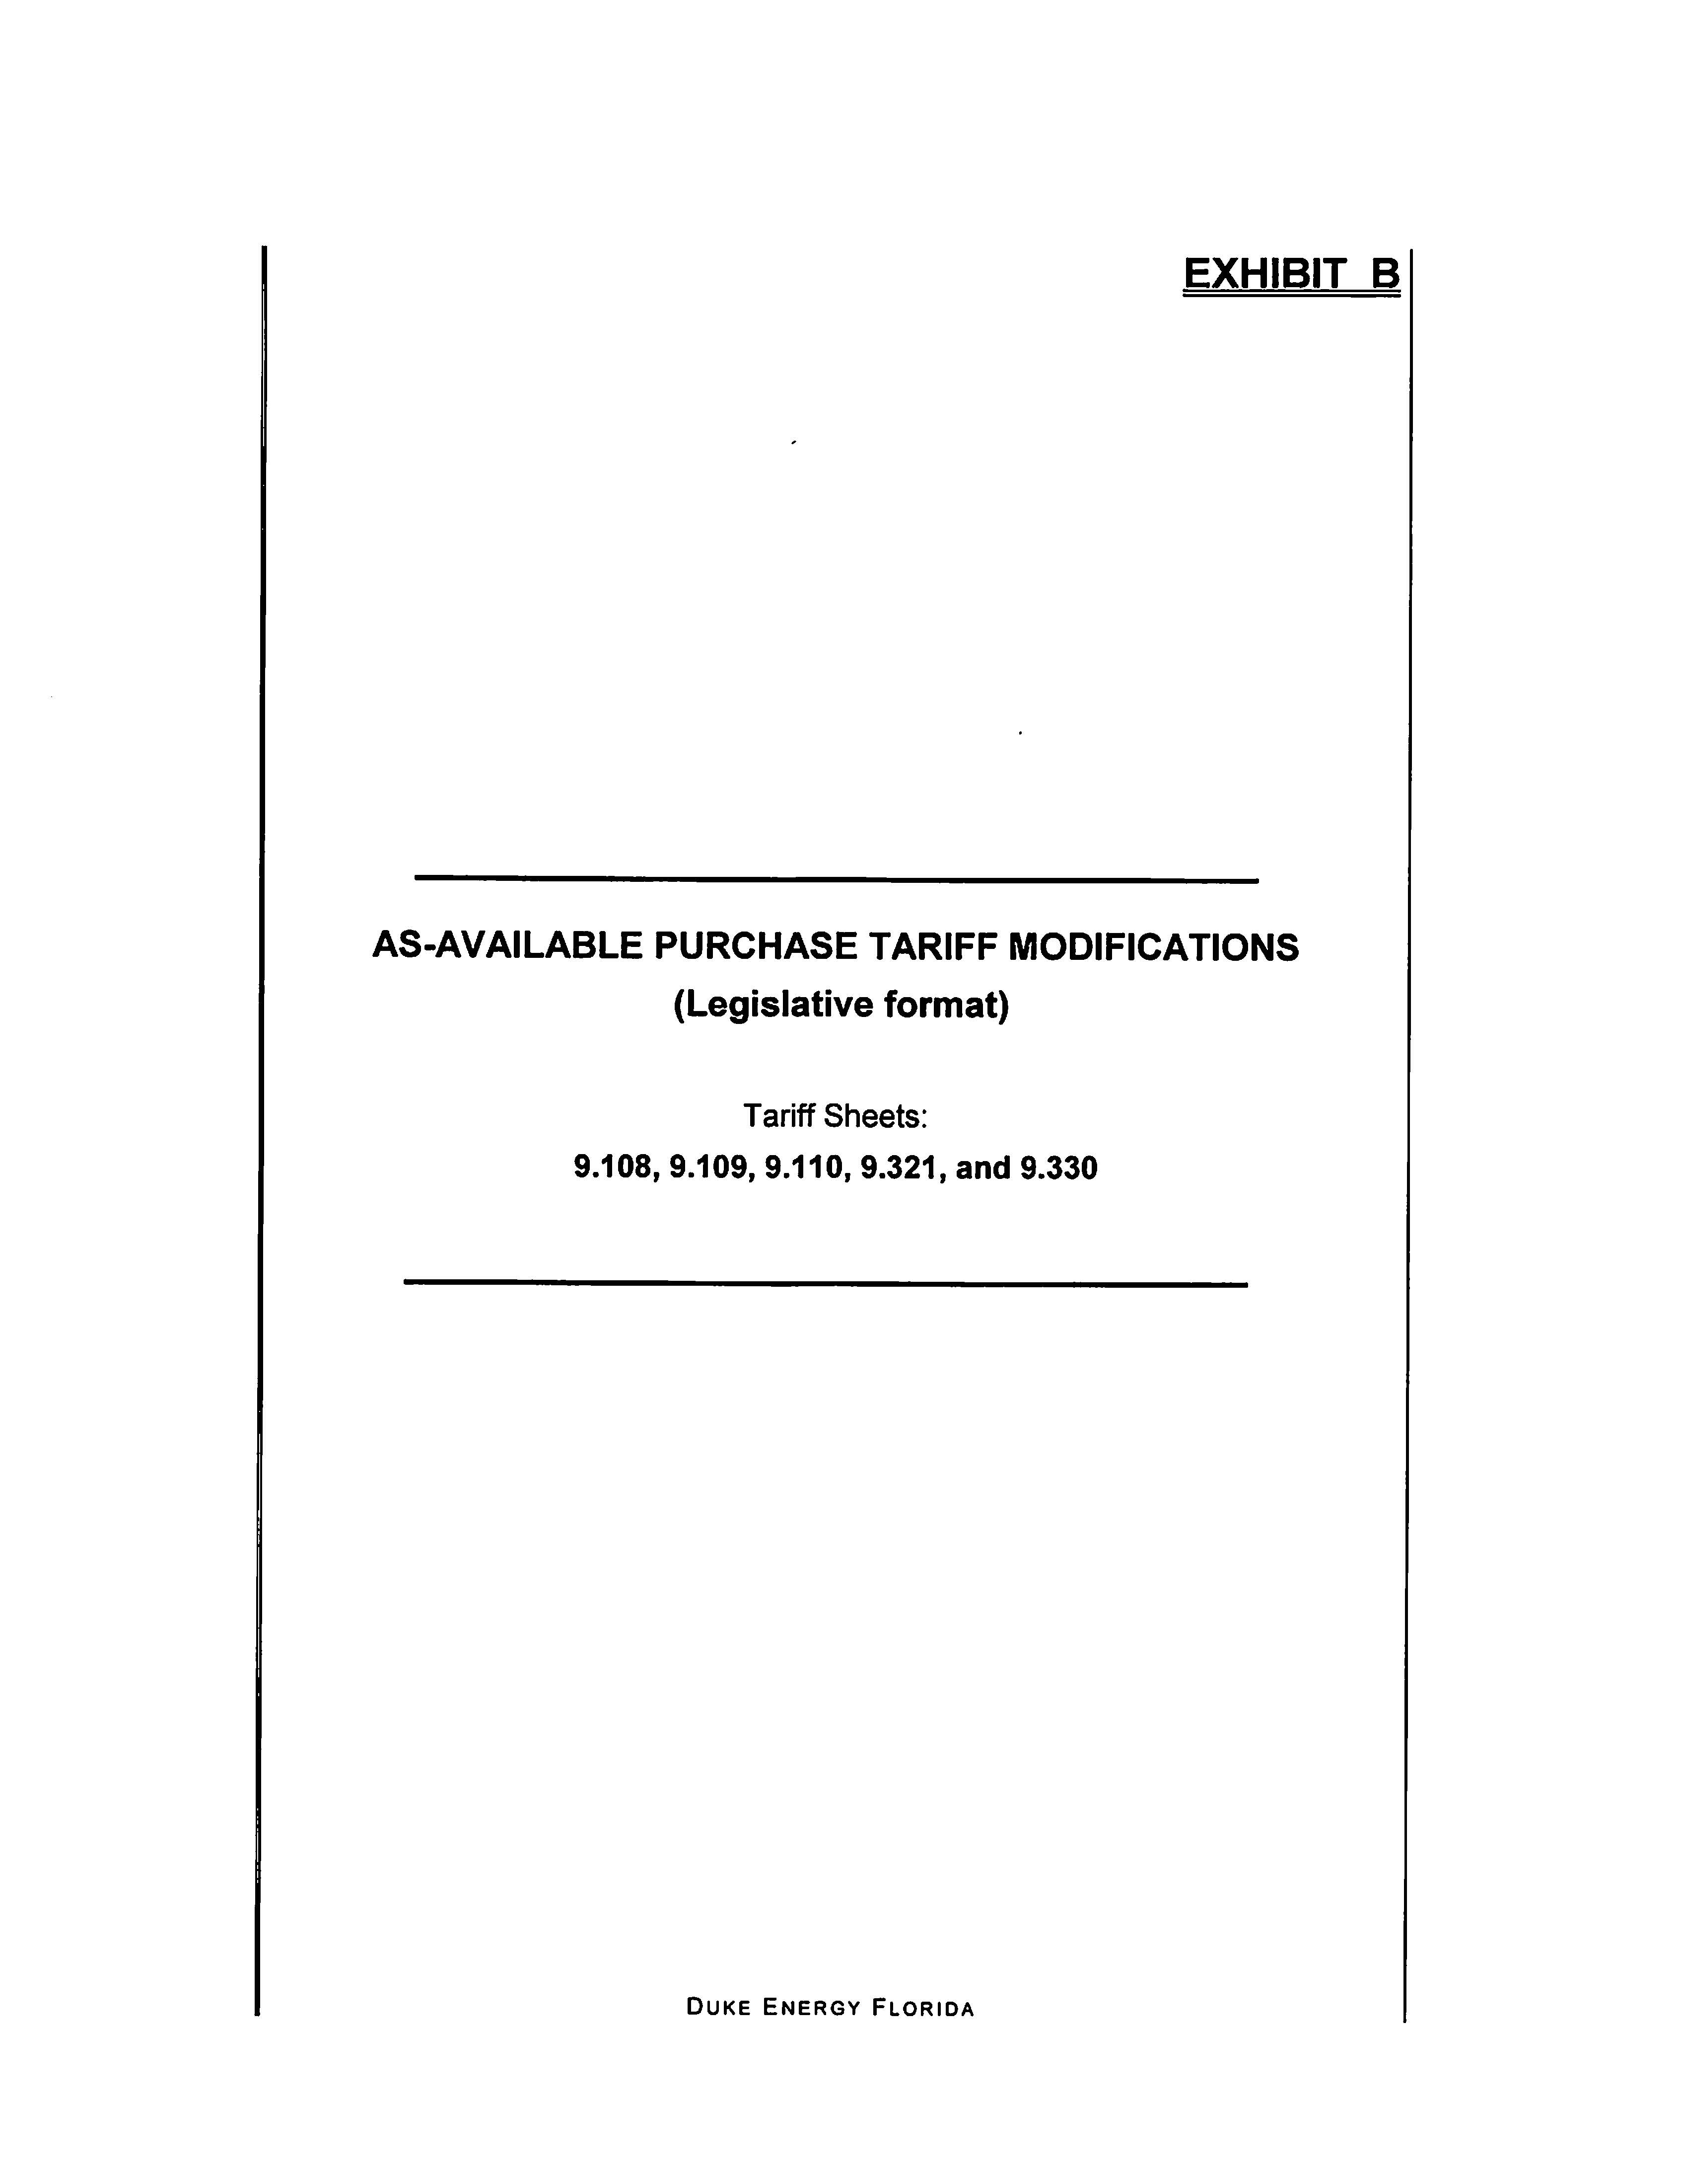

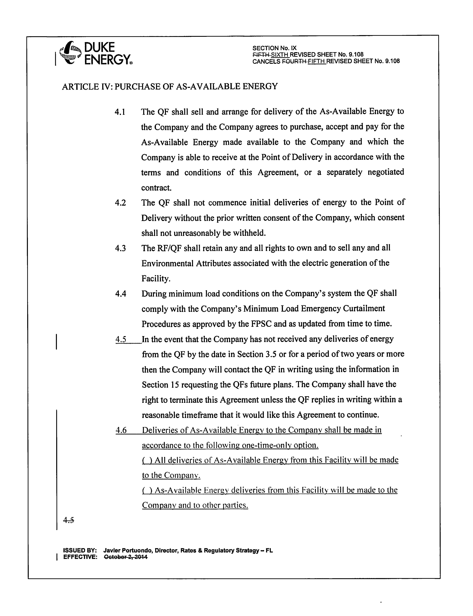

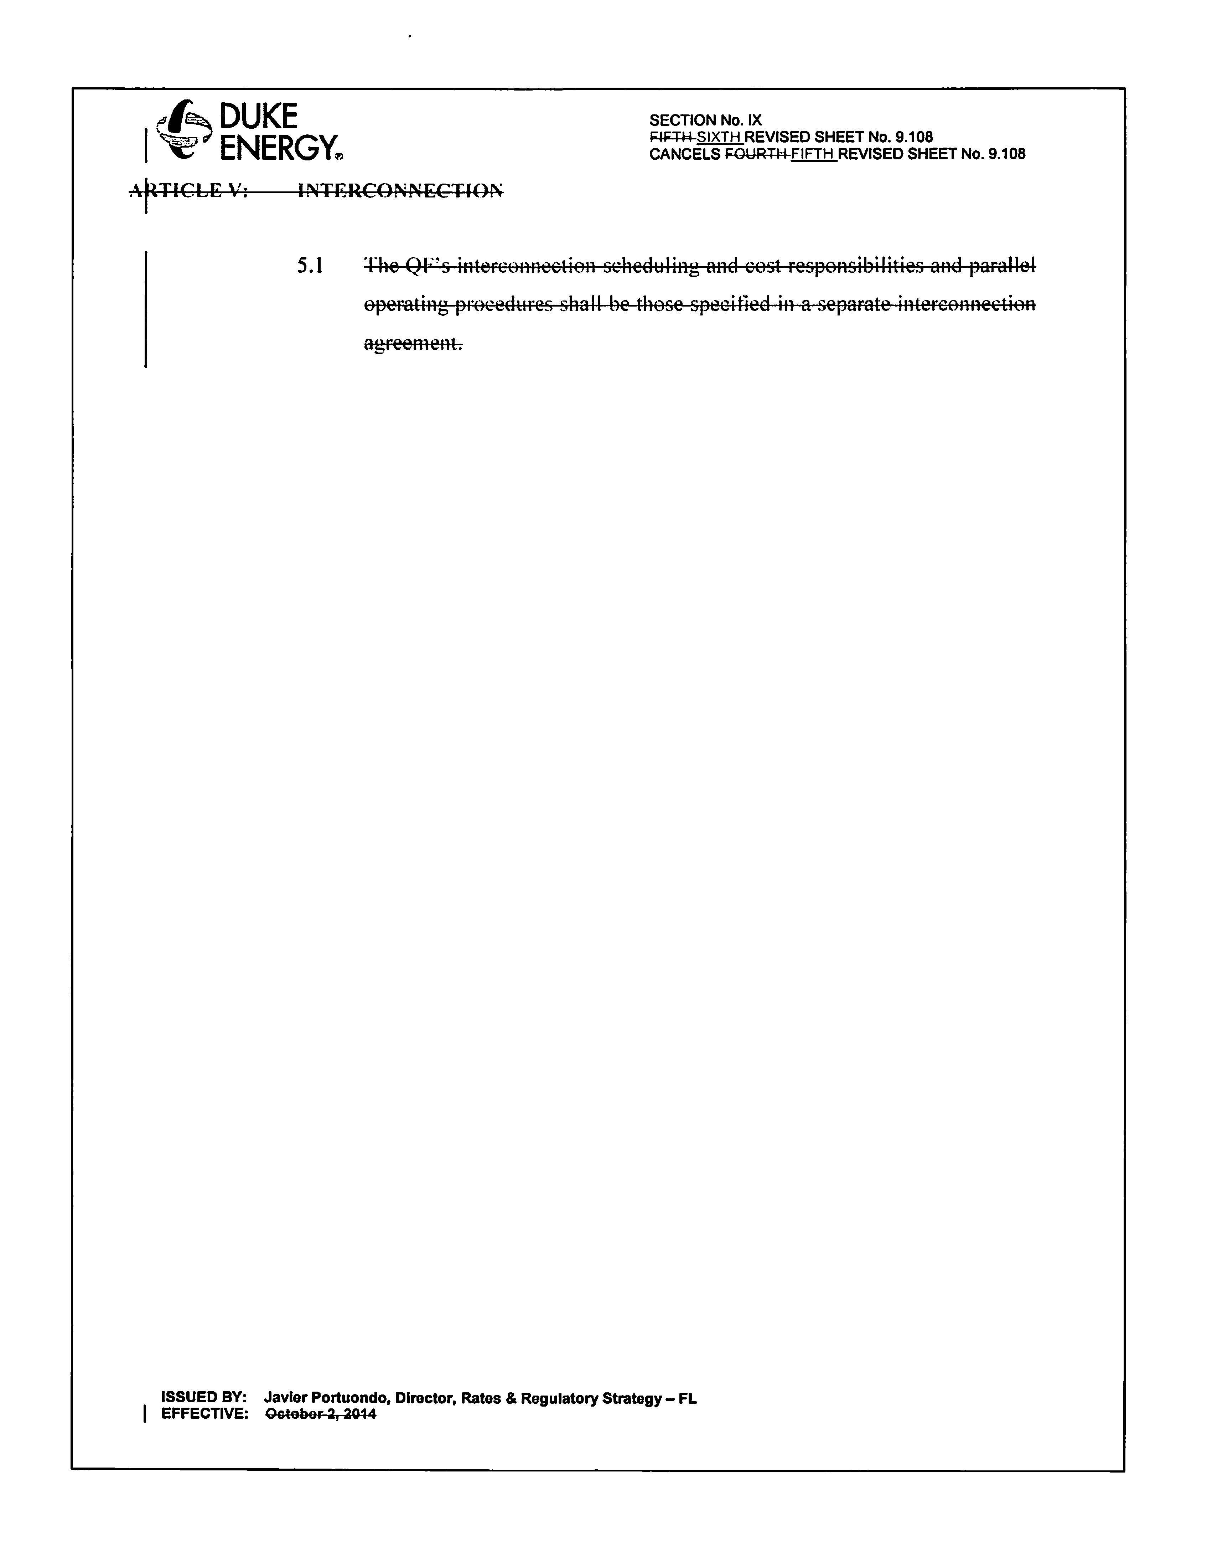
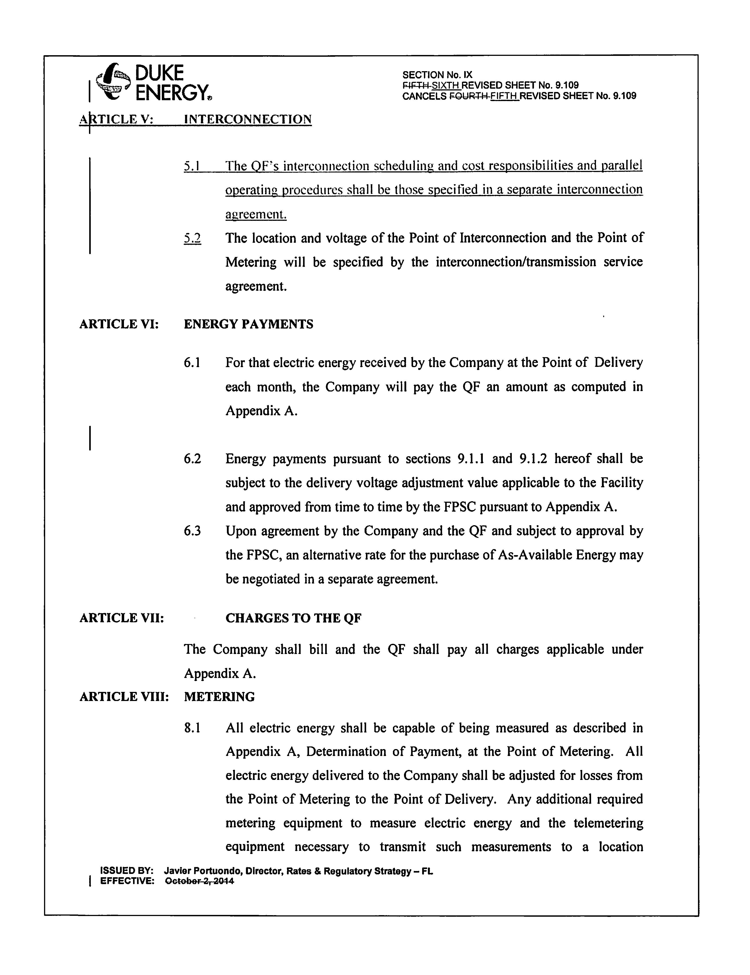

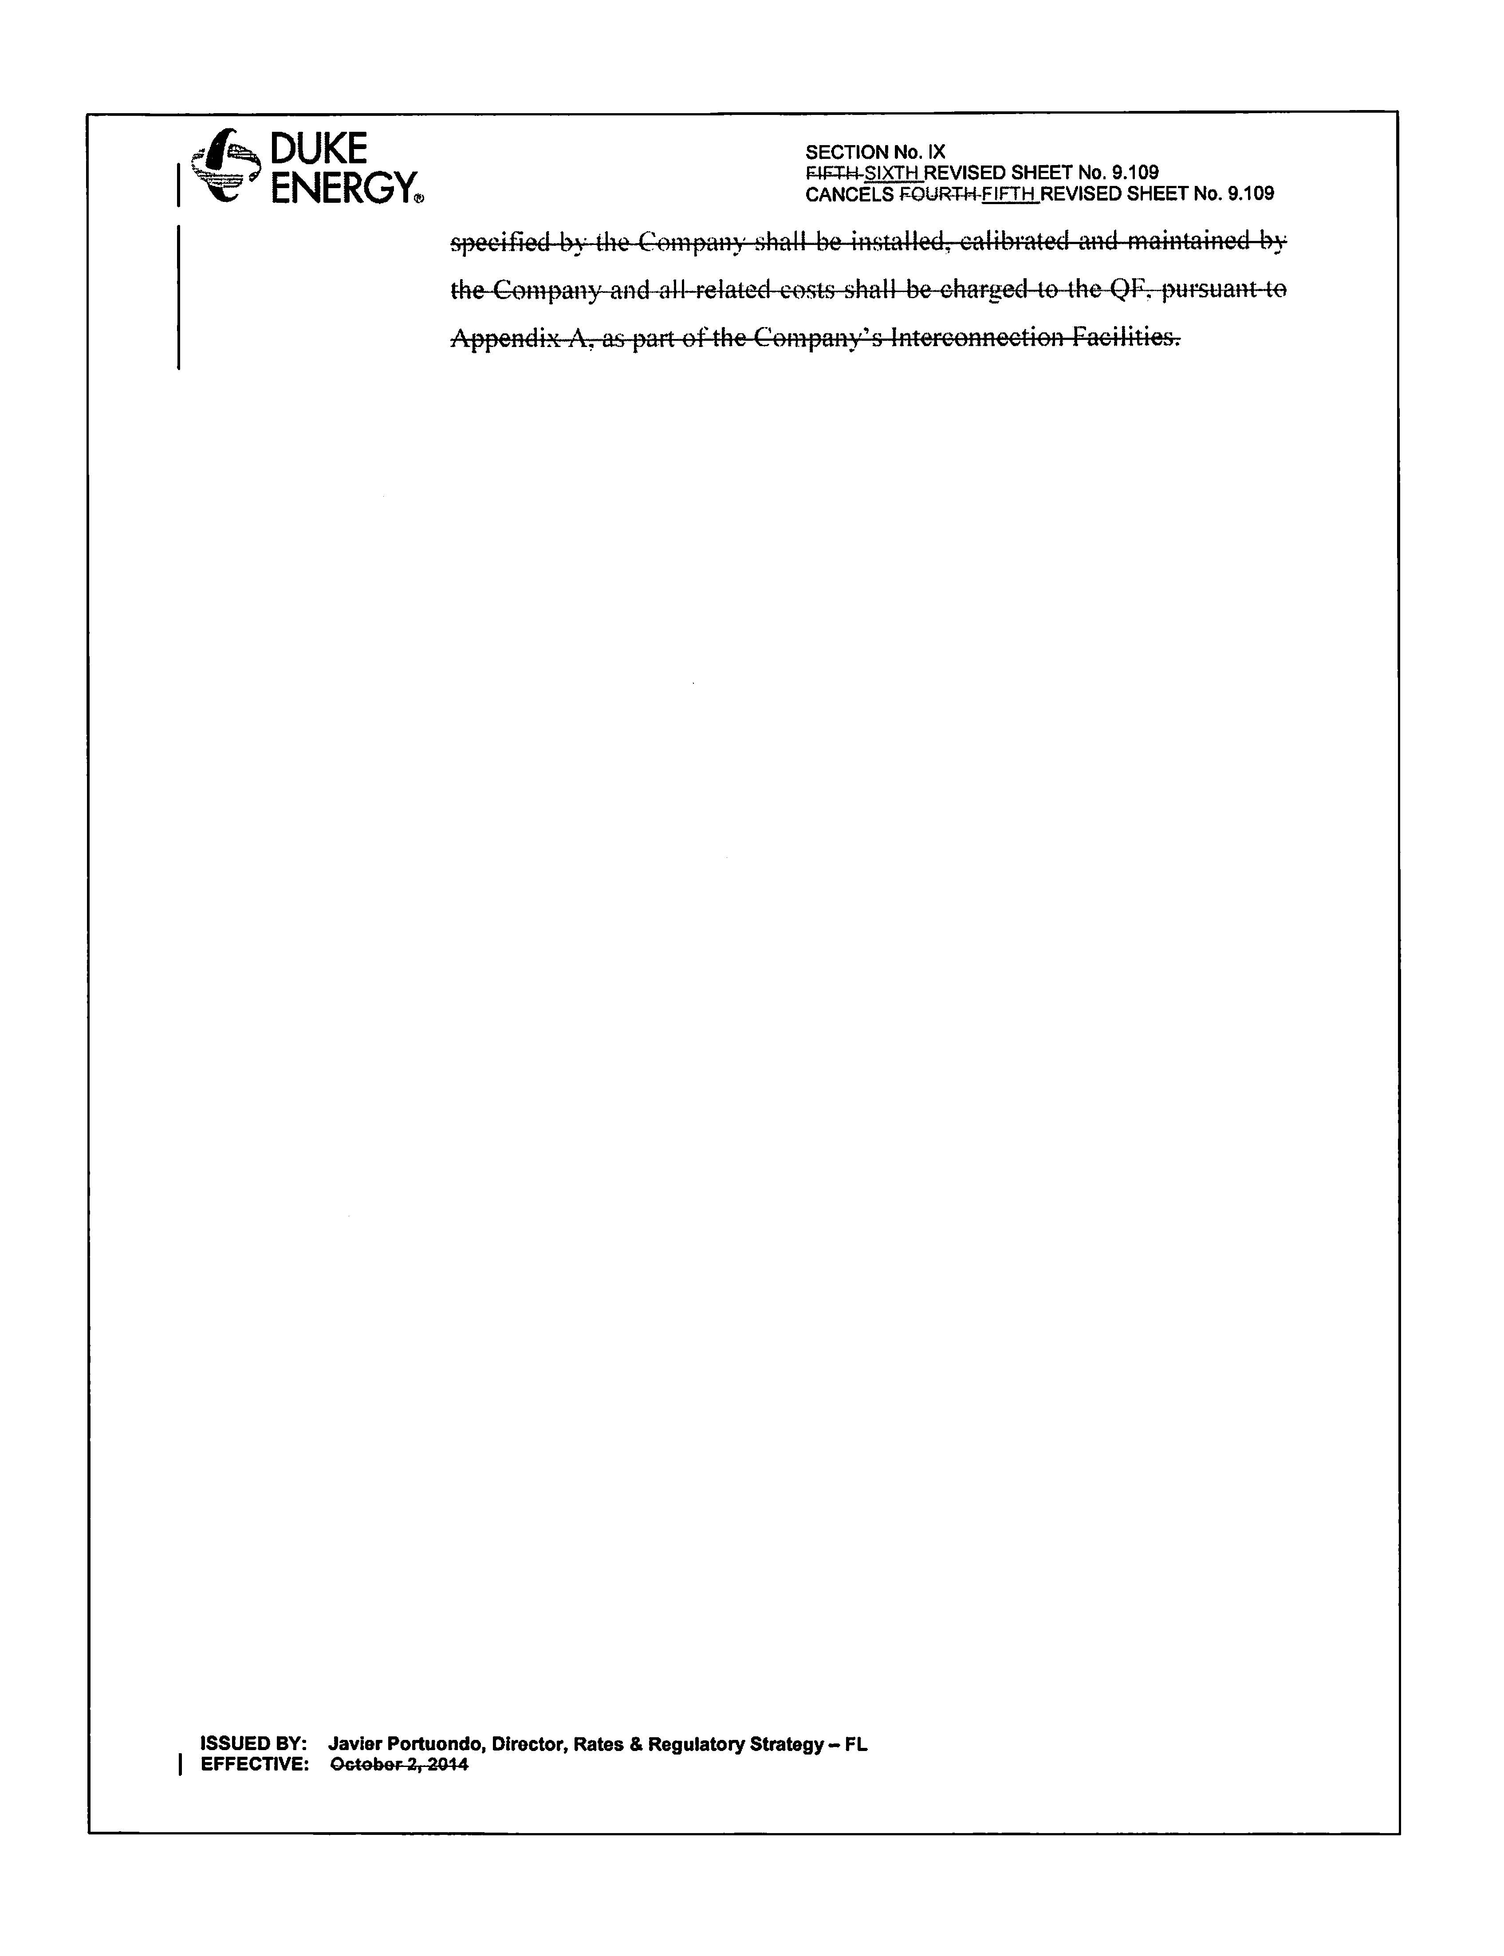

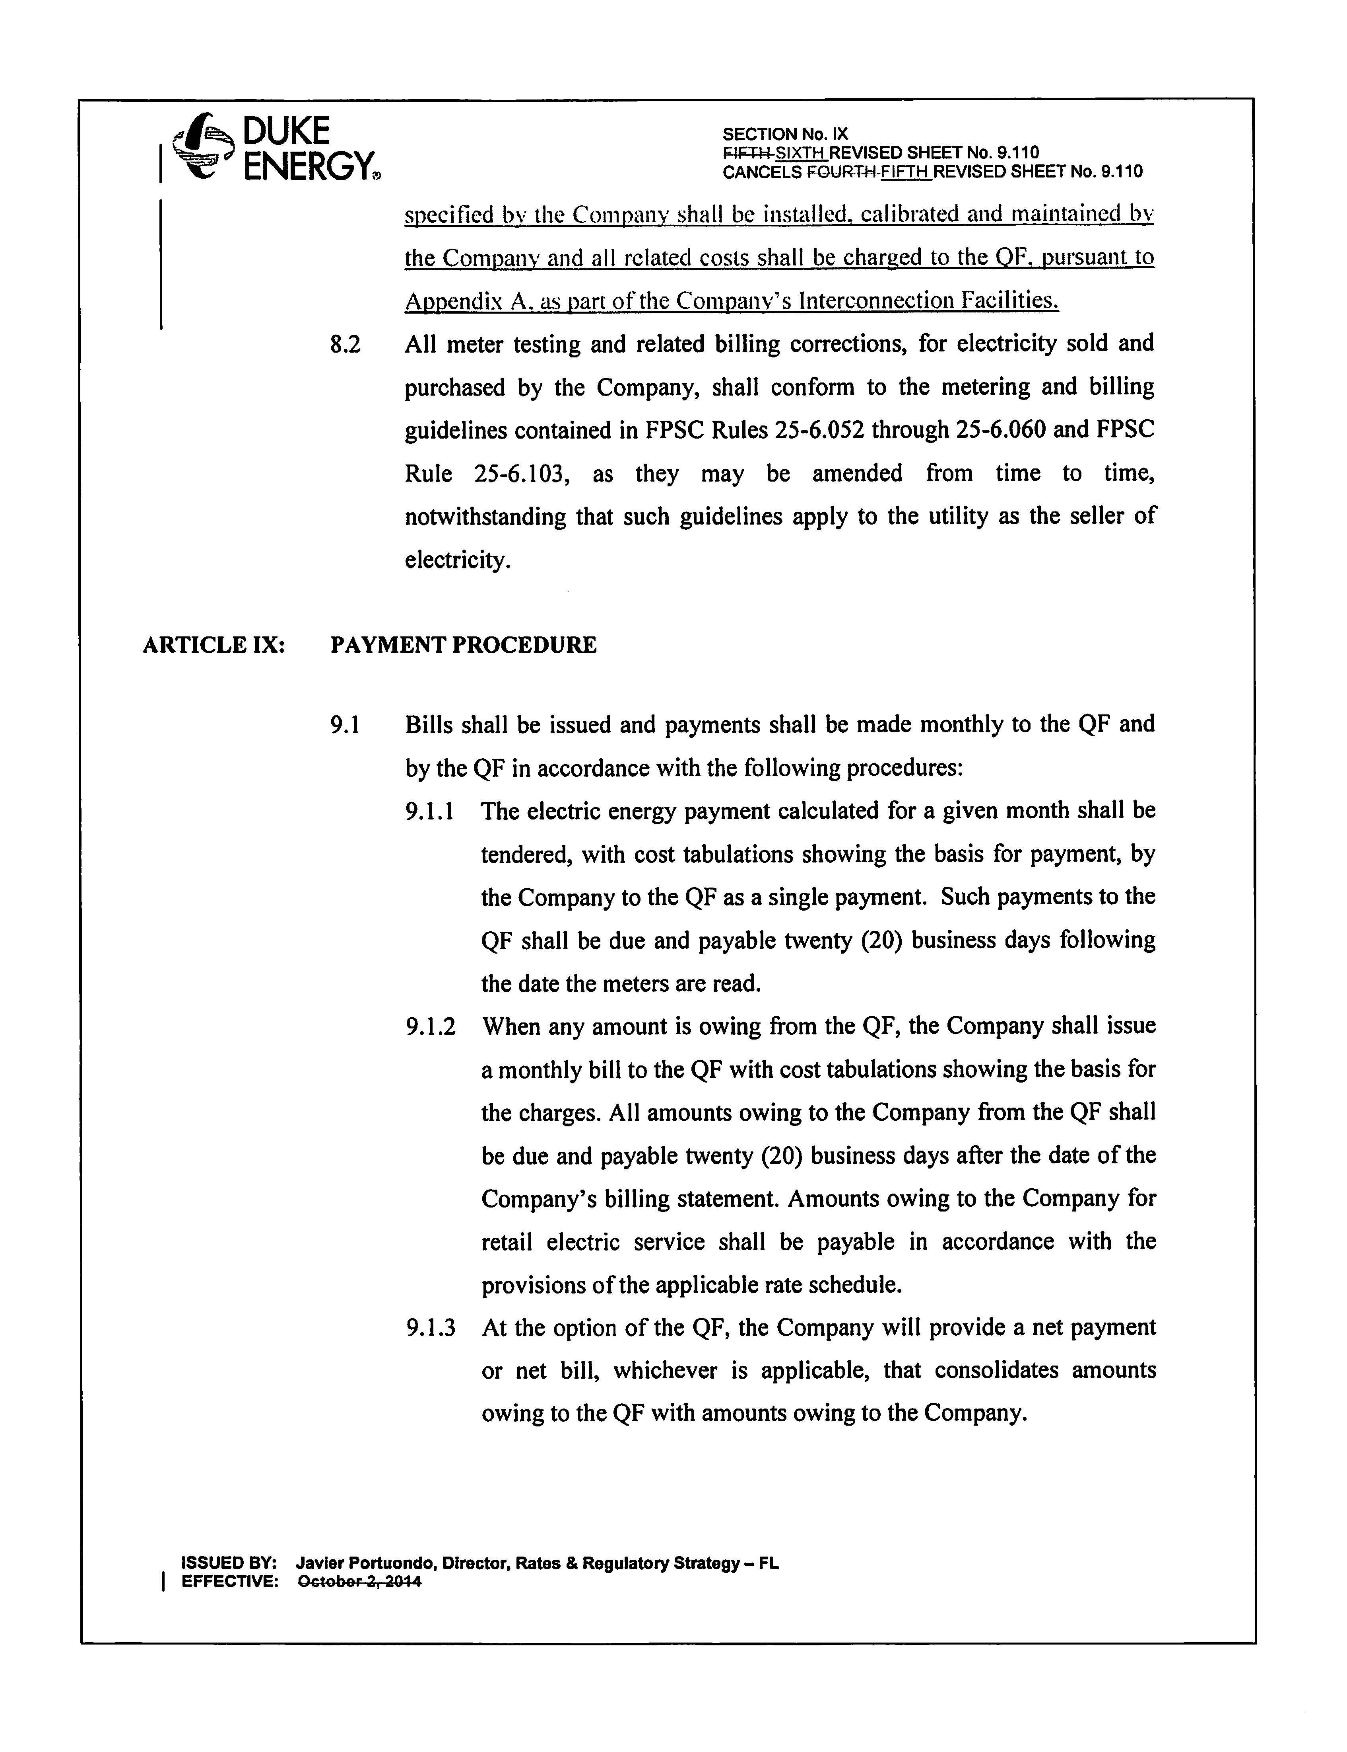

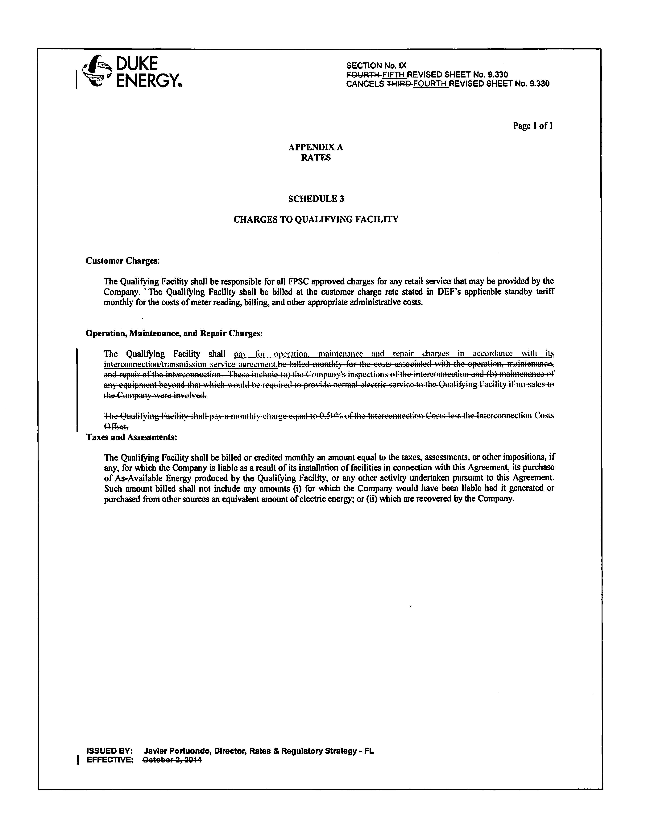

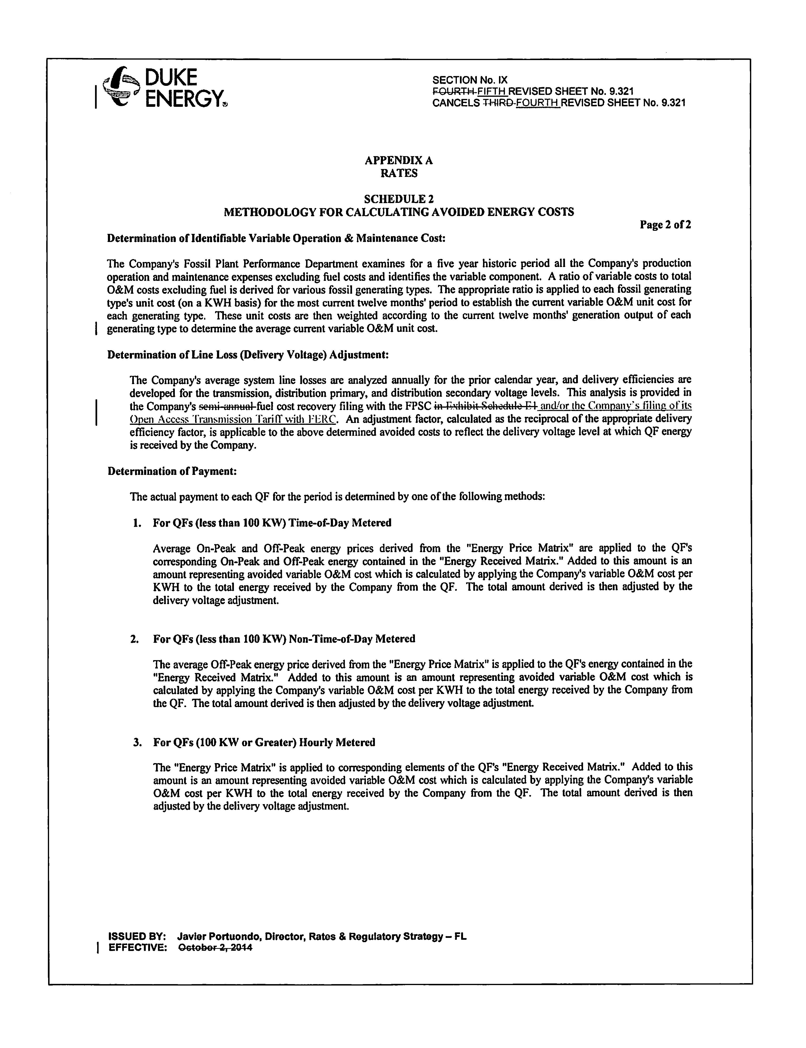

Docket No. 150106-EQ-Petition for approval of amended standard offer contract (Schedule COG-2) and amended interconnection agreement by Duke Energy Florida, Inc.
Id.

