BEFORE THE FLORIDA PUBLIC SERVICE COMMISSION

In re: Petition by Duke Energy Florida, Inc. for approval of modifications to approved as-available purchase tariff. | DOCKET NO. 150110-EI  ORDER NO. PSC-15-0316-PAA-EI  ISSUED: August 5, 2015

The following Commissioners participated in the disposition of this matter:

ART GRAHAM, Chairman
LISA POLAK EDGAR
RONALD A. BRISÉ
JULIE I. BROWN
JIMMY PATRONIS

NOTICE OF PROPOSED AGENCY ACTION ORDER APPROVING
DUKE ENERGY FLORIDA, INC.’S AS-AVAILABLE PURCHASE TARIFF

BY THE COMMISSION:

NOTICE is hereby given by the Florida Public Service Commission that the action discussed herein is preliminary in nature and will become final unless a person whose interests are substantially affected files a petition for a formal proceeding, pursuant to Rule 25-22.029, Florida Administrative Code (F.A.C.).

Background

On April 2, 2015, Duke Energy Florida, Inc. (DEF) filed a petition for approval of modifications to its as-available purchase tariff for clarification and to correspond with proposed revisions to DEF’s interconnection agreement, which is the subject of Docket No. 150106-EQ.

We have jurisdiction in this matter pursuant to Sections 366.04 and 366.051, Florida Statutes (F.S.).

Decision

Rule 25-17.0825, F.A.C., defines as-available energy and sets out a utility’s responsibilities with regard to purchasing as-available energy from qualifying facilities (QF). Rule 25-17.080, F.A.C., outlines the criteria that a small power producer or cogenerator must meet in order to achieve QF status. Pursuant to Rule 25-17.0825, F.A.C., as-available energy is energy produced by a QF on an hour-by-hour basis and utilities are required to purchase as-available energy from any QF. Rule 25-17.0825, F.A.C., also requires that as-available energy sales be made pursuant to the terms and conditions of a tariff or a separately negotiated contract.

DEF’s as-available purchase tariff provides the required contract terms and conditions including the delivery options, payments to the QF, and cost responsibility of the QF for the payment of interconnection costs. Charges to the QF are specified in DEF’s amended interconnection agreement, which we considered and approved in Docket No. 150106-EQ. DEF’s petition seeks to clarify language in its as-available contract language consistent with its modified interconnection agreement.

Consistent with the amended interconnection agreement, DEF proposed a revision to Sheet 9.330 of its as-available purchase tariff, pertaining to QF operation, maintenance, and repair charges in accordance with its modified interconnection agreement. Additional modifications to DEF’s as-available purchase tariff include revisions intended to clarify the as-available contract language. Additional language included in Tariff Sheet 9.108, Article 4.6, specifies delivery options, in order to clarify whether the as-available energy will be delivered to parties other than DEF. Revisions to Tariff Sheet 9.321, Appendix A, Schedule 2, specify filings that contain DEF’s annual average system line loss analysis for the calculation of the line loss adjustment factor to the avoided energy cost. (See Attachment A)

We have reviewed DEF’s proposed modifications to its as-available purchase tariff and it appears that the proposed modifications are reasonable and consistent with our rules. We therefore, approve DEF’s modifications to its as is purchase tariff and corresponding revised tariff sheets as filed, effective July 21, 2015.

Based on the foregoing, it is

ORDERED by the Florida Public Service Commission that Duke Energy Florida, Inc.’s modifications to its As-Available Purchase tariff and revised tariff sheets in tariffs filed April 2, 2015, are hereby approved and the tariff is effective July 21, 2015. It is further

ORDERED that the provisions of this Order, issued as proposed agency action, shall become final and effective upon the issuance of a Consummating Order unless an appropriate petition, in the form provided by Rule 28-106.201, F.A.C., is received by the Office of Commission Clerk, 2540 Shumard Oak Boulevard, Tallahassee, Florida 32399-0850, by the close of business on the date set forth in the “Notice of Further Proceedings” attached hereto. It is further

ORDERED that, if a protest is filed within 21 days of the issuance of the order, Duke Energy Florida, Inc.’s modified tariff should remain in effect, with any revenues held subject to refund, pending resolution of the protest. If no timely protest is filed, this docket should be closed upon the issuance of a consummating order.

By ORDER of the Florida Public Service Commission this 5th day of August, 2015.

/s/ Carlotta S. Stauffer
CARLOTTA S. STAUFFER
Commission Clerk
Florida Public Service Commission
2540 Shumard Oak Boulevard
Tallahassee, Florida 32399
(850) 413-6770
www.floridapsc.com

Copies furnished: A copy of this document is provided to the parties of record at the time of issuance and, if applicable, interested persons.

KFC

NOTICE OF FURTHER PROCEEDINGS OR JUDICIAL REVIEW

The Florida Public Service Commission is required by Section 120.569(1), Florida Statutes, to notify parties of any administrative hearing that is available under Section 120.57, Florida Statutes, as well as the procedures and time limits that apply. This notice should not be construed to mean all requests for an administrative hearing will be granted or result in the relief sought.

Mediation may be available on a case-by-case basis. If mediation is conducted, it does not affect a substantially interested person's right to a hearing.

The action proposed herein is preliminary in nature. Any person whose substantial interests are affected by the action proposed by this order may file a petition for a formal proceeding, in the form provided by Rule 28-106.201, Florida Administrative Code. This petition must be received by the Office of Commission Clerk, 2540 Shumard Oak Boulevard, Tallahassee, Florida 32399-0850, by the close of business on August 26, 2015.

In the absence of such a petition, this order shall become final and effective upon the issuance of a Consummating Order.

Any objection or protest filed in this/these docket(s) before the issuance date of this order is considered abandoned unless it satisfies the foregoing conditions and is renewed within the specified protest period.

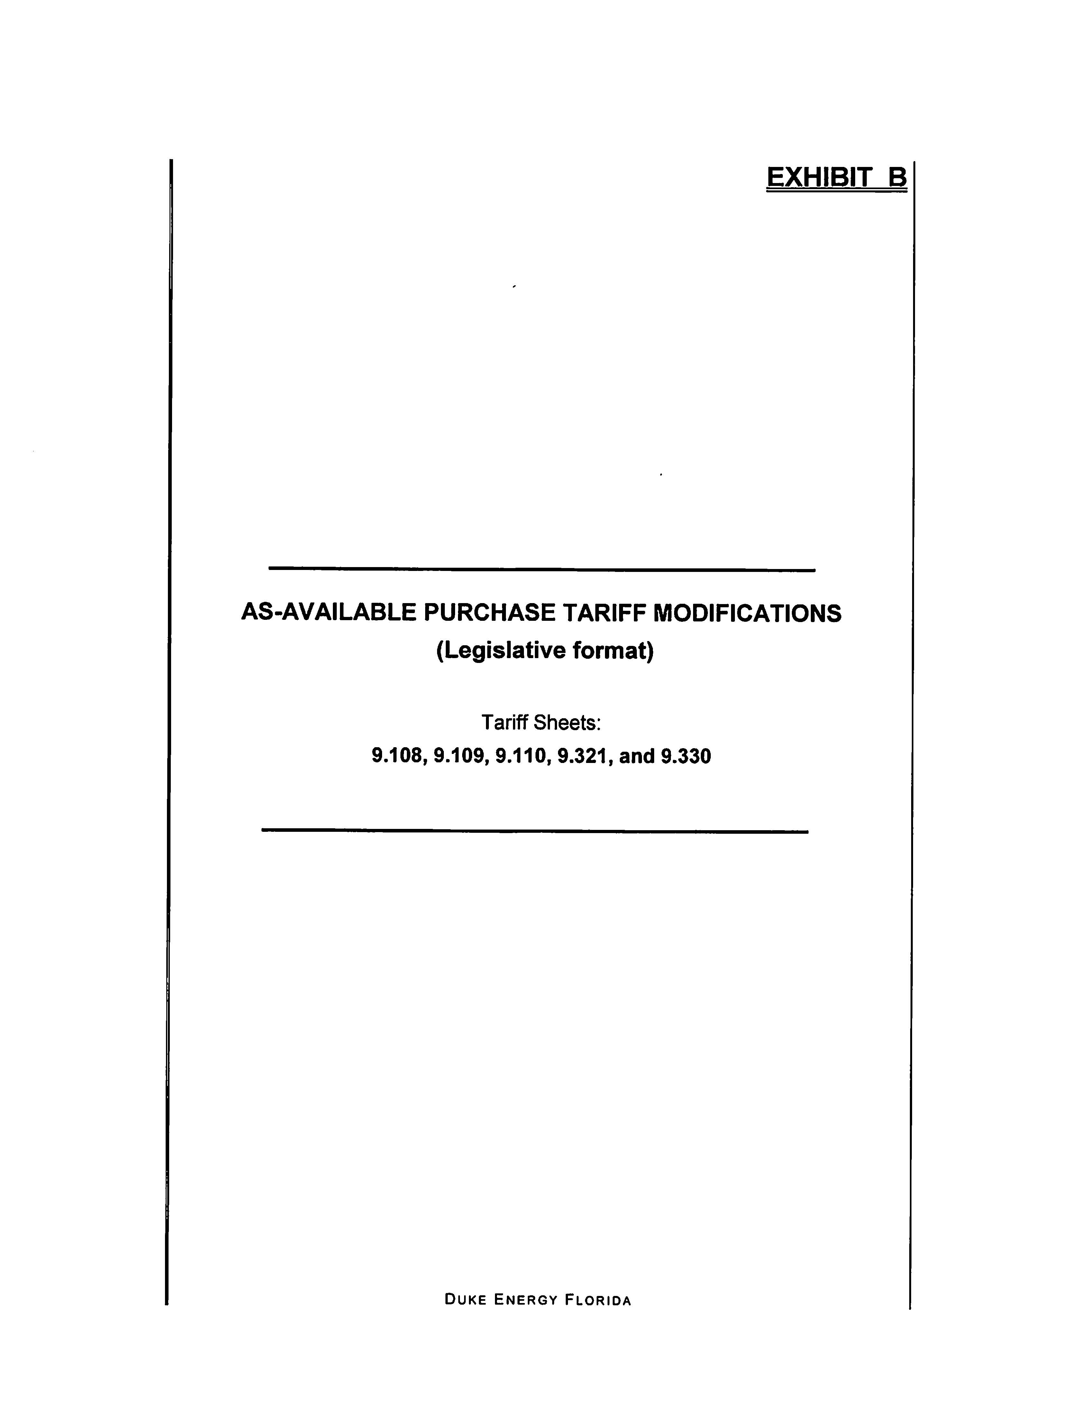
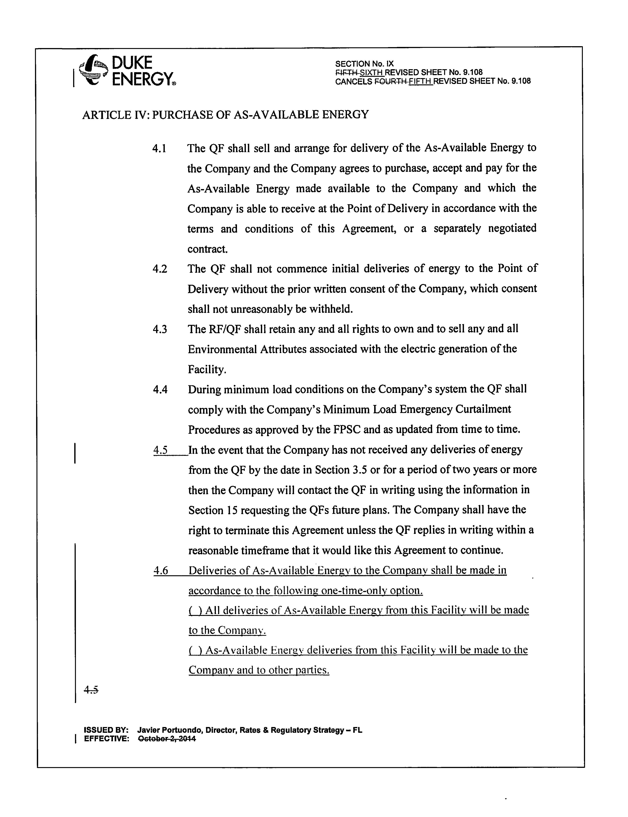
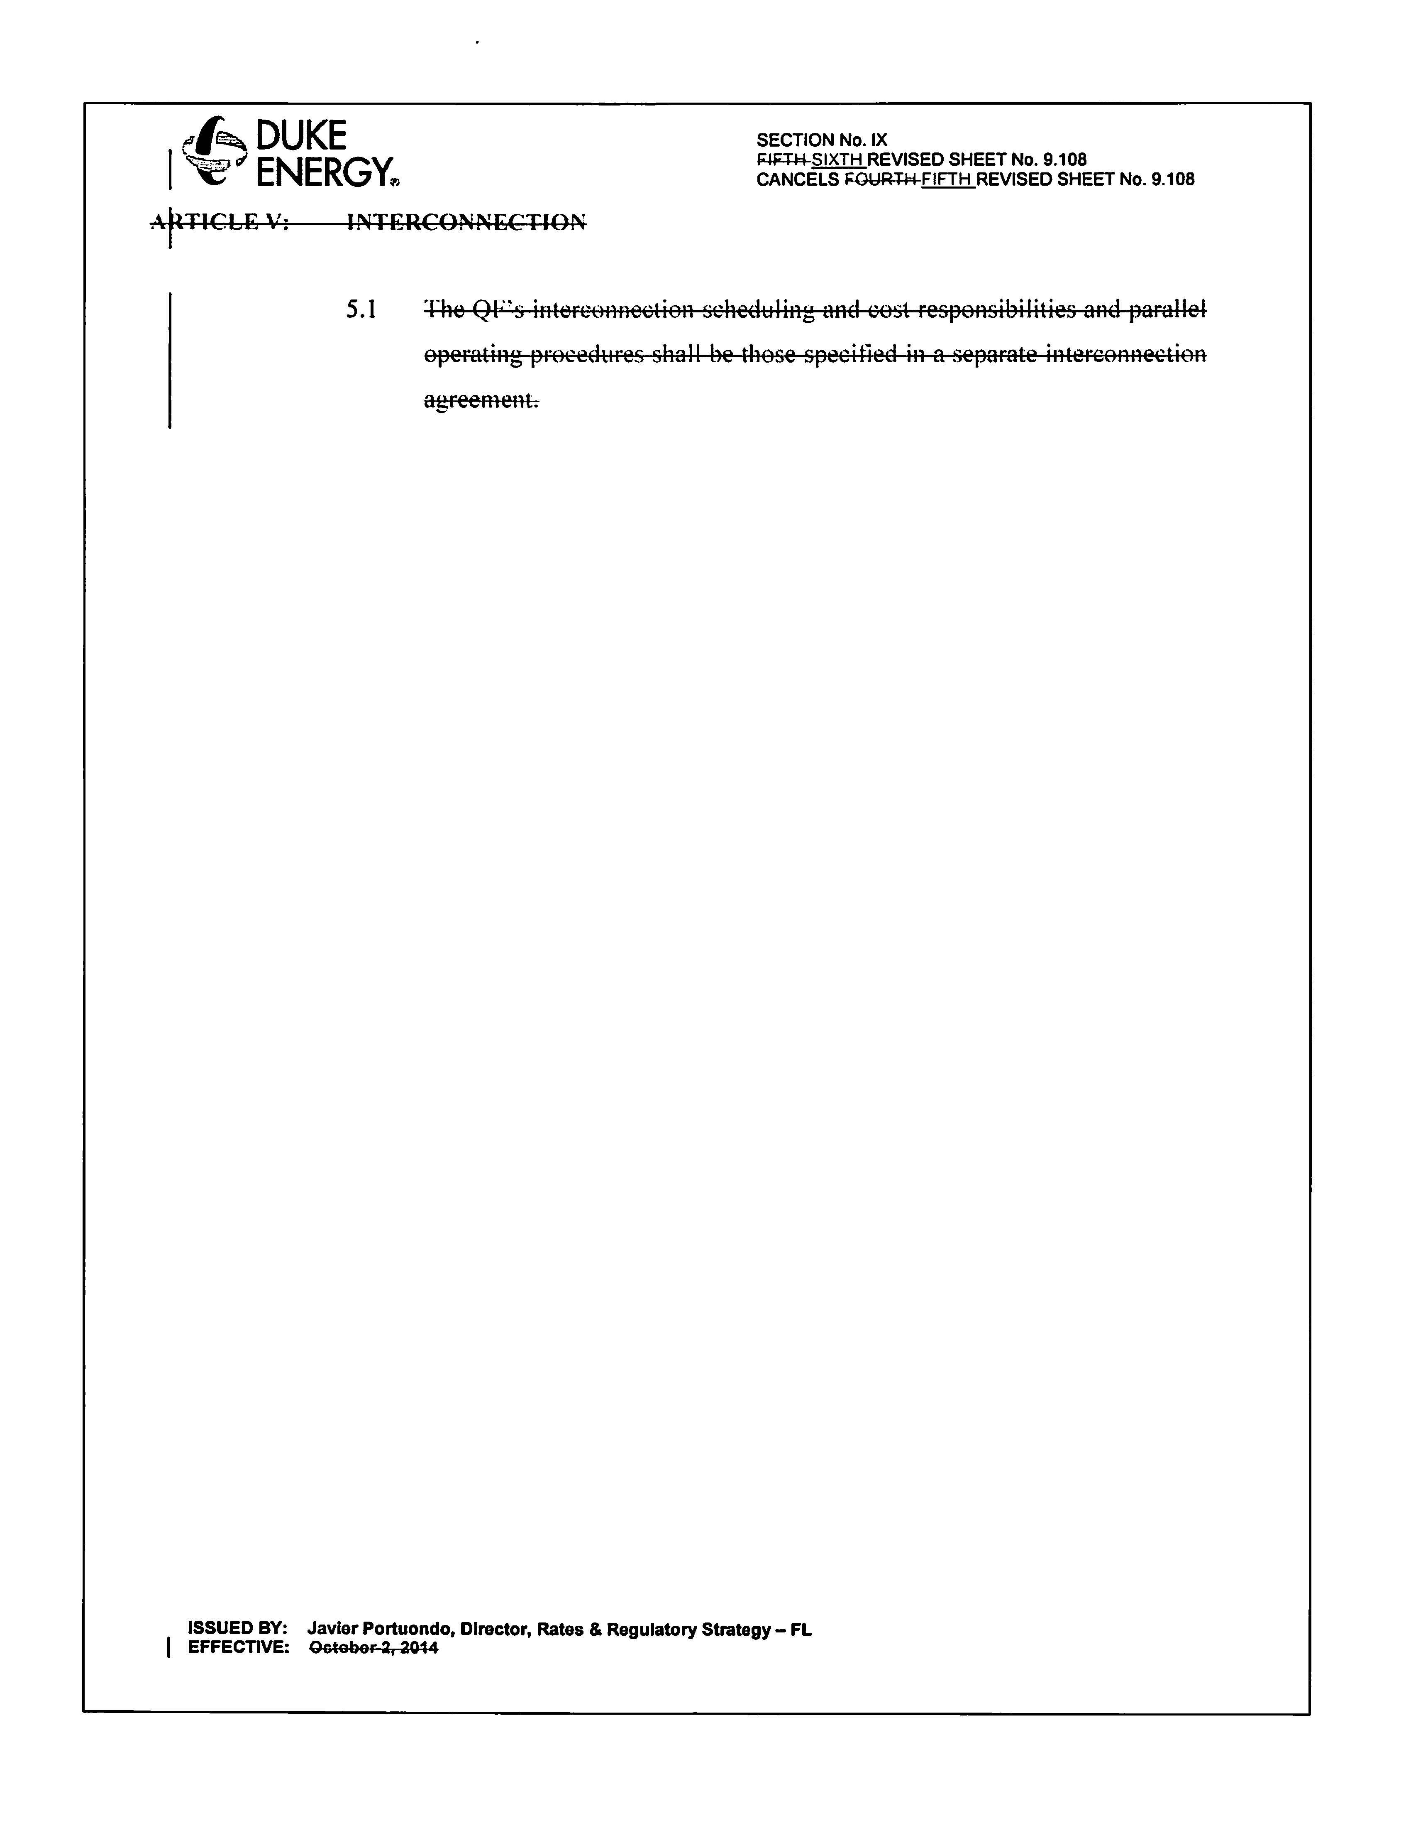
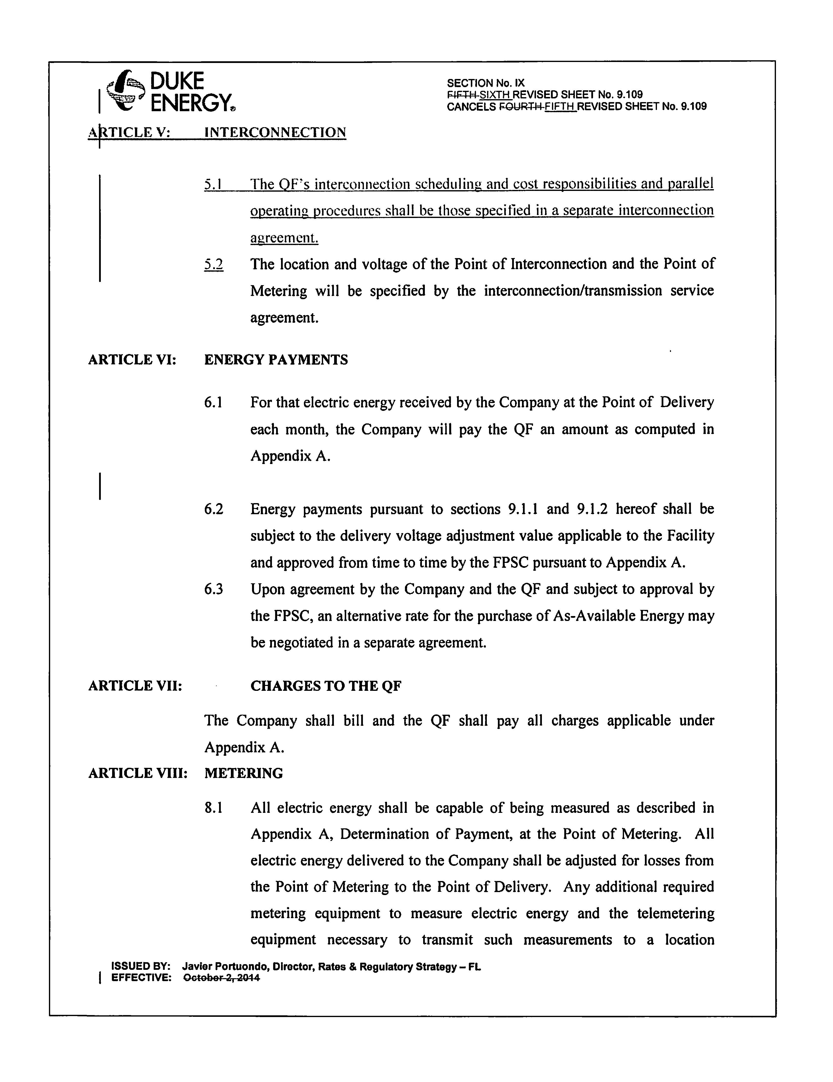
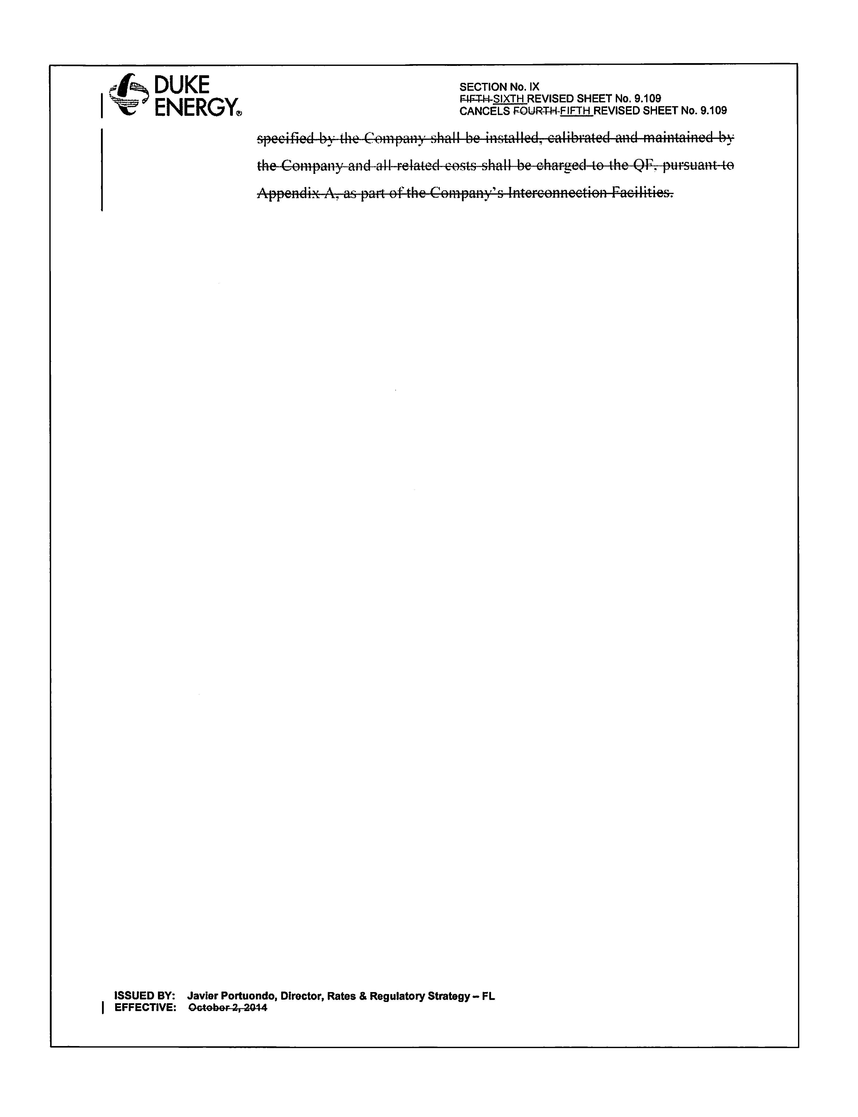
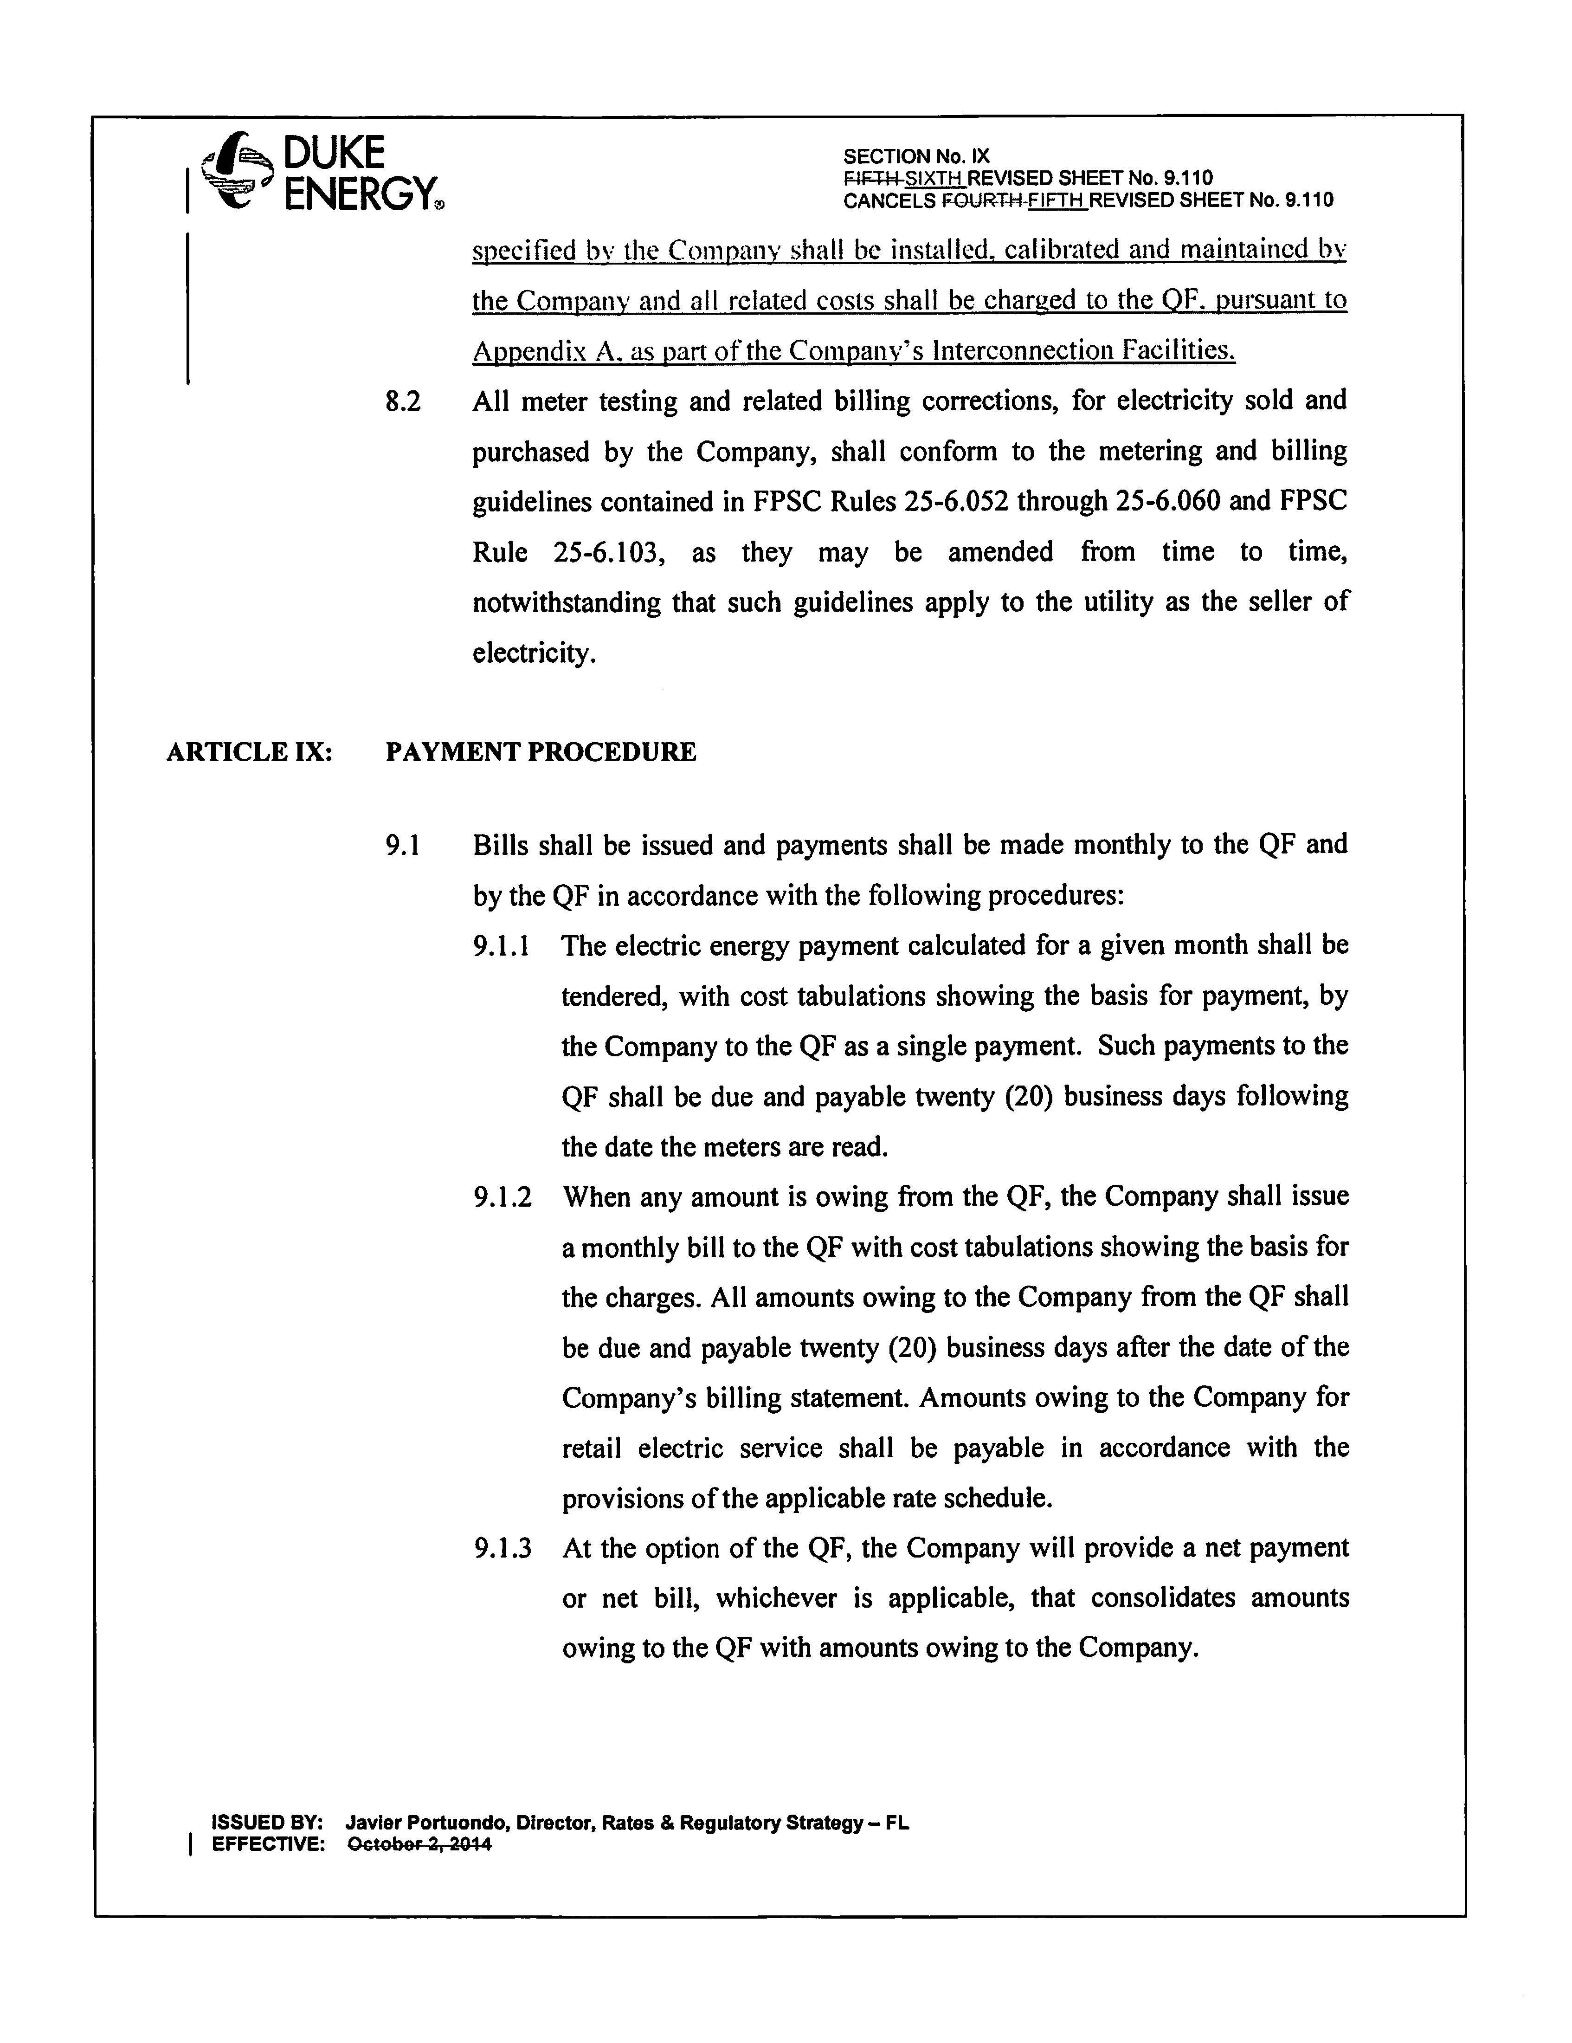
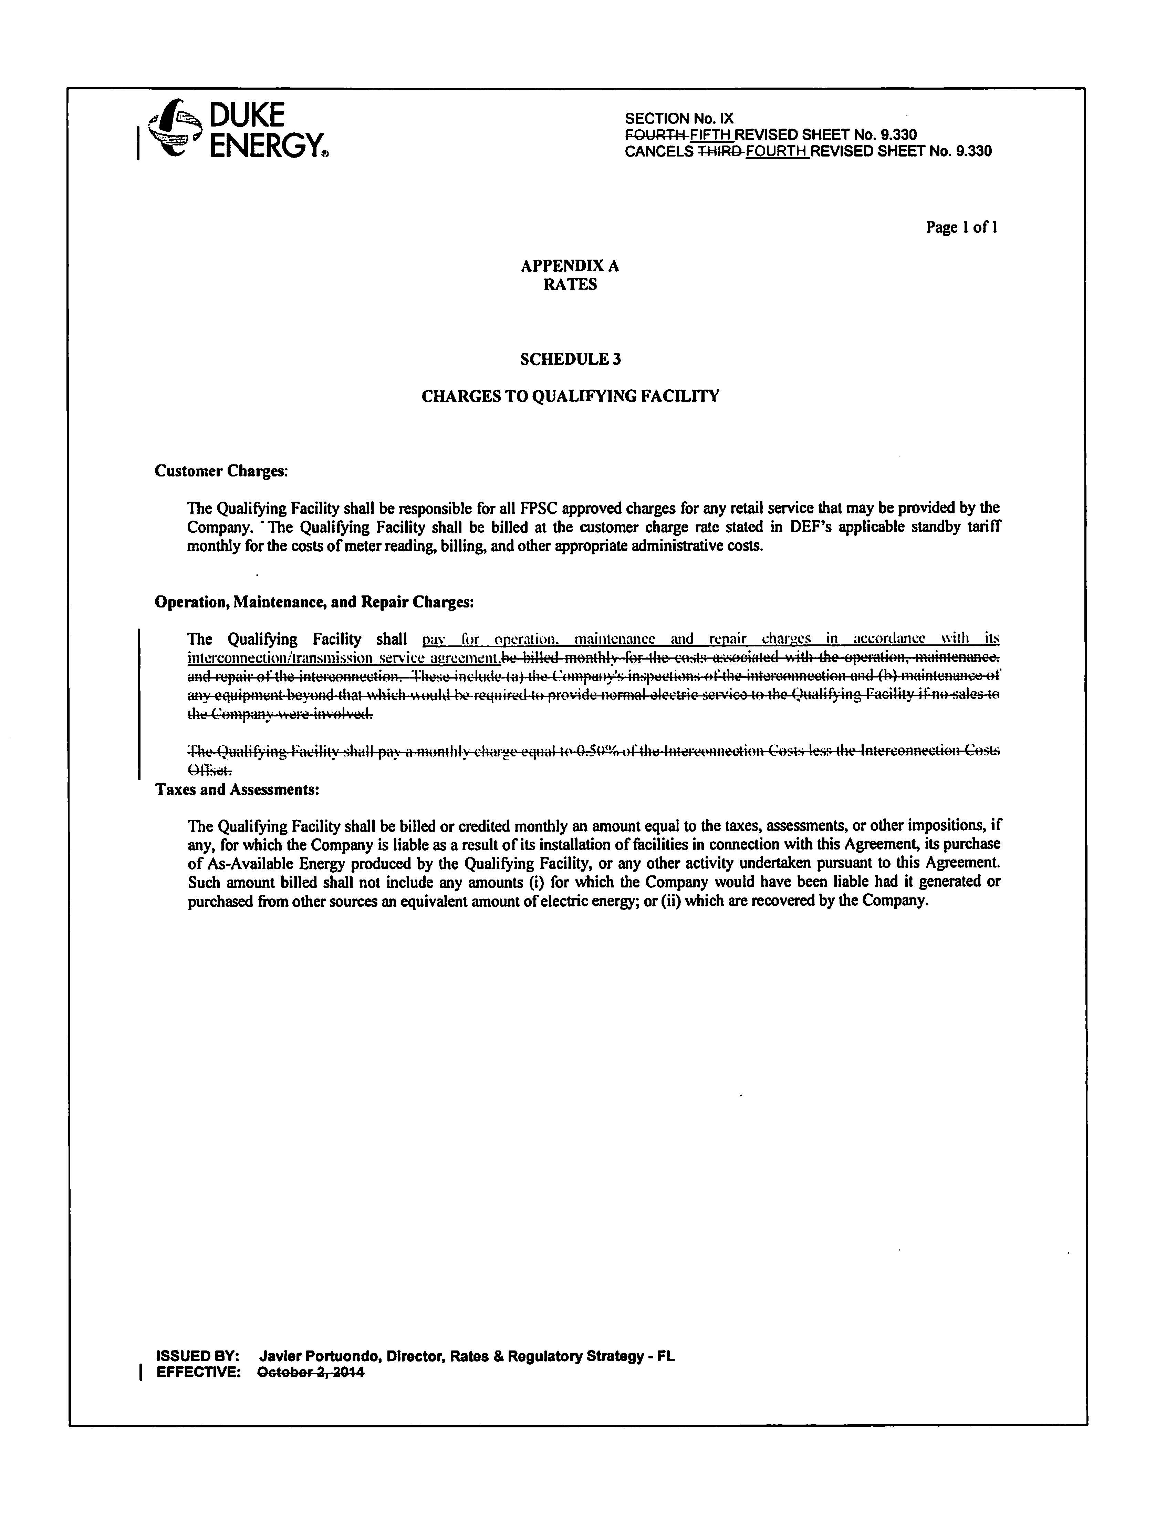
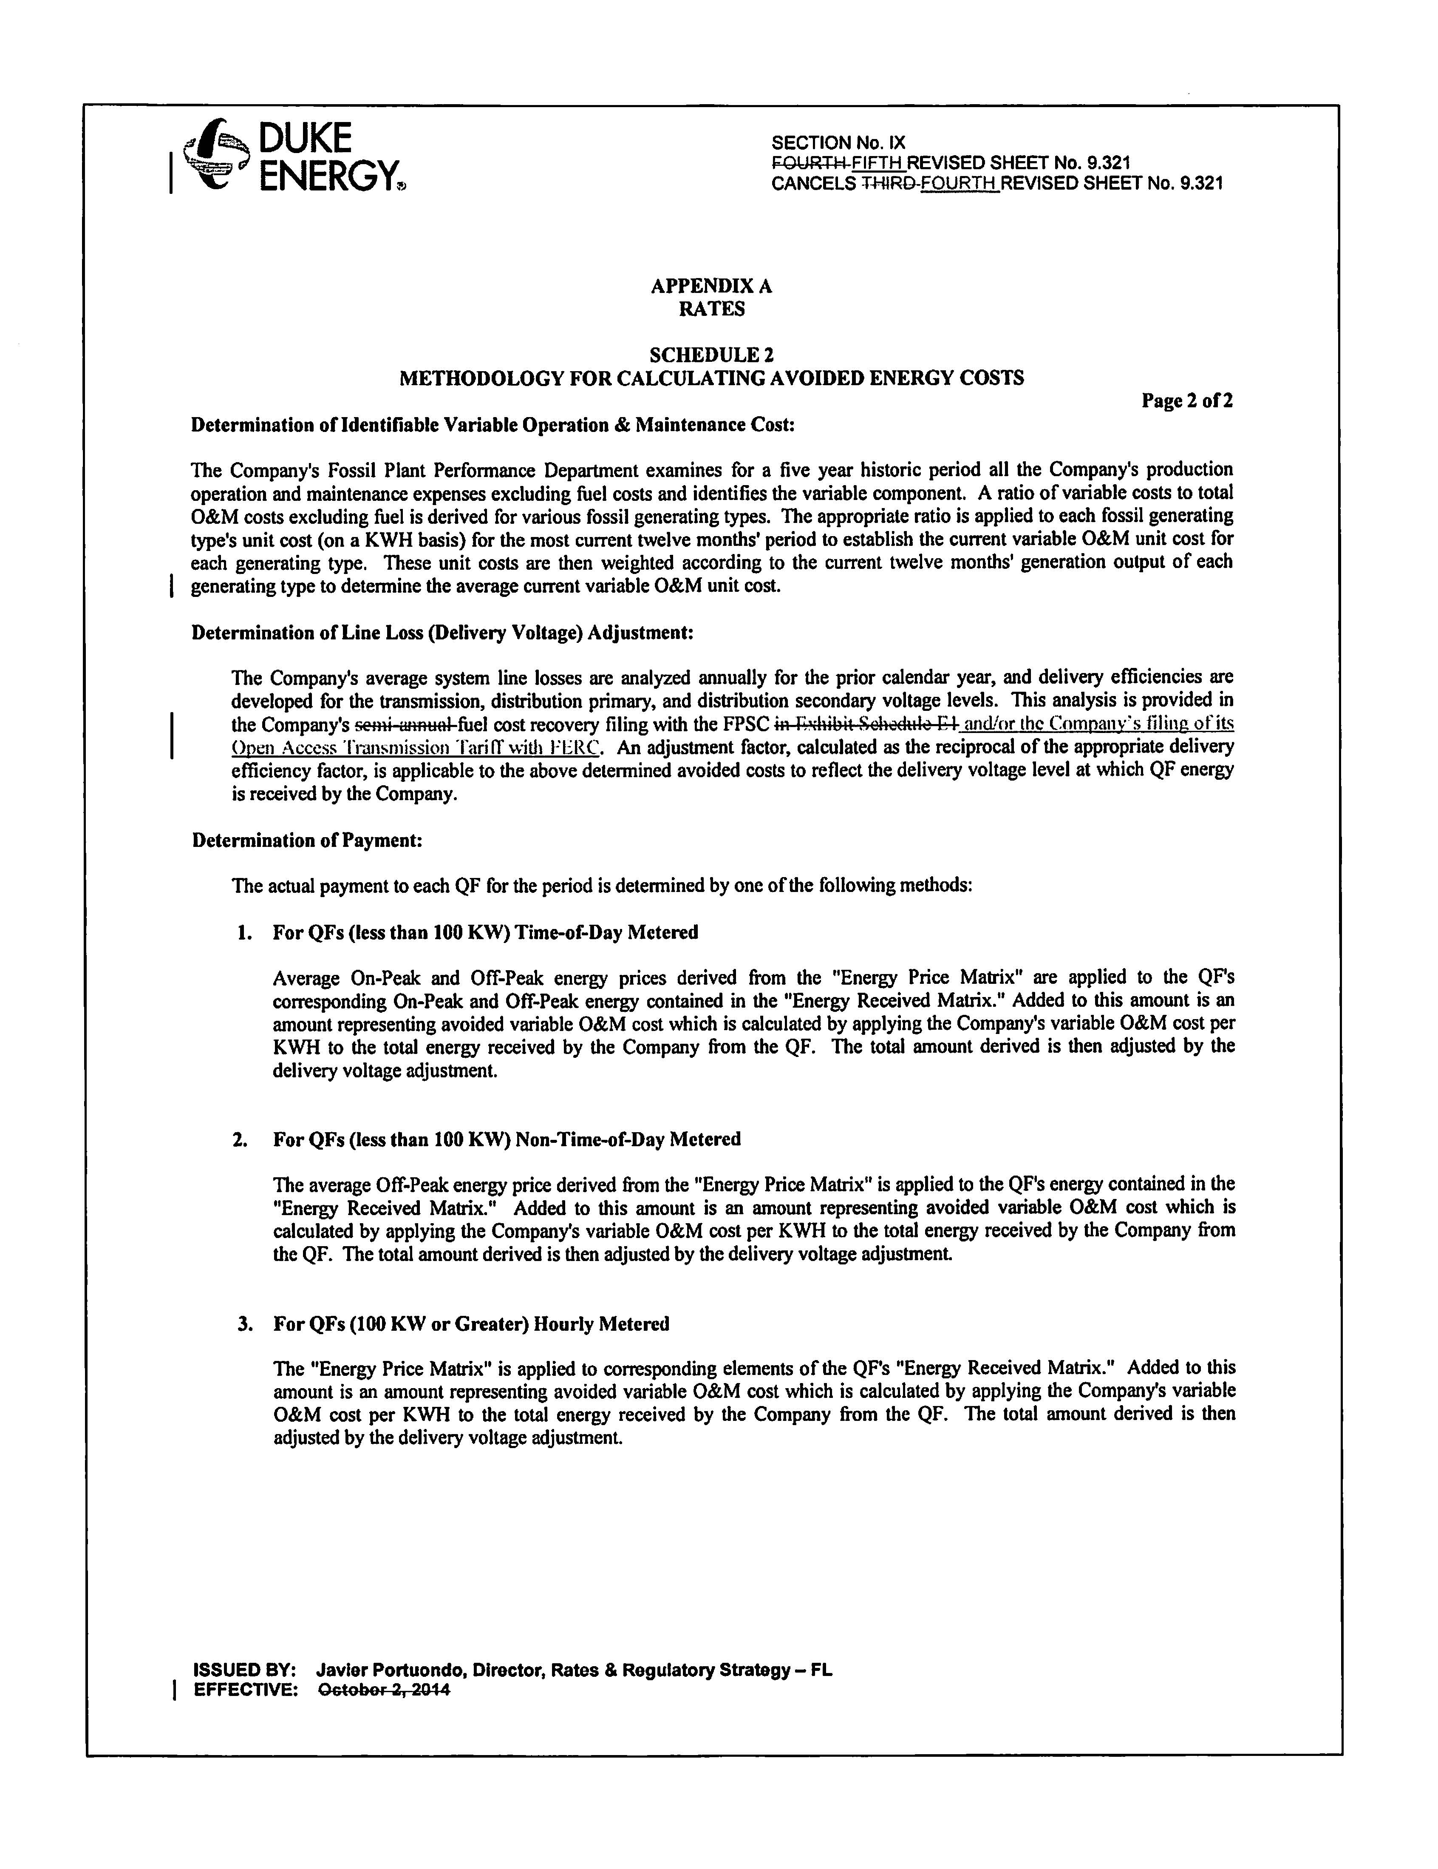

Docket No. 150106-EQ-Petition for approval of amended standard offer contract (Schedule COG-2) and amended interconnection agreement by Duke Energy Florida, Inc.
FPSC Order No. PSC-15-0305-PAA-EQ, issued July 28, 2015, in Docket No. 150106-EQ-Petition for approval of amended standard offer contract (Schedule COG-2) and amended interconnection agreement by Duke Energy Florida, Inc.

