BEFORE THE FLORIDA PUBLIC SERVICE COMMISSION

In re: Joint petition of Florida Public Utilities Company, Florida Public Utilities Company-Fort Meade, Florida Public Utilities-Indiantown Division and the Florida Division of Chesapeake Utilities Corporation for approval of revisions to commercial natural gas vehicle service programs. | DOCKET NO. 150139-GU  ORDER NO. PSC-15-0319-TRF-GU  ISSUED: August 10, 2015

The following Commissioners participated in the disposition of this matter:

ART GRAHAM, Chairman
LISA POLAK EDGAR
RONALD A. BRISÉ
JULIE I. BROWN
JIMMY PATRONIS

ORDER APPROVING REVISIONS TO COMMERCIAL NATURAL GAS VEHICLE SERVICE PROGRAMS

BY THE COMMISSION:

Background

On April 30, 2015, Florida Public Utilities Company, Florida Public Utilities-Fort Meade, Florida Public Utilities-Indiantown Division, and the Florida Division of Chesapeake Utilities Corporation (jointly the companies) filed a joint petition requesting our approval of a modification to each of their respective natural gas vehicle (NGV) tariffs. The companies are owned by Delaware-based Chesapeake Utilities Corporation.
The NGV tariffs provide commercial customers with the option to buy natural gas for the purpose of compression and delivery into motor vehicle fuel tanks. Under the NGV tariffs customers purchase and own the compression and fueling equipment, while the companies install the necessary mains, service line, meters, and associated equipment necessary to deliver natural gas to the customer’s compression and fueling station. Customers are responsible for purchasing their own gas. The NGV tariffs provide for the same charges, terms, and conditions across the companies.
On May 19, 2015, the companies filed a supplemental petition proposing revisions of associated administrative portions of their tariffs. Specifically, the companies wish to revise index pages and natural gas service agreement forms associated with the previously proposed tariff sheets. The companies waived the 60-day file and suspend provisions of Section 366.06(3), Florida Statutes (F.S.). We have jurisdiction in this matter pursuant to Section 366.06, F.S.
Decision
The current NGV tariffs for each of the companies include a $100 monthly customer charge and a $0.17111 per therm transportation charge. The cost of gas is separate. The charges were designed to recover the companies’ estimated annual cost associated with installing the gas line and equipment necessary to deliver gas to a commercial fueling station, owned and maintained by the customer, based upon the projected annual usage of 250,000 therms for a fueling station.
For each customer requesting service under the NGV tariff, the companies perform an analysis to determine the customer-specific cost of service and revenues based on expected usage. This analysis is necessary to determine whether the tariffed NGV charges, that are based on average cost of service, will recover construction costs that vary between customers. Pursuant to Rule 25-7.054, Florida Administrative Code (F.A.C.), and the companies’ tariffs on line extensions, the companies are allowed to request a contribution in aid of construction (CIAC) if the cost of the line extension is greater than the maximum allowable construction cost (MACC). The rule defines the MACC as four times the estimated annual gas revenue to be derived from the facilities less the cost of gas.
The companies proposed to revise their tariffs to provide an additional method for customers to obtain and pay for NGV service in the event that the cost of service analysis demonstrates that the customer would need to be assessed a CIAC amount. Specifically, customers would be able to receive NGV service at a minimum annual therm commitment in lieu of an upfront CIAC payment, i.e., a take or pay provision. This option, if chosen by the customer, allows a line extension cost above the MACC to be recovered over time by the customer’s monthly payments.
The companies’ revised natural gas service agreement protects the company and other ratepayers with a requirement that, if the customer fails or refuses to take gas service, the customer will pay the actual cost incurred by the company in constructing the facilities to serve the customer. The agreement also specifies the term of the agreement that is mutually agreed on by the company and the customer. Furthermore, the agreement specifies that any customer deposits held by the company will be forfeited in payment or partial payment of the facility construction costs.
The companies stated in their petition that while they are able to provide natural gas as a vehicle fuel under their current tariffs, this additional payment option will give the companies another alternative to offer prospective NGV customers. This payment option will only be available in the event that incorporating a minimum annual commitment will result in the customer payments covering the cost to serve that customer. As such, the general body of ratepayers will not be at risk of subsidizing service to the NGV customer. We find the proposed tariff language is consistent with Rule 25-7.054(3)(c), F.A.C., that provides for a utility to establish extension policies that are more favorable to consumers as long as no discrimination is practiced between consumers.
Attachment A shows the substantive proposed tariff language for FPUC under the section titled “Terms and Conditions.” The proposed tariff revisions are the same for all four companies. We find that the proposed NGV tariff revisions are designed to give the companies additional options to facilitate the expansion of NGV service to new customers, protect the general body of ratepayers from subsidizing NGV service, and are consistent with Rule 25-7.054, F.A.C. The proposed tariff modifications shall be approved with an effective date of July 21, 2015.
Based on the foregoing, it is

ORDERED by the Florida Public Service Commission that the joint petition of Florida Public Utilities Company, Florida Public Utilities Company-Fort Meade, Florida Public Utilities-Indiantown Division and the Florida Division of Chesapeake Utilities Corporation for approval of revisions to commercial natural gas vehicle service programs is hereby approved. It is further

ORDERED that the effective date of the revised tariff shall be July 21, 2015. It is further

ORDERED that if a protest is filed within 21 days of issuance of the Order, the tariff shall remain in effect with any charges held subject to refund pending resolution of the protest. It is further

ORDERED that if no timely protest is filed, this docket shall be closed upon the issuance of a Consummating Order.

By ORDER of the Florida Public Service Commission this 10th day of August, 2015.

/s/ Carlotta S. Stauffer
CARLOTTA S. STAUFFER
Commission Clerk
Florida Public Service Commission
2540 Shumard Oak Boulevard
Tallahassee, Florida 32399
(850) 413-6770
www.floridapsc.com

Copies furnished: A copy of this document is provided to the parties of record at the time of issuance and, if applicable, interested persons.

MFB

NOTICE OF FURTHER PROCEEDINGS

The Florida Public Service Commission is required by Section 120.569(1), Florida Statutes, to notify parties of any administrative hearing or judicial review of Commission orders that is available under Sections 120.57 or 120.68, Florida Statutes, as well as the procedures and time limits that apply. This notice should not be construed to mean all requests for an administrative hearing or judicial review will be granted or result in the relief sought.

Mediation may be available on a case-by-case basis. If mediation is conducted, it does not affect a substantially interested person's right to a hearing.

The Commission's decision on this tariff is interim in nature and will become final, unless a person whose substantial interests are affected by the proposed action files a petition for a formal proceeding, in the form provided by Rule 28-106.201, Florida Administrative Code. This petition must be received by the Office of Commission Clerk, 2540 Shumard Oak Boulevard, Tallahassee, Florida 32399-0850, by the close of business on August 31, 2015.

In the absence of such a petition, this Order shall become final and effective upon the issuance of a Consummating Order.

Any objection or protest filed in this docket before the issuance date of this order is considered abandoned unless it satisfies the foregoing conditions and is renewed within the specified protest period.

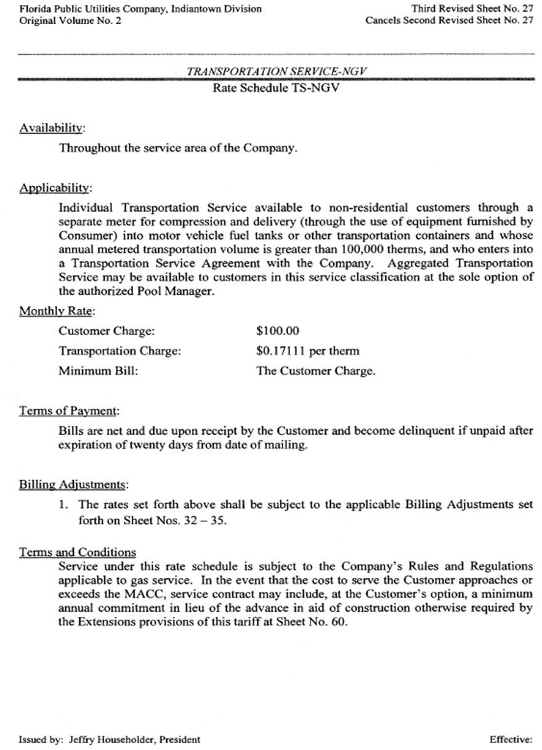

Order No. PSC-13-0395-PAA-GU, issued August 28, 2013, in Docket No. 130135-GU, In re: Joint petition of Florida Public Utilities Company, Florida Public Utilities-Indiantown Division and the Florida Division of Chesapeake Utilities Corporation for approval of Commercial Natural Gas Service Programs, and Order No. PSC-13-0676-TRF-GU, issued December 3, 2013, in Docket No. 130258-GU, In re: Petition for approval of tariff sheets reflecting gas service to customers in the City of Ft. Meade, by Florida Public Utilities Company.

