BEFORE THE FLORIDA PUBLIC SERVICE COMMISSION

In re: Petition for approval of revised net metering tariff and agreement adopting terms of standard interconnection agreement for Tier 1, Tier 2, or Tier 3 renewable generator systems, by Tampa Electric Company. | DOCKET NO. 150099-EI  ORDER NO. PSC-15-0322-TRF-EI  ISSUED: August 10, 2015

The following Commissioners participated in the disposition of this matter:

ART GRAHAM, Chairman
LISA POLAK EDGAR
RONALD A. BRISÉ
JULIE I. BROWN
JIMMY PATRONIS

ORDER APPROVING REVISED NET METERING TARIFF AND AGREEMENT ADOPTING TERMS OF STANDARD INTERCONNECTION AGREEMENT FOR TIER 1, 2, OR TIER 3 RENEWABLE GENERATOR SYSTEMS

Background
In April 2008, Rule 25-6.065, Florida Administrative Code (F.A.C.), governing the interconnection of customer-owned renewable generation systems was amended. The rule implemented Section 366.91(5), Florida Statutes (F.S.), which required each public utility to develop a standardized interconnection agreement and net metering program for customer-owned renewable generation systems by January 1, 2009.

As part of its implementation of Rule 25-6.065, F.A.C., Tampa Electric Company (TECO) filed as tariffs Standard Interconnection Agreements (SIA) for three tiers identified in the rule, separated by total system generating capacity: Tier 1 (0-10 kilowatts (kW), Tier 2 (>10-100 kW), and Tier 3 (>100 kW - 2 Megawatts). While these three SIAs are largely very similar, a few provisions vary by tier, primarily related to insurance requirements and fees. All of the SIAs contain provisions related to the initial installation and connection of renewable generation systems in order to ensure the safety and reliability of the electric grid. Other provisions relate to operation and maintenance, access, liability, and indemnification. The SIA is to be signed by the customer of record who owns the renewable generation system and TECO.

On March 27, 2015, TECO filed its petition for approval of a revised net metering tariff and agreement adopting terms of standard interconnection agreements for Tier 1, Tier 2, or Tier 3 renewable generation systems. In its petition, TECO seeks approval of a modification to its Net Metering Tariff (NM-1) and an associated new agreement that facilitates the adoption of the terms, conditions, and obligations of an existing SIA by tenants who are the customers of record and who lease premises that have pre-existing customer-owned renewable generation systems installed by the property owner.

The SIA that a customer initially signs contains numerous provisions that would not apply to a utility customer that rents, but does not own, the facilities and the renewable generation system. Therefore, TECO’s revised tariff contains a second agreement applicable to tenants of rental properties that contain a renewable generation system. The revised tariff contains a more limited set of obligations for the customer to agree to. TECO envisions that the original SIA signed by the owner of the property also remains in effect.

Following the filing of TECO’s petition, two informal meetings were held between our staff, the utility and interested persons to the docket. During the informal meeting held May 21, 2015, modifications to the proposed agreement were discussed, including identifying the specific provisions of the pre-existing SIA which the tenant would be responsible for and additional clarifying language related to consequences of a property owner’s failure to abide by all of its commitments under the pre-existing SIA between the property owner and TECO. On May 27, 2015, TECO filed a supplement to its petition incorporating changes discussed during the May 21, 2015 meeting. On June 18, 2015, we suspended the proposed tariff revisions until we could rule on the merits of the petition.

We have jurisdiction over this matter pursuant to Section 366.06, F.S.

Decision
TECO’s proposed tariff revision is a new agreement intended for customers who are renting properties that have renewable generation systems already installed. When the owner of the property installed a renewable generation system on the property, he or she signed a SIA with TECO that outlined his or her rights and responsibilities regarding the interconnection of the renewable generation system with TECO’s distribution facilities. The new agreement will attach this original SIA so that the renter understands his or her responsibilities.
Because many provisions of the SIA only apply to a customer installing renewable generation system for the first time, these provisions are not applicable to a renter. The new renter’s agreement identifies only those provisions of the original SIA that apply to renters. Those provisions are:
- Section 2, All Tiers: This provision allows a customer to contract for the lease, operation, or maintenance of a renewable generation system with a third party, provided that any payments in no way mimic or reflect the purchase of energy produced by the system.
- Section 6, All Tiers: This provision requires the customer to ensure that their renewable generation system’s inverter does not energize TECO’s electrical system during a power outage. This capability is standard for inverters for solar generators.
- Tier 1 Section 10, Tier 2 Section 11, Tier 3 Section 12: This provision requires the customer to be responsible for protection of all components of the renewable generation system, and to ensure that the system is inspected, maintained, and tested regularly. It also states that inspections of the system should occur following a large storm.
- Tier 1 Section 11, Tier 2 Section 12, Tier 3 Section 13: This provision concerns the requirement that the customer install a manual disconnect switch between the renewable generation system’s power output and the customer’s wiring. This switch must be accessible to TECO and be capable of being locked with a TECO padlock. TECO will pay for the switch for Tier 1 systems, but the switch comes at the customer’s expense for Tier 2 and 3 systems. Generally, this switch has been installed prior to a renter taking service from TECO, so for renters, the most important part of this provision is the requirement that the manual disconnect switch be accessible to TECO.
- Tier 1 Section 12, Tier 2 Section 13, Tier 3 Section 14: This provision concerns the situations under which TECO may open the manual disconnect switch, isolating the renewable generation system from the customer’s wiring. Doing so would mean that the customer no longer receives energy from the renewable generation system, but does not affect their service from TECO.
  - For all tiers, TECO may trigger the manual disconnect switch for:
    - Company utility system emergencies or maintenance requirements;
    - Hazardous conditions existing on the Company’s utility system due to the customer’s renewable generation system or protective equipment; or
    - Adverse electrical effects (such as power quality problems) on TECO’s customers’ electrical equipment caused by the renewable generation system.
  - For Tier 2 and 3 systems, TECO could also trigger the manual disconnect switch if the owner does not maintain insurance requirements. This will be discussed in greater detail below.
  - TECO can trigger the manual disconnect switch without prior notice, but will provide prior notice to the extent practical. TECO will leave a door hanger at the time of disconnection, including an explanation for the disconnection, if they cannot provide prior notice. TECO will re-close the switch, allowing the customer to receive power from the renewable generation system, as soon as practical once the situation necessitating the opening of the switch has ended.
- Tier 1 Section 13, Tier 2 Section 14, Tier 3 Section 15: This provision concerns indemnification. It requires the customer to indemnify and hold harmless TECO from any liability for claims originating from negligence on the part of the customer, and TECO to indemnify and hold harmless the customer from any liability for claims originating from negligence on the part of TECO. For customers that are state government entities, it notes that any such claims are subject to Section 768.28, F.S. This section of statute concerns Sovereign Immunity and its restrictions on liability claims concerning the state.
- Tier 1 Section 15, Tier 2 Section 16, Tier 3 Section 17: This provision concerns metering equipment. It notes that TECO will furnish, install, own, and maintain any metering equipment necessary for service, that this service will be at a single metering point, and that it will measure power from TECO to the customer and from the customer to TECO. The customer is required to provide safe and reasonable access to the premises for the installation, maintenance, and removal of the metering equipment.
- Tier 1 Section 16, Tier 2 Section 17, Tier 3 Section 18: This provision allows TECO to inspect the renewable generation system and any associated documentation both prior to and following the in-service date. TECO agrees to provide the customer with as much notice as reasonably practicable, and the customer cannot unreasonably refuse access to the premises. This provision also requires that TECO will have access to the manual disconnect switch. The customer also is required to notify TECO at least 10 days prior to the in-service date of the renewable generation system in order to give TECO time to inspect the system.
- Tier 1 Section 18, Tier 2 Section 19, Tier 3 Section 20: This provision requires the customer to get prior written consent from TECO before assigning any benefits or obligations to another party. This new party might need to sign a new agreement, but would not be required to pay an application fee provided the capacity of the system does not change.
- Tier 1 Section 23, Tier 2 Section 24, Tier 3 Section 25: This provision notes that the agreement incorporates by reference the terms of the tariff filed with the Commission, including Rate Schedule NM-1, and all associated terms, abbreviations, rules, regulations, and requirements. In the event of a conflict between this agreement and the tariff, the tariff is considered the controlling document. Rate Schedule NM-1 is TECO’s standard tariff for net metered service.
TECO maintains that their original SIA with the owner of the property remains valid, in addition to the supplemental agreement with the renter. TECO’s definition of “customer” in TECO’s Tariff Sheet 4.040 specifically includes landlords of properties at which a renter takes service from TECO. The new agreement includes a provision notifying the renter that the owner of the property remains responsible for all provisions in the original SIA that the owner signed with TECO. If the owner does not fulfill his responsibilities, TECO reserves the right to isolate the renewable generation system. The SIA requires owners of Tier 2 and 3 systems to maintain property insurance for personal injury and property damage of at least $1 million for Tier 2 systems, and $2 million for Tier 3 systems. If the owner of the property on which the system is installed does not maintain required insurance coverage, TECO could open the manual disconnect switch and the renter could lose access to the energy from the renewable generation systems.
A final provision in the agreement states that the agreement remains valid for the duration of the customer’s rental and control of the premises. The additions to TECO’s tariff that constitute the new agreement for renters are attached as Attachment A.
In its petition, TECO also asks for changes to two pages of its existing NM-1 tariff and its table of contents to incorporate references to the new agreement. These changes have no material effect otherwise.
We have concluded that the new agreement will benefit the security and reliability of the electric grid by clarifying to renters of properties that include renewable generation systems, as well as the owners of those properties, what their respective responsibilities and obligations will be in order to receive the benefits of the renewable generation system. Therefore, we approve TECO’s revised net metering tariff and agreement adopting terms of the standard interconnection agreement for Tier 1, Tier 2, or Tier 3 renewable generator systems.
Based on the foregoing, it is

ORDERED by the Florida Public Service Commission that Tampa Electric Company’s Petition for approval of the revised net metering tariff and agreement adopting terms of standard interconnection agreements for Tier 1, Tier 2, or Tier 3 renewable generator systems, as filed by Tampa Electric Company, is hereby approved, effective the date of the Commission vote. It is further

ORDERED that the provisions of this Order are interim in nature and will become final, unless a person whose substantial interests are affected by the proposed action files a petition for a formal proceeding, in the form provided by Rule 28-106.201, Florida Administrative Code. This petition must be received by the Office of Commission Clerk, 2540 Shumard Oak Boulevard, Tallahassee, Florida 32399-0850, by the close of business on the date set forth in the “Notice of Further Proceedings” attached hereto. It is further

ORDERED that if a protest is filed within 21 days of issuance of this order, the revised tariff shall remain in effect pending the resolution of the protest. Potential signatories to the tariff should be aware that Tampa Electric Company’s tariff may be subject to a request for hearing, and if a hearing is held, may be subsequently revised. It is further

ORDERED that this docket shall be closed upon issuance of a Consummating Order unless a person whose substantial interests are affected by our decision files a protest within 21 days of the issuance of this order.

By ORDER of the Florida Public Service Commission this 10th day of August, 2015.

/s/ Carlotta S. Stauffer
CARLOTTA S. STAUFFER
Commission Clerk
Florida Public Service Commission
2540 Shumard Oak Boulevard
Tallahassee, Florida 32399
(850) 413-6770
www.floridapsc.com

Copies furnished: A copy of this document is provided to the parties of record at the time of issuance and, if applicable, interested persons.

LAA

NOTICE OF FURTHER PROCEEDINGS

The Florida Public Service Commission is required by Section 120.569(1), Florida Statutes, to notify parties of any administrative hearing or judicial review of Commission orders that is available under Sections 120.57 or 120.68, Florida Statutes, as well as the procedures and time limits that apply. This notice should not be construed to mean all requests for an administrative hearing or judicial review will be granted or result in the relief sought.

Mediation may be available on a case-by-case basis. If mediation is conducted, it does not affect a substantially interested person's right to a hearing.

The Commission's decision on this tariff is interim in nature and will become final, unless a person whose substantial interests are affected by the proposed action files a petition for a formal proceeding, in the form provided by Rule 28-106.201, Florida Administrative Code. This petition must be received by the Office of Commission Clerk, 2540 Shumard Oak Boulevard, Tallahassee, Florida 32399-0850, by the close of business on August 31, 2015.

In the absence of such a petition, this Order shall become final and effective upon the issuance of a Consummating Order.

Any objection or protest filed in this docket before the issuance date of this order is considered abandoned unless it satisfies the foregoing conditions and is renewed within the specified protest period.

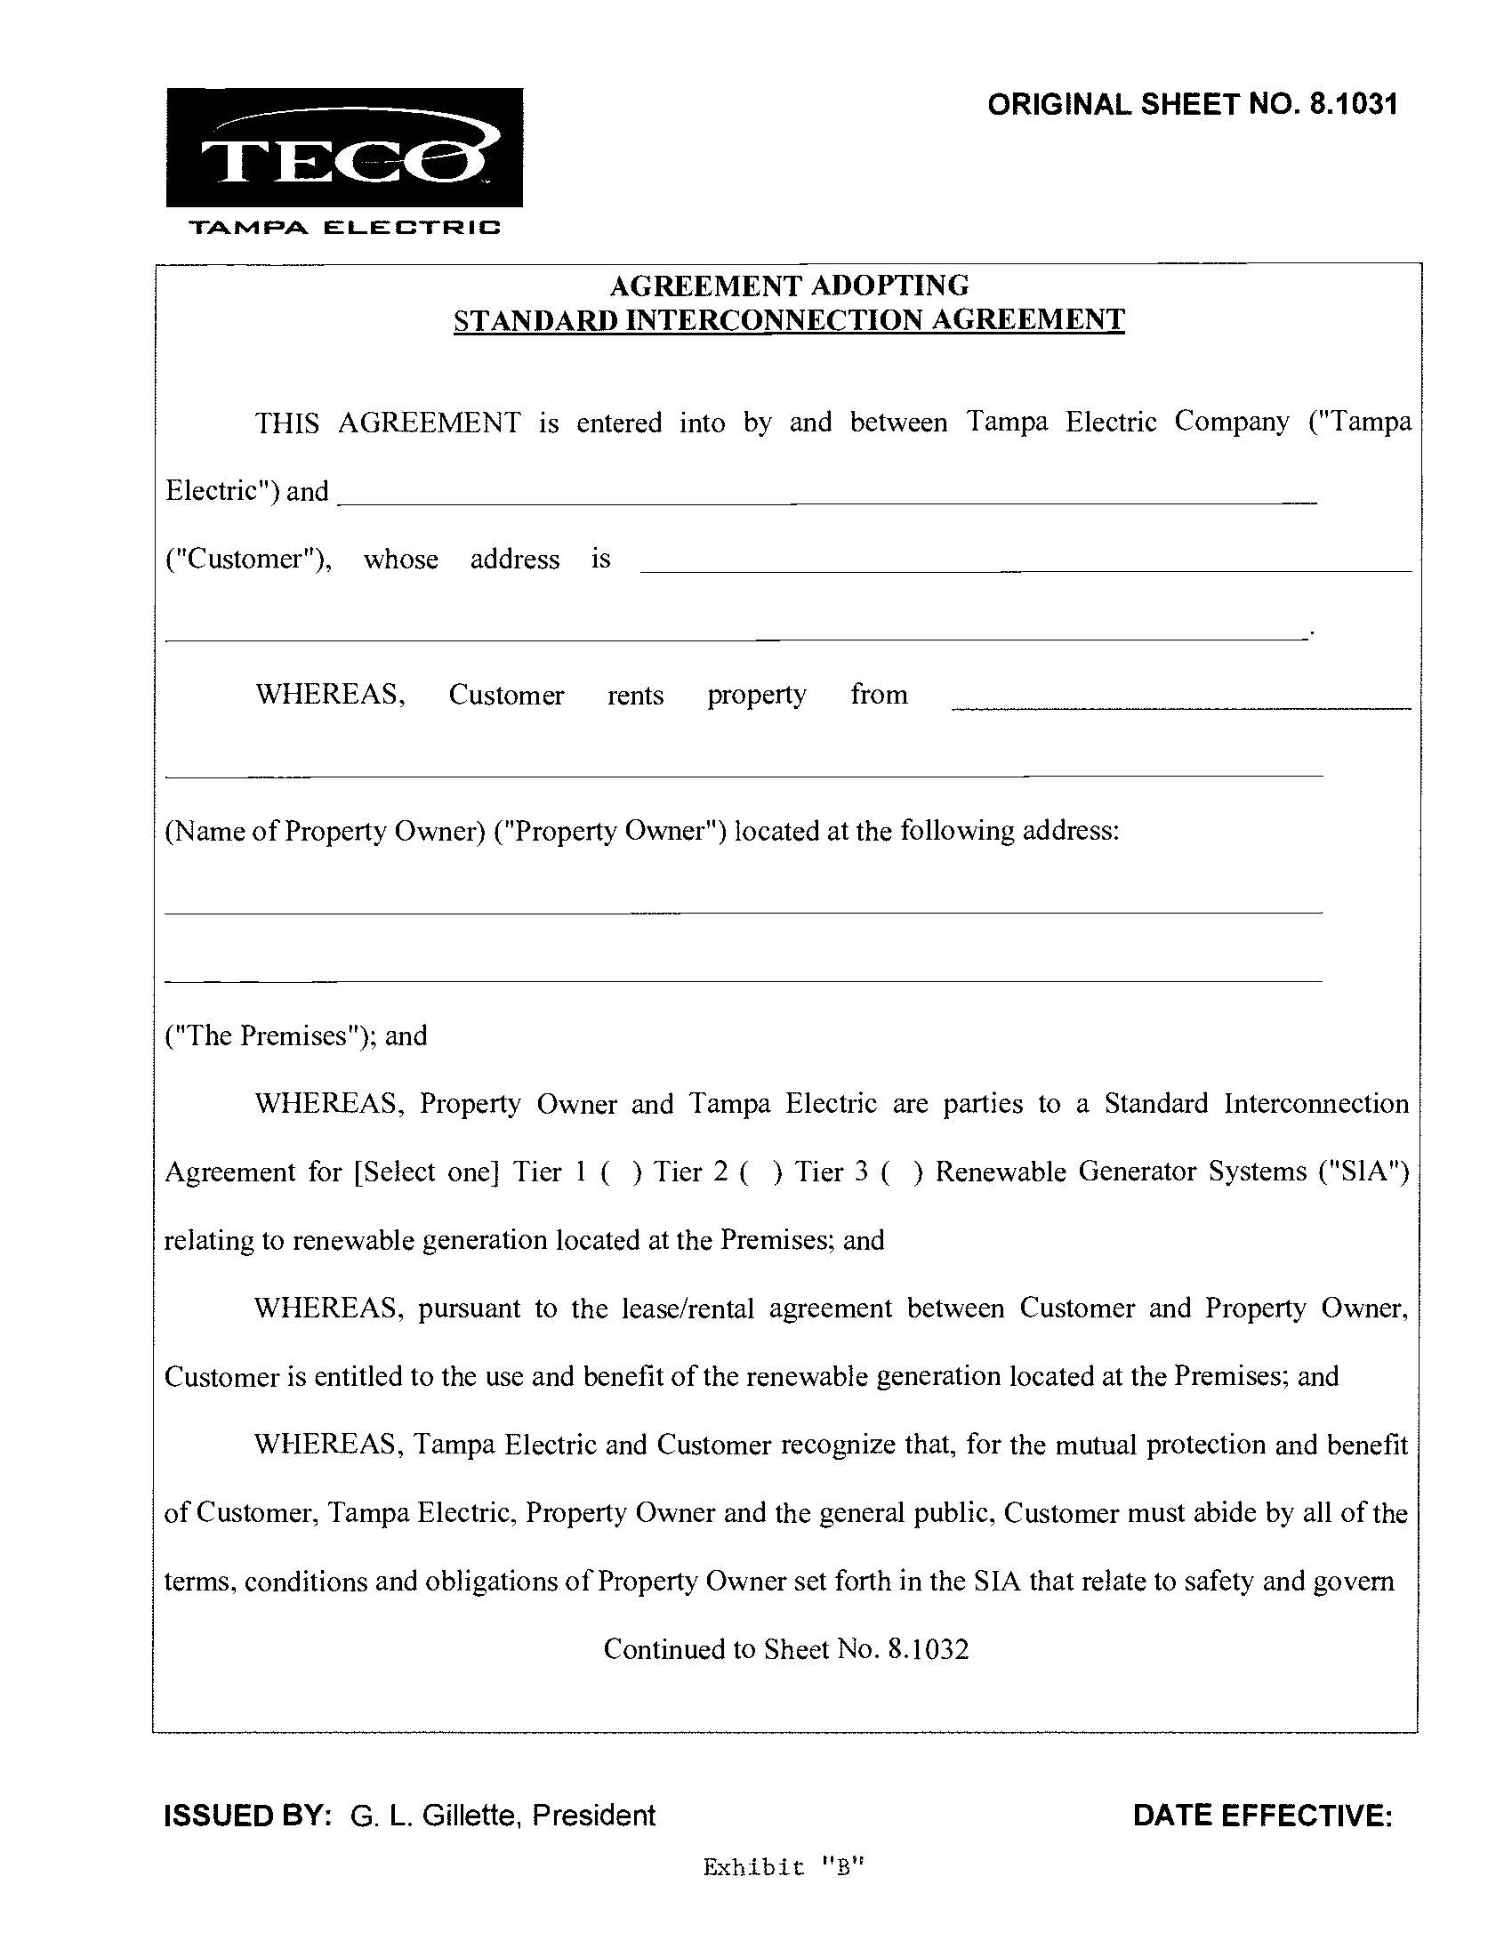
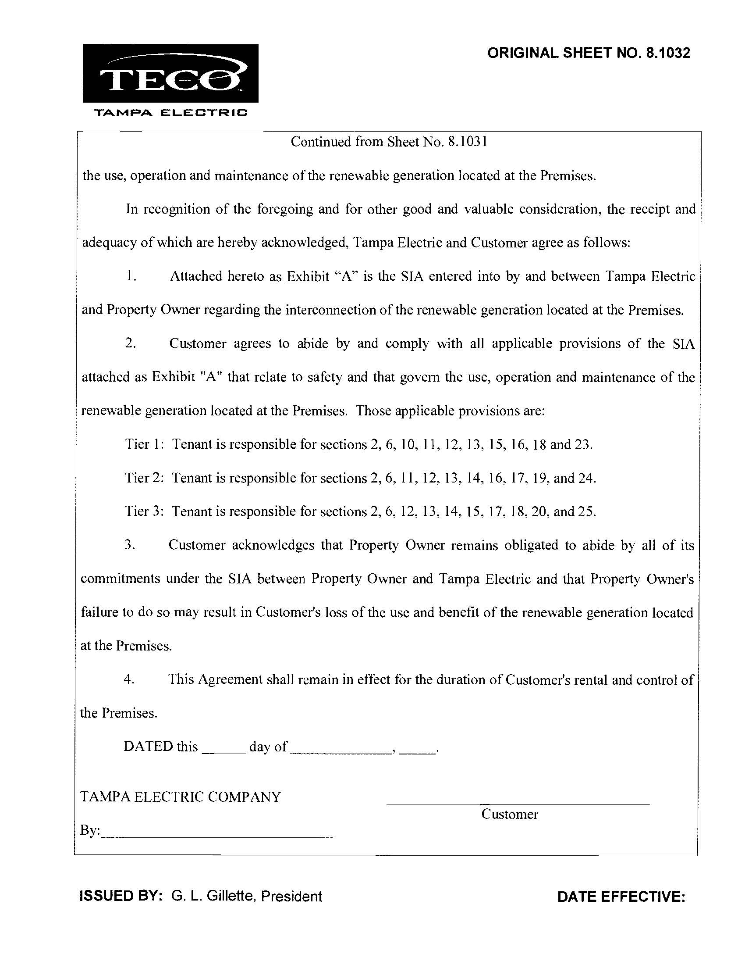

Document No. 02087-15, April 14, 2015, Notice of Informal Meeting between Commission staff and interested persons to Docket No. 150099-EI, and Document No. 02849-15, May 14, 2015, Notice of Informal Meeting between Commission Staff and interested persons to Docket No. 150099-EI.
Document No. 03139-15, May 27, 2015, Tampa Electric Company’s Supplement to Petition in Docket No. 150099-EI.

