State of Florida |  | Public Service Commission  Capital Circle Office Center ● 2540 Shumard Oak Boulevard  Tallahassee, Florida 32399-0850  -M-E-M-O-R-A-N-D-U-M-
DATE: | August 13, 2015
TO: | Office of Commission Clerk (Stauffer)
FROM: | Division of Economics (Ollila)  Division of Accounting and Finance (Mouring)  Division of Engineering (Moses)  Office of the General Counsel (Villafrate)
RE: | Docket No. 150116-GU – Petition for approval of safety, access, and facility enhancement program and associated cost recovery methodology, by Florida City Gas.
AGENDA: | 08/27/15 – Regular Agenda – Tariff Filing – Interested Persons May Participate
COMMISSIONERS ASSIGNED: |  |  | All Commissioners
PREHEARING OFFICER: |  |  | Administrative
CRITICAL DATES: |  |  | 12/07/15 (8-Month Effective Date)
SPECIAL INSTRUCTIONS: |  |  | None

Case Background
On April 7, 2015, Florida City Gas (City Gas or Company) filed its petition requesting Commission approval of a 10-year safety, access, and facility enhancement (SAFE) program and associated cost recovery mechanism. City Gas proposes to relocate on an expedited basis certain existing gas mains and associated facilities located in or associated with rear lot easements to the street front to improve safety and reliability. In addition, the SAFE program will eliminate the majority of City Gas’s 61.3 miles of unprotected steel mains.
In 2009, the Department of Transportation’s Pipeline and Hazardous Material Safety Administration amended the federal pipeline safety regulation to require natural gas distribution pipeline operators to develop Distribution Integrity Management Plans (DIMPs). The regulation requires operators, such as natural gas distribution companies to develop, write, and implement a distribution integrity management program with the following elements: knowledge, identify threats, evaluate and rank risks, identify and implement measures to address risks, measure performance, monitor results, and evaluate effectiveness, periodically evaluate and improve program; and report results. The DIMPs are reviewed by the Pipeline and Hazardous Material Safety Administration.
In 2011 Congress passed the “Pipeline Safety, Regulatory Certainty, and Job Creation Act of 2011,” which was signed into law on January 3, 2012. This law requires the Department of Transportation Secretary to review DIMPs to evaluate, among other things, “the continuing priority to enhance protections for public safety” and “the continuing importance of reducing risk in high consequence areas.”
The Commission has approved cost recovery mechanisms for other gas utilities. Specifically, in 2012, the Commission approved 10-year cast iron/bare steel replacement and cost recovery programs for Peoples Gas System (Peoples), Florida Public Utilities Company (FPUC), and the Florida Division of Chesapeake Utilities Corporation (Chesapeake). In its 2012 orders, the Commission found that the replacement of cast iron/bare steel pipelines is in the public interest to improve Florida’s gas infrastructure safety. The orders instituted a surcharge designed to recover the costs of the replacement programs. The cast iron/bare steel replacement programs require an annual filing, by September 1, to determine the next year’s surcharge. In 2014, the Commission approved the 2015 surcharges for Peoples, FPUC, and Chesapeake. For residential customers using 20 therms per month, the 2015 monthly surcharges are $0.38, $2.10, and $1.14, respectively. City Gas’s proposed monthly surcharge for the SAFE program, effective January 1, 2016, for residential customers using 20 therms per month is $0.71.
In its petition, City Gas waived the 60-day suspension date. Staff issued two data requests to City Gas. On July 31, 2015, the Company filed replacement tariff pages to correct inadvertent typographical errors for two rate classes. The proposed tariff pages are provided in Attachment 1. The Commission has jurisdiction over this matter pursuant to Sections 366.03, 366.04, 366.05, 366.06, and 368, Florida Statutes, (F.S.).

Discussion of Issues

Issue 1:
Should the Commission approve City Gas's proposed SAFE program?

Recommendation:
Yes. The Commission should approve City Gas’s proposed SAFE program and associated tariff using an annual surcharge adjustment mechanism to be implemented January 1, 2016. City Gas should be directed to file its annual SAFE petition on September 1 of each year, starting in 2016. (Ollila, Moses, Mouring)
Staff Analysis: City Gas serves in densely populated areas of South Florida and, according to the Company, the current location of many of its facilities has made it difficult for Company inspectors and repair personnel to access the facilities to identify and address problems. To address this issue, City Gas requests Commission approval of its SAFE program, a 10-year main and facility relocation and replacement program and associated cost recovery mechanism.
Under the SAFE program, City Gas proposes to relocate certain existing gas mains and associated facilities located in or associated with rear lot easements to the street front. According to City Gas, the street front location would provide for more direct access to facilities and would enhance the level of service provided to all customers through improved safety and reliability.
The Company asserts that approval of its proposed program will enable it to expedite necessary residential facility relocation and replacement activities without a general rate proceeding. City Gas anticipates that the SAFE program could lead to the creation of additional construction related jobs.

SAFE
City Gas has approximately 1,200 miles of main and associated services located in rear property easements, with the majority in Miami. Over a 10-year period SAFE would relocate and replace 254.3 miles of 4-inch and smaller mains and associated facilities from rear property easements to the street front, which would also eliminate the majority of the Company’s unprotected steel.
According to City Gas, mains and services located in rear property easements present operational and safety concerns, including the age of the facilities, limitations on the companies’ access to the facilities due to vegetation overgrowth, landscaping and construction in the easements, and potential gas theft or diversion and damages to the facilities.
City Gas’s DIMP includes a pipeline risk assessment which provides guidance in determining the relative risk of pipes, and thus, which pipes should be replaced first based on the risk level. The replacement of mains is prioritized based on location, material (e.g., unprotected steel), leak incident rates, and neighborhood characteristics. Factors such as maintenance access complications, compliance difficulties, and customer encroachments will be included in the analysis. The annual risk assessment results are reviewed by City Gas’s subject matter experts, who have local knowledge of unique operating conditions and access challenges. The subject matter experts make the final determination on which mains and associated facilities need to be replaced. The analysis will be conducted annually to ensure that the highest risk areas are being mitigated. The Company will continue to operate and maintain the remaining miles of rear property facilities throughout the period of the SAFE program and it will use the DIMP process to determine if any of these facilities need to be replaced in the future.

Cost Recovery
The Company requests recovery of the revenue requirement associated with the SAFE program including the return on the capital investment, depreciation, ad valorem taxes, income taxes, and noticing expenses through a surcharge mechanism, consistent with the replacement programs already in place for Peoples, FPUC, and Chesapeake. The cost to remove the facilities identified in the SAFE program will not be recovered through the surcharge; rather, it will be recovered through the cost of removal component in City Gas’s existing depreciation rates.
City Gas proposes a budget of no more than $9.5 million for the first full calendar year to be increased annually by a 3 percent growth factor, for a total of approximately $105 million over the proposed 10-year project life. If the Commission approves the Company’s proposal, City Gas stated that it plans to begin SAFE program spending after the approval and has included the SAFE revenue requirement for the period October through December 2015 in the calculation of rates beginning January 1, 2016.

Cost Allocation
City Gas proposes that the fixed monthly surcharge be applicable to all customers (other than those specified as excluded in its tariff because of pre-existing contractual pricing) because the facilities that would be replaced under SAFE are an integral part of the City Gas’s distribution system, and therefore, common to all customers. City Gas is proposing to use an allocation methodology that focuses on the cost drivers.
Specifically, City Gas’s methodology allocates the SAFE revenue requirement to all customers on a per customer basis at the cost of a 2-inch pipe, and allocates the incremental cost of replacing pipe larger than 2 inches to customers who use 6,000 or more therms per year. Allocating the cost of 2-inch pipes to all customers recognizes the network benefits that will apply to all customers. For larger customers, the cost pool takes into account that the minimum pipe is insufficient to serve their demand, and therefore, allocates an incremental per foot cost in addition to the all-customer cost. Exhibit C to the petition shows the development of the percentage allocation factors for the various rate classes. The allocation factors are applied to the revenue requirement to develop the monthly customer surcharges.

Bill Impact
Staff notes that the average residential customer uses 240 therms per year or 20 therms per month. The fixed surcharge for customers using between 0 and 5,999 therms per year (0 and 499.9 therms per month) is $0.71 per month for the period January 1, 2016, through December 31, 2016. For customers using over 6,000 therms per year (500 therms per month), the fixed surcharge is $1.31 per month. City Gas forecasts the $0.71 to increase to $9.45 in 2025. Because the surcharge is cumulative, if City Gas files a rate case before 2025, the then-current SAFE surcharge program would be folded into any newly approved rate base, and the surcharge would begin anew.

City Gas states that if a customer’s meter needs to be relocated as part of the Company’s SAFE program there will be no charge to customers for relocating meters or adding additional pipe to reroute from the new meter location to the old location behind the dwelling (if necessary). Customers will also not be assessed a reconnection charge.

Customer Communications
City Gas’s plan to provide notification of an approved surcharge to its customers includes:
- An on-bill message on City Gas’s December bills, thus allowing for a 30-day notice period prior to the date the surcharge would first appear on the customer’s bill.
- An article posted during December 2015 in the City Gas customer e-newsletter (for customers who prefer to receive communications via email).
- A message posted during December 2015 on the City Gas homepage and linking it to a Frequently Asked Questions document.
In addition, the Company is developing a comprehensive communication plan to notify the general public of the installations. Examples of communications strategies that City Gas is considering include the use of media, website space, webcast, blogs, social media monitoring, press releases, and advertising. The Company notes that its communications efforts must be bi-lingual to ensure those impacted by SAFE receive the necessary information.

Annual True-up
Beginning in 2016, the Company will file an annual petition with the Commission for a review and reset of the surcharge factors to true-up any over- or under-recovery, and to update the ad valorem rates and debt and equity cost rates with the most recent earnings surveillance report rates. In its petition, City Gas proposed an annual filing date of October 1 to implement the new surcharge to be effective January 1 of the following year. City Gas, however, is amenable to staff’s suggested filing date of September 1, the same filing date as Peoples, FPUC, and Chesapeake. The filing will consist of three components, consistent with the cast iron/bare steel filings of Peoples, FPUC, and Chesapeake:

- A final true-up showing the actual replacement costs and actual surcharge revenues for the most recent 12-month historical period from January 1 through December 31 that ends prior to the annual petition filing, including the final over- or under-recovery for that period.

- An actual/estimated true-up showing seven months of actual and five months of projected costs and revenues.

- A projection showing 12 months of the projected revenue requirement for period beginning January 1 following the annual filing.

City Gas will report in its annual filing any operation and maintenance expense and depreciation expense savings or incremental costs associated with the program that may occur, beginning with the second annual filing on September 1, 2017. City Gas acknowledges that the information contained in its filing would be subject to ongoing Commission review and audit with regard to accuracy, as well as the overall effectiveness of the SAFE program and the rate impact on customers.

Summary
Staff has reviewed the SAFE program and believes it is in the public interest and will serve to improve safety, reduce potential damage to property, and theft. Staff believes that the revenue requirement calculations are reasonable. With regard to the cost allocation, staff believes that City Gas’s methodology is equitable, and that the associated calculations are consistent with the methodology.
Staff recommends that City Gas’s proposed SAFE program and its tariff using an annual surcharge adjustment mechanism to be implemented January 1, 2016, be approved. City Gas should be directed to file its annual SAFE petition on September 1 of each year, starting in 2016.

Issue 2:
Should this docket be closed?

Recommendation:
No. If a protest is filed within 21 days of the issuance of the order, this tariff should remain in effect, with any revenues held subject to refund, pending resolution of the protest. If no timely protest is filed, this docket should be closed upon the issuance of a consummating order. (Villafrate)

Staff Analysis:
If a protest is filed within 21 days of the issuance of the order, this tariff should remain in effect, with any revenues held subject to refund, pending resolution of the protest. If no timely protest is filed, this docket should be closed upon the issuance of a consummating order.

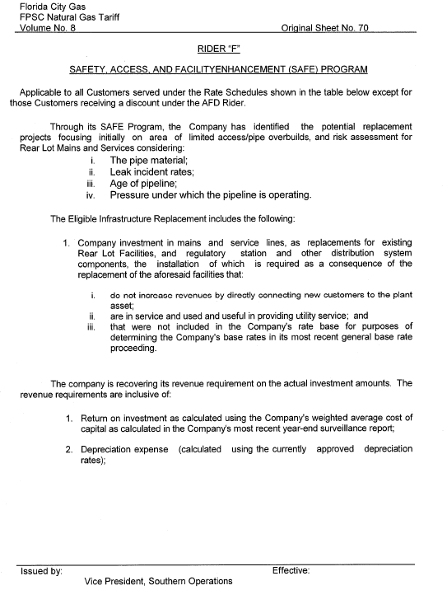
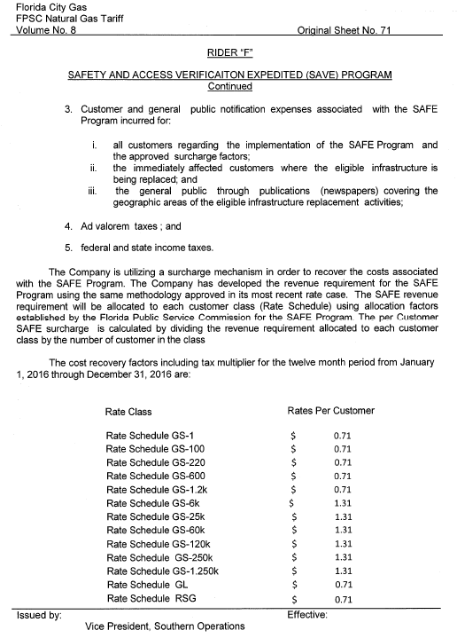
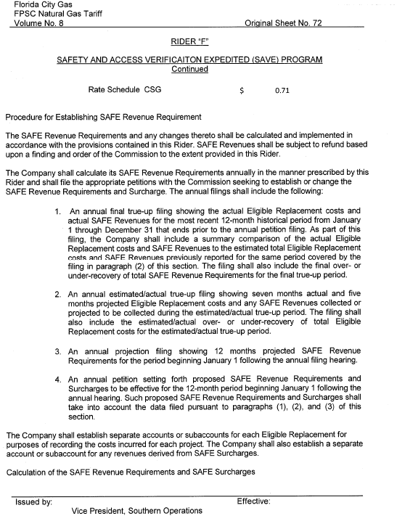

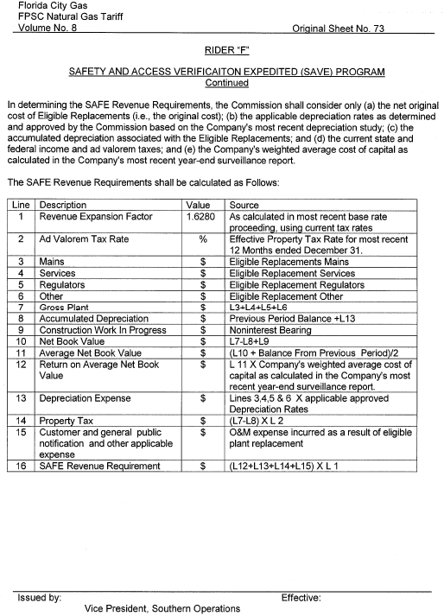

City Gas explained that it has already replaced most of its unprotected steel mains with 61.3 miles of unprotected steel mains remaining in its system. Out of the 61.3 miles, 9 miles of unprotected steel mains are located outside rear lot easements that the Company will replace outside the scope of the SAFE program. Unprotected steel is subject to corrosion, which reduces the structural integrity of the pipeline. The installation of unprotected steel pipeline was prohibited after July 1971 as a result of an amendment to Part 192.455, Code of Federal Regulations.
Order No. PSC-12-0476-TRF-GU, issued September 18, 2012, in Docket No. 110320-GU, In re: Petition for approval of Cast Iron/Bare Steel Pipe Replacement Ride (Rider CI/BSR) by Peoples Gas System and Order No. PSC-12-0490-TRF-GU, issued September 24, 2012, in Docket No. 120036-GU, In re: Joint petition for approval of Gas Reliability Infrastructure Program (GRIP) by Florida Public Utilities Company and the Florida Division of Chesapeake Utilities Corporation, respectively.

