BEFORE THE FLORIDA PUBLIC SERVICE COMMISSION

In re: Petition for approval of safety, access, and facility enhancement program and associated cost recovery methodology, by Florida City Gas. | DOCKET NO. 150116-GU  ORDER NO. PSC-15-0390-TRF-GU  ISSUED: September 15, 2015

The following Commissioners participated in the disposition of this matter:

ART GRAHAM, Chairman
LISA POLAK EDGAR
RONALD A. BRISÉ
JULIE I. BROWN
JIMMY PATRONIS

ORDER APPROVING GAS FACILITIES RELOCATION AND ASSOCIATED RIDER

BY THE COMMISSION:

Background

On April 7, 2015, Florida City Gas (City Gas or Company) filed its petition requesting Commission approval of a 10-year Safety, Access, And Facility Enhancement (SAFE) Program and associated cost recovery mechanism. City Gas proposes to relocate on an expedited basis certain existing gas mains and associated facilities located in or associated with rear lot easements to the street front to improve safety and reliability. In addition, the SAFE program will eliminate the majority of City Gas’s 61.3 miles of unprotected steel mains.
In 2009, the Department of Transportation’s Pipeline and Hazardous Material Safety Administration amended the federal pipeline safety regulation to require natural gas distribution pipeline operators to develop Distribution Integrity Management Plans (DIMPs). The regulation requires operators, such as natural gas distribution companies to develop, write, and implement a distribution integrity management program with the following elements: knowledge, identify threats, evaluate and rank risks, identify and implement measures to address risks, measure performance, monitor results, and evaluate effectiveness, periodically evaluate and improve program; and report results. The DIMPs are reviewed by the Pipeline and Hazardous Material Safety Administration.
In 2011 Congress passed the “Pipeline Safety, Regulatory Certainty, and Job Creation Act of 2011,” which was signed into law on January 3, 2012. This law requires the Department of Transportation Secretary to review DIMPs to evaluate, among other things, “the continuing priority to enhance protections for public safety” and “the continuing importance of reducing risk in high consequence areas.”
This Commission has approved cost recovery mechanisms for other gas utilities. Specifically, in 2012, we approved 10-year cast iron/bare steel replacement and cost recovery programs for Peoples Gas System (Peoples), Florida Public Utilities Company (FPUC), and the Florida Division of Chesapeake Utilities Corporation (Chesapeake). In 2012, we found that the replacement of cast iron/bare steel pipelines is in the public interest to improve Florida’s gas infrastructure safety. The orders instituted a surcharge designed to recover the costs of the replacement programs. The cast iron/bare steel replacement programs require an annual filing, by September 1, to determine the next year’s surcharge. In 2014, we approved the 2015 surcharges for Peoples, FPUC, and Chesapeake. For residential customers using 20 therms per month, the 2015 monthly surcharges are $0.38, $2.10, and $1.14, respectively. City Gas’s monthly surcharge for the SAFE program, effective January 1, 2016, for residential customers using 20 therms per month is $0.71.
In its petition, City Gas waived the 60-day suspension date. Commission staff issued two data requests to City Gas. On July 31, 2015, the Company filed replacement tariff pages to correct inadvertent typographical errors for two rate classes. The tariff pages are provided in Attachment 1. We have jurisdiction over this matter pursuant to Sections 366.03, 366.04, 366.05, 366.06, and 368, Florida Statutes, (F.S.).

Decision

City Gas serves in densely populated areas of South Florida and, according to the Company, the current location of many of its facilities has made it difficult for Company inspectors and repair personnel to access the facilities to identify and address problems. To address this issue, City Gas requests Commission approval of its SAFE program, a 10-year main and facility relocation and replacement program and associated cost recovery mechanism.
Under the SAFE program, City Gas proposes to relocate certain existing gas mains and associated facilities located in or associated with rear lot easements to the street front. According to City Gas, the street front location would provide for more direct access to facilities and would enhance the level of service provided to all customers through improved safety and reliability.
The Company asserts that approval of its program will enable it to expedite necessary residential facility relocation and replacement activities without a general rate proceeding. City Gas anticipates that the SAFE program could lead to the creation of additional construction related jobs.

SAFE
City Gas has approximately 1,200 miles of main and associated services located in rear property easements, with the majority in Miami. Over a 10-year period SAFE would relocate and replace 254.3 miles of 4-inch and smaller mains and associated facilities from rear property easements to the street front, which would also eliminate the majority of the Company’s unprotected steel.
According to City Gas, mains and services located in rear property easements present operational and safety concerns, including the age of the facilities, limitations on the companies’ access to the facilities due to vegetation overgrowth, landscaping and construction in the easements, and potential gas theft or diversion and damages to the facilities.
City Gas’s DIMP includes a pipeline risk assessment which provides guidance in determining the relative risk of pipes, and thus, which pipes should be replaced first based on the risk level. The replacement of mains is prioritized based on location, material (e.g., unprotected steel), leak incident rates, and neighborhood characteristics. Factors such as maintenance access complications, compliance difficulties, and customer encroachments will be included in the analysis. The annual risk assessment results are reviewed by City Gas’s subject matter experts, who have local knowledge of unique operating conditions and access challenges. The subject matter experts make the final determination on which mains and associated facilities need to be replaced. The analysis will be conducted annually to ensure that the highest risk areas are being mitigated. The Company will continue to operate and maintain the remaining miles of rear property facilities throughout the period of the SAFE program and it will use the DIMP process to determine if any of these facilities need to be replaced in the future.

Cost Recovery
The Company requests recovery of the revenue requirement associated with the SAFE program including the return on the capital investment, depreciation, ad valorem taxes, income taxes, and noticing expenses through a surcharge mechanism, consistent with the replacement programs already in place for Peoples, FPUC, and Chesapeake. The cost to remove the facilities identified in the SAFE program will not be recovered through the surcharge; rather, it will be recovered through the cost of removal component in City Gas’s existing depreciation rates.
City Gas proposes a budget of no more than $9.5 million for the first full calendar year to be increased annually by a 3 percent growth factor, for a total of approximately $105 million over the proposed 10-year project life. City Gas stated that it plans to begin SAFE program spending after the approval and has included the SAFE revenue requirement for the period October through December 2015 in the calculation of rates beginning January 1, 2016.

Cost Allocation
City Gas proposes that the fixed monthly surcharge be applicable to all customers (other than those specified as excluded in its tariff because of pre-existing contractual pricing) because the facilities that would be replaced under SAFE are an integral part of the City Gas’s distribution system, and therefore, common to all customers. City Gas is proposing to use an allocation methodology that focuses on the cost drivers.
Specifically, City Gas’s methodology allocates the SAFE revenue requirement to all customers on a per customer basis at the cost of a 2-inch pipe, and allocates the incremental cost of replacing pipe larger than 2 inches to customers who use 6,000 or more therms per year. Allocating the cost of 2-inch pipes to all customers recognizes the network benefits that will apply to all customers. For larger customers, the cost pool takes into account that the minimum pipe is insufficient to serve their demand, and therefore, allocates an incremental per foot cost in addition to the all-customer cost. Exhibit C to the petition shows the development of the percentage allocation factors for the various rate classes. The allocation factors are applied to the revenue requirement to develop the monthly customer surcharges.

Bill Impact
We note that the average residential customer uses 240 therms per year or 20 therms per month. The fixed surcharge for customers using between 0 and 5,999 therms per year (0 and 499.9 therms per month) is $0.71 per month for the period January 1, 2016, through December 31, 2016. For customers using over 6,000 therms per year (500 therms per month), the fixed surcharge is $1.31 per month. City Gas forecasts the $0.71 to increase to $9.45 in 2025. Because the surcharge is cumulative, if City Gas files a rate case before 2025, the then-current SAFE surcharge program would be folded into any newly approved rate base, and the surcharge would begin anew.
City Gas states that if a customer’s meter needs to be relocated as part of the Company’s SAFE program there will be no charge to customers for relocating meters or adding additional pipe to reroute from the new meter location to the old location behind the dwelling (if necessary). Customers will also not be assessed a reconnection charge.

Customer Communications
City Gas’s plan to provide notification of an approved surcharge to its customers includes:
- An on-bill message on City Gas’s December bills, thus allowing for a 30-day notice period prior to the date the surcharge would first appear on the customer’s bill.
- An article posted during December 2015 in the City Gas customer e-newsletter (for customers who prefer to receive communications via email).
- A message posted during December 2015 on the City Gas homepage and linking it to a Frequently Asked Questions document.
In addition, the Company is developing a comprehensive communication plan to notify the general public of the installations. Examples of communications strategies that City Gas is considering include the use of media, website space, webcast, blogs, social media monitoring, press releases, and advertising. The Company notes that its communications efforts must be bi-lingual to ensure those impacted by SAFE receive the necessary information.

Annual True-up
Beginning in 2016, the Company will file an annual petition with this Commission for a review and reset of the surcharge factors to true-up any over- or under-recovery, and to update the ad valorem rates and debt and equity cost rates with the most recent earnings surveillance report rates. In its petition, City Gas proposed an annual filing date of October 1 to implement the new surcharge to be effective January 1 of the following year. City Gas, however, is amenable to Commission staff’s suggested filing date of September 1, the same filing date as Peoples, FPUC, and Chesapeake. The filing will consist of three components, consistent with the cast iron/bare steel filings of Peoples, FPUC, and Chesapeake:

- A final true-up showing the actual replacement costs and actual surcharge revenues for the most recent 12-month historical period from January 1 through December 31 that ends prior to the annual petition filing, including the final over- or under-recovery for that period.

- An actual/estimated true-up showing seven months of actual and five months of projected costs and revenues.

- A projection showing 12 months of the projected revenue requirement for period beginning January 1 following the annual filing.

City Gas will report in its annual filing any operation and maintenance expense and depreciation expense savings or incremental costs associated with the program that may occur, beginning with the second annual filing on September 1, 2017. City Gas acknowledges that the information contained in its filing would be subject to ongoing Commission review and audit with regard to accuracy, as well as the overall effectiveness of the SAFE program and the rate impact on customers.

Summary
We have reviewed the SAFE program and find that it is in the public interest and will serve to improve safety, reduce potential damage to property, and impede theft. We find that the revenue requirement calculations are reasonable. With regard to the cost allocation, we find that City Gas’s methodology is equitable, and that the associated calculations are consistent with the methodology.
We find that City Gas’s SAFE program and its tariff using an annual surcharge adjustment mechanism to be implemented January 1, 2016, shall be approved. City Gas shall be directed to file its annual SAFE petition on September 1 of each year, starting in 2016.

Based on the foregoing, it is

ORDERED by the Florida Public Service Commission that Florida City Gas’ petition for its Safety, Access, And Facility Enhancement Program and associated Rider are approved effective January 1, 2016. It is further
ORDERED that Florida City Gas shall file its annual Safety, Access, And Facility Enhancement Program petition on September 1 of each year, starting in 2016. It is further

ORDERED that if a protest is filed within 21 days of issuance of the Order, the tariff shall remain in effect with any charges held subject to refund pending resolution of the protest. It is further

ORDERED that if no timely protest is filed, this docket shall be closed upon the issuance of a Consummating Order.

By ORDER of the Florida Public Service Commission this 15th day of September, 2015.

/s/ Carlotta S. Stauffer
CARLOTTA S. STAUFFER
Commission Clerk
Florida Public Service Commission
2540 Shumard Oak Boulevard
Tallahassee, Florida 32399
(850) 413-6770
www.floridapsc.com

Copies furnished: A copy of this document is provided to the parties of record at the time of issuance and, if applicable, interested persons.

JEV

NOTICE OF FURTHER PROCEEDINGS

The Florida Public Service Commission is required by Section 120.569(1), Florida Statutes, to notify parties of any administrative hearing or judicial review of Commission orders that is available under Sections 120.57 or 120.68, Florida Statutes, as well as the procedures and time limits that apply. This notice should not be construed to mean all requests for an administrative hearing or judicial review will be granted or result in the relief sought.

Mediation may be available on a case-by-case basis. If mediation is conducted, it does not affect a substantially interested person's right to a hearing.

The Commission's decision on this tariff is interim in nature and will become final, unless a person whose substantial interests are affected by the proposed action files a petition for a formal proceeding, in the form provided by Rule 28-106.201, Florida Administrative Code. This petition must be received by the Office of Commission Clerk, 2540 Shumard Oak Boulevard, Tallahassee, Florida 32399-0850, by the close of business on October 6, 2015.

In the absence of such a petition, this Order shall become final and effective upon the issuance of a Consummating Order.

Any objection or protest filed in this docket before the issuance date of this order is considered abandoned unless it satisfies the foregoing conditions and is renewed within the specified protest period.

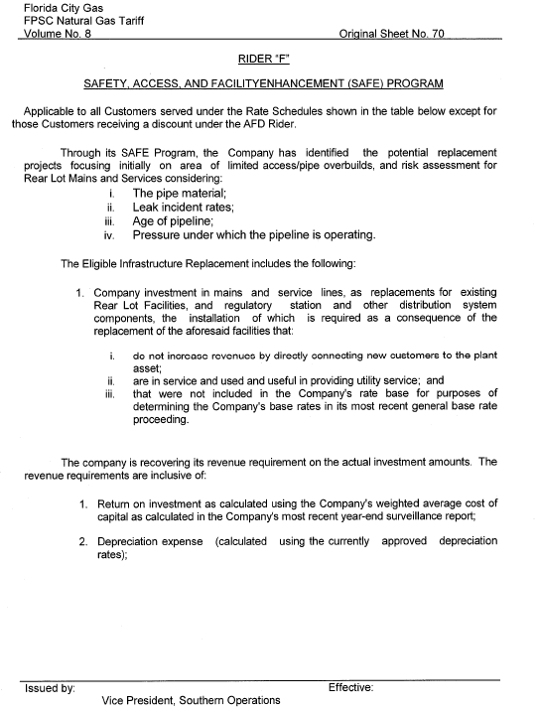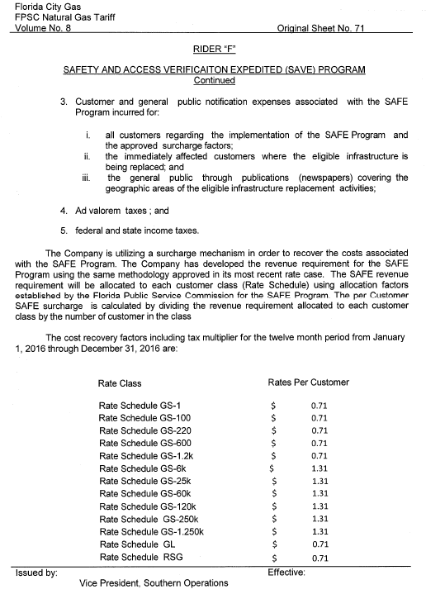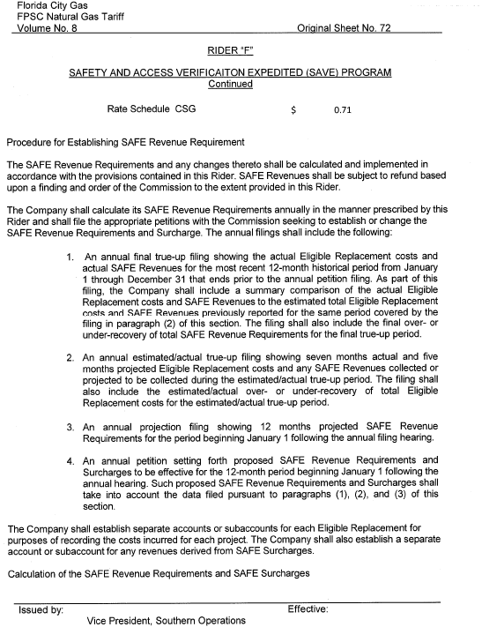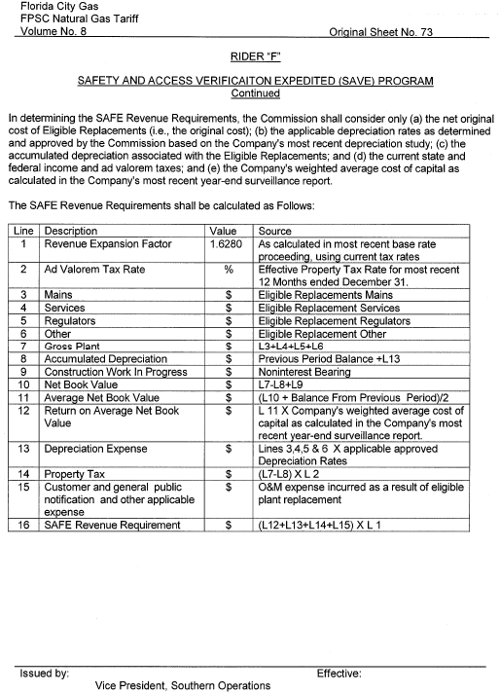

City Gas explained that it has already replaced most of its unprotected steel mains with 61.3 miles of unprotected steel mains remaining in its system. Out of the 61.3 miles, 9 miles of unprotected steel mains are located outside rear lot easements that the Company will replace outside the scope of the SAFE program. Unprotected steel is subject to corrosion, which reduces the structural integrity of the pipeline. The installation of unprotected steel pipeline was prohibited after July 1971 as a result of an amendment to Part 192.455, Code of Federal Regulations.
Order No. PSC-12-0476-TRF-GU, issued September 18, 2012, in Docket No. 110320-GU, In re: Petition for approval of Cast Iron/Bare Steel Pipe Replacement Ride (Rider CI/BSR) by Peoples Gas System and Order No. PSC-12-0490-TRF-GU, issued September 24, 2012, in Docket No. 120036-GU, In re: Joint petition for approval of Gas Reliability Infrastructure Program (GRIP) by Florida Public Utilities Company and the Florida Division of Chesapeake Utilities Corporation, respectively.

