|  |  |  |  |
| --- | --- | --- | --- |
| State of Florida  pscSEAL | | Public Service Commission  Capital Circle Office Center ● 2540 Shumard Oak Boulevard Tallahassee, Florida 32399-0850  -M-E-M-O-R-A-N-D-U-M- | |
| DATE: | October 8, 2015 | | |
| TO: | Office of Commission Clerk (Stauffer) | | |
| FROM: | Office of Industry Development and Market Analysis (Hinton, Breman, Laux)  Division of Economics (Higgins)  Division of Engineering (Matthews)  Office of the General Counsel (Barrera, Mapp) | | |
| RE: | Docket No. 150009-EI – Nuclear cost recovery clause. | | |
| AGENDA: | 10/19/15 –Special Agenda – Post-Hearing Decision – Participation Limited to Commissioners and Staff | | |
| COMMISSIONERS ASSIGNED: | | | All Commissioners |
| PREHEARING OFFICER: | | | Graham |
| CRITICAL DATES: | | | None |
| SPECIAL INSTRUCTIONS: | | | None |

Table of Contents

Issue Description Page

List of Acronyms and Abbreviations 3

Case Background 4

1 Long-term Feasibility of Completing the TP Project (Matthews, Higgins) 7

1A Estimated All-inclusive Costs for the TP Project (Matthews, Higgins) 25

1B Estimated Commercial Operation Date of the TP Project (Matthews, Higgins) 27

2 Prudence of FPL's 2014 TP Project Activities (Breman) 29

3A Can Non-COL Costs be Incurred Prior to COL Isssuance? (Barrera, Mapp) 32

3B Are Initial Assessment Costs COL Related Costs? (Breman, Barrera) 40

3C Proposal to Incur and Defer Recovery of Initial Assessment Cost (Breman) 44

4 Final True-Up of 2014 TP Project Costs (Breman, Laux) 48

5 Reasonableness of Estimated 2015 TP Project Costs (Breman, Laux) 52

6 Reasonableness of Projected 2016 TP Project (Breman, Laux) 55

7 FPL Net 2016 Recovery Amount (Breman, Laux) 58

17 Should this docket be closed? (Barrera, Mapp) 60

Attachment 1 DEF Motion for Approval of Stipulation 61

List of Acronyms and Abbreviation

|  | |
| --- | --- |
| AFUDC | Allowance for funds used during construction |
| COL | Combined operating license (issued by the NRC) |
| Commission | Florida Public Service Commission |
| CR3 Uprate Project | Multi-phased uprate project at DEF’s Crystal River Unit 3 |
| CWIP | Construction work in progress |
| DEF | Duke Energy Florida, LLC |
| EPC Contract | Engineering, Procurement, and Construction Contract |
| F.A.C. | Florida Administrative Code |
| FIPUG | Florida Industrial Power Users Group |
| FPL | Florida Power & Light Company |
| FRF | Florida Retail Federation |
| F.S. | Florida Statutes |
| Levy Project | DEF’s Levy Units 1 & 2 project |
| Miami | City of Miami |
| MW | Megawatt (1,000,000 watts) |
| NCRC | Nuclear Cost Recovery Clause |
| NRC | Nuclear Regulatory Commission |
| OPC | Office of Public Counsel |
| PCS Phosphate | White Springs Agricultural Chemicals Inc. d/b/a PCS Phosphate – White Springs |
| SACE | Southern Alliance for Clean Energy |
| TP Project | FPL’s Turkey Point Units 6 & 7 project |



Case Background

This recommendation addresses petitions for continued alternative cost recovery of new nuclear generation project costs through the Nuclear Cost Recovery Clause (NCRC) pursuant to Rule 25-6.0423, Florida Administrative Code (F.A.C.), and Section 366.93, Florida Statutes (F.S.), that were filed by Florida Power & Light Company (FPL) and Duke Energy Florida, LLC. (DEF).

Traditionally, all power plant construction projects are generally afforded the same regulatory accounting and ratemaking treatment. That is, once the need for a power plant is determined, the utility records expenditures associated with the project into Account 107, Construction Work in Progress (CWIP), for that particular project. A monthly allowance-for-funds-used-during-construction (AFUDC) rate is applied to the average balance in the CWIP account and the resulting dollar amount is then added to the account. This process continues until the project is completed. If a construction project is terminated prior to commercial service, the utility may petition to recover the related CWIP account balance over a period of years.

Once a power plant is in commercial service, the CWIP account balance is transferred to the appropriate plant-in-service accounts and becomes part of the utility’s rate base. The impact of including the total project costs in a utility’s rate base, as well as the impact of plant operating expenses, is addressed during a subsequent proceeding to determine whether customer base rates should be changed in order to provide the utility the opportunity to fully recover the project costs and plant operating expenses.

In 2006, the Florida Legislature enacted Section 366.93, F.S., to encourage utility investment in nuclear electric generation in Florida by authorizing an alternative cost recovery mechanism for new nuclear generation construction projects. Section 366.93, F.S., directed the Florida Public Service Commission (Commission) to allow investor-owned electric utilities to recover certain costs during the licensing and construction process. In 2007, Section 366.93, F.S., was amended to include integrated gasification combined cycle plants, and in 2008, the statute was amended to include new, expanded, or relocated transmission lines and facilities necessary for the new power plant. In 2013, the Florida Legislature further amended the statute to change the applicable carrying costs, restrict cost recovery during the license application process, and require Commission approval prior to commencing certain activities and purchases. The 2013 amendments also established timeframes within which the utility’s physical construction activities must commence after obtaining a combined operating license from the Nuclear Regulatory Commission (NRC).

The Commission revised adopted Rule 25-6.0423, F.A.C., to implement amendments to Section 366.93, F.S.[1] Pursuant to Rule 25-6.0423(5) and (6), F.A.C., once a utility obtains an affirmative need determination for a power plant covered by Section 366.93, F.S., the utility may petition for cost recovery using the alternative mechanism. Pursuant to Section 366.93(2), F.S., and Rule 25-6.0423(6), F.A.C., all prudently incurred preconstruction costs, as well as the carrying charges on prudently incurred construction costs, are to be recovered directly through the Capacity Cost Recovery Clause (CCRC) on an annual basis. Rule 25-6.0423(6)(c)5., F.A.C., requires a utility to submit, for Commission review and approval, an annual detailed analysis of the long-term feasibility of completing the power plant.

When a nuclear power plant enters commercial service, pursuant to statute and rule, a utility is allowed to increase its base rates. Section 366.93(4), F.S., describes the method for calculating the increase and Rule 25-6.0423(8), F.A.C., provides further details on the calculations and the process. In the event a utility elects not to complete or is precluded from completing the power plant project, Section 366.93(6), F.S., and Rule 25-6.0423(7), F.A.C., allow a utility to collect its unrecovered prudently incurred costs over a period of at least 5 years.

Rule 25-6.0423(6), F.A.C., sets forth the process by which the Commission conducts an annual hearing to determine the recoverable amount that will be included in the CCRC pursuant to Section 366.93, F.S. This is the eighth year the Commission has convened an evidentiary hearing to examine alternative cost recovery for new nuclear generation construction projects.

FPL and DEF filed petitions on March 2, 2015, seeking prudence review and final true-up of actual 2014 costs for certain nuclear power plant projects. On May 1, 2015, FPL and DEF filed additional petitions seeking approval of estimated activities and costs for 2015 and 2016. Cost recovery of any approved amounts from these petitions will occur in 2016 through the CCRC.

FPL’s petitions addressed continued development of new nuclear units Turkey Point 6 and 7 (TP Project) for which FPL obtained an affirmative need determination in 2008.[2] DEF’s petitions addressed two nuclear projects: the uprate of its existing Crystal River Unit 3 (CR3 Uprate Project), and the construction of new units Levy 1 and 2 (Levy Project). DEF obtained affirmative need determinations for the CR3 Uprate Project in 2007 and the Levy Project in 2008.[3] DEF announced cancelation of these projects in 2013.

The following parties have intervened in this year’s proceeding: the Office of Public Counsel (OPC), Florida Industrial Power Users Group (FIPUG), Southern Alliance for Clean Energy (SACE), White Springs Agricultural Chemicals Inc. d/b/a PCS Phosphate – White Springs (PCS Phosphate), Florida Retail Federation (FRF) and the City of Miami (Miami). Testimony was submitted by FPL, DEF, OPC, Miami, and Commission staff.

On August 6, 2015, DEF filed its Motion for Approval of Stipulation resolving all DEF issues in this docket.[4] OPC, PSC Phosphate, FRF, and FIPUG supported DEF’s motion while SACE and Miami took no position. DEF’s motion includes the positions of the parties as modified by this stipulation. The motion is included as Attachment 1 to this recommendation.

On August 18, 2015, the Commission convened the evidentiary hearing in the 2015 NCRC proceeding. As part of the preliminary matters, the Commission was presented with DEF’s pending motion and proposed stipulations on all DEF issues. (TR 17-18) Upon discussion with the parties, the Commission approved DEF’s motion. (TR 20) Therefore, DEF is authorized to include $56,469,745 in the calculation of its 2016 CCRC factors.

The remaining contested issues pertain to FPL’s TP Project. The focus of Issues 1, 1A, and 1B is FPL’s analysis of the feasibility of completing the TP Project; Issue 2 addresses the prudence of FPL’s 2014 project management; Issues 3A, 3B, and 3C are related to FPL’s Initial Assessment Studies; and Issues 4, 5, and 6 address project activities and costs for the reviewed period. In Issue 7 staff presents FPL’s net NCRC amount for the 2016 period based on the resolution of all prior FPL issues. On September 4, 2015, post-hearing briefs were filed by FPL, OPC, FIPUG, SACE, FRF, and Miami.

The Commission has jurisdiction over these matters pursuant to Section 366.93, F.S., as well as Sections 366.04, 366.041, 366.05, 366.06 and 366.07, F.S.

Discussion of Issues

Issue 1:

 Should the Commission approve as reasonable what FPL has submitted as its 2015 annual detailed analysis of the long-term feasibility of completing the Turkey Point Units 6 & 7 project, as provided for in Rule 25-6.0423, F.A.C?

Recommendation:

 Yes. The evidence presented demonstrated that FPL has appropriately considered all of the economic, regulatory, technical, financial, and environmental aspects impacting the feasibility of the project. Although uncertainty surrounding all these aspects of the project exists, FPL has demonstrated adequate management of project risks. Staff recommends that the Commission approve as reasonable FPL’s 2015 feasibility analysis of the Turkey Point Units 6 & 7 project. (Matthews, Higgins)

Position of the Parties

FPL:

 Yes. FPL examined fourteen combinations of fuel/environmental compliance cost and plant life scenarios and utilized an updated set of project and resource planning assumptions, including (i) an updated project cost estimate, (ii) a reasonable CO2 compliance cost forecast based on information from a reputable, independent firm, and (iii) a reasonable estimate for transmission investments that would be needed to bring power into the Southeastern Florida area if Turkey Point 6 & 7 were not added. The results of the analysis support the feasibility of continuing the Turkey Point 6 & 7 project and completing the licensing phase currently underway.

OPC:

 No. FPL’s 2015 feasibility analysis is flawed because the analysis utilizes unreasonably low costs for Turkey Point Units 6 and 7. The capital costs of the generation options, projected fuel costs and projected environmental impact cost components of the feasibility analysis must accurately reflect the proposed project costs for the analysis to provide meaningful results. FPL’s feasibility study failed to consider the significant cost increases in the Vogtle and Summer nuclear projects for both the owners and contractor.

FIPUG:

 No.

SACE:

 No. FPL has failed to complete and properly analyze a realistic feasibility analysis. It does not consider the reality of the Vogtle or Summer AP-1000 reactors, nor does it place demand side management on a level playing field with the proposed reactors.

FRF:

 Agree with OPC.

MIAMI:

 No. FPL's analysis of the long-term economic feasibility of Turkey Point 6 & 7 hinges on avoiding carbon costs that FPL projects to be unreasonably extreme and transmission costs that are not well supported. Accordingly, FPL has not met its burden to submit a reasonable long-term feasibility analysis and has failed to demonstrate that its project is economically feasible. Therefore, FPL’s feasibility analysis does not offer any insight into the project’s likely value to ratepayers and the Commission should reject it. Miami incorporates its statement of basic position by reference.

Staff Analysis:

 This issue presents staff’s review and recommendation concerning the reasonableness of FPL 2015 long-term feasibility analysis of completing the TP Project.

Parties’ Arguments

FPL

FPL stated that the results of the 2015 feasibility analysis present a strong case for continuing the TP Project. FPL asserted that in more than half of the scenarios evaluated within the feasibility analysis the TP Project is the clear economic choice for its customers. (FPL BR 3) FPL argued that the high end of its overnight project cost range would still remain reasonable even if it directly took into account reported costs experienced at the Vogtle and Summer projects or reflected an estimate of Vogtle’s contractor cost as suggested by OPC’s witness Jacobs. (FPL BR 15) FPL stated that the carbon dioxide emissions compliance cost included in this years analysis was updated to reflect the draft Clean Power Plan target start date. (FPL BR 5) FPL argued that FPL’s CO2 emission compliance cost forecast is reasonable since no party presented an alternative forecast demonstrating that lower emission compliance cost assumptions would be reasonable. (FPL BR 19) FPL also maintained its assumptions related to avoided transmission investments, as used in the feasibility analysis, are well supported and reasonable compared to the cost of constructing a new pipeline for the competing NGCC resource. (FPL BR 23) FPL, therefore, asserted that its 2015 feasibility analysis should be approved since it utilized updated assumptions to ensure FPL was reflecting the best information that was available at the time the study was developed. (FPL BR 5)

OPC and FRF

OPC, supported by FIPUG and FRF, asserted that FPL’s 2015 long-term feasibility analysis is flawed since the analysis utilizes unreasonably low costs for the TP Project. (OPC BR 3; FIPUG BR 1; FRF BR 1) OPC argued that the costs used by FPL do not reflect the significant cost increases experienced by both the owners and contractor at the Vogtle and Summer nuclear projects. (OPC BR 3, 4) OPC also argued that FPL’s inputs to its feasibility analysis are old, dated or understated. (OPC BR 5) OPC asserted that witness Jacobs testified that a relatively small change in the assumed capital costs can have a significant impact on the feasibility analysis. (OPC BR 10) Therefore, OPC argues that given the risk of significant project cost increases, FPL must be required to update its feasibility study to reflect current and accurate cost information. (OPC BR 9)

FIPUG

In addition to its support of the arguments presented by OPC, FIPUG also argued that FPL’s projections are based on untested assumptions and projections that are uncertain, and for which a high degree of confidence is lacking. (FIPUG BR 1, 4)

SACE

SACE asserted that for the Commission to approve FPL’s feasibility analysis it must find that FPL used realistic capital cost and break even cost estimates. (SACE BR 21) SACE argued that the preponderance of the evidence showed that the non-binding costs used as the foundation of FPL’s feasibility analysis grossly underestimated the costs of the TP Project. (SACE BR 21) SACE contended that FPL is relying on cost estimates that are 5 years old. (SACE BR 8) In addition, SACE stated that it is not reasonable for FPL to assume a 60-year life for the proposed units. SACE argued that while some nuclear reactor licenses have been renewed for an additional 20 years, no nuclear unit anywhere in the United States has operated for a full 60 years. (SACE BR 15) SACE asserted that FPL also did not properly analyze a realistic feasibility analysis since FPL did not provide data to support its non-inclusion of DSM as a resource. (SACE BR 21) SACE argued that without information concerning DSM, the feasibility study does not provide all the appropriate checks and balances to ensure that the construction of the nuclear units continue to be in the best interest of ratepayers. (SACE BR 21) Therefore, SACE argued that FPL has not met its burden under Commission Rule 25-6.0423 F.A.C. (SACE BR 21)

Miami

Miami asserted that FPL’s 2015 long-term feasibility analysis is premised on faulty assumptions which do not provide an accurate picture of TP Project’s value to ratepayers or a reasonable basis on which to approve further recovery. (Miami BR 7) In particular, Miami argued that the feasibility analysis is not reasonable because it includes unrealistic extrapolations of the cost of emitting carbon. (Miami BR 3) Miami stated that both FPL witness Sim and its own witness, Mr. Meehan, agreed that the avoided carbon emission cost is the most significant of the projected benefits of TP Project. (Miami BR 3) Miami contended that the carbon emissions costs as extrapolated by FPL, and used in the feasibility analysis, are based on forecasts that are three years old. (Miami BR 2, 5) Miami argued this extrapolated forecast results in unreasonably extreme carbon emissions costs since the emissions costs are drastically higher than the predicated long run cost of fuel by a factor of two to five and reach up to eight times the cost that would result from inflation alone, increasing by a factor of over 20 during the project’s operating life. (Miami BR 4, 7) Miami similarly argued that the avoided transmission costs used by FPL in the feasibility analysis is unreasonable since FPL provided only hearsay evidence to support this benefit base on a notion that the alternative gas-fired capacity could not be located in South Florida. (Miami BR 7) Based on these arguments, Miami concludes that the Commission should not approve FPL’s submitted long-term feasibility analysis as reasonable. (Miami BR 5)

Analysis

Required Elements

Rule 25-6.0423(6)(c)5, F.A.C., states:

Along with the filings required by this paragraph, each year a utility shall submit for Commission review and approval a detailed analysis of the long-term feasibility of completing the power plant. Such analysis shall include evidence that the utility intends to construct the nuclear or integrated gasification combined cycle power plant by showing that it has committed sufficient, meaningful, and available resources to enable the project to be completed and that its intent is realistic and practical.

In Order No. PSC-08-0237-FOF-EI the Commission provided specific guidance regarding the requirements necessary for FPL to satisfy Rule 25-6.0423(6)(c)5., F.A.C.:

FPL shall provide a long-term feasibility analysis as part of its annual cost recovery process which, in this case, shall also include updated fuel forecasts, environmental forecasts, breakeven costs, and capital cost estimates. In addition, FPL should account for sunk costs. Providing this information on an annual basis will allow us to monitor the feasibility regarding the continued construction of Turkey Point 6 and 7.[5]

Staff recommends that FPL has satisfied the requirements of Order No. PSC-08-0237-FOF-EI and Rule 25-6.0423, F.A.C., through both prefiled direct testimony and discovery responses. (EXH 22; EXH 23; EXH 24; EXH 25; EXH 31; EXH 32; EXH 33; EXH 34)

FPL’s 2015 analysis of the long term feasibility of completing the TP Project remained consistent with the methodology it used in the 2007-2008 need determination proceeding and each subsequent NCRC proceeding.[6] Stated most simply, FPL’s analysis entailed comparing the TP Project to an alternate project which adds non-nuclear generating capacity to its system. The competing, non-nuclear resource option is a new, highly fuel-efficient, natural gas-fired combined cycle generating unit of the type FPL is constructing at its Port Everglades Modernization project. (TR 804) In evaluating these options, FPL considered numerous quantitative and qualitative factors. Among the quantitative factors that FPL examined were fuel price forecasts, environmental compliance cost projections, project costs, and cost-effectiveness using multiple sensitivities for fuel and environmental costs. (TR 798-799) Qualitative factors considered included fuel diversity, energy security, and zero greenhouse gas emissions. (TR 196) Staff examined each of these factors, as well as regulatory considerations, technical considerations, funding potential, joint ownership, reliability, renewable generation sources, and conservation to determine the reasonableness of FPL’s analysis of the long-term feasibility of completing the project.

Staff recommends that the forecasts, cost estimates, and cost-effectiveness analyses are necessary elements to assess FPL's 2015 analysis of the feasibility of completing the TP Project. In addition, staff reviewed regulatory and technical aspects of the project, as well as evidence of FPL’s intent to construct the new power plants, as required by Rule 25-6.0423(6)(c)5., F.A.C. These elements provide a holistic perspective for staff's recommendation regarding the reasonableness of FPL's detailed long-term feasibility analysis.

Economic Analysis

Updated Fuel Forecast

FPL explained it developed its updated fuel price forecasts from the same industry-accepted sources FPL has used since the need determination proceeding. The Company blended natural gas pricing data from the November 3, 2014 Henry Hub natural gas commodity prices and the most current projections from The PIRA Energy Group for 2017 through 2035. Beyond 2035, FPL used the real rate of escalation from the Energy Information Administration. In addition, nominal price forecasts were prepared for transportation cost. The projected transportation costs were added to commodity cost projections to provide delivered price forecasts. (EXH 31)

FPL’s fuel cost forecasting methodology provided a high, medium, and low cost projection. The same methodology has been used in each NCRC proceeding since 2009. FPL witness Sim agreed that future fuel costs are inherently uncertain, but explained that the further in the future the forecast, the more the values are discounted. (TR 866) None of the intervenors in the docket disputed the validity of FPL’s forecasted values for fuel. Staff finds that the range developed by FPL offers a plausible expectation that actual prices will fall somewhere within the forecasted range. Staff is persuaded that FPL’s updated fuel cost data is reasonable for use in this proceeding.

Figure 1-1 depicts the price forecasts for the medium range of natural gas used from the 2009 NCRC proceeding through this year’s filing to support FPL’s feasibility analysis. Staff notes that natural gas price forecasts have trended slightly downward each year, with the exception of the extension of the forecast period past 2040 provided by FPL since last year’s proceeding. The extended forecast for 2015 shows a smaller increase in later years.

**Figure 1-1**

**Forecasted Delivered Natural Gas Prices – Medium Fuel Forecast**

**($/MMBTU, $Nominal)**

Sources: FPSC Order No. PSC-14-0617-FOF-EI, p. 18; EXH 22

Updated Environmental Forecast

Section 403.519(4)(b)3., F.S., requires the Commission to consider air emission compliance costs in evaluating the need for new electrical generation. The absence of greenhouse gas emissions continues to be a benefit associated with nuclear generation. Each increase in projected environmental compliance costs for emitting sulfur dioxide (SO2), nitrous oxides (NOx), and carbon dioxide (CO2) have the effect of making a nuclear plant more cost-effective as compared to fossil fuel generation, such as natural gas, coal, and oil.

The updated environmental cost forecasts FPL submitted were developed with consultant ICF, the same industry-accepted source FPL has used since the need determination proceeding. The forecasted values for SO2 and NOx costs in the current feasibility analysis have changed dramatically from those in the 2014 analysis. These changes result from the 2014 ruling by the U.S. Supreme Court which countermanded a 2011 decision of the District Court of Appeals in D.C. to stay the Environmental Protection Agency’s Cross-State Air Pollution Rule.[7] (EXH 31)

Tables 1-1 through 1-3 below depict the price forecasts for the medium range of environmental costs used from the 2009 NCRC proceeding through this year’s filing to support FPL’s feasibility analysis.

**Table 1-1**

**Forecasted Sulfur Dioxide Compliance Costs ($/ton, $Nominal)**

|  |  |  |  |  |  |  |  |
| --- | --- | --- | --- | --- | --- | --- | --- |
| Selected Years | Forecasted Sulfur Dioxide (SO2)  Compliance Cost ($/ton) | | | | | | |
| 2009 | 2010 | 2011 | 2012 | 2013 | 2014 | 2015 |
| 2025 | $4,998 | $4,882 | $74 | $72 | $72 | $72 | - |
| 2030 | $4,453 | $5,319 | $84 | $82 | $82 | $82 | $0 |
| 2040 | $2,653 | $3,278 | $108 | $105 | $105 | $105 | $0 |
| 2050 | - | - | - | - | - | $134 | $0 |
| 2060 | - | - | - | - | - | $172 | $0 |
| 2070 | - | - | - | - | - | $220 | $0 |
| 2080 | - | - | - | - | - | $282 | $0 |

Sources: FPSC Order No. PSC-14-0617-FOF-EI, p. 19; EXH 22

Note: a “-” denotes no value provided for specified year

**Table 1-2**

**Forecasted Nitrogen Oxide Compliance Costs ($/ton, $Nominal)**

|  |  |  |  |  |  |  |  |
| --- | --- | --- | --- | --- | --- | --- | --- |
| Selected Years | Forecasted Nitrogen Oxide (NOx)  Compliance Cost ($/ton) | | | | | | |
| 2009 | 2010 | 2011 | 2012 | 2013 | 2014 | 2015 |
| 2025 | $3,408 | $1,257 | $668 | $652 | $652 | $652 | - |
| 2030 | $1,545 | $1,085 | $756 | $737 | $737 | $737 | $125 |
| 2040 | $0 | $1,389 | $968 | $944 | $944 | $944 | $125 |
| 2050 | - | - | - | - | - | $1,208 | $125 |
| 2060 | - | - | - | - | - | $1,547 | $125 |
| 2070 | - | - | - | - | - | $1,980 | $125 |
| 2080 | - | - | - | - | - | $2,534 | $125 |

Sources: FPSC Order No. PSC-14-0617-FOF-EI, p. 19; EXH 22

Note: a “-” denotes no value provided for specified year

**Table 1-3**

**Forecasted Carbon Dioxide Compliance Costs ($/ton, $Nominal)**

|  |  |  |  |  |  |  |  |
| --- | --- | --- | --- | --- | --- | --- | --- |
| Selected Years | Forecasted Carbon Dioxide (CO2)  Compliance Cost ($/ton) | | | | | | |
| 2009 | 2010 | 2011 | 2012 | 2013 | 2014 | 2015 |
| 2025 | $43 | $44 | $47 | $11 | $11 | $11 | - |
| 2030 | $67 | $67 | $68 | $21 | $21 | $21 | $31 |
| 2040 | $149 | $149 | $141 | $64 | $64 | $64 | $85 |
| 2050 | - | - | - | - | - | $154 | $195 |
| 2060 | - | - | - | - | - | $321 | $377 |
| 2070 | - | - | - | - | - | $448 | $482 |
| 2080 | - | - | - | - | - | $573 | $617 |

Sources: FPSC Order No. PSC-14-0617-FOF-EI, p. 19; EXH 22

Note: a “-” denotes no value provided for specified year

In the 2011 NCRC proceeding, witness Sim explained that the reduction in SO2 and NOx emission compliance costs between 2010 and 2011 were due to projections that utilities would add control devices for these emissions in response to Environmental Protection Agency rules.[8] The decision by the U.S. Supreme Court in 2014 has again led to a reduction in the forecasted emissions costs for SO2 and NOx. The forecasted cost for CO2 emissions, however, has increased slightly since 2014. (EXH 22)

The City of Miami argued that FPL’s projection of the costs of CO2 emissions is unreasonable because it is based on unrealistic extrapolations that are extreme. (TR 607-608) FPL stated that its CO2 cost forecast is based on the best information available at the time the feasibility analysis was performed. (TR 835, 943-946) FPL has been using the same source (consulting firm ICF International or ICF) for its CO2 cost projections in all its resource planning work, including all NCRC proceedings, since it began using such forecasts in 2006-2007. (TR 832) Although the ICF CO2 cost projection forecast extends only through the year 2030, FPL’s extrapolation of the values beyond 2030 was based on guidance from ICF. (TR 903-904) Miami witness Meehan stated that FPL’s CO2 emissions cost projections are unreasonable, stating that “carbon price assumptions made by FP&L do not pass a common sense test.” (TR 607) However, witness Meehan provided no alternative CO2 cost forecasts for comparison. (TR 835)

Through discovery, staff requested that Miami provide copies of any additional CO2 price forecasts that witness Meehan relied upon in formulating his testimony. Staff was informed that witness Meehan did not review any alternative pricing schedules, but rather was testifying to the “facial implausibility of FP&L’s forecast and the need for a thorough investigation of this issue.” (EXH 42) Staff is unable to systematically analyze witness Meehan’s claims that the Company’s CO2 assumptions are implausible without having access to a credible alternative forecast for comparison purposes. Therefore, staff is not persuaded that the Company’s forecast of environmental compliance costs related to CO2 is unreasonable.

Miami witness Meehan suggested the Commission examine FPL’s projected transmission investment associated with the alternative to the TP Project. (TR 607) Staff notes that FPL’s analysis of the resource plan with TP Project includes assumed transmission cost savings associated with increasing capacity at the Turkey Point Site. (TR 822) FPL Witness Sim testified:

Mr. Meehan calls for the FPSC to conduct a thorough review of the feasibility analysis, apparently unaware that is what the FPSC do[es] each year in accordance with the Nuclear Cost Recovery (NCR) Rule. Although he calls particular attention to the fact that CO2 and transmission-related projected benefits are significant, he offers no alternative forecasts or analysis methodologies that he believes are superior to FPL’s forecasts and methodologies.

(TR 827)

FPL witness Sim also testified that “FPL’s approach in its 2015 feasibility analysis, including transmission benefits and CO2 benefits, is essentially unchanged from prior feasibility analyses that have been filed by FPL,” and that these methodologies and assumptions have been “consistently reviewed and accepted by the FPSC.” (TR 828)

With regard to further examining the assumed costs of additional transmission to support the alternative to the TP Project, staff believes there is a lack of compelling evidence that would point to the unreasonableness of the FPL’s analysis of additional transmission requirements related to the resource plan without the TP Project.

SACE produced an alternative forecast from Synapse which illustrated the fact that an alternative forecast exists for CO2 costs which are higher than those projected by FPL. (TR 910) Staff notes that using such a forecast in the analysis would tend to improve the relative cost-effectiveness of the TP Project.

Staff notes that CO2 forecasts lower than that provided by FPL may exist. However, none were identified or presented for the Commission’s consideration in this proceeding. Staff is not persuaded that the projections offered by FPL for environmental emissions costs are unreasonable. Staff recommends that FPL’s environmental cost projections are reasonable for the purposes of the feasibility study.

Updated Project Cost Estimate

FPL Witness Scroggs, in presenting the Company’s 2015 estimated project costs and feasibility, testified that the estimated overnight cost[9] range of completing the TP project is $3,844 per kW to $5,589 per kW. Including inflation and carrying costs, with Commercial Operation Dates (CODs) of 2027 and 2028, the total non-binding cost estimate range of the TP Project is $13.7 to $20.0 billion. (TR 218) FPL’s cost estimates for the TP Project are based on the original cost estimate range filed as part of the 2008 need determination proceeding.[10] (TR 637) In their respective position statement briefs, OPC, FIPUG, Miami, and SACE stated the opinion that the all-inclusive cost estimate of completing the TP Project is understated and will likely be exceeded. While proffering no testimony on this issue, FIPUG, SACE, and FRF share in the beliefs of OPC and Miami. The history of cost range estimates is shown in Figure 1-2 below.

**Figure 1-2**

**Range of Non-Binding Overnight Capital Cost Estimates ($/kW)**

Sources: FPSC Order No. PSC-14-0617-FOF-EI, p. 21; TR 813

OPC witness Jacobs testified that the cost estimate for completing the TP Project is flawed due to old, dated, and understated data. The witness stated he believed that certain construction delays and cost increases experienced at nuclear projects currently under construction (Plant Vogtle and V.C. Summer) have not been incorporated into FPL’s cost estimate. (TR 503-504) Witness Jacobs stated that “[t]he precise amount of these additional costs is not publicly available; however, the magnitude of these costs can be inferred.” (TR 504)

OPC witness Jacobs further testified that the current schedule for commercial operation of Vogtle Unit 3 is 39 months later than originally planned, and due to the terms of the construction agreement, much of the delay costs are being borne by the contractor. (TR 504) The witness opined that the actual costs being incurred are substantially higher than those being publically reported. (TR 504) Witness Jacobs stated that he believes the additional costs of schedule overruns will be reflected in future new build nuclear projects and should be accounted for in the current analysis. (TR 510) More specifically, witness Jacobs recommended that, prior to FPL commencing preconstruction work, cost estimates based on actual, binding bids from qualified contractors with an appropriate amount of contingency added to the bids should be incorporated into the analysis. The witness argued that in lieu of binding bids from qualified contractors, the feasibility analysis should “reflect the higher costs” being experienced by other new-build nuclear projects consisting of both owners’ costs and an estimate of the contractors’ costs. (TR 513)

FPL Witness Scroggs testified that he believed it is not possible to obtain binding bids based on the actual costs of other nuclear projects at this stage of the TP Project, especially in light of recent amendments to NCRC statutes. (TR 641) The witness went on to state that “[u]ntil a clear path to implementation is identified and approved by the Commission, FPL will not be able to obtain meaningful and realistic competitive bids reflecting the combined influences of current costs, a defined schedule, and associated terms and conditions needed to support a more certain and executable cost and schedule estimate.” (TR 642) Witness Scroggs also testified that, due to Vogtle and Summer being first-of-a-kind construction projects, using cost and schedule data based on those projects fails to reflect the impact of lessons learned which could impact the outcome of the TP Project. (TR 644) Additionally, FPL witness Reed testified that cost and schedule improvements in the construction industry are generally considered to occur between construction of first-of-a-kind projects and subsequent similar projects. (TR 719)

Staff is not persuaded that incorporating unquantified project cost overruns, as well as project delays, occurring at the Vogtle and Summer construction projects into the analysis for the TP Project is appropriate. Because OPC witness Jacobs provided no reasonable alternative cost estimates, staff is unable to conclude that FPL’s cost analysis is unreasonable. Staff is persuaded that the TP Project will likely benefit from lessons learned during the construction of the Vogtle and Summer plants.

Project Cost Effectiveness

FPL conducted its cost-effectiveness analysis using its updated fuel and environmental compliance costs, projected in-service dates of 2027-2028, and overnight capital cost ranging from $3,844/kW to $5,589/kW. (TR 807, 813) OPC witness Jacobs expressed doubts regarding the accuracy of the estimated cost and in-service dates. (TR 535) However, no reasonable alternative estimates for either cost or in-service dates were presented by any of the intervening parties.

FPL asserted it used dates that are the "earliest practicable" in-service dates, fully acknowledging that future events could impact the project schedule. (TR 215) In fact, FPL witness Sim testified that not all of the changes in the assumptions made between performing the 2014 and 2015 feasibility analysis were favorable to the TP Project. (TR 814) However, FPL argued that even with the changes to the in-service dates, the results of the overall analysis indicate that the project should continue to move forward. (TR 823-824) Staff recommends that FPL’s currently projected in-service dates, even after being revised to later dates, does not render its feasibility analysis inadequate.

FPL’s assessment of the cost-effectiveness of the TP Project once again relied on the same breakeven analysis it has used since the need determination. (TR 806) This methodology first requires calculation of the breakeven capital costs in terms of both the cumulative present value of revenue requirements (CPVRR) and overnight construction costs for two competing resource plans. One resource plan includes the new nuclear units, and the alternative resource plan utilizes two new natural gas-fired combined cycle generating units. The costs for the two resource plans are then analyzed over a multi-year period and compared in terms of relative costs. (TR 804)

In order to calculate the breakeven nuclear capital costs, the cost corresponding to a $1/kW overnight cost is found to be $2.048 million CVPRR (in 2015$). Then, the CPVRR cost differentials between the two resource plans is divided by $2.048 million to yield the $/kW breakeven costs. (EXH 31) The comparison of the $/kW breakeven costs between the two competing resource plans provides an estimate of the highest capital costs at which nuclear generation would still be cost-effective compared to the combined cycle alternative over the life of the project. In order to provide a more robust picture, FPL’s analysis utilized a total of 14 different scenarios with various fuel and environmental compliance cost forecasts. These scenarios combined varying fuel cost forecasts (low, medium, and high) and environmental compliance cost projections (ENV I, ENV II, and ENV III). ENV I represented a low compliance cost scenario, while ENV II and ENV III represented the medium and high compliance cost scenarios, respectively. Seven different combinations of fuel and environmenta1 cost scenarios were analyzed for each operating life alterative. The present value cost estimates over the study period for each scenario were then used to calculate a breakeven capital cost to estimate what the cost for the nuclear units could be while still producing a net savings when compared to the combined cycle units. Each breakeven value was then compared to the overnight capital cost range of $3,844/kW to $5,589/kW to determine the likelihood of the nuclear project producing a net savings over the study period. (TR 816) If the breakeven values are higher than the current capital cost estimates, then the nuclear plants are projected to provide net savings over the life of the units compared to alterative base load units. Staff is persuaded that FPL’s approach in performing this analysis remains reasonable.

Since its 2014 analysis, FPL has included the consideration of the TP Project having an operating life of 60 years. While analyses previous to 2014 have addressed an operating life of only 40 years, FPL witness Sim observed that “all four of FPL's nuclear units have received a license extension from the Nuclear Regulatory Commission enabling each unit to operate for a total of 60 years.” (TR 813) Witness Sim also cited three additional units owned and operated by FPL’s parent company, NextEra Energy, that have received license extensions to operate for a total of 60 years. Witness Sim summarizes by saying he believes “that a 40-year operating life assumption for Turkey Point 6 & 7 is increasingly conservative.” (TR 813) FPL again presented a breakeven analysis for both a 40-year operational life, referred to as Case #1, and a 60-year operational life, referred to as Case #2. (EXH 25; EXH 26)

Miami witness Meehan testified that he did not currently believe FPL’s 2015 Feasibility Analysis remains a reasonable basis for concluding the TP Project will be cost effective for ratepayers. (TR 602) The witness listed several factors that influenced his conclusion, including major long-term changes in the natural gas market, delays in the TP Project’s CODs, speculative environmental regulations and associated cost assumptions, and delays being experienced at other new build nuclear projects which are currently underway. Further, witness Meehan testified that “the economic justification for Turkey Point units 6 and 7 is increasingly dependent upon a 60[-]year life assumption” and that the economic viability of the TP project using a 40-year life assumption is increasingly uncertain. (TR 603)

Staff agrees with Witness Meehan that a using a 40-year operating life assumption increases the economic uncertainty of the TP Project. (EXH 25; EXH 26) However, staff is not persuaded that assuming a 60-year life for the TP Project is unreasonable. In fact, witness Meehan testified that “I do not question the likelihood that Turkey Point, if built would operate for 60 years.” (TR 613)

The results of the 40-year (Case #1) and 60-year (Case #2) breakeven analyses, shown respectively in Tables 1-4 and 1-5 below, demonstrate that the TP Project is projected to remain cost-effective compared to the alternative combined cycle unit. For Case #1, two of the seven scenario analyzed illustrated that the breakeven nuclear capital costs are projected to be above FPL’s estimated range of $3,844 per kW to $5,589 per kW, which represents the expectation that the TP Project is the more cost-effective alternative. These cases are shown in bold print in Table 1-4. In the remaining five scenarios, the breakeven nuclear capital costs fall within the non-binding cost estimate range. (TR 816)

**Table 1-4**

**2015 Breakeven Analyses Results: 40-year Operating Life (Case # 1)**

|  |  |  |  |  |  |
| --- | --- | --- | --- | --- | --- |
| Fuel Cost Forecast | Environmental Compliance Cost Forecast | Total Costs for Plans  (million CPVRR 2015$) | | | Breakeven Nuclear Capital Costs  ($/kW in 2015$) |
| Plan w/ TP 6 & 7 | Plan w/o TP 6 & 7 | Total Cost Difference |
| (1) | (2) | (3) | (4) | (5) = (3) – (4) | (6) |
| High | Env I | 140,810 | 151,571 | (10,762) | 5,254 |
| High | Env II | 148,047 | 159,595 | (11,548) | **5,639** |
| High | Env III | 155,298 | 167,645 | (12,348) | **6,031** |
| Medium | Env I | 125,989 | 135,525 | (9,536) | 4,654 |
| Medium | Env II | 133,186 | 143,498 | (10,312) | 5,034 |
| Medium | Env III | 140,393 | 151,496 | (11,103) | 5,421 |
| Low | Env I | 110,950 | 119,248 | (8,298) | 4,049 |

Source: Exhibit 25

The results of the 60-year breakeven analysis, Case #2 shown in Table 1-5 below, demonstrated that the TP Project was projected to be clearly cost-effective compared to the alternative combined cycle unit. The results in six of the seven scenarios illustrated that breakeven nuclear capital costs are above FPL’s estimated range of costs of $3,844 per kW to $5,589 per kW, which demonstrate a high likelihood of cost-effectiveness across the full range of environmental compliance costs when fuel costs are in the medium to high ranges. These cases are shown in bold print in Table 1-5. In the remaining scenario, the breakeven nuclear capital cost falls within the non-binding cost estimate range. (TR 816)

**Table 1-5**

**2015 Breakeven Analyses Results: 60-year Operating Life (Case #2)**

|  |  |  |  |  |  |
| --- | --- | --- | --- | --- | --- |
| Fuel Cost Forecast | Environmental Compliance Cost Forecast | Total Costs for Plans  (million CPVRR 2015$) | | | Breakeven Nuclear Capital Costs  ($/kW in 2015$) |
| Plan w/ TP 6 & 7 | Plan w/o TP 6 & 7 | Total Cost Difference |
| (1) | (2) | (3) | (4) | (5) = (3) – (4) | (6) |
| High | Env I | 165,666 | 178,785 | (13,119) | **6,408** |
| High | Env II | 177,061 | 191,427 | (14,366) | **7,018** |
| Hight | Env III | 188,470 | 204,108 | (15,638) | **7,640** |
| Medium | Env I | 149,624 | 161,367 | (11,743) | **5,734** |
| Medium | Env II | 160,969 | 173,950 | (12,982) | **6,341** |
| Medium | Env III | 172,319 | 186,565 | (14,246) | **6,959** |
| Lowt | Env I | 133,349 | 143,709 | (10,360) | 5,058 |

Source: Exhibit 26

Breakeven cost values above the maximum estimated cost suggest a high likelihood of cost-effectiveness; those breakeven values below the minimum estimated cost suggest a low likelihood of cost-effectiveness. Breakeven cost values within the estimated cost range may or may not be cost-effective, depending on the actual values of the variables at play, such as fuel and environmental costs. (TR 816-817)

In 2014, the range of breakeven costs for a 40-year plant operating life was slightly lower than the current range. In 2015, both the ranges of estimated capital costs and breakeven costs have increased, with the low end of the breakeven cost range rising above the low end of the capital cost range. The ranges of estimated capital cost and breakeven costs have also increased under an assumption of a 60-year plant operating life for the 2015 analysis. These results illustrate that, under both the 40-year and the 60-year operating life assumptions, the nuclear generation alternative is projected to be cost-effective in comparison to the combined cycle option. Given the current expectation that a new nuclear unit will in fact have an operating life of 60 years, along with the increased projected cost-effectiveness of the TP Project under that assumption, staff is persuaded that the project demonstrates a reasonable expectation of cost-effectiveness.

In discovery, staff requested that FPL provide the breakeven cost results assuming delays in the CODs of five years (2032 and 2033) and ten years (2037 and 2038). The results of these analyses for both Case #1 and Case #2 show that the TP Project remains cost-effective when compared to the high end of the estimated capital cost of $5,589/kW. (EXH 31)

Staff is persuaded that FPL clearly considered projected costs of natural gas and emissions in its feasibility analysis, as evidenced by the decline in cost-effectiveness for both operating life assumptions. Staff recommends that the Commission should accept FPL’s cost-effectiveness analysis as reasonable.

Fuel Diversity, Reliability, Renewables, and Conservation

Section 403.519, F.S., requires the Commission to consider fuel diversity when determining the need for new power plants, nuclear or otherwise. The need determination proceeding for the TP Project was completed in 2008.[11] In support of the TP project in addressing regional energy matters, FPL witness Scroggs stated “[a] future plan that does not include new nuclear capacity increases and prolongs reliance on fossil fuels, increases exposure to fuel supply reliability and price volatility, and is not effective at reducing system emissions, including greenhouse gas emissions, when compared to a plan that does include new nuclear generation capacity.” (TR 212) FPL witness Reed adds “[r]esource diversification provides numerous benefits to Florida residents by mitigating exposure to any single fuel source. This concept, as explained in modern portfolio theory, is based on the idea that a group of diverse assets collectively lower the risks relative to holding any individual asset or type of asset.” (TR 384-385)

The two resource plans used by the company for its 2015 feasibility analysis of the TP Project were identical through 2026, but began to differ in 2027. (TR 815) The first resource plan utilized the TP Project for meeting the company’s future generation needs, with one unit coming online in 2027, and the other in 2028. The alternate resource plan utilized two natural gas-fired combined cycle plants as the generating resource, with one unit coming online in 2027 and the other in 2029. (EXH 24) Either of the two resource plans would be fully implemented by 2030. If the utility meets its need with two additional combined cycle plants, the generation fuel mix between nuclear and natural gas generation is 20 percent and 75 percent respectively. However, if the need is met with new nuclear generation, the fuel mix will be approximately 33 percent nuclear and 62 percent natural gas, or approximately 13 percent less system reliance on natural gas generation. (TR 818)

The company also expressed concerns that utilizing coal for base load generation/diversifying current fuel mix may not be a cost-effective alternative in the future. Further, witness Sim testified that “[t]he important point regarding gas and coal usage is that the contribution of coal generation will decline; not that projected gas usage is increasing while coal usage remains constant. . . . The role of additional nuclear energy in regard to fuel diversity thus becomes even more important.” (TR 821)

Miami witness Meehan testified to fuel diversity and addressed what he perceived as a shortcoming of FPL’s Feasibility Analysis. The witness argued that if the feasibility of the TP Project is based on the value of fuel diversity, the company should quantify the value to its ratepayers. (TR 615) Staff notes that witness Meehan did not provide support as to how the valuation should be undertaken. However, staff believes that a meaningful quantitative measure of fuel diversity with respect to system planning is the utility’s projected overall generation mix. As FPL witness Sim testified, the difference between the TP Project and the gas-fired alternative, is an approximate 13 percent system-wide difference in usage of natural gas for generation. (TR 818)

FPL argued that renewable energy resources are “complementary to base load capacity resource options, such as Turkey Point 6 & 7.” (EXH 31) FPL stated that in order to be considered a viable potential alternative to the TP Project, a renewable resource option would need to consist of 2,200 megawatts (MWs) of capacity, all of which must be firm. (EXH 31) The company stated that, currently, solar and wind options were not considered firm in Florida, but that it considers biomass to be a possible firm capacity resource option. However, FPL asserted that it does not believe there is 2,200 MWs of untapped biomass potential in its service territory. Therefore, the company does not consider biomass to currently be a viable potential alternative to the TP Project. (EXH 31) Staff is persuaded that there is no reasonable expectation that biomass or other renewable resources will exist in sufficient quantities to be considered as an alternative to the TP Project.

In its brief, SACE contended that FPL had not placed Demand-Side Management (DSM) on a level playing field with the proposed TP project. (SACE BR 3) In discovery, staff asked the company what actions it undertook in identifying additional conservation measures over the past year that could be adopted as an alternative to the TP Project. The company stated that it does not view DSM as an alternative to the TP Project. One given reason for this position was that the Commission’s most recent DSM Goals Docket identified approximately 525 MWs of achievable DSM for FPL over the next 10-year period beginning 2015.[12] (EXH 31) In contrast, completing the TP Project would add 2,200 MWs of capacity to FPL’s System. FPL viewed identification of comparable amounts of achievable DSM within the next 13 years as “highly unlikely.” (EXH 31) Staff is persuaded that it is unreasonable for FPL to consider implementing conservation measures as a viable substitute for the TP Project.

Regulatory Considerations

Permits and Licenses

During the Commission’s 2014 NCRC Proceeding, FPL witness Scroggs asserted to the Commission that the company’s efforts in 2015 relating to regulatory and permitting matters would focus on completing the state site certification process and obtaining the federal licenses and permits necessary to construct and operate the TP Project.[13] Staff is persuaded that satisfactory progress was made over the past year in the licensing phase which validates the company’s assertions to the Commission in 2014. Evidence of this progress includes finalization of the State of Florida Site Certification Process and completing the informational requirements phase of the NRC’s Safety and Environmental reviews.[14] (TR 173)

The State Site Certification Order was issued on May 13, 2014. (TR 166) Staff notes a power plant site certification grants approval for the location of the power plant and its associated facilities. Associated facilities include structures for supplying fuel to the plant, transmission lines, and roadways. The process for certifying the site of the TP Project was coordinated by the Florida Department of Environmental Protection (FDEP).

The Federal permitting of the TP Project generally focuses on health, safety, and environmental issues. Various formal reviews of the proposed nuclear project are conducted with the ultimate goal of obtaining a Combined Operating License (COL). Key NRC reviews required to obtain a COL include stringent evaluations of environmental impacts and safety-related matters of the proposed plant and site. Upon completion of the environmental and safety reviews, the NRC issues both an Environmental Impact Statement (EIS) and a Safety Evaluation Report (SER). Staff notes the current NRC schedule calls for issuance of a final EIS to the Environmental Protection Agency by February 2016 and a final SER by October 2016. (Diaz TR 372; EXH 31, Bates 11-13) FPL witness Diaz testified that he believes the company, by satisfying the NRC requirements for public health, safety of the public, environmental, and security concerns, will be issued a COL for the TP Project by March 2017. (TR 373)

Evidence of Intent

The January 29, 2014, amendment to Rule 25-6.0423(6)(c)5., F.A.C., requires that FPL provide evidence of intent to construct the TP Project. The rule specifies that the utility show “it has committed sufficient, meaningful, and available resources to enable the project to be completed and that its intent is realistic and practical.”

FPL witness Scroggs testified the company “had in place an appropriate project management structure that relied on both dedicated and matrixed employees, the necessary contractors for specialized expertise and a robust system of project controls. These resources enabled the project to make significant progress in the current licensing phase.” (TR 172) In addition, witness Scroggs discussed FPL’s review of the TP Project schedule and planning in anticipation of its petition to the Commission for approval to begin preconstruction work, which it plans to file upon receipt of the COL. (TR 178, 217-218) FPL has undertaken various studies intended to improve TP Project schedule details, further define work scope, and validate project assumptions in support of post-licensure preconstruction work. (EXH 29; EXH 43)

No intervening party challenged FPL’s intent to construct the TP Project. Staff is persuaded that the company has demonstrated sufficient evidence of intent to construct the TP Project by furthering licensing and permitting as discussed in the “Regulatory Considerations”section of this Issue’s recommendation, and that no evidence that the project is impractical or unrealistic has been shown in this proceeding.

Technical Considerations

The company is planning two Westinghouse AP1000 nuclear reactors for the TP Project. As a newly developed reactor design, the AP1000 can potentially face unforeseen issues related to its deployment into operational service. To address potential issues facing new nuclear deployments, the company is participating in the AP1000 related Design Centered Working Group, the AP1000 Owners Group, and the Advanced Nuclear Technology Group. FPL stated “[t]he collective purpose of these groups is to identify and resolve issues potentially affecting the licensing, design, construction, operation, and maintenance of the AP1000 design.” (TR 207) The company stated that its participation in these groups provides benefits to its customers in terms of efficiency and cost control. (TR 207)

In his testimony, FPL witness Scroggs referenced other new nuclear construction projects that are currently underway. These new nuclear projects include Plant Vogtle in Georgia, and V.C. Summer Nuclear Station in South Carolina, both AP1000 reactors. The witness offered that while these projects have experienced delays related to fabrication and delivery of certain plant components, in general, the status of these projects demonstrate “substantial and consistent progress” in deploying AP1000 nuclear reactors. (TR 210)

None of the intervenors contested any technical aspects of the project. Staff is persuaded that the evidence proposed by FPL in support of the TP Project demonstrates a reasonable expectation of technically feasibility.

Funding Potential

In addition to economic feasibility, staff recommends that the availability of funding for the project should also be considered. While financing for the construction period of the TP Project has not yet been obtained, FPL witness Scroggs testified that certain efforts to finance Georgia Power’s Vogtle Project have been successful. Georgia Power (45.7 percent ownership interest) and Oglethorpe Power (30 percent ownership interest) have closed on approximately $6.5 billion in loan guarantees from the Department of Energy (DOE) for the Vogtle Project. Also, the Municipal Electric Authority of Georgia is pursuing finalization of a $1.8 billion loan guarantee for its interest in the Vogtle Project. (TR 210) In addition, witness Scroggs stated that the existence of the Nuclear Cost Recovery process “enables FPL to go to the financial markets and obtain competitive financing rates” for the TP Project. (TR 202)

In order for a loan guarantee by the DOE for the TP Project to be obtained, a new solicitation would need to be issued. Witness Scroggs stated that it is “prepared to pursue such a guarantee should one be offered, and should FPL determine that participation would benefit its customers.” (TR 211) Staff is persuaded that FPL has adequately assessed project funding options.

Joint Ownership

The Commission’s need determination order directed the establishment of Docket No. 080271-EI for monitoring the status of joint ownership negotiations among interested parties. The order directed FPL to “report the status of such ongoing status discussions to the FPSC every quarter thereafter.”[15] FPL reported in its most recent annual update that no significant developments have yet occurred. Representatives from Florida Municipal Electric Association, Florida Municipal Power Agency, Jacksonville Electric Authority, Seminole Electric Cooperative, City of Homestead, Lakeland Electric, and Ocala Electric Cooperative attended the meeting for an update by FPL on potential project participation. (EXH 23, p. 37)

No intervening party challenged the status of joint ownership in the TP Project. The project is still in its early stages with uncertainties, associated risks, and pending NRC licensing. Given the current status of the project, staff is persuaded that the current lack of joint ownership should not be deemed a fatal flaw to project feasibility at this time.

Conclusion

The assessment of the feasibility analysis for the TP Project is based on multiple factors. FPL provided an adequate spectrum of assumptions on which the feasibility analysis was based. Staff is persuaded that for the 2015 NCRC proceeding, FPL’s analysis fully considered the economic, regulatory, technical, financial, environmental, and joint ownership considerations impacting the feasibility of continuing the TP Project. Although uncertainty surrounding the various assumptions continues to exist, staff is persuaded that continuing the TP Project appears feasible at this time. Staff recommends that the Commission accept FPL’s 2015 detailed analysis of the long-term feasibility of continuing the TP Project as reasonable.

Issue 1A:

 What is the current total estimated all-inclusive cost (including AFUDC and sunk costs) of the proposed Turkey Point Units 6 & 7 nuclear project?

Recommendation:

 The Commission should find that the current total estimated all-inclusive cost of the TP Project is a range of $13.7 to $20.0 billion. (Matthews, Higgins)

Position of the Parties

FPL:

 The overnight capital cost estimate range is $3,844/kW to $5,589/kW. When time-related costs such as inflation and carrying costs are included, and the earliest practicable in-service dates of 2027 and 2028 are assumed, the total project non-binding cost estimate range is $13.7 to $20.0 billion for the 2,200 MW project.

OPC:

 The current total estimated all-inclusive costs of Turkey Point Units 6 and 7 are based on non-binding estimates which are significantly understated.

FIPUG:

 FPL’s current estimated costs are low and the ultimate cost of the proposed Turkey Point units 6 & 7 will likely exceed the cost figure FPL is projecting in this proceeding.

SACE:

 The current estimated costs are too low, and the ultimate cost of the proposed Turkey Point Units 6 & 7 will likely significantly exceed current estimates.

FRF:

 Agree with OPC.

MIAMI:

 Adopt the position of OPC.

Staff Analysis:

 This issue addresses FPL’s estimated current total all-inclusive cost for the TP Project as was previously discussed in Issue 1.

PARTIES’ ARGUMENTS

FPL

FPL jointly argued Issues 1, 1A, and 1B. (FPL BR 6-7) With respect to Issue 1A, FPL asserted that the estimated total project cost ranges from $13.7 billion to $20 billion. (FPL BR 10)

OPC, FRF, Miami

OPC, joined by FRF and Miami, argued that FPL’s total cost estimate is understated as discussed in Issue 1. (OPC BR 12; FRF BR 1; Miami BR 7)

FIPUG

FIPUG asserted that its position on Issue 1A was proven at hearing in that FPL conceded the TP Project costs will increase compared to past years. (FIPUG BR 3) Thus, FIPUG maintained that the costs for these units will be higher than FPL projects. (FIPUG BR 4)

SACE

SACE opined that FPL’s estimated costs are too low. (SACE BR 4) In support of its position, SACE argued that FPL is not using the best and most current information available. (SACE BR 15) For example, FPL did not make any changes to the nonbinding cost estimates based on the delays recorded for the Summer and Vogtle Projects. (SACE BR 15)

Analysis

FPL witness Scroggs testified that including inflation and carrying costs, with commercial operation dates of 2027 and 2028, the total non-binding cost estimate range of the TP Project is $13.7 to $20.0 billion. (TR 218) The Intervenors argued that the TP Project will cost more than what FPL has currently estimated. Staff’s review of the record revealed no other all-inclusive cost estimate. Staff observes the intervenors arguments were not supported by an alternative cost estimate for the TP Project.

Further, the significance and usefulness of the total project cost estimate is with respect to assessing FPL’s analysis of the long-term feasibility of completing the TP Project (Issue 1), pursuant to Rule 25-6.0423(6)(c)5., F.A.C. Thus, all relevant matters of Issue 1A are addressed in Issue 1.

Conclusion

Staff recommends the Commission find that the current total estimated all-inclusive cost the TP Project is a range of $13.7 to $20.0 billion.

Issue 1B:

 What is the current estimated planned commercial operation date of the planned Turkey Point Units 6 & 7 nuclear facility?

Recommendation:

 The Commission should find that the currently planned commercial operation dates of the TP Project are June 2027 for Unit 6, and June 2028 for Unit 7. (Matthews, Higgins)

Position of the Parties

FPL:

 FPL’s current estimated in-service dates for Turkey Point Units 6 & 7 are June 2027 and June 2028, respectively. These dates reflect the earliest practicable in-service dates resulting from FPL’s comprehensive project schedule review that followed receipt of the revised safety and environmental review schedules from the NRC in late 2014. These dates also reflect the effect of the 2013 amendments to the NCR statute and review of construction lessons learned from other U.S. AP1000 projects.

OPC:

 No position.

FIPUG:

 The current estimated planned commercial operation dates of the planned Turkey Point Units 6 & 7, are overly optimistic. The actual commercial operation dates of these units will occur later in time than the commercial operation dates put forward by FPL.

SACE:

 The in-service dates for the proposed reactors have already been moved back three times. The actual commercial operation dates of these reactors will occur further in time than the current projected dates, if at all.

FRF:

 No position.

MIAMI:

 The current estimated planned commercial operation dates of the planned Turkey Point Units 6 & 7, are overly optimistic. The actual commercial operation dates of these units will occur later in time than the commercial operation dates put forward by FPL.

Staff Analysis:

 This issue addresses FPL’s estimated current commercial operation dates of the Turkey Point Units 6 & 7 nuclear facility as was previously discussed in Issue 1.

PARTIES’ ARGUMENTS

FPL

FPL jointly argued Issues 1, 1A, and 1B. (FPL BR 6-7) With respect to Issue 1B, FPL asserted that the estimated earliest practical in-service dates are 2027 and 2028. (FPL BR 7, 9)

FIPUG

FIPUG asserted that its position on Issue 1B was proven at hearing in that FPL delayed the timing of the TP Project to 2027 and 2028. (FIPUG BR 3-4) Thus, FIPUG maintained that the in-service dates will be later than FPL projections. (FIPUG BR 4)

SACE

SACE opined that the in-service dates will be further than what FPL’s estimated, if at all. (SACE BR 4) In support of its position, SACE argued that the TP Project has already been delayed three times. (SACE BR 11)

Miami

In its position statement, Miami opined that FPL’s estimated in-service dates are overly optimistic. (Miami BR 8)

Analysis

FPL witness Scroggs testified that projected in-service dates for Turkey Point Unit 6 is June 2027, and June 2028 for Unit 7. (TR 178) The Intervenors argued that the TP project in-service dates will be later than what FPL has currently estimated. Staff’s review of the record found that no alternative in-service dates were identified. Staff observes the Intervenors arguments were not supported by alternative in-service dates for the TP Project.

Further, the significance and usefulness of the estimated project in-service dates is with respect to assessing FPL’s analysis of the long-term feasibility of completing the TP Project (Issue 1), pursuant to Rule 25-6.0423(6)(c)5., F.A.C. Thus, all relevant matters of Issue 1B are addressed in Issue 1.

Conclusion

The Commission should find that the currently planned commercial operation dates of the TP Project are June 2027 for Unit 6, and June 2028 for Unit 7.

Issue 2:

 Should the Commission find that FPL's 2014 project management, contracting, accounting and cost oversight controls were reasonable and prudent for the Turkey Point Units 6 & 7 project?

Recommendation:

 Yes. Staff recommends the Commission find FPL’s 2014 Turkey Point Units 6 & 7 project management, contracting, accounting and cost oversight controls reasonable and prudent. (Breman)

Position of the Parties

FPL:

 Yes. FPL relied on its comprehensive corporate and overlapping business unit controls. These controls included FPL’s Accounting Policies and Procedures; financial systems and related controls; FPL’s annual budgeting and planning process and reporting and monitoring of costs incurred; and Business Unit specific controls and processes. These controls include regular financial audits. FPL’s management decisions with respect to the Turkey Point 6 & 7 project were the product of properly qualified, well-informed FPL management following appropriate procedures and internal controls.

OPC:

 No position.

FIPUG:

 No.

SACE:

 No position.

FRF:

 No position.

MIAMI:

 No position.

Staff Analysis:

 This issue addresses the prudence of FPL’s 2014 project management, contracting, accounting and cost oversight controls for the TP Project.

PARTIES’ ARGUMENTS

FPL

FPL asserted that the evidence demonstrates its project management, contracting, accounting, and cost oversight controls for the TP Project were reasonable and prudent. (FPL BR 25) FPL has and relies on comprehensive and overlapping business unit controls for recording and reporting its transactions. (FPL BR 23-24) The accounting controls are assessed and audited regularly. (FPL BR 24) FPL further maintained that it routinely and methodically evaluates project risks, costs and issues using a system of internal controls, routine project meetings, communication tools, management reports and reviews, and internal and external audits. (FPL BR 24) Additionally, FPL claimed that no party or staff presented evidence disputing the adequacy of FPL’s project management and internal controls for the TP Project. (FPL BR 25)

FIPUG

In lieu of providing argument in support of its position on this issue, FIPUG stated it “adopts the post-hearing brief of the Office of Public Counsel for matters not addressed or arguments not made” within its post-hearing brief. (FIPUG BR 5) OPC and the other Intervenors took no position on this issue.

Analysis

FPL’s 2014 activities consisted of licensing, permitting and reevaluation of the project schedule. FPL witness Scroggs provided a general description of FPL’s project management structure, staffing approach, and elements of its project management process. Elements of FPL’s project management process include periodic internal reports, risk management flow of information, procurement process and expenditure authorizations. (TR 166-167, 172-187; EXH 4, 5, 6, 7)

FPL witness Reed, with Concentric Energy Advisors, Inc., presented an independent review of FPL’s 2014 internal project controls, processes and procedures. He opined that FPL appropriately and prudently managed the TP Project. (TR 188, 377, 380, 387-392, 788; EXH 17) FPL retained witness Diaz with ND2 Group, a consulting firm, to review the prudence of FPL’s continued pursuit of a COL. (TR 366-373) Witness Diaz opined that the decisions and management approaches used by FPL during 2014 were prudent and consistent with a reasonable strategy for pursing the COL. (TR 368)

Audit staff witness Rich also independently reviewed FPL’s 2014 project management controls. (TR 590-592; EXH 29) The review examined the adequacy of FPL’s project management and internal controls with respect to planning, management and organization, cost and schedule controls, contractor selection and management, as well as auditing and quality assurance. (TR 592; EXH 29) Witness Rich examined an audit of 2014 project expenditures performed by FPL consultant Experis that revealed no noted exceptions. (EXH 29, p. 18) Audit staff’s report, Exhibit 29, stated that FPL’s “project internal controls, risk evaluation, and management oversight are adequate and responsive to the current project requirements.” Audit staff’s review did not present any findings.

FPL’s TP Project accounting and related controls were generally described by FPL witness Grant-Keene. (TR 548-553, 389-391) Witness Grant-Keene noted that the 2014 costs and controls were subject to audit. (TR 550, 578-579) No deficiencies were reported in an independent audit performed by Deloitte & Touche, LLP. (TR 550, 578-579)

Commission staff accounting audit witness Piedra provided testimony and sponsored an accounting audit report of FPL’s 2014 costs associated with the TP Project. (TR 586-589; EXH 28) As noted in this testimony, the staff’s audit activities included tracing and verification of 2014 costs and the final true-up amount. Witness Piedra also verified that FPL’s 2014 NCRC filings were consistent with and in compliance with Section 366.93, F.S., and Rule 25-6.0423, F.A.C. Witness Piedra did not report any findings. (TR 589; EXH 28)

The only party contesting FPL’s position is FIPUG. FIPUG did not provide argument in support of its position on this issue other than stating it “adopts the post-hearing brief of the Office of Public Counsel for matter not addressed or arguments not made” within its brief. (FIPUG BR 5) However, OPC took “no position” on this issue and provided no arguments. (OPC BR 13) Consequently, staff does not believe FIPUG’s post-hearing brief identifies any support for its position.

Staff notes that pursuant to longstanding Commission practice, “the standard for determining prudence is consideration of what a reasonable utility manager would have done, in light of the conditions and circumstances which were known, or should been known, at the time the decision was made.”[16] Staff believes there is no record evidence identifying any FPL 2014 TP Project management decisions or accounting as imprudent.

Conclusion

Staff recommends the Commission find FPL’s 2014 Turkey Point Units 6 & 7 project management, contracting, accounting and cost oversight controls reasonable and prudent.

Issue 3A:

 Legal: Pursuant to Section 366.93, Florida Statutes, can costs, which are not related to, or necessary for, obtaining or maintaining a combined license from the Nuclear Regulatory Commission for a nuclear power plant be incurred prior to the issuance of the COL and deferred for later recovery?

Recommendation:

 Yes. Any interpretation of Section 366.93, F.S., that prohibits all costs prudently incurred during the preconstruction period from being recovered or deferred for later recovery is contrary to the intent of the Legislature to promote and encourage investment in nuclear power plants by providing for recovery of costs. Specifically, costs prudently incurred prior to the issuance of the COL, to comply with the regulatory requirements of Section 366.93, F.S., and the Commission rule, are recoverable through the NCRC after the COL is obtained and the Commission approves the utility’s petition for approval to proceed with preconstruction work. (Barrera, Mapp)

Position of the Parties

FPL:

 Yes, so long as the costs are not for “preconstruction work” or the “construction phase.” For example, Section 366.93 is silent with respect to the incurrence and recovery of costs related to the feasibility analysis necessary to obtain Commission approval to begin “preconstruction work.” A more restrictive interpretation of Section 366.93(3) could not be read consistently with Section 366.93(2), which states that the NCR mechanism “must be designed to promote utility investment in nuclear . . . power plants and allow for the recovery in rates of all prudently incurred costs.”

OPC:

 No. The plain language of Section 366.93, Florida Statutes, requires that only costs related to, or necessary for, obtaining a combined license for the Nuclear Regulatory Commission prior to the issuance of the COL are eligible for recovery through the NCRC. Further, the statute requires that, before preconstruction costs can be incurred for recovery through the NCRC, the utility must first seek Commission approval and prove up the continued feasibility of the project and the reasonableness of the costs.

FIPUG:

 Section 366.93, Florida Statutes, requires that only costs related to, or necessary for, obtaining or maintaining a combined license for the NCR prior to the issuance of the COL can be incurred. Further, the statute requires that before non-COL related preconstruction costs can be incurred, the utility must seek Commission approval and prove the continued feasibility of the project and the reasonableness of the costs. Thus, no non-COL related costs can or should be incurred and deferred for later recovery prior to the NRC’s issuance of the COL.

SACE:

 No, such costs cannot be deferred for later recovery.

FRF:

 Agree with OPC.

MIAMI:

 Adopt the position of OPC.

Staff Analysis:

 Changes made to Section 366.93, F.S. during the 2013 legislative session address time periods during which only certain costs may be recovered from customers by the utility. During the time that a utility seeks to obtain a combined license from the Nuclear Regulatory Commission for a nuclear power plant, the utility may recover only costs related to, or necessary for, obtaining such licensing or certification. Once a utility has obtained a license or certification, the only costs that a utility may recover before obtaining commission approval to proceed with preconstruction work are those that are previously approved or necessary to maintain the license or certification. This issue addresses the relationship of the incurrence of costs by the utility which are not related to, or necessary for, obtaining a combined license from the Nuclear Regulatory Commission and the ability to recover those costs.

Parties’ Arguments[17]

FPL

FPL and OPC agree that the language of the 2013 amendments to Section 366.93, F.S., is clear and thus, there is no need to look behind the statute’s plain language for legislative intent or resort to rules of statutory construction to ascertain intent. (Citing State v. Burris, 875 So. 2d 408, 410 (Fla. 2004); and Lee County Elec. Co-op., Inc. v. Jacobs, 820 So. 2d 297, 303 (Fla. 2002)). However, FPL arrives at a different interpretation of the language of 366.93(3)(c), F.S., and asserts that the clear intent of the statute allows utilities to incur and later recover costs for activities designed to support the feasibility analysis to ensure a careful, well-informed review by the Commission prior to approving a utility’s request to begin “preconstruction work beyond those activities necessary to obtain or maintain a license.” (FPL BR 26, Footnote 10)

FPL argues that Section 366.93, F.S., does not prohibit a utility from incurring costs unrelated to obtaining or maintaining a COL and does not prohibit the Commission from approving such costs as reasonable for future recovery. FPL argues that Sections 366.93(3)(b) and 366.93(3)(c), F.S., address the timing of recovery of costs (not recovery per se), and require Commission approval to begin “preconstruction work.” FPL argues that these sections do not address the incurrence or recovery of costs related to the feasibility analysis necessary to obtain Commission approval to begin “preconstruction work.” FPL asserts that these types of costs (i.e., costs reasonably necessary for the Commission’s feasibility review) have previously been recovered. A more restrictive interpretation of Sections 366.93(3)(b) or (c), F.S., FPL asserts, could not be read consistently with Section 366.93(2), F.S., which states that the NCR mechanism “must be designed to promote utility investment in nuclear…power plants and allow for the recovery in rates of all prudently incurred costs.” (FPL BR 25) FPL, in its introductory statement, additionally cites Section 403.519(4)(e), F.S., which states, in part, that “the right of a utility to recover any costs incurred prior to commercial operation, including but not limited to costs associated with the siting, design, licensing, or construction of the plant . . . shall not be subject to challenge unless and only to the extent the commission finds, based on a preponderance of the evidence . . . that certain costs were imprudently incurred.” (FPL BR 2)

FPL asserts that the other parties desire more schedule and cost certainty before FPL begins the next phase of the project, and that is exactly what the Initial Assessment Studies are intended to provide, without engaging in “preconstruction work.” FPL specifically states that Section 366.93, F.S., is silent about other types of project activities that occur during the broadly defined “preconstruction” period. For example, FPL asserts to the extent someone took the position that costs associated with the annual NCRC process or costs required to comply with the added Commission approval steps were not related to obtaining a combined license, those costs would fall into this unnamed, unaddressed category. Logically, FPL states, one cannot take the position that the NCRC statute prohibits FPL from meeting its obligations to the Commission, including providing well-supported data and analyses and meeting filing requirements. FPL believes such an approach would not be in customers’ best interests. (FPL BR 26)

OPC

OPC asserts that the plain language of Section 366.93(3)(a)-(c), F.S., requires that only costs related to, or necessary for, obtaining or maintaining a combined license from the NRC, prior to the issuance of the COL, can be incurred and cannot be deferred for future recovery. Further, OPC argues, the statute requires that before non-COL related preconstruction costs can be incurred, the utility must seek Commission approval and prove the continued feasibility of the project and the reasonableness of the costs. (OPC BR 12) OPC, in support, cites J.R. v. Palmer, 2015 Fla. LEXIS 1055; 40 Fla. L. Weekly S 267 (Fla. 2015), where the Florida Supreme Court held that if the language of the statute is plain and unambiguous, and conveys a clear and definite meaning, legislative intent is discerned primarily from the actual language of the statute. Thus, the Court concludes, there is no occasion for resorting to the rules of statutory construction. J.R. v Palmer, at 14. The Court, citing Holly v Auld, 450 So. 2d 217, 219 (Fla. 1984), further stated that “courts of this state are without power to construe an unambiguous statute in a way which would extend, modify, or *limit*, its express terms or its *reasonable and obvious implications*. To do so would be an abrogation of legislative power.” (Emphasis in opinion).

OPC asserts, in light of the amendments to Section 366.93(3)(b), F.S., that costs not associated with obtaining or maintaining the COL can never be incurred and deferred for later recovery prior to the Nuclear Regulatory Commission issuing the COL. OPC states that the language in Section 366.93(3)(c), F.S., requiring the utility to petition the Commission before proceeding with preconstruction work beyond those activities necessary to obtain or maintain a license, clearly, refers only to those activities necessary to obtain the COL. OPC asserts that the costs related to the Initial Assessment Studies are not recoverable because the work required for the Initial Assessment Studies are not activities required to obtain or maintain the COL. OPC states that the legislation contemplates that non-qualifying costs cannot be incurred in the licensing phase and “ever become eligible for recovery through the NCRC.” (OPC BR 17)

Principles of Statutory Construction

In matters of statutory construction, legislative intent is “the polestar that guides the Court.” Bautista v. State, 863 So. 2d 1180, 1185 (Fla. 2003). When a statute is clear and unambiguous, the courts will not look behind its plain language for legislative intent or resort to rules of statutory construction to ascertain intent. In such an instance, the statute's plain and ordinary meaning must control, unless this leads to an unreasonable result or a result clearly contrary to legislative intent. A literal interpretation of the language of a statute need not be given when to do so would lead to unreasonable conclusions or defeat legislative intent. Daniels v. FDOH, 898 So. 2d 61, at 64, 65 (Fla. 2005); Winemiller v. Feddish, 568 So. 2d 483, 484-85 (Fla. 4th DCA 1990); Holly v. Auld, 450 So. 2d 217 (Fla. 1984).

FPL and OPC assert that the statute is clear and unambiguous, but come to different conclusions as to its meaning. As evidenced by the vast difference in the parties’ interpretation of the same provisions, the statute is not clear and unambiguous. Thus, in order to discern the legislative intent of the statute, the Commission must apply the relevant principles of statutory construction and resort to an examination of the statutory scheme laid out by the Legislature in Sections 366.93 and 403.519(4)(e), F.S. Specifically, the doctrine of *in pari materia* applies to this statutory interpretation. The doctrine is a principle of statutory construction that requires statutes relating to the same subject or object be construed together to harmonize the statutes and to give effect to the Legislature's intent. Southern Alliance v. Graham, 113 So. 3d 742 (Fla. 2015); Fla. Dep't of State v. Martin, 916 So. 2d 763, 768, (Fla. 2005). When dealing with an entire statutory scheme, the Commission should not look at only one portion of the statute in isolation but review the entire statute to determine intent. See GTC, Inc. v. Edgar, 967 So. 2d 781, 787 (Fla. 2007). The Legislature does not intend to enact useless legislation; thus, the Commission should give significance and effect to every word, phrase, sentence, and part of the statute and construe same “in harmony with one another." Heart of Adoptions, Inc. v. J.A., 963 So. 2d 189, 194 (Fla. 2007). Further, the Commission cannot construe a statutory section in a manner that renders another statutory section meaningless. See Hechtman v. Nations Title Ins. of New York, 840 So. 2d 993, 996 (Fla. 2003); State v. Goode, 830 So. 2d 817, 824 (Fla. 2002). So. 2d 422 (4th DCA 1972). Finally, the Commission should apply a "common-sense approach" to statutory interpretation [36] in order to give effect to legislative intent. Sch. Bd. v. Survivors Charter Sch., Inc., 3 So. 3d 1220, 1232-1237 (Fla. 2009) (“We are not required to abandon either our common sense or principles of logic in statutory interpretation.”).

Statutory Scheme

In 2013, the Legislature amended Section 366.93, F.S., by creating Sections 366.93(3)(b) and (c), F.S.,[18] which provide:

(b) During the time that a utility seeks to obtain a combined license from the Nuclear Regulatory Commission for a nuclear power plant or a certification for an integrated gasification combined cycle power plant, the utility may recover only costs related to, or necessary for, obtaining such licensing or certification.

(c) After a utility obtains a license or certification, it must petition the commission for approval before proceeding with preconstruction work beyond those activities necessary to obtain or maintain a license or certificate.

1. The only costs that a utility that has obtained a license or certification may recover before obtaining commission approval are those that are previously approved or necessary to maintain the license or certification.

2. In order for the commission to approve preconstruction work on a plant, it must determine that:

a. The plant remains feasible; and

b. The projected costs for the plant are reasonable.

In its 2013 amendments to Section 366.93, F.S., the Legislature also created Section 366.93(3)(f)3., F.S., which provides that the Commission may find that the utility intends to construct the nuclear power plant “only if the utility proves by a preponderance of the evidence that it has committed sufficient, meaningful, and available resources to enable the project to be completed and that its intent is realistic and practical.”

The issue, as framed in this docket, is whether the costs FPL incurs in conducting Initial Assessment Studies, which may not be related to, or necessary for, obtaining or maintaining a COL, can be incurred prior to the issuance of the COL and deferred for later recovery.[19] OPC argues that no costs can be incurred during preconstruction prior to the issuance of the COL and Commission approval of the petition to proceed with post-licensure preconstruction work. FPL argues that costs of the Initial Assessment Studies can be incurred and deferred for later recovery. The issue of whether costs can be incurred cannot be discerned from the specific statutory language of Section 366.93(3), F.S., as nowhere in this provision is the word incurred used. If the Legislature had expressly stated that no prudently incurred costs could be incurred and deferred for later recovery, the answer would be clear and the language unambiguous. See: Sch. Bd. v. Survivors Charter Sch., Inc., 3 So. 3d at 1232-1237. That is not the case here.

In order to apply the doctrine of *in pari materia*, the entire Sections 366.93 and 403.519(4)(e), F.S., must be examined. When examined, the intent of the Legislature in Section 366.93, F.S., is to promote and encourage investment in nuclear power plants by providing for alternative recovery of costs, including costs that occur during the preconstruction period that have been approved by the Commission. Section 366.93(1)(a), F.S., in part, defines “cost” to include all expenses related to or resulting from the siting, licensing, design, construction, or operation of the nuclear power plant. Section 366.93(1)(f), F.S., defines "preconstruction" as the period of time after a site has been selected through the date the utility completes site clearing work. Section 366.93(1)(f), F.S., provides that “preconstruction costs” must be “afforded deferred accounting treatment and accrue a carrying charge equal to the utility's allowance for funds used during construction (AFUDC) rate until recovered in rates.” Section 366.93(3)(a), F.S., provides that after a petition for determination of need is granted, a utility may “petition the Commission for cost recovery as permitted by this section and commission rules.” Section 366.93(3)(b), F.S., provides that the utility may recover only costs related to, or necessary for, obtaining a COL. The Legislature limits this provision by providing that costs cannot be recovered “during the time that a utility seeks to obtain a combined license.” Section 366.93(3)(c), F.S., provides that after a utility obtains the COL, it must petition the Commission for approval before proceeding with preconstruction work beyond those activities necessary to obtain or maintain a license or certificate. Section 366.93(3)(c)1., F.S., provides that the only costs that a utility that has obtained the COL may recover before obtaining Commission approval are those that are previously approved or necessary to maintain the license. Staff notes that neither section prohibits deferring costs incurred to support the utility’s petition to proceed with preconstruction work. In fact, under newly created Section 366.93(3)(f)3., F.S., the “Commission may find that the utility intends to construct the nuclear power plant only if the utility proves by a preponderance of the evidence that it has committed sufficient, meaningful, and available resources to enable the project to be completed and that its intent is realistic and practical.”

Section 403.519(4)(e), F.S., is the companion statute to Section 366.93, F.S., and should also be considered in determining the intent of the Legislature through this statutory scheme. Southern Alliance v. Graham, 113 So. 3d at 752-753. In Section 403.519(4)(e), F.S., the Legislature stated that a utility has the right to recover any costs incurred prior to commercial operation including, but not limited to, costs associated with the siting, design, licensing, or construction of the plant and new, expanded, or relocated electrical transmission lines or facilities of any size that are necessary to serve the nuclear power plant, and the costs shall not be subject to challenge unless the Commission finds that, based on the evidence at a hearing, certain costs were imprudently incurred.

Analyzing these statutory sections together, it is evident that the statutory scheme set by the Legislature is designed to allow recovery of prudently incurred costs. The limitation of whether costs approved as prudently incurred will be recovered is a question of timing, not total prohibition. Thus, Sections 366.93(3)(b) and (c), F.S., do not specifically prohibit the utility from incurring and deferring costs to perform the proposed Initial Assessment Studies in support of its petition for approval to proceed with post-licensure preconstruction work, although under the statutory timeline, they are considered preconstruction costs.

Regulatory Scheme

The mechanism through which the utility seeks approval to recover its costs is through the Nuclear Cost Recovery Clause (NCRC), an annual process during which the utility must demonstrate that it intends to proceed with the steps necessary to construct the nuclear plant. Section 366.93(2), F.S., requires the Commission to establish, by rule, alternative cost recovery mechanisms for the “recovery of costs incurred in the siting, design, licensing, and construction” of a nuclear power plant, which ultimately became the NCRC proceedings. Tellingly, the section further requires the mechanisms to be designed to “promote utility investment in nuclear . . . power plants and allow for the recovery in rates of all prudently incurred costs.” Section 366.93(3)(c)2., F.S., specifically requires, in a proceeding to approve post-licensure preconstruction work on a plant, that the Commission determine, by a preponderance of the evidence, that the plant remains feasible and that the projected costs for the plant are reasonable. Thus, in order for the Commission to arrive at this determination, under Section 366.93(3)(f)3., F.S., the utility is required to present evidence to prove the feasibility of completing the plant and the reasonableness of the costs. Sections 366.93(2)(a) and (b), F.S., provide that recovery of such costs include, but is not limited to recovery through the capacity cost recovery clause of any preconstruction costs and recovery of the carrying costs on the utility's projected construction cost balance associated with the nuclear power plant.

Pursuant to its statutory mandate, the Commission promulgated Rule 25-6.0423, F.A.C. Each year a utility must submit for Commission review and approval, as part of its cost recovery filing, a true up of the previous year, true up and projections for the current year, and projected costs for the subsequent year. Rule 25-6.0423(6)(1)(c), F.A.C. The Commission conducts an annual hearing, the purpose of which is to determine reasonableness and prudence of actual preconstruction expenditures. Pertinent to the issue before the Commission regarding the recoverability of the costs of the Initial Assessment Studies is Rule 25-6.0423(6)(c)5. and (9), F.A.C., requiring the utility to file, along with the yearly filings for Commission review and approval, a “detailed analysis of the long-term feasibility of completing the power plant. Such analysis shall include evidence that the utility intends to construct the nuclear or integrated gasification combined cycle power plant by showing that it has committed sufficient, meaningful, and available resources to enable the project to be completed and that its intent is realistic and practical.” Rule 25-6.0423(9), F.A.C., requires the utility to file every year “a detailed statement of project costs sufficient to support a Commission determination of prudence including, but not limited to, the information required in paragraphs (9)(b) - (9)(e).”

Under this regulatory scheme, the statutes and rule governing the NCRC identify specific activities a utility must undertake to comply with the regulatory requirements of the NCRC process. FPL undoubtedly incurs costs associated with compliance with the annual NCRC proceedings during the preconstruction period. Costs associated with these activities, by definition, are preconstruction costs incurred during the preconstruction period. Even though they may not be related to obtaining or maintaining the COL, these costs are recoverable if found reasonable and prudent as they are part of the regulatory requirements a utility must follow. There is a yearly proceeding where FPL must prove that it intends to construct the nuclear plant through a long-term feasibility study, that it has committed sufficient, meaningful and available resources to enable the project to be completed, and that its intent is realistic and practical. Similarly, Section 366.93(3)(c), F.S., requires the utility, after it has obtained a COL, to file a petition for approval to proceed with post-licensure preconstruction work and develop and submit to the Commission the evidence to support its petition. Section 366.93(3)(c)1., F.S.

OPC maintains that preconstruction costs cannot ever be recovered if performed prior to the issuance of the COL. Taken to its logical conclusion, the NCRC process would be reduced to providing rate relief only for costs uniquely and directly related to the Nuclear Regulatory Commission’s requirements until the COL is obtained and the Commission approves a petition to proceed with preconstruction work. This would prohibit the utility from filing for cost recovery for activities required to meet the statutory requirements of the NCRC. Read *in pari materia,* it is evident that the legislative intent of the amended provisions of Section 366.93, F.S., is that the costs necessary to comply with the regulatory requirements of 366.93, F.S., and Rule 25-6.0423, F.A.C., are costs that may be recovered after a COL is issued and before the utility obtains Commission approval to proceed with preconstruction work. Any other interpretation is contrary to the statutory framework of Sections 366.93 and 403.519, F.S. OPC’s interpretation is contrary to the legislative intent of the statute by rendering the provisions of Sections 366.93(2), (3)(c), and (3)(f)3., F.S., meaningless.

Conclusion

For the reasons stated herein, staff recommends that the Commission interpret Section 366.93, F.S., as authorizing the recovery of costs prudently incurred during the preconstruction period, prior to obtaining Commission approval to proceed with post-licensure preconstruction work, when incurred to comply with the regulatory requirements of Sections 366.93 and 403.519, F.S., and Commission rules. The costs may be incurred and deferred for recovery after the COL is obtained and the Commission approves the utility’s petition to proceed with preconstruction work. Further, staff recommends that the Commission interpret the Section 366.93(3)(c), F.S., requirement to obtain Commission approval before proceeding with “preconstruction work beyond those activities necessary to obtain or maintain a license or certificate,” to refer to activities associated with the construction of a nuclear or integrated gasification combined cycle power plant, such as engineering and design, site preparation, and building on-site construction facilities.

Issue 3B:

 Are the Initial Assessment costs incurred as set forth in FPL's Petition and Testimony for which FPL is seeking deferred recovery, costs that are related to or necessary for obtaining or maintaining a combined license?

Recommendation:

 No. The Commission should find FPL’s costs for the Initial Assessment Studies are not related to or necessary for obtaining or maintaining a COL. (Breman, Barrera)

Position of the Parties

FPL:

 Yes. Initial Assessments are related to the COL process in two ways. First, Initial Assessments are necessary to the NCR process that enables FPL to obtain and maintain a COL. Second, the Initial Assessments better inform the technical work necessary to maintain compliance with the COL. However, even if the Commission were to determine that FPL’s Initial Assessment costs were not related to or necessary for obtaining or maintaining a COL, Section 366.93 does not prohibit FPL from incurring or deferring these costs for future recovery (see Issue 3A).

OPC:

 No. The Initial Assessment costs are not necessary to obtain or maintain a combined license from the NRC. The Initial Assessment costs are preconstruction costs. While FPL maintains that the Initial Assessment study cost are needed for its NCRC feasibility study, the hearing evidence demonstrates that the studies are not being created to meet any NRC requirement.

FIPUG:

 No.

SACE:

 No, Initial Assessment costs are not related to or necessary for obtaining or maintaining a combined license.

FRF:

 Agree with OPC.

MIAMI:

 Adopt the position of OPC.

Staff Analysis:

 This issue addresses whether FPL’s Initial Assessment Studies are related to or necessary for obtaining or maintaining a combined license.

Parties’ Arguments

FPL

FPL maintained that absent the NCRC statute and rule it would not be able to pursue its new nuclear power plant investments. It further argued that the NCRC filing requirements must be satisfied to obtain and then maintain the COL. The Initial Assessment Studies are intended to provide the best schedule and cost estimation available for the TP Project feasibility analysis. Thus, FPL argued that because the feasibility analysis is necessary for cost recovery and because cost recovery is necessary to obtain and later maintain the COL, the feasibility analysis and supporting Initial Assessment Studies are also related to obtaining or maintaining the COL. (FPL BR 30)

FPL asserted that the pertinent issue is whether cost recovery is allowable at this time pursuant to Section 366.93(3)(b), F.S. FPL contended that Intervenors depend on replacing the words “related to” with “required” in the statute and argue that Initial Assessment Studies are not “required” to obtain the COL. However, the Intervenors cannot rewrite the statute. FPL concluded that the statute permits recovery of costs that are related to obtaining the COL but not required for obtaining the COL. (FPL BR 30)

OPC, FRF, FIPUG and Miami

OPC, supported by FRF, FIPUG and Miami, maintained that the costs for Initial Assessment Studies “simply do not qualify for recovery through the NCRC given the clear language of the statute and the timing of the expenses.” (OPC BR 19; FRF BR 1; FIPUG BR 5; Miami BR 8) Direct linkage to the Nuclear Regulatory Commission COL process cannot be shown. Pursuant to Section 366.93, F.S., FPL can only seek to recover costs that it has prudently incurred to obtain a COL. OPC argued that it cannot be logically inferred that the statutory scheme permits or requires FPL to engage in preconstruction work such as “feasibility study and the Initial Assessment Studies to be able to obtain a COL and be eligible for COL-related cost recovery.” (OPC BR 19)

OPC further asserted that allowing recovery of preconstruction work costs would be “a fundamental violation of the hold point the Legislature inserted into the NCRC cost recovery.” (OPC BR 19) OPC argued that Section 366.93(3)(c), F.S., inserts a hold point in the process and provides that after the COL is granted, the utility must petition the Commission for approval before proceeding with preconstruction work beyond those activities necessary to obtain or maintain a license. (OPC BR 16) OPC contended that this Section clearly refers only to those activities necessary to obtain and maintain the license issued by the Nuclear Regulatory Commission. (OPC BR 16) OPC further argued that FPL witness Scroggs conceded that if the Initial Assessment Studies were not done, FPL could still receive the COL for the TP Project. (OPC BR 21) OPC concluded that the costs are simply non-qualifying and ineligible for “advanced recovery.” (OPC BR 20)

SACE

SACE asserted that Initial Assessment costs are not related to or necessary for obtaining or maintaining a combined license. (SACE BR 5) SACE did not provide post-hearing argument specific to this issue apart from those raised concerning FPL’s feasibility analysis (Issue 1). (SACE BR 1-22)

Analysis

FPL’s Initial Assessment Studies are intended to further refine the TP Project schedule in support of a future analysis of the long-term feasibility of completing the TP Project (feasibility analysis) and its petition to the Commission for further project development after receipt of the COL. (TR 340) Staff notes that while FPL witness Scroggs discussed a plan to make both these filings in 2016, prior to receipt of the COL, he also acknowledged that those plans could change. (TR 352) The permissibility of filing a petition for approval to proceed with post-licensure preconstruction work prior to receipt of the COL may be a potential future issue; however, staff’s analysis sets that potential matter aside because it is not dispositive of the resolution of this issue.

Relevant to this issue is determining whether FPL’s costs for Initial Assessment Studies are related to or necessary for obtaining or maintaining a COL. In review of the parties’ arguments and record evidence, staff believes the pertinent factor to consider is the primary purpose or objective of the Initial Assessment Studies.

FPL witness Scroggs testified that it is conducting Initial Assessment Studies to support its decision concerning the beginning of post-licensure preconstruction work. (TR 217, 342, 647) The results of the studies will be used to enhance the cost and schedule estimates FPL will use in its feasibility analysis. (TR 218, 342, 647) Witness Scroggs asserted that the studies would be relied on in future NCRC testimony and available for review. (TR 342) When asked for the main objective of conducting the studies, witness Scroggs confirmed that it is to refine the project schedule for purposes of FPL’s 2016 feasibility analysis. (TR 340)

FPL, nonetheless, asserted that costs for its Initial Assessment Studies are related to the COL because the studies are necessary to the NCRC process that enables it to obtain and maintain a license. (FPL BR 30; Scroggs TR 647) FPL contended that absent cost recovery it would not be able to pursue the TP Project. (FPL BR 30; TR 647)

Witness Scroggs further opined that the studies are related to the COL because information from the studies may serve to demonstrate compliance with the COL. (TR 685-686, 706-707) Staff notes that such assertion may become true; however, it cannot be tested prior to completion of the studies and issuance of the COL. Additionally, witness Scroggs affirmed that the Initial Assessment Studies are not explicitly required by the Nuclear Regulatory Commission and that the COL could be secured without the Initial Assessment Studies. (TR 349, 665, 686)

OPC, joined by FRF, FIPUG, and Miami, argued that the Initial Assessment costs are not necessary to obtain or maintain a combined license from the NRC. (OPC BR 17; FRF BR 1; FIPUG BR 5; Miami BR 8) OPC witness Jacobs arrived at the same conclusion based on a review of FPL’s description of the Initial Assessment Studies. (TR 512, 533-534; Exhibit 37, Bates 00114-00115) OPC contended that a direct linkage to the Nuclear Regulatory Commission process cannot be shown because FPL argued that the feasibility analysis and NCRC filing requirements are related to the COL through cost recovery. (OPC BR 19) Witness Scroggs affirmed that the Initial Assessment Studies are not required to obtain the COL and that FPL does not plan to file the studies with the Nuclear Regulatory Commission in support of its COL application. (TR 342, 647, 655-656) Therefore, OPC maintained that the Initial Assessment Studies are not being created to meet any Nuclear Regulatory Commission requirement. (OPC BR 17)

As previously noted the Initial Assessment Studies are intended to support a future feasibility analysis and petition to proceed with post-licensure preconstruction work. Thus, staff is not persuaded by FPL’s arguments that the costs for Initial Assessment Studies are, at this time, related to or necessary for obtaining or maintaining the COL.

Conclusion

Staff recommends that the Commission find FPL’s costs for the Initial Assessment Studies are not related to or necessary for obtaining or maintaining a COL.

Issue 3C:

 Should the Commission approve FPL's proposal to incur and defer for later recovery its Initial Assessment costs, as set forth in FPL's petition and supporting testimony?

Recommendation:

 Yes. The Commission should approve FPL's proposal to incur and defer for later recovery its Initial Assessment costs. (Breman)

Position of the Parties

FPL:

 Yes. The Initial Assessments will improve the project schedule certainty and resulting project cost information for use in the feasibility analysis required by the NCR statute to support authorization to begin preconstruction work. FPL and other parties desire more schedule and cost certainty before FPL begins the next phase of the project, and that is exactly what the Initial Assessments are intended to provide. Accordingly, FPL’s incurrence of $1,842,105 in actual/estimated 2015 costs and $3,157,895 in projected 2016 costs for Initial Assessments, and FPL’s request to defer recovery, is reasonable and should be approved.

OPC:

 No. Based on the plain language of the statute, the Commission has no discretion to approve FPL’s incurring preconstruction costs for deferral and later recovery through the NCRC prior to the issuance of the COL.

FIPUG:

 No.

SACE:

 No. The Commission should not approve FPL’s proposal to incur and defer for later recovery its Initial Assessment costs.

FRF:

 Agree with OPC.

MIAMI:

 Adopt the position of OPC.

Staff Analysis:

 This issue addresses approval of FPL’s proposal to incur costs for Initial Assessment Studies and its request for deferred accounting treatment. Resolution of this issue does not impact the resolution of Issues 5, 6, and 7 because cost recovery is not being sought at this time.

Parties’ Arguments

FPL

FPL asserted that Initial Assessment Studies in advance of the decision to begin preconstruction work are reasonable and appropriate. (FPL BR 32) In support of its views, FPL argued that OPC witness Jacobs agreed that FPL need not wait until after receipt of the COL, that the activity can take place whenever it is appropriate, and that the studies would be consistent with the updated feasibility analysis he proposed. (FPL BR 32; TR 524) FPL noted that witness Jacobs supported gathering additional information to better refine FPL’s estimated project costs. (FPL BR 32) Additionally, Miami witness Meehan opined that further study of project schedule and costs is needed before significant investments are made. (FPL BR 32)

FPL also maintained that the Initial Assessment Studies themselves are not “preconstruction work.” (FPL BR 33) FPL interpreted “preconstruction work” to include the front end engineering and design studies, bid specification development and project implementation planning necessary to begin physical construction. (FPL BR 33; EXH 33, Bates 00119) FPL explained that its “Level 1 Baseline Project Schedule” shows that these preconstruction activities are scheduled to being in 2017, not before. (OPC BR 33; EXH 35, Bates 00107)

Regarding cost recovery, FPL asserted it is recording the costs for Initial Assessment Studies in its TP Project construction work in progress account consistent with how it has recorded all other TP Project preconstruction costs, as defined by Section 366.93(1)(f), F.S., and Rule 25-6.0423(1)(g), F.A.C. (FPL BR 33; EXH 35, Bates 00126) FPL proposed to defer recovery of these costs to 2017 which will coincide with when FPL expects to receive its COL. (FPL BR 33) FPL asserted that OPC witness Jacobs seemed to agree with this proposal. (FPL BR 33-34) FPL argued that neither the incurrence of costs for Initial Assessment Studies nor its proposed deferral of cost recovery is prohibited or otherwise inconsistent with the statute and rule and its request should be approved (FPL BR 34).

OPC, FRF, FIPUG and Miami

OPC, supported by FRF, FIPUG and Miami, asserted that it is abundantly clear that the non-COL related preconstruction costs are not eligible for recovery through the NCRC if incurred before the Commission approves a petition to begin preconstruction work. (OPC BR 22; FRF BR 1; FIPUG BR 5; Miami BR 8) While it may be true that the Initial Assessment Studies will be used to support FPL beginning preconstruction work, it does not change the non-qualifying status of the costs. (OPC BR 23) OPC further contended that it would put the cart before the horse in that FPL has not obtained a COL and thus cannot seek approval to move into preconstruction work at this time. (OPC BR 23) Thus, OPC asserted that the Commission has no discretion to waive the timing of eligibility of certain costs and must deny FPL’s request. (OPC BR 25)

SACE

SACE asserted that the Commission should not approve FPL’s proposal to incur and defer for later recovery. (SACE BR 5) SACE did not provide post-hearing argument specific to this issue apart from those raised concerning FPL feasibility analysis (Issue 1). (SACE BR 1-22)

Analysis

Reasonableness of Initial Assessment Studies

In 2014, FPL began a project schedule review that was driven by three major factors. (TR 175, 337) One factor was FPL’s observation concerning cost and schedule impacts at other projects. FPL sought to apply lessons learned from the Vogtle and Summer projects regarding site layout, site logistics, designs for slurry walls, and other site specific coordination of events to refine the TP Project critical path. (TR 175, 247-248, 337-340) A second major factor was FPL’s view that the 2013 amendments limited its ability to conduct preconstruction activities, such as site engineering, procurement and design work, in parallel with the licensing process, in advance of receiving the COL. (TR 176-177, 208-281, 337-338, 356) The third major factor influencing FPL’s updated project schedule was receipt of revised target dates for completion of Nuclear Regulatory Commission reviews. (TR 176) Based on the Nuclear Regulatory Commission’s revised timeline, FPL estimated that the COL issuance could occur between December 2016 and March 2017. (TR 176)

During the schedule review, FPL consulted with Chicago Bridge & Iron Company, the constructor of both the Vogtle and Summer projects. (TR 247-248, 339) FPL ultimately identified 18 studies intended to improve TP Project schedule detail, further defining work scope and validating project assumptions in support of preconstruction work. (EXH 29, p. 9; EXH 43) The 18 individual studies were grouped into four categories and prioritized as some study results are expected to influence other studies. (TR 345-346; EXH 43) FPL estimated completion dates for each of the four categories as September 2015, December 2015, February 2016, and December 2016. (EXH 43) Collectively, these 18 studies are the Initial Assessment Studies. (EXH 43)

When asked for the main objective of the studies, witness Scroggs stated, “the main objective is to refine the project schedule so that when we conduct the feasibility analysis in 2016, we’re doing that with the best schedule information that’s available.” (TR 340, 343, 647) He explained that the studies address the sequence of construction based on the type of equipment, materials and labor needed. (TR 341-342) He further noted that this type of information does not change over time. (TR 341-342) Waiting until receipt of the COL to begin the Initial Assessment Studies could extend the project schedule by two years. (EXH 31, Bates 00013)

FPL differentiated the Initial Assessment Studies from post-licensure work “because the purpose, objective, and scope is not to implement post-licensure activities.” The studies are not sufficient to implement post-licensure preconstruction work such as developing bid specifications that could be used to obtain binding bids. (TR 343-344, 642-643) Furthermore, FPL noted that it requires Commission approval and receipt of the COL before binding bids can be obtained. (EXH 38A) Post-licensure preconstruction work, as defined by FPL, includes front-end engineering and design studies, bid specification development, and project implementation planning necessary to begin physical construction. (EXH 38)

Staff notes that OPC witness Jacobs recommended that FPL undertake additional efforts to confirm and verify site-specific TP Project schedule before committing to binding contracts. (TR 533) Witness Jacobs also recommended that the feasibility analysis supporting FPL’s request to proceed from the licensing phase to the initiation of post-licensure preconstruction work be based on actual binding bids or include estimates of both owner and contractor cost data from the Vogtle and Summer projects. (TR 513) When asked if the Initial Assessment Studies proposed by FPL would be consistent with the feasibility analysis that he recommended, witness Jacobs agreed. (TR 534) He opined that FPL should undertake the Initial Assessment Studies whenever it is appropriate in the project schedule and before securing binding contracts. (TR 523-524, 529)

In this proceeding, the need for FPL to further assess TP Project costs and timeline prior to beginning post-licensure preconstruction work is supported by OPC witness Jacobs, Miami witness Meehan, and FPL witness Scroggs. (Jacobs TR 513, 532-533; Meehan TR 614, 617; Scroggs TR 217-218, 271, 640-643) The expert testimony in this proceeding represented that FPL’s current level of information is not the best information that can be presented. Consequently, additional effort by FPL is necessary prior to submitting a petition to begin post-licensure preconstruction work pursuant to a Section 366.93(3)(c), F.S., and Commission rules.

Deferred Accounting Treatment

FPL estimated the Initial Assessment Studies will cost $5 million through 2016. (TR 561) FPL plans to request cost recovery at the time it petitions for approval to proceed with post-licensure preconstruction work. (TR 217-218; FPL BR 33) FPL witness Grant-Keene testified that the costs are being recorded in FERC Account 107 consistent with FPL’s historical recording of all prior preconstruction costs. (TR 561-562, 571; EXH 38, Bates 00126; EXH 31, Bates 00087; EXH 79; FPL BR 33) Staff reviewed FPL’s filings and verified that costs for Initial Assessment Studies are not included in Issues 5, 6, and 7. (EXH 10, p. 32; EXH 10, p. 45)

Both FPL witness Scroggs and OPC witness Jacobs opined that the costs for Initial Assessment Studies are preconstruction costs. (Scroggs EXH 10; Jacobs TR 511-512) Pursuant to Section 366.93(1)(f), F.S., preconstruction is that period of time after a site has been selected through and including the date the utility completes site clearing work. Thus, FPL’s costs for Initial Assessment Studies are preconstruction costs by definition since the studies are occurring after the power plant site was selected and before site clearing work is completed.

As addressed in Issue 3B, the Initial Assessment Studies are non-COL related because the primary purpose of the studies is to address requirements of the Commission in the NCRC proceeding and not those of the Nuclear Regulatory Commission. OPC argued that non-COL related costs are ineligible for the NCRC if incurred prior to receipt of the COL. (OPC BR 22-23) Staff disagrees. As explained in Issue 3A, costs incurred to comply with the regulatory requirements of Section 366.93, F.S., and Commission rules are preconstruction costs recoverable through the NCRC.

As discussed above, it is necessary for FPL to engage in additional non-COL related work to support its future petition to proceed with post-licensure preconstruction work. The Initial Assessment Studies are intended to address this regulatory requirement. FPL has proposed deferring recovery of the costs for the Initial Assessment Studies. As addressed in Issue 3B, since these costs are not related to, or necessary for, obtaining the COL, staff agrees that recovery of these costs should be deferred until after receipt of the COL.

Conclusion

Consistent with staff’s verification of FPL’s calculations, a preponderance of the evidence in the record, and staff’s recommendation in Issues 3A, and 3B, staff believes FPL's proposal to incur and defer for later recovery of its Initial Assessment costs should be approved.

Issue 4:

 What jurisdictional amounts should the Commission approve as FPL's actual 2014 prudently incurred costs and final true-up amounts for the Turkey Point Units 6 & 7 project?

Recommendation:

 The Commission should approve $23,577,203 as FPL’s final 2014 prudently incurred costs and an over recovery of $691,433 as the final 2014 true-up amount for the TP Project. (Breman, Laux)

Position of the Parties

FPL:

 The Commission should approve FPL’s final 2014 prudently incurred Turkey Point 6 & 7 Preconstruction expenditures of $18,448,666 (jurisdictional), and the final 2014 true-up over-recovery amount of $821,804. The Commission also should approve actual 2014 Preconstruction carrying charges of $4,970,056 and the resulting true-up amount of $130,292; and actual 2014 Site Selection carrying charges of $158,482 and the resulting true-up under-recovery amount of $79. FPL’s 2014 expenditures were supported by comprehensive procedures, processes and controls that help ensure those expenditures were prudently incurred. The net 2014 jurisdictional true-up amount of ($691,433) should be included in FPL’s 2016 NCR amount.

OPC:

 No position.

FIPUG:

 Less than the $18,448,666 (jurisdictional), the final 2014 true-up amount of (821,804), the $4,970,056 in carrying charges, $130,292 in true up sums, and $158,482 in site selection carrying charges.

SACE:

 None. SACE has argued that FPL did not complete and properly analyze realistic feasibility analysis in past NCRC proceedings. Therefore requested cost recovery flowing from such analysis are not prudently incurred and should be denied.

FRF:

 No position.

MIAMI:

 Adopt the position of FIPUG.

Staff Analysis:

 This issue addresses the prudence of FPL’s 2014 actions, incurred costs and the resultant final true-up amount that FPL will either refund or collect during 2016.

Parties’ Arguments

FPL

FPL asserted that during 2014, FPL continued to make progress on the licensing and permitting activities required for the TP Project and maintained costs within the annual budget. FPL further asserted that all 2014 costs were incurred as a result of a deliberately managed process at the direction of a well informed, properly qualified management team. (FPL BR 34-35) FPL noted that no intervenor presented any evidence that any particular cost was imprudently incurred. (FPL BR 35) FPL argued that SACE’s position ignores the fact that the Commission approved FPL’s 2014 feasibility analysis and rejected the arguments SACE made in 2014. (FPL BR 36) FPL further asserted that the record overwhelmingly supports a finding that FPL’s 2014 cost where prudently incurred and argues that the Commission should approve FPL’s final 2014 TP Project preconstruction expenditures as presented in its position on this issue. (FPL BR 36)

FIPUG and Miami

FIPUG and Miami did not provide argument to support their positions on this issue. FIPUG, nevertheless, adopted the post-hearing brief of the OPC for matters FIPUG did not addressed or argue in its brief.

SACE

SACE asserted, as it has in past years, that FPL has not performed a complete and properly analyzed realistic feasibility analysis. Therefore, SACE argues that FPL is not entitled to any cost recovery as provided for in Rule 25-6.0423 F.A.C. (SACE BR 4, 5, 13-16, 18-22)

Analysis

2014 TP Project Activities and Jurisdictional Amounts

FPL witness Scroggs provided summary descriptions of the 2014 TP Project activities and costs for licensing, permitting, engineering and design, reevaluation of the project schedule, and data on executed contracts in excess of $250,000. (TR 166-167, 172-178, 189-192, 337-339; EXH 2; EXH 4; EXH 8) The licensing category of activities consisted of FPL employee and contractor labor as well as specialty consulting services necessary to support the COL and the state certification applications. (TR 190; EXH 2; EXH 8) The cost for the 2014 project schedule review was also included in the licensing category. (TR 338-339) The permitting category of activities consisted of additional support provided by employees and legal services. (TR 190-191; EXH 2; EXH 8) The engineering and design category of activities included employee and/or consulting services supporting the continued permitting of the underground injection exploratory well, and membership fees for Electric Power Research Institute’s advanced nuclear technology working group and the AP1000 owners group. (TR 191; EXH 2; EXH 8) Witness Scroggs explained that FPL did not incur any costs during 2014 for long-lead procurement advance payments, power block engineering and procurement, or transmission facilities. (TR 192; EXH 2; EXH 8)

Witness Scroggs provided, in Exhibit 3, a listing of 57 different federal, state and local licenses, permits and authorizations necessary for the TP Project. In 2014, the Power Plant Siting Board approved the Site Certification and issued its Final Order. This Final Order has been appealed by Miami-Dade County, the City of Miami, the City of South Miami, and the Village of Pinecrest. (TR 173). Other events included the Florida Department of Environmental Protection approval of FPL’s underground injection well test results, receipt of the Nuclear Regulatory Commission’s revised review schedule, and a subsequent reassessment of the project schedule. (TR 172-173) The project schedule review was performed in support of the 2015 feasibility analysis, determination of critical path items, and revised in-service dates. (TR 178)

FPL provided a series of schedules in Exhibit 2 detailing its final 2014 project costs that included a calculation of its requested 2014 recovery amount. FPL witnesses Grant-Keene and Scroggs indicated that the jurisdictional expense amount was $18,446,666 and the associated carrying costs totaled $5,128,538. (Grant-Keene TR 544-545; Scroggs TR 168; EXH 2, pp. 7, 10, 16, 19, 21) Consequently, FPL’s total 2014 jurisdictional amount, including carrying costs, is $23,577,203 ($18,446,666 + $5,128,538 = $23,577,203 due to rounding).

As discussed in Issue 2, FPL witness Reed, with Concentric Energy Advisors, Inc., presented an independent review of FPL’s 2014 internal project controls, processes and procedures and opined that FPL appropriately and prudently managed the TP Project. (TR 188, 377, 380) FPL also retained witness Diaz with ND2 Group, a consulting firm, to review the reasonableness of FPL’s continued pursuit of a COL for the TP Project. (TR 366-367) Based on a review of FPL’s 2014 decisions and management approaches, witness Diaz concluded that FPL’s activities were prudent and consistent with a reasonable strategy for securing the COL. (TR 368) Audit staff witness Rich reported no findings based on his review of FPL’s 2014 project management oversight and controls. (EXH 29)

Staff notes that OPC witness Jacobs and Miami witness Meehan did not recommend any adjustments to FPL’s 2014 costs. (Jacobs TR 522-523; Meehan TR 628) As discussed in Issue 2, no record evidence was presented challenging the prudence of FPL’s 2014 project oversight.

In support of its position that FPL should recover less than what FPL requested, FIPUG supported by Miami, identified no specific adjustment. (FIPUG BR 3; Miami BR 8) Staff notes that post-hearing briefs by FIPUG and Miami argued matters pertaining to Issues 1, 1A, and 1B. (FIPUG BR 1-5; Miami BR 1-9) The resolution of prospective Issues 1, 1A, and 1B do not impact FPL’s 2014 TP Project activities and costs. In its brief, FIPUG asserts it adopts the post-hearing brief of the OPC for matters not addressed or argued. (FIPUG BR 3) However, OPC’s post-hearing brief provided no argument and stated “no position” on this issue. (OPC BR 26) Consequently, staff does not believe FIPUG’s post-hearing brief identifies any adjustment to FPL’s 2014 TP Project costs.

In its position statement, SACE maintained that FPL did not complete and properly analyze a realistic 2014 analysis of the long-term feasibility of completing the TP Project in the 2014 NCRC proceeding. (SACE BR 5) Thus, SACE concluded that FPL’s 2014 recovery amount should be zero. (SACE BR 5) Staff notes that the reasonableness of FPL’s 2014 analysis was addressed by the Commission as part of the 2014 NCRC proceeding.[20] In the 2015 NCRC proceeding, SACE did not identify any new or additional information concerning the analysis FPL presented in the 2014 NCRC proceeding. Additionally, staff notes that in Issue 2, SACE did not challenge the prudence of FPL’s 2014 TP Project activities, oversight, management and controls. Consequently, staff believes SACE’s arguments in this issue did not present new information concerning the reasonableness and prudence of FPL’s 2014 TP Project activities or costs.

Final 2014 True-up of Recoverable Amounts

In support of the final 2014 true-up recovery amount, witness Scroggs described variances in project activities compared to FPL’s May 2014 filings. (TR 190-192; EXH 2, p. 23) FPL reported increased costs for licensing activities primarily due to Nuclear Regulatory Commission requests for additional analysis and greater than expected contractor work to support the COL safety analysis. (TR 190; EXH 2, p. 23) Costs for permitting, however, decreased due to reductions in employee support and legal services. (TR 191; EXH 2, p. 23) FPL witness Scroggs noted a net decrease in engineering and design costs compared to prior projections due to reductions in internal support costs and use of contingency. (TR 191-192; EXH 2, p. 23)

FPL witness Grant-Keene provided additional support for the reported costs and methods used to determine the requested final 2014 true-up recovery amount. (TR 546-548; EXH 2, pp. 10, 14; EXH 18; EXH 20) Witness Grant-Keene explained that actual 2014 project costs were compared to the prior estimate of 2014 project costs to determine the final true-up amount of $691,433 over-recovery. (TR 545-548; EXH 2; EXH 18; EXH 20) The requested 2014 final true-up amount includes $821,804 over recovery of pre-construction expenses and an under recovery of $130,371 for associated carrying charges. (TR 546-547; EXH 18; EXH 20) Audit staff witness Piedra reported no findings based on her review of FPL’s 2014 TP Project costs, true-up calculations, financial reporting procedures and controls. (TR 589)

Staff notes that no evidence of imprudent action or adjustment to FPL’s petitioned recovery amounts were presented. Thus, staff believes no adjustment to FPL’s final 2014 TP Project costs and final true-up amount should be made.

Conclusion

Consistent with staff’s verification of FPL’s calculations, a preponderance of the evidence in the record, and the resolution of Issue 2, staff believes FPL’s final 2014 prudently incurred TP Project costs were $23,577,203 (jurisdictional) for the TP Project. Staff also believes FPL appropriately identified the final 2014 true-up amount as an over recovery of $691,433.

Issue 5:

 What jurisdictional amounts should the Commission approve as reasonably estimated 2015 costs and estimated true-up amounts for FPL's Turkey Point Units 6 & 7 project?

Recommendation:

 The Commission should approve $25,444,523 as FPL’s reasonably estimated 2015 costs and an under recovery of $6,101,628 as the estimated 2015 true-up amount for the TP Project. (Breman, Laux)

Position of the Parties

FPL:

 For current recovery purposes, the Commission should approve as reasonable FPL’s 2015 actual/estimated Preconstruction expenditures of $18,638,220 (jurisdictional, excluding Initial Assessment costs). This results in an actual/estimated 2015 true-up under-recovery of $6,089,262 (jurisdictional). The Commission also should approve FPL’s 2015 actual/estimated Preconstruction carrying charges of $6,646,558 and resulting under-recovery of $11,769; and 2015 actual/estimated Site Selection carrying charges of $159,744 and resulting under-recovery of $598. The net under-recovery amount of $6,101,628 should be included in FPL’s 2016 NCR amount. FPL’s 2015 actual/estimated expenditures are supported by comprehensive procedures, processes and controls which help ensure that these costs are reasonable.

OPC:

 The Commission must exclude for recovery in this docket any costs related to Initial Assessment Costs or any other non-COL costs that are not necessary to obtaining or maintaining a COL.

FIPUG:

 Less than the sums claimed by FPL. The Commission should exclude any costs related to Initial Assessment Costs or any other non-COL related preconstruction cost, or cost not necessary to obtain or maintain the COL.

SACE:

 None. FPL did not complete and properly analyze a realistic feasibility analysis in the 2014 & 2015 NCRC proceedings. Therefore, requested cost recovery flowing from such analysis, are not prudently incurred and should be denied.

FRF:

 Agree with OPC.

MIAMI:

 Adopt the position of OPC.

Staff Analysis:

 This issue addresses the reasonableness of FPL’s 2015 estimated TP Project activities, and incurred costs, as well as the associated estimated 2015 true-up amount FPL will either refund or collect during 2016.

Parties’ Arguments

FPL

FPL asserted that in 2015, it continued to focus on obtaining the necessary licenses, authorizations, and approvals needed for the TP Project. (FPL BR 37) FPL argued that its actual/estimated costs are presented in detail in its filings and are fully supported by witness Scroggs and Grant-Keene. (FPL BR 37) FPL contended that its costs were shown to be reasonable. (FPL BR 4) Consequently, FPL maintained that the Commission should approve FPL’s request. (FPL BR 37-38)

OPC, FRF, Miami, and FIPUG

OPC, supported by FRF, Miami, and FIPUG, argued for removing the costs for Initial Assessment Studies from FPL’s recovery in this docket. (OPC BR 26; FRF BR 1; Miami BR 8; FIPUG BR 5) OPC further asserted that the Commission should exclude any additional costs related to Initial Assessment Studies or any other non-COL related costs that are not necessary to obtaining or maintaining a COL to the extent any have been included in FPL’s filings. (OPC BR 26) OPC argued that making a determination of reasonableness or prudence related to Initial Assessment Studies at this time would be unlawful pursuant to Section 366.93, F.S. (OPC BR 26)

SACE

SACE maintained that in 2014 and 2015, FPL did not complete and properly analyze a realistic feasibility analysis. Thus SACE argued that FPL’s requested recovery are not prudently incurred. (SACE BR 22)

Analysis

2015 TP Project Licensing and Permitting Activities and Costs

FPL witness Scroggs’ May 1, 2015 testimony provided summary descriptions of the 2015 TP Project permit and licensing activities and costs. (TR 194-196, 213-218, 225-232; EXH 9; EXH 10; EXH 13) In support of FPL’s request, FPL witness Scroggs testified that the expenditures allow “FPL to support and defend the required licenses, permits and approvals, and to maintain those that have been obtained.” (TR 195)

Witness Scroggs identified ongoing factors that influence the scope and pace of the Nuclear Regulatory Commission reviews such as the March 2011 Japanese earthquake and tsunami. (TR 208) In February 2015, the Nuclear Regulatory Commission’s draft Environmental Impact Statement was published and the public comment period extended through May. (TR 213) The Nuclear Regulatory Commission staff and U.S. Army Corps of Engineers will address the comments. The final Environmental Impact Statement, tentatively, scheduled to be published in February 2016. (TR 213) FPL estimated that a hearing on contested environmental matters may occur in the latter part of 2016. (TR 213) The Nuclear Regulatory Commission estimated publishing a draft Safety Evaluation Report in January 2016 and a final report in October 2016. (TR 213) While FPL estimates that it may receive the COL in early 2017, witness Scroggs noted that the Nuclear Regulatory Commission gives priority to emergent issues that affect the existing nuclear fleet. (TR 213, 215)

FPL is also engaged in a land exchange process with the Everglades National Park. (TR 216-217) Public comments have been received and the U.S. National Park Service will address those matters later in 2015. (TR 217) Any agreement resulting from the land exchange process will likely include terms and conditions as established by the U.S. Secretary of Interior. (TR 217)

Other permitting activities include defending an appeal of the Siting Board Final Order. (TR 209, 213) Witness Scroggs noted that the duration of the appeal process is dependent on the court’s calendar. He estimated that the court may rule within the next 12 months. (TR 209) The potential impact of a negative outcome of the appeal could require an additional year to address the transmission corridors that are in question. (EXH 31, Bates 00019) Witness Scroggs asserted that FPL will continue to take actions required to maintain compliance. (TR 216)

FPL witnesses Grant-Keene and Scroggs co-sponsored Exhibit 9 that includes a series of schedules supporting FPL’s estimated 2015 jurisdictional expense amount of $18,638,220 and associated carrying costs totaling $6,806,302. (Grant-Keene TR 556, 560-561; Scroggs TR 225-232; EXH 9, pp. 5, 7, 25, 27; EXH 20) FPL’s total 2015 jurisdictional amount, including carrying costs, is $25,444,523 ($18,638,220 + $6,806,302 = $25,444,523 due to rounding).

Staff notes that OPC witness Jacobs testified that FPL’s 2015 and 2016 costs for licensing, permitting and engineering and design activities are related to obtaining the COL. (TR 511) Witness Jacobs asserted that only costs related to, or necessary for, obtaining the COL be approved for recovery at this time. (TR 512) However, witness Jacobs also made clear that he was not an expert on cost recovery matters. (TR 521, 535; OPC BR 24) Therefore, witness Jacobs’ testimony is not dispositive on cost recovery matters.

Staff observes that in this issue, Intervenors expressed concerns with FPL’s 2015 feasibility analysis (Issues 1, 1A, 1B) and FPL’s Initial Assessment Studies (Issues 3A, 3B, 3C). Those concerns are addressed in the respective issues. Staff notes that no evidence of unreasonable permitting and licensing action was presented. Thus, staff believes no adjustment to FPL’s estimated 2015 TP Project costs should be made.

Estimated True-up of the Recoverable Amount for 2015 TP Project Activities

FPL witness Scroggs supported FPL’s estimated true-up amount by describing variances from prior projections of 2015 activities. (TR 228-231; EXH 9, p. 34) Costs for licensing activities were estimated to increase due to Nuclear Regulatory Commission fees and technical support, primarily for review of seismic matters. (TR 228; EXH 9, p. 34) Estimated costs for permitting activities increased relative 2014 projections due to external legal support for the land exchange process with the Everglades National Park. (TR 229; EXH 9, p. 34) Cost for engineering and design was estimated to increase due to higher estimates of AP1000 owner group membership contributions in support of licensing activities. (TR 230; EXH 9, p. 33) FPL witness Grant-Keene explained and demonstrated that the updated cost estimate for 2015 was compared to the prior projection to determine the estimated under recovery true-up amount of $6,101,628. (TR 559-561; EXH 9, pp. 5, 25; EXH 20)

Conclusion

Consistent with staff’s verification of FPL’s calculations and a preponderance of the evidence in the record, staff believes reasonably estimated 2015 TP Project costs are $25,444,523 (jurisdictional). Staff also believes FPL appropriately identified the estimated 2015 true-up amount as an under recovery of $6,101,628.

Issue 6:

 What jurisdictional amounts should the Commission approve as reasonably projected 2016 costs for FPL's Turkey Point Units 6 & 7 project?

Recommendation:

 The Commission should approve $28,839,419 as FPL’s reasonably projected 2016 costs for the TP Project. (Breman, Laux)

Position of the Parties

FPL:

 For current recovery purposes, the Commission should approve as reasonable FPL’s 2016 projected Preconstruction costs of $21,057,310 (jurisdictional, excluding Initial Assessment costs). The Commission also should approve for recovery projected Preconstruction carrying charges of $7,622,521, and projected Site Selection carrying charges of $159,588. The total jurisdictional amount of $28,839,419 should be included in FPL’s 2016 NCR amount. FPL’s 2016 projected expenditures are supported by comprehensive procedures, processes and controls which help ensure that these costs are reasonable.

OPC:

 The Commission must exclude for recovery in this docket any costs related to Initial Assessment Costs or any other non-COL costs that are not necessary to obtaining or maintaining a COL.

FIPUG:

 Less than the sums claimed by FPL. The Commission should exclude any costs related to Initial Assessment Costs or any other non-COL related preconstruction cost, or cost not necessary to obtain or maintain the COL.

SACE:

 None. FPL did not complete and properly analyze a realistic feasibility analysis. Moreover, the reactors are not qualitatively feasible as they impose enormous costs on customers, many who will never realize a net economic benefit from the proposed reactors.

FRF:

 Agree with OPC.

MIAMI:

 No costs that are dependent on FPL’s 2015 long-term feasibility analysis should be approved. The submission of a reasonable long-term feasibility analysis is a prerequisite for approval that FPL has not met. Miami incorporates its statement of basic position and position on Issue 1 by reference.

Staff Analysis:

 This issue addresses the reasonableness of FPL’s 2016 projected TP Project activities and costs and the associated amount FPL will collect during 2016. All Intervenors oppose FPL’s position on this issue.

Parties’ Arguments

FPL

During 2016, FPL projects it will incur costs to support the licensing and permitting application reviews and to support compliance with obtained permits and approvals. (FPL BR 38) FPL argued that its projected costs are presented in detail in its filings and are fully supported by witnesses Scroggs and Grant-Keene. (FPL BR 38) FPL contended that its projections were shown to be reasonable. (FPL BR 4) Consequently, FPL maintained that the Commission should approve FPL’s request. (FPL BR 38-39)

OPC

OPC, supported by FRF and FIPUG, argued for removing the costs for Initial Assessment Studies from FPL’s recovery in this docket. (OPC BR 26; FRF BR 1; FIPUG BR 5) OPC further asserted that the Commission should exclude any additional costs related to Initial Assessment Studies or any other non-COL related costs that are not necessary to obtaining or maintaining a COL to the extent any have been included in FPL’s filings. (OPC BR 26) OPC argued that making a determination of reasonableness or prudence related to Initial Assessment Studies at this time would be unlawful pursuant to Section 366.93, F.S. (OPC BR 26)

SACE

SACE maintained that FPL did not complete and properly analyze a realistic feasibility analysis. (SACE BR 5) Therefore, FPL’s requested recovery amount is not reasonable. (SACE BR 22)

Miami

Based on arguments presented in Issue 1, Miami asserted FPL has not met its prerequisite requirement to file a reasonable long-term feasibility analysis. (Miami BR 9) Miami opined that no costs dependent on FPL’s 2015 long-term feasibility analysis should be approved for recovery. (Miami BR 9)

Analysis

2016 TP Project Licensing and Permitting Activities and Costs

FPL witness Scroggs presented the 2016 licensing and permitting activities and costs. (TR 196, 226-232; EXH 9, 10) In Exhibit 13, witness Scroggs provided a summary timeline depicting the remaining significant state and federal permitting and licensing efforts. Witness Scroggs stated:

In 2015 and 2016 FPL will continue its progress on the project primarily by defending an appeal of the state Site Certification Final Order and moving to the final stages of the Nuclear Regulatory Commission's (NRC) Combined License Application (COLA) review process.

(TR 196)

FPL witness Scroggs explained that 2016 expenditures include costs for specialty software to maintain the required license documentation and the necessary qualified professionals to administer the processes. (TR 227) Witness Scroggs expressed FPL’s intent to pursue completion of the TP Project and a conviction that FPL had sufficient, meaningful, and available resources dedicated to the TP Project through the current licensing phase. (TR 224-225)

FPL witnesses Grant-Keene and Scroggs co-sponsored Exhibit 9 that includes a series of schedules detailing the projections of 2016 costs. Exhibit 9 includes the calculation of FPL’s requested jurisdictional recovery amount of $21,057,310 and associated carrying costs of $7,782,109. (Grant-Keene TR 561; EXH 9, pp. 14, 41, 44, 45; EXH 20) Thus, FPL’s total 2016 jurisdictional amount is $28,839,419 ($21,057,310 + $7,782,109 = $28,839,419).

As in Issue 5, the Intervenors express concerns with FPL’s 2015 feasibility analysis (Issues 1, 1A, 1B) and FPL’s Initial Assessment Studies (Issues 3A, 3B, 3C). However, no record evidence was presented that challenged the reasonableness of FPL’s projected 2016 activities and cost estimates. Staff notes that OPC witness Jacobs opined that FPL’s 2015 and 2016 costs for licensing, permitting and engineering and design activities are related to obtaining the COL. (TR 511) As noted in Issue 3C costs for the Initial Assessment Studies are not included in FPL’s cost recovery amounts.

Conclusion

Consistent with staff’s verification of FPL’s calculations and a preponderance of the evidence in the record, staff believes FPL’s request for recovery of $28,839,419 (jurisdictional) for 2016 TP Project licensing and permitting activities is reasonable and should be approved.

Issue 7:

 What is the total jurisdictional amount to be included in establishing FPL's 2016 Capacity Cost Recovery Clause factor?

Recommendation:

 The Commission should approve a total jurisdictional amount of $34,249,614 as FPL's 2016 NCRC recovery amount to be used in establishing FPL's 2016 Capacity Cost Recovery Clause factor. (Breman, Laux)

Position of the Parties

FPL:

 The total jurisdictional amount of $34,249,614 should be included in establishing FPL’s 2016 CCRC factor.

OPC:

 The Commission must exclude for recovery in this docket any costs related to Initial Assessment Costs or any other non-COL related preconstruction cost, or cost not necessary to obtaining or maintaining a COL.

FIPUG:

 Less than the sums claimed by FPL. The Commission should exclude any costs related to Initial Assessment Costs or any other non-COL related preconstruction cost, or cost not necessary to obtain or maintain the COL.

SACE:

 No cost recovery should be approved that flows from this year’s or last year’s flawed feasibility studies.

FRF:

 Agree with OPC.

MIAMI:

 No costs that are dependent on FPL’s 2015 long-term feasibility analysis should be approved or included. The submission of a reasonable long-term feasibility analysis is a prerequisite for approval that FPL has not met. Miami incorporates its statement of basic position and position on Issue 1 by reference.

Staff Analysis:

 This is a fall-out issue addressing the amount the Commission should establish as FPL’s NCRC recovery amount to be collected through the 2016 Capacity Cost Recovery Clause factor. No new arguments or concerns are addressed in this issue. The total jurisdictional amount is the sum of the recovery amounts decided in Issues 4, 5, and 6.

The positions of SACE and Miami in this issue are based on their respective views concerning FPL’s annual analysis of the feasibility of completing the TP Project. SACE maintained that FPL should not recover any 2014-2016 costs (Issues 4, 5, and 6). (SACE BR 22) Miami contended that FPL should not recover any 2016 costs (Issue 6). (Miami BR 9) The net jurisdictional amount consistent with Miami’s position is $5,410,195 (- $691,433 + $6,101,628 + $0 = $5,410,195).

As addressed in prior issues, staff believes no evidence of unreasonableness or imprudence was presented and thus no adjustments to FPL’s requested recovery amounts are necessary. Consistent with staff’s analysis in all prior issues, FPL’s total jurisdictional recovery amount is $34,249,614 (- $691,433 + $6,101,628 + $28,839,419 = $34,249,614).

Conclusion

Staff recommends the Commission approve a total jurisdictional amount of $34,249,614 as FPL's 2016 NCRC recovery amount. This amount should be used in establishing FPL's 2016 Capacity Cost Recovery Clause factor.

Issue 17:

 Should this docket be closed?

Recommendation:

 No. The Nuclear Cost Recovery Clause is an on-going docket and should remain open. (Barrera, Mapp)

Staff Analysis:

 The Nuclear Cost Recovery Clause is an on-going docket and should remain open.

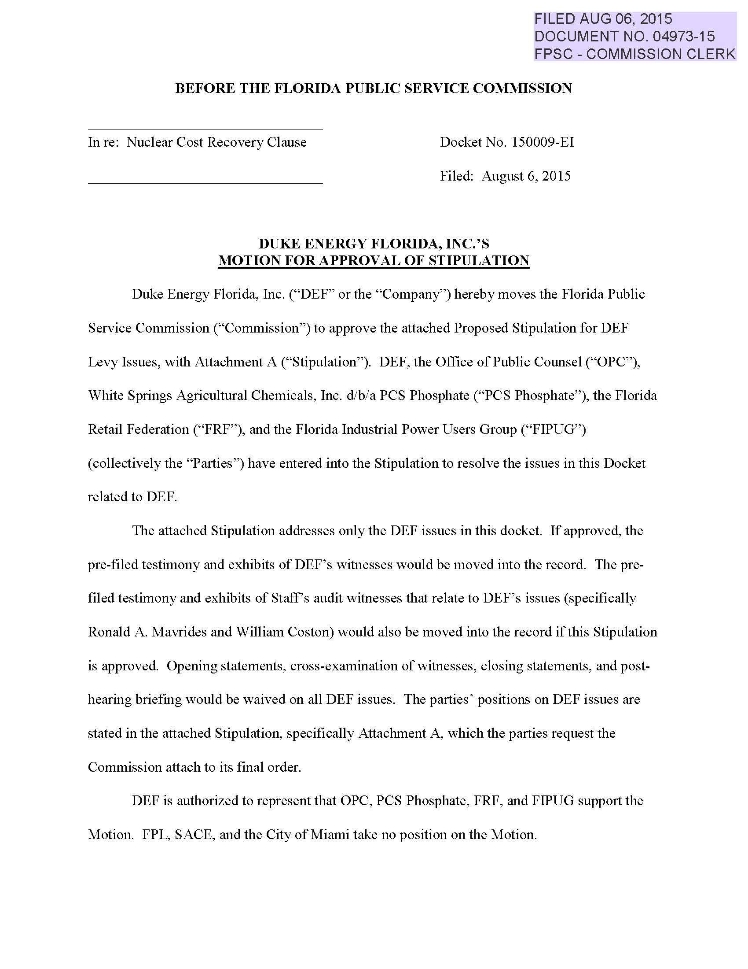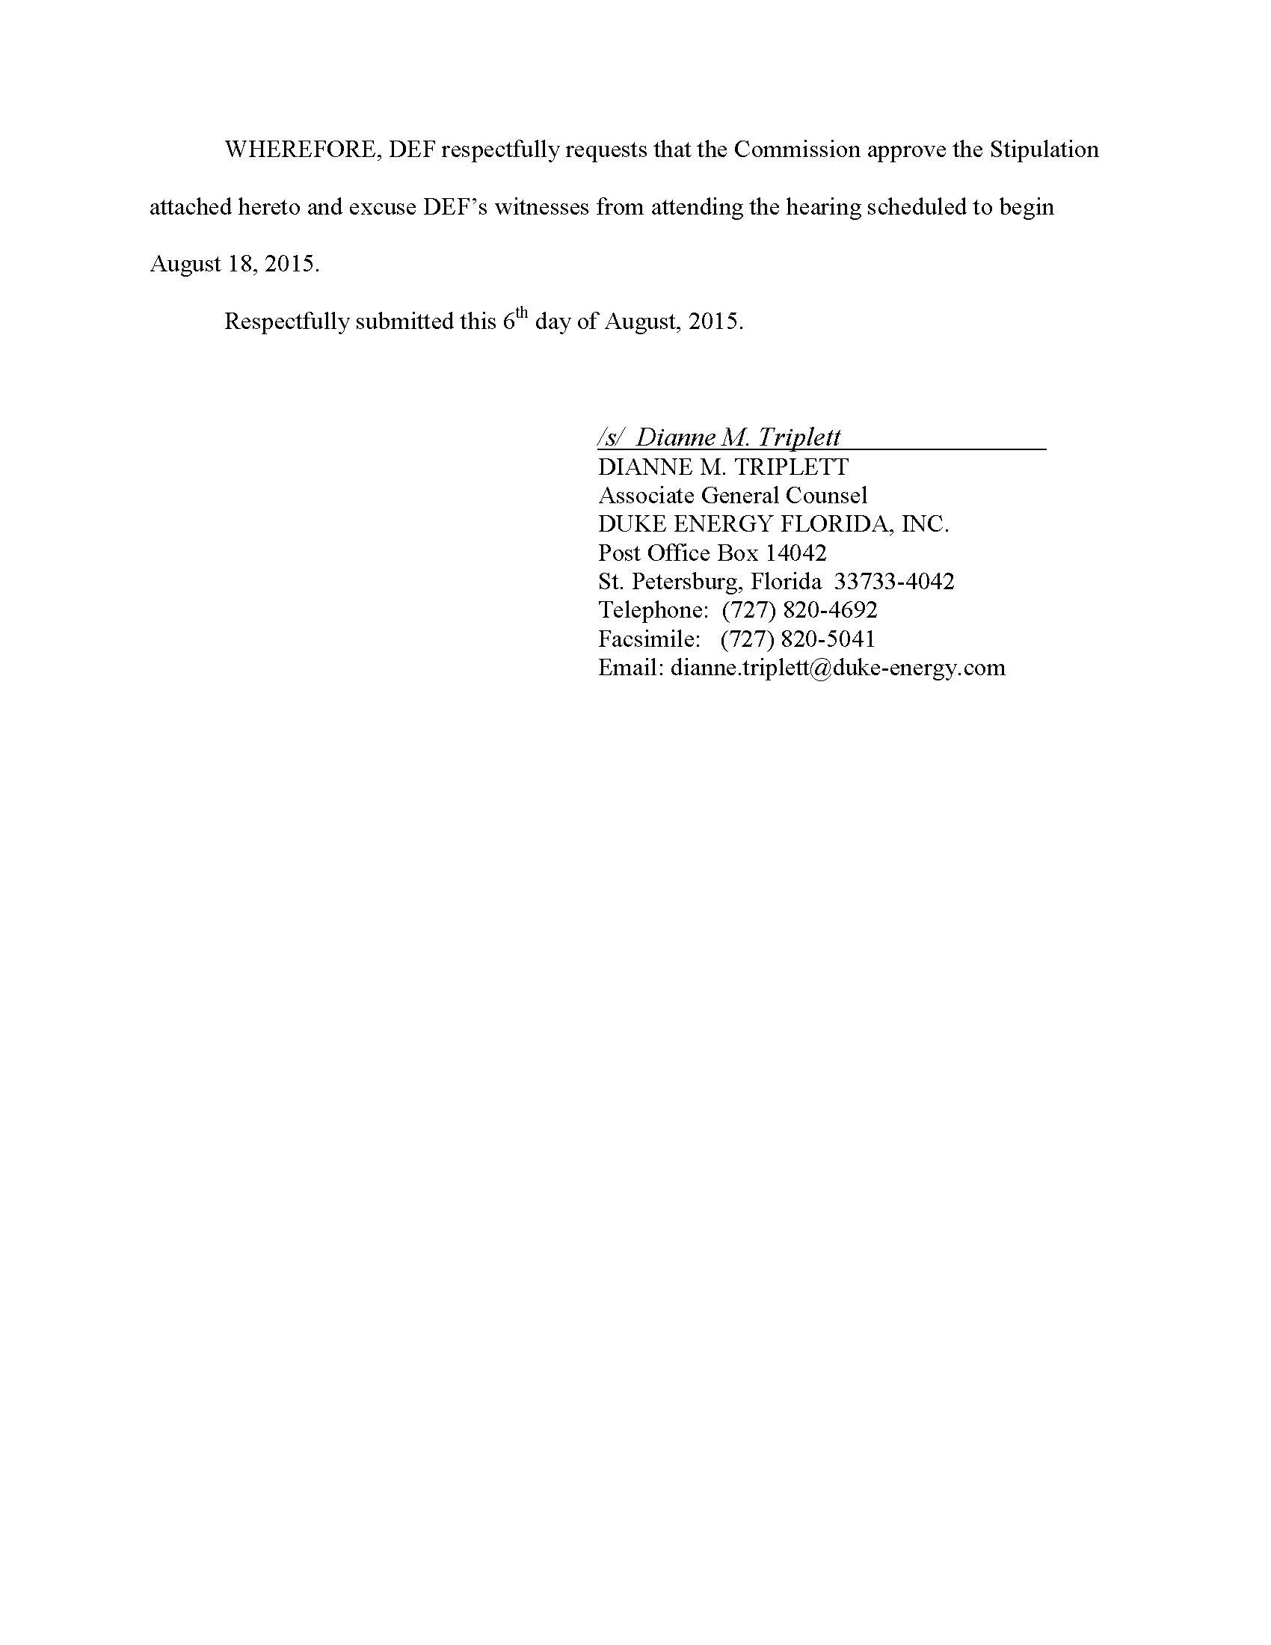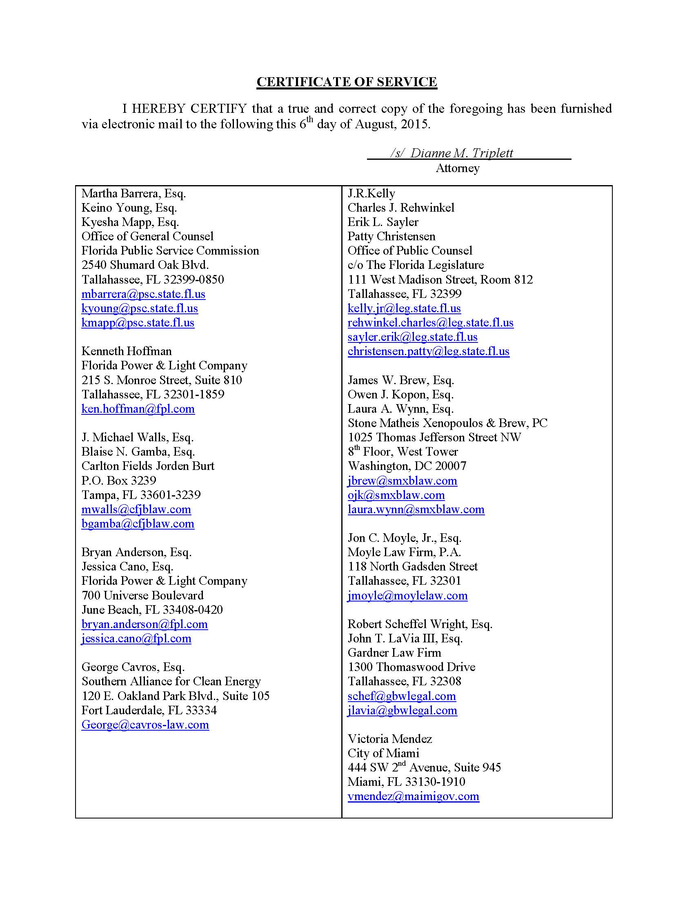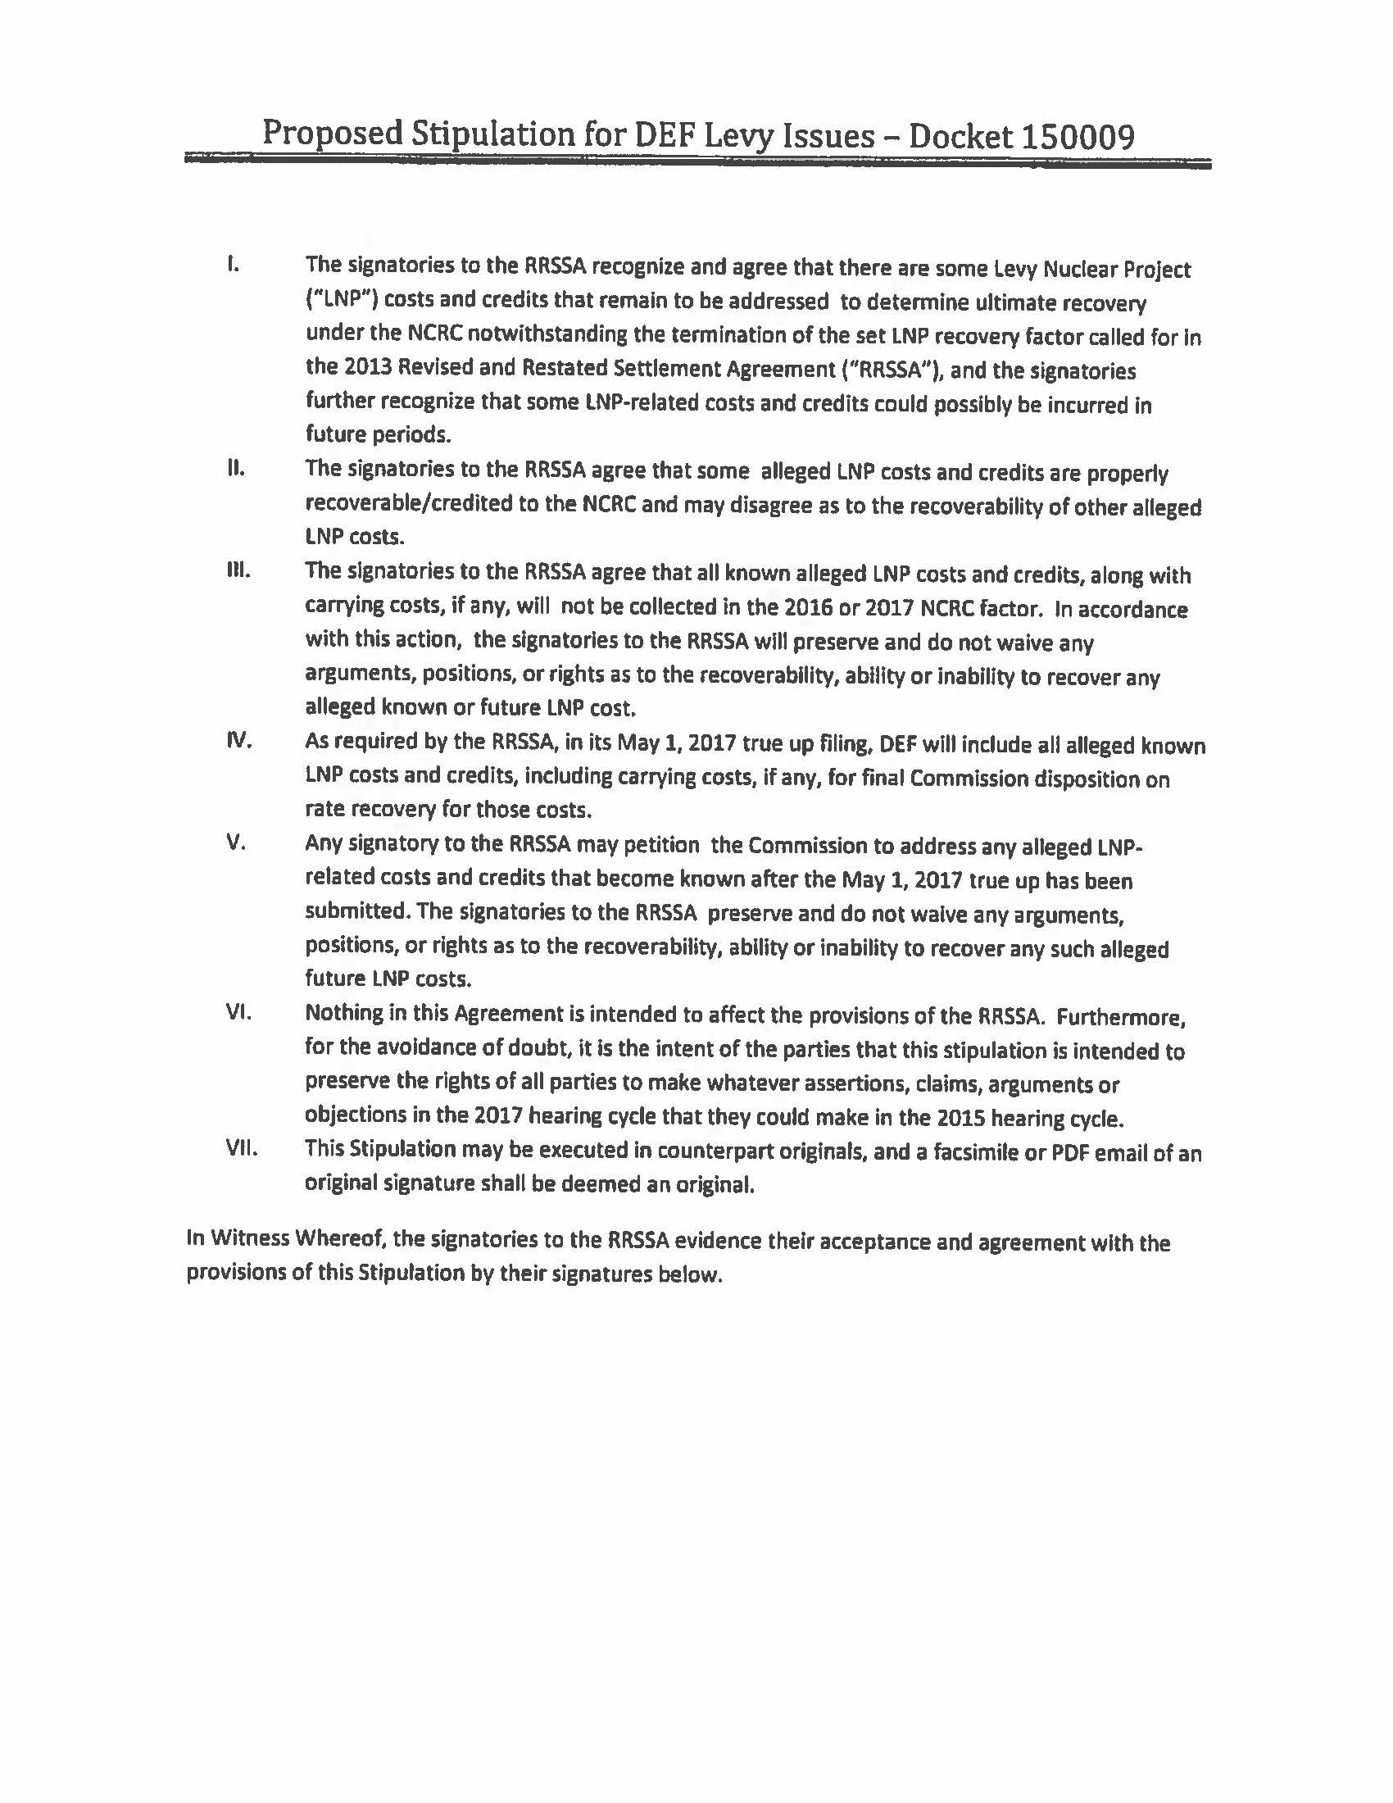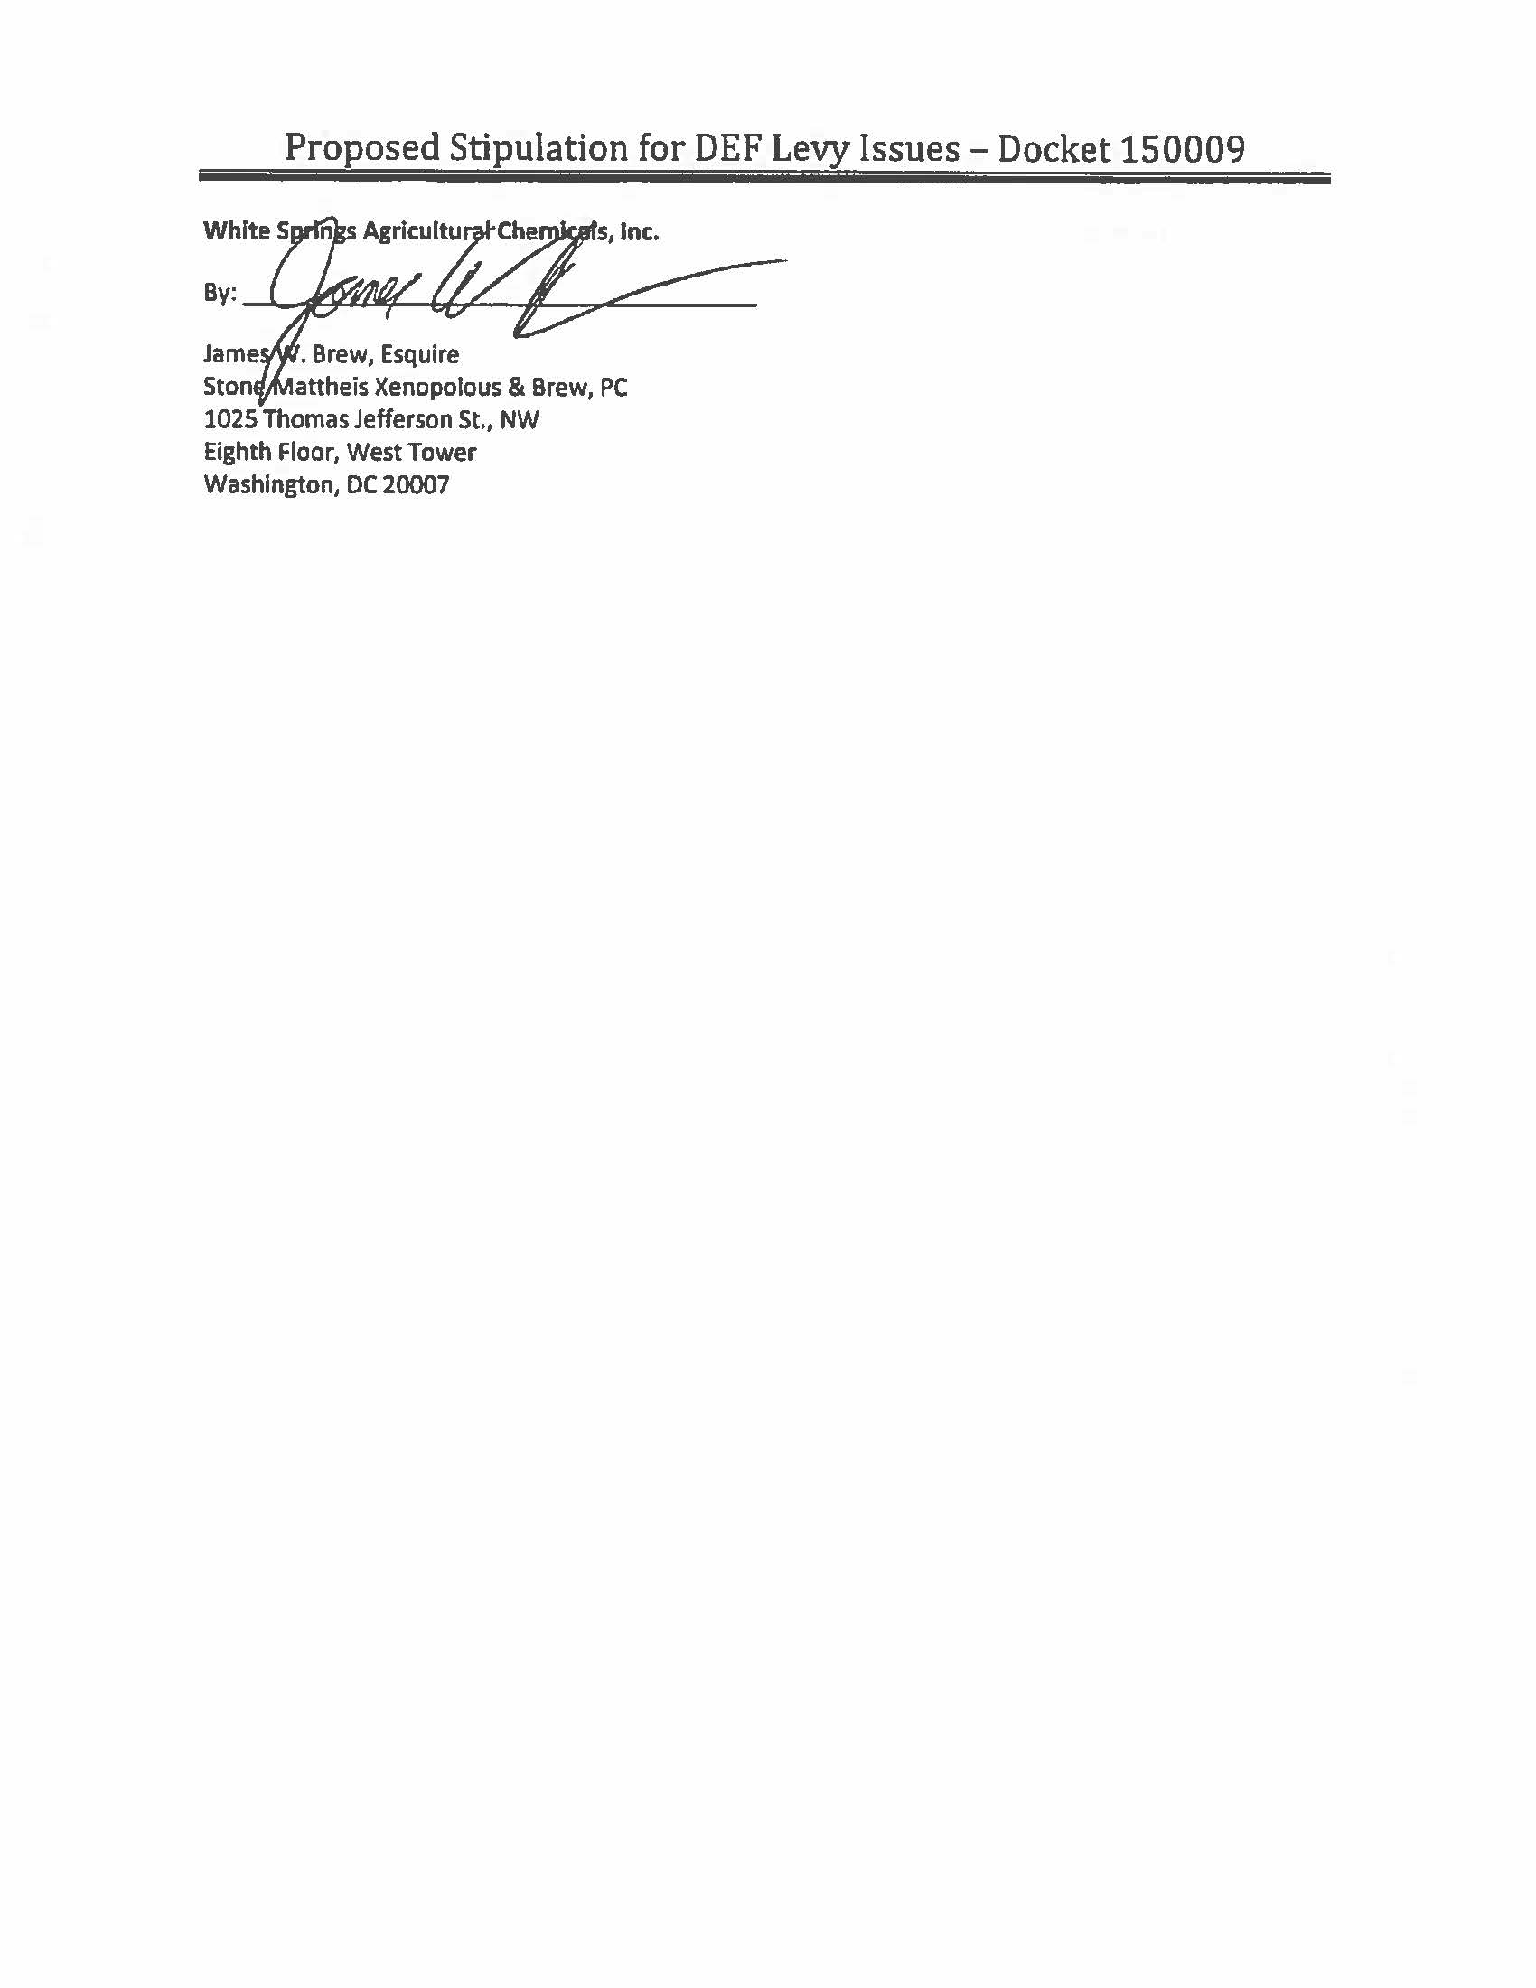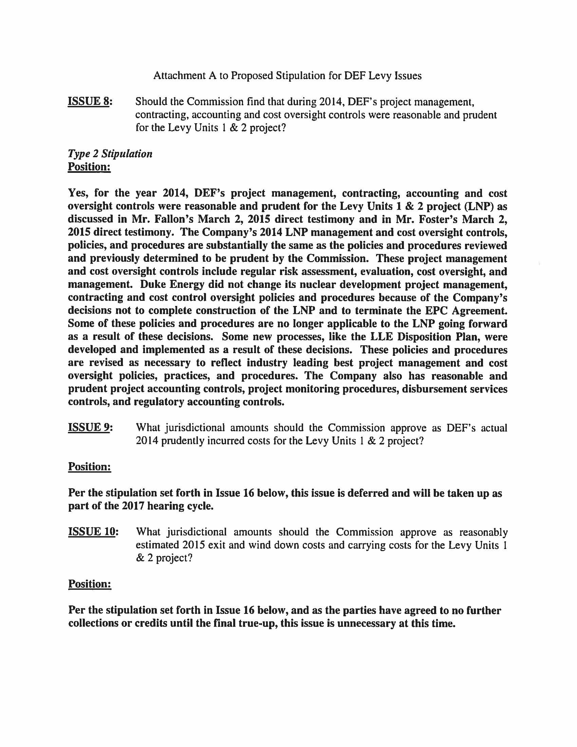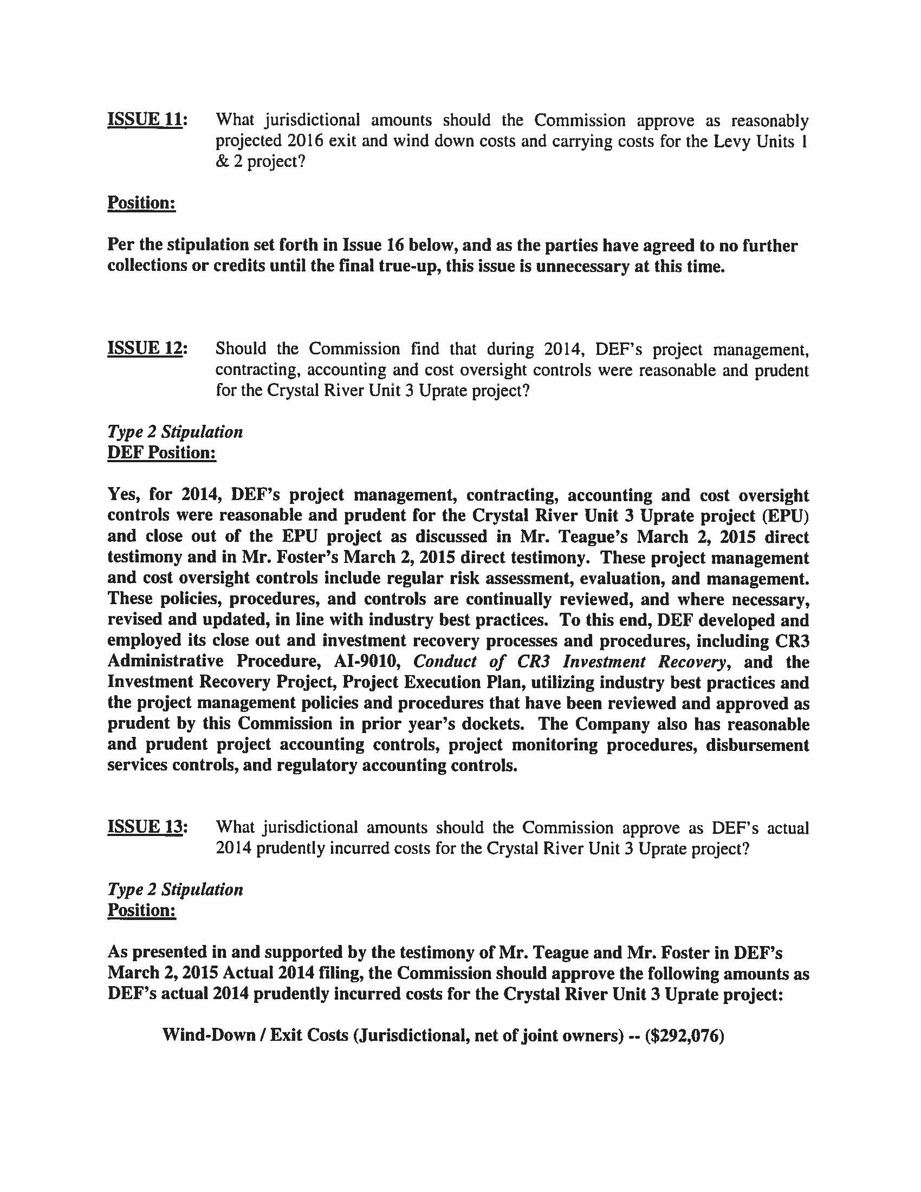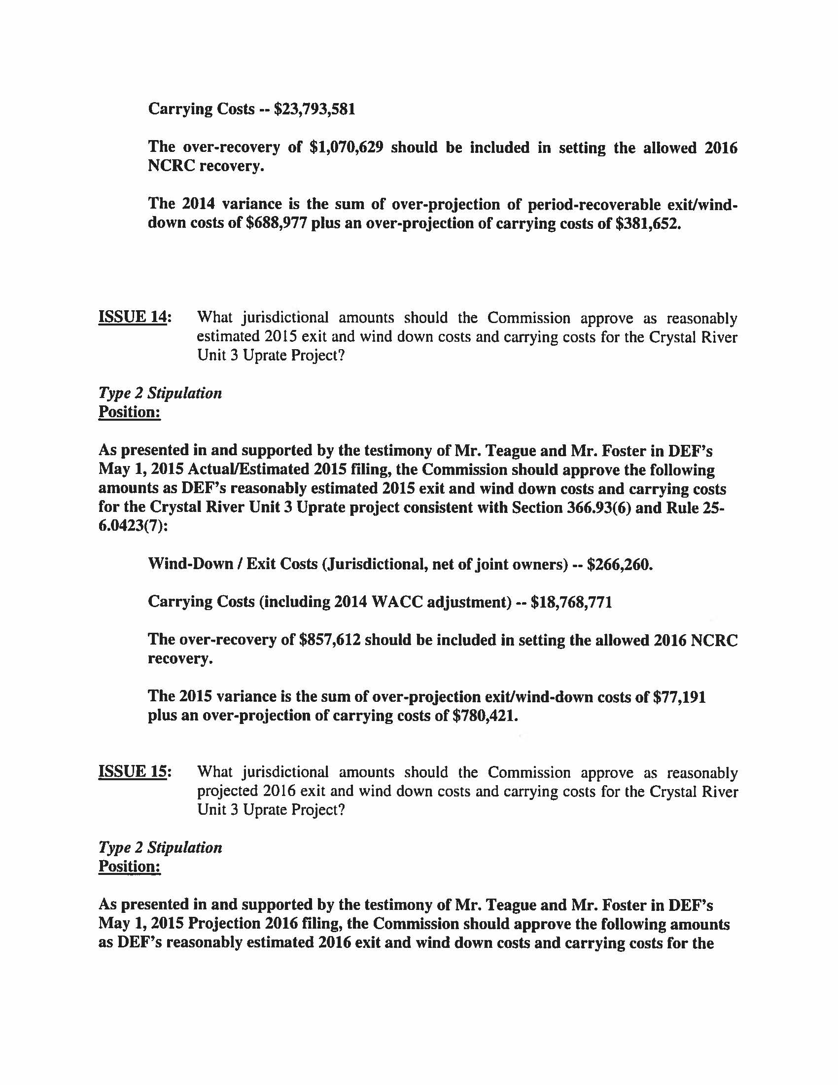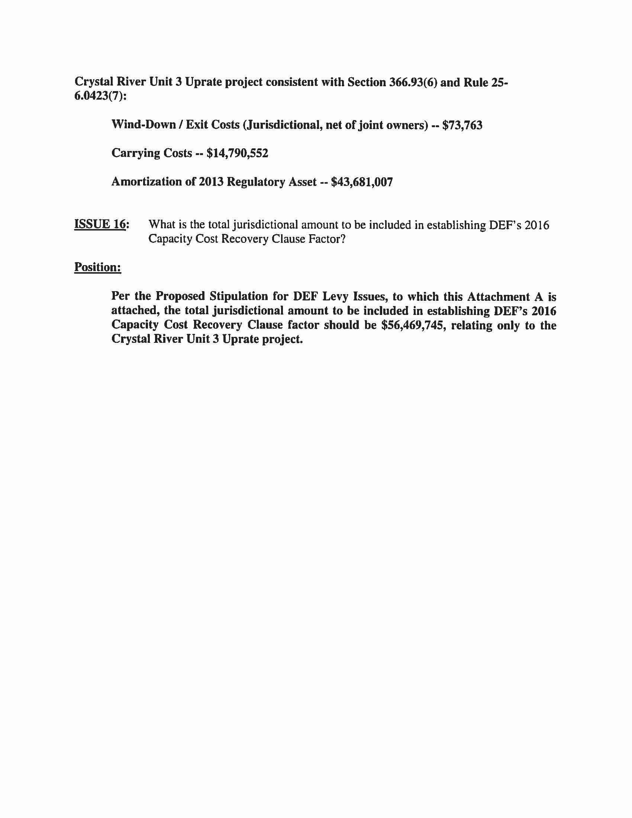

1. See FPSC Order No. PSC-14-0022-FOF-EI, Docket No. 130222-EI, Proposed amendment of Rule 25-6.0423, F.A.C., Nuclear or Integrated Gasification Combined Cycle Power Plant Cost Recovery, issued January 10, 2014.
2. See FPSC Order No. PSC-08-0237-FOF-EI, Docket No. 070650-EI, Petition to determine need for Turkey Point Nuclear Units 6 and 7 electrical power plant, by Florida Power & Light Company, issued April 11, 2008.
3. See FPSC Order No. PSC-07-0119-FOF-EI, Docket No. 060642-EI, Petition for determination of need for expansion of Crystal River 3 nuclear power plant, for exemption from Bid Rule 25-22.082, F.A.C. and for cost recovery through fuel clause, by Progress Energy Florida, Inc., issued February 8, 2007; See FPSC Order No. PSC-08-0518-FOF-EI, Docket No. 080148-EI, Petition for determination of need for Levy Units 1 and 2 nuclear power plants, by Progress Energy Florida, Inc., issued August 12, 2008.
4. Document Number 04973-15.pdf as filed in Docket 150009-EI.
5. FPSC Order No. PSC-08-0237-FOF-EI, Docket No. 070650-EI, Petition to determine need for Turkey Point Nuclear Units 6 and 7 electrical power plants, by Florida Power & Light Company, issued April 11, 2008, p. 29.
6. Id.; FPSC Order No. PSC-14-0617-FOF-EI, Docket 140009-EI, Nuclear cost recovery clause, issued October 27, 2014, p. 17.
7. EPA v. EME Homer City Generation, L.P., 134 S. Ct. 1584 (2014).
8. FPSC Order No. PSC-11-0547-FOF-EI, Docket 110009-EI, Nuclear cost recovery clause, issued November 23, 2011, p. 13.
9. Overnight cost is the cost of a construction project if no interest was incurred nor cost escalation applied during construction, as if the project was completed "overnight."
10. FPSC Order No. PSC-08-0237-FOF-EI, Docket No. 070650-EI, Petition to determine need for Turkey Point Nuclear Units 6 & 7 electrical power plant, by Florida Power and Light Company, issued April 11, 2008.
11. See FPSC Order No. PSC-08-0237-FOF-EI, Docket No. 070650-EI, Petition to determine need for Turkey Point Nuclear Units 6 & 7 electrical power plant, by Florida Power and Light Company, issued April 11, 2008.
12. See FPSC Order No. PSC-14-0696-FOF-EU, Docket No. 130199-EI, Commission review of numeric conservation goals (Florida Power & Light Company), issued December 16, 2014.
13. See FPSC Order No. PSC-14-0617-FOF-EI, Docket No. 140009-EI, Nuclear cost recovery clause, issued October 27, 2014.
14. The Final Order on Site Certification (*In re: Florida Power & Light Company Turkey Point Units 6 & 7 Power Plant Siting Application No. PA 03-45A3*, Case No. 09-3575EPP, issued May 19, 2014) has been appealed to the 3rd District Court of Appeals Case Number: 3D14-1467 by Miami Dade County, The City of Miami, The City of South Miami, and The Village of Pinecrest. (TR 173)
15. See FPSC Order No. PSC-08-0237-FOF-EI, Docket No. 070650-EI, Petition to determine need for Turkey Point Nuclear Units 6 & 7 electrical power plant, by Florida Power and Light Company, issued April 11, 2008.
16. FPSC Order No. PSC-07-0816-FOF-EI, Docket No. 060658-EI, Petition on behalf of Citizens of the State of Florida to require Progress Energy Florida, Inc. to refund customers $143 million, issued October 10, 2007, p. 3; FPSC Order No. PSC-08-0749-FOF-EI, Docket No. 080009-EI, Nuclear cost recovery clause, issued November 12, 2008, p. 28; FPSC Order No. PSC-09-0783-FOF-EI, Docket No. 090009-EI, Nuclear cost recovery clause, issued November 19, 2009, pp. 11, 13; FPSC Order No. PSC-11-0547-FOF-EI, Docket No. 110009-EI, Nuclear cost recovery clause, issued November 23, 2011, pp. 26, 28, 57, 61, 91, 93; FPSC Order No. PSC-12-0650-FOF-EI, Docket No. 120009-EI, Nuclear cost recovery clause, issued December 11, 2012, pp. 23, 24, 32, 59, 60; FPSC Order No. PSC-13-0493-FOF-EI, Docket No. 130009-EI, Nuclear cost recovery clause, issued October 18, 2013, p. 26.
17. FRF, SACE, FIPUG, and Miami adopt OPC’s brief on this issue.
18. The former Section 366.93(3), F.S., was re-numbered as 366.93(3)(a). This section provides that “[A]fter a petition for determination of need is granted, a utility may petition the commission for cost recovery as permitted by this section and commission rules.”
19. See also staff’s recommendation and analysis for Issues 3B and 3C, which are inextricably intertwined with Issue 3A.
20. FPSC Order No. PSC-14-0617-FOF-EI, Docket No. 140009-EI, Nuclear cost recovery clause, issued October 27, 2014, pp. 16-32.