BEFORE THE FLORIDA PUBLIC SERVICE COMMISSION

|  |  |
| --- | --- |
| In re: Petition for approval to include in base rates the revenue requirement for the CR3 regulatory asset, by Duke Energy Florida, Inc. | DOCKET NO. 150148-EI |
| In re: Petition for issuance of nuclear asset-recovery financing order, by Duke Energy Florida, Inc. d/b/a Duke Energy. | DOCKET NO. 150171-EI  ORDER NO. PSC-15-0465-S-EI  ISSUED: October 14, 2015 |

The following Commissioners participated in the disposition of this matter:

ART GRAHAM, Chairman

LISA POLAK EDGAR

RONALD A. BRISÉ

JULIE I. BROWN

JIMMY PATRONIS

Final Order Approving Stipulation   
and for Relief From Rebuttal Testimony Deadline

Set Forth in Order Establishing Procedure

BY THE COMMISSION:

**Case Background**

In February 2013, Duke Energy Florida, Inc. (DEF) announced its decision to retire its nuclear plant, Crystal River Unit 3 (CR3), in Citrus County, Florida. The retirement of CR3 was the subject of two settlement agreements. The first settlement agreement, reached in 2012, was a global settlement that addressed several issues, including issues related to the CR3 retirement.[1] The second settlement agreement, reached in 2013, replaced and supplanted the 2012 settlement agreement. The Commission approved the Revised and Restated Stipulation and Settlement Agreement (RRSSA) by Order No. PSC-13-0598-FOF-EI.[2] Among other things, the 2013 RRSSA contemplated that DEF would create a regulatory asset to account for the recovery of costs associated with the retirement of CR3. The parties to the RRSSA were DEF, the Office of Public Counsel (OPC), the Florida Industrial Power Users Group (FIPUG), the Florida Retail Federation (FRF), and White Springs Agriculture Chemicals, Inc. d/b/a PCS Phosphate (PCS Phosphate).

Docket No. 150148-EI – CR3 Regulatory Asset

On May 22, 2015, pursuant to Sections 366.04 and 366.05, Florida Statutes (F.S.), DEF filed its Petition for Approval to Include in Base Rates the Revenue Requirement for the Crystal River Unit 3 Regulatory Asset (CR3 Regulatory Asset Petition), along with supporting testimony and exhibits. DEF intended its petition to be the first step in the securitization process, authorized by Section 366.95, F.S.[3] Under Section 366.95, F.S., investor-owned electric utilities “subject to a settlement agreement that governs the type and amount of principal costs that could be included in nuclear asset-recovery costs,” may seek a financing order to obtain low-cost funds to recover principal costs of retired nuclear generation assets. Section 366.95(2)(b), F.S., also provides that before an electric utility can file a petition for a financing order, the utility must file a petition for “review and approval of those principal costs” that could be “included in nuclear asset-recovery costs,” at least 60 days prior to seeking a financing order. DEF’s CR3 Regulatory Asset Petition was the first step in the securitization process.

Docket No. 150171-EI – Financing Order

On July 27, 2015, pursuant to Sections 366.04, 366.05, and 366.95, F.S., the RRSSA, and its CR3 Regulatory Asset Petition, DEF filed its Petition for Issuance of a Nuclear Asset-Recovery Financing Order (Financing Order Petition), along with supporting testimony and exhibits, requesting that the Commission issue a financing order to permit DEF to securitize certain costs, including the CR3 Regulatory Asset value as outlined in its CR3 Regulatory Asset Petition filed in Docket No. 150148-EI. DEF also filed a Motion to Consolidate, requesting that its CR3 Regulatory Asset Petition and Financing Order Petition be consolidated pursuant to Rule 28-106.108, Florida Administrative Code (F.A.C.).

Consolidation of Dockets and Orders Establishing Procedure

By Order No. PSC-15-0238-PCO-EI (Order Establishing Procedure), issued on June 5, 2015, Docket No. 150148-EI was set for hearing and controlling dates were established for filing testimony as well as other procedural matters. By Order No. PSC-15-0327-PCO-EI (Consolidation Order), issued on August 13, 2015, Docket Nos. 150148-EI and 150171-EI were consolidated into Docket No. 150171-EI, pursuant to Rules 28-106.108 and 28-106.211, F.A.C. The consolidated proceeding was scheduled for a formal evidentiary hearing on October 14-16, 2015.

Stipulation

On August 31, 2015, DEF filed its Motion for Approval of Stipulation and for Relief from Rebuttal Testimony Deadline Set Forth in Order Establishing Procedure (Motion for Approval of Stipulation).[4] On September 1, 2014, DEF filed revised pages to Attachment A, Exhibit 1 of the proposed Stipulation to correct a scrivener’s error contained in the proposed Stipulation filed on August 31, 2015.[5] On September 14, 2015, DEF filed a Motion to Remove and Replace Page 11 of Stipulation to correct a scrivener’s error contained in the Stipulation Attachment A Exhibit 1 filed on September 1, 2015.[6] DEF requested that we approve the proposed Stipulation reached by the parties to the RRSSA, and provide relief from the Order Establishing Procedure that required DEF to file rebuttal testimony by September 1, 2015. The proposed Stipulation would resolve the CR3 Regulatory Asset related issues in Docket No. 150148-EI and amend the RRSSA to ensure that if a financing order is issued in Docket No. 150171-EI, the financing order would be consistent with the RRSSA.

During our September 15, 2015, Agenda Conference, we heard comments from our staff and the signatories to the RRSSA regarding the proposed Stipulation.

We have jurisdiction pursuant to Chapter 366, F.S., including Sections 366.04, 366.05, 366.95, and 120.57(2) and (4), F.S.

**Decision**

The terms of the proposed, amended Stipulation attached as Attachment I to this Order include:

* The value of the CR3 Regulatory Asset is reduced by $15 million, from $1,298,012,000 to $1,283,012,000;
* All issues raised by the Intervenors with respect to the CR3 Regulatory Asset in Docket 150148-EI are resolved;
* DEF and the Intervenors stipulated positions on Issues 2 through 13, regarding the value of the Regulatory Asset, with Intervenors taking “No Position” on Issue 1, in Docket 150148-EI;[7]
* DEF will terminate recovery of the CR3 Regulatory Asset carrying cost through the fuel clause with the last billing cycle in 2015 and will not implement the scheduled 2016 fuel clause recovery of the $1.50 per megawatt hour rate increase related to the CR3 Regulatory Asset carrying cost;
* The signatories to the RRSSA agreed to amend the RRSSA to clarify the appropriate recovery period should nuclear asset-recovery bonds be issued pursuant to Section 366.95, F.S. The RRSSA Amendment revises the recovery period from 240 months to no longer than 276 months, in order to allow for a 20-year bond maturity period plus an additional period for implementing a true-up mechanism should recovery be through nuclear asset-recovery bonds issued pursuant to Section 366.95, F.S.; and
* DEF reserved the right to file rebuttal testimony should the Proposed Stipulation not be approved by the Commission.

DEF’s amended Motion for Approval of Stipulation and for Relief from Rebuttal Testimony Deadline Set Forth in Order Establishing Procedure was noticed for consideration and public comment at our September 15, 2015 Agenda Conference.

Ruling

We find that the Stipulation is in the public interest. The Stipulation provides a positive impact to DEF customers and concludes a very complex and technical matter that has lasted six years. Because Section 366.95, F.S., was not enacted at the time the parties executed the RRSSA, the RRSSA did not contain provisions that would apply to a proposed securitization of the CR3 Regulatory Asset. Accordingly, we find that it is necessary to amend certain provisions of the RRSSA to ensure that a financing order, if issued, will be consistent with the RRSSA. The Stipulation, as amended, appears to accomplish such consistency, and shall be approved in its entirety, as attached hereto as Attachment I.

The Intervenors took no position on Issue 1 in Docket No. 150148-EI, which asked whether DEF “has provided adequate internal controls and management oversight of its CR3 investment recovery procedures and plan.” At our September 15, 2015 Agenda Conference, our staff and DEF proposed the following Stipulation on Issue 1: “Yes, DEF has provided adequate internal controls and management oversight of its CR3 investment recovery procedures and plan.” In addition, our staff and DEF stipulated that our staff’s witnesses’ testimony and exhibits regarding the CR3 Regulatory Asset be entered into the record during the October 14, 2015, hearing and our staff’s witnesses be excused. Upon examination and having heard no objection from the Intervenors on Issue, we approve the Proposed Type II Stipulation[8] on Issue 1, attached hereto as Attachment II.

Based on the foregoing, it is

ORDERED by the Florida Public Service Commission that Duke Energy Florida, LLC’s Motion for Approval of Stipulation and Relief from Rebuttal Testimony Deadline Set Forth in Order Establishing Procedure, as amended, is hereby granted. It is further

ORDERED that the Proposed Stipulation for CR3 Regulatory Asset Issues and the Revised and Restated Stipulation and Settlement Agreement Amendment, as amended, are in the public interest and are approved in their entirety as attached hereto as Attachment I. It is further

ORDERED that the Proposed Type II Stipulation of Docket No. 150148-EI Issue 1 is approved as attached hereto as Attachment II. It is further

ORDERED that the pre-filed witness testimony and exhibits of DEF, OPC and Commission staff regarding the CR3 Regulatory Asset shall be moved into the record at the hearing on the Financing Order Petition in this consolidated proceeding, and DEF and staff’s witnesses are excused from the hearing. It is further

ORDERED that opening statements, cross-examination of witnesses, closing statements, and post-hearing briefs have been waived on the issues related to the CR3 Regulatory Asset. It is further

ORDERED that each of the findings made in the body of this Order are hereby approved in every respect. It is further

ORDERED that all matters contained in the attachments and schedules appended hereto are incorporated herein by reference. It is further

ORDERED that the consolidated dockets shall remain open pending the resolution of Docket No. 150171-EI.

By ORDER of the Florida Public Service Commission this 14th day of October, 2015.

|  |  |
| --- | --- |
|  | /s/ Carlotta S. Stauffer |
|  | CARLOTTA S. STAUFFER  Commission Clerk |

Florida Public Service Commission

2540 Shumard Oak Boulevard

Tallahassee, Florida 32399

(850) 413‑6770

www.floridapsc.com

Copies furnished: A copy of this document is provided to the parties of record at the time of issuance and, if applicable, interested persons.

KFC

NOTICE OF FURTHER PROCEEDINGS OR JUDICIAL REVIEW

The Florida Public Service Commission is required by Section 120.569(1), Florida Statutes, to notify parties of any administrative hearing or judicial review of Commission orders that is available under Sections 120.57 or 120.68, Florida Statutes, as well as the procedures and time limits that apply. This notice should not be construed to mean all requests for an administrative hearing or judicial review will be granted or result in the relief sought.

Any party adversely affected by the Commission's final action in this matter may request: 1) reconsideration of the decision by filing a motion for reconsideration with the Office of Commission Clerk, 2540 Shumard Oak Boulevard, Tallahassee, Florida 32399-0850, within fifteen (15) days of the issuance of this order in the form prescribed by Rule 25-22.060, Florida Administrative Code; or 2) judicial review by the Florida Supreme Court in the case of an electric, gas or telephone utility or the First District Court of Appeal in the case of a water and/or wastewater utility by filing a notice of appeal with the Office of Commission Clerk, and filing a copy of the notice of appeal and the filing fee with the appropriate court. This filing must be completed within thirty (30) days after the issuance of this order, pursuant to Rule 9.110, Florida Rules of Appellate Procedure. The notice of appeal must be in the form specified in Rule 9.900(a), Florida Rules of Appellate Procedure.

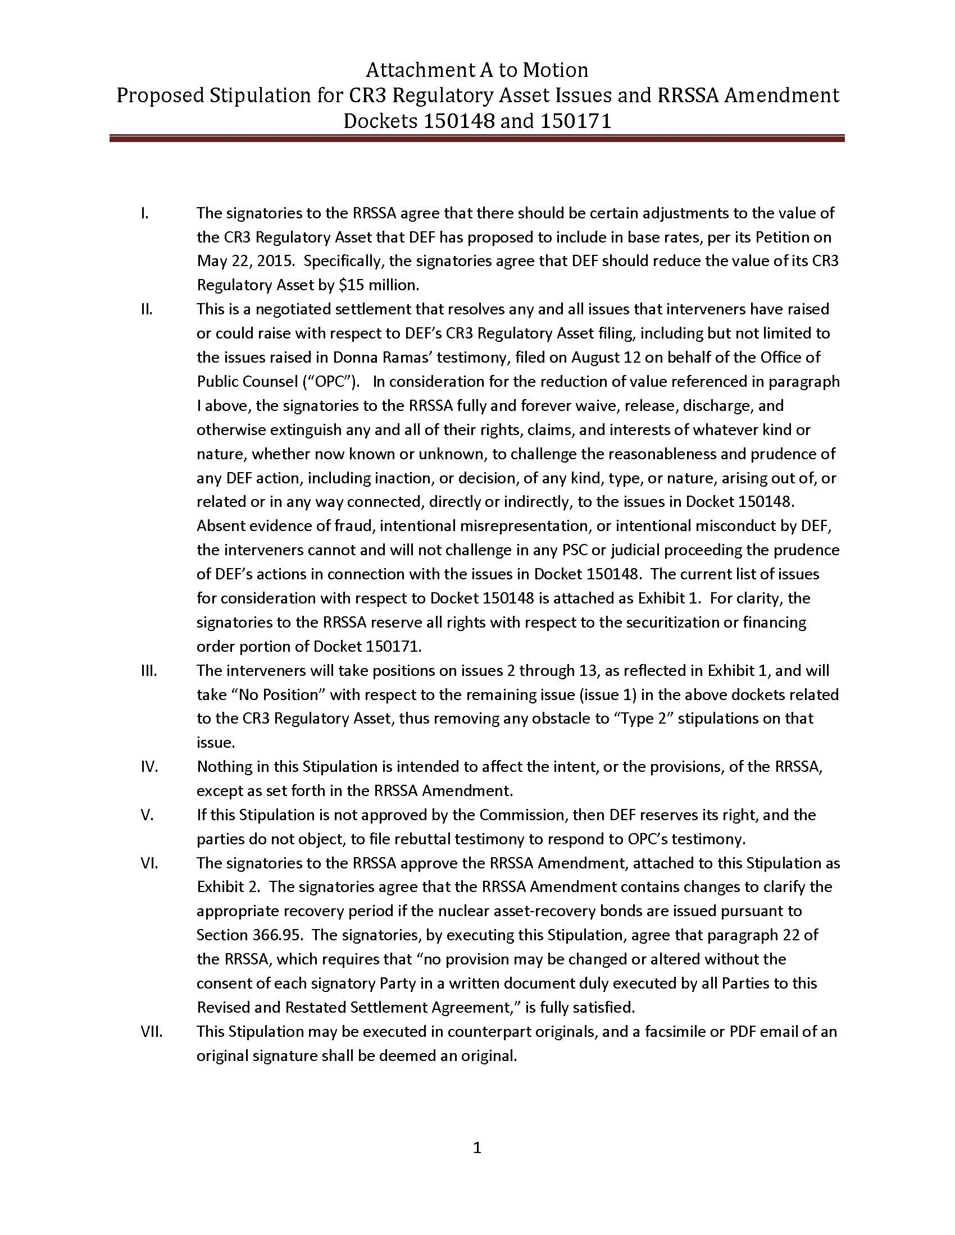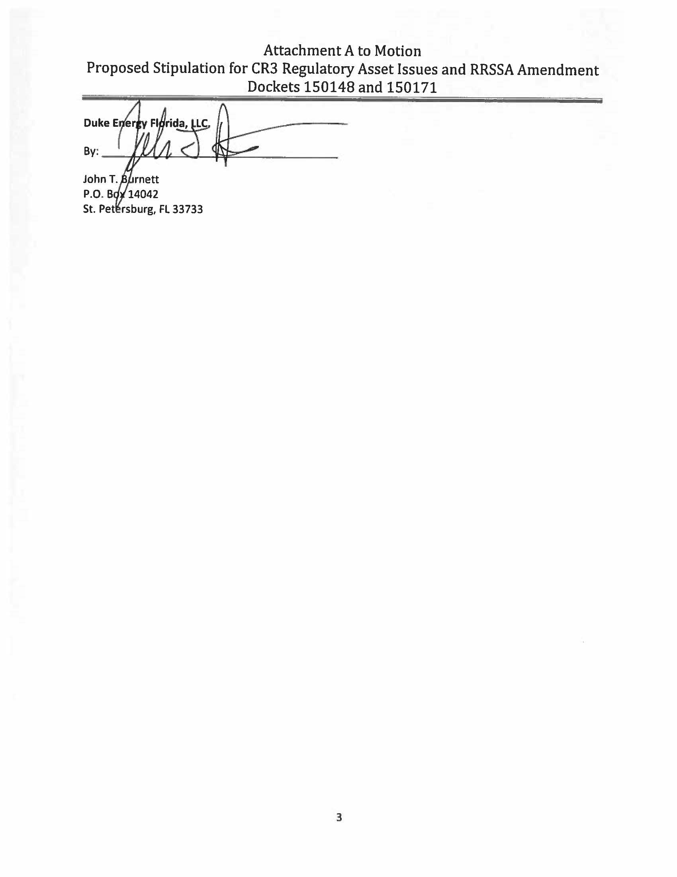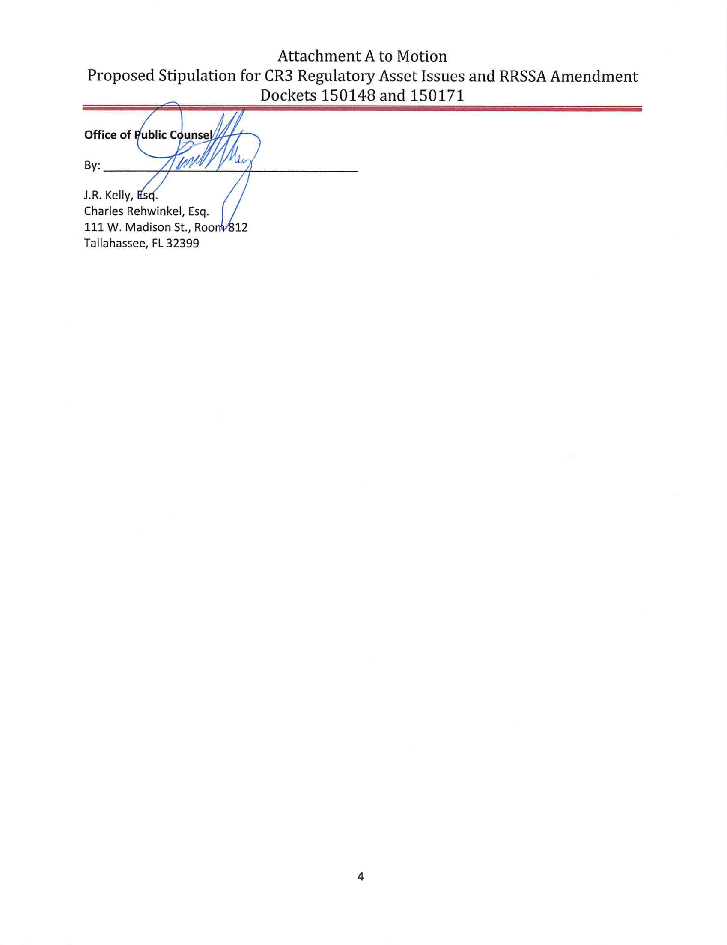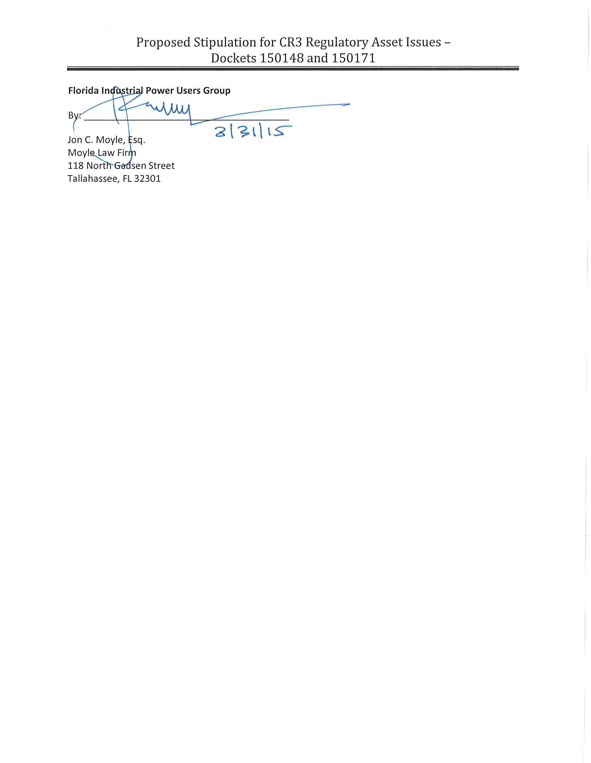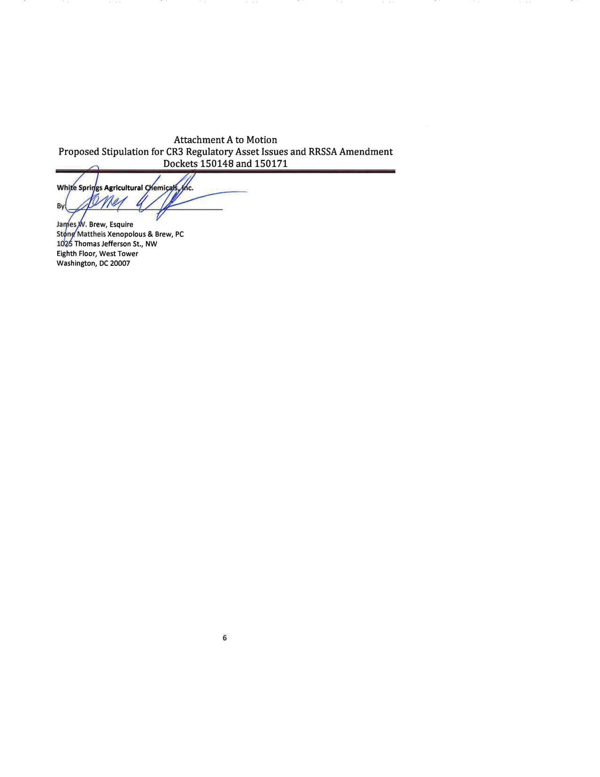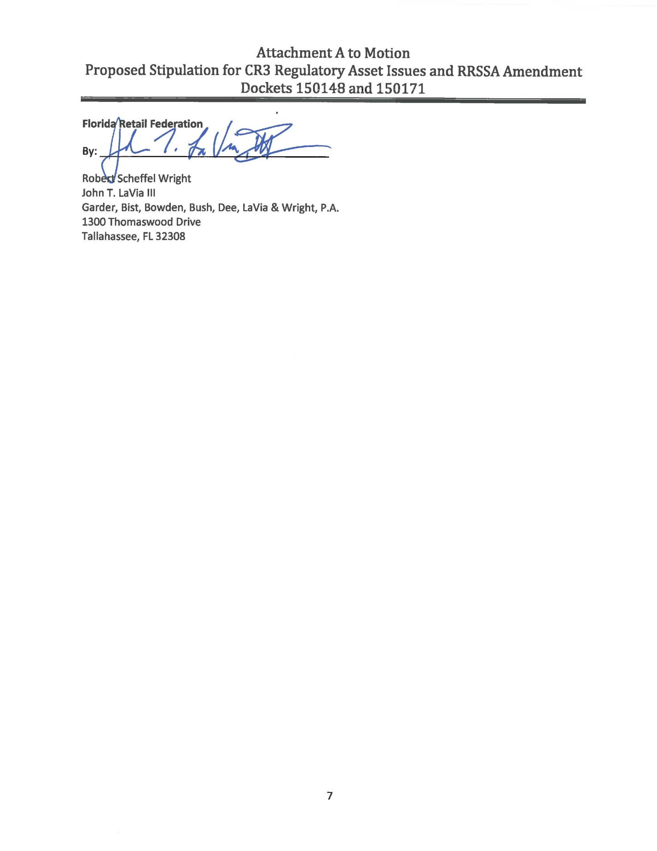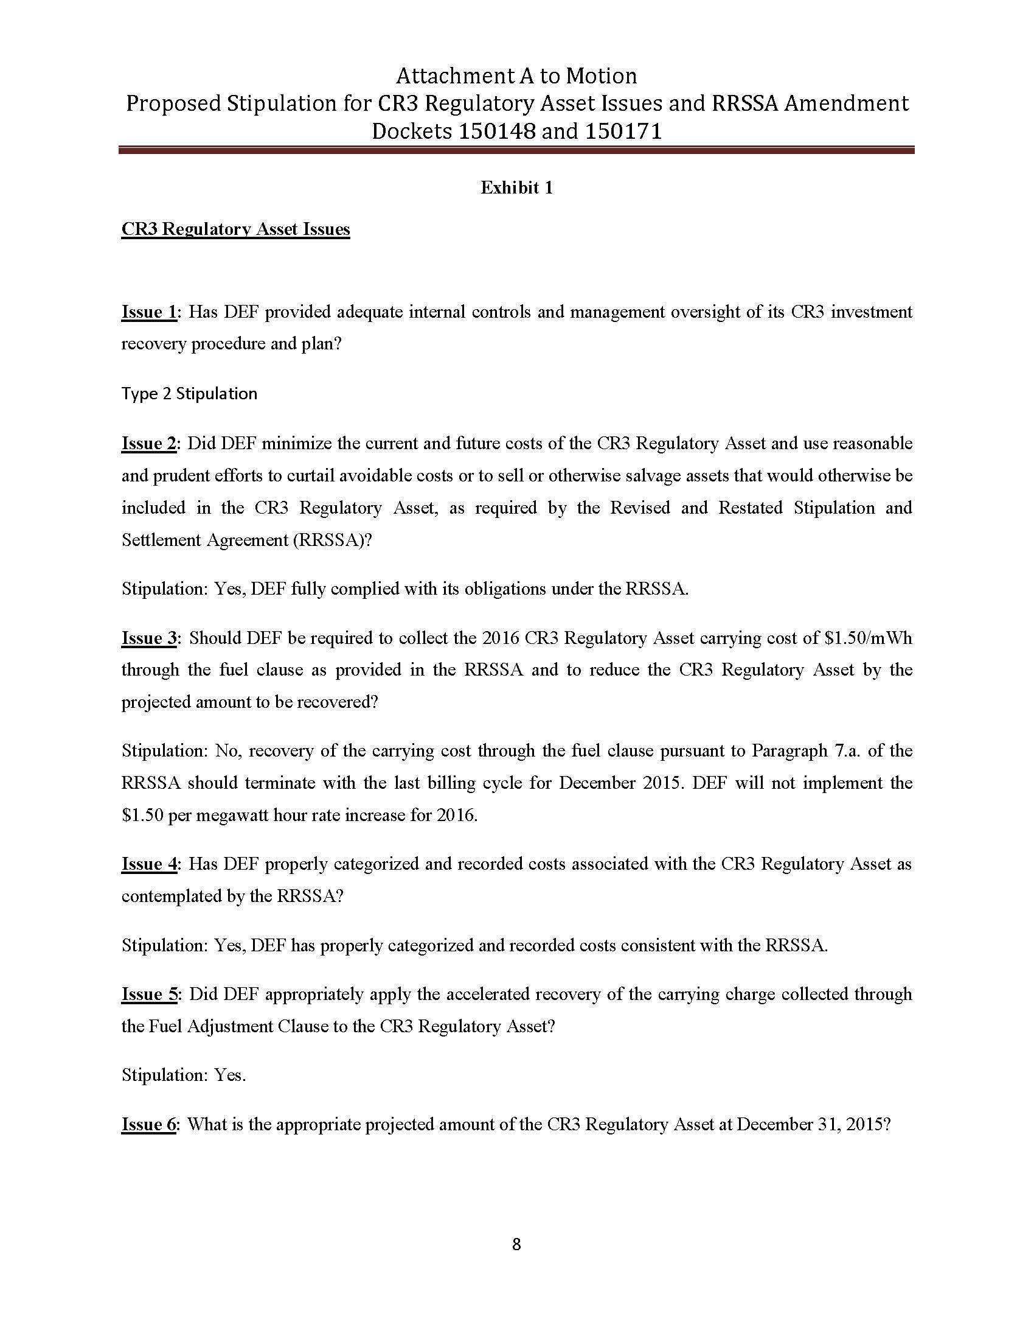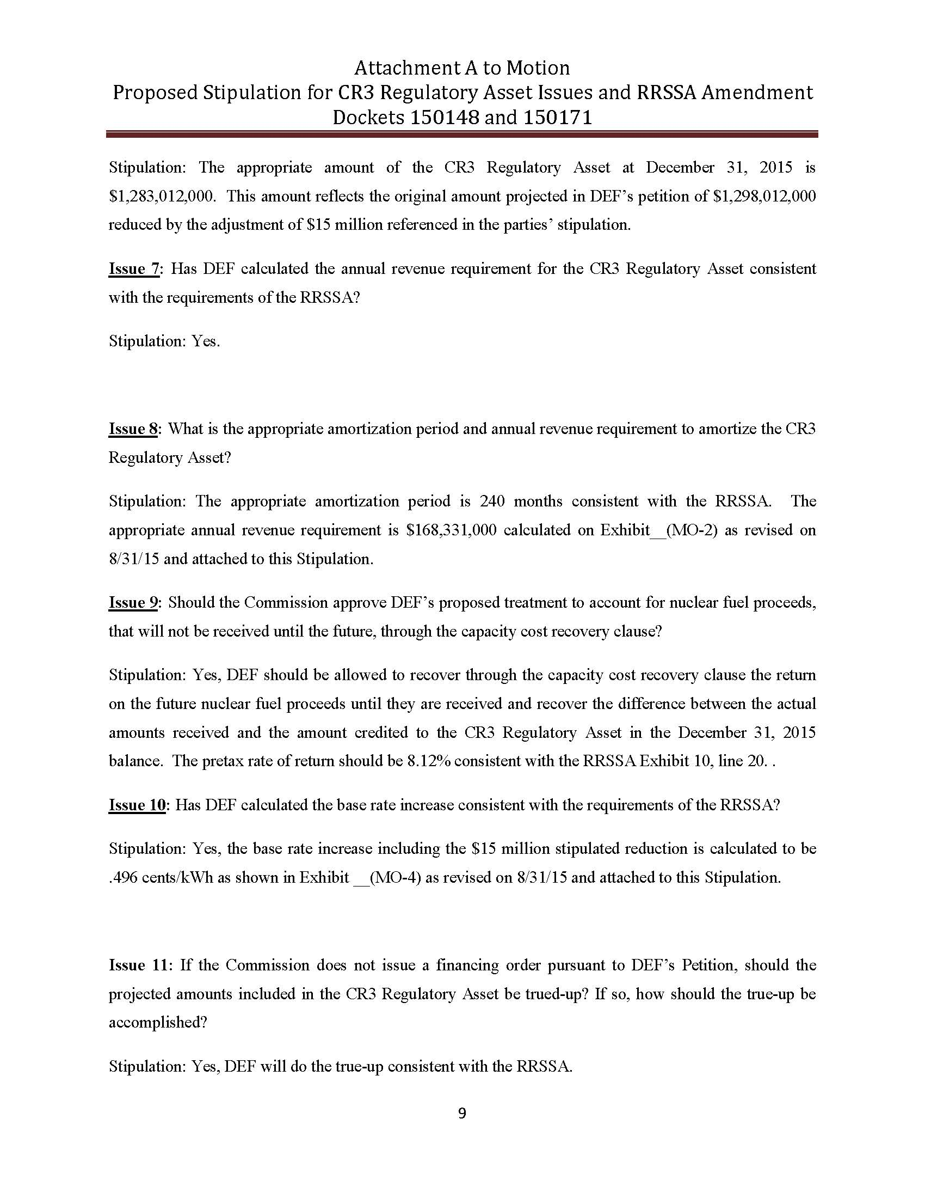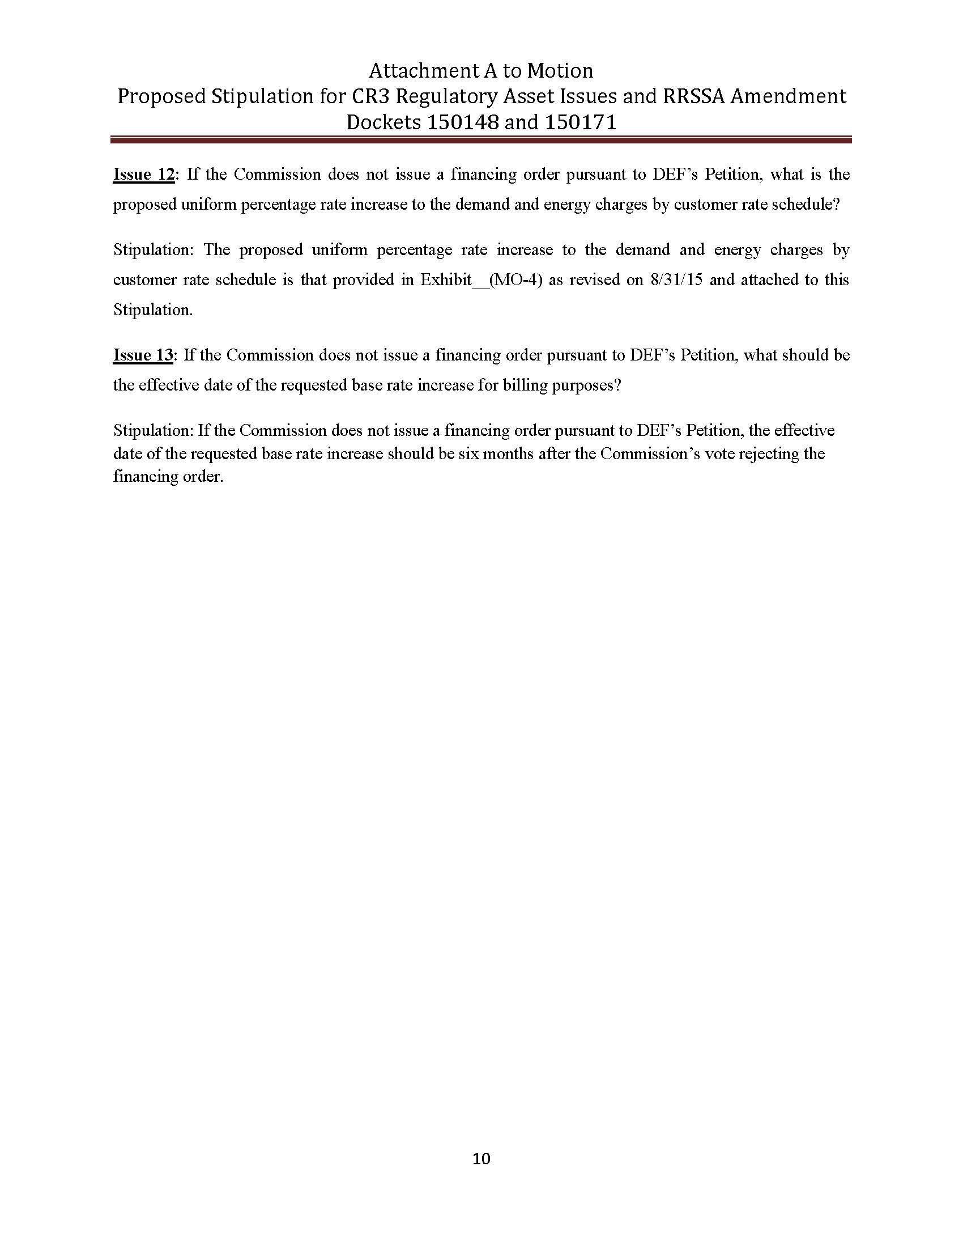

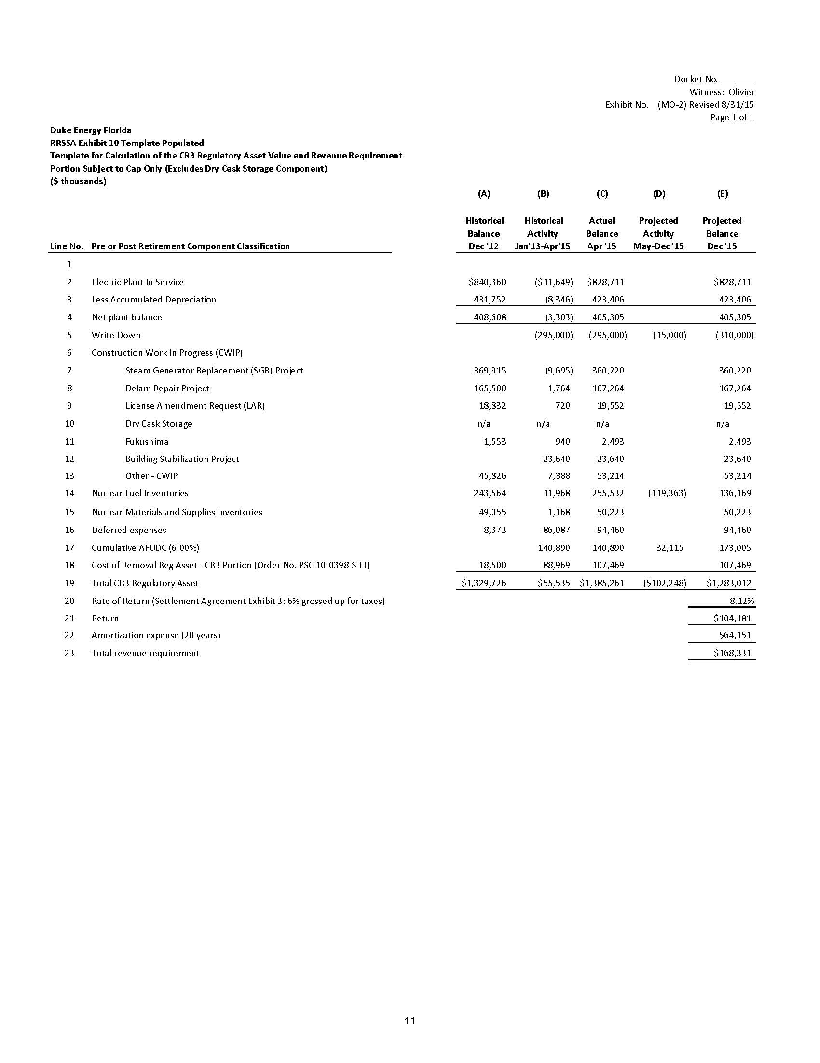

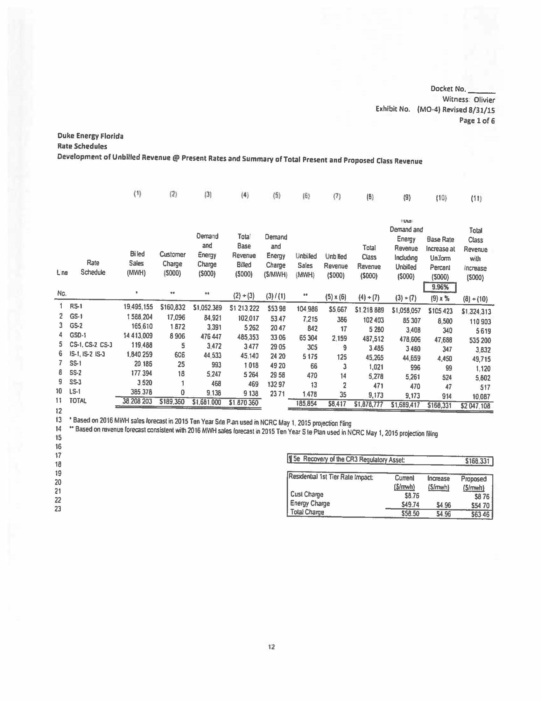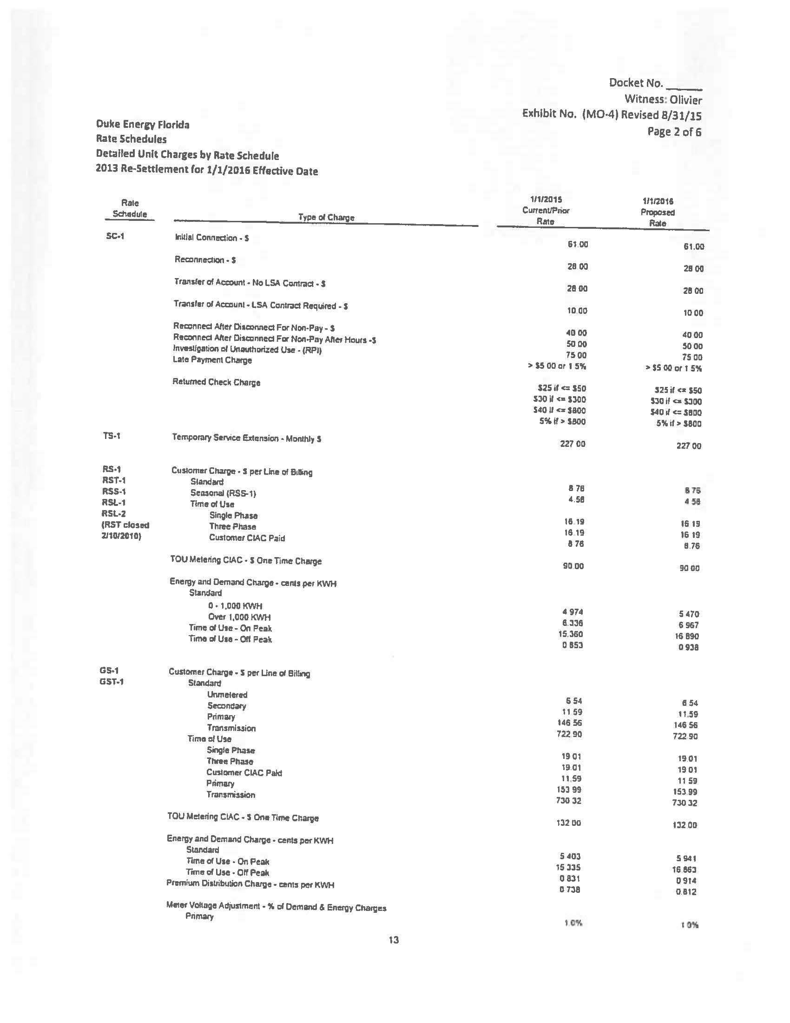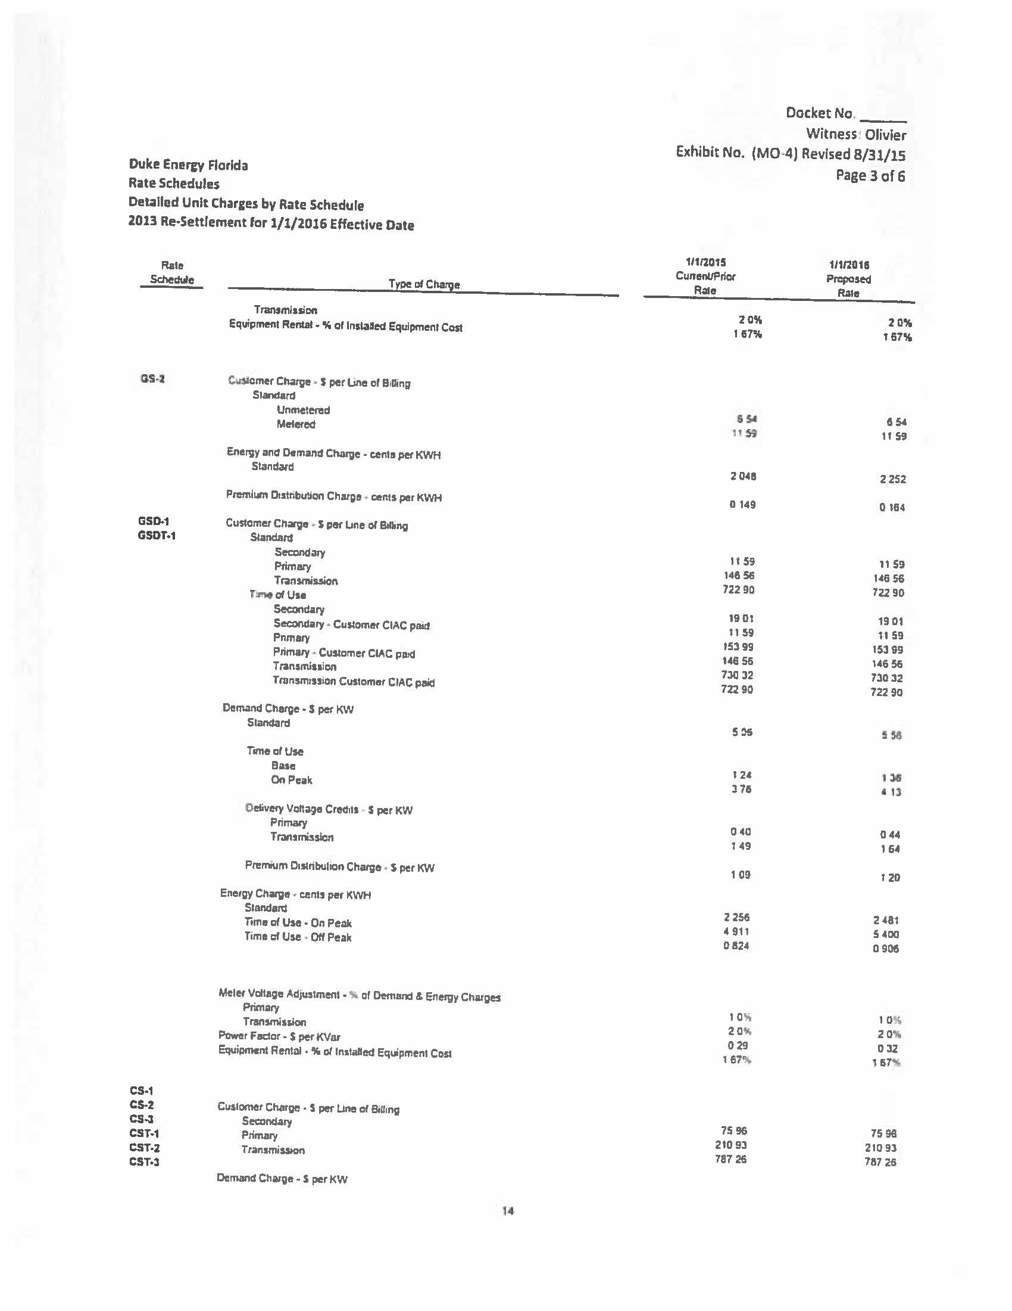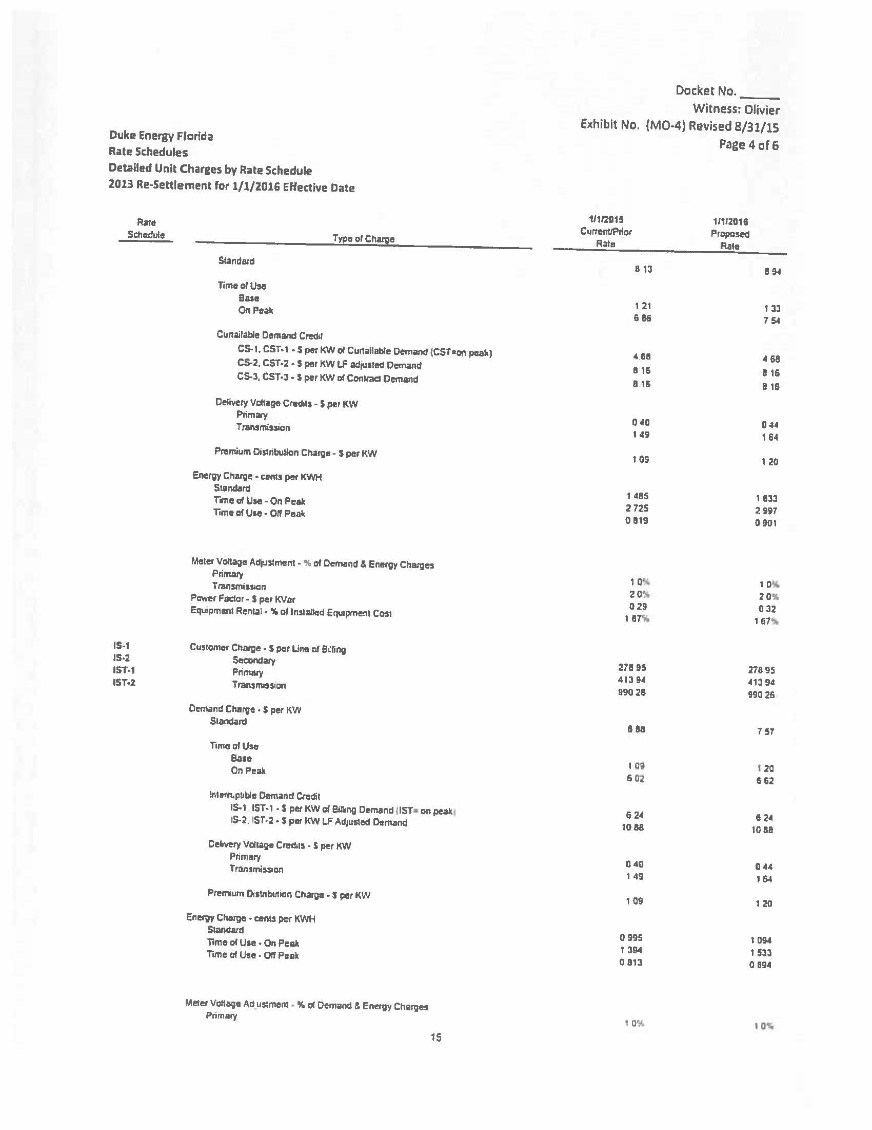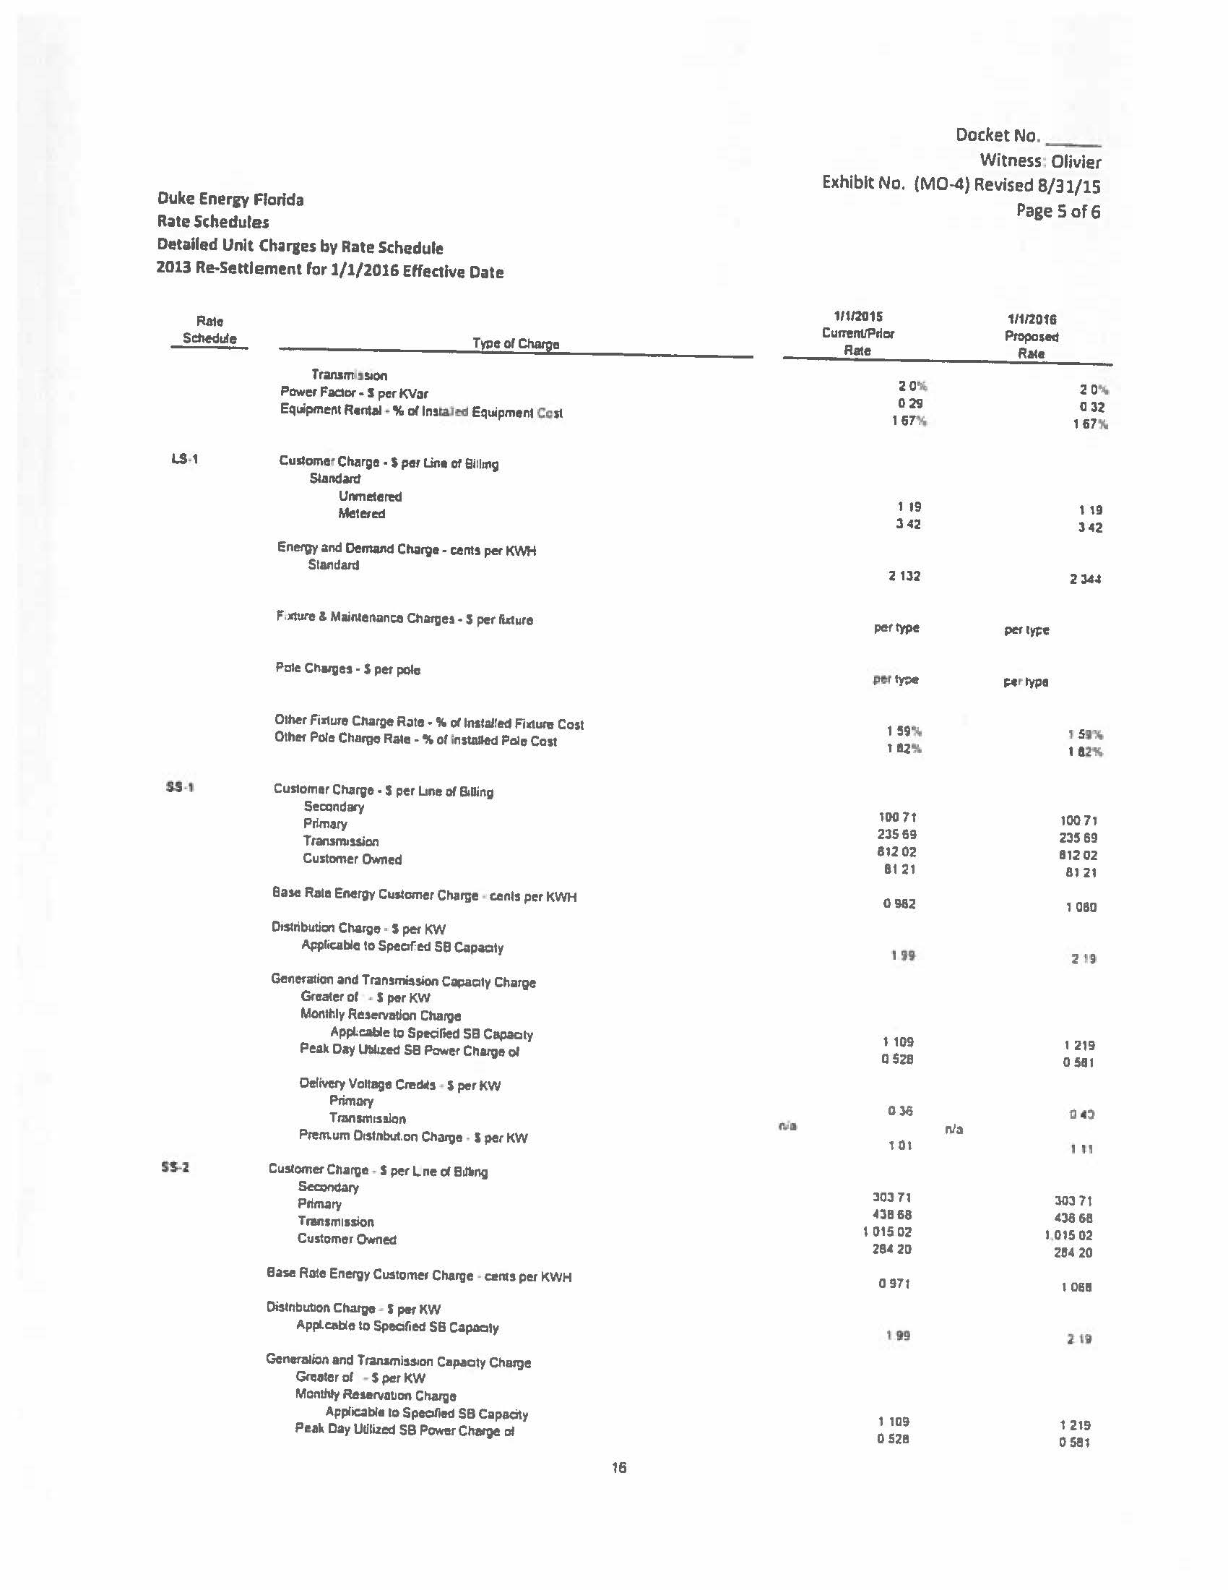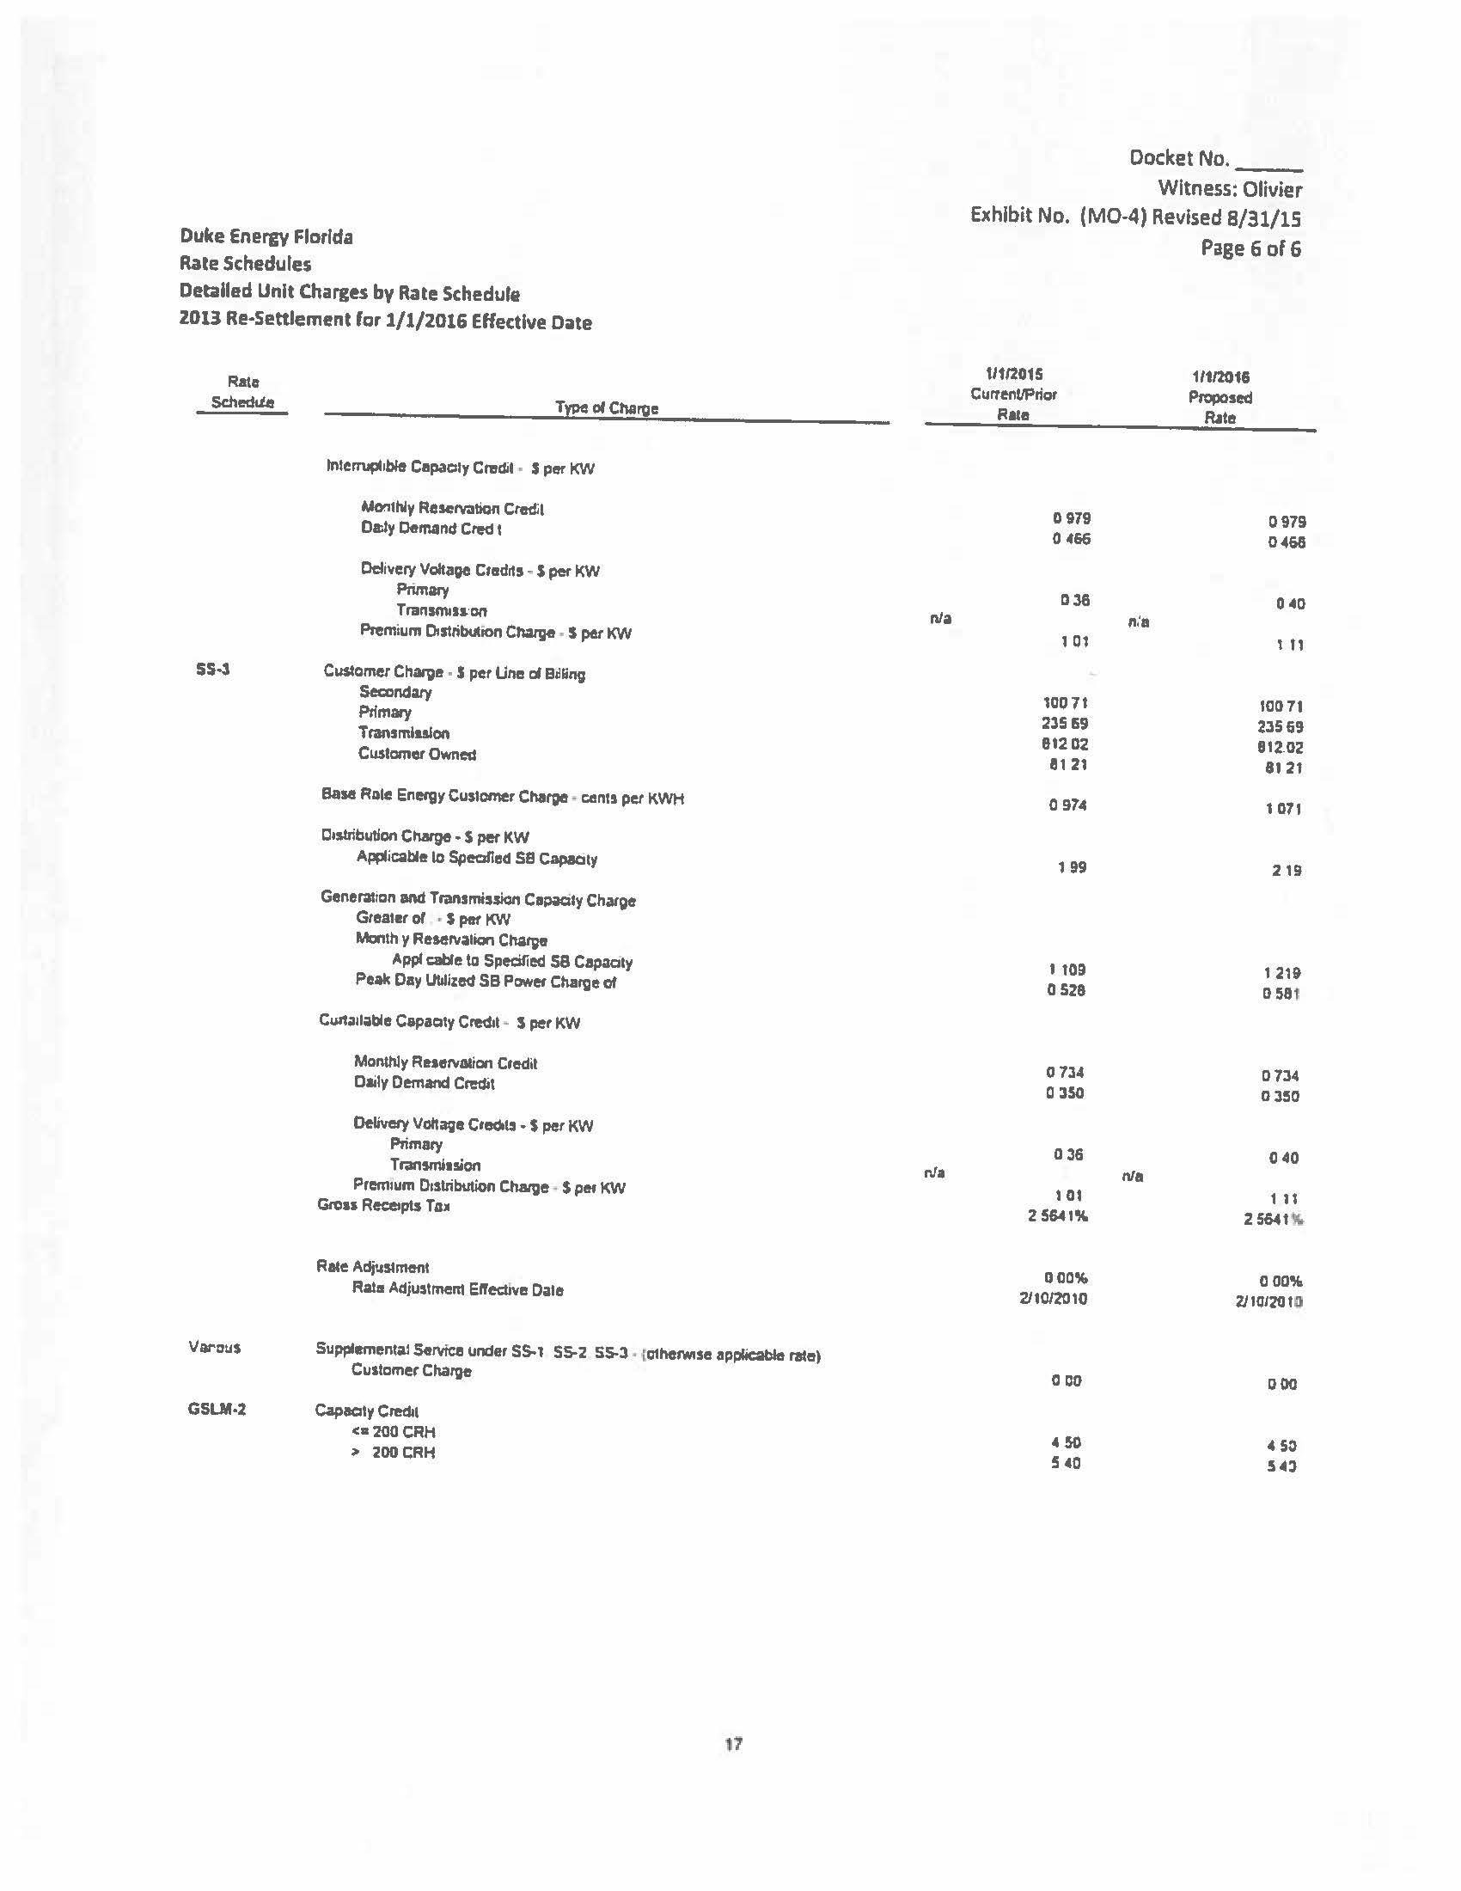



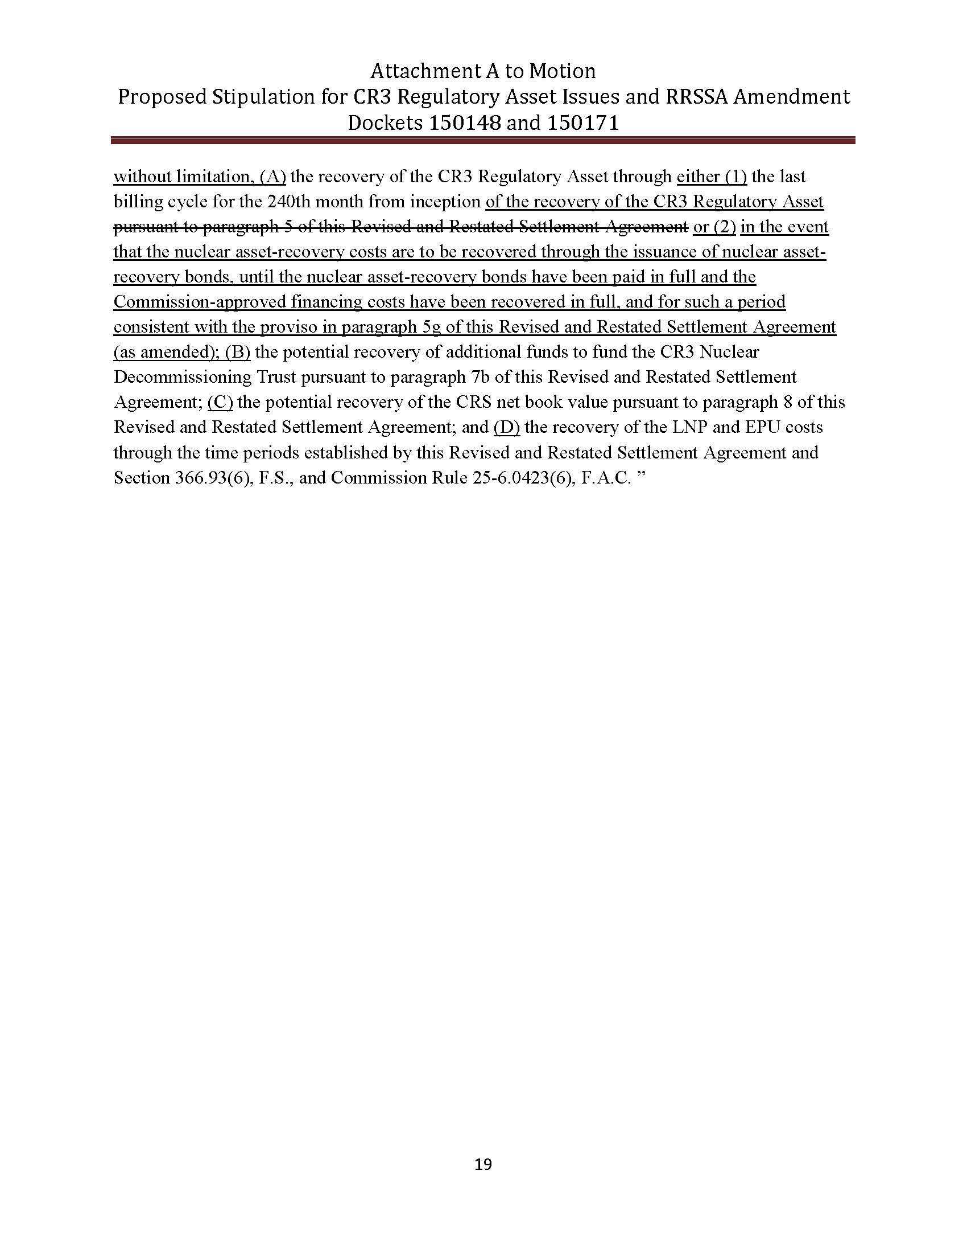

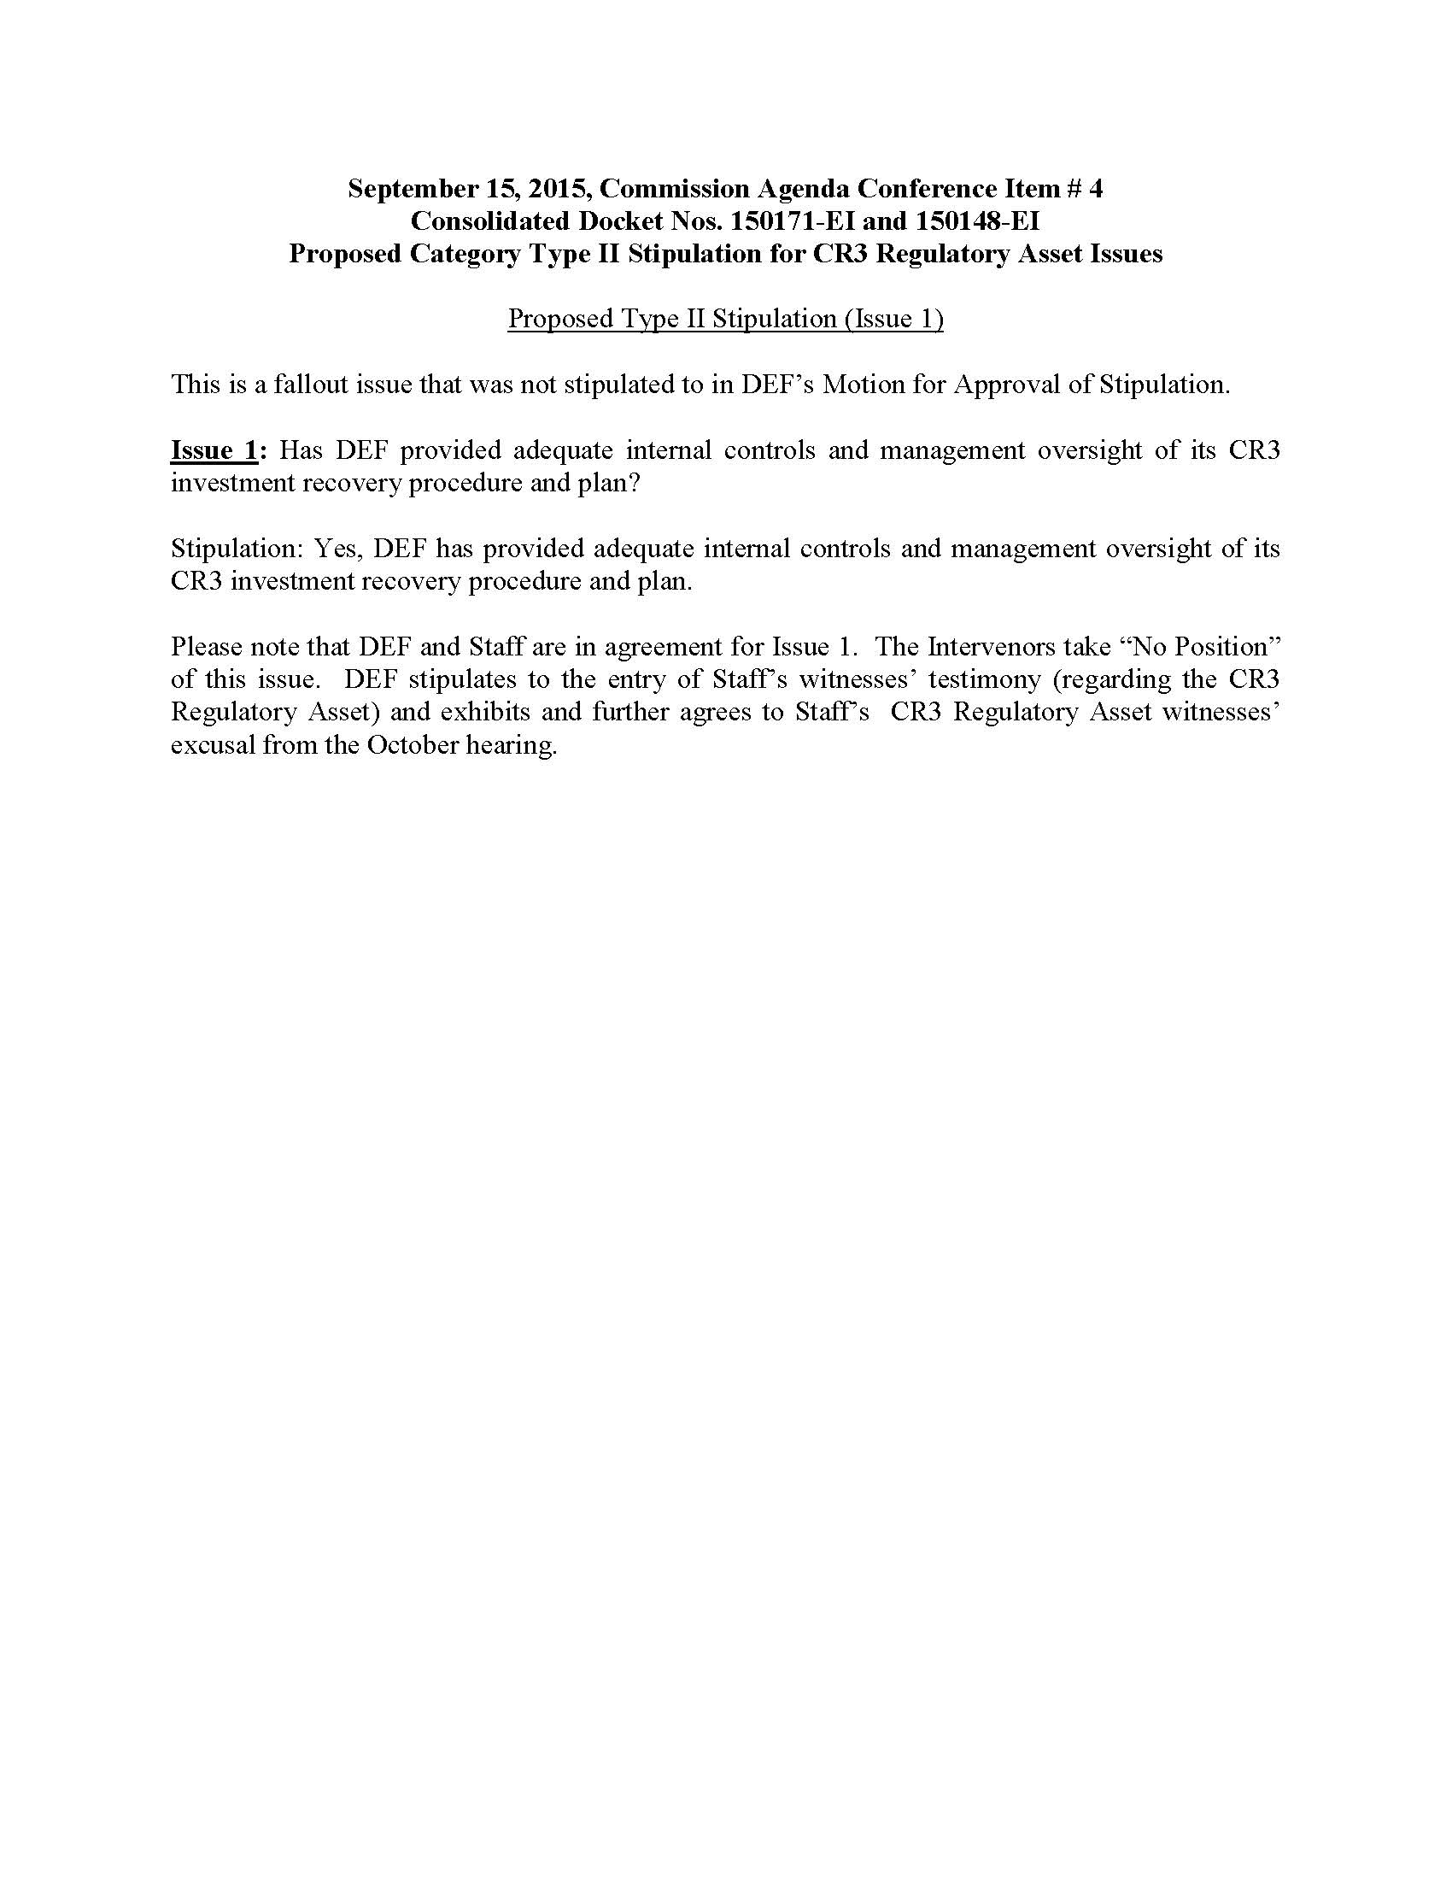

1. Order No. PSC-12-0104-FOF-EI, issued March 8, 2012, as amended by Order No. PSC-12-0104A-FOF-EI, issued March 15, 2012, in Docket No. 120022-EI, In re: Petition for limited proceeding to approve stipulation and settlement agreement by Progress Energy Florida, Inc. (approving the 2012 settlement agreement).
2. Order No. PSC-13-0598-FOF-EI, issued November 12, 2013, in Docket No. 130208-EI, as amended by Order No. PSC-13-0598A-FOF-EI, issued November 13, 2013, In re: Petition for limited proceeding to approve revised and restated stipulation and settlement agreement by Duke Energy Florida, Inc. d/b/a Duke Energy.
3. “DEF’s Petition for Approval to Include in Base Rates the Revenue Requirement for the Crystal River Unit 3 Regulatory Asset,” pgs. 8-10, filed on May 22, 2015, in Docket No. 150148-EI.
4. The stipulation addresses only the CR3 regulatory asset-related issues that are the subject of Docket No. 150148-EI (CR3 Regulatory Asset Petition) and does not address the issues raised in Docket No. 150171-EI (Financing Order Petition). The issues related to Docket No. 150171-EI are still set for hearing beginning October 14, 2015.
5. See Document No. 05443-15, filed in Docket 150171-EI.
6. See Document No. 05690-15, filed in Docket 150171-EI.
7. The stipulated positions on Issues 2 through 13 are included as Exhibit 1 to the Proposed Stipulation attached hereto as Attachment I.
8. Type II Stipulation is a stipulation in which all the parties do not join but do not object to the stipulation.