State of Florida |  | Public Service Commission  Capital Circle Office Center ● 2540 Shumard Oak Boulevard  Tallahassee, Florida 32399-0850  -M-E-M-O-R-A-N-D-U-M-
DATE: | October 22, 2015
TO: | Office of Commission Clerk (Stauffer)
FROM: | Office of the General Counsel (Page)  Division of Economics (Draper, Rome)
RE | Docket No. 150187-PU – Proposed Amendments to Rule 25-9.001, F.A.C., Application and Scope, Rule 25-9.002, F.A.C., Definitions, Rule 25-9.050, F.A.C., Application and Scope, Rule 25-9.051, F.A.C., Definitions, Rule 25-9.052, F.A.C., General Submittal Instructions, and Rule 25-9.053, F.A.C., Filing and Evaluation of Submittals.
AGENDA: | 11/05/15 – Regular Agenda – Rule Proposal - Interested Persons May Participate
COMMISSIONERS ASSIGNED: |  |  | All Commissioners
PREHEARING OFFICER: |  |  | Brisé
RULE STATUS: |  |  | Proposal May Be Deferred
SPECIAL INSTRUCTIONS: |  |  | None

Case Background
Rules 25-9.001, Florida Administrative Code (F.A.C.), through 25-9.045, F.A.C., prescribe the procedures to be followed by public utilities in filing rules and regulations, rate schedules, standard forms and riders, contracts and agreements, and tariffs. These rules implement Section 366.04(1), Florida Statutes (F.S.), which states that the Commission has jurisdiction to regulate and supervise each public utility with respect to its rates and service.

Rules 25-9.050, F.A.C., through 25-9.071, F.A.C., prescribe the procedures to be followed by municipal electric utilities and rural electric cooperatives in submitting documentation of rate schedules and contracts and agreements. These rules implement Section 366.04(2), F.S., which sets forth the Commission’s power over electric utilities, including prescribing a uniform system and classification of accounts and prescribing a rate structure for all electric utilities.
Staff initiated this rulemaking to clarify and simplify the rules and delete unnecessary and redundant rule provisions. The Commission’s Notice of Development of Rulemaking was published in the Florida Administrative Register (FAR) on April 13, 2015, in Volume 41, Number 71. A rule development workshop was held on June 9, 2015. The workshop was attended by representatives from Jacksonville Electric Authority (JEA), Florida Electric Cooperatives Association (FECA), Florida Municipal Power Association (FMPA), City of Tallahassee, and the Office of Public Counsel (OPC). OPC’s comments were made during the June 9, 2015 workshop. Post-workshop comments were received from JEA, FECA, FMPA, and Duke Energy (Duke).
This recommendation addresses whether the Commission should propose the repeal of Rule 25-9.050, F.A.C., and the amendment of Rules 25-9.001, 25-9.002, 25-9.051, 25-9.052, and 25-9.053, F.A.C. The Commission has jurisdiction pursuant to Section 120.54, F.S., and Section 366.04(1) and (2), F.S.

Discussion of Issues

Issue 1:
Should the Commission propose the repeal of Rule 25-9.050, F.A.C., and the amendment of Rules 25-9.001, 25-9.002, 25-9.051, 25-9.052, and 25-9.053, F.A.C.?

Recommendation:
Yes. The Commission should propose the repeal of Rule 25-9.050, F.A.C., and the amendment of Rules 25-9.001, 25-9.002, 25-9.051, 25-9.052, and 25-9.053, F.A.C., as set forth in Attachment A. (Page, Rome, Draper)

Staff Analysis:
The most significant portion of the amendments recommended by staff concerns the tariff rules in Chapter 25-9, F.A.C., applicable to municipal electric utilities and rural electric cooperatives. The amendments that staff suggests for the rules applicable to public utilities are minor.

Public Utilities
The requirements and procedures for rules and regulations, rate schedules, standard forms and riders, contracts and agreements, and tariffs filed by public utilities are set forth in Rules 25-9.001 through 25-9.045, F.A.C. Staff is recommending that Rules 25-9.001 and 25-9.002, F.A.C, be amended to clarify and simplify the rules and delete unnecessary and redundant rule provisions.

Rule 25-9.001, F.A.C., Application and Scope
Rule 25-9.001, F.A.C., states that the provisions of Parts, I, II and III of Chapter 25-9, F.A.C., shall only apply to public utilities and that Parts IV and V of the rules shall only apply to municipalities and rural electric cooperatives. Staff recommends amendments to Rule 25-9.001, F.A.C., to clarify which rules apply to each type of utility. The references to “Parts” would be deleted and amendments specifying the rules applicable to public utilities, municipalities and cooperatives would be added in place of the former language. Staff recommends that the remainder of the rule be deleted as obsolete and unnecessary.

Rule 25-9.002, F.A.C., Definitions
Rule 25-9.002, F.A.C., contains definitions of pertinent terms such as “rate,” “rate schedule,” and “tariff.” Staff recommends that these definitions be identified as applicable to Rules 25-9.002 through 25-9.045, F.A.C., rather than the rule’s reference to “these regulations.” The purpose of this amendment is to clarify and update the rule regarding the definitions applicable to public utilities.

Municipal Electric Utilities and Rural Electric Cooperatives
Rules 25-9.050 through 25-9.071, F.A.C., set forth the requirements and procedures for submittal and evaluation of proposed changes in rate structure by municipal electric utilities and rural electric cooperatives. Staff is recommending that Rule 25-9.050, F.A.C., be repealed as obsolete and that Rules 25-9.051 through 25-9.071 be amended to clarify and simplify the rules and delete unnecessary and redundant rule provisions.

Rule 25-9.050, F.A.C., Application and Scope
Rule 25-9.050, F.A.C., states that Rules 25-9.050 through 25-9.071, F.A.C., apply only to municipal electric utilities and rural electric cooperatives. Rule 25-9.050, F.A.C., would be unnecessary if the amendments staff is recommending to Rule 25-9.001, F.A.C., are adopted because that rule would set forth the application and scope of Chapter 25-9, F.A.C. Thus, staff recommends the repeal of Rule 25-9.050, F.A.C., as it would be obsolete and unnecessary due to the recommended amendments to Rule 25-9.001, F.A.C.

Rule 25-9.051, F.A.C., Definitions
Rule 25-9.051, F.A.C., defines terms for the purposes of “these rules.” Staff recommends an amendment to this rule stating that the definitions pertain to Rules 25-9.051 through 25-9.071, F.A.C. Staff recommends this amendment to clarify and update the rule regarding the definitions applicable to municipal and cooperative electric utilities.
Rule 25-9.051(6), F.A.C., states that documentation to be filed with the Commission Clerk consists of the assembled volume containing rate schedules, contracts and agreements, and other required materials as designated by the rule. Staff recommends amendments to Rule 25-9.051(6), F.A.C., which would define documentation as the assembled volume containing the materials required by Rules 25-9.054 through 25-9.071, F.A.C.

Rule 25-9.052, F.A.C., General Submittal Instructions
Rule 25-9.052(1), F.A.C., requires the utility to submit to the Commission documentation of all territory and customers served by it. Staff recommends that for purposes of consistency, this language be amended to refer to the documentation defined in Rule 25-9.051(6), F.A.C.
Rule 25-9.052 (2), (3), and (4), F.A.C., requires filings in quadruplicate, specifies the terms and conditions of a comment letter, and outlines the Commission’s authority to prescribe a rate structure. Staff recommends that these provisions be deleted and that amendments setting forth procedures for the filing of documentation be added so that the requirements for filings are identified.
On April 27, 2015, FECA and FMPA submitted written comments suggesting that Rule 25-9.052(4), F.A.C., should state that in filing documentation for a proposed change in rate structure, the utility shall provide documentation to support the change in rate structure or an analysis of utility-specific costs and operating data prepared using a methodology previously approved by the Commission for any comparable utility or investor-owned utility. Staff does not recommend the inclusion of this language because the term “using a methodology previously approved by the Commission for a comparable utility or investor-owned utility” would create ambiguity and vagueness as to the analysis required of the utility to support a change in rate structure.

Rule 25-9.053, F.A.C., Filing and Evaluation of Submittals
Rule 25-9.053(1), F.A.C., states that when a utility files for a proposed change in its rate structure, supporting documentation must be accompanied by information with sufficient detail to allow the Commission to determine the derivation of all rate structure modifications. The rule states that the supporting information shall consist of either a utility-specific cost study or an analysis of utility-specific cost and operating data prepared using a methodology previously approved by the Commission for any comparable utility.
Staff recommends amendments to Rule 25-9.053(1), F.A.C., which directly set forth the criteria that a utility must meet for the Commission to approve a proposed change in the utility’s rate structure. Staff recommends amendments that the utility’s proposed change in rate structure must satisfy one of the following criteria: (a) is cost based; (b) has historical precedent; (c) embodies pricing concepts previously approved by the Commission; or (d) is not unduly discriminatory. Staff recommends this amendment because it is more informative than the provisions of Rule 25-9.053(1), F.A.C., and it notifies utilities of the criteria which must be met to obtain approval of a proposed change in rate structure.
The April 27, 2015 written comments from FECA and FMPA suggested additional amendments to Rule 25-9.053(1), F.A.C., stating that if the typical bill ratios of kilowatt-hours charged under the proposed rate structure fall within the range of 10 percent of the ratios of a comparable utility or investor-owned utility, then the proposed rate structure should be deemed to satisfy the criteria in Rule 25-9.053(1), F.A.C. Staff does not recommend this suggested amendment to Rule 25-9.053(1), F.A.C., because the amendment contains the term “comparable utility” which is not defined in the rule. Definition of the term “comparable utility” would be difficult because the standards for definition are subjective and open to a wide range of possible interpretation.
Rule 25-9.053(2), F.A.C., states that if the utility does not submit supporting information for the proposed change in rate structure, the Commission shall evaluate the proposed change in rate structure on the basis of cost and operating data from one or more comparably situated public electric utilities which the Commission determines to be most similar to the utility filing the proposed change in rate structure. The term “one or more comparably situated public electric utilities” is not defined in Rule 25-9.053(2), F.A.C. Staff recommends amendments to the rule that after review of the proposed change in rate structure, staff will notify the utility in writing either that the documentation filed has been administratively approved or how the proposed rate structure is inconsistent with the criteria specified in Rule 25-9.053(1), F.A.C. Staff believes these amendments to Rule 25-9.053(2), F.A.C., specify and describe evaluation methodology more effectively than the current rule.
Staff’s recommended amendment to Rule 25-9.053(2), F.A.C., states that if staff notifies the utility that the proposed change in rate structure is inconsistent with the criteria in Rule 25-9.053(1), F.A.C., the utility shall either file an alternative proposed rate structure addressing staff’s concerns, or file a statement that the utility disagrees with staff’s determination of inconsistency and requesting the Commission to consider the proposed rate structure as filed. Staff recommends this amendment because it reflects the procedure and practice followed by staff in reviewing proposed changes in rate structure for municipal and cooperative electric utilities.
FMPA submitted post-workshop comments suggesting that Rule 25-9.053, F.A.C., include language allowing municipal utilities to put a proposed rate structure into effect during the time period when staff informs the utility that the proposed rate structure is inconsistent with subsection (1) of the rule and the Commission makes a determination of the proposed rate structure under subsection (2) of the rule. The Commission does not have authority over the effective date of a tariff proposed by a municipal or cooperative utility. Thus, staff does not recommend that these practices be codified in Rule 25-9.053(2), F.A.C.
At the June 9, 2015, workshop, OPC suggested that the authority of staff to administratively approve proposed changes in rate structure is outside the scope of functions to be performed by staff. The Commission authorized staff to administratively approve filings for municipal and cooperative electric utilities in Order No. 16784. In consideration of this precedent, staff recommends the amendments to Rule 25-9.053, F.A.C., as a clarification of the administrative action which the Commission has authorized staff to take upon review of a municipal or cooperative electric utility’s proposed change in rate structure.
OPC also expressed a concern at the workshop on the effect of recent amendments to Section 366.05, F.S., has on Rule 25-9.053 F.A.C. The amendments provide that new tariffs and changes to existing tariffs other than an administrative change that does not substantially change the meaning or operation of the tariff must be approved by majority vote of the Commission. OPC suggested that this amendment precludes staff from administratively approving municipals’ and cooperatives’ proposed changes in rate structure. However, the amendments to Section 366.05, F.S., only apply to public utilities, not municipals or rural electric cooperatives. Rule 25-9.053, F.A.C., is only applicable to municipals and rural electric cooperatives. Therefore, the amendments to Section 366.05, F.S., are not applicable to the administrative approval process described in staff’s suggested amendments to Rule 25-9.053, F.A.C.
Staff recommends the addition of subsection (3) to Rule 25-9.053, F.A.C., stating that if the Commission finds the proposed rate structure inconsistent with the criteria listed in Rule 25-9.053(1), F.A.C., the Commission shall direct the utility to file a rate structure consistent with these criteria. FECA suggested that subsection (3) should state that if staff finds that the utility’s proposed rate structure is inconsistent with the criteria in Rule 25-9.053(1), F.A.C., staff, not the Commission, will issue the letter to the utility directing it to file a proposed change in rate structure meeting the requirements of Rule 25-9.053(1), F.A.C. FECA also suggested that subsection (3) of Rule 25-9.053, F.A.C., should state that staff is given authority to find that the utility cannot justify its proposed change in rate structure, and to initiate an “appropriate proceeding.”
Staff believes that the amendment requested by FECA diverges from the process of the utility requesting that the Commission consider the proposed change in rate structure as filed if the utility disagrees with staff’s determination that the proposed rate structure is inconsistent with the criteria in Rule 25-9.053(1), F.A.C. FECA’s suggestion would put the responsibility for the Commission’s approval of the utility’s proposed change in rate structure on staff. Staff recommends that the burden of obtaining the Commission’s approval of the proposed change in rate structure should remain on the utility. Therefore, staff does not recommend FECA’s amendments to subsection (3) of Rule 25-9.053, F.A.C.

Statement of Estimated Regulatory Costs
Pursuant to Section 120.54, F.S., agencies are encouraged to prepare a statement of estimated regulatory costs (SERC) before the adoption, amendment, or repeal of any rule. The SERC is appended as Attachment B to this recommendation. The SERC analysis includes whether the rule amendment is likely to have an adverse impact on growth, private sector job creation or employment, or private sector investment in excess of $1 million in the aggregate within five years after implementation.
The SERC concludes that the rule amendments will likely not directly or indirectly increase regulatory costs in excess of $200,000 in the aggregate in Florida within one year after implementation. The SERC also states that it is anticipated that affected entities, such as municipal and cooperative electric utilities, may benefit from the recommended rule changes. Further, the SERC concludes that the rule amendments will not likely have an adverse impact on economic growth, private-sector job creation or employment, private-sector investment, business competitiveness, productivity, or innovation in excess of $1 million in the aggregate within five years of implementation. Thus, the rule amendments do not require legislative ratification pursuant to Section 120.541(3), F.S. In addition, the SERC states that the rule amendments will not have an adverse impact on small business and will have no impact on small cities or small counties.

Conclusion
Based on the foregoing, staff recommends the repeal of Rule 25-9.050, F.A.C., and the amendment of Rules 25-9.001, 25-9.002, 25-9.051, 25-9.052, and 25-9.053, F.A.C.

Issue 2:
Should this docket be closed?

Recommendation:
Yes. If no requests for hearing or comments are filed, the rules may be filed with the Department of State, and this docket should be closed. (Page)

Staff Analysis:
If no requests for hearing or comments are filed, the rules may be filed with the Department of State, and this docket should be closed.

25-9.001 Application and Scope.
(1) The provisions of Rules 25-9.002 through 25-9.045, F.A.C., Parts I, II and III of these rules shall only apply to public utilities as defined in Rule subsection 25-9.002(2), F.A.C., and the provisions of Rules 25-9.051 through 25-9.071, F.A.C., Parts IV and V of these rules shall only apply to municipalities and cooperatives as defined in Rule subsection 25-9.051(2), F.A.C. The provisions of this chapter shall not apply to Interexchange Companies, Pay Telephone Service Companies, Shared Tenant Service Companies, Operator Service Provider Companies, Alternative Access Vendor Service Providers, Competitive Local Exchange Companies, or Local Exchange Companies.
(2) The following shall prescribe the procedures to be used by public utilities in filing:
(a) Rules and Regulations.
(b) Rate Schedules.
(c) Standard Forms and Riders.
(d) Contracts and Agreements.
(e) Tariffs.
(3) No rules and regulations, or schedules of rates and charges, or modifications or revisions of the same, shall be effective until filed with and approved by the Commission as provided by law.
(4) Upon acceptable showing by any utility, the Commission may waive or modify, as to that utility, the provisions of any rule herein contained, except when such provisions are fixed by statute.
(5) No deviation from these rules shall be permitted unless authorized in writing by the Commission.
Rulemaking Authority 350.127(2), 366.05(1), 367.121 FS. Law Implemented 366.04(2)(b), 366.05(1), 367.091, 367.101 FS. History–New 1-8-75, Repromulgated 10-22-75, Amended 8-9-79, Formerly 25-9.01, Amended 2-23-86, 1-8-95, 1-25-09, ___________.

25-9.002 Definitions.
For the purposes of Rules 25-9.002 through 25-9.045, F.A.C., these regulations the following definitions shall apply:
(1) The word “Commission” refers to the Florida Public Service Commission.
(2) Except where a different meaning clearly appears from the context, Tthe word or words “utility” or “public utility” as used in these rules shall mean and include all electric and gas utilities, water systems, and wastewater systems, which are, or may hereafter be, subject to the rate jurisdiction of this Commission.
(3) The term “rules” and/or “regulations” refers to the general practices followed by the utility in carrying on its business with its customers and includes the rules, practices, classifications, exceptions and conditions observed by the utility in supplying service.
(4) The term “rate” refers to the price or charge for utility service.
(5) The term “rate schedule” refers to the rate or charge for the particular classification of service plus the several provisions necessary for billing, including all special terms and conditions under which service shall be furnished at such rate or charge.
(6) The term “standard forms” means and includes all standard contract or agreement forms for execution between the utility and its customers.
(7) “Contracts and agreements” shall refer to special contracts entered into by the utility for the sale of commodities commodity or services in a manner or subject to provisions not specifically covered by its filed standard rate schedules.
(8) The term “tariff” shall refer to the assembled volume containing the “rules,” “regulations,” “rate schedules,” “standard forms,” “contracts,” and other material required by these regulations as filed with the Commission.
Rulemaking Authority 350.127(2), 366.05(1), 367.121 FS. Law Implemented 366.05(1), 367.081, 367.091, 367.101, 367.021 FS. History–New 1-8-75, Repromulgated 10-22-75, Formerly 25-9.02, Amended 1-25-09, ___________.

25-9.050 Application and Scope.
(1) The following rules apply only to municipal electric utilities and rural electric cooperatives and prescribe the procedure to be followed by such utilities in submitting documentation of:
(a) Rate Schedules
(b) Contracts and Agreements
(2) Upon acceptable showing by the utility, the Commission may waive or modify, as to that utility, the provisions of any rule herein contained, except when such provisions are fixed by statute.
(3) No deviation from these rules shall be permitted unless authorized in writing by the Commission.
Rulemaking Authority 366.05(1) FS. Law Implemented 366.04(2)(b) FS. History–New 8-9-79, Formerly 25-9.50, Repealed __________.

25-9.051 Definitions.
For the purposes of Rules 25-9.051 through 25-9.071, F.A.C., these rules the following definitions shall apply:
(1) “Commission” refers to the Florida Public Service Commission.
(2) “Utility” refers applies to the municipal electric utilities and rural electric cooperatives subject to the jurisdiction of this Commission pursuant to Section 366.04(2), F.S. except where a different meaning clearly appears from the context.
(3) “Rate” refers to the price or charge for utility service.
(4) “Rate schedules” refer to the rate for a particular classification of service and the provisions necessary for billing, including all special terms and conditions under which service shall be furnished at such rate or charge.
(5) “Contracts and agreements” refer to the special contracts entered into by the utility for the sale of electricity to consumers in a manner or subject to provisions not specifically covered by its submitted rate schedules.
(6) “Documentation” refers applies to the assembled volume containing the materials required by Rules 25-9.054 through 25-9.071, F.A.C. rate schedules, contracts and agreements and other materials required by these rules.
(7) “Rate structure” refers to the classification system used in justifying different rates and, more specifically, to the rate relationship between various customer classes, as well as the rate relationship between members of a customer class.
(8) “Customer class” refers to any group of customers distinguishable from other customers by load, consumption or other characteristic.
Rulemaking Authority 366.05(1) FS. Law Implemented 366.04(2)(b) FS. History–New 8-9-79, Amended 5-3-83, Formerly 25-9.51, Amended __________.

25-9.052 General Filing Submittal Instructions.
(1) Each utility shall submit to the Commission file with the Commission Clerk documentation as defined in Rule 25-9.051(6), F.A.C. documentation of all territory and customers served by it.
(2) All supplements, revisions, modifications or changes to the documentation shall be filed with the Commission Clerk submitted to the Commission in quadruplicate and in the form prescribed herein at least 30 days prior to final adoption by the utility. All materials filed with the Commission Clerk submitted to the Commission pursuant to subsection (1) of this rule will be reviewed for compliance with Rules 25-9.051 through 25-9.071, F.A.C., and retained in the Commission’s files. After review, a letter indicating the Commission receipt of or comments on the utility’s proposed rate structure will be transmitted to the utility. The comment letter may contain a request for data or explanation of the basis for any change in the utility’s rate structure.
(3) All documentation filed with the Commission Clerk shall be accompanied by a list of the materials being filed. After reviewing Commission comments and adopting a final rate structure, the utility shall submit the adopted rate structure to the Commission, along with any response to the Commission’s comment letter. The Commission will acknowledge these filings.
(4) When a utility’s filing reflects a proposed change in rate structure, the utility shall provide documentation to support the change in rate structure. In the event the Commission determines that the rate structure of a utility may not be fair, just and reasonable, the Commission may initiate appropriate proceedings to prescribe a rate structure that is fair, just and reasonable. In so doing the Commission may, among other things, consider the cost of providing service to each customer class, as well as the rate history, value of service and experience of the utility, the consumption and load characteristics of the various classes of customers and the public acceptance of rate structures. The following principles may also be considered: simplicity, freedom from controversy, rate stability, fairness in apportioning costs, avoidance of undue discrimination and encouragement of efficiency.
(5) All documented materials filed with the Commission shall be accompanied by a letter listing the sheets being transmitted. The filing shall be acknowledged if the letter is sent in duplicate with a request for acknowledgement.
Rulemaking Authority 366.05(1) FS. Law Implemented 366.04(2)(b) FS. History–New 8-9-79, Amended 5-3-83, Formerly 25-9.52, Amended__________.

25-9.053 Filing and Evaluation of Filings Submittals.
(1) A change to a utility’s rate structure must meet one of the following criteria: (a) is cost based; (b) has historical precedent; (c) embodies pricing concepts previously approved by the Commission; or (d) is not unduly discriminatory. Each letter transmitting a utility’s proposed documentation in which any change in rate structure is proposed shall be accompanied by supporting information in sufficient detail as to allow the Commission to determine the derivation of all rate structure modifications. The supporting information shall consist of either a utility-specific cost study or an analysis of utility-specific cost and operating data prepared using a methodology previously approved by the Commission for any comparable utility. All additional relevant information deemed necessary by the Commission shall be submitted in addition to the above request.
(2) After review of the utility’s proposed change in rate structure, staff will send written notification to the utility indicating: (a) administrative approval of the documentation or (b) how the proposed rate structure is inconsistent with the criteria listed in subsection (1) of this rule. Upon receipt of staff’s notification of inconsistency, the utility shall file an alternative proposed rate structure addressing staff’s concerns or file a statement that the utility disagrees with the staff determination of inconsistency and requesting the Commission to consider the proposed rate structure as filed. If the utility does not submit such supporting information the Commission shall evaluate the proposed change in rate structure on the basis of cost and operating data from one or more comparably situated public electric utilities which the Commission determines to be most similar to the filing utility. Data from the comparable utilities shall be considered in conjunction with all submitted information which is specific to the filing utility.
(3) If the Commission finds the proposed rate structure inconsistent with subsection (1), the Commission shall direct the utility to file a rate structure that is consistent with the criteria in subsection (1) of this rule.
Rulemaking Authority 366.05(1) FS. Law Implemented 366.04(2)(b), FS. History–New 8-9-79, Formerly 25-9.53, Amended 1-17-93, ____________.

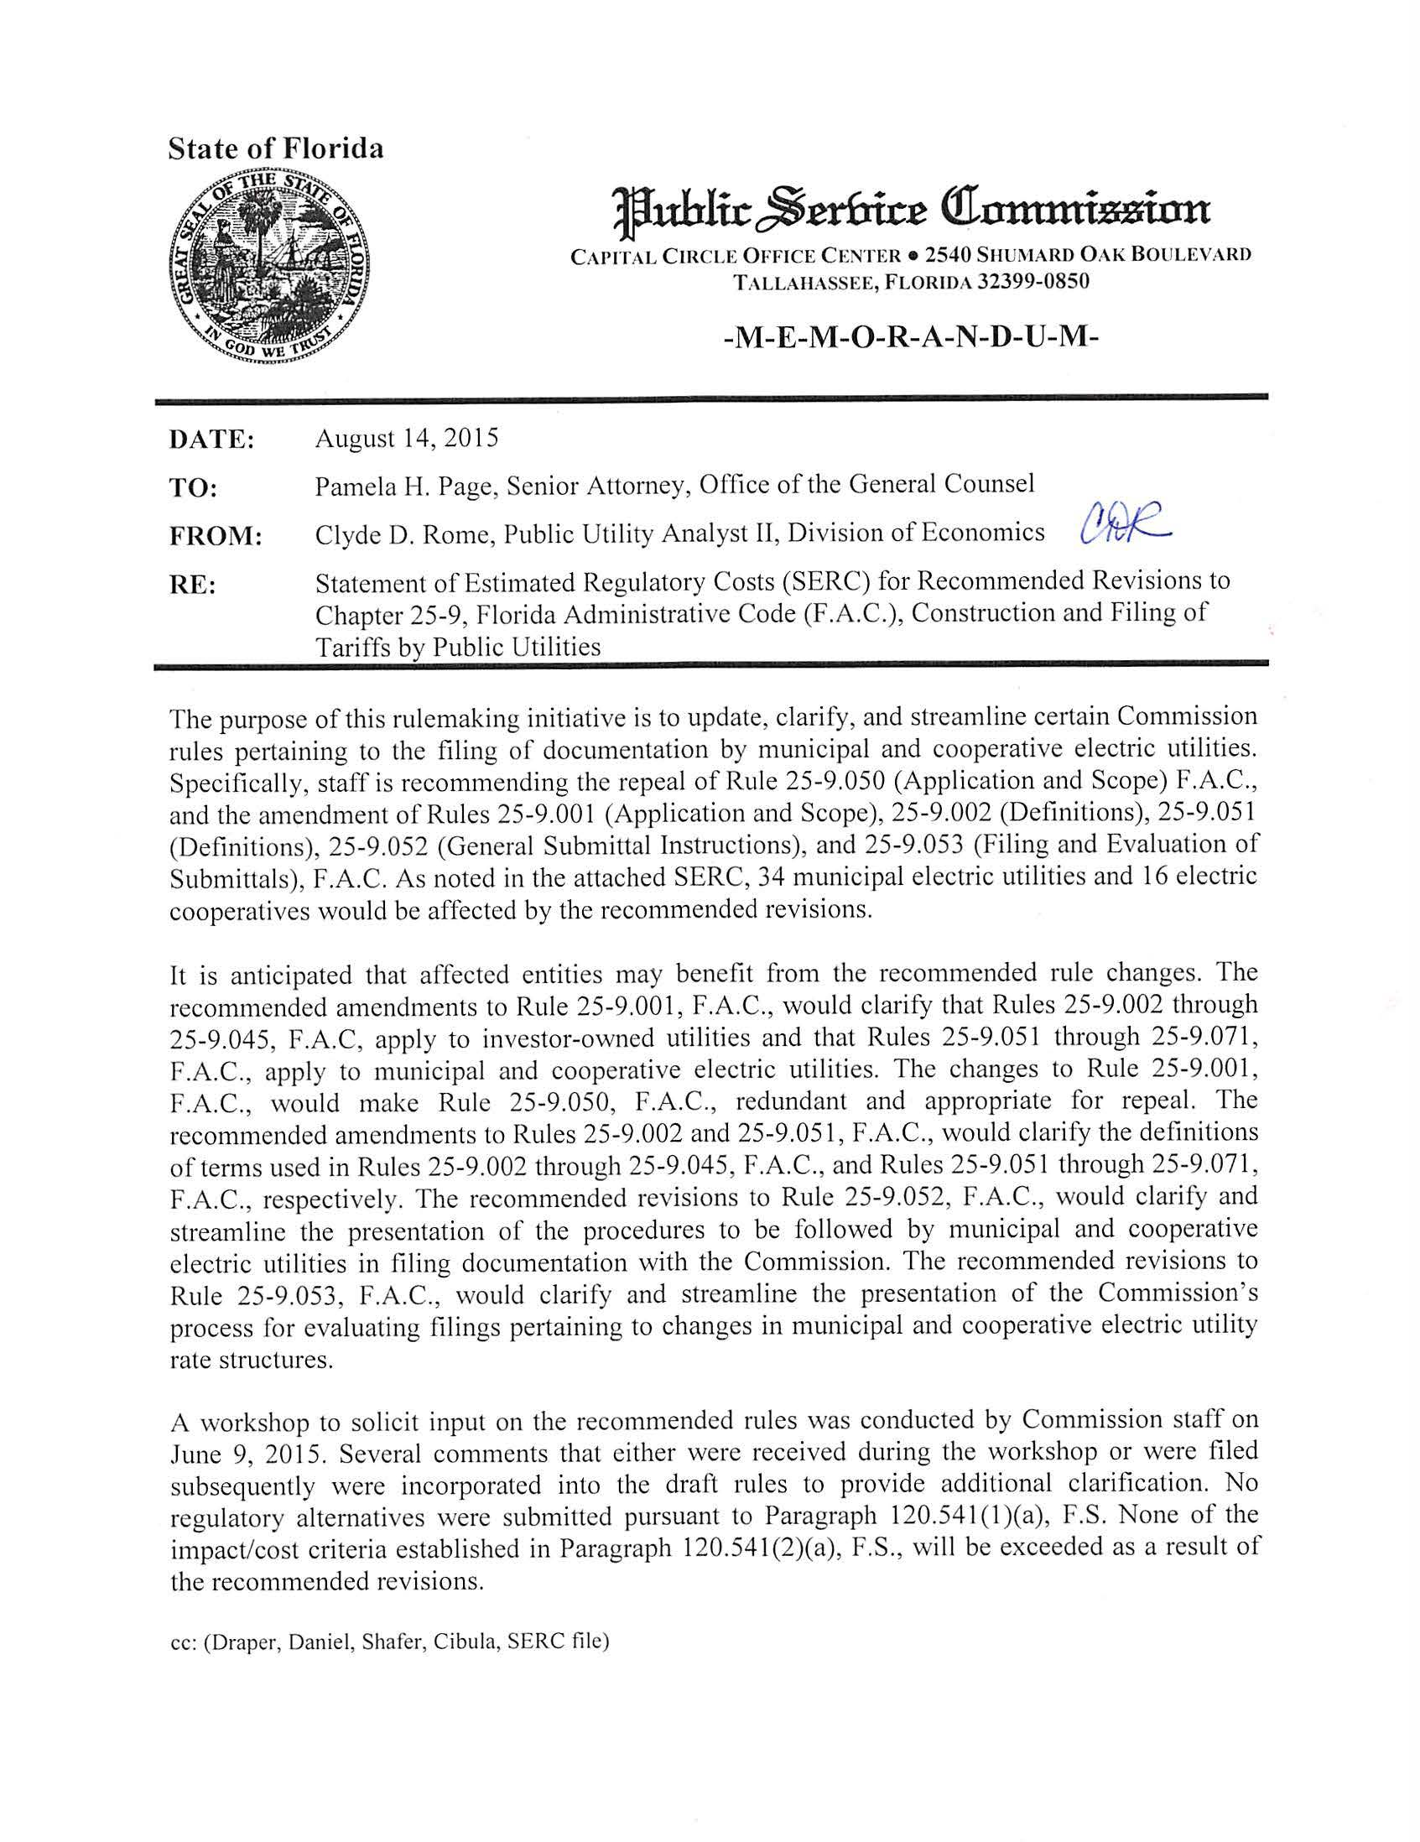

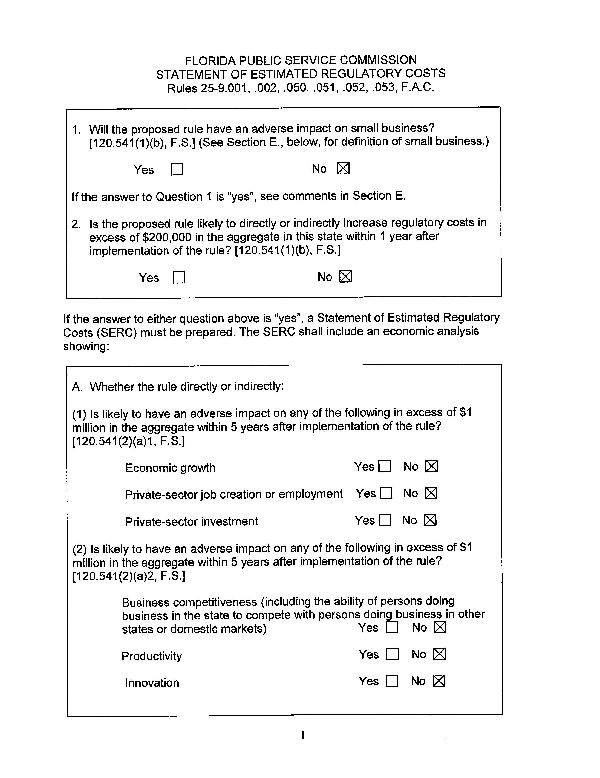

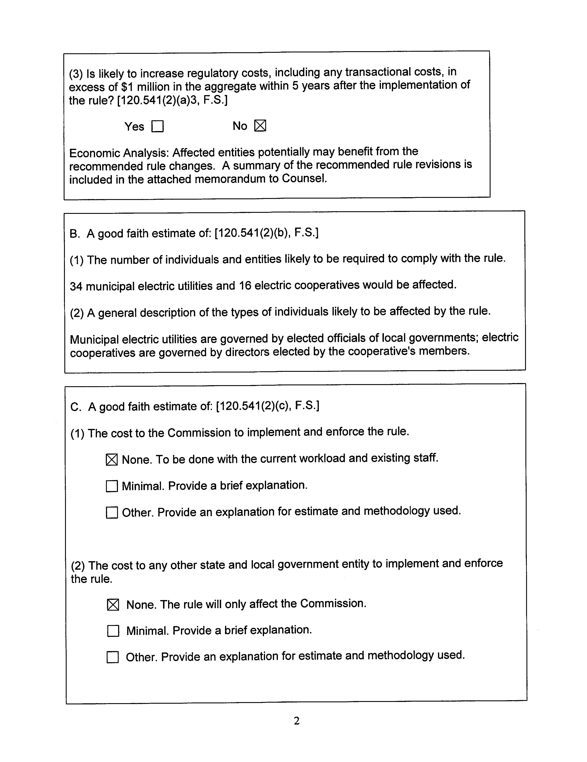

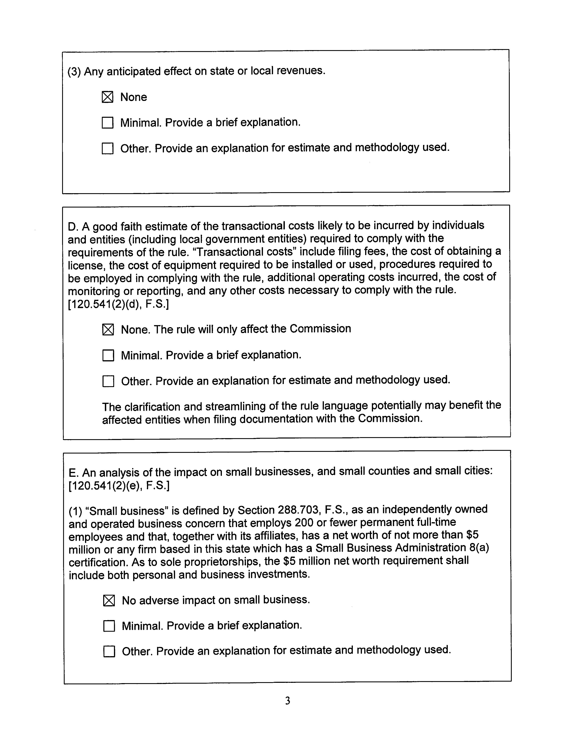

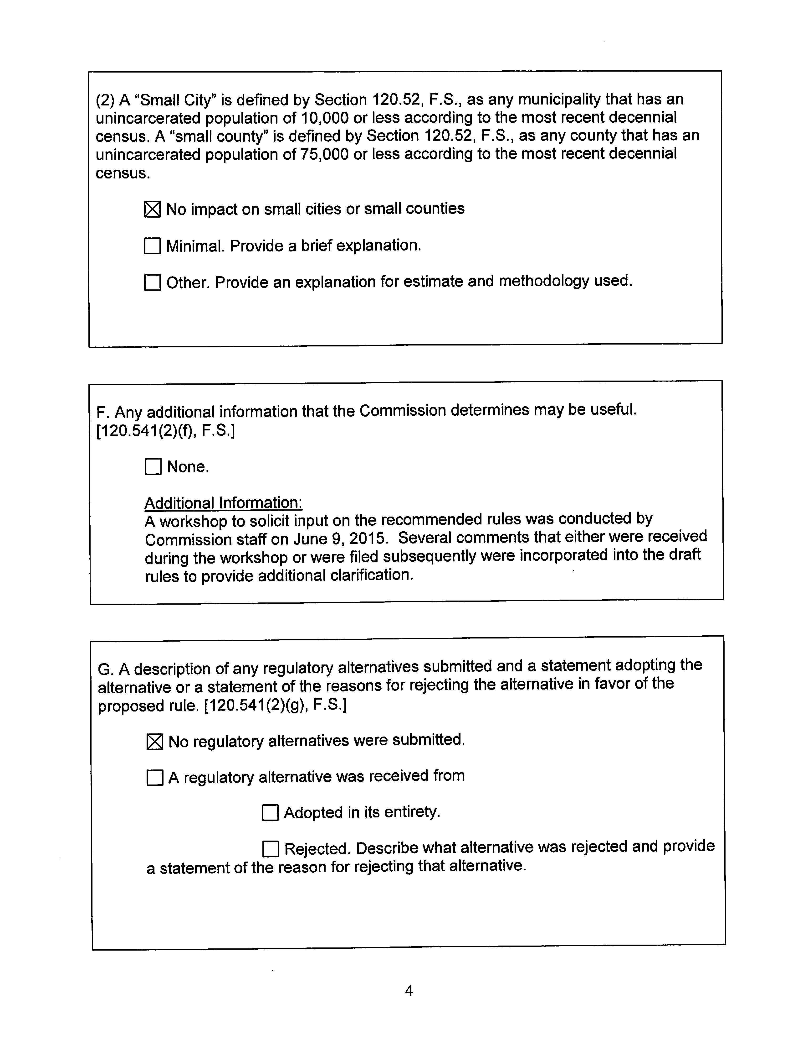

Pursuant to Section 366.02(1), F.S., “public utility” is defined as every person, corporation, partnership, association or other legal entity supplying electricity or gas to or for the public.
Pursuant to Section 366.02(2), F.S., “electric utility” is defined as any municipal electric utility or rural electric cooperative.
Duke requested that Rule 25-9.004 (2), F.A.C., be amended to remove the current requirement that public utilities file tariffs in quadruplicate. This rule is not part of this rulemaking. Staff will consider this for future rulemaking.
See Docket No. 850595-EU-A, Order No. 17613, issued May 26, 1987, In re: Filing Requirements for Municipal Electric Authorities and Rural Electric Cooperatives, (the four criteria were agreed upon in a stipulation agreement between the municipals, cooperatives and staff which was approved by the Commission).
See Docket No. 850595-EU-A, Order No. 16784, issued October 27, 1986, In re: Filing Requirements for Municipal Electric Authorities and Rural Electric Cooperatives, (the Commission delegated authority to staff to administratively approve proposed changes in rate structure filed by municipals and rural electric cooperatives).
Section 120.541(2), F.S.

