BEFORE THE FLORIDA PUBLIC SERVICE COMMISSION

In re: Nuclear cost recovery clause. | DOCKET NO. 150009-EI  ORDER NO. PSC-15-0521-FOF-EI  ISSUED: November 3, 2015

The following Commissioners participated in the disposition of this matter:

ART GRAHAM, Chairman
LISA POLAK EDGAR
RONALD A. BRISÉ
JULIE I. BROWN
JIMMY PATRONIS

APPEARANCES:

DIANNE M. TRIPLETT, and MATTHEW R. BERNIER, ESQUIRES, Duke Energy Florida, LLC, Post Office Box 14042, Saint Petersburg, Florida 33733; JAMES MICHAEL WALLS and BLAISE N. GAMBA, ESQUIRES, Carlton Fields Jorden Burt, P.A., Post Office Box 3239, Tampa,
Florida 33601-3239
On behalf of Duke Energy Florida, LLC (DEF)

JESSICA CANO, and KEVIN I.C. DONALDSON, ESQUIRES, Florida Power & Light Company, 700 Universe Boulevard, Juno Beach, Florida 33408
On behalf of Florida Power & Light Company (FPL)

J.R. KELLY, CHARLES J. REHWINKEL, PATRICIA A. CHRISTENSEN, and ERIK L. SAYLER, ESQUIRES, Office of Public Counsel, c/o The Florida Legislature, 111 W. Madison Street, Room 812, Tallahassee, Florida 32399-1400
On behalf of the Citizens of the State of Florida (OPC)

JON MOYLE, JR., VICKI GORDON KAUFMAN, and KAREN A. PUTNAL, ESQUIRES, Moyle Law Firm, P.A., 118 North Gadsden Street, Tallahassee, Florida 32301
On behalf of the Florida Industrial Power Users Group (FIPUG)

JAMES W. BREW, OWEN J. KOPON, and LAURA A. WYNN, ESQUIRES, Stone Mattheis Xenopoulos & Brew, PC, 1025 Thomas Jefferson St., NW, Eighth Floor, West Tower, Washington, DC 20007
On behalf of White Springs Agricultural Chemicals, Inc. d/b/a PCS Phosphate – White Springs (PCS Phosphate)

GEORGE CAVROS, ESQUIRE, 120 E. Oakland Park Boulevard, Suite 105, Fort Lauderdale, Florida, 33334
On behalf of the Southern Alliance for Clean Energy (SACE)

ROBERT SCHEFFEL WRIGHT and JOHN T. LAVIA, III, ESQUIRES, Gardner, Bist, Bowden, Bush, Dee, LaVia & Wright, P.A., 1300 Thomaswood Drive, Tallahassee, Florida 32308
On behalf of the Florida Retail Federation (FRF)

VICTORIA MÉNDEZ and MATTHEW HABER, ESQUIRES, City of Miami, 444 S.W. 2nd Avenue, Suite 945, Miami, Florida 33130-1910
On behalf of City of Miami (Miami)

MARTHA BARRERA and KYESHA MAPP, ESQUIRES, Florida Public Service Commission, 2540 Shumard Oak Boulevard, Tallahassee, Florida 32399-0850
On behalf of the Florida Public Service Commission (Staff)

Mary Anne Helton, ESQUIRE, Deputy General Counsel, Florida Public Service Commission, 2540 Shumard Oak Boulevard, Tallahassee, Florida 32399-0850
Advisor to the Florida Public Service Commission

FINAL ORDER APPROVING NUCLEAR COST RECOVERY AMOUNTS FOR
FLORIDA POWER & LIGHT COMPANY AND
DUKE ENERGY FLORIDA, LLC

BY THE COMMISSION:

BACKGROUND

This Order addresses petitions for continued alternative cost recovery of new nuclear generation project costs through the Nuclear Cost Recovery Clause (NCRC) pursuant to Rule 25-6.0423, Florida Administrative Code (F.A.C.), and Section 366.93, Florida Statutes (F.S.), that were filed by Florida Power & Light Company (FPL) and Duke Energy Florida, LLC (DEF).
Traditionally, all power plant construction projects are generally afforded the same regulatory accounting and ratemaking treatment. That is, once the need for a power plant is determined, the utility records expenditures associated with the project into Account 107, Construction Work in Progress (CWIP), for that particular project. A monthly allowance-for-funds-used-during-construction (AFUDC) rate is applied to the average balance in the CWIP account and the resulting dollar amount is then added to the account. This process continues until the project is completed. If a construction project is terminated prior to commercial service, the utility may petition to recover the related CWIP account balance over a period of years.
Once a power plant is in commercial service, the CWIP account balance is transferred to the appropriate plant-in-service accounts and becomes part of the utility’s rate base. The impact of including the total project costs in a utility’s rate base, as well as the impact of plant operating expenses, is addressed during a subsequent proceeding to determine whether customer base rates should be changed in order to provide the utility the opportunity to fully recover the project costs and plant operating expenses.
In 2006, the Florida Legislature enacted Section 366.93, F.S., to encourage utility investment in nuclear electric generation in Florida by authorizing an alternative cost recovery mechanism for new nuclear generation construction projects. Section 366.93, F.S., directed us to allow investor-owned electric utilities to recover certain costs during the licensing and construction process. In 2007, Section 366.93, F.S., was amended to include integrated gasification combined cycle plants, and in 2008, the statute was amended to include new, expanded, or relocated transmission lines and facilities necessary for the new power plant. In 2013, the Florida Legislature further amended the statute to change the applicable carrying costs, restrict cost recovery during the license application process, and require our approval prior to commencing certain activities and purchases. The 2013 amendments also established timeframes within which the utility’s physical construction activities must commence after obtaining a combined operating license from the Nuclear Regulatory Commission.
We revised Rule 25-6.0423, F.A.C., to implement amendments to Section 366.93, F.S. Pursuant to Rule 25-6.0423(5) and (6), F.A.C., once a utility obtains an affirmative need determination for a power plant covered by Section 366.93, F.S., the utility may petition for cost recovery using the alternative mechanism. Pursuant to Section 366.93(2), F.S., and Rule 25-6.0423(6), F.A.C., all prudently incurred preconstruction costs, as well as the carrying charges on prudently incurred construction costs, are to be recovered directly through the Capacity Cost Recovery Clause (CCRC) on an annual basis. Rule 25-6.0423(6)(c)5., F.A.C., requires a utility to submit, for our review and approval, an annual detailed analysis of the long-term feasibility of completing the power plant.
When a nuclear power plant enters commercial service, pursuant to statute and rule, a utility is allowed to increase its base rates. Section 366.93(4), F.S., describes the method for calculating the increase and Rule 25-6.0423(8), F.A.C., provides further details on the calculations and the process. In the event a utility elects not to complete or is precluded from completing the power plant project, Section 366.93(6), F.S., and Rule 25-6.0423(7), F.A.C., allow a utility to collect its unrecovered prudently incurred costs over a period of at least 5 years.
Rule 25-6.0423(6), F.A.C., sets forth the process by which we conduct an annual hearing to determine the recoverable amount that will be included in the CCRC pursuant to Section 366.93, F.S. This is the eighth year we have convened an evidentiary hearing to examine alternative cost recovery for new nuclear generation construction projects.
FPL and DEF filed petitions on March 2, 2015, seeking prudence review and final true-up of actual 2014 costs for certain nuclear power plant projects. On May 1, 2015, FPL and DEF filed additional petitions seeking approval of estimated activities and costs for 2015 and 2016. Cost recovery of any approved amounts from these petitions will occur in 2016 through the CCRC.
FPL’s petitions addressed continued development of new nuclear units Turkey Point 6 and 7 (TP Project) for which FPL obtained an affirmative need determination in 2008. DEF’s petitions addressed two nuclear projects: the uprate of its existing Crystal River Unit 3 (CR3 Uprate Project), and the construction of new units Levy 1 and 2 (Levy Project). DEF obtained affirmative need determinations for the CR3 Uprate Project in 2007 and the Levy Project in 2008. DEF announced cancelation of these projects in 2013.
The following parties have intervened in this year’s proceeding: the Office of Public Counsel (OPC), Florida Industrial Power Users Group (FIPUG), Southern Alliance for Clean Energy (SACE), White Springs Agricultural Chemicals Inc. d/b/a PCS Phosphate – White Springs (PCS Phosphate), Florida Retail Federation (FRF) and the City of Miami (Miami). Testimony was submitted by FPL, DEF, OPC, Miami, and Commission staff.
On August 6, 2015, DEF filed its Motion for Approval of Stipulation (Motion) resolving all DEF issues in this docket. OPC, PCS Phosphate, FRF, and FIPUG supported DEF’s motion while SACE and Miami took no position. DEF’s motion includes the positions of the parties as modified by this stipulation.
On August 18, 2015, we convened the evidentiary hearing in the 2015 NCRC proceeding. As part of the preliminary matters, we were presented with DEF’s Motion and proposed stipulations on all DEF issues. Commissioner Edgar did not appear and did not vote on the Motion. Upon discussion with the parties, we accepted and approved the proposed resolutions on each of these issues. We find the terms of the stipulations, as agreed to by all parties to be in the public interest. A copy of the motion, the stipulation and the resolved issues with position statements is included in Attachment 1 to this Order. Therefore, DEF is authorized to include $56,469,745 in the calculation of its 2016 CCRC factors.
The remaining contested issues pertain to FPL’s TP Project. These issues address FPL’s analysis of the feasibility of completing the TP Project; the prudence of FPL’s 2014 project management; FPL’s Initial Assessment Studies; project activities and costs for the reviewed period; and FPL’s net NCRC amount for the 2016 period based on the resolution of all prior FPL issues. On September 4, 2015, post-hearing briefs were filed by FPL, OPC, FIPUG, SACE, FRF, and Miami.
We have jurisdiction over these matters pursuant to Section 366.93, F.S., as well as Sections 366.04, 366.041, 366.05, 366.06 and 366.07, F.S.

List of Acronyms and Abbreviation
AFUDC | Allowance for funds used during construction
COL | Combined operating license (issued by the NRC)
Commission | Florida Public Service Commission
CR3 Uprate Project | Multi-phased uprate project at DEF’s Crystal River Unit 3
CWIP | Construction work in progress
DEF | Duke Energy Florida, LLC
EPC Contract | Engineering, Procurement, and Construction Contract
F.A.C. | Florida Administrative Code
FIPUG | Florida Industrial Power Users Group
FPL | Florida Power & Light Company
FRF | Florida Retail Federation
F.S. | Florida Statutes
Levy Project | DEF’s Levy Units 1 & 2 project
Miami | City of Miami
MW | Megawatt (1,000,000 watts)
NCRC | Nuclear Cost Recovery Clause
OPC | Office of Public Counsel
PCS Phosphate | White Springs Agricultural Chemicals Inc. d/b/a PCS Phosphate – White Springs
SACE | Southern Alliance for Clean Energy
TP Project | FPL’s Turkey Point Units 6 & 7 project

DECISION
Long-term Feasibility of Completing the TP Project
Rule 25-6.0423(6)(c)5., F.A.C., provides that a utility shall annually submit for our review and approval a detailed analysis of the long-term feasibility of completing the power plant, which shall include evidence that the utility intends to construct the nuclear or integrated gasification combined cycle power plant by showing that it has committed sufficient, meaningful, and available resources to enable the project to be completed and that its intent is realistic and practical.
By Order No. PSC-08-0237-FOF-EI we provided specific guidance regarding the requirements necessary for FPL to satisfy Rule 25-6.0423(6)(c)5., F.A.C.:
FPL shall provide a long-term feasibility analysis as part of its annual cost recovery process which, in this case, shall also include updated fuel forecasts, environmental forecasts, breakeven costs, and capital cost estimates. In addition, FPL should account for sunk costs. Providing this information on an annual basis will allow us to monitor the feasibility regarding the continued construction of Turkey Point 6 and 7.
We find that FPL has satisfied the requirements of Order No. PSC-08-0237-FOF-EI and Rule 25-6.0423, F.A.C., through both testimony and exhibits presented at the hearing.
FPL’s 2015 analysis of the long-term feasibility of completing the TP Project remained consistent with the methodology it used in the 2007-2008 need determination proceeding and each subsequent NCRC proceeding. Stated most simply, FPL’s analysis entailed comparing the TP Project to an alternate project which adds non-nuclear generating capacity to its system. The competing, non-nuclear resource option is a new, highly fuel-efficient, natural gas-fired combined cycle generating unit of the type FPL is constructing at its Port Everglades Modernization project. In evaluating these options, FPL considered numerous quantitative and qualitative factors. Among the quantitative factors that FPL examined were fuel price forecasts, environmental compliance cost projections, project costs, and cost-effectiveness using multiple sensitivities for fuel and environmental costs. Qualitative factors considered included fuel diversity, energy security, and zero greenhouse gas emissions. We examined each of these factors, as well as regulatory considerations, technical considerations, funding potential, joint ownership, reliability, renewable generation sources, and conservation to determine the reasonableness of FPL’s analysis of the long-term feasibility of completing the project.
The forecasts, cost estimates, and cost-effectiveness analyses are necessary elements to assess FPL's 2015 analysis of the feasibility of completing the TP Project. We reviewed regulatory and technical aspects of the project, as well as evidence of FPL’s intent to construct the new power plants, as required by Rule 25-6.0423(6)(c)5., F.A.C. These elements provide a holistic perspective for our findings regarding the reasonableness of FPL's detailed long-term feasibility analysis.
Economic Analysis
Updated Fuel Forecast
FPL explained it developed its updated fuel price forecasts from the same industry-accepted sources FPL has used since the need determination proceeding. The company blended natural gas pricing data from the November 3, 2014 Henry Hub natural gas commodity prices and the most current projections from The PIRA Energy Group for 2017 through 2035. Beyond 2035, FPL used the real rate of escalation from the Energy Information Administration. In addition, nominal price forecasts were prepared for transportation cost. The projected transportation costs were added to commodity cost projections to provide delivered price forecasts.
FPL’s fuel cost forecasting methodology provided a high, medium, and low cost projection. The same methodology has been used in each NCRC proceeding since 2009. FPL witness Sim agreed that future fuel costs are inherently uncertain, but explained that the further in the future the forecast, the more the values are discounted. None of the intervenors in the docket disputed the validity of FPL’s forecasted values for fuel. We find that the range developed by FPL offers a plausible expectation that actual prices will fall somewhere within the forecasted range. We find that FPL’s updated fuel cost data is reasonable for use in this proceeding.
Figure 1 depicts the price forecasts for the medium range of natural gas used from the 2009 NCRC proceeding through this year’s filing to support FPL’s feasibility analysis. Natural gas price forecasts have trended slightly downward each year, with the exception of the extension of the forecast period past 2040 provided by FPL since last year’s proceeding. The extended forecast for 2015 shows a smaller increase in later years.
Figure 1
Forecasted Delivered Natural Gas Prices – Medium Fuel Forecast
($/MMBTU, $Nominal)

Sources: Order No. PSC-14-0617-FOF-EI, p. 18
Updated Environmental Forecast
Section 403.519(4)(b)3., F.S., requires that we consider air emission compliance costs in evaluating the need for new electrical generation. The absence of greenhouse gas emissions continues to be a benefit associated with nuclear generation. Each increase in projected environmental compliance costs for emitting sulfur dioxide (SO₂), nitrous oxides (NO_{x}), and carbon dioxide (CO₂) have the effect of making a nuclear plant more cost-effective as compared to fossil fuel generation, such as natural gas, coal, and oil.
The updated environmental cost forecasts FPL submitted were developed with consultant ICF, the same industry-accepted source FPL has used since the need determination proceeding. The forecasted values for SO₂ and NO_{x} costs in the current feasibility analysis have changed dramatically from those in the 2014 analysis. These changes result from the 2014 ruling by the U.S. Supreme Court which countermanded a 2011 decision of the District Court of Appeals in D.C. to stay the Environmental Protection Agency’s Cross-State Air Pollution Rule.
Tables 1 through 3 below depict the price forecasts for the medium range of environmental costs used from the 2009 NCRC proceeding through this year’s filing to support FPL’s feasibility analysis.
Table 1
Forecasted Sulfur Dioxide Compliance Costs ($/ton, $Nominal)
Selected Years | Forecasted Sulfur Dioxide (SO₂)  Compliance Cost ($/ton)
 | 2009 | 2010 | 2011 | 2012 | 2013 | 2014 | 2015
2025 | $4,998 | $4,882 | $74 | $72 | $72 | $72 | -
2030 | $4,453 | $5,319 | $84 | $82 | $82 | $82 | $0
2040 | $2,653 | $3,278 | $108 | $105 | $105 | $105 | $0
2050 | - | - | - | - | - | $134 | $0
2060 | - | - | - | - | - | $172 | $0
2070 | - | - | - | - | - | $220 | $0
2080 | - | - | - | - | - | $282 | $0
Sources: Order No. PSC-14-0617-FOF-EI, p. 19
Note: a “-” denotes no value provided for specified year

Table 2
Forecasted Nitrogen Oxide Compliance Costs ($/ton, $Nominal)
Selected Years | Forecasted Nitrogen Oxide (NO_{x})  Compliance Cost ($/ton)
 | 2009 | 2010 | 2011 | 2012 | 2013 | 2014 | 2015
2025 | $3,408 | $1,257 | $668 | $652 | $652 | $652 | -
2030 | $1,545 | $1,085 | $756 | $737 | $737 | $737 | $125
2040 | $0 | $1,389 | $968 | $944 | $944 | $944 | $125
2050 | - | - | - | - | - | $1,208 | $125
2060 | - | - | - | - | - | $1,547 | $125
2070 | - | - | - | - | - | $1,980 | $125
2080 | - | - | - | - | - | $2,534 | $125
Sources: Order No. PSC-14-0617-FOF-EI, p. 19
Note: a “-” denotes no value provided for specified year

Table 3
Forecasted Carbon Dioxide Compliance Costs ($/ton, $Nominal)
Selected Years | Forecasted Carbon Dioxide (CO₂)  Compliance Cost ($/ton)
 | 2009 | 2010 | 2011 | 2012 | 2013 | 2014 | 2015
2025 | $43 | $44 | $47 | $11 | $11 | $11 | -
2030 | $67 | $67 | $68 | $21 | $21 | $21 | $31
2040 | $149 | $149 | $141 | $64 | $64 | $64 | $85
2050 | - | - | - | - | - | $154 | $195
2060 | - | - | - | - | - | $321 | $377
2070 | - | - | - | - | - | $448 | $482
2080 | - | - | - | - | - | $573 | $617
Sources: FPSC Order No. PSC-14-0617-FOF-EI, p. 19
Note: a “-” denotes no value provided for specified year
In the 2011 NCRC proceeding, witness Sim explained that the reduction in SO₂ and NO_{x} emission compliance costs between 2010 and 2011 were due to projections that utilities would add control devices for these emissions in response to Environmental Protection Agency rules. The decision by the U.S. Supreme Court in 2014 has again led to a reduction in the forecasted emissions costs for SO₂ and NO_{x}. The forecasted cost for CO₂ emissions, however, has increased slightly since 2014.
Miami argued that FPL’s projection of the costs of CO₂ emissions is unreasonable because it is based on unrealistic extrapolations that are extreme. FPL stated that its CO₂ cost forecast is based on the best information available at the time the feasibility analysis was performed. FPL has been using the same source (consulting firm ICF International or ICF) for its CO₂ cost projections in all its resource planning work, including all NCRC proceedings, since it began using such forecasts in 2006-2007. Although the ICF CO₂ cost projection forecast extends only through the year 2030, FPL’s extrapolation of the values beyond 2030 was based on guidance from ICF. Miami witness Meehan stated that FPL’s CO₂ emissions cost projections are unreasonable, stating that “carbon price assumptions made by FP&L do not pass a common sense test.” However, witness Meehan provided no alternative CO₂ cost forecasts for comparison.
Through discovery, Commission staff requested that Miami provide copies of any additional CO₂ price forecasts that witness Meehan relied upon in formulating his testimony. Miami responded that witness Meehan did not review any alternative pricing schedules, but rather was testifying to the “facial implausibility of FP&L’s forecast and the need for a thorough investigation of this issue.” We reviewed the responses and are unable to systematically analyze witness Meehan’s claims that the company’s CO₂ assumptions are implausible without having access to a credible alternative forecast for comparison purposes. Therefore, we find that the company’s forecast of environmental compliance costs related to CO₂ is reasonable.
Miami witness Meehan suggested we examine FPL’s projected transmission investment associated with the alternative to the TP Project. We note that FPL’s analysis of the resource plan with TP Project includes assumed transmission cost savings associated with increasing capacity at the Turkey Point Site. FPL Witness Sim testified:
Mr. Meehan calls for the FPSC to conduct a thorough review of the feasibility analysis, apparently unaware that is what the FPSC do[es] each year in accordance with the Nuclear Cost Recovery (NCR) Rule. Although he calls particular attention to the fact that CO₂ and transmission-related projected benefits are significant, he offers no alternative forecasts or analysis methodologies that he believes are superior to FPL’s forecasts and methodologies.
FPL witness Sim also testified that “FPL’s approach in its 2015 feasibility analysis, including transmission benefits and CO₂ benefits, is essentially unchanged from prior feasibility analyses that have been filed by FPL,” and that these methodologies and assumptions have been “consistently reviewed and accepted by the FPSC.”
With regard to further examining the assumed costs of additional transmission to support the alternative to the TP Project, we find there is a lack of compelling evidence that would point to the unreasonableness of the FPL’s analysis of additional transmission requirements related to the resource plan without the TP Project.
SACE produced an alternative forecast from Synapse which illustrated the fact that an alternative forecast exists for CO₂ costs which are higher than those projected by FPL. We note that using such a forecast in the analysis would tend to improve the relative cost-effectiveness of the TP Project.
We note that CO₂ forecasts lower than that provided by FPL may exist. However, none were identified or presented for our consideration in this proceeding. Thus, we find that the projections offered by FPL for environmental emissions costs are reasonable. We find that FPL’s environmental cost projections are reasonable for the purposes of the feasibility study.
Updated Project Cost Estimate
FPL Witness Scroggs, in presenting the company’s 2015 estimated project costs and feasibility, testified that the estimated overnight cost range of completing the TP project is $3,844 per kW to $5,589 per kW. Including inflation and carrying costs, with Commercial Operation Dates (CODs) of 2027 and 2028, the total non-binding cost estimate range of the TP Project is $13.7 to $20.0 billion. FPL’s cost estimates for the TP Project are based on the original cost estimate range filed as part of the 2008 need determination proceeding.
In their respective briefs, OPC, FIPUG, Miami, and SACE stated their opinion that the all-inclusive cost estimate of completing the TP Project is understated and will likely be exceeded. While proffering no testimony or evidence on this issue, FIPUG, SACE, and FRF share in the beliefs of OPC and Miami. The history of cost range estimates is shown in Figure 2 below.
Figure 2
Range of Non-Binding Overnight Capital Cost Estimates ($/kW)

Sources: Order No. PSC-14-0617-FOF-EI, p. 21
OPC witness Jacobs testified that the cost estimate for completing the TP Project is flawed due to old, dated, and understated data. The witness stated he believed that certain construction delays and cost increases experienced at nuclear projects currently under construction (Plant Vogtle and V.C. Summer) have not been incorporated into FPL’s cost estimate. Witness Jacobs stated that “[t]he precise amount of these additional costs is not publicly available; however, the magnitude of these costs can be inferred.”
OPC witness Jacobs further testified that the current schedule for commercial operation of Vogtle Unit 3 is 39 months later than originally planned, and due to the terms of the construction agreement, much of the delay costs are being borne by the contractor. The witness opined that the actual costs being incurred are substantially higher than those being publically reported. Witness Jacobs stated that he believes the additional costs of schedule overruns will be reflected in future new build nuclear projects and should be accounted for in the current analysis. More specifically, witness Jacobs recommended that, prior to FPL commencing preconstruction work, cost estimates based on actual, binding bids from qualified contractors with an appropriate amount of contingency added to the bids should be incorporated into the analysis. The witness testified that in lieu of binding bids from qualified contractors, the feasibility analysis should “reflect the higher costs” being experienced by other new-build nuclear projects consisting of both owners’ costs and an estimate of the contractors’ costs.
FPL Witness Scroggs testified that he believed it is not possible to obtain binding bids based on the actual costs of other nuclear projects at this stage of the TP Project, especially in light of recent amendments to NCRC statutes. The witness went on to state that “[u]ntil a clear path to implementation is identified and approved by the Commission, FPL will not be able to obtain meaningful and realistic competitive bids reflecting the combined influences of current costs, a defined schedule, and associated terms and conditions needed to support a more certain and executable cost and schedule estimate.” Witness Scroggs also testified that, due to Vogtle and Summer being first-of-a-kind construction projects, using cost and schedule data based on those projects fails to reflect the impact of lessons learned which could impact the outcome of the TP Project. Additionally, FPL witness Reed testified that cost and schedule improvements in the construction industry are generally considered to occur between construction of first-of-a-kind projects and subsequent similar projects.
We find that incorporating unquantified project cost overruns, as well as project delays, occurring at the Vogtle and Summer construction projects into the analysis for the TP Project is not appropriate. Because OPC witness Jacobs provided no reasonable alternative cost estimates, we are unable to conclude that FPL’s cost analysis is unreasonable. We find that the TP Project will likely benefit from lessons learned during the construction of the Vogtle and Summer plants.
Project Cost Effectiveness
FPL conducted its cost-effectiveness analysis using its updated fuel and environmental compliance costs, projected in-service dates of 2027-2028, and overnight capital cost ranging from $3,844/kW to $5,589/kW. OPC witness Jacobs expressed doubts regarding the accuracy of the estimated cost and in-service dates. However, no reasonable alternative estimates for either cost or in-service dates were presented by any of the intervening parties.
FPL asserted it used dates that are the "earliest practicable" in-service dates, fully acknowledging that future events could impact the project schedule. In fact, FPL witness Sim testified that not all of the changes in the assumptions made between performing the 2014 and 2015 feasibility analysis were favorable to the TP Project. However, FPL argued that even with the changes to the in-service dates, the results of the overall analysis indicate that the project should continue to move forward. Thus, we find that FPL’s currently projected in-service dates, even after being revised to later dates, does not render its feasibility analysis inadequate.
FPL’s assessment of the cost-effectiveness of the TP Project once again relied on the same breakeven analysis it has used since the need determination. This methodology first requires calculation of the breakeven capital costs in terms of both the cumulative present value of revenue requirements (CPVRR) and overnight construction costs for two competing resource plans. One resource plan includes the new nuclear units, and the alternative resource plan utilizes two new natural gas-fired combined cycle generating units. The costs for the two resource plans are then analyzed over a multi-year period and compared in terms of relative costs.
In order to calculate the breakeven nuclear capital costs, the cost corresponding to a $1/kW overnight cost is found to be $2.048 million CPVRR (in 2015$). Then, the CPVRR cost differentials between the two resource plans is divided by $2.048 million to yield the $/kW breakeven costs. The comparison of the $/kW breakeven costs between the two competing resource plans provides an estimate of the highest capital costs at which nuclear generation would still be cost-effective compared to the combined cycle alternative over the life of the project. In order to provide a more robust picture, FPL’s analysis utilized a total of 14 different scenarios with various fuel and environmental compliance cost forecasts. These scenarios combined varying fuel cost forecasts (low, medium, and high) and environmental compliance cost projections (ENV I, ENV II, and ENV III). ENV I represented a low compliance cost scenario, while ENV II and ENV III represented the medium and high compliance cost scenarios, respectively. Seven different combinations of fuel and environmenta1 cost scenarios were analyzed for each operating life alterative. The present value cost estimates over the study period for each scenario were then used to calculate a breakeven capital cost to estimate what the cost for the nuclear units could be while still producing a net savings when compared to the combined cycle units. Each breakeven value was then compared to the overnight capital cost range of $3,844/kW to $5,589/kW to determine the likelihood of the nuclear project producing a net savings over the study period. If the breakeven values are higher than the current capital cost estimates, then the nuclear plants are projected to provide net savings over the life of the units compared to alterative base load units. We find that FPL’s approach in performing this analysis remains reasonable.
Since its 2014 analysis, FPL has included the consideration of the TP Project having an operating life of 60 years. While analyses previous to 2014 have addressed an operating life of only 40 years, FPL witness Sim observed that “all four of FPL's nuclear units have received a license extension from the Nuclear Regulatory Commission enabling each unit to operate for a total of 60 years.” Witness Sim also cited three additional units owned and operated by FPL’s parent company, NextEra Energy, that have received license extensions to operate for a total of 60 years. Witness Sim summarizes by saying he believes “that a 40-year operating life assumption for Turkey Point 6 & 7 is increasingly conservative.” FPL again presented a breakeven analysis for both a 40-year operational life, referred to as Case #1, and a 60-year operational life, referred to as Case #2.
Miami witness Meehan testified that he did not currently believe FPL’s 2015 Feasibility Analysis remains a reasonable basis for concluding the TP Project will be cost effective for ratepayers. The witness listed several factors that influenced his conclusion, including major long-term changes in the natural gas market, delays in the TP Project’s CODs, speculative environmental regulations and associated cost assumptions, and delays being experienced at other new build nuclear projects which are currently underway. Further, witness Meehan testified that “the economic justification for Turkey Point units 6 and 7 is increasingly dependent upon a 60[-]year life assumption” and that the economic viability of the TP project using a 40-year life assumption is increasingly uncertain.
We agree with Witness Meehan that using a 40-year operating life assumption increases the economic uncertainty of the TP Project. However, we find that assuming a 60-year life for the TP Project is reasonable. In fact, witness Meehan testified that “I do not question the likelihood that Turkey Point, if built would operate for 60 years.”
The results of the 40-year (Case #1) and 60-year (Case #2) breakeven analyses, shown respectively in Tables 4 and 5 below, demonstrate that the TP Project is projected to remain cost-effective compared to the alternative combined cycle unit. For Case #1, two of the seven scenarios analyzed illustrated that the breakeven nuclear capital costs are projected to be above FPL’s estimated range of $3,844 per kW to $5,589 per kW, which represents the expectation that the TP Project is the more cost-effective alternative. These cases are shown in bold print in Table 4. In the remaining five scenarios, the breakeven nuclear capital costs fall within the non-binding cost estimate range.
Table 4
2015 Breakeven Analyses Results: 40-year Operating Life (Case # 1)
Fuel Cost Forecast | Environmental Compliance Cost Forecast | Total Costs for Plans  (million CPVRR 2015$) |  |  | Breakeven Nuclear Capital Costs  ($/kW in 2015$)
 |  | Plan w/ TP 6 & 7 | Plan w/o TP 6 & 7 | Total Cost Difference
(1) | (2) | (3) | (4) | (5) = (3) – (4) | (6)
High | Env I | 140,810 | 151,571 | (10,762) | 5,254
High | Env II | 148,047 | 159,595 | (11,548) | 5,639
High | Env III | 155,298 | 167,645 | (12,348) | 6,031
Medium | Env I | 125,989 | 135,525 | (9,536) | 4,654
Medium | Env II | 133,186 | 143,498 | (10,312) | 5,034
Medium | Env III | 140,393 | 151,496 | (11,103) | 5,421
Low | Env I | 110,950 | 119,248 | (8,298) | 4,049

The results of the 60-year breakeven analysis, Case #2 shown in Table 5 below, demonstrated that the TP Project was projected to be clearly cost-effective compared to the alternative combined cycle unit. The results in six of the seven scenarios illustrated that breakeven nuclear capital costs are above FPL’s estimated range of costs of $3,844 per kW to $5,589 per kW, which demonstrate a high likelihood of cost-effectiveness across the full range of environmental compliance costs when fuel costs are in the medium to high ranges. These cases are shown in bold print in Table 5. In the remaining scenario, the breakeven nuclear capital cost falls within the non-binding cost estimate range.
Table 5
2015 Breakeven Analyses Results: 60-year Operating Life (Case #2)
Fuel Cost Forecast | Environmental Compliance Cost Forecast | Total Costs for Plans  (million CPVRR 2015$) |  |  | Breakeven Nuclear Capital Costs  ($/kW in 2015$)
 |  | Plan w/ TP 6 & 7 | Plan w/o TP 6 & 7 | Total Cost Difference
(1) | (2) | (3) | (4) | (5) = (3) – (4) | (6)
High | Env I | 165,666 | 178,785 | (13,119) | 6,408
High | Env II | 177,061 | 191,427 | (14,366) | 7,018
High | Env III | 188,470 | 204,108 | (15,638) | 7,640
Medium | Env I | 149,624 | 161,367 | (11,743) | 5,734
Medium | Env II | 160,969 | 173,950 | (12,982) | 6,341
Medium | Env III | 172,319 | 186,565 | (14,246) | 6,959
Low | Env I | 133,349 | 143,709 | (10,360) | 5,058

Breakeven cost values above the maximum estimated cost suggest a high likelihood of cost-effectiveness; those breakeven values below the minimum estimated cost suggest a low likelihood of cost-effectiveness. Breakeven cost values within the estimated cost range may or may not be cost-effective, depending on the actual values of the variables at play, such as fuel and environmental costs.
In 2014, the range of breakeven costs for a 40-year plant operating life was slightly lower than the current range. In 2015, both the ranges of estimated capital costs and breakeven costs have increased, with the low end of the breakeven cost range rising above the low end of the capital cost range. The ranges of estimated capital cost and breakeven costs have also increased under an assumption of a 60-year plant operating life for the 2015 analysis. These results illustrate that, under both the 40-year and the 60-year operating life assumptions, the nuclear generation alternative is projected to be cost-effective in comparison to the combined cycle option. Given the current expectation that a new nuclear unit will in fact have an operating life of 60 years, along with the increased projected cost-effectiveness of the TP Project under that assumption, we find that the project demonstrates a reasonable expectation of cost-effectiveness.
In record evidence, FPL provided the breakeven cost results assuming delays in the CODs of five years (2032 and 2033) and ten years (2037 and 2038). The results of these analyses for both Case #1 and Case #2 show that the TP Project remains cost-effective when compared to the high end of the estimated capital cost of $5,589/kW.
We find that FPL clearly considered projected costs of natural gas and emissions in its feasibility analysis, as evidenced by the decline in cost-effectiveness for both operating life assumptions, and that FPL’s cost-effectiveness analysis is reasonable.
Fuel Diversity, Reliability, Renewables, and Conservation
Section 403.519, F.S., requires that we consider fuel diversity when determining the need for new power plants, nuclear or otherwise. The need determination proceeding for the TP Project was completed in 2008. In support of the TP project in addressing regional energy matters, FPL witness Scroggs stated “[a] future plan that does not include new nuclear capacity increases and prolongs reliance on fossil fuels, increases exposure to fuel supply reliability and price volatility, and is not effective at reducing system emissions, including greenhouse gas emissions, when compared to a plan that does include new nuclear generation capacity.” FPL witness Reed added “[r]esource diversification provides numerous benefits to Florida residents by mitigating exposure to any single fuel source. This concept, as explained in modern portfolio theory, is based on the idea that a group of diverse assets collectively lower the risks relative to holding any individual asset or type of asset.”
The two resource plans used by the company for its 2015 feasibility analysis of the TP Project were identical through 2026, but began to differ in 2027. The first resource plan utilized the TP Project for meeting the company’s future generation needs, with one unit coming online in 2027, and the other in 2028. The alternate resource plan utilized two natural gas-fired combined cycle plants as the generating resource, with one unit coming online in 2027 and the other in 2029. Either of the two resource plans would be fully implemented by 2030. If the utility meets its need with two additional combined cycle plants, the generation fuel mix between nuclear and natural gas generation is 20 percent and 75 percent respectively. However, if the need is met with new nuclear generation, the fuel mix will be approximately 33 percent nuclear and 62 percent natural gas, or approximately 13 percent less system reliance on natural gas generation.
The company also expressed concerns that utilizing coal for base load generation/diversifying current fuel mix may not be a cost-effective alternative in the future. Further, witness Sim testified that “[t]he important point regarding gas and coal usage is that the contribution of coal generation will decline; not that projected gas usage is increasing while coal usage remains constant. . . . The role of additional nuclear energy in regard to fuel diversity thus becomes even more important.”
Miami witness Meehan testified to fuel diversity and addressed what he perceived as a shortcoming of FPL’s Feasibility Analysis. The witness argued that if the feasibility of the TP Project is based on the value of fuel diversity, the company should quantify the value to its ratepayers. Witness Meehan did not provide support as to how the valuation should be undertaken. However, we find that a meaningful quantitative measure of fuel diversity with respect to system planning is the utility’s projected overall generation mix. As FPL witness Sim testified, the difference between the TP Project and the gas-fired alternative, is an approximate 13 percent system-wide difference in usage of natural gas for generation.
FPL argued that renewable energy resources are “complementary to base load capacity resource options, such as Turkey Point 6 & 7.” FPL stated that in order to be considered a viable potential alternative to the TP Project, a renewable resource option would need to consist of 2,200 megawatts (MWs) of capacity, all of which must be firm. The company stated that, currently, solar and wind options were not considered firm in Florida, but that it considers biomass to be a possible firm capacity resource option. However, FPL asserted that it does not believe there is 2,200 MWs of untapped biomass potential in its service territory. Therefore, the company does not consider biomass to currently be a viable potential alternative to the TP Project. We find that there is no reasonable expectation that biomass or other renewable resources will exist in sufficient quantities to be considered as an alternative to the TP Project.
In its brief, SACE contended that FPL had not placed demand-side management (DSM) on a level playing field with the proposed TP project. FPL described the actions it undertook in identifying additional conservation measures over the past year that could be adopted as an alternative to the TP Project. The company stated that it does not view DSM as an alternative to the TP Project. One reason given for this position was that our most recent DSM Goals Docket identified approximately 525 MWs of achievable DSM for FPL over the next 10-year period beginning 2015. In contrast, completing the TP Project would add 2,200 MWs of capacity to FPL’s System. FPL viewed identification of comparable amounts of achievable DSM within the next 13 years as “highly unlikely.” We find that it is unreasonable for FPL to consider implementing conservation measures as a viable substitute for the TP Project.
Regulatory Considerations
Permits and Licenses
During the 2014 NCRC Proceeding, FPL witness Scroggs testified that the company’s efforts in 2015 relating to regulatory and permitting matters would focus on completing the state site certification process and obtaining the federal licenses and permits necessary to construct and operate the TP Project. We find that satisfactory progress was made over the past year in the licensing phase which validates the company’s assertions to us in 2014. Evidence of this progress includes finalization of the State of Florida Site Certification Process and completing the informational requirements phase of the Nuclear Regulatory Commission’s Safety and Environmental reviews.
The State Site Certification Order was issued on May 13, 2014. A power plant site certification grants approval for the location of the power plant and its associated facilities. Associated facilities include structures for supplying fuel to the plant, transmission lines, and roadways. The process for certifying the site of the TP Project was coordinated by the Florida Department of Environmental Protection.
The Federal permitting of the TP Project generally focuses on health, safety, and environmental issues. Various formal reviews of the proposed nuclear project are conducted with the ultimate goal of obtaining a Combined Operating License (COL). Key Nuclear Regulatory Commission reviews required to obtain a COL include stringent evaluations of environmental impacts and safety-related matters of the proposed plant and site. Upon completion of the environmental and safety reviews, the Nuclear Regulatory Commission issues both an Environmental Impact Statement (EIS) and a Safety Evaluation Report (SER). The current Nuclear Regulatory Commission schedule calls for issuance of a final EIS to the Environmental Protection Agency by February 2016 and a final SER by October 2016. FPL witness Diaz testified that he believes the company, by satisfying the Nuclear Regulatory Commission requirements for public health, safety of the public, environmental, and security concerns, will be issued a COL for the TP Project by March 2017.
Evidence of Intent
The January 29, 2014, amendment to Rule 25-6.0423(6)(c)5., F.A.C., requires that FPL provide evidence of intent to construct the TP Project. The rule specifies that the utility show “it has committed sufficient, meaningful, and available resources to enable the project to be completed and that its intent is realistic and practical.”
FPL witness Scroggs testified the company “had in place an appropriate project management structure that relied on both dedicated and matrixed employees, the necessary contractors for specialized expertise and a robust system of project controls. These resources enabled the project to make significant progress in the current licensing phase.” In addition, witness Scroggs discussed FPL’s review of the TP Project schedule and planning in anticipation of its petition for approval to begin preconstruction work, which it plans to file upon receipt of the COL. FPL has undertaken various studies intended to improve TP Project schedule details, further define work scope, and validate project assumptions in support of post-licensure preconstruction work.
No intervening party challenged FPL’s intent to construct the TP Project. We find that the company has demonstrated sufficient evidence of intent to construct the TP Project by furthering licensing and permitting as discussed in the “Regulatory Considerations” section of this order, and that no evidence that the project is impractical or unrealistic has been shown in this proceeding.
Technical Considerations
The company is planning two Westinghouse AP1000 nuclear reactors for the TP Project. As a newly developed reactor design, the AP1000 can potentially face unforeseen issues related to its deployment into operational service. To address potential issues facing new nuclear deployments, the company is participating in the AP1000 related Design Centered Working Group, the AP1000 Owners Group, and the Advanced Nuclear Technology Group. FPL stated “[t]he collective purpose of these groups is to identify and resolve issues potentially affecting the licensing, design, construction, operation, and maintenance of the AP1000 design.” The company stated that its participation in these groups provides benefits to its customers in terms of efficiency and cost control.
In his testimony, FPL witness Scroggs referenced other new nuclear construction projects that are currently underway. These new nuclear projects include Plant Vogtle in Georgia, and V.C. Summer Nuclear Station in South Carolina, both AP1000 reactors. The witness offered that while these projects have experienced delays related to fabrication and delivery of certain plant components, in general, the status of these projects demonstrate “substantial and consistent progress” in deploying AP1000 nuclear reactors.
None of the intervenors contested any technical aspects of the project. We find that the evidence proposed by FPL in support of the TP Project demonstrates a reasonable expectation of technical feasibility.
Funding Potential
In addition to economic feasibility, we considered the availability of funding for the project. While financing for the construction period of the TP Project has not yet been obtained, FPL witness Scroggs testified that certain efforts to finance Georgia Power’s Vogtle Project have been successful. Georgia Power (45.7 percent ownership interest) and Oglethorpe Power (30 percent ownership interest) have closed on approximately $6.5 billion in loan guarantees from the Department of Energy (DOE) for the Vogtle Project. Also, the Municipal Electric Authority of Georgia is pursuing finalization of a $1.8 billion loan guarantee for its interest in the Vogtle Project. In addition, witness Scroggs stated that the existence of the Nuclear Cost Recovery process “enables FPL to go to the financial markets and obtain competitive financing rates” for the TP Project.
In order for a loan guarantee by the DOE for the TP Project to be obtained, a new solicitation would need to be issued. Witness Scroggs stated that it is “prepared to pursue such a guarantee should one be offered, and should FPL determine that participation would benefit its customers.” We find that FPL has adequately assessed project funding options.
Joint Ownership
Our need determination order directed the establishment of Docket No. 080271-EI for monitoring the status of joint ownership negotiations among interested parties. The order directed FPL to “report the status of such ongoing status discussions to the FPSC every quarter thereafter.” FPL reported in its most recent annual update that no significant developments have yet occurred. Representatives from Florida Municipal Electric Association, Florida Municipal Power Agency, Jacksonville Electric Authority, Seminole Electric Cooperative, City of Homestead, Lakeland Electric, and Ocala Electric Cooperative attended the meeting for an update by FPL on potential project participation.
No intervening party challenged the status of joint ownership in the TP Project. The project is still in its early stages with uncertainties, associated risks, and pending Nuclear Regulatory Commission licensing. Given the current status of the project, we find that the current lack of joint ownership shall not be deemed a fatal flaw to project feasibility at this time.
Conclusion
The assessment of the feasibility analysis for the TP Project is based on multiple factors. FPL provided an adequate spectrum of assumptions on which the feasibility analysis was based. We find that for the 2015 NCRC proceeding, FPL’s analysis fully considered the economic, regulatory, technical, financial, environmental, and joint ownership considerations impacting the feasibility of continuing the TP Project. Although uncertainty surrounding the various assumptions continues to exist, we find that continuing the TP Project appears feasible at this time. We find FPL’s 2015 detailed analysis of the long-term feasibility of continuing the TP Project is reasonable.
Estimated All-inclusive Costs for the TP Project
FPL witness Scroggs testified that including inflation and carrying costs, with commercial operation dates of 2027 and 2028, the total non-binding cost estimate range of the TP Project is $13.7 to $20.0 billion. The Intervenors argued that the TP Project will cost more than what FPL has currently estimated. Our review of the record revealed no other all-inclusive cost estimate. The intervenors arguments were not supported by an alternative cost estimate for the TP Project.
Further, the significance and usefulness of the total project cost estimate is with respect to assessing FPL’s analysis of the long-term feasibility of completing the TP Project pursuant to Rule 25-6.0423(6)(c)5., F.A.C. We find that the current total estimated all-inclusive cost the TP Project is a range of $13.7 to $20.0 billion.
Estimated Commercial Operation Date of the TP Project
FPL witness Scroggs testified that projected in-service dates for Turkey Point Unit 6 are June 2027, and June 2028 for Unit 7. The Intervenors argued that the TP project in-service dates will be later than what FPL has currently estimated. Our review of the record found that no alternative in-service dates were identified. The Intervenors arguments were not supported by alternative in-service dates for the TP Project.
Further, the significance and usefulness of the estimated project in-service dates is with respect to assessing FPL’s analysis of the long-term feasibility of completing the TP Project, pursuant to Rule 25-6.0423(6)(c)5., F.A.C. For the reasons stated above, we find that the currently planned commercial operation dates of the TP Project are June 2027 for Unit 6, and June 2028 for Unit 7.
Prudence of FPL's 2014 TP Project Activities
FPL’s 2014 activities consisted of licensing, permitting and reevaluation of the project schedule. FPL witness Scroggs provided a general description of FPL’s project management structure, staffing approach, and elements of its project management process. Elements of FPL’s project management process include periodic internal reports, risk management flow of information, procurement process and expenditure authorizations.
FPL witness Reed, with Concentric Energy Advisors, Inc., presented an independent review of FPL’s 2014 internal project controls, processes and procedures. He opined that FPL appropriately and prudently managed the TP Project. FPL witness Diaz with ND2 Group, a consulting firm, reviewed the prudence of FPL’s continued pursuit of a COL. Witness Diaz opined that the decisions and management approaches used by FPL during 2014 were prudent and consistent with a reasonable strategy for pursuing the COL.
Audit staff witness Rich also independently reviewed FPL’s 2014 project management controls. The review examined the adequacy of FPL’s project management and internal controls with respect to planning, management and organization, cost and schedule controls, contractor selection and management, as well as auditing and quality assurance. Witness Rich examined an audit of 2014 project expenditures performed by FPL consultant Experis that revealed no noted exceptions. Audit staff’s report stated that FPL’s “project internal controls, risk evaluation, and management oversight are adequate and responsive to the current project requirements.” Audit staff’s review did not present any findings.
FPL’s TP Project accounting and related controls were generally described by FPL witness Grant-Keene. Witness Grant-Keene noted that the 2014 costs and controls were subject to audit. No deficiencies were reported in an independent audit performed by Deloitte & Touche, LLP.
Commission staff accounting audit witness Piedra provided testimony and sponsored an accounting audit report of FPL’s 2014 costs associated with the TP Project. As noted in this testimony, the staff’s audit activities included tracing and verification of 2014 costs and the final true-up amount. Witness Piedra also verified that FPL’s 2014 NCRC filings were consistent with and in compliance with Section 366.93, F.S., and Rule 25-6.0423, F.A.C. Witness Piedra did not report any findings.
The only party contesting FPL’s position is FIPUG. FIPUG did not provide argument in support of its position on this issue other than stating it “adopts the post-hearing brief of the Office of Public Counsel for matters not addressed or arguments not made” within its brief. However, OPC took “no position” on this issue and provided no arguments. FIPUG’s post-hearing brief does not identify any support for its position.
Pursuant to our longstanding practice, “the standard for determining prudence is consideration of what a reasonable utility manager would have done, in light of the conditions and circumstances which were known, or should been known, at the time the decision was made.” There is no record evidence identifying any FPL 2014 TP Project management decisions or accounting as imprudent. Thus, we find FPL’s 2014 Turkey Point Units 6 & 7 project management, contracting, accounting and cost oversight controls reasonable and prudent.
Incurrence of Non-COL Costs Prior to COL Issuance
Changes made to Section 366.93, F.S., during the 2013 legislative session address time periods during which only certain costs may be recovered from customers by the utility. During the time that a utility seeks to obtain a combined license from the Nuclear Regulatory Commission for a nuclear power plant, the utility may recover only costs related to, or necessary for, obtaining such licensing or certification. Once a utility has obtained a license or certification, the only costs that a utility may recover before obtaining our approval to proceed with preconstruction work are those that are previously approved or necessary to maintain the license or certification. This issue addresses the relationship of the incurrence of costs by the utility which are not related to, or necessary for, obtaining a combined license from the Nuclear Regulatory Commission and the ability to recover those costs.
FPL and OPC agree that the language of the 2013 amendments to Section 366.93, F.S., is clear and thus, there is no need to look behind the statute’s plain language for legislative intent or resort to rules of statutory construction to ascertain intent. (Citing State v. Burris, 875 So. 2d 408, 410 (Fla. 2004); and Lee County Elec. Co-op., Inc. v. Jacobs, 820 So. 2d 297, 303 (Fla. 2002)). However, FPL arrives at a different interpretation of the language of Section 366.93(3)(c), F.S., and asserts that the clear intent of the statute allows utilities to incur and later recover costs for activities designed to support the feasibility analysis to ensure our careful, well-informed review prior to approving a utility’s request to begin “preconstruction work beyond those activities necessary to obtain or maintain a license.”
FPL argues that Section 366.93, F.S., does not prohibit a utility from incurring costs unrelated to obtaining or maintaining a COL and does not prohibit us from approving such costs as reasonable for future recovery. FPL argues that Sections 366.93(3)(b) and (c), F.S., address the timing of recovery of costs (not recovery per se), and require our approval to begin “preconstruction work.” FPL argues that these sections do not address the incurrence or recovery of costs related to the feasibility analysis necessary to obtain our approval to begin “preconstruction work.” FPL asserts that these types of costs (i.e., costs reasonably necessary for our feasibility review) have previously been recovered. A more restrictive interpretation of Sections 366.93(3)(b) or (c), F.S., FPL asserts, could not be read consistently with Section 366.93(2), F.S., which states that the NCR mechanism “must be designed to promote utility investment in nuclear…power plants and allow for the recovery in rates of all prudently incurred costs.” FPL, in its introductory statement, additionally cites Section 403.519(4)(e), F.S., which states, in part, that “the right of a utility to recover any costs incurred prior to commercial operation, including but not limited to costs associated with the siting, design, licensing, or construction of the plant . . . shall not be subject to challenge unless and only to the extent the commission finds, based on a preponderance of the evidence . . . that certain costs were imprudently incurred.”
FPL asserts that the other parties desire more schedule and cost certainty before FPL begins the next phase of the project, and that is exactly what the Initial Assessment Studies are intended to provide, without engaging in “preconstruction work.” FPL specifically states that Section 366.93, F.S., is silent about other types of project activities that occur during the broadly defined “preconstruction” period. For example, FPL asserts to the extent someone took the position that costs associated with the annual NCRC process or costs required to comply with our added approval steps were not related to obtaining a combined license, those costs would fall into this unnamed, unaddressed category. Logically, FPL states, one cannot take the position that the NCRC statute prohibits FPL from meeting its obligations to provide well-supported data and analyses and meeting filing requirements. FPL believes such an approach would not be in customers’ best interests.
OPC asserts that the plain language of Sections 366.93(3)(a)-(c), F.S., requires that only costs related to, or necessary for, obtaining or maintaining a combined license from the Nuclear Regulatory Commission, prior to the issuance of the COL, can be incurred and cannot be deferred for future recovery. Further, OPC argues, the statute requires that before non-COL related preconstruction costs can be incurred, the utility must seek our approval and prove the continued feasibility of the project and the reasonableness of the costs. OPC, in support, cites J.R. v. Palmer, 2015 Fla. LEXIS 1055; 40 Fla. L. Weekly S 267 (Fla. 2015), where the Florida Supreme Court held that if the language of the statute is plain and unambiguous, and conveys a clear and definite meaning, legislative intent is discerned primarily from the actual language of the statute. Thus, the Court concludes, there is no occasion for resorting to the rules of statutory construction. J.R. v Palmer, at 14. The Court, citing Holly v Auld, 450 So. 2d 217, 219 (Fla. 1984), further stated that “courts of this state are without power to construe an unambiguous statute in a way which would extend, modify, or limit, its express terms or its reasonable and obvious implications. To do so would be an abrogation of legislative power.” (Emphasis in opinion).
OPC asserts, in light of the amendments to Section 366.93(3)(b), F.S., that costs not associated with obtaining or maintaining the COL can never be incurred and deferred for later recovery prior to the Nuclear Regulatory Commission issuing the COL. OPC states that the language in Section 366.93(3)(c), F.S., requiring the utility to petition for approval before proceeding with preconstruction work beyond those activities necessary to obtain or maintain a license, clearly, refers only to those activities necessary to obtain the COL. OPC asserts that the costs related to the Initial Assessment Studies are not recoverable because the work required for the Initial Assessment Studies are not activities required to obtain or maintain the COL. OPC states that the legislation contemplates that non-qualifying costs cannot be incurred in the licensing phase and “ever become eligible for recovery through the NCRC.”
Principles of Statutory Construction
In matters of statutory construction, legislative intent is “the polestar that guides the Court.” Bautista v. State, 863 So. 2d 1180, 1185 (Fla. 2003). When a statute is clear and unambiguous, the courts will not look behind its plain language for legislative intent or resort to rules of statutory construction to ascertain intent. In such an instance, the statute's plain and ordinary meaning must control, unless this leads to an unreasonable result or a result clearly contrary to legislative intent. A literal interpretation of the language of a statute need not be given when to do so would lead to unreasonable conclusions or defeat legislative intent. Daniels v. FDOH, 898 So. 2d 61, at 64, 65 (Fla. 2005); Winemiller v. Feddish, 568 So. 2d 483, 484-85 (Fla. 4th DCA 1990); Holly v. Auld, 450 So. 2d 217 (Fla. 1984).
FPL and OPC assert that the statute is clear and unambiguous, but come to different conclusions as to its meaning. As evidenced by the vast difference in the parties’ interpretation of the same provisions, the statute is not clear and unambiguous. Thus, in order to discern the legislative intent of the statute, we must apply the relevant principles of statutory construction and resort to an examination of the statutory scheme laid out by the Legislature in Sections 366.93 and 403.519(4)(e), F.S. Specifically, the doctrine of in pari materia applies to this statutory interpretation. The doctrine is a principle of statutory construction that requires statutes relating to the same subject or object be construed together to harmonize the statutes and to give effect to the Legislature's intent. Southern Alliance v. Graham, 113 So. 3d 742 (Fla. 2015); Fla. Dep't of State v. Martin, 916 So. 2d 763, 768, (Fla. 2005). When dealing with an entire statutory scheme, we do not look at only one portion of the statute in isolation but review the entire statute to determine intent. See GTC, Inc. v. Edgar, 967 So. 2d 781, 787 (Fla. 2007). The Legislature does not intend to enact useless legislation; thus, we give significance and effect to every word, phrase, sentence, and part of the statute and construe same “in harmony with one another." Heart of Adoptions, Inc. v. J.A., 963 So. 2d 189, 194 (Fla. 2007). Further, we cannot construe a statutory section in a manner that renders another statutory section meaningless. See Hechtman v. Nations Title Ins. of New York, 840 So. 2d 993, 996 (Fla. 2003); State v. Goode, 830 So. 2d 817, 824 (Fla. 2002). Finally, we apply a "common-sense approach" to statutory interpretation in order to give effect to legislative intent. Sch. Bd. v. Survivors Charter Sch., Inc., 3 So. 3d 1220, 1232-1237 (Fla. 2009) (“We are not required to abandon either our common sense or principles of logic in statutory interpretation.”).
Statutory Scheme
In 2013, the Legislature amended Section 366.93, F.S., by creating Sections 366.93(3)(b) and (c), F.S., which provide:
(b) During the time that a utility seeks to obtain a combined license from the Nuclear Regulatory Commission for a nuclear power plant or a certification for an integrated gasification combined cycle power plant, the utility may recover only costs related to, or necessary for, obtaining such licensing or certification.
(c) After a utility obtains a license or certification, it must petition the commission for approval before proceeding with preconstruction work beyond those activities necessary to obtain or maintain a license or certificate.
1. The only costs that a utility that has obtained a license or certification may recover before obtaining commission approval are those that are previously approved or necessary to maintain the license or certification.
2. In order for the commission to approve preconstruction work on a plant, it must determine that:
a. The plant remains feasible; and
b. The projected costs for the plant are reasonable.
In its 2013 amendments to Section 366.93, F.S., the Legislature also created Section 366.93(3)(f)3., F.S., which provides that we may find the utility intends to construct the nuclear power plant “only if the utility proves by a preponderance of the evidence that it has committed sufficient, meaningful, and available resources to enable the project to be completed and that its intent is realistic and practical.”
The issue, as framed in this docket, is whether the costs FPL incurs in conducting Initial Assessment Studies, which may not be related to, or necessary for, obtaining or maintaining a COL, can be incurred prior to the issuance of the COL and deferred for later recovery. OPC argues that no costs can be incurred during preconstruction prior to the issuance of the COL and our approval to proceed with post-licensure preconstruction work. FPL argues that costs of the Initial Assessment Studies can be incurred and deferred for later recovery. The issue of whether costs can be incurred cannot be discerned from the specific statutory language of Section 366.93(3), F.S., as nowhere in this provision is the word incurred used. If the Legislature had expressly stated that no prudently incurred costs could be incurred and deferred for later recovery, the answer would be clear and the language unambiguous. See Sch. Bd. v. Survivors Charter Sch., Inc., 3 So. 3d at 1232-1237. That is not the case here.
In order to apply the doctrine of in pari materia, the entire Sections 366.93 and 403.519(4)(e), F.S., must be examined. When examined, the intent of the Legislature in Section 366.93, F.S., is to promote and encourage investment in nuclear power plants by providing for alternative recovery of costs, including costs that occur during the preconstruction period that we have approved. Section 366.93(1)(a), F.S., in part, defines “cost” to include all expenses related to or resulting from the siting, licensing, design, construction, or operation of the nuclear power plant. Section 366.93(1)(f), F.S., defines "preconstruction" as the period of time after a site has been selected through the date the utility completes site clearing work. Section 366.93(1)(f), F.S., provides that “preconstruction costs” must be “afforded deferred accounting treatment and accrue a carrying charge equal to the utility's allowance for funds used during construction (AFUDC) rate until recovered in rates.” Section 366.93(3)(a), F.S., provides that after a petition for determination of need is granted, a utility may “petition the Commission for cost recovery as permitted by this section and commission rules.” Section 366.93(3)(b), F.S., provides that the utility may recover only costs related to, or necessary for, obtaining a COL. The Legislature limits this provision by providing that costs cannot be recovered “during the time that a utility seeks to obtain a combined license.” Section 366.93(3)(c), F.S., provides that after a utility obtains the COL, it must petition for approval before proceeding with preconstruction work beyond those activities necessary to obtain or maintain a license or certificate. Section 366.93(3)(c)1., F.S., provides that the only costs that a utility that has obtained the COL may recover before obtaining our approval are those that are previously approved or necessary to maintain the license. Neither section prohibits deferring costs incurred to support the utility’s petition to proceed with preconstruction work. In fact, under newly created Section 366.93(3)(f)3., F.S., the “Commission may find that the utility intends to construct the nuclear power plant only if the utility proves by a preponderance of the evidence that it has committed sufficient, meaningful, and available resources to enable the project to be completed and that its intent is realistic and practical.”
Section 403.519(4)(e), F.S., is the companion statute to Section 366.93, F.S., and shall also be considered in determining the intent of the Legislature through this statutory scheme. Southern Alliance v. Graham, 113 So. 3d at 752-753. In Section 403.519(4)(e), F.S., the Legislature stated that a utility has the right to recover any costs incurred prior to commercial operation including, but not limited to, costs associated with the siting, design, licensing, or construction of the plant and new, expanded, or relocated electrical transmission lines or facilities of any size that are necessary to serve the nuclear power plant, and the costs shall not be subject to challenge unless we find that, based on the evidence at a hearing, certain costs were imprudently incurred.
Analyzing these statutory sections together, it is evident that the statutory scheme set by the Legislature is designed to allow recovery of prudently incurred costs. The limitation of whether costs approved as prudently incurred will be recovered is a question of timing, not total prohibition. Thus, Sections 366.93(3)(b) and (c), F.S., do not specifically prohibit the utility from incurring and deferring costs to perform the proposed Initial Assessment Studies in support of its petition for approval to proceed with post-licensure preconstruction work, although under the statutory timeline, they are considered preconstruction costs.
Regulatory Scheme
The mechanism through which the utility seeks approval to recover its costs is through the Nuclear Cost Recovery Clause (NCRC), an annual process during which the utility must demonstrate that it intends to proceed with the steps necessary to construct the nuclear plant. Section 366.93(2), F.S., requires us to establish, by rule, alternative cost recovery mechanisms for the “recovery of costs incurred in the siting, design, licensing, and construction” of a nuclear power plant, which ultimately became the NCRC proceedings. Tellingly, the section further requires the mechanisms to be designed to “promote utility investment in nuclear . . . power plants and allow for the recovery in rates of all prudently incurred costs.” Section 366.93(3)(c)2., F.S., specifically requires, in a proceeding to approve post-licensure preconstruction work on a plant, that we determine, by a preponderance of the evidence, that the plant remains feasible and that the projected costs for the plant are reasonable. Thus, in order for us to arrive at this determination, under Section 366.93(3)(f)3., F.S., the utility is required to present evidence to prove the feasibility of completing the plant and the reasonableness of the costs. Sections 366.93(2)(a) and (b), F.S., provide that recovery of such costs includes, but is not limited to recovery through the capacity cost recovery clause of any preconstruction costs and recovery of the carrying costs on the utility's projected construction cost balance associated with the nuclear power plant.
Pursuant to our statutory mandate, we promulgated Rule 25-6.0423, F.A.C. Each year a utility must submit for our review and approval, as part of its cost recovery filing, a true-up of the previous year, true up and projections for the current year, and projected costs for the subsequent year. Rule 25-6.0423(6)(c)1., F.A.C. We conduct an annual hearing, the purpose of which is to determine reasonableness and prudence of actual preconstruction expenditures. Pertinent to the issue before us regarding the recoverability of the costs of the Initial Assessment Studies is Rule 25-6.0423(6)(c)5. and (9), F.A.C., requiring the utility to file, along with the yearly filings for our review and approval, a “detailed analysis of the long-term feasibility of completing the power plant. Such analysis shall include evidence that the utility intends to construct the nuclear or integrated gasification combined cycle power plant by showing that it has committed sufficient, meaningful, and available resources to enable the project to be completed and that its intent is realistic and practical.” Rule 25-6.0423(9), F.A.C., requires the utility to file every year “a detailed statement of project costs sufficient to support a Commission determination of prudence including, but not limited to, the information required in paragraphs (9)(b) - (9)(e).”
Under this regulatory scheme, the statutes and rule governing the NCRC identify specific activities a utility must undertake to comply with the regulatory requirements of the NCRC process. FPL undoubtedly incurs costs associated with compliance with the annual NCRC proceedings during the preconstruction period. Costs associated with these activities, by definition, are preconstruction costs incurred during the preconstruction period. Even though they may not be related to obtaining or maintaining the COL, these costs are recoverable if found reasonable and prudent as they are part of the regulatory requirements a utility must follow. There is a yearly proceeding where FPL must prove that it intends to construct the nuclear plant through a long-term feasibility study, that it has committed sufficient, meaningful and available resources to enable the project to be completed, and that its intent is realistic and practical. Similarly, Section 366.93(3)(c), F.S., requires the utility, after it has obtained a COL, to file a petition for approval to proceed with post-licensure preconstruction work and develop and submit to this Commission the evidence to support its petition. Section 366.93(3)(c)1., F.S.
OPC maintains that preconstruction costs cannot ever be recovered through the NCRC if performed prior to the issuance of the COL. Taken to its logical conclusion, the NCRC process would be reduced to providing rate relief only for costs uniquely and directly related to the Nuclear Regulatory Commission’s requirements until the COL is obtained and the petition to proceed with preconstruction work is approved. This would prohibit the utility from filing for cost recovery for activities required to meet the statutory requirements of the NCRC. Read in pari materia, it is evident that the legislative intent of the amended provisions of Section 366.93, F.S., is that the costs necessary to comply with the regulatory requirements of 366.93, F.S., and Rule 25-6.0423, F.A.C., are costs that may be recovered after a COL is issued and before the utility obtains approval to proceed with preconstruction work. Any other interpretation is contrary to the statutory framework of Sections 366.93 and 403.519, F.S. OPC’s interpretation is contrary to the legislative intent of the statute by rendering the provisions of Sections 366.93(2), (3)(c), and (3)(f)3., F.S., meaningless.
For the foregoing reasons, we interpret Section 366.93, F.S., as authorizing the recovery of costs prudently incurred during the preconstruction period, prior to obtaining our approval to proceed with post-licensure preconstruction work, when incurred to comply with the regulatory requirements of Sections 366.93 and 403.519, F.S., and Commission rules. The costs may be incurred and deferred for recovery after the COL is obtained and we approve the utility’s petition to proceed with preconstruction work. Further, we interpret the Section 366.93(3)(c), F.S., requirement to obtain our approval before proceeding with preconstruction work beyond those activities necessary to obtain or maintain a license or certificate, to refer to activities associated with the construction of a nuclear or integrated gasification combined cycle power plant, such as engineering and design, site preparation, and building on-site construction facilities.
Determining Initial Assessment Costs are not COL Related Costs
FPL’s Initial Assessment Studies are intended to further refine the TP Project schedule in support of a future analysis of the long-term feasibility of completing the TP Project (feasibility analysis) and its petition for further project development after receipt of the COL. While FPL witness Scroggs discussed a plan to make both these filings in 2016, prior to receipt of the COL, he also acknowledged that those plans could change. The permissibility of filing a petition for approval to proceed with post-licensure preconstruction work prior to receipt of the COL may be a potential future issue; however, we set that potential matter aside because it is not dispositive in this docket.
Relevant to our findings is determining whether FPL’s costs for Initial Assessment Studies are related to or necessary for obtaining or maintaining a COL. In review of the parties’ arguments and record evidence, we find the pertinent factor to consider is the primary purpose or objective of the Initial Assessment Studies.
FPL witness Scroggs testified that it is conducting Initial Assessment Studies to support its decision concerning the beginning of post-licensure preconstruction work. The results of the studies will be used to enhance the cost and schedule estimates FPL will use in its feasibility analysis. Witness Scroggs asserted that the studies would be relied on in future NCRC testimony and available for review. When asked for the main objective of conducting the studies, witness Scroggs confirmed that it is to refine the project schedule for purposes of FPL’s 2016 feasibility analysis.
FPL, nonetheless, asserted that costs for its Initial Assessment Studies are related to the COL because the studies are necessary to the NCRC process that enables it to obtain and maintain a license. FPL contended that absent cost recovery it would not be able to pursue the TP Project.
Witness Scroggs further opined that the studies are related to the COL because information from the studies may serve to demonstrate compliance with the COL. Such assertion may become true; however, it cannot be tested prior to completion of the studies and issuance of the COL. Additionally, witness Scroggs affirmed that the Initial Assessment Studies are not explicitly required by the Nuclear Regulatory Commission and that the COL could be secured without the Initial Assessment Studies.
OPC, joined by FRF, FIPUG, and Miami, argued that the Initial Assessment costs are not necessary to obtain or maintain a combined license from the Nuclear Regulatory Commission. OPC witness Jacobs arrived at the same conclusion based on a review of FPL’s description of the Initial Assessment Studies. OPC contended that a direct linkage to the Nuclear Regulatory Commission process cannot be shown because FPL argued that the feasibility analysis and NCRC filing requirements are related to the COL through cost recovery. Witness Scroggs affirmed that the Initial Assessment Studies are not required to obtain the COL and that FPL does not plan to file the studies with the Nuclear Regulatory Commission in support of its COL application. Therefore, OPC maintained that the Initial Assessment Studies are not being created to meet any Nuclear Regulatory Commission requirement.
As we previously discussed, the Initial Assessment Studies are intended to support a future feasibility analysis and petition to proceed with post-licensure preconstruction work. Thus, we find that the costs for Initial Assessment Studies are not related to or necessary for obtaining or maintaining the COL.
Proposal to Incur and Defer Recovery of Initial Assessment Cost
Reasonableness of Initial Assessment Studies
In 2014, FPL began a project schedule review that was driven by three major factors. One factor was FPL’s observation concerning cost and schedule impacts at other projects. FPL sought to apply lessons learned from the Vogtle and Summer projects regarding site layout, site logistics, designs for slurry walls, and other site specific coordination of events to refine the TP Project critical path. A second major factor was FPL’s view that the 2013 amendments limited its ability to conduct preconstruction activities, such as site engineering, procurement and design work, in parallel with the licensing process, in advance of receiving the COL. The third major factor influencing FPL’s updated project schedule was receipt of revised target dates for completion of Nuclear Regulatory Commission reviews. Based on the Nuclear Regulatory Commission’s revised timeline, FPL estimated that the COL issuance could occur between December 2016 and March 2017.
During the schedule review, FPL consulted with Chicago Bridge & Iron Company, the constructor of both the Vogtle and Summer projects. FPL ultimately identified 18 studies intended to improve TP Project schedule detail, further defining work scope and validating project assumptions in support of preconstruction work. The 18 individual studies were grouped into four categories and prioritized as some study results are expected to influence other studies. FPL estimated completion dates for each of the four categories as September 2015, December 2015, February 2016, and December 2016. Collectively, these 18 studies are the Initial Assessment Studies. When asked for the main objective of the studies, witness Scroggs stated, “the main objective is to refine the project schedule so that when we conduct the feasibility analysis in 2016, we’re doing that with the best schedule information that’s available.” He explained that the studies address the sequence of construction based on the type of equipment, materials and labor needed. He further noted that this type of information does not change over time. Waiting until receipt of the COL to begin the Initial Assessment Studies could extend the project schedule by two years.
FPL differentiated the Initial Assessment Studies from post-licensure work “because the purpose, objective, and scope is not to implement post-licensure activities.” The studies are not sufficient to implement post-licensure preconstruction work such as developing bid specifications that could be used to obtain binding bids. Furthermore, FPL noted that it requires our approval and receipt of the COL before binding bids can be obtained. Post-licensure preconstruction work, as defined by FPL, includes front-end engineering and design studies, bid specification development, and project implementation planning necessary to begin physical construction.
OPC witness Jacobs recommended that FPL undertake additional efforts to confirm and verify site-specific TP Project schedule before committing to binding contracts. Witness Jacobs also recommended that the feasibility analysis supporting FPL’s request to proceed from the licensing phase to the initiation of post-licensure preconstruction work be based on actual binding bids or include estimates of both owner and contractor cost data from the Vogtle and Summer projects. When asked if the Initial Assessment Studies proposed by FPL would be consistent with the feasibility analysis that he recommended, witness Jacobs agreed. He opined that FPL should undertake the Initial Assessment Studies whenever it is appropriate in the project schedule and before securing binding contracts.
In this proceeding, the need for FPL to further assess TP Project costs and timeline prior to beginning post-licensure preconstruction work is supported by OPC witness Jacobs, Miami witness Meehan, and FPL witness Scroggs. The expert testimony in this proceeding represented that FPL’s current level of information is not the best information that can be presented. Consequently, additional effort by FPL is necessary prior to submitting a petition to begin post-licensure preconstruction work pursuant to a Section 366.93(3)(c), F.S., and Commission rules.
Deferred Accounting Treatment
FPL estimated the Initial Assessment Studies will cost $5 million through 2016. FPL plans to request cost recovery at the time it petitions for approval to proceed with post-licensure preconstruction work. FPL witness Grant-Keene testified that the costs are being recorded in FERC Account 107 consistent with FPL’s historical recording of all prior preconstruction costs. We reviewed FPL’s filings and verified that costs for Initial Assessment Studies are not included in FPL’s requested 2014-2016 recovery amounts.
Both FPL witness Scroggs and OPC witness Jacobs opined that the costs for Initial Assessment Studies are preconstruction costs. Pursuant to Section 366.93(1)(f), F.S., preconstruction is that period of time after a site has been selected through and including the date the utility completes site clearing work. Thus, FPL’s costs for Initial Assessment Studies are preconstruction costs by definition since the studies are occurring after the power plant site was selected and before site clearing work is completed.
Per our finding above, the Initial Assessment Studies are non-COL related because the primary purpose of the studies is to address our requirements in the NCRC proceeding and not those of the Nuclear Regulatory Commission. OPC argued that non-COL related costs are ineligible for the NCRC if incurred prior to receipt of the COL. We disagree. As explained above, costs incurred to comply with the regulatory requirements of Section 366.93, F.S., and our rules are preconstruction costs recoverable through the NCRC.
As discussed above, it is necessary for FPL to engage in additional non-COL related work to support its future petition to proceed with post-licensure preconstruction work. The Initial Assessment Studies are intended to address this regulatory requirement. FPL has proposed deferring recovery of the costs for the Initial Assessment Studies. Since these costs are not related to, or necessary for, obtaining the COL, recovery of the costs of the Initial Assessment Studies shall be deferred until after receipt of the COL.
Consistent with our review of the record in these proceedings and verification of FPL’s calculations, we find that there is competent substantial evidence to support FPL's proposal to incur and defer for later recovery of its Initial Assessment costs. Therefore, FPL’s proposal shall be approved.
Final True-Up of 2014 TP Project Costs
2014 TP Project Activities and Jurisdictional Amounts
FPL witness Scroggs provided summary descriptions of the 2014 TP Project activities and costs for licensing, permitting, engineering and design, reevaluation of the project schedule, and data on executed contracts in excess of $250,000. The licensing category of activities consisted of FPL employee and contractor labor as well as specialty consulting services necessary to support the COL and the state certification applications. The cost for the 2014 project schedule review was also included in the licensing category. The permitting category of activities consisted of additional support provided by employees and legal services. The engineering and design category of activities included employee and/or consulting services supporting the continued permitting of the underground injection exploratory well, and membership fees for Electric Power Research Institute’s advanced nuclear technology working group and the AP1000 owners group. Witness Scroggs explained that FPL did not incur any costs during 2014 for long-lead procurement advance payments, power block engineering and procurement, or transmission facilities.
Witness Scroggs provided a listing of 57 different federal, state and local licenses, permits and authorizations necessary for the TP Project. In 2014, the Power Plant Siting Board approved the Site Certification and issued its Final Order. This Final Order has been appealed by Miami-Dade County, the City of Miami, the City of South Miami, and the Village of Pinecrest. Other events included the Florida Department of Environmental Protection approval of FPL’s underground injection well test results, receipt of the Nuclear Regulatory Commission’s revised review schedule, and a subsequent reassessment of the project schedule. The project schedule review was performed in support of the 2015 feasibility analysis, determination of critical path items, and revised in-service dates.
FPL provided a series of schedules detailing its final 2014 project costs that included a calculation of its requested 2014 recovery amount. FPL witnesses Grant-Keene and Scroggs indicated that the jurisdictional expense amount was $18,446,666 and the associated carrying costs totaled $5,128,538. Consequently, FPL’s total 2014 jurisdictional amount, including carrying costs, is $23,577,203 ($18,446,666 + $5,128,538 = $23,577,203 due to rounding).
As discussed above, FPL witness Reed, with Concentric Energy Advisors, Inc., presented an independent review of FPL’s 2014 internal project controls, processes and procedures and opined that FPL appropriately and prudently managed the TP Project. FPL witness Diaz, with ND2 Group, a consulting firm, reviewed the reasonableness of FPL’s continued pursuit of a COL for the TP Project. Based on a review of FPL’s 2014 decisions and management approaches, witness Diaz concluded that FPL’s activities were prudent and consistent with a reasonable strategy for securing the COL. Audit staff witness Rich reported no findings based on his review of FPL’s 2014 project management oversight and controls.
OPC witness Jacobs and Miami witness Meehan did not recommend any adjustments to FPL’s 2014 costs. No record evidence was presented challenging the prudence of FPL’s 2014 project oversight.
In support of its position that FPL should recover less than what FPL requested, FIPUG, supported by Miami, identified no specific adjustment. Post-hearing briefs by FIPUG and Miami argued matters pertaining to the long-term feasibility of completing the TP Project. The resolution of this issue does not impact FPL’s 2014 TP Project activities and costs. In its brief, FIPUG asserts it adopts the post-hearing brief of the OPC for matters not addressed or argued. However, OPC’s post-hearing brief provided no argument and stated “no position” on this issue.
In its post-hearing brief, SACE maintained that FPL did not complete and properly analyze a realistic 2014 analysis of the long-term feasibility of completing the TP Project in the 2014 NCRC proceeding. Thus, SACE concluded that FPL’s 2014 recovery amount should be zero. We addressed the reasonableness of FPL’s 2014 analysis in the 2014 NCRC proceeding. In the 2015 NCRC proceeding, SACE did not identify any new or additional information concerning the analysis FPL presented in the 2014 NCRC proceeding. Additionally, SACE did not challenge the prudence of FPL’s 2014 TP Project activities, oversight, management and controls. SACE’s arguments in this issue did not present new information concerning the reasonableness and prudence of FPL’s 2014 TP Project activities or costs.
Final 2014 True-up of Recoverable Amounts
In support of the final 2014 true-up recovery amount, witness Scroggs described variances in project activities compared to FPL’s May 2014 filings. FPL reported increased costs for licensing activities primarily due to Nuclear Regulatory Commission requests for additional analysis and greater than expected contractor work to support the COL safety analysis. Costs for permitting, however, decreased due to reductions in employee support and legal services. FPL witness Scroggs noted a net decrease in engineering and design costs compared to prior projections due to reductions in internal support costs and use of contingency.
FPL witness Grant-Keene provided additional support for the reported costs and methods used to determine the requested final 2014 true-up recovery amount. Witness Grant-Keene explained that actual 2014 project costs were compared to the prior estimate of 2014 project costs to determine the final true-up amount of $691,433 over-recovery. The requested 2014 final true-up amount includes $821,804 over recovery of pre-construction expenses and an under recovery of $130,371 for associated carrying charges. Audit staff witness Piedra reported no findings based on her review of FPL’s 2014 TP Project costs, true-up calculations, financial reporting procedures and controls.
No evidence of imprudent action or adjustment to FPL’s petitioned recovery amounts were presented. Thus, no adjustment to FPL’s final 2014 TP Project costs and final true-up amount shall be made.
Consistent with our review of the record in these proceedings and verification of FPL’s calculations, we find that there is competent substantial evidence to support our finding that FPL’s final 2014 prudently incurred TP Project costs were $23,577,203 (jurisdictional) for the TP Project. We also find FPL appropriately identified the final 2014 true-up amount as an over recovery of $691,433.
Reasonableness of Estimated 2015 TP Project Costs
2015 TP Project Licensing and Permitting Activities and Costs
FPL witness Scroggs’ May 1, 2015 testimony provided summary descriptions of the 2015 TP Project permit and licensing activities and costs. In support of FPL’s request, FPL witness Scroggs testified that the expenditures allow “FPL to support and defend the required licenses, permits and approvals, and to maintain those that have been obtained.”
Witness Scroggs identified ongoing factors that influence the scope and pace of the Nuclear Regulatory Commission reviews such as the March 2011 Japanese earthquake and tsunami. In February 2015, the Nuclear Regulatory Commission’s draft Environmental Impact Statement was published and the public comment period extended through May. The Nuclear Regulatory Commission staff and U.S. Army Corps of Engineers will address the comments. The final Environmental Impact Statement is tentatively scheduled to be published in February 2016. FPL estimated that a hearing on contested environmental matters may occur in the latter part of 2016. The Nuclear Regulatory Commission estimated publishing a draft Safety Evaluation Report in January 2016 and a final report in October 2016. While FPL estimates that it may receive the COL in early 2017, witness Scroggs noted that the Nuclear Regulatory Commission gives priority to emergent issues that affect the existing nuclear fleet.
FPL is also engaged in a land exchange process with the Everglades National Park. Public comments have been received and the U.S. National Park Service will address those matters later in 2015. Any agreement resulting from the land exchange process will likely include terms and conditions as established by the U.S. Secretary of Interior.
Other permitting activities include defending an appeal of the Siting Board Final Order. Witness Scroggs noted that the duration of the appeal process is dependent on the court’s calendar. He estimated that the court may rule within the next 12 months. The potential impact of a negative outcome of the appeal could require an additional year to address the transmission corridors that are in question. Witness Scroggs asserted that FPL will continue to take actions required to maintain compliance.
FPL witnesses Grant-Keene and Scroggs co-sponsored an exhibit that includes a series of schedules supporting FPL’s estimated 2015 jurisdictional expense amount of $18,638,220 and associated carrying costs totaling $6,806,302. FPL’s total 2015 jurisdictional amount, including carrying costs, is $25,444,523 ($18,638,220 + $6,806,302 = $25,444,523 due to rounding).
OPC witness Jacobs testified that FPL’s 2015 and 2016 costs for licensing, permitting and engineering and design activities are related to obtaining the COL. Witness Jacobs asserted that only costs related to, or necessary for, obtaining the COL should be approved for recovery at this time. However, witness Jacobs also made clear that he was not an expert on cost recovery matters. Therefore, witness Jacobs’ testimony is not dispositive on cost recovery matters.
Intervenors expressed concerns with FPL’s 2015 feasibility analysis and FPL’s Initial Assessment Studies. Those concerns are addressed above in this Order. No evidence of unreasonable permitting and licensing action was presented. Thus, no adjustment to FPL’s estimated 2015 TP Project costs shall be made.
Estimated True-up of the Recoverable Amount for 2015 TP Project Activities
FPL witness Scroggs supported FPL’s estimated true-up amount by describing variances from prior projections of 2015 activities. Costs for licensing activities were estimated to increase due to Nuclear Regulatory Commission fees and technical support, primarily for review of seismic matters. Estimated costs for permitting activities increased relative 2014 projections due to external legal support for the land exchange process with the Everglades National Park. Cost for engineering and design was estimated to increase due to higher estimates of AP1000 owner group membership contributions in support of licensing activities. FPL witness Grant-Keene explained and demonstrated that the updated cost estimate for 2015 was compared to the prior projection to determine the estimated under recovery true-up amount of $6,101,628.
Consistent with our review of the record in these proceedings and verification of FPL’s calculations, we find that there is competent substantial evidence to support our finding that reasonably estimated 2015 TP Project costs are $25,444,523 (jurisdictional). We also find that FPL appropriately identified the estimated 2015 true-up amount as an under recovery of $6,101,628.
Reasonableness of Projected 2016 TP Project
2016 TP Project Licensing and Permitting Activities and Costs
FPL witness Scroggs presented the 2016 licensing and permitting activities and costs. In Exhibit 13, witness Scroggs provided a summary timeline depicting the remaining significant state and federal permitting and licensing efforts. Witness Scroggs stated:
In 2015 and 2016 FPL will continue its progress on the project primarily by defending an appeal of the state Site Certification Final Order and moving to the final stages of the Nuclear Regulatory Commission's Combined License Application (COLA) review process.
FPL witness Scroggs explained that 2016 expenditures include costs for specialty software to maintain the required license documentation and the necessary qualified professionals to administer the processes. Witness Scroggs expressed FPL’s intent to pursue completion of the TP Project and a conviction that FPL had sufficient, meaningful, and available resources dedicated to the TP Project through the current licensing phase.
FPL witnesses Grant-Keene and Scroggs co-sponsored an exhibit that includes a series of schedules detailing the projections of 2016 costs. The exhibit includes the calculation of FPL’s requested jurisdictional recovery amount of $21,057,310 and associated carrying costs of $7,782,109. Thus, we find FPL’s total 2016 jurisdictional amount is $28,839,419 ($21,057,310 + $7,782,109 = $28,839,419).
The Intervenors expressed concerns with FPL’s 2015 feasibility analysis but did not present evidence to challenge the reasonableness of FPL’s projected 2016 activities and cost estimates. OPC witness Jacobs opined that FPL’s 2015 and 2016 costs for licensing, permitting and engineering and design activities are related to obtaining the COL. Costs for the Initial Assessment Studies are not included in FPL’s cost recovery amounts.
Consistent with our review of the record in these proceedings and verification of FPL’s calculations, we find that there is competent substantial evidence to support our finding that FPL’s request for recovery of $28,839,419 (jurisdictional) for 2016 TP Project licensing and permitting activities is reasonable and shall be approved.
FPL Net 2016 Recovery Amount
We next find FPL’s NCRC recovery amount to be collected through the 2016 Capacity Cost Recovery Clause factor. This amount is the sum of the recovery amounts decided above.
The positions of SACE and Miami in this issue are based on their respective views concerning FPL’s annual analysis of the feasibility of completing the TP Project. SACE maintained that FPL should not recover any 2014-2016 costs. Miami contended that FPL should not recover any 2016 costs. The net jurisdictional amount consistent with Miami’s position is $5,410,195 (- $691,433 + $6,101,628 + $0 = $5,410,195).
As addressed in prior issues, we find there is no evidence of unreasonableness or imprudence, and thus no adjustments to FPL’s requested recovery amounts are necessary. Consistent with our findings in this Order, FPL’s total jurisdictional recovery amount is $34,249,614 (- $691,433 + $6,101,628 + $28,839,419 = $34,249,614).
We approve a total jurisdictional amount of $34,249,614 as FPL's 2016 NCRC recovery amount. This amount shall be used in establishing FPL's 2016 Capacity Cost Recovery Clause factor.
Based on the foregoing, it is

ORDERED by the Florida Public Service Commission that the findings set forth in the body of this Order are hereby approved. It is further

ORDERED that all matters contained in the attachments appended hereto are incorporated herein by reference. It is further

ORDERED that Duke Energy Florida, LLC, is hereby authorized to include the estimated nuclear cost recovery amount of $56,469,745 for establishing its 2016 capacity cost recovery factor. It is further

ORDERED that Florida Power & Light Company is hereby authorized to include the nuclear cost recovery amount of $34,249,614 to be used in establishing its 2016 capacity cost recovery factor.

By ORDER of the Florida Public Service Commission this 3rd day of November, 2015.

/s/ Carlotta S. Stauffer
CARLOTTA S. STAUFFER
Commission Clerk
Florida Public Service Commission
2540 Shumard Oak Boulevard
Tallahassee, Florida 32399
(850) 413-6770
www.floridapsc.com

Copies furnished: A copy of this document is provided to the parties of record at the time of issuance and, if applicable, interested persons.

MFB

NOTICE OF FURTHER PROCEEDINGS OR JUDICIAL REVIEW

The Florida Public Service Commission is required by Section 120.569(1), Florida Statutes, to notify parties of any administrative hearing or judicial review of Commission orders that is available under Sections 120.57 or 120.68, Florida Statutes, as well as the procedures and time limits that apply. This notice should not be construed to mean all requests for an administrative hearing or judicial review will be granted or result in the relief sought.

Any party adversely affected by the Commission's final action in this matter may request: 1) reconsideration of the decision by filing a motion for reconsideration with the Office of Commission Clerk, 2540 Shumard Oak Boulevard, Tallahassee, Florida 32399-0850, within fifteen (15) days of the issuance of this order in the form prescribed by Rule 25-22.060, Florida Administrative Code; or 2) judicial review by the Florida Supreme Court in the case of an electric, gas or telephone utility or the First District Court of Appeal in the case of a water and/or wastewater utility by filing a notice of appeal with the Office of Commission Clerk, and filing a copy of the notice of appeal and the filing fee with the appropriate court. This filing must be completed within thirty (30) days after the issuance of this order, pursuant to Rule 9.110, Florida Rules of Appellate Procedure. The notice of appeal must be in the form specified in Rule 9.900(a), Florida Rules of Appellate Procedure.

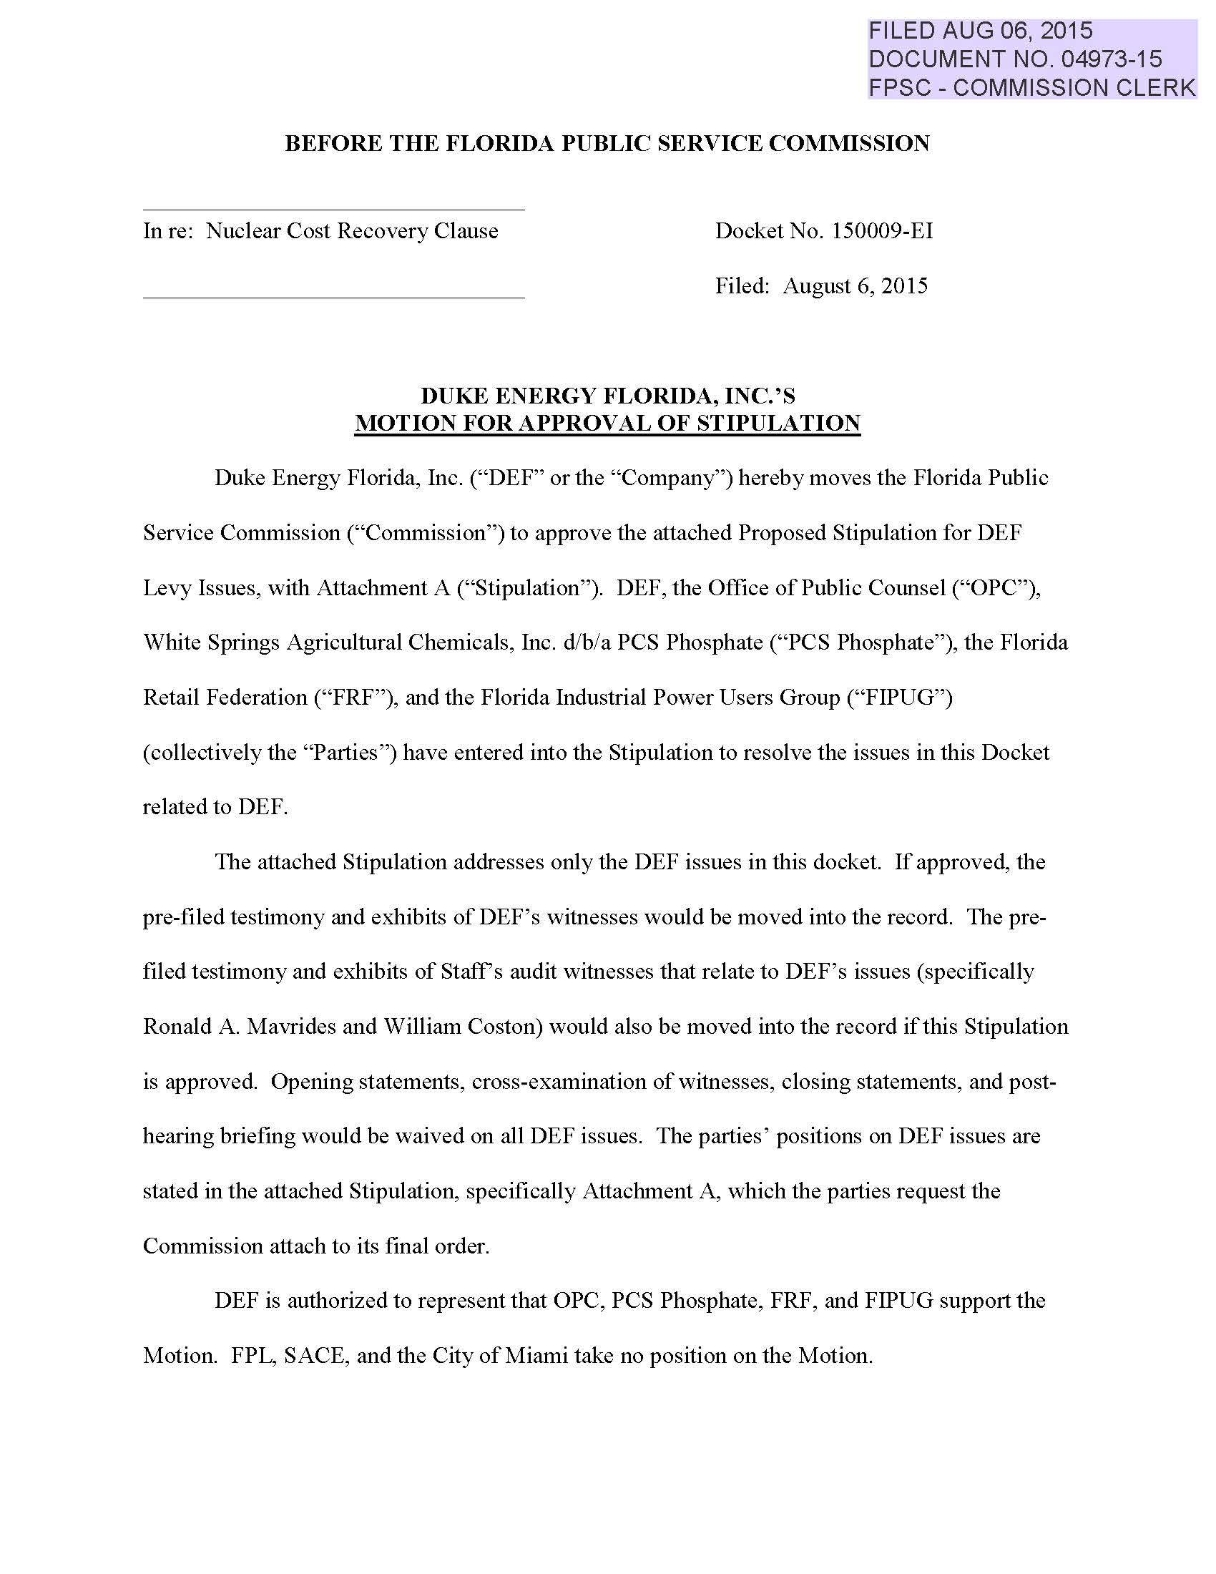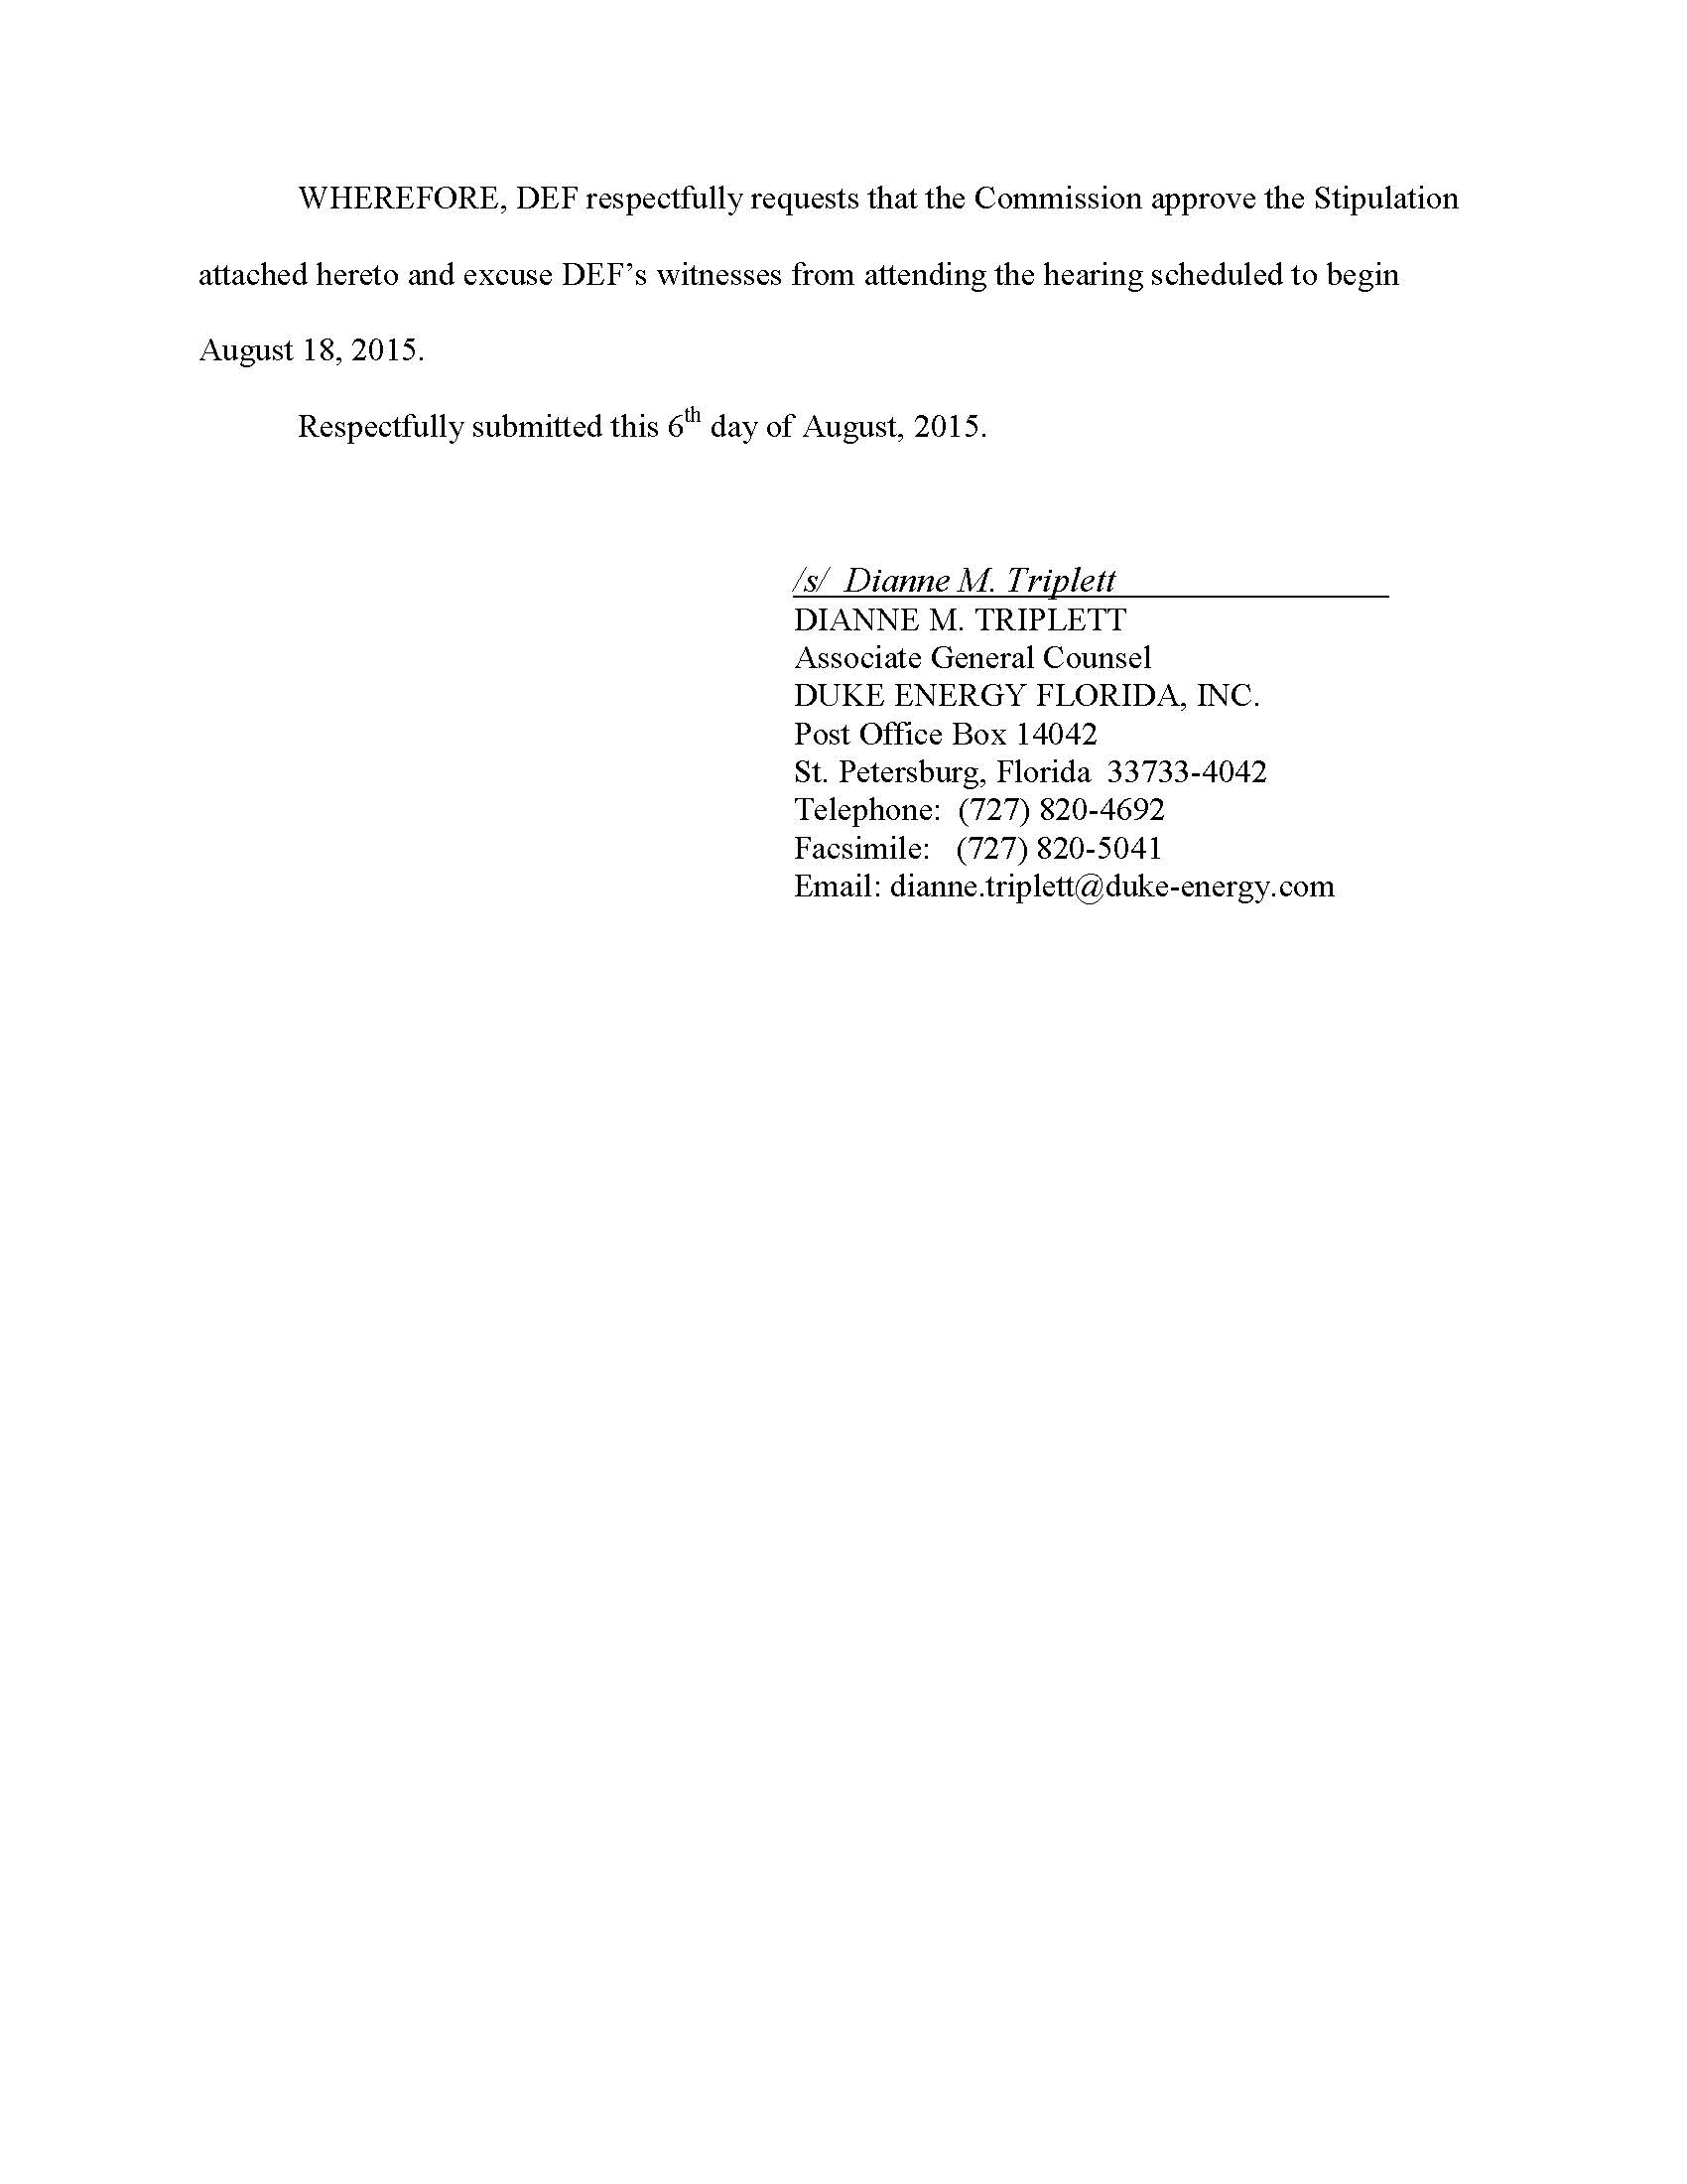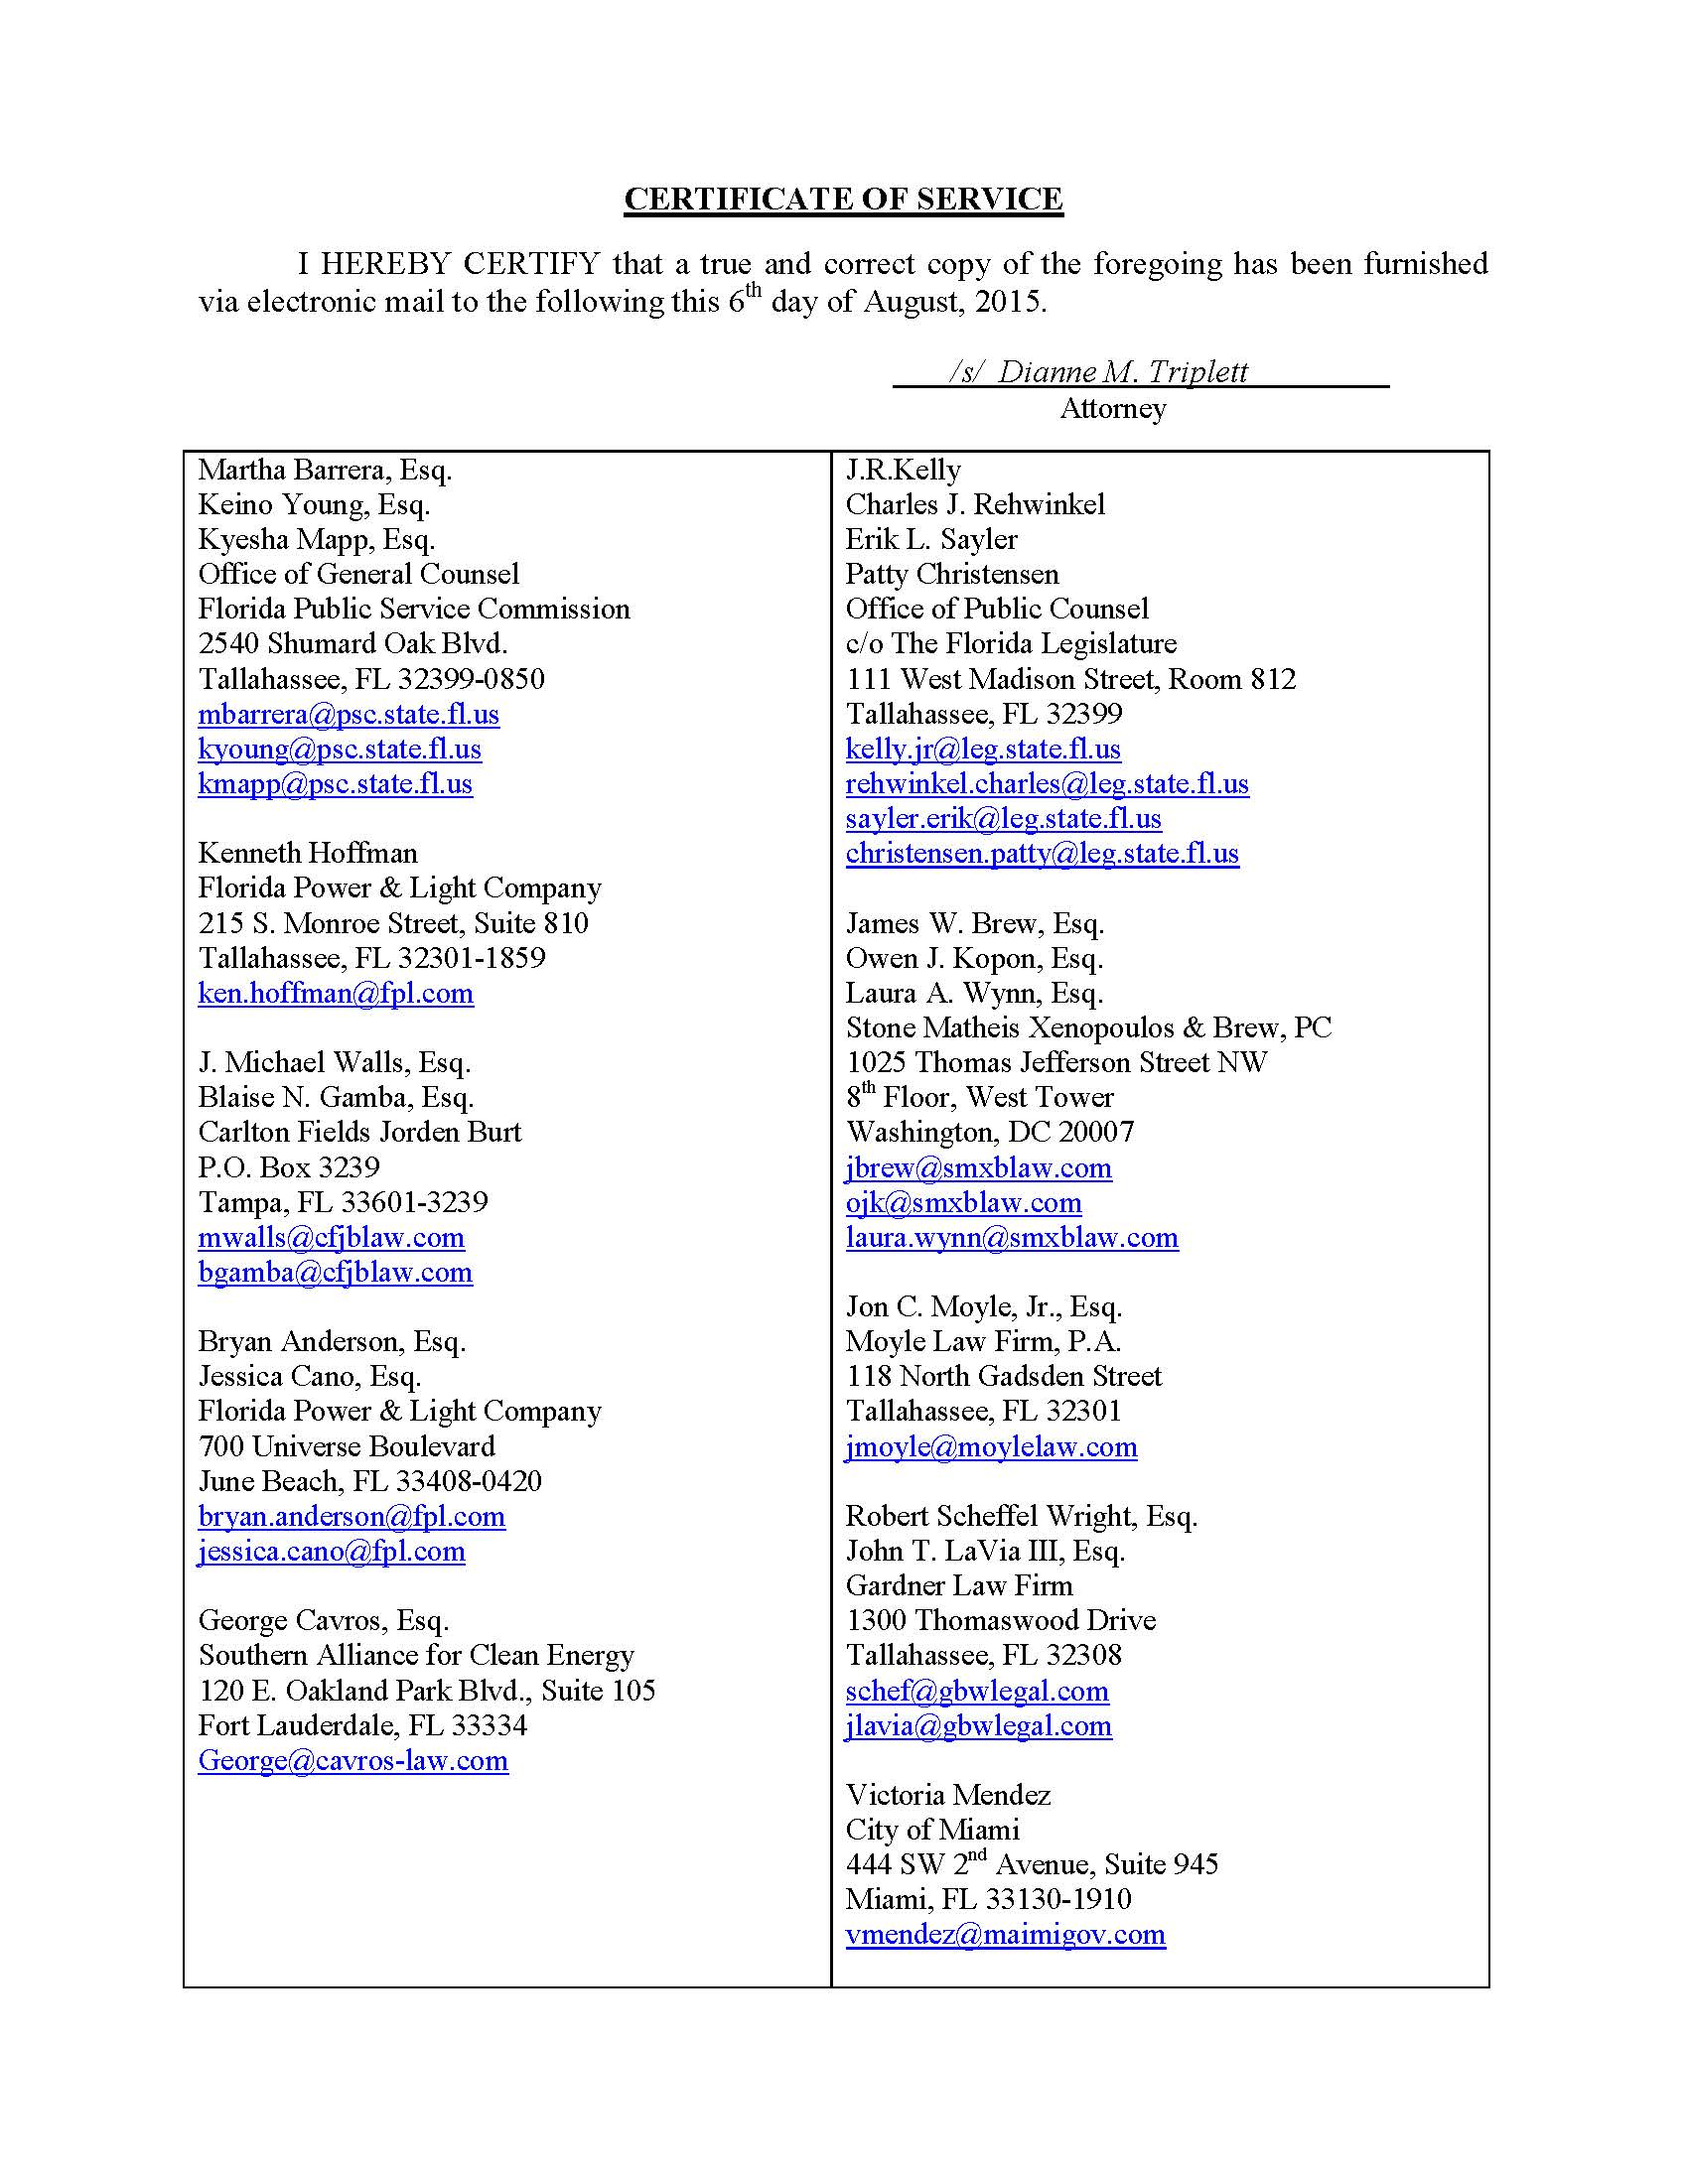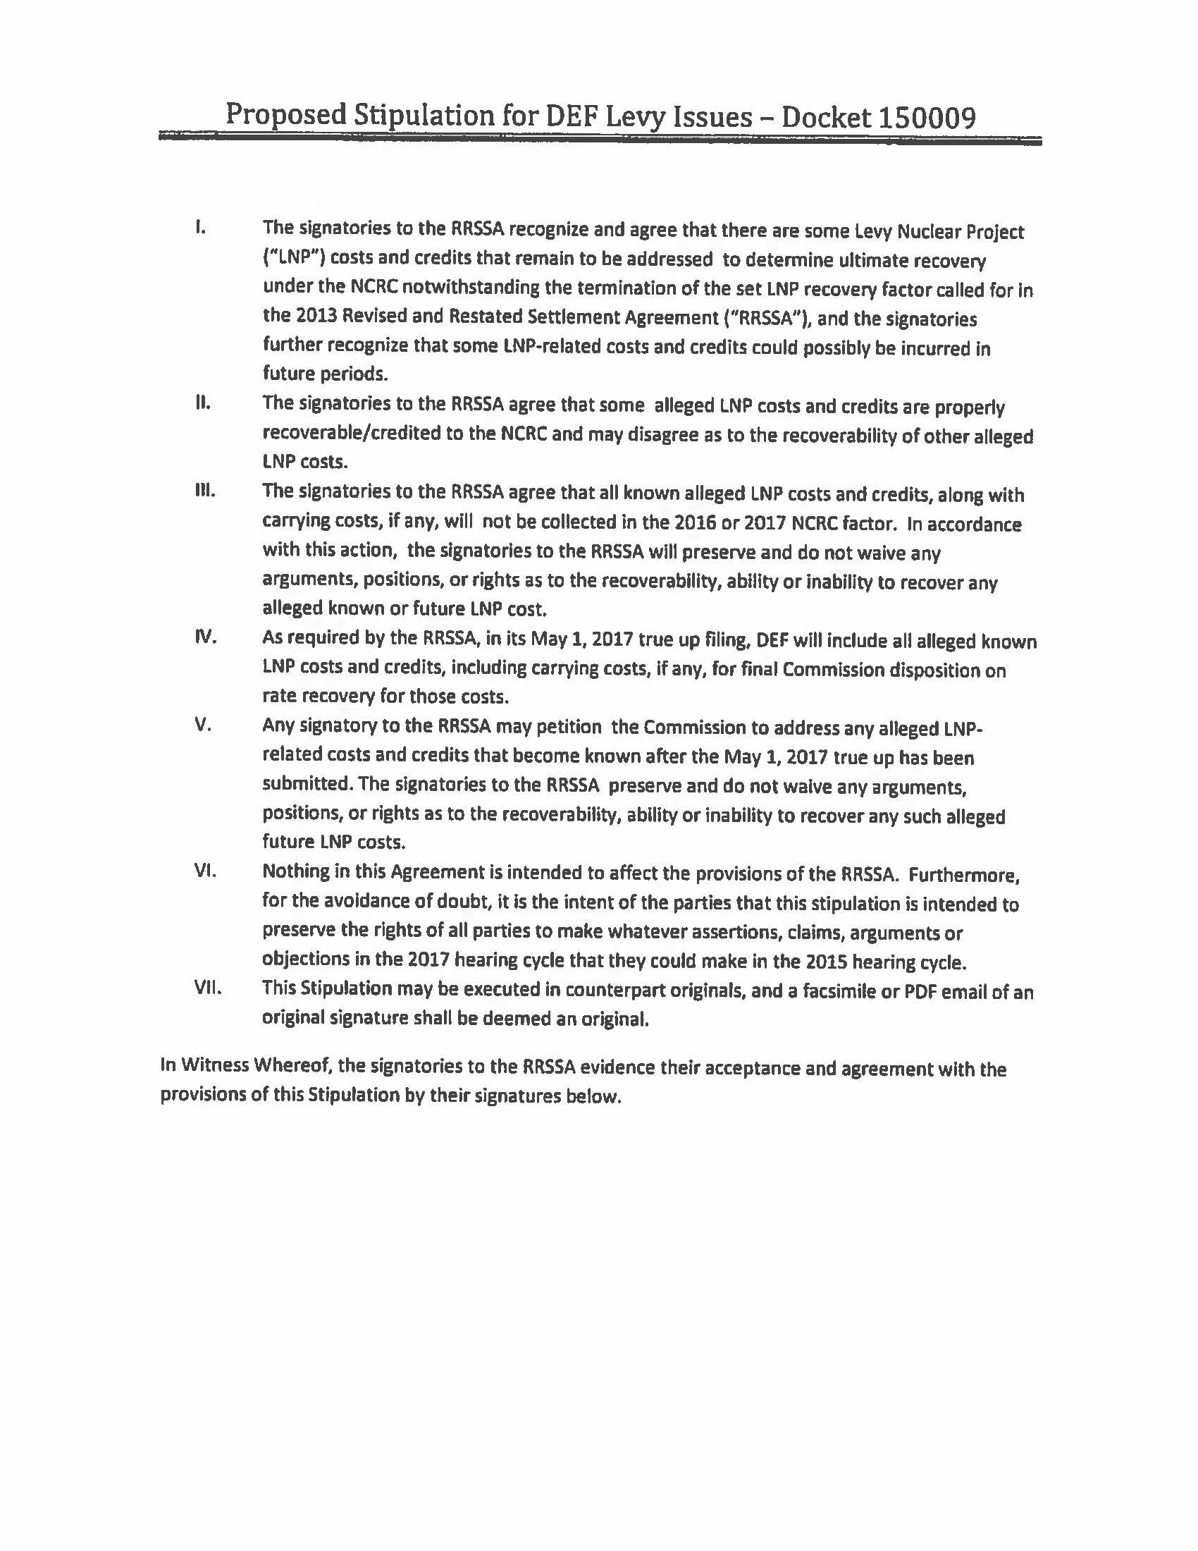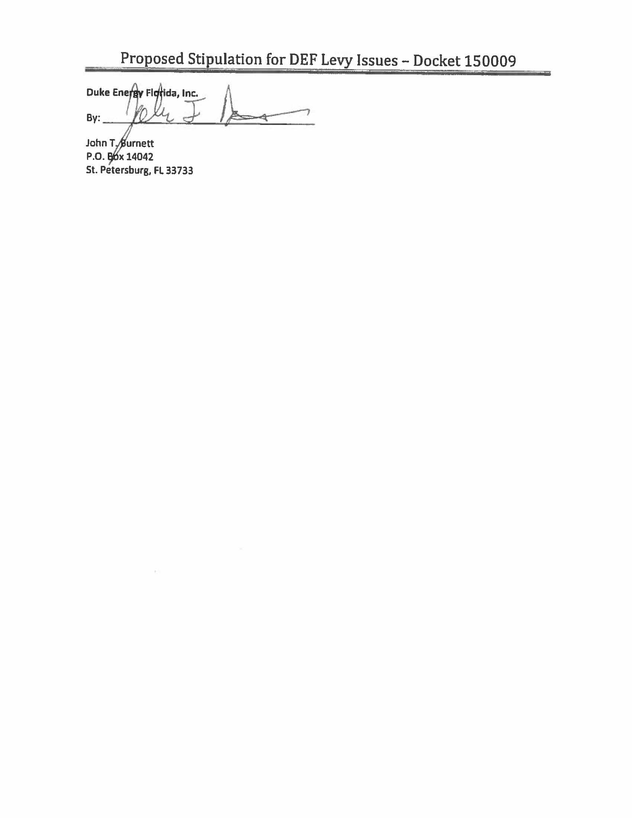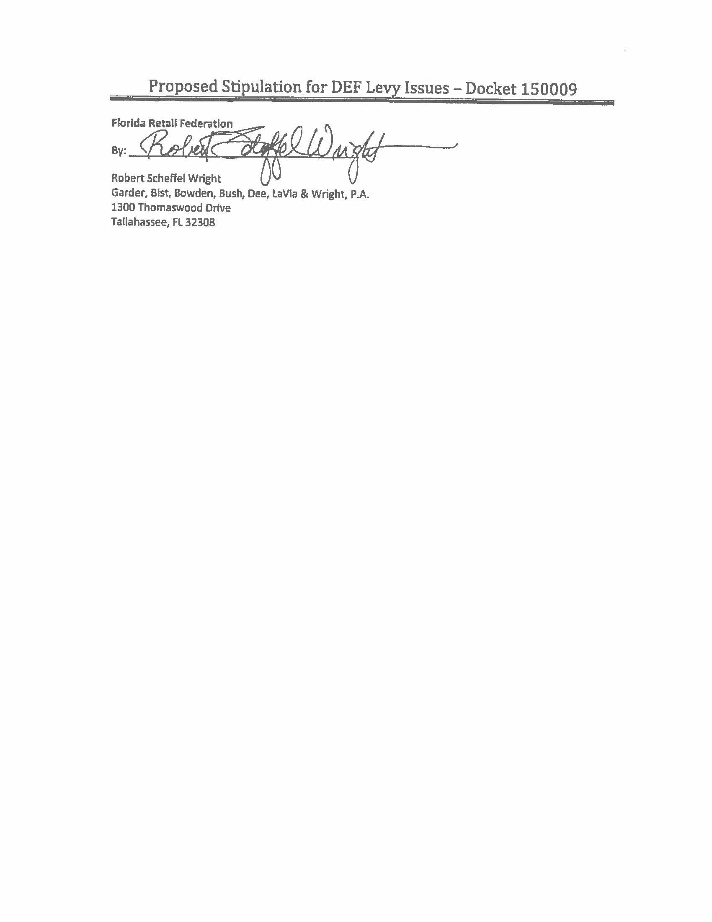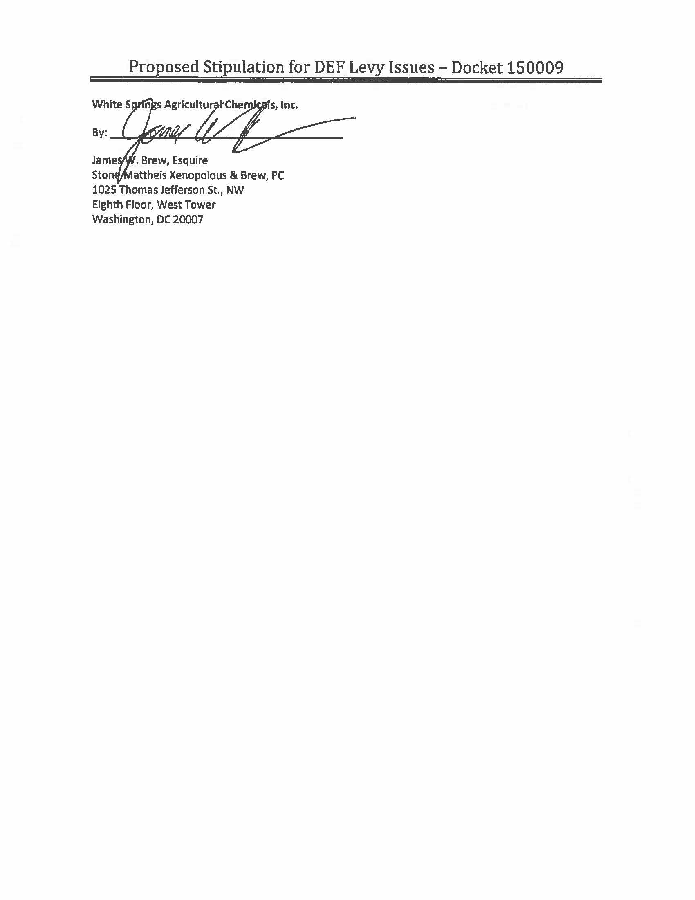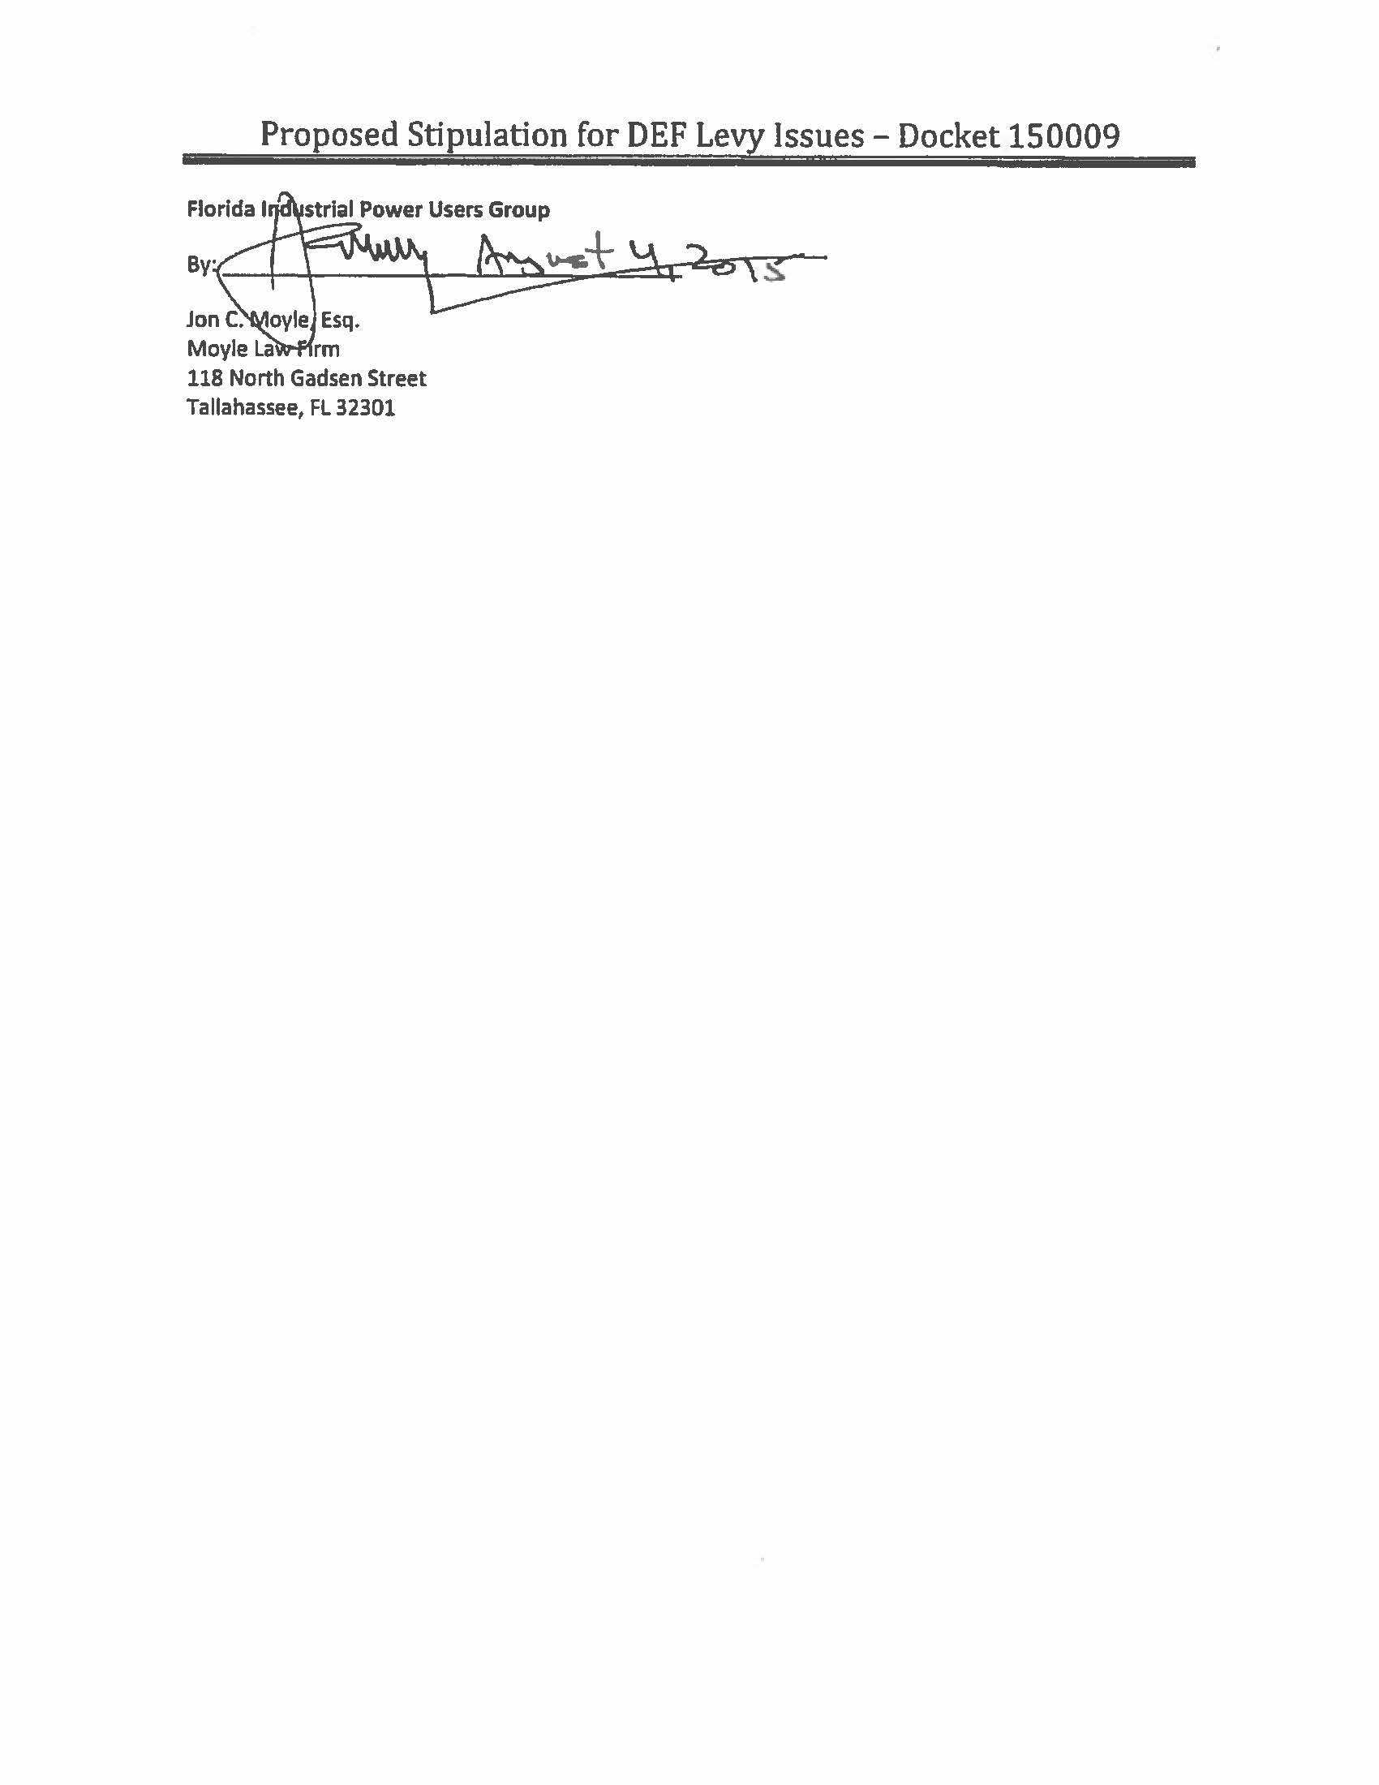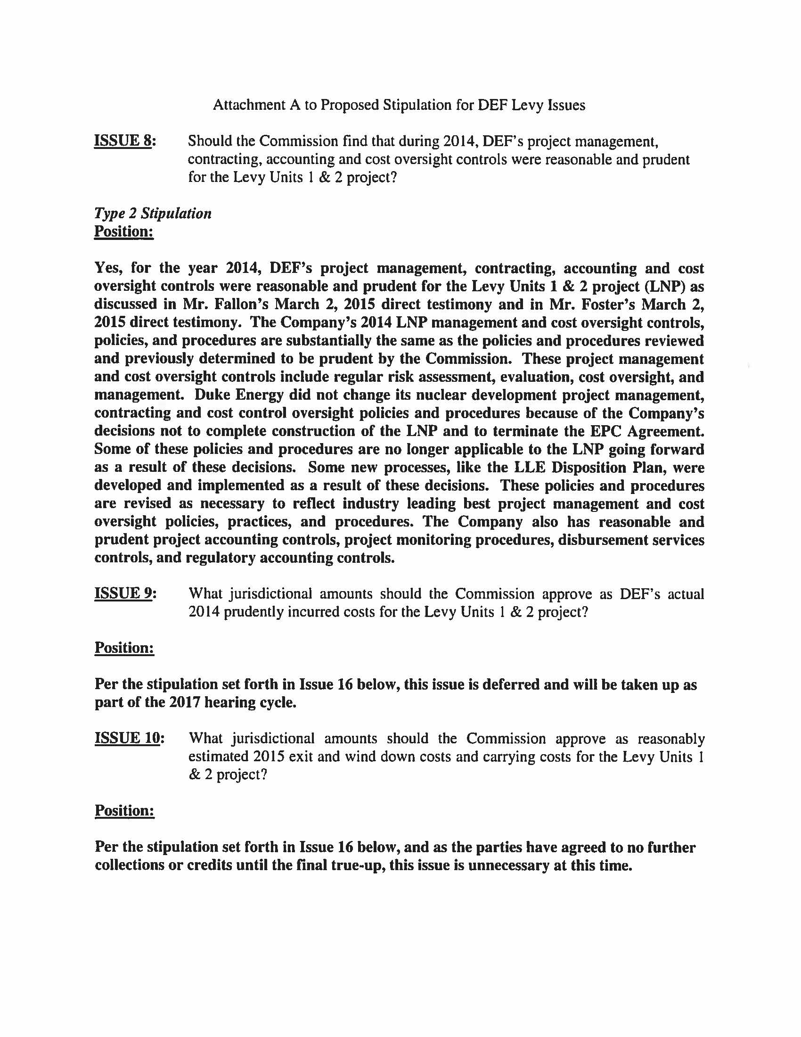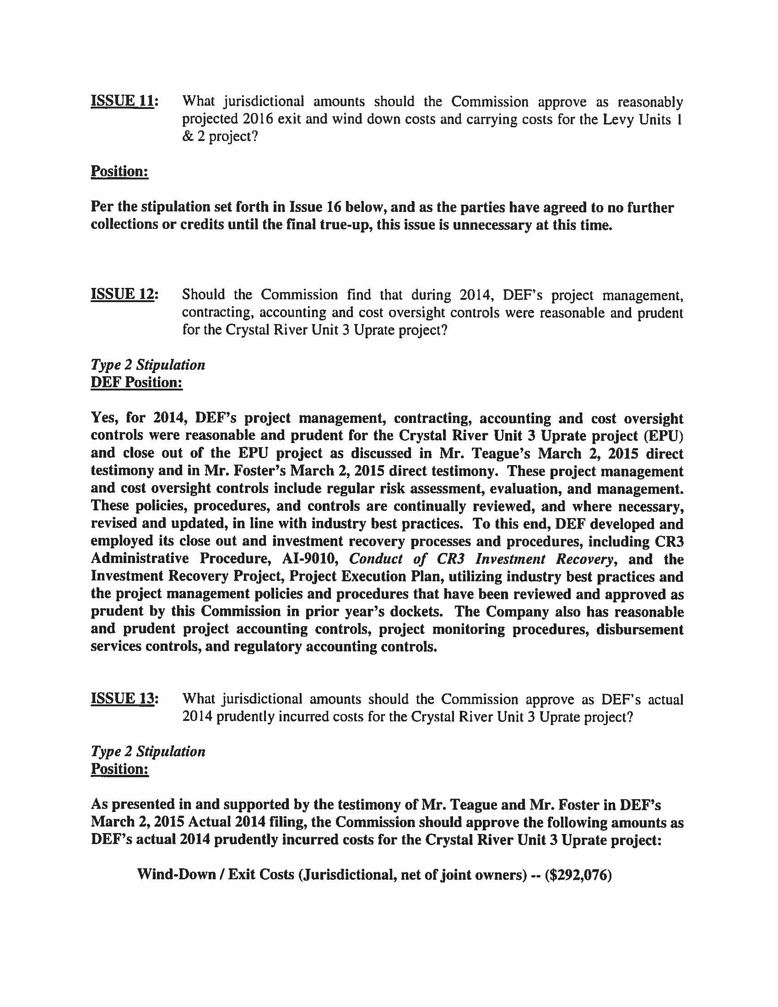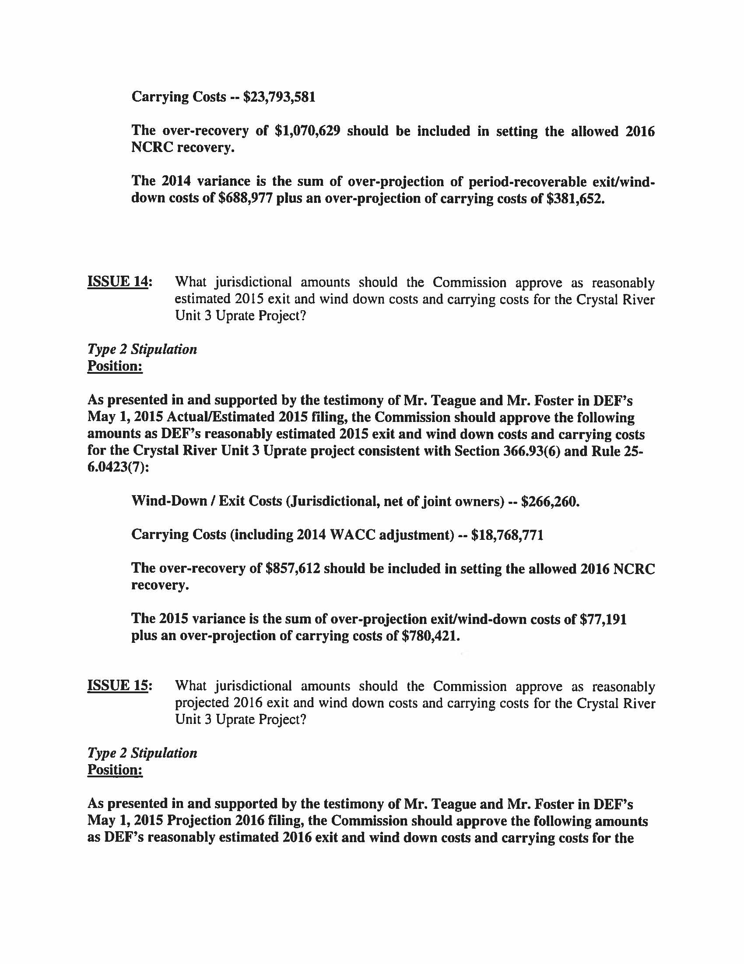

Commissioner Edgar was not present at the August 18, 2015 hearing and did not vote on the DEF Motion for Approval of Stipulation. The Commissioner was present and voted at the October 19, 2015 Special Agenda regarding the matters pertaining to FPL.
See Order No. PSC-14-0022-FOF-EI, issued January 10, 2014, in Docket No. 130222-EI, In re: Proposed amendment of Rule 25-6.0423, F.A.C., Nuclear or Integrated Gasification Combined Cycle Power Plant Cost Recovery.
See Order No. PSC-08-0237-FOF-EI, issued April 11, 2008, in Docket No. 070650-EI, In re: Petition to determine need for Turkey Point Nuclear Units 6 and 7 electrical power plant, by Florida Power & Light Company.
See Order No. PSC-07-0119-FOF-EI, issued February 8, 2007; in Docket No. 060642-EI, In re: Petition for determination of need for expansion of Crystal River 3 nuclear power plant, for exemption from Bid Rule 25-22.082, F.A.C. and for cost recovery through fuel clause, by Progress Energy Florida, Inc. See Order No. PSC-08-0518-FOF-EI, issued August 12, 2008, in Docket No. 080148-EI, In re: Petition for determination of need for Levy Units 1 and 2 nuclear power plants, by Progress Energy Florida, Inc.
Document Number 04973-15.pdf as filed in Docket 150009-EI.
Order No. PSC-08-0237-FOF-EI, issued April 11, 2008, in Docket No. 070650-EI, In re: Petition to determine need for Turkey Point Nuclear Units 6 and 7 electrical power plants, by Florida Power & Light Company, p. 29.
Id.; Order No. PSC-14-0617-FOF-EI, issued October 27, 2014, in Docket 140009-EI, In re: Nuclear cost recovery clause, p. 17.
EPA v. EME Homer City Generation, L.P., 134 S. Ct. 1584 (2014).
Order No. PSC-11-0547-FOF-EI, issued November 23, 2011, in Docket 110009-EI, In re: Nuclear cost recovery clause, p. 13.
Overnight cost is the cost of a construction project if no interest was incurred nor cost escalation applied during construction, as if the project was completed "overnight."
Order No. PSC-08-0237-FOF-EI, issued April 11, 2008, in Docket No. 070650-EI, In re: Petition to determine need for Turkey Point Nuclear Units 6 & 7 electrical power plant, by Florida Power and Light Company.
Order No. PSC-08-0237-FOF-EI, issued April 11, 2008, in Docket No. 070650-EI, In re: Petition to determine need for Turkey Point Nuclear Units 6 & 7 electrical power plant, by Florida Power and Light Company.
See Order No. PSC-14-0696-FOF-EU, issued December 16, 2014, in Docket No. 130199-EI, In re: Commission review of numeric conservation goals (Florida Power & Light Company).
See Order No. PSC-14-0617-FOF-EI, issued October 27, 2014, in Docket No. 140009-EI, In re: Nuclear cost recovery clause.
The Final Order on Site Certification (In re: Florida Power & Light Company Turkey Point Units 6 & 7 Power Plant Siting Application No. PA 03-45A3, Case No. 09-3575EPP, issued May 19, 2014) has been appealed to the 3rd District Court of Appeals Case Number: 3D14-1467 by Miami Dade County, The City of Miami, The City of South Miami, and The Village of Pinecrest.
Order No. PSC-08-0237-FOF-EI, issued April 11, 2008, in Docket No. 070650-EI, In re: Petition to determine need for Turkey Point Nuclear Units 6 & 7 electrical power plant, by Florida Power and Light Company.
Order No. PSC-07-0816-FOF-EI, issued October 10, 2007, in Docket No. 060658-EI, In re: Petition on behalf of Citizens of the State of Florida to require Progress Energy Florida, Inc. to refund customers $143 million, p. 3; Order No. PSC-08-0749-FOF-EI, issued November 12, 2008, in Docket No. 080009-EI, In re: Nuclear cost recovery clause, p. 28; Order No. PSC-09-0783-FOF-EI, Docket No. 090009-EI, In re: Nuclear cost recovery clause, pp. 11, 13; Order No. PSC-11-0547-FOF-EI, issued November 19, 2009, in Docket No. 110009-EI, In re: Nuclear cost recovery clause, issued November 23, 2011, pp. 26, 28, 57, 61, 91, 93; Order No. PSC-12-0650-FOF-EI, issued December 11, 2012, in Docket No. 120009-EI, In re: Nuclear cost recovery clause, pp. 23, 24, 32, 59, 60; Order No. PSC-13-0493-FOF-EI, issued October 18, 2013, in Docket No. 130009-EI, In re: Nuclear cost recovery clause, p. 26.
The former Section 366.93(3), F.S., was re-numbered as 366.93(3)(a). This section provides that “[A]fter a petition for determination of need is granted, a utility may petition the commission for cost recovery as permitted by this section and commission rules.”
Order No. PSC-14-0617-FOF-EI, issued October 27, 2014, in Docket No. 140009-EI, In re: Nuclear cost recovery clause, pp. 16-32.

