BEFORE THE FLORIDA PUBLIC SERVICE COMMISSION

In re: Petition for approval of firm service agreement with Peoples Gas System for an extension in Clay County, by SeaCoast Gas Transmission, L.L.C. | DOCKET NO. 150221-GU  ORDER NO. PSC-15-0574-PAA-GU  ISSUED: December 18, 2015

The following Commissioners participated in the disposition of this matter:

ART GRAHAM, Chairman
LISA POLAK EDGAR
RONALD A. BRISÉ
JULIE I. BROWN
JIMMY PATRONIS

NOTICE OF PROPOSED AGENCY ACTION
ORDER APPROVING FIRM TRANSPORTATION SERVICE AGREEMENT

BY THE COMMISSION:

NOTICE is hereby given by the Florida Public Service Commission that the action discussed herein is preliminary in nature and will become final unless a person whose interests are substantially affected files a petition for a formal proceeding, pursuant to Rule 25-22.029, Florida Administrative Code (F.A.C).

Background

On October 13, 2015, SeaCoast Gas Transmission, L.L.C. (SeaCoast) filed a petition seeking approval of a firm transportation service agreement (Agreement) between SeaCoast and Peoples Gas System (Peoples). Pursuant to the Agreement, SeaCoast will transport natural gas to Peoples’ distribution system on a firm basis. SeaCoast operates as a natural gas transmission company as defined in Section 368.103(4), Florida Statutes (F.S.). Peoples is a natural gas distribution company serving retail customers throughout Florida and is subject to this Commission’s jurisdiction under Chapter 366, F.S.
In Order No. PSC-08-0747-TRF-GP, SeaCoast received approval of an intrastate gas pipeline tariff that allows it to construct and operate intrastate pipeline facilities and to actively pursue agreements with gas customers. SeaCoast provides transportation service only and does not engage in the sale of natural gas. Pursuant to Order No. PSC-08-0747-TRF-GP, SeaCoast is allowed to enter into certain gas transmission agreements without prior Commission approval. However, SeaCoast is requesting approval of this agreement as it does not fit any of the criteria enumerated in the tariff for which Commission approval would not be required. SeaCoast and Peoples are affiliates in that their parent company is TECO Energy, Inc. Agreements between affiliated companies must be approved by this Commission pursuant to Section 368.105, F.S., and Order No. PSC-08-0747-TRF-GP.
SeaCoast plans to construct and operate an approximately 9.5-mile, 6-inch coated steel transmission pipeline in Clay County, Florida and is seeking our approval of a firm transportation service agreement with Peoples. Peoples will then interconnect with the new SeaCoast transmission pipeline and expand its distribution system to serve new load in Green Cove Springs and surrounding areas of Clay County where natural gas service is not currently available. The route of the SeaCoast pipeline is shown in Attachment A.
On October 20, 2015, the Office of Public Counsel (OPC) filed a notice of intervention in the docket and on October 21, 2015, Peoples, OPC and Commission staff met in a noticed meeting. During its evaluation of the petition, Commission staff issued a data request to both SeaCoast and Peoples for which responses were received on October 26, 2015. We have jurisdiction over this matter pursuant to Sections 366.06 and 368.105, F.S.
Decision
To provide intrastate transportation of gas to Peoples, SeaCoast will tap into its existing 24-inch transmission pipeline near Asbury Lake and construct an approximately 9.5-mile 6-inch coated steel transmission pipeline to interconnect with a new Peoples distribution main in the vicinity of Green Cove Springs. In addition to the distribution main, Peoples will construct service lines for the purpose of delivering gas to customers in and around Green Cove Springs. Seacoast’s existing 24-inch transmission pipeline interconnects with Southern Natural Gas Company (SNG), an interstate pipeline company, in northwest Clay County.
SeaCoast and Peoples stated that the preliminary design for the infrastructure extensions has been completed and the negotiation of a franchise agreement with the City of Green Cove Springs has commenced. Pending Commission approval of the Agreement, the permitting process will be initiated and is expected to take from three to six months. Construction is anticipated to begin around the end of the first quarter or second quarter of 2016. SeaCoast and Peoples estimated that the SeaCoast transmission pipeline and the Peoples distribution main will be complete by the end of 2016.
The initial term of the Agreement is 15 years, with an option to extend for an additional ten years. The negotiated reservation charge (confidential) included in the Agreement is designed to allow SeaCoast to recover its operational and maintenance costs, depreciation, taxes, and return on investment associated with the new transmission pipeline. SeaCoast asserts that the rate set forth in the Agreement is a cost-based market rate similar to the rate set forth in the firm service agreement with its other customer, is just and reasonable, is not unreasonably preferential or unduly discriminatory, and is therefore consistent with Section 368.105(3)(b), F.S. While specific circumstances vary for different projects due to pipe size, construction conditions, permitting, etc., we find that the information provided by SeaCoast for the pipeline appears reasonable and comparable to similar agreements.
Consideration of Potential Alternatives to the SeaCoast Extension
Peoples stated that it evaluated other options to deliver gas to customers in the Green Cove Springs area, but those alternatives had shortcomings. One of the options considered was Peoples constructing a transmission pipeline that would have interconnected with Florida Gas Transmission (FGT) in northwest Clay County. However, Peoples explained that capacity constraints on the FGT interstate pipeline would leave customers in Green Cove Springs vulnerable to interruptions and potential other difficulties in scheduling deliveries of gas at certain times. SeaCoast, on the other hand, provides Peoples with access to the SNG interstate pipeline system which currently has no capacity constraints.
In response to Commission staff’s data request, SeaCoast and Peoples provided a cost estimate for the 6-inch SeaCoast transmission pipeline and stated that this alternative is the most cost effective. The SeaCoast line utilizes existing pipeline infrastructure thereby eliminating duplication of facilities in the area and minimizing the impact on the environment and population in Clay County. Any other alternative would require approximately nine to ten additional miles of transmission line as well as additional taps and interconnects with FGT and SNG. These incremental costs would exceed the costs of the proposed SeaCoast alternative because the necessary SeaCoast taps with the interconnecting interstate pipelines are already in place.
Peoples also stated that it did not believe there are other companies capable of completing construction of the required interstate pipeline taps, interconnects, and the new pipeline from the interstate supply sources (i.e., FGT and/or SNG) within the time frame in which the larger prospective Green Cove Springs customers desire natural gas service (mid-2016).
Peoples’ Cost Recovery of Payments to SeaCoast
Peoples’ payments to SeaCoast will be included in the calculation of the monthly Purchased Gas Adjustment (PGA) factor. Consistent with the methodology approved by this Commission in Docket No. 000810-GU, a portion of the costs will be paid by transportation customers taking service under Peoples’ Natural Choice Transportation Service program via the swing charge mechanism. Swing service charge revenues collected from transportation customers will then be credited back to the PGA. The remaining balance of the swing service charge will remain embedded in Peoples’ PGA and recovered from Peoples’ sales customers. Sales customers purchase their gas from Peoples and are subject to Peoples’ PGA charges.
In Docket No. 150220-GU, Peoples filed for Commission approval of tariff modifications related to the swing service charge. Peoples has included the reservation charges it would pay to SeaCoast under the Agreement in this docket in the swing service charges in Docket No. 150220-GU.
Peoples anticipates that initially all of the approximately 60 new commercial customers in the Green Cove Springs area will receive transportation service under Peoples’ Natural Choice Transportation Service program. Peoples further anticipates an increasing customer base throughout the term of the Agreement due to significant economic development activities in Clay County.
Conclusion
Based on the petition and responses from SeaCoast and Peoples to Commission staff’s data request, SeaCoast and Peoples have supported the importance of the need for the new pipeline to provide gas service to Green Cove Springs and the surrounding area. We find that the agreement is reasonable, meets the requirements of Section 368.105, F.S., and benefits Peoples’ customers. Therefore, we approved of the Agreement dated October 7, 2015, for SeaCoast to provide firm transportation service to Peoples.
Based on the foregoing, it is

ORDERED by the Florida Public Service Commission that

ORDERED that the Agreement dated October 7, 2015, for SeaCoast Gas Transmission, L.L.C. to provide firm transportation service to Peoples Gas System, shall be approved. It is further

ORDERED that the provisions of this Order, issued as proposed agency action, shall become final and effective upon the issuance of a Consummating Order unless an appropriate petition, in the form provided by Rule 28-106.201, Florida Administrative Code, is received by the Commission Clerk, 2540 Shumard Oak Boulevard, Tallahassee, Florida 32399-0850, by the close of business on the date set forth in the “Notice of Further Proceedings” attached hereto. It is further

ORDERED that if no person whose substantial interests are affected by the proposed agency action files a protest within 21 days of the issuance of the order, this docket shall be closed upon the issuance of a consummating order.

By ORDER of the Florida Public Service Commission this 18th day of December, 2015.

/s/ Carlotta S. Stauffer
CARLOTTA S. STAUFFER
Commission Clerk
Florida Public Service Commission
2540 Shumard Oak Boulevard
Tallahassee, Florida 32399
(850) 413-6770
www.floridapsc.com

Copies furnished: A copy of this document is provided to the parties of record at the time of issuance and, if applicable, interested persons.

JEV

NOTICE OF FURTHER PROCEEDINGS OR JUDICIAL REVIEW

The Florida Public Service Commission is required by Section 120.569(1), Florida Statutes, to notify parties of any administrative hearing that is available under Section 120.57, Florida Statutes, as well as the procedures and time limits that apply. This notice should not be construed to mean all requests for an administrative hearing will be granted or result in the relief sought.

Mediation may be available on a case-by-case basis. If mediation is conducted, it does not affect a substantially interested person's right to a hearing.

The action proposed herein is preliminary in nature. Any person whose substantial interests are affected by the action proposed by this order may file a petition for a formal proceeding, in the form provided by Rule 28-106.201, Florida Administrative Code. This petition must be received by the Office of Commission Clerk, 2540 Shumard Oak Boulevard, Tallahassee, Florida 32399-0850, by the close of business on January 8, 2016.

In the absence of such a petition, this order shall become final and effective upon the issuance of a Consummating Order.

Any objection or protest filed in this/these docket(s) before the issuance date of this order is considered abandoned unless it satisfies the foregoing conditions and is renewed within the specified protest period.

Proposed SeaCoast Transmission Pipeline and Vicinity

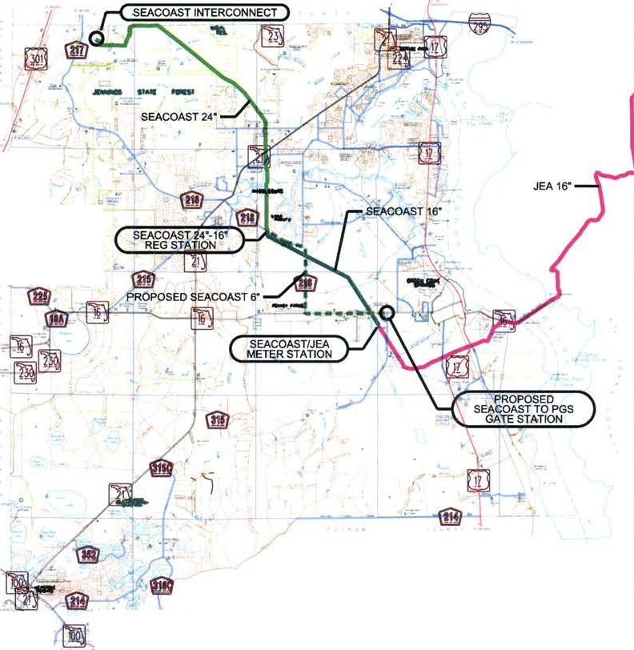

\

Order No. PSC-08-0747-TRF-GP, issued November 12, 2008, in Docket No. 080561-GP, In re: Petition for approval of natural gas transmission pipeline tariff by SeaCoast Gas Transmission, LLC.
SeaCoast Gas Transmission, LLC, Intrastate Pipeline Tariff, Original Volume 1, Sheet No. 2.
See Order No. PSC-15-0206-PAA-GU, issued May 26, 2015, in Docket No. 150031-GU, In re: Petition for approval of transportation service agreement with the Florida Division of Chesapeake Utilities Corporation by Peninsula Pipeline Company, Inc., Order No. PSC-14-0713-PAA-GU, issued December 31, 2014, in Docket No. 140189-GU, In re: Petition for approval of transportation service agreement for an extension in Nassau County with Florida Public Utilities Company, by Peninsula Pipeline Company, Inc., and Order No. PSC-14-0712-PAA-GU, issued December 31, 2014, In Docket No. 140190-GU, In re: Petition for approval of transportation service agreement for an extension in Palm Beach County with Florida Public Utilities Company, by Peninsula Pipeline Company, Inc.
Peoples does not anticipate any impact on its 2016 PGA cap approved in Docket No. 150003-GU due to the de minimis nature of the SeaCoast charges when compared to Peoples’ total projected 2016 PGA expenses.
Order No. PSC-00-1814-TRF-GU, issued October 4, 2000, in Docket No. 000810-GU, In re: Petition for approval of modifications to tariff provisions governing transportation of customer-owned gas and tariff provisions to implement Rule 25-7.0335, F.A.C., by Tampa Electric Company d/b/a Peoples Gas System.

