BEFORE THE FLORIDA PUBLIC SERVICE COMMISSION

In re: Complaint by Eagleridge I, LLC against Lake Utility Services, Inc. for declaration that connections have been made and all amounts due have been paid, and mandatory injunction requiring refund of amounts paid under protest. | DOCKET NO. 150026-WS  ORDER NO. PSC-15-0577-PAA-WS  ISSUED: December 21, 2015

The following Commissioners participated in the disposition of this matter:

ART GRAHAM, Chairman
LISA POLAK EDGAR
RONALD A. BRISÉ
JULIE I. BROWN
JIMMY PATRONIS

PROPOSED AGENCY ACTION ORDER GRANTING A REFUND OF THE INCREASED WASTEWATER MAIN EXTENSION CHARGE

BY THE COMMISSION:

Background
Eagleridge I, LLC (Eagleridge), is a Florida Limited Liability Company which develops properties in Lake County, Florida. Lake Utility Services, Inc. (LUSI), is a utility company providing water and wastewater service in Lake County, Florida, and is a wholly owned subsidiary of Utilities, Inc. Eagleridge developed a parcel of commercial property (the Development) located on U.S. Highway 27 in Clermont, Florida. The Development is commonly known as Golden Eagle Village, which consists of a Publix-anchored shopping center.
On April 29, 2010, Eagleridge entered into a letter agreement (the Contract) with LUSI. A copy of the Contract is attached as Attachment A. Pursuant to the Contract, in exchange for LUSI providing water and wastewater utility services to the Development, Eagleridge agreed to pay an up-front System Capacity Charge in the amount of $87,242.36, Plan Review Fees in the amount of $300, and Inspection Fees in the amount of $150. The System Capacity Charges were based on the utility’s approved water and wastewater plant capacity charges and the projected demand for the Development. In addition, Eagleridge was responsible for constructing the on-site water and wastewater lines necessary to connect the Development to the utility’s existing lines, consistent with the utility’s approved main extension policy. Eagleridge paid all fees and charges identified in the Contract. The Contract also contains waiver language, in pertinent part:
In consideration of this contribution, [LUSI] waive[d] all other tap fees/connection fees. Water and wastewater usage charges will be levied in accordance with our authorized tariff as required and approved by the Florida Public Service Commission.
Eagleridge proceeded with the Development, including obtaining all necessary permits. On August 10, 2010, Eagleridge applied for a Florida Department of Environmental Protection (DEP) permit to construct a wastewater collection line from the utility’s existing collection system to the Development. In March 2011, Eagleridge submitted to DEP its Request for Approval to Place a Domestic Wastewater Collection/Transmission System into Operation. A copy of the Request for Approval is attached as Attachment B. On March 18, 2011, Patrick Flynn, LUSI’s Regional Director, signed the Request for Approval certifying to DEP that all connections to LUSI’s wastewater facility had been completed to LUSI’s satisfaction. On March 31, 2011, the DEP granted Eagleridge’s application and the connection between the Development and LUSI’s wastewater system was completed in April 2011.
On November 3, 2011, we granted LUSI’s application for increase in water and wastewater rates. Before we revised LUSI’s main extension charge, the main extension charge was negotiable. We also revised the utility’s water plant capacity and water and wastewater main extension charges. According to the order, LUSI’s wastewater service availability policy provided that developers would install new collection lines and donate them to the utility. We approved a wastewater main extension charge that would allow the utility to collect the appropriate charge from a single property owner in lieu of donated lines.
On March 4, 2013, LUSI wrote a letter to Eagleridge stating that we granted LUSI the right to increase its wastewater main extension charge. LUSI’s letter further stated that the new charge applied to the balance of the prepaid capacity fees for units that had yet to be connected for service. LUSI requested an additional main extension charge of $63,625.20 based on the new main extension charges of $4.44 per gallon ($1,243/280 gallons per equivalent residential connection) and 14,330 gallons of reserved capacity yet to be assigned. The March 4, 2013, letter is attached as Attachment C.
The parties dispute whether LUSI is entitled to charge the increased wastewater main extension charge to Eagleridge. Eagleridge, relying on Rule 25-30.475, Florida Administrative Code (F.A.C.), argues that LUSI “may not charge the fees for services rendered or connections made prior to the effective date of the PSC Order.” The parties unsuccessfully attempted to resolve the dispute. Eagleridge, under protest, paid the increased fees to LUSI. Eagleridge recently sold the Development, but Eagleridge has retained all rights to pursue and recover a refund of the subject disputed fees.
On January 8, 2015, Eagleridge filed a complaint with us requesting (i) a declaration that the fees are not applicable to Eagleridge where connections already have been made; (ii) a declaration that all amounts due and owing for service availability charges and connection fees have been paid by Eagleridge; and (iii) an order directing LUSI to immediately refund all monies paid under protest. On January 20, 2015, LUSI filed a response to Eagleridge’s complaint with the Office of Commission Clerk. Our staff, in order to facilitate the review of the complaint filed by Eagleridge, issued a Data Request to LUSI. LUSI responded to our staff’s Data Request by letter. On April 3, 2015, our staff held a conference call for the parties to discuss the complaint. Eagleridge subsequently filed a supplemental filing in response to LUSI’s answer to the complaint, LUSI’s answer to our first data request, and LUSI’s response to questioning during the conference call.
We have jurisdiction over this matter pursuant to Chapter 367, Florida Statutes (F.S.) and Rule 25-30, F.A.C.

Decision

To determine whether LUSI appropriately charged increased fees to Eagleridge, we reviewed the Contract, supporting documents, the date of connection, and our Rules. Both parties believe, pursuant to Rule 25-30.475(2), F.A.C., unless authorized by us and provided that customers have received notice, non-recurring charges, such as service availability charges, shall be effective for service rendered or connections made on or after the stamped approval date on the tariff sheets. We find that the crux of this complaint is whether the wastewater connection was completed prior to the new wastewater service availability charge we ordered.

Eagleridge’s Complaint

Eagleridge argues that the wastewater main extension charge of $63,625.20 paid to LUSI under protest should be refunded because the Development was connected to the utility’s collection system in April 2011, prior to us approving a new main extension charge for LUSI in November 2011. To support its argument, Eagleridge argues that (1) the contract provided that all other tap fees/connection fees would be waived in consideration of Eagleridge’s payment of the service availability charges, (2) all connections to LUSI’s wastewater system were made in April 2011 prior to the increase in service availability charges, and (3) LUSI was explicitly prohibited by our Rules and Order No. PSC-11-0514-PAA-WS (November 2011 Order) from charging the new service availability charge. Eagleridge argues that Rules 25-30.210, and 25-30.515, F.A.C., and Eager v. Florida Keys Aqueduct Authority, 580 So. 2d 771 (Fla. 3d DCA 1991), support their request for refund.
Pursuant to Rule 25-30.210(4), F.A.C., “service pipe” is defined as the pipe between the utility’s main and the point of delivery, including the “pipe, fittings, and valves necessary to make the connection excluding the meter.” Eagleridge argues that Rule 25-30.210(6), F.A.C., applies because the Rule provides that “point of delivery” is where the service pipe is connected to the utility company’s main. Regarding service availability policies or contracts, Rule 25-30.515(1), F.A.C., provides “active connection means a connection to the utility’s system at the point of delivery of service, whether or not service is currently being provided.” In August 2010, Eagleridge applied for a DEP permit to construct a wastewater collection line from the utility’s existing collection system to the Development. In March 2011, Eagleridge submitted its Request for Approval to Place a Domestic Wastewater Collection/Transmission System into Operation to DEP. DEP approved Eagleridge’s request to place its wastewater main extension to LUSI’s collection system into service.

Eagleridge argues that the Contract contains a waiver of additional fees, in pertinent part:
In consideration of this contribution, we waive all other tap fees/connection fees. Water and wastewater usage charges will be levied in accordance with our authorized tariff as required and approved by the Florida Public Service Commission.
Eagleridge argues that this waiver provides that “all other ‘tap fees/connection fees’ would be ‘waived,’ while any water and wastewater usage charges would be levied as approved by the [Commission].” Eagleridge argues that LUSI “does not have any legitimate basis to charge the fees to Eagleridge . . . [and] the water and wastewater connections have already been made and, by rule (i.e., Florida Administrative Code) and the PSC Order, LUSI is prohibited from charging the Fee to Eagleridge.”
Further, Eagleridge argues that, pursuant to Eager, we should apply the “plain and unambiguous language in the [F.A.C.] to find that the connections were completed when LUSI’s service pipe was connected to Eagleridge’s piping.” Eagleridge argues that “LUSI is requesting that the [Commission] ignore the plain language of the [F.A.C.] under the guise of ‘interpretation.’” Eagleridge argues that we are obligated to apply the plain and unambiguous language of the F.A.C., which provides that a connection is completed when the utility’s service pipe is connected with the customer whether or not service is currently being provided.
LUSI’s Response

LUSI argues that it is entitled to collect the wastewater main extension charge approved by this Commission for the portion of the Development not yet receiving water service. To support its argument, LUSI argues that (1) the utility did not waive the right to collect the increased charges and (2) not all connections had been made when the increased charges were implemented. LUSI references H. Miller & Sons v. Hawkins, 373 So. 2d 913 (Fla. 1979), and Rules 25-30.210, and 25-30.515, F.A.C., in support of their arguments.
Citing H. Miller & Sons v. Hawkins, LUSI argues that contracts with public utilities are made subject to the reserved authority of the state, under the police power of express statutory or constitutional authority, to modify the contract in the interest of the public welfare without unconstitutional impairment of contracts. Regarding the waiver contained in the Contract, LUSI argues Eagleridge “misconstrues the waiver language” in that the “meaning of the waiver is that LUSI waived any other tap fees/connection fees that were in existence at that time” and “there is no significance in the language regarding usage charges.” LUSI argues that the waiver language relates to any other tap fees/connection fees that were in existence at the time the contract was signed.

LUSI argues that Rule 25-30.210(7), F.A.C., should apply when determining the definition of “point of delivery.” Rule 25-30.210(7), F.A.C., provides “‘point of delivery’ for water systems shall mean the outlet connection of the meter for metered service or the point at which the utility’s piping connects with the customer’s piping for non-metered service.”
While LUSI argues that “[a] connection is not a connection for purposes of applying increases in service availability charges unless service has been previously implemented . . . the actual cost of maintaining sufficient capacity cannot be determined until the date that service actually initially commences.” LUSI argues that “unless water service is active there can be no wastewater flow and therefore, no wastewater service is provided.” LUSI contends that a connection within the Eagleridge Development occurs only when a meter is installed after service is requested. Increasing service availability charges prevents current customers from subsidizing costs associated with future plant capacity. Referencing Rule 25-30.515(9), F.A.C., LUSI argues that Guaranteed Revenue Charges are designed to help the utility recover part of its cost from the time capacity is reserved until a customer begins to pay monthly service rates.
Waiver of Fees

Pursuant to the Contract, Eagleridge paid an up-front System Capacity charge, Plan Review Fees, and Inspection Fees to LUSI. The Contract included language which Eagleridge argues is a waiver of additional “tap fees/connection fees,” in pertinent part: “[i]n consideration of this contribution, [LUSI] waive all other tap fees/connection fees. Water and wastewater usage charges will be levied in accordance with our authorized tariff as required and approved by the Florida Public Service Commission.” LUSI argues that the waiver language related to any other tap fees/connection fees that were in existence at the time the contract was signed. Pursuant to 367.011(2), F.S., we have “exclusive jurisdiction over each utility with respect to its authority, service, and rates.” We find that the waiver language in the Contract would be insufficient to prevent LUSI from collecting fees when appropriate.

Donated Lines
The change we approved in the utility’s wastewater main extension charge in November 2011 was to provide a charge that would be applicable to individual customers. Prior to the November 2011 Order, the utility’s approved main extension policy allowed the utility to receive donated lines from a developer, but did not address the appropriate charge for a wastewater customer connecting to a main constructed by the utility. In that Order, we approved a wastewater main extension charge that would allow the utility to collect the appropriate charge from a single property owner in lieu of donated lines. Therefore, the main extension charge was not intended to be collected from a developer, such as Eagleridge, who constructed and donated a collection line to the utility. We find that because Eagleridge donated its lines, a charge cannot be assessed.
Active Connection
Rule 25-30.210(6) and (7), F.A.C., define “point of delivery.” We find that in this case the “point of delivery” for wastewater service is where the service pipe is connected to the utility company’s main, as defined in Rule 25-30.210(6), F.A.C. Subsection (7) addresses “point of delivery” for a water system; therefore, it does not apply to this docket.
Pursuant to Rule 25-30.515(1), F.A.C., an “active connection means a connection to the utility’s system at the point of delivery of service, whether or not service is currently being provided.” Although it is LUSI’s contention than an active connection was not made, in March 2011, DEP approved Eagleridge’s request to place its wastewater main extension to LUSI’s collection system into service. The DEP approval included the consent and understanding of the utility. We find that an active wastewater connection was made when the physical connection was completed, even though water service has not been provided to the entire Development. If DEP had not accepted the line into operation, we find, as mentioned above, that the terms in the Contract that parties refer to as a waiver would be insufficient to prevent LUSI from collecting fees. However, that is not the situation in this docket.
Status of Contract

To determine whether LUSI appropriately charged increased fees to Eagleridge, staff assessed the status of the Contract at the time the fees were levied. Pursuant to our rules, we find that the Contract was fulfilled because (1) Eagleridge paid the up-front System Capacity Charge, including the other fees identified in the contract, when signed in April 2010; (2) the main extension charge should not have been charged because Eagleridge constructed and donated a collection line to the utility; and (3) LUSI’s piping was connected to Eagleridge’s Development and both DEP and the utility signed off on the active connection. Thus, it was an error for LUSI to charge Eagleridge $63,625.20 in addition to what was contemplated in the Contract. Our analysis would end here if LUSI did not raise the argument that H. Miller & Sons applies to this docket.

Applicability of H. Miller & Sons

LUSI argues that under H. Miller & Sons, Inc. v. Hawkins, LUSI is permitted to increase service availability charges because the Commission has authority to change rates in a private contract between a utility and developer. In H. Miller & Sons, the developer, H. Miller and Sons, Inc., entered into an agreement with Cooper City Utilities, Inc., to obtain water and sewer utility service for a 500-unit subdivision. In early 1975, Miller completed the payments in accordance with the agreement. However, not all of the homes were connected to the utility system. In late 1975, this Commission, in Order No. 6953, issued on October 9, 1975, in Docket No. 750368-WS, In Re: Application of Cooper City Utilities, Inc., For Approval of Tariff Modifications, authorized the Utility to increase its wastewater main extension charges.
In H. Miller & Sons, the Supreme Court of Florida affirmed this Commission’s decision to modify the contract in the interest of the public welfare based on the principle that contracts with public utilities are subject to the reserved authority of the state. This Commission ordered Miller to “pay for all connections added to the Cooper City Utility Water and Sewer System after the effective date of Order No. 6953.”
We have applied H. Miller & Sons in over 40 cases. In an Order issued in 2001, as well as in fourteen prior Orders, we referenced H. Miller & Sons to explain “applicable service availability charges are those in effect at the time of actual connection, because the actual cost of maintaining sufficient capacity cannot be ascertained until that date.”
We find that LUSI would be correct that H. Miller & Sons applies only if the connection with Eagleridge had not yet been made at the time the Commission granted LUSI’s application for increase in water and wastewater rates. We find that H. Miller & Sons is not applicable in this case because three events occurred before we granted a rate increase: (i) Eagleridge paid the up-front System Capacity Charge, including the other fees identified in the contract; (ii) LUSI’s piping was connected to Eagleridge’s Development; and (iii) DEP and the utility signed off on the active connection. Therefore, we find the Contract was fulfilled and that LUSI charged increased fees to Eagleridge in error.
We find that it was not appropriate for LUSI to charge increased fees to Eagleridge I, LLC. We find that the full amount of $63,625.20, plus interest, shall be refunded to Eagleridge, pursuant to 25-30.360, F.A.C. We find that the interest shall be calculated pursuant to Rule 25-30.360(4), F.A.C., to the amount of $1,737.32. Rule 25-30.360(2), F.A.C., contemplates that the refund amount shall be returned within 90 days of our final Order. We find that this docket shall remain open until the completion of the refund to Eagleridge. Upon our staff’s verification that the refund has been completed, this docket shall be administratively closed.
Based on the foregoing, it is

ORDERED by the Florida Public Service Commission that Lake Utility Services, Inc., shall refund the full amount of $63,625.20, plus interest, to Eagleridge I, LLC, pursuant to 25-30.360, F.A.C. It is further

ORDERED that the interest shall be calculated pursuant to Rule 25-30.360(4), F.A.C., to the amount of $1,737.32. It is further

ORDERED that the refund amount shall be returned within 90 days of our final Order, pursuant to Rule 25-30.360(2), F.A.C. It is further

ORDERED that this docket shall remain open until the completion of the refund to Eagleridge. It is further

ORDERED that upon our staff’s verification that the refund has been completed, this docket shall be administratively closed. It is further

ORDERED that the provisions of this Order, issued as proposed agency action, shall become final and effective upon the issuance of a Consummating Order unless an appropriate petition, in the form provided by Rule 28-106.201, Florida Administrative Code, is received by the Office of Commission Clerk, 2540 Shumard Oak Boulevard, Tallahassee, Florida 32399- 0850, by the close of business on the date set forth in the “Notice of Further Proceedings” attached hereto.

By ORDER of the Florida Public Service Commission this 21st day of December, 2015.

/s/ Carlotta S. Stauffer
CARLOTTA S. STAUFFER
Commission Clerk
Florida Public Service Commission
2540 Shumard Oak Boulevard
Tallahassee, Florida 32399
(850) 413-6770
www.floridapsc.com

Copies furnished: A copy of this document is provided to the parties of record at the time of issuance and, if applicable, interested persons.

BYL

NOTICE OF FURTHER PROCEEDINGS OR JUDICIAL REVIEW

The Florida Public Service Commission is required by Section 120.569(1), Florida Statutes, to notify parties of any administrative hearing that is available under Section 120.57, Florida Statutes, as well as the procedures and time limits that apply. This notice should not be construed to mean all requests for an administrative hearing will be granted or result in the relief sought.

Mediation may be available on a case-by-case basis. If mediation is conducted, it does not affect a substantially interested person's right to a hearing.

The action proposed herein is preliminary in nature. Any person whose substantial interests are affected by the action proposed by this order may file a petition for a formal proceeding, in the form provided by Rule 28-106.201, Florida Administrative Code. This petition must be received by the Office of Commission Clerk, 2540 Shumard Oak Boulevard, Tallahassee, Florida 32399-0850, by the close of business on January 11, 2016.

In the absence of such a petition, this order shall become final and effective upon the issuance of a Consummating Order.

Any objection or protest filed in this/these docket(s) before the issuance date of this order is considered abandoned unless it satisfies the foregoing conditions and is renewed within the specified protest period.

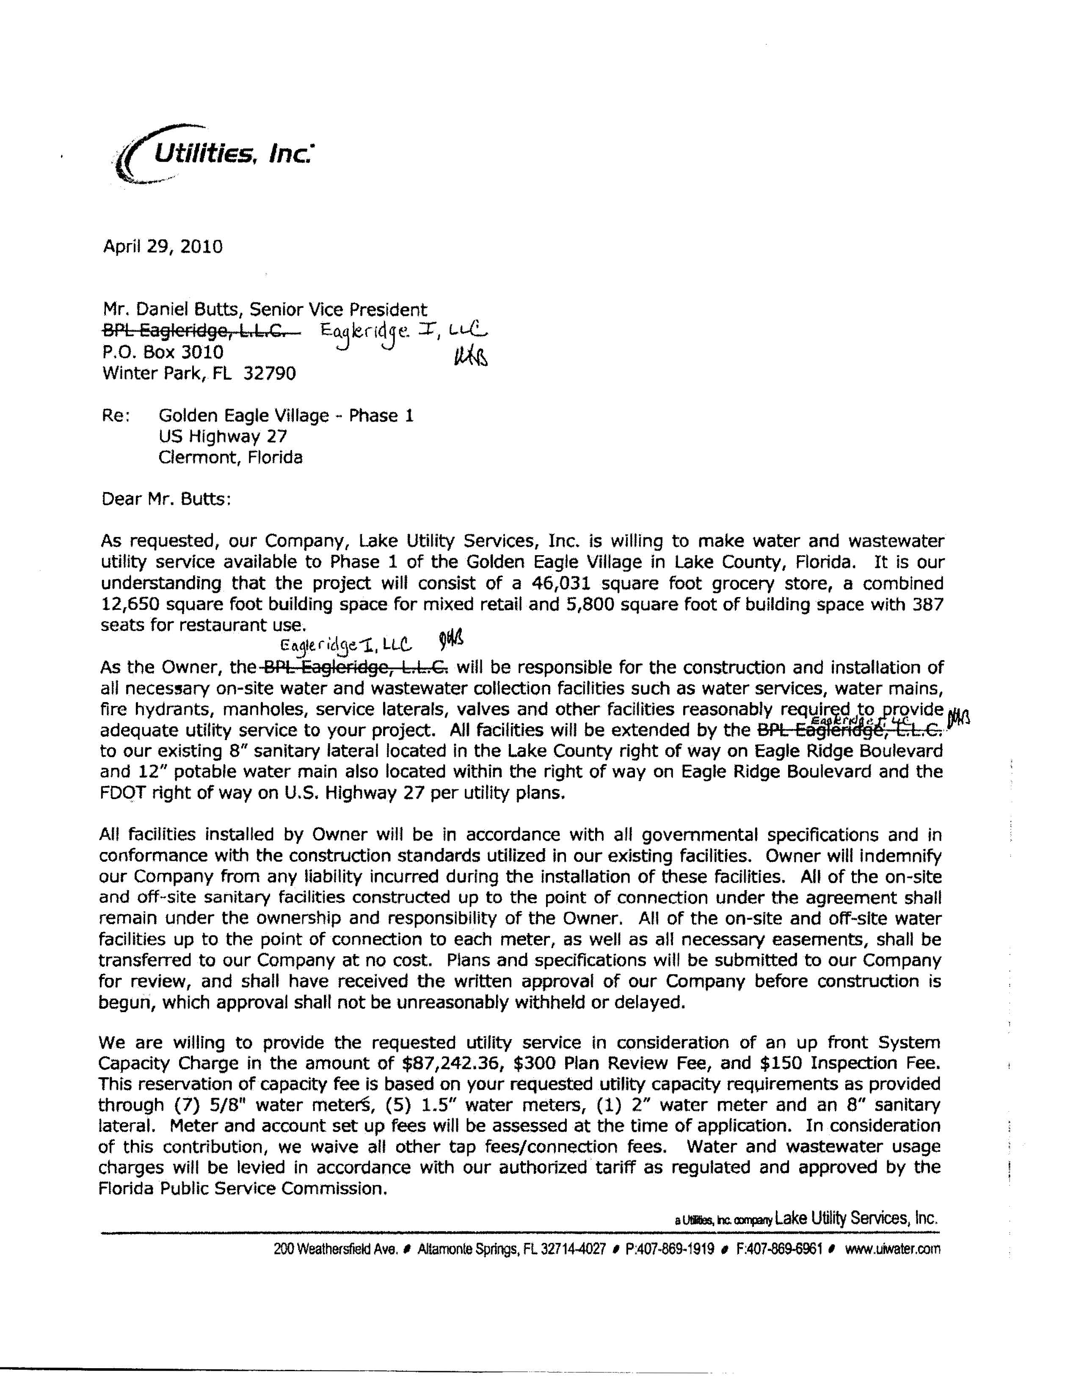
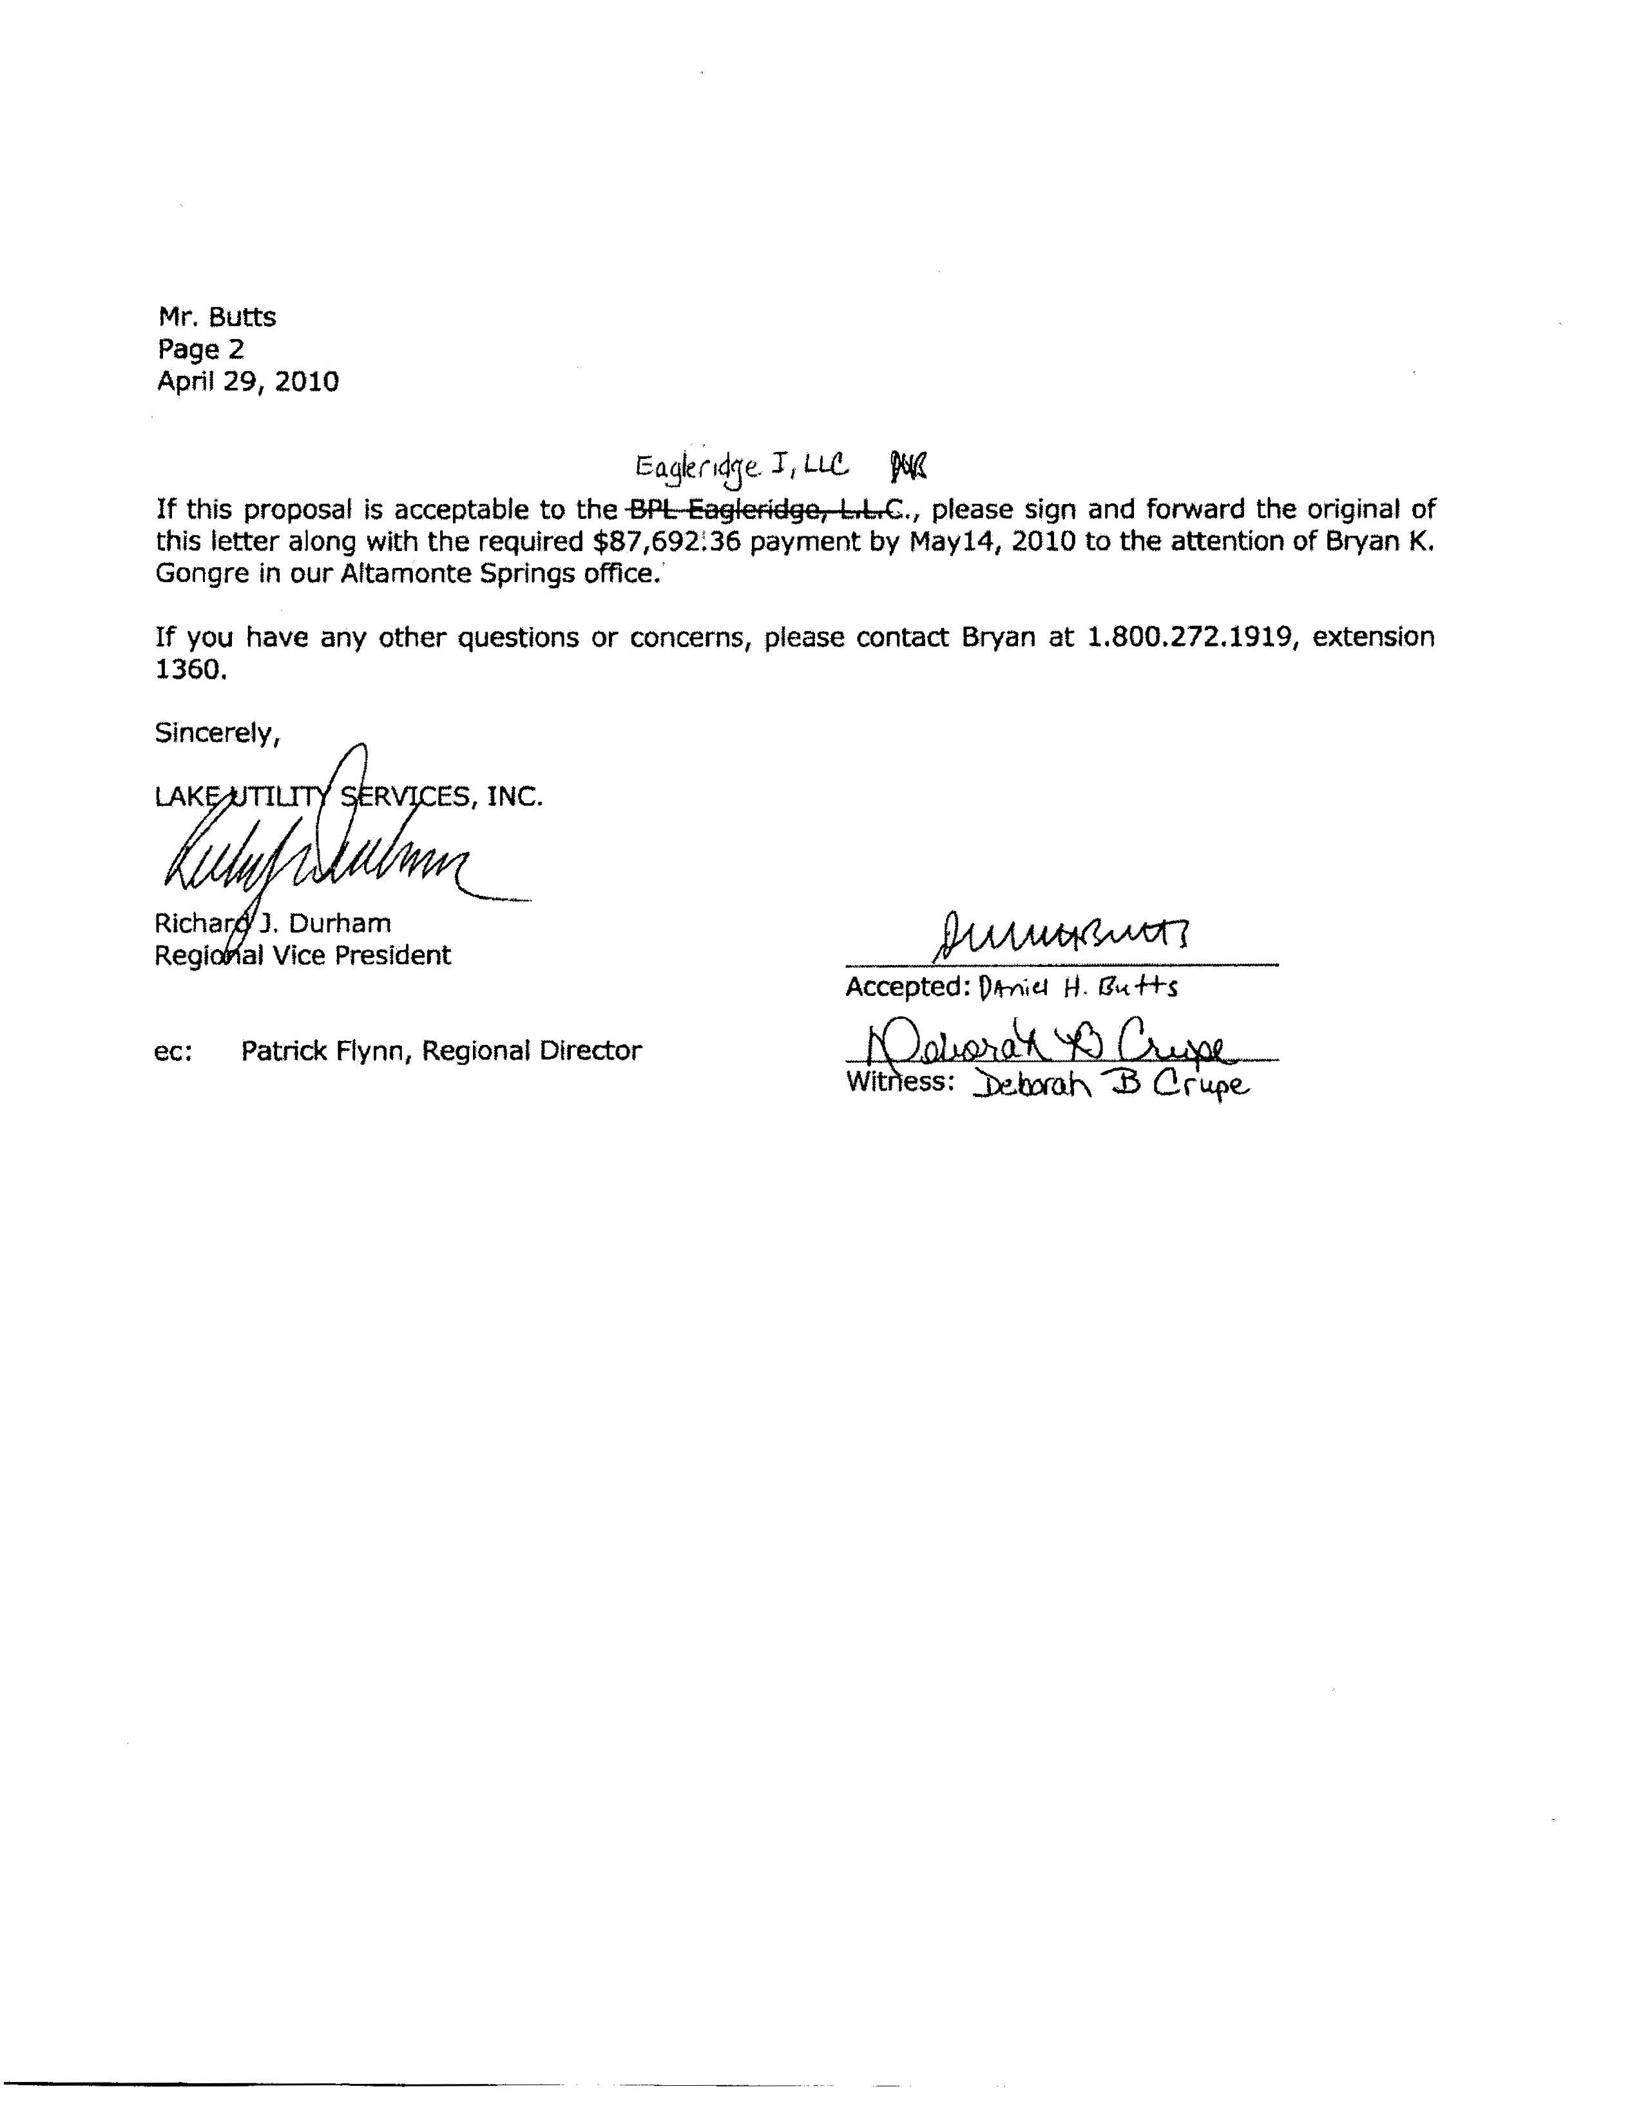
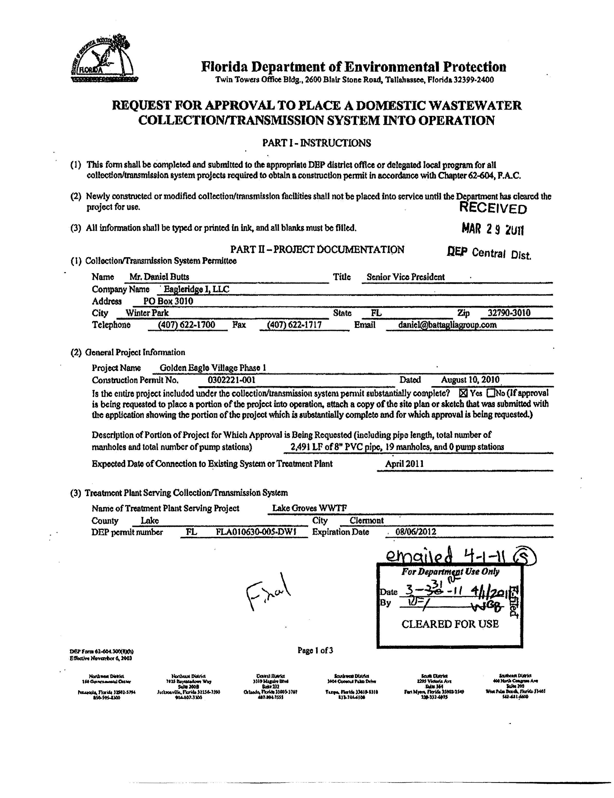
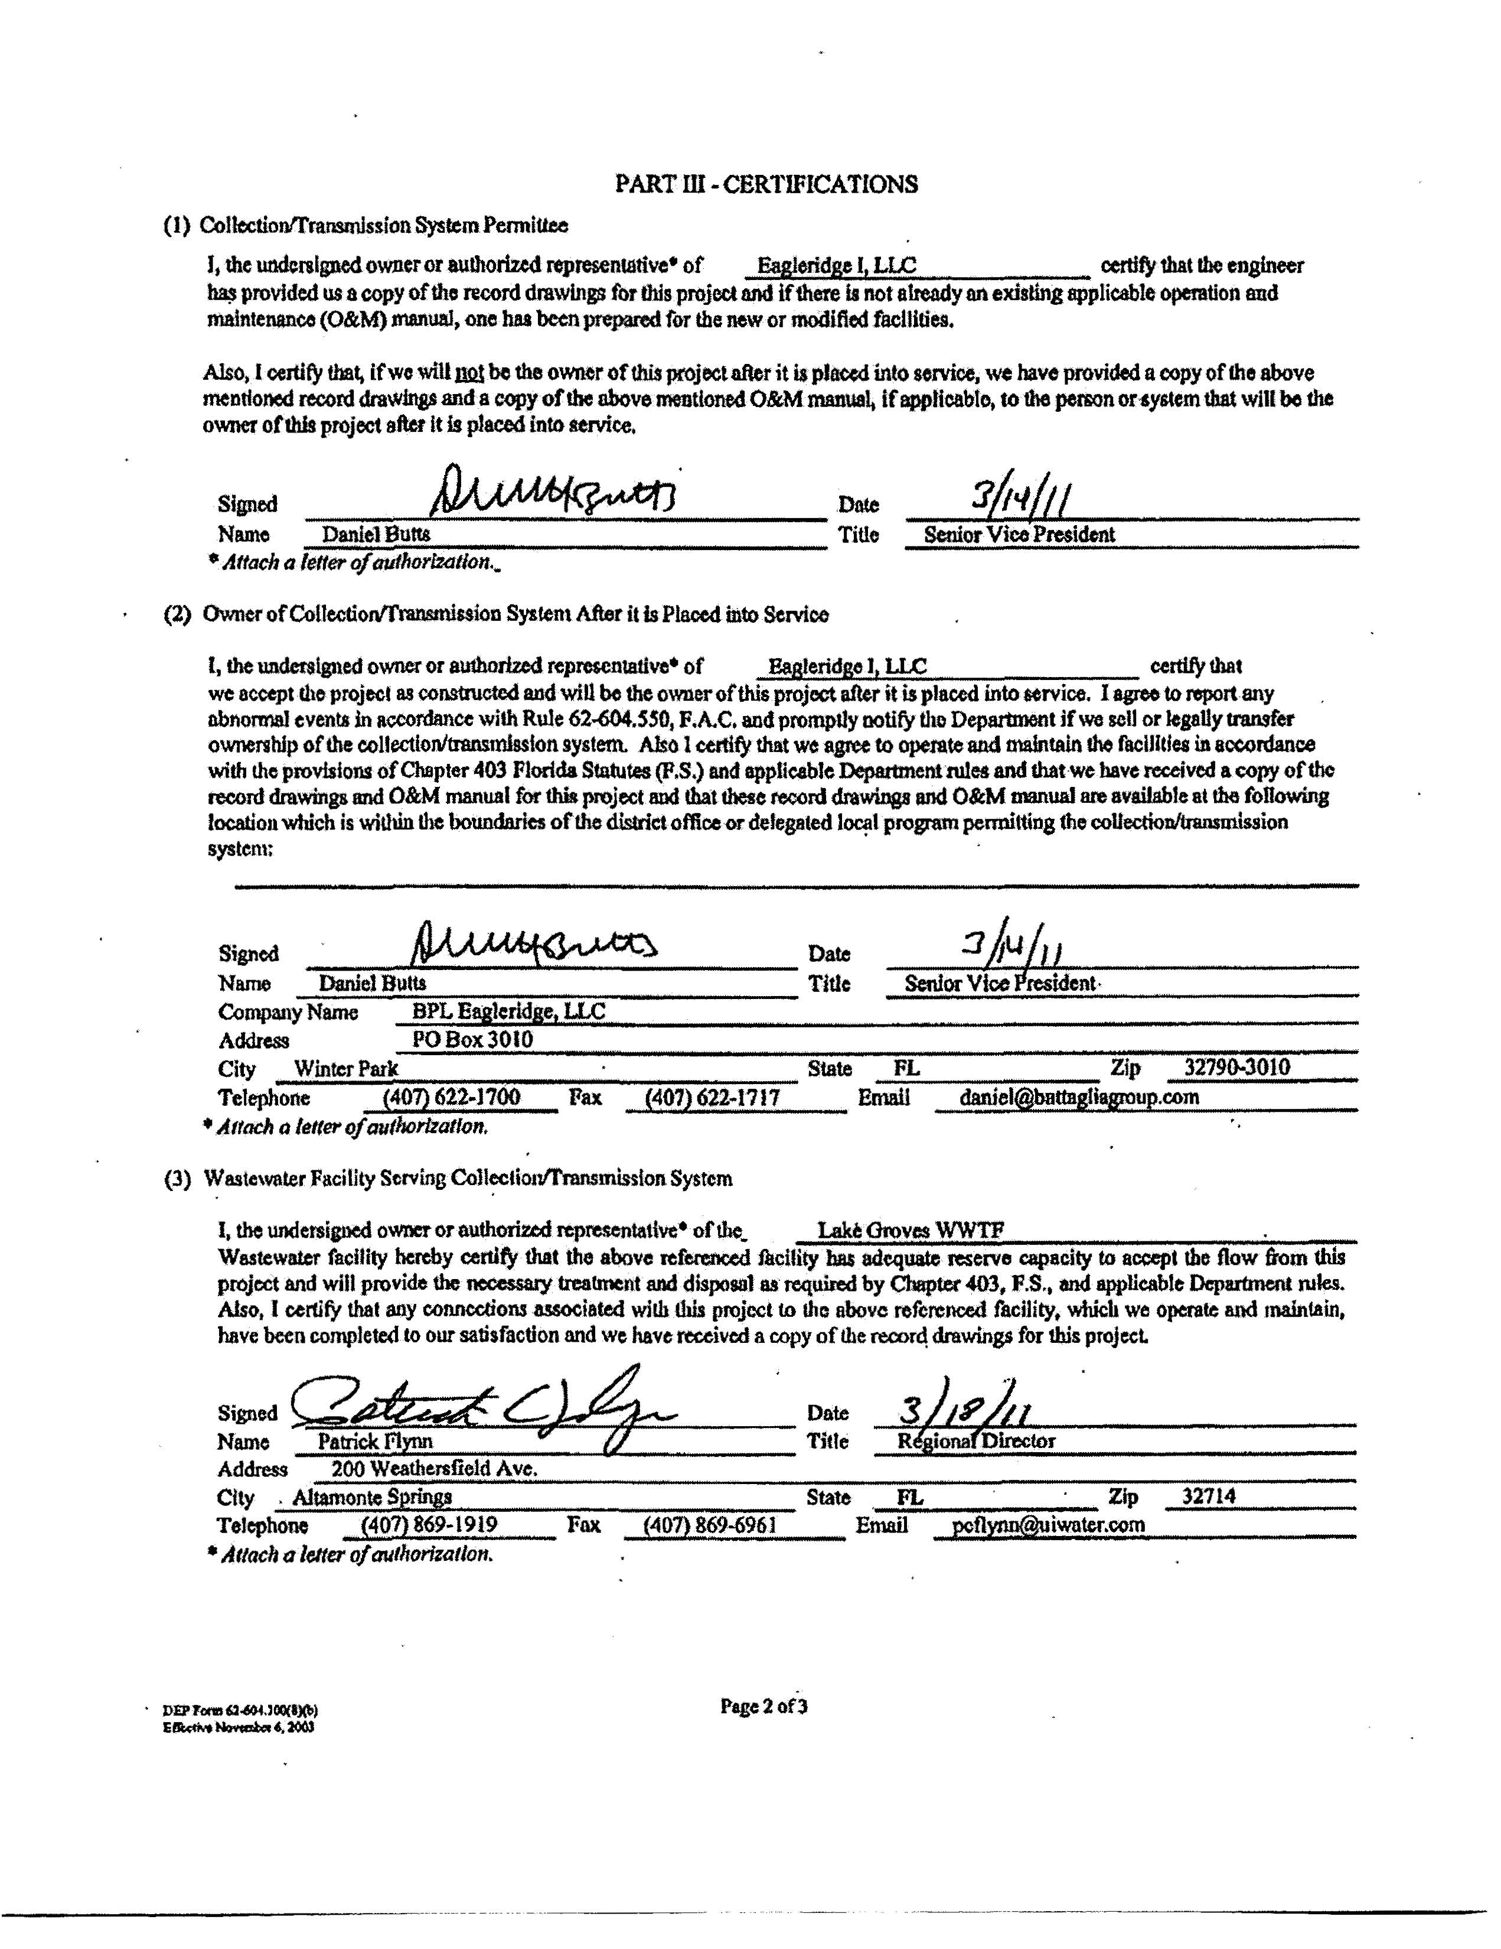
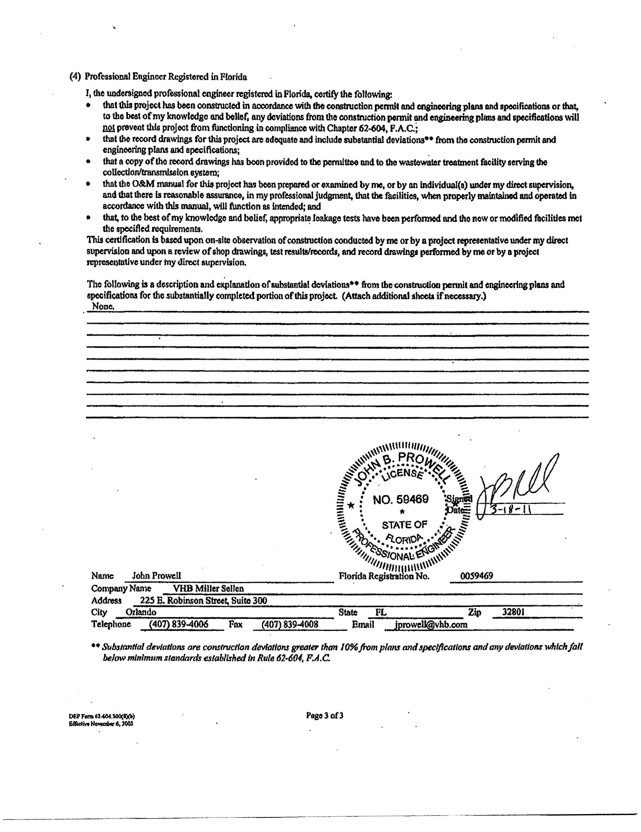
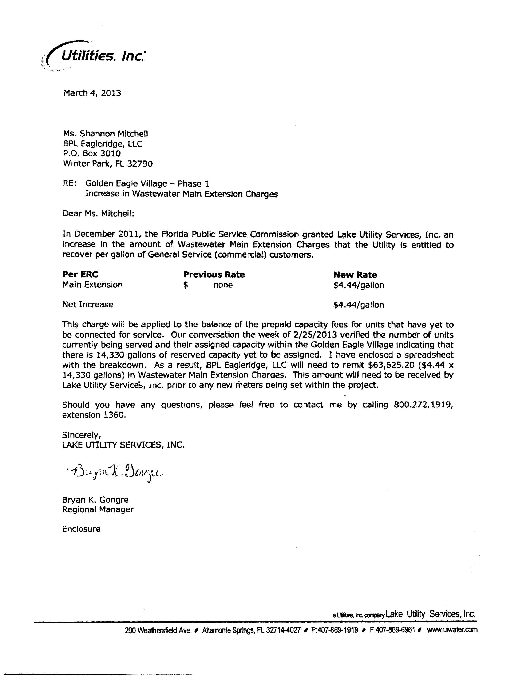

See Order PSC-11-0514-PAA-WS, issued November 3, 2011, in Docket No. 100426-WS, In re: Application for increase in water and wastewater rates in Lake County by Lake Utility Services, Inc. (November 2011 Order)
See November 2011 Order.
Id.
Id.
Document No. 00342-15, in Docket No. 150026-WS, Lake Utility Services, Inc.’s Answer to Complaint.
Document No. 00817-15, in Docket No. 150026-WS, Staff Data Request.
Document No. 00996-15, in Docket No. 150026-WS, Lake Utility Services, Inc.’s responses to our Staff’s First Data Request.
Document No. 01788-15, in Docket No. 150026-WS, Memo to all parties and interested persons advising of a conference to discuss the complaint.
Document No. 02038-15, in Docket No. 150026-WS, Eagleridge I, LLC’s Supplemental Filing In Response To Lake Utility Services, Inc.’s Answer To Complaint And Answer To Staff’s First Data Request And Response To Staff’s Questioning During April 3, 2015 Conference.
Document No. 00148-15, in Docket No. 150026-WS, Complaint Requesting Declaration That Connections Have Been Made and All Amounts Due Have Been Paid and Mandatory Injunction Requiring Refund Of Amounts Paid Under Protest.
Id.
Document No. 00342-15, in Docket No. 150026-WS, Lake Utility Services, Inc.’s Answer to Complaint.
Document No. 00342-15, in Docket No. 150026-WS, Lake Utility Services, Inc.’s Answer to Complaint.
November 2011 Order.
Id. at 39.
H. Miller & Sons, 373 So. 2d at 915.
Order No. 7650, issued February 21, 1977, in Docket No. 760299-WS, In re: H. Miller and Sons, Inc. v. Cooper City Utilities, Inc.
Order No. PSC-01-0857-PAA-WS, issued April 2, 2001, in Docket No. 000610-WS, In re: Application for uniform service availability charges in Duval, Nassau, and St. Johns Counties by United Water Florida, Inc.

