BEFORE THE FLORIDA PUBLIC SERVICE COMMISSION

In re: Joint petition for approval to implement gas reliability infrastructure program (GRIP) for Florida Public Utilities Company-Fort Meade and for approval of GRIP cost recovery factors by Florida Public Utilities Company, Florida Public Utilities Company-Fort Meade and the Florida Division of Chesapeake Utilities Corporation. | DOCKET NO. 150191-GU  ORDER NO. PSC-15-0578-TRF-GU  ISSUED: December 21, 2015

The following Commissioners participated in the disposition of this matter:

ART GRAHAM, Chairman
LISA POLAK EDGAR
RONALD A. BRISÉ
JULIE I. BROWN
JIMMY PATRONIS

ORDER APPROVING TARIFFS

BY THE COMMISSION:

Background

On September 1, 2015, Florida Public Utilities Company (FPUC), FPUC-Fort Meade (Fort Meade), and the Florida Division of Chesapeake Utilities Corporation (Chesapeake), collectively the Company, filed a petition seeking approval to implement a new gas reliability infrastructure program (GRIP) for Fort Meade and for approval of GRIP cost recovery factors for FPUC, Fort Meade, and Chesapeake.
The GRIP program for FPUC and Chesapeake was originally approved in Order No. PSC-12-0490-TRF-GU (2012 Order) to recover the cost of accelerating the replacement of cast iron and bare steel distribution mains and services through a surcharge on customers’ bills. FPUC and Chesapeake’s currently effective surcharges were approved in Order No. PSC-14-0693-TRF-GU.
Fort Meade does not have a GRIP program and has requested our approval to implement a GRIP program in the instant petition. On October 27, 2015, the Company filed an amended petition for approval to implement GRIP for Fort Meade.
The 2012 Order for FPUC and Chesapeake addressed the reliability and safety rationale for pipeline replacement, the scope of the program, similar actions in other states, and the procedure for annually setting the GRIP surcharge to recover the costs of the program. The procedure requires an annual filing with three components:
- A final true-up showing the actual replacement costs, actual surcharge revenues, and over- or under-recovery amount for the 12-month historical period from January 1 through December 31 of the year prior to FPUC’s/Chesapeake’s annual GRIP petition.
- An actual/estimated true-up showing seven months of actual and five months of projected replacement costs, surcharge revenues, and over- or under-recovery amount.
- A revenue requirement projection showing 12 months of projected GRIP revenue requirement for the period beginning January 1 following FPUC’s/Chesapeake/s annual GRIP petition filing.
We concluded the 2012 Order by stating:
Replacement of bare steel pipelines is in the public interest to improve the safety of Florida’s natural gas infrastructure, thereby reducing the risk to life and property. Given the length of time these pipelines have been installed and the leak history due to corrosion, we find that it is appropriate to approve the proposed replacement program. Without the GRIP surcharge, it is reasonable to expect that FPUC/Chesapeake will have to file for more frequent base rate proceedings to recover the expenses of an accelerated replacement program. The annual filings will provide us with the oversight to ensure that projected expenses are trued-up and only actual costs are recovered. FPUC’s/Chesapeake’s GRIP and its associated surcharges will terminate when all replacements have been made and the revenue requirement rolled into rate base.
On October 22, 2015, the Company filed responses to Commission Staff’s First Data Request. We have jurisdiction over this matter pursuant to Sections 366.03, 366.04, 366.05, and 366.06, Florida Statutes (F.S.).

Decision

FPUC and Chesapeake’s Proposed GRIP Surcharge Factors for 2016

The FPUC and Chesapeake surcharges have been in effect since January 2013. FPUC and Chesapeake state that they continue to replace eligible infrastructure aggressively. Both companies prioritize the potential replacement projects in areas of high consequence and areas susceptible to corrosion. These areas are dictated by the Distribution Integrity Management Program, which uses a risk-based prioritization designed to determine the replacement order for cast iron and bare steel pipelines. Attachment 1 provides an update of mains and services replaced and the replacement forecast through the end of the term of the GRIP program in 2022 for FPUC and Chesapeake. The companies appear to be on track to complete the replacements on time.
FPUC’s True-ups by Year
FPUC’s calculations for the 2016 GRIP revenue requirement and surcharges include a final true-up for 2014, an actual/estimated true-up for 2015, and projected costs for 2016. Attachment 2 contains tables showing the calculation for each year. FPUC recovers $747,727 of annual GRIP expenses in base rates. The amount included in base rates is excluded from the GRIP surcharge calculation.
Final True-up for 2014
FPUC stated that the GRIP revenues for 2014 were $674,601, compared to a revenue requirement of $2,381,424. The resulting under-recovery is $1,706,823. After adding interest of $139 and the end of 2013 over-recovery ($414,542), the final 2014 true-up is an under-recovery of $1,292,420.
Actual/Estimated 2015 True-Up
FPUC provided actual GRIP revenues for January through July and estimated revenues for August through December, which total $4,283,483. The actual/estimated revenue requirement for 2015 is $5,770,685 and includes a return on investment, depreciation expense, and property tax expense. The forecast under-recovery for 2015 is $1,487,202. After adding interest of $1,388, and the final 2014 under-recovery of $1,292,420, the total 2015 under-recovery is $2,781,010.
Projected 2016 Costs
FPUC projects capital expenditures of $12,237,715 for the replacement of cast iron/bare steel infrastructure in 2016. This compares with final 2014 expenditures of $19,128,274 and actual/estimated 2015 expenditures of $25,207,005. The return on investment, net depreciation expense, customer notification, and property tax expenses associated with that investment are $8,920,386. Subtracting the revenue requirement for bare steel replacement investment included in base rates results in a 2016 revenue requirement of $8,172,659. After adding the total 2015 under-recovery of $2,781,010, the 2016 revenue requirement is $10,953,669.
Chesapeake’s True-ups by Year
Chesapeake does not have a replacement recovery amount embedded in base rates. Chesapeake’s calculations for the 2016 GRIP revenue requirement and surcharges include a final true-up for 2014, an actual/estimated true-up for 2015, and projected costs for 2016. Attachment 3 contains tables showing the calculation for each year.
Final True-Up for 2014
Chesapeake’s stated that the GRIP revenues for 2014 were $666,121, compared to total replacement costs of $967,391. The resulting under-recovery is $301,270. After adding interest of $12 and the end of 2013 over-recovery amount ($90,107), the final 2014 under-recovery is $211,175.
Actual/Estimated 2015 True-Up
Chesapeake provided actual GRIP revenues for January through July and forecast revenues for August through December, which total $1,800,824. The actual/estimated GRIP revenue requirement for 2015 is $1,717,692 and includes a return on investment, depreciation expense, and property tax expense. The forecast over-recovery for 2015 is $83,132. After adding interest of $81 and the 2014 over-recovery amount ($211,175), the total 2015 under-recovery is $127,962.
Projected 2016 Costs
Chesapeake projects capital expenditures of $4,447,860 for the replacement of cast iron/bare steel infrastructure in 2016. This compares with final 2014 expenditures of $5,196,099 and actual/estimated 2015 expenditures of 5,815,969. The return on investment, depreciation expense, and property tax expense to be recovered in 2016 totals $2,432,850. After adding the total 2015 under-recovery of $127,962, the total 2016 revenue requirement is $2,560,812.
Proposed Surcharges for FPUC and Chesapeake
As established in the 2012 Order approving the GRIP, the total 2016 revenue requirement is allocated to the rate classes using the same methodology that was used for the allocation of mains and services in the cost of service study used in the companies’ most recent rate case. After calculating the percentage of total plant costs attributed to each rate class, the respective percentages were multiplied by the 2016 revenue requirement, resulting in the revenue requirement by rate class. Dividing each rate class’ revenue requirement by projected therm sales provides the GRIP surcharge for each rate class.
The proposed 2016 GRIP surcharge for residential FPUC customers is $0.26393 per therm (compared to the current surcharge of $0.10516 per therm). The monthly bill impact is $5.50 beginning January 2016 for a residential customer who uses 20 therms per month. The proposed FPUC tariff page is provided in Attachment 4.
The proposed 2016 GRIP surcharge for residential Chesapeake customers on the FTS-1 rate is $0.08568 per therm (compared to the current surcharge of $0.05713 per therm). The monthly bill impact is $1.71 beginning January 2016 for a residential Chesapeake customer who uses 20 therms per month. The proposed tariff page is provided in Attachment 5.
We find that the calculation of the 2016 GRIP surcharge revenue requirement and the proposed GRIP surcharges for FPUC and Chesapeake are reasonable and accurate. Therefore, we approve FPUC and Chesapeake’s proposed 2016 GRIP surcharge for each rate class commencing with bills rendered for meter readings taken on and after January 1, 2016, and approve the associated tariffs. We further note that there will be a true-up process done.
Proposed GRIP Program for Fort Meade
Fort Meade does not have a GRIP program. Fort Meade is located in Polk County and Fort Meade serves approximately 650 natural gas residential and commercial customers. FPUC and the City of Fort Meade executed a purchase agreement in 2013 for the sale of the City of Fort Meade’s natural gas system and FPUC acquired the system in December 2013. We approved Fort Meade’s initial tariff sheets in Order No. PSC-13-0676-TRF-GU. At that point Fort Meade started operating as a new investor-owned natural gas utility in Florida as a division of FPUC.
The Company explained that after the acquisition of the Fort Meade system, it found during a routine maintenance survey approximately 250 steel tubing services in the Fort Meade system. Steel services are subject to corrosion and are typically replaced with plastic services. In the petition filed on September 1, 2015, Fort Meade requested our approval to implement a GRIP program to replace the steel tubing services and associated GRIP surcharges effective January 2016 consistent with the purpose of the FPUC and Chesapeake GRIP programs weapproved in the 2012 Order.
After filing the September 1, 2015 petition, the Company determined that the implementation of the GRIP surcharge for Fort Meade prior to October 2016 would be in violation of a term in the purchase agreement for the Fort Meade system. Therefore, the Company submitted an amended petition on October 27, 2015 as it relates to Fort Meade. Specifically, the amended petition requests that Fort Meade be allowed to implement a new GRIP program to be able to start the replacement of the Fort Meade steel services effective January 2016, however, defer collecting GRIP surcharges from customers until January 2017. After the approval of Fort Meade’s proposed GRIP program, the Company anticipates making a GRIP filing in the fall of 2016 concurrent with the annual FPUC and Chesapeake GRIP filing, which will include actual/estimated replacement cost for 2016, projected replacement cost for 2017, and GRIP surcharges effective January 2017.
The Company states that using the same average replacement cost of services for FPUC and Chesapeake of $1,900 per service, the total projected investment for Fort Meade is $475,000 to replace 250 services. The Company anticipates if it acts aggressively that it will take approximately two years to replace the Fort Meade steel services. The estimated annual revenue requirement associated with half of the investment ($237,500) is $15,086. As with the approved FPUC and Chesapeake GRIP programs, the revenue requirement for Fort Meade includes depreciation expenses, return on investment, and property taxes. In response to Commission staff’s data request, the Company explained that it will notify the Fort Meade customers of the GRIP surcharge in December 2016 through a message on the customer’s bill, separate mailing, and a message on the FPUC-Fort Meade website.
While the 2017 Fort Meade GRIP surcharge will not be determined until Fort Meade files a petition for a surcharge by September 1, 2017, Fort Meade currently estimates the 2017 residential GRIP surcharge to be $0.24155 per therm, or $4.83 for a customer who uses 20 therms per month. This estimated residential GRIP surcharge includes the revenue requirement for 2016 and 2017. If Fort Meade had implemented a surcharge in 2016, as contemplated in the petition filed September 1, 2016, based on only the 2016 projected revenue requirement, the surcharge would be $0.12065 per therm, or $2.41 for a customer who uses 20 therms per month. Delaying the implementation of the surcharge by a year therefore increases the surcharge to customers. However, replacement cost may vary from current estimates and Commission staff discussed with the Company to consider options such as spreading the recovery of the GRIP revenue requirement over two years to mitigate the initial impact on customers, if necessary. We find, as was stated in the 2012 Order, that the replacement of bare steel pipelines is in the public interest and Fort Meade shall start replacing the steel services in January 2016 and not delay implementation until January 2017.
We approve the proposed GRIP program for Fort Meade effective January 1, 2016. Fort Meade shall file a petition to implement 2017 GRIP surcharges no later than September 1, 2016. Approval of a GRIP program for Fort Meade is consistent with the GRIP programs we approved for FPUC, Chesapeake and Peoples Gas System.
Based on the foregoing, it is

ORDERED by the Florida Public Service Commission that the joint petition by Florida Public Utilities Company and Florida Division of Chesapeake Utilities Corporation for approval of Gas Reliability Infrastructure Program is approved for each rate class commencing with bills rendered for meter readings taken on and after January 1, 2016, and approve the associated tariffs. We further note that there will be a true-up process done. It is further

ORDERED that the petition by FPUC-Fort Meade for approval of Gas Reliability Infrastructure Program is approved effective January 1, 2016. It is further

ORDERED that FPUC-Fort Meade shall file a petition to implement 2017 Gas Reliability Infrastructure Program surcharges no later than September 1, 2016. It is further

ORDERED that if a protest is filed within 21 days of issuance of the Order, the tariff shall remain in effect with any charges held subject to refund pending resolution of the protest. It is further

ORDERED that the docket shall remain open until the process is complete.

By ORDER of the Florida Public Service Commission this 21st day of December, 2015.

/s/ Carlotta S. Stauffer
CARLOTTA S. STAUFFER
Commission Clerk
Florida Public Service Commission
2540 Shumard Oak Boulevard
Tallahassee, Florida 32399
(850) 413-6770
www.floridapsc.com

Copies furnished: A copy of this document is provided to the parties of record at the time of issuance and, if applicable, interested persons.

DJ

NOTICE OF FURTHER PROCEEDINGS

The Florida Public Service Commission is required by Section 120.569(1), Florida Statutes, to notify parties of any administrative hearing or judicial review of Commission orders that is available under Sections 120.57 or 120.68, Florida Statutes, as well as the procedures and time limits that apply. This notice should not be construed to mean all requests for an administrative hearing or judicial review will be granted or result in the relief sought.

Mediation may be available on a case-by-case basis. If mediation is conducted, it does not affect a substantially interested person's right to a hearing.

The Commission's decision on this tariff is interim in nature and will become final, unless a person whose substantial interests are affected by the proposed action files a petition for a formal proceeding, in the form provided by Rule 28-106.201, Florida Administrative Code. This petition must be received by the Office of Commission Clerk, 2540 Shumard Oak Boulevard, Tallahassee, Florida 32399-0850, by the close of business on January 11, 2016.

In the absence of such a petition, this Order shall become final and effective upon the issuance of a Consummating Order.

Any objection or protest filed in this docket before the issuance date of this order is considered abandoned unless it satisfies the foregoing conditions and is renewed within the specified protest period.

Table 1
FPUC Pipe Replacement Program Progress
 | Main Replacements |  |  |  |  | Service Replacements
 | Replaced  Cast Iron  (miles) | Replaced  Bare Steel  (miles) | Remaining  Cast Iron at Year  End  (miles) | Remaining  Bare Steel  at Year End  (miles) | Total Miles  Remaining | Replaced  Number of  Steel  Services | Total Number of  Remaining  Steel  Services
Year
July 2012 |  |  | 0.9 | 197.10 | 198.00 |  | 7980
2012 |  | 6.00 | 0.9 | 191.10 | 192.00 | 91 | 7889
2013 | 0.6 | 26.40 | 0.3 | 164.70 | 165.00 | 2071 | 5818
2014 |  | 38.00 | 0.3 | 126.70 | 127.00 | 1275 | 4543
2015 |  | 41.00 | 0.3 | 85.70 | 86.00 | 905 | 3638
2016 |  | 20.00 | 0.3 | 65.70 | 66.00 | 815 | 2823
2017 | 0.3 | 13.70 | 0 | 52.00 | 52.00 | 595 | 2228
2018 |  | 14.00 | 0 | 38.00 | 38.00 | 595 | 1633
2019 |  | 14.00 | 0 | 24.00 | 24.00 | 595 | 1038
2020 |  | 14.00 | 0 | 10.00 | 10.00 | 595 | 443
2021 |  | 8.00 | 0 | 2.00 | 2.00 | 385 | 58
2022 |  | 2.00 | 0 | 0.00 | 0.00 | 58 | 0
Source: FPUC’s response to Commission staff’s first data request
Table 2
Chesapeake Pipe Replacement Program Progress
 | Main Replacements |  |  |  |  | Service Replacements
 | Replaced  Cast Iron  (miles) | Replaced  Bare Steel  (miles) | Remaining  Cast Iron at Year  End  (miles) | Remaining  Bare Steel  at Year End  (miles) | Total Miles  Remaining | Replaced  Number of  Steel  Services | Total Number of  Remaining  Steel  Services
Year
July 2012 |  |  |  | 152 | 152 |  | 762
2012 |  | 5 | 0 | 147 | 147 | 34 | 728
2013 |  | 3 | 0 | 144 | 144 | 139 | 589
2014 |  | 19 | 0 | 125 | 125 | 47 | 542
2015 |  | 40 | 0 | 85 | 85 | 280 | 262
2016 |  | 14 | 0 | 71 | 71 | 42 | 220
2017 |  | 14 | 0 | 57 | 57 | 42 | 178
2018 |  | 14 | 0 | 43 | 43 | 42 | 136
2019 |  | 14 | 0 | 29 | 29 | 42 | 94
2020 |  | 14 | 0 | 15 | 15 | 42 | 52
2021 |  | 12 | 0 | 3 | 3 | 40 | 12
2022 |  | 3 | 0 | 0 | 0 | 12 | 0
Source: Chesapeake’s response to Commission staff’s first data request

Table 3
FPUC Final True-up for 2014
2014 GRIP Revenues | $674,601
2014 Net Revenue Requirement | $2,381,424
2014 Under-recovery | $1,706,823
Interest | $139
2013 Final True-up (over-recovery) | $414,542
2014 Final True-Up (under-recovery) | $1,292,420
Source: Schedule B-1 of the petition

Table 4
FPUC Actual/Estimated True-up for 2015
2015 GRIP Revenues | $4,283,483
2015 Net Revenue Requirement | $5,770,685
2015 Under-recovery | $1,487,202
Interest | $1,388
2014 Final True-up (under-recovery) | $1,292,420
2015 Total True-Up (under-recovery) | $2,781,010
Source: Schedule B-2 of the petition

Table 5
FPUC Projected 2016 Costs
2016 Projected Expenditures | $12,237,715
Return on Investment | $6,195,036
Depreciation Expense | $1,535,625
Tax and Customer Notice Expenses | $1,189,725
2016 Revenue Requirement | $8,920,386
Less Revenue Requirement in Base Rates | $747,727
2016 GRIP Revenue Requirement | $8,172,659
Plus Prior Period Under-Recovery | ($2,781,010)
Total 2016 Revenue Requirement | $10,953,669
Source: Schedule C-1 of the petition

Table 6
Chesapeake Final True-up for 2014

2014 GRIP Revenues | $666,121
2014 Net Revenue Requirement | $967,391
2014 Under-recovery | $301,270
Interest | $12
2013 Final True-Up (over-recovery) | $90,107
2014 Final True-up (under-recovery) | $211,175

Source: Schedule B-1 of the petition

Table 7
Chesapeake Actual/Estimated True-up for 2015
2015 GRIP Revenues | $1,800,824
2015 Net Revenue Requirement | $1,717,692
2015 Over-Recovery | $83,132
Interest | $81
2014 Final True-Up (under-recovery) | $211,175
2015 Total True-Up (under-recovery) | $127,962
Source: Schedule B-2 of the petition

Table 8
Chesapeake Projected 2016 Costs
2016 Projected Expenditures | $4,447,860
Return on Investment | $1,669,415
Depreciation Expense | $427,963
Tax and Customer Notice Expenses | $335,472
2016 Revenue Requirement | $2,432,850
Plus Prior Period Under-recovery | $127,962
Total 2016 Revenue Requirement | $2,560,812
Source: Schedule C-1 of the petition

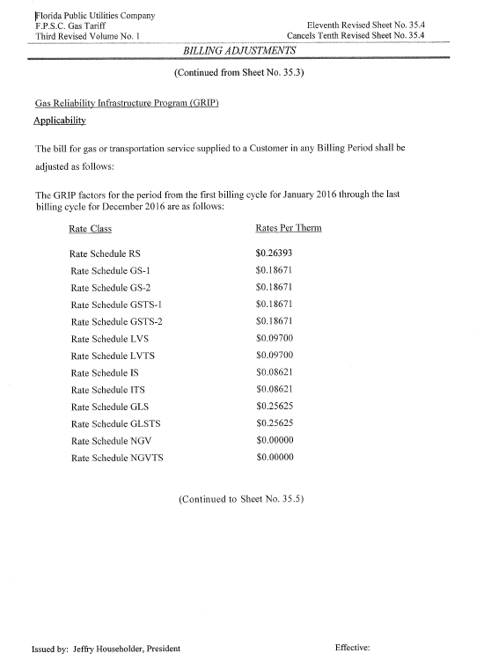
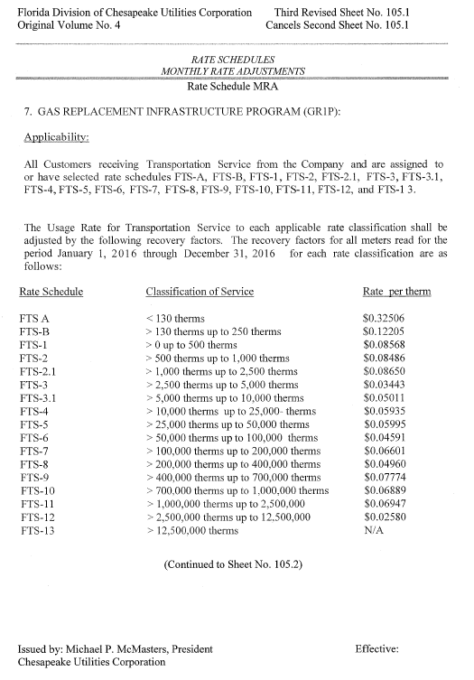

Order No. PSC-12-0490-TRF-GU, issued September 24, 2012, in Docket No. 120036-GU, In re: Joint petition for approval of Gas Reliability Infrastructure Program (GRIP) by Florida Public Utilities Company and the Florida Division of Chesapeake Utilities Corporation.
Order No. PSC-14-0693-TRF-GU, issued December 15, 2014, in Docket No. 140166-GU, In re: Joint petition for approval of Gas Reliability Infrastructure Program (GRIP) by Florida Public Utilities Company and the Florida Division of Chesapeake Utilities Corporation.
Order No. PSC-13-0676-TRF-GU, issued December 20, 2013, Docket No. 130258-GU, In re: Petition for approval of tariff sheets reflecting gas service to customers in the City of Ft. Meade, by Florida Public Utilities Company.
Order No. PSC-12-0476-TRF-GU, issued September 18, 2012, in Docket No. 110320-GU, In re: Petition for approval of Cast Iron/Bare Steel Pipe Replacement Rider (Rider CI/BSR), by Peoples Gas System.

