State of Florida  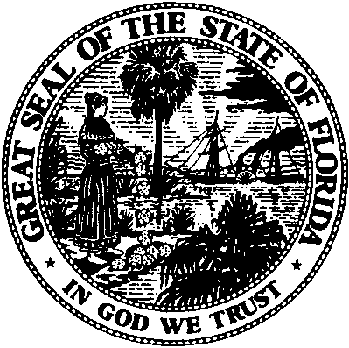 | Public Service Commission  Capital Circle Office Center ● 2540 Shumard Oak Boulevard  Tallahassee, Florida 32399-0850  -M-E-M-O-R-A-N-D-U-M-
DATE: | February 18, 2016
TO: | Office of Commission Clerk (Stauffer)
FROM: | Office of Telecommunications (Williams)  Office of the General Counsel (Lherisson)
RE: | Application for Certificate of Authority to Provide Telecommunications Service
AGENDA: | 3/1/2016 - Consent Agenda - Proposed Agency Action - Interested Persons May Participate
SPECIAL INSTRUCTIONS: |  | None

Please place the following Application for Certificate of Authority to Provide Telecommunications Service on the consent agenda for approval.

DOCKET NO. | COMPANY NAME | CERT. NO.
150244-TX | Pure Telephone Corp | 8882
The Commission is vested with jurisdiction in this matter pursuant to Section 364.335, Florida Statutes. The Certificate of Authority authorizes Pure Telephone Corp to provide Telecommunications Services in the State of Florida as a Telecommunications Company as defined by Section 364.02(13), Florida Statutes. Pursuant to Section 364.336, Florida Statutes, certificate holders must pay a minimum annual Regulatory Assessment Fee if the certificate is active during any portion of the calendar year. A Regulatory Assessment Fee Return Notice will be mailed each December to the entity listed above for payment by January 30.

