State of Florida |  | Public Service Commission  Capital Circle Office Center ● 2540 Shumard Oak Boulevard  Tallahassee, Florida 32399-0850  -M-E-M-O-R-A-N-D-U-M-
DATE: | February 18, 2016
TO: | Office of Commission Clerk (Stauffer)
FROM: | Division of Economics (Rome)  Office of the General Counsel (Janjic)
RE: | Docket No. 160025-EU – Joint petition for approval of amendment to territorial agreement in Orange County, by Orlando Utilities Commission and Duke Energy Florida, LLC.
AGENDA: | 03/01/16 – Regular Agenda – Proposed Agency Action – Interested Persons May Participate
COMMISSIONERS ASSIGNED: |  |  | All Commissioners
PREHEARING OFFICER: |  |  | Brisé
CRITICAL DATES: |  |  | None
SPECIAL INSTRUCTIONS: |  |  | None

Case Background
On January 22, 2016, Orlando Utilities Commission (OUC) and Duke Energy Florida, LLC (Duke) filed a joint petition to extend the term of their current territorial agreement (current agreement) until August 1, 2017. In 2007, the Commission approved the current agreement for a nine year term expiring February 1, 2016. The joint petitioners stated that they need additional time to negotiate a new territorial agreement. The proposed amendment to extend the term is shown in Attachment A. The Commission has jurisdiction over this matter pursuant to Section 366.04, Florida Statutes (F.S.).

Discussion of Issues

Issue 1:
Should the Commission approve the amendment to the territorial agreement between OUC and Duke?

Recommendation:
Yes, the Commission should approve the amendment to the territorial agreement between OUC and Duke. (Rome)

Staff Analysis:
The proposed amendment to the territorial agreement, as shown in Attachment A, extends the term of the current agreement until August 1, 2017, to allow the joint petitioners additional time to negotiate a new territorial agreement. All other provisions of the current agreement remain in effect.
In approving the current agreement, the Commission found that the agreement is “…in the public interest…eliminates existing or potential uneconomic duplication of facilities, and it does not cause a decrease in the reliability of electric service to existing or future ratepayers.” Staff believes that the requested extension of time is reasonable and does not appear to be detrimental to the parties or the public interest. Any subsequent modification to the territorial agreement will be brought before the Commission for its consideration pursuant to Section 366.04, F.S. Therefore, staff recommends approval of the proposed amendment to the territorial agreement to provide OUC and Duke with additional time to negotiate a new territorial agreement.

Issue 2:
Should this docket be closed?

Recommendation:
If no protest is filed by a person whose substantial interests are affected within 21 days of the issuance of the Order, this docket should be closed upon the issuance of a Consummating Order. (Janjic)

Staff Analysis:
If no protest is filed by a person whose substantial interests are affected within 21 days of the issuance of the Order, this docket should be closed upon the issuance of a Consummating Order.
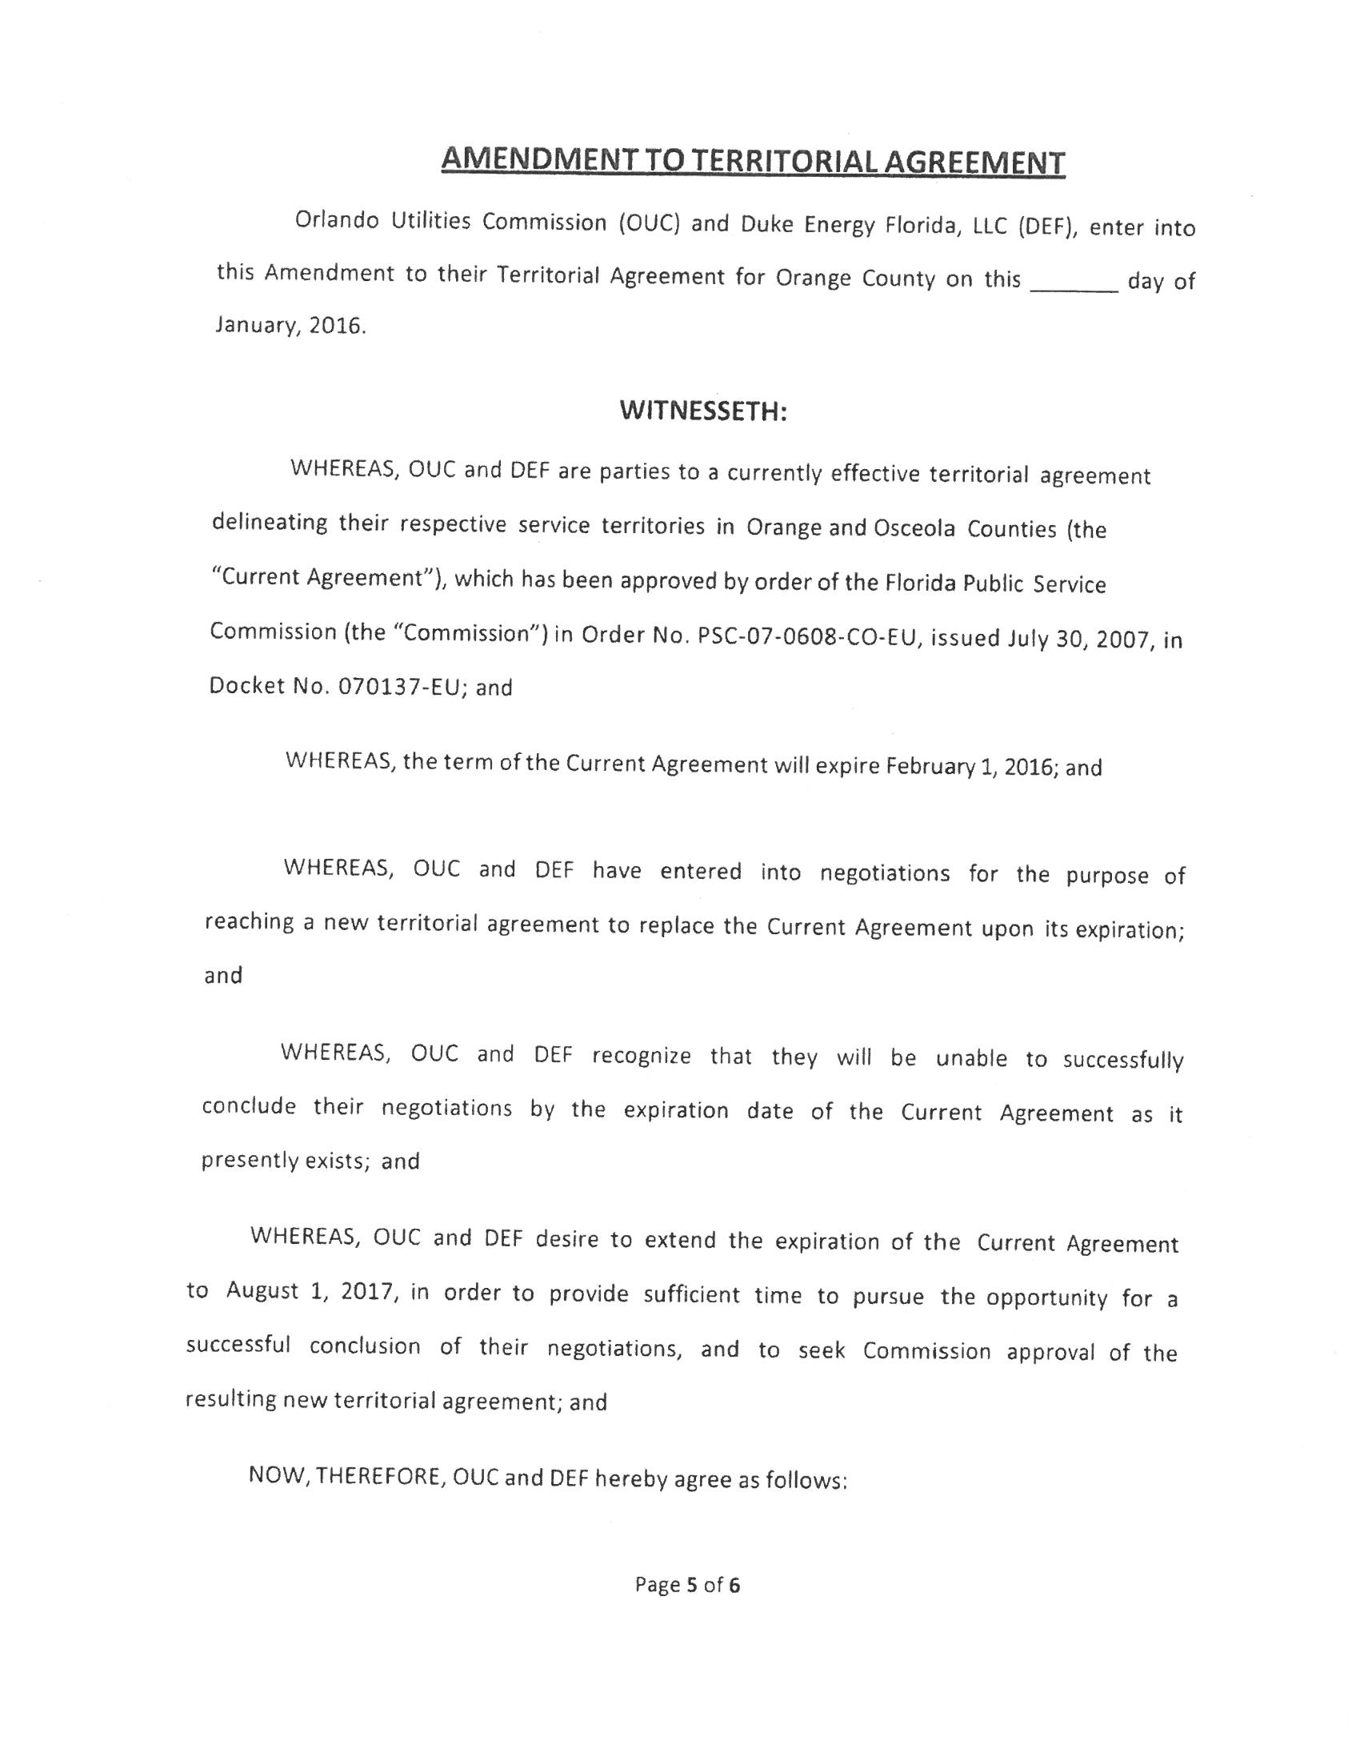

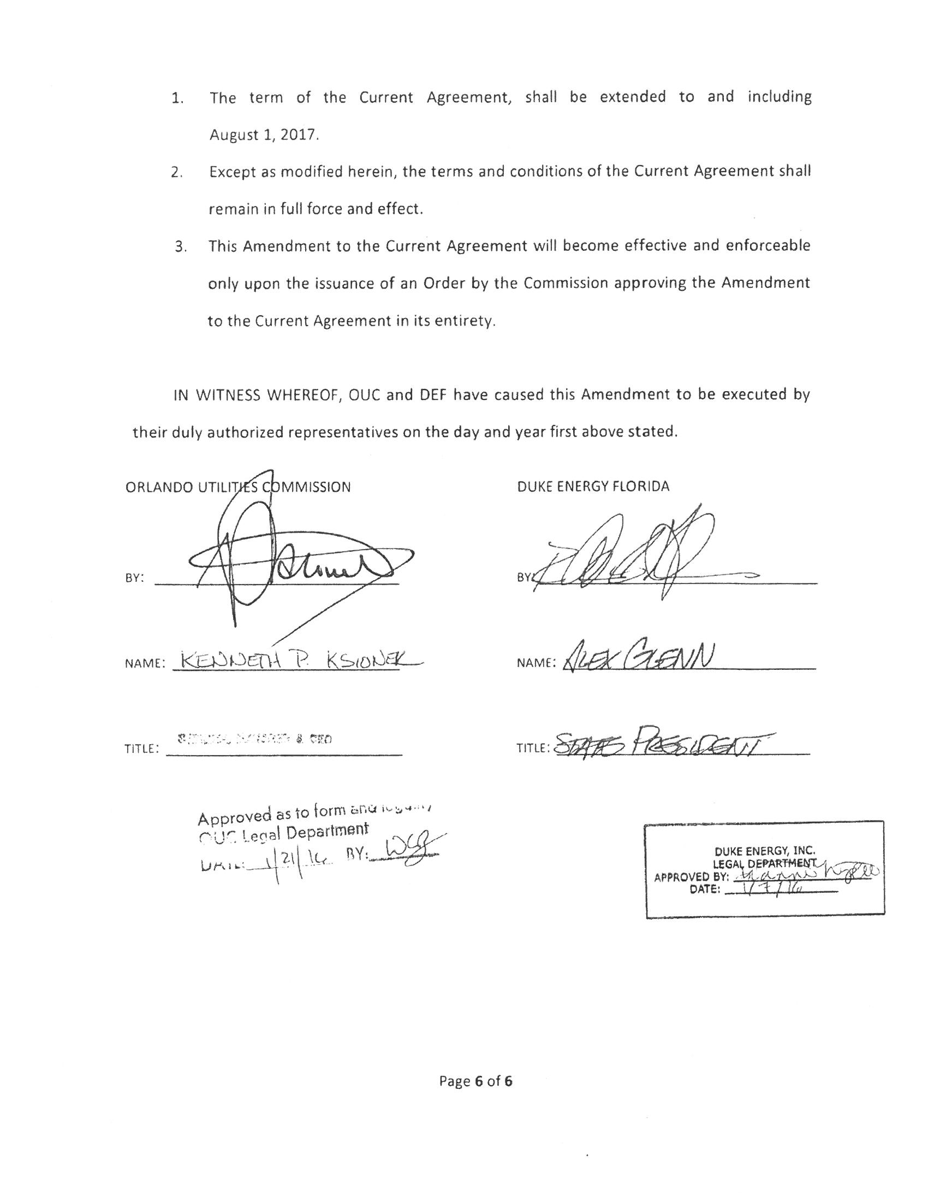

Order No. PSC-07-0562-PAA-EU, issued July 5, 2007, in Docket No. 070137-EU, In re: Joint petition for approval of territorial agreement in Orange County by Orlando Utilities Commission and Progress Energy Florida, Inc.
In response to a staff inquiry, the joint petitioners clarified that references to Osceola County in the joint petition and the proposed amendment to the territorial agreement were scrivener’s errors.
Order No. PSC-07-0562-PAA-EU, issued July 5, 2007, in Docket No. 070137-EU, In re: Joint petition for approval of territorial agreement in Orange County by Orlando Utilities Commission and Progress Energy Florida, Inc., page 3.

