BEFORE THE FLORIDA PUBLIC SERVICE COMMISSION

In re: Petition for declaratory statement regarding the Florida Public Service Commission's jurisdiction to adjudicate the Town of Indian River Shores' constitutional rights. | DOCKET NO. 160013-EU  ORDER NO. PSC-16-0093-FOF-EU  ISSUED: March 4, 2016

The following Commissioners participated in the disposition of this matter:

JULIE I. BROWN, Chairman
LISA POLAK EDGAR
ART GRAHAM
RONALD A. BRISÉ
JIMMY PATRONIS

DECLARATORY STATEMENT

BY THE COMMISSION:

I. Background

On January 5, 2016, the Town of Indian River Shores (Indian River Shores) filed a petition for declaratory statement (Petition). Pursuant to Rule 28-105.0024, Florida Administrative Code (F.A.C.), a Notice of Declaratory Statement was published in the January 7, 2016, edition of the Florida Administrative Register, informing interested persons of the Petition.
On January 27, 2016, the City of Vero Beach (Vero Beach) filed a motion to intervene and its response in opposition to the Petition (Vero Beach’s Response). On February 3, 2016, Indian River Shores filed its reply to Vero Beach’s response in opposition to its petition (Indian River Shores’ Reply). On February 17, 2016, intervention was granted to Vero Beach. The parties were allowed to participate at the March 1, 2016 Agenda Conference. We have jurisdiction pursuant to Section 120.565 and Chapter 366, Florida Statutes (F.S.).
II. Statutes and rules governing declaratory statements

Declaratory statements are governed by Section 120.565, F.S., and the Uniform Rules of Procedure in Chapter 28-105, F.A.C. Section 120.565, F.S., states, in pertinent part:

- Any substantially affected person may seek a declaratory statement regarding an agency's opinion as to the applicability of a statutory provision, or of any rule or order of the agency, as it applies to the petitioner's particular set of circumstances.

- The petition seeking a declaratory statement shall state with particularity the petitioner's set of circumstances and shall specify the statutory provision, rule or order that the petitioner believes may apply to the set of circumstances.

Rule 28-105.001, F.A.C., Purpose and Use of Declaratory Statement, provides:
A declaratory statement is a means for resolving a controversy or answering questions or doubts concerning the applicability of statutory provisions, rules, or orders over which the agency has authority. A petition for declaratory statement may be used to resolve questions or doubts as to how the statutes, rules, or orders may apply to the petitioner’s particular circumstances. A declaratory statement is not the appropriate means for determining the conduct of another person.

Rule 28-105.002(5), F.A.C., requires a petition for declaratory statement to include a description of how the statutory provisions or orders on which a declaratory statement is sought may substantially affect the petitioner in the petitioner’s particular set of circumstances. A party seeking a declaratory statement must not only show that it is in doubt as to the existence or nonexistence of some right or status, but also that there is a bona fide, actual, present, and practical need for the declaration. State Department of Environmental Protection v. Garcia, 99 So. 2d 539, 544-45 (Fla. 3d DCA 2011). A declaratory statement procedure is intended to enable members of the public to definitively resolve ambiguities of law arising in the planning of their future affairs and to enable the public to secure definitive binding advice as to the applicability of agency-enforced law to a particular set of facts. Department of Business and Professional Regulation, Div. of Pari-Mutual Wagering v. Investment Corp. of Palm Beach, 747 So. 2d 374, 382 (Fla. 1999).

In accordance with Rule 28-105.003, F.A.C., we rely on the facts alleged in this proceeding without taking a position on the validity of those facts. This Declaratory Statement is controlling only as to the facts relied upon and not as to other, different or additional facts. As our conclusion is limited to the facts described herein, any alteration or modification of those facts could materially affect the conclusions reached.

III. The Town of Indian River Shores’ Petition for Declaratory Statement

- Facts and circumstances alleged in the Petition

The Petition states that Indian River Shores is an incorporated Florida municipality of approximately 4,000 residents in Indian River County, Florida, that was established by Chapter 29163, Laws of Florida (1953). The Petition further states that Vero Beach first provided electric service to Indian River Shores’ residents pursuant to a 1968 agreement that was superseded by a 1986 franchise agreement between Indian River Shores and Vero Beach (Franchise Agreement). Indian River Shores has notified Vero Beach that it will not renew the Franchise Agreement when it expires on November 6, 2016. The Petition alleges that upon expiration of the Franchise Agreement, Vero Beach will no longer have Indian River Shores’ consent to furnish electricity to Indian River Shores’ residents.

The Petition acknowledges that Vero Beach has been authorized to provide electric service to a portion of Indian River Shores’ residents pursuant to our territorial orders approving territorial agreements between Vero Beach and Florida Power and Light (Territorial Orders), but believes that Vero Beach does not have the statutory authority under general or special law to provide electric service to Indian River Shores without Indian River Shores’ consent as is required by Article VIII, section 2(c), Florida Constitution. The Petition states that under the Territorial Orders, FPL serves approximately 739 customers and Vero Beach serves approximately 3,500 customers located within Indian River Shores. The Petition alleges that FPL has proposed to purchase Vero Beach’s electrical facilities in Indian River Shores and that such a purchase would enable Indian River Shores and its residents to receive electric service from one utility.

The Petition states that Indian River Shores filed a lawsuit against Vero Beach in the Circuit Court case Town of Indian River Shores v. City of Vero Beach, Case No. 31-2014CA-000748 (Circuit Court Lawsuit), asking the Circuit Court to adjudicate the constitutional and statutory question of whether Vero Beach has the requisite statutory authority to exercise extra-territorial powers within Indian River Shores’ corporate boundaries absent Indian River Shores’ consent. A copy of the portion of Indian River Shores’ Amended Complaint relevant to the Petition is attached as Attachment A. The Petition states that Vero Beach filed a motion to dismiss this issue and that our legal counsel appeared as amicus curiae in support of this motion to dismiss, asserting that only we and not the Circuit Court had jurisdiction to resolve the issues presented by Indian River Shores.

The Petition alleges that in the Circuit Court Lawsuit, Indian River Shores agreed that only we can approve a modification of the territorial agreement between FPL and Vero Beach and that Vero Beach can continue to provide electric service in Indian River Shores until we modify the Territorial Order. The Petition emphasized that in the Circuit Court Lawsuit, Indian River Shores made sure that the Court and the parties understood that Indian River Shores was only asking the Court for a declaratory judgment on a threshold constitutional question as to whether Vero Beach has the requisite organic statutory authority conferred by general or special law to furnish electricity inside the corporate boundaries of Indian River Shores without Indian River Shores’ consent. The Petition states that the Circuit Court accepted the jurisdictional assertions of our counsel and dismissed Indian River Shores’ request for declaratory relief with prejudice because the Circuit Court lacked jurisdiction (Court’s Order of Dismissal). A copy of the Court’s Order of Dismissal is attached as Attachment B.

- Statutory provisions and orders to be applied to the facts

The Petition states that Section 366.04, F.S., appears to be the only necessary statute to consider with respect to the jurisdictional question presented. Section 366.04, F.S., states, in pertinent part:

(1) In addition to its existing functions, the [C]ommission shall have jurisdiction to regulate and supervise each public utility with respect to its rates and service; assumption by it of liabilities or obligations as guarantor, endorser, or surety; and the issuance and sale of its securities. . . . The jurisdiction conferred upon the [C]ommission shall be exclusive and superior to that of all other boards, agencies, political subdivisions, municipalities, towns, villages, or counties, and, in case of conflict therewith, all lawful acts, orders, rules, and regulations of the [C]ommission shall in each instance prevail.

(2) In the exercise of its jurisdiction, the [C]ommission shall have power over electric utilities for the following purposes:

* * *

(b) To prescribe a rate structure for all electric utilities.

(c) To require electric power conservation and reliability within a coordinated grid, for operational as well as emergency purposes.

(d) To approve territorial agreements between and among rural electric cooperatives, municipal electric utilities, and other electric utilities under its jurisdiction. However, nothing in this chapter shall be construed to alter existing territorial agreements as between the parties to such agreements.

(e) To resolve, upon petition of a utility or on its own motion, any territorial dispute involving service areas between and among rural electric cooperatives, municipal electric utilities, and other electric utilities under its jurisdiction. In resolving territorial disputes, the [C]ommission may consider, but not be limited to consideration of, the ability of the utilities to expand services within their own capabilities and the nature of the area involved, including population, the degree of urbanization of the area, its proximity to other urban areas, and the present and reasonably foreseeable future requirements of the area for other utility services.

* * *

(5) The [C]ommission shall further have jurisdiction over the planning, development, and maintenance of a coordinated electric power grid throughout Florida to assure an adequate and reliable source of energy for operational and emergency purposes in Florida and the avoidance of further uneconomic duplication of generation, transmission, and distribution facilities.
The Petition states that our orders applicable to the jurisdictional question raised are:

Commission Order No. PSC-15-0101-DS-EM, issued February 12, 2015, in Docket No. 140142-EM, In re: Petition for Declaratory Statement or Other Relief Regarding the Expiration of the Vero Beach Electric Service Franchise Agreement, by the Board of County Commissioners, Indian River County, Florida (Indian River County Order); and

Commission Order No. PSC-11-0579-FOF-EI, issued December 16, 2011, in Docket No. 110001-EI, In re: Fuel and purchased power cost recovery clause with generating performance incentive factor (2011 Fuel Clause Order).

- Description of how the Town of Indian River Shores is substantially affected

The Petition states that under its particular circumstances:

[T]here is a pressing question of whether Vero Beach can lawfully exercise extra-territorial powers within the Town’s corporate limits without the Town’s consent in the absence of general or special law giving Vero Beach such authority as required by the Florida Constitution.

Indian River Shores alleges that it has a right under the Florida Constitution to be protected from Vero Beach providing electric service within Indian River Shores without Indian River Shores’ consent. The Petition maintains that this is a “threshold constitutional question” that must be decided before we may address any issues concerning Vero Beach’s Territorial Orders, and that we have no authority to address this constitutional issue. The Petition argues that the Florida Supreme Court has cautioned that, generally speaking, administrative agencies are not the appropriate forum in which to consider questions of constitutional import.

The Petition argues that our legal position taken in the Circuit Court Lawsuit that the Circuit Court lacked jurisdiction because the issues raised were within our sole and exclusive jurisdiction appears to contradict the Indian River County Order and the 2011 Fuel Clause Order. The Petition alleges that in the Indian River County Order, we stated that we had no authority to address statutes granting local governmental home rule and police powers, or to address the powers of local governments under the Florida Constitution. The Petition further alleges that in the 2011 Fuel Clause Order, we stated that we have no authority under Chapter 366, F.S., to resolve constitutional issues.

The Petition argues that because of these contradictions and ambiguities, Indian River Shores is in doubt “regarding whether the PSC in fact has jurisdiction under Chapter 366 or any other applicable law to adjudicate and resolve the threshold constitutional questions raised by the Town.” The Petition alleges that it needs to know where to go to adjudicate and enforce the rights and protections afforded to it by the Florida Constitution, and needs to know if we have jurisdiction to adjudicate this constitutional issue before engaging in costly administrative proceedings. Indian River Shores states that it wants to promptly take any and all appropriate steps to assert and protect its municipal rights under the Florida Constitution. The Petition alleges that our declaration would substantially affect Indian River Shores because it will allow Indian River Shores to plan its future conduct regarding where and how to enforce its constitutional rights. The Petition states that declaratory statements seeking clarification of our jurisdiction are an appropriate use of Section 120.565, F.S.

- Declaration requested

The Petition seeks a declaration that we lack the jurisdiction under Chapter 366, F.S., or any other applicable law, to interpret Article VIII, Section (2)(c) of the Florida Constitution, and Section 166.021, F.S., for purposes of adjudicating and resolving whether Indian River Shores has a constitutional right, codified in the statutes, to be protected from unconsented exercises of extra-territorial powers by Vero Beach within Indian River Shores’ corporate limits.

IV. Vero Beach’s Response in Opposition to the Petition

- Factual Background

Vero Beach gives additional detail about the history of its providing electric service from the time of Vero Beach’s inception through the present, including discussion of the Territorial Orders approving the territorial agreements between Vero Beach and FPL; the Franchise Agreement; communications between FPL and Vero Beach about negotiations for the sale of Vero Beach’s utility facilities in Indian River Shores to FPL; the location of its transmission and distribution facilities in Indian River Shores; the Circuit Court Lawsuit; and the procedural background of the Indian River County Order and the Declaratory Statement issued on Vero Beach’s Petition for Declaratory Statement in Docket No. 140244-EM, noting that Indian River County’s appeal of both orders to the Florida Supreme Court remains pending in Board of Commissioners of Indian River County, Florida v. Graham, consolidated Case Nos. 15-504 and 15-505.

Vero Beach states that it serves approximately 34,000 customer accounts, of which approximately 12,900 are located within Vero Beach city limits and approximately 3,000 are located within Indian River Shores. Vero Beach alleges that in reliance upon our Territorial Orders and other legal authority, it has provided safe and reliable electric service to all its customers for nearly 100 years, invested tens of millions of dollars, borrowed tens of millions of dollars, and entered into long-term power supply projects and related contracts involving hundreds of millions of dollars of long-term financial commitments.

- Vero Beach’s Legal Argument

Vero Beach argues that the Petition should be denied because the Circuit Court has decided the substantive and jurisdictional issues posed in the Petition. Vero Beach alleges that Indian River Shores asked the Circuit Court to rule on Indian River Shores’ constitutional claim that Vero Beach did not have the power to provide electric service in Indian River Shores because of Section 166.021, F.S., and Article VIII, section 2(c), Florida Constitution, because Vero Beach can only provide electric service outside its corporate limits pursuant to general or special law. Vero Beach argues that Indian River Shores fully argued its Section 166.021, F.S., and constitutional argument before the Circuit Court and that after being fully informed, the Circuit Court specifically rejected that argument, finding that “the actual relief sought by the Town amounts to an unfeasible request that the court determine what utility will provide electric service to the Town.” Vero Beach argues that the Circuit Court has adjudicated Indian River Shores’ constitutional claim by expressly recognizing that Vero Beach is providing service within Indian River Shores through our exercise of our jurisdiction under the general law established by the Legislature, Chapter 366, F.S., thus meeting the requirements of the Florida Constitution.

Vero Beach alleges that the Circuit Court decided Indian River Shores’ jurisdictional issue when it held that only we could grant the “actual relief” that Indian River Shores wants by modifying the Territorial Orders that have been issued pursuant to general law. Vero Beach states that the Court did not suggest that Indian River Shores could or should seek resolution of its constitutional claim from us through a petition for declaratory statement or any other form of pleading, and thus the Court’s statement that Indian River Shores can seek relief before us cannot be read as creating any basis for doubt as to where jurisdiction over Indian River Shores’ constitutional claim lies. Vero Beach states that Indian River Shores’ avenue for relief, if any is available, is to appeal the Court’s Order of Dismissal pursuant to the Florida Rules of Appellate Procedure.

Vero Beach argues that the Petition does not meet the requirement of showing that there is an “actual present and practical need” for the requested declaratory statement and does not address a “present controversy,” citing particularly to Sutton v. Department of Environmental Protection, 654 So. 2d 1047, 1048 (Fla. 5th DCA 1995). Vero Beach argues that if we were to issue the Petition’s requested declaratory statement to the effect that we cannot adjudicate Indian River Shores’ constitutional claim, Indian River Shores would be in exactly the same position it is now, that is, with a binding Circuit Court order recognizing that we have granted Vero Beach the right and obligation to provide electric service in the territorial area approved in the Territorial Orders through an exercise of our jurisdiction under the general law established by the Legislature. Vero Beach states that for this reason, there is no basis for doubt regarding Indian River Shores’ rights or status and, accordingly, we should deny or decline to issue the requested declaratory statement.

Relying upon Padilla v. Liberty Mutual Insurance Company, 832 So. 2d 916, 919 (Fla. 1st DCA 2002), Vero Beach argues that we should deny the Petition because the substantive issue presented by the Petition is the subject of pending judicial proceedings in the Circuit Court Lawsuit. Vero Beach alleges that although the Circuit Court has ruled on the issues raised in the Petition, Indian River Shores retains the right to file an appeal of the Circuit Court’s Order of Dismissal at the appropriate time. Therefore, Vero Beach states, the proper avenue by which Indian River Shores should seek relief lies in an appeal of a final judgment from the Circuit Court Lawsuit, and we should therefore deny the Petition.

Vero Beach maintains that as it relates to Indian River Shores’ ability to seek relief from us, the Court’s Order of Dismissal applies only to Indian River Shores’ ability to seek the “actual relief sought by the Town” and the Court’s ability to decide the relief. Vero Beach alleges that the actual relief sought by Indian River Shores was an order from the Court stating that, after the Franchise Agreement expires, Vero Beach has no right to serve in Indian River Shores and Indian River Shores may thereafter choose its electric supplier. Vero Beach states that the Court found that this relief can only be granted by us through a modification of the Territorial Orders.

Vero Beach argues that there is no reasonable basis for doubt as to whether we have jurisdiction over Indian River Shores’ constitutional claim. Vero Beach further argues that the Circuit Court decided this constitutional claim when it recognized that the “PSC exercised its jurisdiction under the general law established by the Legislature when it issued the Territorial Orders granting the city the right and obligation to provide electric service in the territorial area approved in the Territorial Orders.” Vero Beach alleges that the Court’s Order of Dismissal did not create any doubt as to the venue for jurisdiction over Indian River Shores’ constitutional claim and that it did not suggest that Indian River Shores could or should seek resolution of its constitutional claim from us. For this reason, Vero Beach states, the Court’s statement that Indian River Shores can seek relief before us cannot be read as creating any basis for doubt as to where jurisdiction over Indian River Shores’ constitutional claim lies.

Vero Beach alleges that our argument in the Circuit Court Lawsuit does not create doubt regarding our jurisdiction with respect to Indian River Shores’ constitutional claims. Vero Beach maintains that our argument addressed our jurisdiction with respect to the relief specifically requested by Indian River Shores in the Circuit Court Lawsuit, and further specifically recognized that we will not interpret municipal powers and constitutional provisions.

Vero Beach further alleges that the Petition does not meet the Section 120.565, F.S., requirements for a declaratory statement because it does not ask us for a declaration as to Indian River Shores’ status, rights, or obligations under our statutes, rules, or orders, but rather asks us to affirm or confirm Indian River Shores’ view of jurisdiction over its constitutional claim, which has already been decided by the Circuit Court. Vero Beach argues that, as in Sutton, 654 So. 2d at 1049, Indian River Shores’ rights and status, having been clearly stated by the Circuit Court, are not in doubt, and that if Indian River Shores wants the relief for which it asked the Court, it must seek our modification of the Territorial Orders, not a determination of its purported constitutional claim. Vero Beach states further that because Indian River Shores’ constitutional claim has been addressed by the Circuit Court, as argued previously, there is no basis for Indian River Shores to be in doubt, and we should deny the requested declaratory statement.

V. Indian River Shores’ Reply

Indian River Shores argues that the Circuit Court dismissed its constitutional claim for lack of subject matter jurisdiction and not on the merits. Indian River Shores states that Florida law makes clear that a dismissal for lack of jurisdiction is not an adjudication on the merits. Indian River Shores points to the Court’s Order of Dismissal that states:

[a]lthough this Court is without jurisdiction to decide the relief requested in Count I, the Town may seek relief before the Commission and, if unsuccessful there, by direct appeal to the Florida Supreme Court.

Indian River Shores alleges that Vero Beach’s motion to dismiss was based only on grounds that the Circuit Court lacked jurisdiction because we have exclusive and superior jurisdiction; we have primary jurisdiction over the subject matter; and Indian River Shores failed to exhaust its administrative remedies by not going to us first.

Indian River Shores argues that at hearing before the Circuit Court, our counsel stated that the Office of General Counsel would recommend to us that a declaratory statement be issued if Indian River Shores were to ask us the same questions it asked the Court. Indian River Shores acknowledges, however, that it has not brought those questions to us, and, instead, is asking only that we issue a declaration on our jurisdiction to adjudicate Indian River Shores’ constitutional rights.

Indian River Shores restates its position that there needs to be an adjudication on its threshold constitutional argument of whether it has a constitutional right to be protected from unconsented exercises of extra-territorial power by Vero Beach. Indian River Shores argues that after that decision is made “[i]n an appropriate proceeding, the PSC will need to consider that the Legislature has not granted Vero Beach extra-territorial power to serve within the boundaries of the Town just as the PSC did for [Reedy Creek Improvement District].”

Indian River Shores maintains that its requested declaratory statement would not improperly interfere with or preempt legal issues in a pending judicial proceeding. Indian River Shores argues that a party whose claim is dismissed with prejudice is not barred from seeking relief as to the claim dismissed on jurisdictional grounds in a separate cause or court having jurisdiction. Indian River Shores points out that the Circuit Court advised that it could seek relief from us.

Indian River Shores alleges that Vero Beach’s reliance on Padilla, 832 So. 2d at 919, is misplaced. Indian River Shores argues that it is not attempting to obtain administrative preemption over legal issues pending in a court proceeding because the Circuit Court has already ruled that it does not have jurisdiction. Indian River Shores states that Vero Beach is correct that Indian River Shores retains an appellate right to appeal the Court’s Order of Dismissal, but even if that could be considered a “pending issue,” Vero Beach expressly argued in the Circuit Court that we must be allowed to declare our own jurisdiction, and that is what the Petition is requesting.

Finally, Indian River Shores argues that Vero Beach’s opposition should be rejected because it improperly injects other issues and alleged factual omissions that contradict Rule 25-22.039, F.A.C., that requires that intervenors take the case as they find it. Indian River Shores states that the Petition is limited to Indian River Shores’ particular circumstances as set forth in the Petition, not as to Vero Beach’s circumstances. Indian River Shores alleges that Vero Beach’s Response admits that we do not have jurisdiction to rule on constitutional claims. Indian River Shores further argues that Vero Beach’s Response and motion to intervene fail to clearly articulate Vero Beach’s substantial interest in the narrow jurisdictional question presented by Indian River Shores and that Vero Beach has nothing to add to this proceeding since there are no disputed facts involved.

VI. Findings and Conclusion

Indian River Shores’ Amended Complaint in the Circuit Court Lawsuit asked the Court to:

Declare that upon expiration of the Franchise Agreement the Town has the right to determine how electric service should be provided to its inhabitants, which includes either through direct provision of service or by contracting with other utility providers of its choosing; and

Declare that upon expiration of the Franchise Agreement the City has no legal right to provide extra-territorial electric service to customers residing within the corporate limits of the Town.

(Attachment A) In support of these requested declarations, Indian River Shores argued to the Circuit Court that Article VIII, Section 2(c), Florida Constitution, and Sections 166.021(3)(a) and 180.02(2), F.S., require that Vero Beach must have authority provided by general or special law in order to provide electric service in Indian River Shores, and that our Territorial Orders do not grant this authority. Article VIII, Section 2(c), states that exercise of extra-territorial powers by municipalities shall be as provided by general or special law. Section 166.021(3)(a), F.S., provides that pursuant to the Florida Constitution, each municipality has the power to enact legislation concerning any subject matter upon which the state Legislature may act, but not including the subject of “exercise of extraterritorial power, which require general or special law pursuant to s. 2(c), Art. VIII of the State Constitution.” Indian River Shores also argued that if the Circuit Court were to rule in its favor, our Territorial Orders granting Vero Beach the right and obligation to provide service within Indian River Shores should “simply be conformed to the Court’s order.”

Vero Beach moved to dismiss Indian River Shores’ request for the Circuit Court to declare that upon expiration of the Franchise Agreement, Vero Beach no longer has a right to provide service within the corporate limits of Indian River Shores and that Indian River Shores has the right to determine its service provider. Vero Beach argued that the Circuit Court lacks jurisdiction and we have sole jurisdiction to decide these questions. Participating as amicus curiae, we supported Vero Beach’s motion to dismiss, arguing that we have sole and exclusive jurisdiction to decide these questions. The Court granted Vero Beach’s motion to dismiss. (Attachment B)

Vero Beach’s Response to the Petition argues that the Circuit Court reached the merits on whether Vero Beach has authority to provide electric service upon expiration of the Franchise Agreement. We disagree with Vero Beach’s argument. The Court’s Order of Dismissal, although deciding the issue of subject matter jurisdiction on the merits, did not make a ruling on the merits of the requested declarations. Dismissal of a case for lack of subject matter jurisdiction does not decide the actual substantive issues raised. See, e.g., Neapolitan Enters., LLC v. City of Naples, 2016 Fla. App. LEXIS 1183 (Fla. 2d DCA 2016)(citing to Fla. R. Civ. P. 1.420(b)).

Indian River Shores’ requested declaration must be read in conjunction with the particular circumstances and substantial interests alleged by Indian River Shores, as required by subsections 120.565(1) and (2), F.S., and Rules 28-105.001 and 28-105.002, F.A.C. Based on the facts set forth in the Petition, “extra-territorial powers” in the context of Indian River Shores’ question means Vero Beach’s authority to provide electric service within Indian River Shores’ corporate limits. Indian River Shores filed the Petition as part of its overall position that when the Franchise Agreement expires on November 6, 2016, Vero Beach will no longer have the authority to provide electric service in Indian River Shores and Indian River Shores will have the authority to choose a new service provider. Indian River Shores’ legal theory for this position is that without Indian River Shores’ consent, Vero Beach is not authorized by the Territorial Orders or any general or special law to provide electric service in Indian River Shores as is required by Section 166.021, F.S., and the Florida Constitution.

The essential question raised by the Petition, whether Vero Beach has the right and obligation to continue to provide electric service within Indian River Shores upon expiration of the Franchise Agreement, is within our sole, exclusive jurisdiction to answer in approving territorial agreements or resolving territorial disputes pursuant to Section 366.04, F.S. Pursuant to Section 366.04(2), F.S., we have the power to approve territorial agreements between municipal electric utilities and to resolve any territorial dispute between municipal electric utilities and other electric utilities under our jurisdiction. Section 366.04(5), F.S., gives us jurisdiction over the planning, development, and maintenance of a coordinated electric power grid throughout Florida to assure an adequate and reliable source of energy for operational and emergency purposes in Florida and the avoidance of further uneconomic duplication of generation, transmission, and distribution facilities. Section 366.04(1), F.S., states that the jurisdiction conferred upon us shall be exclusive and superior to that of all other political subdivisions, including municipalities, and, in case of conflict therewith, all our lawful acts and orders shall in each instance prevail.

Consistent with Section 366.04, F.S., the Circuit Court appropriately found that it did not have jurisdiction to address Indian River Shores’ constitutional argument because Indian River Shores’ requested relief amounted to “an unfeasible request that the court determine what utility will provide electric service to the Town” and that the “relief requested by the Town is squarely within the jurisdiction of the PSC.” The Circuit Court appropriately rejected Indian River Shores’ argument that there is a threshold constitutional issue requiring Circuit Court resolution. However, Indian River Shores’ Petition questions the Circuit Court’s ruling.

The Circuit Court’s finding that Indian River Shores may “seek relief before the Commission” referred to Indian River Shores’ request for declarations that upon expiration of the Franchise Agreement: (1) Indian River Shores has the right to determine how electric service should be provided to its inhabitants; and (2) Vero Beach has no legal right to provide electric service in Indian River Shores. The Circuit Court recognized that these questions are under our jurisdiction to decide if brought to us in a future, appropriate proceeding. However, the Petition does not ask these questions. For this reason, the parties’ arguments on the merits of these questions are irrelevant to the Petition.

The Circuit Court did not invite Indian River Shores to relitigate before us the Court’s Order of Dismissal for lack of subject matter jurisdiction. But the Petition does just that. The Petition asks us to conclude that a threshold constitutional issue exists that we do not have jurisdiction to decide and that the Circuit Court must hear this argument before we may address a territorial dispute concerning Vero Beach’s authority to provide electric service in Indian River Shores. The Court’s Order of Dismissal rejected this argument.

To the extent that the Petition is asking us to determine whether there is a threshold constitutional issue for the Circuit Court to decide, it appears that there is no actual present and practical need for a declaratory statement because the Circuit Court has already decided there is not a threshold constitutional issue. See Sutton, 654 So. 2d at 1048 (affirming DEP’s dismissal of a petition for declaratory statement because petitioner’s rights, status, or other equitable or legal relations were not in doubt since petitioner was given the relief requested through the administrative hearing process). Further, to the extent the Petition is asking us to evaluate the correctness of the Circuit Court’s decision that we, not the Circuit Court, have sole jurisdiction to address the constitutional argument raised, the Petition amounts to a request for an advisory opinion. There is no doubt concerning the Circuit Court’s decision that it lacks jurisdiction. To the extent that the Petition is in any manner relitigating the questions addressed in the Court’s Order of Dismissal, Vero Beach and Indian River Shores agree that Indian River Shores’ remedy for challenging the Circuit Court’s Order of Dismissal is an appeal to the Third District Court of Appeal. See Garcia, 99 So. 3d at 544 (disapproving use of a declaratory action as an “end run” around the Florida Rules of Appellate Procedure).

Subject matter jurisdiction was fully and fairly litigated by the parties before the Circuit Court. The Court’s determination on the issue of jurisdiction was a critical and necessary part of resolution since it meant the Circuit Court was without jurisdiction to proceed on the merits of Indian River Shores’ requested declarations. Under these circumstances, collateral estoppel bars Indian River Shores from relitigating the issue of the Circuit Court’s subject matter jurisdiction. See Marquardt v. State, 145 So. 3d 464, 481 (Fla. 2015)(identifying the elements of collateral estoppel); and North Georgia Elec. Membership Corp. v. City of Calhoun, 989 F.2d 429 (11th Cir. 1993)(stating that dismissal of a complaint for lack of jurisdiction adjudicates the court’s jurisdiction and bars relitigation of the jurisdictional question).

We have recognized that collateral estoppel may apply in our proceedings. See Order Denying Request for Formal Hearing and Request for Deferral etc., issued March 11, 1996, Order No. PSC-96-0350-FOF-WS, Docket No. 921098-WS, In re: Applications for certificates by Turkey Creek Utilities (where, in denying a request for deferral, we found that the defenses of collateral estoppel and res judicata appeared applicable because we had already ruled upon the same question that was then affirmed by the First District Court of Appeal). See also Zimmerman v. Office of Insurance Regulation, 944 So. 2d 1163, 1166-69 (Fla. 4th DCA 2006)(holding that the appellate court’s ruling on appeal from the circuit court collaterally estopped petitioner from relitigating the same arguments involving the same parties at the administrative agency).

Indian River Shores, however, alleges that it is in doubt as to where to bring its constitutional argument because it perceives conflict between the Court’s Order of Dismissal and the Indian River County Order and the 2011 Fuel Clause Order, which the Petition alleges stand for the proposition that we have no jurisdiction to decide constitutional issues. The purpose of a declaratory statement is to resolve ambiguities of law as applied to a petitioner’s specific circumstances. Investment Corp., 747 So. 2d at 382.

In Citizens v. Fla. PSC, 164 So. 3d 58, 64 (Fla. 1st DCA 2015), the Court held that where contradictory orders of an agency make applicability of statutes or rules an administrative agency enforces uncertain as to particular circumstances, a declaratory statement may well be appropriate for clarification of the petitioner’s rights, duties, and privileges. In Citizens, the Court found that the Office of Public Counsel was entitled to a declaratory statement because it had alleged that its discovery rights we acknowledged in past cases had “arguably” been terminated or restricted by a later order, and thus that its discovery rights were subject to doubt and uncertainty. Similarly, although not alleging conflict between our orders, the Petition is alleging that we took a legal position in the Circuit Court Lawsuit concerning our ability to interpret statutory and constitutional provisions in a declaratory statement that conflicts with two of our prior orders. Staff believes that under Citizens, the Petition’s allegations are sufficient to meet the requirements for issuance of a declaratory statement for purposes of giving our opinion explaining why the Court’s Order of Dismissal does not conflict with the Indian River County Order and the 2011 Fuel Clause Order.

Indian River Shores’ argument that there is a threshold constitutional issue that must be determined by the Circuit Court is based on caselaw that stands for the proposition that an administrative agency does not have the authority to determine whether a statute or rule is unconstitutional, based on the separation of powers provision of Article II, Section 3 of the Florida Constitution. We agree with these cases. However, the Petition is not challenging the constitutionality of a statute, rule, or Commission action. For this reason, the Petition’s arguments and citation to Gulf Pines Memorial Park v. Oaklawn Memorial Park, 361 So. 2d 695 (Fla. 1978), and Department of Revenue v. Young American Builders, 330 So. 2d 864 (Fla. 1st DCA 1976), are not on point. Indian River Shores’ framing of its argument as a “constitutional issue” is insufficient in and of itself to divest us of jurisdiction under Section 366.04, F.S., to determine questions concerning territorial agreements and territorial orders. The mere assertion of constitutional questions does not automatically entitle a party to bypass administrative channels. Gulf Pines, 361 So. 2d at 699.

There is no separation of powers prohibition against our interpreting the phrase “as provided by general or special law,” as used in Article VIII, Section 2(c), Florida Constitution, for the purpose of determining, in a proper proceeding, whether Vero Beach has authority to continue to provide electric service within Indian River Shores upon expiration of the Franchise Agreement. See Communications Workers, Local 3170 v. City of Gainesville, 697 So. 2d 167, 170 (Fla. 1st DCA 1997)(stating that administrative law judges and PERC Commissioners “not purporting to invalidate legislative enactments do not usurp judicial prerogatives by deciding – in the first instance - the constitutional issues that arise in cases properly before them”); Order No. PSC-99-0535-FOF-EM, 1999 Fla. PUC LEXIS 534 *48, issued March 22, 1999, Docket No. 981042-EM, In re: Joint petition for determination of need by City of New Smyrna Beach et al. (where we found that a challenge to the constitutionality of interpreting Section 403.519, F.S., “clearly falls squarely within our administrative expertise”). In this regard, Myers v. Hawkins, 362 So. 2d 926, 929 (Fla. 1978), cited in the Petition, does not support Indian River Shores’ argument because in that case the Florida Supreme Court acknowledged the Florida Commission on Ethics’ authority to interpret the term “judicial forum” in the Florida Constitution.

There would also be no prohibition against our interpreting the language of Section 166.021, F.S., in a proper proceeding concerning the Territorial Orders between Vero Beach and FPL. Under our Section 366.04, F.S., jurisdiction over territorial agreements, we have properly and necessarily interpreted in a Section 120.569 and 120.57, F.S., proceeding, statutory provisions that are not under our authority to enforce or implement. In resolving territorial disputes involving electric cooperatives, we have interpreted Chapter 425, F.S., the Rural Electric Cooperative Law. See Choctawhatchee Elec. Coop. v. Graham, 132 So. 3d 208, 211, n. 1 (Fla. 2014); Escambia River Elec. Coop. v. Fla. Public Serv. Com., 421 So. 2d 1384 (Fla. 1982)(where we interpreted Section 425.04, F.S., in resolving the territorial dispute); and Gainesville-Alachua County Regional Electric, Water & Sewer Utilities Board v. Clay Electric Cooperative, Inc., 340 So. 2d 1159 (Fla. 1976)(where our order on appeal interpreted the definition of “rural area” under Section 425.03(1), F.S.). Our interpretation of the phrase “general or special law” as used in Section 166.021, F.S., and the Florida Constitution, in the context of a territorial dispute or question involving a municipality, would be analogous to our interpretation of the definition of “rural area” under Chapter 425, F.S., in a territorial dispute involving an electric cooperative.
The law as applied in the Court’s Order of Dismissal does not conflict with the 2011 Fuel Clause Order. Our support of Vero Beach’s motion to dismiss for lack of jurisdiction in the Circuit Court Lawsuit is consistent with the 2011 Fuel Clause Order. The issue in the Circuit Court Lawsuit was whether we or the Circuit Court had jurisdiction to answer the questions raised to the Court. The issue raised in the 2011 Fuel Clause Order did not involve the issue of circuit court jurisdiction over constitutional questions. In the 2011 Fuel Clause Order, the consumer intervenors argued that allowance of recovery of certain fuel costs violated the Florida Constitution by taking consumers’ property without due process of law. Even though we could not address this constitutional question, we, nonetheless, heard the docket, recognizing the intervenors’ ability to raise their constitutional issue on appeal. In a proceeding concerning Vero Beach’s Territorial Orders, we would not need to reach any questions of Indian River Shores’ constitutional rights in order to make a decision and issue a final order. As we stated in the 2011 Fuel Clause Order:

Consumer Intervenors have been given the opportunity, in this docket, to prepare a record upon which the Supreme Court can consider the constitutional issues de novo. [citation omitted] Thus in accordance with Key Haven and the cited cases, we decline to determine the constitutional issues raised by the Consumer Intervenors. The issue of whether we can allow recovery of fuel costs, subject to refund, prior to a determination of prudence, can be resolved without resorting to a determination of the constitutional claims.
An adversely affected party can raise its constitutional issues on appeal, having had the opportunity to provide support for its position on the record of the agency proceeding. See Key Haven Associated Enterprises. v. Board of Trustees, 427 So. 2d 153, 157-58 (Fla. 1983)(finding that the aggrieved party could complete the administrative process and then challenge the statute’s facial constitutionality in the district court of appeal); Florida Hospital Adventist Health v. Agency of Health Case Administration, 823 So. 2d 844 (Fla. 1st DCA 2002)(holding that a person appealing an agency order could raise for first time on appeal the issue that the agency’s statutory interpretation was unconstitutional as applied); and Rice v. Department of Health & Rehabilitative Services, 386 So. 2d 844, 848-50 (Fla. 1st DCA 1980)(where the Court remanded the case to the agency to conduct a Section 120.57, F.S., hearing in order for there to be the necessary record to allow the appellate court to resolve the claim of statutory unconstitutionality). Both the Court’s Order of Dismissal and the 2011 Fuel Clause Order are consistent with the requirement of exhaustion of administrative remedies. Key Haven, 427 So. 2d at 158.
Likewise, the Court’s Order of Dismissal does not conflict with the Indian River County Order. The context in which we declined to interpret Chapter 125, F.S., and Florida constitutional provisions in the Indian River County Order was a Section 120.565, F.S., declaratory statement proceeding where Indian River County (County) raised 16 declaratory statement questions. Based on the parameters for the issuance of declaratory statements found in Section 120.565, F.S., and Chapter 28-105, F.A.C., we found that the County’s petition was not proper for a declaratory statement because the questions posed were hypothetical; did not allege a present ascertained set of facts; were based on an incorrect legal conclusion; asked for a declaration determining the conduct of third parties; and that questions concerning the County’s rights-of-way and interpretation of the County’s franchise agreement with Vero Beach were not subject to our jurisdiction. We did not decide the Indian River County Order on the basis that a “threshold constitutional issue” existed that had to be decided by a circuit court before we could address whether Vero Beach had the right to continue to provide electric service in the County upon expiration of the franchise agreement between Vero Beach and the County.
Even though Indian River Shores frames its argument as a constitutional question, the actual relief it seeks is a determination of what utility will provide electric service to Indian River Shores customers upon expiration of the Franchise Agreement. Who is authorized to provide electric service to Indian River Shores has been determined in the Territorial Orders. Any modification to the Territorial Orders is within our exclusive and superior jurisdiction. If a proceeding were held before us on a territorial dispute and Indian River Shores was an adversely affected party, it could raise its constitutional rights arguments on appeal to the Florida Supreme Court. This statement, however, should in no way be construed as a predetermination that Indian River Shores would meet the requirements of Chapter 120, F.S., and Chapter 366, F.S., entitling it to a hearing before us or to an appeal of a final order to the appellate court.

The Petition asks us to make the following declaration:

The Commission lacks the jurisdiction under Chapter 366, F.S., or any other applicable law, to interpret Article VIII, Section (2)(c) of the Florida Constitution, and Section 166.021, F.S., for purposes of adjudicating and resolving whether the Town has a constitutional right, codified in the statutes, to be protected from unconsented exercises of extra-territorial powers by Vero Beach within the Town’s corporate limits.

Based upon the foregoing, we find that a declaratory statement should be issued, but that we should not issue the declaratory statement requested by the Petition. Instead, we declare that we have the jurisdiction under Section 366.04, F.S., to determine whether Vero Beach has the authority to continue to provide electric service within the corporate limits of the Town of Indian River Shores upon expiration of the franchise agreement between the Town of Indian River Shores and the City of Vero Beach.
It is therefore,
ORDERED by the Florida Public Service Commission, for the reasons stated in the body of this Order, that we have the jurisdiction under Section 366.04, F.S., to determine whether Vero Beach has the authority to continue to provide electric service within the corporate limits of the Town of Indian River Shores upon expiration of the franchise agreement between the Town of Indian River Shores and the City of Vero Beach. It is further
ORDERED that this docket shall be closed.
By ORDER of the Florida Public Service Commission this 4th day of March, 2016.

/s/ Carlotta S. Stauffer
CARLOTTA S. STAUFFER
Commission Clerk
Florida Public Service Commission
2540 Shumard Oak Boulevard
Tallahassee, Florida 32399
(850) 413-6770
www.floridapsc.com

Copies furnished: A copy of this document is provided to the parties of record at the time of issuance and, if applicable, interested persons.

KGWC

NOTICE OF FURTHER PROCEEDINGS OR JUDICIAL REVIEW

The Florida Public Service Commission is required by Section 120.569(1), Florida Statutes, to notify parties of any administrative hearing or judicial review of Commission orders that is available under Sections 120.57 or 120.68, Florida Statutes, as well as the procedures and time limits that apply. This notice should not be construed to mean all requests for an administrative hearing or judicial review will be granted or result in the relief sought.

Any party adversely affected by the Commission's final action in this matter may request: 1) reconsideration of the decision by filing a motion for reconsideration with the Office of Commission Clerk, 2540 Shumard Oak Boulevard, Tallahassee, Florida 32399-0850, within fifteen (15) days of the issuance of this order in the form prescribed by Rule 25-22.060, Florida Administrative Code; or 2) judicial review by the Florida Supreme Court in the case of an electric, gas or telephone utility or the First District Court of Appeal in the case of a water and/or wastewater utility by filing a notice of appeal with the Office of Commission Clerk, and filing a copy of the notice of appeal and the filing fee with the appropriate court. This filing must be completed within thirty (30) days after the issuance of this order, pursuant to Rule 9.110, Florida Rules of Appellate Procedure. The notice of appeal must be in the form specified in Rule 9.900(a), Florida Rules of Appellate Procedure.

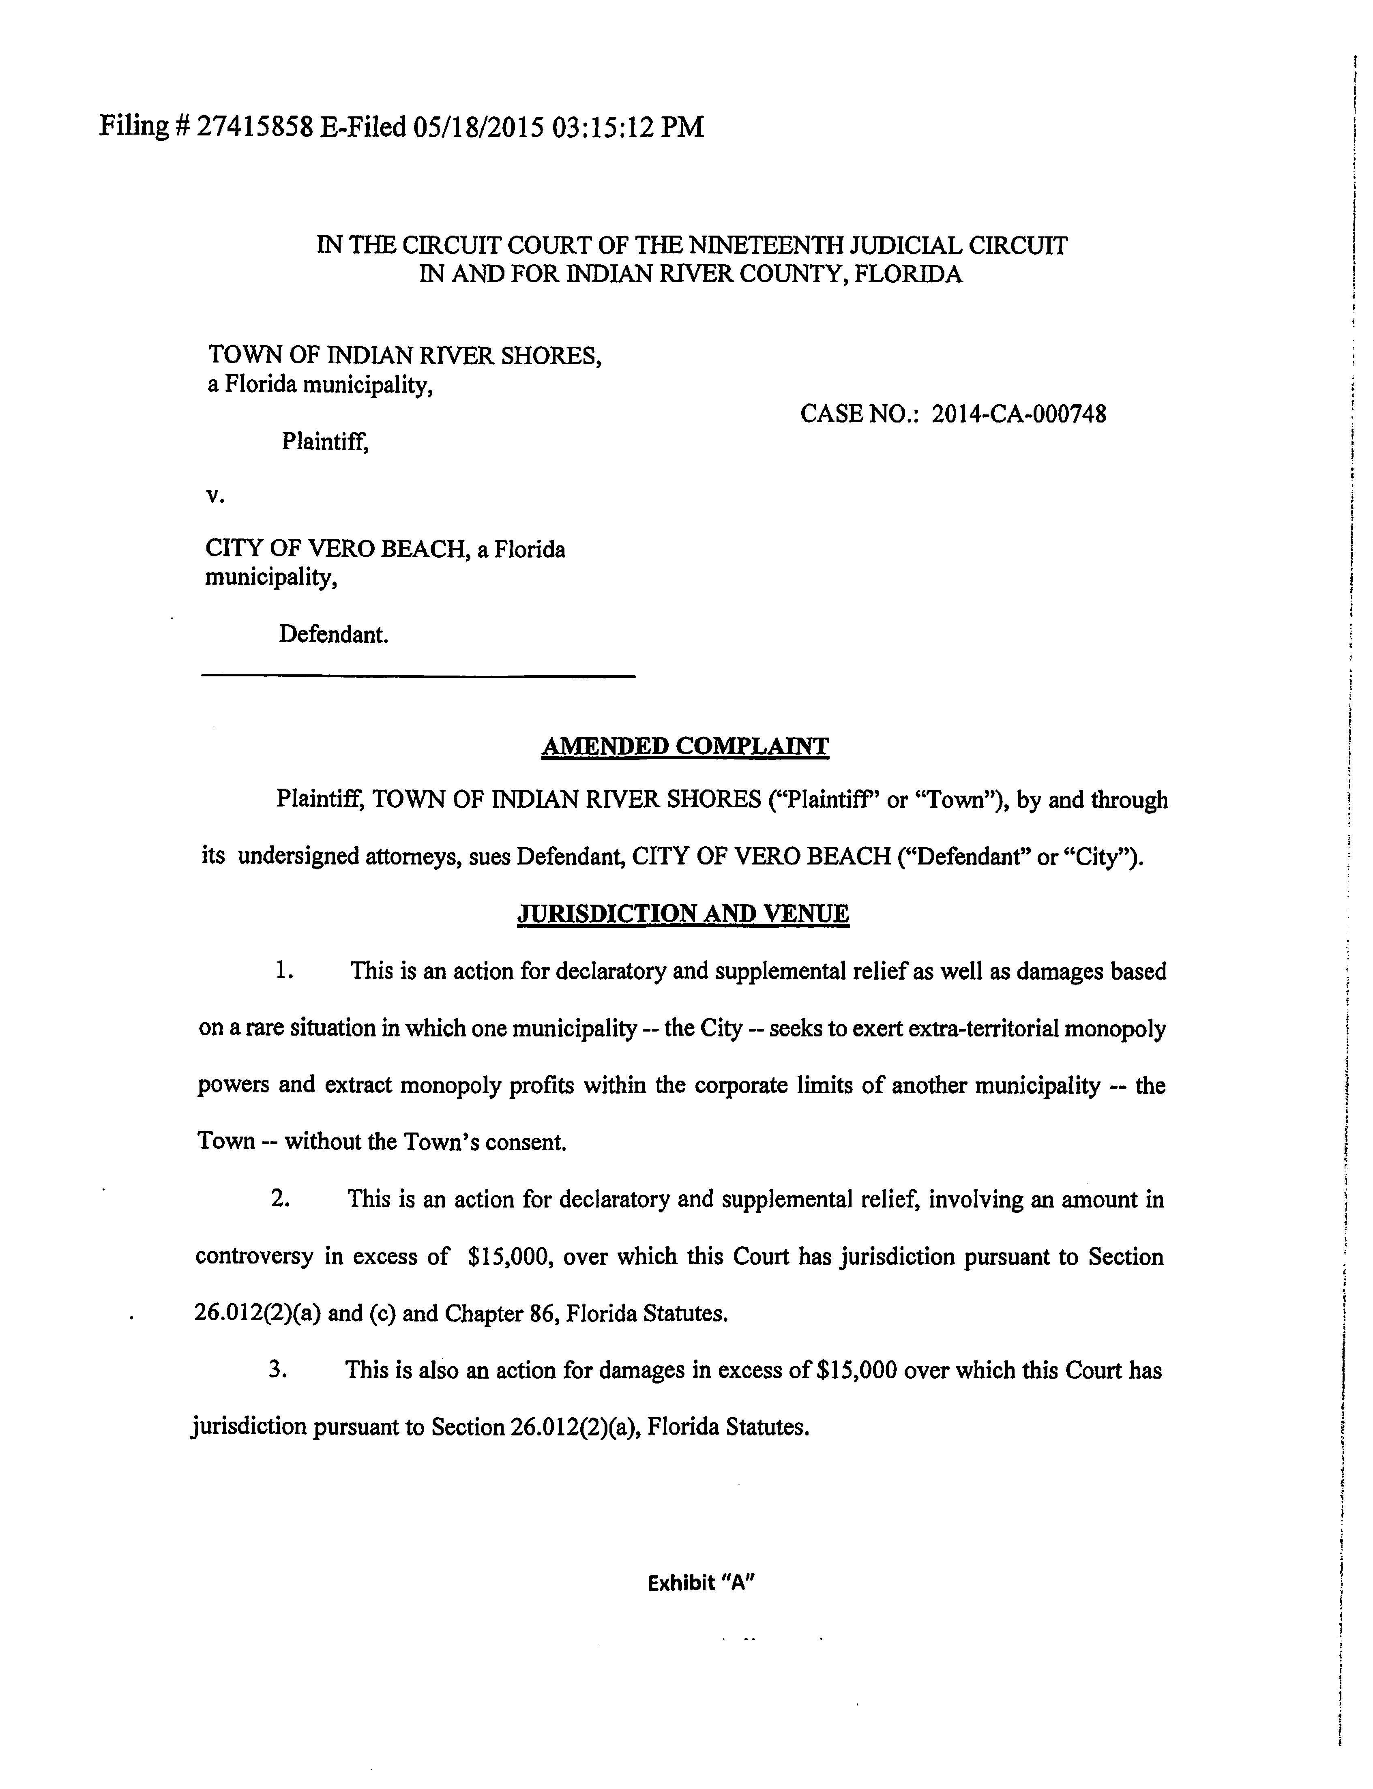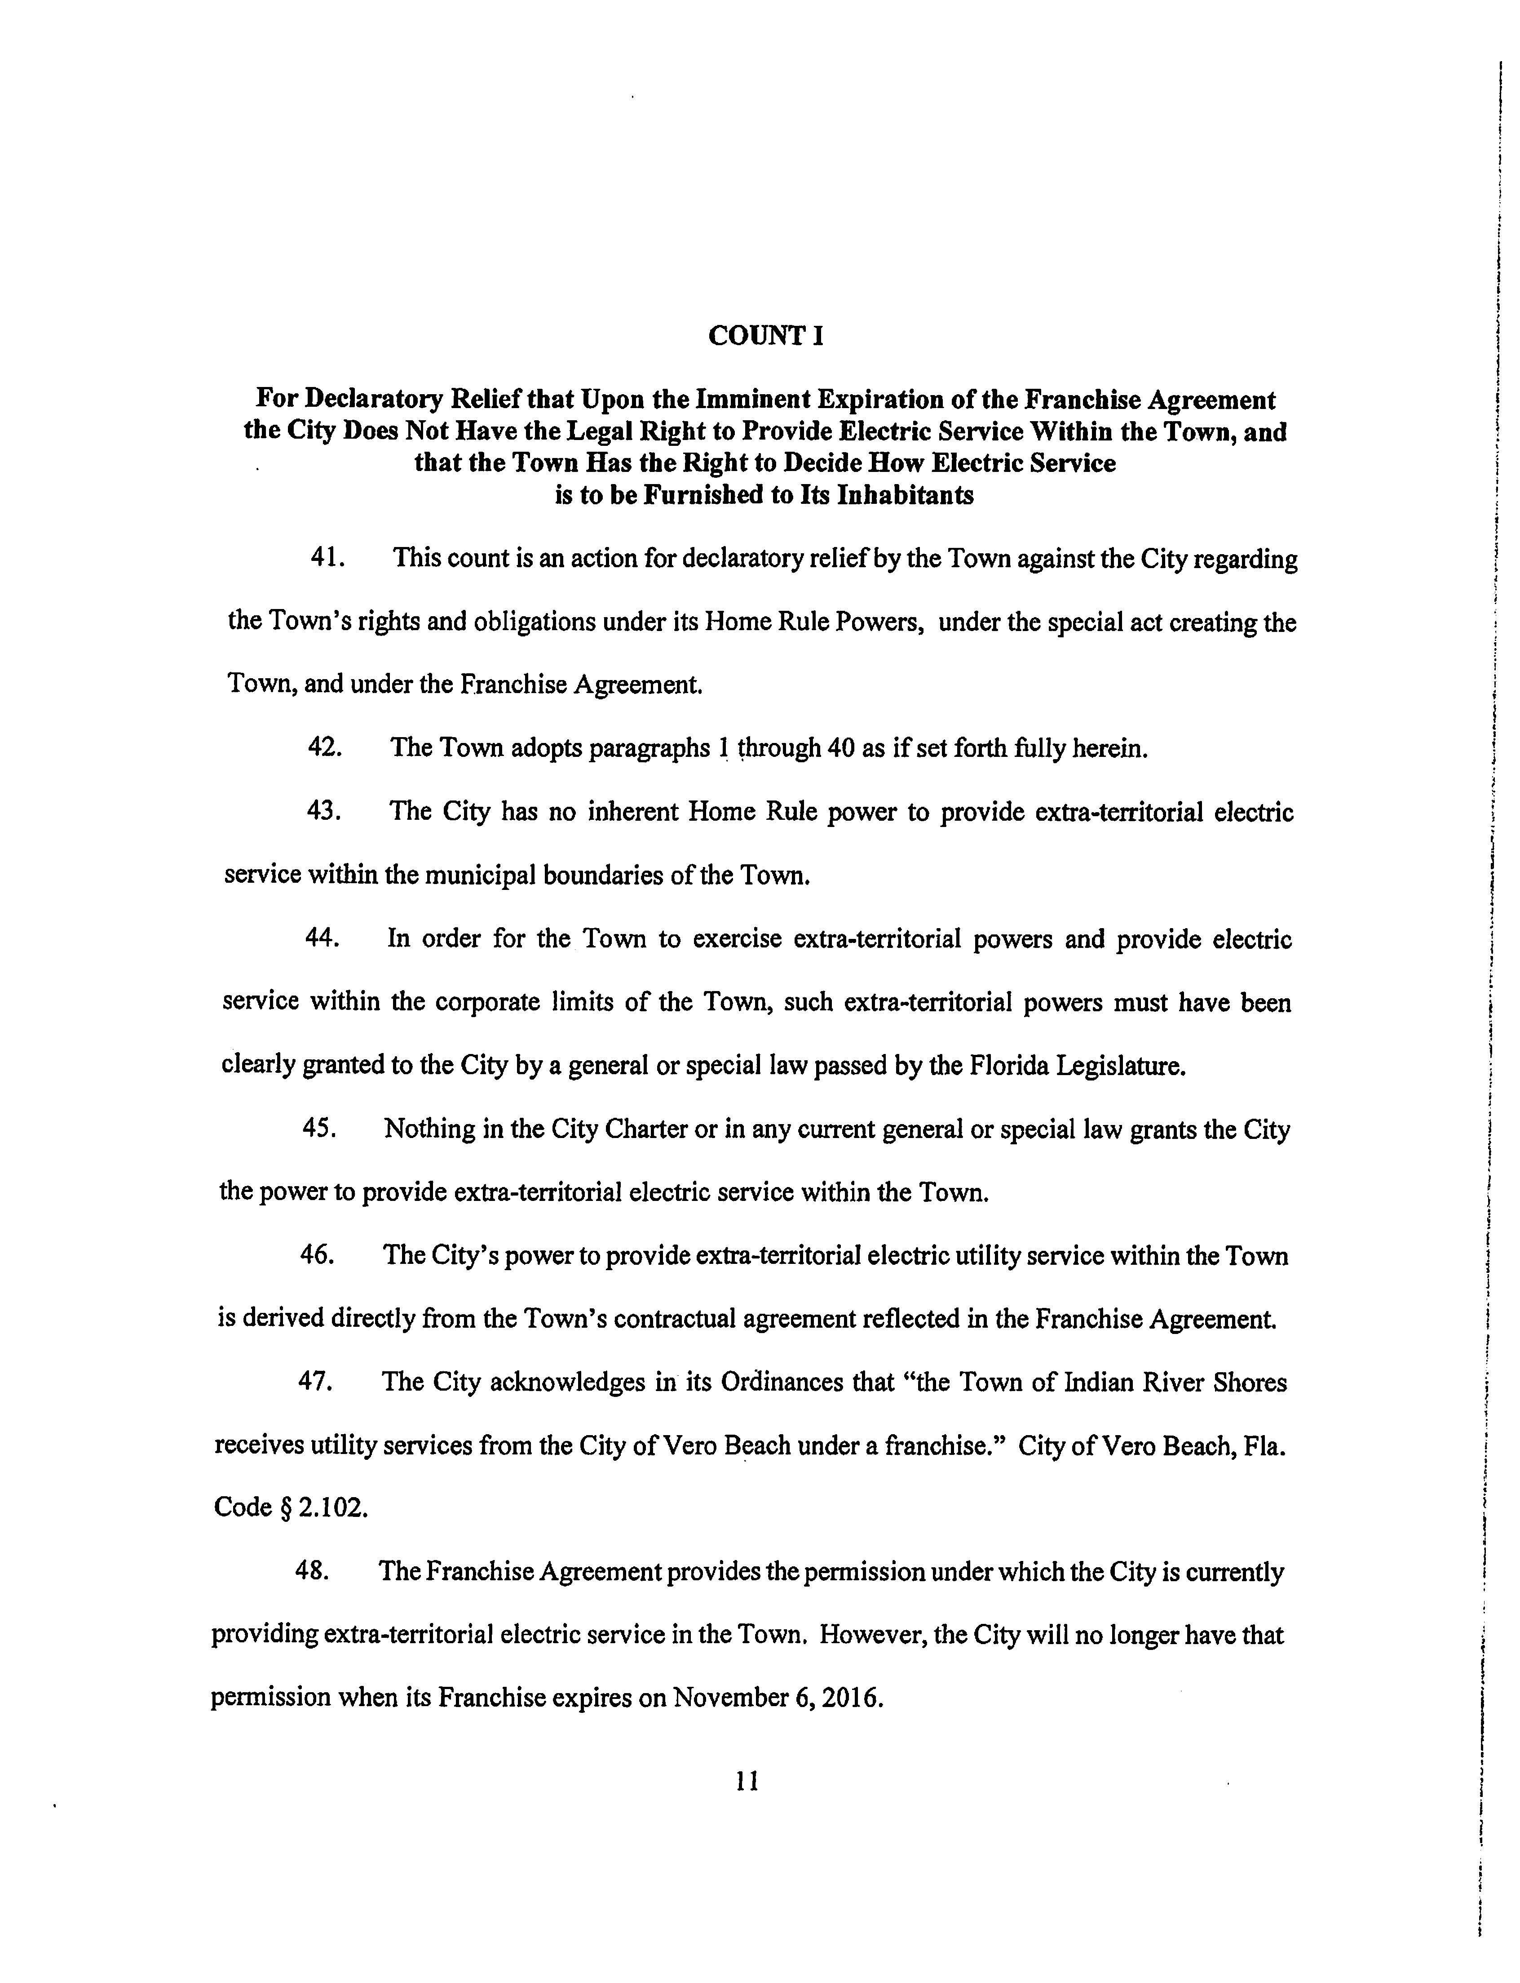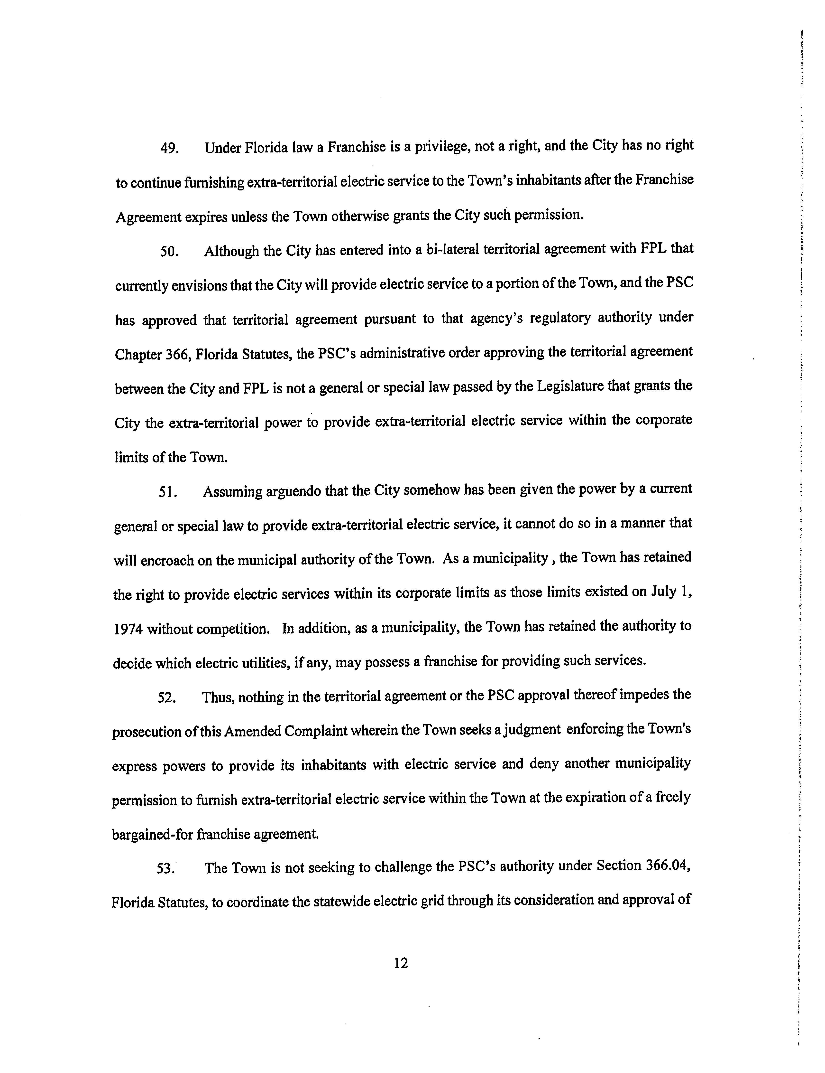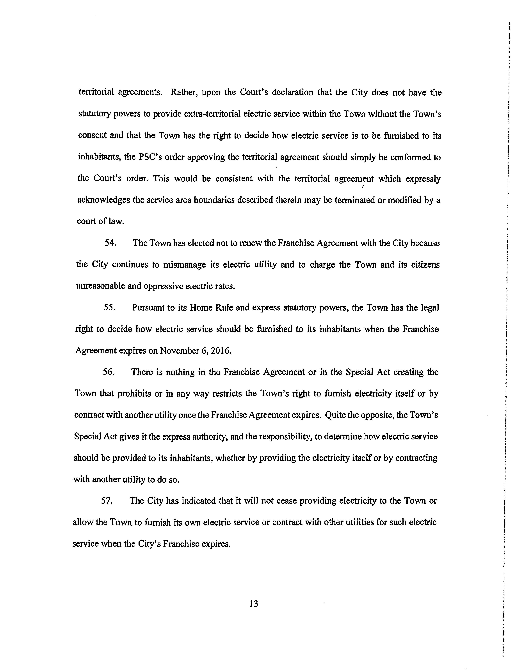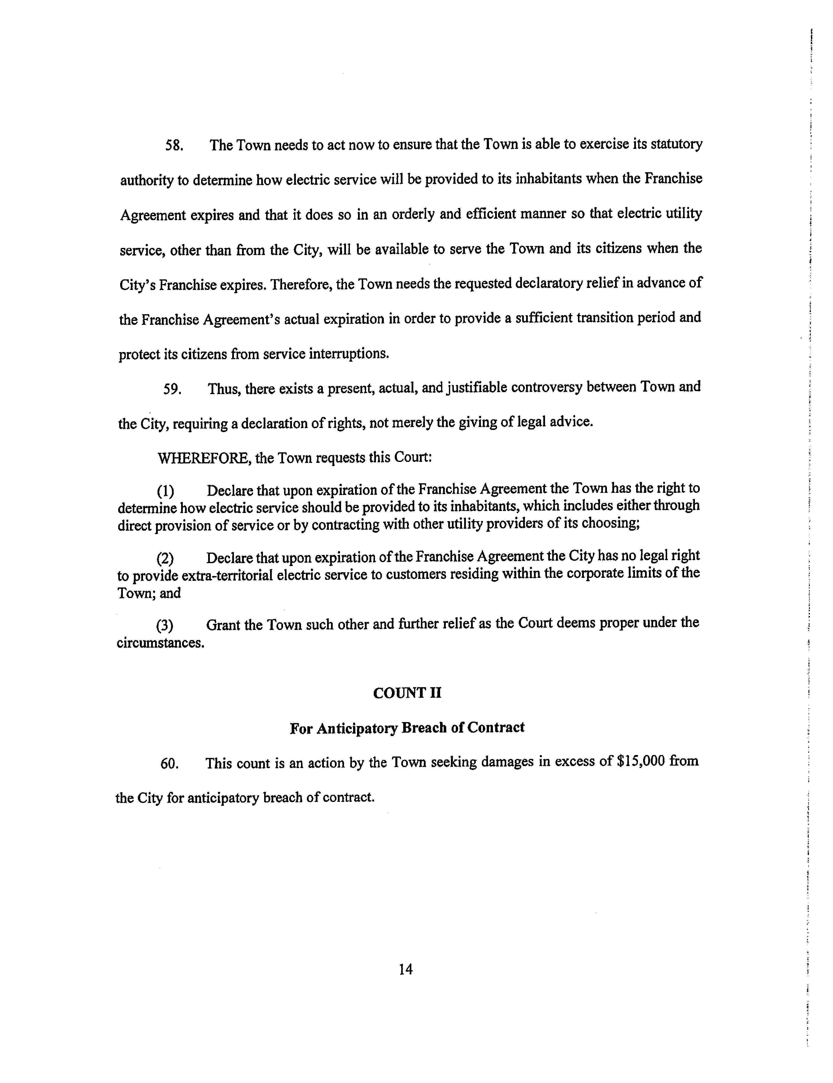
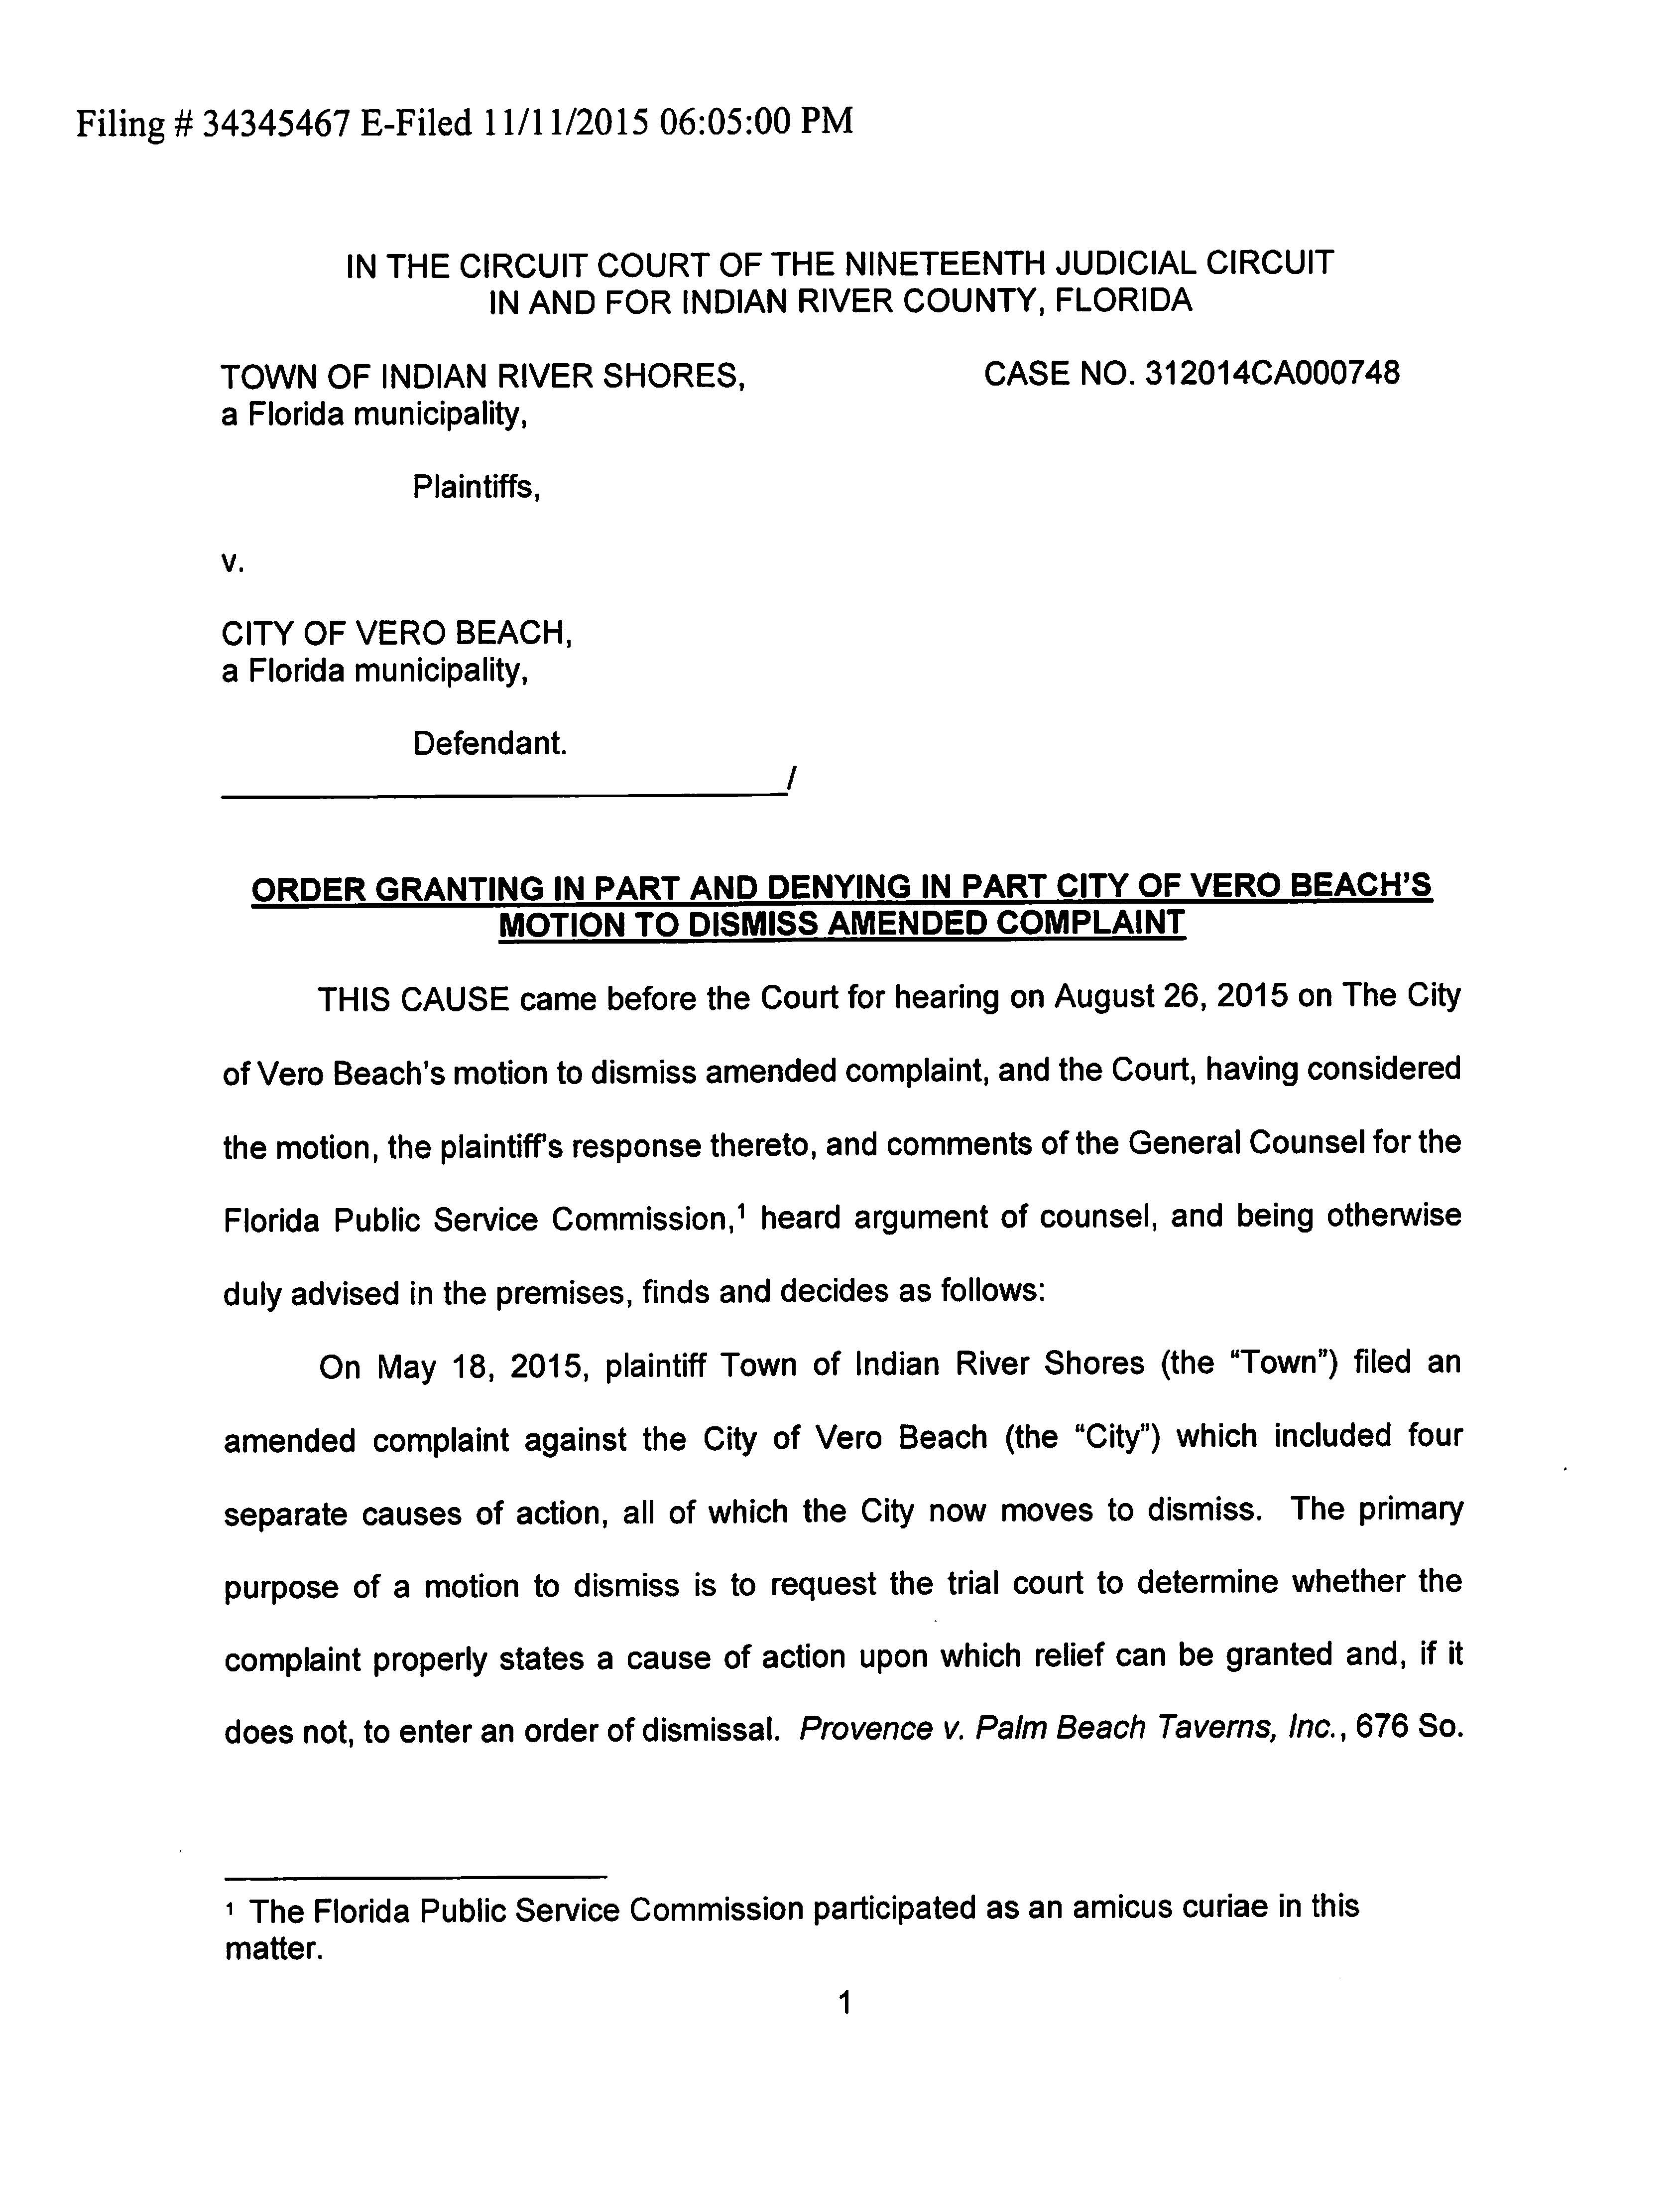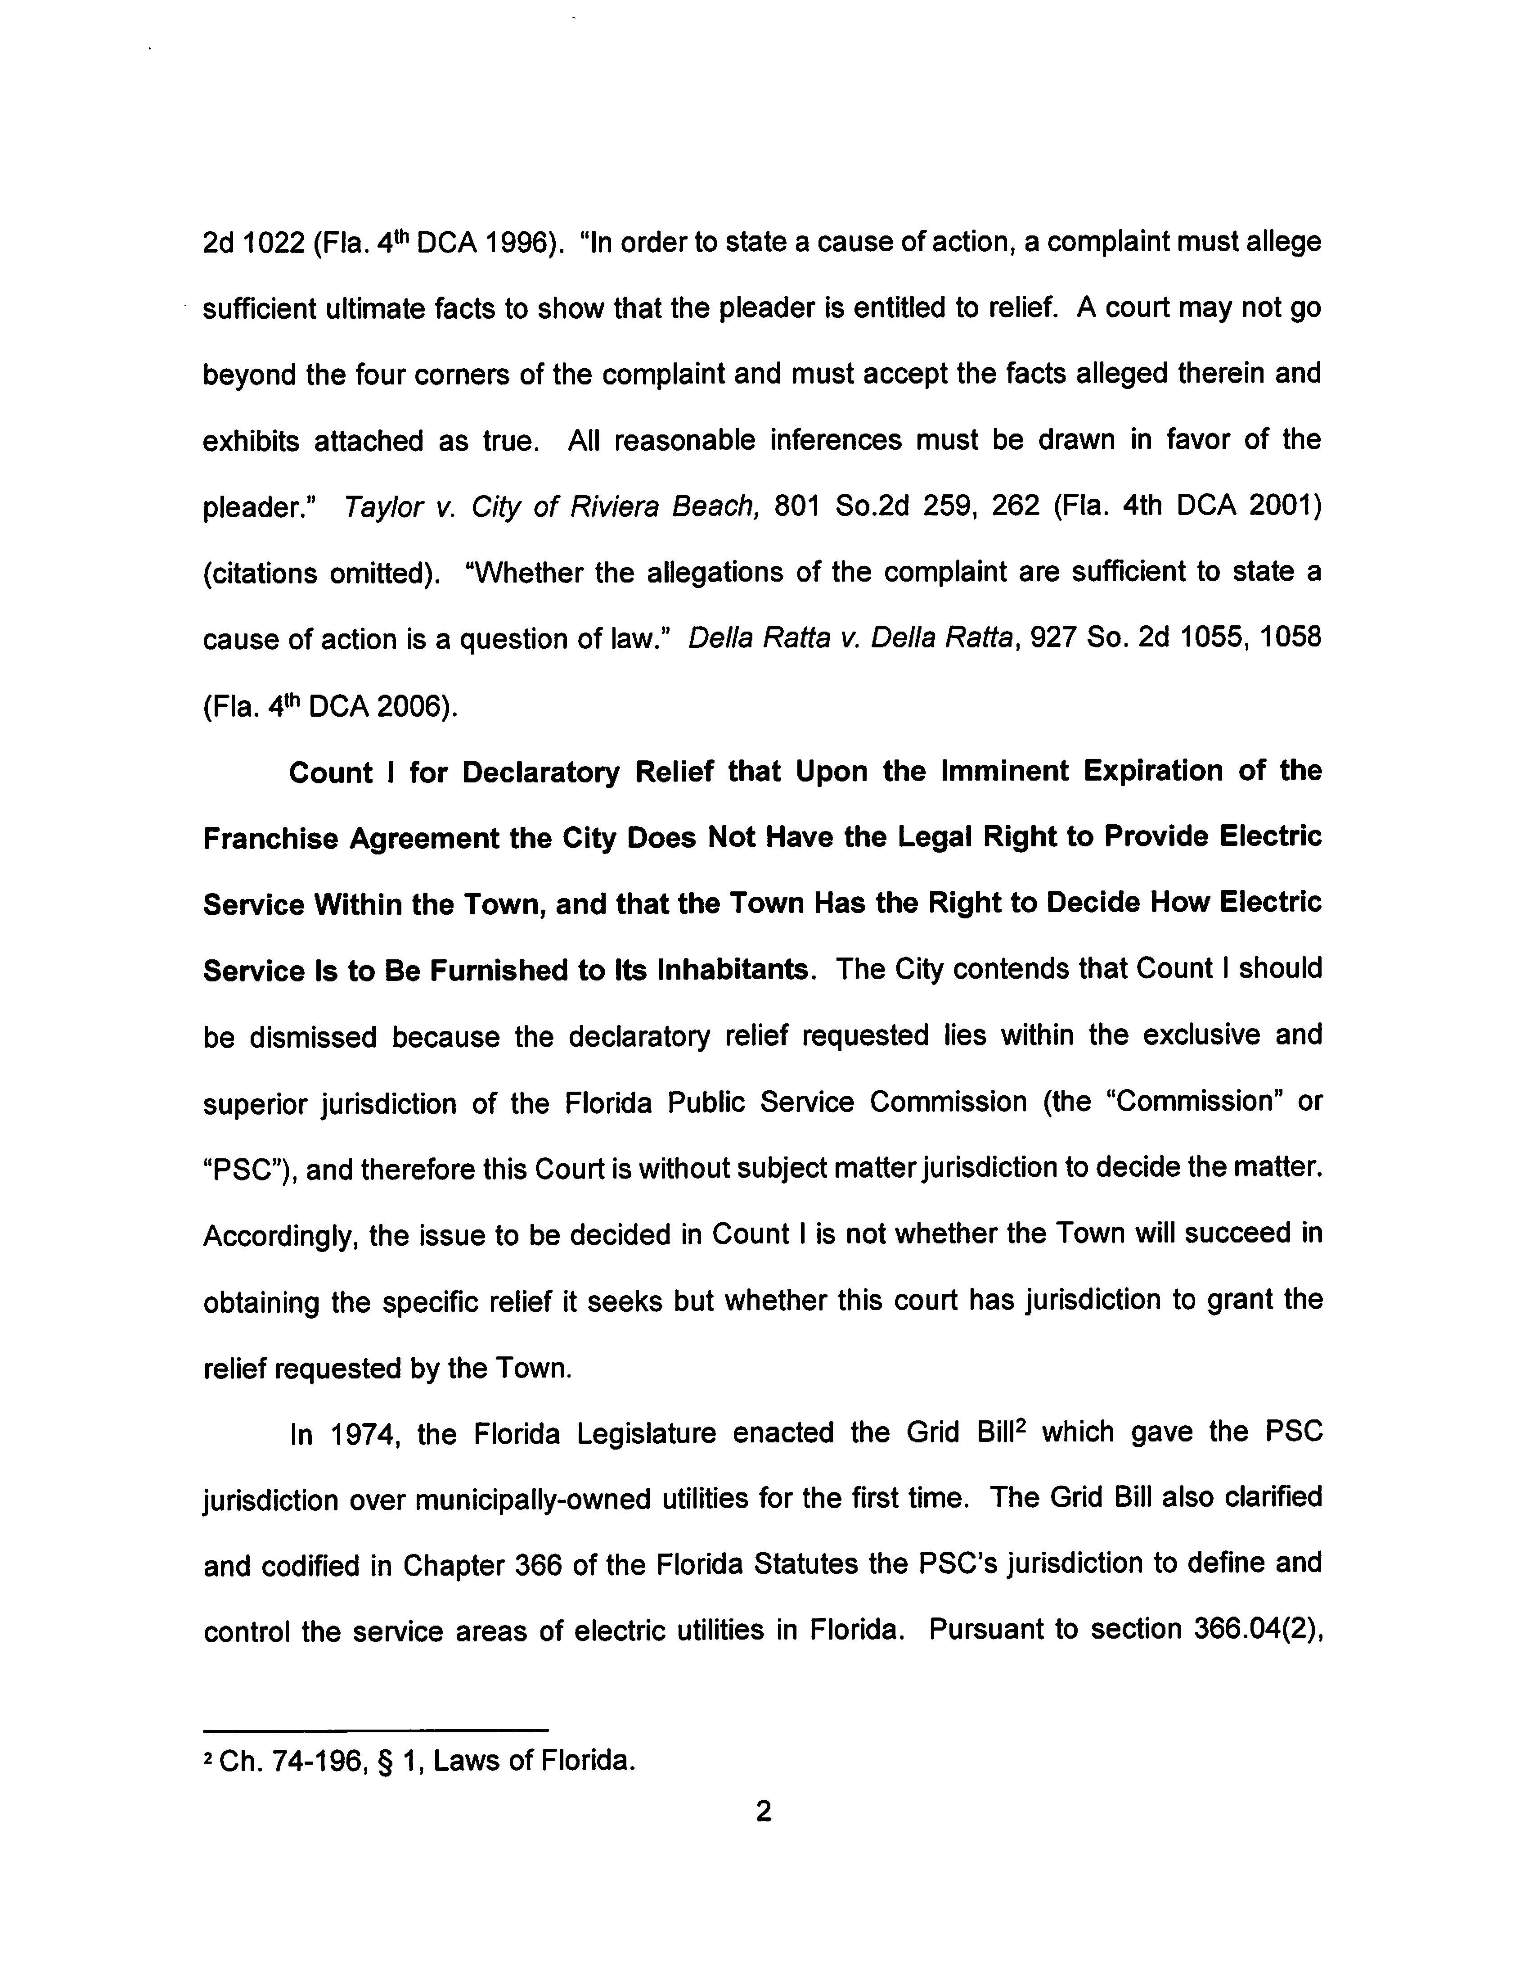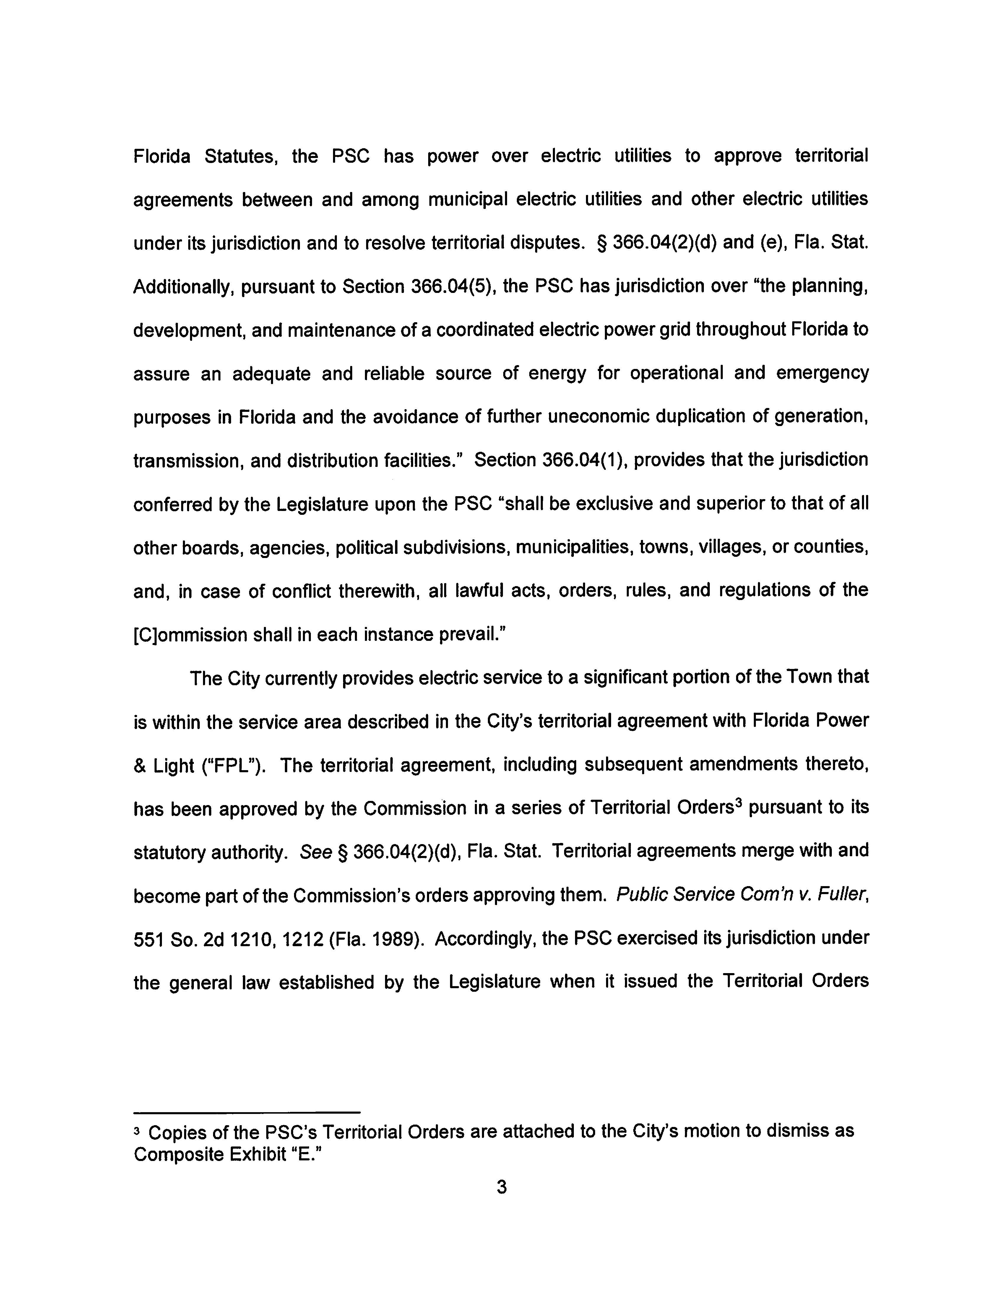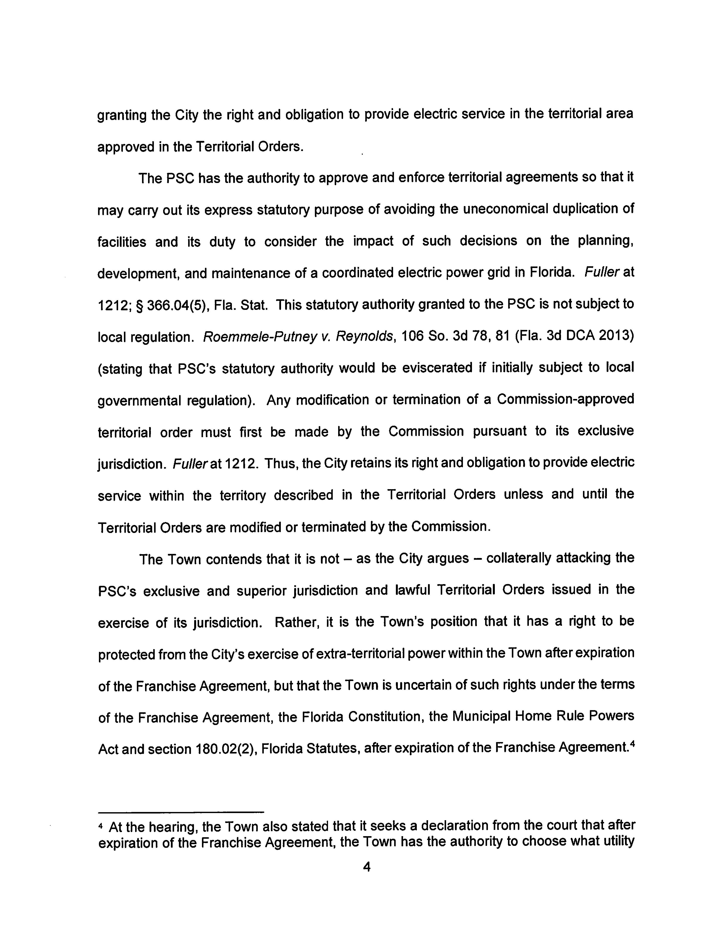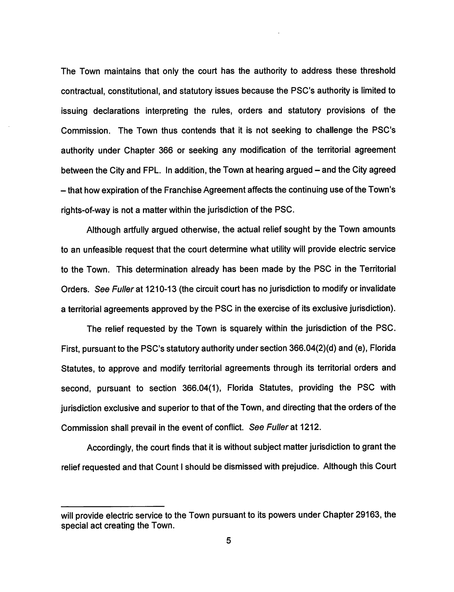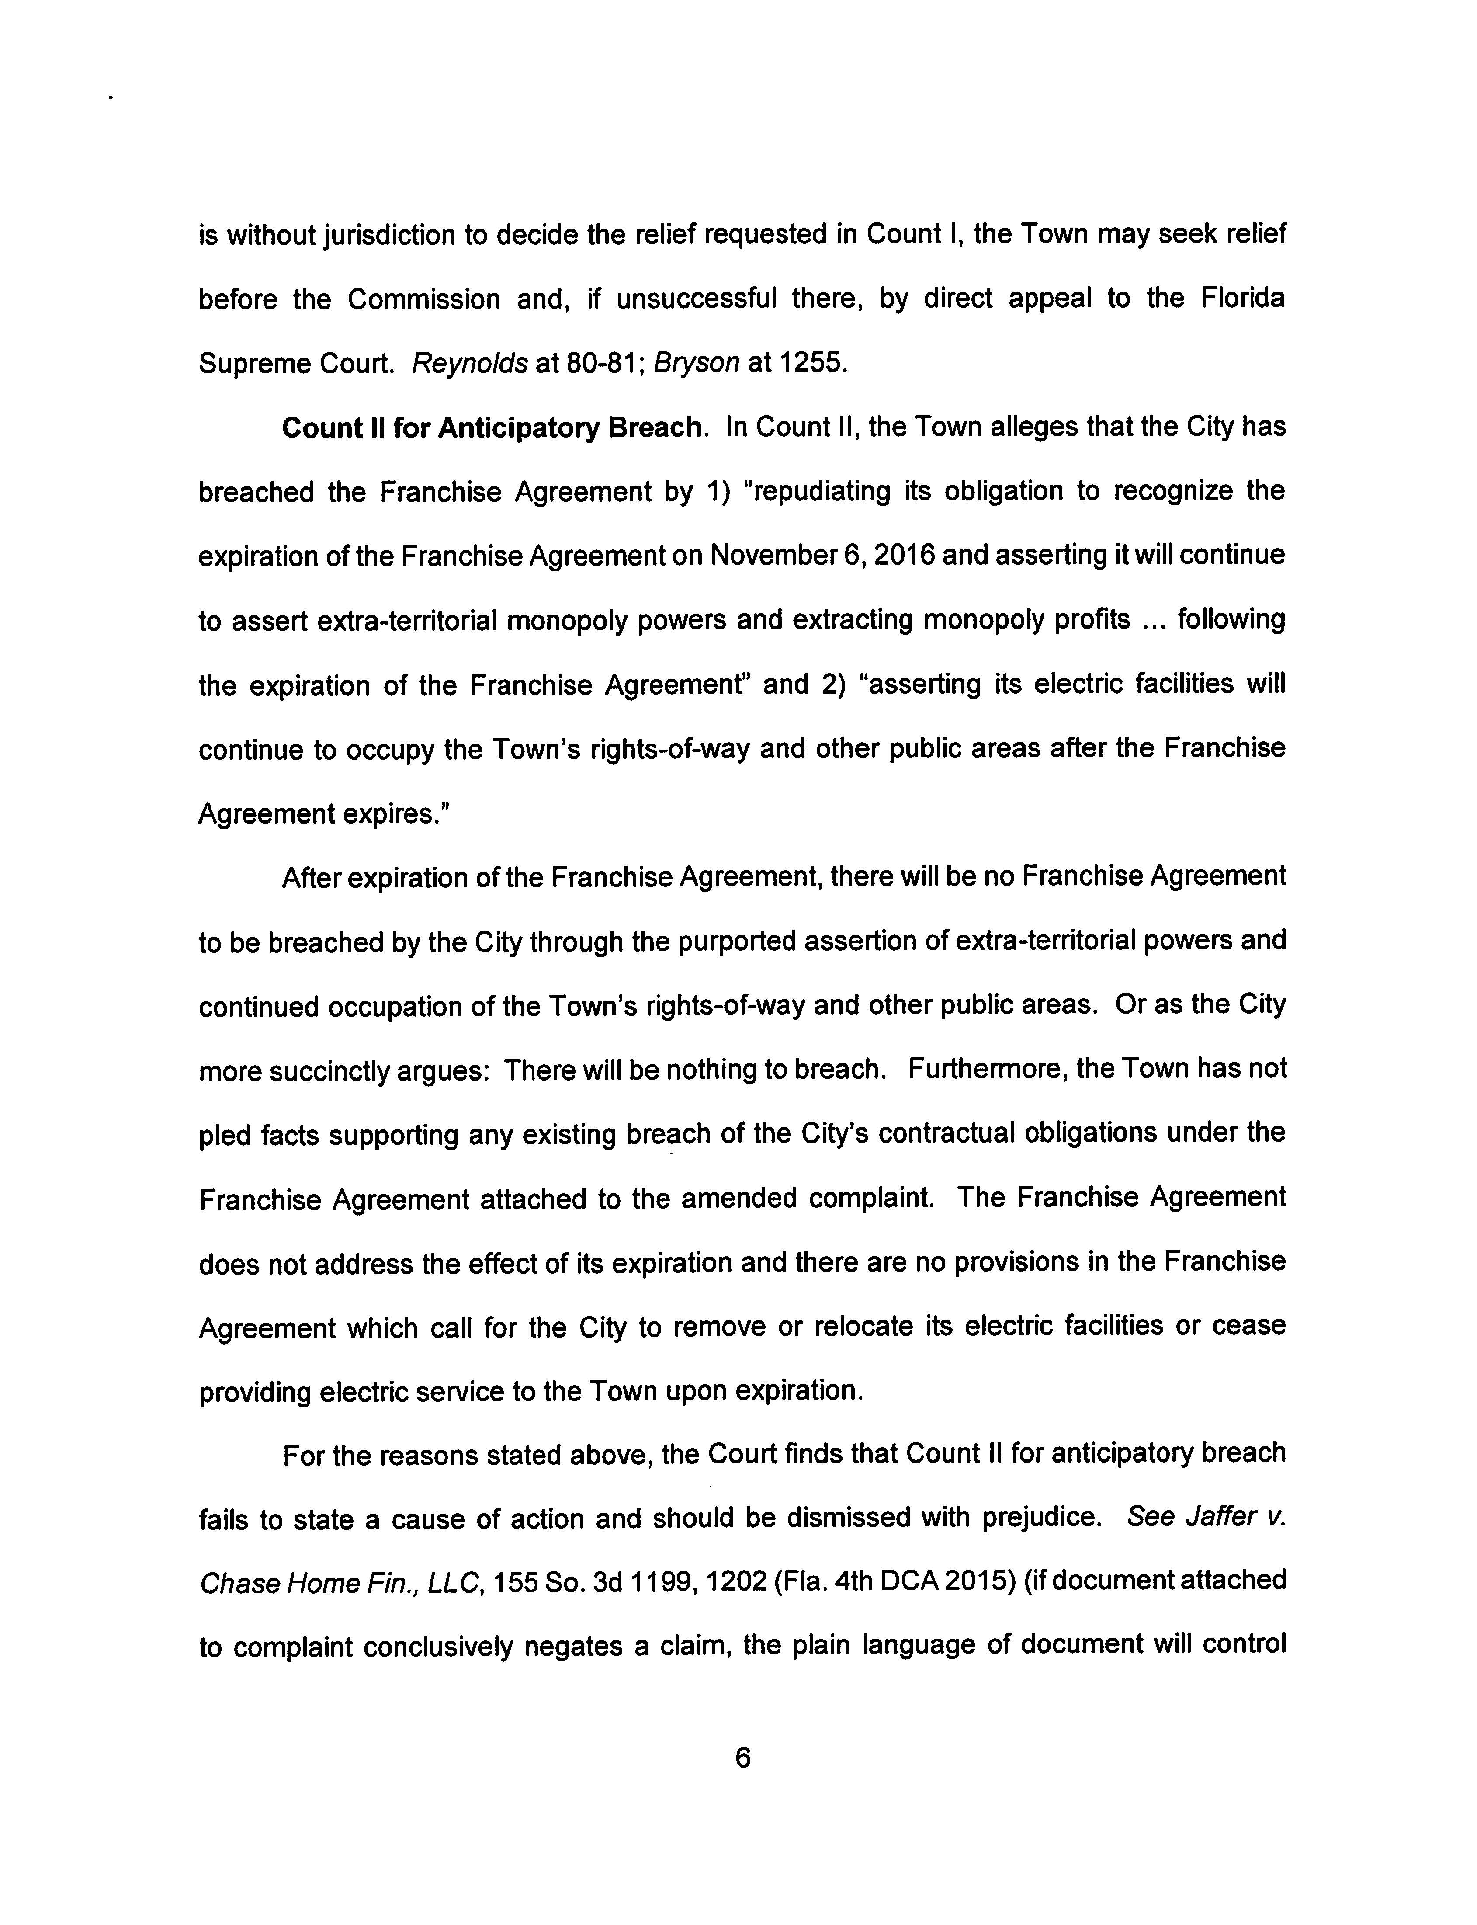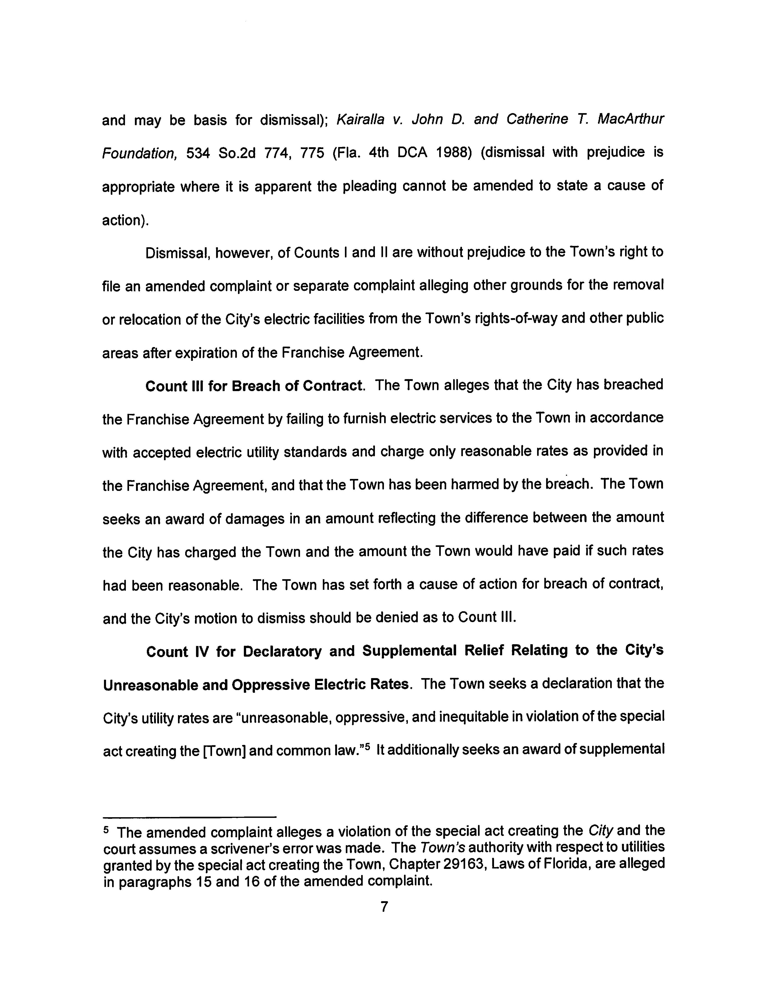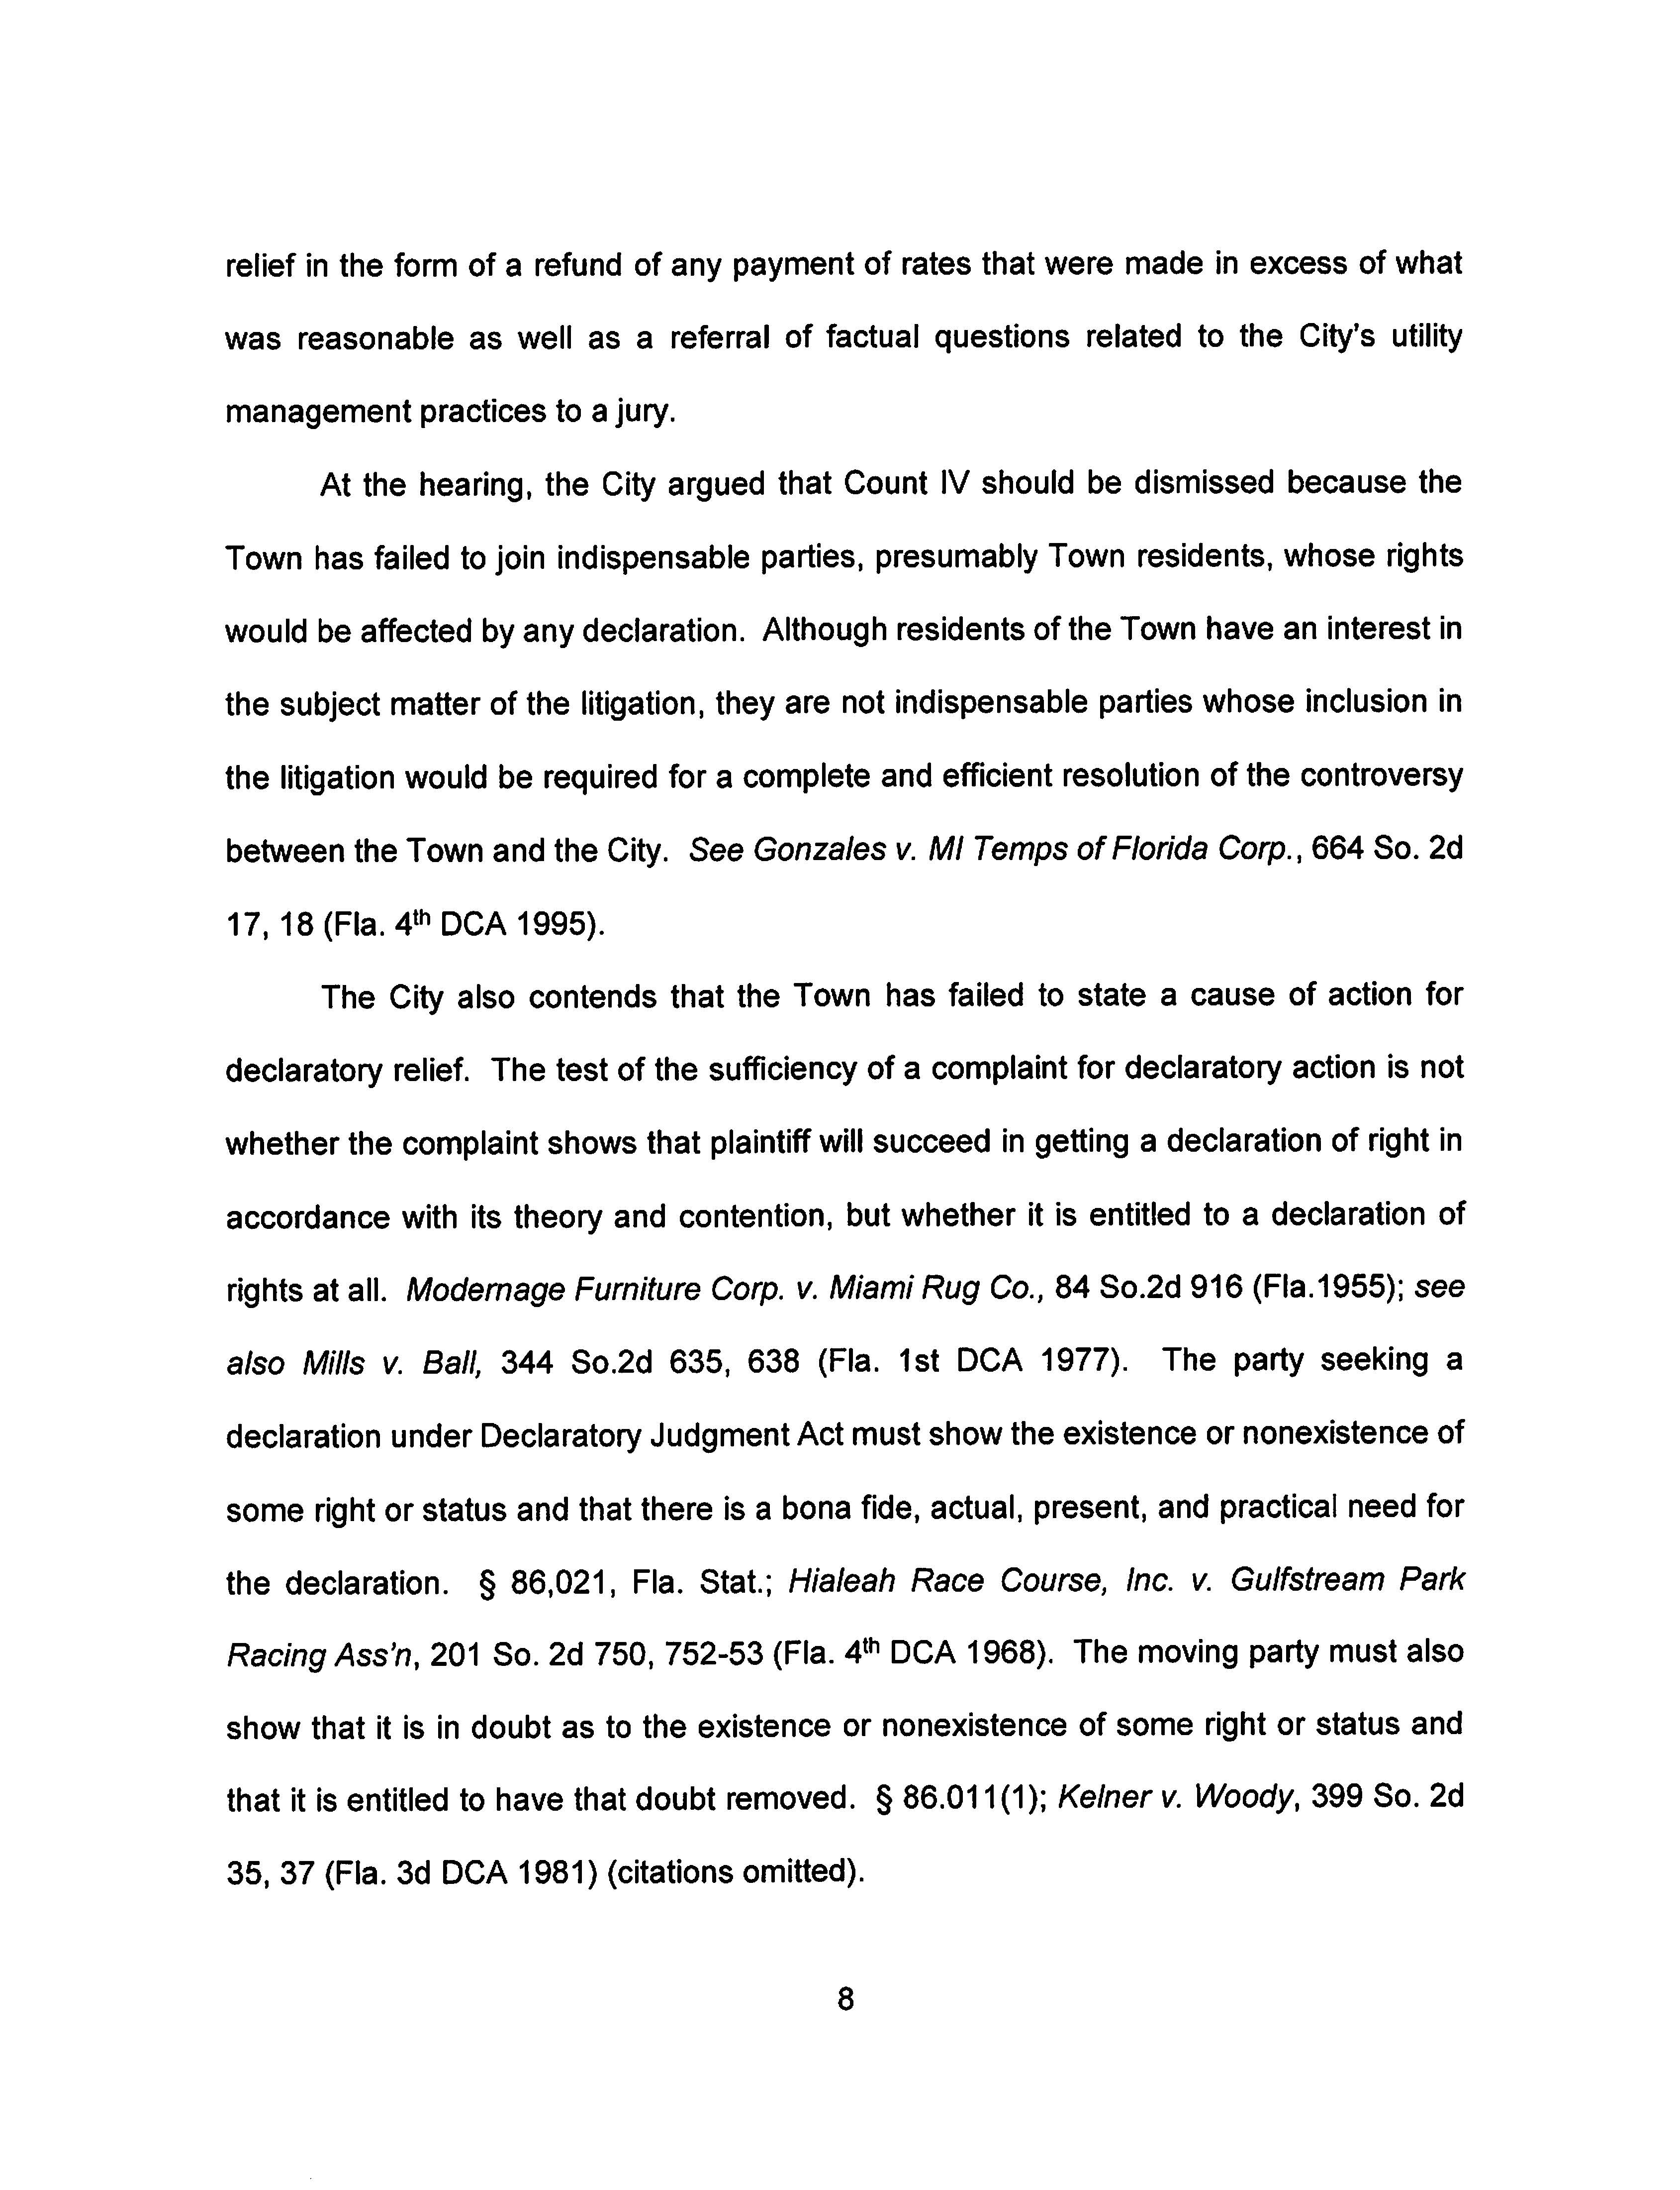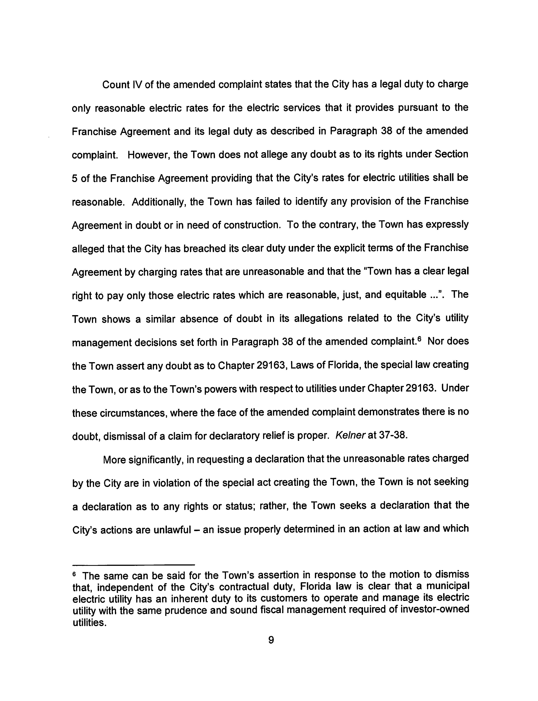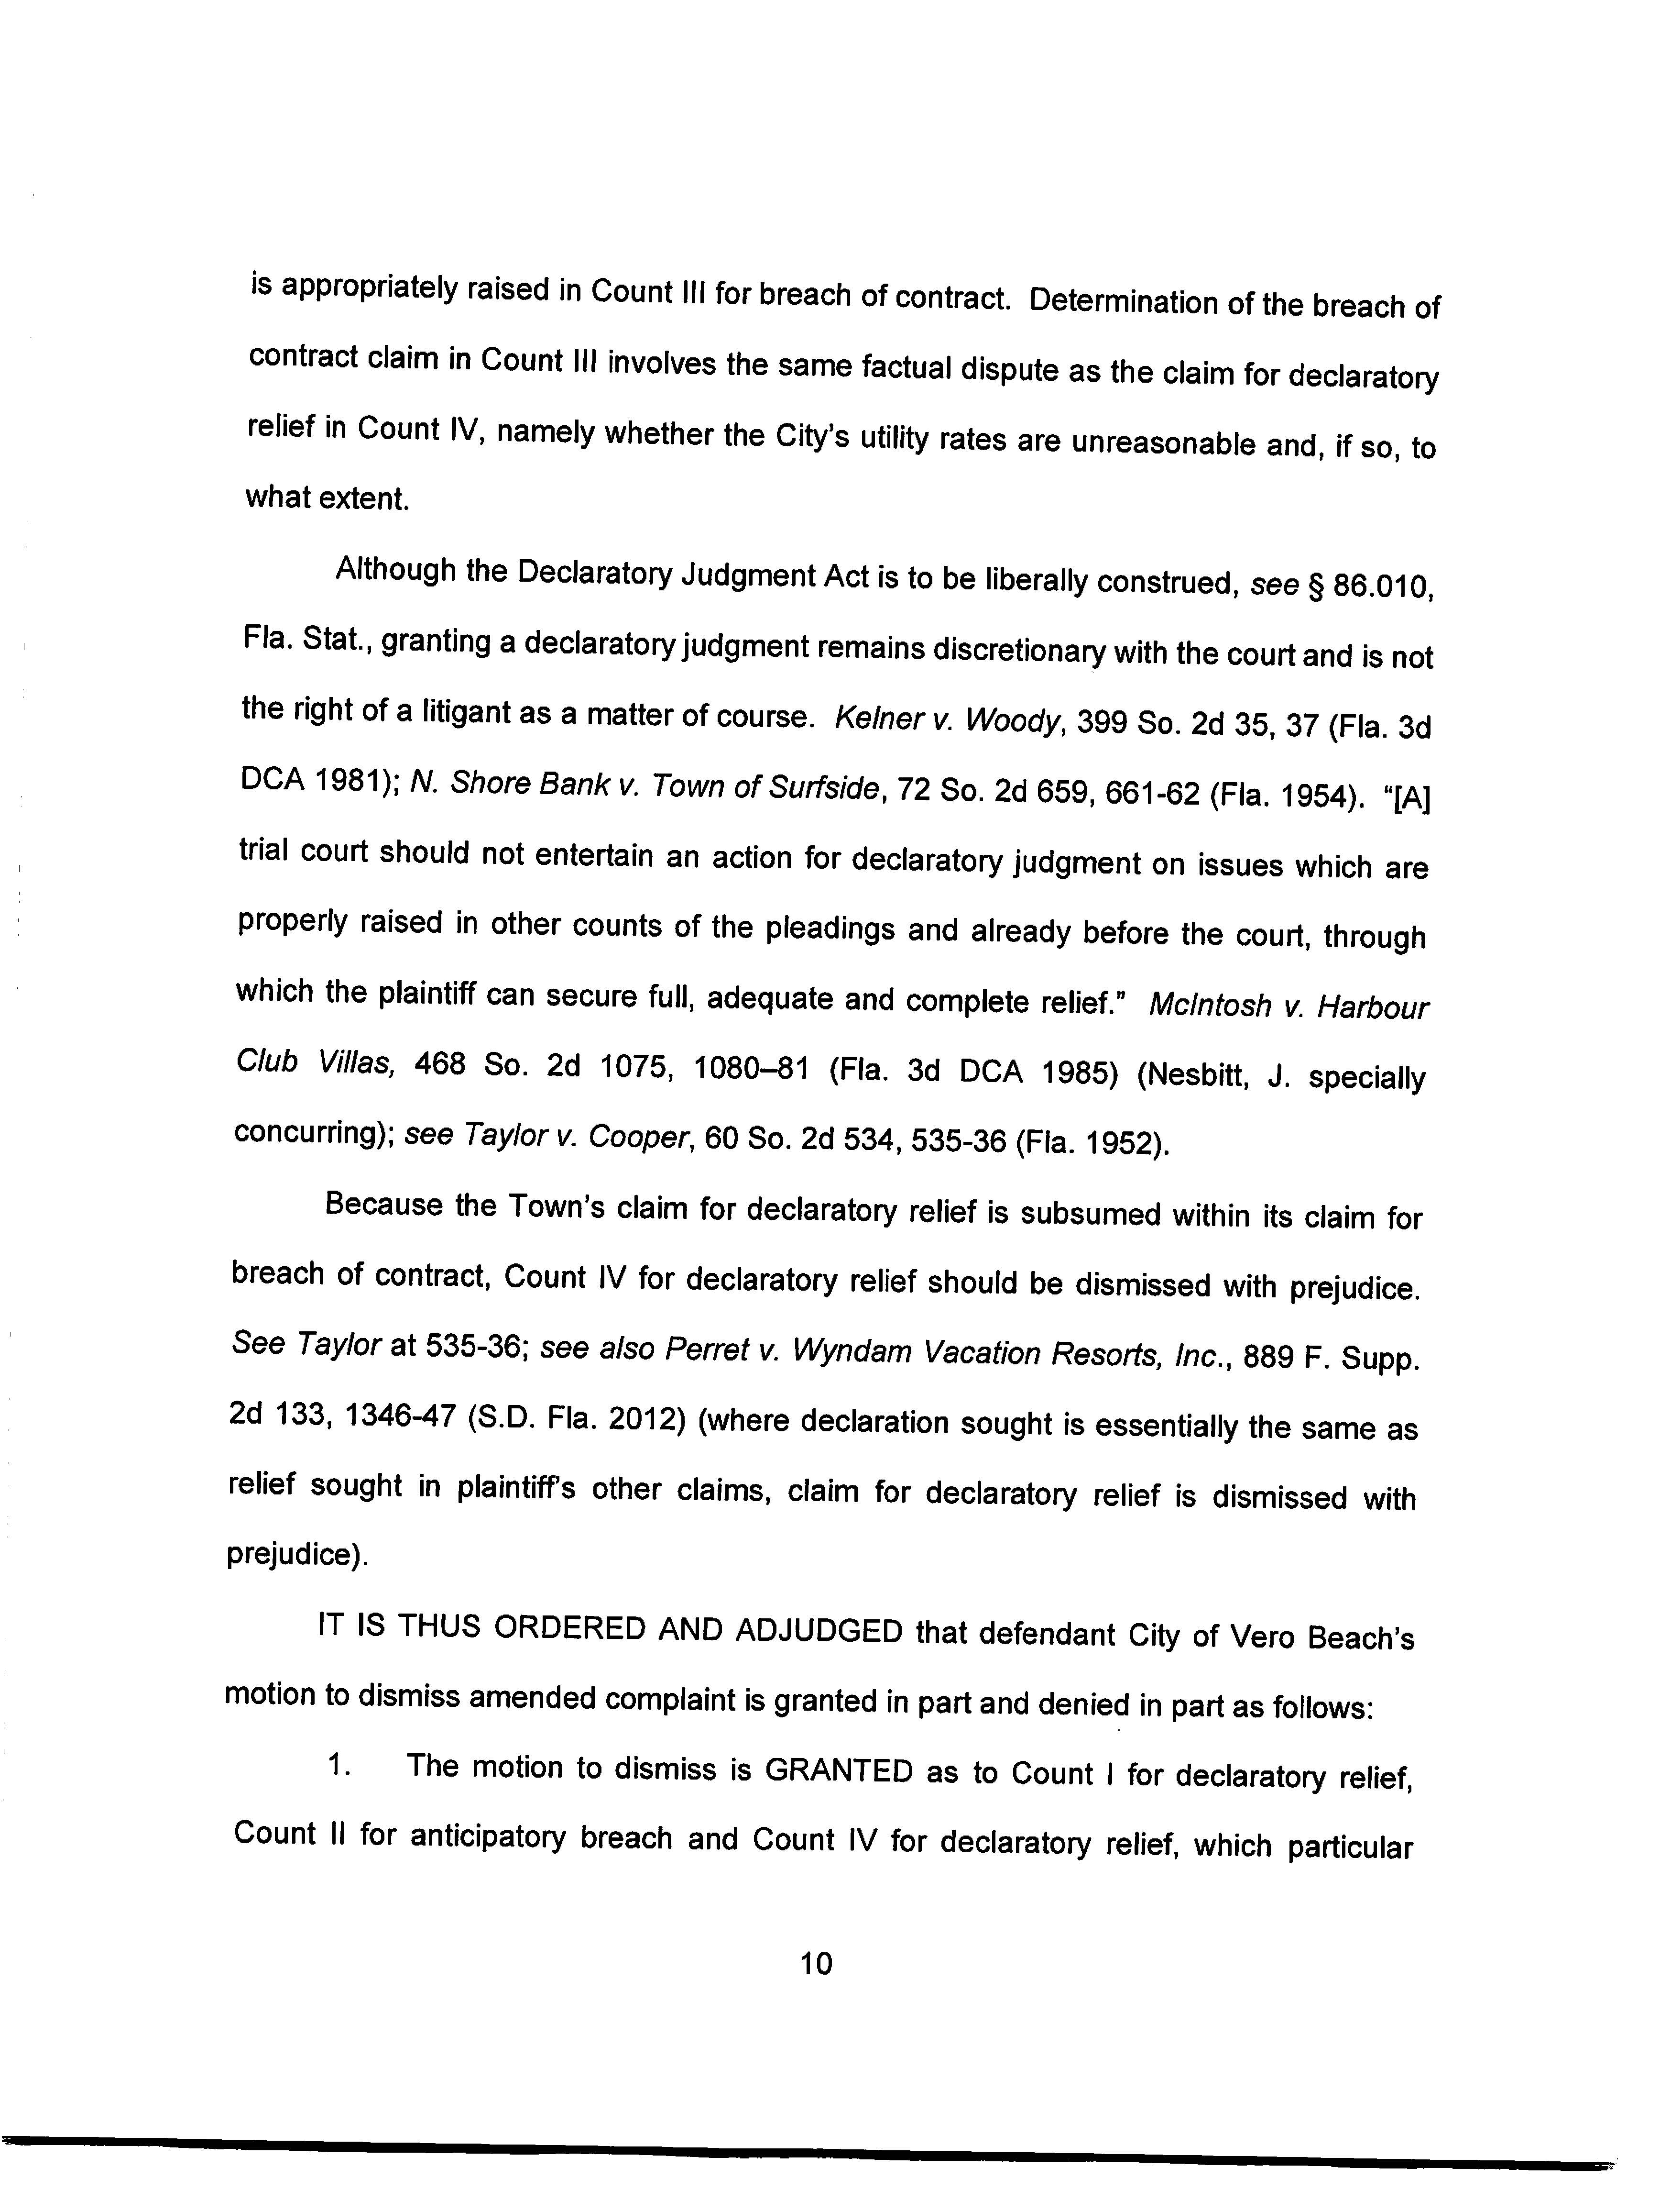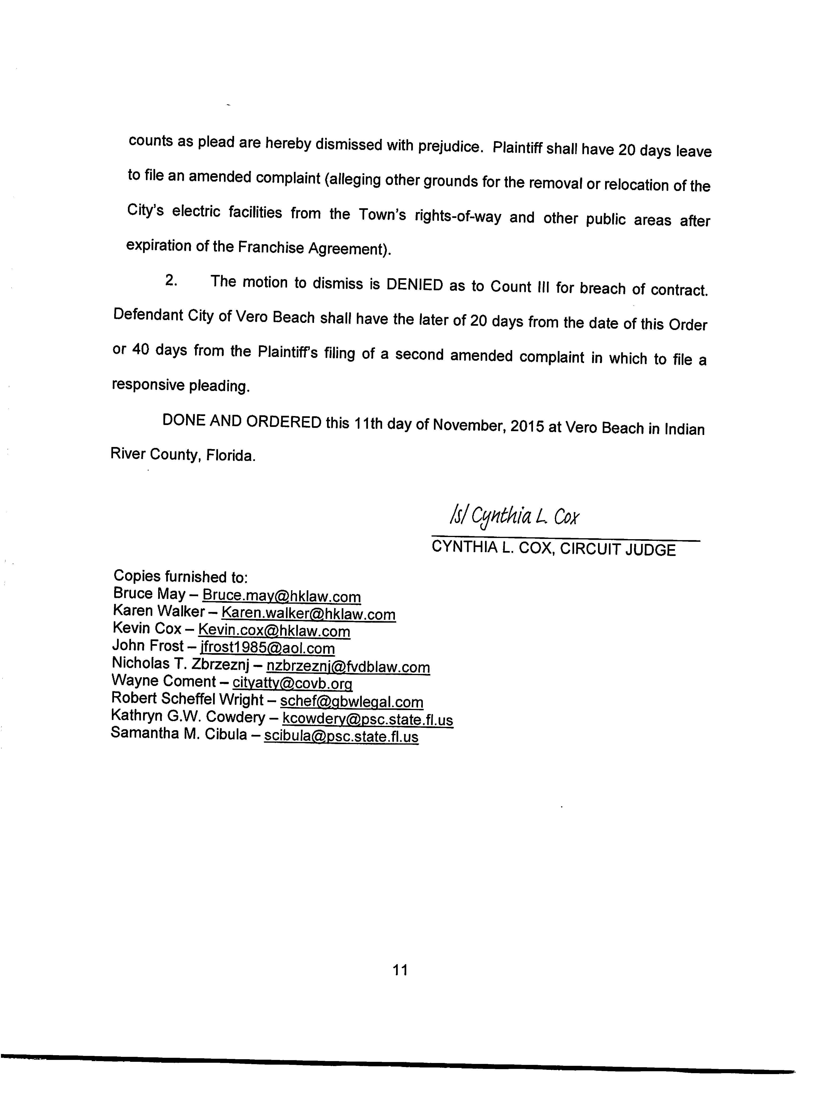

Order No. 5520, issued August 29, 1972, in Docket No. 72045-EU, In re: Application of Florida Power and Light Company for approval of a territorial agreement with the City of Vero Beach (approving the original territorial agreement between Vero Beach and FPL); Order No. 6010, issued January 18, 1974, in Docket No. 73605-EU, In re: Application of Florida Power & Light Company for approval of a modification of territorial agreement and contract for interchange service with the City of Vero Beach, Florida (approving a slight modification of the territorial agreement with no facilities or customers being affected); Order No. 10382, issued November 3, 1981 and Order No. 11580, issued February 2, 1983, in Docket No. 800596-EU, In re: Application of FPL and the City of Vero Beach for approval of an agreement relative to service areas (proposed agency action order and consummating order approving as in the public interest a territorial agreement where each utility transferred a number of electric service accounts to the other); and Order No. 18834, issued February 9, 1988, in Docket No. 871090-EU, In re: Petition of Florida Power & Light Company and the City of Vero Beach for Approval of Amendment of a Territorial Agreement (approving amendment to the territorial agreement by establishing a new territorial dividing line).

