BEFORE THE FLORIDA PUBLIC SERVICE COMMISSION

In re: Joint petition for approval of amendment to territorial agreement in Orange County, by Orlando Utilities Commission and Duke Energy Florida, LLC. | DOCKET NO. 160025-EU  ORDER NO. PSC-16-0116-PAA-EU  ISSUED: March 21, 2016

The following Commissioners participated in the disposition of this matter:

JULIE I. BROWN, Chairman
LISA POLAK EDGAR
ART GRAHAM
RONALD A. BRISÉ
JIMMY PATRONIS

NOTICE OF PROPOSED AGENCY ACTION
ORDER APPROVING AMENDMENT TO TERRITORIAL AGREEMENT
BY ORLANDO UTILITIES COMMISSION AND DUKE ENERGY FLORIDA, LLC.

BY THE COMMISSION:

NOTICE is hereby given by the Florida Public Service Commission that the action discussed herein is preliminary in nature and will become final unless a person whose interests are substantially affected files a petition for a formal proceeding, pursuant to Rule 25-22.029, Florida Administrative Code (F.A.C.).

Background

On January 22, 2016, the Orlando Utilities Commission (OUC) and Duke Energy Florida, LLC (Duke) filed a joint petition to extend the term of their current territorial agreement (current agreement) until August 1, 2017. In 2007, we approved the current agreement for a nine year term expiring February 1, 2016. The joint petitioners stated that they need additional time to negotiate a new territorial agreement. The proposed amendment to extend the term is shown in Attachment A. We have jurisdiction over this matter pursuant to Section 366.04, Florida Statutes (F.S.).

Decision

The proposed amendment to the territorial agreement, as shown in Attachment A, extends the term of the current agreement until August 1, 2017, to allow the joint petitioners additional time to negotiate a new territorial agreement. All other provisions of the current agreement remain in effect.
In approving the current agreement, we found that the agreement is “…in the public interest…eliminates existing or potential uneconomic duplication of facilities, and it does not cause a decrease in the reliability of electric service to existing or future ratepayers.” We find that the requested extension of time is reasonable and does not appear to be detrimental to the parties or the public interest. Any subsequent modification to the territorial agreement will be brought before us for consideration pursuant to Section 366.04, F.S. We hereby approve the proposed amendment to the territorial agreement to provide OUC and Duke with additional time to negotiate a new territorial agreement.
Based on the foregoing, it is

ORDERED by the Florida Public Service Commission that the Joint Petition for approval of amendment to territorial agreement in Orange County, by Orlando Utilities Commission and Duke Energy Florida, LLC is approved. It is further

ORDERED that the provisions of this Order, issued as proposed agency action, shall become final and effective upon the issuance of a Consummating Order unless an appropriate petition, in the form provided by Rule 28-106.201, Florida Administrative Code, is received by the Commission Clerk, 2540 Shumard Oak Boulevard, Tallahassee, Florida 32399-0850, by the close of business on the date set forth in the “Notice of Further Proceedings” attached hereto. It is further

ORDERED that in the event this Order becomes final, this docket shall be closed.

By ORDER of the Florida Public Service Commission this 21st day of March, 2016.

/s/ Carlotta S. Stauffer
CARLOTTA S. STAUFFER
Commission Clerk
Florida Public Service Commission
2540 Shumard Oak Boulevard
Tallahassee, Florida 32399
(850) 413-6770
www.floridapsc.com

Copies furnished: A copy of this document is provided to the parties of record at the time of issuance and, if applicable, interested persons.

DJ

NOTICE OF FURTHER PROCEEDINGS OR JUDICIAL REVIEW

The Florida Public Service Commission is required by Section 120.569(1), Florida Statutes, to notify parties of any administrative hearing that is available under Section 120.57, Florida Statutes, as well as the procedures and time limits that apply. This notice should not be construed to mean all requests for an administrative hearing will be granted or result in the relief sought.

Mediation may be available on a case-by-case basis. If mediation is conducted, it does not affect a substantially interested person's right to a hearing.

The action proposed herein is preliminary in nature. Any person whose substantial interests are affected by the action proposed by this order may file a petition for a formal proceeding, in the form provided by Rule 28-106.201, Florida Administrative Code. This petition must be received by the Office of Commission Clerk, 2540 Shumard Oak Boulevard, Tallahassee, Florida 32399-0850, by the close of business on April 11, 2016.

In the absence of such a petition, this order shall become final and effective upon the issuance of a Consummating Order.

Any objection or protest filed in this/these docket(s) before the issuance date of this order is considered abandoned unless it satisfies the foregoing conditions and is renewed within the specified protest period.

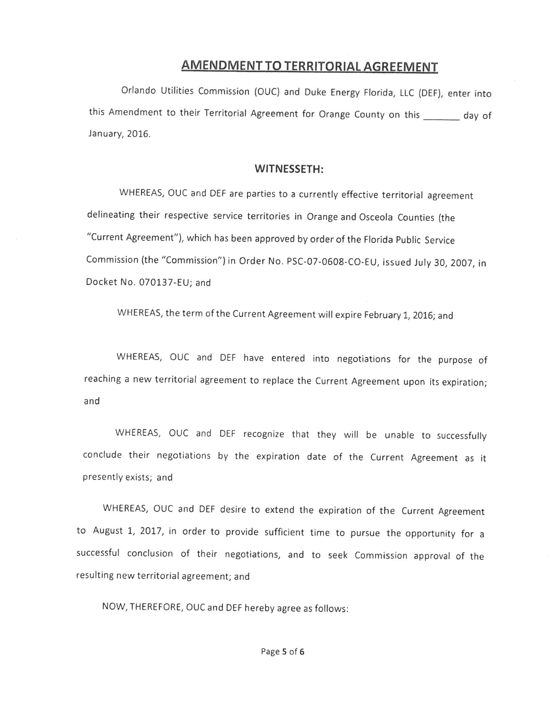

Order No. PSC-07-0562-PAA-EU, issued July 5, 2007, in Docket No. 070137-EU, In re: Joint petition for approval of territorial agreement in Orange County by Orlando Utilities Commission and Progress Energy Florida, Inc.
In response to a Commission staff inquiry, the joint petitioners clarified that references to Osceola County in the joint petition and the proposed amendment to the territorial agreement were scrivener’s errors.
Order No. PSC-07-0562-PAA-EU, issued July 5, 2007, in Docket No. 070137-EU, In re: Joint petition for approval of territorial agreement in Orange County by Orlando Utilities Commission and Progress Energy Florida, Inc., page 3.

