BEFORE THE FLORIDA PUBLIC SERVICE COMMISSION

In re: Petition for approval of Amendment No. 1 to transportation service agreement with the City of Lake Worth, by Florida Public Utilities Company. | DOCKET NO. 160028-GU  ORDER NO. PSC-16-0156-PAA-GU  ISSUED: April 19, 2016

The following Commissioners participated in the disposition of this matter:

JULIE I. BROWN, Chairman
LISA POLAK EDGAR
ART GRAHAM
RONALD A. BRISÉ
JIMMY PATRONIS

NOTICE OF PROPOSED AGENCY ACTION
ORDER APPROVING AMENDMENT TO TRANSPORTATION SERVICE AGREEMENT

BY THE COMMISSION:

NOTICE is hereby given by the Florida Public Service Commission that the action discussed herein is preliminary in nature and will become final unless a person whose interests are substantially affected files a petition for a formal proceeding, pursuant to Rule 25-22.029, Florida Administrative Code (F.A.C.).

Background

On February 2, 2016, Florida Public Utilities Company (FPUC) filed a petition to amend its gas transportation service agreement (agreement) with the City of Lake Worth (City). FPUC is a gas utility subject to the regulatory jurisdiction of the Commission pursuant to Section 366.06, Florida Statutes (F.S.). The City is a Florida municipality that is developing a compressed natural gas (CNG) station.
We approved the agreement between FPUC and the City in 2003 for a 30-year term. The proposed amendment to the agreement is limited in nature and consists solely of a modification to Section 4.8 of the agreement to allow the City to resell natural gas provided by FPUC to the City’s CNG station for compression and resale as CNG fuel. The proposed amendment is shown in Attachment A.
During its evaluation of the petition, Commission staff issued a data request to FPUC for which a response was received on February 18, 2016. The Office of Public Counsel requested interested party status in the docket on February 9, 2016 and submitted oral comments at the April 5, 2016, Agenda Conference which did not dispute staff’s recommendation. We have jurisdiction over this matter pursuant to Section 366.06, F.S.
Decision

The agreement currently provides that FPUC is obligated to transport gas through its pipeline and appurtenant facilities (Lake Worth Lateral or LW Lateral) from the gate station interconnected with Florida Gas Transmission’s facilities to the City’s generation and water utility complex (project site). The proposed amendment reflects a modification to a limitation in the agreement. As currently written, Section 4.8 of the agreement prohibits the resale of gas transported through the LW Lateral:
4.8 Resale Prohibited. Natural gas transported through the LW Lateral shall be used solely at the Project Site by CITY or the other Project Parties, and shall not be offered for resale to any third party.
However, the City is developing a CNG station at the project site and will require deliveries of natural gas to that station for compression and subsequent resale to the public. FPUC and the City have reached agreement to eliminate the resale prohibition as applicable to natural gas supplied by FPUC for delivery to the City’s CNG station. The revised Section 4.8 as shown in Attachment A would allow resale by the City only to customers of the CNG station.
Cost of Service Considerations
The proposed amendment would not alter either the term or the pricing under the agreement. In the joint petition filed in 2003 by FPUC and the City, the parties provided a cost of service study as Exhibit A to the joint petition. The transportation charge derived from the cost of service study is paid monthly by the City to FPUC and was designed to enable FPUC to recover its investment in the LW Lateral, provide a rate of return on that investment, and recover the costs of operating and maintaining the facilities. In addition, the City pays FPUC the actual delivered cost plus 25 percent for the cost of odorant for the LW Lateral. Based on analysis of the cost of service study and a requirement that the City provide a letter of credit under specified contingent circumstances, we approved the agreement between FPUC and the City.
In the instant petition, FPUC states that it will continue to recover its cost to serve under the amended agreement. We reviewed FPUC’s response to staff inquiries and we find, pursuant to FPUC’s response, that our approval of the proposed amendment would have a de minimis impact on the cost of service. Section 3.2 of the agreement allows the City to transport up to 4,070 thousand cubic feet (MCF) per hour through the LW Lateral. At present, the City is transporting approximately 75 MCF per hour. In response to a staff inquiry, FPUC estimated that it would be necessary to transport an additional 80 MCF per hour to meet the needs of the CNG station at the project site. Therefore, based on the information provided, we note that through the transportation charge paid by the City each month to FPUC, the City has been paying, and will continue to pay, for a significant amount of unused capacity.
The cost of service study provided as Exhibit A to the 2003 joint petition indicated a 2003 net plant value of $4,195,556 for FPUC’s LW Lateral facilities. This amount was one of the factors used to develop the transportation charge payable by the City to FPUC. In response to a staff inquiry, FPUC estimated that the cost of adding additional facilities (tap, meter, and regulator) to serve the CNG station should not exceed $30,000. This amount is approximately one percent of the 2016 remaining net plant value of the LW Lateral facilities used in the development of the transportation charges payable to FPUC under the current agreement. As such, we find that the costs of adding the additional facilities to serve the CNG station would have a de minimis impact on FPUC’s cost of service under the agreement.
Based on the foregoing, we find that FPUC’s assertion that it will continue to recover its cost to serve under the proposed amended agreement is reasonable and that FPUC’s ratepayers will continue to benefit. Additionally, the City benefits from the proposed amendment by having additional quantities of gas available to compress and sell to customers at its CNG station.
Conclusion
We find that the agreement, as amended, is reasonable, to the benefit of both the City and FPUC, and in the public interest. The amendment to the agreement between FPUC and the City, attached in Exhibit A to this Order, shall be approved.
Based on the foregoing, it is

ORDERED by the Florida Public Service Commission that Florida Public Utilities Company’s petition to amend its gas transportation service agreement with the City of Lake Worth is granted and the amendment to the agreement is hereby approved. It is further
ORDERED that the provisions of this Order, issued as proposed agency action, shall become final and effective upon the issuance of a Consummating Order unless an appropriate petition, in the form provided by Rule 28-106.201, Florida Administrative Code, is received by the Commission Clerk, 2540 Shumard Oak Boulevard, Tallahassee, Florida 32399-0850, by the close of business on the date set forth in the “Notice of Further Proceedings” attached hereto. It is further

ORDERED that in the event this Order becomes final, this docket shall be closed.

By ORDER of the Florida Public Service Commission this 19th day of April, 2016.

/s/ Carlotta S. Stauffer
CARLOTTA S. STAUFFER
Commission Clerk
Florida Public Service Commission
2540 Shumard Oak Boulevard
Tallahassee, Florida 32399
(850) 413-6770
www.floridapsc.com

Copies furnished: A copy of this document is provided to the parties of record at the time of issuance and, if applicable, interested persons.

MFB

NOTICE OF FURTHER PROCEEDINGS OR JUDICIAL REVIEW

The Florida Public Service Commission is required by Section 120.569(1), Florida Statutes, to notify parties of any administrative hearing that is available under Section 120.57, Florida Statutes, as well as the procedures and time limits that apply. This notice should not be construed to mean all requests for an administrative hearing will be granted or result in the relief sought.

Mediation may be available on a case-by-case basis. If mediation is conducted, it does not affect a substantially interested person's right to a hearing.

The action proposed herein is preliminary in nature. Any person whose substantial interests are affected by the action proposed by this order may file a petition for a formal proceeding, in the form provided by Rule 28-106.201, Florida Administrative Code. This petition must be received by the Office of Commission Clerk, 2540 Shumard Oak Boulevard, Tallahassee, Florida 32399-0850, by the close of business on May 10, 2016.

In the absence of such a petition, this order shall become final and effective upon the issuance of a Consummating Order.

Any objection or protest filed in this/these docket(s) before the issuance date of this order is considered abandoned unless it satisfies the foregoing conditions and is renewed within the specified protest period.

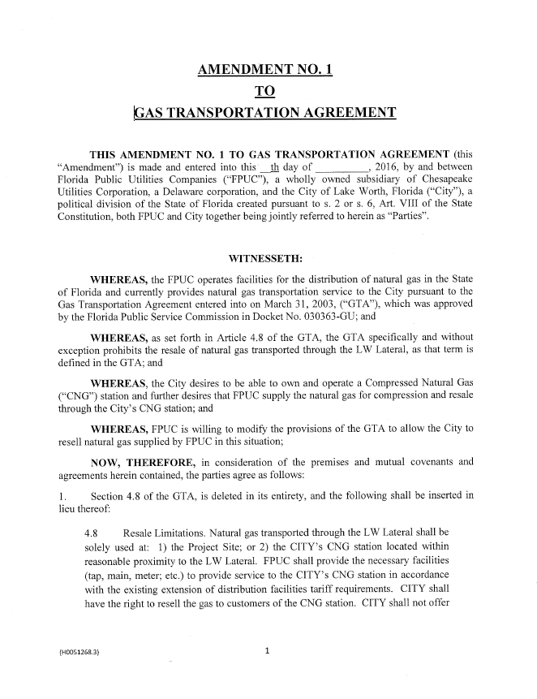

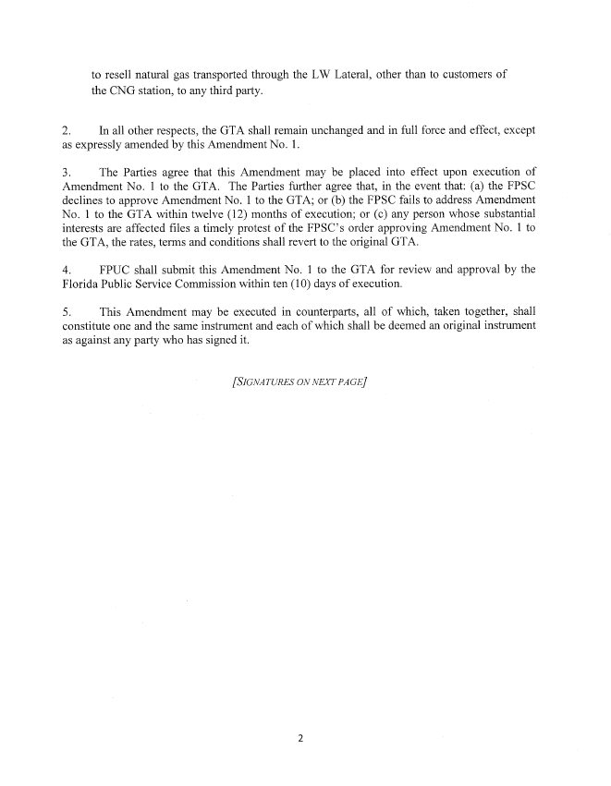

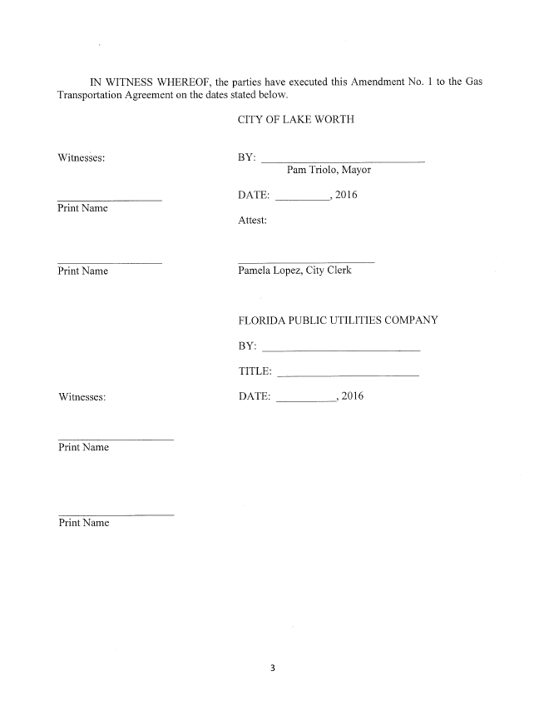

Order No. PSC-03-0846-PAA-GU, issued July 21, 2003, in Docket No. 030363-GU, In re: Joint petition for approval of gas transportation agreement between Florida Public Utilities Company and City of Lake Worth, and request for expedited treatment.
Id., pp. 3-4.
1 MCF equals 1 million British thermal units (Btu).
Cost of service study included as Exhibit A to the joint petition filed in Docket No. 030363-GU.

