State of Florida |  | Public Service Commission  Capital Circle Office Center ● 2540 Shumard Oak Boulevard  Tallahassee, Florida 32399-0850  -M-E-M-O-R-A-N-D-U-M-
DATE: | April 22, 2016
TO: | Office of Commission Clerk (Stauffer)
FROM: | Division of Economics (Ollila)  Office of the General Counsel (Villafrate)
RE: | Docket No. 160050-GU – Joint petition for approval of amendment to territorial agreement in Pasco County, by Peoples Gas System and the City of Clearwater, d/b/a Clearwater Gas System.
AGENDA: | 05/05/16 – Regular Agenda – Proposed Agency Action – Interested Persons May Participate
COMMISSIONERS ASSIGNED: |  |  | All Commissioners
PREHEARING OFFICER: |  |  | Patronis
CRITICAL DATES: |  |  | None
SPECIAL INSTRUCTIONS: |  |  | None

Case Background
On March 4, 2016, Peoples Gas System (Peoples) and the City of Clearwater, d/b/a/ Clearwater Gas System (Clearwater) filed a joint petition for approval of a third amendment to their territorial agreement in Pasco County. The territorial agreement was originally approved in 1995. The first amendment, approved in 2005, allowed Clearwater to provide natural gas service to proposed developments adjacent to its territory in Pasco County. The second amendment, approved in 2006, permitted Clearwater to provide service to a new development (Lakeshore Ranch and surrounding areas). The proposed third amendment would permit Clearwater to provide service to Asturia, a new mixed use development in Pasco County.
The proposed third amendment is contained in Attachment 1. The Commission has jurisdiction over this matter pursuant to Section 366.04, Florida Statutes (F.S.).

Discussion of Issues

Issue 1:
Should the Commission approve the proposed third amendment to the territorial agreement between Peoples and Clearwater?

Recommendation:
Yes, the Commission should approve the proposed third amendment to the territorial agreement between Peoples and Clearwater. (Ollila)

Staff Analysis:
Pursuant to Section 366.04(3)(a), F.S., the Commission has the jurisdiction to approve territorial agreements between and among natural gas utilities. Rule 25-7.0471(2), Florida Administrative Code, states that in approving territorial agreements, the Commission shall consider:
- The reasonableness of the purchase price of any facilities being transferred;
- The reasonable likelihood that the agreement, in and of itself, will not cause a decrease in the reliability of natural gas service to the existing or future ratepayers of any utility party to the agreement; and
- The reasonable likelihood that the agreement will eliminate existing or potential uneconomic duplication of facilities.
- Other relevant factors that may arise from the circumstances of a particular case.
Unless the Commission determines that the agreement will cause a detriment to the public interest, the agreement should be approved.

In September 2014, Clearwater entered into an agreement with a developer, pursuant to which Clearwater agreed to install natural gas distribution facilities to provide natural gas service to Asturia. A portion of the Asturia development lies within an area reserved to Peoples under the original 1995 agreement, thus, according to the petitioners, creating a potential territorial dispute. The proposed third amendment would permit Clearwater to provide service to Asturia and resolve the potential territorial dispute. There are no customers or facilities to be transferred as a result of the third amendment, as the Asturia subdivision is still under development.

The petitioners represent that approval and implementation of the third amendment will not cause a decrease in the availability or reliability of natural gas service to existing or future ratepayers of Peoples or Clearwater. According to the petitioners, approval of the third amendment will permit Peoples and Clearwater to continue to avoid future uneconomic duplication of facilities, will permit the party best suited to provide service to Asturia, and, thus is in the public interest.

After review of the petition, staff believes that the proposed third amendment will enable Peoples and Clearwater to better serve their current and future customers. It appears that the proposed amendment will serve to eliminate any potential uneconomic duplication of facilities and will not cause a decrease in reliability of gas service. As such, staff believes that the proposed third amendment between Peoples and Clearwater will not cause a detriment to the public interest and recommends that the Commission approve it.

Issue 2:
Should this docket be closed?

Recommendation:
If no protest is filed by a person whose substantial interests are affected within 21 days of the issuance of the Order, this docket should be closed upon the issuance of a Consummating Order. (Villafrate)

Staff Analysis:
If no protest is filed by a person whose substantial interests are affected within 21 days of the issuance of the Order, this docket should be closed upon the issuance of a Consummating Order.

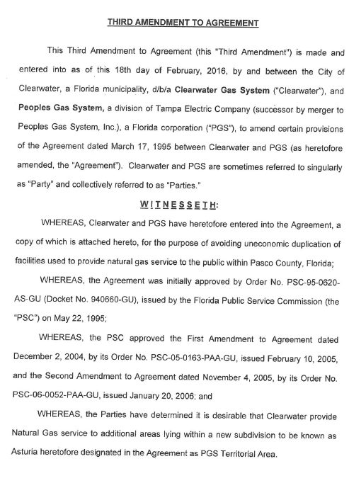

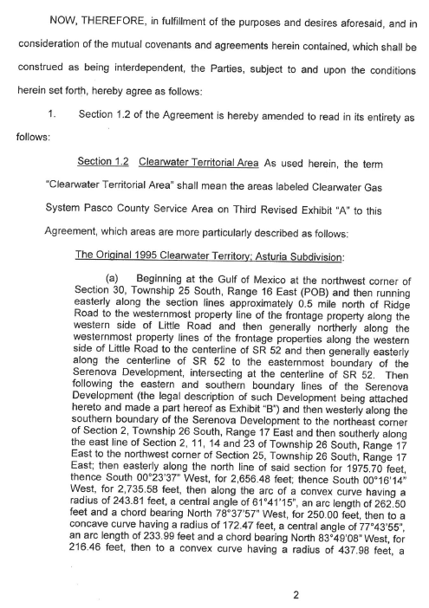

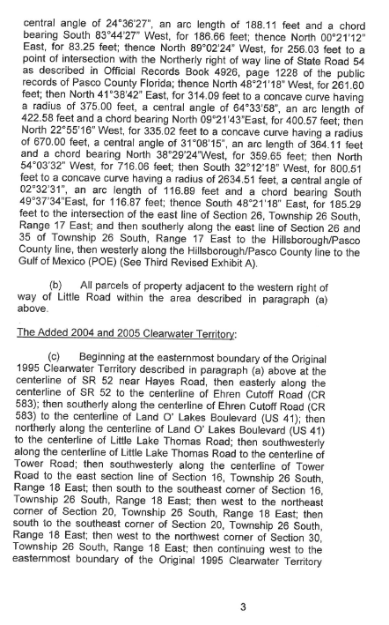

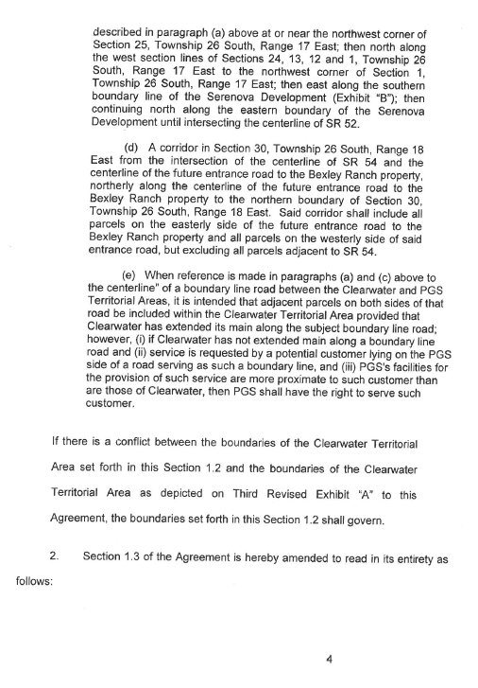

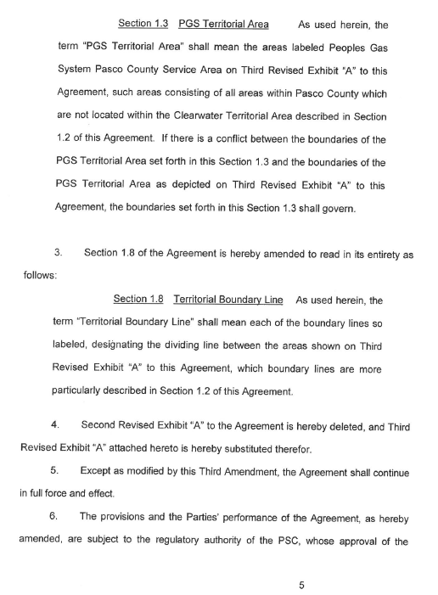

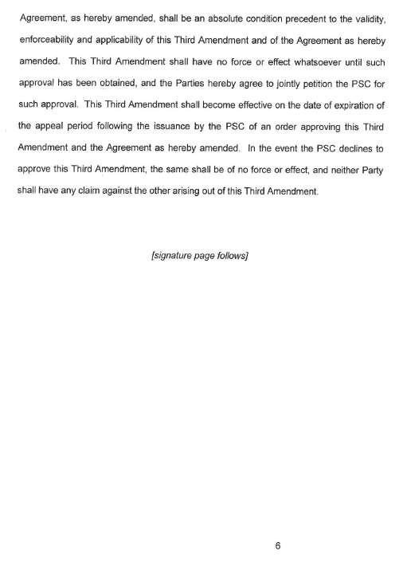

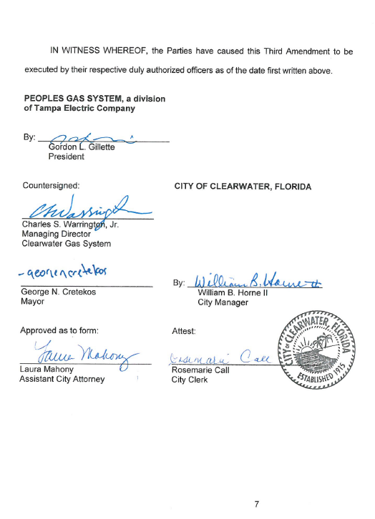

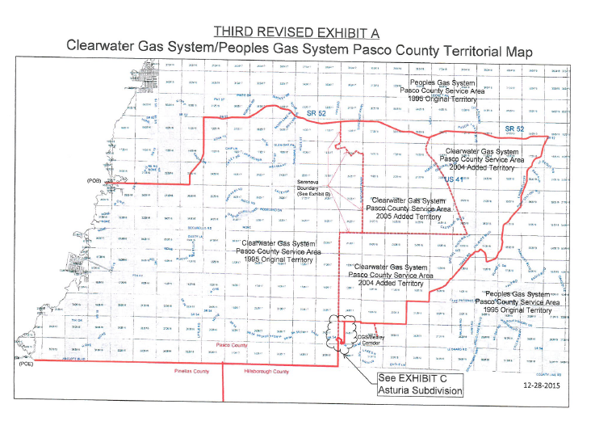

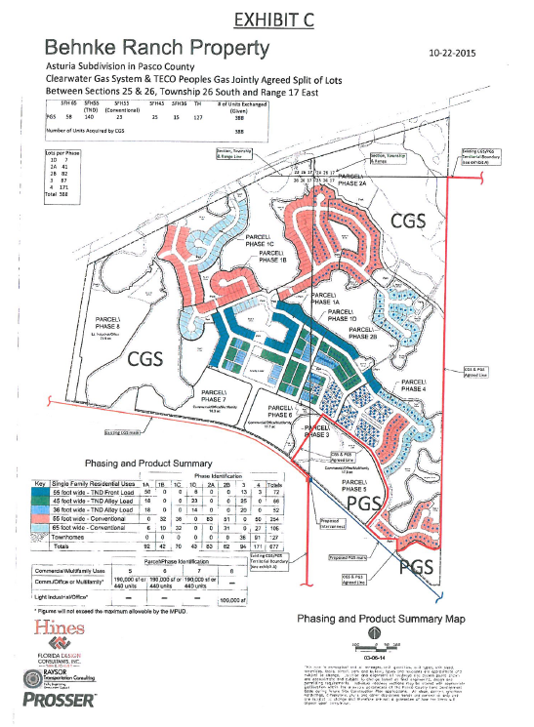

Order No. PSC-95-0620-AS-GU, issued May 22, 1995, in Docket No. 940660-GU, In re: Petition to resolve territorial dispute with Clearwater Gas System, a Division of the City of Clearwater, by Peoples Gas System, Inc.
Order No. PSC-05-0163-PAA-GU, issued February 10, 2005, in Docket No. 041385-GU, In re: Joint petition for approval of amendment to territorial agreement in Pasco County, by Peoples Gas System and Clearwater Gas System, a department of the City of Clearwater.
Order No. PSC-06-0052-PAA-GU, issued January 20, 2006, in Docket No. 050877-GU, In re: Joint petition for approval of amendment to territorial agreement in Pasco County by Peoples Gas System and Clearwater Gas System, a department of the City of Clearwater.
Utilities Commission of the City of New Smyrna v. Florida Public Service Commission, 469 So. 2d 731 (Fla. 1985).

