BEFORE THE FLORIDA PUBLIC SERVICE COMMISSION

In re: Petition by Peoples Gas System for approval of special contract with United Parcel Service, Inc. | DOCKET NO. 160029-GU  ORDER NO. PSC-16-0159-PAA-GU  ISSUED: April 22, 2016

The following Commissioners participated in the disposition of this matter:

JULIE I. BROWN, Chairman
LISA POLAK EDGAR
ART GRAHAM
RONALD A. BRISÉ
JIMMY PATRONIS

NOTICE OF PROPOSED AGENCY ACTION
ORDER APPROVING PEOPLES GAS SYSTEM’S SPECIAL CONTRACT WITH UNITED PARCEL SERVICE, INC.

BY THE COMMISSION:

NOTICE is hereby given by the Florida Public Service Commission (Commission) that the action discussed herein is preliminary in nature and will become final unless a person whose interests are substantially affected files a petition for a formal proceeding, pursuant to Rule 25-22.029, Florida Administrative Code (F.A.C.).

Background

On February 4, 2016, Peoples Gas System (Peoples) filed a petition for approval of a special contract with United Parcel Service, Inc. (UPS). Peoples proposes to extend its distribution facilities to provide natural gas transportation service to a compressed natural gas (CNG) vehicle fueling station to be constructed by UPS to serve its fleet in the Orlando operating center.
UPS currently has a fleet of 5,400 vehicles which operate on alternative fuels and advanced technology. UPS expanded its use of CNG in 2015 and continues to build CNG stations across the country to support its daily operations. The proposed Orlando facility will initially serve 30 vehicles with opportunities for future expansion. The 30 CNG fueled vehicles will displace the use of 700,000 gallons of traditional fuels annually. Section 334.044(33)(a)4., Florida Statutes, (F.S.), encourages the increased use of natural gas to reduce transportation costs for businesses and residents within the state.
During the evaluation of this petition, Commission staff issued its first data request to Peoples for which responses were received on March 3, 2016. After reviewing the responses, Commission staff issued a second data request on March 9, 2016, for which responses were received on March 11, 2016. The Office of the Public Counsel (OPC) filed a Notice of Intervention on February 17, 2016, which was acknowledged by Order No. PSC-16-0097-PCO-GU, issued March 9, 2016.
Rule 25-9.034(1), F.A.C., requires that whenever a special contract is entered into by a utility for the sale of its product or service in a manner not specifically covered by its filed regulations and standard approved rate schedules, such a contract must be approved by the Commission prior to its execution. We have jurisdiction over this matter pursuant to Section 366.04, F.S.

Decision

As required by Rule 25-9.034(1), F.A.C., Peoples filed for our approval of its proposed special contract with UPS. In order to provide natural gas to UPS’s proposed CNG filling station, Peoples will extend its distribution facilities by 3.8 miles of 6-inch coated steel pipes. The confidential dollar per therm distribution charge contained in the contract is higher than the otherwise applicable tariff rate to allow Peoples to recover the cost of the pipeline extension made to UPS’ planned fueling station. In addition to the distribution charge contained in the contract, UPS will be responsible for all other applicable charges and clauses of Rate Schedule GS-5, such as the customer charge, swing service charge, energy conservation cost recovery clause, and cast iron bare steel replacement surcharge.
Peoples will provide natural gas transportation service only to UPS; the natural gas UPS will compress and sell as CNG will be provided by a gas marketer. Specifically, UPS will receive transportation service under Peoples Natural Choice Transportation Service Rider (Rider NCTS). Rider NCTS customers acquire gas from a gas marketer as a part of a customer pool. The gas marketer delivers gas to Peoples’ distribution system for all Rider NCTS customers, and Peoples subsequently transports the gas to the customers. All Rider NCTS customers are required to execute a Letter of Authorization, a contract setting forth the terms and conditions under which Peoples will provide transportation service to the customer, which UPS has already executed. The proposed special contract, for which Peoples seeks Commission approval because it contains a charge that is higher than standard tariff rates, is an addendum to the Letter of Authorization. The redacted special contract is shown as Attachment A to this order.
The term of the contract is 10 years and can be extended for an additional five years upon mutual agreement by Peoples and UPS under the otherwise applicable rate schedule and tariff rate as approved by this Commission and in effect at the time of the extension of the term.

Peoples provided a confidential cost of service study to show that the revenues generated by charges contained in the contract will cover the annual operating cost of providing natural gas to UPS. The estimated annual costs associated with the facility extension include operation and maintenance, depreciation, taxes, and a return on investment.
Peoples stated that only a certain portion of the extension costs (according to the amount of gas usage) are allocated to UPS who will be the first customer on the new distribution line. Peoples explained that it anticipates other gas customers, including a large industrial customer, to come on line later in 2016 who would then be allocated most of the remaining pipeline extension cost. The remaining capacity of the gas line will be used for system reinforcement and peaking requirements. The contract also provides for annual minimum volumes to be taken or paid for during the term of the contract.
Based on the foregoing, we hereby approve the proposed special contract between Peoples and UPS as it will generate revenues in excess of the cost of service, and thereby provide benefits to Peoples’ general body of ratepayers.
Based on the foregoing, it is

ORDERED by the Florida Public Service Commission that Peoples Gas System’s petition for approval of a special contract with United Parcel Service, Inc., is hereby approved. It is further

ORDERED that the provisions of this Order, issued as proposed agency action, shall become final and effective upon the issuance of a Consummating Order unless an appropriate petition, in the form provided by Rule 28-106.201, Florida Administrative Code, is received by the Commission Clerk, 2540 Shumard Oak Boulevard, Tallahassee, Florida, 32399-0850, by the close of business on the date set forth in the “Notice of Further Proceedings” attached hereto. It is further

ORDERED that in the event this Order becomes final, this docket shall be closed.

By ORDER of the Florida Public Service Commission this 22nd day of April, 2016.

/s/ Carlotta S. Stauffer
CARLOTTA S. STAUFFER
Commission Clerk
Florida Public Service Commission
2540 Shumard Oak Boulevard
Tallahassee, Florida 32399
(850) 413-6770
www.floridapsc.com

Copies furnished: A copy of this document is provided to the parties of record at the time of issuance and, if applicable, interested persons.

KRM

NOTICE OF FURTHER PROCEEDINGS OR JUDICIAL REVIEW

The Florida Public Service Commission is required by Section 120.569(1), Florida Statutes, to notify parties of any administrative hearing that is available under Section 120.57, Florida Statutes, as well as the procedures and time limits that apply. This notice should not be construed to mean all requests for an administrative hearing will be granted or result in the relief sought.

Mediation may be available on a case-by-case basis. If mediation is conducted, it does not affect a substantially interested person's right to a hearing.

The action proposed herein is preliminary in nature. Any person whose substantial interests are affected by the action proposed by this order may file a petition for a formal proceeding, in the form provided by Rule 28-106.201, Florida Administrative Code. This petition must be received by the Office of Commission Clerk, 2540 Shumard Oak Boulevard, Tallahassee, Florida 32399-0850, by the close of business on May 13, 2016.

In the absence of such a petition, this order shall become final and effective upon the issuance of a Consummating Order.

Any objection or protest filed in this/these docket(s) before the issuance date of this order is considered abandoned unless it satisfies the foregoing conditions and is renewed within the specified protest period.

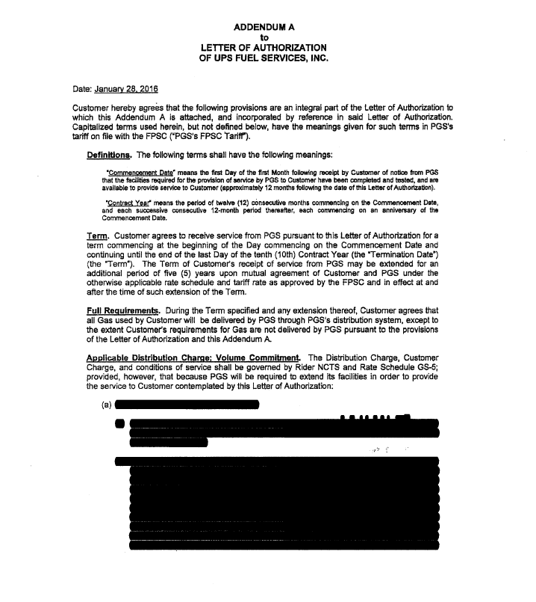
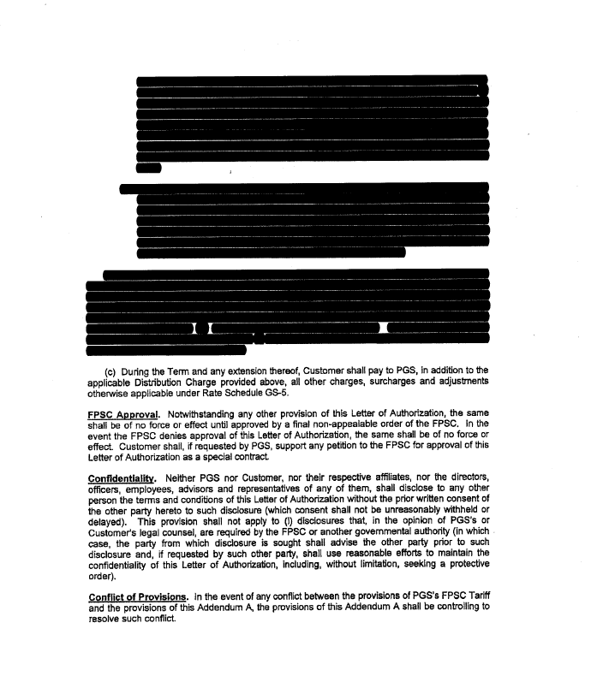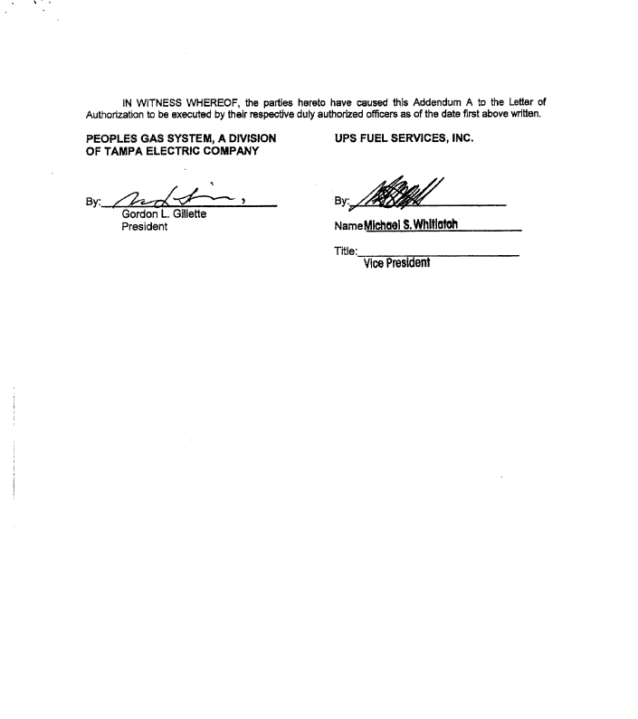

The Letter of Authorization is a standard form and does not require Commission approval.

