BEFORE THE FLORIDA PUBLIC SERVICE COMMISSION

In re: Joint petition to reopen and extend the term of existing territorial agreement in Columbia, Lafayette, Madison, and Suwannee Counties, by Suwannee Valley Electric Cooperative and Duke Energy Florida, LLC. | DOCKET NO. 160056-EU  ORDER NO. PSC-16-0193-PAA-EU  ISSUED: May 17, 2016

The following Commissioners participated in the disposition of this matter:

JULIE I. BROWN, Chairman
LISA POLAK EDGAR
ART GRAHAM
RONALD A. BRISÉ
JIMMY PATRONIS

NOTICE OF PROPOSED AGENCY ACTION
ORDER TO REOPEN AND EXTEND TERM OF
EXISTING TERRITORIAL AGREEMENT

BY THE COMMISSION:

NOTICE is hereby given by the Florida Public Service Commission that the action discussed herein is preliminary in nature and will become final unless a person whose interests are substantially affected files a petition for a formal proceeding, pursuant to Rule 25-22.029, Florida Administrative Code (F.A.C.).

Background

On March 9, 2016, Suwannee Valley Electric Cooperative (Suwannee) and Duke Energy Florida, LLC (DEF) filed a joint petition to reopen and extend the term of their existing territorial agreement in Columbia, Lafayette, Madison, and Suwannee Counties.
This Commission first approved a territorial agreement between Suwannee and DEF in Columbia, Lafayette, Madison, and Suwannee Counties in 1995, in Order No. PSC-95-0351-FOF-EU. This original agreement had a 20-year term which expired on March 14, 2015. In Order No. PSC-15-0128-PAA-EU this Commission extended the terms of the agreement until March 14, 2016, to give the joint petitioners additional time to negotiate a new territorial agreement. The joint petitioners were not able to conclude their negotiations by March 14, 2016, and therefore request to reopen and extend the term of their agreement until September 14, 2016. All other provisions of the territorial agreement remain in effect. The proposed stipulation to reopen and extend the term of the territorial agreement is shown as Attachment A of this Order. We have jurisdiction over this matter pursuant to Section 366.04, Florida Statutes (F.S.).
Decision
Pursuant to Section 366.04(2)(d), F.S., this Commission has jurisdiction to approve territorial agreements between and among rural electric cooperatives, municipal electric utilities, and other electric utilities. Unless this Commission determines that the agreement will cause a detriment to the public interest, the agreement should be approved.
The joint petitioners explained that they have been conducting discussions regarding a new territorial agreement, however, it has become apparent to the petitioners that additional time is needed to successfully conclude their negotiations toward a new territorial agreement. The proposed stipulation as shown in Attachment A will extend the expiration date of the agreement from March 14, 2016, to September 14, 2016, upon approval by this Commission.
In originally approving the agreement in 1995, this Commission found that the agreement is “in the public's interest and that its adoption will further the Commission's policy of avoiding unnecessary and uneconomic duplication of facilities.” We find that the requested extension of time is reasonable and does not appear to be detrimental to the parties or to the public interest. Therefore, the proposed stipulation between Suwannee and DEF to reopen and extend the existing territorial agreement until September 14, 2016, is hereby approved.
Based on the foregoing, it is

ORDERED by the Florida Public Service Commission that the existing territorial agreement between Suwannee Valley Electric Cooperative and Duke Energy Florida, LLC, is hereby reopened and extended until September 14, 2016. It is further

ORDERED that the provisions of this Order, issued as proposed agency action, shall become final and effective upon the issuance of a Consummating Order unless an appropriate petition, in the form provided by Rule 28-106.201, Florida Administrative Code, is received by the Commission Clerk, 2540 Shumard Oak Boulevard, Tallahassee, Florida 32399-0850, by the close of business on the date set forth in the “Notice of Further Proceedings” attached hereto. It is further

ORDERED that in the event this Order becomes final, this docket shall be closed.

By ORDER of the Florida Public Service Commission this 17th day of May, 2016.

/s/ Hong Wang
HONG WANG
Chief Deputy Commission Clerk
Florida Public Service Commission
2540 Shumard Oak Boulevard
Tallahassee, Florida 32399
(850) 413-6770
www.floridapsc.com

Copies furnished: A copy of this document is provided to the parties of record at the time of issuance and, if applicable, interested persons.

MAL

NOTICE OF FURTHER PROCEEDINGS OR JUDICIAL REVIEW

The Florida Public Service Commission is required by Section 120.569(1), Florida Statutes, to notify parties of any administrative hearing that is available under Section 120.57, Florida Statutes, as well as the procedures and time limits that apply. This notice should not be construed to mean all requests for an administrative hearing will be granted or result in the relief sought.

Mediation may be available on a case-by-case basis. If mediation is conducted, it does not affect a substantially interested person's right to a hearing.

The action proposed herein is preliminary in nature. Any person whose substantial interests are affected by the action proposed by this order may file a petition for a formal proceeding, in the form provided by Rule 28-106.201, Florida Administrative Code. This petition must be received by the Office of Commission Clerk, 2540 Shumard Oak Boulevard, Tallahassee, Florida 32399-0850, by the close of business on June 7, 2016.

In the absence of such a petition, this order shall become final and effective upon the issuance of a Consummating Order.

Any objection or protest filed in this/these docket(s) before the issuance date of this order is considered abandoned unless it satisfies the foregoing conditions and is renewed within the specified protest period.

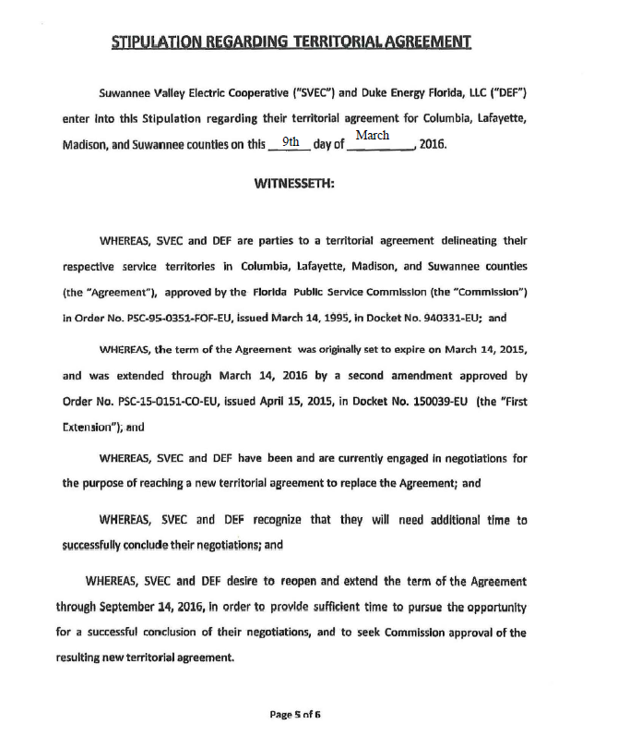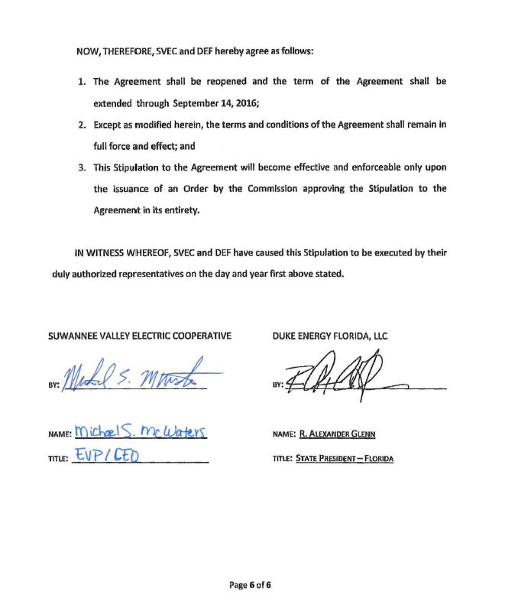

Order No. PSC-95-0351-FOF-EU, issued March 14, 1995, in Docket No. 940331-EU, In Re: Petition to resolve territorial dispute with FLORIDA POWER CORPORATION by SUWANNEE VALLEY ELECTRIC COOPERATIVE, INC.
Order No. PSC-15-0128-PAA-EU, issued March 20, 2015, in Docket No. 150039-EU, In Re: Joint petition to reopen and extend the term of existing territorial agreement in Columbia, Lafayette, Madison, and Suwannee Counties, by Suwannee Valley Electric Cooperative, Inc. and Duke Energy Florida, Inc.
Utilities Commission of the City of New Smyrna Beach v. Florida Public Service Commission, 469 So. 2d 731 (Fla. 1985).
Order No. PSC-95-0351-FOF-EU.

