BEFORE THE FLORIDA PUBLIC SERVICE COMMISSION

In re: Joint petition for approval of amendment to territorial agreement in Pasco County, by Peoples Gas System and the City of Clearwater, d/b/a Clearwater Gas System. | DOCKET NO. 160050-GU  ORDER NO. PSC-16-0201-PAA-GU  ISSUED: May 19, 2016

The following Commissioners participated in the disposition of this matter:

JULIE I. BROWN, Chairman
LISA POLAK EDGAR
ART GRAHAM
RONALD A. BRISÉ
JIMMY PATRONIS

NOTICE OF PROPOSED AGENCY ACTION
ORDER APPROVING TERRITORIAL AGREEMENT AMENDMENT

BY THE COMMISSION:

NOTICE is hereby given by the Florida Public Service Commission that the action discussed herein is preliminary in nature and will become final unless a person whose interests are substantially affected files a petition for a formal proceeding, pursuant to Rule 25-22.029, Florida Administrative Code (F.A.C.).

Background

On March 4, 2016, Peoples Gas System (Peoples) and the City of Clearwater, d/b/a/ Clearwater Gas System (Clearwater) filed a joint petition for approval of a third amendment to their territorial agreement in Pasco County. The territorial agreement was originally approved in 1995. The first amendment, approved in 2005, allowed Clearwater to provide natural gas service to proposed developments adjacent to its territory in Pasco County. The second amendment, approved in 2006, permitted Clearwater to provide service to a new development (Lakeshore Ranch and surrounding areas). The proposed third amendment would permit Clearwater to provide service to Asturia, a new mixed use development in Pasco County.
The third amendment is contained in Attachment 1. We have jurisdiction over this matter pursuant to Section 366.04, Florida Statutes (F.S.).
Decision

Pursuant to Section 366.04(3)(a), F.S., this Commission has the jurisdiction to approve territorial agreements between and among natural gas utilities. Rule 25-7.0471(2), F.A.C., states that in approving territorial agreements, this Commission shall consider:
- The reasonableness of the purchase price of any facilities being transferred;
- The reasonable likelihood that the agreement, in and of itself, will not cause a decrease in the reliability of natural gas service to the existing or future ratepayers of any utility party to the agreement; and
- The reasonable likelihood that the agreement will eliminate existing or potential uneconomic duplication of facilities.
- Other relevant factors that may arise from the circumstances of a particular case.
Unless this Commission determines that the agreement will cause a detriment to the public interest, the agreement should be approved.

In September 2014, Clearwater entered into an agreement with a developer, pursuant to which Clearwater agreed to install natural gas distribution facilities to provide natural gas service to Asturia. A portion of the Asturia development lies within an area reserved to Peoples under the original 1995 agreement, thus, according to the petitioners, creating a potential territorial dispute. The third amendment would permit Clearwater to provide service to Asturia and resolve the potential territorial dispute. There are no customers or facilities to be transferred as a result of the third amendment, as the Asturia subdivision is still under development.

The petitioners represent that approval and implementation of the third amendment will not cause a decrease in the availability or reliability of natural gas service to existing or future ratepayers of Peoples or Clearwater. According to the petitioners, approval of the third amendment will permit Peoples and Clearwater to continue to avoid future uneconomic duplication of facilities, will permit the party best suited to provide service to Asturia, and, thus is in the public interest.
After review of the petition, we find that the third amendment will enable Peoples and Clearwater to better serve their current and future customers. It appears that the third amendment will serve to eliminate any potential uneconomic duplication of facilities and will not cause a decrease in reliability of gas service. As such, we find that the third amendment between Peoples and Clearwater will not cause a detriment to the public interest and therefore approve it.
Based on the foregoing, it is

ORDERED by the Florida Public Service Commission that the third amendment to the territorial agreement between Peoples Gas System and the City of Clearwater, d/b/a/ Clearwater Gas System. shall be approved.

ORDERED that the provisions of this Order, issued as proposed agency action, shall become final and effective upon the issuance of a Consummating Order unless an appropriate petition, in the form provided by Rule 28-106.201, Florida Administrative Code, is received by the Commission Clerk, 2540 Shumard Oak Boulevard, Tallahassee, Florida 32399-0850, by the close of business on the date set forth in the “Notice of Further Proceedings” attached hereto. It is further

ORDERED that in the event this Order becomes final, this docket shall be closed.

By ORDER of the Florida Public Service Commission this 19th day of May, 2016.

/s/ Hong Wang
HONG WANG
Chief Deputy Commission Clerk
Florida Public Service Commission
2540 Shumard Oak Boulevard
Tallahassee, Florida 32399
(850) 413-6770
www.floridapsc.com

Copies furnished: A copy of this document is provided to the parties of record at the time of issuance and, if applicable, interested persons.

JEV

NOTICE OF FURTHER PROCEEDINGS OR JUDICIAL REVIEW

The Florida Public Service Commission is required by Section 120.569(1), Florida Statutes, to notify parties of any administrative hearing that is available under Section 120.57, Florida Statutes, as well as the procedures and time limits that apply. This notice should not be construed to mean all requests for an administrative hearing will be granted or result in the relief sought.

Mediation may be available on a case-by-case basis. If mediation is conducted, it does not affect a substantially interested person's right to a hearing.

The action proposed herein is preliminary in nature. Any person whose substantial interests are affected by the action proposed by this order may file a petition for a formal proceeding, in the form provided by Rule 28-106.201, Florida Administrative Code. This petition must be received by the Office of Commission Clerk, 2540 Shumard Oak Boulevard, Tallahassee, Florida 32399-0850, by the close of business on June 9, 2016.

In the absence of such a petition, this order shall become final and effective upon the issuance of a Consummating Order.

Any objection or protest filed in this/these docket(s) before the issuance date of this order is considered abandoned unless it satisfies the foregoing conditions and is renewed within the specified protest period.

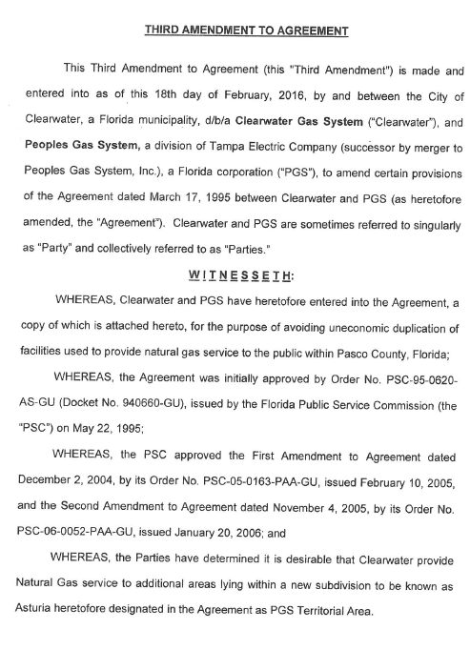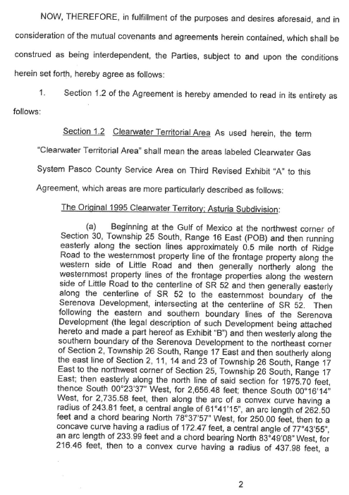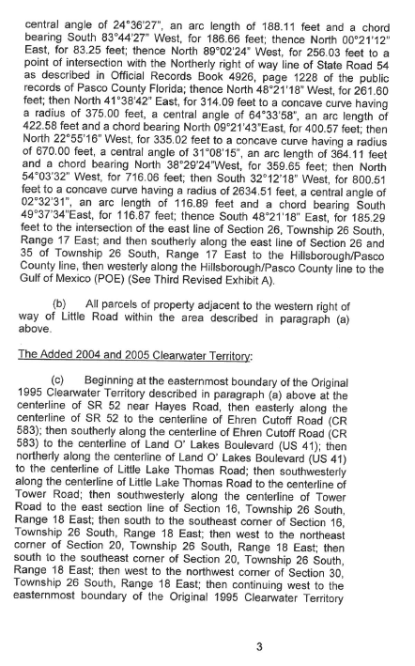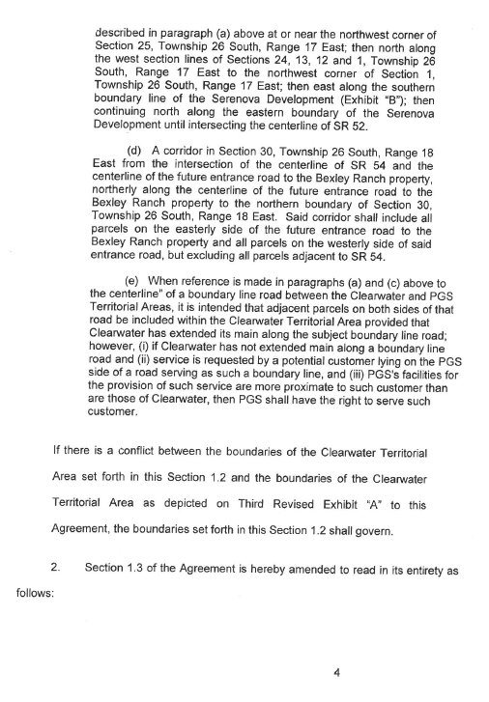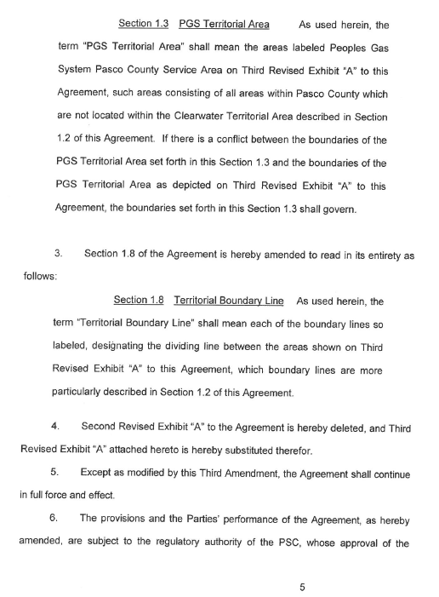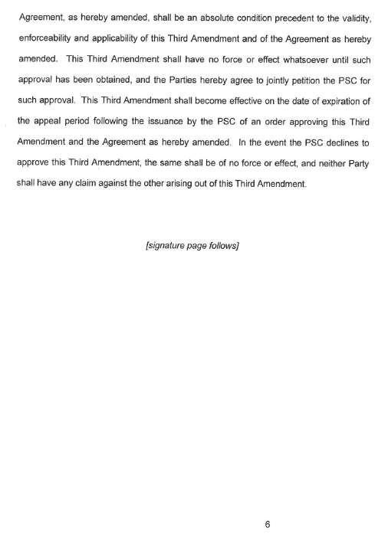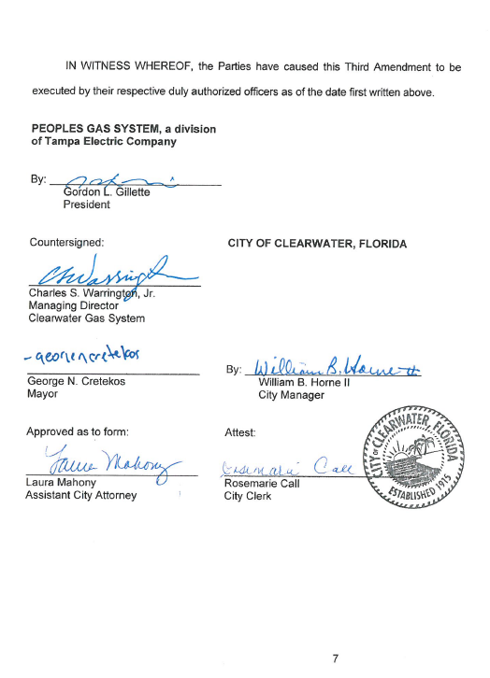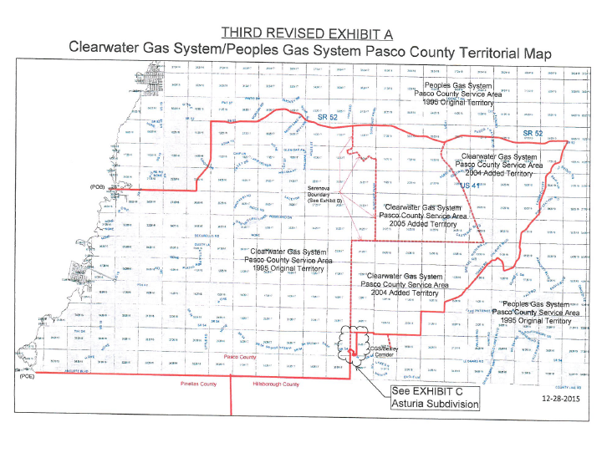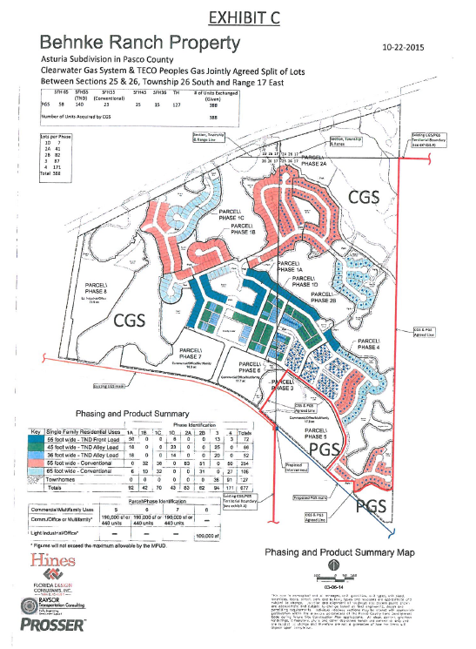

Order No. PSC-95-0620-AS-GU, issued May 22, 1995, in Docket No. 940660-GU, In re: Petition to resolve territorial dispute with Clearwater Gas System, a Division of the City of Clearwater, by Peoples Gas System, Inc.
Order No. PSC-05-0163-PAA-GU, issued February 10, 2005, in Docket No. 041385-GU, In re: Joint petition for approval of amendment to territorial agreement in Pasco County, by Peoples Gas System and Clearwater Gas System, a department of the City of Clearwater.
Order No. PSC-06-0052-PAA-GU, issued January 20, 2006, in Docket No. 050877-GU, In re: Joint petition for approval of amendment to territorial agreement in Pasco County by Peoples Gas System and Clearwater Gas System, a department of the City of Clearwater.
Utilities Commission of the City of New Smyrna v. Florida Public Service Commission, 469 So. 2d 731 (Fla. 1985).

