State of Florida |  | Public Service Commission  Capital Circle Office Center ● 2540 Shumard Oak Boulevard  Tallahassee, Florida 32399-0850  -M-E-M-O-R-A-N-D-U-M-
DATE: | June 23, 2016
TO: | Office of Commission Clerk (Stauffer)
FROM: | Division of Economics (Ollila)  Division of Engineering (Ellis, Wooten)  Office of the General Counsel (Brownless)
RE: | Docket No. 160093-EI – Petition for approval of modifications to standby generation tariff and program participation standards, by Duke Energy Florida, LLC.
AGENDA: | 07/07/16 – Regular Agenda – Tariff Filing – Interested Persons May Participate
COMMISSIONERS ASSIGNED: |  |  | All Commissioners
PREHEARING OFFICER: |  |  | Administrative
CRITICAL DATES: |  |  | 60-Day Suspension Date Waived by the Company Until the 7/7/16 Agenda Conference
SPECIAL INSTRUCTIONS: |  |  | None

Case Background
On April 19, 2016, Duke Energy Florida, LLC (Duke) filed a petition for approval of modifications to its standby generation program tariff and program participation standards (program standards).
The standby generation program is one of several commercial/industrial programs the Commission approved in 2015 as part of Duke’s Demand Side Management (DSM) plan and associated tariffs. The standby generation program is designed to reduce Duke’s peak demand based on control of customer equipment. The program is voluntary and is available to all commercial and industrial customers that have on-site generation capability and are willing to reduce their Duke demand when required by initiating their own generation. The program is offered through rate schedule GSLM-2, and provides monthly credits based on the participants’ ability to reduce demand.
Based on Environmental Protection Agency (EPA) regulations regarding emission standards for standby generation equipment in effect in 2015, Duke’s standby generation program was split into two options: Schedule A (emergency standby generation) and Schedule B (non-emergency standby generation). Schedule A was open to customers whose standby generation equipment was not compliant with EPA regulations, but could be dispatched by Duke up to 100 hours during emergency situations (i.e., severe capacity constraints on Duke’s system). Schedule B was open only to those customers whose equipment was compliant with EPA regulations and could be dispatched by Duke any time.
Effective May 1, 2016, revised EPA regulations require owners of generators to comply with new emission standards for hazardous air pollutants. Therefore, customers with standby generation equipment that is not compliant with EPA regulations face more restrictions on operation, which limits the ability of Duke to dispatch them as necessary. Duke’s proposed tariff modifications update the tariff to conform with the revised EPA regulations and allow non-compliant (i.e., Schedule A) customers to remain on the tariff until December 31, 2016, so that those customers have time to bring their generation equipment into compliance.
Duke’s original April 19, 2016 proposed tariff revisions reference specific EPA rules with which customers with standby generation must comply. On May 11, 2016, Duke filed revised tariff pages that substituted generic language for the technical language used in the original filing. On May 13, 2016, Duke filed revised program standards consistent with the revised tariff pages filed on May 11, 2016. Attachment 1 contains the May 11 proposed tariff. Exhibit D to the petition contains a sample copy of the letter Duke sent to its standby generation customers. The Commission has jurisdiction over this matter pursuant to Sections 366.03, 366.04, 366.05, and 366.06, Florida Statutes.

Discussion of Issues

Issue 1:
Should the Commission approve Duke’s proposed modifications to its standby generation tariff and program standards effective December 31, 2016, and allow Schedule A customers to remain on the tariff until December 31, 2016, to bring their generation equipment into compliance with the revised EPA rules?

Recommendation:
Yes, staff recommends that the Commission approve Duke’s proposed modifications to its standby generation tariff and program standards effective December 31, 2016, and allow current Schedule A customers to remain on the tariff until December 31, 2016, to bring their generation equipment into compliance with the revised EPA rules. (Ollila, Wooten)

Staff Analysis:
Duke’s proposed modifications update its standby tariff and program participation standards to conform with current EPA regulations. Customers with standby generation include grocery stores and hospitals. Duke currently has 288 customers on the standby tariff.
Duke’s original proposed modifications contained language specific to the applicable federal regulation. In the May 11 revisions, Duke removed language referring to specific EPA requirements and replaced it with generic terms, i.e., applicable federal, state, and local codes and rules. The revision also includes language stating that customers are responsible for ensuring that equipment remains compliant with all applicable federal, state, and local codes and rules.
Beginning in April 2016, Duke contacted its standby customers by letter, email, telephone calls, and face-to-face meetings to explain the EPA rule changes and Duke’s proposals. The letter explained the rule changes and the customers’ options. The letter asked that the customer provide Duke with notice of whether or not the customer’s equipment is compliant by May 31, 2016. If the equipment is not compliant, the letter asked if the customer intends to upgrade its equipment, and if yes, asked the customer to attest to that compliance prior to December 31, 2016. For customers who are not compliant, Duke proposes that they be given until December 31, 2016 to comply. Duke reported that as of June 15, 2016, 141 of the 288 customers participating in the standby program comply with current EPA regulations, 10 are not compliant but intend to upgrade, 15 are non-compliant and do not intend to upgrade, and 122 responses are pending.
Customers who are not compliant by December 31, 2016 will be removed from the standby generation tariff. Customers will need to provide certification that their generation equipment is compliant with all applicable federal, state, and local codes and rules in order to continue participation in the standby generation program and tariff.
All customers are credited a monthly amount based on their standby generator rating (capacity) as well as an amount when the standby generator is used. Customers who do not certify that their equipment is compliant will continue to be credited the monthly amount based on their standby generator rating until they are removed from the tariff effective December 31, 2016.
Schedule A customers who certify that their equipment is compliant will receive an increase in the per kilowatt hour (kWh) credit from $0.05 to the Schedule B credit of $0.50 per kWh. Providing a greater credit per kWh, according to Duke, serves as an incentive for Schedule A customers to become compliant, which in turn provides Duke with more flexibility in its use of standby generation.
The only change to the current program standards is in Section 3, which was made to be consistent with the tariff language.

Conclusion
Staff believes that current regulations necessitate Duke’s tariff modification and that Duke’s more generic wording is reasonable and likely to promote efficiency by requiring fewer tariff changes in the future. The proposed change to the program participation standards comports with the tariff modifications. Staff believes it is reasonable to give customers who are not compliant an opportunity to upgrade their equipment in order to become compliant and that Duke’s proposed effective date for customers to become compliant is also reasonable.
Staff recommends that the Commission approve Duke’s proposed modifications to its standby generation tariff and program standards effective December 31, 2016, and allow current Schedule A customers to remain on the tariff until December 31, 2016, to bring their generation equipment into compliance with the revised EPA rules.
Issue 2: Should this docket be closed?

Recommendation:
If Issue 1 is approved and no timely protest is filed, this docket should be closed upon the issuance of a consummating order. (Brownless)

Staff Analysis:
If Issue 1 is approved and no timely protest is filed, this docket should be closed upon the issuance of a consummating order.

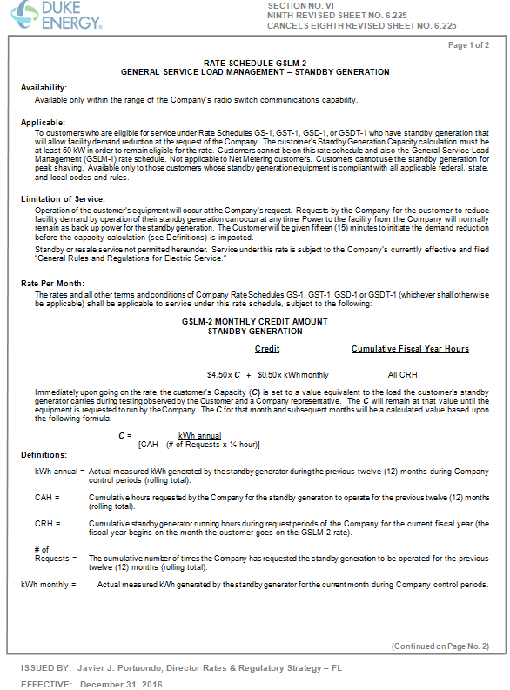
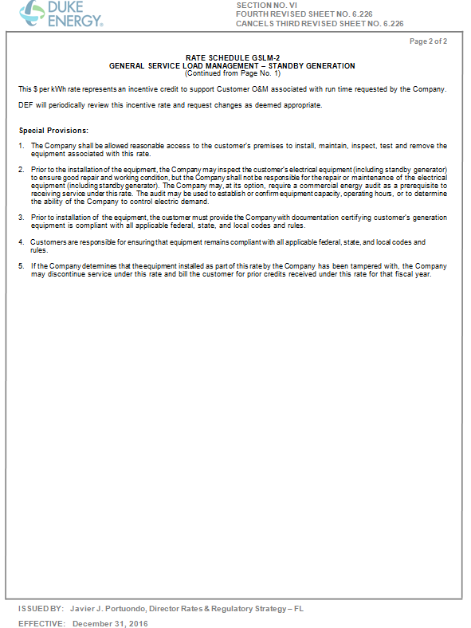

Order No. PSC-15-0332-PAA-EG, issued August 20, 2015, in Docket No. 150083-EG, In re: Petition for approval of demand-side management plan of Duke Energy Florida, Inc.
Equipment owners remain responsible for ensuring that standby generators participating in Duke’s tariff program are compliant with EPA rules, not Duke.
The use of generic language is similar to, for example, what Tampa Electric Company uses in its standby tariff.

