BEFORE THE FLORIDA PUBLIC SERVICE COMMISSION

In re: Water and wastewater industry annual reestablishment of authorized range of return on common equity for water and wastewater utilities pursuant to Section 367.081(4)(f), F.S. | DOCKET NO. 160006-WS  ORDER NO. PSC-16-0254-PAA-WS  ISSUED: June 29, 2016

The following Commissioners participated in the disposition of this matter:

JULIE I. BROWN, Chairman
LISA POLAK EDGAR
ART GRAHAM
RONALD A. BRISÉ
JIMMY PATRONIS

NOTICE OF PROPOSED AGENCY ACTION
ORDER ESTABLISHING AUTHORIZED RANGE OF RETURNS ON COMMON EQUITY FOR WATER AND WASTEWATER UTILITIES

BY THE COMMISSION:

NOTICE is hereby given by the Florida Public Service Commission that the action discussed herein is preliminary in nature and will become final unless a person whose interests are substantially affected files a petition for a formal proceeding, pursuant to Rule 25-22.029, Florida Administrative Code (F.A.C.).

Background

Section 367.081(4)(f), Florida Statutes (F.S.), authorizes this Commission to establish, not less than once each year, a leverage formula to calculate a reasonable range of returns on equity (ROE) for water and wastewater (WAW) utilities. The leverage formula methodology currently in use was established in Order No. PSC-01-2514-FOF-WS. On October 23, 2008, this Commission held a formal hearing in Docket No. 080006-WS to allow interested parties to provide testimony regarding the validity of the leverage formula. Based on the record in that proceeding, this Commission approved the 2008 leverage formula in Order No. PSC-08-0846-FOF-WS. In that order, this Commission reaffirmed the methodology that was previously approved in Order No. PSC-01-2514-FOF-WS.
This order continues to use the leverage formula methodology established in Order No. PSC-01-2514-FOF-WS and reaffirmed in Order No. PSC-08-0846-FOF-WS. This methodology uses ROEs derived from financial models applied to an index of natural gas utilities. Based on the results of our annual review, there are an insufficient number of WAW utilities that meet the requisite criteria to assemble an appropriate proxy group using only WAW utilities. Therefore, since 2001, we have used natural gas utilities as the proxy companies for the leverage formula. There are many natural gas utilities that have actively traded stocks and forecasted financial data. We use natural gas utilities that derive at least 49 percent of their revenue from regulated rates. These utilities have market power and are influenced significantly by economic regulation. As explained below, the model results based on natural gas utilities are adjusted to reflect the risks faced by Florida WAW utilities.
This Commission approved the current leverage formula in 2011 by Order No. PSC-11-0287-PAA-WS. In 2012, 2013, 2014, and 2015, we continued to use the 2011 leverage formula for establishing the authorized ROE for WAW utilities. In 2012, 2013, 2014, and 2015, we found that the range of returns on equity derived from the annual leverage formulas were not optimal for determining the appropriate authorized ROE for WAW utilities due to Federal Reserve monetary policies that resulted in historically low interest rates. Consequently, this Commission decided that the range of returns on equity of 8.74 percent to 11.16 percent from the 2011 leverage formula was more reasonable.
Although Section 367.081(4)(f), F.S., authorizes this Commission to establish a range of returns for setting the authorized ROE for WAW utilities, this Commission may set an ROE for WAW utilities based on record evidence in any proceeding. If one or more parties file testimony in opposition to the use of the leverage formula, this Commission will determine the appropriate ROE based on the evidentiary record in that proceeding.
We have jurisdiction pursuant to Section 367.081, F.S.
Decision
The current leverage formula approved by this Commission in Order No. PSC-15-0259-PAA-WS shall continue to be used until the leverage formula is readdressed in 2017. Accordingly, the leverage formula is as follows:
Return on Common Equity = 7.13% + (1.610 ÷ Equity Ratio)
Where the Equity Ratio = Common Equity ÷ (Common Equity + Preferred Equity + Long-Term and Short-Term Debt)
Range: 8.74% @ 100% equity to 11.16% @ 40% equity
Additionally, we shall cap returns on common equity at 11.16 percent for all WAW utilities with equity ratios less than 40 percent. We believe this will discourage imprudent financial risk. This cap is consistent with the methodology we used in Order No. PSC-08-0846-FOF-WS.
Section 367.081(4)(f), F.S., authorizes this Commission to establish a leverage formula to calculate a reasonable range of returns on common equity for WAW utilities. We must establish this leverage formula not less than once a year. For administrative efficiency, the leverage formula is used to determine the appropriate return for an average Florida WAW utility. Traditionally, we have applied the same leverage formula to all WAW utilities. As is the case with other regulated companies under our jurisdiction, this Commission has discretion in the determination of the appropriate ROE based on the evidentiary record in any proceeding. If one or more parties file testimony in opposition to the use of the leverage formula, this Commission will determine the appropriate ROE based on the evidentiary record in that proceeding.
The leverage formula relies on two ROE models. We adjusted the results of these models to reflect differences in risk and debt cost between the index of companies used in the models and the average Florida WAW utility. Both models include a four percent adjustment for flotation costs. The models are as follows:
- A Discounted Cash Flow (DCF) model applied to an index of natural gas utilities that have publicly traded stock and are followed by the Value Line Investment Survey (Value Line). This DCF model is an annual model and uses prospective growth rates.
- The index consists of eight natural gas companies that derive at least 49 percent of their total revenue from gas distribution service. These companies have a median Standard and Poor’s bond rating of A-.
- A Capital Asset Pricing Model (CAPM) using a market return for companies followed by Value Line, the average yield on the Treasury’s long-term bonds projected by the Blue Chip Financial Forecasts, and the average beta for the index of natural gas utilities.
We averaged the indicated returns of the above models and adjusted the result as follows:
- A bond yield differential of 57 basis points is added to reflect the difference in yields between an A-/A3 rated bond, which is the median bond rating for the natural gas utility index, and a BBB-/Baa3 rated bond. Florida WAW utilities are assumed to be comparable to companies with the lowest investment grade bond rating, which is Baa3. This adjustment compensates for the difference between the credit quality of “A-” rated debt and the credit quality of the minimum investment grade rating.
- A private placement premium of 50 basis points is added to reflect the difference in yields on publicly traded debt and privately placed debt, which is illiquid. Investors require a premium for the lack of liquidity of privately placed debt.
- A small utility risk premium of 50 basis points is added because the average Florida WAW utility is too small to qualify for privately placed debt.
After the above adjustments, the resulting cost of equity estimate is included in the average capital structure for the natural gas utilities.
We note that the leverage formula depends on four basic assumptions:
- Business risk is similar for all WAW utilities;
- The cost of equity is an exponential function of the equity ratio but a linear function of the debt to equity ratio over the relevant range;
- The marginal weighted average cost of investor capital is constant over the equity ratio range of 40 percent to 100 percent; and
- The debt cost rate at an assumed Moody’s Baa3 bond rating, plus a 50 basis point private placement premium and a 50 basis point small utility risk premium, represents the average marginal cost of debt to a Florida WAW utility over an equity ratio range of 40 percent to 100 percent.
For these reasons, the leverage formula is appropriate for the average Florida WAW utility.
In the instant docket, we updated the leverage formula using the most recent 2016 financial data and our previously approved methodology. Using the updated financial data in the leverage formula decreases both the lower end of the current allowed ROE range by 111 basis points and the upper end of the range by 53 basis points. Overall, the spread between the range of returns on equity based on the updated leverage formula is 300 basis points (7.63 percent to 10.63 percent). In comparison, the spread in the range of returns on equity for the existing leverage formula is 242 basis points (8.74 percent to 11.16 percent). The 300 basis point spread reflected in the updated leverage formula is significantly greater than the 20-year average spread of 187 basis points.
The inflated ROE spread relative to the 2011 leverage formula is caused by the very low bond rates resulting from the Federal Reserve’s various monetary policies and quantitative easing programs, which are largely still in effect. In its press release dated April 27, 2016, the Federal Reserve stated:
Consistent with its statutory mandate, the Committee seeks to foster maximum employment and price stability. The Committee currently expects that, with gradual adjustments in the stance of monetary policy, economic activity will expand at a moderate pace and labor market indicators will continue to strengthen. Inflation is expected to remain low in the near term, in part because of earlier declines in energy prices, but to rise to 2 percent over the medium term as the transitory effects of declines in energy and import prices dissipate and the labor market strengthens further. The Committee continues to closely monitor inflation indicators and global economic and financial developments.
Against this backdrop, the Committee decided to maintain the target range for the federal funds rate at 1/4 to 1/2 percent. The stance of monetary policy remains accommodative, thereby supporting further improvement in labor market conditions and a return to 2 percent inflation.
In determining the timing and size of future adjustments to the target range for the federal funds rate, the Committee will assess realized and expected economic conditions relative to its objectives of maximum employment and 2 percent inflation. This assessment will take into account a wide range of information, including measures of labor market conditions, indicators of inflation pressures and inflation expectations, and readings on financial and international developments. In light of the current shortfall of inflation from 2 percent, the Committee will carefully monitor actual and expected progress toward its inflation goal. The Committee expects that economic conditions will evolve in a manner that will warrant only gradual increases in the federal funds rate; the federal funds rate is likely to remain, for some time, below levels that are expected to prevail in the longer run. However, the actual path of the federal funds rate will depend on the economic outlook as informed by incoming data.
The most recent assumed Baa3 bond rate of 5.63 percent used in the updated leverage formula calculation, which includes a 50 basis point adjustment for small company risk and a 50 basis point adjustment for a private placement premium, remains low relative to historic levels. In comparison, the assumed Baa3 bond rate used in the existing leverage formula is 7.13 percent.
Because interest rates are at historically low levels, thereby increasing the slope of the leverage formula relative to prior years, we find that the range of returns on equity produced from the updated leverage formula is not optimal for determining the appropriate authorized ROE for Florida WAW utilities at this time. An increase in the slope of the leverage formula means a given change in the equity ratio will result in a greater change to the cost of equity. The results of this year’s leverage formula produced a slope consistent with the slopes produced by financial data for 2012 through 2015. As shown below, Chart 1 illustrates the change in the slope of the leverage formula using updated data compared to the current leverage formula.
Chart 1
Comparison of Annual Leverage Formulas
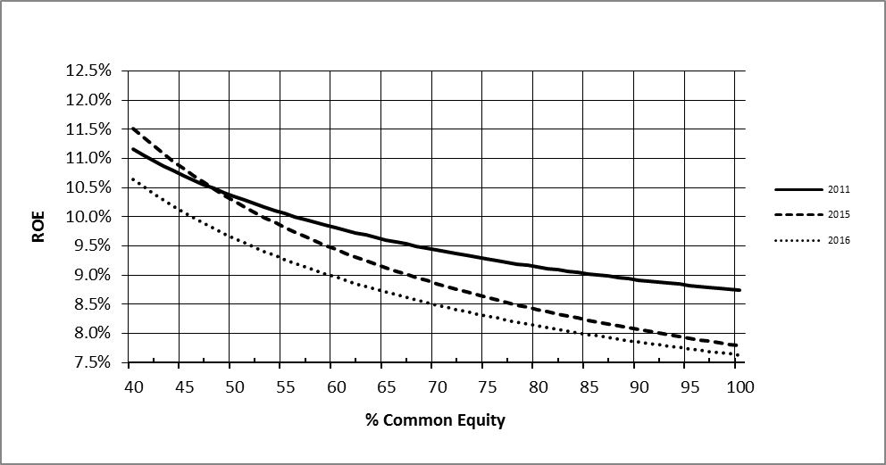
Source: FPSC Staff Analysis

Chart 2 illustrates the change in the slope of the leverage formula for the six years 2011 through 2016.
Chart 2
Comparison of Annual Leverage Formulas since 2011
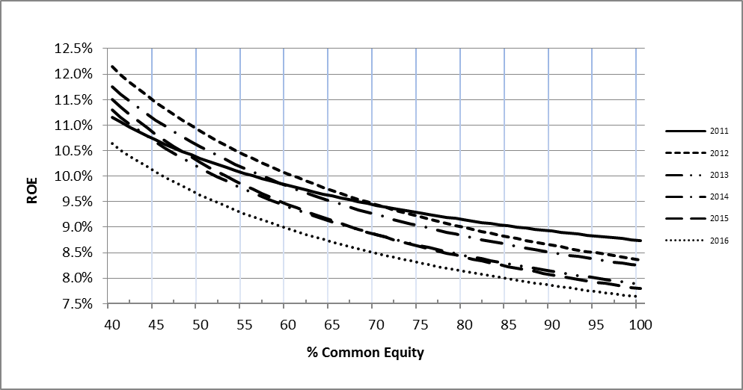Source: FPSC Staff Analysis
In 2015, by Order No. PSC-15-0259-PAA-WS, this Commission continued to use the leverage formula initially approved in 2011. This Commission kept the 2011 leverage formula in place because Federal Reserve monetary policies lowered interest rates to historically low levels, thereby increasing the slope of the leverage formula graph relative to previous years. The Federal Reserve’s monetary policies and resulting capital market conditions that existed in 2012 through 2015 are expected to continue in 2016.
This Commission finds that the existing leverage formula range of 8.74 percent to 11.16 percent initially approved in 2011 is still reasonable for WAW utilities. We find that retaining the use of the current in-place leverage formula until the leverage formula is addressed again in 2017 is a reasonable alternative to updating the formula using current 2016 financial information.
We continue to find that the leverage formula is a sound, workable methodology that reduces the costs and administrative burdens in WAW rate cases by eliminating the need for cost of equity testimony. Many of the WAW utilities under our jurisdiction are small operations that find it beneficial to avoid the costs associated with presenting cost of equity testimony.
Based on the aforementioned, we find that the current leverage formula approved by this Commission in Order No. PSC-15-0259-PAA-WS shall continue to be used until the leverage formula is readdressed in 2017.
Based on the foregoing, it is

ORDERED by the Florida Public Service Commission that the current leverage formula approved by this Commission in Order No. PSC-15-0259-PAA-WS, Return on Common Equity = 7.13% + (1.610 ÷ Equity Ratio), shall continue to be used until the leverage formula is readdressed in 2017. It is further

ORDERED that the current range of returns on common equity of 8.74 percent to 11.16 percent is hereby approved for water and wastewater utilities as set forth in this Order. It is further

ORDERED that the returns on common equity shall be capped at 11.16 percent for all water and wastewater utilities with equity ratios less than 40 percent. It is further

ORDERED that Attachment 1 is incorporated herein by reference. It is further

ORDERED that the provisions of this Order, issued as proposed agency action, shall become final and effective upon the issuance of a Consummating Order unless an appropriate petition, in the form provided by Rule 28-106.201, Florida Administrative Code, is received by the Commission Clerk, 2540 Shumard Oak Boulevard, Tallahassee, Florida 32399-0850, by the close of business on the date set forth in the “Notice of Further Proceedings” attached hereto. It is further

ORDERED that this docket shall remain open to allow Commission staff to monitor changes in capital market conditions and to readdress the reasonableness of the leverage formula as conditions warrant.

By ORDER of the Florida Public Service Commission this 29th day of June, 2016.

/s/ Carlotta S. Stauffer
CARLOTTA S. STAUFFER
Commission Clerk
Florida Public Service Commission
2540 Shumard Oak Boulevard
Tallahassee, Florida 32399
(850) 413-6770
www.floridapsc.com

Copies furnished: A copy of this document is provided to the parties of record at the time of issuance and, if applicable, interested persons.

MAL

NOTICE OF FURTHER PROCEEDINGS OR JUDICIAL REVIEW

The Florida Public Service Commission is required by Section 120.569(1), Florida Statutes, to notify parties of any administrative hearing that is available under Section 120.57, Florida Statutes, as well as the procedures and time limits that apply. This notice should not be construed to mean all requests for an administrative hearing will be granted or result in the relief sought.

Mediation may be available on a case-by-case basis. If mediation is conducted, it does not affect a substantially interested person's right to a hearing.

The action proposed herein is preliminary in nature. Any person whose substantial interests are affected by the action proposed by this order may file a petition for a formal proceeding, in the form provided by Rule 28-106.201, Florida Administrative Code. This petition must be received by the Office of Commission Clerk, 2540 Shumard Oak Boulevard, Tallahassee, Florida 32399-0850, by the close of business on July 20, 2016.

In the absence of such a petition, this order shall become final and effective upon the issuance of a Consummating Order.

Any objection or protest filed in this/these docket(s) before the issuance date of this order is considered abandoned unless it satisfies the foregoing conditions and is renewed within the specified protest period.

SUMMARY OF LEVERAGE FORMULA FACTORS
(A) DCF ROE for Natural Gas Utility Index |  |  |  | 8.25%
(B) CAPM ROE for Natural Gas Utility Index |  |  |  | 9.40%
AVERAGE |  |  |  | 8.83%
Bond Yield Differential |  |  |  | 0.57%
Private Placement Premium |  |  |  | 0.50%
Small-Utility Risk Premium |  |  |  | 0.50%
Adjustment to Reflect ROE at 40% Equity Ratio |  |  |  | 0.76%
Cost of Equity for Average Florida WAW Utility
with a capital structure containing a 40% Equity Ratio |  |  |  | 11.16%
Authorized Formula
Return on Common Equity = | 7.13% + (1.610 ÷ Equity Ratio)
Range of Returns on Equity (100% to 40%) = | 8.74% to 11.16%

Order No. PSC-01-2514-FOF-WS, issued December 24, 2001, in Docket No. 010006-WS, In re: Water and wastewater industry annual reestablishment of authorized range of return on common equity for water and wastewater utilities pursuant to Section 367.081(4)(f), F.S.
At the May 20, 2008, Commission Conference, upon request of the Office of Public Counsel, this Commission voted to set the establishment of the appropriate leverage formula directly for hearing.
Order No. PSC-08-0846-FOF-WS, issued December 31, 2008, in Docket No. 080006-WS, In re: Water and wastewater industry annual reestablishment of authorized range of return on common equity for water and wastewater utilities pursuant to Section 367.081(4)(f), F.S.
Order No. PSC-11-0287-PAA-WS, issued July 5, 2011, in Docket No. 110006-WS, In re: Water and wastewater industry annual reestablishment of authorized range of return on common equity for water and wastewater utilities pursuant to Section 367.081(4)(f), F.S.
Order No. PSC-12-0339-PAA-WS, issued June 28, 2012, in Docket No. 120006-WS, In re: Water and wastewater industry annual reestablishment of authorized range of return on common equity for water and wastewater utilities pursuant to Section 367.081(4)(f), F.S.; Order No. PSC-13-0241-PAA-WS, issued June 3, 2013, in Docket No. 130006-WS, In re: Water and wastewater industry annual reestablishment of authorized range of return on common equity for water and wastewater utilities pursuant to Section 367.081(4)(f), F.S.; Order No. PSC-14-0272-PAA-WS, issued May 29, 2014, in Docket No. 140006-WS, In re: Water and wastewater industry annual reestablishment of authorized range of return on common equity for water and wastewater utilities pursuant to Section 367.081(4)(f), F.S.; Order No. PSC-15-0259-PAA-WS, issued July 2, 2015, in Docket No. 150006-WS, In re: Water and wastewater industry annual reestablishment of authorized range of return on common equity for water and wastewater utilities pursuant to Section 367.081(4)(f), F.S.
See Federal Reserve System, Statement of the Federal Open Market Committee on April 26-27, 2016, available at https://www.federalreserve.gov/monetarypolicy/files/monetary20160427a1.pdf.
Id.

