State of Florida  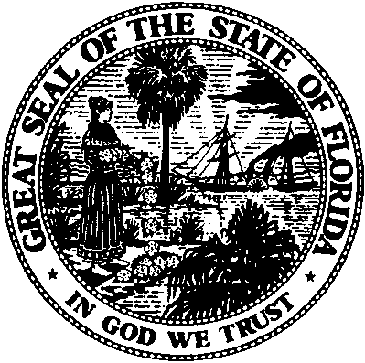 |  | Public Service Commission  Capital Circle Office Center ● 2540 Shumard Oak Boulevard  Tallahassee, Florida 32399-0850  -M-E-M-O-R-A-N-D-U-M-
DATE: | July 28, 2016
TO: | Office of Commission Clerk (Stauffer)
FROM: | Division of Economics (Guffey)  Office of the General Counsel (Trierweiler)
RE: | Docket No. 160152-EU – Joint petition for approval of territorial agreement in Lake County by Sumter Electric Cooperative, Inc. and City of Mount Dora.
AGENDA: | 08/09/16 – Regular Agenda – Proposed Agency Action – Interested Persons May Participate
COMMISSIONERS ASSIGNED: |  |  | All Commissioners
PREHEARING OFFICER: |  |  | Graham
CRITICAL DATES: |  |  | None
SPECIAL INSTRUCTIONS: |  |  | None

Case Background
On June 17, 2016, the City of Mount Dora (Mount Dora) and Sumter Electric Cooperative, Inc. (SECO) filed a joint petition for approval of their territorial agreement (agreement) in Lake County. The proposed agreement is attached as Exhibit 1 to the petition, while the maps and written descriptions are attached as Composite Exhibit A, Composite Exhibit 2, and Exhibit 3 to the agreement (due to the volume of the exhibits, they have not been attached to this recommendation).

The Commission approved the existing territorial agreement between Mount Dora and SECO in 1996. The existing agreement was for a term of 20 years and the joint petitioners wish to continue this territorial agreement delineating their respective service boundaries in Lake County for a term of 20 years. There will be no customer or facility transfers in this agreement. The Commission has jurisdiction over this matter pursuant to Section 366.04, Florida Statutes (F.S.).

Discussion of Issues

Issue 1:
Should the Commission approve the proposed territorial agreement between Mount Dora and SECO?

Recommendation:
Yes, the Commission should approve the proposed territorial agreement between Mount Dora and SECO. (Guffey)

Staff Analysis:
Pursuant to Section 366.04(2)(d), F.S. and Rule 25-6.0440(2), Florida Administrative Code (F.A.C.), the Commission has the jurisdiction to approve territorial agreements between and among rural electric cooperatives, municipal electric utilities, and other electric utilities. Unless the Commission determines that the agreement will cause a detriment to the public interest, the agreement should be approved.
SECO and Mount Dora executed the new agreement on March 1, 2016, to replace the current agreement that expired in July 2016. Through the proposed agreement, the joint petitioners desire to essentially continue the existing agreement with no changes to the territorial boundary lines and no customer transfers. In response to staff inquiry, the petitioners listed the differences between the current and the proposed agreements. All modifications are designed to address possible future events. The modifications include clarification that the territories will not change as a result of expansion of future municipal boundaries, new details to assist in assigning future new customers to the appropriate service territory, new language requiring referral of future service requests made to the wrong utility be referred to the other party, and revisions to the compensation provisions applicable if and when facilities are transferred in the future.

The proposed agreement will remain in effect for 20 years, and after the initial 20-year term the agreement will automatically renew for successive one-year renewal terms unless a party terminates the agreement with 12 months prior written notification.

Per the petition, no customers will be transferred and there are no extra-territorial customers under the new agreement. Since no customers or facilities are being transferred, there is no purchase price to be considered, and no notice to customers is required pursuant to Rule 25-6.0440(1)(d), F.A.C. Each party to the agreement will operate and maintain its lines and facilities. The joint petitioners assert that the proposed agreement will serve to prevent uneconomic duplication of facilities and therefore the proposed agreement is of public interest and should be approved.

After review of the petition and the proposed agreement, staff believes that the proposed agreement is in the public interest and will enable Mount Dora and SECO to serve their current and future customers. It appears that the proposed agreement eliminates any potential uneconomic duplication of facilities and will not cause a decrease in the reliability of electric service. As such, staff believes that the proposed agreement between Mount Dora and SECO will not cause a detriment to the public interest and recommends that the Commission approve it.

Issue 2:
Should this docket be closed?

Recommendation:
If no protest is filed by a person whose substantial interests are affected within 21 days of the issuance of the Order, this docket should be closed upon the issuance of a Consummating Order. (Trierweiler)

Staff Analysis:
If no protest is filed by a person whose substantial interests are affected within 21 days of the issuance of the Order, this docket should be closed upon the issuance of a Consummating Order.

Order No. PSC-96-0886-FOF-EU, issued July 9, 1996, in Docket No. 960396-EU, In re: Joint petition for approval of territorial agreement between Sumter Electric Cooperative, Inc. and City of Mount Dora.
Utilities Commission of the City of New Smyrna Beach v. Florida Public Service Commission, 469 So. 2d 731 (Fla. 1985).
Email provided to staff on July 12, 2016, has been placed in the docket file.

