State of Florida |  | Public Service Commission  Capital Circle Office Center ● 2540 Shumard Oak Boulevard  Tallahassee, Florida 32399-0850  -M-E-M-O-R-A-N-D-U-M-
DATE: | July 28, 2016
TO: | Office of Commission Clerk (Stauffer)
FROM: | Division of Economics (Guffey)  Office of the General Counsel (Leathers)
RE: | Docket No. 160126-EI – Petition for approval of modifications to the approved premier power tariff and the government underground tariff and for approval of new government cost recovery contract, by Duke Energy Florida, LLC.
AGENDA: | 08/09/16 – Regular Agenda – Tariff Filing – Interested Persons May Participate
COMMISSIONERS ASSIGNED: |  |  | All Commissioners
PREHEARING OFFICER: |  |  | Administrative
CRITICAL DATES: |  |  | 8-Month Effective Date: 1/18/2017  (60-Day Suspension Date Waived by the Utility until 8/9/2016)
SPECIAL INSTRUCTIONS: |  |  | None

Case Background
On May 18, 2016, Duke Energy Florida, LLC (DEF or the company) filed a petition for approval of modifications to its approved premier power service rider (PPS rider) and local government underground cost recovery tariff (underground tariff), and for approval of a new local government underground cost recovery contract. The primary purpose of the PPS rider is to provide back-up supply of electricity service in the event normal electricity supply is interrupted.
Staff issued one data request to DEF on May 27, 2016, for which responses were received on June 7, 2016. On May 24, 2016, DEF provided, by email, its waiver of the Commission’s 60-day deadline, as set forth in Section 366.06(3), Florida Statutes (F.S.), through August 9, 2016. The tariff pages with proposed changes are contained in Attachment A of this recommendation. The Commission has jurisdiction over this matter pursuant to Sections 366.05(1) and 366.06, F.S.

Discussion of Issues

Issue 1:
Should the Commission approve DEF's petition for approval of modifications to its approved PPS rider and underground tariff and for approval of a new local government underground cost recovery contract?

Recommendation:
Yes, the Commission should approve DEF's petition for approval of modifications to its approved PPS rider and underground tariff and for approval of a new local government underground cost recovery contract. (Guffey)

Staff Analysis:
DEF has proposed three modifications to its tariff: (1) allow interruptible and curtailable customers to take service under the PPS rider; (2) clarifications to the underground tariff; and (3) add a new local government underground cost recovery contract form. The three revisions are discussed in detail below.

PPS Rider Modification
The PPS rider is available on a voluntary basis to commercial customers who require on-site generators to serve as back-up electric supply. Pursuant to the PPS rider, DEF installs, operates, and maintains back-up power generators at the customer’s premises and customers are responsible for the cost of the back-up generation. The PPS rider is designed for customers such as hospitals, municipal water and wastewater facilities, and financial institutions. The PPS rider was first approved in 2001 as an experimental tariff for five years. In 2006, the Commission approved modifications and extended the tariff for an additional five years. In 2011, the PPS rider became a permanent tariff.
Currently, the PPS rider is available only to customers taking service under a firm rate schedule. DEF is proposing modifications to its PPS rider tariff Sheet Nos. 6.370 and 6.371 to allow customers taking service under the interruptible and curtailable tariffs to also participate in the PPS rider. In response to staff’s data request, DEF explained that there are customers on the interruptible and curtailable tariffs who have sensitive manufacturing and operational processes and need backup generation to support power quality. DEF further explained that interruptible/curtailable customers have the option to install their own back-up generation on the customer’s side of the meter. However, under certain situations, due to the configuration of facilities it may be more advantageous to the customer from an operational perspective to install a back-up system on the company’s side of the meter through the PPS rider.

Underground Tariff Modification
The underground tariff provides local governments with an optional mechanism for the recovery of the costs of converting overhead electric service to underground service through a fee on DEFs electric bill. The local government underground tariff was approved in 2002. The tariff provides for the calculation of an annual recovery amount, which is the amount collected by DEF through a fee added to individual customer electric bills and remitted to the local government that undertook the conversion project. Only customers on whose behalf the conversion was made would pay the fee.
DEF is proposing minor modifications to its underground tariff Sheet Nos. 4.124 and 4.125 to reformat the formula for the annual recovery amount and to correct cross-references to other sections in DEF’s local government underground tariff. DEF is not proposing to change the calculation of the annual recovery amount.

New Local Government Underground Cost Recovery Contract
DEF’s third request is to seek approval for a new local government underground cost recovery contract form (tariff Sheet Nos. 7.000 and 7.060 through 7.063). Although Section 12.06(7) of the currently approved underground tariff discussed above refers to a cost recovery form, DEF currently does not have an approved standard contract form in its tariff. Accordingly, DEF is requesting approval of this new form, which tracks the requirements of the underground tariff and establishes the specific terms and conditions for underground capital cost recovery. In its response to staff’s first data request, DEF stated that the company has not contracted with any local governments for underground cost recovery to date. The company has had discussions with local governments regarding overhead to underground conversion projects; however, none of the local governments have requested to execute a cost recovery contract to date.

Conclusion
Staff has reviewed DEF’s proposed tariff modifications and responses to staff’s data request and believes the proposed modifications are reasonable. Also, because customers who request service under the PPS rider are responsible for the cost of the back-up generation, the general body of ratepayers is protected. Therefore, staff recommends approval of DEF's petition for approval of modifications to its approved PPS rider and underground tariff, and for approval of a new local government underground cost recovery contract.

Issue 2:
Should this docket be closed?

Recommendation:
If Issue 1 is approved and a protest is filed within 21 days of the issuance of the order, the tariff should remain in effect pending resolution of the protest. If no timely protest is filed, this docket should be closed upon the issuance of a consummating order. (Leathers)

Staff Analysis:
If Issue 1 is approved and a protest is filed within 21 days of the issuance of the order, the tariff should remain in effect pending resolution of the protest. If no timely protest is filed, this docket should be closed upon the issuance of a consummating order.

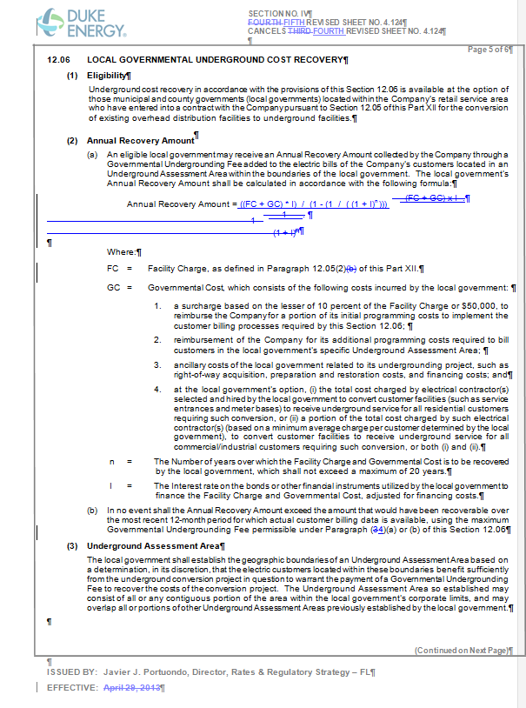

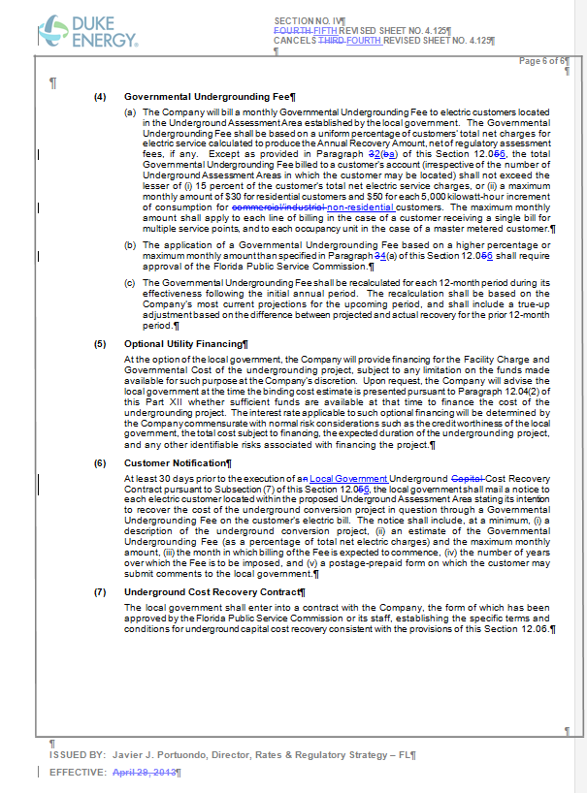

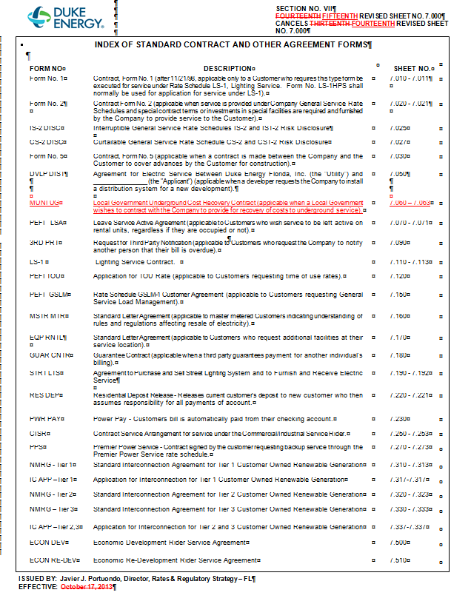

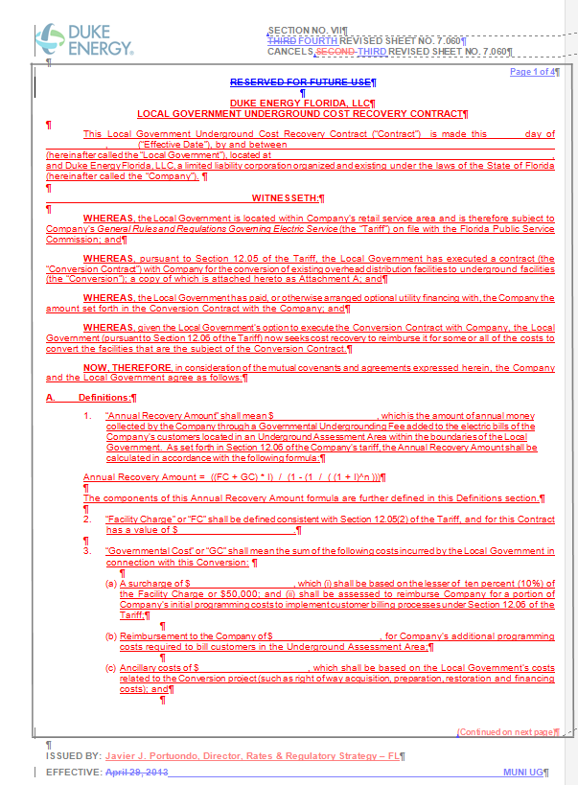

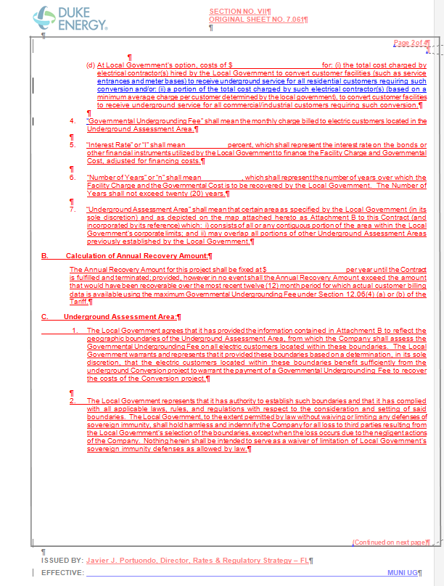
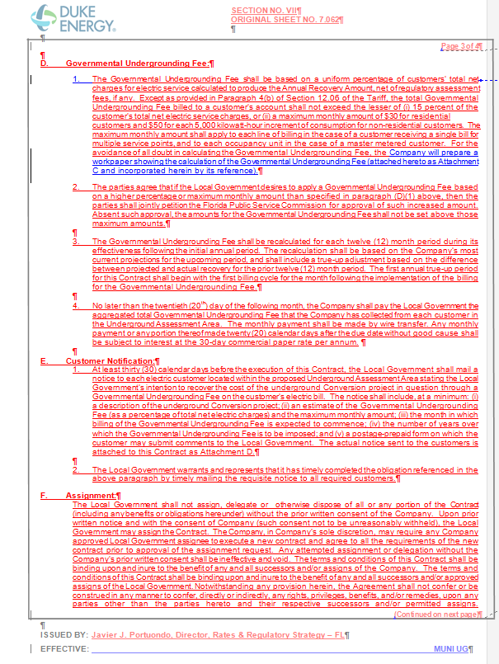

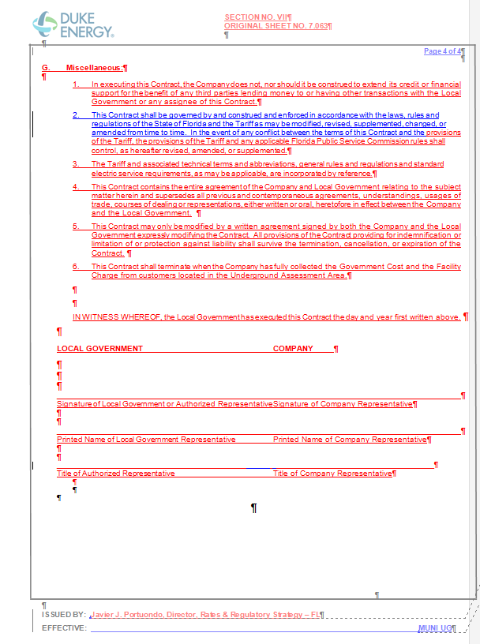

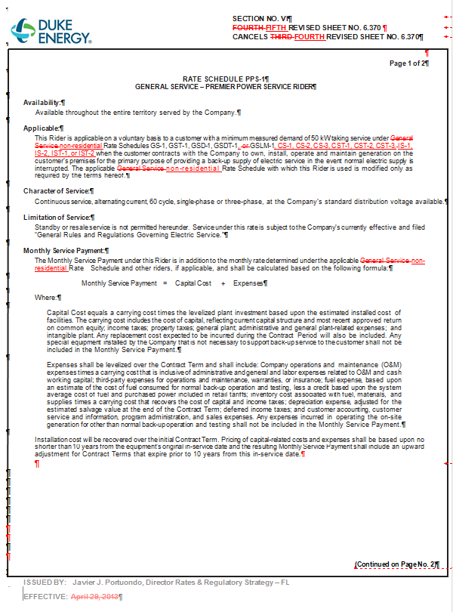

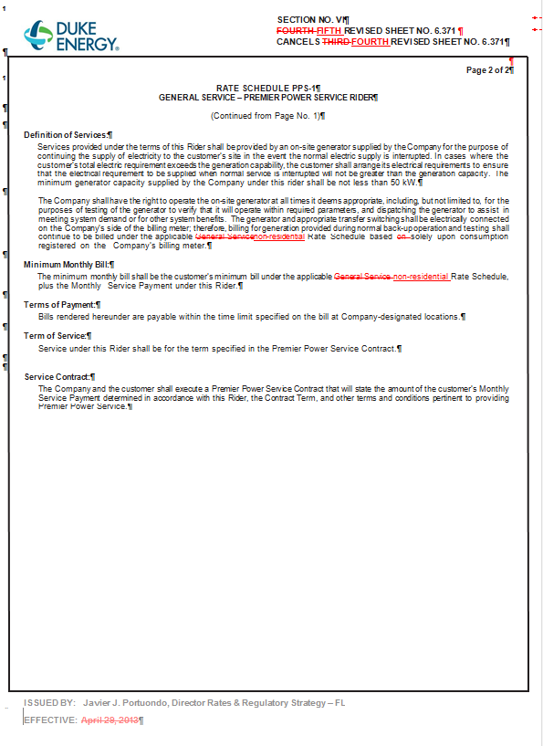

Order No. PSC-01-1648-TRF-EI, issued August 13, 2001, in Docket No. 010373-EI, In re: Petition for approval to provide optional Premier Power Service Rider, Rate Schedule PPS-1, for general service customers by Florida Power Corporation.
Order No. PSC-06-1037-TRF-EI, issued December 18, 2006, in Docket No. 060480-EI, In re: Petition by Progress Energy Florida, Inc. for approval of modification and extension of experimental Premier Power Service Rider, Rate Schedule PPS-1, and for approval of revised Premier Power Service Contract.
Order No. PSC-11-0481-TRF-EI, issued October 25, 2011, in Docket No. 110269-EI, In re: Petition by Progress Energy Florida, Inc. for approval of modification to make the current experimental Premier Power Service Rider, Rate Schedule PPS-1 permanent.
Order No. PSC-02-1629-TRF-EI, issued November 25, 2002, in Docket No. 020993-EI, In re: Petition for approval of Local Government Underground Cost Recovery tariff by Florida Power Corporation.

