BEFORE THE FLORIDA PUBLIC SERVICE COMMISSION

In re: Petition for approval of modifications to the approved premier power tariff and the government underground tariff and for approval of new government cost recovery contract, by Duke Energy Florida, LLC. | DOCKET NO. 160126-EI  ORDER NO. PSC-16-0363-TRF-EI  ISSUED: August 29, 2016

The following Commissioners participated in the disposition of this matter:

JULIE I. BROWN, Chairman
LISA POLAK EDGAR
ART GRAHAM
RONALD A. BRISÉ
JIMMY PATRONIS

ORDER APPROVING DUKE ENERGY FLORIDA, LLC’S MODIFICATIONS TO PREMIER POWER SERVICE RIDER, MODIFICATIONS TO LOCAL GOVERNMENT UNDERGROUND COST RECOVERY TARIFF, AND NEW LOCAL GOVERNMENT UNDERGROUND COST RECOVERY CONTRACT

BY THE COMMISSION:

Background

On May 18, 2016, Duke Energy Florida, LLC (DEF or the company) filed a petition for approval of modifications to its approved premier power service rider (PPS rider) and local government underground cost recovery tariff (underground tariff), and for approval of a new local government underground cost recovery contract. The primary purpose of the PPS rider is to provide back-up supply of electricity service in the event normal electricity supply is interrupted.

Commission staff issued one data request to DEF on May 27, 2016, for which responses were received on June 7, 2016. On May 24, 2016, DEF provided, by email, its waiver of this Commission’s 60-day deadline, as set forth in Section 366.06(3), Florida Statutes (F.S.), through August 9, 2016. The tariff pages with proposed changes are contained in Attachment A of this order. We have jurisdiction over this matter pursuant to Sections 366.05(1) and 366.06, F.S.
Decision
DEF proposed three modifications to its tariff: (1) allow interruptible and curtailable customers to take service under the PPS rider; (2) make clarifications to the underground tariff; and (3) add a new local government underground cost recovery contract form. The three revisions are discussed in detail below.
PPS Rider Modification
The PPS rider is available on a voluntary basis to commercial customers who require on-site generators to serve as back-up electric supply. Pursuant to the PPS rider, DEF installs, operates, and maintains back-up power generators at the customer’s premises and customers are responsible for the cost of the back-up generation. The PPS rider is designed for customers such as hospitals, municipal water and wastewater facilities, and financial institutions. The PPS rider was first approved in 2001 as an experimental tariff for five years. In 2006, this Commission approved modifications and extended the tariff for an additional five years. In 2011, the PPS rider became a permanent tariff.
Currently, the PPS rider is available only to customers taking service under a firm rate schedule. DEF proposed modifications to its PPS rider tariff Sheet Nos. 6.370 and 6.371 to allow customers taking service under the interruptible and curtailable tariffs to also participate in the PPS rider. In response to Commission staff’s data request, DEF explained that there are customers on the interruptible and curtailable tariffs who have sensitive manufacturing and operational processes and need back-up generation to support power quality. DEF further explained that interruptible/curtailable customers have the option to install their own back-up generation on the customer’s side of the meter. However, under certain situations, due to the configuration of facilities it may be more advantageous to the customer from an operational perspective to install a back-up system on the company’s side of the meter through the PPS rider.
Underground Tariff Modification
The underground tariff provides local governments with an optional mechanism for the recovery of the costs of converting overhead electric service to underground service through a fee on DEFs electric bill. The local government underground tariff was approved in 2002. The tariff provides for the calculation of an annual recovery amount, which is the amount collected by DEF through a fee added to individual customer electric bills and remitted to the local government that undertook the conversion project. Only customers on whose behalf the conversion was made would pay the fee.
DEF proposed minor modifications to its underground tariff Sheet Nos. 4.124 and 4.125 to reformat the formula for the annual recovery amount and to correct cross-references to other sections in DEF’s local government underground tariff. DEF did not propose to change the calculation of the annual recovery amount.
New Local Government Underground Cost Recovery Contract
DEF’s third request sought approval for a new local government underground cost recovery contract form (tariff Sheet Nos. 7.000 and 7.060 through 7.063). Although Section 12.06(7) of the currently approved underground tariff discussed above refers to a cost recovery form, DEF currently does not have an approved standard contract form in its tariff. Accordingly, DEF requested approval of this new form, which tracks the requirements of the underground tariff and establishes the specific terms and conditions for underground capital cost recovery. In its response to Commission staff’s data request, DEF stated that the company has not contracted with any local governments for underground cost recovery to date. The company has had discussions with local governments regarding overhead to underground conversion projects; however, none of the local governments have requested to execute a cost recovery contract to date.
Conclusion
This Commission reviewed DEF’s proposed tariff modifications and responses to Commission staff’s data request and finds that the proposed modifications are reasonable. We also find that, because customers who request service under the PPS rider are responsible for the cost of the back-up generation, the general body of ratepayers is protected. Therefore, this Commission finds that DEF's petition for approval of modifications to its approved PPS rider and underground tariff, and for approval of a new local government underground cost recovery contract shall be approved.
Based on the foregoing, it is
ORDERED by the Florida Public Service Commission that Duke Energy Florida, LLC’s petition for approval of modifications to its approved premier power service rider and local government underground cost recovery tariff, and for approval of a new local government underground cost recovery contract is hereby approved. It is further
ORDERED that if a protest is filed within 21 days of issuance of this Order, the tariff shall remain in effect pending resolution of the protest. It is further

ORDERED that if no timely protest is filed, this docket shall be closed upon the issuance of a Consummating Order.

By ORDER of the Florida Public Service Commission this 29th day of August, 2016.

/s/ Carlotta S. Stauffer
CARLOTTA S. STAUFFER
Commission Clerk
Florida Public Service Commission
2540 Shumard Oak Boulevard
Tallahassee, Florida 32399
(850) 413-6770
www.floridapsc.com

Copies furnished: A copy of this document is provided to the parties of record at the time of issuance and, if applicable, interested persons.

MAL

NOTICE OF FURTHER PROCEEDINGS

The Florida Public Service Commission is required by Section 120.569(1), Florida Statutes, to notify parties of any administrative hearing or judicial review of Commission orders that is available under Sections 120.57 or 120.68, Florida Statutes, as well as the procedures and time limits that apply. This notice should not be construed to mean all requests for an administrative hearing or judicial review will be granted or result in the relief sought.

Mediation may be available on a case-by-case basis. If mediation is conducted, it does not affect a substantially interested person's right to a hearing.

The Commission's decision on this tariff is interim in nature and will become final, unless a person whose substantial interests are affected by the proposed action files a petition for a formal proceeding, in the form provided by Rule 28-106.201, Florida Administrative Code. This petition must be received by the Office of Commission Clerk, 2540 Shumard Oak Boulevard, Tallahassee, Florida 32399-0850, by the close of business on September 19, 2016.

In the absence of such a petition, this Order shall become final and effective upon the issuance of a Consummating Order.

Any objection or protest filed in this docket before the issuance date of this order is considered abandoned unless it satisfies the foregoing conditions and is renewed within the specified protest period.

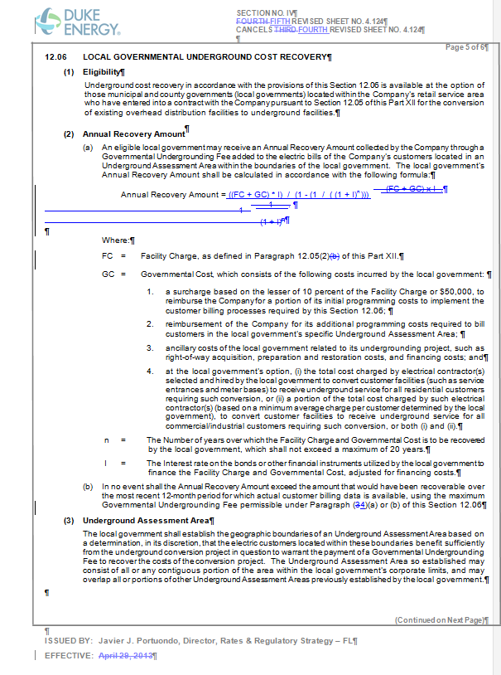

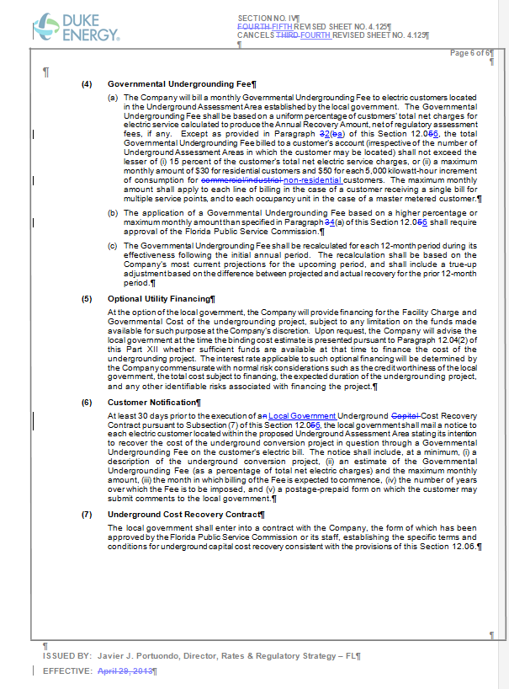

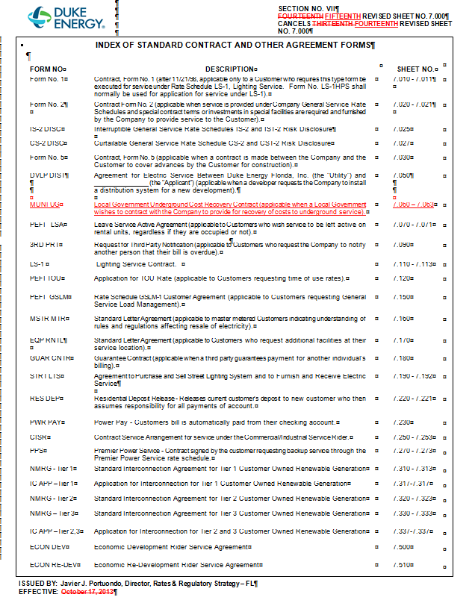

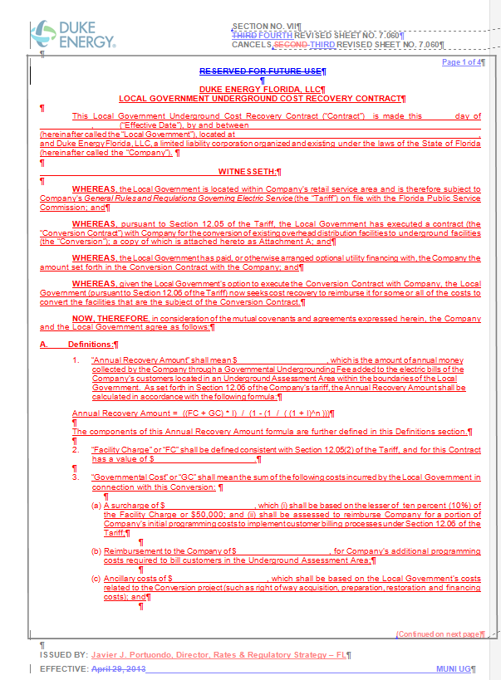

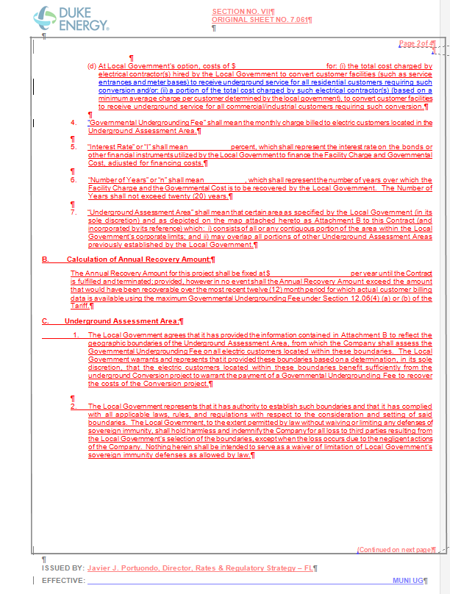
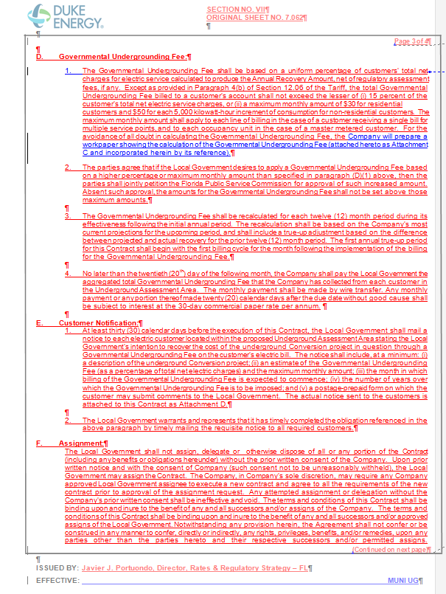

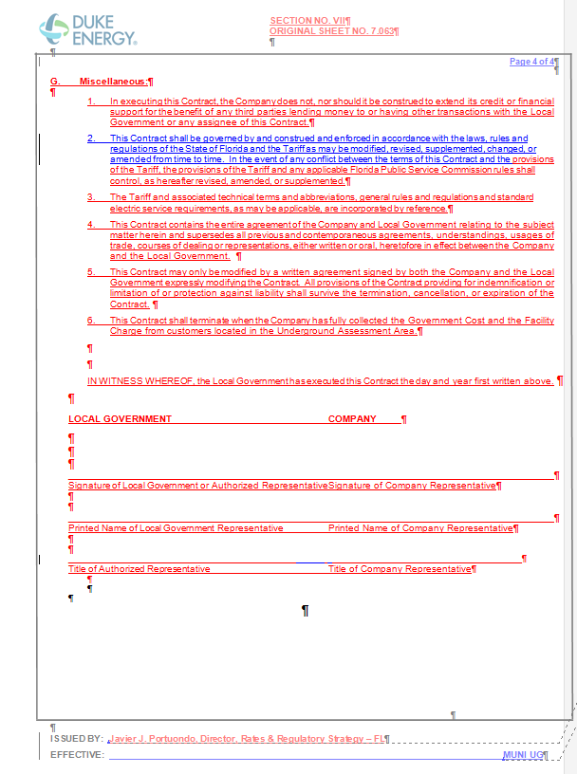
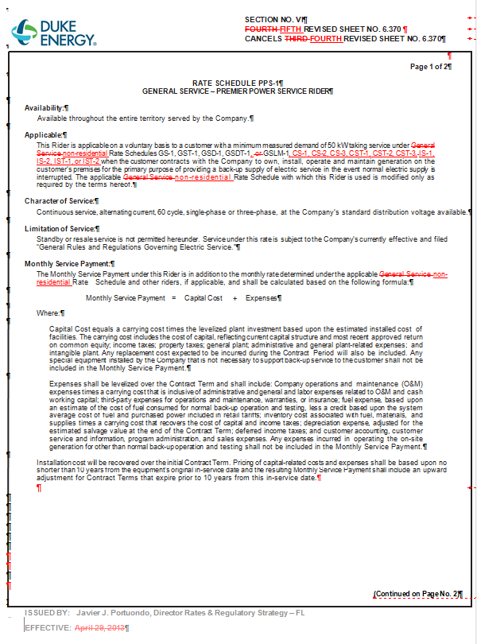
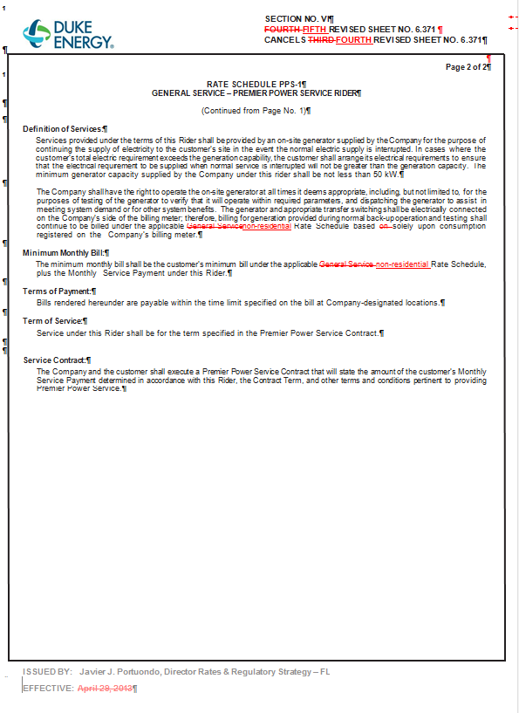

Order No. PSC-01-1648-TRF-EI, issued August 13, 2001, in Docket No. 010373-EI, In re: Petition for approval to provide optional Premier Power Service Rider, Rate Schedule PPS-1, for general service customers by Florida Power Corporation.
Order No. PSC-06-1037-TRF-EI, issued December 18, 2006, in Docket No. 060480-EI, In re: Petition by Progress Energy Florida, Inc. for approval of modification and extension of experimental Premier Power Service Rider, Rate Schedule PPS-1, and for approval of revised Premier Power Service Contract.
Order No. PSC-11-0481-TRF-EI, issued October 25, 2011, in Docket No. 110269-EI, In re: Petition by Progress Energy Florida, Inc. for approval of modification to make the current experimental Premier Power Service Rider, Rate Schedule PPS-1 permanent.
Order No. PSC-02-1629-TRF-EI, issued November 25, 2002, in Docket No. 020993-EI, In re: Petition for approval of Local Government Underground Cost Recovery tariff by Florida Power Corporation.

