State of Florida |  | Public Service Commission  Capital Circle Office Center ● 2540 Shumard Oak Boulevard  Tallahassee, Florida 32399-0850  -M-E-M-O-R-A-N-D-U-M-
DATE: | August 31, 2016
TO: | Office of Commission Clerk (Stauffer)
FROM: | Division of Engineering (Ellis)  Division of Accounting and Finance (Barrett, Lester)  Office of the General Counsel (Janjic)
RE: | Docket No. 160151-EI – Petition for approval of stipulation to amend revised and restated stipulation and settlement agreement by Duke Energy Florida, LLC.
AGENDA: | 09/13/16 – Regular Agenda – Proposed Agency Action – Interested Persons May Participate
COMMISSIONERS ASSIGNED: |  |  | All Commissioners
PREHEARING OFFICER: |  |  | Brisé
CRITICAL DATES: |  |  | None
SPECIAL INSTRUCTIONS: |  |  | None

Case Background
In 2013, Duke Energy Florida, LLC (DEF) announced its decision to retire its nuclear plant, Crystal River Unit 3 (CR3), in Citrus County, Florida. The retirement of CR3 was the subject of two settlement agreements. The first settlement agreement, reached in 2012, was a global settlement that addressed several issues, including issues related to a potential CR3 retirement. The second settlement agreement, the Revised and Restated Stipulation and Settlement Agreement (RRSSA), reached in 2013, replaced and supplanted the 2012 settlement agreement. The parties to the RRSSA were DEF, the Office of Public Counsel (OPC), the Florida Industrial Power Users Group (FIPUG), the Florida Retail Federation (FRF), and White Springs Agricultural Chemicals, Inc., d/b/a PCS Phosphate (PCS Phosphate).
The RRSSA contemplated that DEF would recover through increased base rate charges the combined costs of two items associated with the retirement of CR3, the projected Dry Cask Storage (DCS) facility costs and the CR3 Regulatory Asset. Subsequent to approval of the RRSSA, the Commission approved two amendments. Collectively, these amendments allowed for securitization of the CR3 Regulatory Asset, leaving only the DCS facility costs to be recovered through base rates.
On June 15, 2016, DEF filed a petition for approval of a Third Stipulation to Amend the RRSSA (Third RRSSA Amendment). All parties to the RRSSA, including DEF, OPC, FIPUG, FRF, and PCS Phosphate, are signatories to the Third RRSSA Amendment.
The Commission has jurisdiction pursuant to Sections 366.04 and 366.05, Florida Statutes (F.S.).

Discussion of Issues

Issue 1:
Should DEF’s petition to approve the Third Stipulation to Amend the RRSSA (Third RRSSA Amendment) be approved?

Recommendation:
Yes. The Third RRSSA Amendment contained in Attachment A of this recommendation is in the public interest and should be approved. Recovery of the Dry Cask Storage (DCS) facility costs through the Capacity Cost Recovery Clause (CCR Clause) would allow annual review and adjustment, including potential credits from Department of Energy (DOE) awards. (Ellis)

Staff Analysis:
In its petition for approval of the Third RRSSA Amendment, attached to this recommendation as Attachment A, DEF states that the parties requested changes would shift recovery of the DCS facility costs from increases in base rates to the CCR Clause. Prior to the modifications, DCS facility costs would have been recovered through uniform percentage increases in demand and energy rates, updated at least once every 4 years for a period up to 20 years, and with true-up through the CCR Clause.
Recognizing a previous Commission decision, the deferral of amortization for some costs associated with the DCS facility is included in the Third RRSSA Amendment. The time period for amortization of capital costs associated with the DCS could also be modified through agreement of all parties and approval of the Commission. Cost allocation would remain based upon the methodology outlined in the RRSSA.
The Third RRSSA Amendment alters two paragraphs within the RRSSA to reflect the shift from base rates to the CCR Clause. Paragraph 5(e)(1) is amended to reflect the DCS facility costs are not to be combined with the CR3 Regulatory Asset, but rather are to be recovered through the CCR Clause. DEF states the parties determined that to preserve the intended cost recovery allocation of DCS facility costs, the Third RRSSA Amendment is necessary given the change in circumstances of the CR3 Regulatory Asset. As noted by DEF in response to staff’s data request, the CR3 Regulatory Asset was securitized in June 2016 and is now held in a bankruptcy-remote facility and for all intents and purposes is isolated from further regulatory action. DEF notes it did not seek to add the DCS facility costs to this balance for securitization due to outstanding legal actions with the DOE stemming from its failure to remove spent nuclear fuel from the CR3 facility. If approved, DEF would also be required to credit the CCR Clause for any applicable award from the DOE. The Commission would have an opportunity to review DCS facility costs on an annual basis in the CCR Clause proceedings, including DOE awards.
Paragraph 21, which addresses those portions of the RRSSA that extend beyond December 2018, is amended to reflect that recovery of DCS facility costs through the CCR Clause may continue past 2018. Prior to the modifications, the recovery of DCS facility costs would have ended with the CR3 Regulatory Asset or approximately 20 years.

Conclusion
Staff agrees that the Third RRSSA Amendment contained in Attachment A of this recommendation is in the public interest and should be approved. Recovery of the DCS facility costs through the CCR Clause would allow annual review and adjustment, including potential credits from DOE awards.

Issue 2:
Should this docket be closed?

Recommendation:
Yes. This docket should be closed upon issuance of a consummating order, unless a person whose substantial interests are affected by the Commission’s decision files a protest within 21 days of the issuance of the Commission’s Proposed Agency Action Order. (Janjic)

Staff Analysis:
This docket should be closed upon issuance of a consummating order, unless a person whose substantial interests are affected by the Commission’s decision files a protest within 21 days of the issuance of the Commission’s Proposed Agency Action Order.

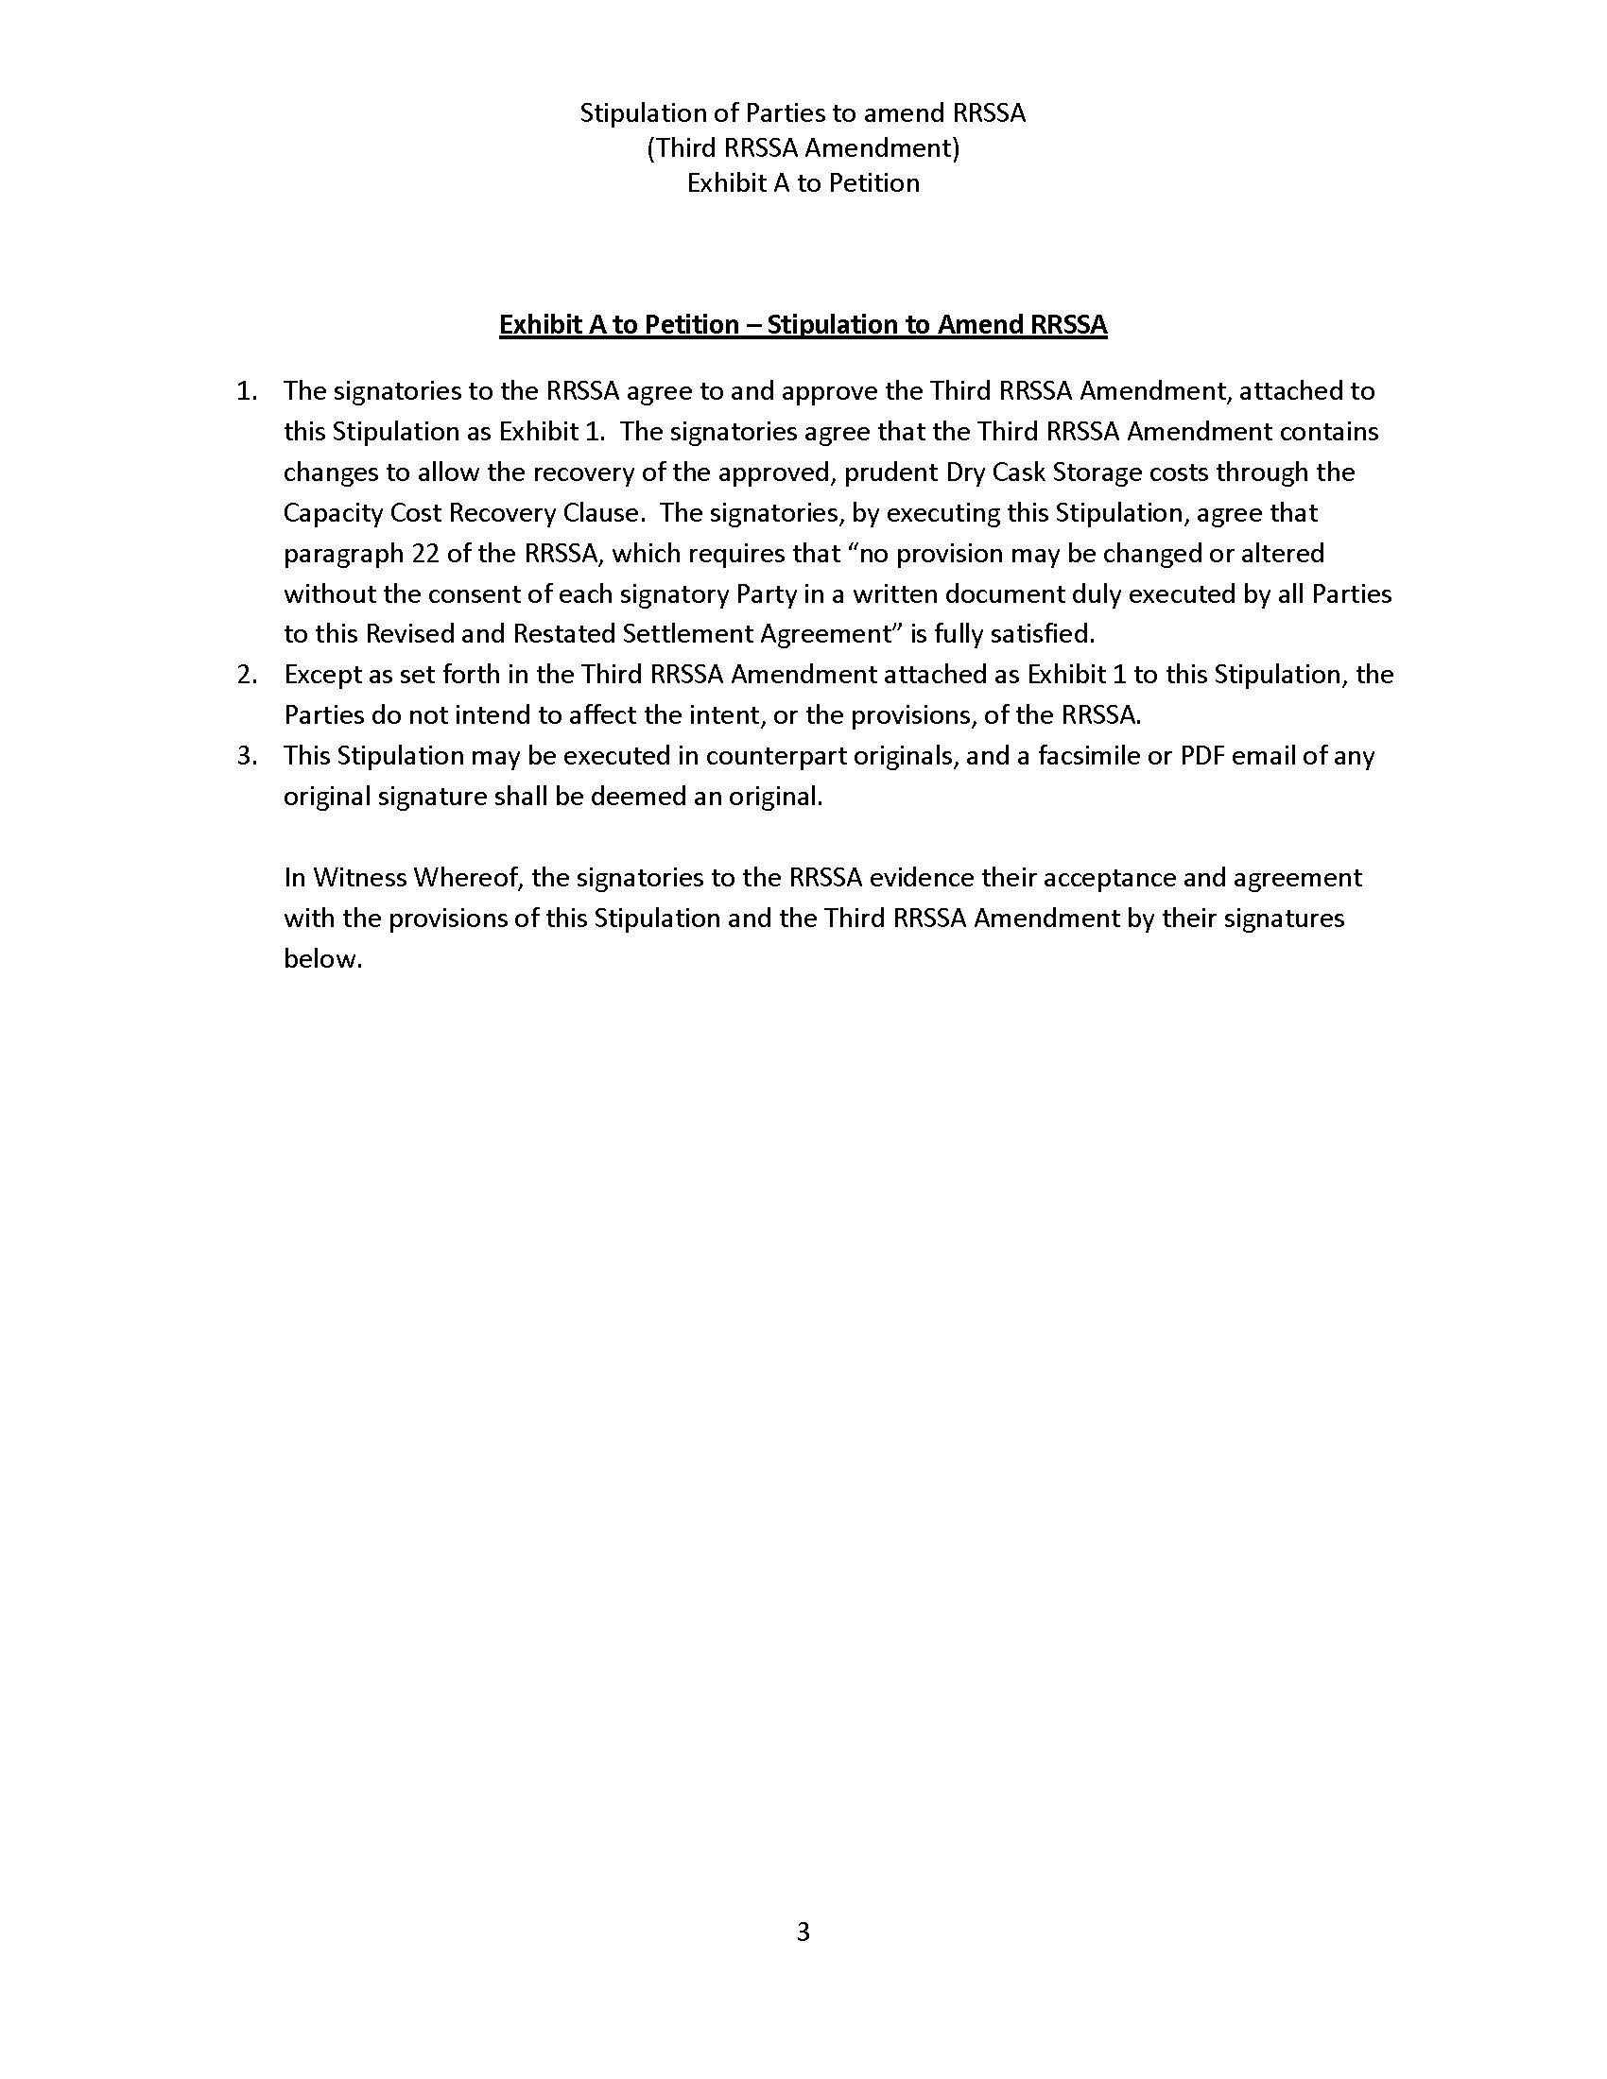

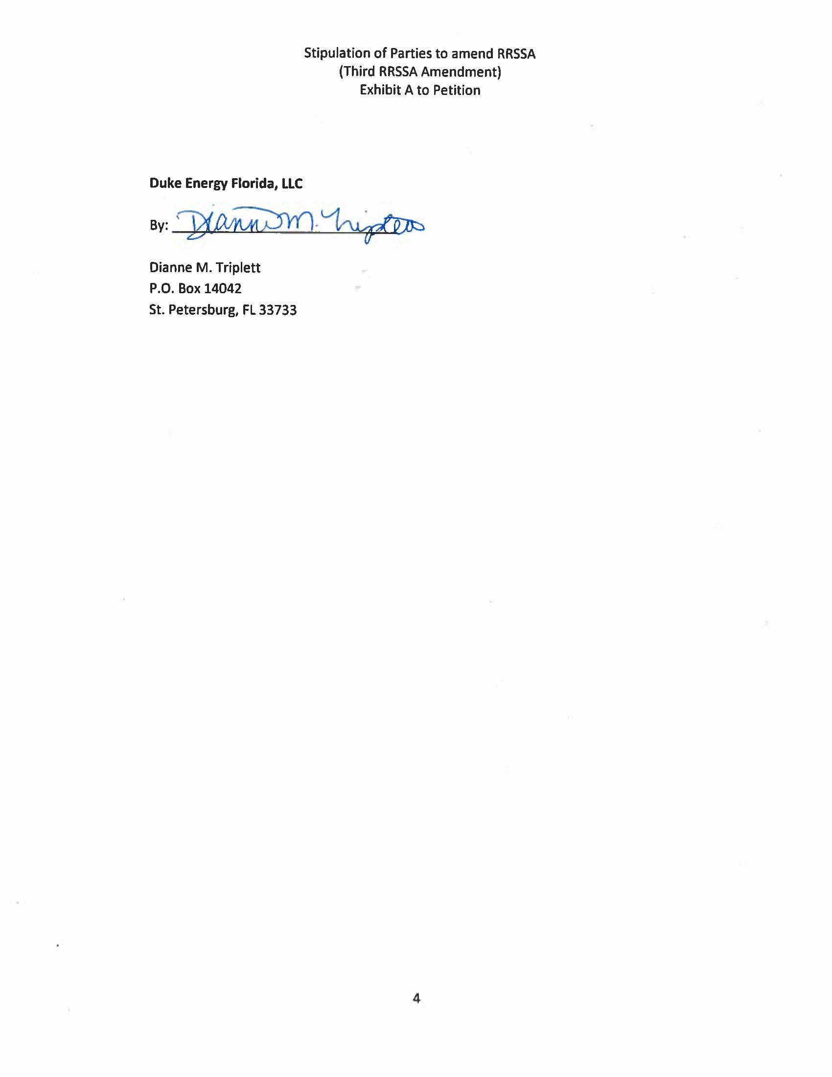

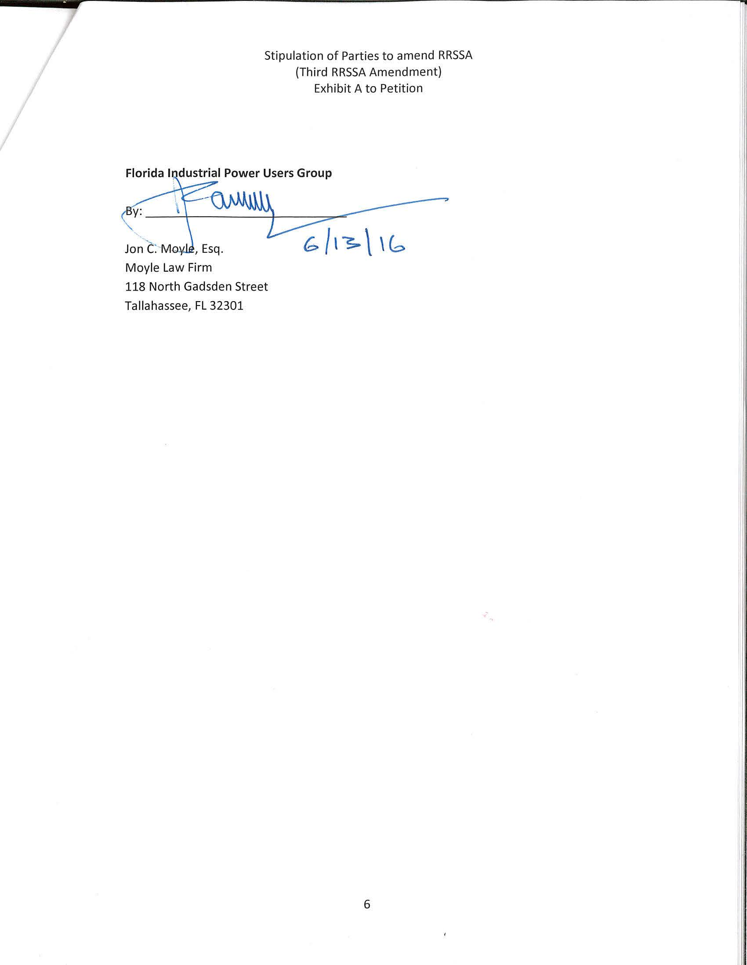

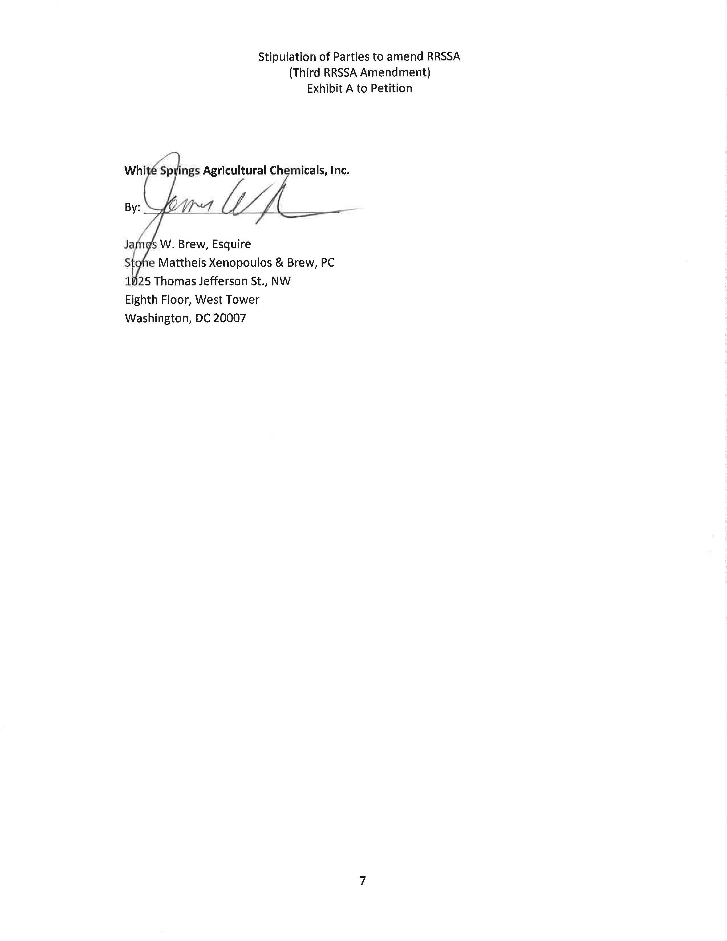

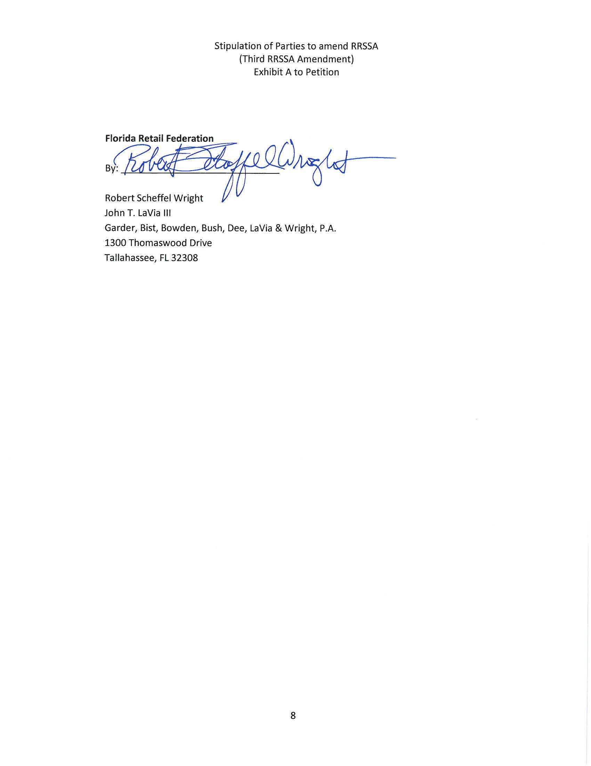

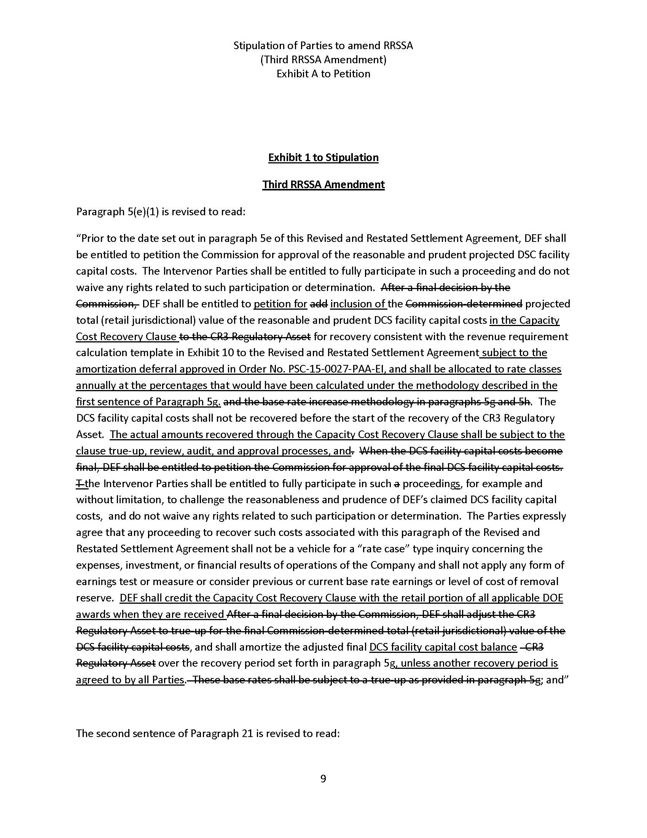

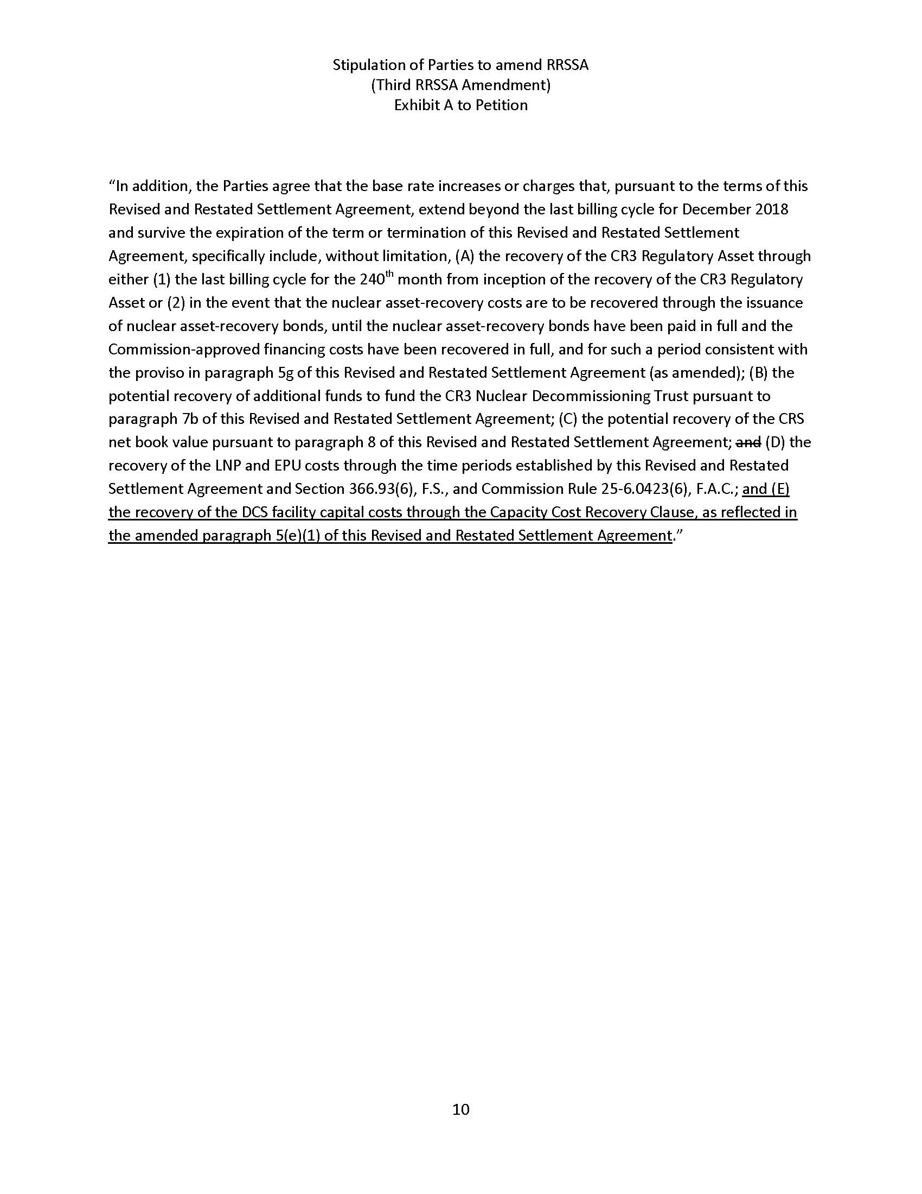

Order No. PSC-12-0104-FOF-EI, issued March 8, 2012, in Docket No. 120022-EI, In re: Petition for limited proceeding to approve stipulation and settlement agreement by Progress Energy Florida, Inc.
Order No. PSC-13-0598-FOF-EI, issued November 12, 2013, in Docket No. 130208-EI, In re: Petition for limited proceeding to approve revised and restated stipulation and settlement agreement by Duke Energy Florida, Inc. d/b/a Duke Energy.
Order No. PSC-15-0465-S-EI, issued October 14, 2015, in Docket Nos. 150148-EI, In re: Petition for approval to include in base rates the revenue requirement for the CR3 regulatory asset, by Duke Energy Florida, Inc. and 150171-EI, In re: Petition for issuance of nuclear asset-recovery financing order, by Duke Energy Florida, Inc. d/b/a Duke Energy, and Order No. PSC-16-0138-FOF-EI, issued April 5, 2016, in Docket Nos. 150148-EI, In re: Petition for approval to include in base rates the revenue requirement for the CR3 regulatory asset, by Duke Energy Florida, Inc. and 150171-EI, In re: Petition for issuance of nuclear asset-recovery financing order, by Duke Energy Florida, Inc. d/b/a Duke Energy.
Order No. PSC-15-0027-PAA-EI, issued January 7, 2015, in Docket No. 140113-EI, In re: Petition for approval to construct an independent spent fuel storage installation and an accounting order to defer amortization pending recovery from the Department of Energy, by Duke Energy Florida, Inc.

