State of Florida |  | Public Service Commission  Capital Circle Office Center ● 2540 Shumard Oak Boulevard  Tallahassee, Florida 32399-0850  -M-E-M-O-R-A-N-D-U-M-
DATE: | August 31, 2016
TO: | Office of Commission Clerk (Stauffer)
FROM: | Division of Economics (Guffey)  Office of the General Counsel (Mapp)
RE: | Docket No. 160173-EI – Petition for approval of modification to and extension of the approved economic development and re-development rider experimental pilot tariffs, by Duke Energy Florida, LLC.
AGENDA: | 09/13/16 – Regular Agenda – Tariff Filing - Interested Persons May Participate
COMMISSIONERS ASSIGNED: |  |  | All Commissioners
PREHEARING OFFICER: |  |  | Administrative
CRITICAL DATES: |  |  | 09/19/16 (60-Day Suspension Date)
SPECIAL INSTRUCTIONS: |  |  | None

Case Background
On July 19, 2016, Duke Energy Florida, LLC (DEF or company) filed a petition requesting approval of modifications to and an extension of the approved pilot Economic Development (ED-1) and Economic Re-Development (EDR-1) riders (economic development riders). Modifications to these tariffs (Sheet Nos. 6.380 and 6.385) are needed to continue the pilot program for an additional three years, along with clarifications to the accompanying standard service agreement forms (Sheet Nos. 7.500 and 7.510). The tariffs and forms in this petition were initially approved by the Commission in Order No. PSC-13-0598-FOF-EI as part of DEFs’ Revised and Restated Stipulation and Settlement Agreement (RRSSA). Paragraph 17 and Exhibit 15 of the RRSSA provided that DEF introduce these tariffs on a pilot basis for three years (from October 2013 to October 2016). The riders, which require a five-year electric service contract, provide base rate credits/reduction for new businesses that meet certain requirements such as minimum load, job creation, and verification that the availability of the riders are a significant factor in the customer’s location or expansion decision.
Staff issued one data request to DEF on August 4, 2016, for which responses were received on August 12, 2016. The tariff pages and service agreement forms with proposed changes are contained in Attachment A of this recommendation. The Commission has jurisdiction over this matter pursuant to Sections 288.035 and 366.06, Florida Statutes.

Discussion of Issues

Issue 1:
Should the Commission approve DEF's petition to extend its economic development riders until October 17, 2019, and approve the revised service agreement forms?

Recommendation:
Yes, the Commission should approve DEF's petition to extend its economic development riders until October 17, 2019, and approve the revised service agreement forms. (Guffey)

Staff Analysis:
The economic development riders are designed to attract new commercial and industrial customers to DEF’s service territory and foster economic growth. The riders offer base rate electric price incentives over a five-year period for new or expanding businesses that meet certain electric load, capital investment, and job creation requirements. As shown in Table 1-1, the two riders require that the rider customers hire and maintain the following number of full-time employees.
Table 1-1
Required Full Time Employees & Capital Investments
Rider | Minimum kW Load | Number of FTEs | Capital Investment
ED-1 | 500 | 25 | $500,000 or greater
EDR-1 | 350 | 15 | $200,000 or greater
Source: Tariff Sheet Nos. 6.380 & 6.385
To take service under the subject riders, the customers must agree to a minimum five-year service agreement and the company will request verification from the rider customers of the number of jobs created as a direct result of the riders. DEF states that the first ED-1 customer enrolled in April 2014, and since then DEF has attracted five more customers for a total of six (one EDR-1 customer and five ED-1 customers) that has the potential to create 968 FTE jobs. DEF is also working on attracting additional customers for whom the economic development rider is a significant factor in their location/expansion decisions. DEF proposes to extend the pilot program for an additional three years, until October 17, 2019.
Table 1-2 illustrates the credits that will be applied to base demand and energy charges.

Table 1-2
Percentage Reduction in Base Demand & Energy Charges
Year | ED-1 | EDR-1
1 | 50% | 50%
2 | 40% | 35%
3 | 30% | 15%
4 | 20% | 0%
5 | 10% | 0%
Source: Tariff Sheet Nos. 6.380 & 6.385
The company, in its response to staff’s data request and a follow-up request, stated that the enrolled customers are currently not taking service under the economic development riders because they are not yet ready to commence their respective discounts. The single EDR-1 applicant who is in the process of ramping up the operation expects to meet the minimum service threshold by September 2016. Of the five ED-1 applicants, four are ramping up their new operations by installing new equipment, increasing product output and/or adding more shifts/increasing hours of operation. However, these four customers have not yet met the minimum ED-1 kW demand and/or load factor threshold. The company estimates these customers might receive their discounts in September 2017. The fifth ED-1 applicant has yet to construct their building.

DEF’s petition states that the company is not requesting the pilot tariffs be made permanent at this time, because the company wants additional time to market the tariff and determine customers’ interest in the program. In response to a staff’s data request and follow-up question regarding if the company would make the riders permanent after October 17, 2019, DEF stated that if this petition is approved, DEF would make a request to the Commission on or before October 17, 2019 to: (1) continue the riders as is; (2) continue the riders with modifications based on the experienced gained from the current customers; or (3) discontinue the riders.

The riders appear to be successful in attracting new load and incremental base revenues to DEF’s service territory, which benefits the general body of ratepayers. Therefore, staff recommends that the Commission approve DEF’s petition for an extension of its economic development riders until October 17, 2019 and approve the revised service agreement forms as shown in Attachment A to this recommendation.

Issue 2:
Should this docket be closed?

Recommendation:
If Issue 1 is approved and a protest is filed within 21 days of the issuance of the order, the tariff should remain in effect pending resolution of the protest. If no timely protest is filed, this docket should be closed upon the issuance of a consummating order. (Mapp)

Staff Analysis:
If Issue 1 is approved and a protest is filed within 21 days of the issuance of the order, the tariff should remain in effect pending resolution of the protest. If no timely protest is filed, this docket should be closed upon the issuance of a consummating order.

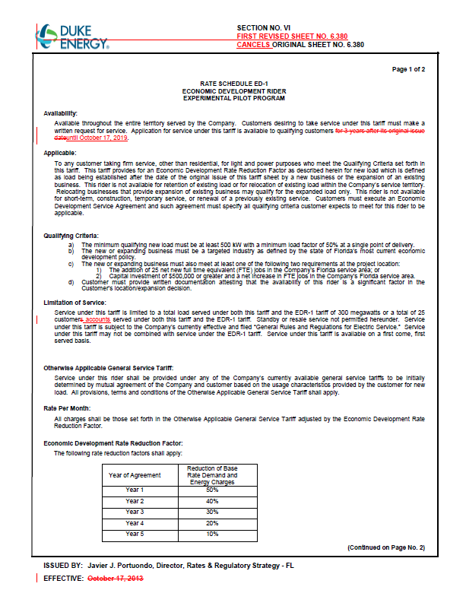
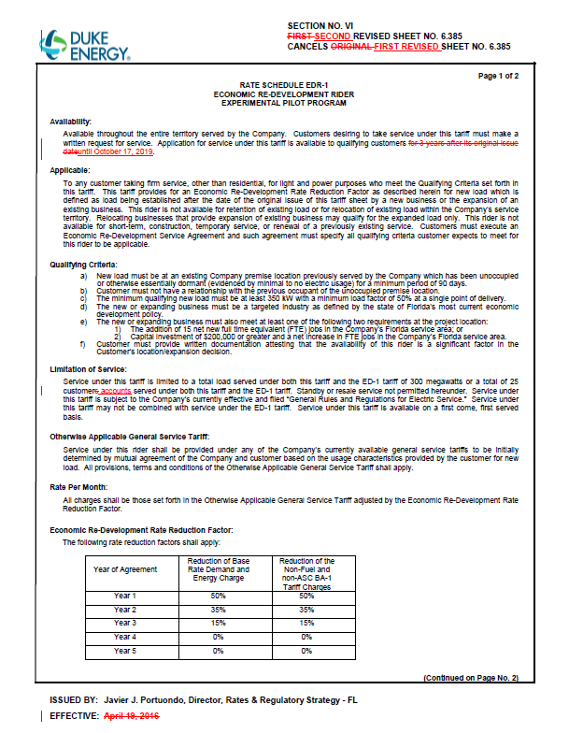
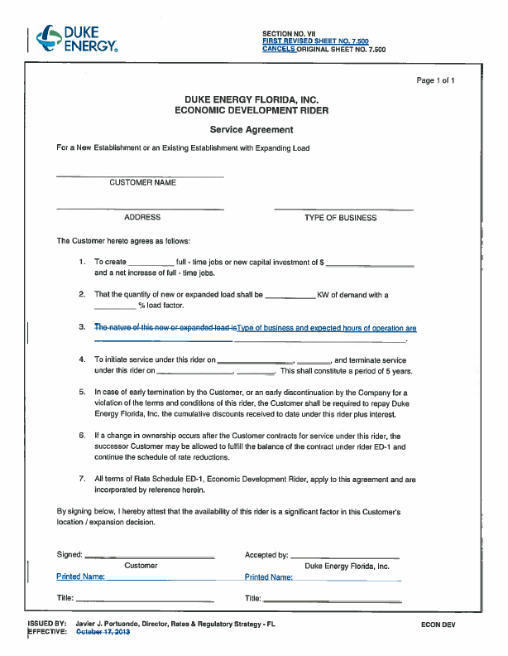
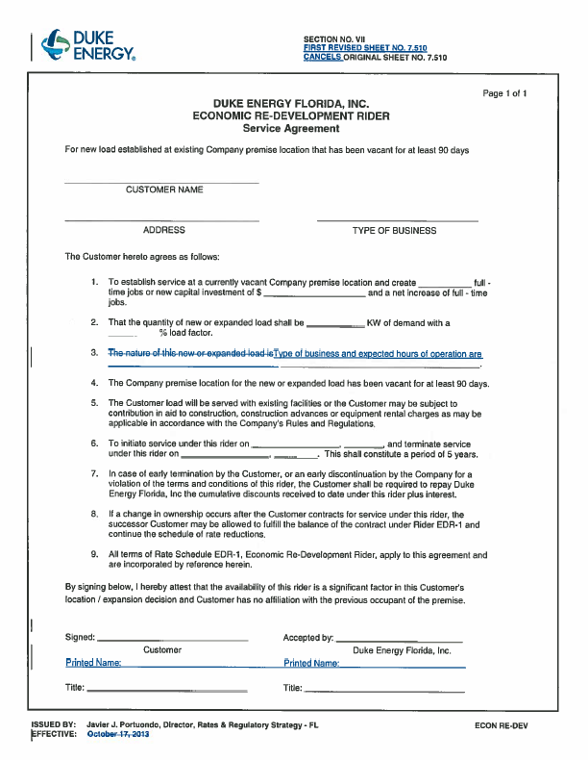

Order No. PSC-13-0598-FOF-EI, issued November 12, 2013, in Docket No. 130208-EI, In re: Petition for limited proceeding to approve revised and restated stipulation and settlement agreement by Duke Energy Florida, Inc. d/b/a Duke Energy.
The EDR-1 rider also provides a reduction of the non-fuel and non-asset securitization charge factors.

