State of Florida |  | Public Service Commission  Capital Circle Office Center ● 2540 Shumard Oak Boulevard  Tallahassee, Florida 32399-0850  -M-E-M-O-R-A-N-D-U-M-
DATE: | August 31, 2016
TO: | Office of Commission Clerk (Stauffer)
FROM: | Division of Economics (Ollila)  Division of Engineering (Wooten)  Office of the General Counsel (Janjic)
RE: | Docket No. 160071-EI – Petition for approval of 2016 revisions to underground residential and commercial differential tariffs, by Florida Power & Light Company.
AGENDA: | 09/13/16 – Regular Agenda – Tariff Filing – Interested Persons May Participate
COMMISSIONERS ASSIGNED: |  |  | All Commissioners
PREHEARING OFFICER: |  |  | Patronis
CRITICAL DATES: |  |  | 12/01/16 (8-Month Effective Date)
SPECIAL INSTRUCTIONS: |  |  | None

Case Background
On April 1, 2016, Florida Power & Light Company (FPL) filed a petition for approval of revisions to its underground residential differential (URD) and underground commercial differential (UCD) tariffs. The URD and UCD tariffs apply to new residential and commercial developments and represent the additional costs FPL incurs to provide underground distribution service in place of overhead service. The proposed URD tariffs are contained in Attachment 1 to the recommendation. FPL’s current charges were approved in Order No. PSC-14-0467-TRF-EI (2014 order).
The Commission suspended FPL’s proposed tariffs in Order No. PSC-16-0208-PCO-EI. FPL responded to staff’s first data request on May 10, 2016, and to staff’s second data request on June 1, 2016. On July 29, 2016, FPL filed an amended petition and revised tariff pages. The amended petition removed a new provision FPL proposed in its original petition. The Commission has jurisdiction over this matter pursuant to Sections 366.03, 366.04, 366.05, and 366.06, Florida Statutes.

Discussion of Issues

Issue 1:
Should the Commission approve FPL's proposed URD tariff and associated charges filed in the amended petition?

Recommendation:
Yes. The Commission should approve FPL’s proposed URD tariffs and associated charges filed in the amended petition, effective October 13, 2016. (Ollila, Wooten)

Staff Analysis:
Rule 25-6.078, Florida Administrative Code (F.A.C.), defines investor-owned utilities’ (IOU) responsibilities for filing updated URD tariffs. IOUs are required to file supporting data and analyses for URD tariffs at least once every three years. In October of each year, IOUs are required to file an updated cost differential using current labor and material costs. If the October cost differential varies from the Commission-approved differential by plus or minus 10 percent or more, then the IOU must file revised tariffs, supporting data and analyses the following April even if it has been less than three years. In its October 2015 filing, FPL reported that the updated cost differential, when compared to the 2014 order, decreased by more than 10 percent; therefore, FPL filed the instant petition.
The URD tariffs provide standard charges for underground service in new residential subdivisions and represent the additional costs, if any, the utility incurs to provide underground service in place of standard overhead service. The cost of standard overhead construction is recovered through base rates from all ratepayers. In lieu of overhead construction, customers have the option of requesting underground facilities. Any additional cost is paid by the customer as contribution-in-aid-of construction (CIAC). Typically, the URD customer is the developer of a subdivision.

Traditionally, three standard model subdivision designs have been the basis upon which each IOU submits URD tariff changes for Commission approval: low density, high density, and a high density subdivision where dwelling units take service at ganged meter pedestals (groups of meters at the same physical location). Examples of this last subdivision type include mobile home and recreational vehicle parks. While actual construction may differ from the model subdivisions, the model subdivisions are designed to reflect average overhead and underground subdivisions.
Table 1-1 shows the current and proposed per service lateral URD differential charges for the low and high density subdivisions. The current and proposed URD differential for a ganged meter installation is $0. As shown in Table 1-1, the proposed URD differentials show a decrease for all subdivisions. The primary reason for the decrease in the URD differentials are larger increases in overhead labor and material costs than in underground labor and material costs.

Table 1-1
Comparison of Differential Per Service Lateral
Types of Subdivision | Number of Service Laterals in Subdivision | Current URD Differential | Proposed URD Differential
Low Density | Tier 1 – 200 or more | $165.99 | $0
 | Tier 2 – 85 – 199 | $415.99 | $183.35
 | Tier 3 – less than 85 | $498.99 | $266.35
High Density | Tier 1 – 300 or more | $0 | $0
 | Tier 2 – 100-299 | $105.71 | $0
 | Tier 3 – less than 100 | $188.71 | $57.97
Ganged Meter | All Tiers | $0 | $0
Source: 2014 order and FPL’s 2016 filing
The calculations of the proposed URD charges include (1) updated labor and material costs and associated loading factors, and (2) operational costs. The costs are discussed below.

Labor and Material Costs

The installation costs of both underground and overhead facilities include the labor and material costs to provide primary, secondary, and service distribution lines as well as transformers. The costs of poles are specific to overhead service while the costs of trenching and backfilling are specific to underground service. Current URD charges are based on 2014 data and the proposed charges are based on 2016 data.

The cost of labor increased for overhead activities at approximately twice the rate it increased for underground activities, resulting in a decrease in the differential. FPL explained in response to staff’s first data request that it uses a labor rate that reflects both FPL and contractor labor rates for all overhead and underground activities, as there are no overhead or underground activities that are exclusively performed by FPL or its contractors. Contractual agreements determine the labor rates for both FPL employees and contractors. The overall overhead labor cost increase is primarily the result of increased overhead contractor labor rates, which have increased more than contractor underground labor rates.

Material costs increased for overhead and decreased for underground from 2014 to 2016, further decreasing the differential. FPL explained in response to staff’s first data request that FPL’s 2016 overhead designs incorporated for the first time automated lateral switches or reclosers. These devices automatically mitigate the effects of a lateral interruption, including clearing temporary faults, isolating the impact of an outage, and avoiding field visits to replace blown fuses. Without the reclosers, 2016 overhead material costs would have been less than 2014 costs. According to FPL, the decline in underground material costs is primarily due to prices obtained through competitive bidding and favorable automatic price adjustments from commodity price changes, for example, resin in PVC conduit.
FPL’s proposed URD tariff also includes updated charges to reflect current labor and material costs for additional customer-requested equipment such as feeder mains or switch packages and credits if a customer performs trenching or installs equipment, such as a splice box. The proposed URD tariff also updates charges for installing underground service laterals from overhead systems, and for the replacement of existing overhead and underground services with underground service laterals.

Loading Factors
The stores loading factor is applied to material costs and declined from 9.3 percent in 2014 to 5.44 percent in this filing. The rate is a calculation, which divides year-to-date stores expense by the year-to-date total cost of inventory. FPL explained in its response to staff’s first data request that the decrease is mainly due to an increased level of inventory because of a higher level of construction activity. The 2016 engineering factor is applied to labor and material. It incorporates both engineering and corporate overhead, which were shown separately in the 2014 filing. The combined factor declined from 27.8 percent in 2014 to 26.9 percent in 2016.
Table 1-2 provides the labor and material differential or pre-operational costs. As Table 1-2 shows, in 2016, only the low density cost differential is a positive number ($141.35), indicating that underground labor/material costs are higher than overhead labor/material costs for the low density subdivision.
Table 1-2
Labor and Material Costs (Pre-operational Costs)
Low Density | 2014 Costs | 2016 Costs | Difference
Underground labor/material costs | $2,325.60 | $2,413.84 | $88.24
Overhead labor/material costs | $1,951.61 | $2,272.49 | $320.88
Per service lateral differential | $373.99 | $141.35 | ($232.64)
High Density
Underground labor/material costs | $1,590.63 | $1,640.45 | $49.82
Overhead labor/material costs | $1,510.92 | $1,691.48 | $180.56
Per service lateral differential | $79.71 | ($51.03) | ($130.74)
Ganged Meter
Underground labor/material costs | $1,052.50 | $1,051.82 | ($0.68)
Overhead labor/material costs | $1,213.77 | $1,344.17 | $130.40
Per service lateral differential | ($161.27) | ($292.35) | ($131.08)
Source: 2014 Order and FPL’s 2016 filing

Operational Costs
Rule 25-6.078, F.A.C., requires that the differences in net present value of operational costs between overhead and underground systems, including average historical storm restoration costs over the life of the facilities, be included in the URD charge. The non-storm operational costs represent the cost differential between maintaining and operating an underground versus an overhead system over the life of the facilities. The storm cost component represents storm restoration costs avoided when an area is undergrounded, thereby reducing the cost to restore an overhead system. The avoided storm cost is subtracted from pre-operational and non-storm operational costs, thus reducing the URD differential charge.
FPL’s operational costs, last updated for the 2014 filing, are a five-year average, which according to FPL, mitigate any significant future volatility. FPL explained that average changes in the non-storm and storm operational cost per lot were approximately 2 percent and 1 percent per year, respectively, from 2007-2014.
Table 1-3 presents the pre-operational, non-storm operational, and the avoided storm restoration cost differentials between overhead and underground systems. The proposed differential is $0 when the calculation results in a negative number.
Table 1-3
Components of the URD Charges
Type of Subdivision | Number of Service Laterals in Subdivision | Pre-operational Costs  (A) | Non-storm operational costs  (B) | Avoided Storm costs  (C) | Proposed URD Differentials  (A)+(B)+(C)
Low Density | Tier 1 – 200 or more | $141.35 | $208 | ($416) | $0
 | Tier 2 – 85 – 199 |  | $208 | ($166) | $183.35
 | Tier 3 – less than 85 |  | $208 | ($83) | $266.35
High Density | Tier 1 – 300 or more | ($51.03) | $192 | ($416) | $0
 | Tier 2 – 100 – 299 |  | $192 | ($166) | $0
 | Tier 3 – less than 100 |  | $192 | ($83) | $57.97
Ganged Meter | Tier 1 – 300 or more | ($292.35) | $192 | ($416) | $0
 | Tier 2 – 100 – 299 |  | $192 | ($166) | $0
 | Tier 3 – less than 100 |  | $192 | ($83) | $0
Source: FPL’s 2016 Filing

Conclusion
Staff has reviewed FPL’s proposed URD tariffs and associated charges, its accompanying work papers, and its responses to staff’s data requests. Staff believes the proposed URD tariffs and associated charges are reasonable and recommends approval. FPL requested that the tariffs be made effective 30 days after the Commission vote. Staff recommends that the Commission approve FPL’s proposed URD tariffs and associated charges filed in the amended petition, effective October 13, 2016.

Issue 2:
Should the Commission approve FPL’s proposed UCD tariffs and associated charges filed in the amended petition?

Recommendation:
Yes. The Commission should approve FPL’s proposed UCD tariffs and associated charges filed in the amended petition, effective October 13, 2016. (Ollila, Wooten)

Staff Analysis:
Utilities are not required to file UCD tariffs, as they are not governed by Rule 25-6.078, F.A.C.; however, FPL has chosen to include its proposed UCD tariffs in the instant petition. Although not required to do so, FPL has incorporated the cost effects of hardening its overhead system in the calculation of the UCD charges.
The UCD charges represent additional costs FPL incurs to provide commercial customers with underground distribution service in place of overhead service. Generally, the UCD charges are tailored to specific equipment and material that are utilized to provide underground service to a single or limited number of commercial buildings in distinct and widely varying circumstances.
The UCD tariffs contain charges for commercial underground distribution facilities such as laterals, risers, and hand-holes. In addition, the UCD tariffs provide for credits that apply if the applicant provides trenching and backfilling. The UCD charges are derived from cost estimates of underground commercial facilities and their equivalent overhead designs. The proposed charges are based on FPL’s standard design, estimating practices, and costs as of 2016.
Staff believes the filing of the tariffs is reasonable and promotes transparency and efficiency and reduces controversy regarding the UCD charges. FPL requested that the tariffs be made effective 30 days after the Commission vote. Staff recommends that the Commission approve FPL’s proposed UCD tariffs and associated charges filed in the amended petition, effective October 13, 2016.

Issue 3:
Should this docket be closed?

Recommendation:
If a protest is filed within 21 days of the issuance of the order, this tariff should remain in effect, with any revenues held subject to refund, pending resolution of the protest. If no timely protest is filed, this docket should be closed upon the issuance of a consummating order. (Janjic)

Staff Analysis:
If a protest is filed within 21 days of the issuance of the order, this tariff should remain in effect, with any revenues held subject to refund, pending resolution of the protest. If no timely protest is filed, this docket should be closed upon the issuance of a consummating order.

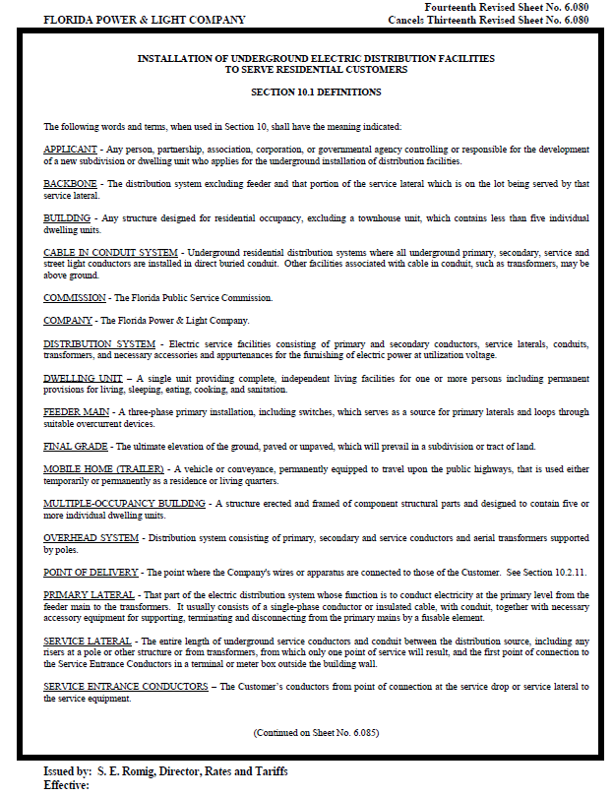
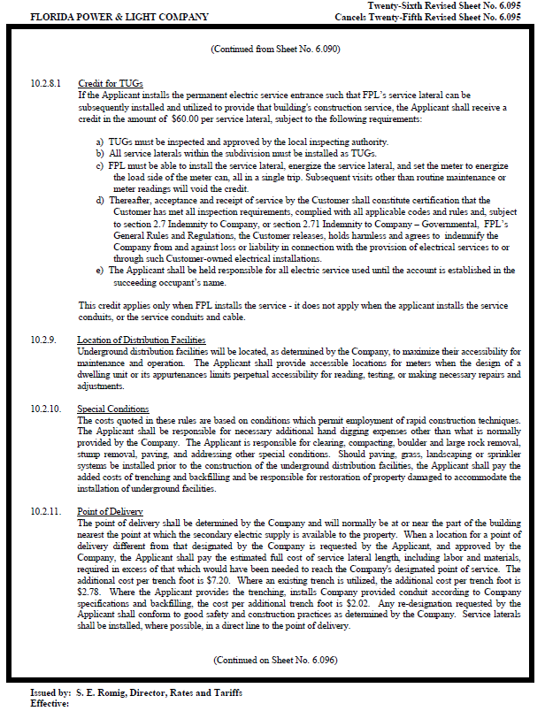
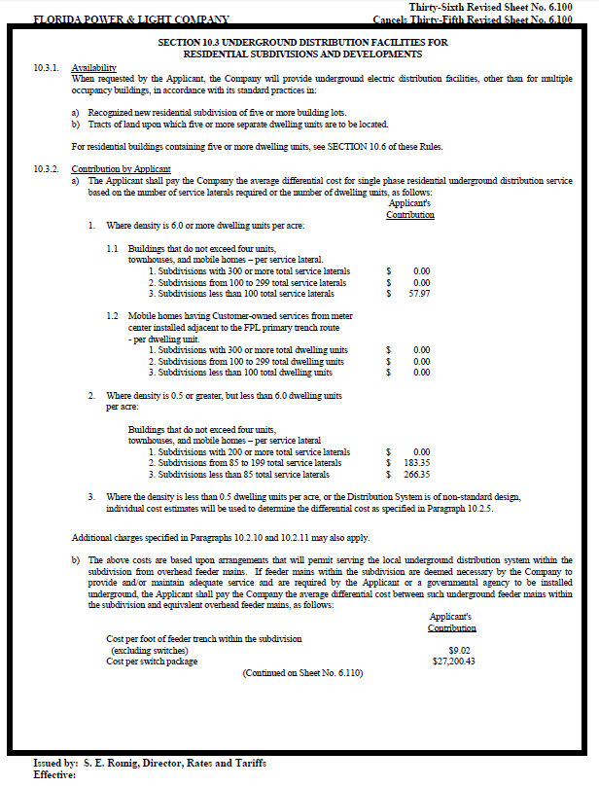
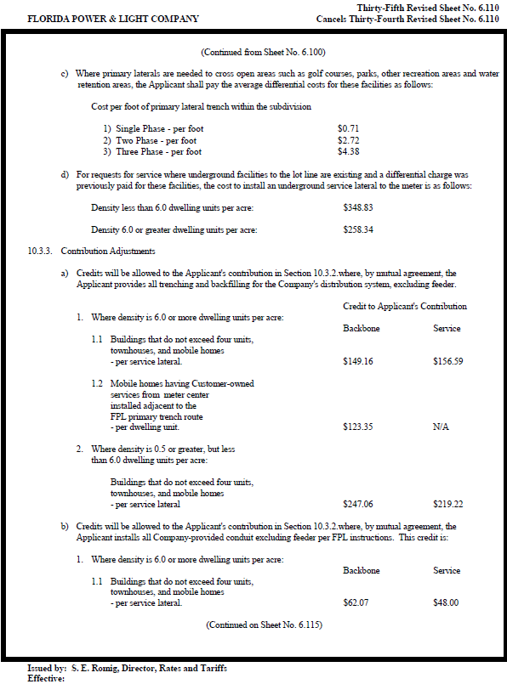
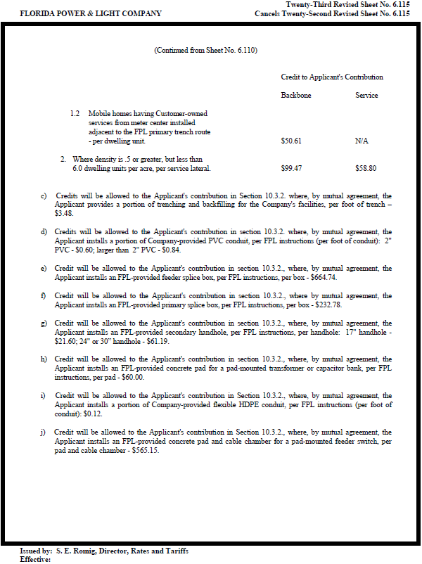
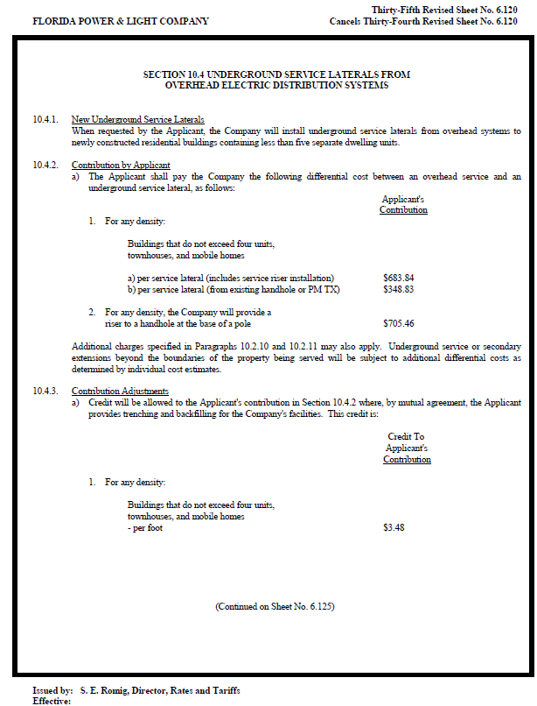
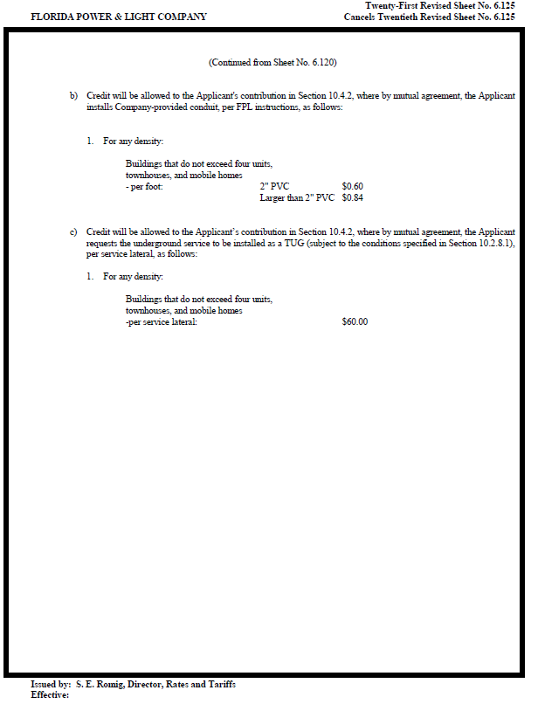
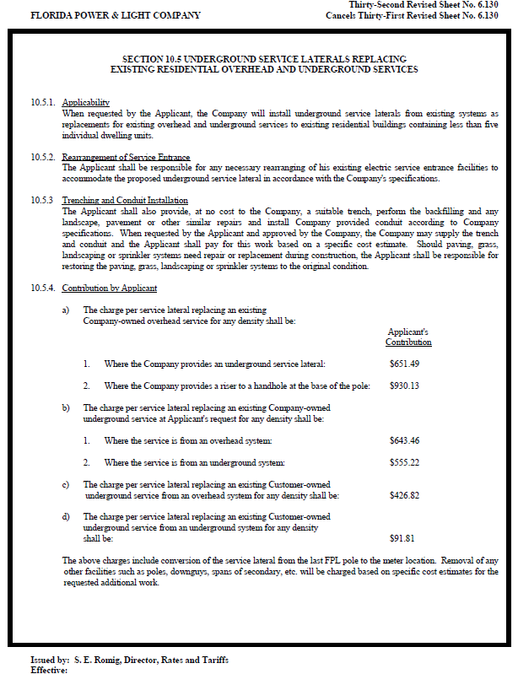

Order No. PSC-14-0467-TRF-EI, issued August 29, 2014, in Docket No. 140066-EI, In re: Petition for approval of amendment to underground residential and commercial differential tariffs, by Florida Power & Light Company.
Order No. PSC-16-0208-PCO-EI, issued May 23, 2016, in Docket No. 160071-EI, In re: Petition for approval of 2016 revisions to underground residential and commercial differential tariffs, by Florida Power & Light Company.

