State of Florida |  | Public Service Commission  Capital Circle Office Center ● 2540 Shumard Oak Boulevard  Tallahassee, Florida 32399-0850  -M-E-M-O-R-A-N-D-U-M-
DATE: | September 29, 2016
TO: | Office of Commission Clerk (Stauffer)
FROM: | Division of Engineering (Wooten, Ellis)  Office of the General Counsel (Trierweiler)
RE: | Docket No. 160140-EQ – Petition for approval of modifications to standard interconnection agreement contained in the approved tariff by Duke Energy Florida, LLC.
AGENDA: | 10/11/16 – Regular Agenda – Tariff Filing - Interested Persons May Participate
COMMISSIONERS ASSIGNED: |  |  | All Commissioners
PREHEARING OFFICER: |  |  | Administrative
CRITICAL DATES: |  |  | 02/02/17 (8-Month Effective Date)
SPECIAL INSTRUCTIONS: |  |  | None

Case Background
On June 2, 2016, Duke Energy Florida, LLC (Duke or Company) filed a petition for approval of modifications to its Interconnection Agreement (Agreement) contained in the approved tariff. The Agreement was created in 2014 by Order No. PSC-14-0589-PAA-EI, which separated the Company’s as-available tariff from the Agreement for Qualifying Facilities (QFs). The agreement was last modified in 2015 by Order No. PSC-15-305-PAA-EQ along with Duke’s Standard Offer Contract.
On July 21, 2016, the Commission suspended the agreement to allow sufficient time for Commission staff to review the application and gather pertinent information.
The Commission has jurisdiction over this matter pursuant to Sections 366.03, 366.04, 366.05, and 366.06, Florida Statutes (F.S.).

Discussion of Issues

Issue 1:
Should the Commission approve Duke’s proposed modifications to the Interconnection Agreement contained in its approved tariffs?

Recommendation:
Yes. Staff recommends the Commission approve Duke’s modifications to its Interconnection Agreement as shown in Attachment A. The new requirements clarify that the Agreement is intended for interconnections with Duke only and improves security to ratepayers by requiring insurance similar to other contracts. The proposed tariff modifications should not place an undue burden on QFs that seek to interconnect with Duke’s system and deliver power to the Company. (Wooten)

Staff Analysis:
In its petition Duke proposes to make certain changes to the approved tariff sheets 9.700 through 9.715 which contains the terms and conditions of Duke’s Interconnection Agreement for QFs. The Company submitted a total of 15 revised sheets of the Interconnection Agreement. The type-and-strike format versions of the revised tariff sheets are included as Attachment A to this recommendation.

Interconnection Agreement Modifications
In its petition and in response to staff data requests, Duke notes that some of the proposed tariff changes are meant to reflect that the Agreement is to address non-Federal Energy Regulatory Commission (FERC) jurisdictional interconnections only. For example, proposed tariff sheet 9.700, paragraph 1.0 is modified to reflect that all net output will be sold to Duke. As a result, any QF wishing to sell power to another party would instead, use the Company’s FERC interconnection tariff, instead of the proposed Agreement.

The proposed Agreement includes a new component to the preliminary cost study, a Feasibility Study, which is meant to provide a list of options available to the QF for its interconnection to narrow the analysis in determining costs. The estimated interconnection costs for all feasibility studies for a 50 MW QF is less than $70,000, or approximately $0.0014/watt. Section 4.2.2 on proposed Tariff Sheet 9.705 also adds a requirement that the QF provides cash or a letter of credit to Duke prior to interconnection field work being conducted. These new requirements seem reasonable, in that the Feasibility Study allows a QF to determine its desired interconnection option, while the credit requirement protects the Company’s ratepayers in the event a QF would not reimburse Duke for interconnection costs.

Section 12 of the proposed Agreement adds liability insurance requirements, including consequences that clarify the results of failing to acquire or maintain insurance coverage. The minimum liability insurance requirement is $1,000,000 per occurrence for bodily injury or property damage. While this increases costs to QFs, the requirement represents a reasonable practice and the language is similar to the insurance requirements included in the Company’s Standard Offer Contract.

Additional legal terms are added to the agreement, including events of default, termination, assignment, references to controlling statutes, and representations that the parties are capable of legally conducting the agreement. These terms are reasonable and provide clarity in the event of a dispute regarding the contract terms. Other revisions to the Agreement include modifications to terminology and definitions with minor substantive changes.

Conclusion
Staff recommends the Commission approve Duke’s modifications to its Interconnection Agreement as shown in Attachment A. The new requirements clarify that the Agreement is intended for interconnections with Duke only and improves security to ratepayers by requiring insurance similar to other contracts. The proposed tariff modifications should not place an undue burden on QFs that seek to interconnect with Duke’s system and deliver power to the Company.

Issue 2:
Should this docket be closed?

Recommendation: Yes.
If a protest is filed within 21 days of the issuance of the order, this tariff should remain in effect, with any revenues held subject to refund, pending resolution of the protest. If no timely protest is filed, this docket should be closed upon the issuance of a consummating order. (Trierweiler)

Staff Analysis:
If a protest is filed within 21 days of the issuance of the order, this tariff should remain in effect, with any revenues held subject to refund, pending resolution of the protest. If no timely protest is filed, this docket should be closed upon the issuance of a consummating order.

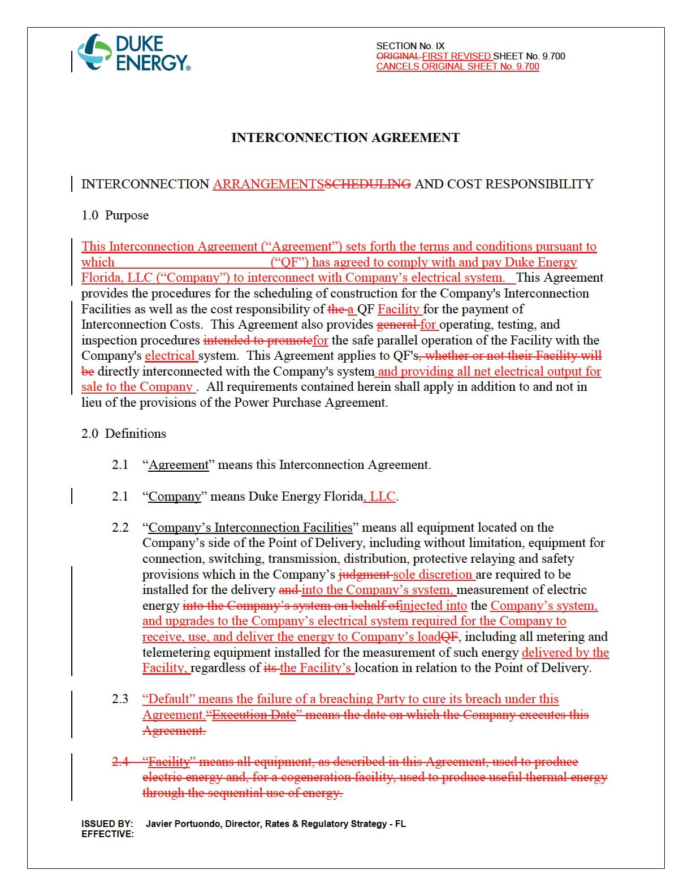

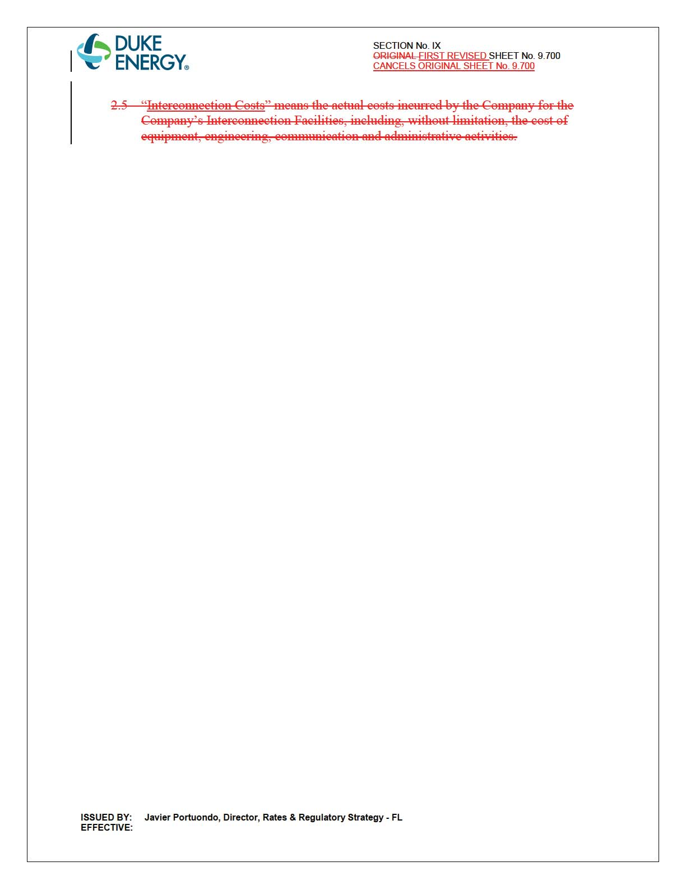

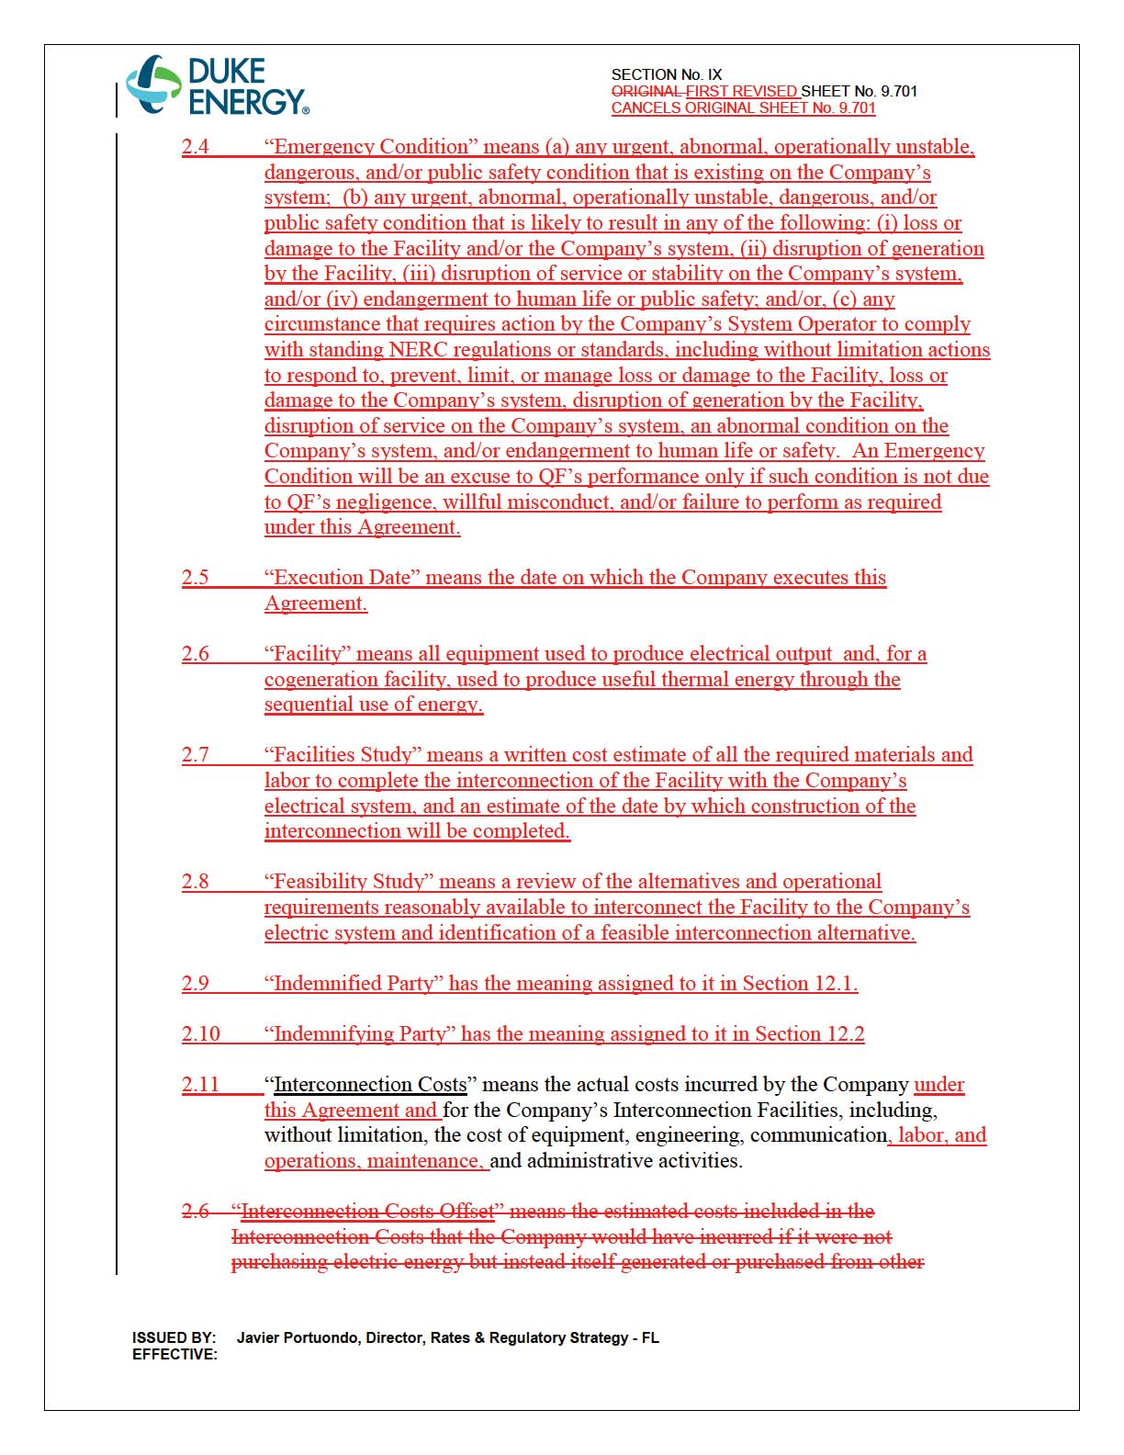

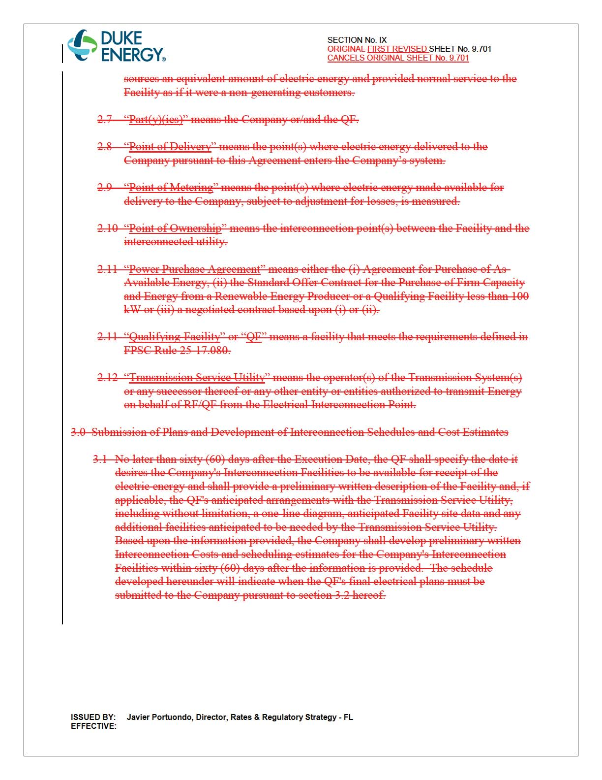

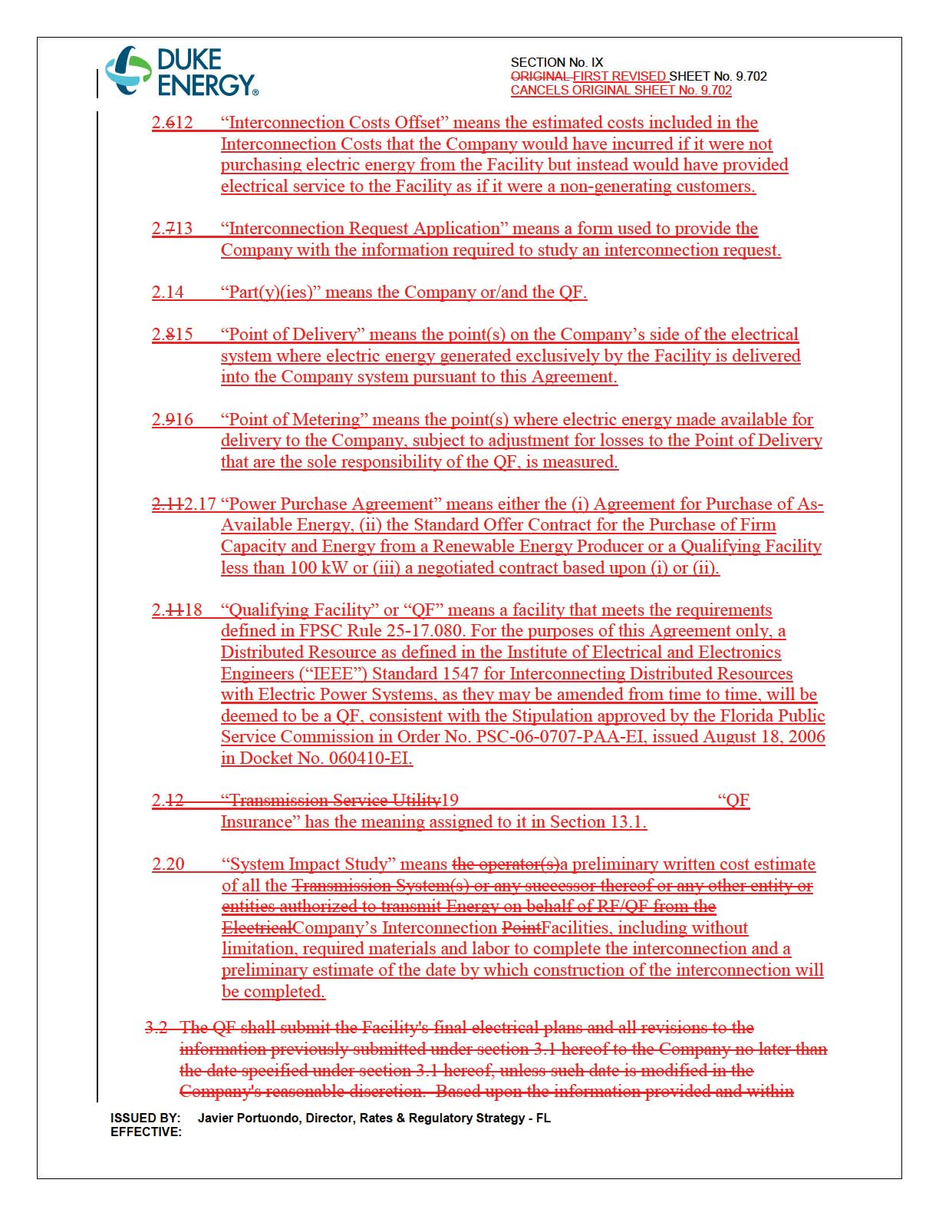

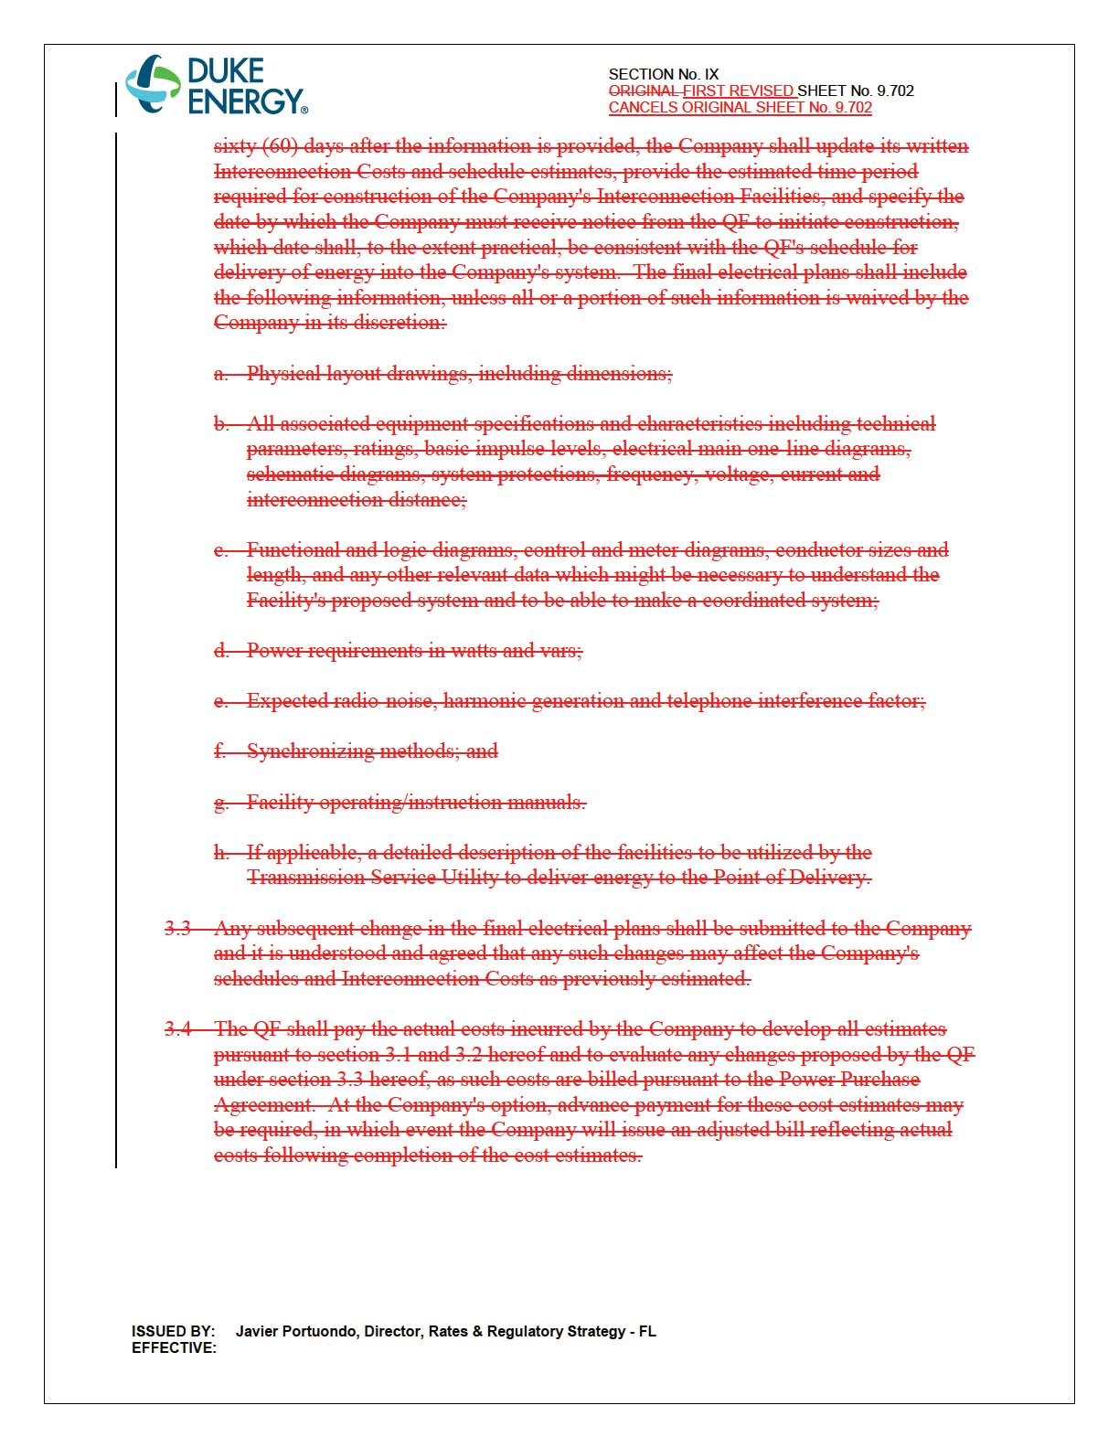

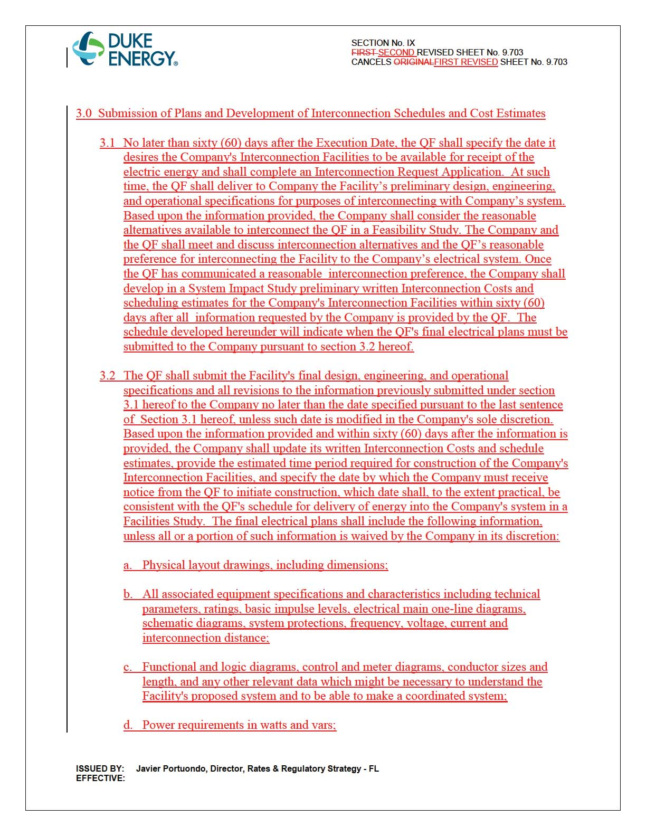

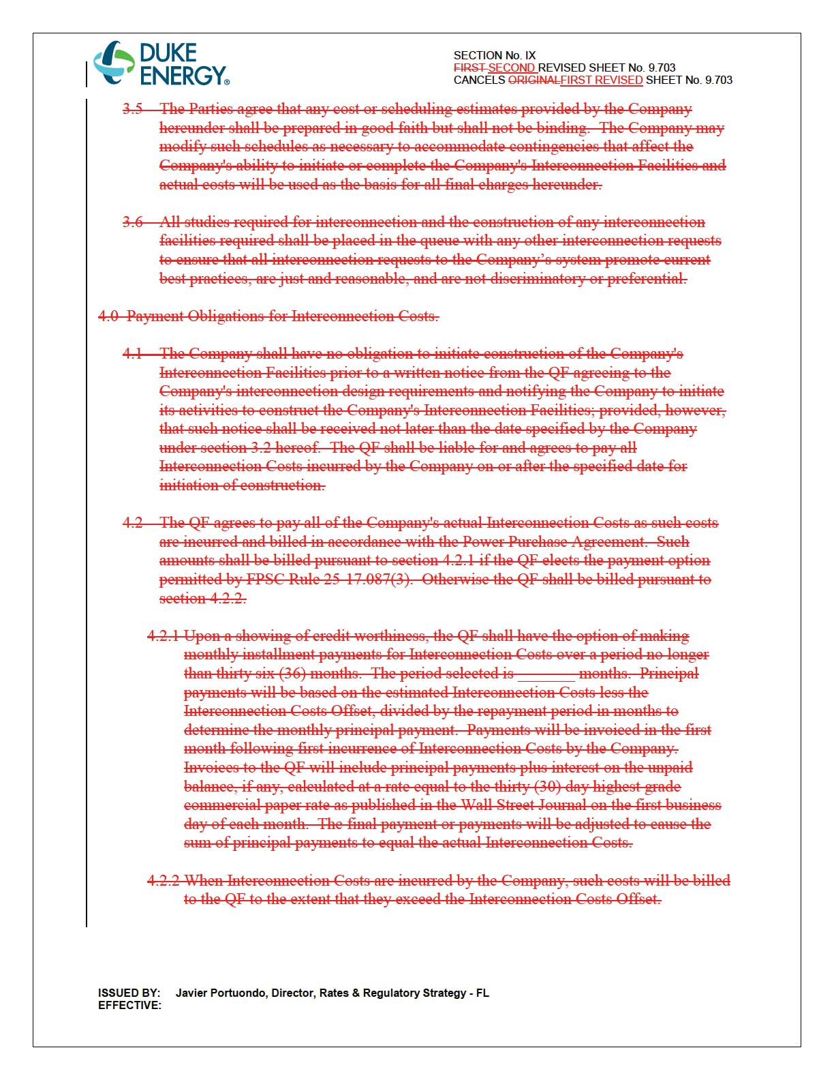

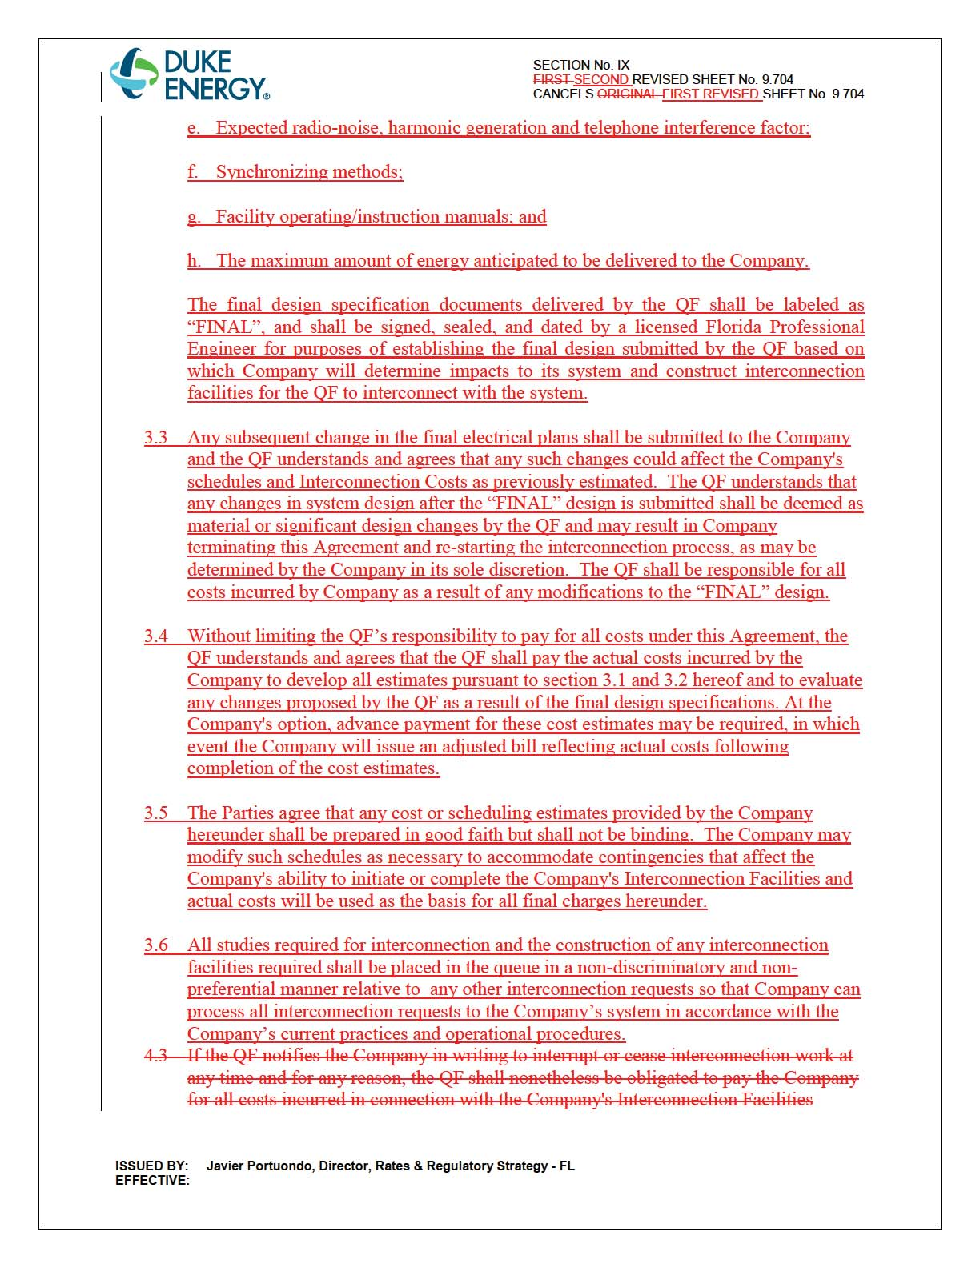

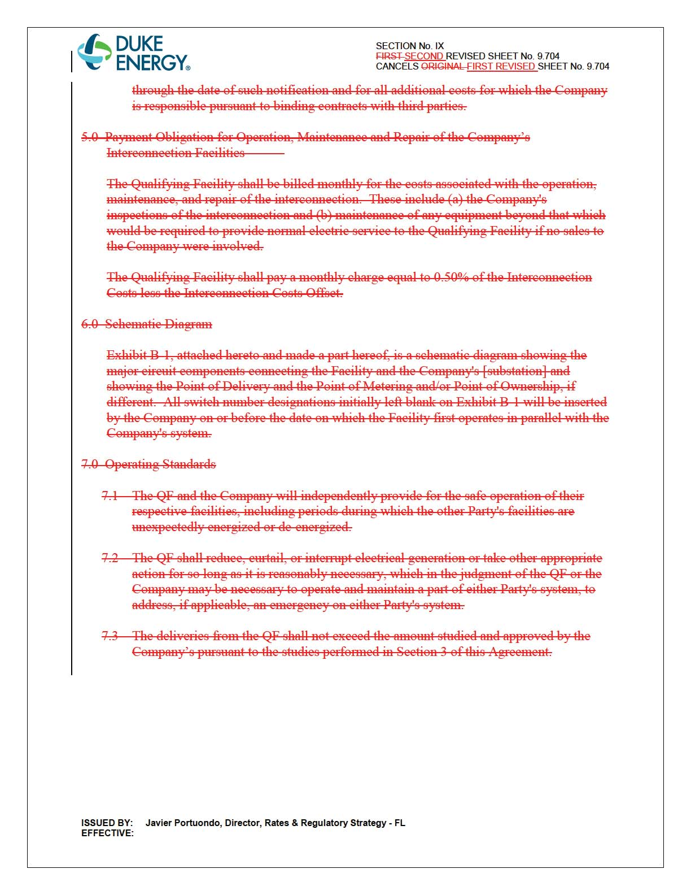

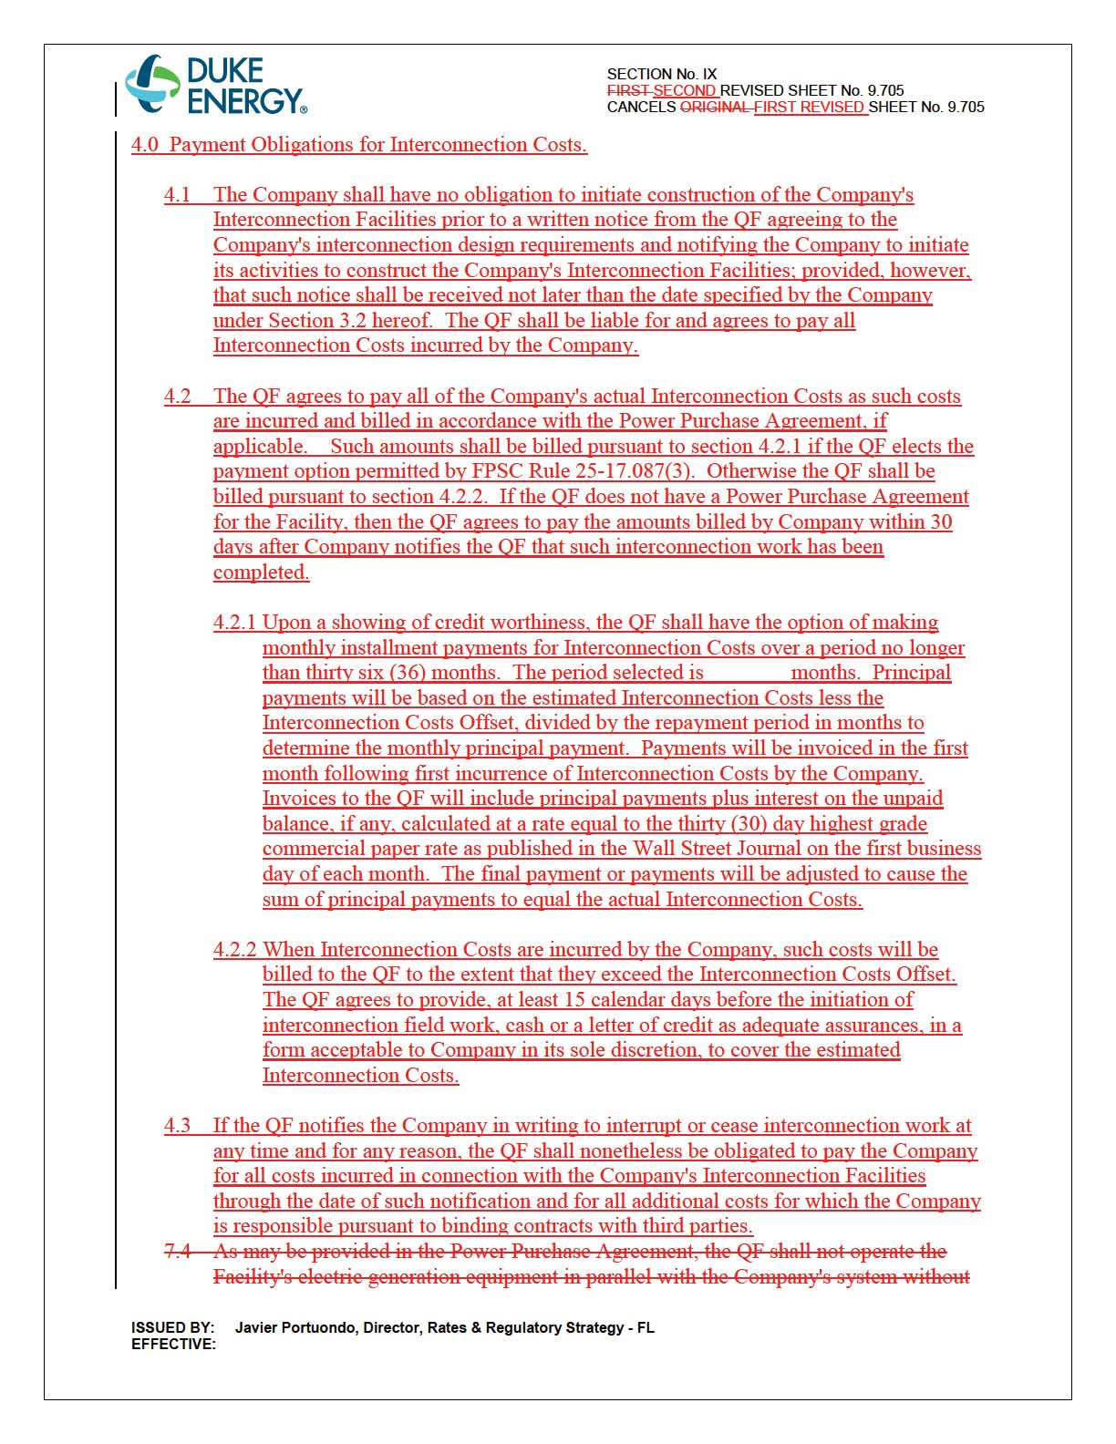

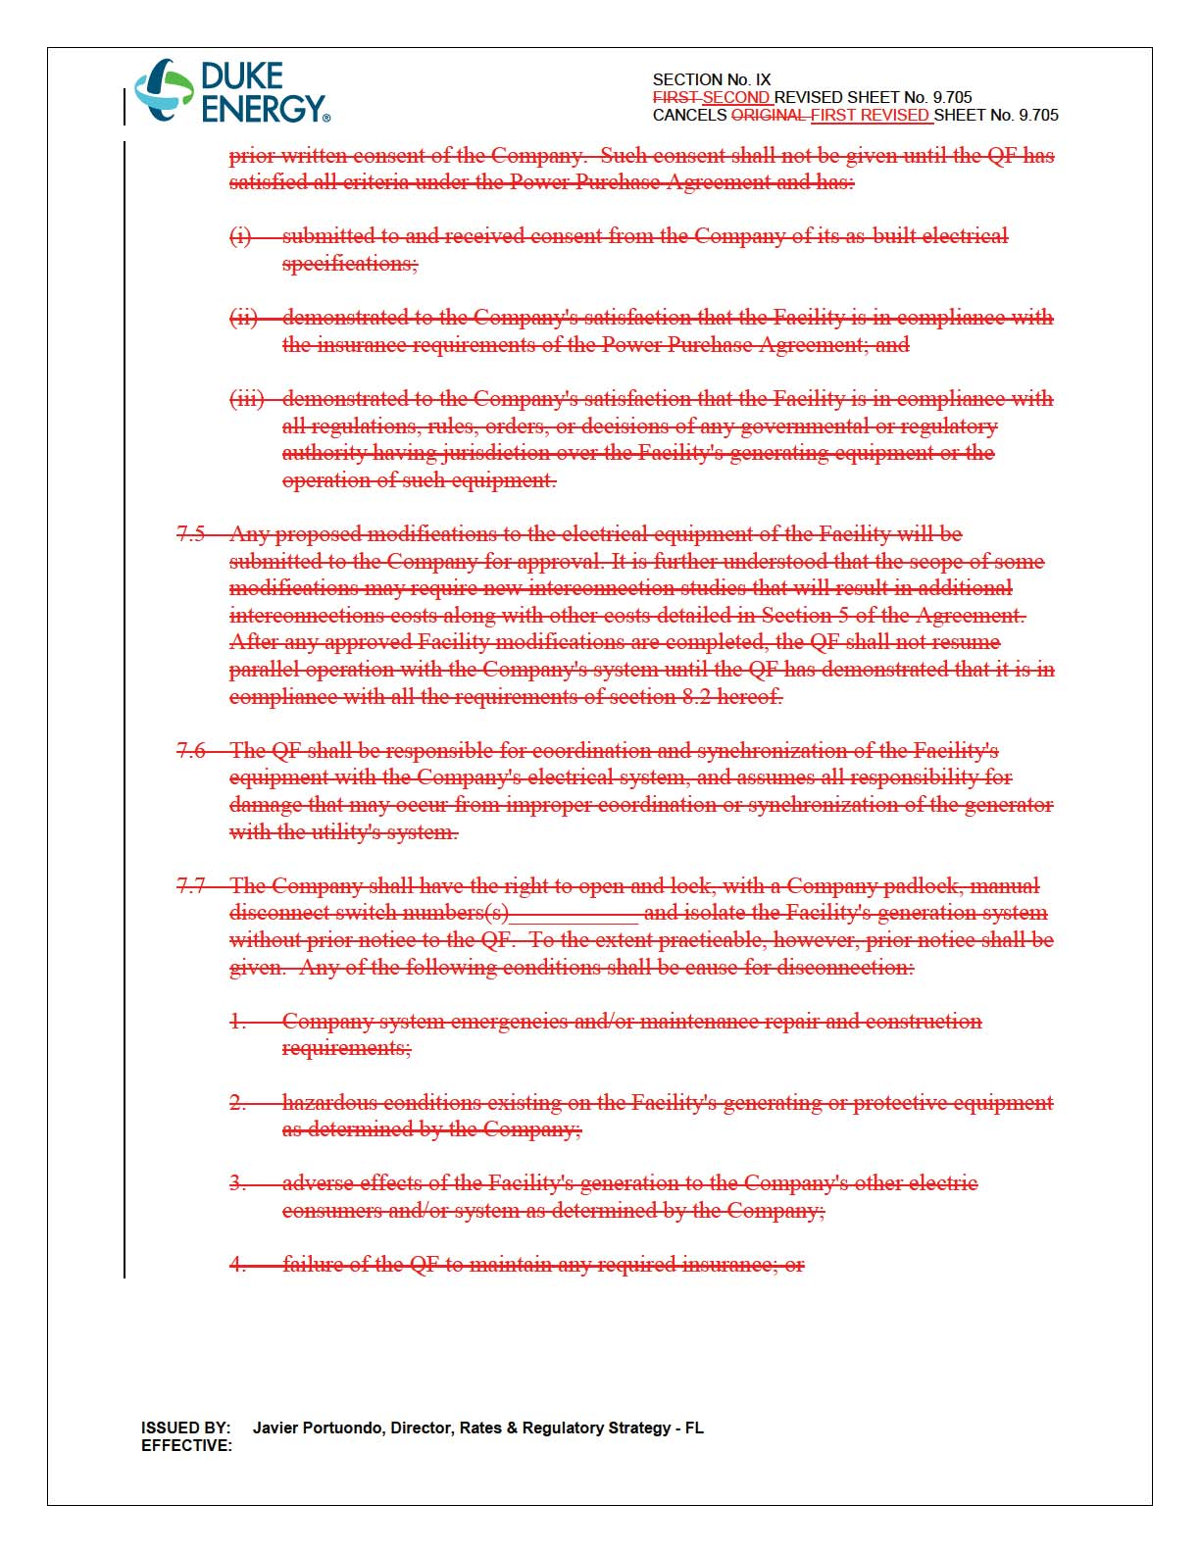

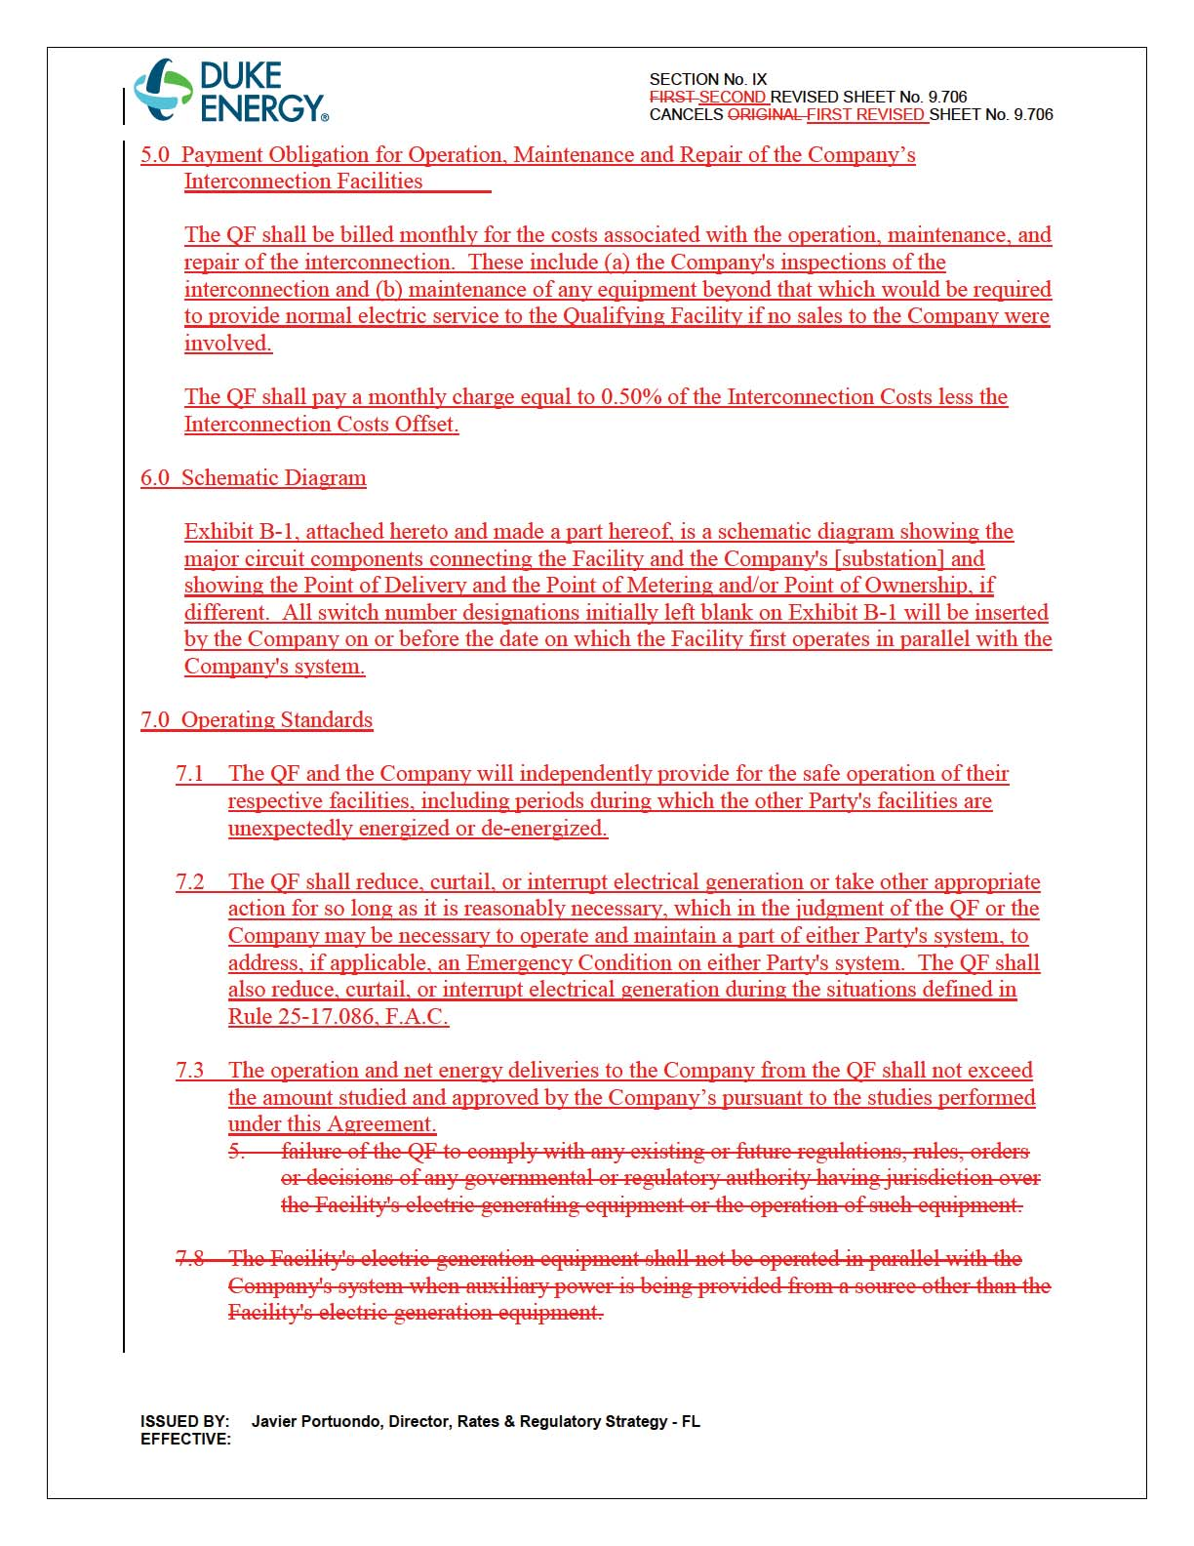

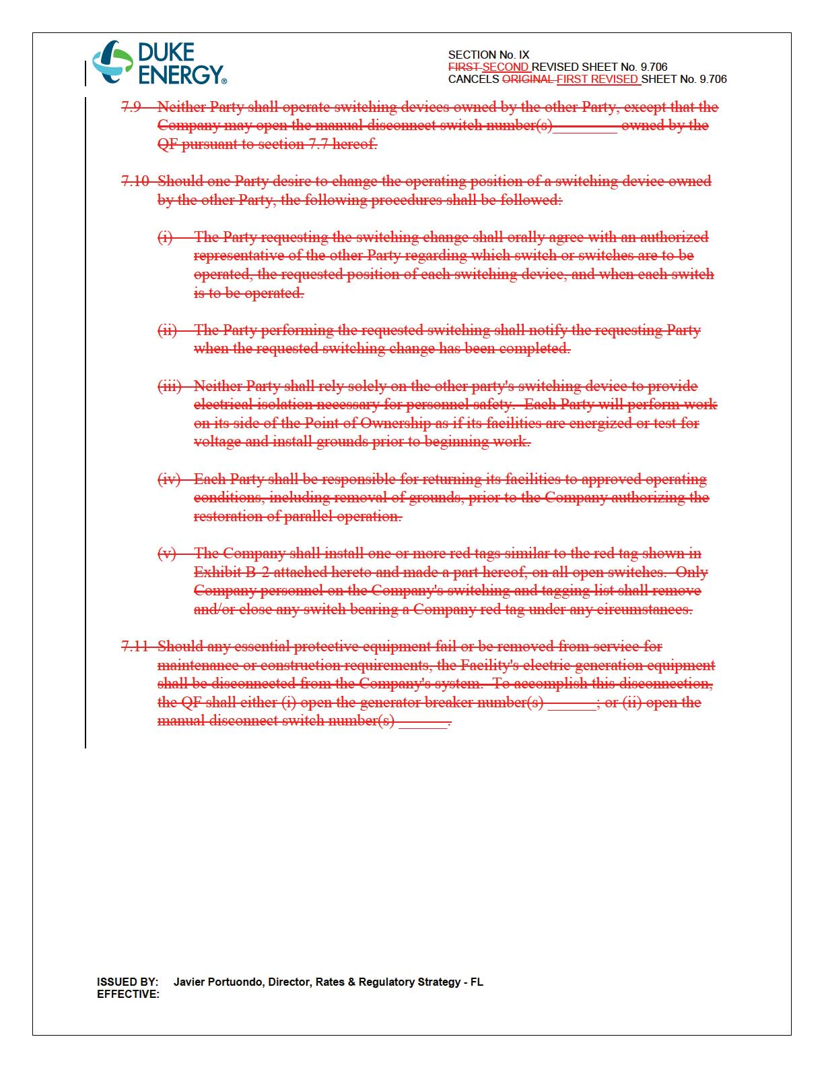

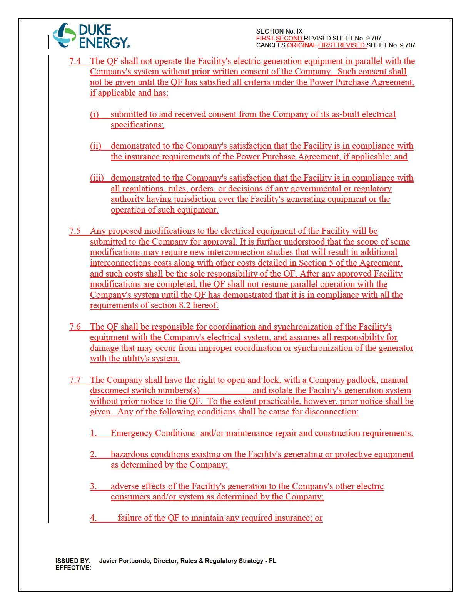

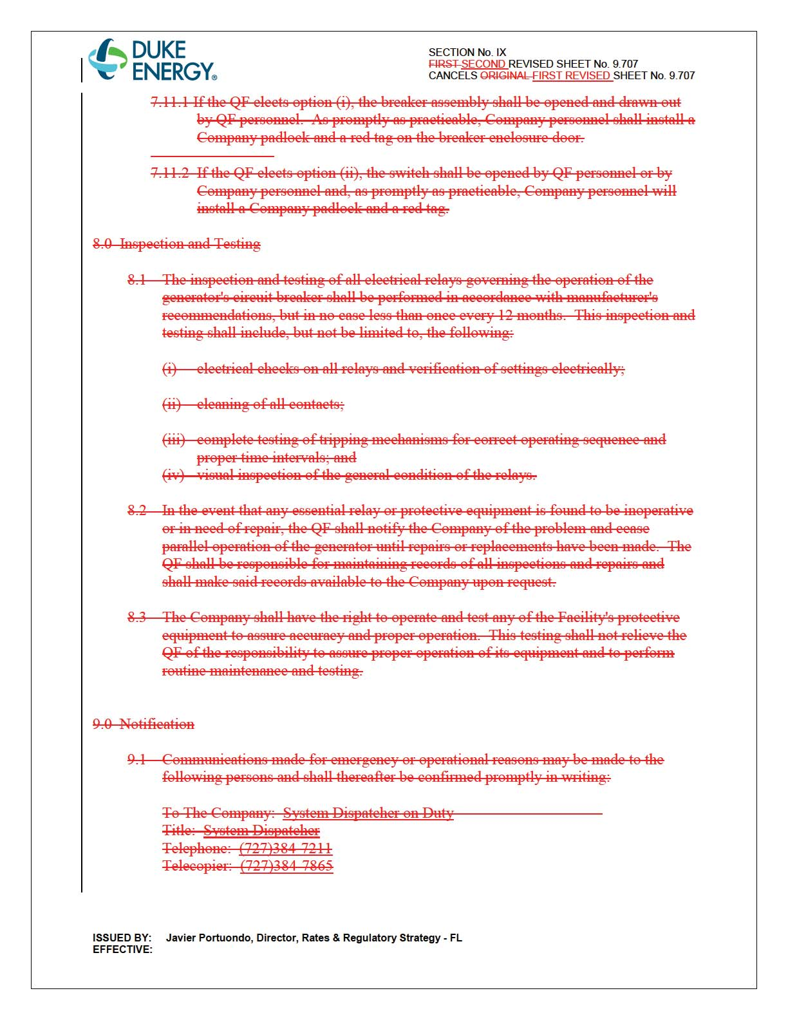

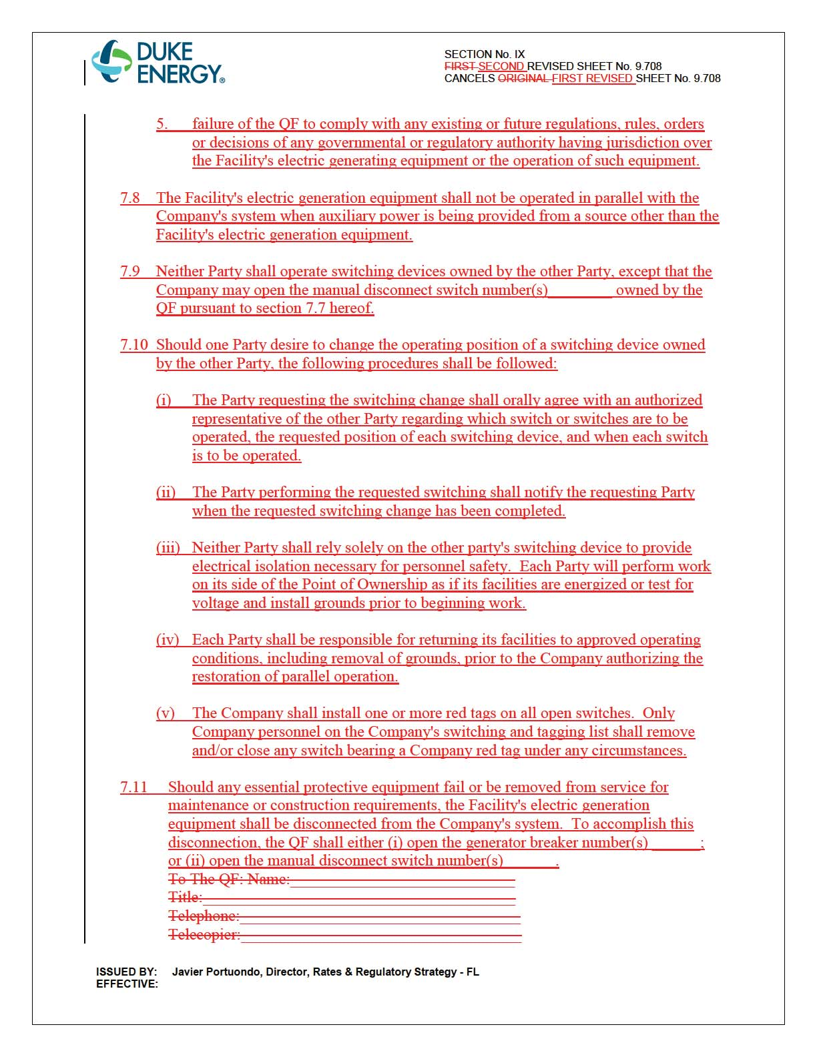

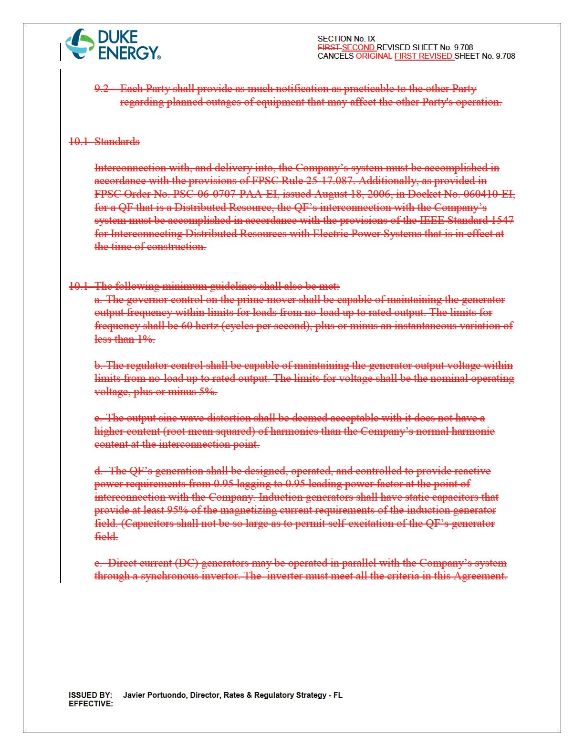

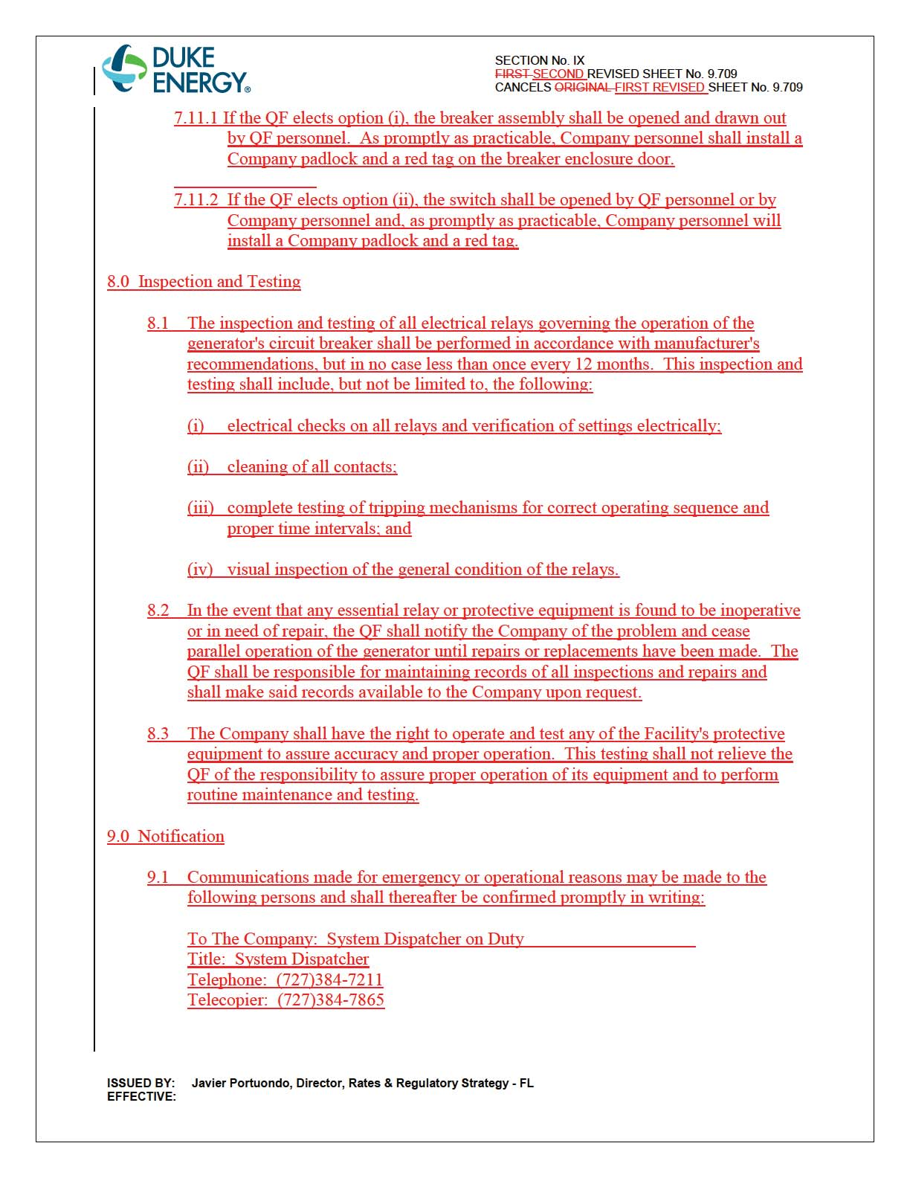

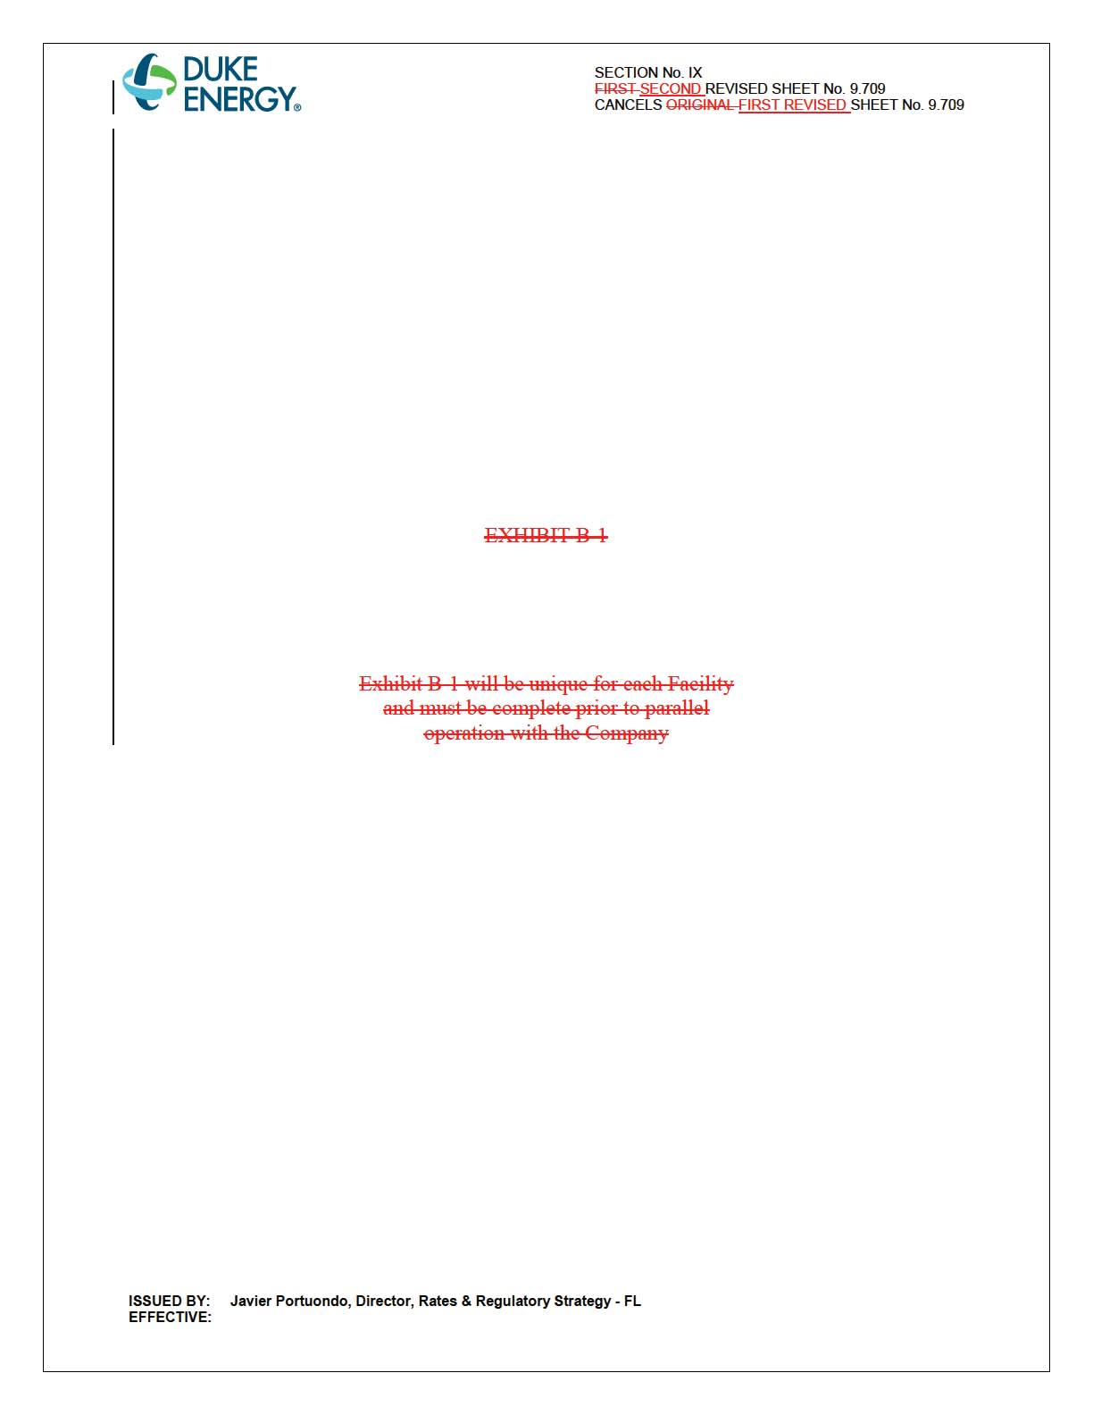

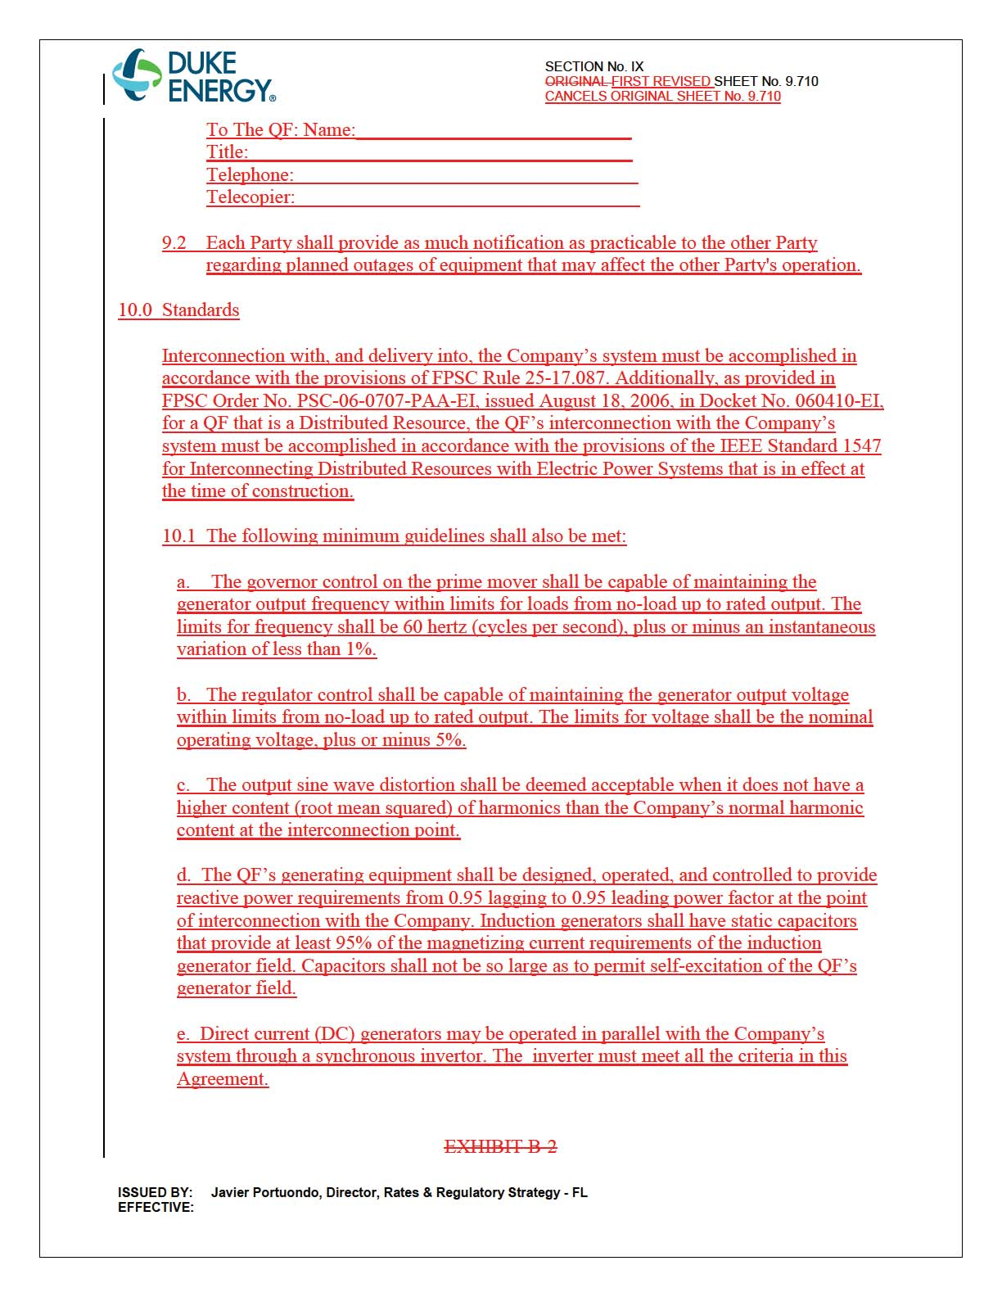

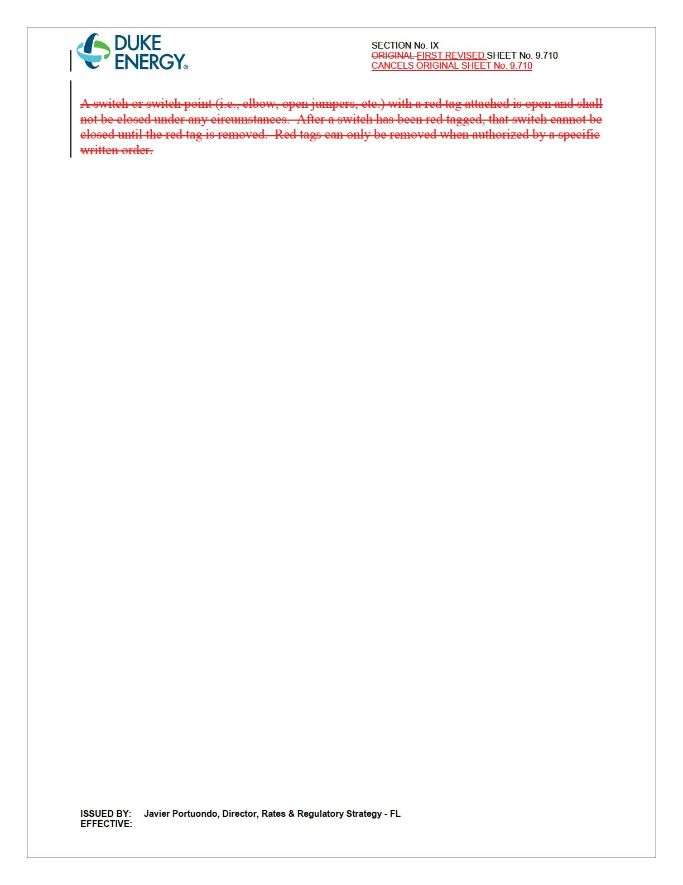

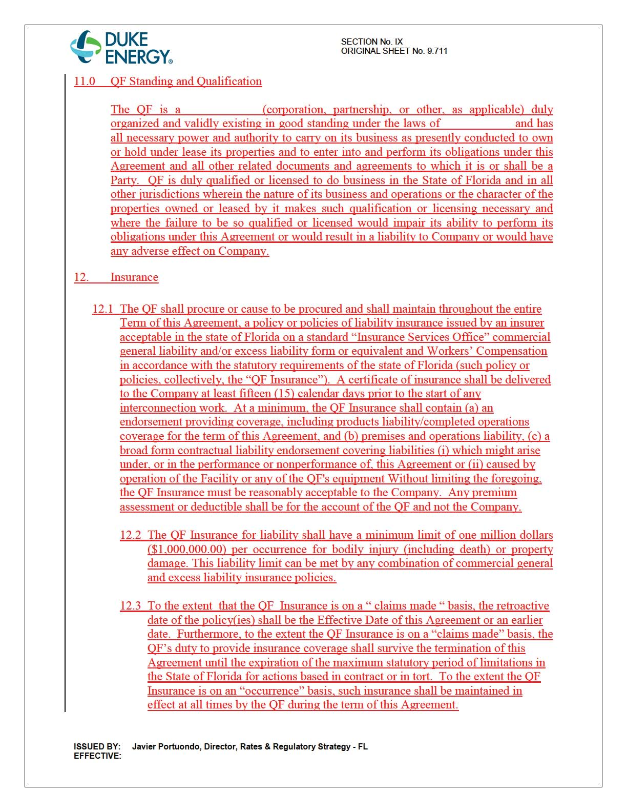

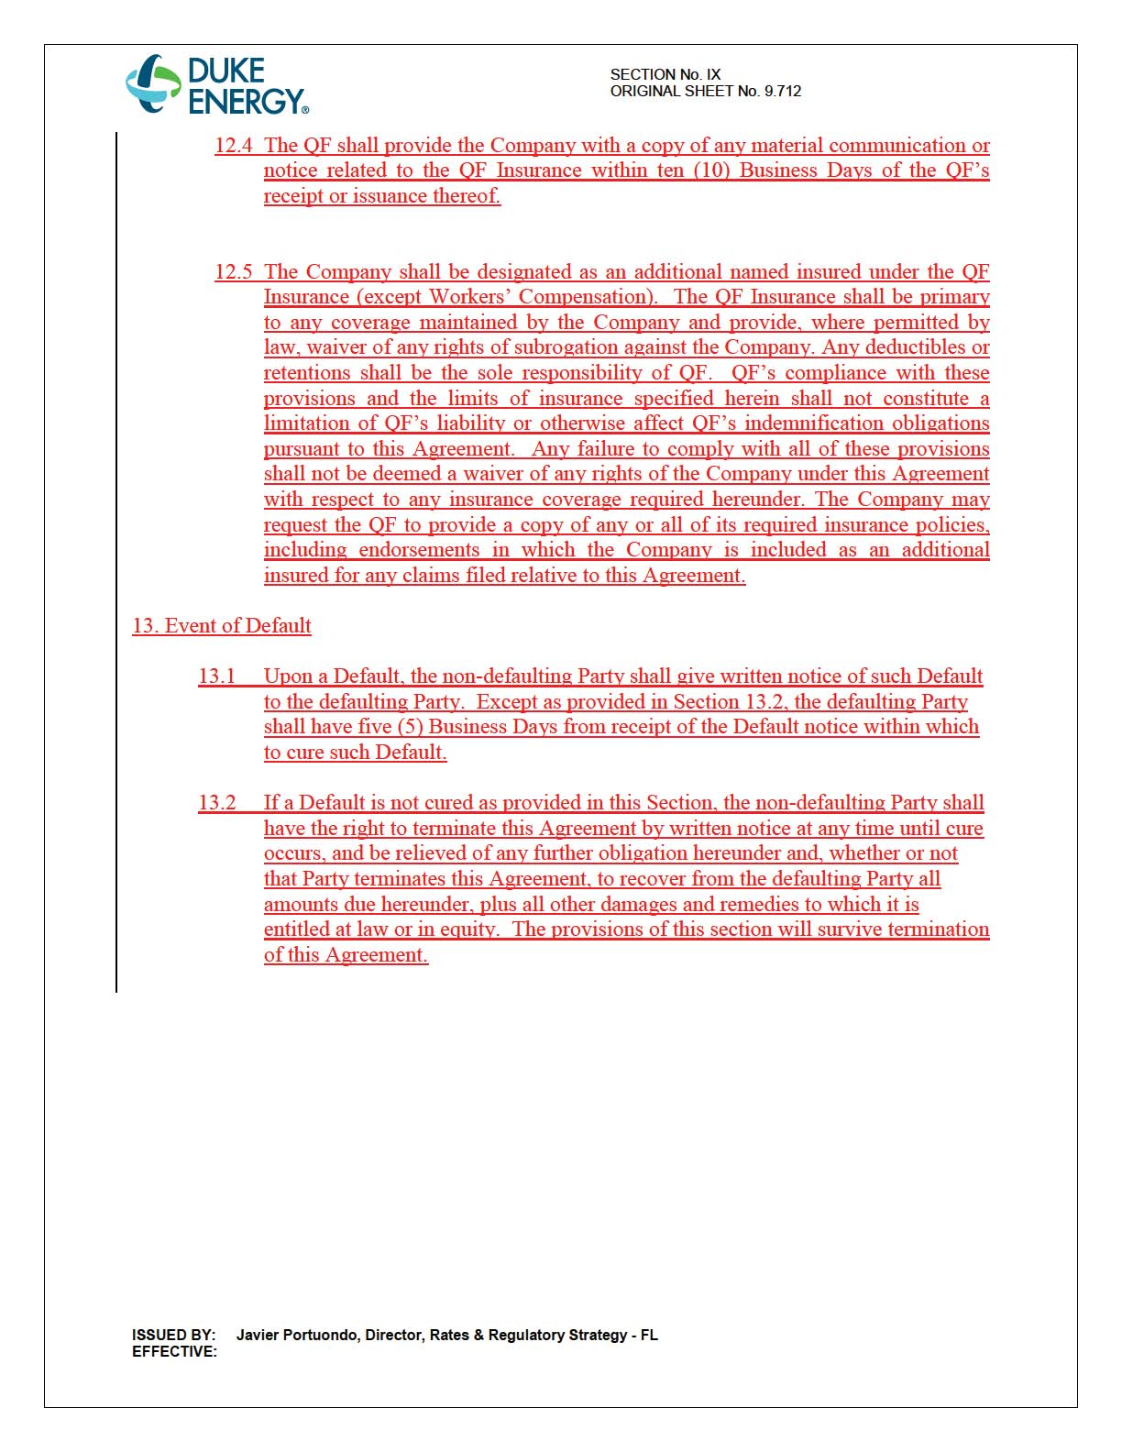

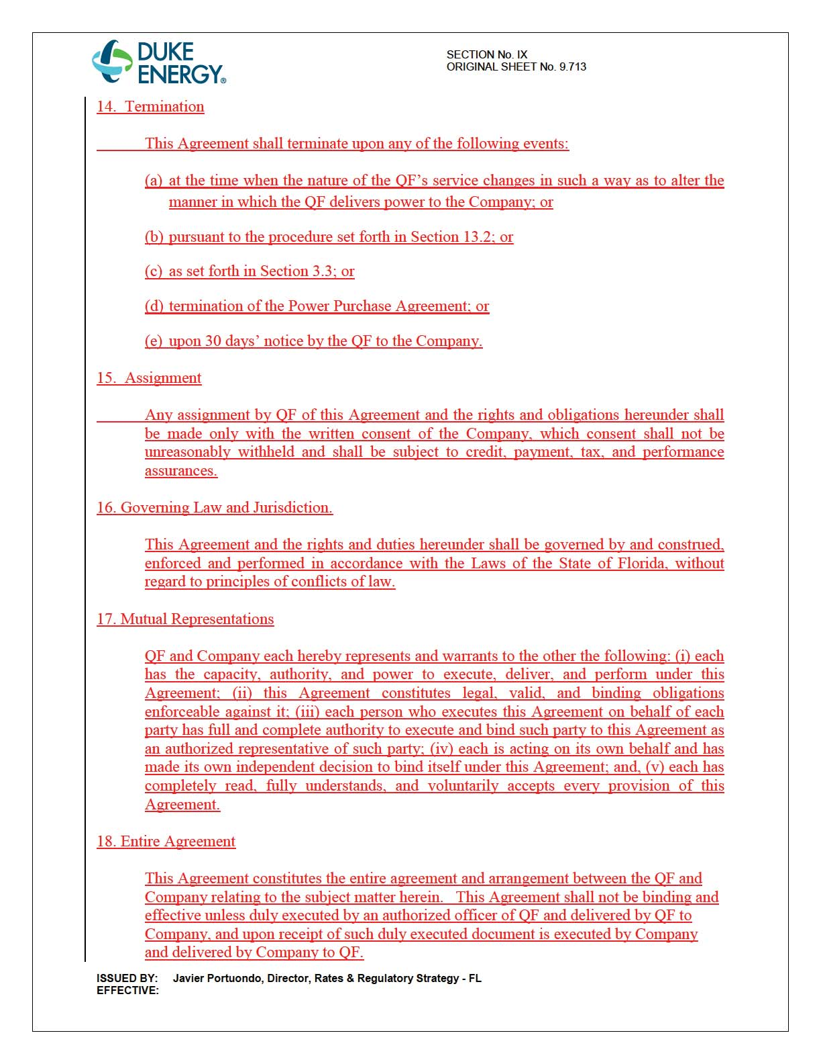

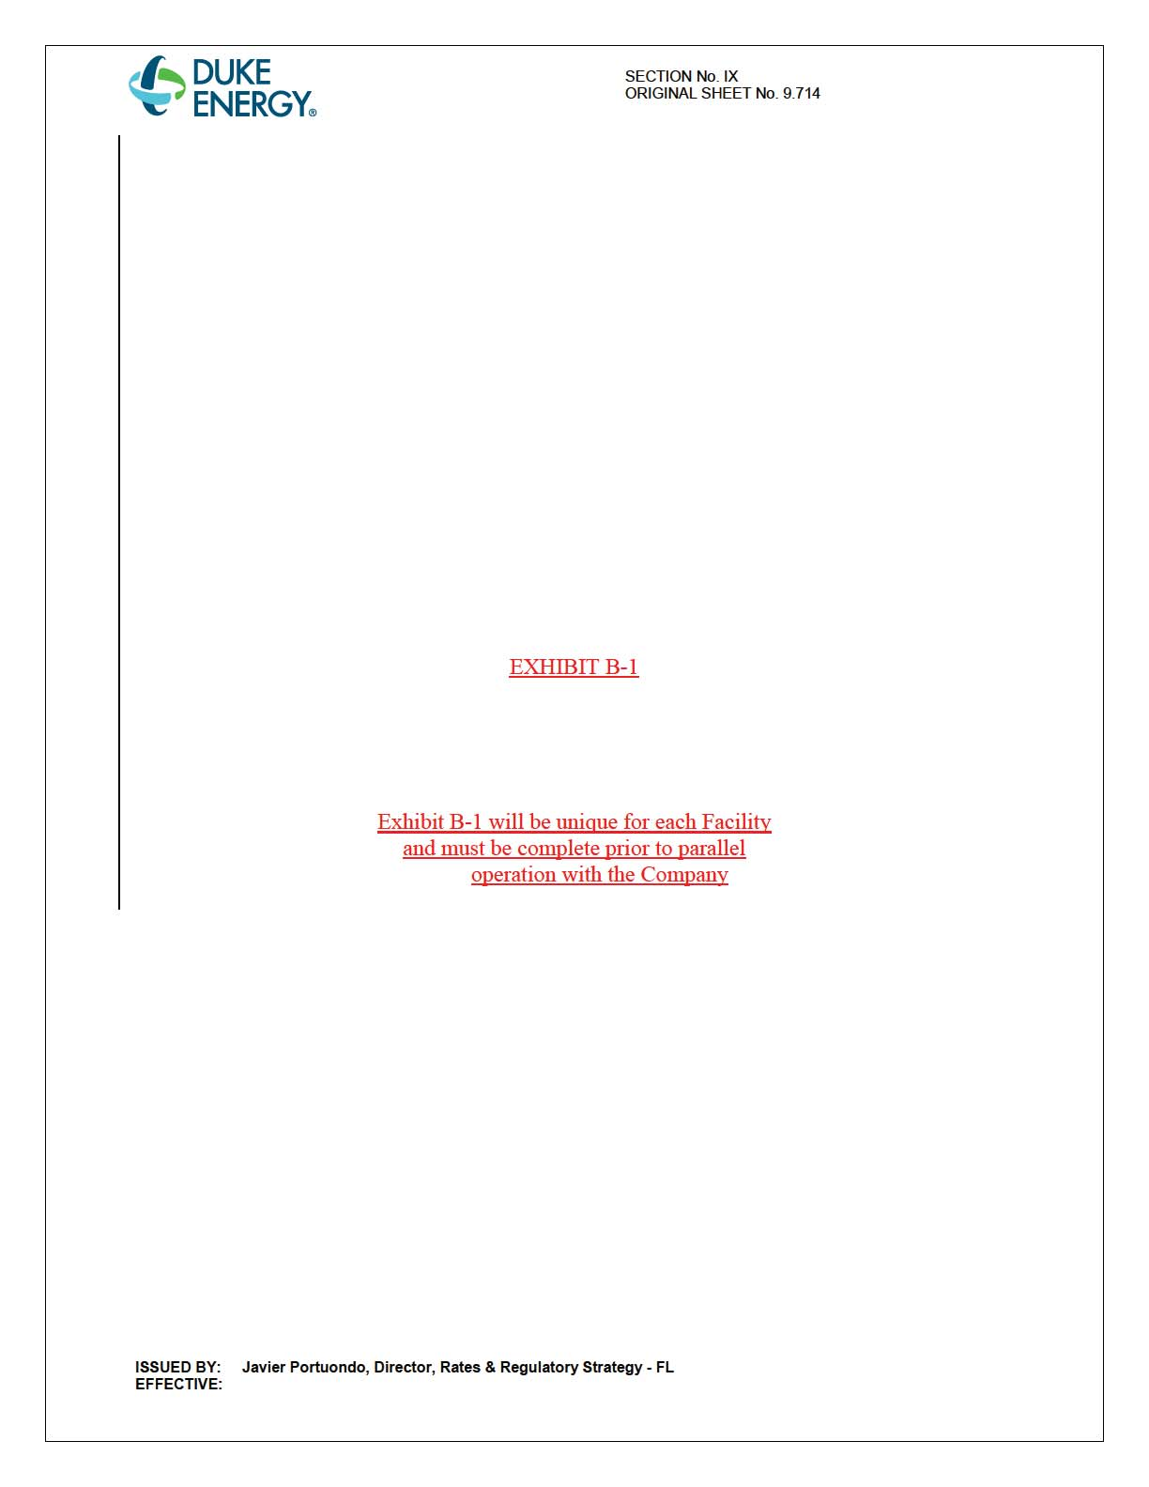

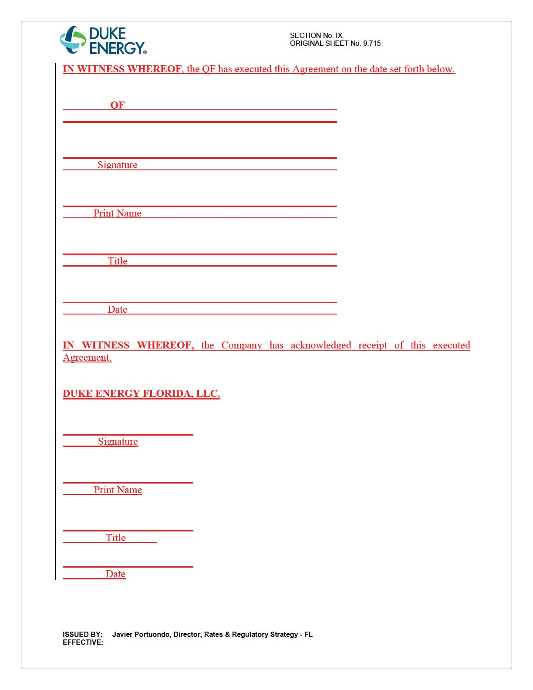

Order No. PSC-14-0589-PAA-EI, issued October 21, 2014, in Docket No. 140137-EI, In re: Petition for approval of modifications to tariff sheet Nos. 9.100 through 9.330 and tariff sheet Nos. 9.700 through 9.709 as-available purchase tariff and interconnection agreement, by Duke Energy Florida, Inc.
Order No. PSC-15-305-PAA-EQ, issued July 28, 2015, in Docket No. 150106-EQ, In re: Petition for approval of amended standard offer contract (Schedule COG-2) and amended interconnection agreement, by Duke Energy Florida, Inc.
Order No. PSC-16-0279-PCO-EQ, issued July 21, 2016, in Docket No. 160140-EQ, In re: Petition for approval of modifications to standard interconnection agreement contained in the approved tariff by Duke Energy Florida, LLC.
See Order No. PSC-16-0252-PAA-EQ, issued June 26, 2016, in Docket No. 160073-EQ, In re: Petition for approval of amended standard offer contract (Schedule COG-2), by Duke Energy Florida, LLC.

