State of Florida |  | Public Service Commission  Capital Circle Office Center ● 2540 Shumard Oak Boulevard  Tallahassee, Florida 32399-0850  -M-E-M-O-R-A-N-D-U-M-
DATE: | September 29, 2016
TO: | Office of Commission Clerk (Stauffer)
FROM: | Division of Economics (Ollila, Rome)  Office of the General Counsel (Janjic)
RE: | Docket No. 160120-GU – Petition for approval of tariff modifications to rider NCTS, the firm delivery and operational balancing agreement, and negative imbalance cash-out prices, by Peoples Gas System.
AGENDA: | 10/11/16 – Regular Agenda – Tariff Filing – Interested Persons May Participate
COMMISSIONERS ASSIGNED: |  |  | All Commissioners
PREHEARING OFFICER: |  |  | Administrative
CRITICAL DATES: |  |  | 8-Month Effective Date: 01/06/17 (60-day suspension date waived by the utility)
SPECIAL INSTRUCTIONS: |  |  | None

Case Background
On May 6, 2016, Peoples Gas System (Peoples or Company) filed a petition for approval of tariff modifications to its Natural Choice Transportation Service Rider (Rider NCTS), the Firm Delivery and Operational Balancing Agreement (Firm Delivery Agreement), and the cash-out price for negative imbalances in Rider NCTS and the Individual Transportation Service Rider (Rider ITS).
Rider NCTS allows certain customers to be part of a customer pool that uses a third party supplier or pool manager to meet their natural gas requirements. The pool manager assumes the responsibility for supplying the natural gas for its customer pool. Peoples receives the gas delivered by the pool manager and redelivers the gas to the customer’s site. Rider ITS is available for larger commercial customers who choose their own pool manager and are not part of a customer pool. The Firm Delivery Agreement is required to be signed by pool managers selling gas to an NCTS pool and is a standard form in Peoples’ tariff.
The Office of Public Counsel (OPC) requested interested party status in this docket on June 7, 2016. Peoples responded to staff’s first data request on June 22, 2016. On June 24, 2016, a noticed informal meeting was held with participation by staff, representatives from Peoples, OPC, and other interested persons, including pool managers. The purpose of the meeting was for Peoples to provide an overview of their filing, explain the calculations, and allow staff and interested persons to ask questions. Prior to the June 24 informal meeting, Tiger Natural Gas, Inc. filed comments expressing concerns regarding certain aspects of Peoples’ petition and Infinite Energy, Inc. sent an email (which is in the docket file), also expressing concerns. On July 15, 2016, Peoples filed an amended petition and tariff, stating that the amended petition resulted in part from comments received at the informal meeting.
In both filings Peoples waived the 60-day suspension deadline pursuant to Section 366.06(3), Florida Statutes (F.S.). The proposed tariff pages are contained in Attachment 1. The Commission has jurisdiction over this matter pursuant to Sections 366.03, 366.04, 366.05, and 366.06, F.S.

Discussion of Issues

Issue 1:
Should the Commission approve Peoples' tariff modifications filed in the amended petition?

Recommendation:
Yes, the Commission should approve Peoples’ tariff modifications filed in the amended petition, effective October 11, 2016. (Ollila, Rome)

Staff Analysis:
Peoples’ proposed modifications to Rider NCTS, the Firm Delivery Agreement, and the cash-out price of Riders NCTS and ITS are discussed below.

Rider NCTS
Rider NCTS was approved by the Commission in 2000, following the Commission’s adoption of Rule 25-7.0335, Florida Administrative Code (F.A.C.). Rule 25-7.0335, F.A.C., requires local distribution companies, such as Peoples, to make gas transportation service available to non-residential customers. Rider NCTS is a voluntary program that allows residential customers with an annual consumption of 2,000 or more therms and non-residential firm customers to use a pool manager to meet their natural gas requirements. There are currently 18 pool managers qualified to serve Peoples’ NCTS customer pools. Peoples stated that the number of NCTS customers has grown from 3,398 in October 2000 to 23,584 in April 2016. NCTS customers consume about 17 percent of system throughput and are not subject to Peoples’ purchased gas adjustment (PGA) charges, whereas sales customers who buy their gas from Peoples are subject to PGA charges.
For 2016, Peoples’ total capacity cost (i.e., the reservation charges Peoples pays pipeline companies, based on how much capacity Peoples reserves) is $95 million. Peoples provides a monthly release of upstream pipeline capacity to the NCTS pool managers and charges the pool managers for released capacity at the weighted average cost of capacity (average capacity cost). Peoples also allocates capacity to shippers outside the NCTS pool, such as shippers who contract directly with ITS transportation customers. Any unallocated capacity and its associated cost are assigned to the PGA. NCTS pool managers use the pipeline capacity released to them by Peoples to transport the gas to the customers in their customer pool. While the Commission does not regulate the prices pool managers charge their customers, staff believes that pool managers recover from the customers in their pool the cost of the gas and the cost of the upstream pipeline transportation.
As part of its total capacity portfolio, Peoples also holds capacity to cover peak system demand and future demand growth. The Company currently recovers the costs associated with capacity that is held for peak demand system requirements and future growth through the PGA mechanism. Furthermore, according to the Company, when upstream capacity is acquired, it must sometimes be grown into (i.e., it may be necessary to acquire additional capacity before the anticipated growth fully materializes). Because NCTS customers do not pay the PGA, they do not pay any of the cost of upstream capacity held for peaking and future growth. According to Peoples, the growth in NCTS customers has caused the PGA customers to pay a disproportionate share of the costs of peaking and future growth capacity.
In this filing Peoples therefore proposes to modify Rider NCTS to increase the rate at which Peoples releases upstream capacity to NCTS pool managers (and passed on to their customers). The increased rate would include a portion of peaking and future growth capacity costs, so that those costs are more equitably allocated between PGA customers and transportation customers in the NCTS pool. According to Peoples, the methodology change is revenue neutral to the Company. The proposed change to the capacity release pricing methodology is discussed below.

Recovery of Costs of Capacity Held for Peaking and Future Growth
Peoples’ proposed change to its capacity release pricing mechanism is the application of a Load Factor Adjusted Release Rate, which is comprised of the average capacity cost plus a Load Factor Adder (adder). The adder represents the NCTS customers’ portion of the upstream capacity costs associated with providing peaking and future growth currently embedded in the PGA.
Peoples provided work papers in response to staff’s first data request No. 3 to illustrate how Peoples currently calculates the average capacity cost, which Peoples is not proposing to change. For May 2016 Peoples’ average capacity cost rate was 58.1 cents per MMBtu. The proposed adder would be derived from dividing the projected NCTS customers’ share of the upstream capacity costs associated with providing peaking and future growth by the projected NCTS customer throughput.
In response to staff’s first data request No. 3, Peoples’ calculated an initial adder of 14 cents per MMBtu, based on May 2016 data. By combining this adder with the average capacity cost rate of 58.1 cents per MMBtu, the resulting Load Factor Adjusted Release Rate would be approximately 72.1 cents per MMBtu. For an NCTS customer using 2,000 therms per year, this would result in an annual increase of approximately $28.
Peoples also stated that the corresponding PGA reduction would be approximately 4 cents per therm. For a typical residential (i.e., PGA) customer using about 240 therms per year, Peoples’ proposed application of the Load Factor Adjusted Release Rate mechanism would result in an annual reduction of approximately $9.60.
According to Peoples, the average capacity cost will continue to be calculated monthly and the adder will be calculated annually, in January. Factors that could vary the adder include the addition of new capacity to Peoples’ portfolio, additional capacity releases to customers, a change in the swing service charge, or upstream transporter rate changes.

Firm Delivery Agreement
Peoples’ proposed modifications to the Firm Delivery Agreement include changes in terminology, cash-out prices for negative monthly imbalances, and a modification that permits pool managers to request an increase in the quantity of gas released during the month.

Terminology
Peoples acquired additional upstream capacity on pipelines on which it did not hold capacity at the inception of Rider NCTS. The current Firm Delivery Agreement refers to only one particular pipeline (Florida Gas Transmission Company). The proposed tariff would change the references to upstream pipelines to “Transporter,” a more generic term. According to Peoples, this proposed change would eliminate the need for administrative tariff changes in the event additional pipelines enter the Florida transportation market in the future.

Cash-out Price for Negative Monthly Imbalance Amounts
A negative monthly imbalance results when the customer pool’s gas consumption exceeds what the pool manager delivered that month. Customer pools in a negative monthly imbalance posture have consumed gas that Peoples had acquired for its system supply or PGA customers. The proposed tariff would change the cash-out prices for negative monthly imbalances. These revisions would include changing the usage rates from the Florida Gas Transmission Company (FGT) FTS-1 usage rate to the FTS-3 usage rate, and changing the capacity reservation charges by replacing Peoples’ average capacity cost with the FGT FTS-3 maximum reservation charge. Table 1-1 displays the current and proposed rates/charges.
Table 1-1
Current and Proposed Usage Rates and Reservation Charges

Current Charge  Description | Current Rate per MMBtu | Proposed Charge  Description | Proposed Rate per MMBtu
FTS-1 Usage Rate | 1.56 cents | FTS-3 Usage Rate | 0.23 cents
Average Capacity Cost (as of May 2016) | 58.1 cents | FTS-3 Reservation Charge | 132.99 cents
Source: Peoples’ filing in Docket No. 160120-GU
As Table 1-1 demonstrates, under Peoples’ proposed tariff, the usage rate would decrease from 1.56 cents to 0.23 cents and the reservation charge would increase from 58.1 cents to 132.99 cents, resulting in an overall increase of 73.56 cents per MMBtu. Peoples asserts that the higher cash-out price is intended as a deterrent to negative monthly imbalances.

Quantity Changes to Upstream Capacity During the Month
Currently, by the 20th of the month, pool managers are allowed to request a decrease in the quantity of the upstream capacity released by Peoples to the pool manager to deliver gas for the customer pool. In its amended petition, Peoples stated that as a result of the informal meeting, it proposes that a pool manager also be permitted to request an increase in the quantity of upstream capacity released to the pool manager for the month. According to Peoples, adding the ability to request an increase during the month should assist pool managers in avoiding negative monthly imbalance cash-outs.

Rider ITS Cash-out Price

Rider ITS is applicable to firm or interruptible individual transportation service for any non-residential customer who uses 182,500 therms or more per year. Peoples proposes that the cash-out prices under Rider ITS be revised so that they continue to be identical to the proposed cash-out prices for Rider NCTS pool managers, as described in Table 1-1 above.

Conclusion
Staff believes that the proposed changes are reasonable, specifically:
- As the number of NCTS customers has grown, PGA customers alone have paid for the cost of reserving upstream capacity for peaking and future demand which benefits both PGA and NCTS customers. Staff believes the proposed change to the allocation methodology is reasonable and will result in a more equitable allocation of capacity costs associated with peaking and future growth across customer classes.
- Staff believes using the more generic term, transporter, is reasonable and likely to promote administrative efficiency by eliminating tariff filings as new pipelines are added.
- Negative monthly imbalances result when NCTS and ITS customers consume gas originally acquired for Peoples’ system supply or PGA customers. Staff believes that an increase in the cash-out price is a deterrent, and therefore, is reasonable.
- The opportunity for pool managers to increase the quantity of upstream capacity released during the month will allow pool managers to better manage their gas requirements and thus, mitigate the potential effect of the increased cost of negative cash-outs.
Staff recommends that the Commission approve Peoples’ tariff modifications filed in the amended petition, effective October 11, 2016.
Issue 2: Should this docket be closed?

Recommendation:
If Issue 1 is approved and a protest is filed within 21 days of the issuance of the order, the tariffs should remain in effect, with any revenues held subject to refund, pending resolution of the protest. If no timely protest is filed, this docket should be closed upon the issuance of a consummating order. (Janjic)

Staff Analysis:
If Issue 1 is approved and a protest is filed within 21 days of the issuance of the order, the tariffs should remain in effect, with any revenues held subject to refund, pending resolution of the protest. If no timely protest is filed, this docket should be closed upon the issuance of a consummating order.

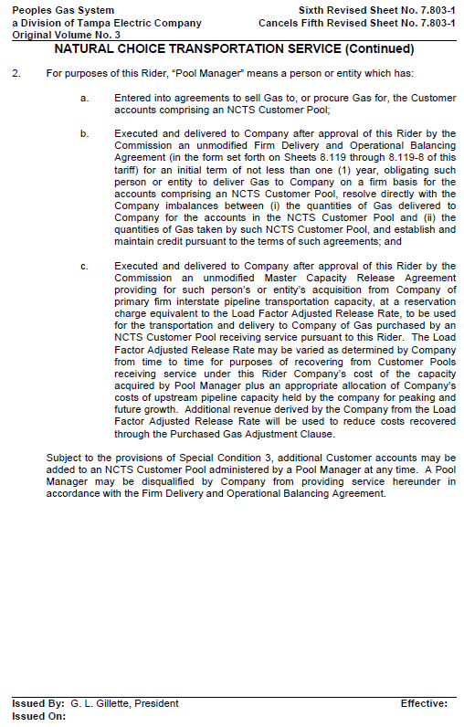
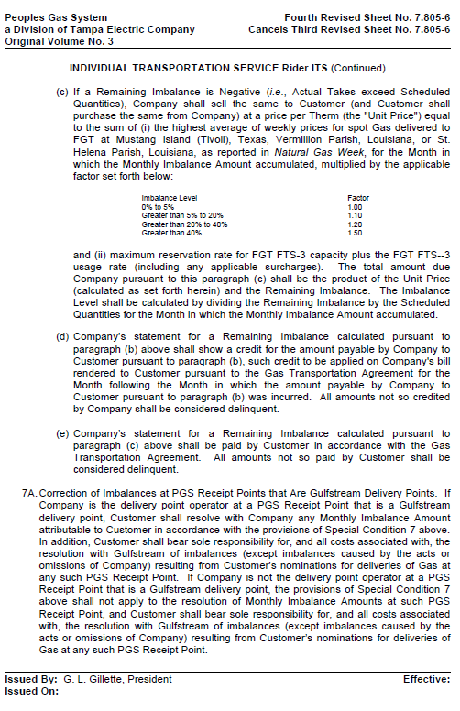
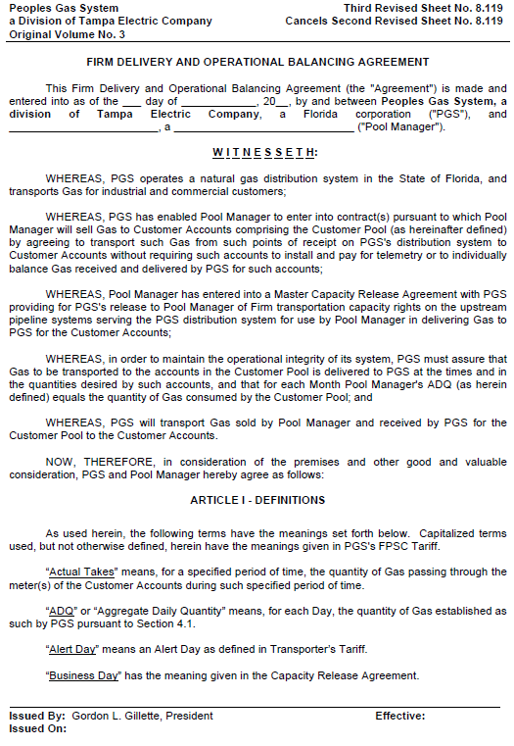
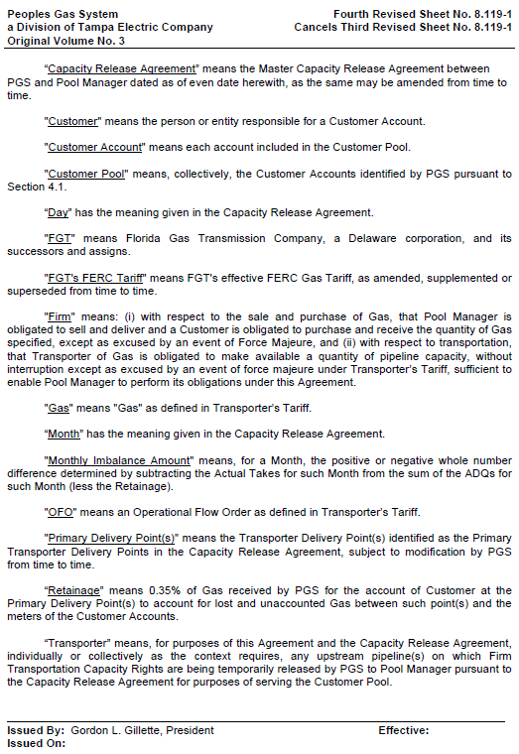
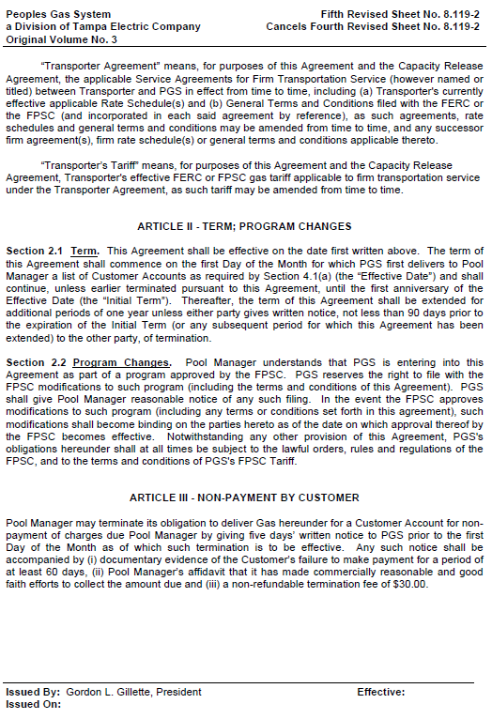
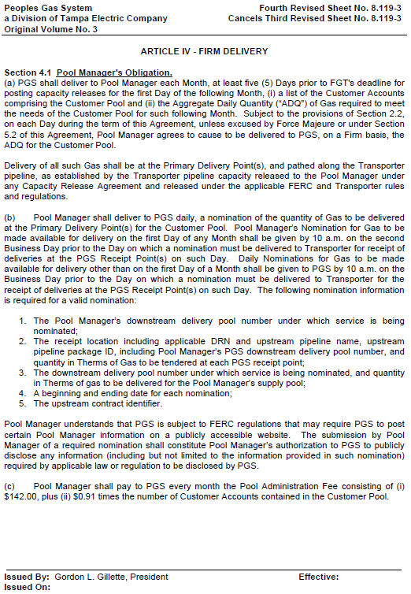
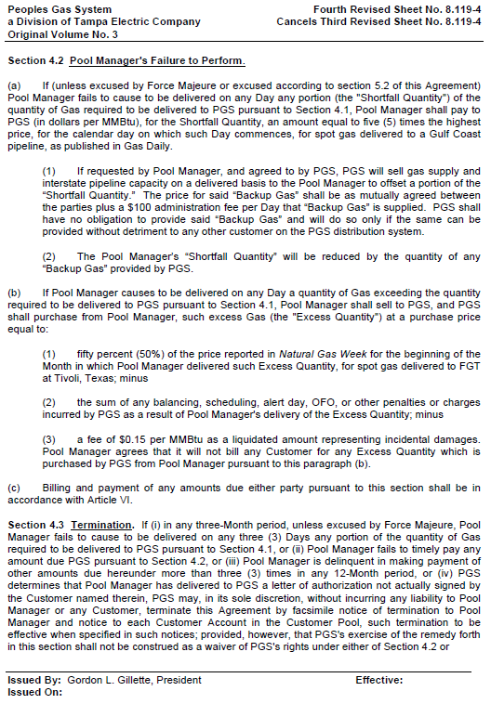
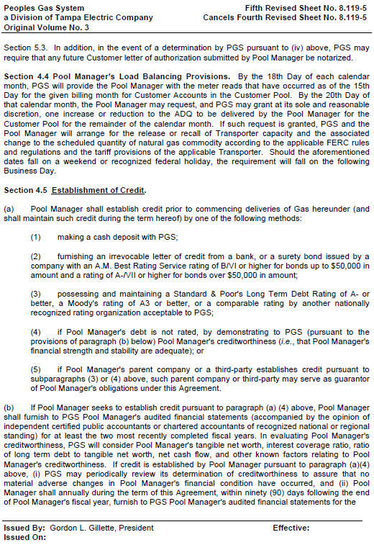
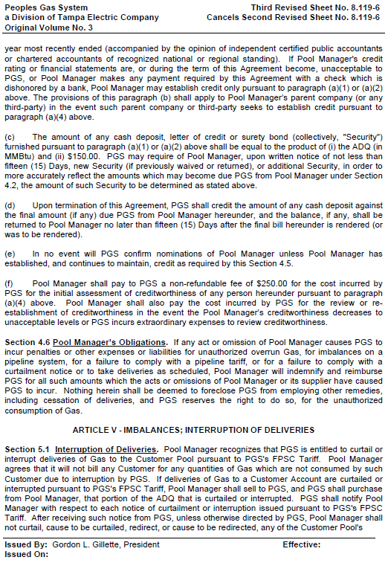
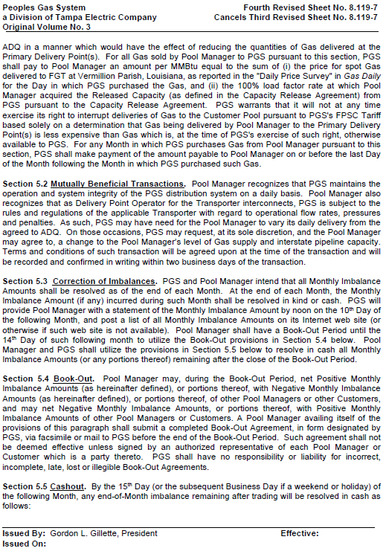
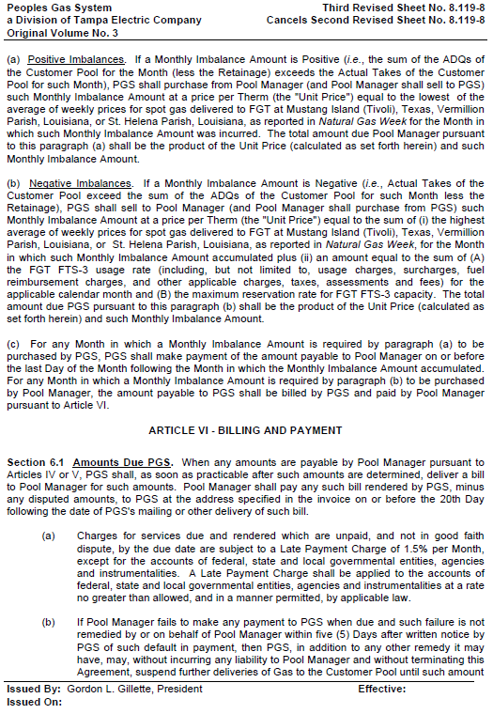
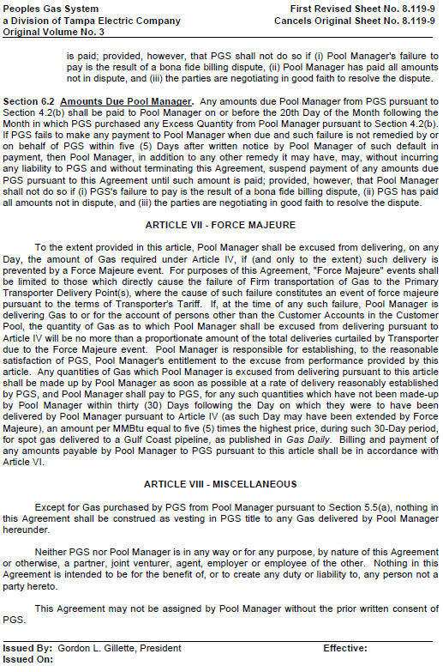

Other interested entities included City of Jacksonville, Gas South, LLC, Infinite Energy, Inc., Interconn Resources, LLC, JEA, Peninsula Energy Services Company, Inc., South Star Energy Services, LLC d/b/a Florida Natural Gas, and Tiger Natural Gas, Inc.
Order No. PSC-00-1814-TRF-GU, issued October 4, 2000 in Docket No. 000810-GU, In re: Petition for approval of modifications to tariff provisions governing transportation of customer-owned gas and tariff provisions to implement Rule 25-7.0335, F.A.C., by Tampa Electric Company d/b/a/ Peoples Gas System.
The weighted average cost of capacity is also known by its abbreviation, WACOC.
Average capacity cost (also known as WACOC) = (total capacity portfolio value – total capacity value released to customers other than NCTS pool managers)/remaining contracted capacity volume MMBtu/month.
Staff notes that one MMBtu equals one million British thermal units or one dekatherm or 10 therms.
The annual increase is calculated as follows: (2,000 x $0.14) / 10 = $28.

