State of Florida  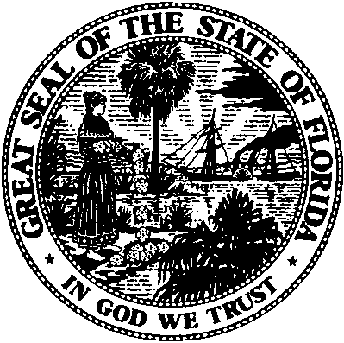 | Public Service Commission  Capital Circle Office Center ● 2540 Shumard Oak Boulevard  Tallahassee, Florida 32399-0850  -M-E-M-O-R-A-N-D-U-M-
DATE: | October 20, 2016
TO: | Office of Commission Clerk (Stauffer)
FROM: | Office of the General Counsel (S. Cuello, S. Hopkins)  Office of Telecommunications (Williams,Flores)
RE: | Application for Certificate of Authority to Provide Telecommunications Service
AGENDA: | 11/1/2016 - Consent Agenda - Proposed Agency Action - Interested Persons May Participate
SPECIAL INSTRUCTIONS: |  | None

Please place the following Application for Certificate of Authority to Provide Telecommunications Service on the consent agenda for approval.

DOCKET NO. | COMPANY NAME | CERT. NO.
160212-TX | TNE Telephone, Inc. | 8902
160205-TX | Synergem Technologies, Inc. | 8901

The Commission is vested with jurisdiction in this matter pursuant to Section 364.335, Florida Statutes.Pursuant to Section 364.336, Florida Statutes, certificate holders must pay a minimum annual Regulatory Assessment Fee if the certificate is active during any portion of the calendar year. A Regulatory Assessment Fee Return Notice will be mailed each December to the entity listed above for payment by January 30.

