BEFORE THE FLORIDA PUBLIC SERVICE COMMISSION

In re: Petition for approval of modifications to standard interconnection agreement contained in the approved tariff by Duke Energy Florida, LLC. | DOCKET NO. 160140-EQ  ORDER NO. PSC-16-0499-TRF-EQ  ISSUED: October 31, 2016

The following Commissioners participated in the disposition of this matter:

JULIE I. BROWN, Chairman
LISA POLAK EDGAR
ART GRAHAM
RONALD A. BRISÉ
JIMMY PATRONIS

ORDER APPROVING PROPOSED MODIFICATIONS TO
STANDARD INTERCONNECTION AGREEMENT

BY THE COMMISSION:

Background

On June 2, 2016, Duke Energy Florida, LLC (Duke), filed a petition for approval of 2016 modifications to its Standard Interconnection Agreement in Duke’s approved tariffs. This Standard Interconnection Agreement was last modified by Order No. PSC-14-0660-CO-EI.
On July 21, 2016, we suspended the tariff in order to allow staff sufficient time to review the application and gather information to present this Commission with an informed recommendation on the proposed tariffs.
We have jurisdiction over this matter pursuant to Sections 366.03, 366.04, 366.05, and 366.06, Florida Statutes (F.S.).
Decision
In its petition Duke proposes to make certain changes to the approved tariff sheets 9.700 through 9.715 which contains the terms and conditions of Duke’s Interconnection Agreement for QFs. The Company submitted a total of 15 revised sheets of the Interconnection Agreement. The type-and-strike format versions of the revised tariff sheets are included as Attachment A.

Interconnection Agreement Modifications

In its petition and in response to staff data requests, Duke notes that some of the proposed tariff changes address only non-Federal Energy Regulatory Commission (FERC) jurisdictional interconnections only. For example, proposed tariff sheet 9.700, paragraph 1.0 is modified to reflect that all net output will be sold to Duke. As a result, any QF wishing to sell power to another party would instead, use the Company’s FERC interconnection tariff, instead of the proposed Agreement.

The proposed Agreement includes a new component to the preliminary cost study, a Feasibility Study, which is meant to provide a list of options available to the QF for its interconnection to narrow the analysis in determining costs. The estimated interconnection costs for all feasibility studies for a 50 MW QF is less than $70,000, or approximately $0.0014/watt. Section 4.2.2 on proposed Tariff Sheet 9.705 also adds a requirement that the QF provides cash or a letter of credit to Duke prior to interconnection field work being conducted. These new requirements appear reasonable, in that the Feasibility Study allows a QF to determine its desired interconnection option, while the credit requirement protects the Company’s ratepayers in the event a QF would not reimburse Duke for interconnection costs.

Section 12 of the proposed Agreement adds liability insurance requirements, including consequences that clarify the results of failing to acquire or maintain insurance coverage. The minimum liability insurance requirement is $1,000,000 per occurrence for bodily injury or property damage. While this increases costs to QFs, the requirement represents a reasonable practice and the language is similar to the insurance requirements included in the Company’s Standard Offer Contract.

Additional legal terms are added to the agreement, including events of default, termination, assignment, references to controlling statutes, and representations that the parties are capable of legally conducting the agreement. These terms are reasonable and provide clarity in the event of a dispute regarding the contract terms. Other revisions to the Agreement include modifications to terminology and definitions with minor substantive changes.

Conclusion

We hereby approve Duke’s modifications to its Interconnection Agreement as shown in Attachment A. The new requirements clarify that the Agreement is intended for interconnections with Duke only and improves security to ratepayers by requiring insurance similar to other contracts. The proposed tariff modifications shall not place an undue burden on QFs that seek to interconnect with Duke’s system and deliver power to the Company.

Based on the foregoing, it is

ORDERED by the Florida Public Service Commission that Duke Energy Florida, LLC’s petition for modification to its Interconnection Agreement as reflected in Attachment A is approved. It is further

ORDERED that if a protest is filed within 21 days of the issuance of the order, this tariff shall remain in effect, with any revenues held subject to refund, pending resolution of the protest. If no timely protest is filed, this docket shall be closed upon the issuance of a consummating order. in the event this Order becomes final, this docket shall be closed.

By ORDER of the Florida Public Service Commission this 31st day of October, 2016.

/s/ Carlotta S. Stauffer
CARLOTTA S. STAUFFER
Commission Clerk
Florida Public Service Commission
2540 Shumard Oak Boulevard
Tallahassee, Florida 32399
(850) 413-6770
www.floridapsc.com

Copies furnished: A copy of this document is provided to the parties of record at the time of issuance and, if applicable, interested persons.

WLT

NOTICE OF FURTHER PROCEEDINGS OR JUDICIAL REVIEW

The Florida Public Service Commission is required by Section 120.569(1), Florida Statutes, to notify parties of any administrative hearing or judicial review of Commission orders that is available under Sections 120.57 or 120.68, Florida Statutes, as well as the procedures and time limits that apply. This notice should not be construed to mean all requests for an administrative hearing or judicial review will be granted or result in the relief sought.

Mediation may be available on a case-by-case basis. If mediation is conducted, it does not affect a substantially interested person's right to a hearing.

The Commission's decision on this tariff is interim in nature and will become final, unless a person whose substantial interests are affected by the proposed action files a petition for a formal proceeding, in the form provided by Rule 28-106.201, Florida Administrative Code. This petition must be received by the Office of Commission Clerk, 2540 Shumard Oak Boulevard, Tallahassee, Florida 32399-0850, by the close of business on November 21, 2016.

In the absence of such a petition, this Order shall become final and effective upon the issuance of a Consummating Order.

Any objection or protest filed in this docket before the issuance date of this order is considered abandoned unless it satisfies the foregoing conditions and is renewed within the specified protest period.

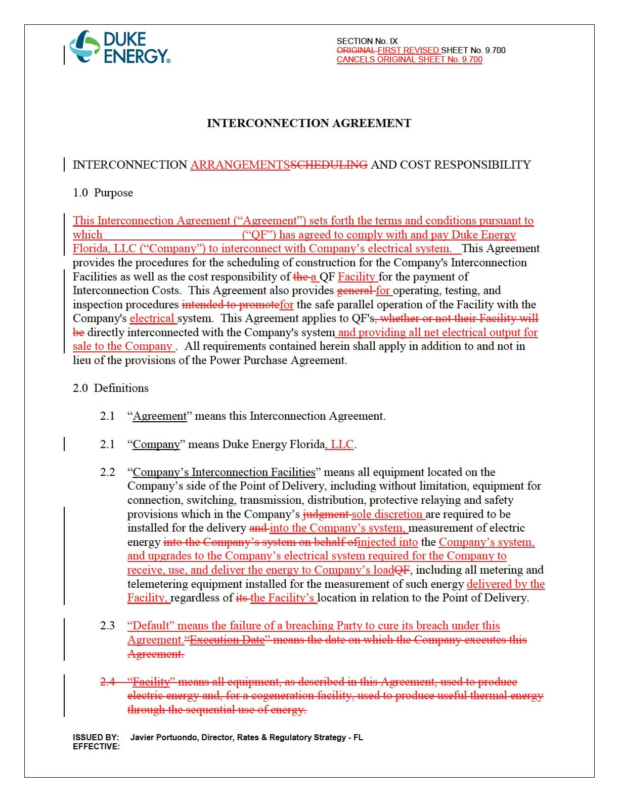
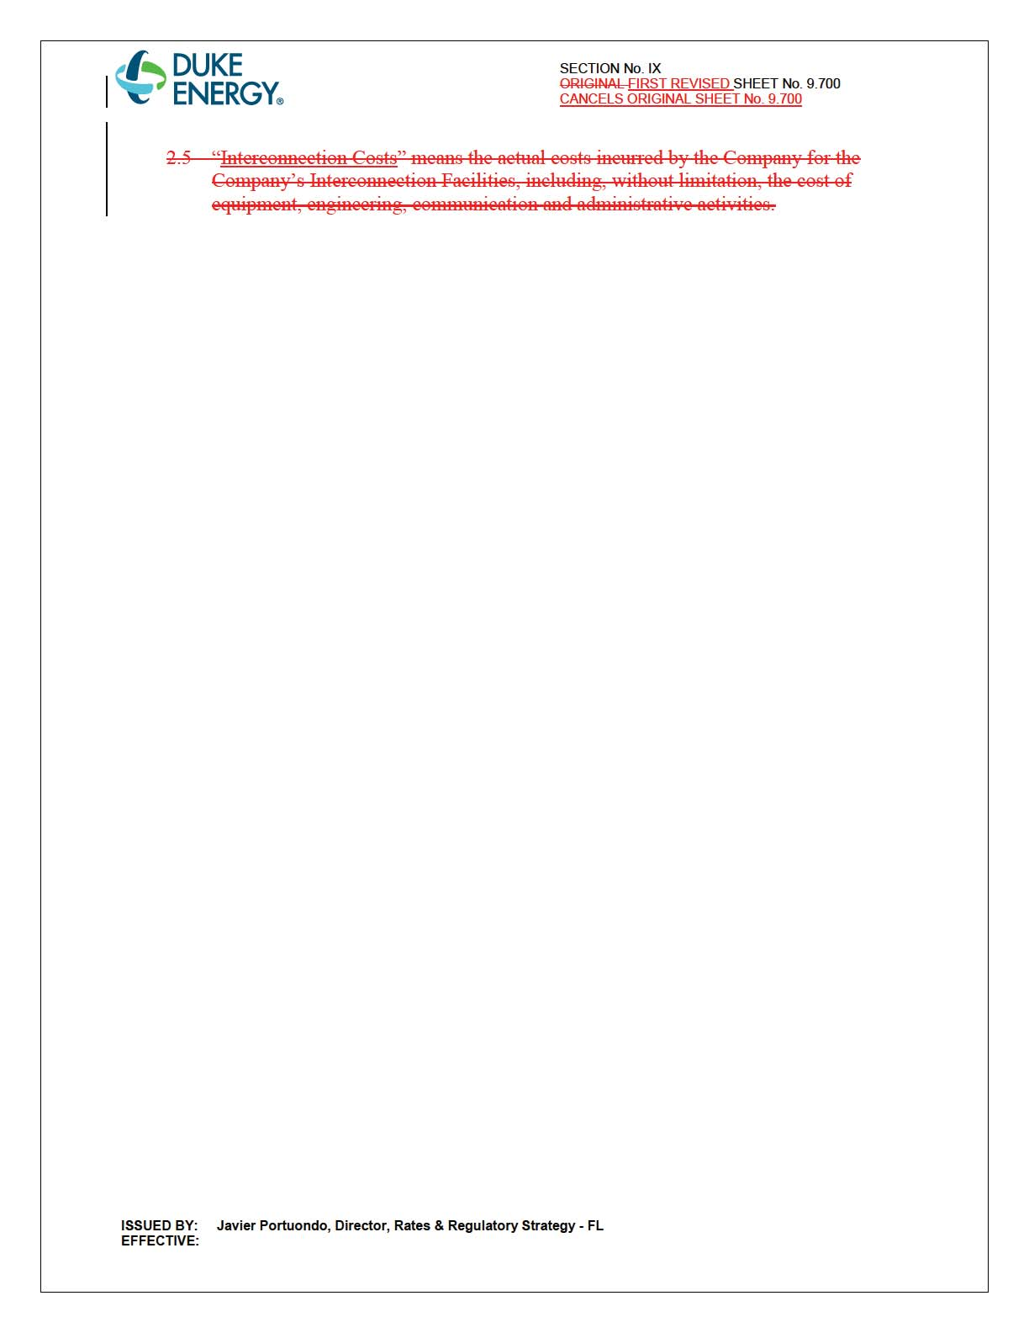

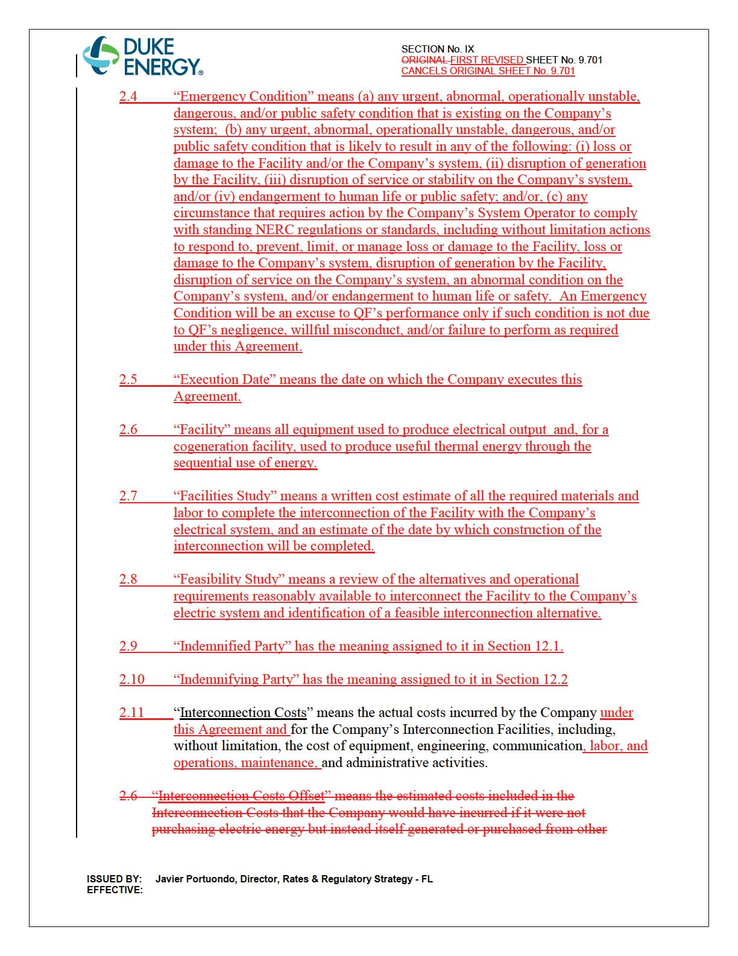

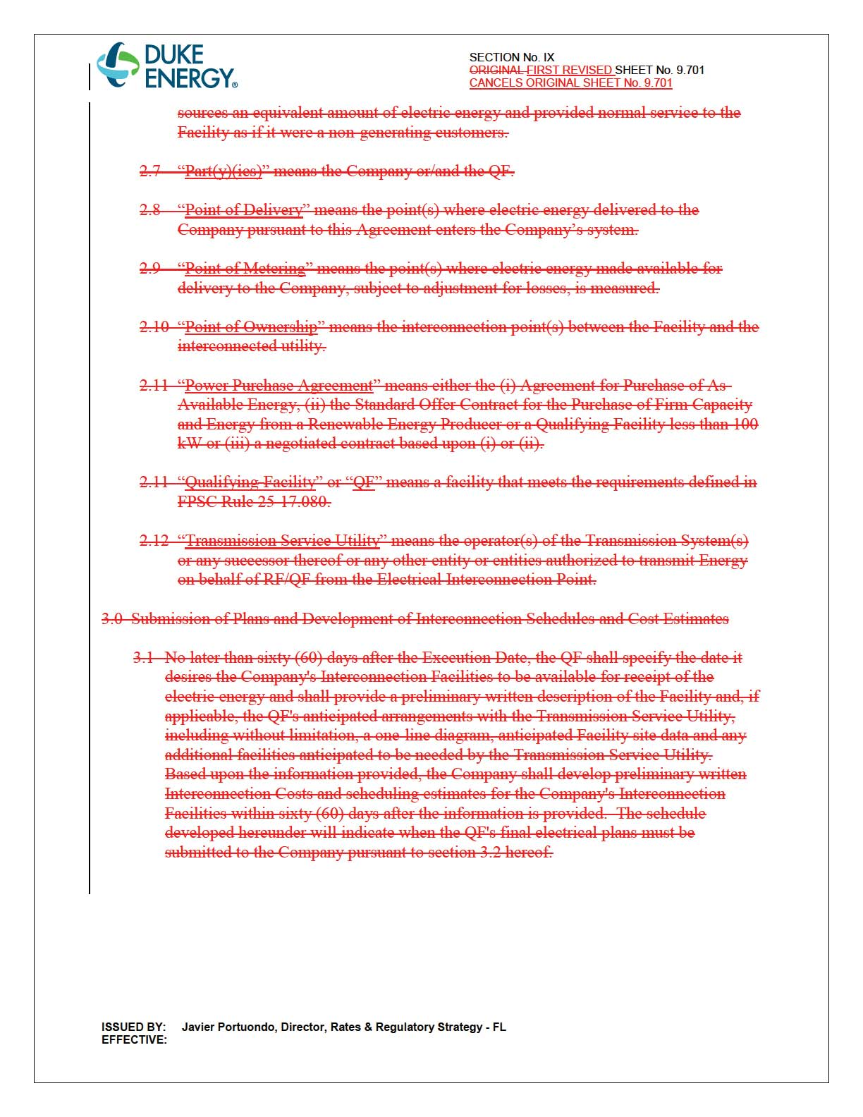
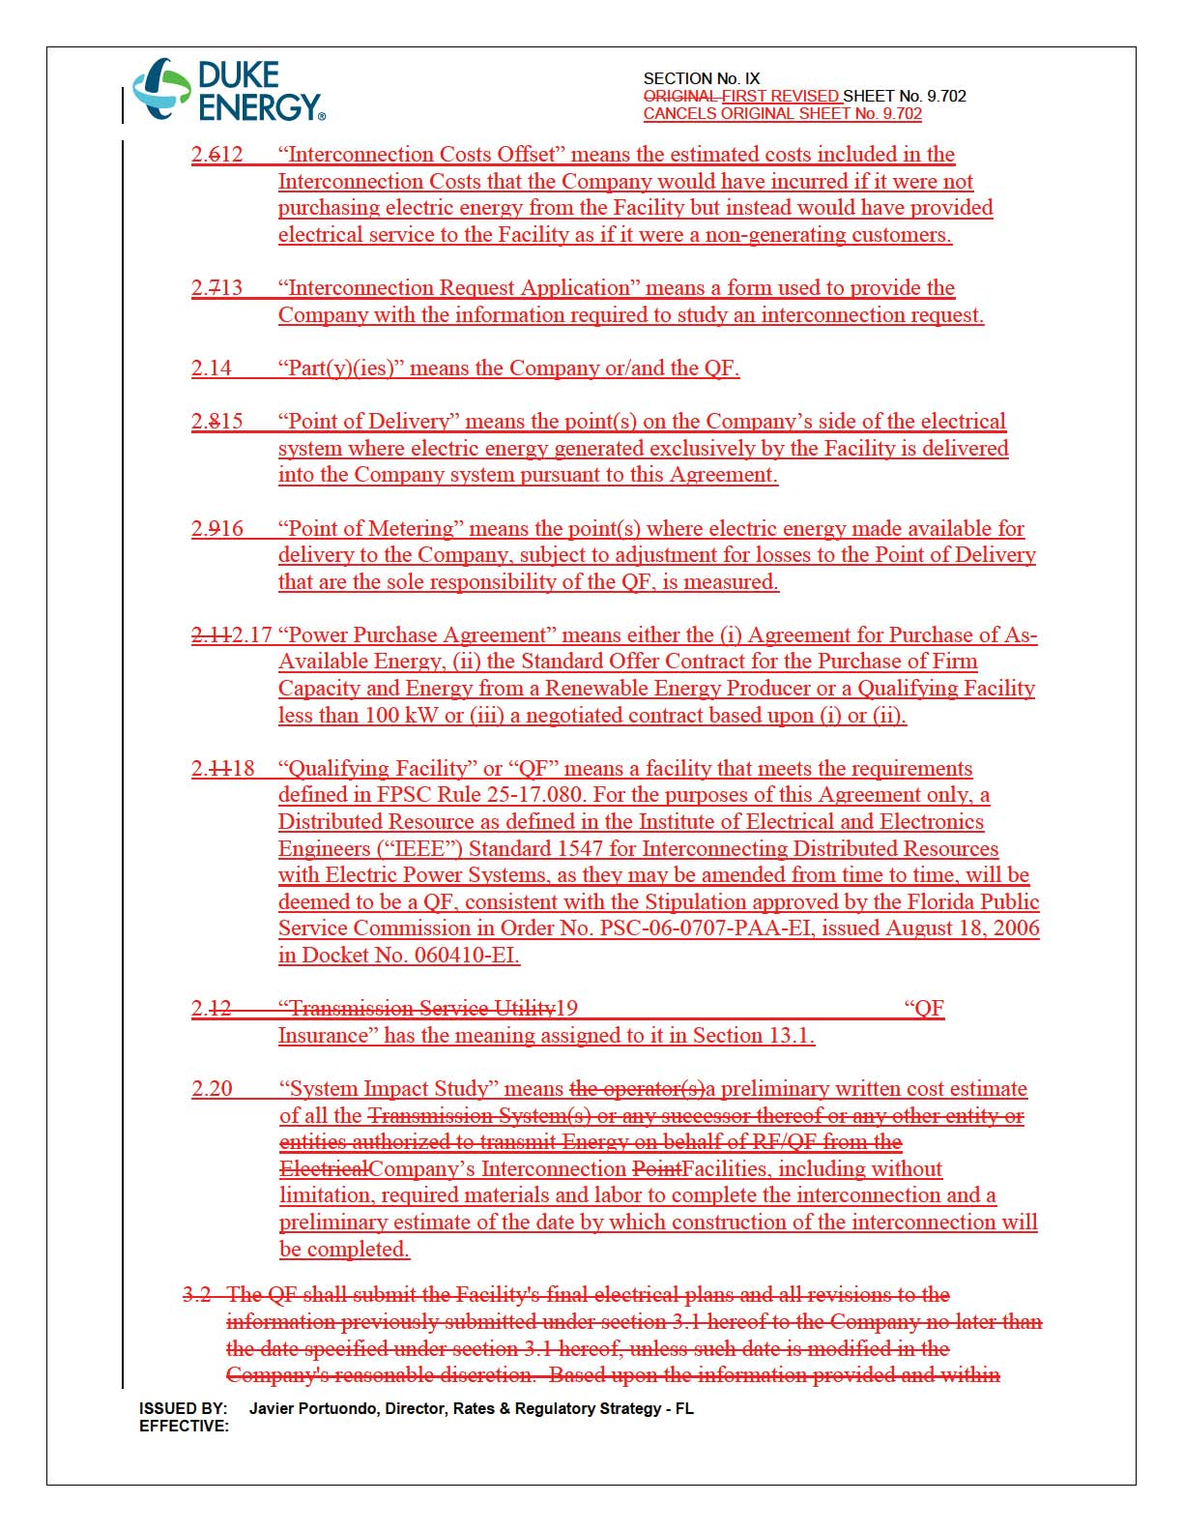

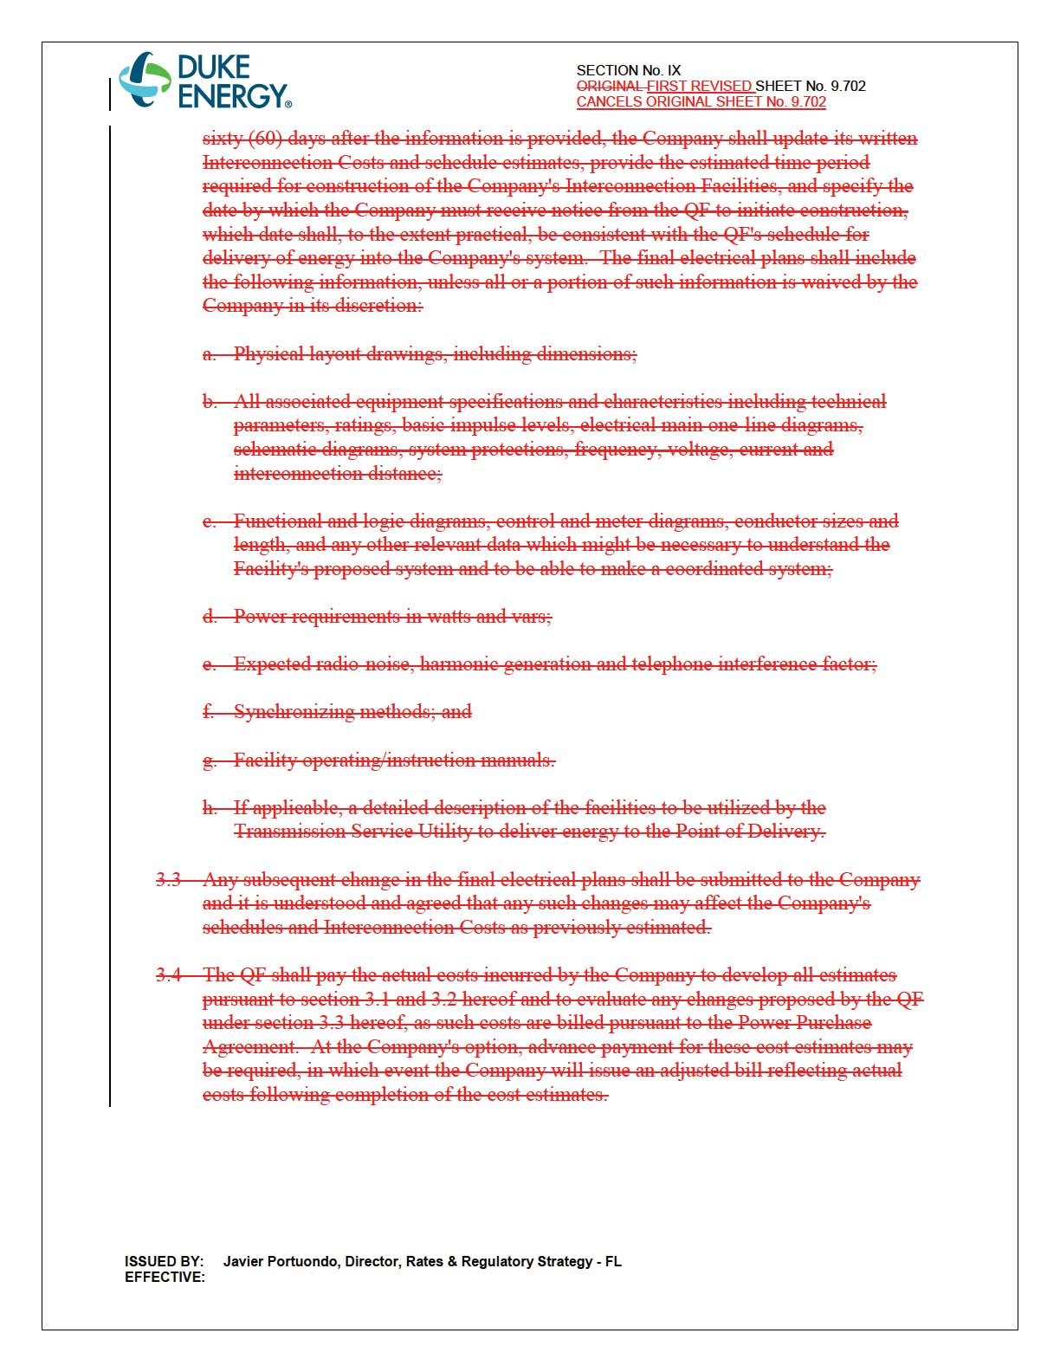

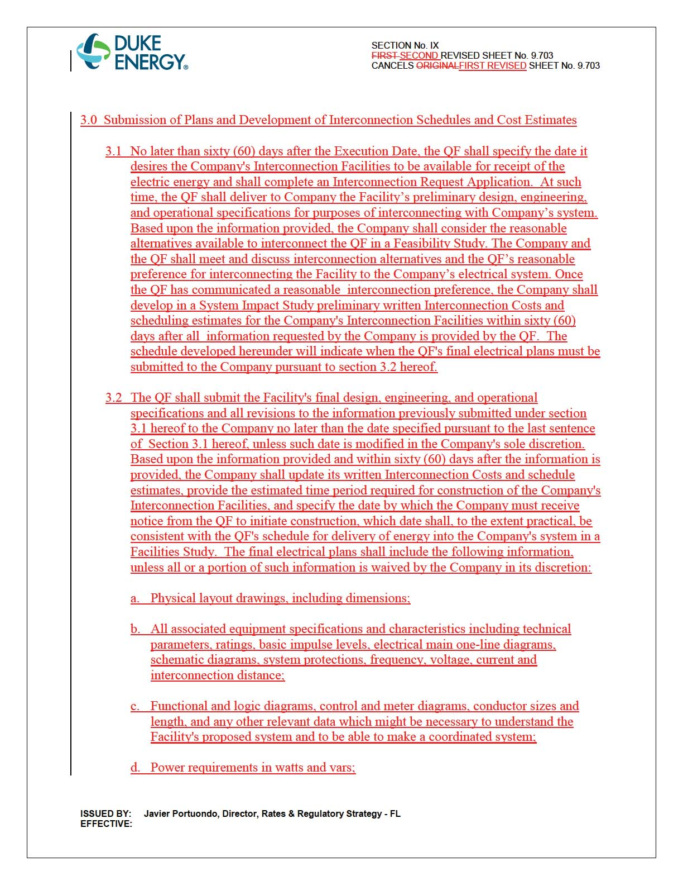

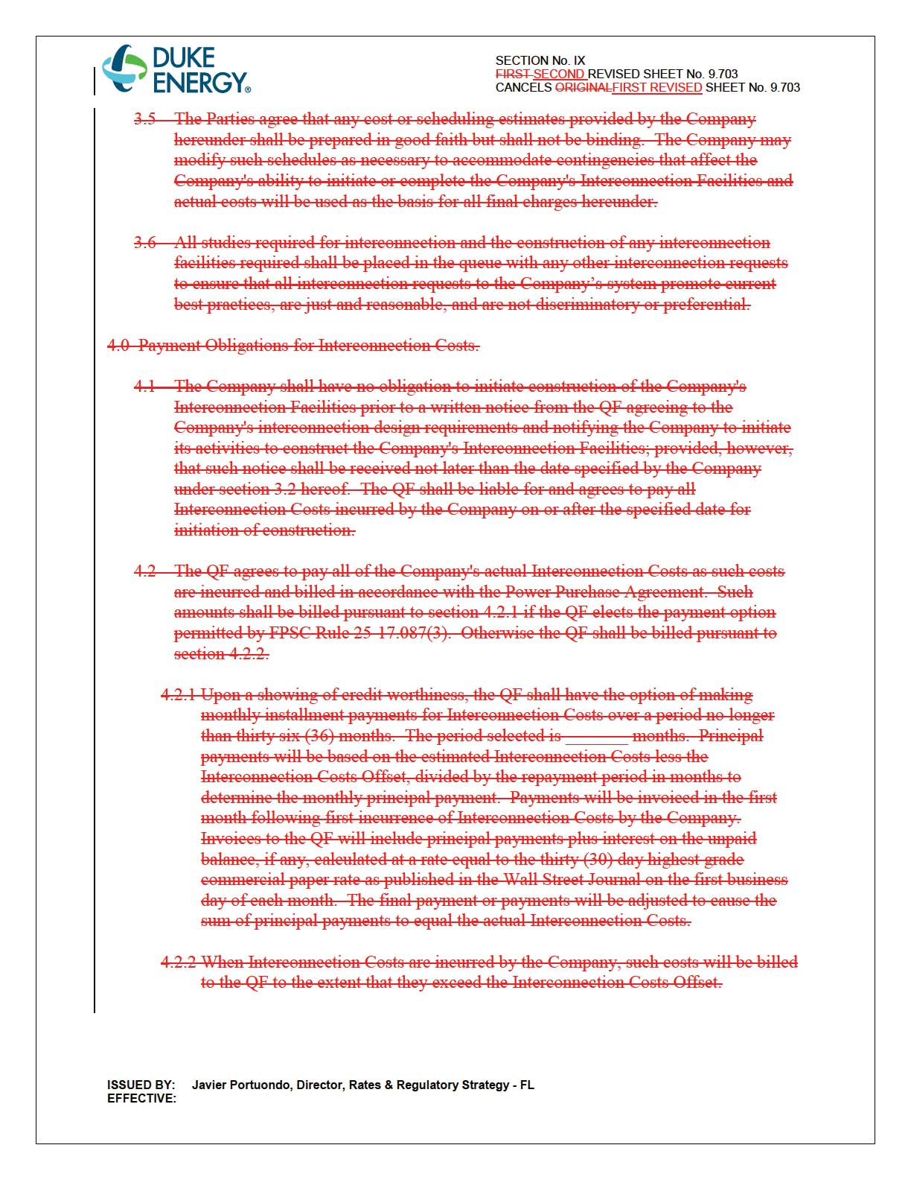

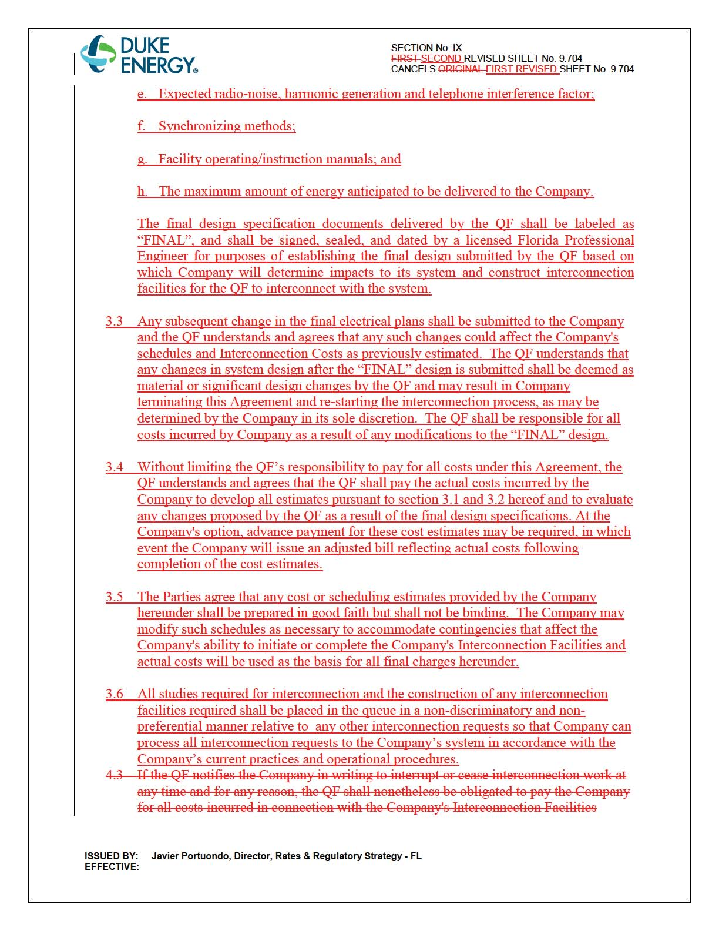

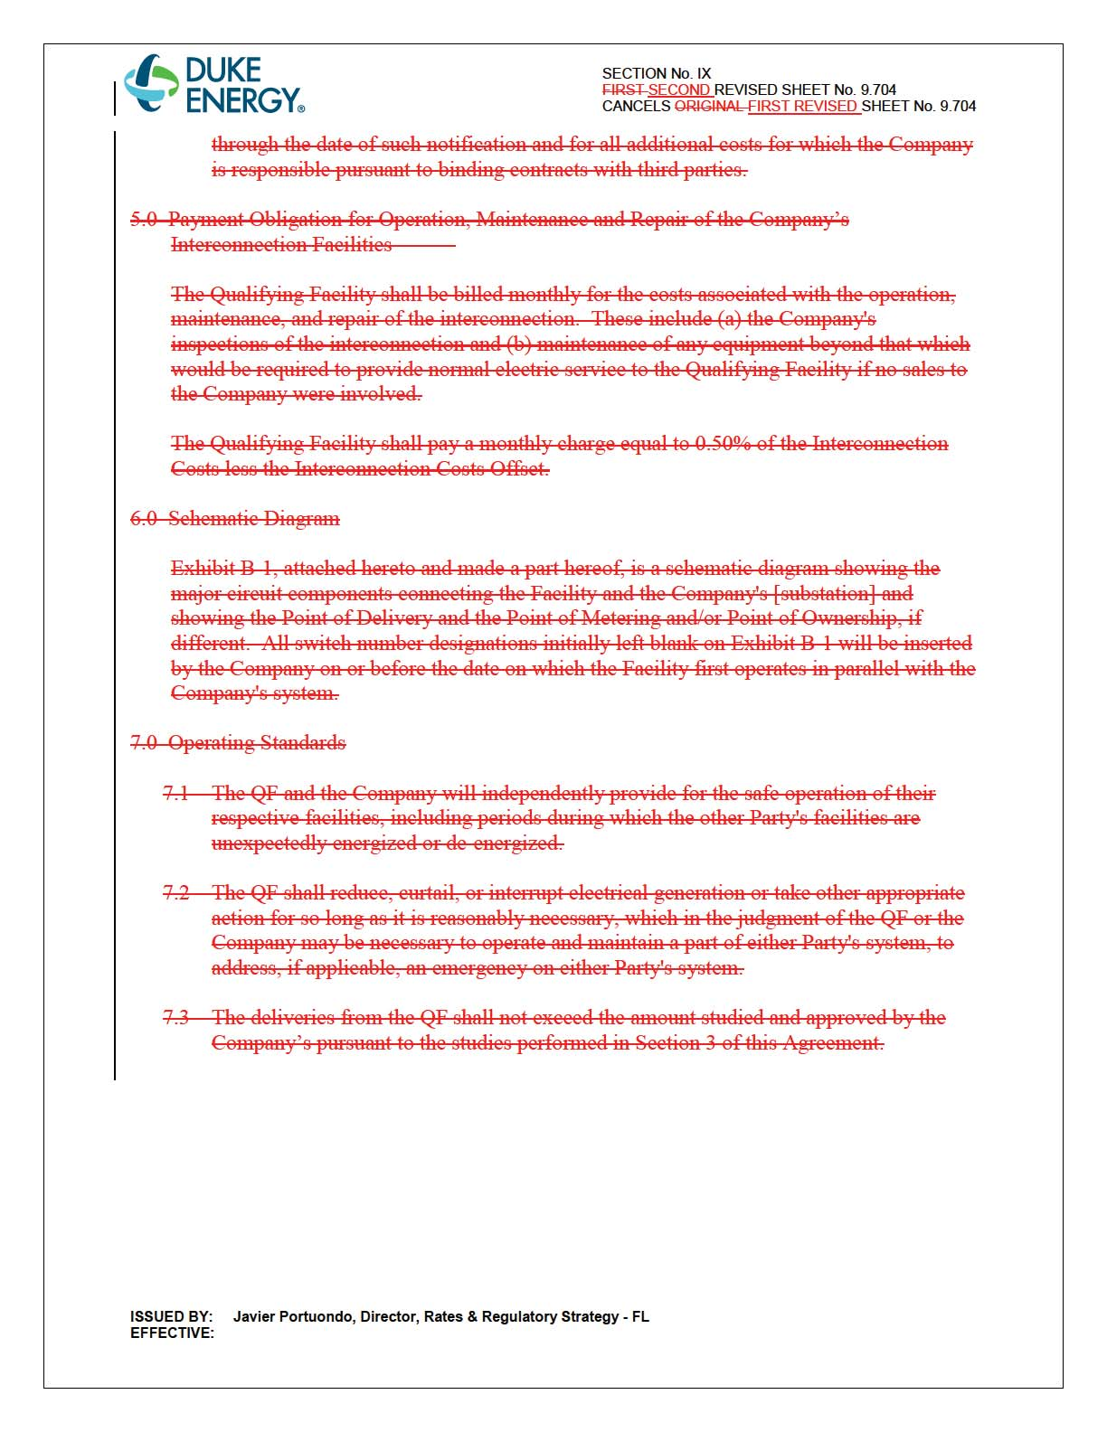

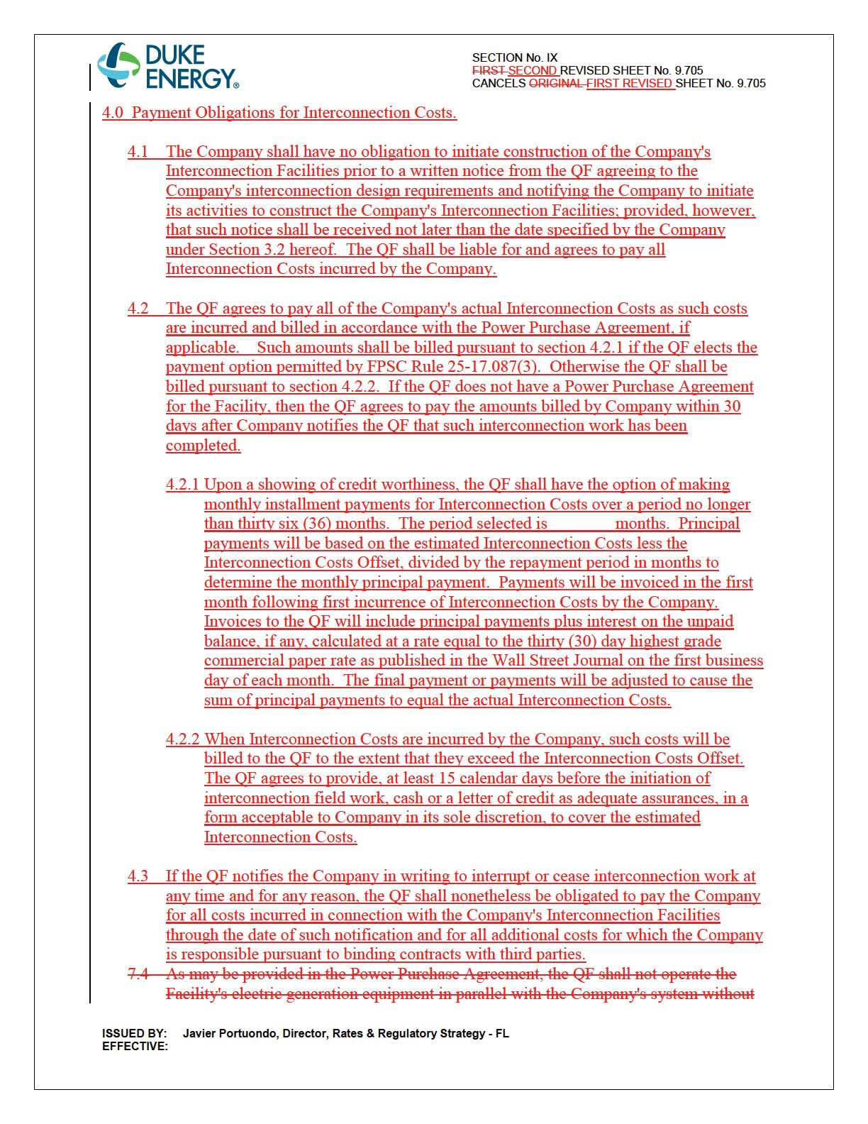

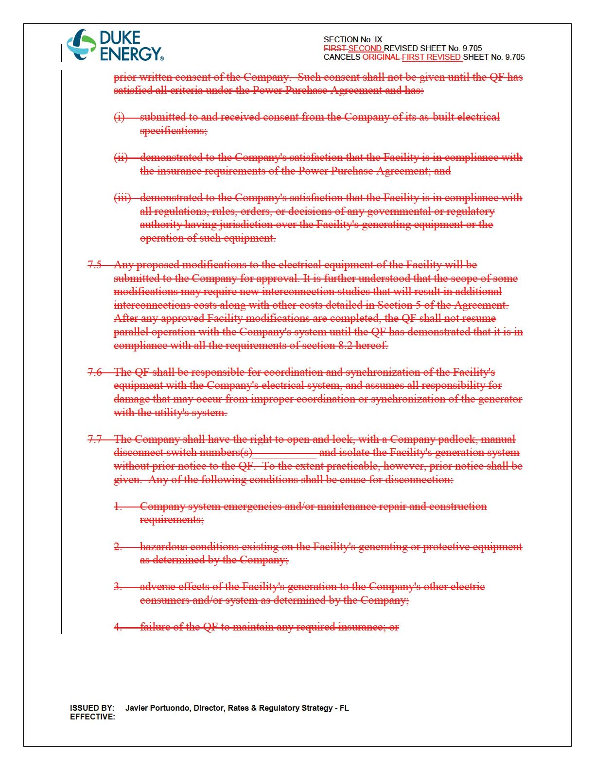

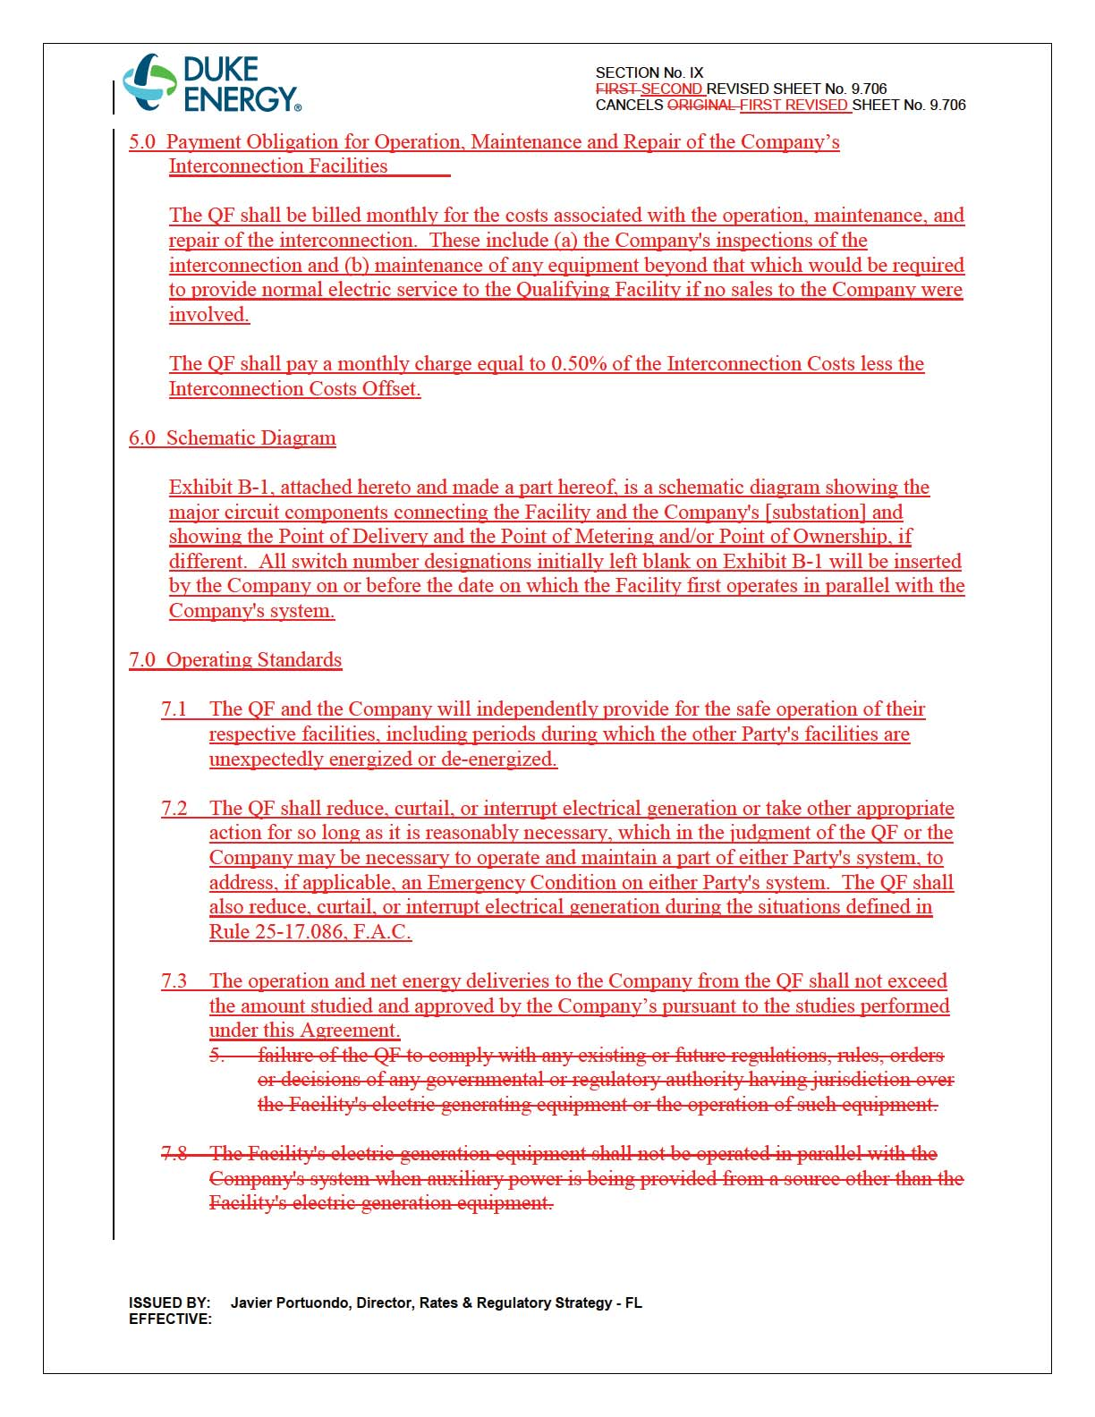

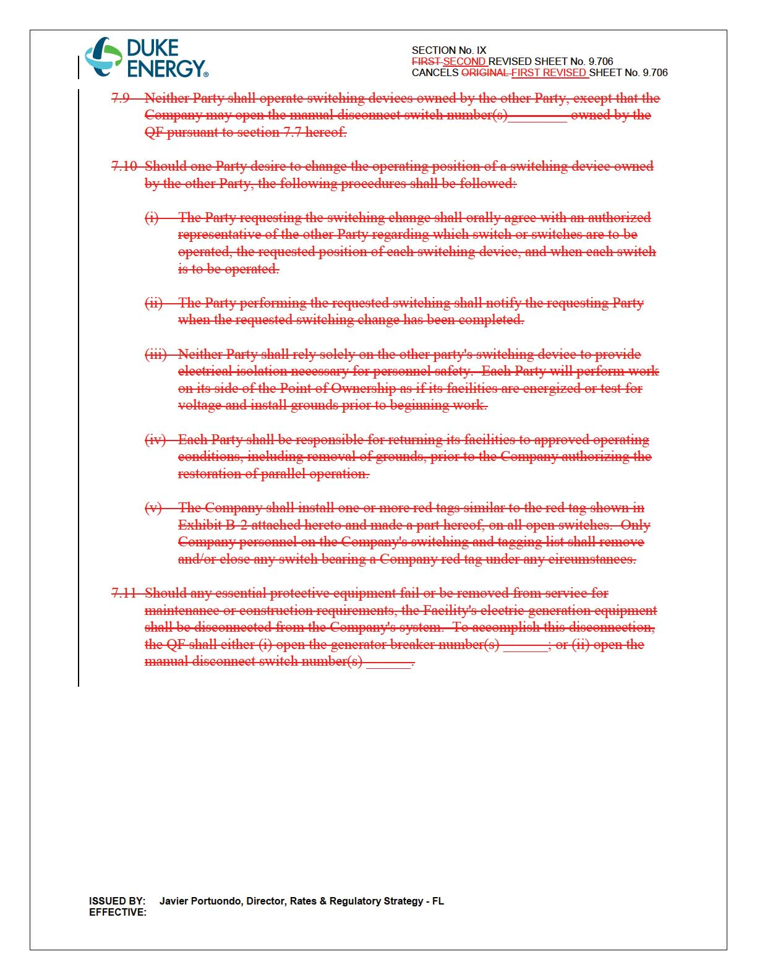

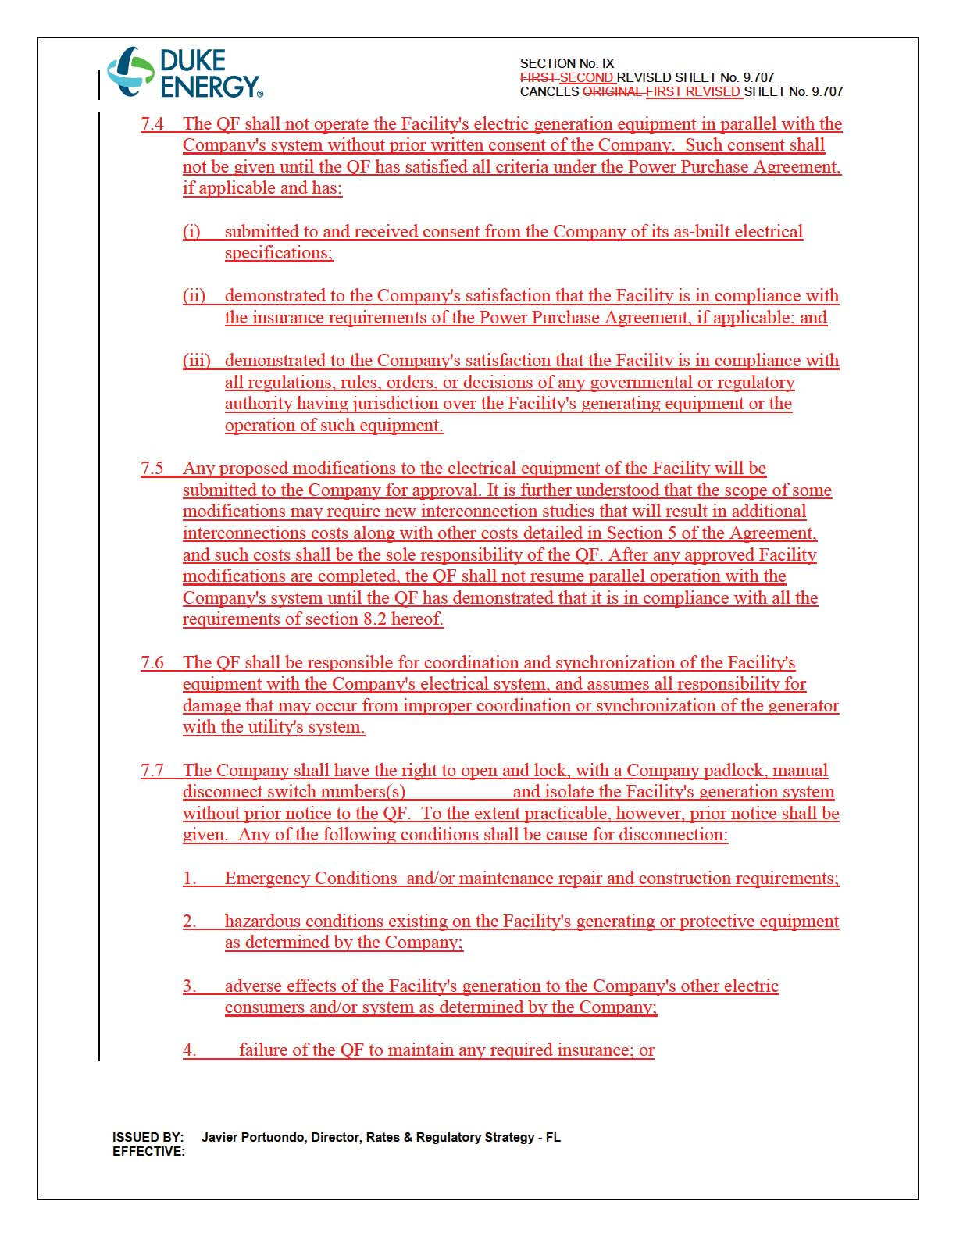

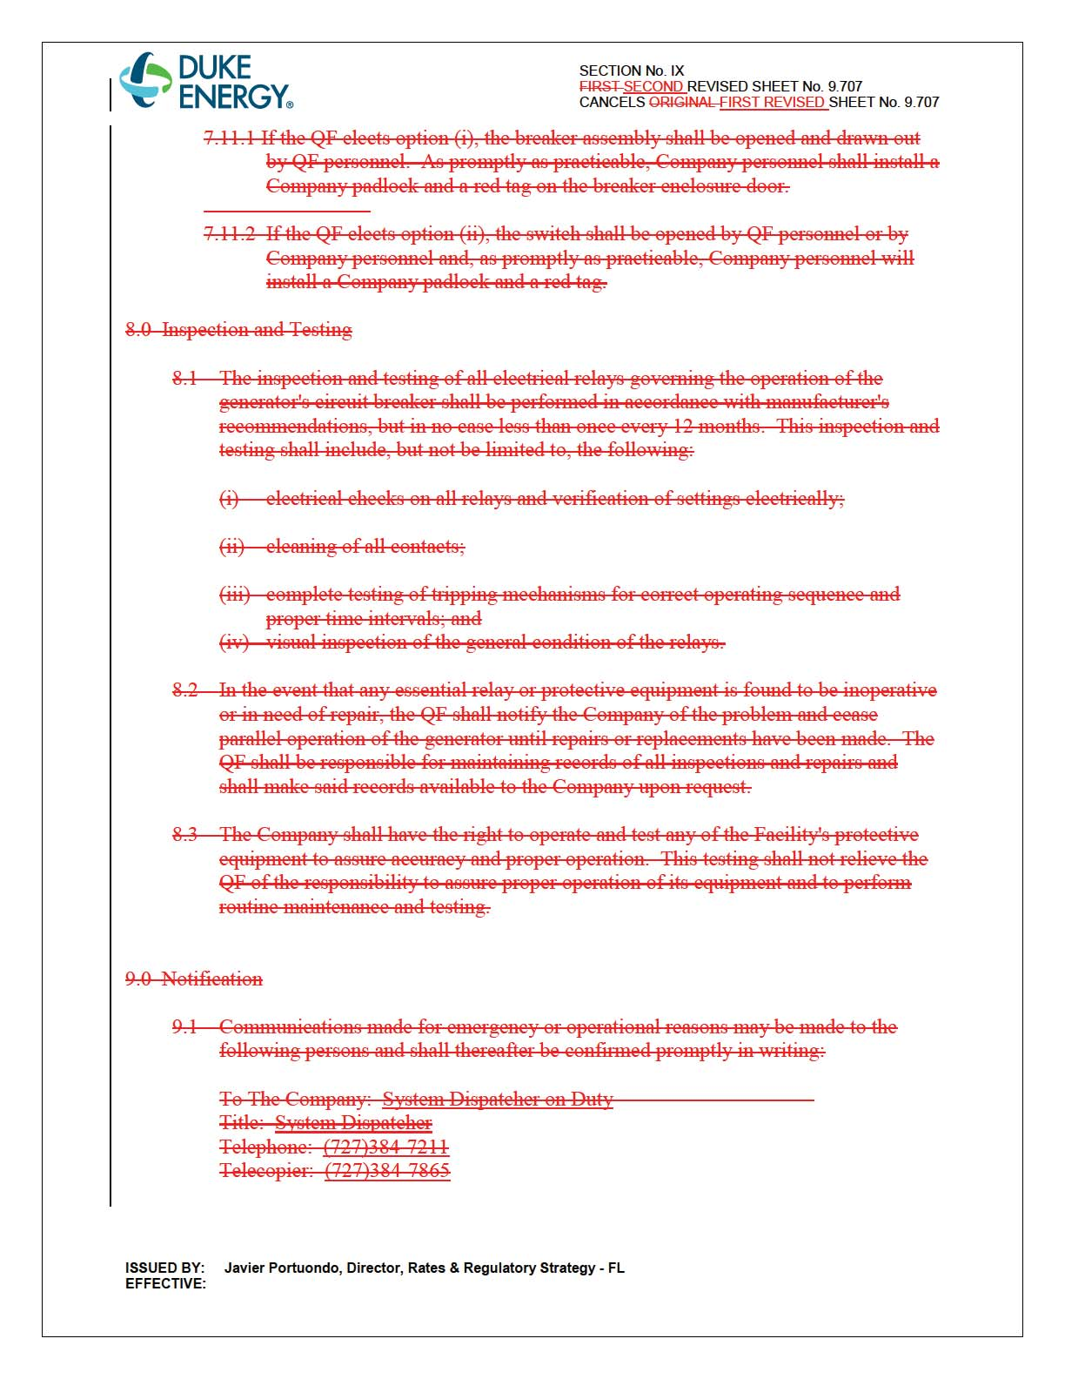

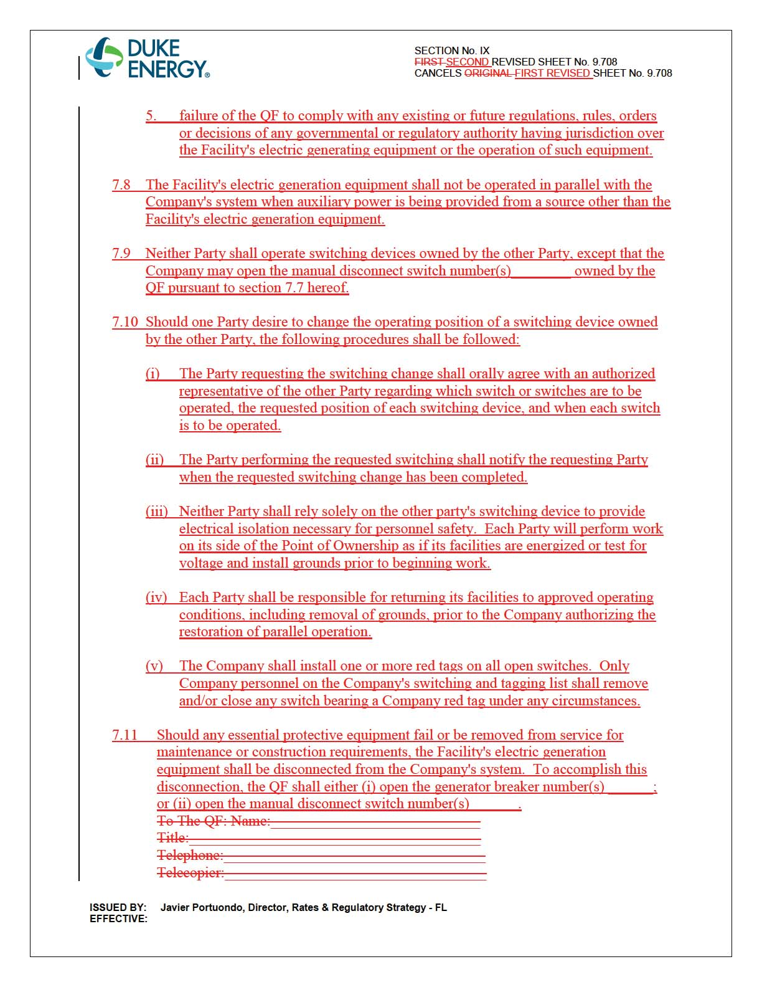

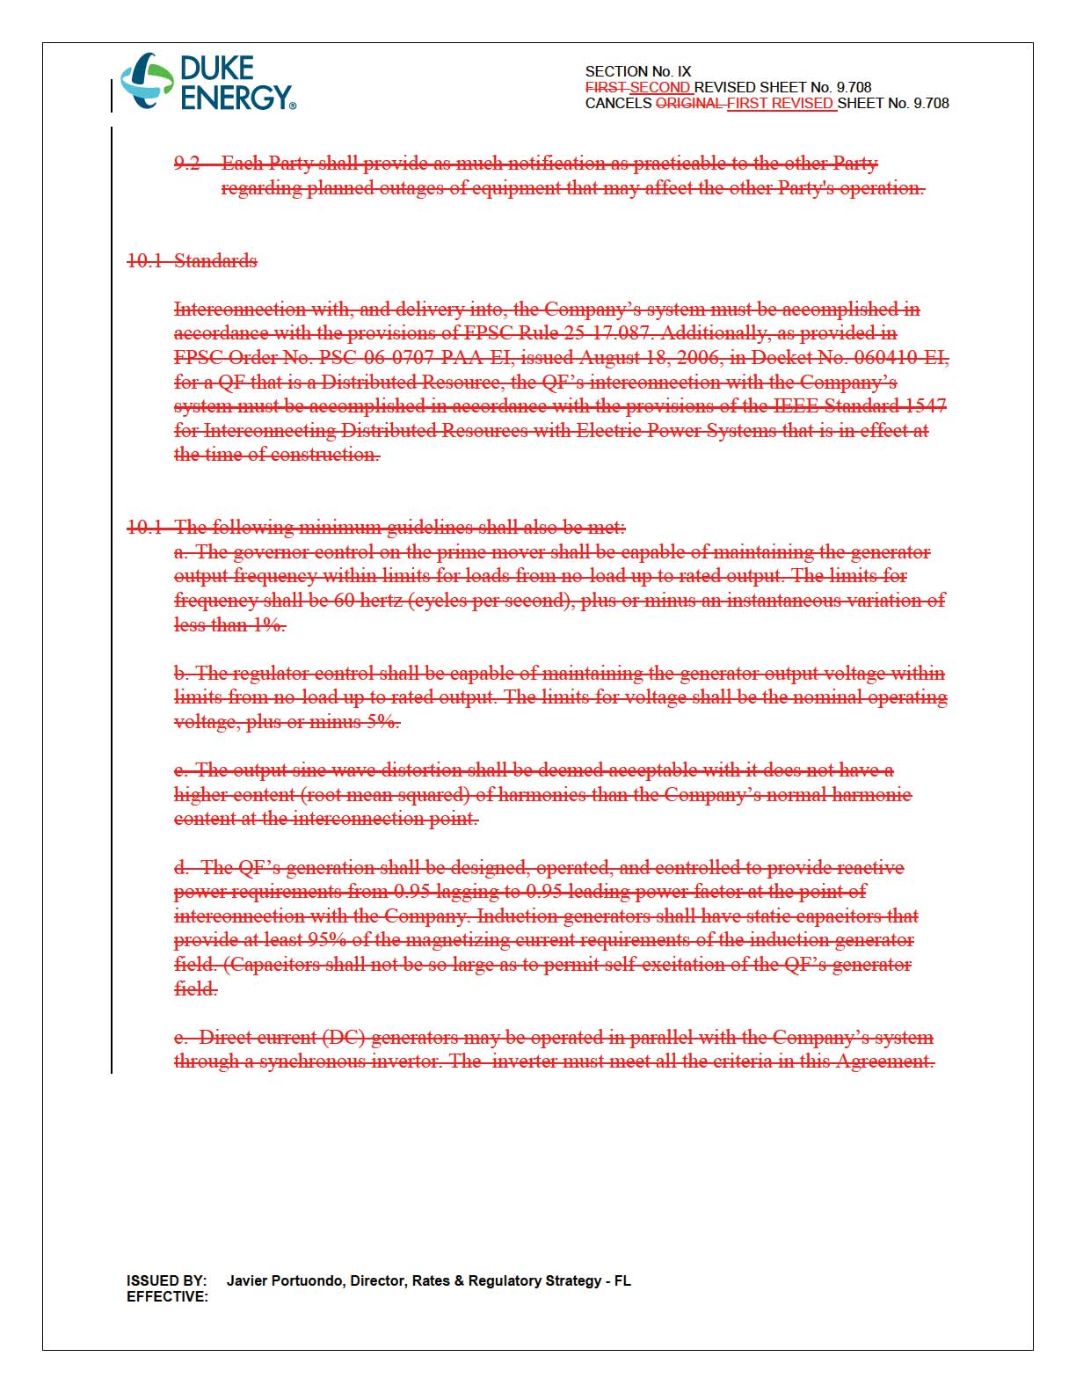

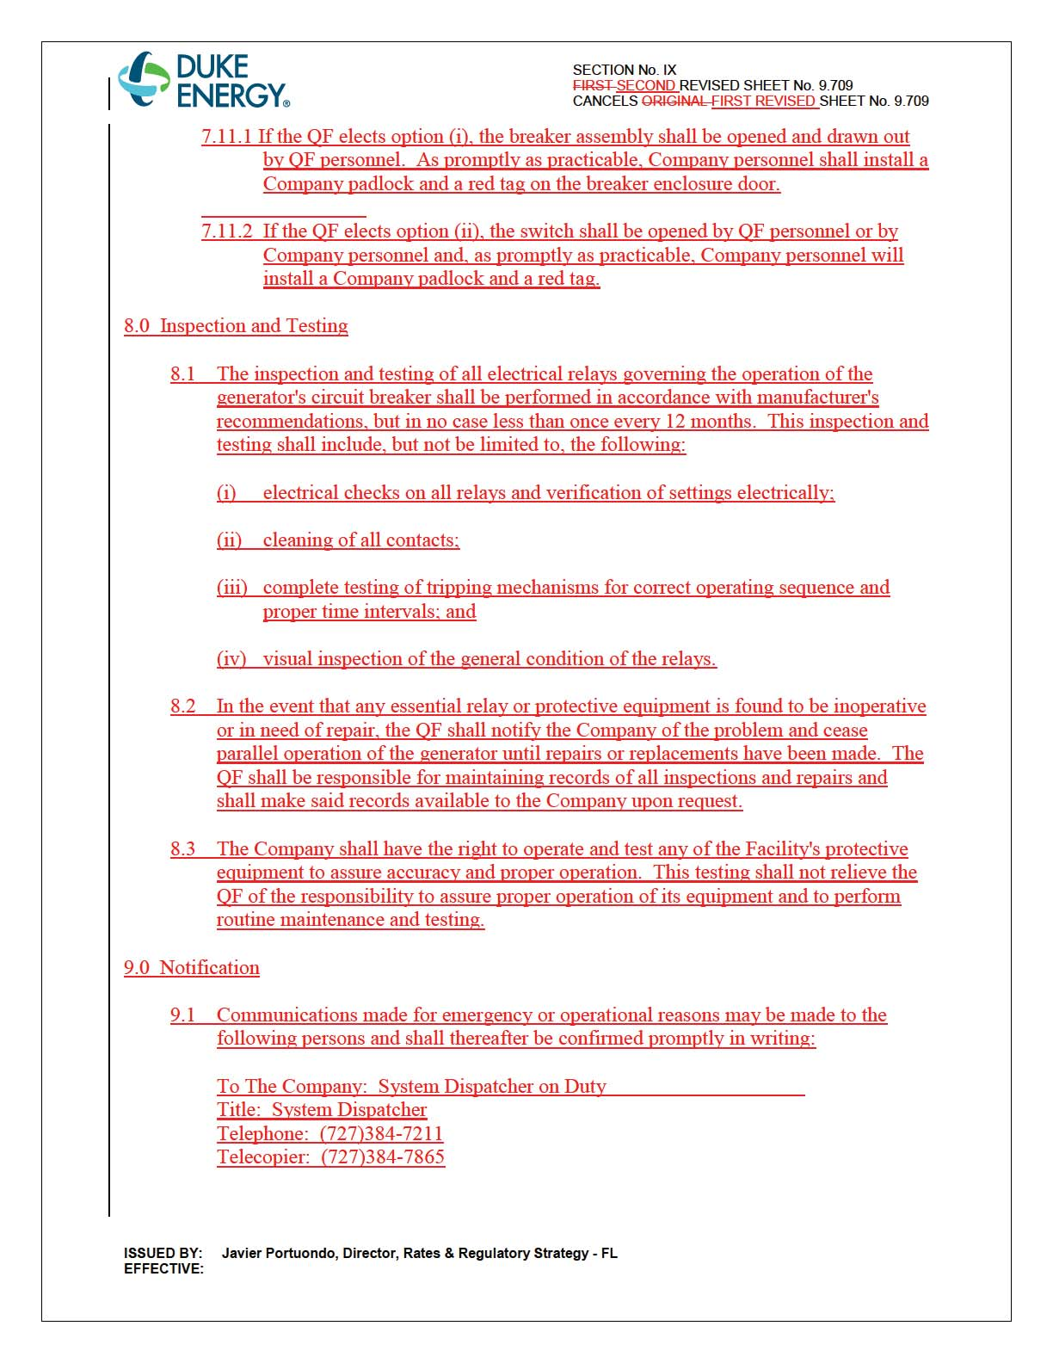

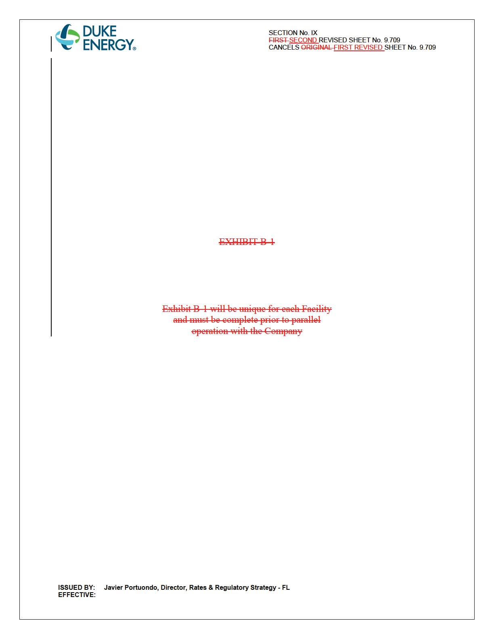

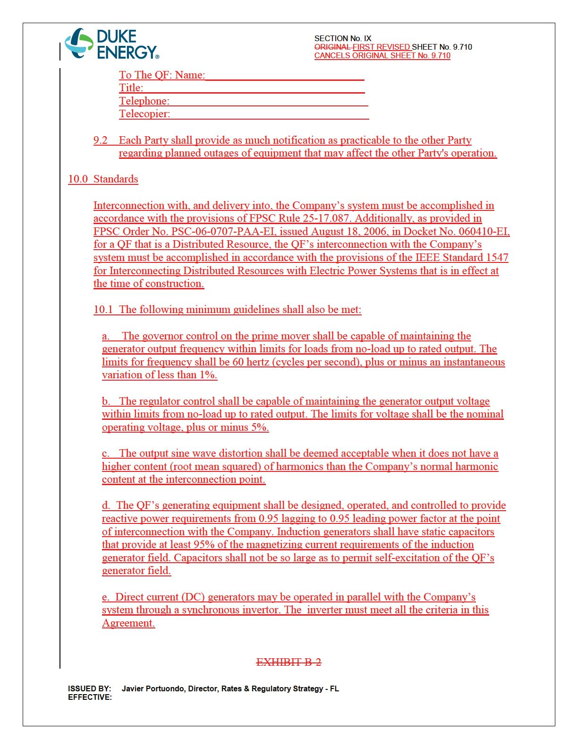

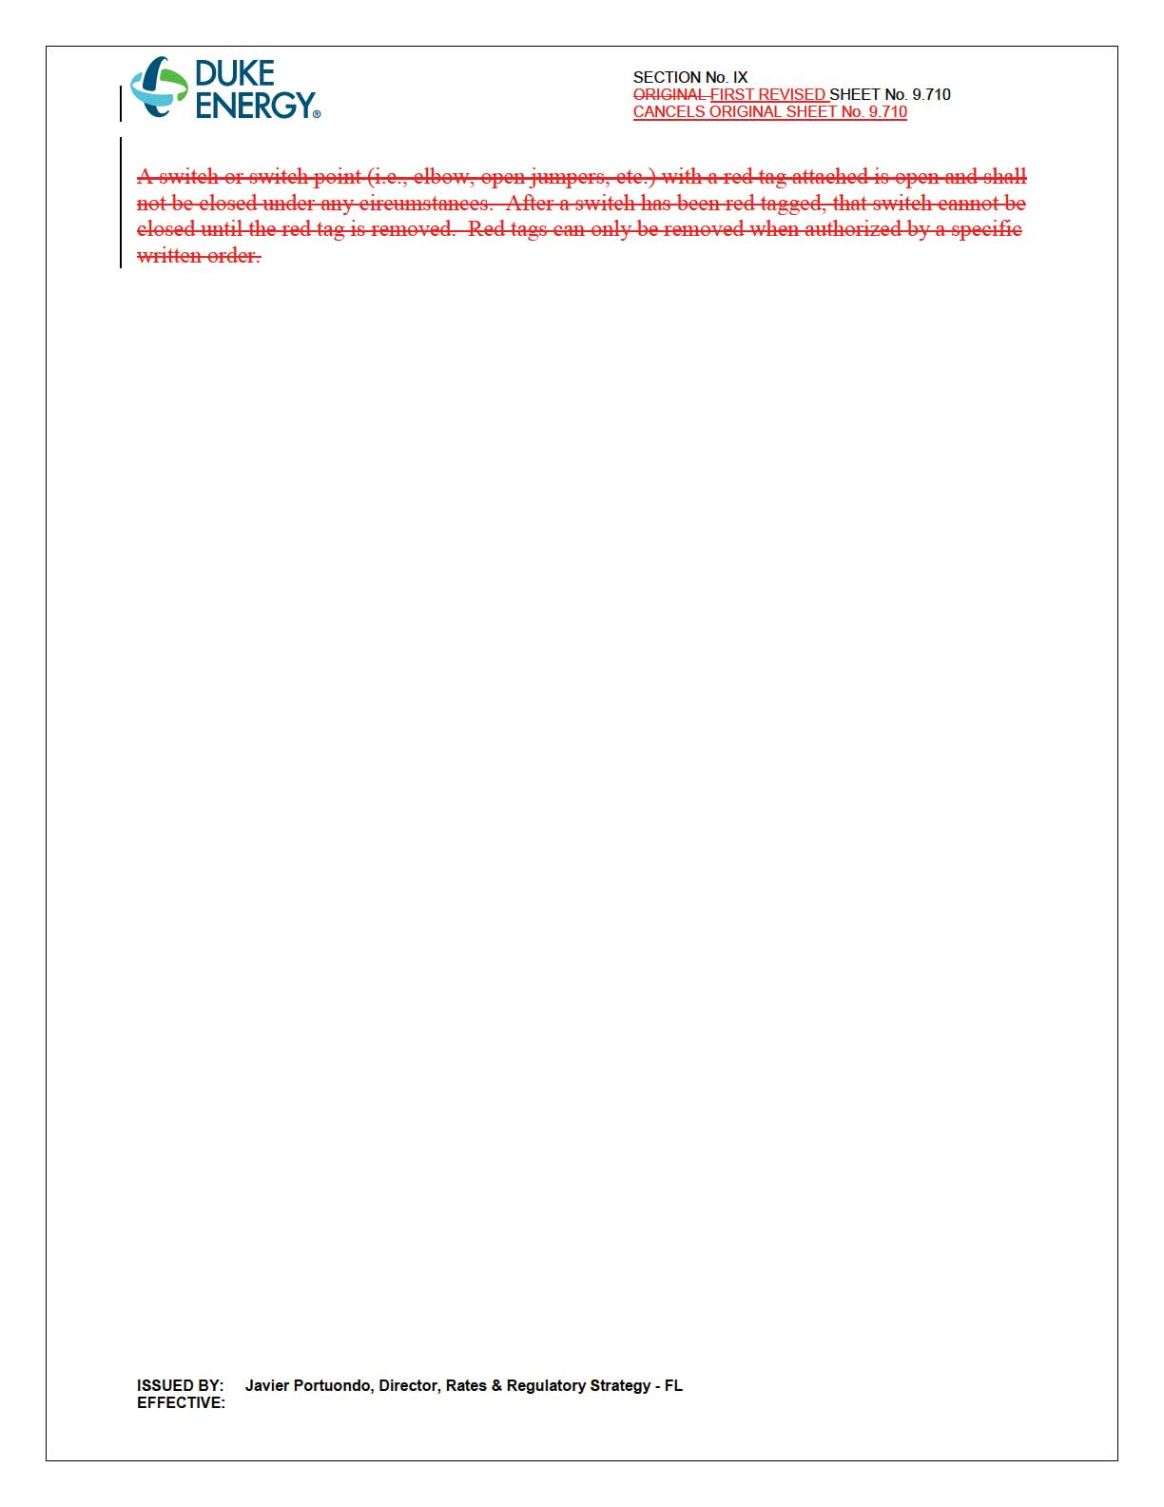

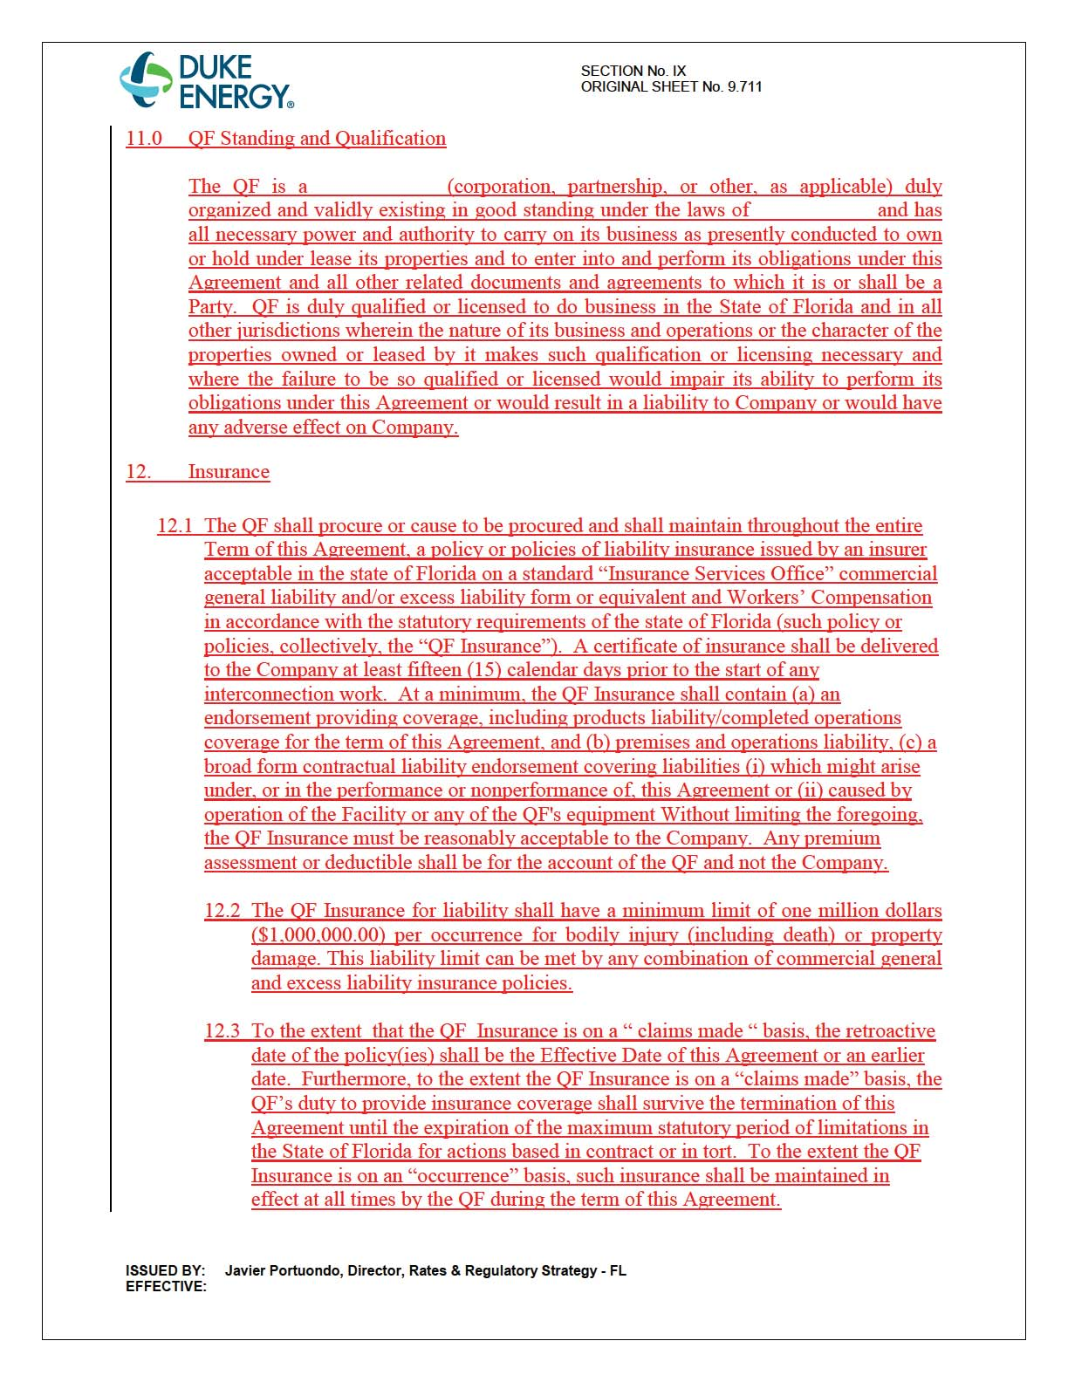

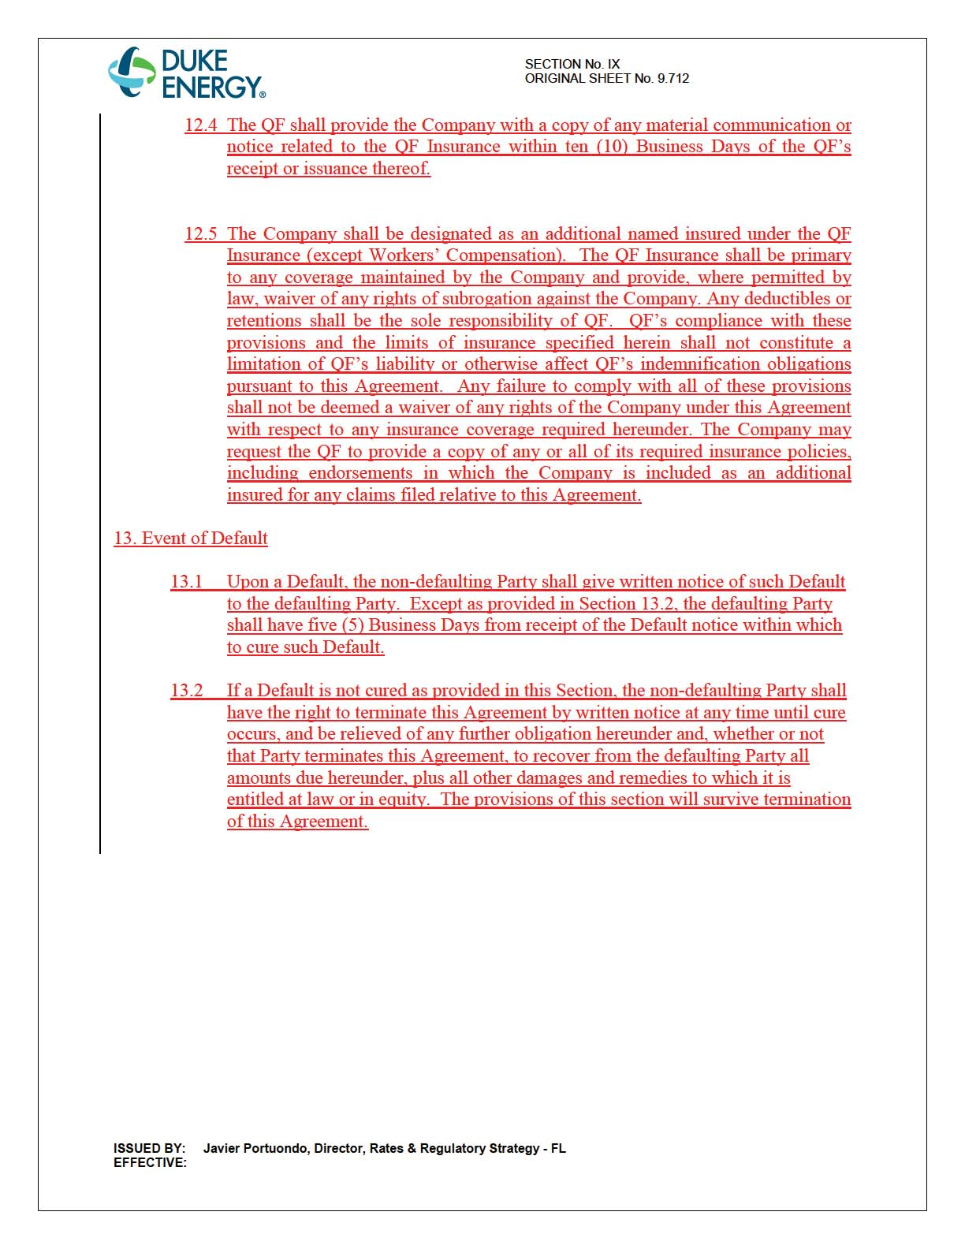

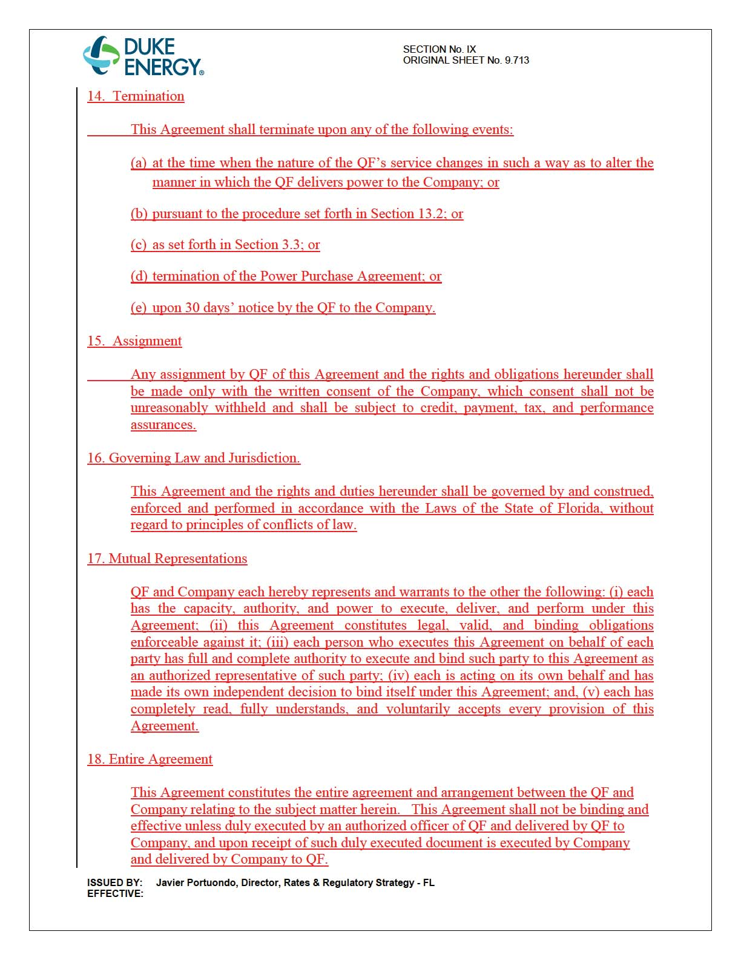

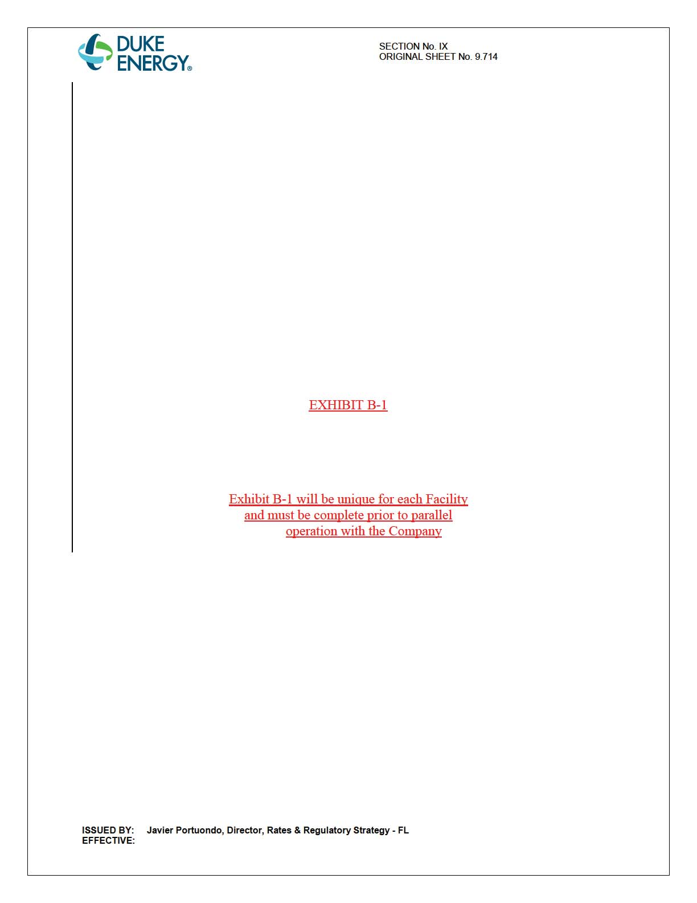

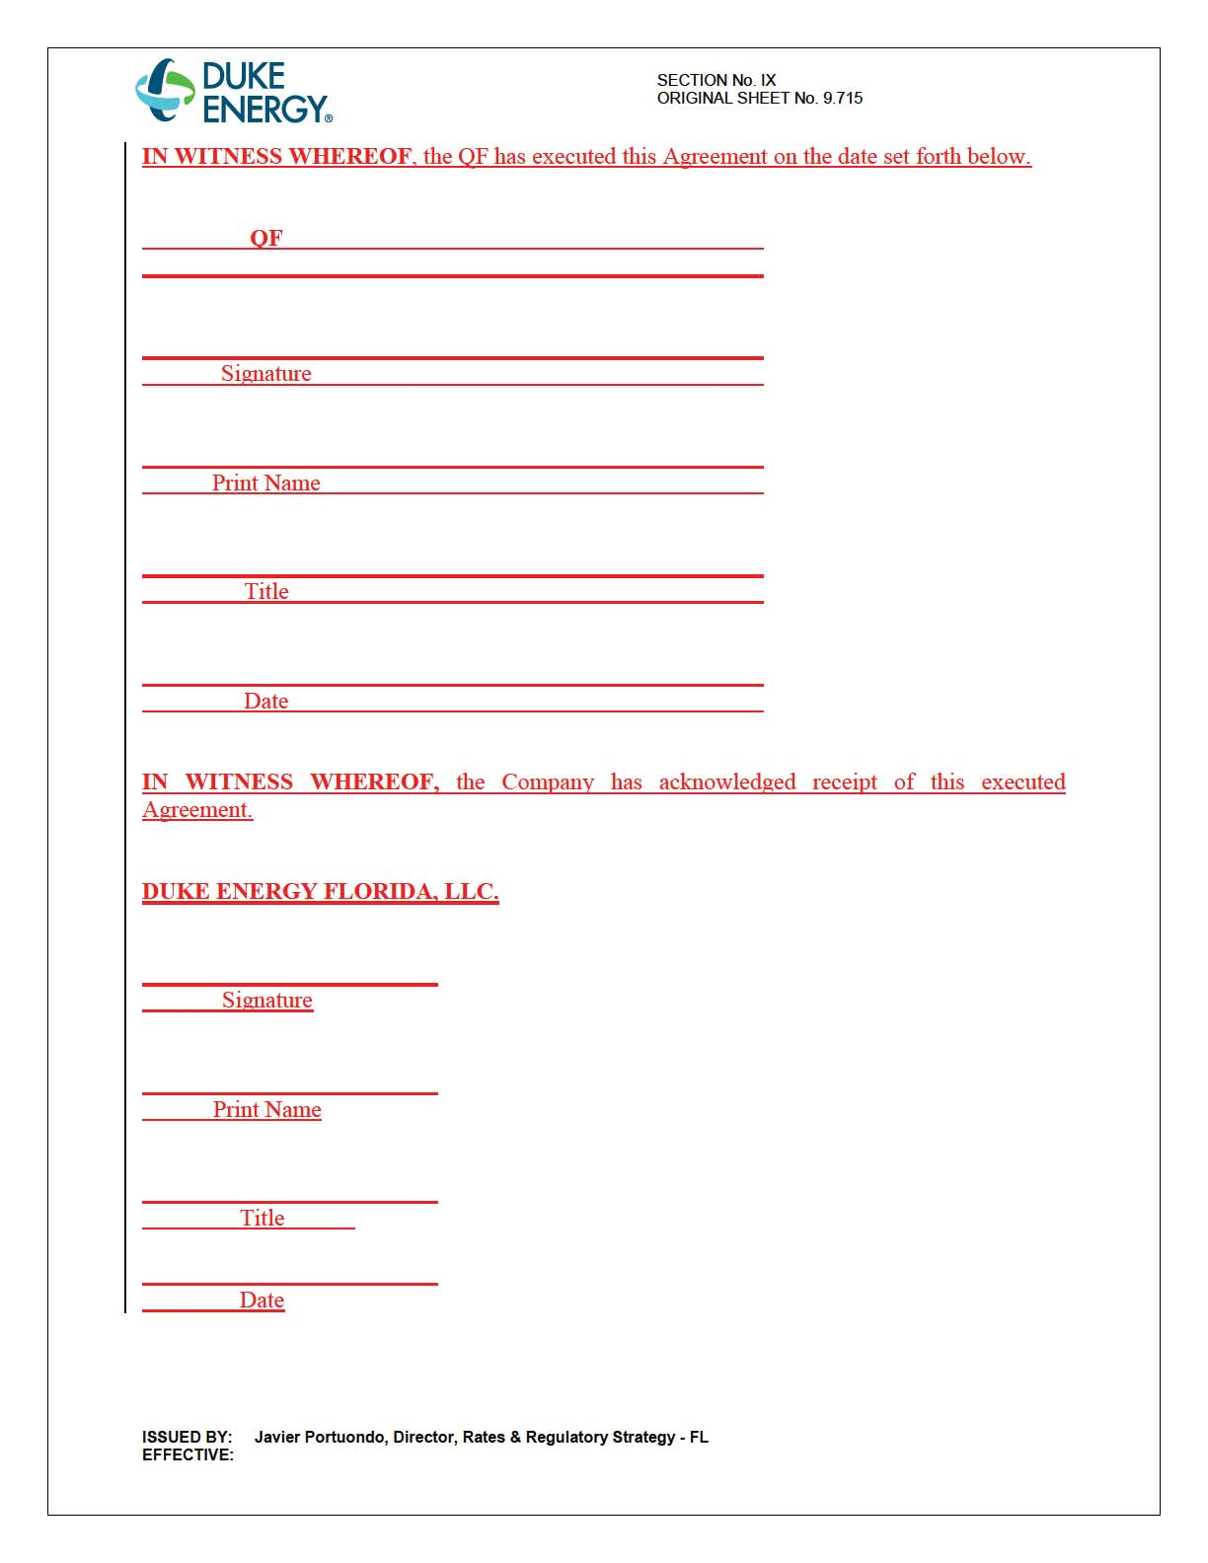

Order No. PSC-14-0660-CO-EI, issued November 14, 2014, in Docket No. 140137-EI, In re: Petition for approval of modifications to tariff sheet Nos. 9.100 through 9.330 and tariff sheet Nos. 9.700 through 9.709 as-available purchase tariff and interconnection agreement, by Duke Energy Florida, Inc.
Order No. PSC-16-0279-PCO-EQ.
See Order No. PSC-16-0252-PAA-EQ, issued June 26, 2016, in Docket No. 160073-EQ, In re: Petition for approval of amended standard offer contract (Schedule COG-2), by Duke Energy Florida, LLC.

