BEFORE THE FLORIDA PUBLIC SERVICE COMMISSION

In re: Application for limited proceeding water rate increase in Marion, Pasco, and Seminole Counties, by Utilities, Inc. of Florida. | DOCKET NO. 150269-WS  ORDER NO. PSC-16-0505-PAA-WS  ISSUED: October 31, 2016

The following Commissioners participated in the disposition of this matter:

JULIE I. BROWN, Chairman
LISA POLAK EDGAR
ART GRAHAM
RONALD A. BRISÉ
JIMMY PATRONIS

NOTICE OF PROPOSED AGENCY ACTION
ORDER GRANTING AN INCREASE IN RATES FOR UTILITIES, INC. OF FLORIDA
AND
ORDER REQUIRING FOUR-YEAR RATE REDUCTION

BY THE COMMISSION:

NOTICE is hereby given by the Florida Public Service Commission that the action discussed herein, except for requiring a four-year reduction in rates is preliminary in nature and will become final unless a person whose interests are substantially affected files a petition for a formal proceeding, pursuant to Rule 25-22.029, Florida Administrative Code (F.A.C.).

Background
Utilities, Inc. of Florida (UIF or Utility) is a Class A utility providing water and wastewater service to twenty-seven systems in the following counties: Charlotte, Highlands, Lake, Lee, Marion, Orange, Pasco, Pinellas, Polk, and Seminole. On December 30, 2015, the Utility requested a limited proceeding water rate increase for Marion, Pasco, and Seminole Counties. UIF is a wholly-owned subsidiary of Utilities, Inc. (UI). The Utility’s last rate case was in 2012.
The petition for a limited proceeding was filed pursuant to Rule 25-30.446, Florida Administrative Code (F.A.C.). Driving the limited proceeding were galvanized service line replacement costs in Marion County, the loss of irrigation customers, plant additions, and purchased water costs in Pasco County, and interconnection plant addition costs in Seminole County.
On March 24, 2016, the Office of Public Counsel (OPC) filed a notice of intervention in this proceeding, and an Order acknowledging intervention was issued on April 4, 2016. Prior to the notice of intervention, OPC submitted a letter, dated February 2, 2016, outlining concerns that OPC had with the Utility’s petition for Marion, Pasco, and Seminole Counties. UIF responded to OPC’s concerns in a letter dated March 2, 2016.
An estimated 500 customers attended the 2 customer meetings held in New Port Richey (Pasco County) on April 12, 2016, with 175 customers providing comments. No customers attended the meeting held on April 13, 2016, in Ocala for the customers in Marion and Seminole Counties.
UIF notified this Commission of its intent to file an application for a rate increase on April 28, 2016, for all regulated systems in Florida. Docket No. 160101-WS was assigned to the forthcoming consolidated proceeding. The Minimum Filing Requirements for Docket No. 160101-WS were filed on August 31, 2016, based on a historical test year ended December 31, 2015.
By letter dated June 8, 2016, UIF requested that the portion of this limited proceeding addressing a rate increase in Pasco County be bifurcated from the portion addressing rate increases in Marion and Seminole Counties. OPC filed a response to UIF’s bifurcation request on June 13, 2016. As a result, rate increases were addressed at the July 7, 2016 Commission Conference for Marion and Seminole Counties only. This Commission’s vote on the limited proceeding for Marion and Seminole Counties was codified in Order No. PSC-16-0296-PAA-WS, issued July 27, 2016. A consummating order was issued in Order No. PSC-16-0342-CO-WS on August 22, 2016.
In its initial filing, UIF’s request for Pasco County was separated into Phase I regarding the loss of revenue associated with customer-installed irrigation wells, and Phase II associated with UIF’s interconnection to Pasco County for bulk provision of water to UIF’s Summertree customers. The Bulk Water Agreement between UIF and Pasco County was executed on August 9, 2016, and is included as Attachment A.
By letter dated August 11, 2016, the Utility withdrew its request for the Phase I rate increase for Pasco County and requested that it be deferred and considered later in the consolidated rate case docket. On August 18, 2016, OPC requested a deferral of the decision to consider any rate increase until the actual amount of any Southwest Florida Water Management District (SWFWMD) grants have been taken into account, any possible overearnings have been evaluated, any potential customer savings from the UIF consolidation have been evaluated, and the quality of water service issues have been addressed and resolved.
This Commission considered the Phase II rate increase at the September 13, 2016 Commission Conference and deferred the matter for further consideration. The Phase I rate increase for Pasco County will be addressed in Docket No. 160101-WS. This order only addresses the requested Phase II rate increase directly related to the interconnection with Pasco County to address water quality issues.
We have jurisdiction pursuant to Sections 367.081 and 367.0822, Florida Statutes (F.S.).

Decision
As a result of UIF’s withdrawal of its Pasco County Phase I request, we modified the Utility’s original request for Pasco County Phase II to recognize rate case expense in operating expense. We also reduced the annualized revenues to reflect the effects of the loss of irrigation customers. Accordingly, the requested rate increase is $52,547 (or 6.05 percent) as shown on Schedule No. 1. Our analysis is based on the modified amounts. However, with regard to UIF’s calculated rate increase of $52,547 (or 6.05 percent) for Pasco County Phase II, it should be noted that the Utility made an error in its calculation of the income subject to state and federal income taxes. In calculating the taxable income amount, UIF multiplied the decreased rate base amount by the total overall rate of return (ROR) of 8.03 percent. The proper calculation would be to multiply the decreased rate base amount by only the common equity weighted cost component of the ROR. In our calculation, we used a common equity weighted cost component of 4.41 percent rather than the total overall ROR of 7.22 percent. Based on our adjustments, we calculated a water rate increase of $48,283 (or 5.50 percent) for Pasco County Phase II as shown in Schedule No. 1.

Rate Base

The Utility requested a rate base reduction of $356,579 to reflect the abandonment of water wells in Pasco County Phase II. The rate base components were Retirements and Cash Working Capital

Retirements

In its filing, UIF reduced rate base by the net book value of $363,697 for the retirement of the abandoned wells.
By Order No. PSC-14-0025-PAA-WS (2014 Order), this Commission found the quality of water in the Summertree water system to be unsatisfactory and ordered that the revenue requirement for the Summertree water system be subject to a 100-basis point reduction in return on equity (or approximately $23,115 annually) until the Utility demonstrated that the water quality had been restored to the point where it is deemed satisfactory by this Commission. To address the water quality issues, we ordered several future actions that would need to be taken by the Utility to satisfy the concerns of its customers.
- Coordinate with OPC to develop a customer engagement plan;
- identify suitable treatment options to address the secondary water quality issues including an estimated rate impact to customers;
- consider the cost and feasibility of connecting to the Pasco County water system with the purchase of bulk water from the County; and
- present options to Summertree customers and conduct a survey to determine customer preferences.
As directed by the 2014 Order, OPC, who was the facilitator, coordinated community meetings between the Utility and Summertree residents beginning in January 2014. A total of 30 meetings were held from 2014 through 2016 with a group consisting of representatives of the Summertree residents, the Utility, OPC and in some instances Pasco County Commissioners and/or Florida State Legislators. OPC compiled thorough minutes of the meetings and provided periodic updates to Commission staff.
On April 28, 2014, a meeting was held to discuss the treatment alternatives analysis report prepared by CPH Engineering (CPH Report) that was submitted by UIF to the group. The CPH Report outlined three possible solutions to the water quality issues: construction of a centralized water treatment plant with upgraded treatment; upgraded water treatment at each well site; or interconnection with Pasco County. As noted on pages 8 and 10 of the CPH Report, the elevated color concentrations in the distribution system were most likely due to the buildup of biomass. Specifically, the CPH Report recommended that prior to any treatment modifications, the Utility should “thoroughly flush the distribution system to remove any [possible] biomass in the system and repeat the flushing process at least annually.” The CPH Report also indicated that interconnecting with Pasco County would require the Utility to decommission its four production wells and associated water treatment facilities to conform to the rules and regulations of SWFWMD. The CPH Report concluded that the interconnection was the lowest cost option that would provide improved water quality with respect to iron, odor and color. The CPH Report ultimately recommended that “Utilities Inc. of Florida pursue a potable water interconnection with Pasco County, including a thorough cleaning of the distribution system.”
In accordance with the 2014 Order, OPC coordinated subsequent meetings between the Utility and representatives of Summertree residents to discuss the different options, with UIF ultimately proposing the recommendation of the Pasco County Interconnection. To solicit customer input, OPC organized a survey ballot, the language of which was finalized in January 2016. The ballot asked the residents whether Summertree should interconnect with Pasco County and to rate the quality of water service provided by UIF. Ballots were mailed to approximately 1,172 customers in March 2016. A total of 876 valid survey responses were returned with 830 of the residents voting in favor of the interconnection and 746 rating the quality of service as unsatisfactory. As noted in the case background, 175 customers provided comments at the April 12, 2016 customer meetings. The majority of the comments focused on the unsatisfactory quality of service provided by UIF.
While the interconnection with Pasco County should improve water quality, the final impact on water quality can be determined only after the completion of the interconnection and the implementation of a flushing protocol. Therefore, the Utility shall be directed to provide secondary water quality results for portions of its Summertree distribution system at least every six months until this Commission finds the water quality to be satisfactory. Samples shall be taken from the same sites labeled “nearby system site” shown in Appendix A of the CPH Report for consistency purposes. Such results shall be filed with this Commission for informational purposes. The first report shall be filed no later than 30 days after the completion of the interconnection with Pasco County. Pursuant to the 2014 Order, the 100-basis point reduction in return on equity shall remain in place until the water quality is deemed satisfactory by this Commission.
As previously discussed, the abandonment of the wells and the interconnection with Pasco County was considered to be the lowest cost option. The Bulk Water Agreement with Pasco County (Attachment A) provides that the $896,141 initial connection fee will be paid for by Pasco County from a grant provided by the Florida Department of Environmental Protection (DEP). The rate base shall be reduced by the $363,697 net book value of the abandoned wells to reflect their removal from rate base.

Working Capital Allowance

UIF included a working capital allowance of $7,118 for Pasco County Phase II. This amount represents 1/8th of the operation and maintenance (O&M) expense increase of $56,941. However, we made several adjustments to O&M expense that increased the O&M expense to $64,062 as explained in the “O&M Expense” section below. As a result, we find that the appropriate amount of incremental working capital is $8,008 ($64,062÷8), or $890 higher than the amount included by UIF.
After reviewing UIF’s requested rate base decrease of $356,579, we hereby decrease rate base by $355,689 for Pasco County Phase II as shown on Schedule No. 1. The $890 difference reflects the change in working capital.

Rate of Return

Per Schedule No. 11 of its filing, UIF calculated an 8.03 percent ROR. This ROR was based on a capital structure ended December 31, 2014, that only included long-term debt with a cost rate of 6.65 percent and common equity with a return on equity of 9.38 percent. The capital structure used by UIF is inconsistent with the capital structure used in the Utility’s last rate case for Pasco County. In addition, Rule 25-30.445(4)(e), F.A.C., requires that the weighted average cost of capital be calculated based on the most recent 12-month period and include all of the appropriate capital structure components. In this instance, the most recent period available is the 12 months ended December 31, 2015. UIF calculated a December 2015 ROR of 7.85 percent on Schedule F-5 of its 2015 Annual Report. However, UIF did not use the appropriate equity cost rate of 9.38 percent or the minimum 2.00 percent cost rate for customer deposits pursuant to Rule 25-30.311(4)(a), F.A.C. Based on the foregoing, we recalculated a December 2015 ROR of 7.22 percent as shown in Schedule No. 2.

Operating Expense

UIF requested an increase to operating expense, excluding income taxes, of $89,692 for Pasco County Phase II. The increase is based on increases for the abandoned well amortization, purchased water expense, and rate case expense that are partially offset by decreases in depreciation expense, O&M expense, and taxes other than income.

Depreciation Expense

UIF decreased its depreciation expense by $22,778 as a result of the abandonment of the water wells. In our review of the Utility’s filing, we noted that an $804 contributions in aid of construction (CIAC) component of the depreciation expense was not included in the total amount. Otherwise, the calculation of the depreciation expense reduction is in accordance with Rule 25-30.140, F.A.C. The inclusion of the $804 CIAC component lowers the total depreciation expense reduction to $21,974.

Abandoned Wells Amortization Expense

UIF calculated an annual amortization expense of $65,022 for the recovery of the $563,697 related to the retirement of the abandoned wells. This represents an 8.67 year amortization period. The $563,697 is the sum of the $363,697 net book value and the $200,000 net cost to retire the abandoned wells. On Schedule No. 16 of its filing, UIF estimated that the gross cost to retire the abandoned wells was $220,000. The Utility reduced the gross amount by $20,000 for anticipated SWFWMD funding resulting in a net retirement cost of $200,000.
In it’s response to OPC’s February 2, 2016 letter outlining certain issues and concerns, UIF stated that the hydro tank at well 13 would either be relocated to an Orangewood system well site or have no salvage value. At the September 13, 2016 Commission Conference, OPC noted that testimony filed in the consolidated rate case in Docket No. 160101-WS stated that the hydro tank will be repurposed at the Cypress Lakes system. Subsequent to the Commission Conference held on September 13, 2016, OPC submitted a letter concerning the calculation of the amortization expense. OPC raised concerns about the value of a hydro tank that will be transferred for use by a system in another county. The net book value of the hydro tank included in the calculation is $57,622 which does not include any salvage value. UIF filed a response to OPC’s letter on September 22, 2016, stating that the salvage value would be less than $5,000. We find it appropriate to recognize the approximate salvage value of $5,000 as a reduction to the net book cost of $363,697 used in the amortization expense calculation.
Rule 25-30.433(9), F.A.C., prescribes the calculation for determining the appropriate amortization period for forced abandonment or the prudent retirement of plant assets prior to the end of their depreciable life. Based on the amounts in its filing, UIF followed the specified calculation except for the return on net book value amount and the hydro tank salvage value. The Utility applied the 8.03 percent rate of return to the total cost of $563,697 rather than just the net book value of $363,697. Rule 25-30.433(9), F.A.C., specifically states that the amount should be “equal to the rate of return that would have been allowed on the net invested plant that would have been included in rate base before the abandonment or retirement.”
In our calculation, we used the approved 7.22 percent rate of return and applied it against the net book value of $358,697. This results in an annual amortization expense of $45,633 and an amortization period of 12.24 years. UIF and this Commission’s calculations are summarized in Table 1 below. Because the $220,000 gross retirement cost and the $20,000 of anticipated State funding are only estimates, these amounts shall be reviewed in the upcoming consolidated rate case and be adjusted if needed. In addition, the use of the hydro tank and its estimated $5,000 salvage value shall also be reviewed and adjusted if needed.
Table 1
Abandoned Wells Amortization Expense Increase
 | UIF | COMMISSION
Net Book Value | $363,697 | $363,697
Tank Salvage Value | 0 | (5,000)
Net Cost to Retire | 200,000 | 200,000
Total Cost | $563,697 | $558,697
Rate of Return | 8.03% | 7.22%
Return on Net Book Value | $45,287 | $25,898
Depreciation Expense | 19,735 | 19,735
Annual Amortization Expense | $65,022 | $45,633
Amortization Period | 8.67 Years | 12.24 Years

O&M Expense

UIF requested an increase of $56,941 to O&M expense. The increase is based on increases for purchased water expense and rate case expense that are partially offset by a decrease in O&M expense related to the abandoned wells.

Well Abandonment O&M Expense

UIF included an O&M expense decrease of $46,245 related to the well abandonments. This was an annualized amount based on actual O&M expenses for the 11 months ended November 30, 2015. In response to a Commission staff data request, the Utility updated the amounts to include the actual amounts for the 12 months ended December 31, 2015. This resulted in a $48,609 decrease in O&M expenses. We reviewed the items included in the O&M expense reduction and they appear to be appropriate. The calculation of the $48,609 O&M expense reduction is shown in Table 2 below.
Table 2
Well Abandonment O&M Expense
Expense Category | Amount
Electric Power – Water System | $10,453
Chemicals | 11,769
Outside Service Expense | 1,260
Salaries and Wages | 3,000
Fleet Transportation Expense | 1,000
Maintenance Testing | 6,000
Maintenance – Water Plant | 15,127
Total O&M Decrease | $48,609

Purchased Water Expense

UIF sold 55.5 million gallons of water in the Summertree subdivision during 2014. In calculating the purchased water expense necessary to replace the water previously produced by its abandoned wells, the Utility reduced the gallons sold by 32.4 million gallons to reflect the reduction in irrigation-related sales. In determining the total gallons of water to be purchased, UIF added 2.3 million gallons (10 percent) for flushing and another 2.3 million gallons (10 percent) for other losses. Per Rule 25-30.4325(1)(e), F.A.C., excessive unaccounted for water (EUW) is unaccounted water in excess of 10 percent of the amount of water produced. In rate cases, it is Commission practice to only make EUW adjustments if the 10 percent threshold is exceeded. UIF’s estimated 10 percent factor for “other losses” appears to be reasonable. UIF then calculated an estimated purchased water expense of $99,101 based on the purchase of 27.8 million gallons from Pasco County at a bulk water rate of $3.57/Kgal. This rate is established in the Bulk Water Agreement (Attachment A) in Section III, paragraph D, page 4 of 11. We have reviewed the Utility’s calculation methodology and agrees that it is appropriate.
In response to a Commission staff data request concerning the possible inclusion of duplicate bills in its calculation on Schedule No. 15 of its filing, UIF updated the amount of the reduced irrigation gallons to 30.7 million. Using UIF’s methodology and the updated amount of reduced irrigation gallons, we calculated a purchased water expense of $106,398. A comparison of the Utility’s calculation and this Commission’s calculation is presented in Table 3 below.
Table 3
Pasco County Phase II Purchased Water Expense Calculation
 | UIF |  | Commission
Total Gallons Sold – Summertree (2014) | 55,541,000 |  | 55,541,000
Irrigation Gallons Reduction | (32,408,260) |  | (30,704,830)
Gallons Difference | 23,132,740 |  | 24,836,170
Water Gallons Needed for Flushing (10%) | 2,313,274 |  | 2,483,617
Other Losses (10%) | 2,313,274 |  | 2,483,617
Total Water Needed From Pasco County | 27,759,288 |  | 29,803,404
Bulk Water Rate ($/Kgal) | $3.57 |  | $3.57
Total Cost of Purchased Water | $99,101 |  | $106,398

Rate Case Expense

UIF estimated that rate case expense would be $16,338, resulting in a 4-year amortization of $4,085. In its petition, UIF included all of the rate case expense associated with the Pasco County portion of the filing in the Phase I portion of its filing. We have included the rate case expense related to Pasco County in Phase II because the primary focus of Phase I was to calculate the gallonage reduction related to the loss of irrigation customers. This information is required to calculate the appropriate purchased water expense for Phase II. Based on our decision in Order No. PSC-16-0296-PAA-WS, which addressed the amount of rate case expense related to Marion and Seminole Counties and updated amounts for Pasco County from the Utility, UIF has provided a revised rate case expense for Pasco County of $25,090. We reviewed the revised rate case expense of $25, 090, and find that it is reasonable. The 4-year amortization amount is $6,273 as shown on Schedule No. 3. The 4-year rate reduction for rate case expense is $6,555.
Based on our adjustments, the net increase in O&M expense is $64,062.

Taxes Other Than Income

The Utility included decreased taxes other than income (TOTI) of $9,493. The reduction was due to a decrease in property taxes as a result of the retirement of the wells. We made an adjustment to recognize the effect on payroll taxes from the $3,000 reduction in O&M salary expense. The FICA, FUTA and SUTA composite rate is 14.67 percent. The resulting adjustment is a reduction of $440 ($3,000 x 14.67 percent). The adjusted total TOTI reduction is $9,933.
Based on our review, the appropriate operating expense increase, excluding income taxes, is $77,788 as shown in Schedule No. 1 attached to this order.

Calculation of Water Rate Increase

UIF calculated a rate increase of $52,547 (or 6.05 percent) for Pasco County Phase II. Based on the adjustments discussed above, we calculated a water rate increase of $48,283 (or 5.50 percent) for Pasco County Phase II as shown in Schedule No. 1. The Bulk Water Agreement with Pasco County (Attachment A) contains a provision that Pasco County is not obligated to provide service, nor is UIF obligated to purchase service, “until the rates necessary to receive such service have been approved by the Florida Public Service Commission” (Section VIII, paragraph G, page 10 of 11).
Application of the Rate Increase
We find that service rates for UIF shall be designed to allow the Utility the opportunity to generate annual service revenues of $925,458 for Pasco County. The annualized service revenues before the rate increase are $877,622, resulting in a $47,836 increase to services revenues. The corresponding percentage increase is 5.45 percent. Due to relatively low increase, the increase shall be applied across-the-board to existing service rates.
The rate increase of 5.45 percent for Pasco County shall be applied as an across-the-board increase to existing service rates for the Orangewood and Summertree systems. The rates, as shown on Schedule No. 4, shall be effective for service rendered on or after the stamped approval date on the tariff sheets pursuant to Rule 25-30.475(1), F.A.C. The Utility shall file revised tariff sheets and a proposed customer notice to reflect the approved rates. In addition, the approved rates shall not be implemented until the interconnection is in-service, testing from the nearby system sites meet DEP secondary water quality standards, and Commission staff has approved the proposed customer notice and the notice has been received by the customers. The Utility shall provide proof of the date notice was given within 10 days of the date of the notice. The rates shall be reduced as shown on Schedule No. 4, to remove rate case expense grossed up for regulatory assessment fees and amortized over a 4-year period. The decrease in rates shall become effective immediately following the expiration of the four-year rate case expense recovery period, pursuant to Section 367.0816, F.S.
Temporary Rates
This order approves an increase in rates. A timely protest might delay what may be a justified rate increase resulting in an unrecoverable loss of revenue to the Utility. As a result, the rates approved herein, shall be approved as temporary rates.
Section 367.0822(1), F.S., provides
Upon petition or by its own motion, the commission may conduct limited proceedings to consider, and action upon, any matter within its jurisdiction, including any matter the resolution of which requires a utility to adjust its rates. The commission shall determine the issues to be considered during such a proceeding and may grant or deny any request to expand the scope of the proceeding to include other related matters. However, unless the issue of rate of return is specifically address in the limited proceeding, the commission shall not adjust rates if the effect of the adjustment would be to change the last authorized rate of return.
While Section 367.0822(1), F.S., does not expressly provide for the granting of temporary rates, it is well settled Commission precedent that temporary rates in the event of a protest may be approved on a case-by-case basis.
Further, Section 367.081(2), F.S., provides that this Commission must fix rates that are just, reasonable, compensatory, and not unfairly discriminatory. Pursuant to its authority to grant just and reasonable rates, this Commission has granted emergency and temporary rates in limited proceedings where a timely protest might delay what may be a justified rate increase resulting in an unrecoverable loss of revenue to the Utility. Similarly, in the instant case, we find that the granting of temporary rates is warranted because a timely protest of the PAA Order may delay a justified rate increase for several months while the matter is adjudicated at hearing. Moreover, we find that the ratepayers are adequately protected because all rates collected by the Utility is be subject to the corporate undertaking as discussed below.
For the foregoing reasons, we find that the rates approved herein shall be approved for the Utility on a temporary basis, subject to the corporate undertaking discussed below. In order to ensure that the Utility may not unfairly benefit from the issuance of temporary rates and in order to comport with the granting of temporary rates in proceedings filed pursuant to Sections 367.081 and 367.0814, F.S., the temporary rates shall only be allowed in the event of a protest filed by an entity or individual other than the Utility

Corporate Undertaking Memorandum

UIF is a wholly-owned subsidiary of UI, which provides all investor capital to its subsidiaries. Based on the amount subject to refund for Pasco County, the incremental increase in UI’s corporate undertaking is $31,891. In Order No. PSC-16-0296-PAA-WS, this Commission approved UI’s request for a corporate undertaking for Marion and Seminole Counties of $30,961 and $10,960, respectively. The total corporate undertaking amount currently outstanding is $41,921. Based on the amount subject to refund for Pasco County, the total cumulative outstanding guarantee shall increase to $73,812.
The criteria for a corporate undertaking include sufficient liquidity, ownership equity, profitability, and interest coverage to guarantee any potential refund. We reviewed UI’s 2013, 2014, and 2015 financial statements to determine if the company can support a corporate undertaking on behalf of its subsidiary. In its 2013 financial statements, UI reported an insufficient working capital amount and an inadequate current ratio and interest coverage ratio. In 2014, UI reported insufficient working capital and an inadequate current ratio; however, the interest coverage ratio improved to adequate. In 2015, UI had sufficient working capital, and both the current ratio and interest coverage ratio were adequate. In addition, UI achieved sufficient profitability and reported adequate ownership equity over the entire 3-year review period.
Based on our review of the financial reports submitted by UI, we find that UI has adequate resources to support a corporate undertaking in the amount requested. Based on this analysis, a cumulative corporate undertaking of $73,812 is acceptable contingent upon receipt of the written guarantee of UI and written confirmation that the cumulative outstanding guarantees on behalf of UI-owned utilities in other states will not exceed $1.2 million (inclusive of all Florida utilities).
The brief financial analysis above is only appropriate for deciding if UI can support a corporate undertaking in the amount proposed and shall not be considered a finding regarding our position on other issues in this proceeding.
The Utility shall maintain a record of the amount of the corporate undertaking memorandum, and the amount of revenues that are subject to refund. In addition, after the increased rates are in effect, pursuant to Rule 25-30.360(6), F.A.C., the Utility shall file reports with the Commission Clerk’s office no later than the 20th of each month indicating the monthly and total amount of money subject to refund at the end of the preceding month.
Further, in no instance shall the maintenance and administrative costs associated with the refund be borne by the customers. These costs are the responsibility of, and shall be borne by, the Utility. Irrespective of the form of security chosen by the Utility, an account of all monies received as a result of the rate increase shall be maintained by the Utility. If a refund is ultimately required, it shall be paid with interest calculated pursuant to Rule 25-30.360(4), F.A.C.
Conclusion

The rates approved herein, shall be approved for the Utility on a temporary basis, subject to refund, in the event of a protest filed by a party other than the Utility. UIF shall file revised tariff sheets and a proposed customer notice to reflect the approved rates. The approved rates shall be effective for service rendered on or after the stamped approval date on the tariff sheet, pursuant to Rule 25-30.475(1), F.A.C. In addition, the temporary rates shall not be implemented until after the interconnection is in-service, testing from the nearby system sites meet DEP secondary water quality standards, and Commission staff has approved the proposed notice, and the notice has been received by the customers. The temporary rates shall only be implemented after the Utility has provided written guarantee of its corporate undertaking in a cumulative amount of $73,812. If the rates approved herein are approved on a temporary basis, the rates collected by the Utility shall be subject to the refund provisions discussed in our analysis. In addition, after the increased rates are in effect, pursuant to Rule 25-30.360(6), F.A.C., the Utility shall file reports with the Commission Clerk’s office no later than the 20th of each month indicating the monthly and total amount of money subject to refund at the end of the preceding month.
Based on the foregoing, it is

ORDERED by the Florida Public Service Commission that Utilities, Inc. of Florida’s application for an increase in rates is granted as set forth in the body of this Order. It is further

ORDERED that all matters contained in the schedules and attachments to this Order are incorporated herein by reference. It is further

ORDERED that the Utility shall provide secondary water quality results for portions of its Summertree distribution system at least every six months until this Commission finds the water quality to be satisfactory. The first report shall be filed no later than 30 days after the completion of the interconnection with Pasco County. It is further

ORDERED that the rates approved herein shall be effective for service rendered on or after the stamped approval date on the tariff sheets pursuant to Rule 25-30.475(1), F.A.C. The Utility shall file revised tariff sheets and a proposed customer notice to reflect the approved rates. It is further

ORDERED that the rates approved rates shall not be implemented until the interconnection is in-service, testing from the nearby system sites meet DEP secondary water quality standards, and Commission staff has approved the proposed customer notice and the notice has been received by the customers. It is further

ORDERED that the Utility shall provide proof of the date notice was given within 10 days of the date of the notice. It is further

ORDERED that the rates approved herein shall be reduced as shown on Schedule No. 4, to remove rate case expense grossed up for regulatory assessment fees and amortized over a 4-year period. The decrease in rates shall become effective immediately following the expiration of the four-year rate case expense recovery period, pursuant to Section 367.0816, F.S. It is further

ORDERED that the provisions of this Order, issued as proposed agency action, shall become final and effective upon the issuance of a Consummating Order unless an appropriate petition, in the form provided by Rule 28-106.201, Florida Administrative Code, is received by the Commission Clerk, 2540 Shumard Oak Boulevard, Tallahassee, Florida 32399-0850, by the close of business on the date set forth in the “Notice of Further Proceedings” attached hereto. It is further

ORDERED that in the event this Order becomes final, this docket shall remain open for Commission staff’s verification that the revised tariff sheets and customer have been filed by the Utility and approved by Commission staff, and that Commission staff verifies that testing from the nearby system sites meet DEP secondary water quality standards. Once these actions are complete, this docket shall be closed administratively.

By ORDER of the Florida Public Service Commission this 31st day of October, 2016.

/s/ Carlotta S. Stauffer
CARLOTTA S. STAUFFER
Commission Clerk
Florida Public Service Commission
2540 Shumard Oak Boulevard
Tallahassee, Florida 32399
(850) 413-6770
www.floridapsc.com

Copies furnished: A copy of this document is provided to the parties of record at the time of issuance and, if applicable, interested persons.

KRM

NOTICE OF FURTHER PROCEEDINGS OR JUDICIAL REVIEW

The Florida Public Service Commission is required by Section 120.569(1), Florida Statutes, to notify parties of any administrative hearing that is available under Section 120.57, Florida Statutes, as well as the procedures and time limits that apply. This notice should not be construed to mean all requests for an administrative hearing will be granted or result in the relief sought.

Mediation may be available on a case-by-case basis. If mediation is conducted, it does not affect a substantially interested person's right to a hearing.

As identified in the body of this order, the action proposed herein, except for requiring a four-year reduction in rates, is preliminary in nature. Any person whose substantial interests are affected by the action proposed by this order may file a petition for a formal proceeding, in the form provided by Rule 28-106.201, Florida Administrative Code. This petition must be received by the Office of Commission Clerk, 2540 Shumard Oak Boulevard, Tallahassee, Florida 32399-0850, by the close of business on November 21, 2016.

In the absence of such a petition, this order shall become final and effective upon the issuance of a Consummating Order.

Any objection or protest filed in this/these docket(s) before the issuance date of this order is considered abandoned unless it satisfies the foregoing conditions and is renewed within the specified protest period.

Any party adversely affected by the Commission's final action in this matter may request: (1) reconsideration of the decision by filing a motion for reconsideration with the Office of Commission Clerk, within fifteen (15) days of the issuance of this order in the form prescribed by Rule 25-22.060, Florida Administrative Code; or (2) judicial review by the Florida Supreme Court in the case of an electric, gas or telephone utility or the First District Court of Appeal in the case of a water or wastewater utility by filing a notice of appeal with the Office of Commission Clerk and filing a copy of the notice of appeal and the filing fee with the appropriate court. This filing must be completed within thirty (30) days after the issuance of this order, pursuant to Rule 9.110, Florida Rules of Appellate Procedure. The notice of appeal must be in the form specified in Rule 9.900(a), Florida Rules of Appellate Procedure.
UTILITIES, INC. OF FLORIDA - PASCO COUNTY - PHASE II |  |  |  | SCHEDULE NO. 1
WATER REVENUE REQUIREMENTS INCREASE |  |  | DOCKET NO. 150269-WS
 |  | MODIFIED UTILITY FILING (a)(b)(c) |  | COMMISSION APPROVED
Line No.
1 | Utility Plant in Service (UPIS) | - |  | -
2 | Retirements | ($363,697) |  | ($363,697)
3 | Accumulated Depreciation | - |  | -
4 | Contributions in Aid of Construction (CIAC) | - |  | -
5 | Accumulated Amortization of CIAC | - |  | -
6 | Cash Working Capital | 7,118 |  | 8,008
7 | Total Increase in Rate Base | ($356,579) |  | ($355,689)
8 | Weighted Cost of Capital | 8.03% |  | 7.22%
9 | Return Required | ($28,633) |  | ($25,681)
10 | Decrease in Depreciation Expense Due to Retirements | ($22,778) |  | ($21,974)
11 | Increase in Recovery of Abandoned Wells | 65,022 |  | 45,633
12 | Increase in CIAC Amortization | - |  | -
13 | Decrease in O&M from Well Abandonments | (46,245) |  | (48,609)
14 | Increase In O&M for Purchased Water Expense | 99,101 |  | 106,398
15 | Increase in Rate Case Expense | 4,085 | (c) | 6,273
16 | Decrease in Taxes Other Than Income Taxes | (9,493) |  | (9,933)
17 | Total Increase in Operating Expenses Before Income Taxes | $89,692 |  | $77,788
18 | Total Taxable Income | ($28,633) |  | ($15,686)
19 | Multiply by State Income Tax (5.5%) | (1,575) |  | (863)
20 | Total Federal Taxable Income | ($27,058) |  | ($14,823)
21 | Multiply by Federal Income Tax (34%) | (9,200) |  | (5,040)
22 | Total Revenue Increase Before RAF (L9 + L17 + L19 + L21) | $50,284 |  | $46,204
23 | Multiply by RAF (4.5%) | 2,263 |  | 2,079
24 | Total Water Revenue Increase | $52,547 |  | $48,283
25 | Annualized Revenues | $868,816 | (a)(b) | $877,622
26 | Percentage Increase in Rates | 6.05% |  | 5.50%
27 | 4-Year Rate Reduction (Rate Case Expense) |  |  | $6,555
NOTES:
(a) Adjusted to exclude the Pasco County - Phase I increase
(b) Adjusted to exclude revenues for reduced irrigation customer volumes
(c) Adjusted to include rate case expense

UTILITIES, INC. OF FLORIDA |  |  | SCHEDULE NO. 2
CAPITAL STRUCTURE |  |  | DOCKET NO. 150269-WS
DECEMBER 31, 2015
 | AMOUNT | RATIO | COST RATE | WEIGHTED COST
PER 2015 ANNUAL REPORT
Common Equity | $5,330,494 | 46.96% | 10.69% | 5.02%
Preferred Stock | - | 0.00% | 0.00% | 0.00%
Long Term Debt | 4,751,261 | 41.86% | 6.66% | 2.79%
Short Term Debt | 14,899 | 0.13% | 10.08% | 0.01%
Customer Deposits | 53,988 | 0.48% | 6.00% | 0.03%
Tax Credits - Wtd. Cost | - | 0.00% | 0.00% | 0.00%
Deferred Income Taxes | 1,199,429 | 10.57% | 0.00% | 0.00%
Total | $11,350,071 | 100.00% |  | 7.85%
COMMISSION APPROVED
Common Equity | $5,330,494 | 46.96% | 9.38% | 4.41%
Preferred Stock | - | 0.00% | 0.00% | 0.00%
Long Term Debt | 4,751,261 | 41.86% | 6.66% | 2.79%
Short Term Debt | 14,899 | 0.13% | 10.08% | 0.01%
Customer Deposits | 53,988 | 0.48% | 2.00% | 0.01%
Tax Credits - Wtd. Cost | - | 0.00% | 0.00% | 0.00%
Deferred Income Taxes | 1,199,429 | 10.57% | 0.00% | 0.00%
Total | $11,350,071 | 100.00% |  | 7.22%

UTILITIES, INC. OF FLORIDA - PASCO COUNTY - PHASE II |  |  |  |  |  |  |  |  |  | SCHEDULE NO. 3
RATE CASE EXPENSE |  |  |  |  |  |  |  |  | DOCKET NO. 150269-WS
 | UIF FILING PHASE I |  | EXPENSES (a)  AS OF 7/7/16 |  | UIF ADJUSTED  PRIOR ADDITIONAL EXPENSES (b)(c) |  | NEW ADDITIONAL  EXPENSES (c) |  | COMMISSION ADJUSTMENTS |  | UPDATED  TOTAL
Filing Fee | $750 |  | $750 |  | $0 |  | $0 |  | $0 |  | $750
Legal Fees | 12,000 |  | 7,152 |  | 4,860 |  | 6,660 |  | 0 |  | 18,672
Legal Expenses | 0 |  | 843 |  | 1,376 |  | 515 |  | 0 |  | 2,734
Customer Notices | 2,840 |  | 1,963 |  | 0 |  | 0 |  | 0 |  | 1,963
FedEx | 0 |  | 103 |  | 0 |  | 0 |  | 0 |  | 103
UIF Travel Costs | 749 |  | 0 |  | 434 |  | 434 |  | 0 |  | 868
Total Rate Case Expense | $16,339 |  | $10,811 |  | $6,670 |  | $7,609 |  | $0 |  | $25,090
4-Year Amortization | $4,085 |  |  |  |  |  |  |  |  |  | $6,273
Notes:
(a) Document No. 04394-16
(b) Document No. 05631-16
(c) Document No. 07735-16

UTILITIES, INC. OF FLORIDA - PASCO COUNTY |  |  | SCHEDULE NO. 4
MONTHLY WATER RATES |  | DOCKET NO. 150269-WS
 | UTILITY | COMMISSION | 4 YEAR
 | CURRENT | APPROVED | RATE
 | RATES | RATES | REDUCTION
Residential and General Service - Orangewood
Base Facility Charge by Meter Size
5/8"X 3/4" | $11.81 | $12.45 | $0.08
3/4" | $17.72 | $18.68 | $0.12
1" | $29.53 | $31.13 | $0.21
1-1/2" | $59.03 | $62.25 | $0.41
2" | $94.45 | $99.60 | $0.66
3" | $188.90 | $199.20 | $1.31
4" | $295.17 | $311.25 | $2.05
6" | $590.33 | $622.50 | $4.11
Charge per 1,000 gallons | $5.45 | $5.75 | $0.04
Residential and General Service - Summertree
Base Facility Charge by Meter Size
5/8"X 3/4" | $11.19 | $11.80 | $0.08
3/4" | $16.78 | $17.70 | $0.12
1" | $27.96 | $29.50 | $0.19
1-1/2" | $55.91 | $59.00 | $0.39
2" | $89.45 | $94.40 | $0.62
3" | $178.91 | $188.80 | $1.25
4" | $279.55 | $295.00 | $1.95
6" | $549.02 | $590.00 | $3.89
Charge per 1,000 gallons | $5.17 | $5.45 | $0.04
Typical Residential 5/8" x 3/4" Meter Bill Comparison - Orangewood
2,000 Gallons | $22.71 | $23.95
6,000 Gallons | $44.51 | $46.95
10,000 Gallons | $66.31 | $69.95
Typical Residential 5/8" x 3/4" Meter Bill Comparison - Summertree
2,000 Gallons | $21.53 | $22.70
6,000 Gallons | $42.21 | $44.50
10,000 Gallons | $62.89 | $66.30
*The approved rates are for illustrative purposes only because the interim rate case rates will be
implemented prior to the effective date for the LIMP rates.

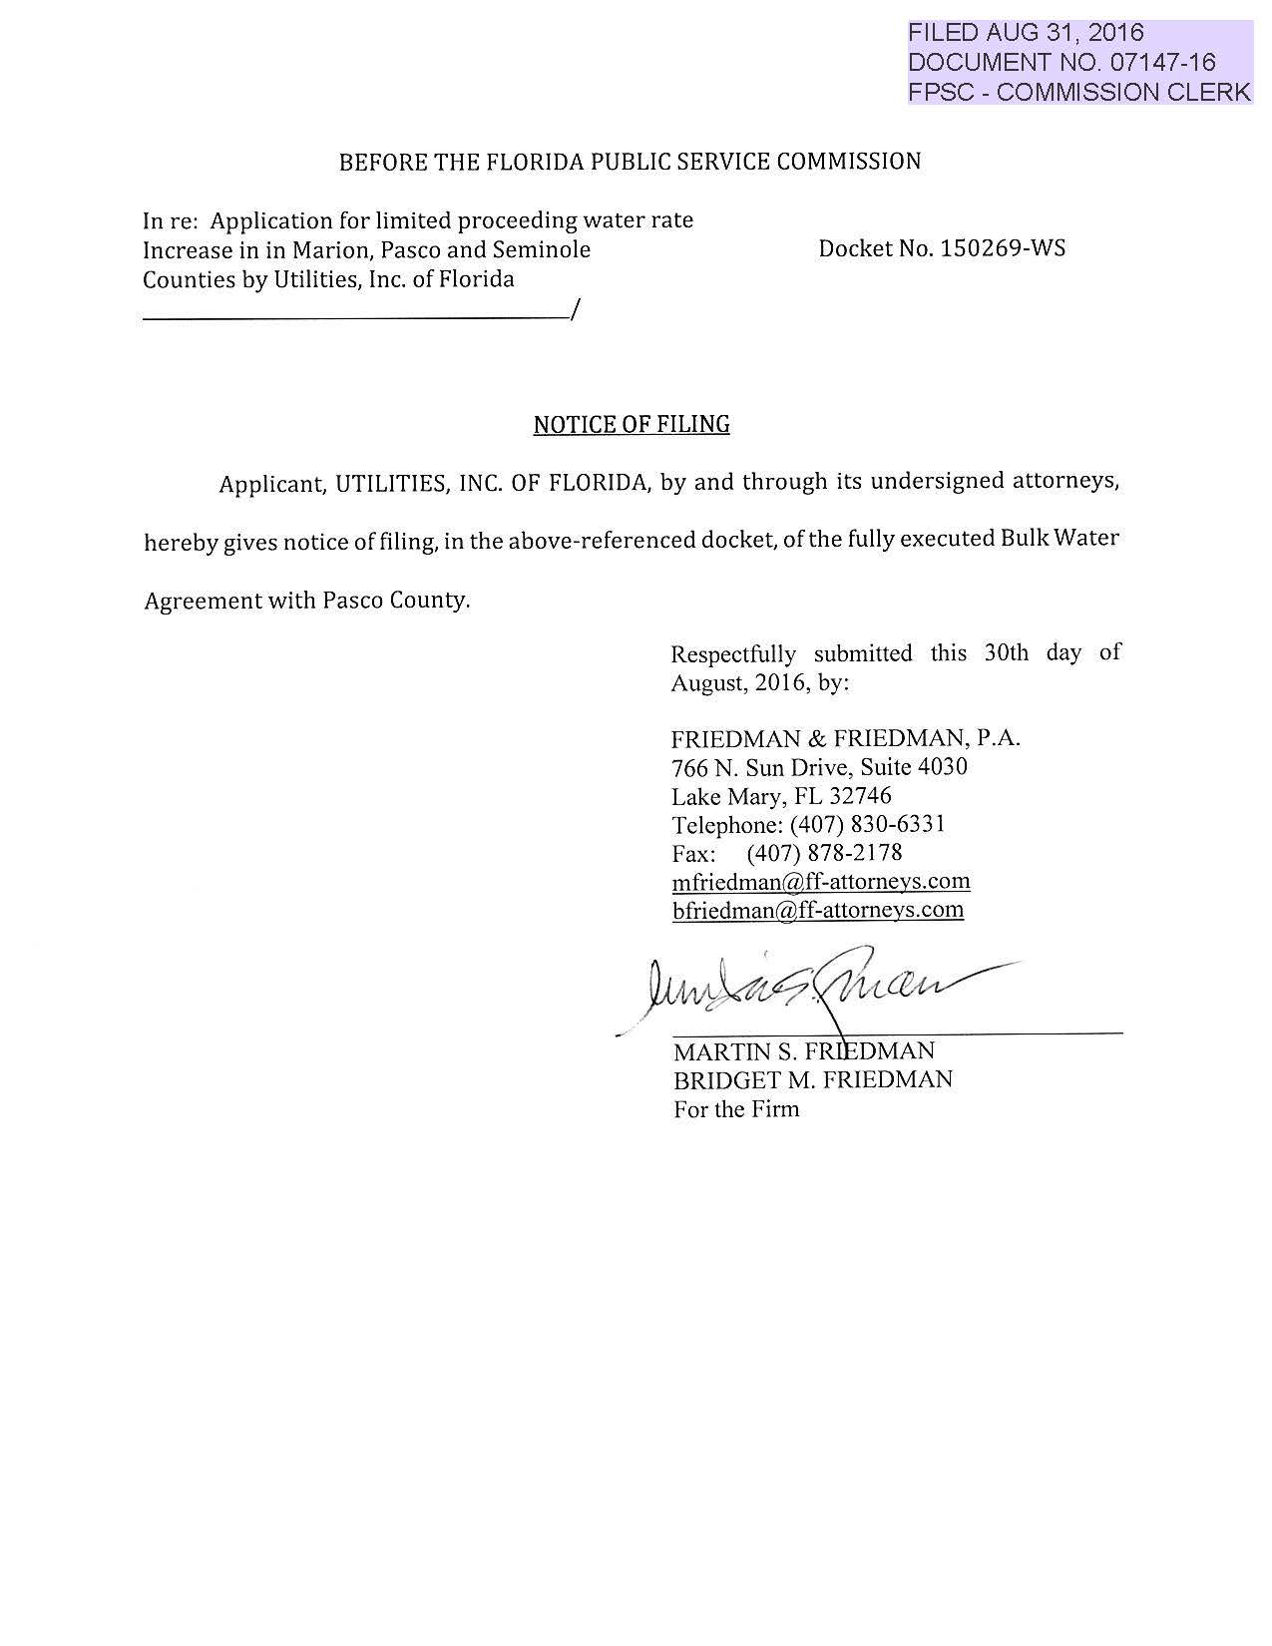
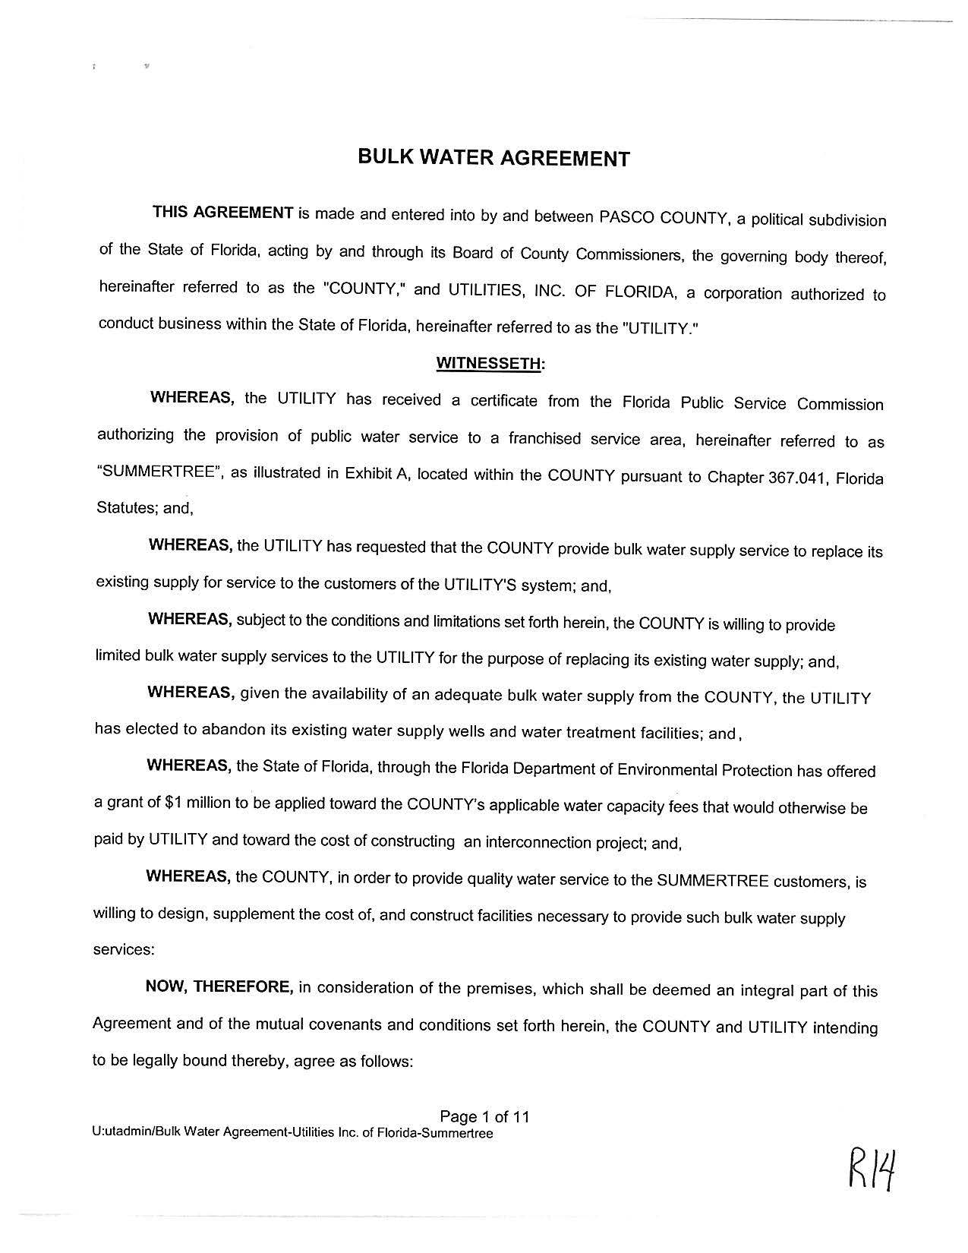
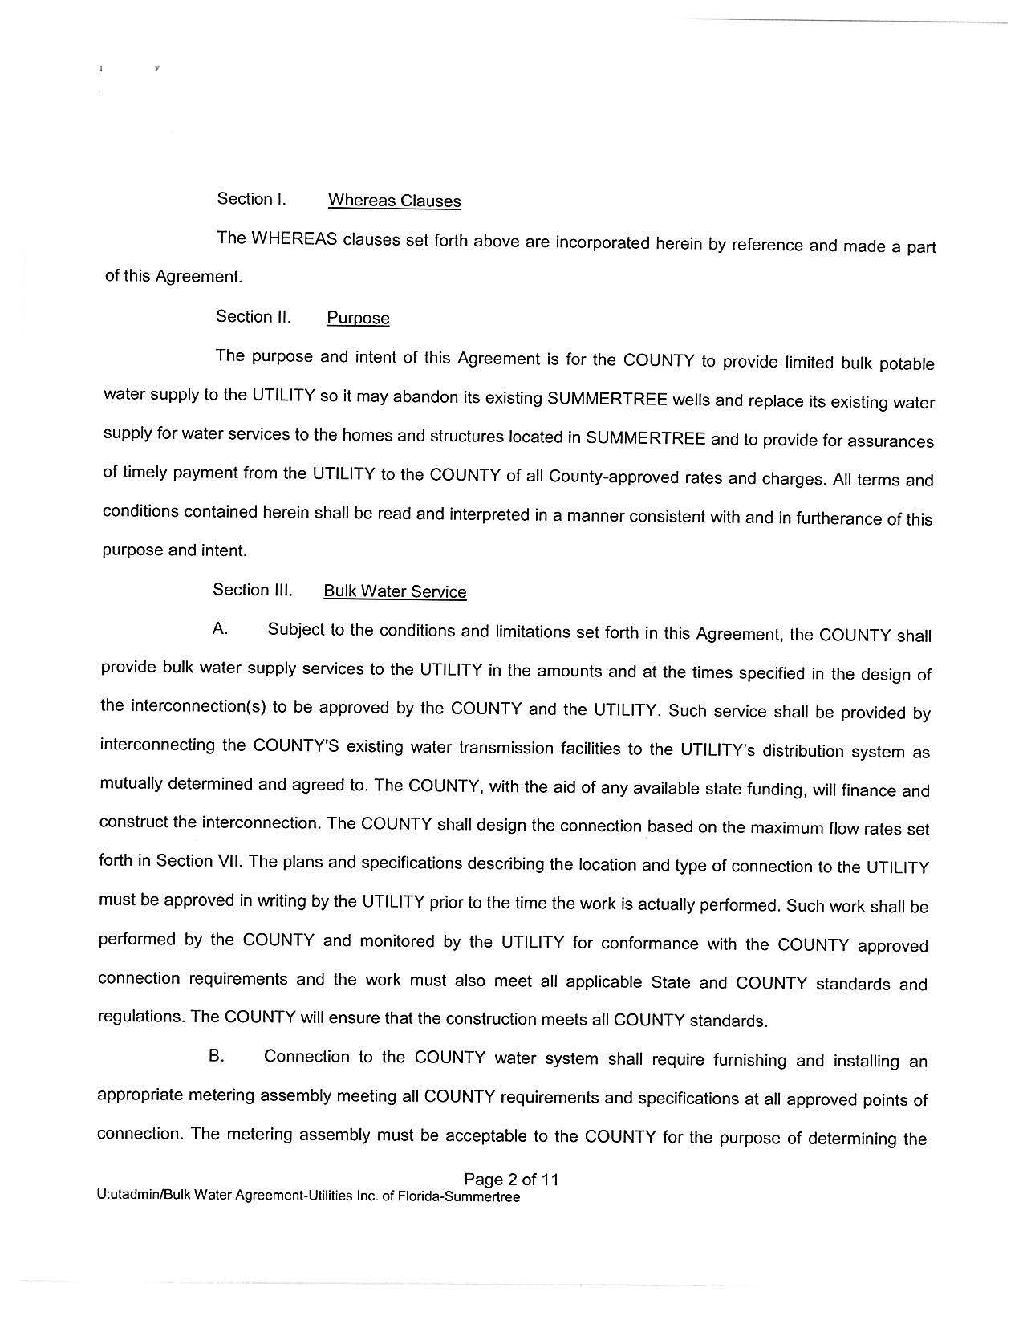
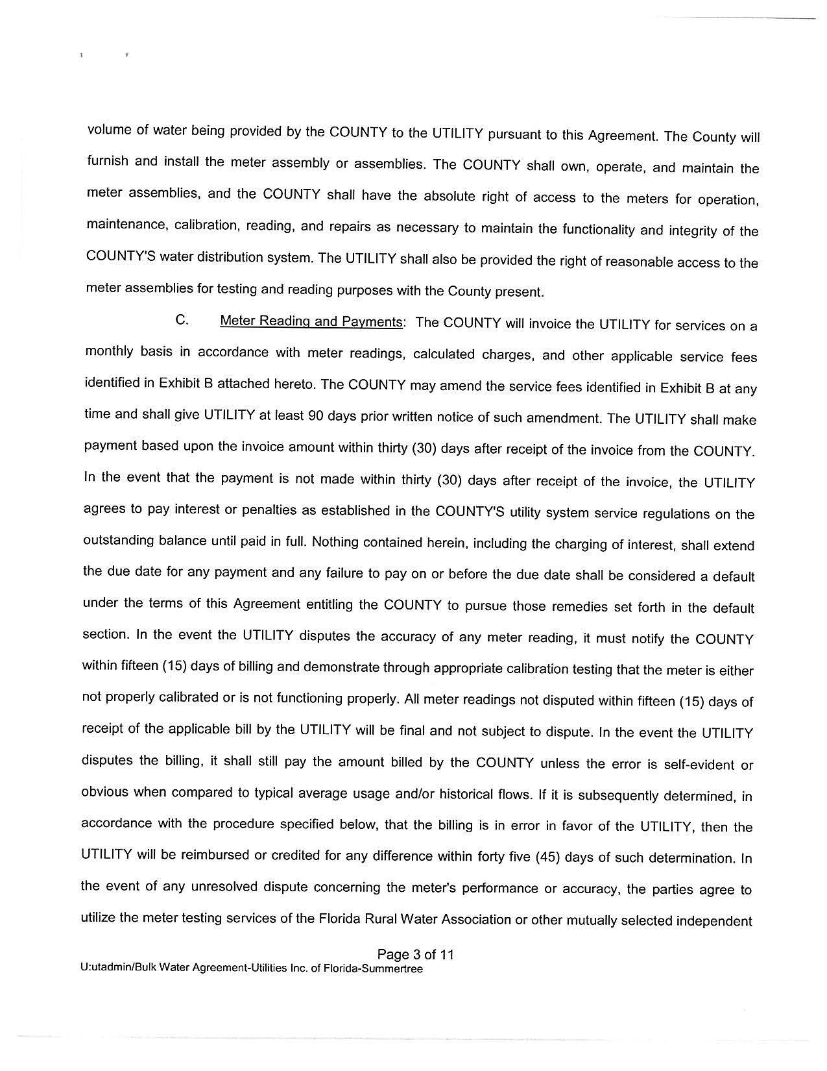
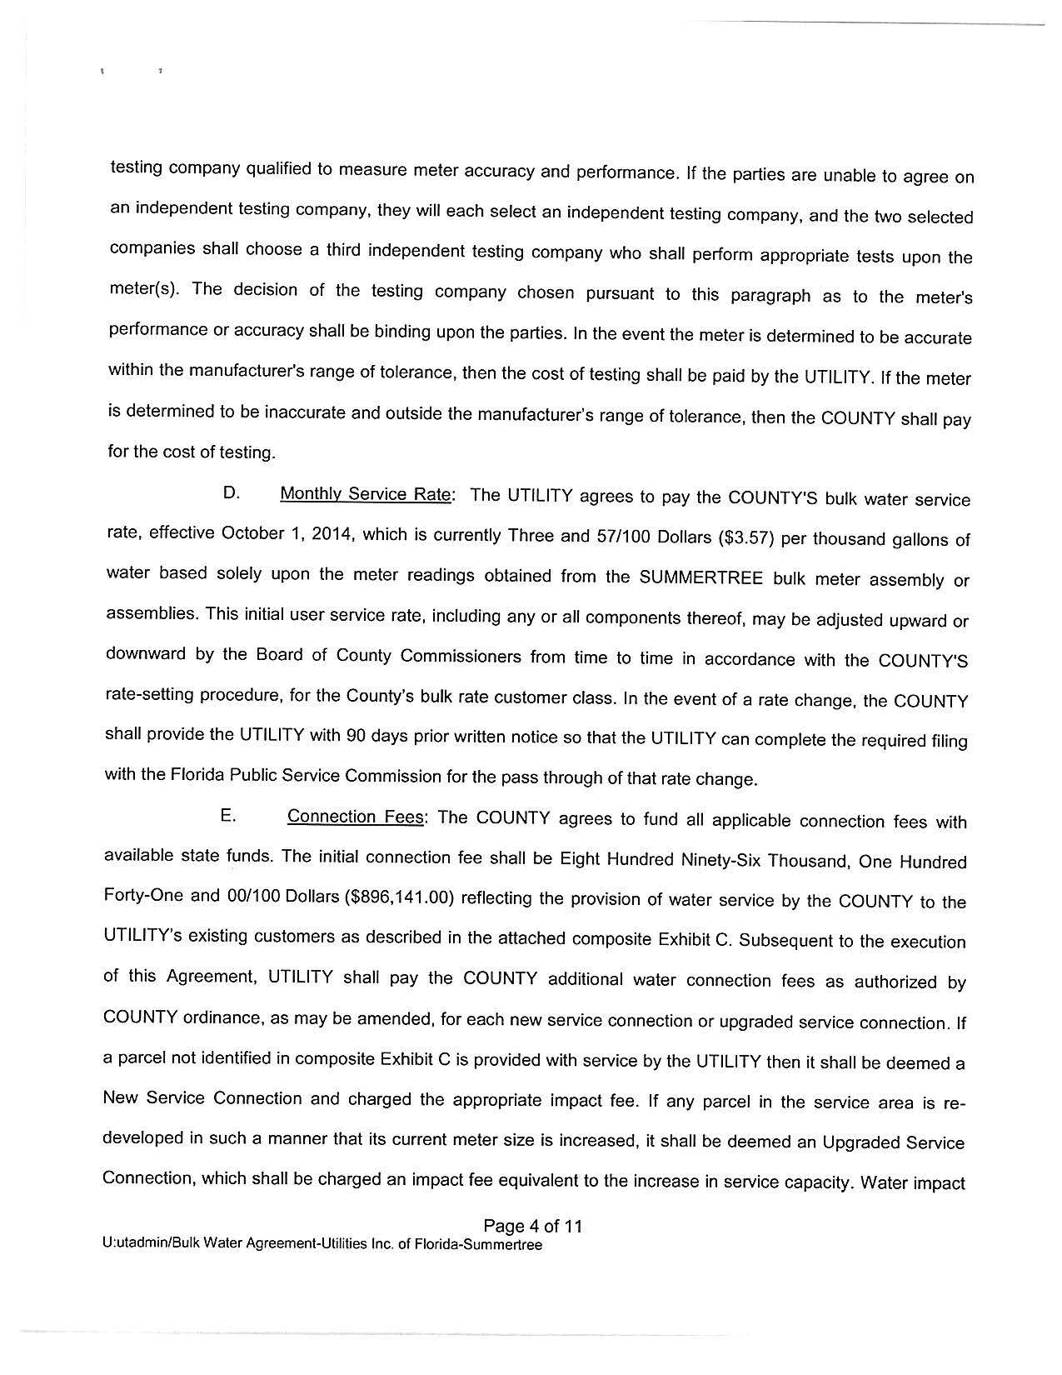
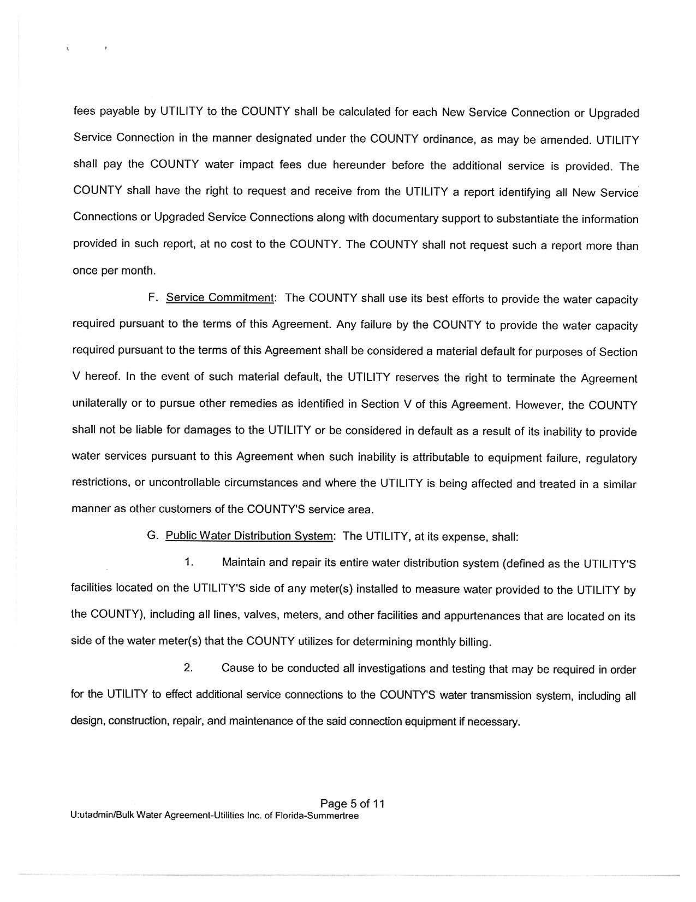
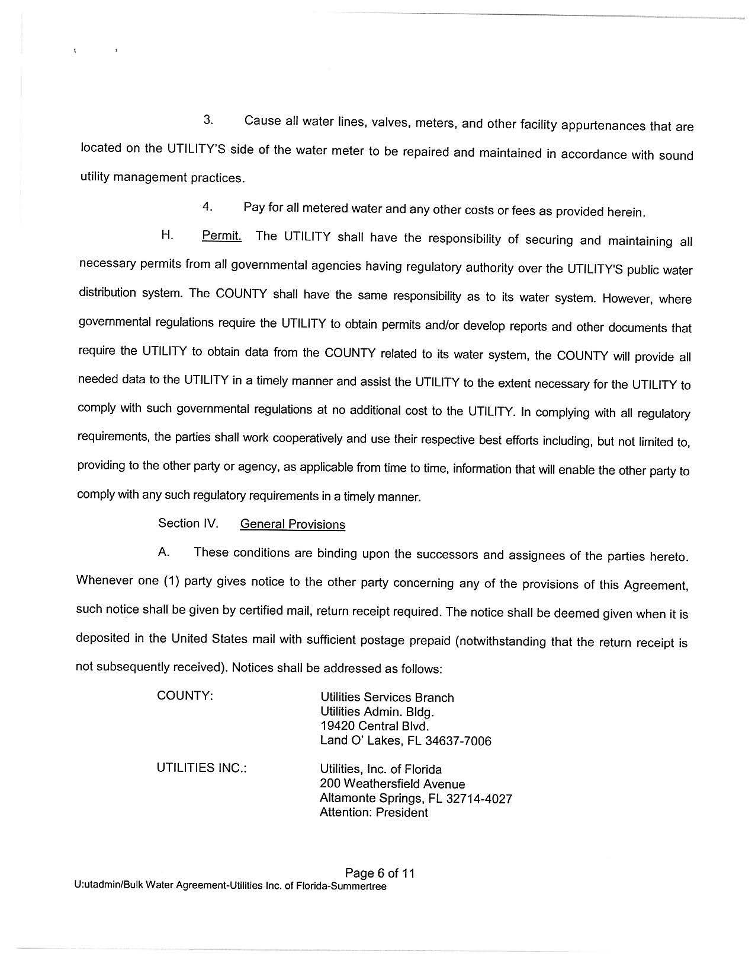
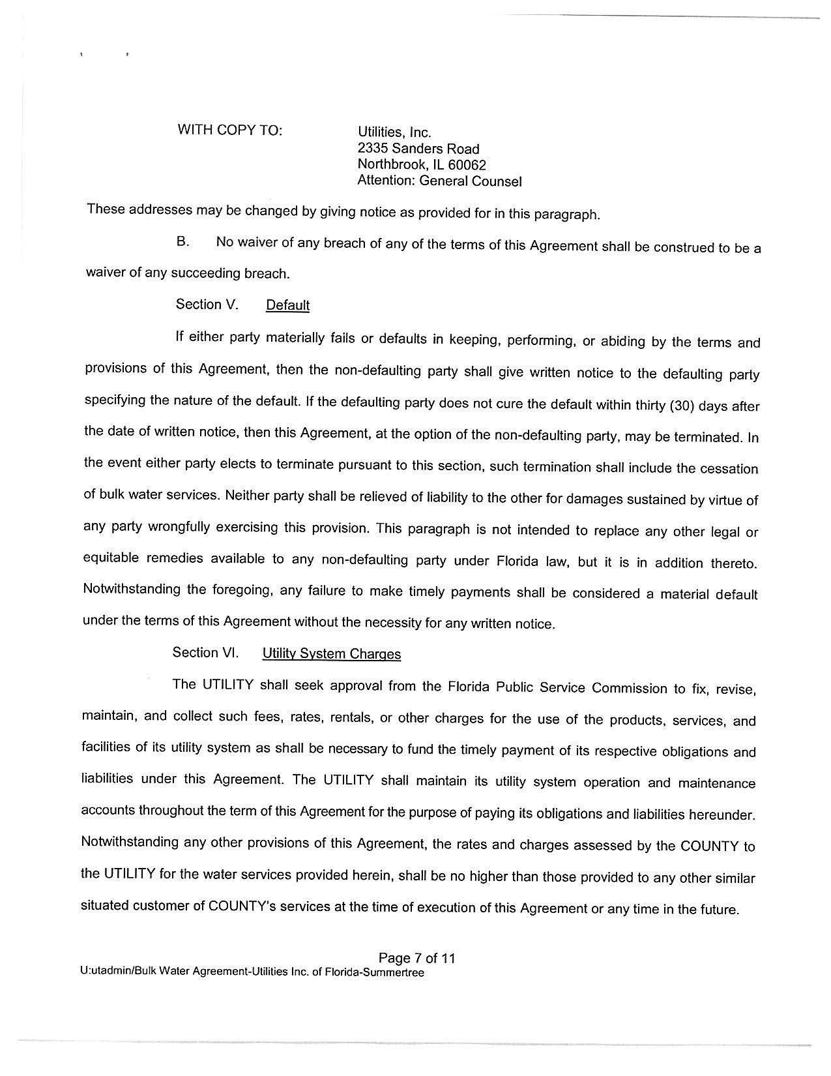
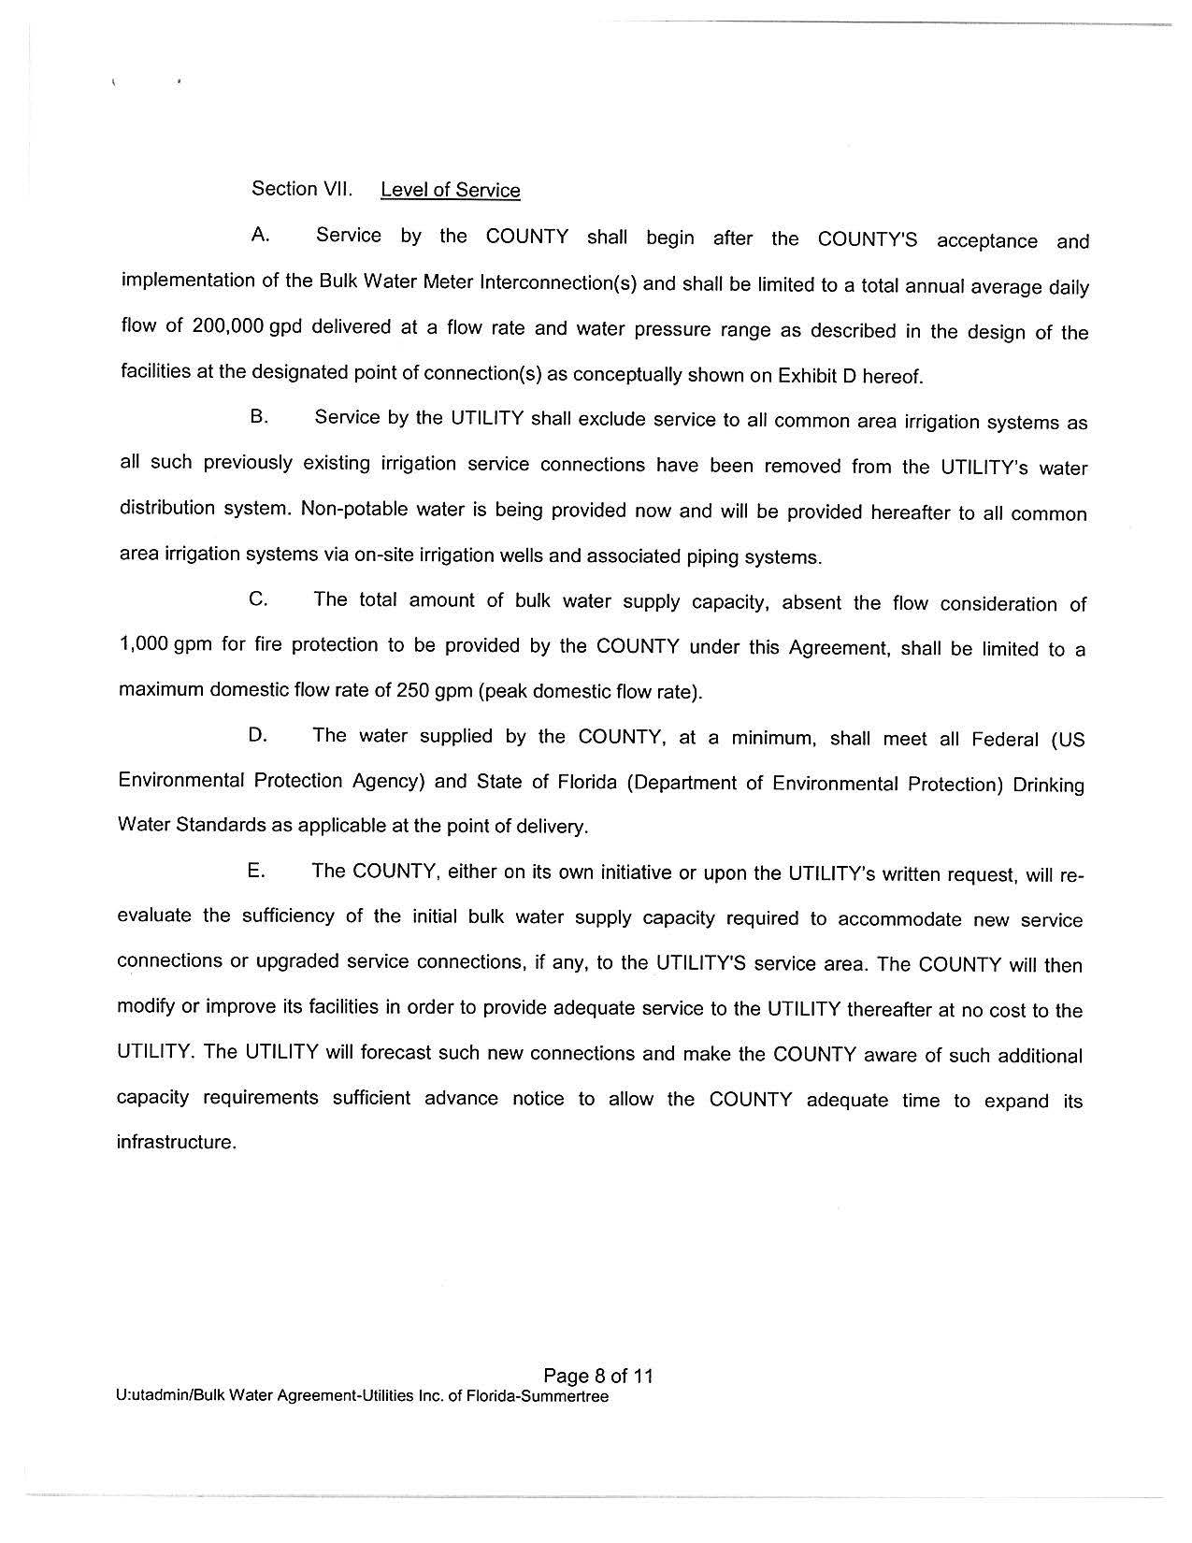
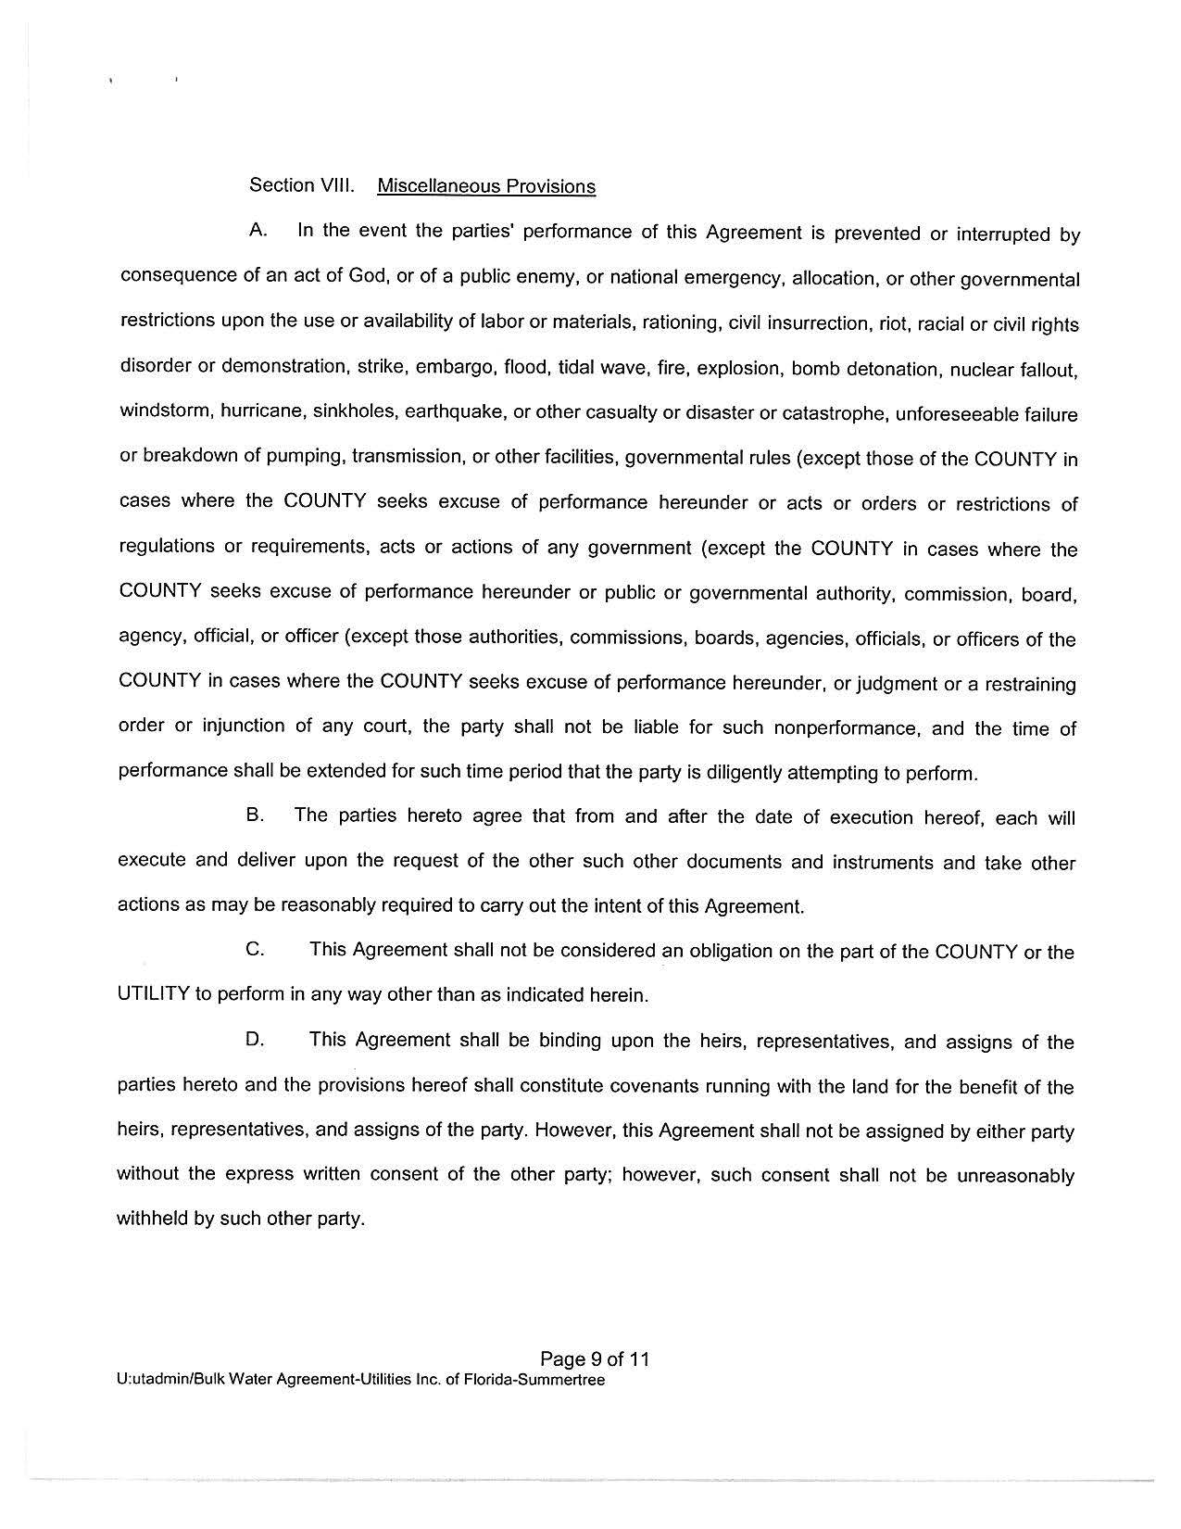
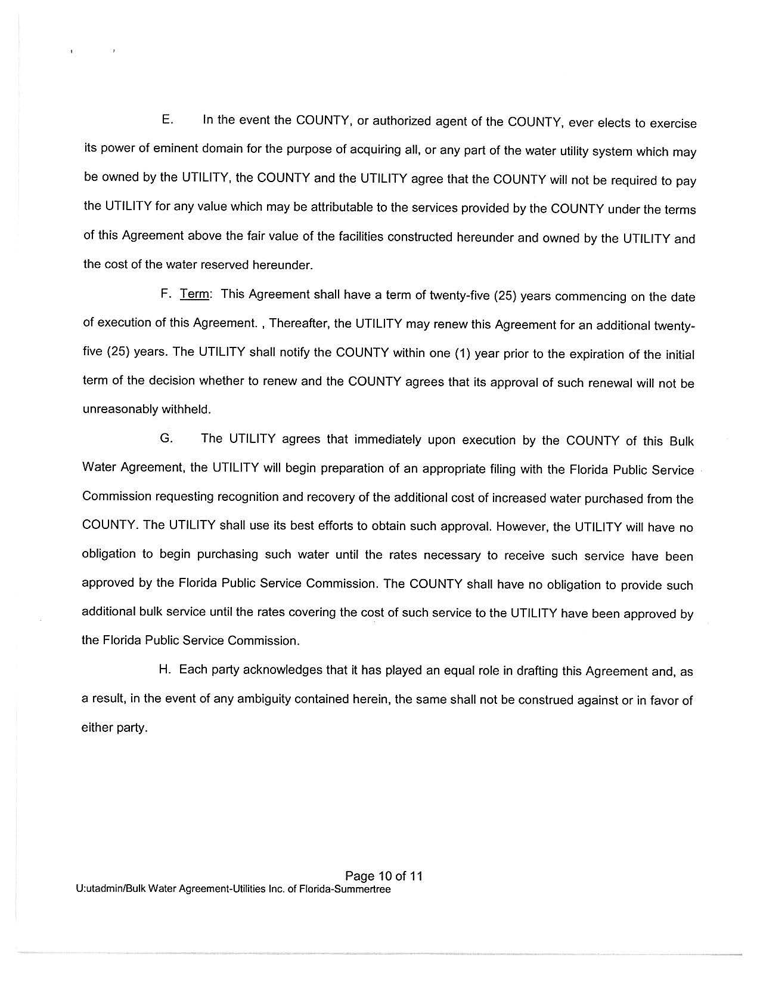
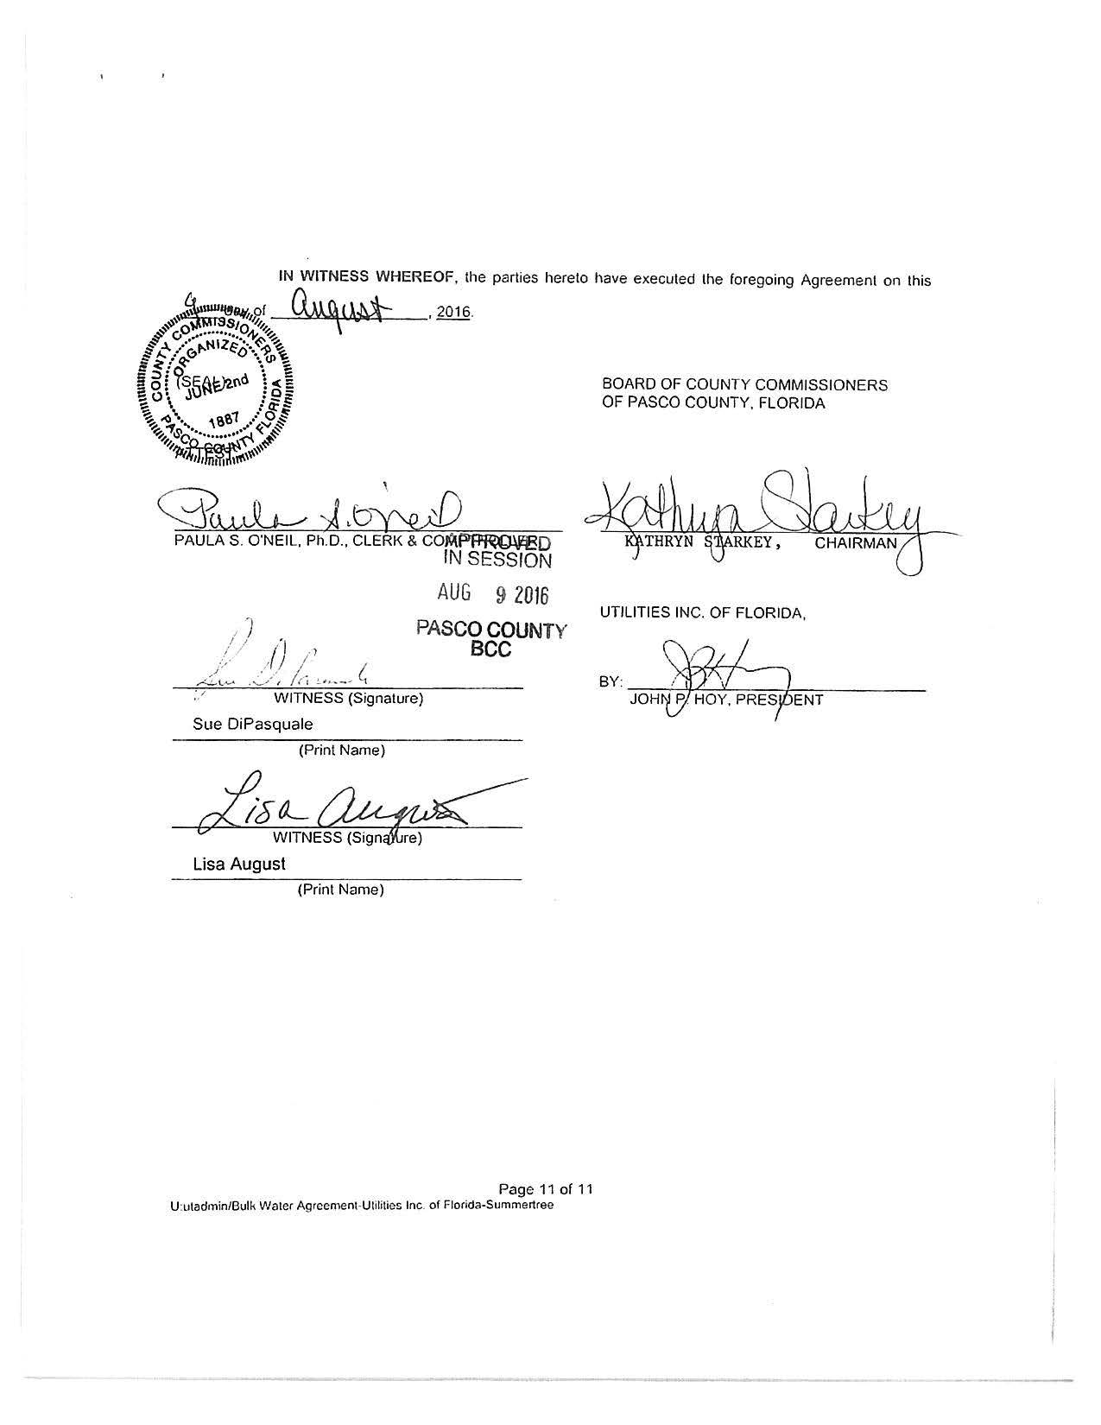

Order No. PSC-14-0025-PAA-WS, issued January 10, 2014, in Docket No. 120209-WS, In re: Application for increase in water and wastewater rates in Marion, Orange, Pasco, Pinellas, and Seminole Counties by Utilities, Inc. of Florida.
On April 12, 2016, this Commission acknowledged the reorganization and name change of UI’s systems in Florida. The instant docket applies only to the former Utilities, Inc. of Florida systems, and does not include Labrador Utilities, Inc. in Pasco County. Order No. PSC-16-0143-FOF-WS, issued April 12, 2016, in Docket No. 150235-WS, In re: Joint application for acknowledgement of corporate reorganization and request for approval of name changes on water and/or wastewater certificates of Cypress Lakes Utilities, Inc. in Polk County; Utilities, Inc. of Eagle Ridge in Lee County; Utilities, Inc. of Florida in Marion, Orange, Pasco, Pinellas, and Seminole Counties; Labrador Utilities, Inc. in Pasco County; Lake Placid Utilities, Inc. in Highlands County; Lake Utility Services, Inc. in Lake County; Utilities, Inc. of Longwood in Seminole County; Mid-County Services, Inc. in Pinellas County; Utilities, Inc. of Pennbrooke in Lake County; Utilities, Inc. of Sandalhaven in Charlotte County; Sanlando Utilities Corporation in Seminole County; and Tierra Verde Utilities, Inc. in Pinellas County, to Utilities, Inc. of Florida.
Order No. PSC-16-0135-PCO-WS
Document No. 00669-16
Document No. 01120-16
Docket No. 160101-WS, In re: Application for increase in water and wastewater rates in Charlotte, Highlands, Lake, Lee, Marion, Orange, Pasco, Pinellas, Polk, and Seminole Counties by Utilities, Inc. of Florida.
Document No. 03459-16
Document No. 03641-16
Document No. 06480-16
Document No. 06823-16
Order No. PSC-14-0025-PAA-WS, issued January 10, 2014, in Docket 120209-WS, In re: Application for increase in water and wastewater rates in Marion, Orange, Pasco, Pinellas, and Seminole Counties by Utilities Inc. of Florida, pp.4-8.
Document No. 05631-16
Document No. 07147-16, p.4
Document No. 06923-16
Order No. PSC-14-0025-PAA-WS, issued January 10, 2014, in Docket No. 120209-WS, In re: Application for increase in water and wastewater rates in Marion, Orange, Pasco, Pinellas, and Seminole Counties by Utilities, Inc. of Florida, p.65.
Document No. 01120-16, p.6
Document No. 07710-16, p.49 (Commission Conference Transcript)
Document No. 07491-16
Document No. 07735-16
UIF Petition, Schedule No. 17
Document No. 00869-16, Commission staff’s First Data Request No. 3
Order No. PSC-14-0025-PAA-WS, issued January 10, 2014, in Docket No. 120209-WS, In re: Application for increase in water and wastewater rates in Marion, Orange, Pasco, Pinellas, and Seminole Counties by Utilities, Inc. of Florida, p.8.
Document No. 00869-16, Commission staff’s First Data Request No. 21.
Order No. PSC-16-0296-PAA-WS, issued July 27, 2016.
Documents No. 05631-16 and 07735-16
Federal Insurance Contributions Act (7.65 percent)
Federal Unemployment Tax Act (6.00 percent)
State Unemployment Tax Act (1.02 percent)
Document No. 07147-16, p.10 (see Attachment A)
Document No. 06975-16
The approved rates are for illustrative purposes only because the interim rate case rates will be implemented prior to the effective date for the LIMP rates.
Order No. PSC-09-0651-PAA-SU, issued September 28, 2009, in Docket No. 090121-SU, In re: Application for limited proceeding rate increase in Seminole County by Alafaya Utilities, Inc.; and Order No. PSC-10-0682-PAA-WS, issued November 15, 2010, in Docket No. 090349-WS, In re: Application for limited proceeding rate increase in Polk County by Cypress Lakes Utilities, Inc.

