BEFORE THE FLORIDA PUBLIC SERVICE COMMISSION

In re: Petition for approval of safety, access, and facility enhancement program (SAFE) true-up and associated cost recovery factors, by Florida City Gas. | DOCKET NO. 160198-GU  ORDER NO. PSC-16-0517-TRF-GU  ISSUED: November 21, 2016

The following Commissioners participated in the disposition of this matter:

JULIE I. BROWN, Chairman
LISA POLAK EDGAR
ART GRAHAM
RONALD A. BRISÉ
JIMMY PATRONIS

ORDER APPROVING SAFETY, ACCESS, AND FACILITY ENHANCEMENT PROGRAMS (SAFE) TRUE-UP AND ASSOCIATED COST RECOVERY FACTORS

BY THE COMMISSION:

Background

On August 31, 2016, Florida City Gas (City Gas or Company) filed a petition for approval of its safety, access, and facility enhancement program (SAFE) true-up and associated cost recovery factors. The SAFE program, which we approved in 2015, is a 10-year program that will relocate mains and associated facilities from rear lot easements to the street front. According to City Gas, relocation to the street front provides for more direct access to facilities and will enhance the level of service provided to all customers through improved safety and reliability. We ordered the Company to file an annual petition, beginning in 2016, for a review and reset of the surcharge factors to true-up any prior over- or under-recovery and to set the surcharge for the coming year.
In its filing, City Gas waived the 60-day suspension deadline pursuant to Section 366.06(3), Florida Statutes (F.S.). The Office of Public Counsel (OPC) requested interested party status in this docket on September 15, 2016. City Gas filed its responses to our staff’s first data request on September 23, 2016, and to staff’s second and third data requests on October 10, 2016. The proposed tariff page is contained in Attachment 2. We have jurisdiction over this matter pursuant to Sections 366.03, 366.04, 366.05, 366.06, and 368, F.S.

Decision
Under the SAFE program, City Gas plans to relocate and replace 254.3 miles of mains and associated facilities from rear property easements to the street front over a 10-year period, ending in 2025. The surcharges have been in effect since January 2016; City Gas began its replacements at the end of 2015, as provided for in the 2015 order.
The Company’s 2015 - 2016 replacement plan includes 10 projects. Six projects are in the Miami area (Cutler Bay, Hialeah, and Opalocka). Four projects are in Brevard County (Rockledge and three on Merritt Island). Attachment 1 displays City Gas’s replacement progress, both actual and forecasted.
City Gas stated in response to our staff’s data request that its replacement projects are generally prioritized based on the risk assessment model in its Distribution Integrity Management (DIM) program. Prioritization factors include, but are not limited to, the location of the pipeline, pipeline material, leak incident rates, and rear lot pipelines with maintenance access complications and customer encroachments.
True-Up
There is no true-up for 2015; however, the revenue requirement associated with the net plant in service installed in 2015 was included in the rates implemented for 2016. The 2016 true-up includes seven months of actual and five months of estimated 2016 expenses and revenues. The actual/estimated revenue requirement for 2016 is $736,045 and includes a return on investment, depreciation, and taxes. The estimated 2016 revenue is $931,494, resulting in an over-recovery of $195,449 for 2016.
The Company’s total projected expenditures for 2017 are $9,583,423. The corresponding revenue requirement, which includes return on investment, depreciation, and taxes, is $2,204,344. After the 2016 over-recovery is subtracted, the 2017 revenue requirement is $2,008,895. Table 1 displays the true-up calculation for 2017.

Table 1
True-up Calculation for 2017
2017 Projected Replacements | $9,583,423
Return on Investment | $1,502,702
Depreciation Expense | $547,033
Property Tax Expense | $154,609
2017 Revenue Requirement | $2,204,344
Less 2016 True-up | ($195,449)
Total 2017 Revenue Requirement | $2,008,895
Source: Schedule 2 of the Petition

Proposed Surcharges
The Company’s cost allocation method was approved in the 2015 Order, and according to City Gas, used for the instant filing. The methodology allocates the cost of a 2-inch pipe to all customers (other than those with pre-existing contracts) on a per customer basis and allocates the incremental cost of replacing pipe larger than 2 inches to customers who use 6,000 or more therms per year. For larger customers, the cost pool takes into account that the minimum pipe is insufficient to serve their demand, and therefore, allocates an incremental per foot cost in addition to the all-customer cost. The resulting allocation factors are applied to the revenue requirement to develop the monthly customer surcharges.
We note that the average residential customer uses 240 therms per year. The proposed fixed monthly surcharge is $1.53 for customers using less than 6,000 therms per year, compared to the current charge of $0.71 per month. For customers using 6,000 therms or more per year, the proposed fixed monthly surcharge is $2.77, compared to the current charge of $1.31 per month. The surcharge is cumulative; therefore, if City Gas files a rate case before 2025, the then-current SAFE surcharge program would be folded into any newly approved rate base, and the surcharge would begin anew.
Summary
We have reviewed the filing and supporting documentation and find the calculations are consistent with the methodology and are reasonable and accurate. Therefore, we approve City Gas’ proposed 2017 SAFE surcharge factors with an effective date of the first billing cycle of 2017.
Based on the foregoing, it is

ORDERED by the Florida Public Service Commission that Florida City Gas’ petition for its Safety, Access, and Facility Enhancement Program and associated cost recovery factors are approved with an effective date of the first billing cycle of January 2017. It is further

ORDERED that Florida City Gas shall file its annual Safety, Access, and Facility Enhancement Program petition on September 1 of each year for a review and reset of the surcharge factors to true-up any prior over- or under-recovery and to set the surcharge for the coming year. It is further

ORDERED that if a protest is filed within 21 days of issuance of the Order, the tariff shall remain in effect with any charges held subject to refund pending resolution of the protest. It is further

ORDERED that if no timely protest is filed, this docket shall be closed upon the issuance of a Consummating Order.

By ORDER of the Florida Public Service Commission this 21st day of November, 2016.

/s/ Carlotta S. Stauffer
CARLOTTA S. STAUFFER
Commission Clerk
Florida Public Service Commission
2540 Shumard Oak Boulevard
Tallahassee, Florida 32399
(850) 413-6770
www.floridapsc.com

Copies furnished: A copy of this document is provided to the parties of record at the time of issuance and, if applicable, interested persons.

WDT

NOTICE OF FURTHER PROCEEDINGS

The Florida Public Service Commission is required by Section 120.569(1), Florida Statutes, to notify parties of any administrative hearing or judicial review of Commission orders that is available under Sections 120.57 or 120.68, Florida Statutes, as well as the procedures and time limits that apply. This notice should not be construed to mean all requests for an administrative hearing or judicial review will be granted or result in the relief sought.

Mediation may be available on a case-by-case basis. If mediation is conducted, it does not affect a substantially interested person's right to a hearing.

The Commission's decision on this tariff is interim in nature and will become final, unless a person whose substantial interests are affected by the proposed action files a petition for a formal proceeding, in the form provided by Rule 28-106.201, Florida Administrative Code. This petition must be received by the Office of Commission Clerk, 2540 Shumard Oak Boulevard, Tallahassee, Florida 32399-0850, by the close of business on December 12, 2016.

In the absence of such a petition, this Order shall become final and effective upon the issuance of a Consummating Order.

Any objection or protest filed in this docket before the issuance date of this order is considered abandoned unless it satisfies the foregoing conditions and is renewed within the specified protest period.

Florida City Gas’ SAFE Program Progress

Year | Main Replacements |  |  | Service Replacements
 | Replaced main (miles) | Remaining main at Year End (miles) | Total Miles Remaining | Replaced Services (No.) | Remaining Services at year end | Total Remaining Services
2014 | 0.0 | 254.3 | 254.3 | 0 | 13956 | 13956
2015 | 0.0 | 254.3 | 254.3 | 0 | 13956 | 13956
2016 | 14.2 | 240.1 | 240.1 | 706 | 13250 | 13250
2017 | 46.8 | 193.3 | 193.3 | 2536 | 10713 | 10713
2018 | 28.2 | 165.1 | 165.1 | 1545 | 9168 | 9168
2019 | 25.0 | 140.1 | 140.1 | 1372 | 7797 | 7797
2020 | 25.0 | 115.1 | 115.1 | 1372 | 6425 | 6425
2021 | 25.0 | 90.1 | 90.1 | 1372 | 5053 | 5053
2022 | 25.0 | 65.1 | 65.1 | 1372 | 3681 | 3681
2023 | 25.0 | 40.1 | 40.1 | 1372 | 2309 | 2309
2024 | 25.0 | 15.1 | 15.1 | 1372 | 937 | 937
2025 | 15.1 | 0.0 | 0.0 | 937 | 0 | 0
2025 | 15.1 | 0.0 | 0.0 | 937 | 0 | 0

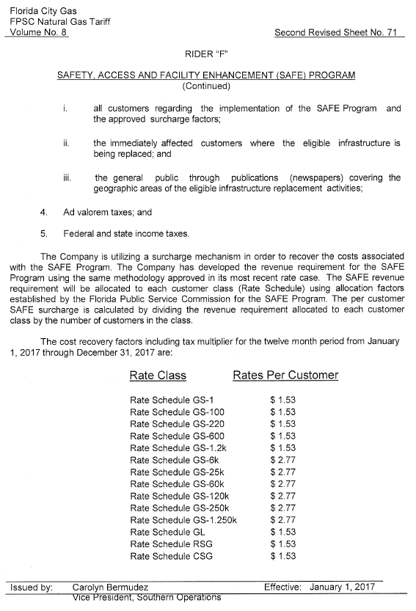

Order No. PSC-15-0390-TRF-GU, issued September 15, 2015, in Docket No. 150116-GU, In re: Petition for approval of safety, access, and facility enhancement program and associated cost recovery methodology, by Florida City Gas. (2015 order)
Beginning with its second annual filing in 2017, the Company will report any operations and maintenance and depreciation expense savings or incremental costs associated with the SAFE program that may occur.

