BEFORE THE FLORIDA PUBLIC SERVICE COMMISSION

In re: Joint petition for approval of gas reliability infrastructure program cost recovery factors by Florida Public Utilities Company, Florida Public Utilities Company-Fort Meade, and the Florida Division of Chesapeake Utilities Corporation. | DOCKET NO. 160199-GU  ORDER NO. PSC-16-0567-TRF-GU  ISSUED: December 19, 2016

The following Commissioners participated in the disposition of this matter:

JULIE I. BROWN, Chairman
LISA POLAK EDGAR
ART GRAHAM
RONALD A. BRISÉ
JIMMY PATRONIS

ORDER APPROVING TARIFFS

BY THE COMMISSION:

Background
On September 1, 2016, Florida Public Utilities Company (FPUC), FPUC-Fort Meade (Fort Meade), and the Florida Division of Chesapeake Utilities Corporation (Chesapeake), collectively the company, filed a joint petition seeking approval to implement the company’s Gas Reliability Infrastructure Program (GRIP) cost recovery factors for the period January 2017 through December 2017.
The GRIP program for FPUC and Chesapeake was originally approved in September 2012 in Order No. PSC-12-0490-TRF-GU (2012 order) to recover the cost of accelerating the replacement of cast iron and bare steel distribution mains and services through a surcharge on customer’s bills. The program is expected to be complete in 2022. FPUC’s and Chesapeake’s currently effective surcharges were approved in Order No. PSC-15-0578-TRF-GU. Additionally, the same order established Fort Meade’s new GRIP program and required Fort Meade to file a petition for 2017 GRIP factors concurrent with the annual FPUC and Chesapeake GRIP filings in September 2016. As provided for in the 2012 order, the filing includes a final true-up for 2015, an actual/estimated true-up for 2016, and the projected revenue requirement for 2017 for the three companies.
The company waived the 60-day suspension deadline to the December 6, 2016 Agenda Conference pursuant to Section 366.06(3), Florida Statutes (F.S.). On October 13, 2016, the company filed responses to Commission staff’s first data request. On October 25, 2016, the company filed corrected data tables per Commission staff’s request. We have jurisdiction over this matter pursuant to Sections 366.03, 366.04, 366.05, and 366.06, F.S.

Decision

The FPUC and Chesapeake GRIP surcharges have been in effect since January 2013, while Fort Meade’s surcharges will be implemented beginning in January 2017. The petitioners assert that certain replacement projects in high consequence areas within cities and larger municipalities continue to be on an accelerated track. In response to Commission staff’s data request, the company stated that it had performed replacement projects in West Palm Beach, Lake Worth, Deland, Debary, Winter Haven, Haines City, Auburndale, Lake Wales, Palm Beach, and North Palm Beach. The accelerated status of these projects has resulted in increased GRIP costs due to various construction requirements imposed by the municipalities. The company anticipates that as the projects in high consequence areas are completed and the activity shifts to less populated areas, the overall GRIP costs will decline.

Attachment 1 provides an update of mains and services replaced and replacement forecasts through the end of the term of the GRIP programs for the company. The company appears to be on track to complete the replacements on time. Attachments 2 through 4 show the tariffs approved by this Commission.

FPUC’s True-Ups by Year

FPUC’s calculations for the 2017 GRIP revenue requirement and surcharges include a final true-up for 2015, an actual/estimated true-up for 2016, and projected costs for 2017. We note that FPUC recovers $747,733 of annual GRIP expenses in base rates. This amount included in base rates is excluded from the GRIP surcharge calculation.

Final True-Up for 2015

FPUC stated that the GRIP revenues for 2015 were $4,089,962, compared to a revenue requirement of $5,774,298. The resulting under-recovery is $1,684,336. After adding interest of $1,954 and the end of 2014 under-recovery of $1,281,394, the final 2015 true-up is an under-recovery of $2,967,684.

Actual/Estimated True-Up for 2016

FPUC provided actual GRIP revenues for January through July and estimated revenues for August through December 2016, totaling $8,026,637. The actual/estimated revenue requirement for 2016 is $8,938,870, and it includes a return on investment, depreciation expense, and property tax expense. The forecasted under-recovery for 2016 is $912,233. After adding interest of $7,444, and the final 2015 under-recovery of $2,967,684, the total 2016 under-recovery is $3,887,361.

Projected Costs for 2017

FPUC projects capital expenditures of $5,139,504 for the replacement of cast iron/bare steel infrastructure in 2017. This compares with final 2015 expenditures of $27,181,346 and actual/estimated 2016 expenditures of $17,944,442. The return on investment, net depreciation expense, customer notification, and property tax expenses associated with that investment are $11,090,358. Subtracting the revenue requirement for bare steel replacement investment included in base rates results in a 2017 revenue requirement of $10,342,631. After adding the total 2016 under-recovery of $3,887,361, the 2017 revenue requirement is $14,229,992. Table 1 shows FPUC’s 2017 revenue requirement calculation.
Table 1
FPUC 2017 Revenue Requirement Calculation
2017 Projected Expenditures | $5,139,504
Return on Investment | $7,516,062
Depreciation Expenses | $2,021,364
Tax and Customer Notice Expenses | $1,552,932
2017 Revenue Requirement | $11,090,358
Less Revenue Requirement in Base Rates | $747,727
2017 GRIP Revenue Requirement | $10,342,631
Plus 2016 Under-Recovery | $3,887,361
2017 Total Revenue Requirement | $14,229,992
Source: GRIP Schedule C-2 of Exhibit MC-1, page 4 of 14

Chesapeake’s True-Ups by Year

Chesapeake does not have a replacement recovery amount embedded in base rates. Chesapeake’s calculations for the 2017 GRIP revenue requirement and surcharges include a final true-up for 2015, an actual/estimated true-up for 2016, and projected costs for 2017.

Final True-Up for 2015

Chesapeake stated that the GRIP revenues for 2015 were $1,775,375, compared to total replacement costs of $1,689,514. The resulting over-recovery is $85,861. After adding interest of $105 and the end of 2014 under-recovery amount of $211,175, the final 2015 under-recovery is $125,419.

Actual/Estimated True-Up for 2016

Chesapeake provided actual GRIP revenues for January through July and estimated revenues for August through December 2016, which total $2,237,448. The actual/estimated GRIP revenue requirement for 2016 is $2,424,705 and includes a return on investment, depreciation expense, and property tax expense. The forecasted under-recovery for 2016 is $187,257. After adding interest of $121 and the 2015 under-recovery amount of $125,419, the total 2016 under-recovery is $312,797.

Projected Costs for 2017

Chesapeake projects capital expenditures of $1,623,012 for the replacement of cast iron/bare steel infrastructure in 2017. This compares with final 2015 expenditures of $5,692,055 and actual/estimated 2016 expenditures of $5,340,859. The return on investment, depreciation expense, and property tax expense to be recovered in 2017 totals to $2,877,498. After adding the total 2016 under-recovery of $312,797, the total 2017 revenue requirement is $3,190,295. Table 2 shows Chesapeake’s 2017 revenue requirement calculation.
Table 2
Chesapeake 2017 Revenue Requirement Calculation
2017 Projected Expenditures | $1,623,012
Return on Investment | $1,927,204
Depreciation Expenses | $519,182
Tax and Customer Notice Expenses | $431,112
2017 Revenue Requirement | $2,877,498
Plus 2016 Under-Recovery | $312,797
2017 Total Revenue Requirement | $3,190,295
Source: GRIP Schedule C-2 of Exhibit MC-1, page 9 of 14

Fort-Meade’s True-Ups by Year

When this Commission first approved the Fort Meade GRIP program in Order No. PSC-15-0578-TRF-GU, we allowed Fort Meade to start the replacement of approximately 250 steel services in 2016; however, the utility was required to defer collecting GRIP surcharges from customers until January 2017. As stated in the order approving the Fort Meade GRIP program, FPUC acquired Fort Meade’s natural gas system in 2013, and the implementation of the GRIP surcharge for Fort Meade prior to October 2016 would be in violation of a term in the purchase agreement of the Fort Meade system. Fort Meade will provide notice to its customers of the this Commission’s approved GRIP factors in the December bills.

Actual/Estimated True-Up for 2016

Fort Meade did not have a GRIP surcharge in 2016. Therefore, GRIP revenues for 2016 are $0. The actual/estimated GRIP revenue requirement for 2016 is $4,208 and includes a return on investment and depreciation expense. After adding interest of $2, the total 2016 under-recovery is $4,210.

Projected Costs for 2017

Fort Meade projects capital expenditures of $277,081 for the replacement of cast iron/bare steel infrastructure in 2017. This compares with actual/estimated 2016 expenditures of $197,915. The return on investment, depreciation expense, and property tax expense to be recovered in 2017 totals $45,648. After adding the total 2016 under-recovery of $4,210, the total 2017 revenue requirement is $49,858. Table 3 shows Fort Meade’s 2017 revenue requirement calculation.

Table 3
Fort Meade 2017 Revenue Requirement Calculation
2017 Projected Expenditures | $277,081
Return on Investment | $31,380
Depreciation Expenses | $10,332
Tax and Customer Notice Expenses | $3,936
2017 Revenue Requirement | $45,648
Plus 2016 Under-Recovery | $4,210
2017 Total Revenue Requirement | $49,858
Source: GRIP Schedule C-2 of Exhibit MC-1, page 13 of 14

Approved Surcharges for FPUC, Chesapeake, and Fort Meade

As established in the 2012 order approving the GRIP, the total 2017 revenue requirement is allocated to the rate classes using the same methodology that was used for the allocation of mains and services in the cost of service study used in the company’s most recent rate case. Fort Meade has the same rate schedules as FPUC, and FPUC’s allocation factors are used to calculate the GRIP surcharges for Fort Meade. After calculating the percentage of total plant costs attributed to each rate class, the respective percentages were multiplied by the 2017 revenue requirement, resulting in the revenue requirement by rate class. Dividing each rate class’ revenue requirement by projected therm sales provides the GRIP surcharge for each rate class.

Our approved 2017 GRIP surcharge for residential FPUC customers on the RS Schedule is $0.34225 per therm (compared to the current surcharge of $0.26393 per therm). The monthly bill impact is $6.85 beginning January 6, 2017 for a residential customer who uses 20 therms per month. This Commission’s approved tariff page for FPUC is provided in Attachment 2.

Our approved 2017 GRIP surcharge for residential Chesapeake customers on the FTS-1 schedule is $0.10371 per therm (compared to the current surcharge of $0.08568 per therm). The monthly bill impact is $2.07 beginning January 6, 2017 for a residential Chesapeake customer who uses 20 therms per month. The approved tariff page for Chesapeake is provided in Attachment 3.

Our approved 2017 GRIP surcharge for residential Fort Meade customers on the RS Schedule is $0.36931 per therm. The monthly bill impact is $7.39 beginning January 6, 2017 for a residential Fort Meade customer who uses 20 therms per month. The approved tariff page for Fort Meade is provided in Attachment 4.

Conclusion

We find that the calculation of the 2017 GRIP surcharge revenue requirement and this Commission’s approved GRIP surcharges for FPUC, Chesapeake, and Fort Meade are reasonable and accurate. Therefore, FPUC, Chesapeake, and Fort Meade’s approved 2017 GRIP surcharge for each rate class shall commence with bills rendered for meter readings taken on or after January 6, 2017.

Based on the foregoing, it is

ORDERED by the Florida Public Service Commission that Florida Public Utilities Company, Florida Public Utilities Company-Fort Meade, and the Florida Division of Chesapeake Utilities Corporation’s joint petition seeking approval to implement Gas Reliability Infrastructure Program cost recovery factors for the period January 2017 through December 2017 is approved as stated herein with an effective date of January 6, 2017. It is further

ORDERED that if a protest is filed within 21 days of the issuance of this Order, the tariff shall remain in effect with any charges held subject to refund pending the resolution of the protest. It is further

ORDERED that if no timely protest is filed, this docket shall be closed upon the issuance of a consummating order.

By ORDER of the Florida Public Service Commission this 19th day of December, 2016.

/s/ Carlotta S. Stauffer
CARLOTTA S. STAUFFER
Commission Clerk
Florida Public Service Commission
2540 Shumard Oak Boulevard
Tallahassee, Florida 32399
(850) 413-6770
www.floridapsc.com

Copies furnished: A copy of this document is provided to the parties of record at the time of issuance and, if applicable, interested persons.
KRM

NOTICE OF FURTHER PROCEEDINGS

The Florida Public Service Commission is required by Section 120.569(1), Florida Statutes, to notify parties of any administrative hearing or judicial review of Commission orders that is available under Sections 120.57 or 120.68, Florida Statutes, as well as the procedures and time limits that apply. This notice should not be construed to mean all requests for an administrative hearing or judicial review will be granted or result in the relief sought.

Mediation may be available on a case-by-case basis. If mediation is conducted, it does not affect a substantially interested person's right to a hearing.

The Commission's decision on this tariff is interim in nature and will become final, unless a person whose substantial interests are affected by the proposed action files a petition for a formal proceeding, in the form provided by Rule 28-106.201, Florida Administrative Code. This petition must be received by the Office of Commission Clerk, 2540 Shumard Oak Boulevard, Tallahassee, Florida 32399-0850, by the close of business on January 9, 2017.

In the absence of such a petition, this Order shall become final and effective upon the issuance of a Consummating Order.

Any objection or protest filed in this docket before the issuance date of this order is considered abandoned unless it satisfies the foregoing conditions and is renewed within the specified protest period.
Attachment 1 – Page 1 of 2
Table 1
FPUC Pipe Replacement Program Progress

Year | Main Replacement |  |  |  |  | Service Replacement
 | Replaced  Cast Iron  (miles) | Replaced  Bare  Steel  (miles) | Remaining  Cast Iron at  Year End  (miles) | Remaining  Bare Steel at  Year End  (miles) | Total Miles  Remaining | Replaced  Number of  Bare Steel  Services | Total Number of  Remaining  Steel  Services
July 2012 |  |  | 0.9 | 197.10 | 198.00 |  | 7980
2012 |  | 6.00 | 0.9 | 191.10 | 192.00 | 91 | 7889
2013 | 0.6 | 26.40 | 0.3 | 164.70 | 165.00 | 2071 | 5818
2014 |  | 38.00 | 0.3 | 126.70 | 127.00 | 1275 | 4543
2015 |  | 30.00 | 0.3 | 96.70 | 97.00 | 605 | 3938
2016 |  | 29.00 | 0.3 | 67.70 | 68.00 | 815 | 3123
2017 | 0.3 | 13.70 | 0 | 54.00 | 54.00 | 650 | 2473
2018 |  | 14.00 | 0 | 40.00 | 40.00 | 650 | 1823
2019 |  | 14.00 | 0 | 26.00 | 26.00 | 650 | 1173
2020 |  | 14.00 | 0 | 12.00 | 12.00 | 650 | 523
2021 |  | 10.00 | 0 | 2.00 | 2.00 | 465 | 58
2022 |  | 2.00 | 0 | 0.00 | 0.00 | 58 | 0
Source: Response to Commission staff’s first data request/Attachment A, Revised 10/21/2016
Table 2
Chesapeake Pipe Replacement Program Progress

Year | Main Replacement |  |  |  |  | Service Replacement
 | Replaced  Cast Iron  (miles) | Replaced  Bare  Steel  (miles) | Remaining  Cast Iron at  Year End  (miles) | Remaining  Bare Steel at  Year End  (miles) | Total Miles  Remaining | Replaced  Number of  Bare Steel  Services | Total Number of  Remaining  Steel  Services
July 2012 |  |  | 0 | 152.00 | 152.00 |  | 762
2012 |  | 5.00 | 0 | 147.00 | 147.00 | 34 | 728
2013 |  | 3.00 | 0 | 144.00 | 144.00 | 139 | 589
2014 |  | 19.00 | 0 | 125.00 | 125.00 | 47 | 542
2015 |  | 34.00 | 0 | 91.00 | 91.00 | 284 | 258
2016 |  | 30.00 | 0 | 61.00 | 61.00 | 52 | 206
2017 |  | 13.00 | 0 | 48.00 | 48.00 | 42 | 164
2018 |  | 13.00 | 0 | 35.00 | 35.00 | 42 | 122
2019 |  | 13.00 | 0 | 22.00 | 22.00 | 42 | 80
2020 |  | 13.00 | 0 | 9.00 | 9.00 | 42 | 38
2021 |  | 7.00 | 0 | 2.00 | 2.00 | 26 | 12
2022 |  | 2.00 | 0 | 0.00 | 0.00 | 12 | 0
Source: Response to Commission staff’s first data request/Attachment A, Revised 10/21/2016

Attachment 1 – Page 2 of 2
Table 3
Fort Meade Pipe Replacement Program Progress

Year | Main Replacement |  |  |  |  | Service Replacement
 | Replaced  Cast Iron  (miles) | Replaced  Bare  Steel  (miles) | Remaining  Cast Iron at  Year End  (miles) | Remaining  Bare Steel at  Year End  (miles) | Total Miles  Remaining | Replaced  Number of  Bare Steel  Services | Total Number of  Remaining  Steel  Services
Jan. 2016 |  |  | 0 | 0 | 0 |  | 250
2016 |  | 0 | 0 | 0 | 0 | 100 | 150
2017 |  | 0 | 0 | 0 | 0 | 125 | 25
2018 |  | 0 | 0 | 0 | 0 | 25 | 0
Source: Response to Commission staff’s first data request/Attachment A, Revised 10/21/2016

Attachment 2
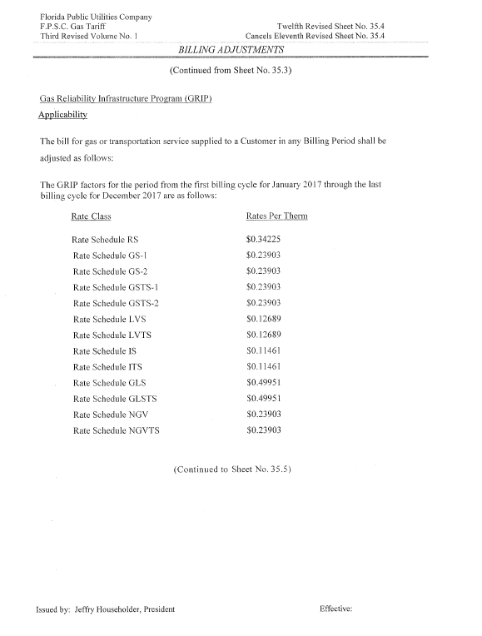

Attachment 3
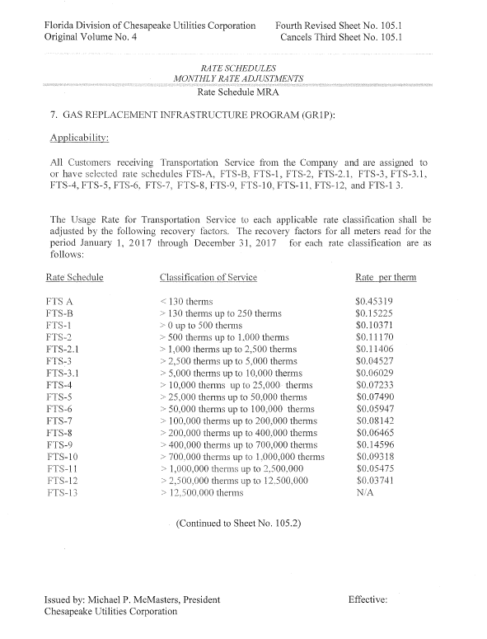

Attachment 4
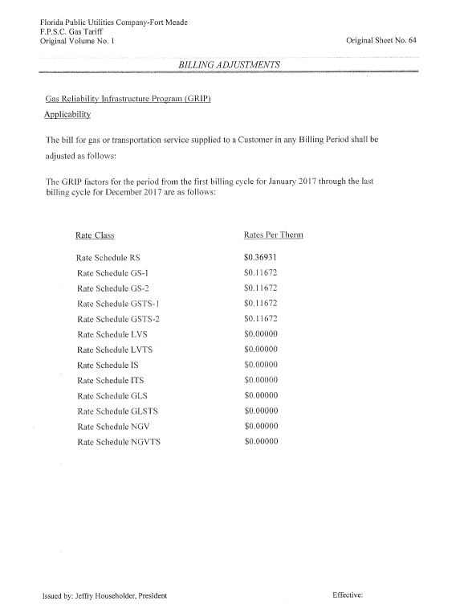

Order No. PSC-12-0490-TRF-GU, issued September 24, 2012, in Docket No. 120036-GU, In re: Joint petition for approval of Gas Reliability Infrastructure Program (GRIP) by Florida Public Utilities Company and the Florida Division of Chesapeake Utilities Corporation.
Order No. PSC-15-0578-TRF-GU, issued December 21, 2015, in Docket No. 150191-GU, In re: Joint petition for approval to implement gas reliability infrastructure program (GRIP) for Florida Public Utilities Company-Fort Meade and for approval of GRIP cost recovery factors by Florida Public Utilities Company, Florida Public Utilities Company-Fort Meade and the Florida Division of Chesapeake Utilities Corporation.

