State of Florida |  | Public Service Commission  Capital Circle Office Center ● 2540 Shumard Oak Boulevard  Tallahassee, Florida 32399-0850  -M-E-M-O-R-A-N-D-U-M-
DATE: | January 26, 2017
TO: | Office of Commission Clerk (Stauffer)
FROM: | Division of Accounting and Finance (Slemkewicz, Archer, D. Buys, Mouring)  Division of Economics (Rome, Draper)  Office of the General Counsel (Brownless)
RE: | Docket No. 160251-EI – Petition for limited proceeding for recovery of incremental storm restoration costs related to Hurricane Matthew by Florida Power & Light Company.
AGENDA: | 02/07/17 – Regular Agenda – Preliminary Procedural – Interested Persons May Participate
COMMISSIONERS ASSIGNED: |  |  | All Commissioners
PREHEARING OFFICER: |  |  | Brown
CRITICAL DATES: |  |  | 03/01/17 (Requested Implementation Date)
SPECIAL INSTRUCTIONS: |  |  | None

Case Background
On December 29, 2016, Florida Power & Light Company (FPL) filed a petition for a limited proceeding seeking authority to implement an interim storm restoration recovery charge to recover a total of $318.5 million for the incremental restoration costs related to Hurricane Matthew and to replenish its storm reserve. In its petition, FPL asserts that as a result of Hurricane Matthew, FPL incurred total retail recoverable costs of approximately $293.8 million, less its pre-storm storm reserve balance of $93.1 million, resulting in net recoverable costs of $200.7 million. In addition, FPL proposes to replenish its storm reserve to the $117.1 million balance that existed on January 2, 2013. Interest and the regulatory assessment fee gross-up add an additional $0.6 million to the recoverable costs.
FPL filed its petition pursuant to the provisions of the Revised Stipulation and Settlement Agreement (RSSA) approved by the Commission in Order No. PSC-13-0023-S-EI. Pursuant to Paragraph 5 of the RSSA, FPL can recover storm costs, not exceeding $4.00/1,000 kWh on monthly residential customer bills, on an interim basis beginning sixty days following the filing of a petition for recovery. In its petition, FPL has requested an interim storm restoration recovery charge of $3.36 on a monthly 1,000 kWh residential bill, effective March 1, 2017. The interim storm restoration recovery charge would remain in effect for a 12-month period.
The Office of Public Counsel has intervened in this docket pursuant to Order No. PSC-17-0030-PCO-EI, issued January 18, 2017.
The Commission has jurisdiction over this matter pursuant to Sections 366.04, 366.05, 366.06, and 366.076, Florida Statutes.

Discussion of Issues

Issue 1:
Should the Commission authorize FPL to implement a 2017 Interim Storm Restoration Recovery Charge?

Recommendation:
Yes. The Commission should authorize FPL to implement a 2017 Interim Storm Restoration Recovery Charge, subject to refund. Once the total actual storm costs are known, FPL should be required to file documentation of the storm costs for Commission review and true up of any excess or shortfall. (Slemkewicz)

Staff Analysis:
As stated in the case background, FPL filed a petition for a limited proceeding seeking authority to implement an interim storm restoration recovery charge to recover a total of $318.5 million for the incremental restoration costs related to Hurricane Matthew and to replenish its storm reserve. The requested recovery of $318.5 million represents net retail recoverable costs of approximately $200.7 million, plus an additional $117.1 million to replenish the storm reserve to the balance that existed on January 2, 2013. In addition, the $318.5 million includes interest of $0.4 million and regulatory assessment fee expense of $0.2 million. The petition was filed pursuant to the provisions of the RSSA approved by the Commission in Order No. PSC-13-0023-S-EI. Pursuant to Paragraph 5 of the RSSA, FPL can begin to recover storm costs, not exceeding $4.00/1,000 kWh on monthly residential customer bills, on an interim basis beginning sixty days following the filing of a petition for recovery. FPL has requested an interim storm restoration recovery charge of $3.36 on a monthly 1,000 kWh residential bill, effective for a 12-month period beginning March 1, 2017.
In its petition, FPL asserts that it incurred total retail recoverable costs of approximately $293.8 million as a result of Hurricane Matthew. This amount was calculated in accordance with the Incremental Cost and Capitalization Approach (ICCA) methodology prescribed in Rule 25-6.0143, Florida Administrative Code (F.A.C.). The net retail recoverable costs of $200.1 million were determined by reducing the $293.8 million total costs by the pre-storm storm reserve balance of $93.1 million. Paragraph 5 of the RSSA also allows FPL to request the replenishment of its storm reserve to the $117.1 million balance that existed on January 2, 2013, the implementation date of the RSSA.
The approval of an interim storm restoration recovery charge is preliminary in nature and is subject to refund pending a further review once the total actual storm restoration costs are known. After the actual costs are reviewed for prudence and reasonableness, and are compared to the actual amount recovered through the interim storm restoration recovery charge, a determination will be made whether any over/under recovery has occurred. The disposition of any over/under recovery, and associated interest, would be considered by the Commission at a later date.
Based on a review of the information provided by FPL in its petition, staff recommends that the Commission authorize FPL to implement a 2017 Interim Storm Restoration Recovery Charge, subject to refund. Once the total actual storm costs are known, FPL should be required to file documentation of the storm costs for Commission review and true up of any excess or shortfall.

Issue 2:
Should the Commission approve FPL's request to establish a regulatory asset for the debit balance in Account 228.1, Accumulated Provision for Property Insurance?

Recommendation:
No. The Commission should not approve FPL's request to establish a regulatory asset for the debit balance in Account 228.1, Accumulated Provision for Property Insurance. (Slemkewicz)

Staff Analysis:
In its petition, FPL asserts that it has maintained the amount of eligible restoration costs that exceed the pre-storm balance of the storm reserve as a debit in Account 228.1 as required by Rule 25-6.0143(1)(i), F.A.C. However, FPL has requested approval to establish a regulatory asset to be recorded in Account 182.1, Extraordinary Property Losses, and transfer the debit balance in Account 228.1 to Account 182.1, effective March 1, 2017. FPL contends that this treatment would be consistent with the storm cost recovery for the 2004 storm season approved by the Commission in Order No. PSC-05-0937-FOF-EI.
When Order No. PSC-05-0937-FOF-EI was issued in 2005, Rule 25-6.0143, F.A.C., stated the following concerning Account 228.1:
(1) Account No. 228.1 Accumulated Provision for Property Insurance.
(a) This account may be established to provide for losses through accident, fire, flood, storms, nuclear accidents and similar type hazards to the utility’s own property or property leased from others, which is not covered by insurance. This account would also include provisions for the deductible amounts contained in property loss insurance policies held by the utility as well as retrospective premium assessments stemming from nuclear accidents under various insurance programs covering nuclear generating plants. A schedule of risks covered shall be maintained, giving a description of the property involved, the character of risks covered and the accrual rates used.
(b) Charges to this account shall be made for all occurrences in accordance with the schedule of risks to be covered which are not covered by insurance. Recoveries or reimbursements for losses charged to this account shall be credited to the account.
Because the rule at that time did not specifically address the treatment of debit balances in Account 228.1, it was necessary to establish a regulatory asset to allow the deferral and subsequent amortization of the storm reserve debit balance in Account 228.1.
In 2007, however, Rule 25-6.0143, F.A.C., was expanded regarding Account 228.1. The extensive rule revisions included the establishment of the ICCA methodology for determining the types of costs eligible to be charged to the reserve. Rule 25-6.0143(1)(i), F.A.C., was also established and states that:
If the charges to Account No. 228.1 exceed the account balance, the excess shall be carried as a debit balance in Account No. 228.1 and no request for a deferral of the excess or for the establishment of a regulatory asset is necessary.
The rule was specifically amended so that any debit balance in Account 228.1 was automatically deferred for accounting purposes. Therefore, a request for a deferral or the establishment of a regulatory asset was no longer required or necessary.
Based on the specific provision in Rule 25-6.0143, F.A.C., regarding debit balances in Account 228.1, staff recommends that FPL’s request to establish a regulatory asset for the debit balance in Account 228.1 be denied.

Issue 3:
Should the Commission approve FPL’s proposed Original Tariff Sheet No. 8.042 and Fifty-Sixth Revised Tariff Sheet No. 8.010 with an effective date of March 1, 2017?

Recommendation:
Yes, the Commission should approve FPL’s proposed Original Tariff Sheet No. 8.042 and Fifty-Sixth Revised Tariff Sheet No. 8.010 as shown in Attachment A with an effective date of March 1, 2017. (Rome, Draper)

Staff Analysis:
FPL proposed to commence the 12-month recovery period for its interim storm restoration recovery charge on March 1, 2017 and to include the charge in the non-fuel energy charge on customer bills. In support of its proposed rate calculations, FPL provided Appendices C and D to the petition.
Appendix C illustrated the computation of the proposed interim storm restoration recovery charges for each rate class. FPL represented that it followed the methodology for allocation of storm costs among rate classes consistent with the method set forth in FPL’s storm financing order. Specifically, FPL developed its proposed charges by rate class using the following steps:
(1) Multiplying the percent allocation of plant share by rate class as shown in the Cost of Service MFR Schedule E-3a approved in Docket No. 120015-EI by the percentage share of plant assets projected to be damaged,
(2) Multiplying the allocation factors for each rate class as determined in Step (1) above by the total amount of storm losses associated with Hurricane Matthew ($318,456,000), and
(3) Dividing the results obtained in Step (2) above for each rate class by the projected sales for each rate class during the 12-month recovery period to arrive at the charges by rate class.
Staff replicated FPL’s calculations and believes the allocation methodology to be reasonable. Most of the storm-related costs are weighted to reflect damage to distribution and transmission assets (71 percent and 20 percent, respectively) with a lesser proportion related to generation and other plant assets.
Application of the allocation methodology for the residential customer rate class results in a proposed interim storm restoration recovery charge of 0.336 cents per kWh, which equates to $3.36 on a 1,000 kWh residential bill. The proposed interim charges for all rate classes are presented on Original Tariff Sheet No. 8.042 included in Appendix D to FPL’s petition. Appendix D also includes Fifty-Sixth Revised Tariff Sheet No. 8.010 which reflects the appropriate addition of Sheet No. 8.042 to FPL’s Index of Rate Schedules. Both tariff sheets are included in Attachment A.
Based on its review of the information provided by FPL, staff recommends that the Commission approve FPL’s proposed Original Tariff Sheet No. 8.042 and Fifty-Sixth Revised Tariff Sheet No. 8.010 as shown in Attachment A with an effective date of March 1, 2017.

Issue 4:
What is the appropriate security to guarantee the amount collected subject to refund through the 2017 Interim Storm Restoration Recovery Charge?

Recommendation:
The appropriate security to guarantee the funds collected subject to refund is a corporate undertaking. (Archer, D. Buys)

Staff Analysis:
Staff recommends that all funds collected subject to refund be secured by a corporate undertaking. The criteria for a corporate undertaking include sufficient liquidity, ownership equity, profitability, and interest coverage to guarantee any potential refund. Staff reviewed the financial statements to determine if FPL can support a corporate undertaking for recovery of incremental storm restoration costs related to Hurricane Matthew. FPL’s 2015, 2014 and 2013 financial statements were used to determine the financial condition of the Company. FPL’s financial performance demonstrates adequate levels of liquidity, ownership equity, profitability, and interest coverage to guarantee the potential refund.
Staff believes FPL has adequate resources to support a corporate undertaking in the amount requested. Based on this analysis, staff recommends that a corporate undertaking of $318.5 million is acceptable. This brief financial analysis is only appropriate for deciding if the Company can support a corporate undertaking in the amount proposed and should not be considered a finding regarding staff's position on other issues in this proceeding.

Issue 5:
Should this docket be closed?

Recommendation:
No, this docket should remain open pending final reconciliation of actual recoverable Hurricane Matthew storm costs with the amount collected pursuant to the 2017 Interim Storm Restoration Recovery Charge, and the calculation of a refund or additional charge if warranted. (Brownless)

Staff Analysis:
No, this docket should remain open pending final reconciliation of actual recoverable Hurricane Matthew storm costs with the amount collected pursuant to the 2017 Interim Storm Restoration Recovery Charge, and the calculation of a refund or additional charge if warranted.

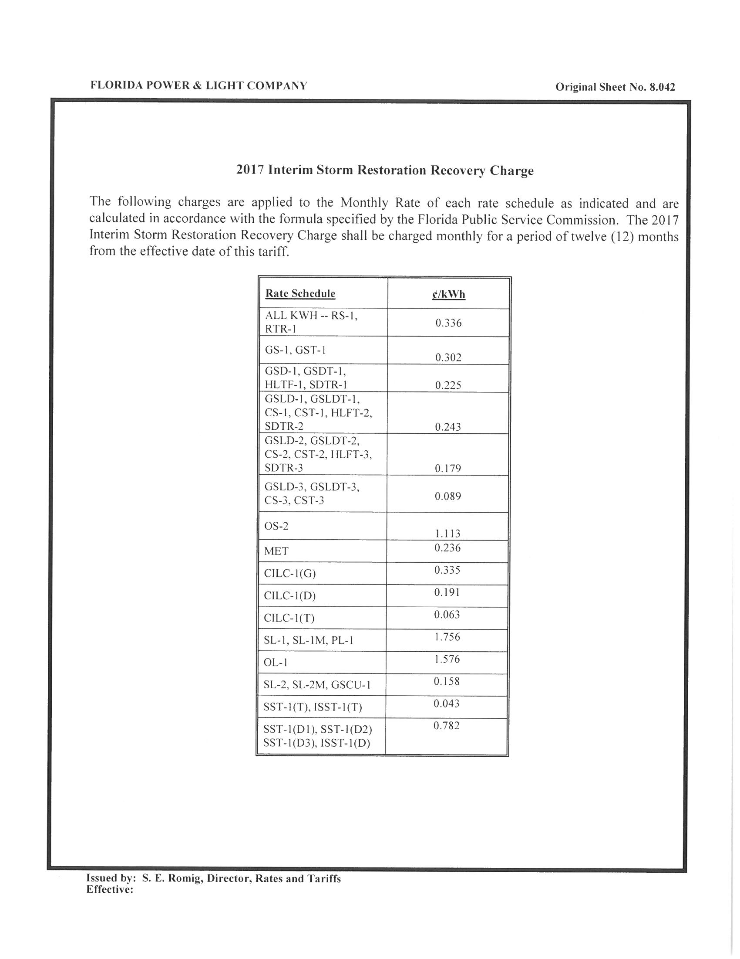
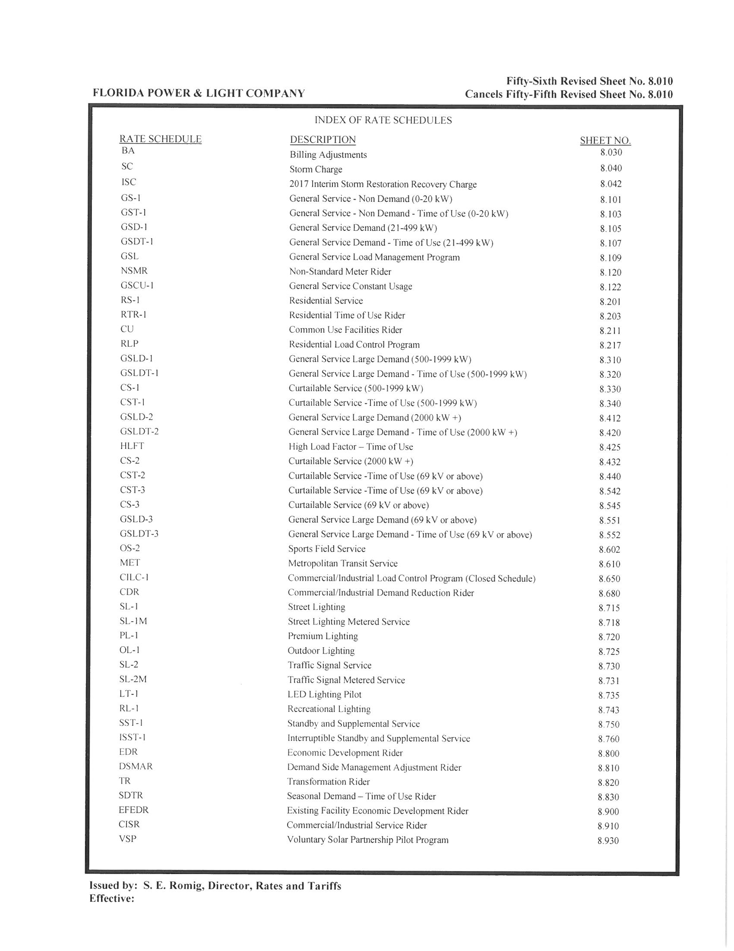

Order No. PSC-13-0023-S-EI, issued January 14, 2013, in Docket No. 120015-EI, In re: Petition for increase in rates by Florida Power & Light Company.
See Document No. 09594-16, Appendix A, Page 1 of 3 (FPL Petition).
Order No. PSC-13-0023-S-EI, issued January 14, 2013, in Docket No. 120015-EI, In re: Petition for increase in rates by Florida Power & Light Company.
Order No. PSC-05-0937-FOF-EI, issued September 21, 2005, in Docket No. 041291-EI, In re: Petition for authority to recover prudently incurred storm restoration costs related to 2004 storm season that exceed storm reserve balance, by Florida Power & Light Company.
Order No. PSC-06-0464-FOF-EI, issued May 30, 2006, in Docket No. 060038-EI, In re: Petition for issuance of a storm recovery financing order, by Florida Power & Light Company.
Order No. PSC-13-0023-S-EI, issued January 14, 2013, in Docket No. 120015-EI, In re: Petition for increase in rates by Florida Power & Light Company.
FPL represented that the percentages of assets projected to be damaged were derived from the “Storm Loss and Reserve Performance Analysis” study prepared for FPL by ABS Consulting in conjunction with Docket No. 080677-EI, In re: Petition for increase in rates by Florida Power & Light Company.

