BEFORE THE FLORIDA PUBLIC SERVICE COMMISSION

In re: Petition for limited proceeding for recovery of incremental storm restoration costs related to Hurricane Matthew by Florida Power & Light Company. | DOCKET NO. 160251-EI  ORDER NO. PSC-17-0055-PCO-EI  ISSUED: February 20, 2017

The following Commissioners participated in the disposition of this matter:

JULIE I. BROWN, Chairman
ART GRAHAM
RONALD A. BRISÉ
JIMMY PATRONIS
DONALD J. POLMANN

ORDER APPROVING 2017 INTERIM STORM
RESTORATION RECOVERY CHARGE

BY THE COMMISSION:
BACKGROUND

On December 29, 2016, Florida Power & Light Company (FPL) filed a petition for a limited proceeding seeking authority to implement an interim storm restoration recovery charge to recover a total of $318.5 million for the incremental restoration costs related to Hurricane Matthew and to replenish its storm reserve. In its petition, FPL asserts that as a result of Hurricane Matthew, FPL incurred total retail recoverable costs of approximately $293.8 million, less its pre-storm storm reserve balance of $93.1 million, resulting in net recoverable costs of $200.7 million. In addition, FPL proposes to replenish its storm reserve to the $117.1 million balance that existed on January 2, 2013. Interest and the regulatory assessment fee gross-up add an additional $0.6 million to the recoverable costs.
FPL filed its petition pursuant to the provisions of the Revised Stipulation and Settlement Agreement (RSSA) approved by this Commission in Order No. PSC-13-0023-S-EI. Pursuant to Paragraph 5 of the RSSA, FPL can recover storm costs, not exceeding $4.00/1,000 kWh on monthly residential customer bills, on an interim basis beginning sixty days following the filing of a petition for recovery. In its petition, FPL has requested an interim storm restoration recovery charge of $3.36 on a monthly 1,000 kWh residential bill, effective March 1, 2017. The interim storm restoration recovery charge would remain in effect for a 12-month period.
The Office of Public Counsel (OPC) filed its Notice of Intervention on January 13, 2017, which was acknowledged by Order No. PSC-17-0030-PCO-EI, issued January 18, 2017. On February 6, 2017, OPC filed an Objection to Petition for Limited Proceeding for Recovery of Incremental Storm Restoration Costs Related to Hurricane Matthew by Florida Power & Light Company and Request for a Section 120.57(1) Hearing. This Commission has jurisdiction over this matter pursuant to Sections 366.04, 366.05, 366.06, and 366.076, Florida Statutes.
DECISION
As stated in the background, FPL filed a petition for a limited proceeding seeking authority to implement an interim storm restoration recovery charge to recover a total of $318.5 million for the incremental restoration costs related to Hurricane Matthew and to replenish its storm reserve. The requested recovery of $318.5 million represents net retail recoverable costs of approximately $200.7 million, plus an additional $117.1 million to replenish the storm reserve to the balance that existed on January 2, 2013. In addition, the $318.5 million includes interest of $0.4 million and regulatory assessment fee expense of $0.2 million. The petition was filed pursuant to the provisions of the RSSA approved by the Commission in Order No. PSC-13-0023-S-EI. Pursuant to Paragraph 5 of the RSSA, FPL can begin to recover storm costs, not exceeding $4.00/1,000 kWh on monthly residential customer bills, on an interim basis beginning sixty days following the filing of a petition for recovery. FPL has requested an interim storm restoration recovery charge of $3.36 on a monthly 1,000 kWh residential bill, effective for a 12-month period beginning March 1, 2017.
In its petition, FPL asserts that it incurred total retail recoverable costs of approximately $293.8 million as a result of Hurricane Matthew. This amount was calculated in accordance with the Incremental Cost and Capitalization Approach (ICCA) methodology prescribed in Rule 25-6.0143, Florida Administrative Code (F.A.C.). The net retail recoverable costs of $200.7 million were determined by reducing the $293.8 million total costs by the pre-storm storm reserve balance of $93.1 million. Paragraph 5 of the RSSA also allows FPL to request the replenishment of its storm reserve to the $117.1 million balance that existed on January 2, 2013, the implementation date of the RSSA.
Paragraph 5 of the RSSA indicates that “all storm related costs subject to interim recovery shall be calculated and disposed of pursuant to Commission Rule 25-6.0143, F.A.C.” and that parties to the RSSA “are not precluded from participating in any such proceedings and opposing the amount of FPL’s claimed costs.” This language clearly indicates that the parties to the RSSA intended that the interim storm restoration recovery charge would be preliminary in nature and that the storm related costs would be reviewed for prudence and reasonableness and any over/under recovery determined and disposed of once all costs and revenues were known in a proceeding in which parties could participate. OPC has requested that we hold an evidentiary hearing for this purpose. We agree and direct the parties to work with our staff to develop an efficient hearing schedule for submittal to the Prehearing Officer assigned to this matter.
Based on a review of the information provided by FPL in its petition, we approve FPL’s implementation of its proposed 2017 Interim Storm Restoration Recovery Charge, subject to refund. Once the total actual storm costs are known, FPL shall be required to file documentation of the storm costs for Commission review and true up of any excess or shortfall.
In its petition, FPL asserts that it has maintained the amount of eligible restoration costs that exceed the pre-storm balance of the storm reserve as a debit in Account 228.1 as required by Rule 25-6.0143(1)(i), F.A.C. However, FPL has requested approval to establish a regulatory asset to be recorded in Account 182.1, Extraordinary Property Losses, and transfer the debit balance in Account 228.1 to Account 182.1, effective March 1, 2017. FPL contends that this treatment would be consistent with the storm cost recovery for the 2004 storm season approved by the Commission in Order No. PSC-05-0937-FOF-EI.
When Order No. PSC-05-0937-FOF-EI was issued in 2005, Rule 25-6.0143, F.A.C., stated the following concerning Account 228.1:
(1) Account No. 228.1 Accumulated Provision for Property Insurance.
(a) This account may be established to provide for losses through accident, fire, flood, storms, nuclear accidents and similar type hazards to the utility’s own property or property leased from others, which is not covered by insurance. This account would also include provisions for the deductible amounts contained in property loss insurance policies held by the utility as well as retrospective premium assessments stemming from nuclear accidents under various insurance programs covering nuclear generating plants. A schedule of risks covered shall be maintained, giving a description of the property involved, the character of risks covered and the accrual rates used.
(b) Charges to this account shall be made for all occurrences in accordance with the schedule of risks to be covered which are not covered by insurance. Recoveries or reimbursements for losses charged to this account shall be credited to the account.
Because the rule at that time did not specifically address the treatment of debit balances in Account 228.1, it was necessary to establish a regulatory asset to allow the deferral and subsequent amortization of the storm reserve debit balance in Account 228.1.
In 2007, however, Rule 25-6.0143, F.A.C., was expanded regarding Account 228.1. The extensive rule revisions included the establishment of the ICCA methodology for determining the types of costs eligible to be charged to the reserve. Rule 25-6.0143(1)(i), F.A.C., was also established and states that:
If the charges to Account No. 228.1 exceed the account balance, the excess shall be carried as a debit balance in Account No. 228.1 and no request for a deferral of the excess or for the establishment of a regulatory asset is necessary.
Since the rule has been specifically amended so that any debit balance in Account 228.1 is automatically deferred for accounting purposes, a request for a deferral or the establishment of a regulatory asset is no longer required or necessary. For this reason, we deny FPL’s request to establish a regulatory asset for the debit balance in Account 228.1.

FPL proposes to commence the 12-month recovery period for its interim storm restoration recovery charge on March 1, 2017 and to include the charge in the non-fuel energy charge on customer bills. In support of its proposed rate calculations, FPL has provided Appendices C and D to the petition. Appendix C illustrates the computation of the proposed interim storm restoration recovery charges for each rate class. FPL represents that it followed the methodology for allocation of storm costs among rate classes consistent with the method set forth in FPL’s storm financing order. Specifically, FPL has developed its proposed charges by rate class using the following steps:
(1) Multiplying the percent allocation of plant share by rate class as shown in the Cost of Service MFR Schedule E-3a approved in Docket No. 120015-EI by the percentage share of plant assets projected to be damaged,
(2) Multiplying the allocation factors for each rate class as determined in Step (1) above by the total amount of storm losses associated with Hurricane Matthew ($318,456,000), and
(3) Dividing the results obtained in Step (2) above for each rate class by the projected sales for each rate class during the 12-month recovery period to arrive at the charges by rate class.
Commission staff has replicated FPL’s calculations and found that the allocation methodology is reasonable. Most of the storm-related costs are weighted to reflect damage to distribution and transmission assets (71 percent and 20 percent, respectively) with a lesser proportion related to generation and other plant assets.
Application of the allocation methodology for the residential customer rate class results in a proposed interim storm restoration recovery charge of 0.336 cents per kWh, which equates to $3.36 on a 1,000 kWh residential bill. The proposed interim charges for all rate classes are presented on Original Tariff Sheet No. 8.042 included in Appendix D to FPL’s petition. Appendix D also includes Fifty-Sixth Revised Tariff Sheet No. 8.010 which reflects the appropriate addition of Sheet No. 8.042 to FPL’s Index of Rate Schedules. Both tariff sheets are included in Attachment A.
Based on the above, we hereby approve FPL’s proposed Original Tariff Sheet No. 8.042 and Fifty-Sixth Revised Tariff Sheet No. 8.010 as shown in Attachment A with an effective date of March 1, 2017.
We further find that all funds shall be collected subject to refund secured by a corporate undertaking. The criteria for a corporate undertaking include sufficient liquidity, ownership equity, profitability, and interest coverage to guarantee any potential refund. Upon review of FPL’s 2015, 2014 and 2013 financial statements, we find that FPL’s financial performance demonstrates adequate levels of liquidity, ownership equity, profitability, and interest coverage to guarantee any potential refund and adequate resources to support a corporate undertaking in the amount requested. Based on this analysis, we find that a corporate undertaking of $318.5 million is acceptable. We note that this brief financial analysis is only appropriate for deciding if FPL can support a corporate undertaking in the amount proposed and shall not be considered a finding regarding our position on other issues in this proceeding.
Based on the foregoing, it is
ORDERED by the Florida Public Service Commission that Florida Power & Light Company shall be allowed to implement its 2017 Interim Storm Restoration Recovery Charge, subject to refund. It is further
ORDERED that Florida Power & Light Company’s Original Tariff Sheet No. 8.042 and Fifty-Sixth Revised Tariff Sheet No. 8.010, as shown on Attachment A, is hereby approved with an effective date of March 1, 2017. It is further
ORDERED that Florida Power & Light Company shall institute a corporate undertaking in the amount of $318.5 to guarantee the funds collected subject to refund. It is further
ORDERED that the parties shall work with Commission staff to set this matter for hearing. It is further
ORDERED that this docket shall remain open pending final reconciliation of actual recoverable Hurricane Matthew storm costs with the amount collected pursuant to the 2017 Interim Storm Restoration Recovery Charge, and the calculation of a refund or additional charge, if warranted.
By ORDER of the Florida Public Service Commission this 20th day of February, 2017.

/s/ Carlotta S. Stauffer
CARLOTTA S. STAUFFER
Commission Clerk
Florida Public Service Commission
2540 Shumard Oak Boulevard
Tallahassee, Florida 32399
(850) 413-6770
www.floridapsc.com

Copies furnished: A copy of this document is provided to the parties of record at the time of issuance and, if applicable, interested persons.

SBr

NOTICE OF FURTHER PROCEEDINGS OR JUDICIAL REVIEW

The Florida Public Service Commission is required by Section 120.569(1), Florida Statutes, to notify parties of any administrative hearing or judicial review of Commission orders that is available under Sections 120.57 or 120.68, Florida Statutes, as well as the procedures and time limits that apply. This notice should not be construed to mean all requests for an administrative hearing or judicial review will be granted or result in the relief sought.

Mediation may be available on a case-by-case basis. If mediation is conducted, it does not affect a substantially interested person's right to a hearing.

Any party adversely affected by this order, which is preliminary, procedural or intermediate in nature, may request: (1) reconsideration within 10 days pursuant to Rule 25-22.0376, Florida Administrative Code; or (2) judicial review by the Florida Supreme Court, in the case of an electric, gas or telephone utility, or the First District Court of Appeal, in the case of a water or wastewater utility. A motion for reconsideration shall be filed with the Office of Commission Clerk, in the form prescribed by Rule 25-22.0376, Florida Administrative Code. Judicial review of a preliminary, procedural or intermediate ruling or order is available if review of the final action will not provide an adequate remedy. Such review may be requested from the appropriate court, as described above, pursuant to Rule 9.100, Florida Rules of Appellate Procedure.

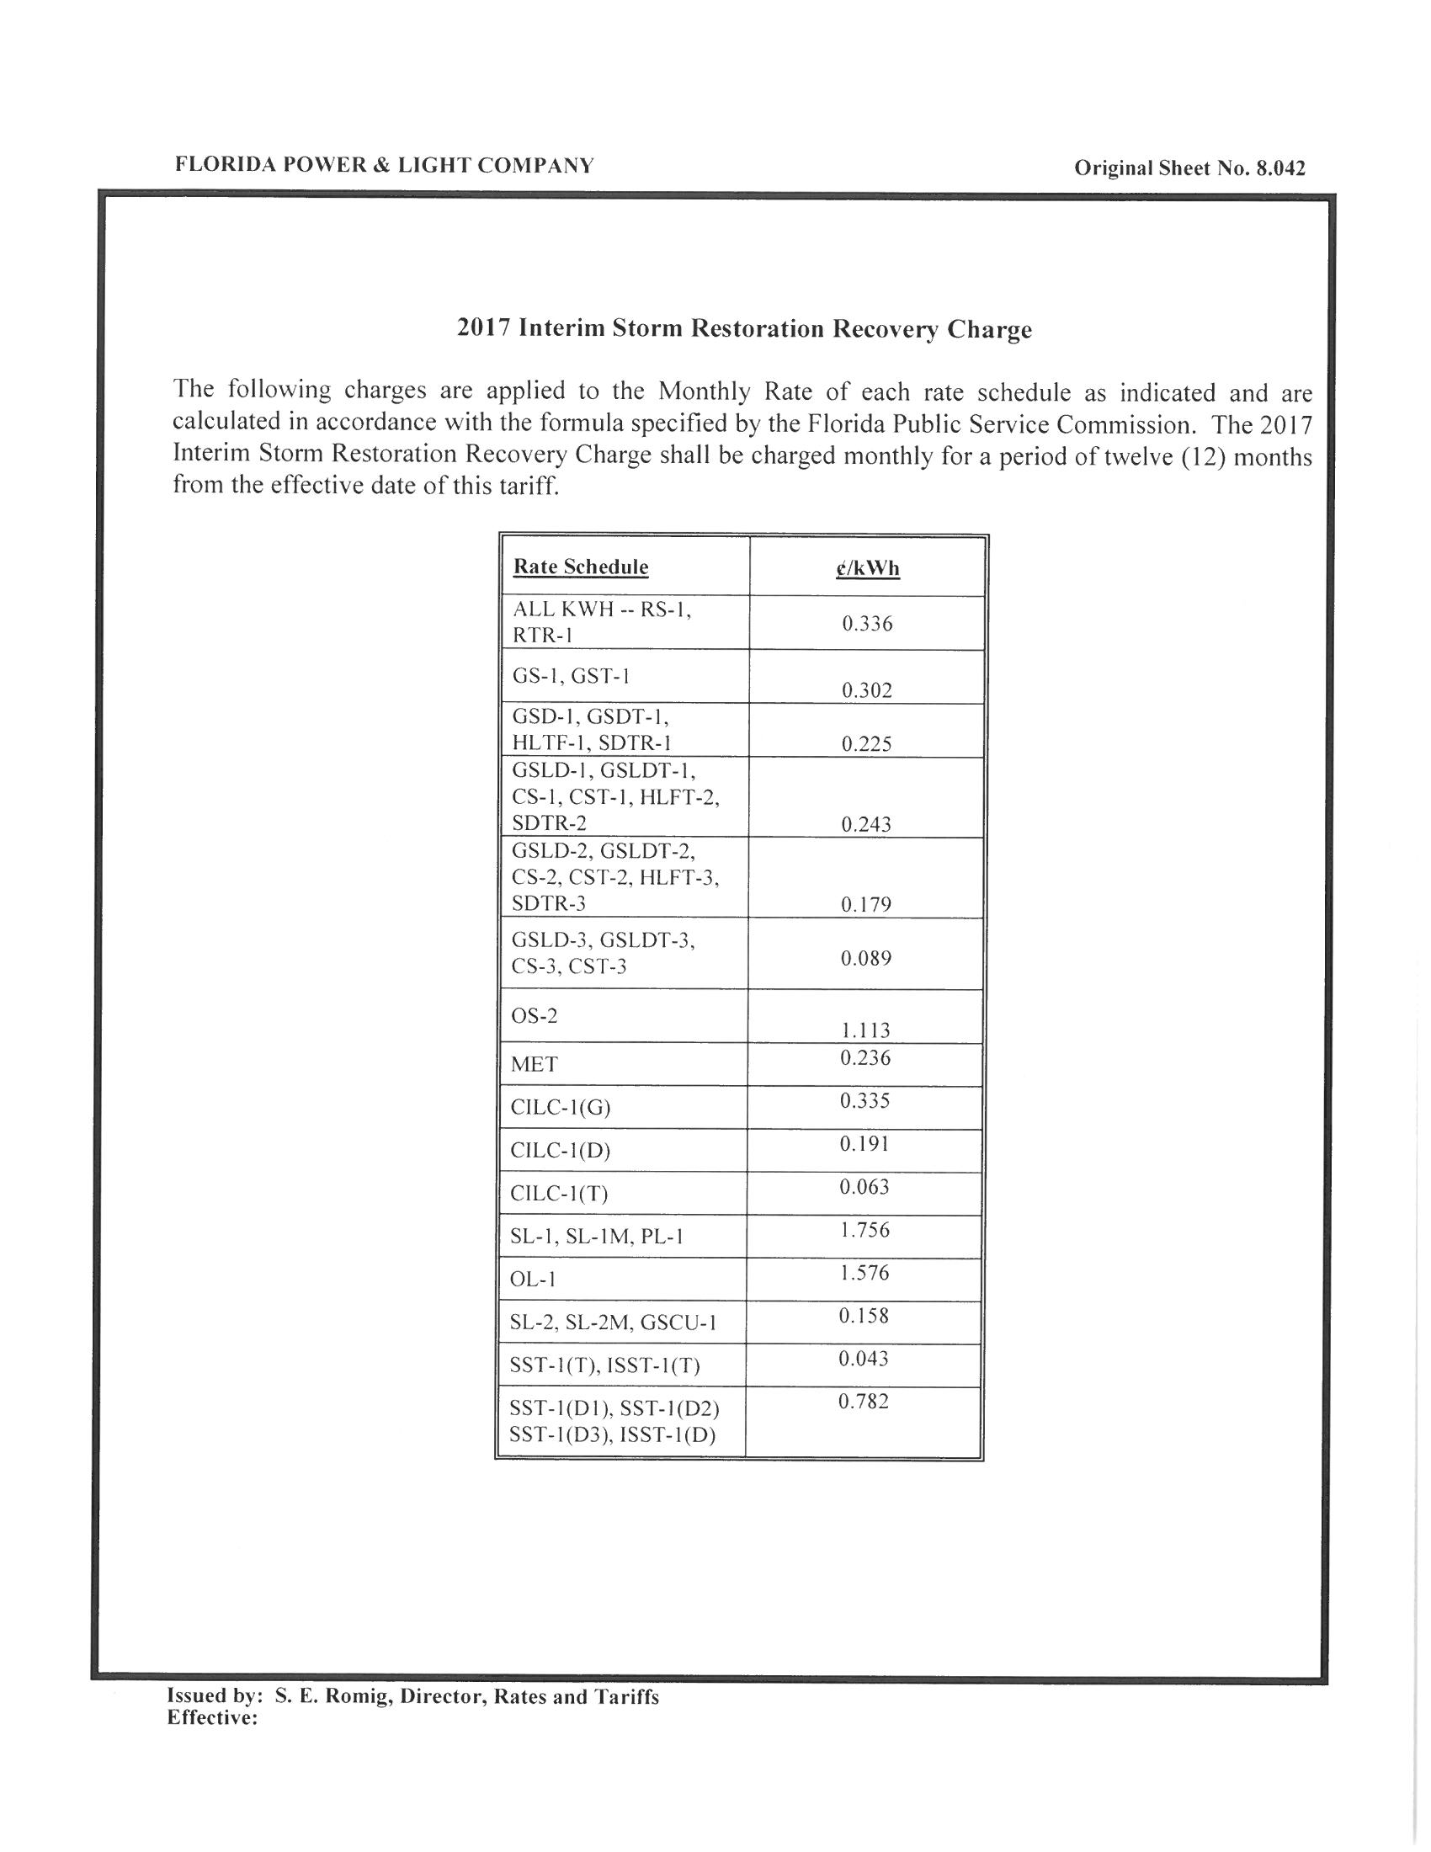

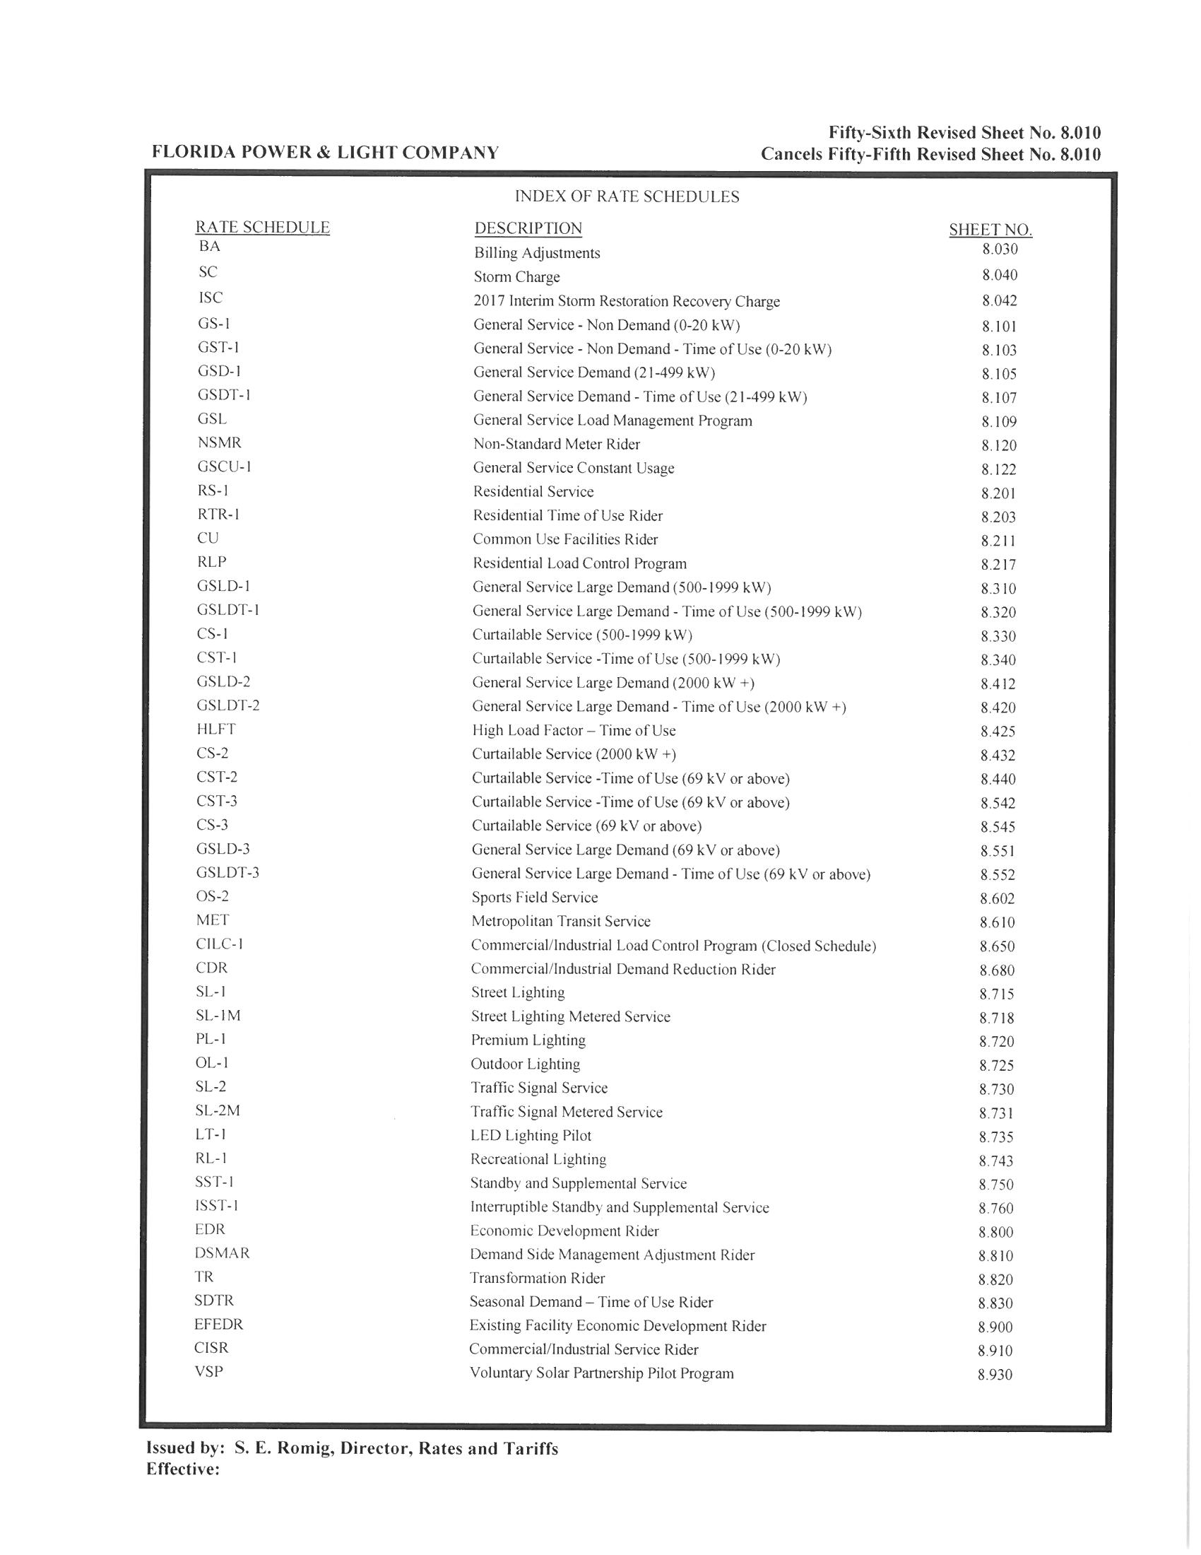

Order No. PSC-13-0023-S-EI, issued January 14, 2013, in Docket No. 120015-EI, In re: Petition for increase in rates by Florida Power & Light Company.
See Document No. 09594-16, Appendix A, Page 1 of 3 (FPL Petition).
Order No. PSC-13-0023-S-EI, issued January 14, 2013, in Docket No. 120015-EI, In re: Petition for increase in rates by Florida Power & Light Company.
Order No. PSC-05-0937-FOF-EI, issued September 21, 2005, in Docket No. 041291-EI, In re: Petition for authority to recover prudently incurred storm restoration costs related to 2004 storm season that exceed storm reserve balance, by Florida Power & Light Company.
Order No. PSC-06-0464-FOF-EI, issued May 30, 2006, in Docket No. 060038-EI, In re: Petition for issuance of a storm recovery financing order, by Florida Power & Light Company.
Order No. PSC-13-0023-S-EI, issued January 14, 2013, in Docket No. 120015-EI, In re: Petition for increase in rates by Florida Power & Light Company.
FPL represented that the percentages of assets projected to be damaged were derived from the “Storm Loss and Reserve Performance Analysis” study prepared for FPL by ABS Consulting in conjunction with Docket No. 080677-EI, In re: Petition for increase in rates by Florida Power & Light Company.

