State of Florida |  | Public Service Commission  Capital Circle Office Center ● 2540 Shumard Oak Boulevard  Tallahassee, Florida 32399-0850  -M-E-M-O-R-A-N-D-U-M-
DATE: | February 23, 2017
TO: | Office of Commission Clerk (Stauffer)
FROM: | Office of the General Counsel (Harper)  Division of Accounting and Finance (Golden)  Division of Economics (Rome)
RE: | Docket No. 160246-WS – Proposed adoption of Rule 25-30.444, F.A.C., Utility Reserve Fund, and 25-30.4445, F.A.C., Notice of Application for Utility Reserve Fund.
AGENDA: | 03/07/17 – Regular Agenda – Interested Persons May Participate.
COMMISSIONERS ASSIGNED: |  |  | All Commissioners
PREHEARING OFFICER: |  |  | Polmann
RULE STATUS: |  |  | Proposal May Not Be Deferred. Rules must be proposed by April 1, 2017.
SPECIAL INSTRUCTIONS: |  |  | None

Case Background
During the 2016 Legislative Session, the Florida Legislature enacted House Bill 491, which was incorporated into Chapter 2016-226, Laws of Florida. The legislation modified Section 367.081(2)(c), F.S., to require the Commission to adopt rules to implement a utility reserve fund for water and wastewater utilities. To implement the new law, staff is recommending adoption of Rule 25-30.444, F.A.C., Utility Reserve Fund, and Rule 25-30.4445, F.A.C., Notice of Application for Utility Reserve Fund. Pursuant to Section 120.74(5), F.S., the Commission must propose rules by April 1, 2017.
The Commission’s Notice of Development of Rulemaking was published in the Florida Administrative Register (F.A.R.), on September 26, 2016, in Volume 42, Number 187. A Rule Development Workshop was held on December 16, 2016. Representatives from the Office of Public Counsel (OPC), the Florida Rural Water Association (FRWA), Milian, Swain & Associates, P.A., Coenson & Friedman, P.A., Florida Utility Services 1, LLC, (FUS1), U.S. Water Services Corporation (USW), and Utilities Inc. of Florida (UIF) participated in the workshop.
This recommendation addresses whether the Commission should propose Rules 25-30.444 and 25-30.4445, F.A.C. The Commission has jurisdiction pursuant to Sections 120.54, 350.127(2)(c), 367.081, and 367.121, F.S.

Discussion of Issues

Issue 1:
Should the Commission propose Rules 25-30.444 and 25-30.4445, F.A.C.?

Recommendation:
Yes. The Commission should propose the adoption of Rules 25-30.444 and 25-30.4445, F.A.C., as set forth in Attachment A. (Harper, Golden, Rome)

Staff Analysis:
The purpose of this rulemaking is to create Rules 25-30.444 and 25-30.4445, F.A.C., to implement a utility reserve fund for water and wastewater utilities, consistent with the Florida Legislature’s 2016 legislation. Staff is recommending that the Commission propose the rules, as set forth in Attachment A. Below is a more detailed explanation of the rules staff is recommending.

Background
Prior to the 2016 legislation, in most cases, water and wastewater utilities could recover costs incurred for repairing or replacing infrastructure only after the work was completed and the Commission granted a utility’s petition for recovery of the repair costs in a rate case or limited proceeding. Water and wastewater utilities’ lack of cash reserves, and limited availability of owner, bank, or investor financing affects the ability of the utility to cover repair costs for critical infrastructure. To address concerns over deferred maintenance of critical infrastructure and delay in necessary repairs, the Legislature amended Section 367.081, F.S., to allow utilities to request that the Commission approve a utility reserve fund. The Legislature determined the establishment of a utility reserve fund may reduce borrowing costs and make funding for repairs more readily available. The availability of the reserve funds may allow the utility to avoid or defer the need for a future rate case, the expenses of which are ultimately borne by ratepayers.

In developing the rules, staff considered suggestions and concerns that were presented in the Report of the Study Committee on Investor-Owned Water & Wastewater Utility Systems on which House Bill 491 was based. For example, staff incorporated several of OPC’s suggestions such as: offsetting utility plant in service (UPIS) with contributions-in-aid-of-construction (CIAC) to recognize the ratepayers funding of the UPIS through a utility reserve fund; requiring periodic review of a utility’s capital improvement plan; placing a possible limit on the percentage increase that may result from implementation of a utility reserve fund surcharge; recognizing possible reductions in operating costs resulting from infrastructure improvements; and annual reporting requirements regarding funds collected, funds spent, and project activity.

Staff also considered concerns that have been raised in recent years by utility representatives regarding the industry’s need for options to obtain additional funding and longer planning periods for necessary infrastructure repair and replacement projects. Some of the stakeholders involved in this rulemaking have opposite views on certain aspects of the rules. Staff has worked to reach a balance between the opposing views while developing rules that will be beneficial to both the ratepayers and utilities.

Rule 25-30.444, F.A.C., Utility Reserve Fund
Rule 25-30.444, F.A.C., implements Section 367.081(2)(c), F.S., which allows the Commission to authorize a utility reserve fund for water and wastewater utilities. Section 367.081(2)(c), F.S., requires the Commission’s rule to include: (a) provisions related to the expenses for which the fund may be used; (b) segregation of the reserve fund accounts; (c) requirements for the utility to maintain a capital improvement plan; and (d) requirements for Commission authorization prior to disbursement from the fund.

Eligible Projects
Subsection 25-30.444(1), F.A.C., provides considerations that shall be applied in determining whether a future infrastructure repair or replacement project is eligible for advance funding through a utility reserve fund and whether a utility reserve fund is the most appropriate methodology to address the required project. Subsection (1) allows consideration of projects to repair or replace existing utility facilities related to the water system, water transmission and distribution system, wastewater treatment system, and wastewater collection system. The rule excludes projects and expenditures related to general plant that are not directly associated with the physical operation of the plant and for which other financing options are generally available, such as office equipment, tools, and vehicles. Projects related to expanding facilities to address future growth are also excluded.

OPC and the utility representatives express different opinions on the scope of the rule and interpret Section 367.081(2)(c), F.S., differently as to what projects and expenses may be considered for the utility reserve fund. OPC argues that the Commission lacks statutory authority to create a utility reserve fund for additional plant that is not considered distribution and collection infrastructure. The utilities and FRWA disagree. In the rule development workshop representatives of FRWA, FUS1, USW, and UIF argued for a more broad interpretation of the statute. USW suggested that a broad interpretation would assist the utilities with making repairs such as a well replacement or complying with new treatment standards required by the Department of Environmental Protection (DEP). Further, FRWA and FUS1 argued that subsection (1) of the rule, which provides a list of eligible projects, should be more expansive and include emergency projects.

Staff’s interpretation of Section 367.081(2)(c), F.S., is not as narrow as OPC’s interpretation, but it is not as broad as the utilities’ interpretation. Section 367.081(2)(c), F.S., provides:

In establishing rates for a utility, upon its own motion or upon the request of a utility, the Commission may authorize a utility to create a utility reserve fund for infrastructure repair and replacement for a utility for existing distribution and collection infrastructure that is nearing the end of its useful life or is detrimental to water quality or reliability of service….

(Emphasis added). Under a narrow interpretation of the statute, the only categories of water plant as defined by the National Association of Regulatory Utility Commissioners’ Uniform System of Accounts (NARUC USOA) that could be considered for inclusion in a utility reserve fund would be those listed as transmission and distribution (T&D) plant, which are: the portion of structures and improvements associated solely with T&D plant; pumping equipment related solely to T&D plant; distribution reservoirs and standpipes; T&D mains; services; meters and meter installations; hydrants; backflow prevention devices; and other plant and miscellaneous equipment related solely to T&D plant. Similarly, this narrow interpretation of the statute would only allow consideration of wastewater repair and replacement projects that are related to collection plant such as collection sewers, collecting structures, and flow measuring devices and installations.

OPC’s narrow interpretation would prohibit the Commission from considering projects related to water plant repair or replacement projects related to source of supply and pumping or treatment plant, including: repairs for structures and improvements, pumping equipment, and other plant and miscellaneous equipment related solely to source of supply and pumping equipment and power generation equipment. The Commission would also be prohibited from considering wastewater repair and replacement projects including treatment and disposal plant, reclaimed water treatment plant, power generation equipment, and pumping equipment.

As noted above, the stakeholders discussed examples of necessary repairs that could be considered under a broader interpretation and that would be beneficial in ensuring that customers receive quality service. However, no examples were provided that would suggest that the customers would be harmed by a broader interpretation. Quality and reliability of service is dependent on the proper functioning of all plant components involved in providing the water and wastewater service. Therefore, staff believes that only addressing repair issues related to the transmission and distribution or collection infrastructure needs for the utility facilities is not in the best interests of the customers in the long term. Rather, a broader interpretation of the statute is necessary to encourage utility planning and necessary infrastructure repair, particularly for utilities that lack adequate financial resources to make needed repairs and have a greater risk of experiencing critical component failure. Staff believes a broader interpretation of Section 367.081(2)(c), F.S., is necessary to encourage long-term capital improvement plans and proactive planning, which is consistent with the intent of the Legislature when the statute is read as a whole.

Accordingly, staff is recommending in subsection (1) of the rule to allow the utilities to collect reserve funds for necessary infrastructure repair or replacement projects associated with the physical operation of the utility’s water or wastewater systems that are necessary to maintain or improve the quality or reliability of service for customers. Further, subsection (2), which will be discussed below, requires the utility to provide a detailed description of the reason(s) that each repair or replacement project is necessary to maintain or improve the quality or reliability of the water or wastewater service. Staff believes this requirement serves to protect the customers by ensuring that each project is necessary to maintain or improve the quality and reliability of the service, regardless of whether the project relates to a treatment plant or lines.

Also, OPC suggested that the rule be revised to clarify that there is a 30 percent cap annually for all advance funding repairs/projects collectively, not a 30 percent cap for each repair/project. In response to OPC’s comments, staff recommends rule langauage in subsection (1) to clarify that the 30 percent is based on the total increase resulting from implementation of the utility reserve fund surcharge. This target would apply regardless of how many projects are included in the surcharge. However, the rule does not propose the 30 percent increase as an absolute cap but rather it is a consideration for the Commission to evaluate the surcharge.

OPC also suggested that an additional element should be listed under subsection (1) of the rule’s eligible projects and expenses. OPC suggested that project eligibility should be based on whether the project benefits the ratepayers. OPC also commented that the rule should specify any pre-qualification conditions that must be met in order to request a utility reserve fund surcharge. Staff believes the project eligibility requirements in subsection (1) of the rule adequately specify the eligible projects for the reserve fund. Staff believes that subsection (1), coupled with the the rules’ detailed noticing, filing, and reporting requrements, which are contained in the latter provisions of the rule that are discussed further below, provide necessary Commission oversight to ensure the funds are being used for necessary repairs to benefit the customers.

Filing Requirements
Subsection 25-30.444(2), F.A.C., provides the information that utilities must submit in an application for a reserve fund. For example, the subsection requires that a utility must provide a capital improvement plan that includes general information about the condition of the utility’s facilities and a description of all infrastructure repair and replacement projects that the utility anticipates will be necessary within the next five years, at a minimum. Also, the subsection requires detailed information about the projects that the utility is requesting be included in a utility reserve fund such as: a description of reasons why each project is necessary to either maintain or improve the quality or reliability of the water or wastewater service; whether the projects are required by a regulatory agency, such as DEP; cost estimates; a projected timeline; and a description of any other funding sources that may be available to pay for a portion of the projects. The rule would also allow any utility that has received an Asset Management Plan prepared by FRWA to submit that plan in lieu of preparing a separate capital improvement plan. In addition, the subsection requires a description of the procedures that the utility will implement to segregate the monies collected from the utility reserve fund surcharge on the utility’s books and records.

At the rule development workshop, OPC argued that the capital improvement plan filing requirements in subsection (2) are not detailed enough. However, the utilities argued that the requirement of the rule as drafted is too burdensome and the additional information requested by OPC is not necessary to evaluate the requested projects. The utilities argued reserve funds may be needed to pay for emergency work that was not part of the capital improvement plan submitted to the Commission. The statute specifically states that the rule must include a requirement for a capital improvement plan. Section 367.081(2)(c), F.S., provides:

The commission shall adopt rules to govern the implementation, management, and use of the fund, including, but not limited to, rules related to expenses for which the fund may be used, segregation of reserve account funds, requirements for a capital improvement plan….

(Emphasis added). To address OPC’s and the utilities’ concerns, staff recommends that the rule require additional general information about the condition of the utility’s facilities, and all repairs or replacements that the utility anticipates making in the next five years, at a minimum. Staff believes this additional general information will provide a good overview of a utility’s condition without requiring additional detail for projects that are not being requested for consideration in the utility reserve fund at that time.

To address the utility companies’ concerns about the situations where an emergency may require the use of the funds in the reserve account, staff is recommending language in subsection (5) of the rule to allow for reserve fund disbursements for certain emergency repairs under specific circumstances so that the utilities’ access to the funds may be considered in limited emergency situations. Staff believes that the recommended rule language provides a reasonable balance of requiring utilities to provide information which encourages the utility’s repair planning while also addressing the need for emergency repairs.

Reporting Requirements
Subsection 25-30.444(3), F.A.C., provides reporting requirements for the utilities in order for the Commission to review the monies collected for the utility reserve fund. The subsection provides several reporting requirements that will continue as long as the utility reserve fund is in effect. The reports include: monthly reports of the money deposited into and disbursed from the utility reserve fund; project status reports every six months; an annual update in the utility’s annual report; and an update of the utility’s capital improvement plan every three years.

The utility representatives expressed concerns at the rule development workshop that providing quarterly project reports would be too burdensome. Because the utility reserve fund would allow utilities to charge customers for planned repair and replacement projects in advance of the construction or improvements, staff believes reporting requirements are necessary to ensure utilities are acting prudently in the planning process. However, in response to the comments by the utilities, staff is recommending that the rule require semi-annual reporting rather than quarterly project status reporting.

Disbursement of Funds
Subsection 25-30.444(4), F.A.C., lists the information that a utility must provide to the Commission in order to receive Commission authorization for disbursement of the reserve fund monies, whether it be from an escrow account or an authorization to use reserve fund monies secured by an irrevocable letter of credit.

The utility representatives argued that the rule was too restrictive because it did not allow for emergency disbursement of funds. OPC argued its interpretation of the statute would not allow for emergency disbursement of funds under any circumstances and that all disbursements should be allowed only in accordance with the capital improvement plan. While staff disagrees with the utilities’ position that the rule should enable a utility to create an emergency fund that is not based on a capital improvement plan, staff believes OPC’s interpretation of the statute to exclude the emergency disbursement of funds under any circumstances is too restrictive.

To balance the opposing views, staff is recommending rule language in subsection 25-30.444(4), F.A.C., that allows for reserve fund disbursements for certain emergency repairs under specific circumstances that result from events that were outside the utilities’ control such as weather- related damage, accidents, or defective parts. The rule language also requires the utilities to reimburse the fund for the emergency repairs or describe how the utility reserve fund projects or timeline may be modified to address the funding needs of the previously approved projects. If these options are not possible, the utility may then request a modification of the surcharge. For these reasons, staff believes the rules balance the interests of customers while encouraging utilities to utilize the fund for planning for necessary repairs.

In addition, OPC suggested that the rule be revised to clarify that staff must verify the surcharge funds are being spent by the utility in accordance with the stated purpose. Staff believes additional language is unnecessary and may be confusing because the rule filing and reporting requirements ensure that utilities are acting in accordance with the stated purpose of the utility capital improvement plan and fund collection.

Utility Reserve Fund Modifications
Subsection 25-30.444(5), F.A.C., allows for modification of the reserve fund when a utility must undertake a project that was not anticipated or when the utility must make significant modifications to a previously approved project. To apply for a modification, the utility must provide the necessary information to the Commission including a statement describing why the new project or modification of a previously approved project is necessary and whether the utility is requesting a change in the utility reserve fund surcharge or only acknowledgement of the project modifications. Also, if the new project or project modification is required by a governmental or regulatory agency, the utility must provide the Commission with a copy of the rule, regulation, order, or other regulatory directive that requires the new project or project modification.

Final Disposition of Reserve Fund
Subsection 25-30.444(6), F.A.C., provides the conditions under which the Commission will determine the final disposition of a utility reserve fund. Subsection 25-30.444(6), F.A.C., provides the utility reserve fund surcharge will be discontinued after all approved eligible projects have been completed, sufficient funds have been collected in the utility reserve fund to cover the cost of the approved eligible project, and the final disbursement has been made from the utility reserve fund. The rule provides that during the utility’s next rate proceeding, the utility’s rate base, capital structure, operating expenses, and rates will be adjusted as needed to reflect the completed projects, and, if applicable, any monies that remain in the utility reserve fund following the last disbursement for the completed eligible project will be refunded to the customers with interest.

The rule also provides a process if there are any changes in utility ownership or if the utility is abandoned, and states that if the utility fails to follow through with the eligible project or comply with the rule requirements, the utility reserve fund may be discontinued and all monies refunded to the customers with interest.

FUS1 suggested that information about the utility reserve funds should be included in the receivership order in the case of abandonment. Staff modified the rule to clarify that the court-appointed receiver shall be responsible for managing the utility reserve fund in accordance with the rule and all applicable Commission orders.

FRWA suggested that when a utility with a reserve fund transfers ownership to a governmental entity, the reserve funds should be automatically refunded to customers prior to the transfer. FRWA’s concern is that customers could be harmed because there is no guarantee that the monies would be used for the intended purpose following the transfer. Staff believes such a requirement is outside the Commission’s jurisdiction. Section 367.071(4)(a), F.S., provides that the sale of facilities to a governmental authority shall be approved as a matter of right, specifies the criteria for a government transfer, and only requires customer refunds in the event that the utility has a rate case pending before the Commission at the time of the transfer and is charging interim rates. Once the criteria of the statute is met by the governmental entity, the Commission acknowledges the transfer as a matter of right. Since the Commission can neither approve nor deny a transfer to a governmental authority, the transfer acknowledgement is typically processed administratively by Commission staff. However, Section 367.071(4)(a), F.S., and Rule 25-30.038, F.A.C., require that the governmental authority obtain certain information from the utility or Commission prior to taking any official action, including: the utility’s most recent income and expense statement, balance sheet, rate base, CIAC, or annual report, which will include information about the utility reserve fund. This will ensure that information about the utility reserve fund is fully disclosed at the time of transfer.

Additional Procedural Comments
In addition to the rule provisions above, there were additional comments from stakeholders related to the rule’s procedure that staff is not recommending. The procedural-related comments are discussed below.

At the workshop, USW questioned whether the utilities would be required to use a fixed surcharge or have the ability to propose a variable surcharge that would be designed to better match the funding needs of the projects. For example, if a project requires more funding in the early stages to purchase materials or pay for engineering work, the utility may want to propose a surcharge that would be higher in the beginning and then be reduced later in the project when the funding needs decrease. OPC subsequently suggested that the rule include language to clarify whether the charge to the customer for the utility reserve fund would be the same each month or if it could be varied and how that would be calculated. Paragraph (2)(h) of the recommended Rule 25-30.444, F.A.C., will require that the utility provide a schedule showing the calculation of the proposed utility reserve fund surcharge. The rule language is consistent with other water and wastewater rules, which do not discuss the mechanics of how rates are calculated or require specific rate calculation methodologies. Accordingly, staff believes it would be more appropriate to determine each utility reserve fund surcharge on a case-by-case basis depending on a utility’s specific projects and customer base. Staff believes the rule language affords the utilities, stakeholders, and customers the opportuntiy to explore various ratesetting options that will work best in each case.

OPC also suggested that if the utility reserve fund charge is imposed on customers, the Commission may consider during the utility’s next general base rate proceeding whether the infrastructure improvements have resulted in any risk being shifted away from investor to customers, thus supporting a corresponding reduction in the utility’s authorized return. Paragraph 25-30.444(6)(a) of the recommended rule states in part: “During the utility’s next rate proceeding, the utility’s rate base, capital structure, operating expenses, and rates shall be adjusted as needed to reflect the completed project.” Paragraph (6)(a) also states, “The amount of the new plant assets that are funded through a utility reserve fund shall be offset with an equal addition to contributions-in-aid-of-construction.” Staff believes this language is sufficient to allow future consideration of appropriate ratemaking adjustments to reflect the completed projects. Also, the offsetting addition to CIAC ensures that the customers receive the full benefit of their financial contribution to make those plant repairs or replacements and that the utility will not earn a return on plant that was contributed by the customers.

Further, staff disagrees with OPC’s assertion that the use of a utility reserve fund will reduce the utility’s risk. Staff believes that the utility’s risk will remain unchanged. The utility’s financial risk will not change because there will be no change in the utility’s debt or equity associated with the portion of the plant that is funded through the utility reserve fund. The utility’s debt and equity associated with the remainder of its plant will not be affected by the utility reserve fund.

Also, the utility’s business risk will not change because the utility reserve fund is unlikely to result in a change in the factors that are most commonly used to measure business risk. Specifically, the utility reserve fund is not expected to change the demand variability, sales price variability, input price variability, ability to adjust output prices for changes in input prices, or the extent to which costs are fixed or the operating leverage. Further, an argument could be made that use of a utility reserve fund will actually serve to prevent an increase in a utility’s risk by enabling the utility to avoid increasing its debt to fund the projects that will instead be funded through the utility reserve fund.

In addition, OPC suggested that the rule include language to indicate that customers have a point of entry to participate in the Commission’s proceeding on the utility reserve fund application and to participate in the review process. The rule provides that the utility reserve fund applications may be submitted to the Commission either in a rate-case proceeding or as a stand-alone application. If the application is submitted as part of a rate-case proceeding, substantially affected persons will have an opportunity to participate as with any rate-case proceeding. If the application is submitted as stand-alone application, the application will likely be considered in a Proposed Agency Action (PAA) process. The PAA process affords a point of entry for interested persons to comment at agenda or substantially affected persons to request a hearing. For these reasons, staff believes the utility reserve fund rule need not specify a point of entry in the rule language.

UIF suggested the rule provide a deadline or time frame in which the Commission must process any applications for the utility reserve fund. Staff believes this is unnecessary because the statute does not impose a deadline on the Commission. Moreover, as with all Commission proceedings that the Legislature has not deemed necessary to impose a statutory deadline, staff will process the matter as quickly as possible.

Rule 25-30.4445, F.A.C., Notice of Application of Utility Reserve Fund
Rule 25-30.4445, F.A.C., provides the noticing requirements for the application of a utility reserve fund. Staff modeled the notice requirements in the rule after the noticing requirements in Rule 25-30.446, F.A.C., for applications for limited proceeding rate increases.
Utility representatives indicated that the rule noticing requirements were burdensome. The utilities suggested that the requirement to publish a notice in a newspaper is no longer an effective means of noticing customers because newspaper subscribership has decreased in recent years, the nearest newspaper is often located in a different city outside a small utility’s service area, and a newspaper notice is not required for staff-assisted rate cases. In addition, the utilities stated concerns about the difficulties and costs involved with placing copies of the application at a local library when the utility does not have an office in the service area.
Staff believes noticing is necessary because approval of a utility reserve fund surcharge may result in a rate increase on the customers’ bills, and customers should be afforded the opportunity to read the utility’s application and provide comments. Also, staff is aware of recent cases where customers requested to review a utility application at a public library. OPC also noted that some customers do not use computers. However, in response to comments on the burdens that may be caused by this provision of the rule, staff did not include a requirement to publish the utility reserve fund notice of application in a newspaper of general circulation, which is required for limited proceedings and file and suspend rate proceedings. Staff also added language to allow additional options for utilities to provide public access to reserve fund applications and their associated MFRs. Additionally, the rule allows a utility that qualifies for staff assistance under Rule 25-30.455, F.A.C., to request assistance with the utility reserve fund process. In those instances, a customer meeting may be held, and the initial customer notice may be deferred.
OPC suggested that the rule be revised to clarify that customer meetings are required before the reserve fund charges can be collected. The statute does not require customer meetings. Staff believes that automatically requiring customer meetings with every reserve fund application may be an unnecessary expense, because there may be some instances where the customers do not object or do not have concerns about the imposition of the reserve fund charge. However, because it is important for customers to have the opportunity to voice concerns about a charge, the rule affords the Commission the discretion to hold a customer meeting consistent with other ratemaking procedures.

Statement of Estimated Regulatory Costs
Pursuant to Section 120.54, F.S., agencies are encouraged to prepare a statement of estimated regulatory costs (SERC) before the adoption, amendment, or repeal of any rule. The SERC is appended as Attachment B to this recommendation. The SERC analysis also includes whether the rule is likely to have an adverse impact on growth, private sector job creation or employment, or private sector investment in excess of $1 million in the aggregate within five years after implementation.
The SERC concludes that any economic impacts that might be incurred by affected entities would be a result of statutory changes to Sections 367.081 and 367.0814, F.S., made by the 2016 legislation and are not due to a Commission-initiated rulemaking effort. Staff believes that the new rules will not likely directly or indirectly increase regulatory costs in excess of $200,000 in the aggregate in Florida within one year after implementation.
Further, the SERC concludes that the rules will not likely have an adverse impact on economic growth, private-sector job creation or employment, private sector investment, business competitiveness, productivity, or innovation in excess of $1 million in the aggregate within five years of implementation. Thus, the new rules do not require legislative ratification pursuant to Section 120.541(3), F.S.
In addition, the SERC states that the new rules will not have an adverse impact on small business and will have no impact on small cities or small counties. No regulatory alternatives were submitted pursuant to Section 120.541(1)(a), F.S. None of the impact/cost criteria established in Section 120.541(2)(a), F.S., will be exceeded as a result of the recommended revisions

Conclusion

Based on the foregoing, staff recommends the Commission propose the adoption of Rules 25-30.444 and 25-30.4445, F.A.C., as set forth in Attachment A.
Issue 2:
Should this docket be closed?

Recommendation:
Yes. If no requests for hearing or comments are filed, the rules may be filed with the Department of State, and this docket should be closed. (Harper)

Staff Analysis:
If no requests for hearing or comments are filed, the rules may be filed with the Department of State, and this docket should be closed.

25-30.444 Utility Reserve Fund
(1) PROJECT ELIGIBILITY. The following considerations shall be applied in determining whether a future infrastructure repair or replacement project is eligible for advance funding through a utility reserve fund and whether a utility reserve fund is the most appropriate methodology to address the requested project.
(a) The following projects shall be eligible for a utility reserve fund:
1. Projects to repair or replace existing utility infrastructure that is nearing the end of its useful life or is detrimental to water quality or reliability of service that is recorded in the National Association of Regulatory Utility Commissioners’ Uniform System of Accounts (NARUC USOA) water utility plant account numbers 304, 305, 306, 307, 308, 309, 310, 311, 320, 330, 331, 333, 334, 335, 336, and 339, and wastewater utility plant account numbers 354, 355, 360, 361, 362, 363, 364, 365, 366, 367, 370, 371, 374, 375, 380, 381, 382, and 389;
2. Future expenditures related to land or land rights recorded in NARUC USOA water utility plant account number 303 or wastewater utility plant account number 353 if the expenditure is necessary to the successful completion of an eligible repair or replacement project;
3. Upgrades or enhancements of existing facilities if it can be demonstrated that the upgrade or enhancement is necessary to comply with federal, state, or local regulatory requirements, or provides a more cost-effective or more reliable alternative than an identical replacement, and that the upgrade or enhancement is not designed solely to address future customer growth;
4. Repair projects that may be expensed rather than capitalized, as prescribed by Rule 25-30.140(1)(g)(3), F.A.C., if it can be demonstrated that the repair expense is not already reflected in the utility’s current rates as an annual or amortized annual expense, or that the annual repair and maintenance expense allowance reflected in the utility’s current rates is insufficient to cover the projected costs of the proposed repair project; or
5. If a project includes both the repair or replacement of existing infrastructure and the expansion or improvement of facilities to meet future customer growth, the portion of the project that is related to the repair and replacement of existing infrastructure is eligible if those costs can be identified and segregated from the portion of the project related to the expansion or improvements designed to meet future customer growth.
(b) The following projects shall not be eligible for a utility reserve fund:
1. Projects to repair or replace general plant that is not directly associated with the physical operation of the utility’s water or wastewater systems that are recorded in NARUC USOA water utility plant account numbers 340, 341,342, 343, 344, 345, 346, 347, and 348, and wastewater utility plant account numbers 390, 391, 392, 393, 394, 395, 396, 397, and 398;
2. Expenditures related to NARUC USOA water utility plant accounts 301 and 302, and wastewater utility plant accounts 351 and 352, which cover organization and franchise related expenditures;
3. Expenditures related to land or land rights recorded in NARUC USOA water utility plant account number 303 or wastewater utility plant account number 353 if the expenditure is necessary solely to meet future customer growth; or
4. Capital improvement projects to expand existing facilities or construct new facilities solely to meet future customer growth.
(c) When evaluating whether the utility’s request to create a utility reserve fund is the most appropriate methodology to address the utility’s eligible future infrastructure repair and replacement projects, the following additional factors will be considered:
1. Whether the anticipated completion date of the project allows sufficient time to accumulate the funds necessary to fund the project;
2. Whether the anticipated completion date is within 24 months of the end of the historic test year used in a jointly filed rate application, if applicable, thereby making the project eligible for consideration as a pro forma project in the rate proceeding pursuant to Section 367.081(2)(a)2., F.S.;
3. Whether the contributions-in-aid-of-construction that will result from the utility reserve fund will cause the utility to exceed the service availability policy guidelines provided in Rule 25-30.580, F.A.C.;
4. Whether any of the eligible projects included in the utility reserve fund will result in the complete elimination of either the water or wastewater treatment process;
5. Whether it has been more than seven years since the utility’s last rate case, if the request is filed as a stand-alone application or in conjunction with a limited proceeding; or
6. Whether the total increase resulting from implementation of the utility reserve fund surcharge will exceed the utility’s annual revenues for the most recent 12-month period or test year by more than 30 percent.
(2) UTILITY RESERVE FUND FILING REQUIREMENTS. Each applicant that requests approval to create a utility reserve fund shall provide the following information to the Commission. The request may be filed as a stand-alone application or in conjunction with an application for rate increase filed pursuant to Sections 367.081(2)(a), 367.0814, or 367.0822, F.S. If the request is filed in conjunction with an application for rate increase that also requires the applicant’s general information, paragraphs (2)(a), (b), and (c) may be omitted from the utility reserve fund portion of the joint application. A utility that qualifies for staff assistance as provided by Rule 25-30.455(1), F.A.C., may also request assistance with the utility reserve fund process.
(a) The utility’s name as it appears on the utility’s certificate, address, telephone number, and, if available, email address and fax number.
(b) The name(s), address(es), and telephone number(s) of the person(s) that should be contacted regarding this application.
(c) The address within the service area where the application is available for customer inspection during the time the rate application is pending.
(d) A statement of the reason(s) why the utility is requesting approval of a utility reserve fund.
(e) A capital improvement plan that includes: a general description of the age and condition of the utility’s facilities; a description of all infrastructure repair or replacement projects that the utility anticipates will be necessary within the next five years, at a minimum, even if some projects will not be included in the utility reserve fund; and the following information for each infrastructure repair or replacement project that the utility requests be included in the utility reserve fund:
1. A description of each plant asset that will be repaired or replaced, including the NARUC USOA account number for each asset;
2. The date each asset was originally placed into service or an estimate of the age of the plant asset(s) as reflected in the utility’s depreciation records if the original service date is unknown;
3. A detailed description of the reason(s) each repair or replacement project is necessary to maintain or improve the quality or reliability of the water or wastewater service, including whether any asset will be replaced prior to the end of its average service life as provided by Rule 25-30.140, F.A.C.;
4. If the repair or replacement project is required by a governmental or regulatory agency, include a copy of the rule, regulation, order, or other regulatory directive that requires the repair or replacement;
5. The projected cost to repair or replace each asset, and documentation that supports the utility’s calculation of the projected cost. The utility shall make all reasonable efforts to obtain at least three comparative cost estimates for each requested project. Acceptable forms of projected cost documentation are: an estimate by a professional engineer or other person knowledgeable in design and construction of water and wastewater plants; a bid from a vendor or service provider that includes a description of all work to be completed and an itemized list of all costs associated with the project; vendor information regarding the purchase price of plant components that will be purchased directly by the utility and labor estimates for work that will be performed on the project by a utility employee or contractual service provider, along with a statement that confirms that the employee’s or contractual service provider’s work on the project is not included in their normal duties; or other information that shows a detailed and verifiable estimate of the projected cost. If the utility is unable to obtain three cost estimates for each project, the utility shall provide a statement explaining what steps the utility took to obtain the estimates, why the utility was unable to obtain three estimates, and any responses received from any contractors solicited.
6. Detailed specifications for each asset that can be used to verify the projected repair or replacement cost, such as type, size, quantity, or quality of the materials used to complete the repair or replacement of the asset. If the type, size, quantity, or quality of the components used to make the repair or replacement will be materially different than the plant asset(s) being repaired or replaced, describe the specific differences and why the change is either necessary or provides a better resolution for the repair or replacement;
7. If the repair or replacement will change the design of the system, include a statement explaining how the design of the system will change and why the change is either necessary or will provide a better resolution for the repair or replacement;
8. A description of any alternatives to the proposed infrastructure repair or replacement project that the utility considered, such as new technologies or interconnection with another utility system, and why the proposed project was determined to be the most cost-effective option or will provide a better resolution for the repair or replacement;
9. If the infrastructure that is being replaced was subject to a non-used and useful adjustment in the utility’s last rate proceeding, include a statement explaining whether the utility considered reducing the size of the replacement infrastructure to better match the utility’s capacity needs and the results of that analysis;
10. A description of any expense increases or decreases that the utility anticipates will occur following completion of the infrastructure repair or replacement project; and
11. The projected timeline and anticipated completion date for the repair or replacement project, including a detailed description of any target dates and significant milestones if the project will be completed in multiple phases. If the repair or replacement project is required by a governmental or regulatory agency, include any specific deadlines that have been imposed by that agency, and describe any penalties that will be incurred by the utility if the deadlines are not met.
(f) A description of any other funding sources that may be used for the project, including a breakdown of the estimated project costs that will be funded with the utility reserve fund, utility investment, and each available external funding source, such as a bank loan, government loan, or government grant, as applicable.
(g) A schedule showing the calculation of the annualized revenues for the most recent 12-month period using the rates in effect at the time the utility files its application for approval to create a utility reserve fund, broken down by customer class and meter size. This schedule may be omitted from the utility reserve fund portion of the application if filed in conjunction with an application for a rate proceeding that also requires an annualized revenue calculation.
(h) A schedule showing the calculation of the proposed utility reserve fund surcharge based on the number of bills by customer class and meter size for the most recent 12-month period, or test year if filed in conjunction with an application for a rate proceeding.
(i) Revised tariff sheets incorporating the utility reserve fund surcharge into the tariff. The utility shall show the utility reserve fund surcharge as a separate charge in its tariff and on its customer bills.
(j) A statement indicating whether the applicant will secure the utility reserve fund through an interest-bearing escrow account or an irrevocable letter of credit. If the utility’s request to create a utility reserve account is approved by the Commission, the utility will be required to provide documentation showing that the escrow account has been established or the irrevocable letter of credit has been obtained prior to implementation of the utility reserve fund surcharge.
(k) A description of the procedures that the utility will implement to segregate the monies collected from the utility reserve fund surcharge on the utility’s books and records. Separate accounting records must be maintained to record all transactions associated with the collection, deposit, and use of monies designated for the utility reserve fund. A separate bank account may be used to segregate the utility reserve fund monies that are secured through an irrevocable letter of credit but is not required.
(l) A statement signed by an officer of the utility that the utility will comply with the noticing requirements in Rule 25-30.4445, F.A.C., if the request is filed as a stand-alone application, Rule 25-22.0407, F.A.C., if the request is filed in conjunction with an application for a rate increase filed pursuant to Sections 367.081(2)(a) or 367.0814, F.S., or Rule 25-30.446, F.A.C., if the request if filed in conjunction with a limited proceeding filed pursuant to Section 367.0822, F.S.
(m) An Asset Management Plan prepared by the Florida Rural Water Association may be provided in lieu of a capital improvement plan in paragraph (2)(e).
(3) Reporting Requirements. Any utility that receives approval from or is required by the Commission to create a utility reserve fund must keep an accurate and detailed account of all monies and report to the Commission all monies it receives from the utility reserve fund surcharge. The reporting requirement shall begin when the utility’s reserve fund surcharge tariff becomes effective. The utility must file periodic reports as follows:
(a) The utility shall file a report with the Commission Clerk’s office no later than the 20th of every month indicating the monthly and total amount of money deposited into, and monthly and total amount of disbursements made from the utility reserve fund as of the end of the preceding month. If the utility bills its customers less frequently than once a month, this reporting requirement may be modified to match the utility’s normal billing frequency. A copy of a bank statement that separately identifies the utility reserve fund deposits and disbursements may serve as the monthly report.
(b) At least once every six months, the utility shall also report the status of all eligible projects included in the utility reserve fund for which work was performed during the last six months including the actual start date, the estimated or actual completion date, the costs incurred during the last six months, and the total cost for any projects completed during the last six months.
(c) The reports shall continue as long as the utility reserve fund is in effect and until all funds have been disbursed either to pay for completed eligible projects or as refunds to customers.
(d) A request for disbursement from the utility reserve fund escrow account or authorization to use funds secured by an irrevocable letter of credit may be filed in conjunction with the utility’s monthly or quarterly reports.
(e) The utility shall also separately identify the utility reserve fund in its annual report filed with the Commission each year pursuant to Rule 25-30.110, F.A.C.
(f) The utility shall file an updated capital improvement plan with the Commission at least once every three years for as long as the utility reserve fund remains active.
(4) DISBURSEMENT OF FUNDS. A utility requesting disbursement of funds from an escrow account or authorization to use funds secured by an irrevocable letter of credit shall file the following information and supporting documentation:
(a) A statement explaining why the disbursement is needed, including a description of the completed project, or if a partial disbursement of funds is necessary prior to completion of the full project, a description of the completed phase of the project, purchase of materials, payments to contractors or vendors, or construction draws, as applicable;
(b) The date the project or phase of the project was completed and the replacement asset(s) was placed in service, as applicable;
(c) Documentation supporting the amount of the requested disbursement. Acceptable forms of documentation are: invoices, receipts, contractor application and request for payment forms, loan documents, documents showing proof of payment, and other information that shows detailed and verifiable project costs and payments;
(d) Documentation showing that the completed work was inspected or approved by the governmental or regulatory authority that required the repair or replacement project, if applicable; and
(e) Other documentation that demonstrates the project was completed, such as photographs of the completed work, may be submitted but is not required.
(f) A utility may request the disbursement of funds from a utility reserve fund to assist with making an emergency repair or replacement that is critical to the operation of the utility facilities and resulted from events that were out of the utility’s control, such as weather related damage, accidents, or defective parts. The utility’s request for an emergency disbursement must include the following information:
1. The information required in paragraphs (4)(a) through (e) above;
2. A description of any future funding sources that may be available to assist the utility with the emergency repair or replacement costs, such as government assistance for weather damage, insurance benefits, or manufacturer warranties for defective parts;
3. A statement explaining how the utility will reimburse the utility reserve fund for the emergency disbursement through future funding sources, such as, government assistance, insurance benefits, manufacturer warranties, bank loans, or utility investment. If no funding sources will be available for reimbursement of the utility reserve fund, the utility shall either provide a statement describing how the utility reserve fund project(s) or timeline may be modified to address the project funding needs without modifying the amount of the utility reserve fund surcharge, or provide the information required in subsection (5) below to request a modification of the utility reserve fund surcharge.
(5) UTILITY RESERVE FUND MODIFICATIONS. A utility that must undertake a project that was not anticipated when the utility reserve fund was created or that must make significant modifications to a previously approved project may request a modification of the utility reserve fund at any time following creation of the fund or in the utility’s next rate proceeding by filing the following information:
(a) A statement describing why the new project or modification of a previously approved project is necessary, and whether the utility is requesting a change in the utility reserve fund surcharge or only acknowledgement of the project modifications. If the new project or project modification is required by a governmental or regulatory agency, include a copy of the rule, regulation, order, or other regulatory directive that requires the new project or project modification; and
(b) The information required in paragraphs (2)(e) or (m), and (f), (g), (h), and (i) if the utility is requesting a change in the utility reserve fund surcharge. Also, if the utility reserve fund is secured through an irrevocable letter of credit, the utility shall provide an updated irrevocable letter of credit prior to implementation of the utility reserve fund surcharge increase.
(6) FINAL DISPOSITION OF UTILITY RESERVE FUND.
(a) The utility reserve fund surcharge shall be discontinued after all approved eligible projects(s) have been completed, sufficient funds have been collected in the utility reserve fund to cover the cost of the approved eligible project(s), and the final disbursement has been made from the utility reserve fund. During the utility’s next rate proceeding, the utility’s rate base, capital structure, operating expenses, and rates shall be adjusted as needed to reflect the completed projects. The amount of the new plant assets that are funded through a utility reserve fund shall be offset with an equal addition to contributions-in-aid-of-construction.
(b) Any monies that remain in the utility reserve fund following the last disbursement for the completed eligible project(s) shall be refunded to the customers with interest in accordance with Rule 25-30.360, F.A.C.
(c) All monies collected and held in the utility reserve fund should remain with the utility regardless of any changes in utility ownership. If a utility’s ownership changes through a transfer or abandonment, the Commission shall determine whether the utility reserve fund should be continued as follows:
1. In the event that the utility’s ownership changes through a transfer as provided in Rule 25-30.037, F.A.C., the transfer agreement shall include provisions that state: that the utility reserve fund shall remain with the utility following the close of the sale; that the seller shall provide copies of all documents related to the utility reserve fund to the buyer, including the approved capital improvement plan, financial records, and status reports; whether the buyer requests to continue the utility reserve fund following the transfer; and whether the buyer will assume responsibility for the escrow account or obtain an irrevocable letter of credit to secure the utility reserve fund. If the buyer does not request to continue the utility reserve fund or does not provide sufficient documentation to guarantee the continued security of the utility reserve fund and compliance with the provisions set forth in this rule, all monies held in the utility reserve fund shall be refunded to the customers with interest in accordance with Rule 25-30.360, F.A.C., and the utility reserve fund surcharge and utility reserve fund shall be discontinued. However, if the transfer of ownership is requested pursuant to Rule 25-30.037(5), F.A.C., and will result in the transfer of ownership to an exempt entity other than a governmental utility, the buyer shall not be required to obtain an escrow account or an irrevocable letter of credit.
2. In the event that the utility is abandoned as provided in Rule 25-30.090, F.A.C., all monies held in the utility reserve fund and all documents related to the utility reserve fund shall remain with the utility and be turned over to the court-appointed receiver. If the utility remains under Commission jurisdiction following the abandonment, the court-appointed receiver shall be responsible for managing the utility reserve fund in accordance with this rule and all applicable Commission Orders.
(d) If the utility fails to follow through with the eligible project(s) covered by the utility reserve fund or comply with the security, fund maintenance, or reporting requirements set forth in this rule, the Commission shall initiate a review of the utility reserve fund and surcharge to determine whether the utility reserve fund and surcharge should be discontinued and whether all monies in the reserve fund should be refunded to the customers with interest in accordance with Rule 25-30.360, F.A.C.
Rulemaking Authority 350.127(2), 367.081(2)(c), 367.121 FS. Law Implemented 367.081(2)(c) FS. History–New __________.

25-30.4445 Notice of Application for Utility Reserve Fund.
(1) This rule applies to all petitions to create a utility reserve fund filed by a water or wastewater utility that are filed as a stand-alone application. Petitions that are filed in conjunction with another rate proceeding filed pursuant to Sections 367.081(2)(a), 367.0814, or 367.0822, F.S., shall comply with the noticing requirements set forth in Rule 25-22.0407 or 25-30.446, F.A.C., as applicable.
(2) Upon filing a petition to create a utility reserve fund, the utility shall mail a copy of the petition to the chief executive officer of the governing body of each municipality and county within the service areas included in the rate request. Each copy of the petition shall be accompanied by a statement that a copy of the utility reserve fund minimum filing requirements (MFRs) set forth in Rule 25-30.444, F.A.C., when accepted by the Commission, can be obtained from the petitioner upon request.
(3) Within 30 days after the official date of the filing established by the Commission, the utility shall place a copy of the petition and MFRs at its official headquarters and at all business offices it has in the service areas included in the request. Such copies shall be available for public inspection during the utility’s regular business hours. If the utility does not have a business office in a service area included in its petition, the utility shall make other arrangements to provide public access to the petition and MFRs. Acceptable public access options are: placing a copy of the petition and MFRs at the main county library, the local community center, or other appropriate location which is within or most convenient to the service area and which is willing to accept and provide public access to the copies; providing customers with information about how to access the petition and MFRs in the utility’s docket file on the Commission’s Web site; or providing a printed or electronic copy of the petition and MFRs to any customer who requests access to a copy.
(4)(a) Within 50 days after the official date of filing established by the Commission, the utility shall provide, in writing, an initial customer notice to all customers within the service areas included in the utility reserve fund request and to all persons in the same service areas who have filed a written request for service or who have been provided a written estimate for service within the 12 calendar months prior to the month the request is filed. If a utility that qualifies for staff assistance under Rule 25-30.455(1), F.A.C., requests assistance with the utility reserve fund process and a customer meeting is scheduled, the initial customer notice may be combined with the customer meeting notice and provided in accordance with subsection (5) instead of 50 days after the official filing date established by the Commission.
(b) The initial customer notice must be approved by Commission staff prior to distribution and shall include the following:
1. The date the notice is to be issued;
2. A statement that the utility has filed a utility reserve fund request with the Commission and a statement of the general reasons for the request;
3. A statement of the location(s) where a copy of the petition and MFRs are available for public inspection and the hours and days when inspection may be made, or instructions on how to obtain a copy if the utility has made alternate public access arrangements as referenced in subsection (3) above;
4. A comparison of current utility reserve fund surcharge, if applicable, and the proposed new utility reserve fund surcharge;
5. The utility’s address, telephone number, and business hours;
6. A statement that written comments regarding utility service or the proposed utility reserve fund rates and charges should be addressed to the Office of Commission Clerk, 2540 Shumard Oak Boulevard, Tallahassee, Florida 32399-0850, and that such comments should identify the docket number assigned to the proceeding;
7. A statement that complaints regarding service may be made to the Commission’s Office of Consumer Assistance and Outreach at the following toll-free number: 1(800) 342-3552; and
8. The docket number assigned by the Commission’s Office of Commission Clerk.
(c) The initial customer notice shall be mailed to the out-of-town address of all customers who have provided the utility with an out-of-town address.
(5) No less than 14 days and no more than 30 days prior to the date of a customer meeting conducted by the Commission staff, the utility shall provide written notice of the date, time, location, and purpose of the customer meeting to all customers within the service areas designated by the Commission staff. The notice must be approved by Commission staff prior to distribution. The notice shall be mailed to the out-of-town address of all customers who have provided the utility with an out-of-town address.
(6) If a proposed agency action order issued in the case is protested and any hearings are subsequently held, the utility shall give notice no less than 14 days and no more than 30 days prior to the date of each hearing held in or near a utility service area included in the utility reserve fund request. No less than 14 days and no more than 30 days prior to the hearing, the utility shall have published in a newspaper of general circulation in the area in which such hearing is to be held a display advertisement stating the date, time, location, and purpose of the hearing. These notices must be approved by Commission staff prior to publication.
(7) After the Commission issues an order granting or denying a utility reserve fund request, the utility shall notify its customers of the order and any revised rates. The customer notification must first be approved by Commission staff and shall be distributed no later than with the first bill containing any revised rates.
Rulemaking Authority 350.127(2), 367.081(2)(c), 367.121 FS. Law Implemented 367.081(2)(c), 367.091, FS. History–New __________.

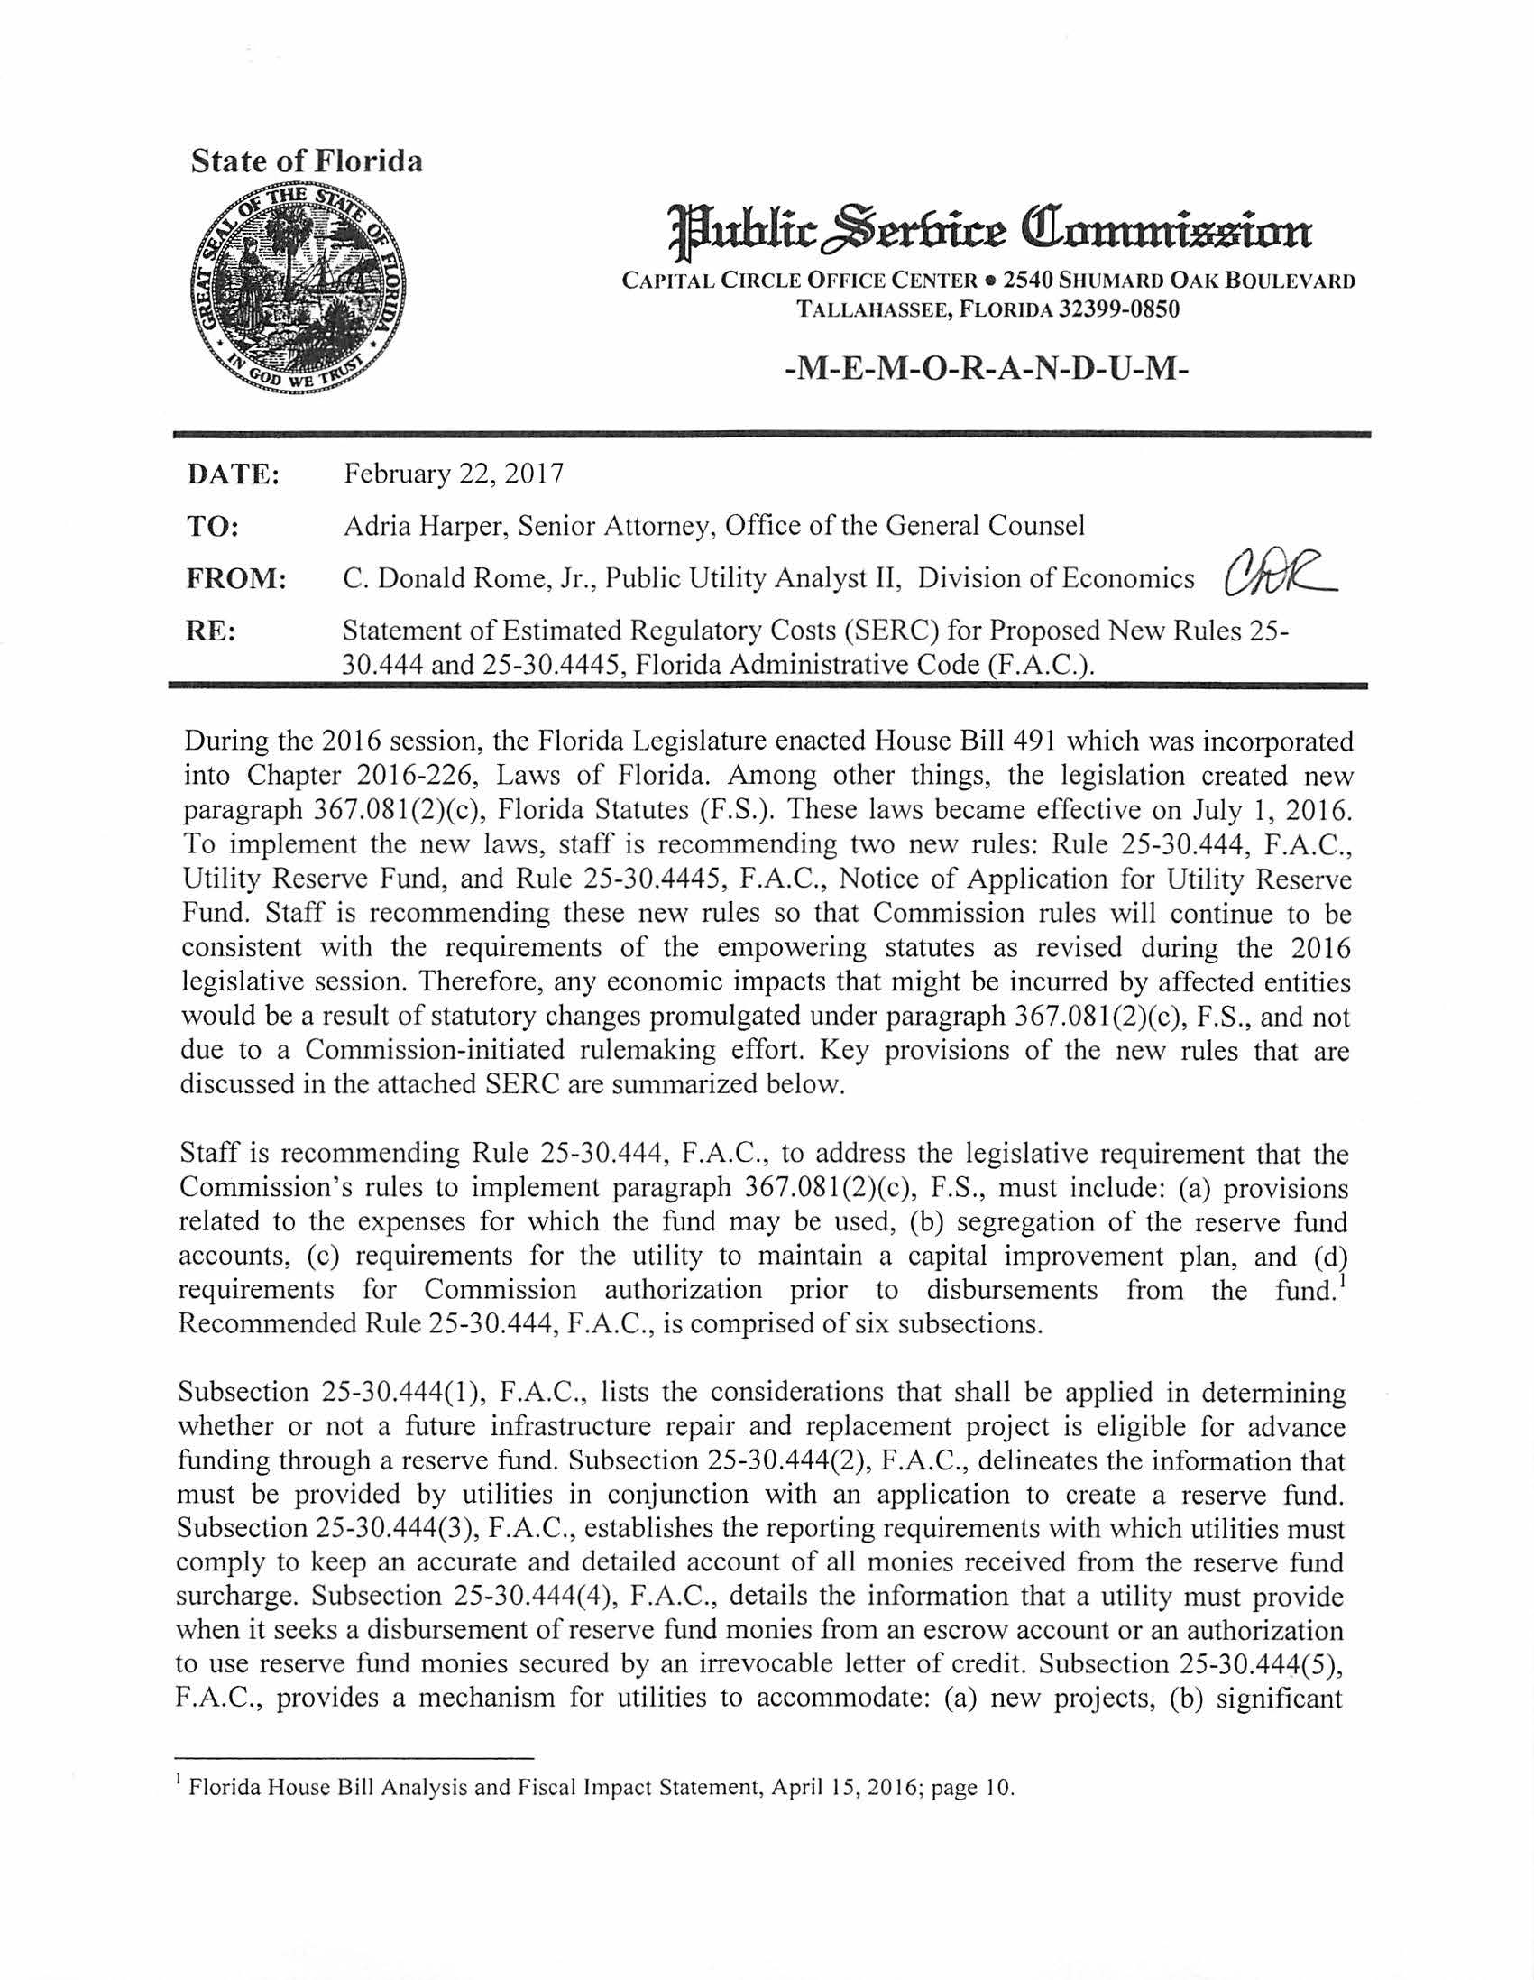

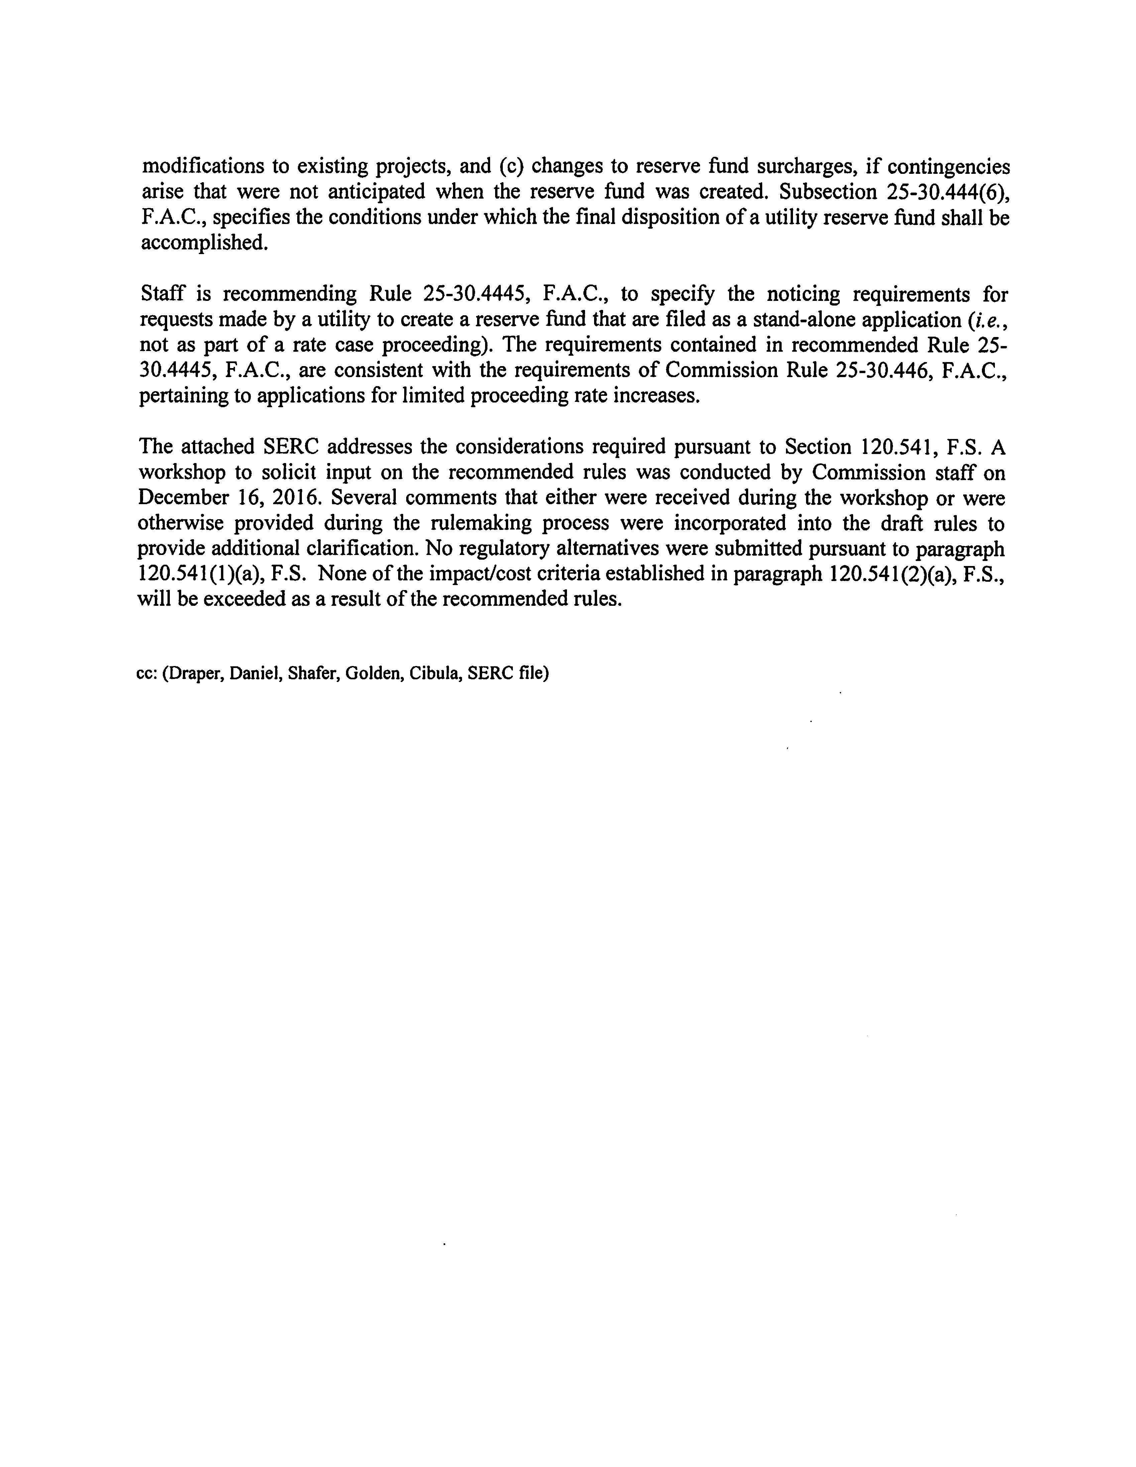

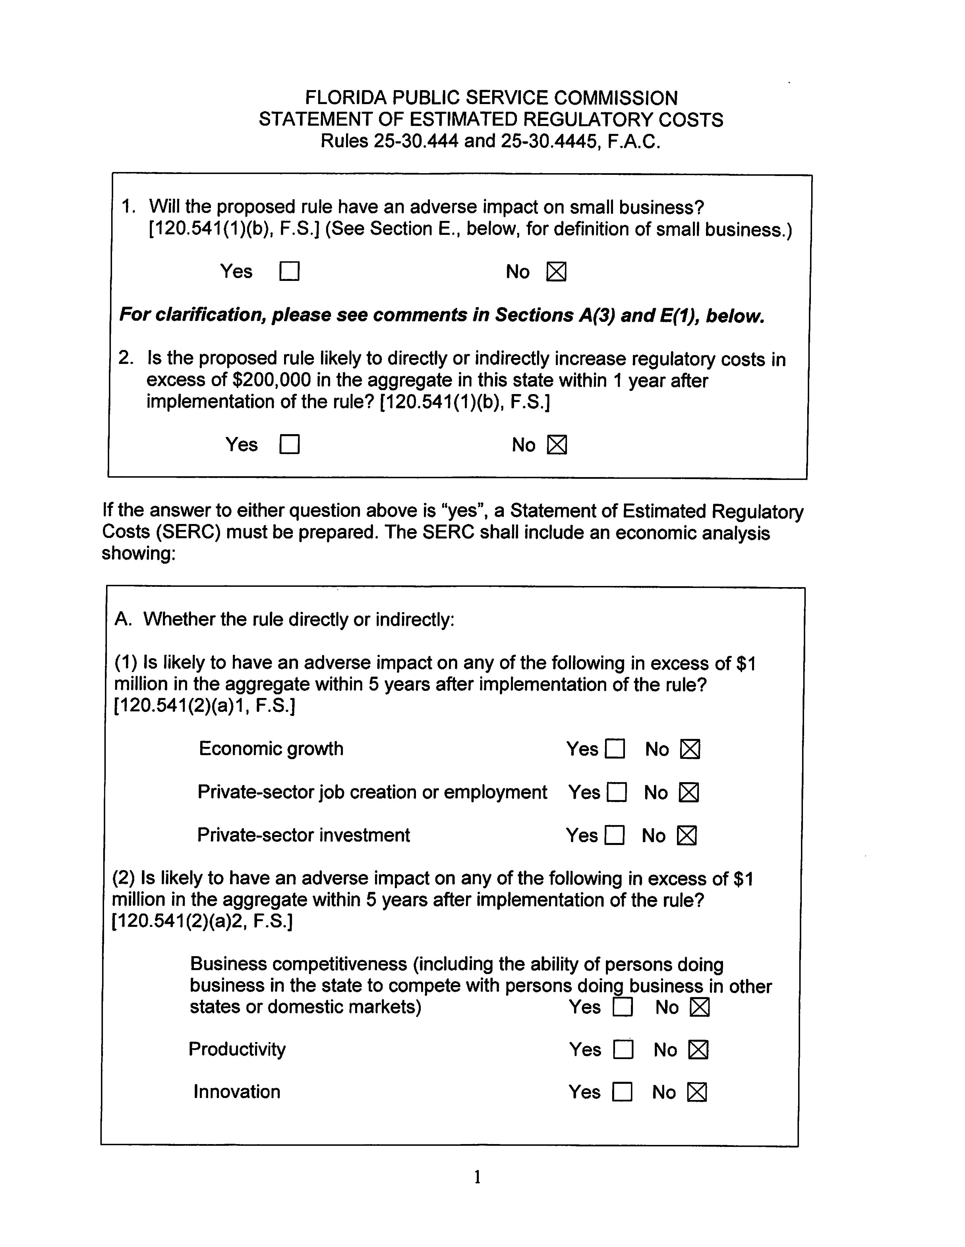

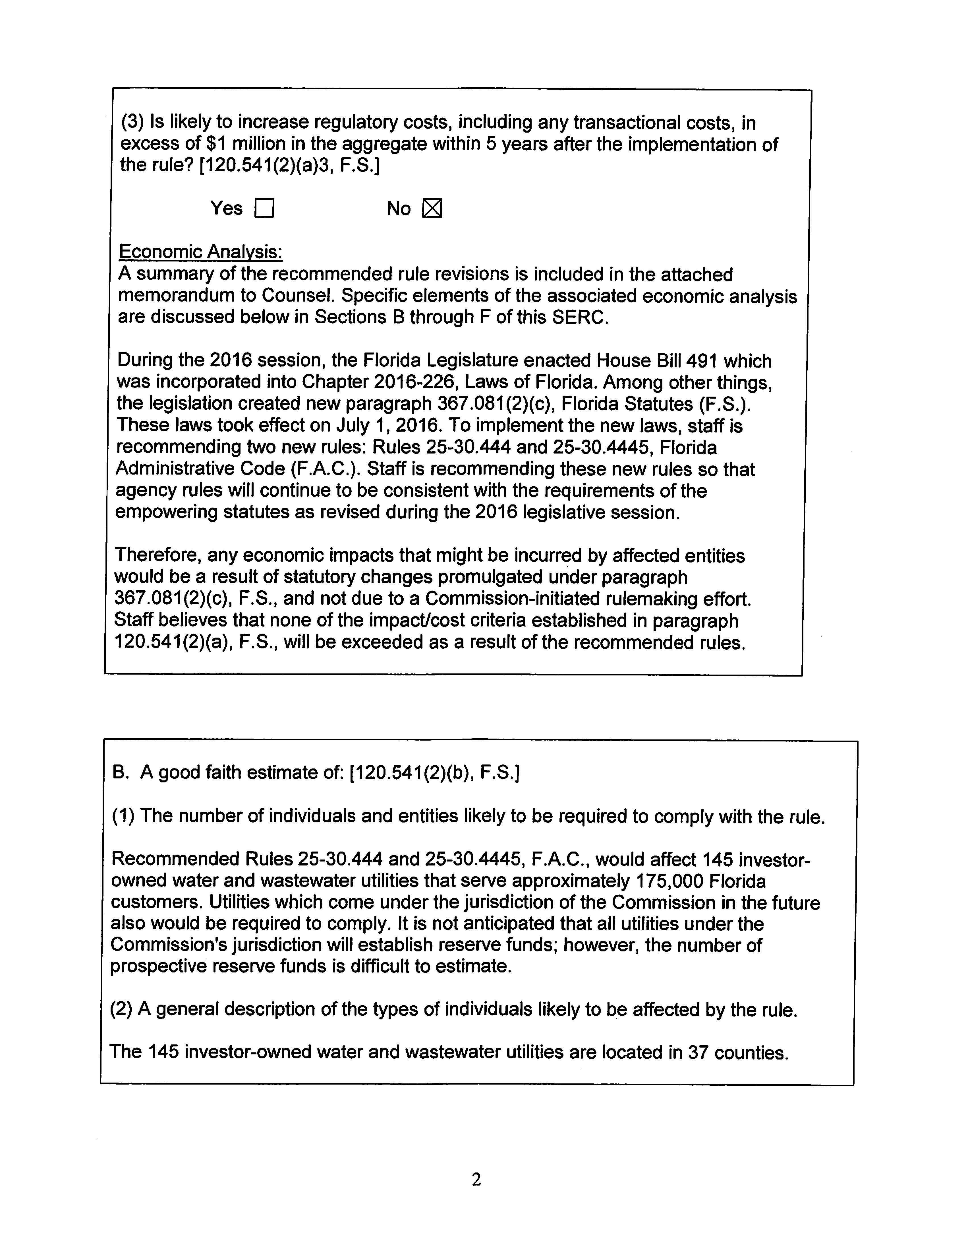

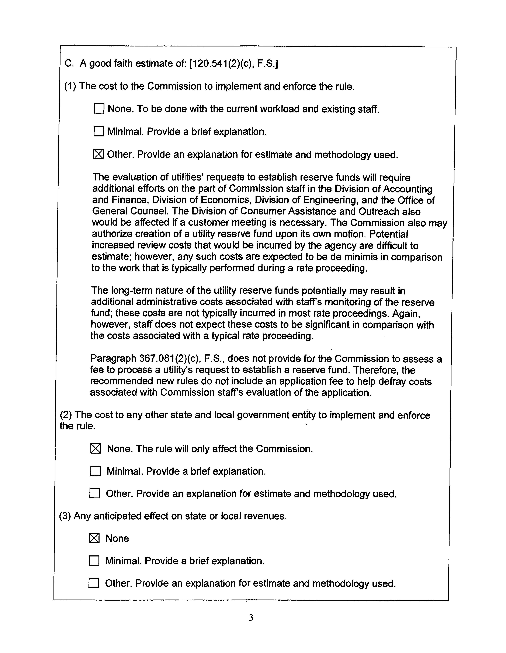

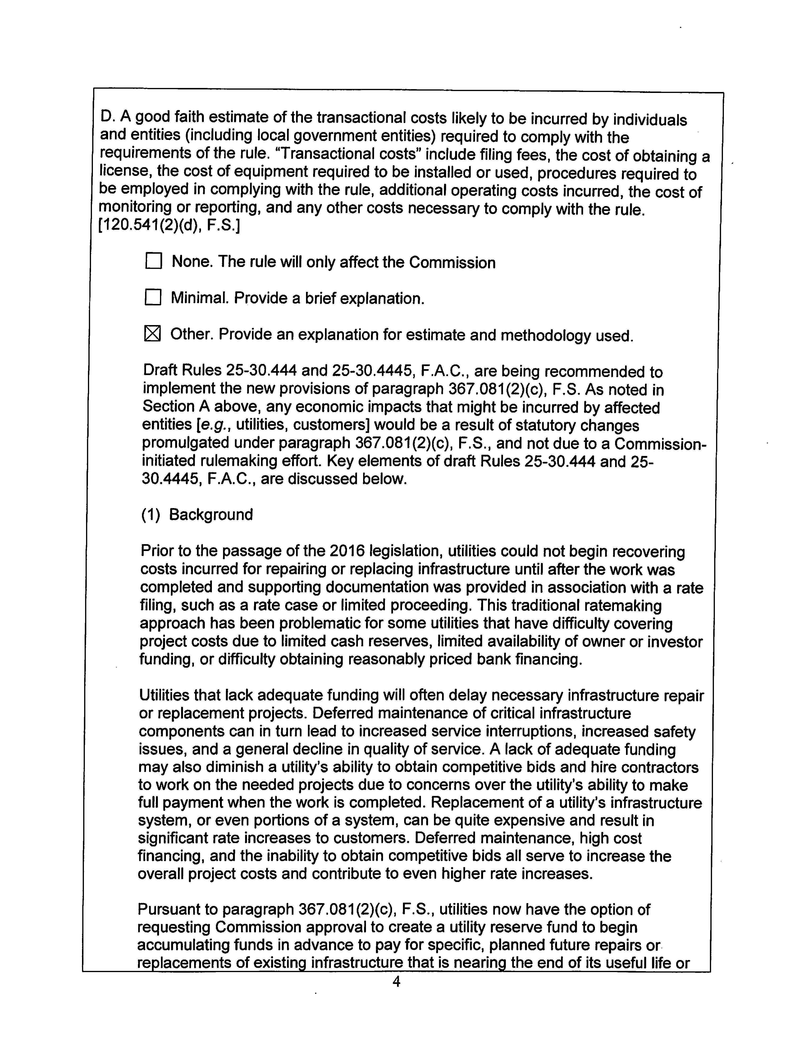

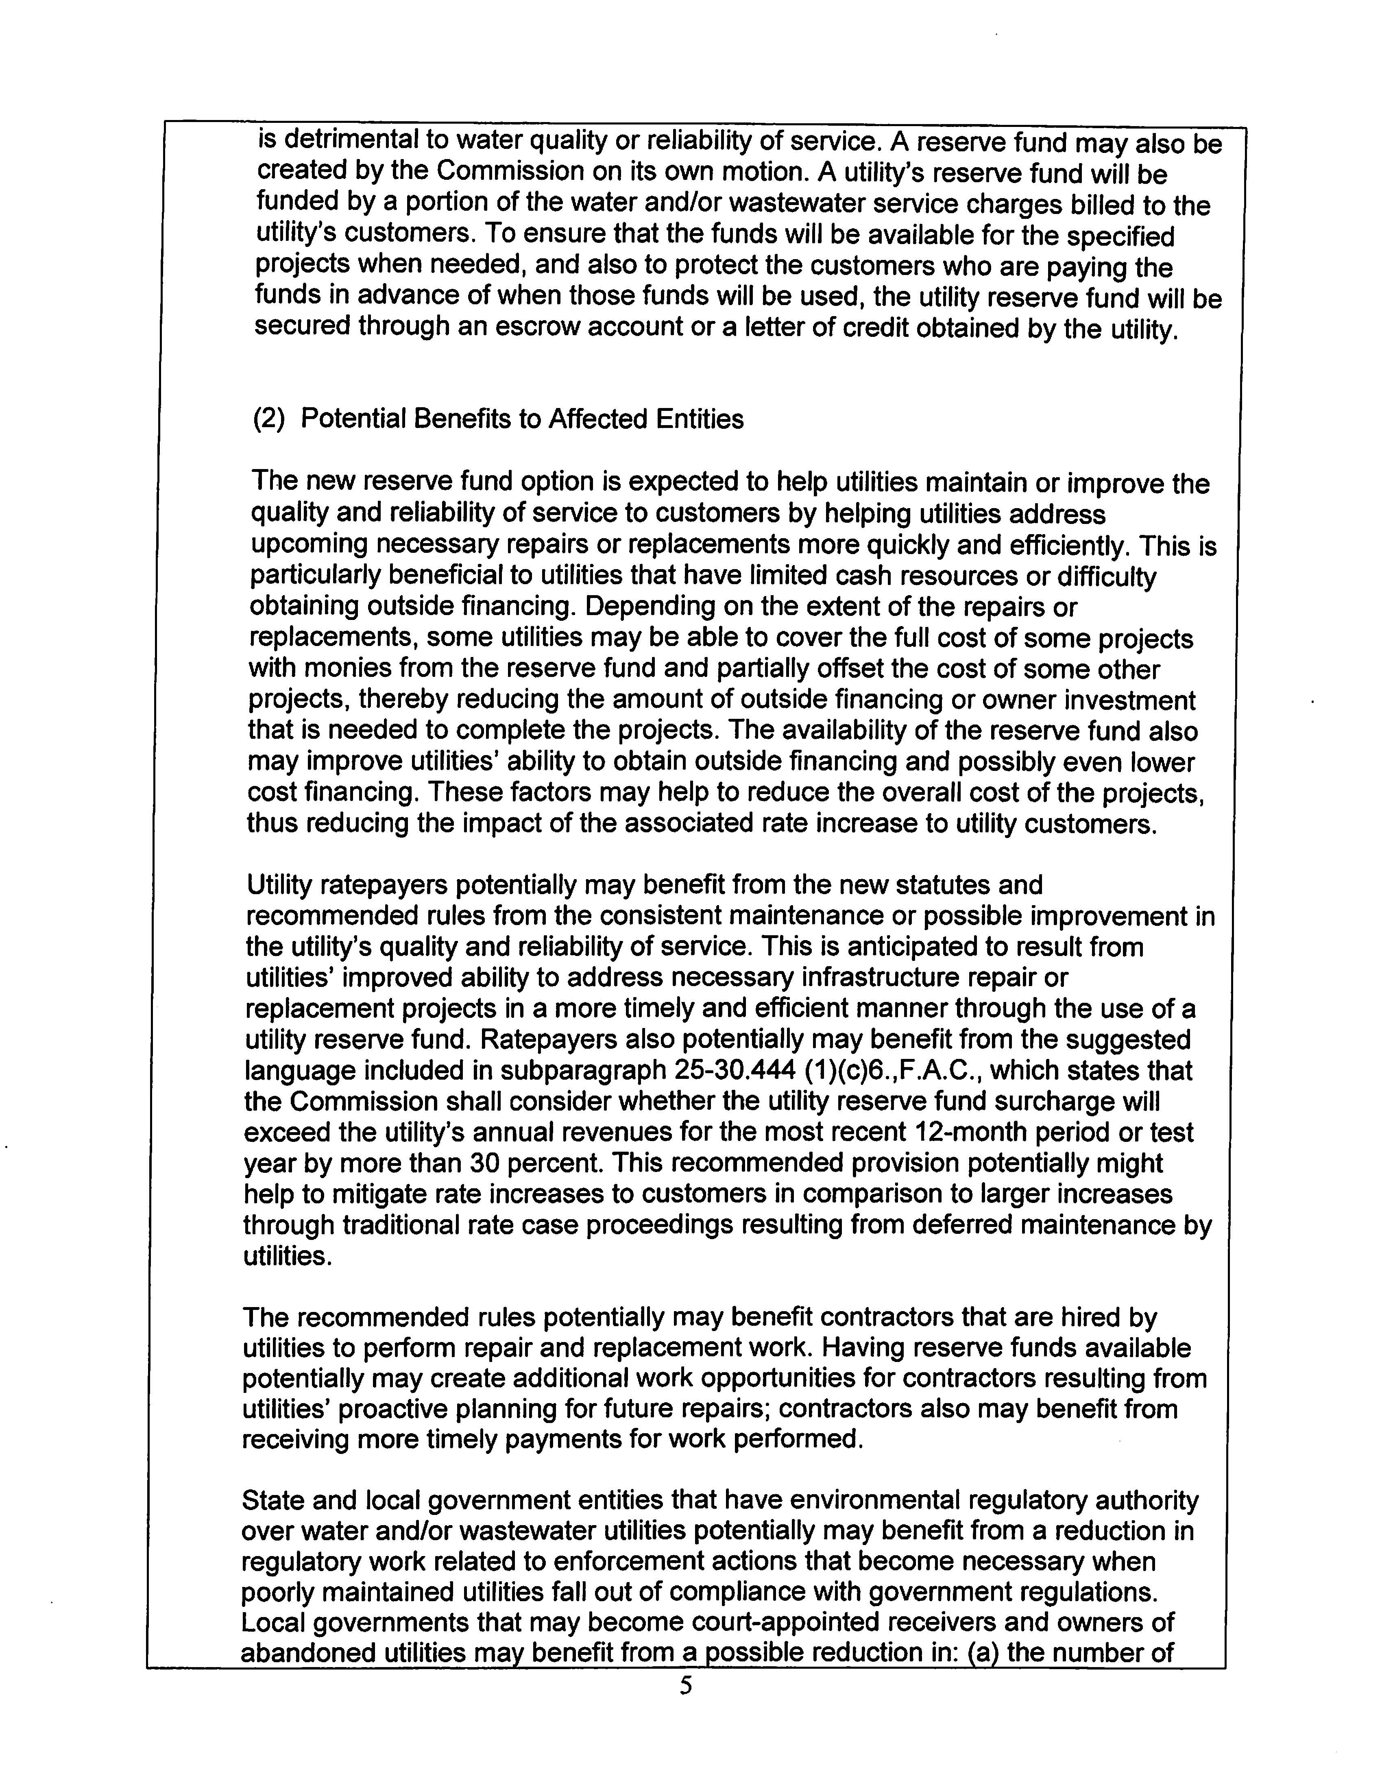

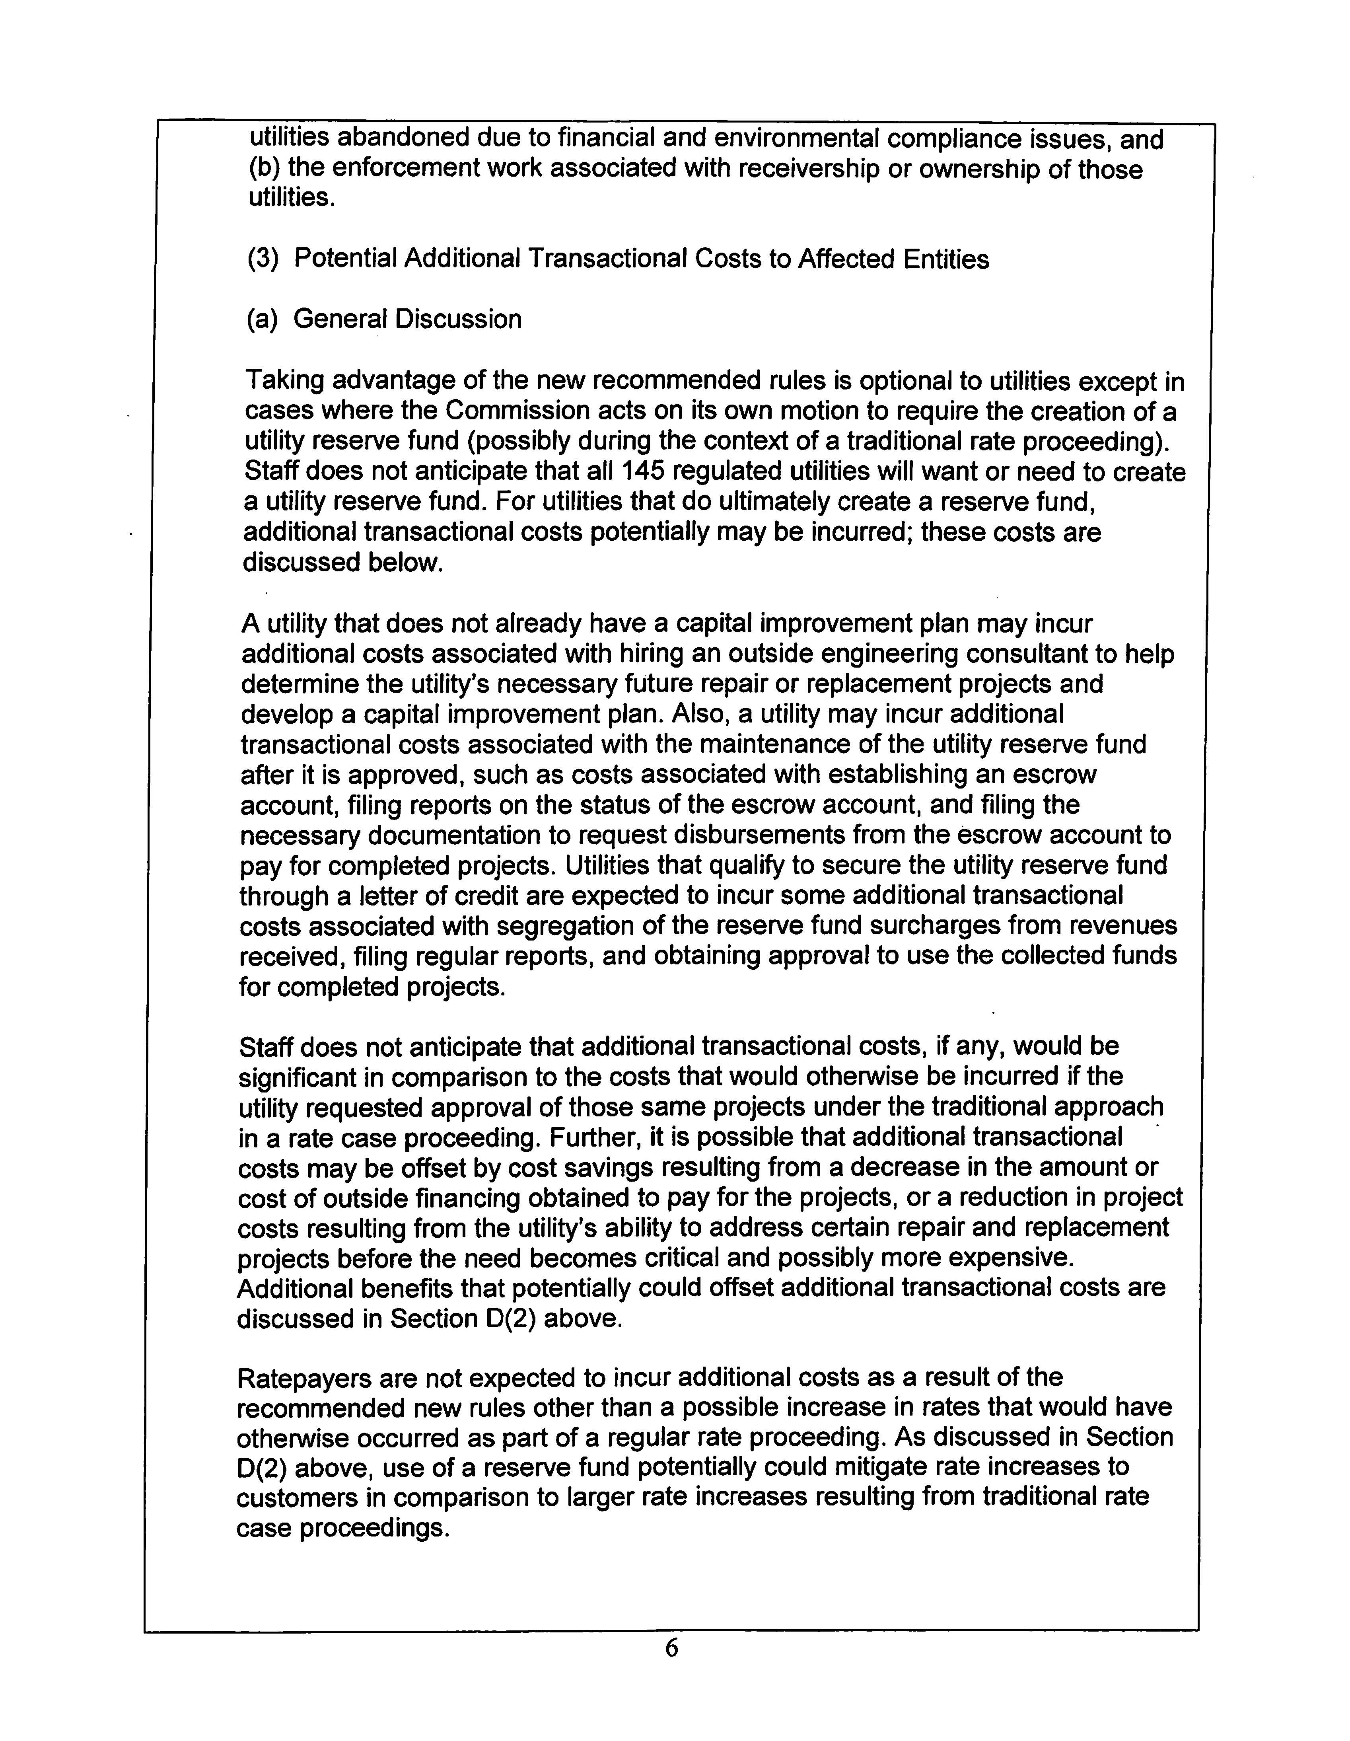

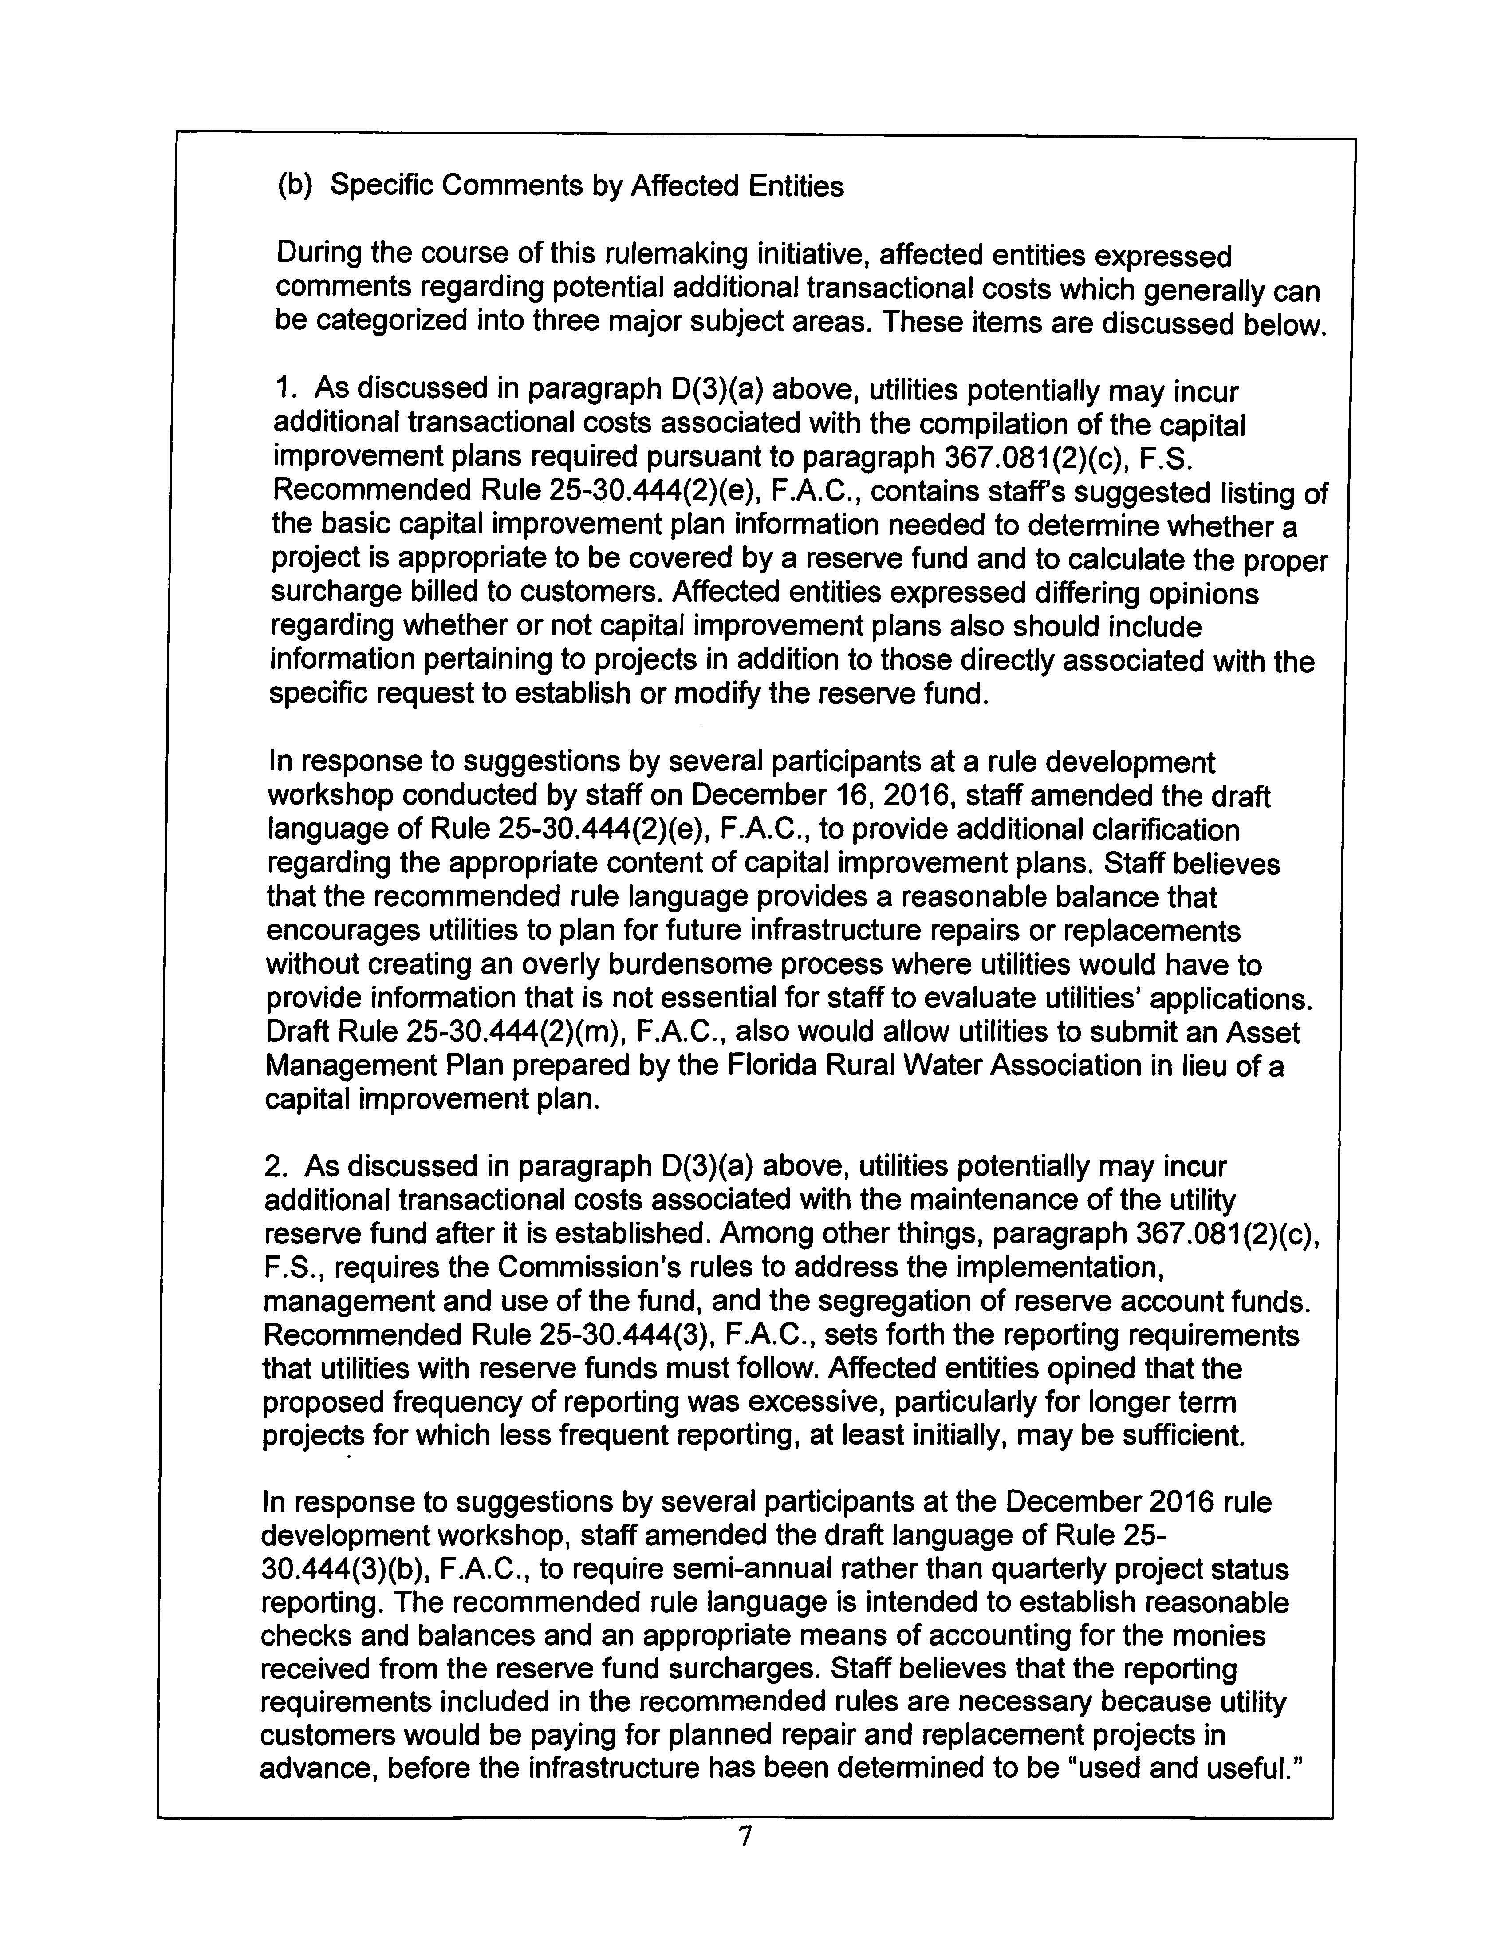

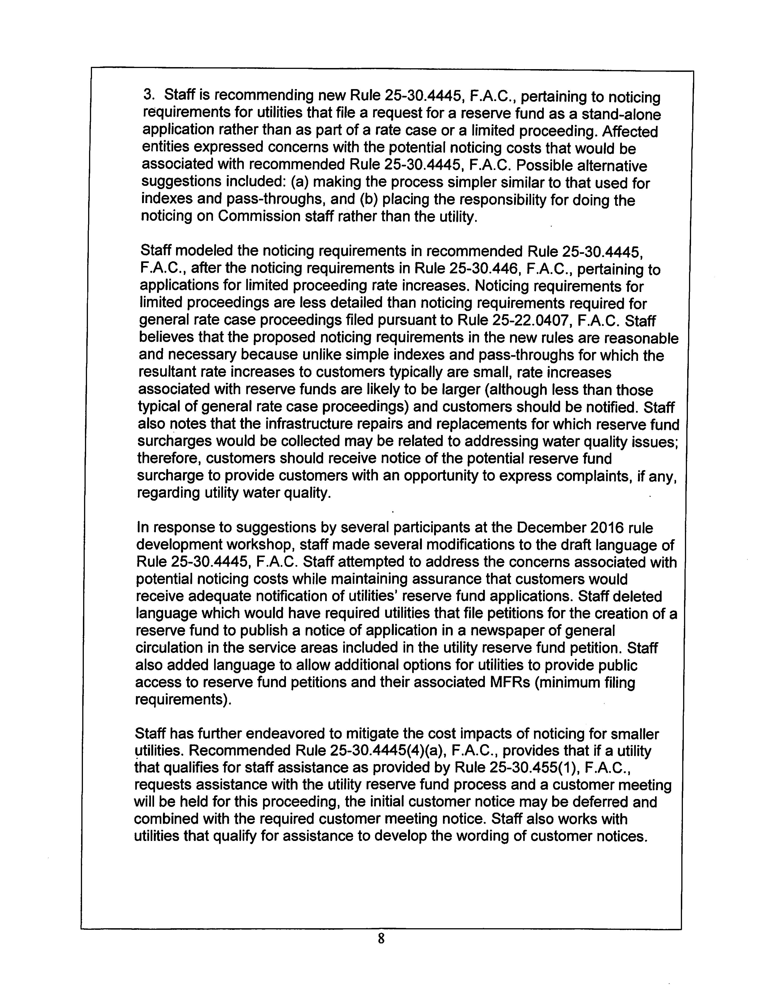

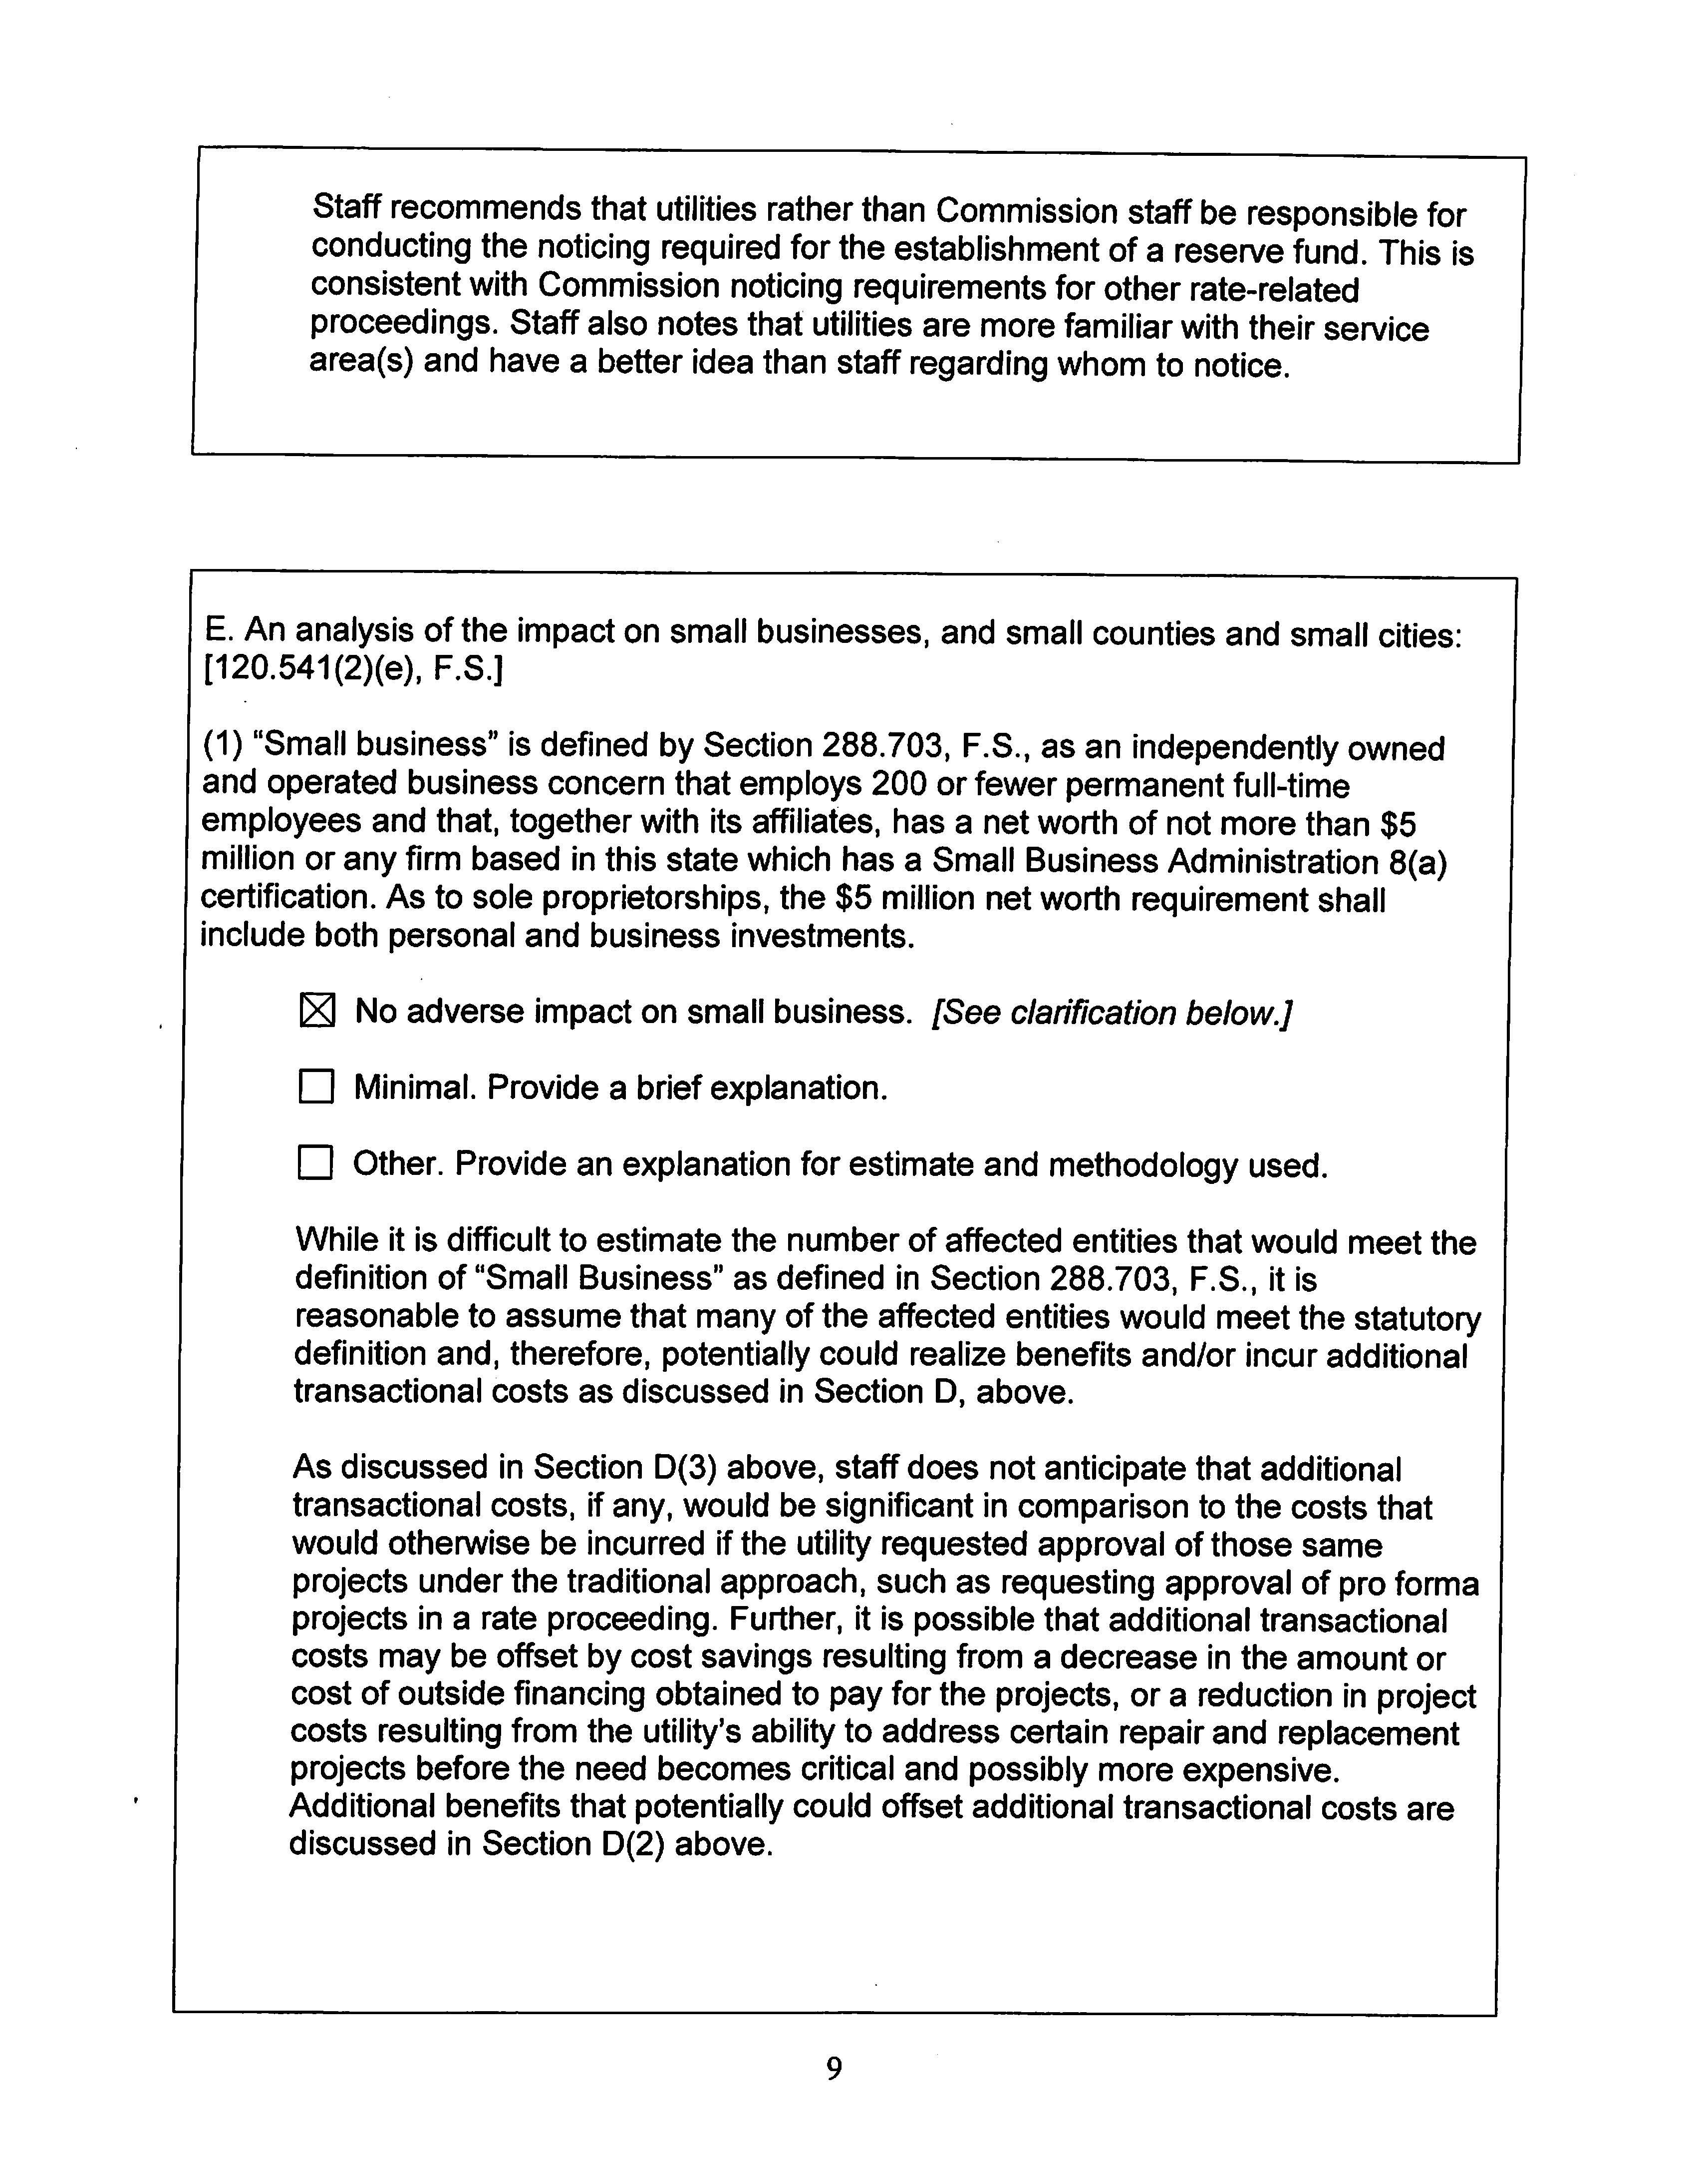

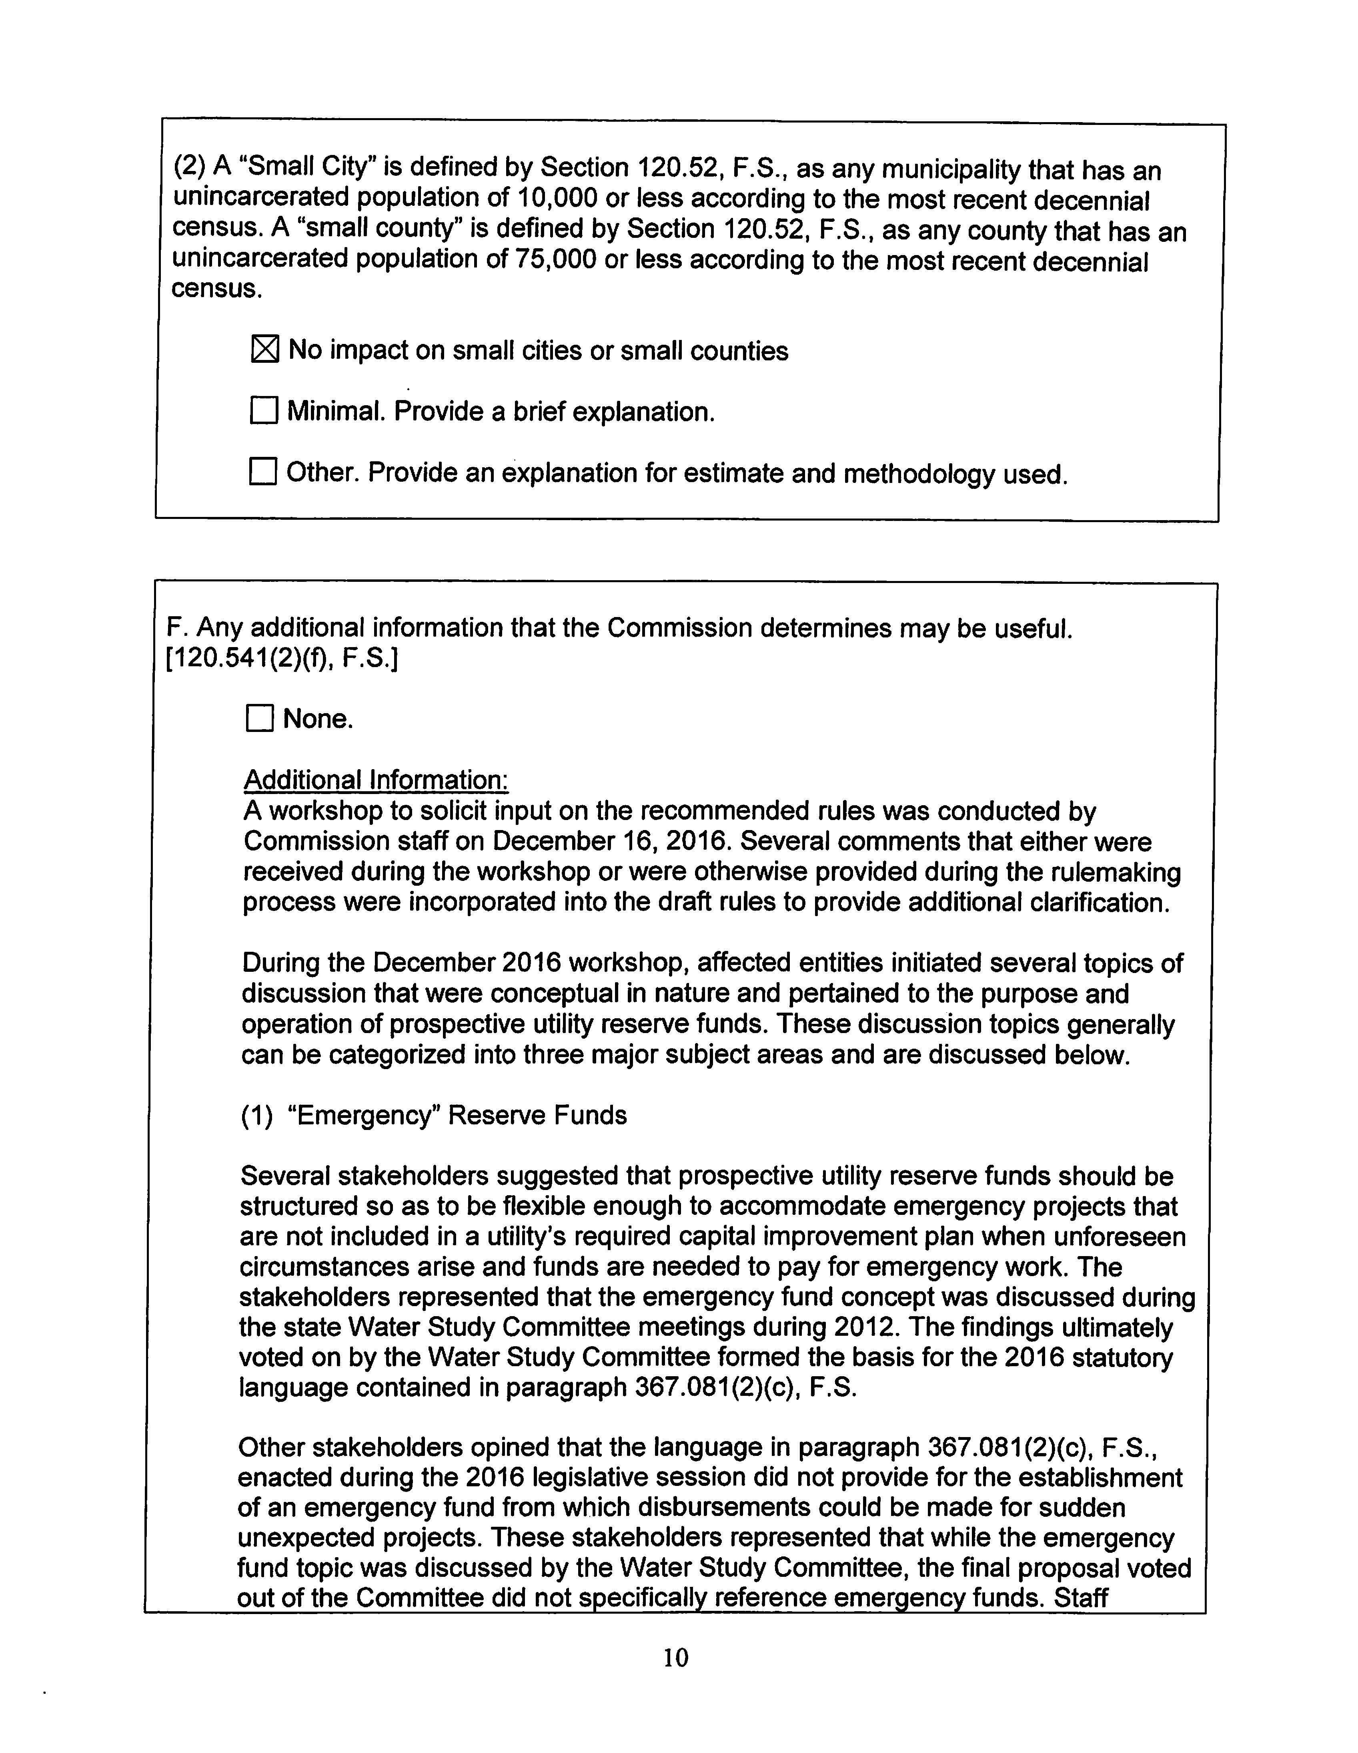

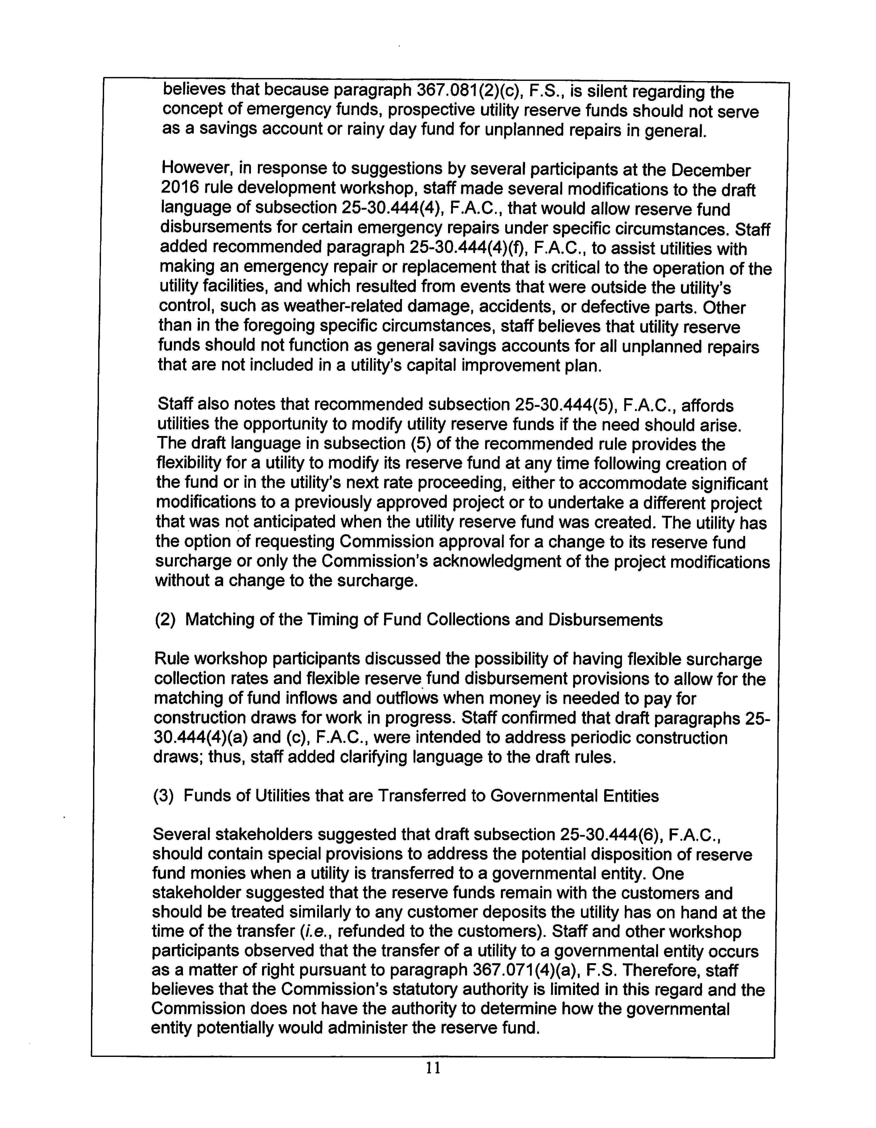

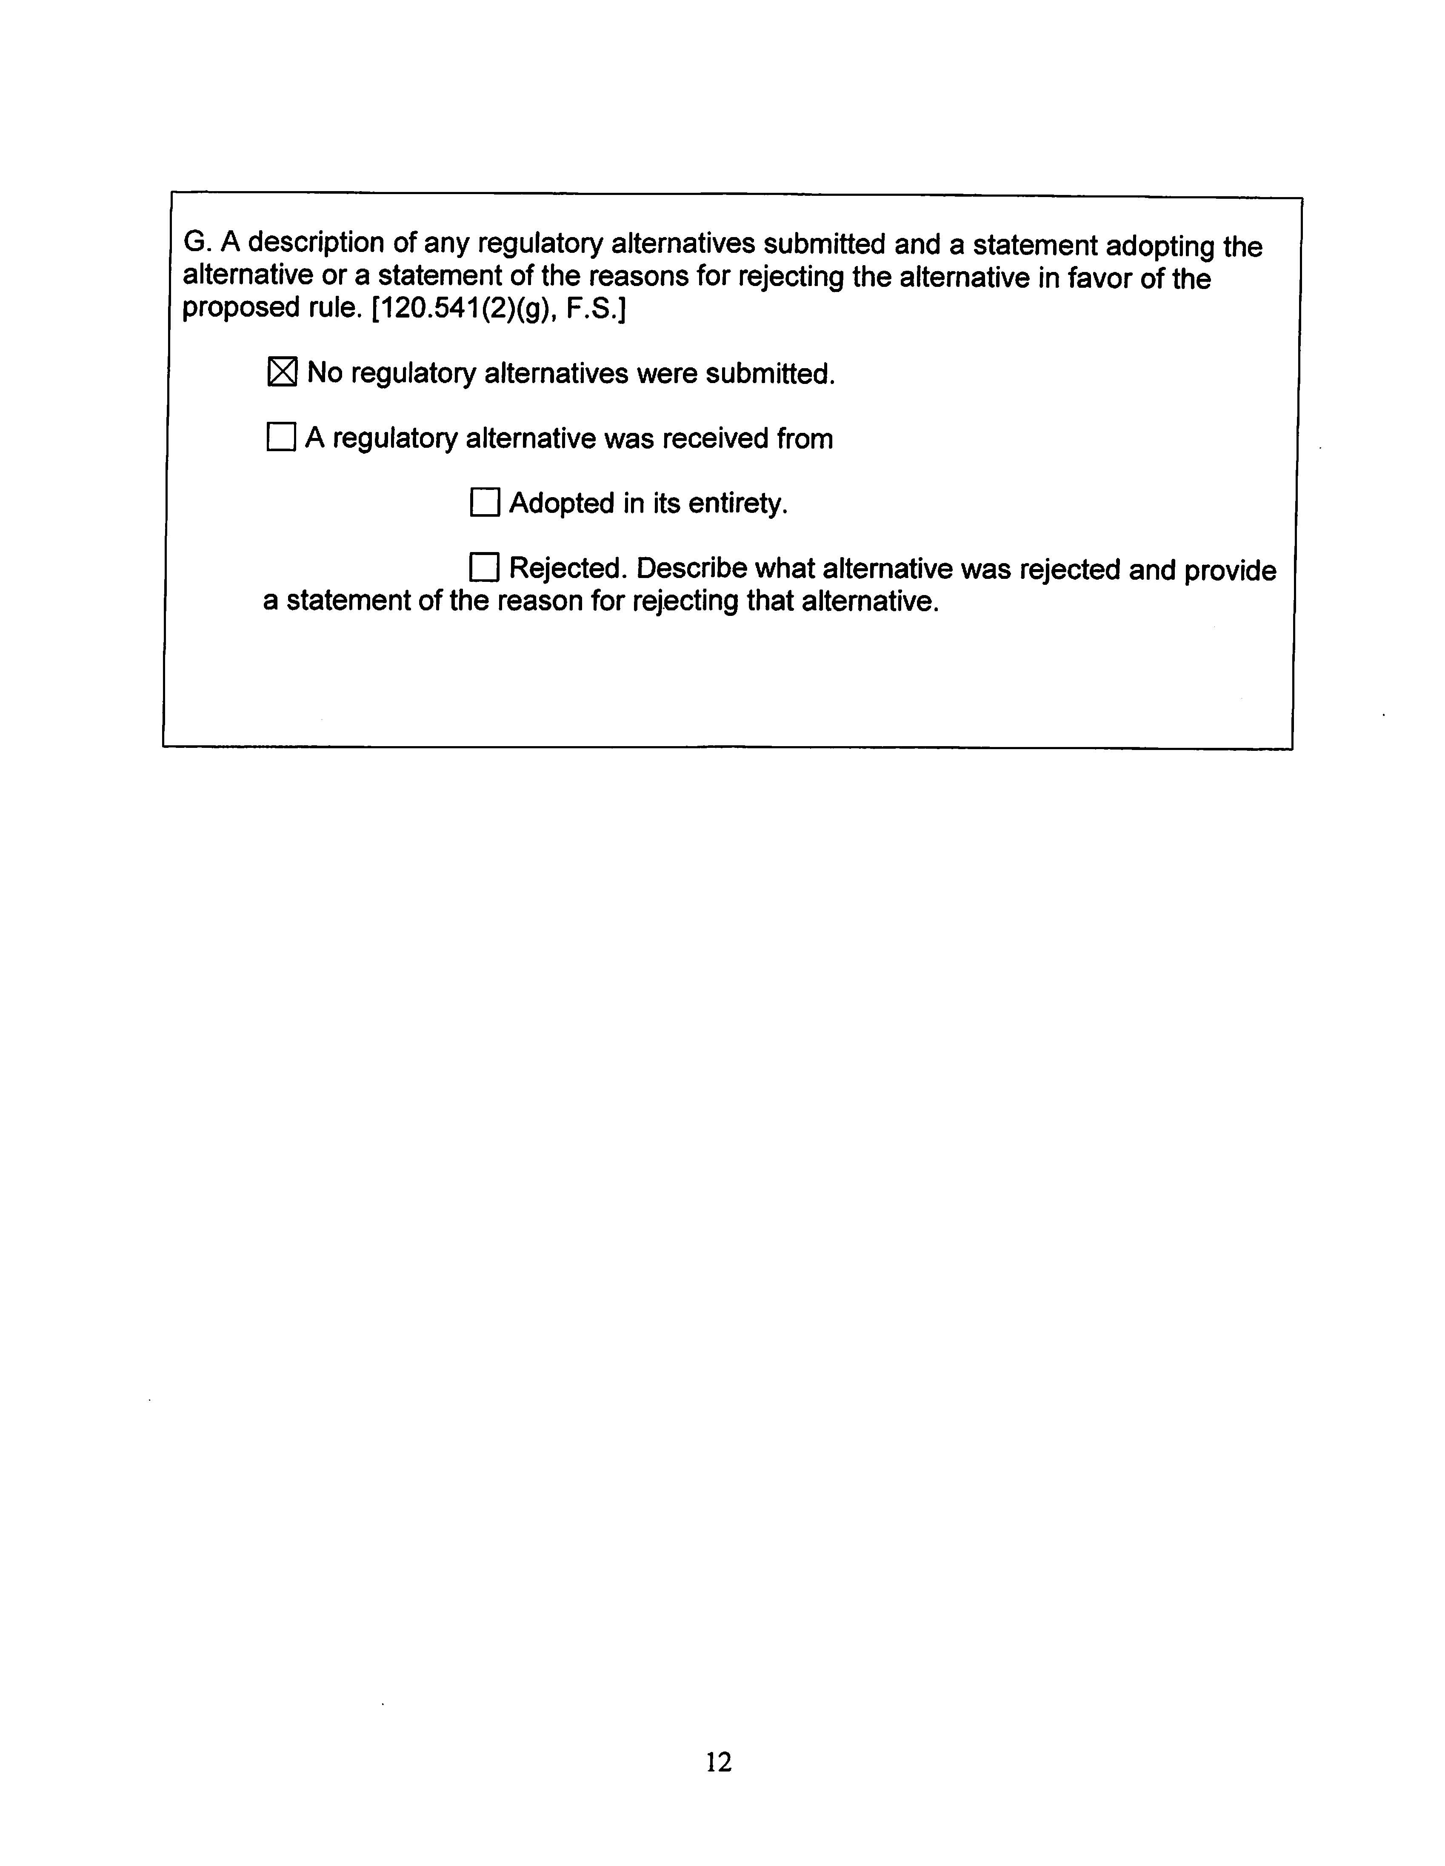

Florida House Bill Analysis, Regulatory Affairs Committee, February 9, 2016; page 3.
Florida House Bill Analysis, Energy and Utilities Subcommittee, April 15, 2016; page 12.
Report of the Study Committee on Investor-Owned Water & Wastewater Utility Systems, issued February 15, 2013, Attachment IV.6-A, pages 74-75.

