State of Florida |  | Public Service Commission  Capital Circle Office Center ● 2540 Shumard Oak Boulevard  Tallahassee, Florida 32399-0850  -M-E-M-O-R-A-N-D-U-M-
DATE: | March 23, 2017
TO: | Office of Commission Clerk (Stauffer)
FROM: | Division of Accounting and Finance (L. Smith, Mouring)  Division of Economics (Rome)  Division of Engineering (King)  Office of the General Counsel (Gervasi)
RE: | Docket No. 160239-WS – Proposed amendment of Rule 25-30.445, F.A.C., General Information and Instructions Required of Water and Wastewater Utilities in an Application for a Limited Proceeding.
AGENDA: | 04/04/17 – Regular Agenda – Rule Proposal – Interested Persons May Participate
COMMISSIONERS ASSIGNED: |  |  | All Commissioners
PREHEARING OFFICER: |  |  | Patronis
RULE STATUS: |  |  | Proposal May Be Deferred
SPECIAL INSTRUCTIONS: |  |  | None

Case Background
In 2014, the Florida Legislature enacted sections 367.072, Florida Statutes (F.S.), Petition to revoke certificate of authorization, and 367.0812, F.S., Rate fixing; quality of water service as criterion. Section 367.0812, F.S., requires that in fixing just, reasonable, compensatory, and not unfairly discriminatory rates, the Commission shall consider the extent to which a water utility provides service that meets secondary water quality standards as established by the Department of Environmental Protection (DEP). Section 367.0812(1)(c), F.S., requires the Commission to consider “[c]omplaints regarding the applicable secondary water quality standards filed by customers with the [C]ommission, the [DEP], the respective local governmental entity, or a county health department during the past 5 years.”
The Commission implemented sections 367.072 and 367.0812, F.S., in 2015. The Commission adopted Rule 25-30.091, Florida Administrative Code (F.A.C.), Petition to Revoke Water Certificate of Authorization, and amended Rule 25-30.440, F.A.C., Additional Engineering Information Required of Class A and B Water and Wastewater Utilities in an Application for Rate Increase, to require that when a utility applies for a rate increase, it must provide a copy of all customer complaints that it has received regarding DEP secondary water quality standards during the past five years. In addition, Rule 25-30.440(3), F.A.C., requires the submission of the most recent secondary water quality standards test results. Rule 25-30.443(1), F.A.C., Minimum Filing Requirements for Class C Water and Wastewater Utilities, makes Rule 25-30.440 applicable to Class C utilities seeking a rate increase, as well.
To promote clarity and consistency among Commission rules, staff is recommending that the Commission propose to amend Rule 25-30.445, F.A.C., to require that when applying for a limited proceeding, water and wastewater utilities must provide the same information pertaining to secondary water quality standards as are contained in Rule 25-30.440, F.A.C. Staff also recommends the elimination of the requirement contained in Rule 25-30.445(8), F.A.C., that a limited proceeding application shall not be filed for underearnings in lieu of a general rate case.
A Notice of Development of Rulemaking was published on July 27, 2016, in Volume 42, Number 145, of the Florida Administrative Register, after which time Utilities Inc., of Florida (UIF), the Office of Public Counsel (OPC), and Michael Smallridge submitted comments on the draft rule. On December 19, 2016, a second notice was issued to inform interested persons of staff’s intent to include the elimination of the requirement in Rule 25-30.445(8), F.A.C., that a limited proceeding shall not be filed for underearnings in lieu of a general rate case. No further comments were received as a result of the second notice. No rule development workshop was requested and none was held.
The Commission has jurisdiction pursuant to sections 120.54, 350.127(2), 367.081, 367.0812, 367.0822, and 367.121, F.S.

Discussion of Issues

Issue 1:
Should the Commission propose the amendment of Rule 25-30.445, F.A.C., General Information and Instructions Required of Water and Wastewater Utilities in an Application for a Limited Proceeding?

Recommendation:
Yes, the Commission should propose the amendment of Rule 25-30.445, F.A.C., as set forth in Attachment A. (Gervasi, King, L. Smith, Mouring, Rome)

Staff Analysis:
Section 367.0812, F.S., requires that in fixing just, reasonable, compensatory, and not unfairly discriminatory rates, the Commission shall consider the extent to which a water utility provides service that meets secondary water quality standards as established by the Department of Environmental Protection (DEP). Section 367.0812(1)(c), F.S., requires the Commission to consider “[c]omplaints regarding the applicable secondary water quality standards filed by customers with the [C]ommission, the [DEP], the respective local governmental entity, or a county health department during the past 5 years.”
Rule 25-30.440(11), F.A.C., Additional Engineering Information Required of Class A and B Water and Wastewater Utilities in an Application for Rate Increase, requires that when a utility applies for a rate increase, it must provide a copy of all customer complaints that it has received regarding DEP secondary water quality standards during the past five years. In addition, Rule 25-30.440(3), F.A.C., requires the submission of the most recent secondary water quality standards test results. Rule 25-30.443(1), F.A.C., Minimum Filing Requirements for Class C Water and Wastewater Utilities, makes Rule 25-30.440 applicable to Class C utilities seeking a rate increase, as well.
To promote clarity and consistency among Commission rules, and to assist the Commission in considering the extent to which a utility provides service that meets secondary water quality standards when evaluating an application for a limited proceeding, staff recommends that the Commission propose to amend Rule 25-30.445, F.A.C., to add Paragraph (4)(o), for Class A and B utilities, and Paragraph (5)(h), for Class C utilities, requiring that the minimum filing requirements (MFRs) for a limited proceeding application shall include: “1. A copy of all customer complaints that the utility has received regarding DEP secondary water quality standards during the past five years; and 2. A copy of the utility’s most recent secondary water quality standards test results.” Staff currently obtains this information via data requests after an application for limited proceeding is filed. By requiring this information as part of the limited proceeding MFRs, the number of data requests that would be necessary to process limited proceedings applications should be reduced, thereby streamlining the process for both staff and applicants. Utility ratepayers also should benefit from the Commission’s consideration of secondary water quality standards prior to allowing a utility to move forward with a rate increase via a limited proceeding.
Staff also recommends that Rule 25-30.445(8), F.A.C., which requires that “[a] limited proceeding application shall not be filed for underearnings in lieu of a general rate case,” should be eliminated. Paragraph (8) of the rule could potentially be interpreted to prohibit justifiable increases simply because a utility is in an underearnings position, or would be in an underearnings position if the costs being sought for recovery are incurred, and it suggests that unless a utility is earning within its authorized range, it would be prohibited from using the limited proceeding process. As such, Paragraph (8) unnecessarily restricts the use of the limited proceeding process, which was designed to save regulatory costs to the utility, its customers, and the Commission. Moreover, Paragraph (6)(b) of the rule provides that in evaluating whether a utility’s request is appropriate for a limited proceeding, the Commission will consider “[w]hether the utility has not had a rate case in more than seven years and the requested rate increase exceeds 30 percent.” Thus, Paragraph (6)(b) provides adequate safeguards to prevent utilities from inappropriately using the limited proceeding process to avoid a general rate case filing in which all costs of the utility would be fully evaluated.
Other non-substantive changes as shown in the attached draft rule are self-explanatory. For informational purposes, copies of the two forms incorporated by reference in the rule are also attached. Staff has not made any recommended changes to the forms. As shown on page 12, lines 11-13, of the draft rule, the Department of State will provide a hyperlink to these forms for inclusion in the rule, as required by section 120.54(1)(i)3.a., F.S., and Rule 1-1.013(6), F.A.C.
In its written comments, UIF states that it believes that the prior three years, rather than five years, of customer complaints is more consistent with prior Commission practice in file and suspend rate cases, and should be adequate in a limited proceeding to retain consistency. UIF also believes that the rule should include a specific deadline within which the Commission must act on a limited proceeding. UIF reasons that a limited proceeding is currently the only type of rate proceeding without a deadline, and that as a result, limited proceedings are being underutilized because utilities have no expectation on when rate relief will be forthcoming. UIF suggests that a five-month deadline is a reasonable time within which the Commission should be able to rule on a limited proceeding, and summarily suggests that a deadline will help to insulate the Commission from political involvement.
In its written comments, OPC agrees with staff’s draft rule language. OPC believes that the inclusion of the staff recommended rule changes to the limited proceeding MFRs will provide a more complete record and additional transparency to the process. OPC states that customer input on these water quality issues plus the most recent test results will not only allow Commission staff to conduct a more thorough evaluation of the case, but will also allow all affected parties and the Commission to gain a greater understanding of issues that are important to water utility customers.
OPC strongly disagrees with UIF’s suggestion to include a specific deadline for the Commission to act on limited proceedings. OPC states that both the Florida Legislature and the Commission have already identified instances where a deadline for the Commission to act is warranted. Chapter 367, F.S., requires an eight-month deadline for the Commission to act on petitions for rate relief through full administrative hearings, and a five-month deadline for the Commission to act on proposed agency action proceedings. And the Commission set a 90-day deadline to vote on a proposed agency action recommendation establishing rates in Rule 25-30.456, F.A.C., which addresses staff assistance in alternative rate setting. OPC argues that there are proceedings where flexibility is paramount and no deadline should be set. To OPC’s knowledge, the lack of a deadline in limited proceedings does not present a hardship for any party, and UIF’s comments are akin to “a solution in search of a problem.”
Mr. Smallridge submitted comments on behalf of the eight utilities that he owns. Mr. Smallridge states that five years is too long of a time to expect the utility to keep every customer complaint. He states that it is hard for some utilities to produce receipts from the past year, much less customer complaints from five years ago, and that a five-year timeframe would be “setting yourself up for failure.” Mr. Smallridge further suggests that the new language on page 12, line 16 of the attached draft rule should specify “A Class A or B water utility’s application for limited proceeding shall also include” instead of “A water utility’s application for limited proceeding shall also include,” to clarify who this provision of the rule applies to, similar to on page 13, line 21 of the draft rule, which states “A Class C water utility’s application for limited proceeding shall also include[.]”
Staff disagrees with UIF’s comment that the prior three years, rather than five years, of customer complaints is more consistent with prior Commission practice in file and suspend rate cases, and should be adequate in a limited proceeding to retain consistency. Staff also disagrees with Mr. Smallridge’s comment that five years is too long of a time for a utility to keep these types of customer complaints. As noted above, the draft rule language is consistent with Rule 25-30.440(11), F.A.C., which requires that when a utility applies for a rate increase, it must provide a copy of all customer complaints that it has received regarding DEP secondary water quality standards during the past five years, and Rule 25-30.443(1), F.A.C., makes this requirement applicable to Class C utilities seeking a rate increase, as well. This rule requirement implements section 367.0812, F.S., which requires the Commission to consider the extent to which a water utility provides service that meets secondary water quality standards when fixing rates. Section 367.0812(1)(c), F.S., requires the Commission to consider “[c]omplaints regarding the applicable secondary water quality standards filed by customers with the [C]ommission, the [DEP], the respective local governmental entity, or a county health department during the past 5 years.” (emphasis added). Moreover, as previously noted, staff currently obtains this information via data requests after an application for limited proceeding is filed. Therefore, only the timing of providing the secondary water quality standards information will be affected by the implementation of the rule amendment, not the nature of the information itself.
Staff further disagrees with UIF’s suggestion to include a five-month deadline within which the Commission must act on a limited proceeding. Staff agrees with OPC that there are statutory deadlines imposed upon the Commission to act within a specified timeframe in certain types of cases, such as in file and suspend rate cases. There is no statutory deadline contained in section 367.0822, F.S., the limited proceedings statute. Moreover, applications for limited proceedings vary in scope and in complexity. Pursuant to section 367.0822, F.S., “[t]he [C]omission shall determine the issues to be considered during such a proceeding and may grant or deny any request to expand the scope of the proceeding to include other related matters.” Thus, some limited proceedings take considerably longer to process than others, and it is important for the Commission to have the flexibility to set its own deadlines to act on limited proceeding applications.
Finally, with respect to Mr. Smallridge’s comment to specify on page 12, line 16 of the attached draft rule that Paragraph (4)(o) applies to Class A and B utilities, the inclusion of this language is unnecessary because Paragraph (4) of the rule already specifies that “The following [MFRs] shall be filed . . . for a Class A or B water or wastewater utility,” as shown on page 9, lines 24-25 of the attached draft rule. The new language of Paragraph (4)(o) of the draft rule is narrowed to water utilities because the inclusion in limited proceeding MFRs of water-related customer complaints and test results is inapplicable to wastewater only utilities.
Statement of Estimated Regulatory Costs
The Florida Administrative Procedure Act encourages an agency to prepare a Statement of Estimated Regulatory Costs (SERC). Section 120.54(3)(b), F.S. An agency must prepare a SERC if the proposed rule is likely to directly or indirectly increase regulatory costs in excess of $200,000 in the aggregate within one year after implementation of the rule, and shall consider the impact of the rule on small businesses, small counties, and small cities. Id.

Section 120.541(2)(a), F.S., requires a SERC to include an economic analysis showing whether the rule, directly or indirectly, is likely to: 1) have an adverse impact on economic growth, private sector job creation, employment, or investment; 2) have an adverse impact on business competitiveness; or 3) increase regulatory costs in excess of $1 million in the aggregate within five years after the implementation of the rule. Section 120.541(3), F.S., requires that if the adverse impact or regulatory costs of the rule exceed any of those criteria, the rule shall be submitted to the President of the Senate and Speaker of the House, and may not take effect until it is ratified by the Legislature.
The SERC prepared by staff is included as Attachment B to this recommendation. It indicates that the rule is not expected to adversely impact economic growth, private job sector employment, investment, and business competitiveness during the five-year period following its implementation, and that any transactional costs that might be incurred by affected entities would be de minimis. Based on the SERC, the recommended rules will not require legislative ratification.
As required by section 120.541(2)(b)-(e), F.S., Attachment B also addresses the estimated number of individuals and entities likely to be required to comply with the rules, the estimated cost of implementing and enforcing the rules, the estimated transactional costs likely to be incurred by individuals and entities required to comply with the rules, and an analysis of the impact on small businesses, small counties, and small cities.
For the foregoing reasons, staff recommends that the Commission should propose the amendment of Rule 25-30.445, F.A.C., as shown on Attachment A.

Issue 2:
Should this docket be closed?

Recommendation:
Yes, if no requests for hearing or comments are filed, the rule amendments as proposed should be filed for adoption with the Secretary of State and the docket should be closed.

Staff Analysis:
Unless comments or requests for hearing are filed, the rule amendments as proposed may be filed with the Secretary of State without further Commission action. The docket may then be closed. (Gervasi)

25-30.445 General Information and Instructions Required of Water and Wastewater Utilities in an Application for a Limited Proceeding.
(1) Each applicant for a limited proceeding shall provide the following general information to the Commission:
(a) The name of the applicant as it appears on the applicant’s certificate and the address of the applicant’s principal place of business;
(b) The type of business organization under which the applicant’s operations are conducted; if the applicant is a corporation, the date of incorporation; the names and addresses of all persons who own 5 percent or more of the applicant’s stock; or the names and addresses of the owners of the business.
(c) The number(s) of the Commission order(s), if any, in which the Commission most recently considered the applicant’s rates for the system(s) involved.
(d) The address within the service area where the application is available for customer inspection during the time the rate application is pending.
(e) A statement signed by an officer of the utility that the utility will comply with the noticing requirements in Rule 25-30.446, F.A.C.
(2) In a limited proceeding application:
(a) Each schedule shall be cross-referenced to identify related schedules.
(b) Except for handwritten official company records, all data in the petition and application shall be typed.
(c) The original and seven copies shall be filed with the Office of Commission Clerk.
(3) A filing fee as required in Rule 25-30.020, F.A.C., shall be submitted at the time of application.
(4) The following minimum filing requirements shall be filed with the utility’s application for limited proceeding for a Class A or B water or wastewater utility:
(a) A detailed statement of the reason(s) why the limited proceeding has been requested.
(b) If the limited proceeding is being requested to recover costs required by a governmental or regulatory agency, provide the following:
1. A copy of any rule, regulation, order or other regulatory directive that has required or will require the applicant to make the improvement or the investment for which the applicant seeks recovery.
2. An estimate by a professional engineer, or other person, knowledgeable in design and construction of water and wastewater plants, to establish the projected cost of the applicant's investment and the period of time required for completion of construction.
(c) A schedule that provides the specific rate base components for which the utility seeks recovery. Supporting detail shall be provided for each item requested, including:
1. The actual or projected cost(s);
2. The date the item will be or is projected to be placed in service;
3. Any corresponding adjustments that are required as a result of adding or removing the requested component(s) from rate base, which may include retirement entries; and
4. Any other relevant supporting information.
(d) If the utility’s application includes a request for recovery of plant in service, accumulated depreciation and depreciation expense, supporting detail shall be provided by primary account as defined by the NARUC Uniform System of Accounts, in accordance with Rule 25-30.110, F.A.C.
(e) A calculation of the weighted average cost of capital shall be provided for the most recent 12-month period, using the mid-point of the range of the last authorized rate of return on equity, the current embedded cost of fixed-rate capital, the actual cost of short-term debt, the actual cost of variable-cost debt, and the actual cost of other sources of capital which were used in the last individual rate proceeding of the utility. If the utility does not have an authorized rate of return on equity, the utility shall use the current leverage formula pursuant to Section 367.081(4)(f), F.S.
(f) If the utility is requesting recovery of operating expenses, the following information shall be provided:
1. A detailed description of the expense(s) requested;
2. The total cost by primary account pursuant to the NARUC Uniform System of Accounts;
3. Supporting documentation or calculations; and
4. Any allocations that are made between systems, affiliates or related parties. If allocations are made, submit full detail that shows the total amount allocated, a description of the basis of the allocation methodology, the allocation percentage applied to each allocated cost, and the workpapers supporting the calculation of the allocation percentages.
(g) Calculations for all items that will create cost savings or revenue impacts from the implementation of the requested cost recovery items.
(h) If the utility includes any other items where calculations are required, supporting documentation shall be filed that reflects the calculations or assumptions made.
(i) A calculation of the revenue increase including regulatory assessment fees and income taxes, if appropriate.
(j) Annualized revenues for the most recent 12-month period using the rates in effect at the time the utility files its application for limited proceeding and a schedule reflecting this calculation by customer class and meter size.
(k) A schedule of current and proposed rates for all classes of customers.
(l) Schedules for the most recent 12-month period showing that, without any increased rates, the utility will earn below its authorized rate of return in accordance with Section 367.082, F.S. The schedules shall consist of a rate base, net operating income and cost of capital schedule with adjustments to reflect those consistent with the utility’s last rate proceeding.
(m) If the limited proceeding is being requested to change the current rate structure, provide a copy of all workpapers and calculations used to calculate requested rates and allocations between each customer class. The test year shall should be the most recent 12-month period. In addition, the following schedules, which are incorporated herein by reference, from Form PSC/AFD 19-W (11/93), entitled “Class A Water and/or Wastewater Utilities Financial, Rate and Engineering Minimum Filing Requirements”, shall should be provided. The schedules can be obtained from the Commission’s Division of Accounting and Finance.
1. Schedule E-2, entitled “Revenue Schedule at Present and Proposed Rates,” is available at [hyperlink].
2. Schedule E-14, entitled “Billing Analysis Schedules,” is available at [hyperlink]. Only two copies are required.
(n) Revised tariff sheets should not be filed with the application.
(o) A water utility’s application for limited proceeding shall also include:
1. A copy of all customer complaints that the utility has received regarding DEP secondary water quality standards during the past five years; and
2. A copy of the utility’s most recent secondary water quality standards test results.
(5) In addition to the requirements stated in subsections (1) through (3), the following minimum filing requirements shall be filed with the utility’s application for limited proceeding for a Class C water or wastewater utility:
(a) A detailed statement of the reason(s) why the limited proceeding has been requested.
(b) If the limited proceeding is being requested to recover costs required by a governmental or regulatory agency, provide a copy of any rule, regulation, order or other regulatory directive that has required or will require the applicant to make the improvement or the investment for which the applicant seeks recovery.
(c) A schedule that provides the specific rate base components for which the utility seeks recovery, if known. Supporting detail shall be provided for each item requested, including:
1. The actual or projected cost(s);
2. The date the item will be or is projected to be placed in service;
3. Any corresponding adjustments, if known, that are required as a result of adding or removing the requested component(s) from rate base, which may include retirement entries; and
4. Any other relevant supporting information, if known.
(d) If the utility is requesting recovery of operating expenses, provide an itemized description of the expense(s), including the cost and any available supporting documentation or calculations.
(e) Provide a description of any known items that will create cost savings or revenue impacts from the implementation of the requested cost recovery items.
(f) A calculation of the revenue increase including regulatory assessment fees and income taxes, if applicable.
(g) Annualized revenues for the most recent 12-month period using the rates in effect at the time the utility files its application for limited proceeding and a schedule reflecting this calculation by customer class and meter size.
(h) A Class C water utility’s application for limited proceeding shall also include:
1. A copy of all customer complaints that the utility has received regarding DEP secondary water quality standards during the past five years; and
2. A copy of the utility’s most recent secondary water quality standards test results.
(6) In evaluating whether the utility’s request is improper for a limited proceeding, the Commission will consider factors such as:
(a) Whether the utility’s filing includes more than 4 separate projects for which recovery is sought and the requested rate increase exceeds 30 percent. Corresponding adjustments for a given project are not subject to the above limitation;
(b) Whether the utility has not had a rate case in more than seven years and the requested rate increase exceeds 30 percent; or
(c) Whether the limited proceeding is filed as the result of the complete elimination of either the water or wastewater treatment process and the requested rate increase exceeds 30 percent.
(7) The utility shall provide a statement in its filing to the Commission which addresses whether the utility’s rate base has declined or whether any expense recovery sought by the utility is offset by customer growth since its most recent rate proceeding or will be offset by future customer growth expected to occur within one year of the date new rates are implemented.
(8) A limited proceeding application shall not be filed for underearnings in lieu of a general rate case.
Rulemaking Authority 350.127(2), 367.121(1)(a) FS. Law Implemented 367.081, 367.0812, 367.0822, 367.121(1)(a), 367.145(2) FS. History–New 3-1-04, Amended___________

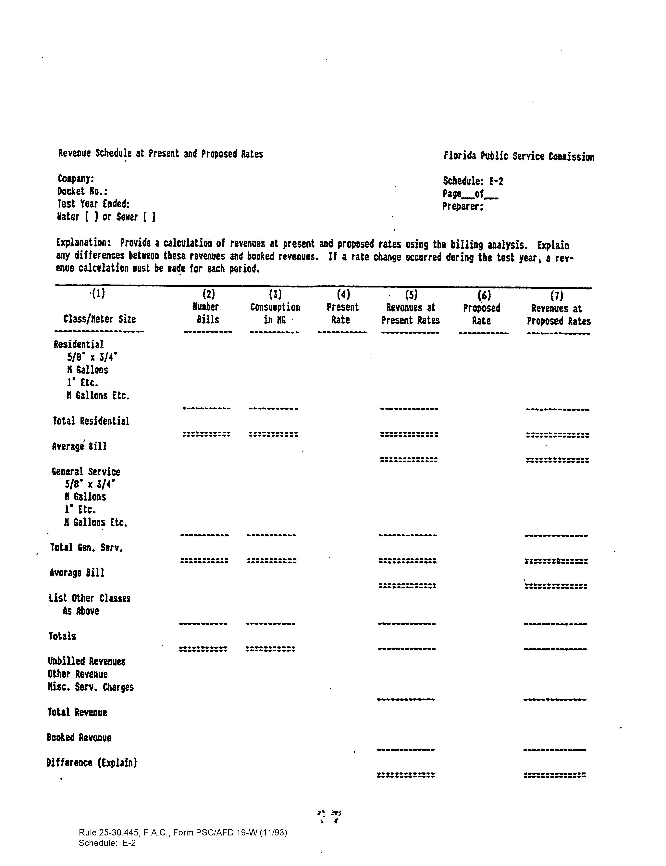

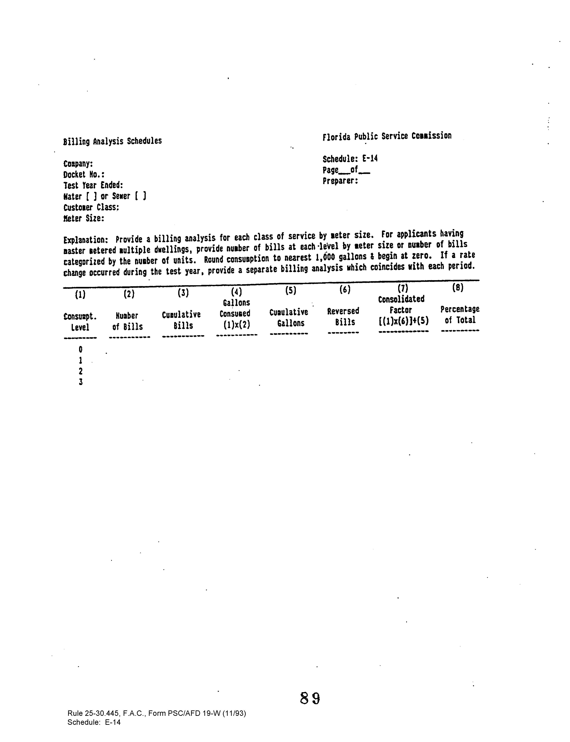

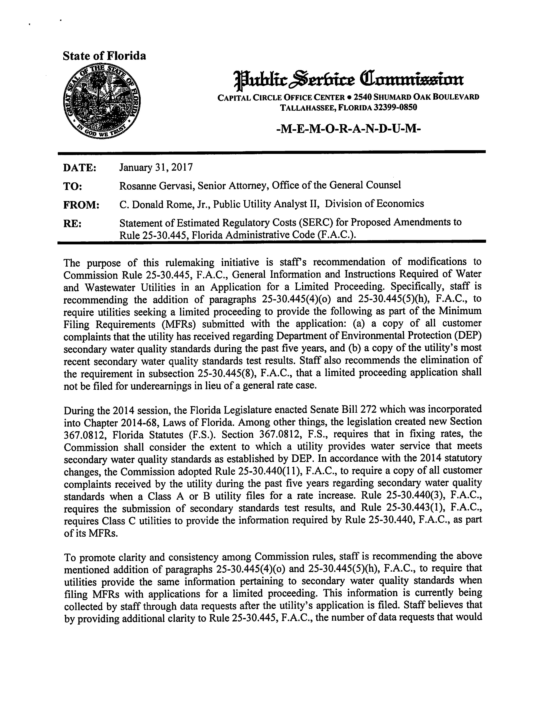

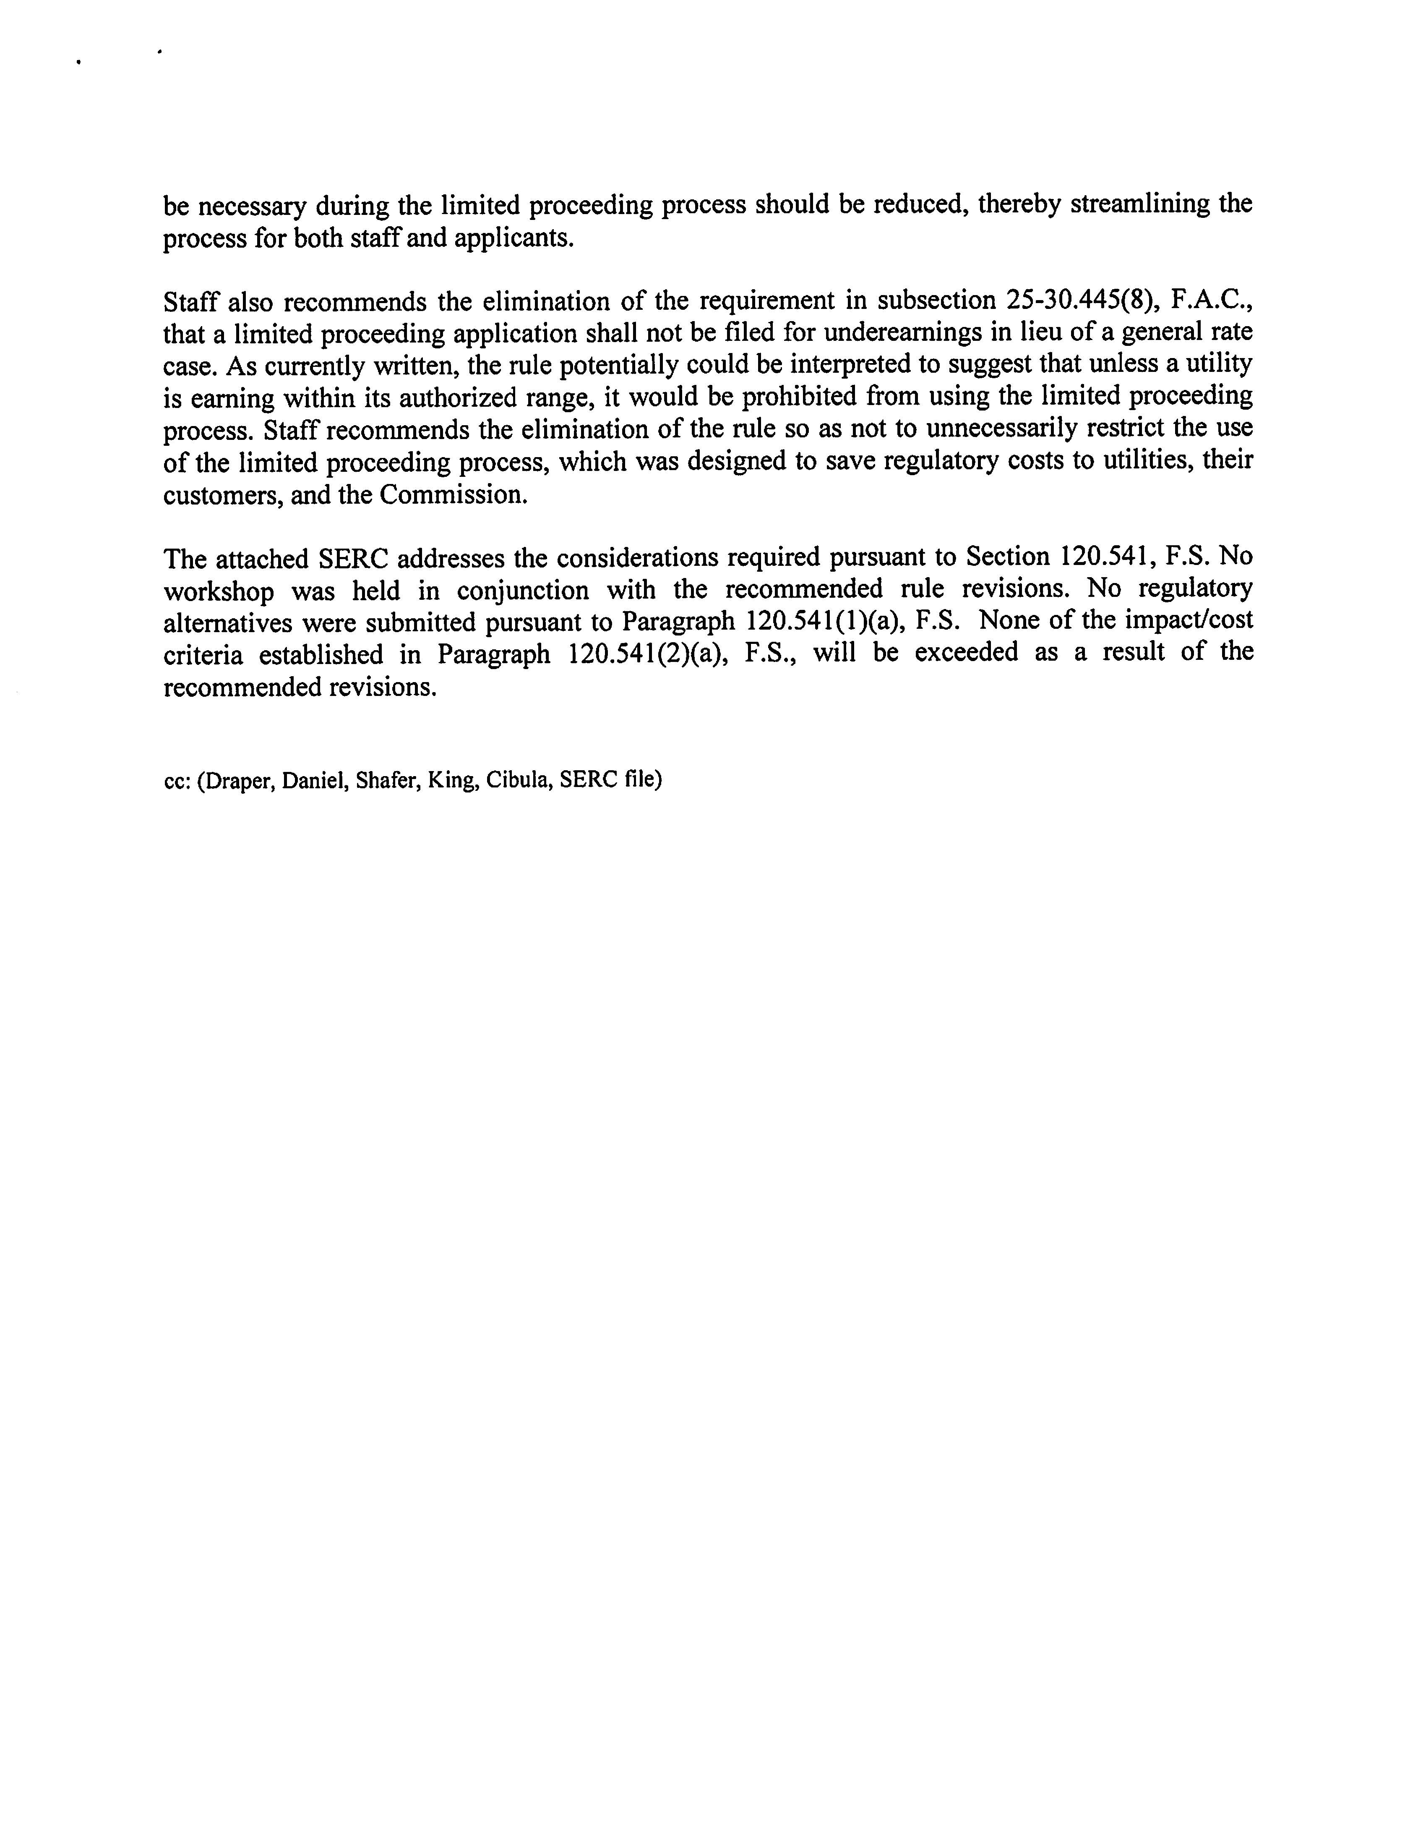

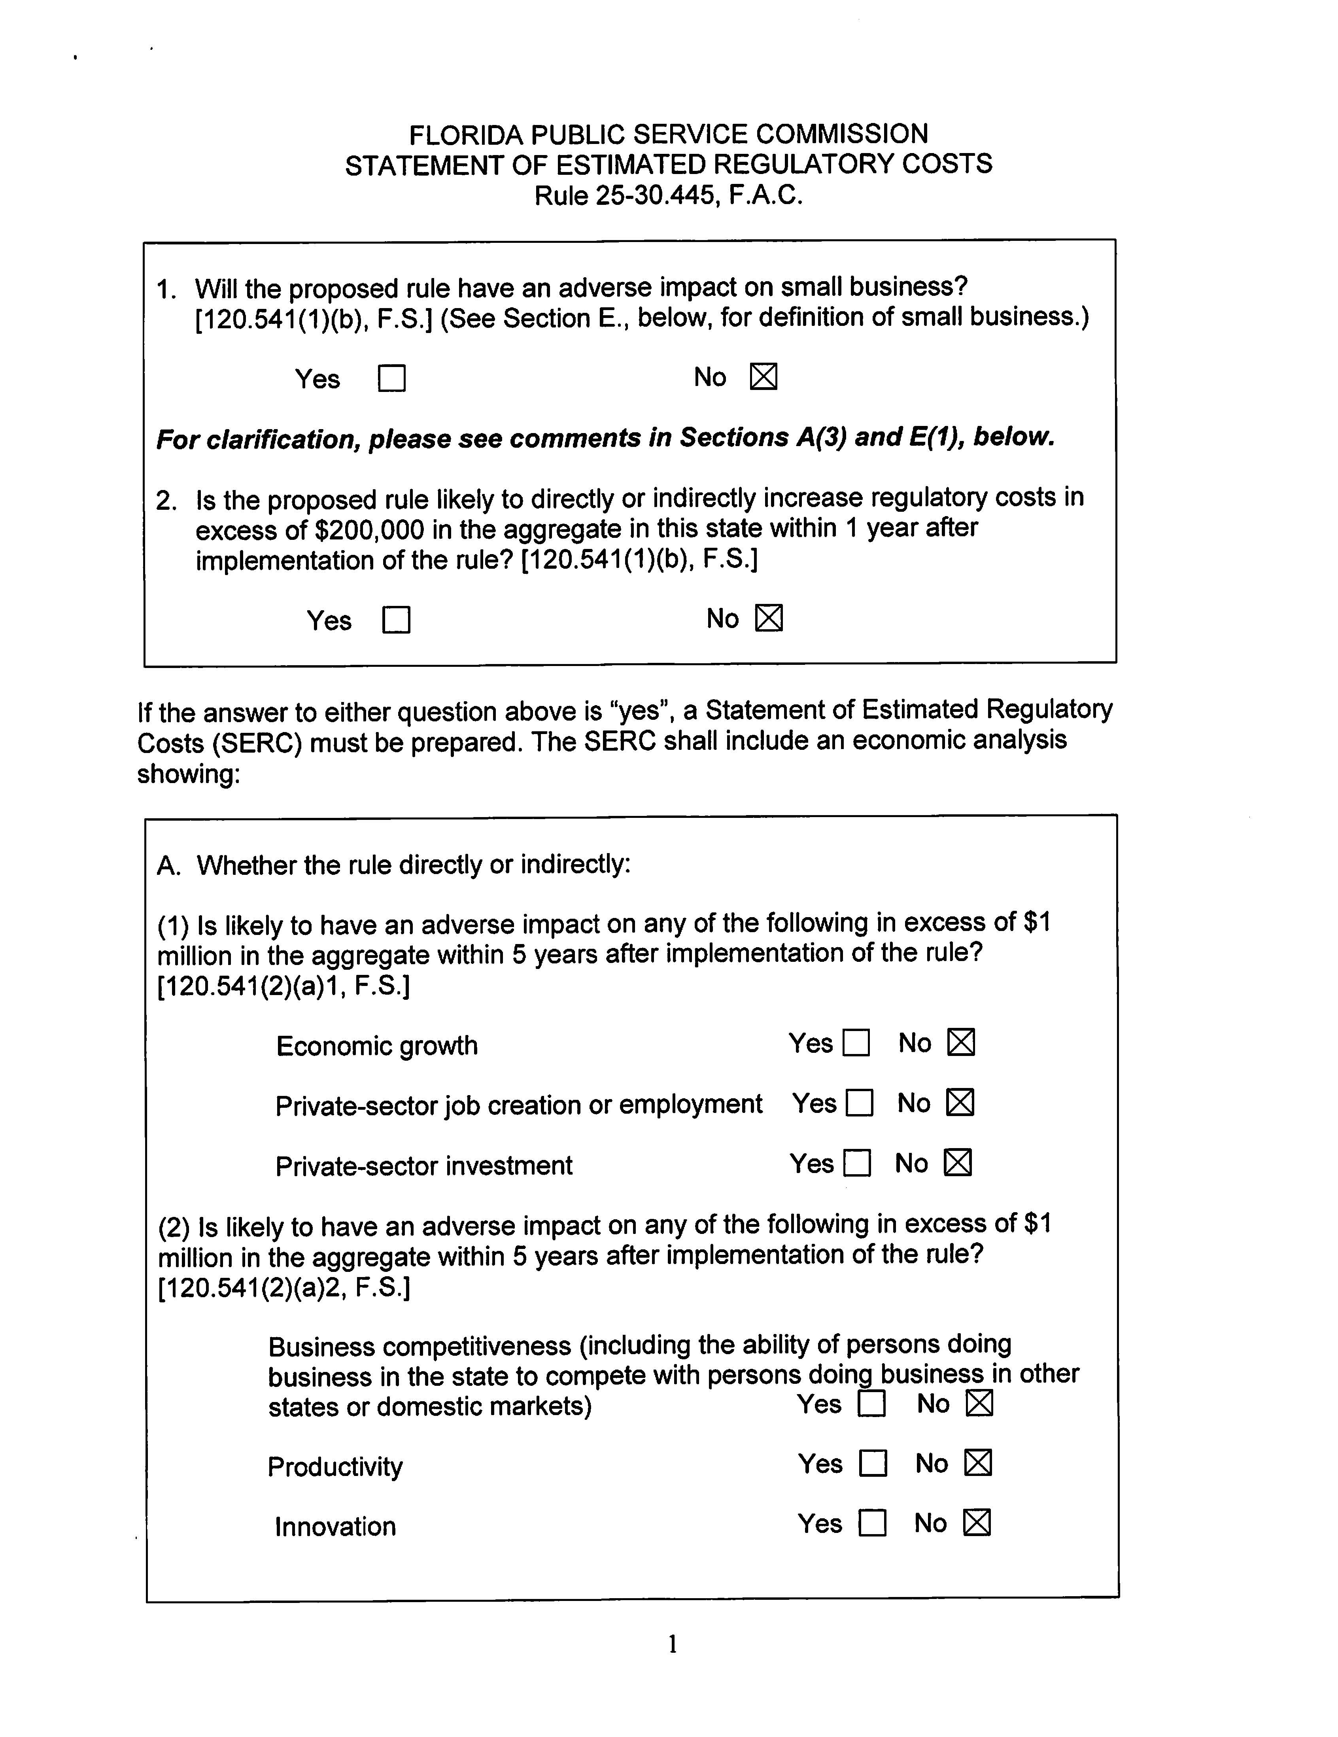

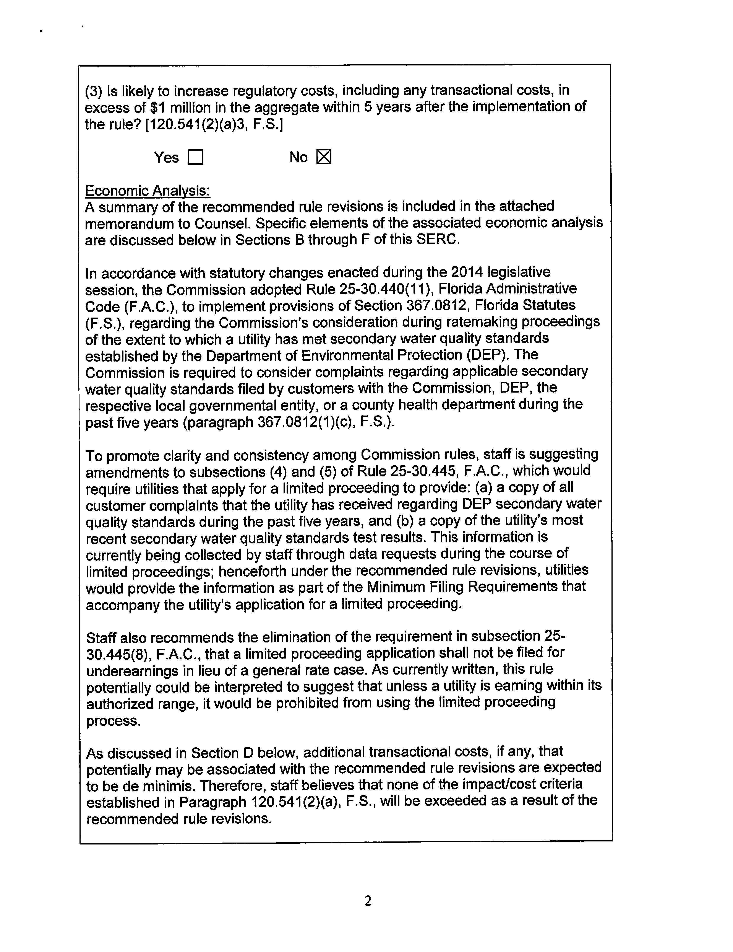

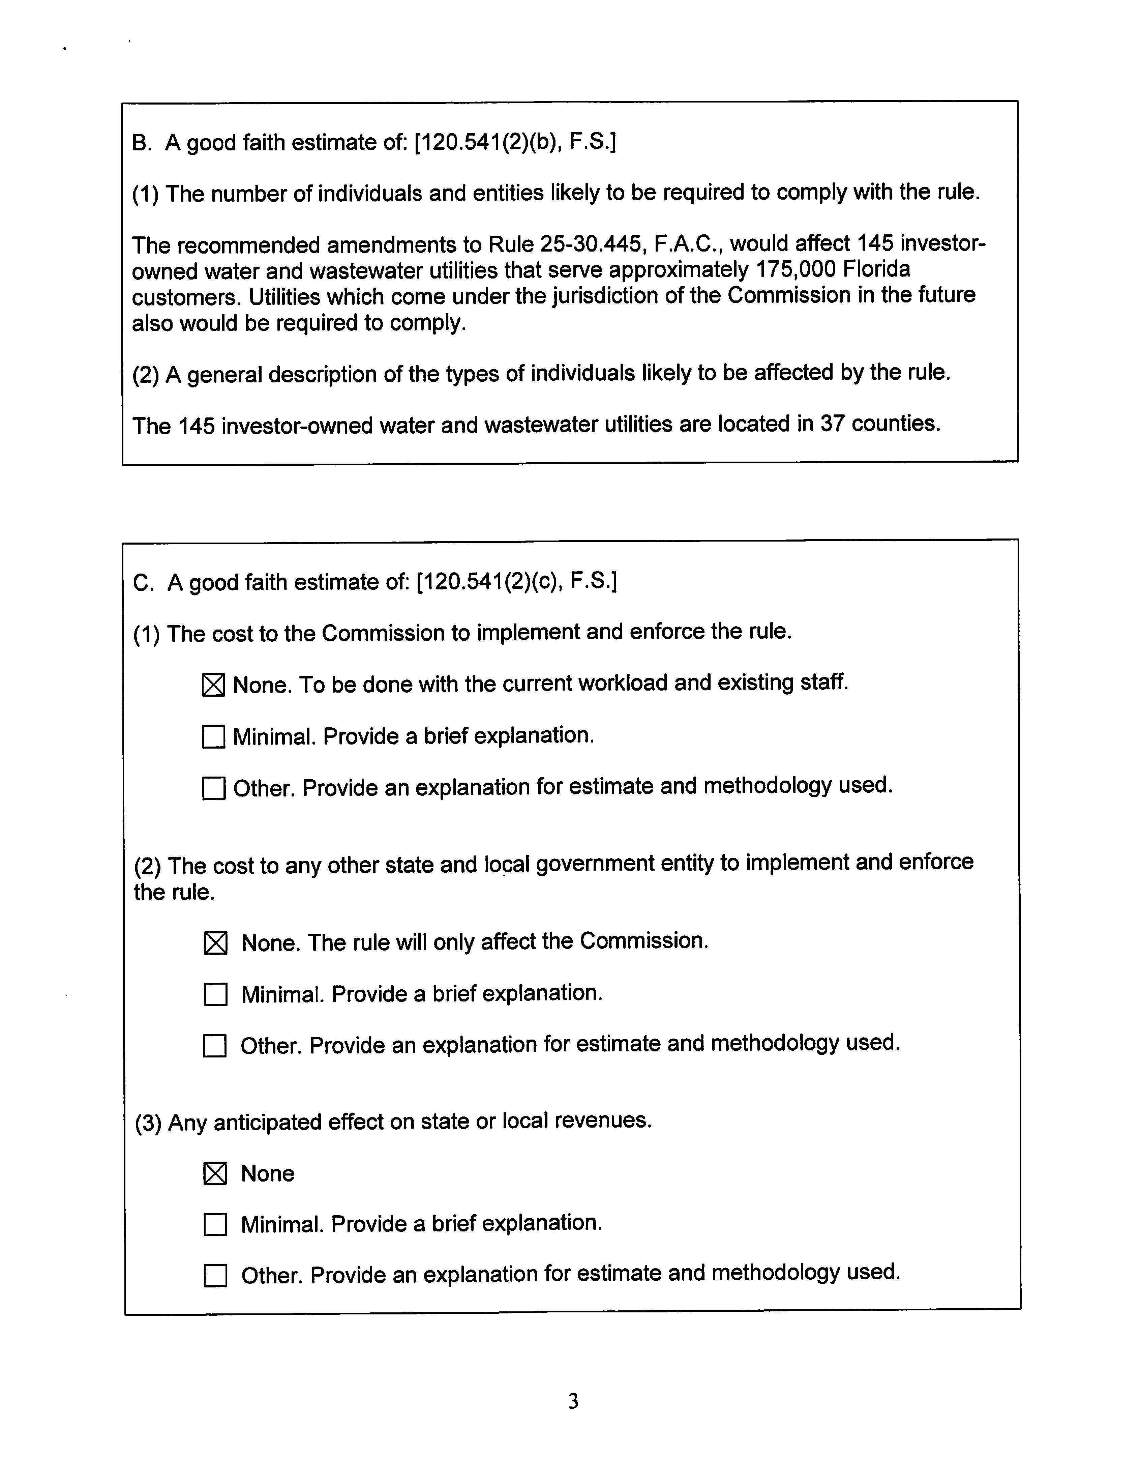

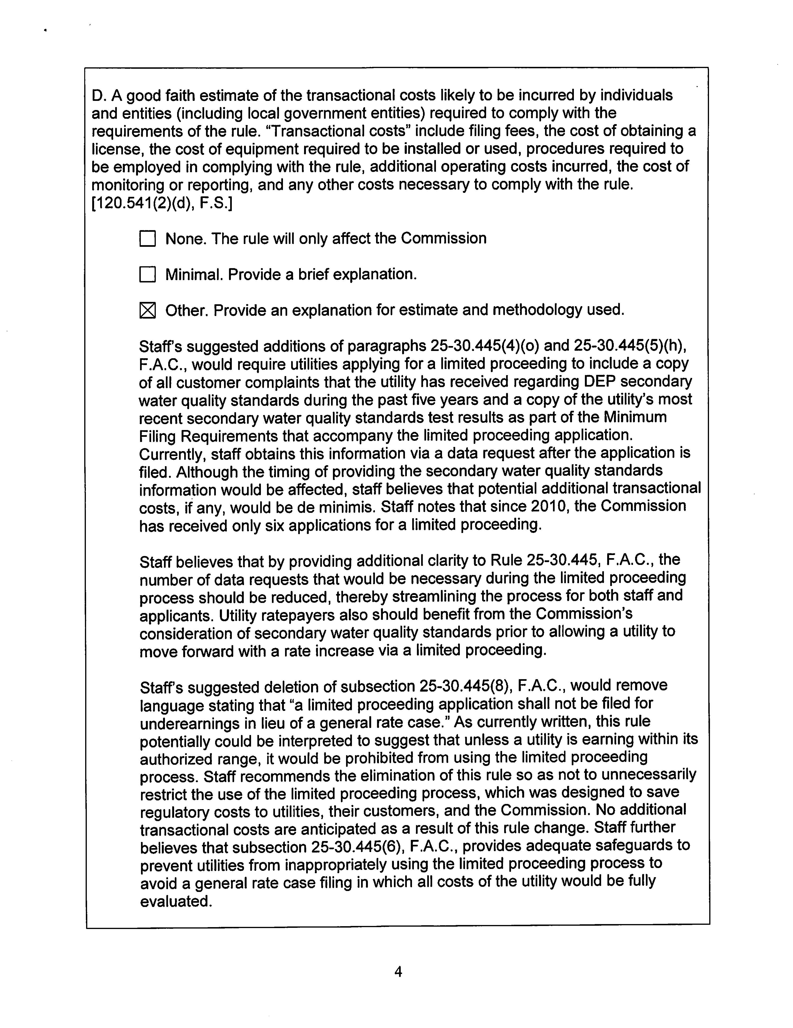

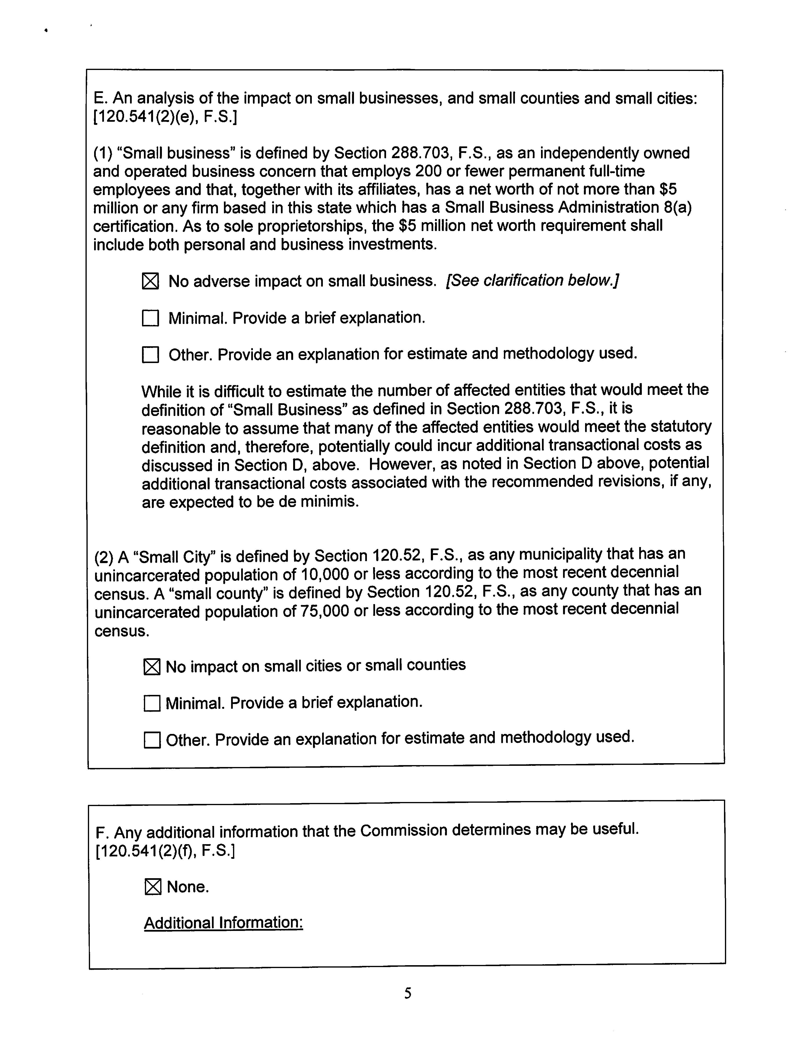

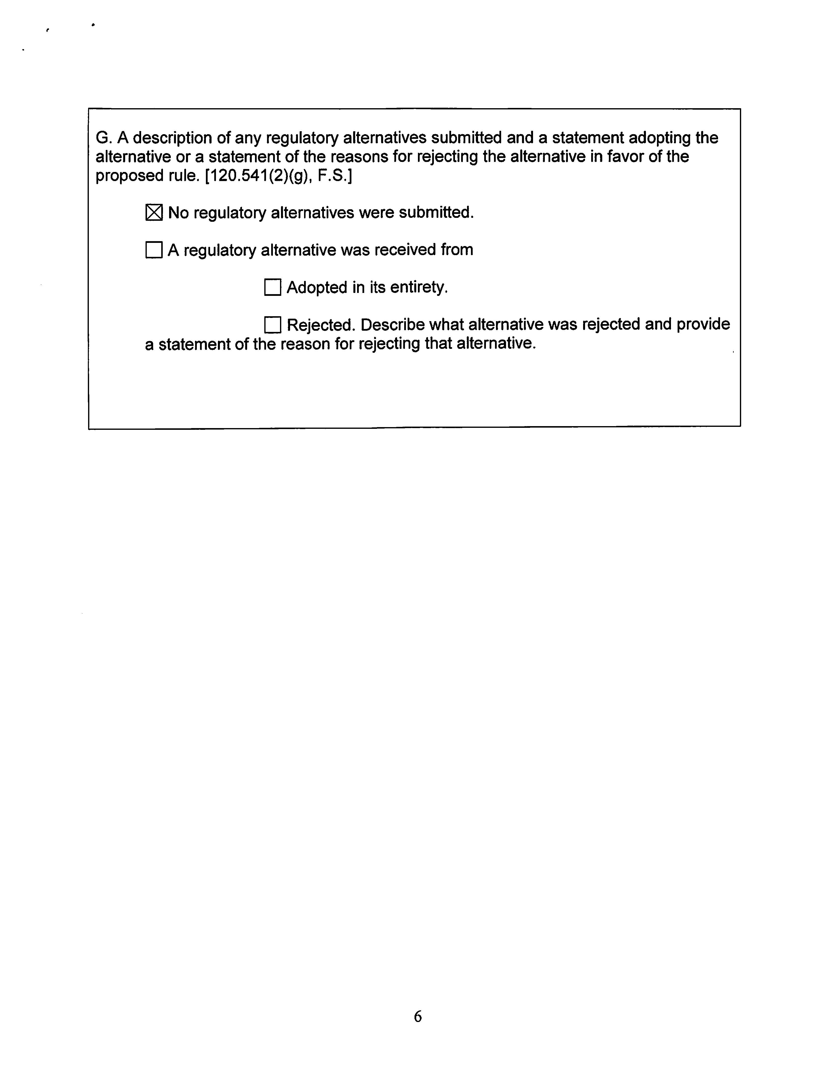

See Order No. PSC-15-0055-FOF-WS, issued January 21, 2015, in Docket No. 140205-WS (noticing the adoption of Rules 25-30.091 and 25-30.440, F.A.C.).
Those utilities include: Charlie Creek Utilities, LLC; Crestridge Utilities, LLC; East Marion Utilities, LLC; McLeod Gardens Utilities, LLC; Holiday Gardens Utilities, LLC; Orange Land Utilities, LLC; Pinecrest Utilities, LLC; and West Lakeland Wastewater, Inc.
Compare Order No. PSC-06-0092-AS-WU, issued February 9, 2006, in Docket No. 000694-WU, In Re: Petition by Water Management Services, Inc. for Limited Proceeding to Increase Water Rates in Franklin County (approving settlement agreement for third and final phase of limited proceeding water rate increase after phases one and two had already been approved, to recover the cost of building a new water transmission main to connect the utility’s wells on the mainland to its service territory on St. George Island, where application for limited proceeding was filed nearly six years earlier, on June 6, 2000) with Order No. PSC-14-0679-PAA-SU, issued December 9, 2014, in Docket No. 140106-SU, In re: Application for limited proceeding rate increase in Polk County by West Lakeland Wastewater, Inc. (granting 1.98 percent limited rate increase to recover additional customer billing costs and for operating permit renewal, where application for limited proceeding was filed less than seven months earlier, on May 20, 2014, and contained deficiencies that needed correction before application could be processed).

